

* The average number of PENDING paternity, divorce and domestic violence cases in Broward County (NOT including DOR cases) totals 6,500 a month.
* The average number of PENDING Department of Revenue cases totals 800 a month.
* There are an average of another 1,000 cases re-opened each month which includes post judgment motions.

✓ = 8,300 PENDING cases each month

* These do NOT include the number of dependency cases with a family law component.
* On average there are 1,273 cases disposed of each month.
* On average, there are 1,255 new cases filed each month.
* Today, there are 1.935 million people in Broward County, FL.

**Settlement Agreements – Trends, Tips and Templates**

*Sheryl A. Moore, Esquire and Jann F. Carlson, Esquire*



***The Public Policy of the State of Florida:***

***TO AMICABLY SETTLE DISPUTES***

***Florida Statues Chapter 61 – Dissolution of Marriage; Support; Timesharing.***

***As per FL Stat. §61.001 –***

1. ***This Chapter shall be liberally construed and applied.***
2. **Its purposes are:**
   1. **To preserve the integrity of marriage and to safeguard**

**meaningful family relationships;**

* 1. **To promote the amicable settlement of disputes that arise between parties to a marriage; and**
  2. **To mitigate the potential harm to the spouses and their children caused by the process of legal dissolution of marriage.**



All marital agreement, whether MSAs or pre or postnuptial agreements shall be construed and interpreted in the same manner as other contracts. Rules of construction and extrinsic evidence shall only be used where the contract language is ambiguous. See Ledea-Genaro v. Genaro, 963 So.2d 749 (Fla. 4th DCA 2007).



**Children of High Conflict Divorces Tend to:**

1. Lie quickly and convincingly to avoid conflict;
2. Learn how to strategize and manipulate as a way to get their needs met;
3. Tend to have impaired relationships with peers as a result of poor role models; and
4. Are more likely to get poor grades, use drugs, and exhibit defiant behavior.



* Collectively over the span of one’s 40-year career, if you practice exclusively family law, you could be involved in drafting between **4,000** and **12,000** settlement agreements, or an average of **8,000** settlement agreements in one’s career. Therefore if, of the **200** lawyers in this room, we fail to clearly draft **10%** of our settlement agreements, the Broward courtroom could have an extra **160,000** cases needlessly back logging our court system.



* A term is ambiguous if it is “rationally

susceptible to more than one

construction.” Elias v. Elias, 152 So. 3d 749 (Fla. 4th DCA 2014)

* Our Judges cannot rewrite poorly drafted contracts.



**THE ROAD TOWARD SUCCESSFUL NEGOTATIONS**

* Have a pre-settlement(Pre-mediation) conference with your client to review all the client's interests and ascertain their goals are realistic
* Discuss the choice of Mediator
* Discuss the location of the mediation
* Contact CPA's, corporate lawyer/estate and trust lawyer to acquire the necessary language prior to the conference for the non-family law provisions contemplated for the settlement agreement



* Determine the appropriate amount of time necessary for the conference –
* Determine whether the timing of the conference/mediation is appropriate or premature Separate the person from the problem (avoid the use of negative history, judgmental language, ultimatums). Focus on the problem, not the personality or the person. Help the parties refocus on the concerns, fear, hopes and aspirations, not the outcome
* Determine if there is an emotional stumbling block which requires removal prior to a successful negotiation session



* Always park your ego at the door (to the extent possible)
* Courtesy and respect should be the cornerstone of all negotiations
* The best settlement is one where the resolution has a low cost to your client and the win is large to the other party and that the win is large to your client and the cost is minimal to the other party-
* Negotiate with a goal toward finding a resolution that neither party will regret after that ink is dry



* If you are attending mediation, figure out who the most difficult party is and choose a mediator who will mesh with the most difficult party.
* Pick the locale carefully.
* How many hours will you devote to the process? Let people know ahead of time if you have time constraints?
* Do you send to the opposing side, ahead of time, your settlement

agreement template tailored to this case?

* Do you have the mediator draft the settlement agreement or do you draft the settlement agreement?



* Use active listening during the settlement process-this does not require that you agree - only that you are attentive and understand what has been said
* Once all parties have expressed their interests and concerns, engage all parties to brainstorm potential options or solutions
* Help the parties shift away from entrenched positions and veer more toward a focus on the issue being addressed



* What is the timing of entry into the settlement agreement?
  + Is it a Global settlement agreement?
  + Is it a Children’s Issues settlement agreement?
  + Is it a Temporary Relief settlement agreement?
  + Is it a Partial Equitable Distribution settlement agreement?
  + Is it a settlement agreement for Discovery Issues?
  + Is it a Partial Settlement Agreement on some not all of the issues; and is there a reservation on the remaining issues?
  + Will a Partial Settlement move the case forward or will it cause you to lose leverage on the non-settled issues?



* For complicated cases, schedule a 2-day settlement conference.
* Proof read the settlement agreement multiple times with

multiple eyes.

* After a settlement agreement is executed, if the final hearing is not immediately scheduled, then do not let the agreement sit idle. File it with the Court attached to an Agreed Order Adopting, Ratifying and Approving Settlement Agreement. This is an important enforcement tool should a party fail to comply with the agreement prior to the final hearing.



* Once a settlement agreement is executed draft a Memo with a detailed bullet point review of the settlement agreement terms. State Actions Steps and layout a Timeline for those actions steps. 1) Tickle your interoffice system for those action steps (on computer and in a paper accordion filing system) and 2) email those Action Steps and the Timeline to the client. Advise the client that it is their responsibility to insure the requisite actions occur OR ask the client if they require your assistance by way of reminders or additional work on their file in order for them to complete these action steps. AREA OF POTENTIAL MALPRACTICE. I.e. QDROS entered; Deeds drafted, signed and recorded; loans refinanced; sums of money exchanged; accounts divided; etc.



* Do you have the parties sign or not on the day/evening of mediation?
* Use Your Gut Instincts
* Does the mediator you choose need to know the law?
* If you want to achieve settlement, decide who the weakest link is and tailor your settlement towards that link to get to “YES”.



* Do you have the parties sign a bullet point document with the agreed upon terms? Is that enforceable or just persuasive?
* County wide differences: Mediation practices in Palm Beach, Broward and Miami-Dade
* Be cognizant of the formation of modern family trend
* Define cumbersome terms in agreements
* Use Examples



* See Family Mediation Rule 12.740 (f)(1) “If agreement is reached as to any matter or issues, including legal or factual issues to be determined by the court, the agreement shall be reduced to writing, signed by the parties and their counsel, if any and if present, and submitted to the court unless the parties agree otherwise.
* Beware of Road Blockers – Third Parties
* FOOD!



**P: PARENTING**

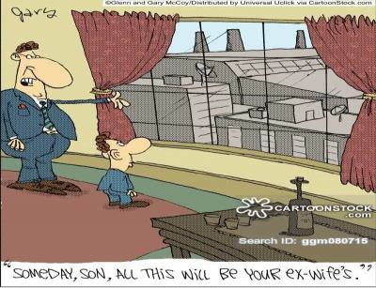

**E: EQUITABLE DISTRIBUTION**



P.E.A.C.E.

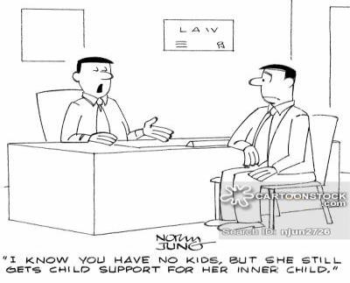

**C: CHILD SUPPORT**

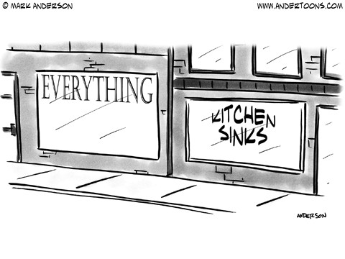

**E: EVERYTHING ELSE**

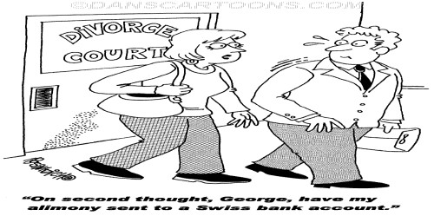

**A. ALIMONY**





***Remember not only to say the right thing in***

***the right place, but far more difficult still to leave unsaid the wrong thing at the tempting moment.***

***- Benjamin Franklin***

***Sheryl A. Moore, Esq.***

[***smoore@fowler-white.com***](mailto:smoore@fowler-white.com) ***Tel: 954.377.8137***

***Janis F. Carlson, Esq.*** [***janisfcarlson@aol.com***](mailto:janisfcarlson@aol.com) ***Tel: 954.202.2011***