
C H A P T E R 5

DIVORCE

RUTHANNE WITHERS, ESQ.

Coogan Smith LLP, Attleboro

Introduction 126

What Is the Difference Between Divorce and a Legal Separation? 126

Jurisdiction 127

No-Fault Divorce 128

Fault Divorce 128

Where to File 129

Complaint 129

Answer 130

Defenses 130

Counterclaim 130

Separation Agreements 131

Recognition of Divorces from Other States or Countries 131

Divorces Adjudged in Foreign Countries 131

Divorces Adjudged in Other (“Sister”) States 132

The Hearing 132

How Long Before the Hearing 132

How to Mark a Case for a Hearing 132

Uncontested Hearing 132

Pretrial Conference 132

What Questions Will the Judge Ask? 133

Using Witnesses at Trial 134

Using Other Evidence at Trial 135

Going to the Courthouse 135

Dress and Protocol 135

Who Is in the Courtroom? 135

Probation Officers 135

The Hearing 136

Proving Your Case 136

Child Custody 136

Child Support 136

Alimony 136

CHECKLIST 5.1—Divorce Checklist 137

EXHIBIT 5A—Joint Petition for Divorce 140

Family Law Advocacy for Low and Moderate Income Litigants, 3rd Edition 2018 125
■ CHAPTER 5: DIVORCE

EXHIBIT 5B—Affidavit in Support of Complaint for Divorce: Irretrievable

Breakdown of the Marriage, G.L. c. 208, § 1A 141

EXHIBIT 5C—Answer to Complaint for Divorce 143

EXHIBIT 5D—Counterclaim for Divorce Action 145

EXHIBIT 5E—Separation Agreement 147

EXHIBIT 5F—Report of Absolute Divorce or Annulment 153

EXHIBIT 5G—Military Affidavit 155

EXHIBIT 5H—Affidavit Disclosing Care or Custody Proceeding 156

EXHIBIT 5I—Parent Education Programs 159

EXHIBIT 5J—Plaintiff’s Pretrial Memorandum 163

EXHIBIT 5K—Motion for State Payment of Fees and Costs 167

EXHIBIT 5L—Financial Statement (Short Form) 168

EXHIBIT 5M—Financial Statement (Long Form) 172

EXHIBIT 5N—Qualified Domestic Relations Order 181

EXHIBIT 5O—Blank Motion Form 183

EXHIBIT 5P—Court Order for Costs and Fees (G.L. c. 261, § 27A et seq.) 185

INTRODUCTION

Divorce is the legal process by which a married couple separates and becomes two individuals instead of a single unit. Through a divorce, the couple’s property and debts can be divided between them. In addition, their obligations and rights in connection with their children and toward each other can be defined. When the divorce becomes final, they can marry other people. Sometimes, if an annulment is granted, the parties will be considered to have never been married to each other. However, when there are unemancipated children in the family, the parties often have not severed all ties but rather redefined them. Generally, the divorced parents of minor children will continue to have financial, emotional, and legal connections. Checklist 5.1 provides a list of items to review when preparing and filing for divorce.

WHAT IS THE DIFFERENCE BETWEEN DIVORCE AND A LEGAL SEPARATION?

The purpose of a divorce is to become unmarried. Through a divorce you can also resolve many other issues, such as custody or alimony. In certain cases, there is just a divorce—a legal acknowledgment that the parties are no longer married.

In Massachusetts, there is no such thing as a legal separation. However, you can decide how you are going to live apart from your spouse in a separate support action, including the amount of support to be paid and with whom the children will live. In this scenario, you would still be married to one another and could not remarry. Separate support makes sense when, for religious or psychological reasons, one person may want to define the terms on which the couple lives apart without getting divorced.

Unmarried parents can resolve issues of custody, parenting time, and child support, but you cannot resolve property division or alimony. Additionally, you can choose to not end the marriage and file a complaint for separate support or a complaint for support pursuant to G.L. c. 209, § 32F. This action is not often used between married persons, but may be filed when, for legal reasons, the court could not hear a divorce but could decide on custody. See “Jurisdiction,” below.

For most people, if you plan to live apart and do not foresee reconciling, divorce is the most reasonable approach.

126 Family Law Advocacy for Low and Moderate Income Litigants, 3rd Edition 2018

CHAPTER 5: DIVORCE 

JURISDICTION

As elaborated upon below, the questions of jurisdiction are frequently confusing, even to some lawyers. There are two requirements that must be met before a court can order a party to do something: the court must have power over the parties in the case and it must also have power over the subject matter of the case. In certain cases, the court may make decisions over child custody or may terminate the marital status of two parties, but it cannot stray beyond those subjects. You may wish to think of the courts as having powers that are limited in certain ways. The power over a person is different from the power over a case. If your spouse does not live in Massachusetts and, after reading this section, you still do not understand jurisdiction issues, you should consult an attorney.

In order for a state court to make decisions about you and your family, it must have the power to make those decisions. This power is called jurisdiction. To decide whether a court has jurisdiction, two questions must be answered. The first question is whether the defendant has enough of a relationship with the state so that the state will have the power to issue orders that are binding on the defendant. The second question is whether the case has enough ties to the state that it is fair for the specific issue or issues to be decided there. These two questions sound similar but have important legal differences.

Whether the state has the power to issue orders that are binding on the defendant is a question of personal jurisdiction. For the court to obtain personal jurisdiction over the defendant, the state must have had enough contact with the defendant for it to be fair to have the state decide the case. As an example, imagine that your wife used to live in Nebraska; her mother still lives there, and when she leaves the marriage, she goes to Nebraska. You, however, have never been to Nebraska and you do not want to go there now. It would not be fair if your wife could file a divorce in Nebraska and force you to go there to argue about paying alimony and dividing up marital property. Because you have no contacts with Nebraska, the Nebraska court cannot obtain personal jurisdiction over you and the case will not be heard there. However, if you lived together in Massachusetts and you now live in Massachusetts, you could have the case heard in Massachusetts even though your spouse has moved away.

The types of contact that would allow you to bring your spouse to court in Massachusetts are defined broadly. They are the following:

- maintaining a home in Massachusetts while involved in a relationship that gives rise to a family law case, such as divorce or paternity;

- the commission of any act in Massachusetts that gives rise to such a case;

- having been previously involved with a case in Massachusetts that ordered child custody, support, alimony, or property division when the later case involves the same people; and

- being served with the complaint in hand in Massachusetts.

The commission of any act that gives rise to such a case includes the act of conceiving a child. G.L. c. 223A, § 3; Rosenfield v. Trombley, 38 Mass. App. Dec. 123 (1967).

Subject matter jurisdiction is the legal term for the second kind of limitation on the state’s power to hear a case. The question is whether the subject of the case is one over which the state’s courts have the power to make decisions. In family law, this question generally arises in custody cases. When children have been living in the state for a while, that state’s courts can decide who should have custody, even if they do not have personal jurisdiction over both of the parents. Most states have passed a law on this issue; the laws are fairly uniform across the country. Basically, what the law says is that child custody cases are about the children and should be decided where they are, rather than where the parents are. However, this may mean that the court that gives custody does not have the power to enter orders against the absent parent, such as an order for child support.

Sometimes a state will find that its courts have subject matter jurisdiction over the marriage even if the state does not have personal jurisdiction over both spouses. In Massachusetts, even if one spouse has never been to Massachusetts and the courts cannot order that spouse to divide marital property or pay alimony, the other spouse can still obtain a divorce. This will only make the spouses legally unmarried to one another; it will not decide other unresolved issues. If you ask the court to decide those other issues, your spouse can always challenge this action, particularly if he or she was not given actual notice that the case was going on or if he or she did not come to the court to argue the case.

Family Law Advocacy for Low and Moderate Income Litigants, 3rd Edition 2018 127

- CHAPTER 5: DIVORCE

NO-FAULT DIVORCE

There are two kinds of no-fault divorce. The first is when both spouses come to an agreement and file a joint petition for divorce together. The second is when one spouse files a complaint for divorce by himself or herself, stating that the marriage has irretrievably broken down. Because the former is allowed under G.L. c. 208, § 1A and the latter under G.L. c. 208, § 1B, they are often referred to by their section numbers. For example, your attorney might ask if this is a “1A” divorce or a “1B” divorce.

The process is different for the two types of no-fault divorce. In a “1A” case, the parties file an agreement and joint petition at the same time. Both spouses sign the joint petition and an affidavit of irretrievable breakdown of the marriage. (An affidavit is a written, sworn statement.) It is understood that the spouses have worked out all the issues in advance without the court’s assistance, including disclosure of all their financial matters to each other. The case can be heard and a judgment entered right away. The divorce is not final until 120 days have passed from the date of judgment.

This is a quicker process overall than other ways to get a divorce. However, how soon the case is heard depends on the backlog of cases in your county. See Exhibits 5A and 5B for examples of the joint petition and affidavit.

In a “1B” case—the most common type of divorce filed—one spouse files a complaint for divorce and states in it that the marriage has irretrievably broken down. If the spouses cannot agree about the outcome of the case, or even whether the marriage has broken down, the court will make those decisions for them through the divorce. The court rarely decides that the marriage is not broken down when one spouse believes that it is. After filing for divorce, you must wait six months to file a request for hearing. This six-month requirement may not make much difference, because you will need time to prepare for the hearing anyway. After the hearing takes place and a judgment is entered, the divorce is not final until ninety days have passed from the date of judgment.

At any time during a “1B” or a fault divorce, the spouses can come to an agreement and file a request that the case be converted into a “1A” divorce. If this happens, the spouses must file the same paperwork that would have been required to file a joint petition in the first place.

FAULT DIVORCE

For the most part, fault divorces are a relic of the past. Essentially, instead of saying the spouses are not able to live together as husband and wife and they therefore need a divorce, one spouse is saying it is the behavior of the other spouse that caused the marriage to end. In order to get a divorce on fault grounds, you must be able to prove that your spouse has done what you allege. The fault must be one for which the statute allows you to get a divorce. The grounds for a fault divorce are the following:

- Adultery. To prove this ground, you need to name the person with whom your spouse was unfaithful and serve that person with a copy of the complaint.

- Impotence.

- Desertion. Your spouse must have deserted or left you for one continuous year prior to filing the complaint. Your spouse cannot have come back to you even for a brief period during the period of desertion and must not have made efforts to reconcile. Laflamme v. Laflamme, 210 Mass. 156 (1911); Miranda v. Miranda,

350 Mass. 478 (1966). In addition, your spouse must not have had a good reason for leaving and staying away, such as leaving in search of employment. Kendrick v. Kendrick, 188 Mass. 550 (1905).

- Gross and confirmed habits of intoxication. This ground need not be daily substance abuse but does need to be regular and severe bouts of intoxication. Jasper v. Jasper, 333 Mass. 223 (1955) (mere use of drugs not ground for divorce but abuse must be shown).

- Cruel and abusive treatment. This ground does not have to be physical violence. The cruel and abusive treatment needs to cause injury or harm to the victim’s health or to create a fear that the spouse may harm the victim’s health. Mere words may wound the feelings to the degree that the health is impaired or endangered. Brown v. Brown, 323 Mass. 332 (1948); Silverman v. Silverman, 5 Mass. App. Ct. 793 (1977).

- Refusal or neglect to support. To prove this ground, you need to show that your spouse was able to provide support. In addition, the law states that the failure to pay should be wanton or gross and cruel. The cases indicate that you need to show that you could not provide for yourself. Holt v. Holt, 117 Mass. 202 (1875).

128 Family Law Advocacy for Low and Moderate Income Litigants, 3rd Edition 2018

CHAPTER 5: DIVORCE 

- Incarceration. Your spouse needs to be sentenced for five years or longer or for life in prison or other correctional facility. G.L. c. 208, § 2.

Clearly, it is easier to prove how long your spouse’s prison sentence is by bringing documents to court than to prove confirmed and severe drunkenness. In general, proving infidelity is hardest. You need to name and serve the person with whom your spouse was unfaithful. If the case finally goes to trial, the time it takes to prove fault will cost you money and take an emotional toll on everyone involved in the case. Moreover, if you decide to pursue a fault divorce, the court may not look upon you favorably. Your children may also be affected by any focus on blaming the other spouse, however accurate your estimation of your spouse’s failings may be. Always remember that, unless you receive the court’s permission, complaints for divorce and all other filings in the Probate and Family Court are public record. Anyone, including your children when they are older, have access to your case file.

There is little advantage legally to obtaining a fault divorce. In deciding alimony and property division issues, the court will weigh your spouse’s conduct whether or not you file a fault divorce. G.L. c. 208, § 34. Even in that situation, the cases say that conduct should not be weighed as heavily as other factors. Filing successfully for a fault divorce will not improve your chances of getting custody. In considering custody and visitation, the court will weigh concerns about your spouse’s ability to provide a safe and loving environment for your children. All important evidence about his or her character and parenting ability will be brought forward regardless of what grounds you named in your complaint.

There are two theoretical advantages to a fault divorce. First, if a spouse has been a victim of domestic violence, the judges generally understand that it can be important for that person to get a divorce for cruel and abusive treatment. Second, you can request a hearing for divorce as soon as you like. Compare this to a no-fault divorce, where the parties have not come to an agreement. These parties must wait six months to file a request for hearing. Realistically, if you and your spouse have serious disagreements, it will probably take longer than six months to be ready for a hearing. If you come to an agreement before six months pass, you can file a motion to convert the case to a “1A” divorce and be heard much sooner.

WHERE TO FILE

Divorce cases are filed with the clerk’s office in the Probate and Family Court. If either spouse lives in the county where the two of you last lived together, you must file in that county. If neither of you live there now, you may file in the county where you or your spouse lives now. G.L. c. 208, § 6. In some counties, the court also allows for electronic filing with the intention of moving to a more streamlined process. All forms are available through the Probate and Family Court website at https://www.mass.gov/service-details/divorce-court-forms.

Each county has at least one Probate and Family Court session. Some have a central courthouse and hold satellite sessions in other courthouses. For example, in Middlesex County, the central courthouse is located in Cambridge and the satellite sessions are located in Concord, Lowell, and Marlborough. In most counties, you should file your complaint in the central courthouse. Call ahead to ask the clerk’s office where and how to file. Then you may ask to be heard in the satellite sessions.

COMPLAINT

The complaint is a one-page form that requires straightforward information. See Exhibit 5C for a sample complaint form. It is important to complete this form accurately, particularly the section regarding other cases involving care and custody of your children. You need to be clear about the dates and places of your marriage and separation because these will determine whether the court has jurisdiction.

The last section of the form is a list of objectives that you can request from your divorce, such as custody, parenting time, and support. The legal term for the things you want is “relief,” and the request for the things you want is the “prayer for relief.” Ask for everything you may want, whether you want it in part or in whole. For example, if you expect that your children will live with your spouse but you will be involved in making major decisions about them, check the box asking for custody. You want legal custody, not physical custody, but you check off custody anyway. The difference between legal and physical custody is discussed below.

Family Law Advocacy for Low and Moderate Income Litigants, 3rd Edition 2018 129

- CHAPTER 5: DIVORCE

The box for freedom from restraint should only be checked if you want a restraining order against your spouse. Years ago, a restraining order was an order that told one spouse not to bother the other. Now, the Probate and Family Courts can only issue orders not to contact or abuse when it is necessary for the health, safety, or welfare of one of the parties or their children. In these cases, the orders are entered into the central registry and violations are criminal matters. G.L. c. 208, § 34C.

If you or spouse own any real estate, you must write the book and page numbers where the deed giving you, your spouse, or both of you ownership of the house can be found. In the last and blank section of the form, you may wish to write a request for division of marital debts and assets.

Although you should be complete and accurate, if you make a mistake, you can correct it by filing a motion to amend the complaint. In general, this will be allowed without any difficulty.

ANSWER

If your spouse files and serves you with a complaint, the proper thing to do is file an answer. In many types of lawsuits, the court will find against you automatically if you do not file an answer within a certain number of days. This is called a default. In Massachusetts, you will not be in default for not filing an answer in a divorce. However, it is considered good practice to file one.

See Exhibit 5D for a model answer. It follows a format that you will use for most of the papers you file with the court. The heading indicates that the answer is filed in Massachusetts, in the Probate and Family Court, and in a particular county. It further describes your case by showing the names of the parties and the docket number. You and your spouse may have had other cases in the same county, but your divorce is known by a certain number. There is a space at the top of the document to write a description of what document you are filing.

You should admit or deny each allegation set forth in the complaint. If you do not know how to answer an allegation, say so. If you know the correct facts, state them in your answer. For example, if your address is wrong, you might write “Deny. I live at 123 Main Street, Anytown, MA.”

DEFENSES

It may be that you do not wish to be divorced, even though your spouse does. In general, this will not matter. If one person says the marriage is broken, it is considered broken under the law. However, you can defend against your spouse’s complaint for divorce in other ways. You can say that any of the statements in the complaint are not accurate. You can also say that if they are true, your spouse should still not be able to divorce you for fault or that the relief he or she wants should not be ordered. For example, you can argue that the court does not have jurisdiction over the case or that it is being heard in the wrong county.

Following are two defenses that are specific to fault divorces:

- Condonation. You cannot file for divorce based on fault if you forgave your spouse at the time and your marriage went forward. You can get divorced for things that happened some time ago if you have lived apart or otherwise not healed your marriage. However, you cannot go back in time to the fault that you condoned.

- Insanity. If a spouse commits a breach of the marriage when insane, he or she is not held responsible for it.

COUNTERCLAIM

If your spouse files a complaint for divorce and you disagree with anything in it, you may wish to file a counterclaim. This is your own complaint, in which you set out your facts and your prayer for relief. By filing a counterclaim, you are asking for a divorce. See Exhibit 5D for a sample answer and counterclaim.

130 Family Law Advocacy for Low and Moderate Income Litigants, 3rd Edition 2018

CHAPTER 5: DIVORCE 

SEPARATION AGREEMENTS

Sooner or later, it is likely that you and your spouse will come to an agreement. Fewer than 10 percent of all cases go to trial. The whole court process encourages settlement.

This is not without reason. Trials are costly and time consuming and increase hostility between spouses. In addition, when you settle a case, you have more control over the outcome. With a trial, you are gambling that the judge will see the case as you would like, rather than as your spouse would like.

In order to settle cases, there is significant pressure on the parties at certain points in the process. While you are swept up in the heat of the moment, it is hard to see things clearly. If you are too rigid, you may lose the best chance to resolve your case and move on with your life. On the other hand, if you just want the whole thing to end, you may give in on subjects that you later regret. As a general rule, do not insist on things merely to hurt the other side. Think about what you really need, what you want, and what you could live without. Think about what is best for your children. Having a cool head and knowing what is important to you are enormous advantages in negotiating an agreement.

While you are in the negotiating process, take the time to read every word of any agreement offered to you. Do not sign anything until you completely understand it. Most agreements written by lawyers include some standard language, or boilerplate, that is not easily understood. Be sure you get an explanation of any technical language. It is never all or nothing. Many agreements have sections scratched out or new provisions written by hand in the margins.

If you and your spouse can settle the issues between you, you should write everything out, formally and in detail. Then you sign that document (also called executing it) in front of a notary public and have it approved by the court at a hearing. At the hearing, the judge will ask you if you have read the agreement, if you think it is fair and reasonable, and if you understand it. If you have any last-minute doubts, particularly if you do not have a lawyer, tell the judge you are not sure. Separation agreements can be complicated. To make them easier to understand, a sample agreement, with explanations in bold type, is included as Exhibit 5E.

RECOGNITION OF DIVORCES FROM OTHER STATES OR COUNTRIES

The general rule of law is that Massachusetts will recognize as valid a divorce adjudged in a foreign jurisdiction (both a foreign country and another state) if the foreign court has jurisdiction over the cause of the case and over both parties. However, Massachusetts will not recognize a foreign divorce as valid in two situations. The first situation is when a husband or wife goes into another jurisdiction to obtain a divorce for a cause that occurred while the parties resided in Massachusetts. G.L. c. 208, § 39. The second situation is when a husband or wife goes into another jurisdiction to obtain a divorce for a cause that would not authorize a divorce under Massachusetts law. G.L. c. 208, § 39.

Divorces Adjudged in Foreign Countries

To determine whether a foreign country divorce decree is recognized in Massachusetts, the Massachusetts court must look to see if the foreign decree offends Massachusetts public policy. For example, when a divorce is granted in a foreign country where there is no requirement for residency and the proceedings are conducted in a foreign language that the participants do not understand, Massachusetts would not recognize the decree. Furthermore, if the grounds for divorce in the foreign country do not exist in Massachusetts, Massachusetts would not recognize the decree because it is contrary to Massachusetts public policy.

The exception to the above rule is when both of the parties appear in the foreign country for the divorce proceeding. In this situation, one of the parties cannot later argue that the judgment is invalid because of what is called the doctrine of estoppel. Put simply, even though the proceedings in the foreign country may be contrary to Massachusetts public policy, the parties are estopped, or forbidden, from later arguing that the judgment was invalid because they both believed in good faith that the foreign country divorce decree was valid. Bushnell v. Bushnell, 393 Mass. 462 (1984); Poor v. Poor, 381 Mass. 392 (1980), as distinguished by Thompson v. Harris, 504 F. Supp. 653 (1980).

Family Law Advocacy for Low and Moderate Income Litigants, 3rd Edition 2018 131

- CHAPTER 5: DIVORCE

Divorces Adjudged in Other (“Sister”) States

Massachusetts must accept a divorce decree of another state and give it full faith and credit if the sister state made a finding that the petitioner was domiciled in that state. See Heron v. Heron, 428 Mass. 537 (1998) (citing Sherrer v. Sherrer, 334 U.S. 343, 354, 68 S. Ct. 1087, 92 L. Ed. 1429 (1948)); Cavanagh v. Cavanagh, 396 Mass. 836, 839 (1986) (and cases cited).

THE HEARING

How Long Before the Hearing

The length of time before a hearing can be scheduled depends on both the complexity of each case and the court in which you filed the case. If you have an agreement on all issues, you have an uncontested case and will not have to wait as long for a hearing. Some courts will allow you to bring the agreement to the court and you can have the hearing the same day you file the paperwork. Depending on the court, an uncontested hearing can take anywhere from a few weeks to several months to schedule. Check with the court personnel, as they will have the most updated information regarding the length of time for a hearing.

It is always best to resolve those issues that you can agree upon. The more issues you and the other party agree upon, the less time you will wait for a hearing to be scheduled because the judge will only have to consider your contested issues. The more complicated and contested a case, the longer you will have to wait for a hearing.

How to Mark a Case for a Hearing

Uncontested Hearing

If you and the other party are filing a joint petition for divorce under G.L. c. 208, § 1A, you should file all of your papers together at the Probate and Family Court clerk’s office. Once the clerk reviews your documents and makes sure you have all of your paperwork in order, the clerk will send you a date for your uncontested hearing.

If you have filed a divorce case under G.L. c. 208, § 1B (a “no-fault” divorce), you will likely receive a notice for a case management conference within the first two or three months after filing your case. The purpose of a case management conference is to schedule a discovery deadline and streamline the timeline of your case. Each court has a different method by which they issue case management notices, so ask a clerk if you have any questions about the next step in your case.

If you have filed a no-fault divorce and have not received any notices, the Probate and Family Court has a form to request a hearing date. See Exhibit 2H. All of your discovery (request for production of documents, interrogatories, and depositions) should be complete before asking for a hearing. Send a copy of your request to the other side. The following documents must be on file:

- a divorce statistical form, which is available in the clerk’s office (included as Exhibit 5F);

- a certified copy of the marriage certificate, which is available from the town hall that issued the license;

- a military affidavit form if one of the parties is unavailable (included as Exhibit 5G);

- an affidavit disclosing care and custody proceedings (included as Exhibit 5H); and

- a parenting class certificate, which each party will receive after attending a parent education program; the class, called “Understanding the Effect of Divorce on Children,” is a required class (see Exhibit 5I).

Pretrial Conference

Whether you have received a case management conference notice in the mail or have requested a hearing yourself, the court will send you a notice in the mail to attend a pretrial conference. A sample notice is included as Exhibit 2I. You are required to prepare a written report for the pretrial known as a pretrial memorandum. A sample memorandum is included as Exhibit 5J. The notice from the court describes everything that should be in it. Failure to give the court a written report often results in monetary sanctions. Each side must file a current financial statement at the pretrial conference. Some courts require that the pretrial memorandum and financial statement be filed with the court before the hearing date. Check with your court for its rules.

132 Family Law Advocacy for Low and Moderate Income Litigants, 3rd Edition 2018
CHAPTER 5: DIVORCE 

The purpose of the pretrial is to determine the contested issues and the possibility of settlement. Prior to the pretrial conference, all parties and their attorneys must meet to discuss possible settlement. In cases where there is domestic violence involved or one party lives far away, this may be accomplished by conference call in some counties, or by requesting that the probation officer meet with each of the parties separately in an attempt to mediate any disputes. At the pretrial conference, the judge will ask whether you have met. He or she will also ask for your written pretrial memorandums and for an estimate of how long it will take to try the case (e.g., one hour, one day, several days). The longer it will take to try the case, the longer you will have to wait for a hearing date. However, you need to give your best estimate of how long the trial will take. If your estimate appears unusual, the judge will ask you how many witnesses you plan to call and what the contested issues are, and then will determine the length of the trial based on the court’s experience with similar cases.

In some courts, the judge might want you to present any evidentiary motions at the pretrial conference. Some courts will have you present evidentiary motions at some other date before the hearing. Either way, the court will want to rule on these motions before the trial can be started. Pretrial motions generally concern evidence such as medical or psychological records. See chapter 2, Overview of the Probate and Family Court. Depending on what side you are on, your motion might seek to submit records or prohibit the other side from using certain records.

Usually it will be several months after the pretrial conference before you have a trial date. In rare instances, the judge will order you to trial right then and there. Be prepared with testimony, witnesses, and any documents you intend to use as evidence at the pretrial conference. In addition to preparing you for a trial if an early date is available, this preparation helps each side to see whether any type of settlement will be possible.

If the parties have reached a settlement, this may be presented at the pretrial conference, and a hearing will be held that day. Be sure to have a written agreement signed and dated by both parties as well as any attorneys. This saves everyone time and stops you from having to return to court merely to have the agreement approved.

What Questions Will the Judge Ask?

Even in an uncontested divorce case, the parties must answer questions to establish grounds for a divorce. If there are no attorneys, the judge might ask the questions. If one of the parties has an attorney, that attorney will ask the questions. The line of questioning follows the statements in your complaint. For example, you might be asked about your name, address, date of marriage, children and their dates of birth, and so forth. There will be specific questions regarding the grounds for divorce. If you have filed a divorce on fault grounds such as cruel and abusive treatment, you must testify about the facts that support your claim. In a case where the grounds are irretrievable breakdown, you merely need to testify that the marriage has irretrievably broken and there is no hope for reconciliation.

If there is an agreement, the judge will ask both parties if they have read it, if they had the opportunity to consult with an attorney, and if they feel the agreement is fair and reasonable. The judge makes his or her own decision about whether an agreement is fair and reasonable and might decide not to approve a provision that he or she finds unreasonable. The judge will tell you what parts he or she is refusing to approve and often will give both parties an opportunity to discuss the issue in the hall.

The following are some of the questions the judge will ask in divorce cases:

- Please state your name.

- Where do you reside?

- Are you married to _____?

- When and where were you married?

- When and where did you live together?

- Are there any children?

- What are their names and ages?

In a hearing on a joint petition (Section 1A), or in an uncontested case under Section 1B, the judge will most likely ask the following questions:

- Do you believe your marriage is irretrievably broken?

- Is there no chance of reconciliation?

Family Law Advocacy for Low and Moderate Income Litigants, 3rd Edition 2018 | 133

- CHAPTER 5: DIVORCE

  - Have you entered into a separation agreement?

  - (Showing you a copy of the agreement) Is this the agreement? And is this your signature?

  - Did you sign this as your free act and deed?

  - Did you have the opportunity to consult with a lawyer before signing it?

  - Do you believe the agreement to be fair and reasonable?

Some judges will ask you to summarize the major points of the agreement or will ask about each major point separately. You should summarize that you agree to a divorce on irretrievable breakdown, what happens with the marital property, what happens with the custody and parenting time with the children, what child support and health insurance is to be provided, whether there will be alimony, and any other provisions.

For fault grounds, there will be questions specific to the allegations. For example, if the allegations are cruel and abusive treatment, the questioning might go like this:

- When did you and your spouse last live together?

- What happened on that date?

- What did you do?

- What did your spouse do?

- Did you ever obtain a restraining order? When? Why? Describe what happened on that date.

- Was your spouse ever abusive toward you on other occasions? When? What happened?

In the event that your case does not settle at the pretrial hearing, the court will schedule a trial date. You will receive a trial notice and order, which will contain all of the specific dates and deadlines in connection with your final hearing. Prior to trial, you and the opposing party must exchange exhibits and your lists of potential witnesses, which is discussed in detail below.

Practice Note

In a contested case, be prepared to present testimony related to the contested issues. Be sure to have witnesses and extra copies of exhibits available. Although an attorney would be helpful in presenting the evidence, you have the right to represent yourself. It is a good idea to review a book on trial practice to learn how to ask questions and present exhibits. There are public law libraries in several counties. See chapter 20, Resources, of this book. The law librarian will usually help you find the appropriate books.

Using Witnesses at Trial

All witnesses must have firsthand knowledge about what they are testifying to. That is, they can only testify about a conversation they had or something that they saw. A witness cannot testify to what someone else told them, as that is considered hearsay. There are exceptions to the hearsay rule, such as if the person is a party to the proceeding or statements made to a guardian ad litem. Generally, however, a person can only testify about things they personally saw or said.

Usually you can only call witnesses that you listed in the pretrial memorandum, except to rebut a witness called by the other party. You should name all people whom you might call as a witness, just to make sure. Listing someone as a witness does not mean you have to call them if you change your mind later.

You may need to subpoena witnesses to make sure they come to testify on the day of trial. See Exhibit 2N. This costs money, unless you qualify to waive the fees and costs and have brought a motion requesting that the Commonwealth pay it. (The clerk’s office has a blank form and the income guidelines. See Exhibit 5K.) If a witness is subpoenaed and does not show up for trial, the judge may hold that person in contempt, issue a “capias” (i.e., a civil arrest warrant), or grant a continuance to compel that person’s attendance. If you do not subpoena a witness and that person does not show up, the court will make you go on without that person. To subpoena a witness, you need to fill out a subpoena form, have it notarized, and have a sheriff, constable, or other person over the age of eighteen serve a copy on the witness. You must also include fees for one day’s hearing and mileage. See chapter 2, Overview of the Probate and Family Court.

134 Family Law Advocacy for Low and Moderate Income Litigants, 3rd Edition 2018

CHAPTER 5: DIVORCE 

Before the hearing, outline questions for each of your witnesses and cross-examination questions for each of the other side’s witnesses. While it is preferable to have an attorney for trial, you can obtain books at a law library that outline questions for various kinds of cases, including expert witnesses. If you are going to represent yourself, it is a good idea to spend some time reading these books. Judges must hold pro se litigants to the same rules as attorneys.

See chapter 2, Overview of the Probate and Family Court, for additional information.

Using Other Evidence at Trial

Every document or thing you want to introduce into evidence must be marked as an exhibit and requires a different foundation requirement—that is, questions and information to establish an exhibit’s admission. Some documents, such as marriage certificates and birth certificates, can be admitted because they are public records. However, you must have a certified copy of public records for the court. Be sure to bring a photocopy of every document for yourself and the opposing party. Generally, you are limited to introducing the exhibits listed in your pretrial memorandum. Again, list everything you might consider using. If you change your mind later, you are not required to submit a document into evidence.

As with witnesses, it is a good idea to obtain library books that outline the steps for introducing various types of evidence. For example, photographs and videos require different foundations than hospital records. Depending on what things you want to use as evidence, you need to follow the steps for introducing them.

Going to the Courthouse

Dress and Protocol

Court is very formal. You should dress in businesslike attire, or as if you are going to church. Shorts, tank tops, and jeans are not recommended. You should arrive on time, so follow any notices you receive in the mail. When in the courtroom, do not interrupt other people when they are speaking. Wait your turn, and if you need to speak, ask “Your Honor, may I please say something?”

Who Is in the Courtroom?

When you first arrive, the judge will probably not be on the bench. There will be a person at the front of the room known as an assistant judicial case manager. Check in with this person; he or she will make sure the paperwork and file are in the courtroom and will direct you to be seated or to go to the Probation Office (also known as the Family Service Office). Some Probate and Family Courts have a “call of the list,” where they call out each case and the parties answer if they are present. Other courts post the names of all of the cases scheduled for that day in a list outside the courtroom. Once you check in with the clerk, you may be referred to the Probation Office, or even another courtroom. Each courtroom has at least one court officer; some have two. They sit at the sides of the courtroom and often have the job of keeping order in the court by announcing the judge’s arrival and departure and ensuring that people are quiet. The officers can remove disorderly people from the room.

Probation Officers

Many courts will send you to the Probation Office to present your case. If there are attorneys, the probation officer will meet with them first and then with you and your spouse. If there are no attorneys, the probation officer (who is also known as a family services officer) will meet with both of you. If there is a history of domestic violence, you can ask the probation officer to meet with each of you separately. The probation officer will ask you background information and attempt to mediate a settlement. If you come to an agreement, it can be written up and presented to the judge. If you do not come to an agreement you will return to the courtroom to see the judge; each party will have the opportunity to present their position and what they want. During your meeting with the probation officer, he or she will take notes about your case. If your case does not settle and you have to return to the courtroom to argue your case, the judge will receive and read the probation officer’s notes from your session. You have the right to hear and/or read the notes taken by the probation officer. Keep in mind that nothing you say in front of the probation officer is confidential.

Family Law Advocacy for Low and Moderate Income Litigants, 3rd Edition 2018 135

- CHAPTER 5: DIVORCE

The Hearing

The clerk will call your case by name (for example, the “Smith case” or “Smith v. Smith”), and the judge will ask everyone to introduce themselves. State your name clearly. The judge may start by summarizing what he or she believes the purpose of the hearing is. You can add to or clarify the purpose of your being there. In a divorce trial, the judge will ask who the witnesses are for each party. Witnesses must be sworn in. This is often done in the beginning. The clerk asks everyone who is to give testimony in the matter before the court to stand and swear that they will tell the truth. If you will testify, you must stand, raise your right hand, and agree to tell the truth.

The plaintiff begins by calling his or her witnesses to the stand. The plaintiff questions each witness. The defendant is then allowed to cross-examine each witness. When the plaintiff has called the last witness, the defendant can begin calling his or her witnesses. The defendant will question his or her witnesses, and the plaintiff will then be allowed to cross-examine each person. At the end, you will be given five to ten minutes to make a closing argument outlining your theory and position in the case. During the trial, each party may object to testimony and introduce or object to the introduction of exhibits.

Remember to answer questions with a “yes” or “no” as the proceedings are audiorecorded and cannot record nods of the head. Also, refer to the judge as “Your Honor,” “Judge” or “The Court.”

At the end of the trial, the judge may not want to announce his or her decision from the bench. The judge will “take it under advisement” and you will receive the decision in the mail. Some judges will require that each party submit proposed findings of fact, a proposed judgment, and conclusions of law to support his or her position.

Proving Your Case

Child Custody

General Laws c. 208, § 31 governs custody of children. The court must determine what is in the best interest of the child and presumes that joint legal custody is best. The court will look at the misconduct of each parent to evaluate what best serves the child’s happiness and welfare. A judge will want to know if a parent is unfit or has alcohol or substance abuse problems, a criminal record, or other characteristics relating to ability to parent. Mental illness of a parent is not a per se disqualification for custody. Angelone v. Angelone, 9 Mass. App. Ct. 728 (1980). Sexual preference of a parent is not grounds to deny him or her custody. Doe v. Doe, 16 Mass. App. Ct. 499 (1983). However, abuse of the child and even abuse of the other parent will be considered in making a custody determination. Custody of Vaughn, 422 Mass. 590 (1996).

Child Support

Massachusetts has child support guidelines and the courts have a form for calculating these guidelines. G.L. c. 208,

- 28. The court looks at the amount and sources for each parent’s income, and the needs of the children. A court can deviate from the guidelines for good reason. For example, an increase in child support may be warranted if the child has significant needs or one parent has access to substantial property. Or a reduction may be warranted if the payor has to travel a long distance to visit with the child or contributes in other ways, such as paying the child’s private school tuition. If one parent is deliberately keeping his or her income low, the court may attribute income to him or her—that is, the court may find that the parent has the ability to earn more money but is refusing to do so. In those cases, in order to calculate the child support order, the court will use the amount the parent can earn rather than the amount that he or she is actually earning.

Alimony

Alimony can be awarded to either spouse. Primarily it is based on the ability of one party to pay and the needs of the other party. Specific criteria are spelled out in G.L. c. 208, § 34, as well as other sections of this book. Massachusetts passed the Alimony Reform Act, G.L. c. 208, §§ 48–55, in 2011. Under the new law, alimony is generally calculated as 30 to 35 percent of the difference in gross income between the parties, but may also be based upon the recipient’s need for support. The length of the marriage determines the duration of alimony payments.

MCLE and the author are grateful to Hon. Megan H. Christopher and Lisa A. Ruggieri, Esq., for their contributions to a previous version of this chapter.

136 Family Law Advocacy for Low and Moderate Income Litigants, 3rd Edition 2018
CHAPTER 5: DIVORCE 

- CHECKLIST 5.1

Divorce Checklist

PREPARING FOR DIVORCE

- Assets—Prepare a complete list of all items of value that you and your partner have. Note the ownership of each item, how it was obtained, and statements about the value of the item. You could use purchase receipts or insurance records for this purpose.

- Automobiles—Is the car titled to you? Do you share the car? How much is owed on the car? Can you afford to make the remaining payments? Does the insurance cover you?

- Children—Are there any issues affecting the children that may cause your divorce or separation to be untimely? Have you thought about the custodial arrangements and parenting-time plans that would be acceptable to you? Do you have adequate room for the children in your new residence? Do you have information concerning medical or dental insurance for the children?

- Counseling—Marriage counseling is an option to consider if you are uncertain about ending your marriage. See chapter 20, Resources, at the end of this book for information about services near you.

- Finances—Separation can cause severe economic hardship, particularly if your partner is the primary wage earner. Consider alternative sources of income such as TAFDC, increasing your hours of employment, moving to less expensive housing, or other ways to cut your costs or to maximize your income. You may also be able to file papers requesting temporary support from your partner when you file your divorce complaint.

- Health insurance—If your partner is the primary owner of your health insurance policy, you may want to find out your right to coverage once you are divorced. Massachusetts laws require “state approved” plans to continue coverage for former spouses under certain circumstances. However, this requirement does not apply to companies that are self-insured or companies that fall under the jurisdiction of federal laws.

- Household income—Be familiar with the true costs of running your household. Review all bank statements, credit card bills, and other financial documents, and make copies of them.

- Income tax documents—Review your recent tax returns, especially those you filed jointly. Obtain copies of your returns for at least the last three years.

- Insurance policies—If you have any insurance policies, identify the purpose of the policies and the carrier.

- Liabilities—Prepare a complete list of all debts that you and your partner have. Identify each debt, the original amount of the debt, when it was incurred, the reason for the debt, who has made the payments, the amount of the payments, and the balance owed.

- Marital residence—Do not move without consulting an attorney if you are in the process of buying your home or you and your partner share a subsidized apartment. You may have rights that need to be protected.

- Savings—Do you have any joint savings or checking accounts? If so, you may want to consider closing the account or withdrawing your share of the money in those accounts. You may want to consult an attorney regarding your rights to the money in those accounts.

Family Law Advocacy for Low and Moderate Income Litigants, 3rd Edition 2018 137

- CHAPTER 5: DIVORCE

FILING FOR DIVORCE

- Decide if you are obtaining a divorce on the basis of an irretrievable breakdown (no-fault divorce) or one on grounds, or both.

  - If you are filing a no-fault divorce, consider which petition is best. A joint petition may be appropriate if your partner agrees to a divorce and you are able to negotiate a settlement of all of the issues relating to the children, spousal support, and property.

  - If you choose to proceed on grounds, decide which grounds you have evidence to prove. Review “No-Fault Divorce” and “Fault Divorce,” above.

  - Remember, you may list both fault and no-fault grounds at the same time.

- Complete the appropriate complaint. Consider your claims. Do you want custody of your children? Do you want to go by your birth or previous name again? Do you want support? Do you want a restraining order?

- Obtain a certified copy of your marriage certificate, which is available from the Department of Public Health Office of Vital Statistics, and complete a statistical information form, which is available from the Probate and Family Court.

- Prepare a motion to waive fees and the accompanying affidavit, or get a money order to pay the filing fees. File a financial statement. See chapter 2, Overview of the Probate and Family Court.

- Decide whether you need to file any temporary or ex parte orders.

- Decide whether you are filing for divorce in the appropriate court. You should file in the court with jurisdiction over the county where you and your partner last lived together, the county where your partner lives now, or the county where either of you live now if you last lived together in another country.

- Refresh your knowledge about serving the complaint. Review “Complaint,” above.

BEYOND FILING

After the defendant answers your complaint, decide the following:

- Are there any counterclaims that you must answer?

- Are there any issues in contest—e.g., Is the defendant also asking for custody? Typical contested issues are

– custody (see chapter 9),

– child support (see chapter 8),

– paternity (see chapter 7), and

– alimony (see chapter 6).

- Do you have the information you need to defend your claims or to prove your case? Consider using discovery to get the information you need. Determine how helpful and knowledgeable your witnesses are.

- Decide whether settlement is possible. See chapter 19, Dispute Resolution Options.

If the defendant does not answer your complaint, you may proceed as if your case is uncontested. However, you still must be able to prove your case.

THE HEARING

When preparing for the hearing:

- Prepare a statement of the facts of your marriage. For example, when were you married, and to whom? What happened that led to this action?

138 Family Law Advocacy for Low and Moderate Income Litigants, 3rd Edition 2018

CHAPTER 5: DIVORCE 

- State the relief you want. This relief could include

– child support, in which case you should complete the child support worksheet (Exhibit 8B) as well as a financial statement (Exhibits 5L and 5M);

– alimony, in which case you should state your reasons for seeking it;

– a court order allowing you to return to a former name (if you want to go by another name);

– a permanent restraining order (if necessary); and

– custody and parenting time arrangements.

Family Law Advocacy for Low and Moderate Income Litigants, 3rd Edition 2018 139

- CHAPTER 5: DIVORCE

EXHIBIT 5A—Joint Petition for Divorce

140 Family Law Advocacy for Low and Moderate Income Litigants, 3rd Edition 2018

CHAPTER 5: DIVORCE 

EXHIBIT 5B—Affidavit in Support of Complaint for Divorce:

Irretrievable Breakdown of the Marriage, G.L. c. 208, § 1A

 |  | COMMONWEALTH OF MASSACHUSETTS
 | Middlesex, ss. |  | Probate and Family Court Dept.
 |  |  | No. 17D-3333-D1
 |  | )
 | Jane Smith, | )
 | Plaintiff | )
 |  | )
 | v. | )
 |  | )
 | John Smith, | )
 | Defendant | )
 |  | )
 |  | )
 |  | AFFIDAVIT IN SUPPORT OF JOINT PETITION
 |  | FOR DIVORCE: IRRETRIEVABLE BREAKDOWN
 |  | OF THE MARRIAGE, G.L. c. 208, § 1A

We, Jane Smith and John Smith, under oath, do depose and say as follows:

- We are the respective parties to this action for divorce.

- We were married in Boston, MA on August 3, 2004.

- We last lived together at 35 Great Road, Stow, MA on January 1, 2017.

- There has developed a progressive estrangement between us prior to the separation that became intolerable on or about January 1, 2017, and that led to our separation.

- This estrangement was characterized by serious lack of communication, and nonexistence of any personal interactions between us. There no longer exists between us the basis for any type of relationship.

- There is no possibility of reconciliation. We are mutually incompatible by various differences in our respective temperaments.

- All issues as they relate to alimony, division of property and debt have been resolved to our mutual satisfaction, and said resolution is manifested by an agreement dated _____.

Signed under the pains and penalties of perjury this 1st day of June 2017.

Jane Smith John Smith

Family Law Advocacy for Low and Moderate Income Litigants, 3rd Edition 2018 141

- CHAPTER 5: DIVORCE

COMMONWEALTH OF MASSACHUSETTS

Middlesex, ss. Date: June 1, 2017

On this _____ day of _____, _____, personally appeared before me _____, who proved to me through satisfactory evidence of identification, to wit, [Describe with specificity the means of identification.], to be the signer of the foregoing document, and acknowledged to me that the same was signed voluntarily for its stated purpose.

Notary Public

My commission expires July 1, 2019

COMMONWEALTH OF MASSACHUSETTS

Middlesex, ss. Date: June 1, 2017

On this _____ day of _____, _____, personally appeared before me _____, who proved to me through satisfactory evidence of identification, to wit, [Describe with specificity the means of identification.], to be the signer of the foregoing document, and acknowledged to me that the same was signed voluntarily for its stated purpose.

Notary Public

My commission expires July 1, 2019

142 Family Law Advocacy for Low and Moderate Income Litigants, 3rd Edition 2018

CHAPTER 5: DIVORCE 

EXHIBIT 5C—Answer to Complaint for Divorce
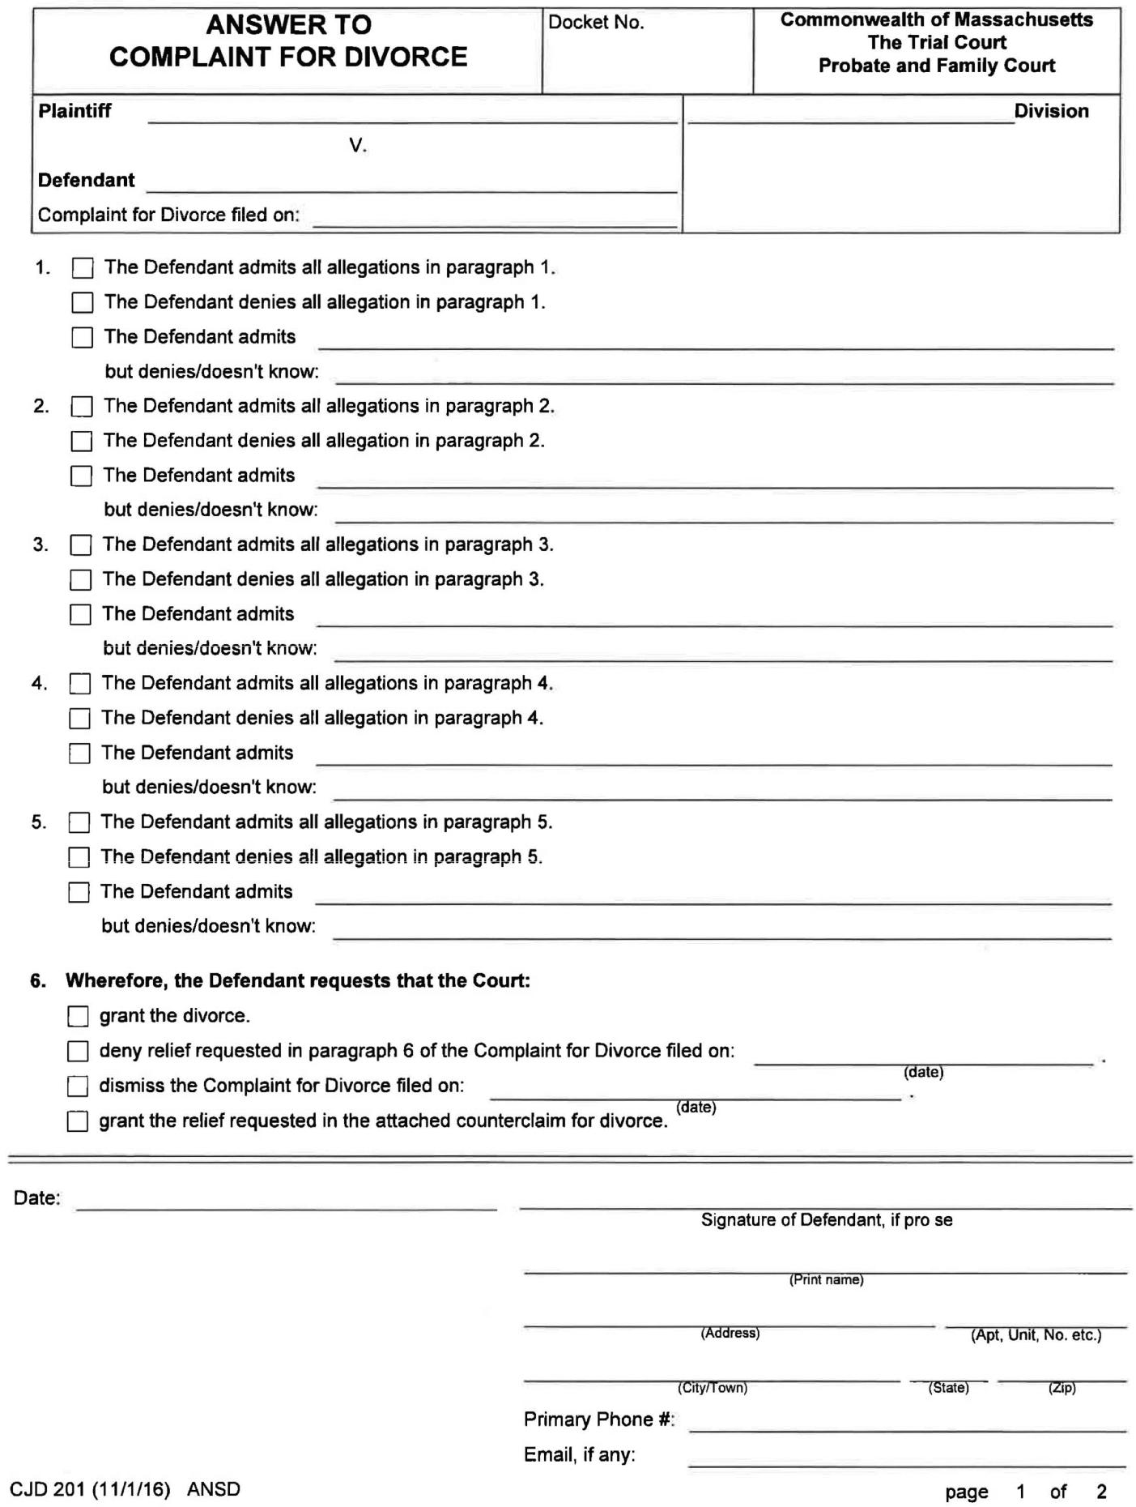

Family Law Advocacy for Low and Moderate Income Litigants, 3rd Edition 2018 143

- CHAPTER 5: DIVORCE
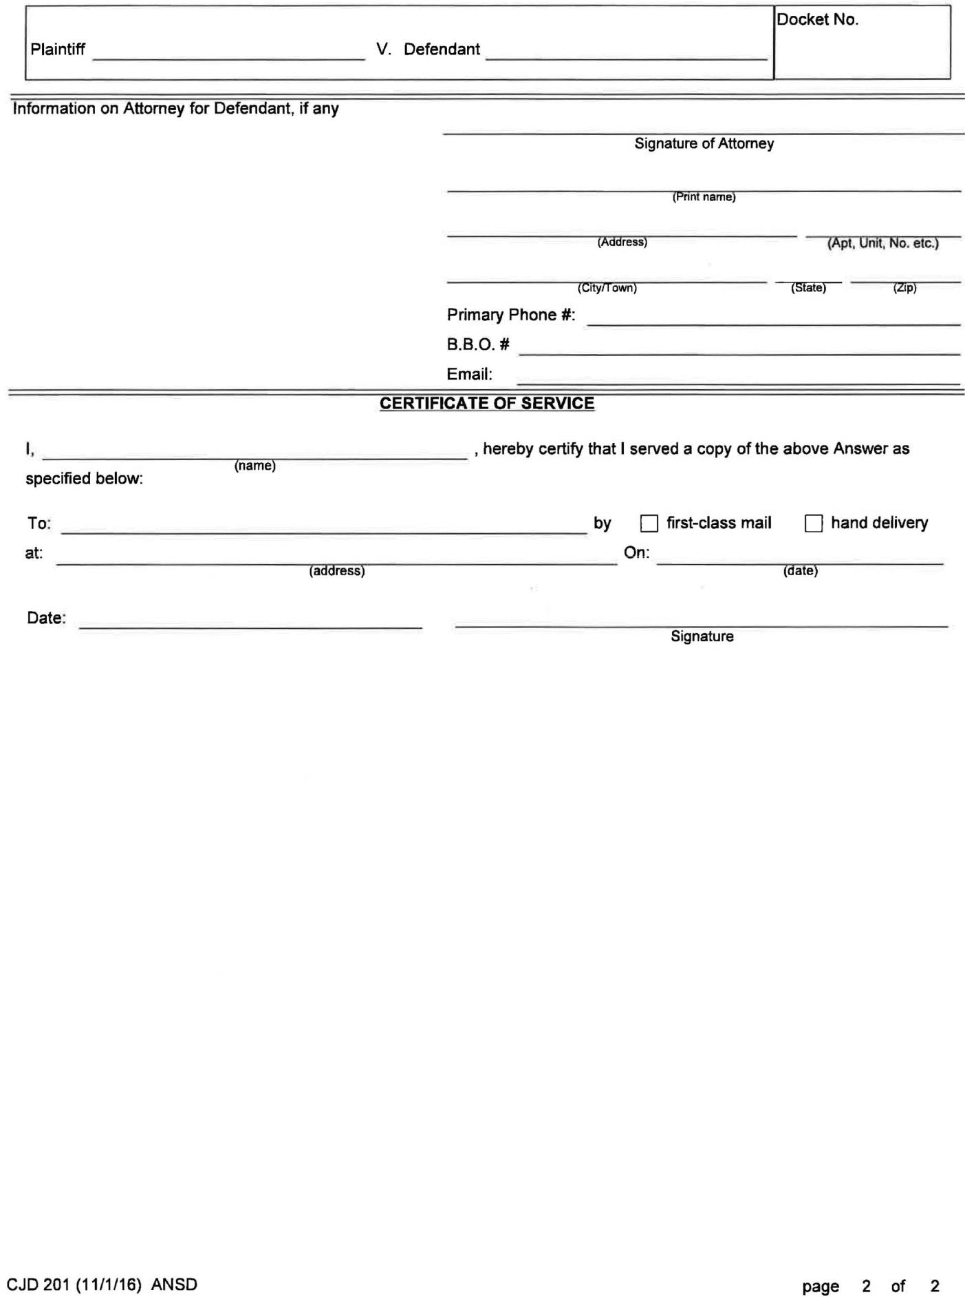

144 Family Law Advocacy for Low and Moderate Income Litigants, 3rd Edition 2018

CHAPTER 5: DIVORCE 

EXHIBIT 5D—Counterclaim for Divorce Action
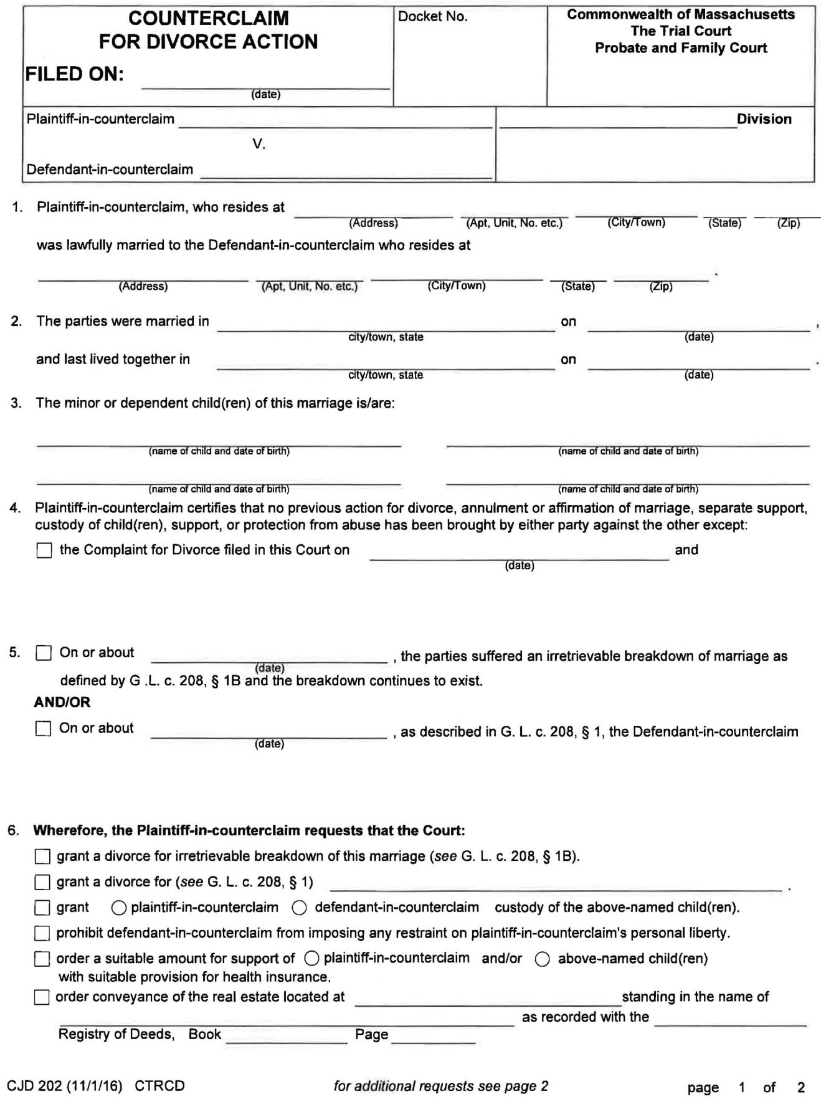

Family Law Advocacy for Low and Moderate Income Litigants, 3rd Edition 2018 145

- CHAPTER 5: DIVORCE
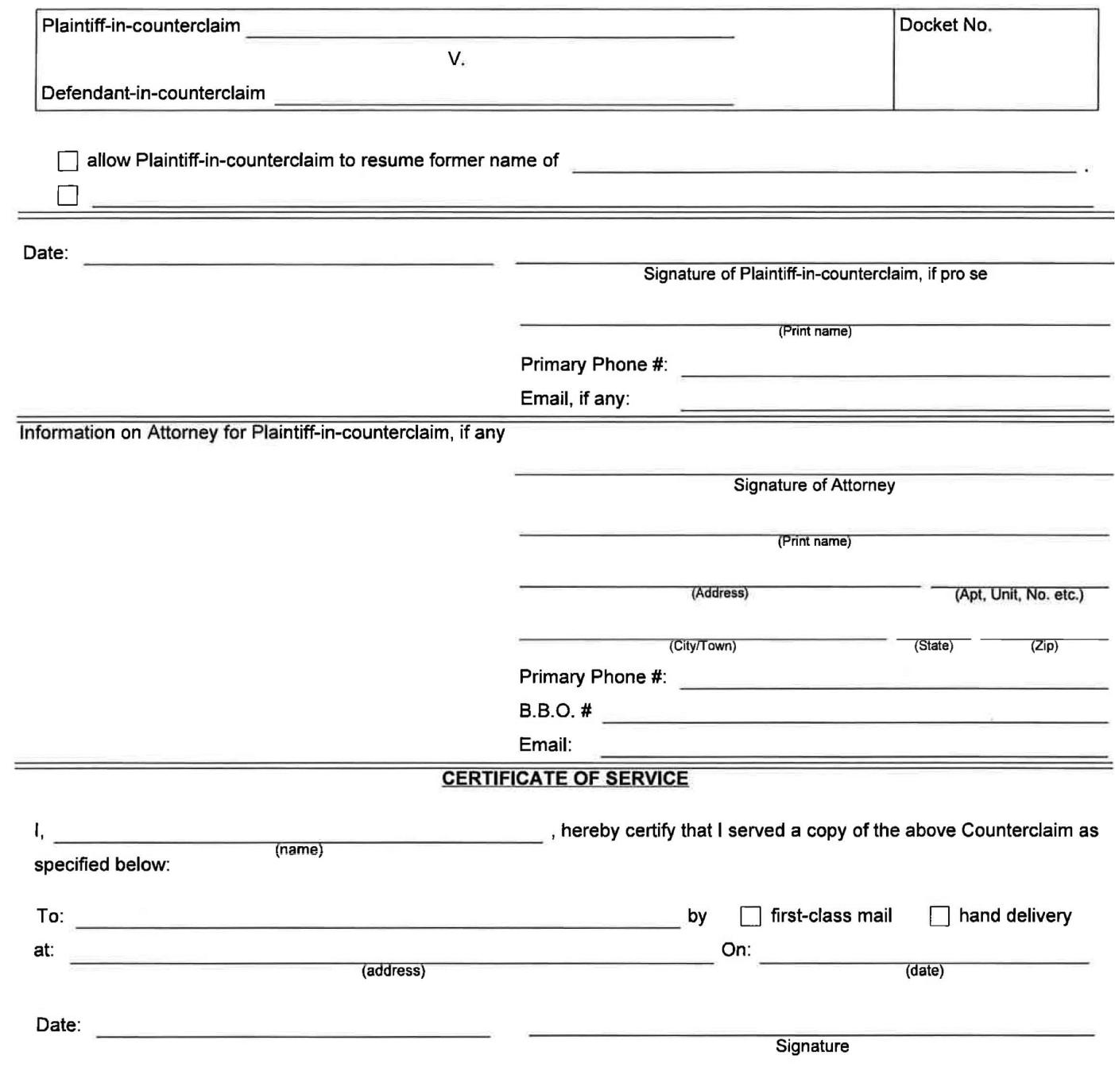


146 Family Law Advocacy for Low and Moderate Income Litigants, 3rd Edition 2018

 |  |  | CHAPTER 5: DIVORCE 
 | EXHIBIT 5E—Divorce Agreement
 |  | COMMONWEALTH OF MASSACHUSETTS
 |  | THE TRIAL COURT
 |  | PROBATE AND FAMILY COURT DEPARTMENT
 | MIDDLESEX DIVISION |  | C.A. NO. 17D-9876-DV1
 |  | )
 | SHEILA JONES, | )
 | Plaintiff | )
 |  | )
 | v. |  | ) DIVORCE AGREEMENT
 |  | )
 | STANLEY JONES, | )
 | Defendant | )
 |  | )
 |  | )

This part is the heading, which identifies the case by Docket or Civil Action Number (C.A. No.), the parties’ names, the court, and the county. The court is the Probate and Family Court, and the county is Middlesex.

This agreement is made between Sheila Jones of 1234 High Street, Melrose, Middlesex County, Massachusetts and Stanley Jones of 5678 Cedar Street, Woburn, Middlesex County, Massachusetts. The parties were married in Boston, Massachusetts on January 1, 1997. There are two children born of the marriage, namely Nancy Marie Jones, born on January 1, 1999 and Mary Louisa Jones born on January 1, 2001. The couple separated on or about January 1, 2007. They last lived together at 1234 High Street, Melrose, Middlesex County, Massachusetts. Mrs. Jones filed a Complaint for Divorce on June 1, 2017, alleging as grounds an irretrievable breakdown of the marriage.

This is the statement of the facts. It describes what the divorce is all about. It is not necessary, but it helps to be sure that everyone understands some of the basic facts to be the same. Later on, no one can say that Nancy was not a child of the marriage, or that the marriage actually took place in 1995.

The parties have both had the opportunity to consult with the separate and independent attorneys of their choice, although Mr. Jones has chosen to proceed unrepresented. The parties enter into this agreement freely and voluntarily, without any restraint or coercion. Each party makes this agreement in reliance on the representations of the other party with regard to his or her financial position. This agreement resolves all issues raised by the Complaint for Divorce, including custody and visitation of the minor children, division of liabilities and assets, support for the children and alimony.

This section is here to describe what the process was in negotiating the separation agreement and what issues are being resolved.

It is possible for one spouse to sue the other for personal injury. This may be important for victims of domestic violence. Some separation agreements say that all issues between the parties back until the beginning of time are settled in the divorce. This means that one spouse abused by the other gives up the right to sue for personal injury. That is not something a judge could order at trial and should not be given up without something of value in return. If you were a victim of domestic abuse, then you may wish to speak with a lawyer experienced in such cases to get some idea of the value of the case you would be waiving. Remember, strict time limits apply to personal injury cases. You may wish to speak to a lawyer sooner rather than later. To protect the rights of a victim, this agreement is more limited in its scope.

___ Sheila Jones ___ Stanley Jones

Family Law Advocacy for Low and Moderate Income Litigants, 3rd Edition 2018 147

- CHAPTER 5: DIVORCE

Each party hereby waives and releases any and all rights that he or she may now or hereafter acquire as spouse under the present or future laws of any jurisdiction to make a claim for a share of the estate of the other or to act as executor or administrator for the estate of the other. However, nothing in this paragraph is intended to or shall constitute a waiver of any rights or claims he or she may have against the other’s estate to enforce this agreement or to enforce a judgment of another court of competent jurisdiction. Nor shall this paragraph constitute a waiver by either party of any testamentary provisions which the other may voluntarily make for him or her.

In general, one spouse automatically receives at least some of the estate of the other spouse when he or she dies. Once you get divorced, you give up your rights to receive a share of your spouse’s estate. This paragraph acknowledges this fact. However, this paragraph says that if the deceased spouse owed the other some money, such as back child support, the surviving spouse could still sue for it. Again, this paragraph is not absolutely necessary, but it does explain what you both understand that the situation would be regarding the parties’ estates. If a spouse dies prior to the passage of ninety days from the date the divorce was entered into the court’s docketing system, then the divorce is dismissed. In many cases, this could mean that the other party retains his or her rights as a spouse.

From this date forward, the parties shall continue to live separate and apart from one another for the rest of their lives. Each shall be free from the interference, authority and control of the other as if they were unmarried.

This paragraph is found in some agreements and means only that once you are divorced, you live separately. Oddly enough, many lawyers will write out the same obvious things routinely because it is what they have always done. Many judges do not allow this language any longer, because it implies that a restraining order will issue.

Each party indemnifies the other from and against any losses incurred by the other as a result of a breach of this agreement, and from and against all attorney’s fees costs and expenses incurred in enforcing the provisions of the within agreement, providing however, that it is within the power of the breaching party to perform.

This paragraph means that if one party fails to live up to the terms of the agreement, then she or he will have to pay any costs required to enforce it. This paragraph states that if you have to hire an attorney to enforce the agreement, the other side will have to pay the attorney fees and your other costs. If the other party cannot perform, he or she will not have to pay the costs.

For example, if your former spouse is fired and has no income to pay child support, then, at least for a while, it might not be in his or her “power to perform.” It is possible that no costs would be assessed. The payment of costs is generally under the judge’s discretion, and not all judges will order costs. Therefore, it is important not to rely on this provision too much.

The failure of either party to insist in any instance upon the strict performance of any provision of this agreement shall not be construed as a waiver of such provision and same shall nonetheless continue in full force and effect.

Even if you and your spouse generally do not follow the agreement, you are still bound by its terms and not by your new ways of dealing with each other. Each of you can decide later to enforce the agreement strictly.

This agreement shall be construed and governed according to the laws of the Commonwealth of Massachusetts.

You and your former spouse may move to other states, but the terms of your agreement will still be viewed through the laws of Massachusetts. Please refer to Chapter 16, Modifications, as well.

This agreement will become operative at the time a Probate and Family Court finds it fair and reasonable and shall MERGE with the judgment of divorce.

___ Sheila Jones ___ Stanley Jones

148 Family Law Advocacy for Low and Moderate Income Litigants, 3rd Edition 2018

CHAPTER 5: DIVORCE 

There is a significant choice here between using the term “merger” or “survival.” When an agreement “merges” with the judgment of divorce, then you or your spouse can ask that any of the terms be modified upon a “significant change in circumstances.” You can enforce it only by going to the Probate and Family Court and filing a contempt action. Your spouse can claim that he or she is not able to live up to the terms of the agreement and the judge may not order him or her to comply with the agreement. On the other hand, it is sometimes a good idea for you to have that defense available to you.

When an agreement “survives” the judgment of divorce, it is a separate contract that binds you just the way any other contract does, such as a contract to pay your credit card bill or to buy a house. It can be enforced by going to the Probate and Family Court or the Superior Court. The defense of inability to perform is not available with this type of agreement. A surviving agreement cannot be modified easily. See Chapter 16 for more information on modifying the agreement.

Issues relating to your children, such as support and custody, cannot survive.

Theoretically, if you sign a surviving agreement that becomes operative right away, you could be bound by it immediately. However, later you are going to take it to a judge to have it made part of the court’s decision. The judge reads it and decides if it is fair and reasonable. If it is not, then the judge will not approve it. You do not want to be bound to an agreement that the judge does not find fair. For that reason, the sample agreement does not take effect until the judge makes the finding of fairness.

Custody of Mary

Sheila Jones shall have sole physical custody of the minor child of the marriage, named above. The parties shall share legal custody.

Chapter 9 describes more fully the meaning of custody arrangements. What you may wish to consider is whether you want to include some provision that will describe more fully what you both mean by joint legal custody.

The example above may not be suitable language for a case where the noncustodial parent is not involved in the child’s life or may be difficult to locate.

If you are a survivor of domestic violence, you may not wish to share legal custody. In some cases, it may be inevitable unless you go to trial and even then, you may have to appeal the judge’s decision. It is especially important that you tailor the language to reflect your safety concerns and the well-being of your children. For example:

Mr. Jones shall have no right of access to any records containing information concerning Mary, including medical, school, counseling, personnel or any information or data held by another person or agency concerning her.

It may be that you and your spouse have a history of not being able to agree on subjects related to the children. One spouse may be often unavailable to assist with decisions. Sometimes the following provision can assist you.

The parties shall have shared legal custody and shall make every effort to resolve significant issues relating to the children by agreement. If they are unable to agree, then Mrs. Jones shall make the final decision. Mr. Jones shall be informed of such decision in a timely fashion and he may bring the matter before the Probate and Family Court.

___ Sheila Jones ___ Stanley Jones

Family Law Advocacy for Low and Moderate Income Litigants, 3rd Edition 2018 149

- CHAPTER 5: DIVORCE

Support and Maintenance

Child support is discussed in Chapter 8. Described below is at what time the child support obligation will end. The end of this obligation is defined as the time when the child becomes emancipated. The statute sets forth this definition, which could be changed according to the parties’ wishes. For example, you might wish to balance payment of college costs against payment of child support for the child who is living in a dorm or apartment at school.

Mr. Jones will be obligated to pay child support by wage assignment in the amount of $100 per week, according to the Guidelines of the Massachusetts Probate and Family Court. He will pay such child support until the emancipation of the minor children, which for each child will be on the occurrence of the first of the following events:

- The marriage of a child;

- The death of a child;

- The enlistment of a child in the military, on the date actual service in the military commences;

- The attainment of the age of 18, providing the provisions of paragraphs 5 and 6, below, do not apply;

- The attainment of the age 21, providing that the child resides primarily with the custodial parent and is principally dependent upon the custodial parent and the provisions of paragraph 6, below, do not apply;

- The attainment of the age of 23, providing that the child is engaged in education or training programs, except for summer employment.

A child shall be considered to reside primarily with the custodial parent notwithstanding any temporary residence at an educational, medical, camping or other facility. If a child is disabled at the time when she or he would otherwise be emancipated, the issue may be raised before the Probate and Family Court to establish further order of appropriate child support.

The parties agree to co-operate in application for financial assistance in higher education costs. Each party will contribute to the children’s educational expenses according to his or her ability to do so. If no agreement can be made between the parties, this issue can be brought forward for resolution by the Probate and Family Court.

It is important to make sure there is some statement about the parties’ obligation for payment of college costs.

Especially if your children are older and you think they will go to college, be sure to include this.

When both children are emancipated, Mrs. Jones may bring forward the issue of alimony to be resolved by the Probate and Family Court, applying the factors set forth in G.L. c. 208, § 34.

In most cases involving parties with moderate incomes, it is very unlikely that one parent will be ordered to pay both child support and alimony. With this statement, you keep the possibility of paying alimony open after the child support is ended. Otherwise, you will have to show a substantial change in circumstances. The other side may be understandably very reluctant to include this provision. It is an area for negotiation.

Health and Life Insurance

Mr. Jones shall provide health insurance for the children and Ms. Jones through his employment when possible. The parties shall share equally the necessary uninsured medical, counseling, dental and orthodontic expenses for the parties’ unemancipated children. Mr. Jones shall maintain life insurance through his employment, if available, for the benefit of the children of the marriage until they are emancipated. Such insurance shall be payable to Ms. Jones as custodian of the funds.

___ Sheila Jones ___ Stanley Jones

150 Family Law Advocacy for Low and Moderate Income Litigants, 3rd Edition 2018

CHAPTER 5: DIVORCE 

Sometimes one party wants the insurance money to go to a trust and to have another person serve as trustee. This is a cumbersome arrangement that requires that an actual trust document be drafted. It may limit the custodial parent’s ability to spend the money on meeting the children’s daily needs. In instances where there is a significant sum of money at stake, it may make sense to consider a trust.

Liabilities and Assets

The parties have divided the personal property in a temporary order entered on August 14, 2007. All tangible personal property in the possession of Mr. Jones is his sole and separate property and all tangible personal property in the possession of Ms. Jones is her sole and separate property. The parties have relied upon the information they have supplied each other in the division of assets.

Sometimes there will be a list of assets to be divided in the future. Identify such property as specifically as possible and be clear about the date and the manner of transfer. For example:

On January 1, 2008, at noon, Mr. Jones will remove from the marital home the following items:

Grandfather clock left to him by his mother,

Stainless steel pots received as a wedding gift, and

Bedroom set, including double bed, bureau, armoire and two night stands which were in the master bedroom at the time of separation.

OR

The amount of Mr. Jones’ pension through the Gizmo Corporation which accrued during the marriage, from the date of the wedding up to this day, will be divided equally between the parties. Counsel for Mr. Jones will draft a Qualified Domestic Relations Order to effectuate this division, which will not be unreasonably delayed.

Division of pensions and certain other financial assets require special expertise. Be sure that these transfers actually take place. It would be very awkward for Mrs. Jones to discover fifteen years from now that Mr. Jones is collecting his pension and nothing was done to protect her rights.

Mr. Jones will be responsible for the MasterCard bill and Mrs. Jones will be responsible for the Visa bill.

This is another area for negotiation. It is important to be realistic about payment of debt. If you cannot afford to make the payments, do not make an agreement to do so. A provision such as this one could preclude you from eliminating your obligations through bankruptcy. If Mrs. Jones files for bankruptcy, including joint debts she agreed to pay, then the company holding the debt will try to get it paid by Mr. Jones. Presumably, Mr. Jones bargained away something in order to obtain Mrs. Jones’ agreement to assume responsibility for the debt.

The parties agree that they will not hereafter make any purchases or contracts or incur any expenses in the name or upon the credit of the other. Each will indemnify and save each other harmless from any and all liability, loss or expense, including reasonable attorney’s fees arising from such purchase or contract made by him or her after the date this judgment is entered. The parties warrant and represent that they will not hereafter use the other’s name for the purposes of having credit extended to him or her. Both parties will bear the costs of their own attorneys for this action.

This means that you cannot use your spouse’s credit, such as using a credit card in your spouse’s name. If you do, then he or she can sue you and make you pay for attorney fees.

___ Sheila Jones ___ Stanley Jones

Family Law Advocacy for Low and Moderate Income Litigants, 3rd Edition 2018 151

- CHAPTER 5: DIVORCE

IN WITNESS WHEREOF, the parties have hereunto set their hands and seals.

Sheila Jones Stanley Jones

COMMONWEALTH OF MASSACHUSETTS

_____, SS. Date:

On this _____ day of _____, 20__, before me, the undersigned notary public, personally appeared Sheila Jones, proved to me through satisfactory evidence of identification which was/were

_____, to be the person who signed the preceding document in my presence, and who, being duly sworn, made oath that the foregoing Agreement was her free act and deed.

Notary Public

My Commission Expires:

COMMONWEALTH OF MASSACHUSETTS

_____, SS. Date:

On this _____ day of _____, 20__, before me, the undersigned notary public, personally appeared Stanley Jones, proved to me through satisfactory evidence of identification which was/were

_____, to be the person who signed the preceding document in my presence, and who, being duly sworn, made oath that the foregoing Agreement was his free act and deed.

Notary Public

My Commission Expires:

Notaries should check to make sure you are who you say you are. It would be very unhelpful if your spouse

could have someone else sign your name to a separation agreement. It is also a good idea to initial or sign every page and every change that was scratched out or written in. That way, there is no confusion about which
version was the final one and exactly what you agreed to.

152 Family Law Advocacy for Low and Moderate Income Litigants, 3rd Edition 2018

CHAPTER 5: DIVORCE 

EXHIBIT 5F—Report of Absolute Divorce or Annulment
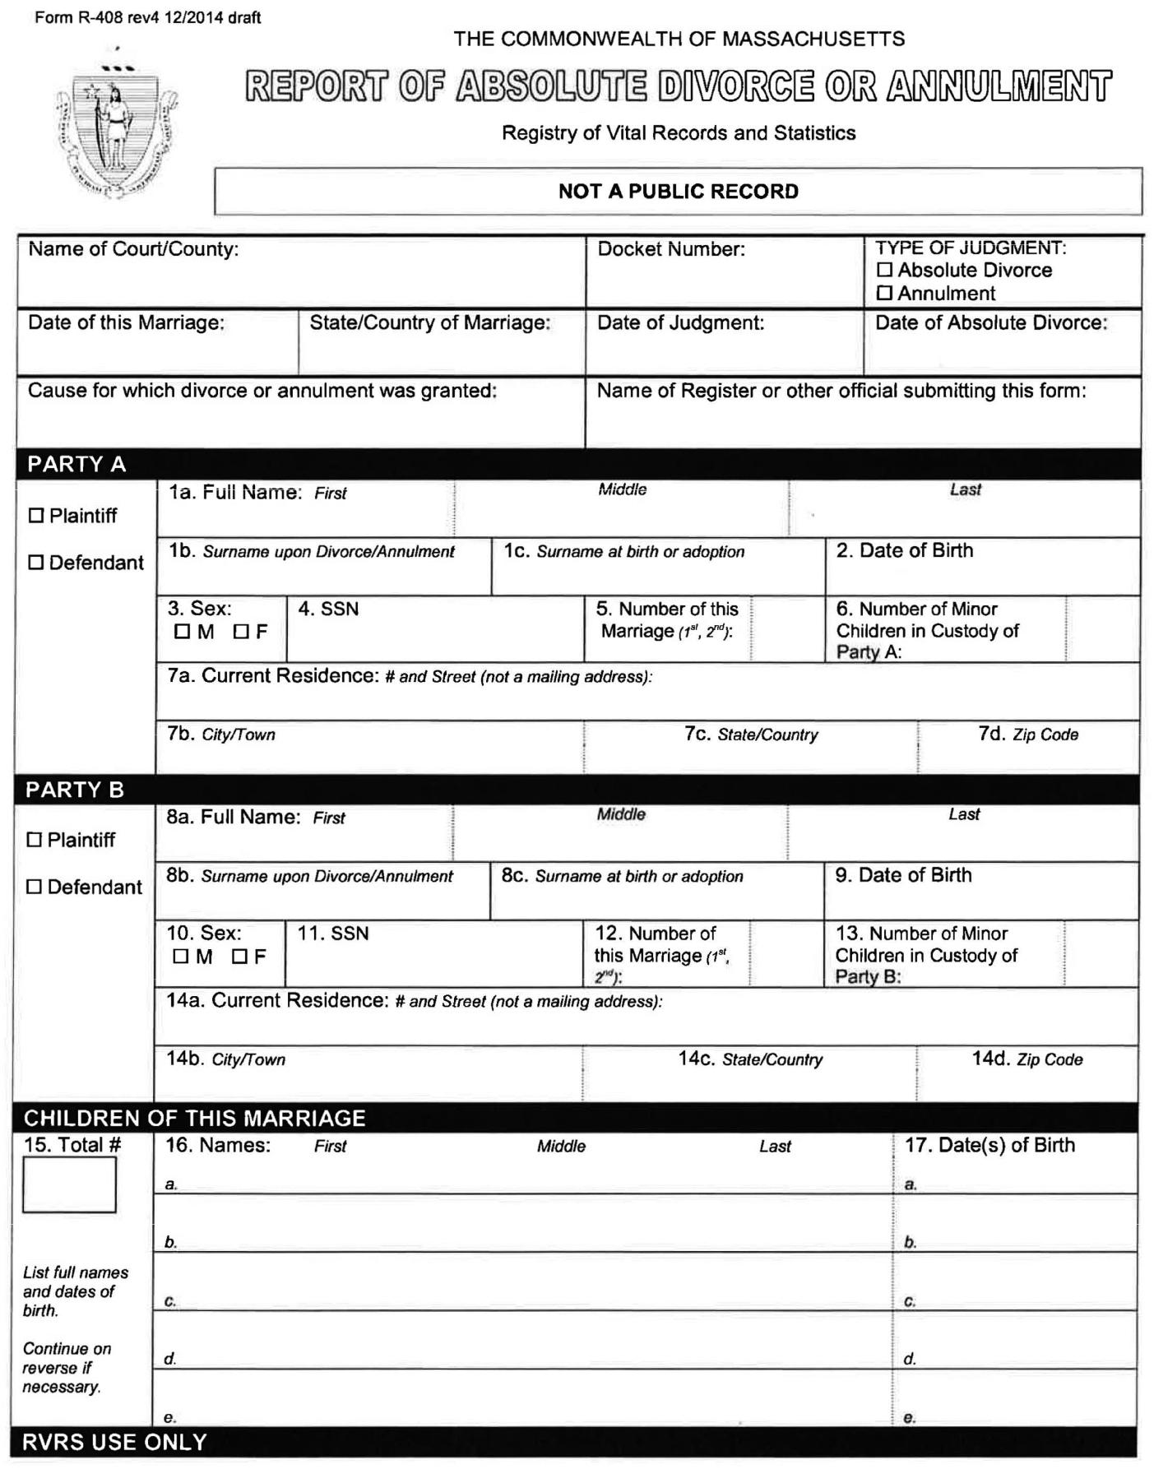

Family Law Advocacy for Low and Moderate Income Litigants, 3rd Edition 2018 153

- CHAPTER 5: DIVORCE
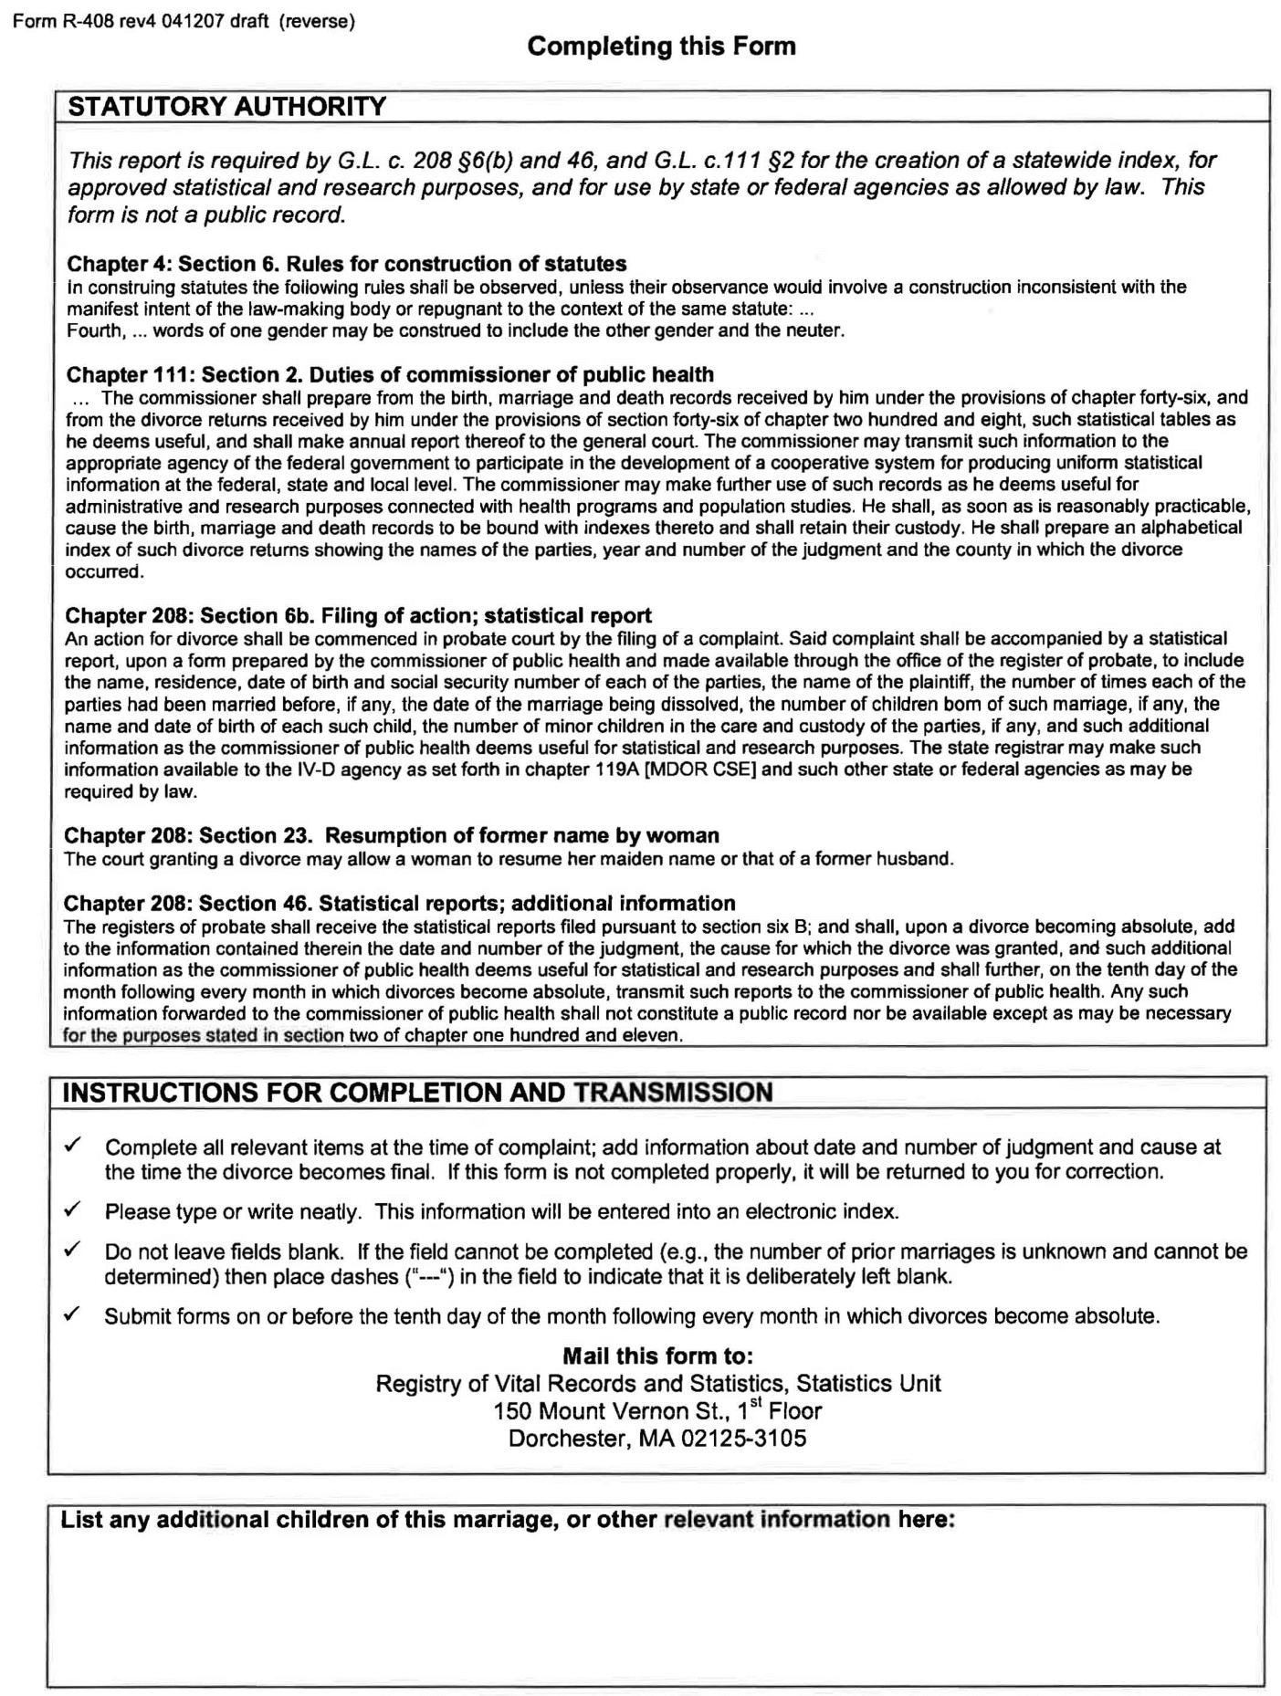

154 Family Law Advocacy for Low and Moderate Income Litigants, 3rd Edition 2018

CHAPTER 5: DIVORCE 

EXHIBIT 5G—Military Affidavit
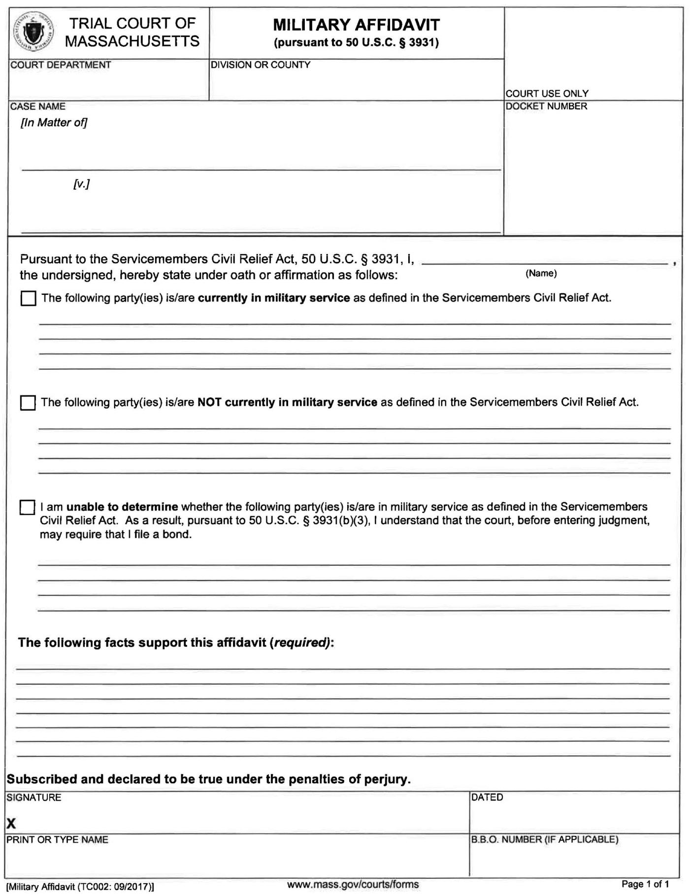

Family Law Advocacy for Low and Moderate Income Litigants, 3rd Edition 2018 155

- CHAPTER 5: DIVORCE

EXHIBIT 5H—Affidavit Disclosing Care or Custody Proceeding
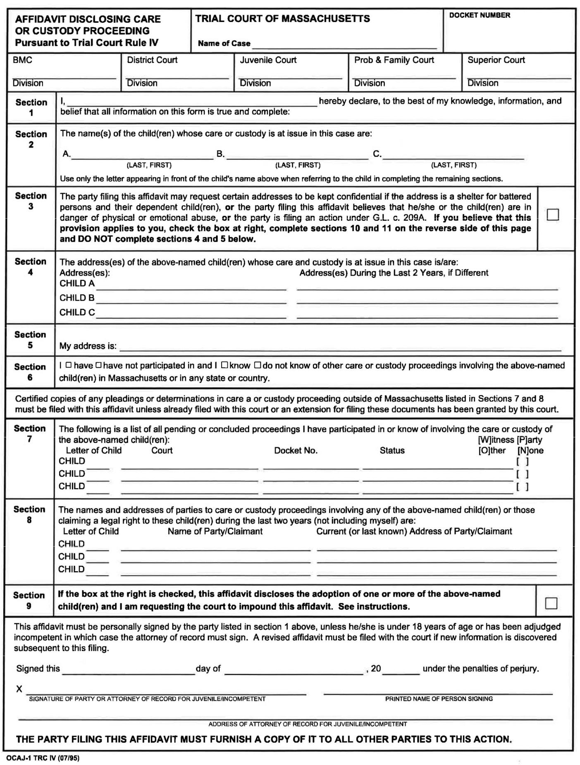

156 Family Law Advocacy for Low and Moderate Income Litigants, 3rd Edition 2018

CHAPTER 5: DIVORCE 
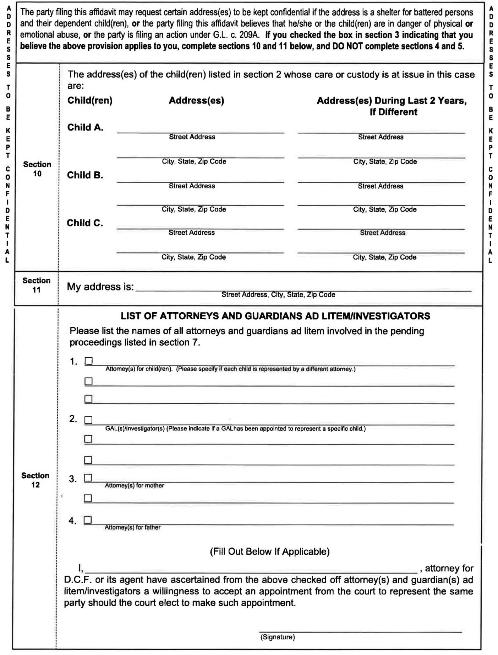

Family Law Advocacy for Low and Moderate Income Litigants, 3rd Edition 2018 157

- CHAPTER 5: DIVORCE
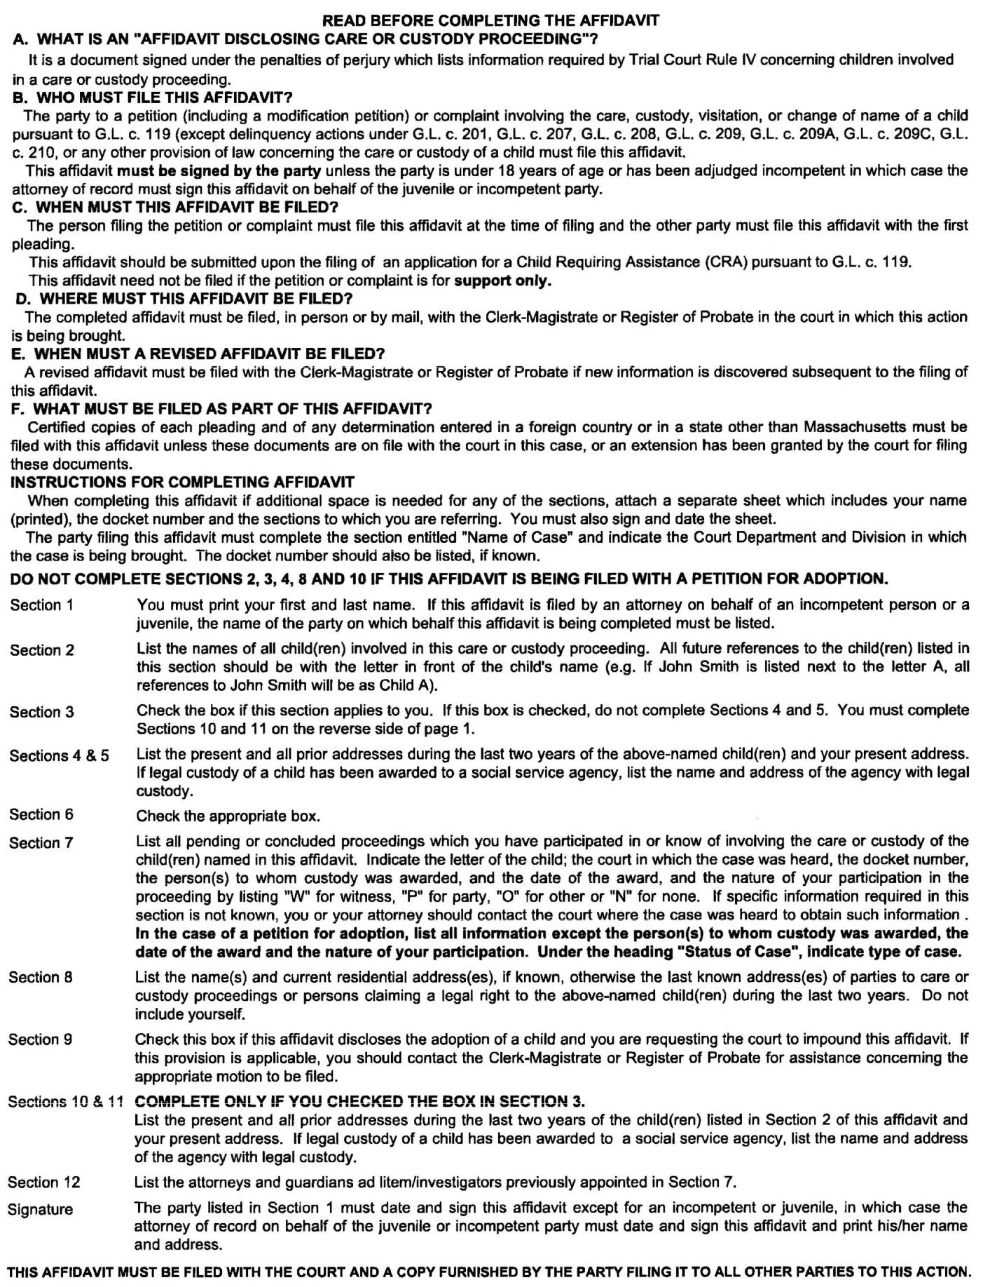

158 Family Law Advocacy for Low and Moderate Income Litigants, 3rd Edition 2018

EXHIBIT 5I—Parent Education Programs

Court-approved programs across the state, listed by county
CHAPTER 5: DIVORCE 

BARNSTABLE

“Set a Good Example” (SAGE)

206 Breeds Hill Road, Hyannis, MA

508-775-0275 Contact: Donna Davis

For the Sake of the Children

Center for Families in Transition Sandwich Library

142 Main Street, Sandwich, MA

857-373-9011 Contact: Robin Zucker http://www.cftclass.org or parentclass@yahoo.com

BERKSHIRE

Families in Transition

Brien Center for Mental Health and Substance Abuse Services 333 East Street, Pittsfield, MA

413-629-1185

Contact: Heather Blanchard

BRISTOL

Family Service Association

Parents Forever

25 Forest Street, Attleboro, MA

508-677-3822 Contact: Sue Roque https://www.frfsa.org

Family Service Association

Parents Forever

101 Rock Street, Fall River, MA

508-677-3822 Contact: Sue Roque https://www.frfsa.org

Family Service Association Parents Forever

UMASS Dartmouth, Main Building 285 Old Westport Road

North Dartmouth, MA 508-677-3822 Contact: Sue Roque http://www.frfsa.org

Family Service Association Parents Forever

Silver City Mall, Community Room

2 Galleria Mall Drive, Taunton, MA

508-677-3822

Contact: Sue Roque

http://www.frfsa.org

Family Service Association Parents Forever

Southeastern Regional Vocational Technical High School 250 Foundry Street,

South Easton, MA

508-677-3822

Contact: Sue Roque

http://www.frfsa.org

ESSEX

Divorce Workshops, LLC

Divorce and Its Impact on Children’s Development 10 Church St, Lynn, MA
978-907-3084

Contact: Dina Guay

http://www.divorceworkshops.org

Divorce Workshops, LLC

Divorce and Its Impact on

Children’s Development

385 Essex St

Salem, MA

978-907-3084

Contact: Dina Guay

http://www.divorceworkshops.org

Parent Education and Custody Effectiveness (PEACE)

North Shore Counseling Center

- Cummings Center, Suite 324-S Beverly, MA

978-922-2280

Contact: Reception Desk Lynn Huber, LICSW Program Director for Parent Education http://www.nscc-inc.com

Family Healthy Choices Parenting Education

Peabody Inst. Library (Danvers Town Library), Gordon Room 15 Sylvan Street, Danvers, MA
978-887-6342

Contact: Jill Levine

http://www.familyhealthychoices.org

Putting Children First

Family Service of Merrimack Valley

Merrimack College (McQuade Library)

North Andover, MA

978-327-6650

Contact: Rosey Gonzalez

http://www.fsmv.org

Family Healthy Choices Parenting Education
Newburyport High School, Classroom 310

214 High Street, Newburyport, MA

978-887-6342

Contact: Jill Levine

http://www.familyhealthychoices.org

Positive Co-Parenting in Difficult Times

Psychotherapy Associates of North Reading

Northern Essex Community College

100 Elliot Street, Haverhill, MA

978-664-2566, ext. 5 Contact: Dr. Donna Whipple http://www.panr.net

Reducing the Effects of Divorce (Spanish & English)

CO-PE trainings

Cambridge College 280 Merrimack Street Entrance North B, 5th Floor, Suite 502, Lawrence, MA 01843 978-266-0234

Contact: Arthur Baxter http://www.copetrainings.com

Family Law Advocacy for Low and Moderate Income Litigants, 3rd Edition 2018 159

- CHAPTER 5: DIVORCE

FRANKLIN

Families in Transition (FIT)

Franklin County Bar Association Franklin Medical Center

164 High Street, Greenfield, MA

413-773-9839

Contact: Christine Baronas http://www.franklincountybar.org

HAMPDEN

Parent Education Program

Behavioral Health Network

Agawam Counseling Center

30 Southwick Street

Feeding Hills, Agawam, MA

413-786-6410

Contact: Coordinator

Parent Education Program

Behavioral Health Network Child Guidance Clinic

110 Maple Street, Springfield, MA

413-732-7419 Contact: Coordinator

Parents and Children in Divorce

West Springfield Center 246 Park Street,

West Springfield, MA 413-737-4718 Contact: John Maloney http://www.chd.org

Parents and Children in Divorce

Baystate Health

3300 Main Street, Springfield, MA

413-737-4718 Contact: John Maloney http://www.chd.org

HAMPSHIRE

Parents and Children in Transition (PACT)

Hampshire County Bar Association 15 Gothic Street, Northampton, MA 413-586-4597

Contact: Rebecca Ryan http://www.hampshirebar.org

CHD’s Parents and Children in Divorce Program (PACD)

offered bi-monthly at Mary Lane Hospital

85 South Street, Ware, MA

413-737-4718 Contact: John Maloney http://www.chd.org

MIDDLESEX

Divorce Workshops, LLC

Divorce and Its Impact on Children’s Development

7 Concord Rd, Billerica, MA

978-907-3084

Contact: Dina Guay

http://www.divorceworkshops.org

Divorce Workshops, LLC

Divorce and Its Impact on Children’s Development

15 Mammoth Rd, Lowell, MA

978-907-3084

Contact: Dina Guay

http://www.divorceworkshops.org

Divorce Workshops, LLC

Divorce and Its Impact on Children’s Development

355 Franklin St, Melrose, MA

978-907-3084

Contact: Dina Guay

http://www.divorceworkshops.org

For the Sake of the Children

Center for Families in Transition Cambridge College

1000 Mass Avenue, Cambridge, MA

857-373-9011 Contact: Robin Zucker http://www.cftclass.org or parentclass@yahoo.com

Moving Forward

Life Transitions, Inc.

All Saints Episcopal Church

10 Billerica Road, Chelmsford, MA

978-649-6255

Contact: Robert Di Meo http://www.lifetransitionsinc.net

Consider the Children

Divorce Education, Inc.

Mass Bay Community College

19 Flagg Drive, Framingham, MA

508-435-4745

Contact: Diane Ferkler or Samuel Chiancola

Parents Apart

Lexington Institute, Inc.

3 Militia Drive, Lexington, MA

781-860-0600

Contact: Dr. Paul Bombara

Parents Forever

Avidia Bank

17 Pope Street, Hudson, MA 01749

508-798-6699 Contact: Karen Feeney

Moving Forward

Life Transitions, Inc.

First Baptist Church

461 King Street, Littleton, MA

978-649-6255

Contact: Robert Di Meo http://www.lifetransitionsinc.net

Consider the Children

Divorce Education, Inc.

Marlborough High School

431 Bolton Street, Marlborough, MA

508-435-4745

Contact: Diane Ferkler or Samuel Chiancola

Positive Co-Parenting in Difficult Times

Psychotherapy Assoc. Of North Reading

Medford High School

489 Winthrop Street, Medford, MA

978-664-2566 ext. 5 Contact: Dr. Donna Whipple http://www.panr.net

Positive Co-Parenting in Difficult Times

Psychotherapy Assoc. of North Reading

E. Little School

7 Barberry Lane, North Reading, MA

978-664-2566 ext. 5 Contact: Dr. Donna Whipple http://www.panr.net

160 Family Law Advocacy for Low and Moderate Income Litigants, 3rd Edition 2018

Parents Apart

Divorce Center, Inc. Brandeis University Olin-Sang Bldg., Classroom 124, 415 South Street, Waltham, MA 888-434-8787

Contact: Coordinator http://www.thedivorcecenter.org

Families Divided

DivorceStep Watertown High School

50 Columbia Street, Watertown, MA

978-443-3262

Contact: Michele Diamond http://www.divorcestep.com

Families Divided

DivorceStep

First Parish Church

349 Boston Post Road, Weston, MA

978-443-3262

Contact: Michele Diamond http://www.divorcestep.com

NORFOLK

Parents Apart

Braintree/Canton

The Divorce Center, Inc. Massasoit Community College— Canton Campus, Classroom 301 900 Randolph Street, Canton MA Contact: Coordinator, (508) 446-4134, or

Toll-free: (888) 434-8787

Monday evenings, 6:45 to 9:15 p.m.

Online registration available at

http://www.thedivorcecenter.org

For the Sake of the Children

Center for Families in Transition Brookline PDHQ

350 Washington Street Brookline, MA 857-373-9011 Contact: Robin Zucker http://www.cftclass.org or parentclass@yahoo.com

Focusing on our Children

Divorce Education Services Dedham Community House
671 High Street, Dedham, MA

781-237-5064

Contact: Ann Steele

http://www.divorceeducationservic

es.com

Parents Apart

Mass Bay Counseling

Quincy High School

52 Coddington Street, Quincy, MA

617-786-3027

Contact: Mass Bay Counseling

The Door is Open Counseling Center

1245 Hancock Street # 25 Quincy, MA

781-925-3500

Contact: Ashleigh Miller http://www.doorisopen.net

PLYMOUTH

Parents Apart

Mass Bay Counseling Massasoit Community College

1 Massasoit Avenue, Brockton, MA

617-786-3027

Contact: Mass Bay Counseling

Parents Apart

Marvista Psychological Associates

South Shore Vocational High School

Hanover, MA

781-383-0860

Contact: Selma Ingber or Charles Mundhenk

The Door is Open Counseling Center

485 Nantasket Avenue, Unit C Hull, MA

781-925-3500

Contact: Ashleigh Miller

Family Service Association— Parents Forever
Stop & Shop Community Room Cranberry Plaza Shopping Center 2991 Cranberry Highway East Wareham, MA

508-677-3822

Contact: Sue Roque

http://www.frfsa.org
CHAPTER 5: DIVORCE 

SUFFOLK

Family Healthy Choices Parenting Education
Massachusetts General Hospital

Yawkey Building, Suite 4A

Boston, MA

978-887-6342

Contact: Jill Levine

http://www.familyhealthychoices.org

Family Healthy Choices Parenting Education Tufts Medical Center Stearns Auditorium

800 Washington Street, 1st floor Boston, MA

978-887-6342

Contact: Jill Levine

http://www.familyhealthychoices.org

Better Parent

MWI

10 Liberty Square, 4th Floor Boston, MA

617-895-4028

Contact: Josh Hoch

http://www.better-parent.org

Reducing the Effects of Divorce (Spanish & English)

CO-PE trainings

East Boston Social Center John Roch

68 Central Square, East Boston, MA

978-266-0234

Contact: Arthur Baxter

http://www.copetrainings.com

WORCESTER

Parents Forever

Pilgrim Congregational Church

26 West Street, Leominster, MA

508-798-6699

Contact: Karen Feeney

http://www.eastpointservices.com

Parents Forever

Pakachoag Church

203 Pakachoag Church, Auburn, MA

508-798-6699

Contact: Karen Feeney

http://www.eastpointservices.com

Family Law Advocacy for Low and Moderate Income Litigants, 3rd Edition 2018 | 161

- CHAPTER 5: DIVORCE

Parents Forever

St. Mary’s School

16 Summer Street, Shrewsbury, MA

508-798-6699

Contact: Karen Feeney

http://www.eastpointservices.com

Parents Apart

Family Services of Central Massachusetts

31 Harvard Street, Worcester, MA

508-756-4646

Contact: Intake Department http://www.fscm.org

Consider the Children

Divorce Education, Inc.

Relationship Institute @

6 Melville St., Worcester, MA 508-435-4745 or 508-853-7373 Contact: Diane Ferkler or Samuel Chiancola

Reducing the Effects of Divorce (Spanish Only)

CO-PE trainings Centro Tina Velazquez

11 Sycamore Street, Worcester, MA

978-266-0234

Contact: Arthur Baxter

http://www.copetrainings.com

Reducing the Effects of Divorce

CO-PE trainings Centro Tina Velazquez

11 Sycamore Street, Worcester, MA

978-243-3464

Contact: Marta Medina

http://www.copetrainings.com

Reducing the Effects of Divorce CO-PE trainings

Seven Hills Family Support Center

1460 John Fitch Highway

Fitchburg, MA

978-266-0234

Contact: Arthur Baxter

http://www.copetrainings.com

Reducing the Effects of Divorce CO-PE trainings

Gardner 7th Day Adventist Church 100 Colony Road, Westminster, MA 978-266-0234

Contact: Arthur Baxter http://www.copetrainings.com

Consider the Children

Divorce Education, Inc.

Milford High School 31 West Fountain Street Milford, MA

508-435-4745 or 508-473-4674 Contact: Diane Ferkler or Samuel Chiancola

Parents Forever

Blackstone Chamber of Commerce

670 Linwood Ave. Bldg. A, Suite 5

Whitinsville, MA 01588

508-798-6699

Contact: Karen Feeney

Parents Apart

Harrington Memorial Hospital Outpatient Behavioral Health 29 Pine Street, Southbridge, MA

508-765-9167 Contact: Coordinator https://www.mass.gov

Reducing the Effects of Divorce

CO-PE Trainings

Gardner 7 Day Adventist Church

100 Colony Road, Gardner, MA

- 266-0234 Contact: Arthur Baxter http://www.copetrainings.com

Reducing the Effects of Divorce

CO-PE trainings

First Parish Church of Berlin

24 Central Street, Berlin, MA 01503

978-266-0234

Contact: Arthur Baxter

http://www.copetrainings.com

162 Family Law Advocacy for Low and Moderate Income Litigants, 3rd Edition 2018

 |  |  | CHAPTER 5: DIVORCE 
 | EXHIBIT 5J—Plaintiff’s Pretrial Memorandum
 |  | COMMONWEALTH OF MASSACHUSETTS
 |  | THE TRIAL COURT
 |  | PROBATE AND FAMILY COURT DEPARTMENT
 | Suffolk Division |  | Probate and Family Court Dept.
 |  |  | Docket No. 00D0000
 |  | )
 | [HUSBAND], | )
 | Plaintiff | )
 |  | )
 | v. | )
 |  | )
 | [WIFE], | )
 | Defendant | )
 |  | )

PLAINTIFF’S PRETRIAL MEMO

I. Uncontested Facts

- The parties were married on November 6, 2005 at Boston, Massachusetts.

- Plaintiff, Husband, resides at 75 Main Avenue, Dorchester, Massachusetts.

- Defendant, [WIFE], resides in the marital home at 2 South Street, Dorchester, Massachusetts.

- The parties have two adult children born of the marriage. The Plaintiff still financially assists one son when he can.

- The parties have one minor child, John, born August 21, 2006.

- The parties purchased the marital home at 2 South Street, Dorchester on July 14, 2005.

- The marital home is a three-family building. One apartment has six rooms, the second has three rooms, and the third (which the Defendant resides in ) consists of eight rooms.

- On or about January 1, 2014, the parties suffered an irretrievable breakdown of the marriage.

- On or about June 16, 2015, Plaintiff filed a Complaint for Divorce on the grounds of Irretrievable Breakdown.

- Defendant answered said Complaint also seeking a divorce on the grounds of Irretrievable Breakdown.

- On November 24, 2005, the parties entered an Agreement for Temporary Orders providing joint legal custody of John, primary physical with the wife, parenting time with the Father on Tuesday and Thursday evenings and every other weekend overnight visitation.

- Parenting time has not occurred according to this schedule.

- The November 24, 2015 agreement also provided that the husband pay $300 per week as child support and maintain life insurance for the benefit of the minor child and wife.

- Child support has been paid via wage assignment and the life insurance is maintained.

- The Husband has also maintained the family health insurance policy.

Family Law Advocacy for Low and Moderate Income Litigants, 3rd Edition 2018 163

- CHAPTER 5: DIVORCE

II. Contested Issues of Fact and Law

- Defendant’s income, from all sources.

- Defendant’s assets.

- Value of the realty.

- Value of the Defendant’s automobile, and the amount, if any, of the auto loan.

- Defendant’s ability to earn income.

- What a fair division of the marital property would be.

- What custody and parenting plan arrangement would serve the best interests of John.

- Whether either party should receive alimony from the other.

III. Discovery Status

Discovery has not been completed. Despite numerous promises to produce documents, Defendant still has not provided Plaintiff’s counsel with copies of savings and checking account documents or tax returns.

IV. Financial Statements

Plaintiff’s current financial statement is being filed with the court together with this Memorandum.

V. Potential Witnesses

- [HUSBAND], Plaintiff

- [WIFE], Defendant

- Amy Smith, John’s fourth grade school teacher

- Holly Jones, tax preparer

Plaintiff reserves the right to call additional witnesses, if necessary, during the course of trial with reasonable notice to opposing counsel.

VI. Exhibits

- Defendant’s financial statements

- Tax returns of the parties

- Checking and Savings account statements of the Defendant

Plaintiff reserves the right to introduce documents necessary to refresh a witness’ recollection or to impeach a witness if appropriate.

VII. Depositions

There are no depositions to introduce at trial in this matter.

VIII. Stipulation of Current Values of All Realty and Personalty in Issue

Plaintiff estimates the value of realty and personality as follows:

164 Family Law Advocacy for Low and Moderate Income Litigants, 3rd Edition 2018

CHAPTER 5: DIVORCE 

Property in Joint Names

Real estate located at 2 South Street: $250,000 less $28,000 mortgage

Property in [HUSBAND’S] Name

Investments | $2,400
Stocks | $2,000
Bonds | $4,600
Life Insurance | $ 907

[HUSBAND’S] Pension from work: Value unknown
Property in control or possession of [WIFE]
Household goods and furniture in marital home | $4,000 to $5,000
[WIFE’S] motor vehicle | $4,400
[WIFE’S] Savings | $47,000

IX. Estimate of Trial Time

Plaintiff’s counsel estimates that trial will take one day.

X. G.L. c. 208, § 34 considerations

- Length of Marriage

The parties have been married 30 years.

- Age and Health of Each Party

[WIFE] is 47-years old. [WIFE] is in fair to poor health, stating she has high blood pressure, and diabetes.

[HUSBAND] is 53-years old. [HUSBAND] is in good health but has minor health concerns such as cholesterol.

- Contribution or Dissipation of Each Party in Acquisition, Depreciation or Appreciation

[HUSBAND] was the major financial contributor to the acquisition of marital assets. He performed all repairs, remodeling and upkeep of the marital property. [WIFE] put the money she received from an inheritance and her work into her own savings account. [HUSBAND’S] income was used for the payment of the mortgage and ordinary expenses.

- Ability of Each to Acquire Property in the Future

Neither party is likely to acquire property in the future. [WIFE] inherited at least $5,000 from her mother and is unlikely to inherit anything else. [HUSBAND] is unlikely to have an inheritance.

- Education and Job Experience of Each Party

[HUSBAND] currently works as a meter technician for Boston Water & Sewer. Prior to that he worked as a painter, mechanic and furniture refinisher.

[WIFE] has been a homemaker. [WIFE] also has a secretarial position. At the time of the marriage, the wife had experience as a nursing assistant. [WIFE] graduated from High School and has attended classes at the local Community College.

Family Law Advocacy for Low and Moderate Income Litigants, 3rd Edition 2018 165

- CHAPTER 5: DIVORCE

- Needs of Each Party

Both parties had a lower–middle-income lifestyle while married. [HUSBAND] earns approximately $50,000 per year and has limited income. [WIFE] collects almost $50,000 per year in salary and rental income. In addition, [WIFE] is receiving interest income from the money she inherited. When living together, the parties were able to budget and live a modest lifestyle.

Respectfully submitted,

[HUSBAND]

[ADDRESS]

[PHONE]

Date:

166 Family Law Advocacy for Low and Moderate Income Litigants, 3rd Edition 2018

CHAPTER 5: DIVORCE 

EXHIBIT 5K—Motion for State Payment of Fees and Costs

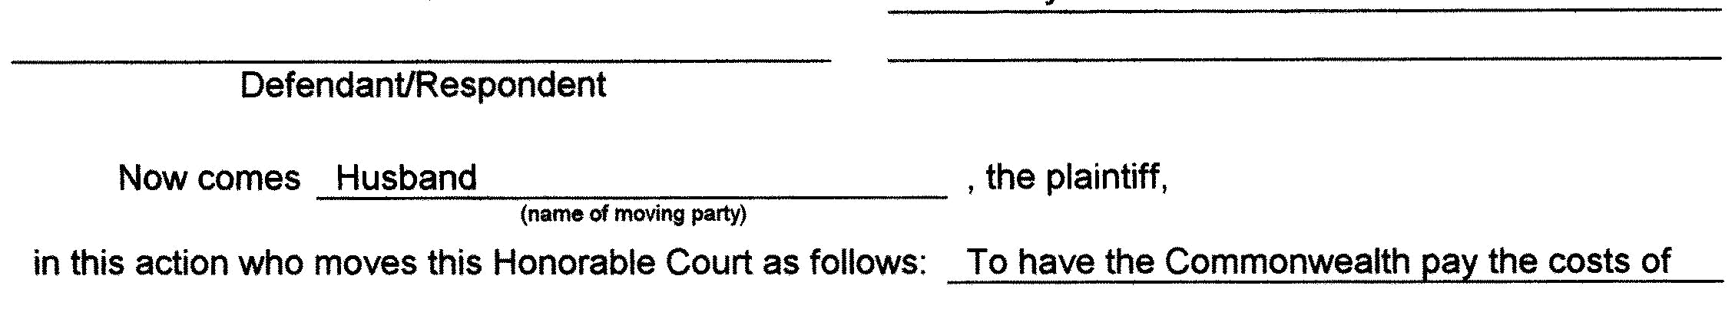
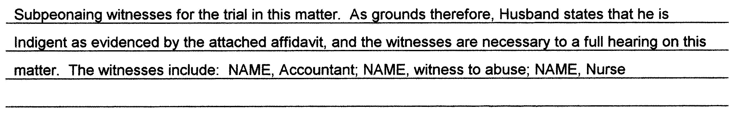



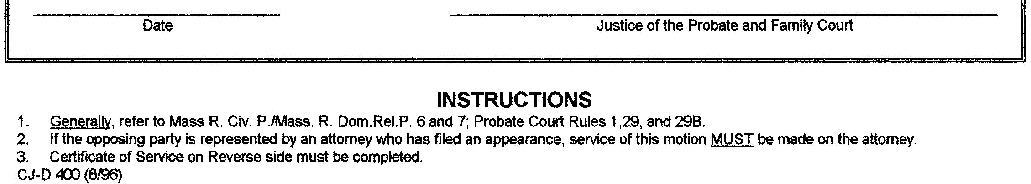

Family Law Advocacy for Low and Moderate Income Litigants, 3rd Edition 2018 167

- CHAPTER 5: DIVORCE

EXHIBIT 5L—Financial Statement (Short Form)

168 Family Law Advocacy for Low and Moderate Income Litigants, 3rd Edition 2018

CHAPTER 5: DIVORCE 

Family Law Advocacy for Low and Moderate Income Litigants, 3rd Edition 2018 169

- CHAPTER 5: DIVORCE

170 Family Law Advocacy for Low and Moderate Income Litigants, 3rd Edition 2018

CHAPTER 5: DIVORCE 

Family Law Advocacy for Low and Moderate Income Litigants, 3rd Edition 2018 171

- CHAPTER 5: DIVORCE

EXHIBIT 5M—Financial Statement (Long Form)

172 Family Law Advocacy for Low and Moderate Income Litigants, 3rd Edition 2018

CHAPTER 5: DIVORCE 

Family Law Advocacy for Low and Moderate Income Litigants, 3rd Edition 2018 173

- CHAPTER 5: DIVORCE

174 Family Law Advocacy for Low and Moderate Income Litigants, 3rd Edition 2018

CHAPTER 5: DIVORCE 

Family Law Advocacy for Low and Moderate Income Litigants, 3rd Edition 2018 175

- CHAPTER 5: DIVORCE

176 Family Law Advocacy for Low and Moderate Income Litigants, 3rd Edition 2018

CHAPTER 5: DIVORCE 

Family Law Advocacy for Low and Moderate Income Litigants, 3rd Edition 2018 177

- CHAPTER 5: DIVORCE

178 Family Law Advocacy for Low and Moderate Income Litigants, 3rd Edition 2018

CHAPTER 5: DIVORCE 

Family Law Advocacy for Low and Moderate Income Litigants, 3rd Edition 2018 179

- CHAPTER 5: DIVORCE

180 Family Law Advocacy for Low and Moderate Income Litigants, 3rd Edition 2018

CHAPTER 5: DIVORCE 

EXHIBIT 5N—Qualified Domestic Relations Order

 |  | COMMONWEALTH OF MASSACHUSETTS
 |  | THE TRIAL COURT
 |  | PROBATE AND FAMILY COURT DEPARTMENT
 | Suffolk Division |  | Probate and Family Court Dept.
 |  |  | Docket No. 00D0000
 |  | )
 | [HUSBAND], | )
 | Plaintiff | )
 |  | ) _____
 | v. | )
 |  | )
 | [WIFE], | )
 | Defendant | )
 |  | )
 |  | QUALIFIED DOMESTIC RELATIONS ORDER

As a part of the final Judgment in this matter, pursuant to G.L. c. 208, § 34, governing the division of marital property between spouses and from spouses in divorce actions, and in conformance with I.R.C. § 414(p), it is hereby ordered as follows:

- For purposes of this Order, the following terms shall have the following meanings:

  - “Retirement Plan” shall refer to the ABC Co. Pension Plan.

  - “Plan Administrator” shall refer to the Benefits Committee as defined in said Retirement Plan.

  - “Participant” shall refer to [HUSBAND], [ADDRESS], [SOCIAL SECURITY NUMBER], [DATE OF BIRTH].

  - “Alternate Payee” shall refer to [WIFE], [ADDRESS], [SOCIAL SECURITY NUMBER], [DATE OF BIRTH].

  - “Alternate Payee’s Account” shall refer to the separate account to be established and administered for the Alternate Payee pursuant to Paragraph 3 of this Order.

- The Plan Administrator is advised that the Alternate Payee and the Participant have agreed on allocating the account of the Participant under the Retirement Plan as of the date of divorce.

- The Plan Administrator shall forthwith establish a separate account under the Retirement Plan for the Alternate Payee (the “Alternate Payee’s Account”), to be administered as the account of a participant in the Retirement Plan, in accordance with the provisions thereof. The initial balance in the Alternate Payee’s Account shall be 50 percent of the amount in the account of the Participant on the date of the divorce. From and after the establishment of the Alternate Payee’s Account, the Alternate Payee’s Account shall be administered under the Retirement Plan as an account separate and distinct from the Participant’s account thereunder. All payments to be made to the Alternate Payee under the terms of this Order and under the provisions of the Retirement Plan shall be made only from the Alternate Payee’s Account and only as otherwise permitted under the provisions of the Retirement Plan.

IV. After the date of this Order, with respect to the Alternate Payee’s Account in the Retirement Plan created and recognized in Paragraph 3 above, the Alternate Payee shall have the sole and exclusive right

Family Law Advocacy for Low and Moderate Income Litigants, 3rd Edition 2018 181

- CHAPTER 5: DIVORCE

  - to direct the investment of her account among such investment options as may be available under the Retirement Plan;

  - to commence receiving her benefit under the Retirement Plan on or after the earliest date on which the Participant is, becomes, or would have become eligible to commence receiving his benefit under the Retirement Plan;

  - to elect to receive her benefit in a lump sum or in any optional form of annuity which is available under the Retirement Plan, or any other optional form as the Plan Administrator may permit, provided that the amount of benefit payable under such optional form shall be actuarially equivalent to the balance in the Alternate Payee’s Account as of the date of commencement of such benefits; and

  - to designate the beneficiary of her choice for her death benefit if she should elect an optional form of annuity which provides a death benefit (other than a subsequent spouse of the Alternate Payee), without regard to any beneficiary designation made by the Participant with respect to his benefit under the Retirement Plan.

- Pursuant to I.R.C. § 414(p)(3) and except as provided by I.R.C. § 414(p)(3), nothing in this Order shall be construed to require the Retirement Plan or Plan Administrator

  - to provide the Alternate Payee any type or form of benefit or any option not otherwise provided under the Retirement Plan;

  - to provide to the Alternate Payee increased benefits (determined on the basis of actuarial value); or

  - to pay any benefits to the Alternate Payee which are required to be paid to another alternate payee under another order previously determined to be a Qualified Domestic Relations Order.

VI. This order is intended to be a Qualified Domestic Relations Order made pursuant to the Retirement Equity Act of 1984, Pub. L. No. 98-397 (codified at 26 U.S.C. § 417), and the provisions herein shall be administered and interpreted in conformity with that Act.

VII. The Court retains jurisdiction over this matter to amend this Order to establish or maintain its status as a Qualified Domestic Relations Order under the Retirement Equity Act of 1984, 26 U.S.C. § 417.

So Ordered,

Justice of the Probate and Family Court

Date:

182 Family Law Advocacy for Low and Moderate Income Litigants, 3rd Edition 2018

CHAPTER 5: DIVORCE 

EXHIBIT 5O—Blank Motion Form
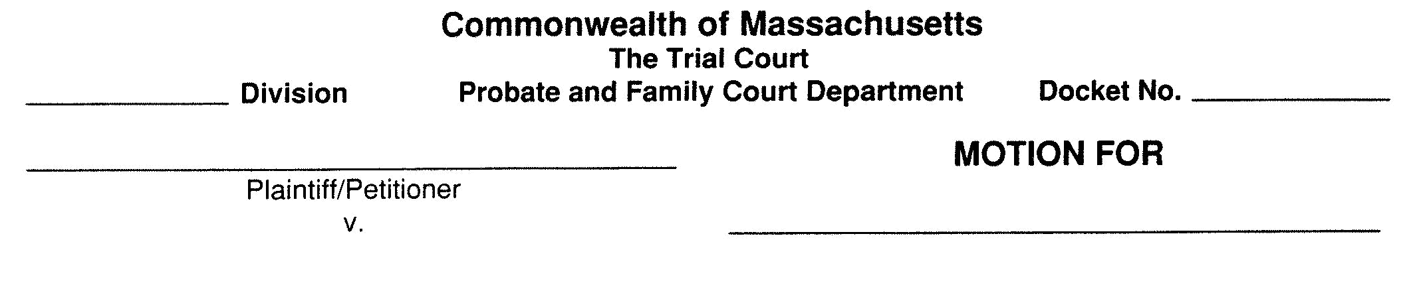
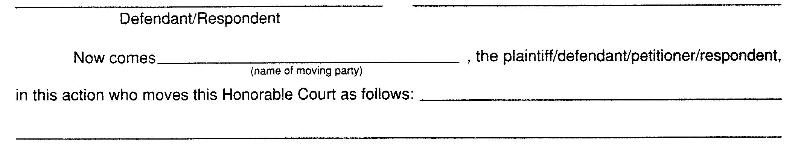


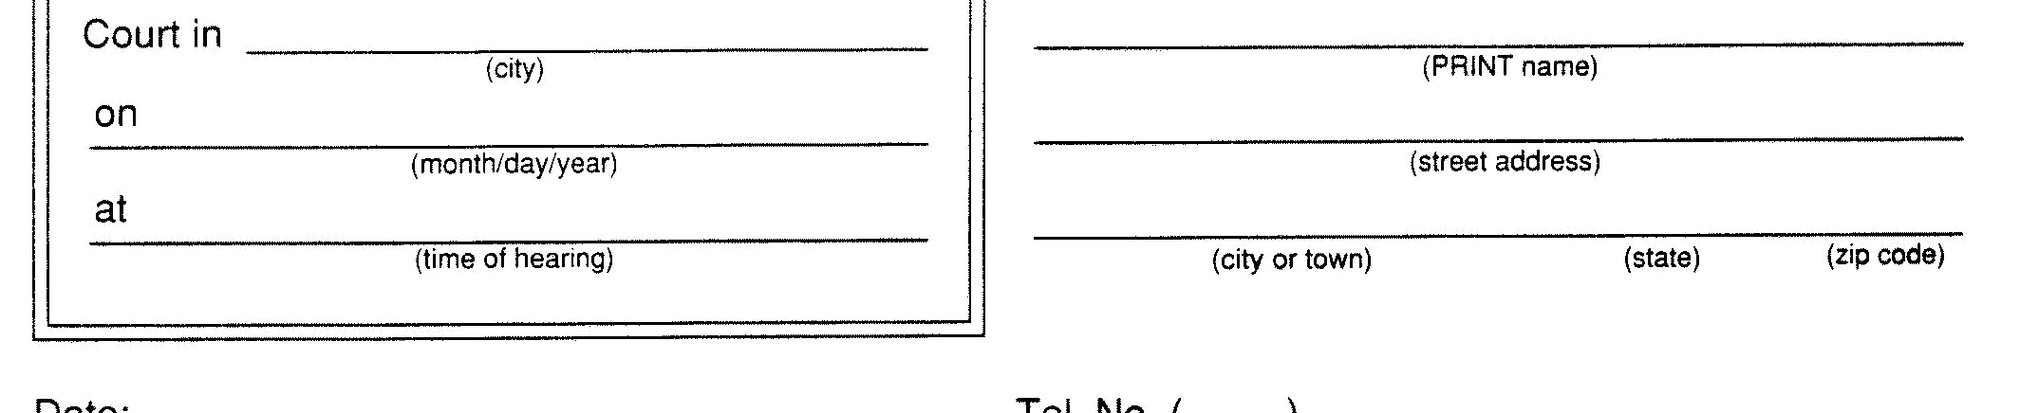
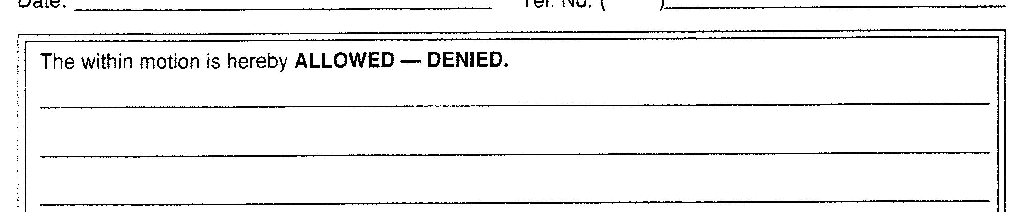
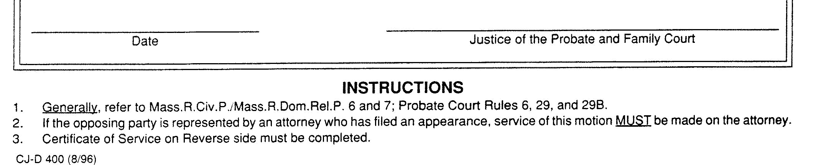

Family Law Advocacy for Low and Moderate Income Litigants, 3rd Edition 2018 183

- CHAPTER 5: DIVORCE



184 Family Law Advocacy for Low and Moderate Income Litigants, 3rd Edition 2018

CHAPTER 5: DIVORCE 

EXHIBIT 5P—Court Order for Costs and Fees (G.L. c. 261, § 27A et seq.)
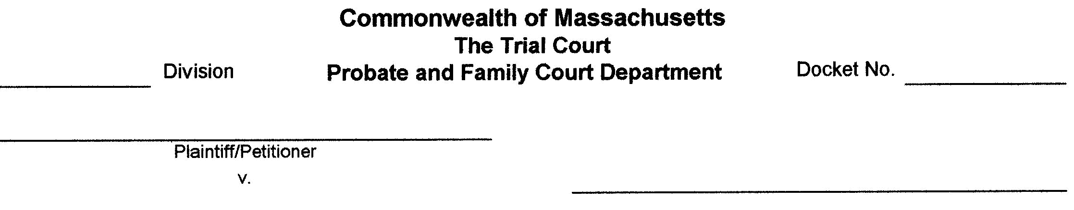
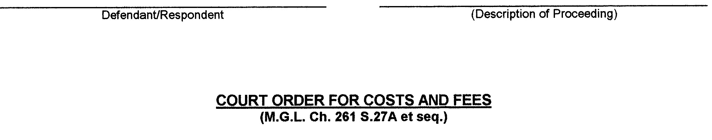
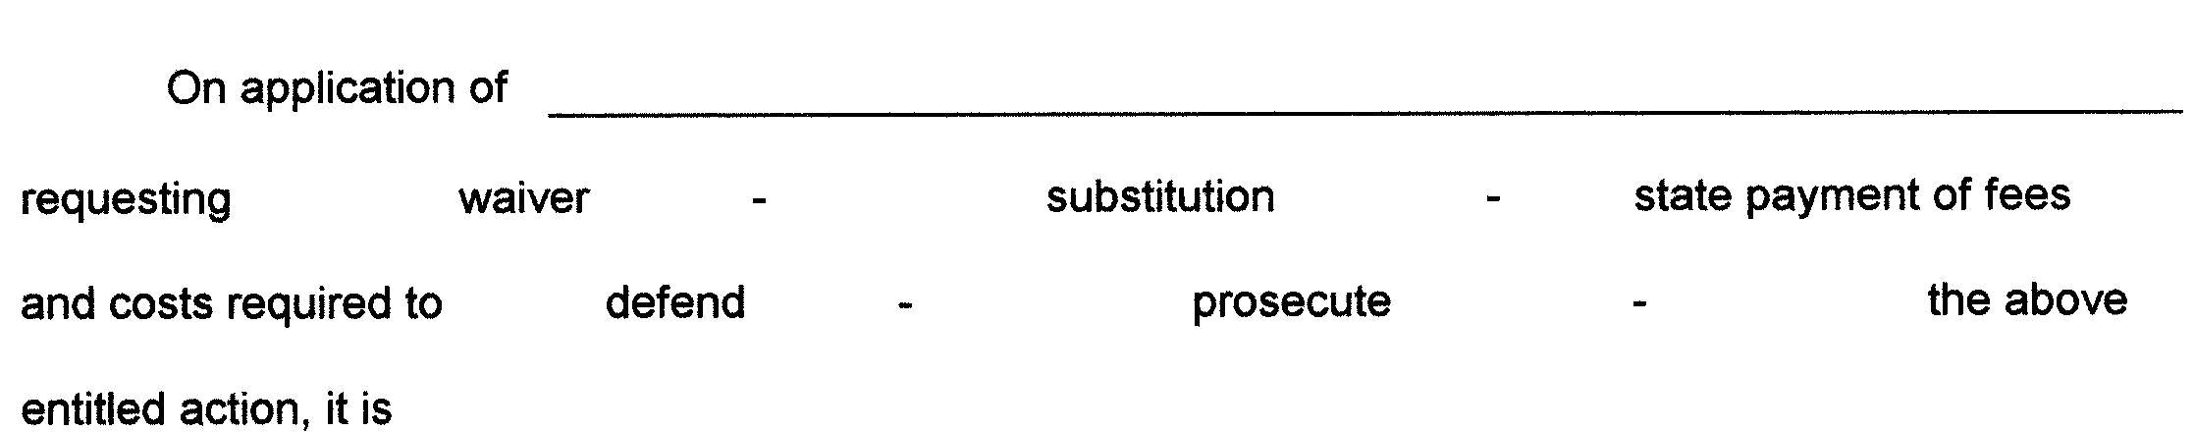

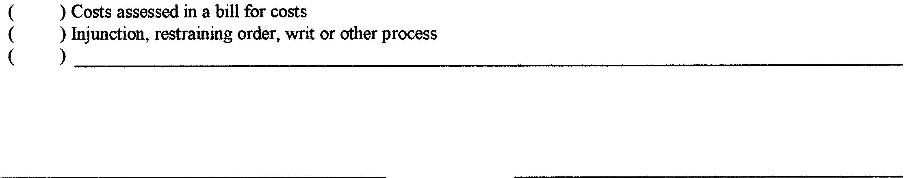


Family Law Advocacy for Low and Moderate Income Litigants, 3rd Edition 2018 185

- CHAPTER 5: DIVORCE

186 Family Law Advocacy for Low and Moderate Income Litigants, 3rd Edition 2018

