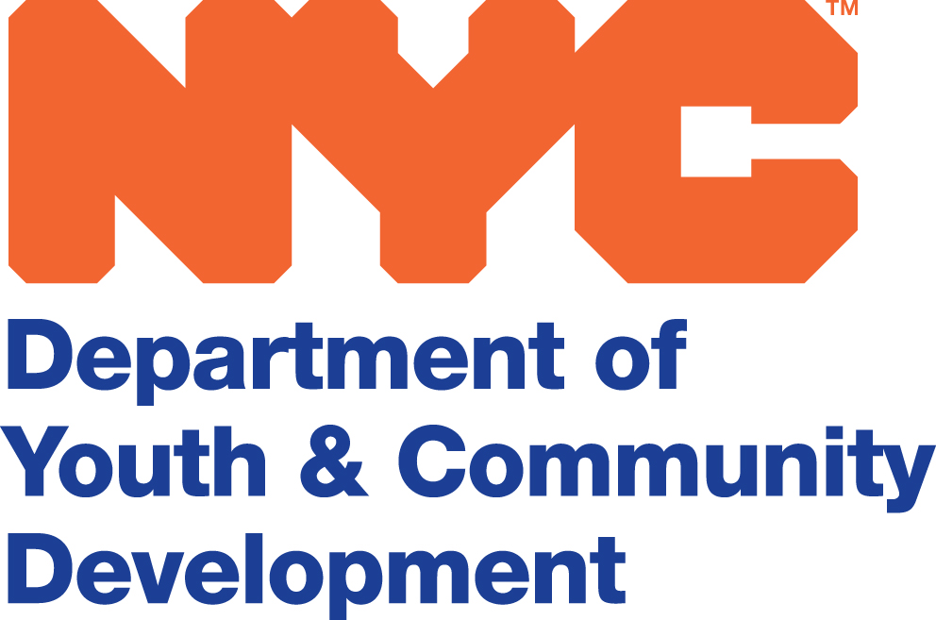

Bill Chong  Commissioner  123 William Street, Suite 17  New York, NY 10038  646 343 6000 tel  646 343 6973 fax  www.nyc.gov/dycd | INSTRUCTIONS FOR THE COMPLETION OF THE SIGNATURE OF AUTHORIZATION LETTER AND THE BOARD RESOLUTION  The purpose of the Signature Authorization Letter is to show authenticity to the NYC Comptroller’s Office that the people who are signing the letter are the same as those signing the contracts and reviewing the invoices. The letter must be typed on the Vendor’s letterhead. The signatures and notary stamp must be both clear and have original signatures.  The people, usually the Not-for-Profit Organization’s officers or their designees, who are authorized to sign the letter are left to the discretion of the Board of Directors. The letter must be accompanied by the Vendor’s most recent Board Resolution that states the Board’s designees may act as their agent.  Samples of both the Letter of Authorization and the Board Resolution are attached. Should you have any questions regarding either of these documents, please contact your contract manager.

SAMPLE OF AN AFFADAVIT OF SIGNATURE OF AUTHORITY

Your Letterhead
Address
(212) 555 – 5555

NYC Department of Youth and Community Development
2 Lafayette Street
New York, NY10007

I hereby authorize: , Executive Director

Signature

, Chief Financial Officer

Signature

Whose specimen signatures appear above to authenticate and certify to sign contracts and certify claims and other related documents under the provision of the Contract/PIN
260 between the Department of Youth and Community Development and
Your Agency for the services provided during the period from July 1, 2015 to June 30,
2016.

State of New York

County of (Signature of Board Officer)

This day of
,

(Title of Board Officer)

SAMPLE OF A BOARD RESOLUTION

RESOLUTION

RESOLVED, that this Board of Directors does hereby authorize and direct Jim Jones, Executive Director and John Smith, Chief Financial Officer to sign contracts and amendments to the contracts and to review claims on behalf of the ABC Not-for-Profit Corporation’s Board of Directors.

Constance Carter
Chairman of the Board of Directors

