Sample Reminder Email to
VOLUNTEER REGISTRANTS

Subject Line: FAFSA Day Reminder: Boston Public Library / ASA, Sunday, November 6th

FAFSA Day is almost here!

Thank you for signing up as a FAFSA Day 2016-2017 volunteer at the Boston Public Library / ASA Center this Sunday, November 6th! It’s because of dedicated volunteers like you that we are able to continue the wonderful work of providing families with free assistance in completing their FAFSA throughout the Commonwealth of Massachusetts!

Site Logistics

In order to have everything set up in advance we would like to request that everyone plan on arriving by 12:30 pm. At that time we can determine what your responsibilities will be for the afternoon (set-up, registration, photography, one-on-one help, survey reminders, etc.). We advise that you all wear comfortable shoes, as you will likely be spending the majority of the day on your feet. Please plan to be on site until 4:30.

Note that the Boston Public Library does not officially open until 1:00 pm on Sunday, but if you let the guard know that you are volunteering for FAFSA Day, they will be able to let you in. Upon arrival, please plan to check in at the ASA College Planning Center, which is located inside the Kirstein Business Library and Innovation Center on the lower level. The address and map are as follows:

Copley Square Boston Public Library
700 Boylston Street
Boston MA, 02116

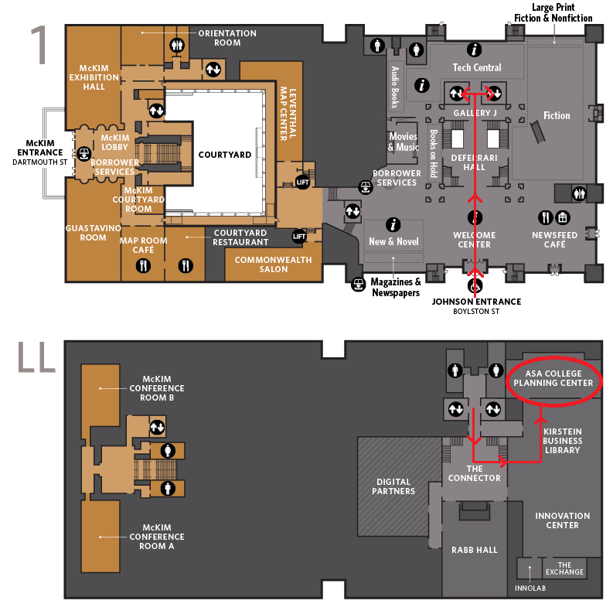
Volunteer Attire

We ask that you wear your vintage FAFSA Day t-shirts, along with the vintage FAFSA Day pins, if you have them from previous FAFSA Day events. If you do not have these, please wear a red shirt to signify that you are a volunteer.
To ensure that volunteers are easily recognizable to the registrants, we ask that all volunteers either wear khakis, black or dark blue jeans.

Surveys

The surveys will need to be completed online. Only one entry form will be given per family, unless there are multiple college-bound students who've participated. Please also complete the volunteer survey after the event is complete!

If you have any questions, feel free to email fafsaday@gmail.com.

Thank you and we look forward to seeing you all on Sunday, November 6th at 12:30 pm!!

Sincerely,
Darnell Stowers and Debbie Mills
Boston Public Library Site Coordinators

