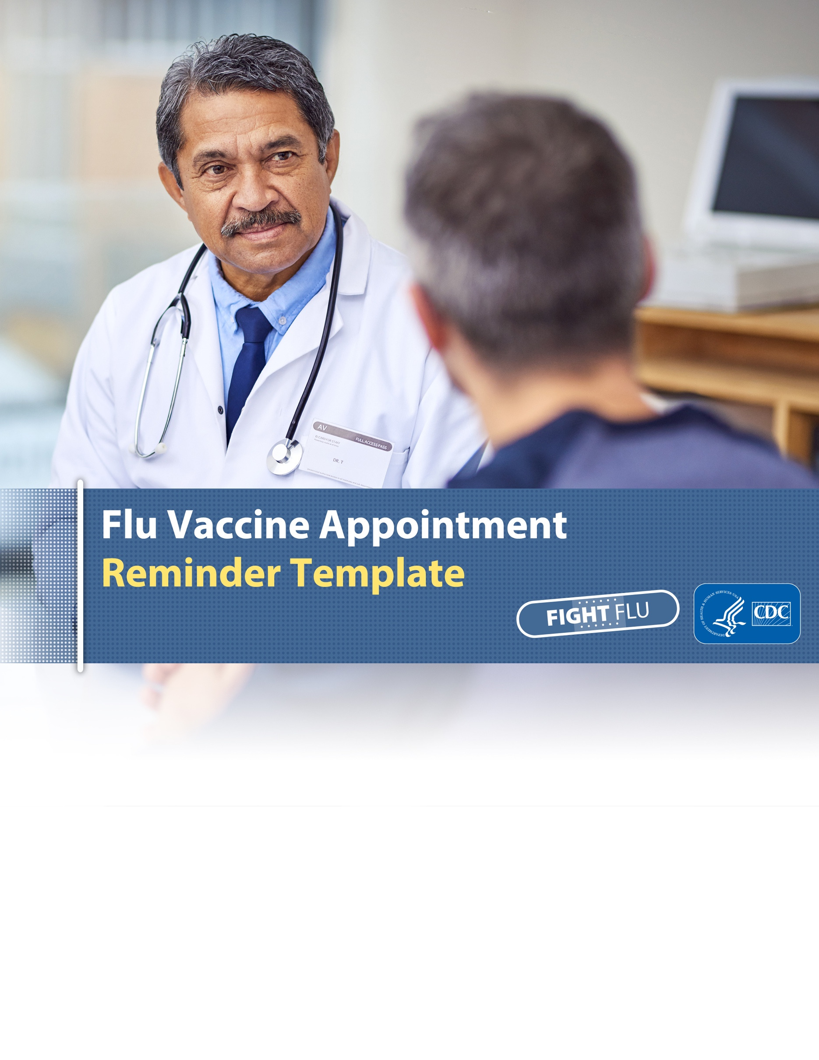

About This Email Template:

As a health care professional, your strong vaccine recommendation can make all the difference for your patients. By ensuring your patients get their annual flu vaccine, you decrease their risk of getting flu. Flu can have serious complications, which can result in hospitalization and even death.

This flu vaccine appointment reminder template is a tool for clinical practices to remind patients, especially high-risk patients, to schedule an appointment for their flu vaccine by October or as soon as possible after. Available in Word format below, this template is customizable to best fit your practice and patient population, offering language for specific high-risk groups, such as people 65 and older, pregnant women, young children, and people with certain medical conditions.

Email Subject: Reminder from [Insert Practice Name]: Get Your Flu Vaccine Now

[Insert Practice Letter Head]

Hello [Patient Name],

Now is the time to get a flu vaccine! In the U.S., millions of people get sick, hundreds of thousands are hospitalized, and thousands or tens of thousands of people die from flu every year. Every flu season is different, and flu vaccine can vary in how well it works, but receiving a flu vaccine every year offers the best available protection against flu and has been shown to reduce illnesses, hospitalizations, and deaths in children.

The Centers for Disease Control and Prevention (CDC) recommends that everyone ages 6 months and older receive a flu vaccine every year.* [If relevant, include information from the below category of high-risk populations] A flu vaccine is particularly important for you because:

- [For parents of young children]: children younger than 5 years and especially younger than 2 years are at high risk for serious flu-related complications. About 80% of reported child deaths occur in children who have not been vaccinated. A flu vaccine can be life-saving for children. A 2017 study found that flu vaccination reduced the risk of flu-associated death by half (51%) among children with underlying high-risk medical conditions and by nearly two-thirds (65%) among healthy children.
- [For pregnant women]: flu is more likely to cause severe illness in pregnant women possibly due to changes in the body, such as the immune system, heart, and lungs that make them more prone to illness. A flu vaccine during pregnancy has been shown to help protect you and your baby from flu during pregnancy and can help protect your baby for several months after birth.
- [For adults ages 50 to 64]: about 30% of adults 50 to 64 years have a medical condition that puts them at high risk of serious flu complications. During recent seasons, adults 50 – 64 have had the second highest rate of hospitalization from flu-related complications, after adults 65 years and older.
- [For adults ages 65 years and older]: adults 65 years and older are at high risk of serious complications from flu due to weakening of the immune system. In fact, during most years, most flu-related hospitalizations and deaths occur in adults 65 years and older. A study published in 2016 showed the flu vaccination reduced the risk of hospitalization among older adults by more than half.
- [For patients with chronic medical conditions]: People with chronic medical conditions—such as heart disease, diabetes and asthma—are at higher risk of developing flu-related complications. Complications can range from pneumonia and bronchitis to intensified symptoms of chronic medical conditions and a weakened ability to fight off infections. Studies showed that flu vaccination was associated with lower rates of cardiac events among people with heart disease, as well as reduced hospitalizations among people with diabetes and chronic lung disease.

Some people who get a flu vaccine may still get flu, but remember that vaccination may make illness milder if you do get sick. Schedule your flu vaccine appointment today or call our office at [Office Number] if you have any questions.

Sincerely,
[Physician Name]
[Practice Footer]

*We recommend vaccination in accordance with the CDC immunization schedule.

