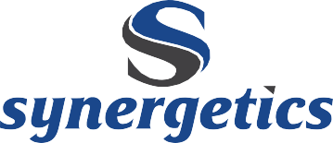

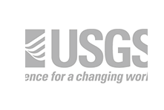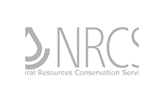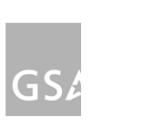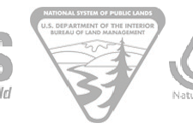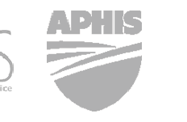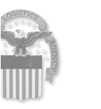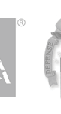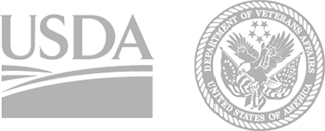

**CAPABILITY STATEMENT**

Synergetics is a professional services company that provides strategy, custom information technology, information security, consulting, digital, technology, operations and R&D services. Synergetics builds government and enterprise data solutions, ranging from business process optimization to mission-critical software systems. Our cutting-edge solutions are used to detect earthquakes worldwide, track food supply chain information and manage defense logistics data processing across the globe.

**DUNS**: 966870115

**CAGE**: 1FBW9

**GSA Schedule 70**

Number: GS-35F-0389K

**GSA 8(a) STARS II GWAC**

Constellations I & II, Functional Areas 1 & 2

Number: GS-06F-0780Z

**COMMITTED EXPERTS** Synergetics principals are involved in each engagement to add oversight and commitment to every project’s success. We enable our clients’ transformation into customer-centric digital organizations. Our work extends beyond ideas into tangible outcome-driven results.

**INDUSTRY VETTED** Synergetics is authorized to provide managed cloud services on leading FedRAMP CSPs, including Microsoft Azure Government and Amazon AWS

GovCloud. We currently provide FedRAMP management services to DoD and have been approved to operate on DLA’s exclusive Azure Government region.

**With Contract Vehicle GSA 8(a) STARS II**, the U.S. Federal Government may award Synergetics task orders under the

$4 million competitive threshold on a **sole-source basis**.

No protests on orders under $10 million.

*per Section 8(a) of the Small Business Act (15 U.S.C. 637 and FAR 19.8).*

“Costs were always below or **within**

**budget at all times**, contractor even suggested ways to streamline and cut costs, **amazing!**”

“Contractor was consistently

**ahead of milestone completion times**. [Synergetics] production and processes never missed a deadline.”

– J. ROGERS, FED LOG PM, DLA INFORMATION OPERATIONS

**LOCAL ACCOUNTABILITY** With oﬃces in Colorado, Illinois, Michigan

and Washington DC, Synergetics is prepared to respond quickly and in person.

**COMPREHENSIVE QUALITY** Synergetics’s quality is supported by industry- leading frameworks, such as the CMMI Level 3 appraisal and ISO 9001:2015 quality management system, along with rigorous client feedback assessments.

**FLEXIBLE ARCHITECTURE** Synergetics builds cross-platform,

cross-device and automated deployment systems. We oﬀer COTS solutions for input interaction testing (i.e. keyboard, mouse) to non-technical user operated database solutions. Our software can run anywhere, on any device type.

**SET-ASIDE PROGRAMS**

» SBA 8(a) Program Certified

» Minority-Owned Business

» Small Business

» Small Disadvantaged Business

**CERTIFICATIONS**

» CMMI Level 3 Appraisal

» ISO 9001:2015 QMS

» ISO 8000-110:2009 Data Quality

**INDUSTRY CONNECTIONS**

» Microsoft Certified Partner

» Apple Developer

» Oracle Partner

» Microsoft .NET

» Microsoft SQL Server

» Microsoft Azure Government

» Amazon AWS GovCloud

**NAICS CODES**

Software Publishers

Data Processing, Hosting, and Related Services

All Other Information Services Custom Computer

Programming Services

Computer Systems Design Services

Computer Facilities Management Services

Other Computer Related Services Administrative Management

and General Management Consulting Services

Process, Physical Distribution, and Logistics Consulting Services

511210

518210

519190

541511

“[Synergetics team] are always cooperative, and often **go above and beyond** what is required.

Where many contractors will only follow the exact word of the contract, [Synergetics team] applies logic and common sense to work to the intent of the contract.

They are very concerned about making sure customers are taken care of, and **happy** with the results.”

– J. MICHAEL, DOD, DLA, LEAD CONTRACT SPECIALIST

541512

541513

541519

541611

541614

© Synergetics, Inc. [www.synergetics.com](http://www.synergetics.com/) 970-498-9723 contact @ synergetics.com

1520 South College Avenue, Fort Collins, CO 80524

**MISSION SUPPORT SERVICES**

**PROGRAM, PLANNING**

**& MANAGEMENT SERVICES**

**INFORMATION MANAGEMENT**

»

»

»

»

»

»

»

»

»

»

»

Field Support Services

Systems Engineering Lifecycle Support Managed Cloud Services (FedRAMP) Research and Development (R&D) Modeling and Simulation

Logistics Data Syndication and Dissemination Engineering

Operations Support Staﬃng

Virtualization Support

IT Infrastructure Support

»

»

»

»

»

»

»

»

»

»

Enterprise Architecture & Technology Support COTS Enterprise Database Solutions Responsive Web/Mobile Solutions

DevOps, Release Management & Monitoring Business Application Services Support Systems Integration and Exercise Support Database Design, Development, DaaS System and Database Administration

LAN/WAN Management Disaster Planning & Operational Continuity Support

Software Technology Demonstration/Transition Conﬁguration Management & Standards Support Health IT Support Services

Social Networking & Collaboration Services Knowledge and Content Management Services

Quality Assurance Services, Automated Testing, User Acceptance Testing, TDD

»

»

»

»

»

»

»

»

»

»

»

Administrative and Operations Support Business Process Reengineering Program, Fiscal & Acquisition

Planning and Support

Program and Budget Documentation Budget/Management Analysis Change Management

Cost Estimating and Analysis Data Analytics

Earned Value Management Enterprise Resource Planning

Federal Sustainability Compliance Planning and Management

»

»

»

»

»

»

**CYBERSECURITY SERVICES & SUPPORT**

**ENTERPRISE CUSTOMER SERVICE**

»

»

»

»

»

»

»

»

»

»

»

»

»

Cybersecurity Compliance Information Assurance

NOC/SOC Cybersecurity Services Risk Assessment and Mitigation Penetration Testing

Intrusion Detection, Analytics, Monitoring Incident Handling and Mitigation

Digital Forensics SIEM Monitoring

DIACAP to RMF Transition and ATO FISMA Assessment Services

IV&V and Software Testing

24/7 Network and Security Operations and Data Center Support

»

»

»

»

»

»

»

»

»

»

»

Help Desk Services

Service Desk Management (ITIL v.3)

IT Service Management (ITSM) Development and Deployment Services

Desktop Support and Application Support Request, Incident & Problem Management Services

Telecommunications Support Services SharePoint Administration Support Services Business Intelligence/Report Writing

Metric & Service Delivery Analysis and Development

Conﬁguration Management & Inventory Database Management

On-Boarding Support Services

**TRAINING SERVICES**

»

»

Computer-Based Training (CBT) Development Development of Project-Speciﬁc Training Policies, Procedures, and Standards

Instructional System Design Course Design, including Virtual Classroom Delivery

Curriculum Development

Training Assessment Development and Delivery Services Competency Modeling

»

»

»

»

»

**CLIENT TESTIMONIALS**

Exceptional CPARS rating for over 20 years

“Quality was always stressed by both my staff and the [Synergetics team]. There is no margin for error in some of the projects we have. Contractors **take quality seriously and pride themselves in their work** and their zero quality errors.”

“Contract team has always immediately notified me of issues/potential problems. Upon discovery of the issue they worked relentlessly, no matter the day of week or hour of the day to ensure problem was resolved.

**All the key management staff were responsive and available 24/7**, exceeding our qualifications and requirements. Their team **shared diverse and rich knowledge**, enabling support on all echelons. All my staff would attest to the enthusiastic support they provided for both the team and customers alike.”

“[Synergetics team] were clear in identifying the company size, assets and advantages. Their business arrangement and ability to subcontract additional personnel to their team gave them all the great personnel aspects of working with a small company yet asset availability of a large company. I feel they are **truly prepared to execute and deliver**, regardless of the project scope.”

-J. Rogers, FED LOG PM, DLA Information Operations

“[Synergetics team] consistently produces a **quality product that exceeds expectations**. Any problem or program bug/error is addressed expeditiously to ensure that the product exceeds the warfighter’s needs. They are innovative in overcoming any obstacles that arise, and are flexible as government processes and procedures present ever changing challenges. Additionally they eagerly make suggestions for changes that will benefit the product, process, and warfighter.”

“Given what I know today about the contractor’s ability to perform in accordance with this contract or order’s most significant requirements, **I would recommend [Synergetics’s team] for similar requirements in the future**.”

– J. Michael, DoD, DLA, Lead Contract Specialist

© Synergetics, Inc. [www.synergetics.com](http://www.synergetics.com/) 970-498-9723 contact @ synergetics.com 1520 South College Avenue, Fort Collins, CO 80524