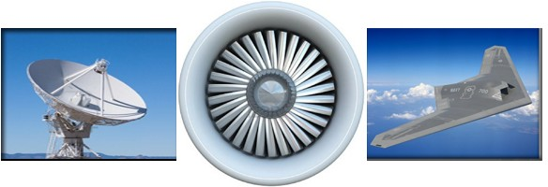

**CAPABILITY STATEMENT**

OVERVIEW

Established in 1992, WestWind Engineering, Inc. provides full service staffing and payroll solutions for Government, Commercial and Private Sectors.

**“Our strength is our people and the experience they bring to your projects with their extensive background in information technology, aerospace and defense engineering and management.”**

CAPABILITIES

COMPANY DATA

WestWind Engineering has the very best professional staff of engineers, scientists and managers available to you for:

WestWind Engineering has earned a reputation built upon producing results that not only meet, but surpass expectations.

➢

➢

➢

System Engineering and Integration Project Management, Planning and control Electronic, Optical and Mechanical Design, Development and Test

Software and Information Systems

Quality, Reliability and Safety Planning and Implementation

Contract and Subcontract Management Capture, Proposal, Red/Blue Team Support

➢

➢

➢

➢

➢

➢

➢

➢

**SBA Certified SDB**

**SBA Certified 8(a) Business SBA Certified EDWOSB Supplier Clearinghouse WBE**

GSA Schedule – 736-5 - GS-02F-100AA

Incorporated in California in 1992 DUNS – 007911907

Cage Code – 0VSK6

➢

➢

➢

➢

NAICS

PROGRAMS

WestWind Engineering primary NAICS:

WestWind has contributed subject matter expertise towards many successful aerospace and defense programs including:

➢

➢

➢

➢

➢

➢

561311 – Employment Placement Agencies 541214 – Payroll Services

541330 – Engineering Services

541511 - Computer Programming Services 541611 – Admin/Gen Management Consulting 541614 – Professional, Scientific & Technical Services

541712 – R&D in the Physical, Engineering, and Life Sciences (except biotech)

➢

➢

➢

➢

➢

➢

➢

ABL AEHF AMP AP-910

Argon B-2 CEV

➢

➢

➢

➢

➢

➢

➢

COIL F-35

GOES-R HESSLT ISAT JIMO JWST

➢

➢

➢

➢

➢

➢

➢

NPOESS SBIRS SBR STSS TDRSS UCAS-D UCLASS

➢

CUSTOMERS

WestWind’s past and present customers include:

➢

➢

➢

➢

➢

BAE Systems Eastman Kodak Good Engineering Hughes

JPL

➢

➢

➢

➢

➢

Maxima Systems NASA MFFC

Northrop Grumman Optimal Energy Raytheon

CONTACT

Address - 461 W. 6th St., Suite 226, San Pedro, CA 90731 – Tel (310) 831-3454 / Fax (310) 540-7172 Mary Anne Graves – [ma.graves@westwind111.com](mailto:ma.graves@westwind111.com)