

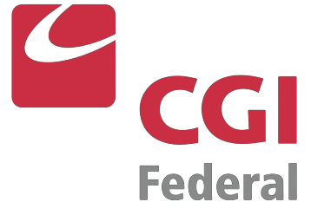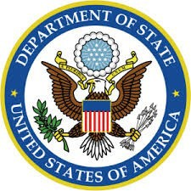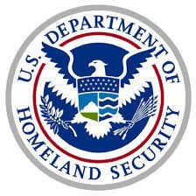

***Woman-Owned Small Business***

**CAGE Code: 69LT4 DUNS: 967015855**

**NAICS Codes:**

**541611**

Administrative Management & General Management Consulting Services

**541219**

Other Accounting Services

**541519**

Other Computer Related Services

**541612**

Human Resources Consulting Services

**541618**

Other Management Consulting Services

**541990**

All Other Professional, Scientific & Technical Services

**561312**

Executive Search Services

**561320**

Temporary Help Services

**561499**

All Other Business Support Services

**561611**

Investigation Services

**CAPABILITY STATEMENT**

Allied Government Solutions, Inc. (AGS) is an **SBA HUBZone-Certified, Woman-Owned Small Business** that provides comprehensive solutions and support services to federal

government agencies (classified/non-classified contracts), prime contractors, state

governments and local municipalities. AGS is a highly respected, service-oriented business

built on strong client relationships, tailoring its services to meet its customers’ specific needs.

Core Competencies

•

•

•

•

•

•

•

•

Administrative Support Services

Staff Augmentation & Surge Recruitment HR Consulting & Personnel Management

Security Clearance Processing Key Personnel Recruitment

Professional & Accounting Services Records Management

Mailroom Operations

SCA Contract Management & Compliance •

•

Operations & Management Consulting

Past Performance/Differentiators

•

•

Hired over 2,000 employees at 20+ locations nationwide in 12 different states since 2000

Performance on DoS Passport Support Services contract since 2000, and DoS Book Personalization Facility contract since 2011

Successfully onboarded 90 FTE’s within a 30-day transition period in 2016 on DHS/USCIS National Benefits Center Records Operations contract

Timely delivery of 120 cleared employees within a 3-month period for annual H1B Visa Cap on DHS/USCIS Service Center Operations Support Services contract since 2015

Experience with establishment and adherence to Collective Bargaining Agreement (CBA) under DoS Visa Support Services contract

20 years’ experience managing employees in Service Contract Act (SCA) positions

Received *SBA Administrator’s Award for Excellence*

•

•

•

•

•

CONTACT INFORMATION

**Allison Aboody**

President (800) 559-2611

[aaboody@alliedgov.com](mailto:aaboody@alliedgov.com)

**Roy S. Aboody**

Chief Executive Officer (603) 234-6070

[raboody@alliedgov.com](mailto:raboody@alliedgov.com)

**Tricia-Marie Closs** Director of Operations (800) 559-2611

[tcloss@alliedgov.com](mailto:tcloss@alliedgov.com)

90 Washington Street, Suite 211 • PO Box 1275 • Dover, NH 03821 • Phone: 800-559-2611 • Fax: 603-772-1930 • [www.alliedgov.com](http://www.alliedgov.com/)

Clients