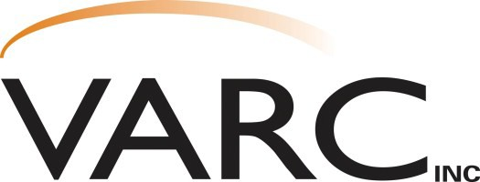

**Capability Statement**

**Contact: Eric Filter**

**District Manager**

608-637-3934 Ext. 335

Fax: 608-637-7016

[efilter@varcinc.com](mailto:efilter@varcinc.com)

**Corporate Office**

1133 Nelson Parkway

Viroqua, WI 54665

608-637-3934

**Sauk Division**

220 Wengel Drive

Reedsburg, WI 53959

608-524-3716

**Richland Division**

111 W. Robb Road Richland Center, WI 53581

608-647-3850

**Juneau Division**

925 W. State St. Mauston, WI 53948

608-847-4675

**History and Growth**

VARC, Inc. is a value-added service provider to major corporations throughout the Midwest. Over the past 38 years, through very strong and steady growth, we have expanded from one small op- eration to a world class assembly and packaging fulfillment company with four locations in West Central Wisconsin. VARC, Inc. has over 125,000 square feet of production space and 60,000 square feet of warehousing, giving us the ability to perform a wide range of services. Examples of our diverse range of capabilities include, but are not limited to:

**Packaging Assembly Additional**

* Blister Sealing • Cable and Wire Harness • Inspection/Sorting/Rework
* Strapping Assembly • Inventory Control
* Heat Sealing • Collating • Label Printing
* Shrink Wrapping • Sanding/Buffing • Second Shift Capacity
* Autobagging • Hand Soldering • 400 Production Employees
* Stapling • Drilling/Deburring • ISO 9001 Process Ready
* Polybagging • Ultrasonic Welding • P.O.P. Displays
* Custom Packing Programs • Manual Printing/Binding • Sewing
  + Electronic Board Assembly • Weigh Counting and Testing

**Why VARC?**

**When you work with VARC, Inc., you gain a partner who:**

* Consistently meets or exceeds customer deadlines, production goals and delivery dates.
* Is a solution to help customers deal with spikes in demand.
* Assists in setting priorities to better serve long term and strategic goals
* Currently incorporates Management Resource Systems such as SAP and Navision.
* Has a proven reputation for high quality, efficiency, innovation, creativity and excellence.

**People**

Enough cannot be said about our employees at VARC, Inc. The staff is knowledgeable, committed, and proud of the work we do. Our management team and production workers all strive to main-

tain the success for our customers.

**Quality Assurance**

VARC takes pride in our very thorough and extensive Quality Assurance Program. This has been the cornerstone of our success and has separated us from our competitors. This system enables us to meet customer specifications and maintain being “Committed to Quality and Excellence”.

**References and Quality Assurance System Available Upon Request**

“Where Quality and Innovation Meet”