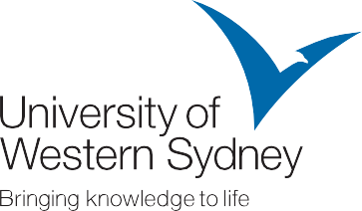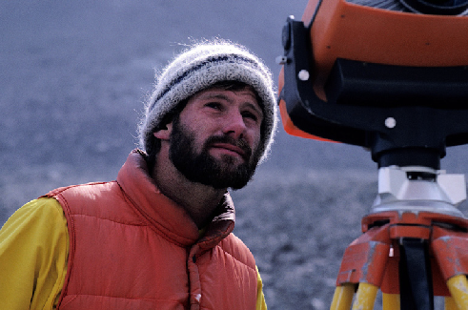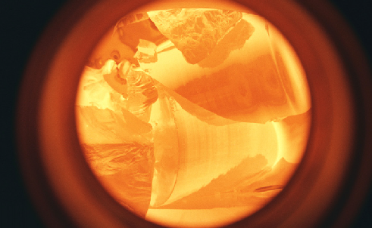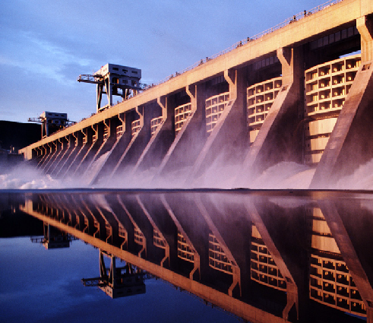

Capability Statement

**Overview**

*The University of Western Sydney (UWS) offers highly specialised engineering consulting and research capabilities aimed at identifying practical and efficient solutions to clients’ needs across the main disciplines of construction technology, engineering and industrial design. This expertise is delivered to corporate and government clients from academic staff in the School of Engineering.*

**Areas of Research Activities**

The research concentration areas for UWS engineering staff include:

◆ **Civionics**

Civionics Research Node is the first of its kind in Australia and conducts unique cross-disciplinary research across the Engineering, Construction and Industrial Design programs. Civionics focusses on the application of electronics to civil infrastructure for health monitoring purposes. Research into this field will provide engineers with feedback necessary to aid in optimising design techniques and understanding infrastructure performance, behaviour and state of condition to assist with intelligent maintenance and repair of structures in the future.

◆ **Civil/Structural Engineering**

The Australian Research Council (ARC) is currently funding the following projects:

❚ Development of computational methods for thin walled structures

❚ Unified theory for the behaviour and design of composite steel-concrete beams subjected to generalised loading and support conditions

❚ Utilising the benefits of high performance steels (HPS) and infill materials for critical infrastructure protection against extreme loads

❚ Geotechnical characterisation of compacted ground based on passive ambient noise techniques

◆ **Electrical/Computer Engineering and Robotics**

Examples of recent/current Node-funded projects include:

❚ Remote monitoring and control of sensors over 3G wireless networks

❚ Passive wireless sensors for structural health monitoring

❚ Determination of strains based on visual information

Other projects in the School include conducting research in the fields of environmental engineering, power engineering, fire safety engineering, construction and industrial design.

**Teaching, Learning and Training**

UWS engineering academics specialise in the following areas:

❚ Civil/Structural Engineering

❚ Computer/Mechanical/Electrical and Telecommunications Engineering

❚ Fire Safety Engineering

❚ Construction Technology

❚ Mechatronics and Signal Processing

❚ Industrial Design

The School offers a diverse range of innovative professional degree programs at both undergraduate and postgraduate levels.



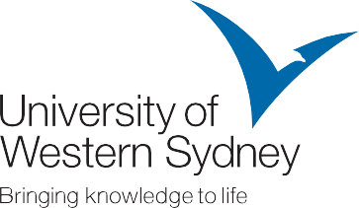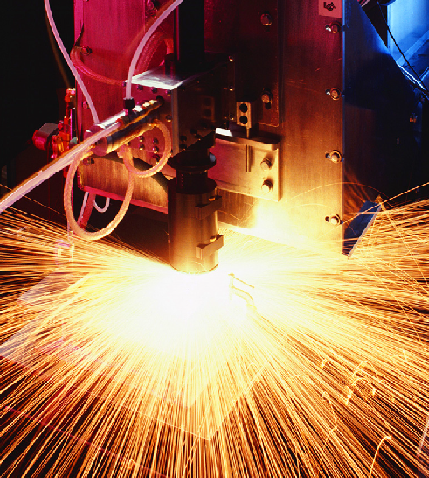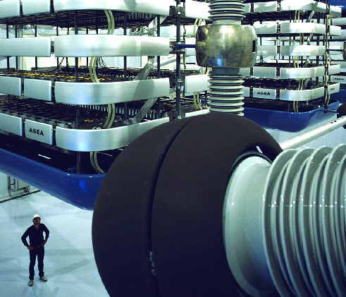

Capability Statement

**Resources**

The School has approximately 45 full-time academic staff supported by 15 full-time technical staff. The majority of academic staff have practical industry and consulting experience.

◆ **Construction Technology Research laboratory:**

This research laboratory is a NATA accredited testing facility complying with Australian and ISO standards. NATA testing is available not only to published standards, but also using in house developed procedures for unusual samples. Services available include both static and dynamic testing for components and assemblies within the research laboratory or on-site. Concrete, steel, plastics, composites of these, as well as polystyrene, alloys and timber can all tested using this facility.

◆ **Design and Manufacturing:**

The facility has a range of capabilities for mechatronics, industrial design and small scale production that incorporate sustainable design concepts. Examples are 3D computer modelling and simulation laboratory, rapid prototyping equipment, a materials analysis and testing laboratory, product ergonomics studies and usability laboratory, and robotic assembly laboratory.

**Previous Clients and Projects**

Engineering academics at UWS are engaged in collaborative research efforts with government and industry partners including:

◆ Laboratory testing and research on structural and reinforcing steel in vertical structures and tunnels - One Steel Corporation

◆ Tilt up wall anchor testing - BlueScope Steel

◆ Research on application of universal design concepts to open spaces and parks - Penrith City Council

◆ Testing of road surfaces on the site and construction materials – various Commonwealth and State Government Departments

**Areas of International Activity**

The School has a number of international research collaborations with Universities overseas. Recent examples include:

◆ Research collaboration on concrete filled stainless steel tubular columns under extreme loads - Tsinghua University, Beijing China:

◆ Autonomous multi-robot system in welding - Shanghai Jiao-Tong University

**How to Become Involved as a Partner with UWS Engineering Experts**

UWS operates commercial engagement with the business community through UWS Innovation & Consulting. This provides business partners with a single clear point of access to UWS leading edge research and delivery of projects utilising high calibre staff. This dedicated unit, comprised of professionals with extensive corporate experience, can be the catalyst to help your business keep in touch and up-to-date. We invite you to discuss with us some of the issues your business is facing.

All projects facilitated by UWS Innovation & Consulting are allocated to a project manager who acts as the primary point of contact between the University and a client. This ensures and maintains a consistent high quality of delivery tailored to commercial imperatives.

For information on consultancy services, assistance in finding an engineering specialist to meet your particular needs, or information on current commercialisation opportunities please contact:

**UWS Innovation & Consulting:**

P: + 61 2 9685 9800

F: + 61 2 9685 9850

E: [Innovate@uws.edu.au](mailto:Innovate@uws.edu.au)

Locked Bag 1797, Penrith South DC NSW 1797

[**www.uws.edu.au**](http://www.uws.edu.au/)

03 09