

Inventory

Management

&

Kanban

- 2007 Frost & Sullivan. All rights reserved. This document contains highly confidential information and is the sole property of Frost & Sullivan. No part of it may be circulated, quoted, copied or otherwise reproduced without the written approval of Frost & Sullivan.

1 - 30

1982

1983

1991

1996

1999

2000

2001

2002

2003

3 - 30

Incorporation 
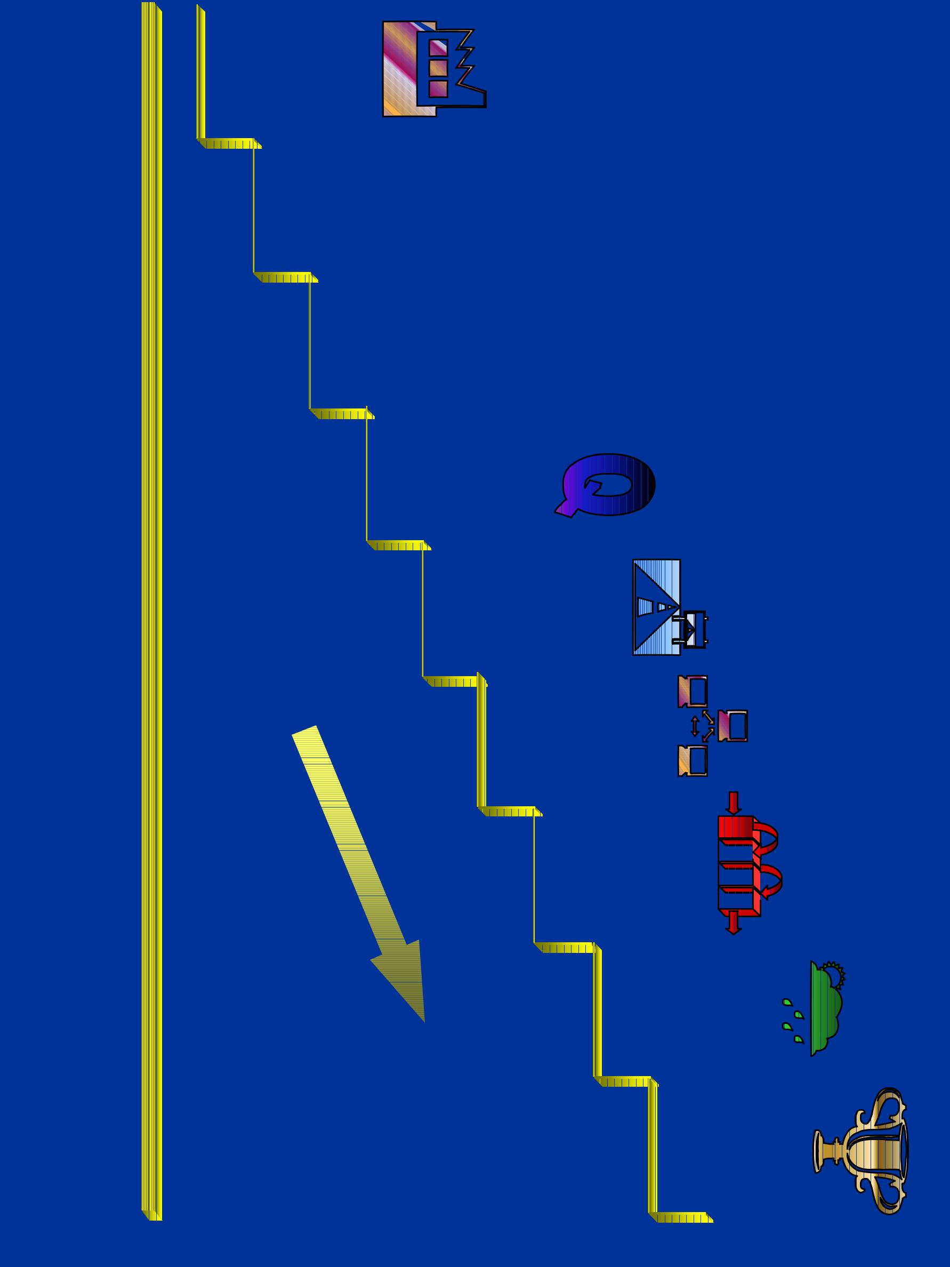

ISO 9001

TPM Kick off

ERP

Lean Mfg.

ISO 14001

ISO9001-2000

TPM Award

CONTINUOUS IMPROVEMENT

Raw materials - Super Market

Back ground :

Inventory high and not leveled.

Many stock outs with high inventory.

Re order point ,re order quantity and lead time

not controlled for all items as there was no system.

First in first out difficult .

4 - 30

Raw materials - Super Market

Identified Actions :

Follow an address system

Arrive at a Kanban Quantity

Put up a system for arriving re-order level

5 - 30


Raw materials - Super Market

Storage Address System

 | 3 |  | 4 |  | 3 |  | 4 |  | 3 |  | 4 |  |  | 3 |  | 4
 |  |  |  |  |  |  |  |  |  |  |  |  |  |  |  |  | E
 | 2 |  | 1 |  | 2 |  | 1 |  | 2 |  | 1 |  |  | 2 |  | 1 | E
 |  |  |  |  |  |  |  |  |  |  |  |  | Aisle
 | 3 |  | 4 |  | 3 |  | 4 |  | 3 |  | 4 |  |  | 3 |  | 4
 | 3 |  | 4 |  | 3 |  | 4 |  | 3 |  | 4 |  |  |  |  | 4 | D | K
 | 2 |  | 1 |  | 2 |  | 1 |  | 2 |  | 1 |  |  | 2 |  | 1 | D | A
 |  |  |  |  |  |  |  |  |  |  |  |  | Aisle |  |  |  |  | N
 |  |  |  |  |  |  |  |  |  |  |  |  |  |  |  |  |  | B
 |  |  |  |  |  |  |  |  |  |  |  |  |  |  |  |  |  | A
 | 3 |  | 4 |  | 3 |  | 4 |  | 3 |  | 4 |  |  | 3 |  | 4 |  | A
 | 3 |  | 4 |  | 3 |  | 4 |  | 3 |  | 4 |  |  |  |  | 4 |  | N
 |  |  |  |  |  |  |  |  |  |  |  |  |  |  |  |  | C | N
 | 2 |  | 1 |  | 2 |  | 1 |  | 2 |  | 1 |  |  | 2 |  | 1 | C
 |  |  |  |  |  |  |  |  |  |  |  |  | Aisle |  |  |  |  | B
 |  |  |  |  |  |  |  |  |  |  |  |  |  |  |  |  |  | O
 |  |  |  |  |  |  |  |  |  |  |  |  |  |  |  |  |  | A
 | 3 |  | 4 |  | 3 |  | 4 |  | 3 |  | 4 |  |  | 3 |  | 4 |  | A
 | 3 |  | 4 |  | 3 |  | 4 |  | 3 |  | 4 |  |  |  |  | 4 |  | R
 |  |  |  |  |  |  |  |  |  |  |  |  |  |  |  |  | B | R
 | 2 |  | 1 |  | 2 |  | 1 |  | 2 |  | 1 |  |  | 2 |  | 1 | B | D
OUT |  |  |  |  |  |  |  |  |  |  |  |  | Aisle
OUT | 3 |  | 4 |  | 3 |  | 4 |  | 3 |  | 4 |  |  | 3 |  | 4
 |  |  |  |  |  |  |  |  |  |  |  |  |  |  |  |  | A
 | 2 |  | 1 |  | 2 |  | 1 |  | 2 |  | 1 |  |  | 2 |  | 1 | A
 |  | IV |  |  |  | III |  |  |  | II |  |  |  |  |  | I

IN

6 - 30

Raw materials - Super Market Kanban Quantity Estimation

ITEM |  |  |  | DESCRPN |  |  |  |  |  |  |  |  |  |  |  | UOM |  |  |  |  |  | P U |  |  |  |  | SU |  |  | PU /SU |  |  |  | BQ |  |  |  | CON -4W |  |  |  |  |  |  | CON /DAY |  |  |  |  |  |  |  | CON -8W |  |  |  |  |  | CON /DAY
 |  |  |  |  |  |  |  |  |  |  |  |  |  |  |  |  |  |  |  |  |  |  |  |  |  |  |  |  |  |  |  |  |  |  | SU |  |  |  |  |  | PU |  |  |  |  |  |  | PU |  |  |  |  |  |  | PU |  |  |  |  | PU
 | 1 |  |  |  |  | Zinc oxide |  |  |  |  |  |  |  |  |  |  | Kgs |  |  | 25 |  |  |  |  |  | 5000 |  |  |  | 200 |  |  |  | 200 |  |  |  | 540 |  |  |  |  |  |  | 18 |  |  |  |  |  |  |  | 1080 |  |  |  |  |  | 18
 | 2 |  |  |  | 402 Reclaim |  |  |  |  |  |  |  |  |  |  |  | Kgs |  |  | 50 |  |  |  |  |  | 9000 |  |  |  | 180 |  |  |  | 180 |  |  |  | 700 |  |  |  |  |  |  | 23.3 |  |  |  |  |  |  |  | 1400 |  |  |  |  |  | 23.3
 | 3 |  |  |  |  |  |  |  | HS |  |  |  |  |  |  |  | Kgs |  |  | 20 |  |  |  |  |  | 500 |  |  |  | 25 |  |  |  | 25 |  |  |  | 150 |  |  |  |  |  |  | 5 |  |  |  |  |  |  |  | 300 |  |  |  |  |  | 5
 | 4 |  |  |  |  |  |  | BSM |  |  |  |  |  |  |  |  | Kgs |  |  | 25 |  |  |  |  |  | 500 |  |  |  | 20 |  |  |  | 20 |  |  |  | 120 |  |  |  |  |  |  | 4 |  |  |  |  |  |  |  | 240 |  |  |  |  |  | 4
 | 5 |  |  |  |  |  |  | CBS |  |  |  |  |  |  |  |  | Kgs |  |  | 20 |  |  |  |  |  | 500 |  |  |  | 25 |  |  |  | 25 |  |  |  | 60 |  |  |  |  |  |  | 2 |  |  |  |  |  |  |  | 120 |  |  |  |  |  | 2
 | 6 |  |  | 4020/Pil flex |  |  |  |  |  |  |  |  |  |  |  |  | Kgs |  |  | 50 |  |  |  |  |  | 1000 |  |  |  | 20 |  |  |  | 20 |  |  |  | 96 |  |  |  |  |  |  | 3.2 |  |  |  |  |  |  |  | 192 |  |  |  |  |  | 3
 | 7 |  |  |  |  | Crmb 803 |  |  |  |  |  |  |  |  |  |  | Kgs |  |  | 40 |  |  |  |  |  | 8000 |  |  |  | 200 |  |  |  | 200 |  |  |  | 900 |  |  |  |  |  |  | 30 |  |  |  |  |  |  |  | 1800 |  |  |  |  |  | 30
ITEM |  |  |  |  |  |  | DESCRPN |  |  |  |  |  |  |  |  | UOM |  |  |  | CON /DAY |  |  |  |  |  | L-TIME |  |  |  |  | SU FOR |  |  | F-FACT |  |  |  |  |  | SU FOR |  |  |  |  |  |  | ROQ |  |  |  |  |  |  |  | NO OF |  |  |  |  | ROUNDED
 |  |  |  |  |  |  |  |  |  |  |  |  |  |  |  |  |  |  |  |  |  | SU |  |  |  | DAYS |  |  |  |  | L-TIME |  |  | DAYS |  |  |  |  |  | F-FACT |  |  |  |  |  |  |  | SU |  |  |  |  |  | KANBAN |  |  |  |  |  | KANBAN
1 |  |  |  |  |  | Zinc oxide |  |  |  |  |  |  |  |  |  |  | Kgs |  |  | 0.09 |  |  |  |  |  | 2 |  |  |  | 0.18 |  |  |  | 2 |  |  |  | 0.18 |  |  |  |  |  |  | 1 |  |  |  |  |  |  |  | 1.4 |  |  |  |  |  | 2
2 |  |  |  |  | 402 Reclaim |  |  |  |  |  |  |  |  |  |  |  | Kgs |  |  | 0.13 |  |  |  |  |  | 7 |  |  |  | 0.89 |  |  |  | 2 |  |  |  | 0.26 |  |  |  |  |  |  | 1 |  |  |  |  |  |  |  | 2.2 |  |  |  |  |  | 3
3 |  |  |  |  |  |  |  |  | HS |  |  |  |  |  |  |  | Kgs |  |  | 0.2 |  |  |  |  |  | 4 |  |  |  | 0.8 |  |  |  | 2 |  |  |  | 0.4 |  |  |  |  |  |  | 1 |  |  |  |  |  |  |  | 2.2 |  |  |  |  |  | 3
4 |  |  |  |  |  |  |  | BSM |  |  |  |  |  |  |  |  | Kgs |  |  | 0.2 |  |  |  |  |  | 7 |  |  |  | 1.4 |  |  |  | 2 |  |  |  | 0.4 |  |  |  |  |  |  | 1 |  |  |  |  |  |  |  | 2.8 |  |  |  |  |  | 3
5 |  |  |  |  |  |  |  | CBS |  |  |  |  |  |  |  |  | Kgs |  |  | 0.08 |  |  |  |  |  | 7 |  |  |  | 0.56 |  |  |  | 2 |  |  |  | 0.16 |  |  |  |  |  |  | 1 |  |  |  |  |  |  |  | 1.7 |  |  |  |  |  | 2
6 |  |  |  | 4020/Pil flex |  |  |  |  |  |  |  |  |  |  |  | Kgs |  |  |  | 0.15 |  |  |  |  |  | 7 |  |  |  | 1.05 |  |  |  | 2 |  |  |  | 0.3 |  |  |  |  |  |  | 1 |  |  |  |  |  |  |  | 2.4 |  |  |  |  |  | 3
7 |  |  |  |  |  | Crmb 803 |  |  |  |  |  |  |  |  |  |  | Kgs |  |  | 0.15 |  |  |  |  |  | 4 |  |  |  | 0.6 |  |  |  | 2 |  |  |  | 0.3 |  |  |  |  |  |  | 1 |  |  |  |  |  |  |  | 1.9 |  |  |  |  |  | 2
UOM - UNIT OF MEASURE |  |  |  |  |  |  |  |  |  |  |  |  |  |  |  |  |  |  |  | SU - STOCK U NITS |  |  |  |  |  |  |  |  |  |  |  |  |  | PU - PURCHASE UNIT |  |  |  |  |  |  |  |  |  |  |  |  |  |  |  |  |  |  | L-TIME - LEAD TIME
F-FACT - FEAR FACTOR |  |  |  |  |  |  |  |  |  |  |  |  |  |  |  |  |  |  |  | CON - CONSUMPTION |  |  |  |  |  |  |  |  |  |  |  |  |  | CON -4 W - CONSUMPTION FOR 4 WEEKS

7 - 30

 |  |  |  |  |  |  |  | Raw materials - Super Market
 | Front side |  |  |  |  |  |  | - Kanban Cards
 | MATERIAL |  |  |  |  |  |  |  | ZINC OXIDE
 | STOCK QTY |  |  |  |  | 3000 Kgs. |  |  |  | ISSUE QTY : 1 BAG
 | LOCATION |  |  |  |  | B-I - 4 |  |  |  | NO. OF BAGS : 60
 | LAB TEST |  |  |  |  | OK |  |  |  | LOT NO |  |  |  | 5446
 | 1 |  | 2 |  | 3 | 4 |  | 5 |  | 6 |  | 7 |  | 8 |  | 9
 | 10 |  | 11 |  | 12 | 13 |  | 14 |  | 15 |  | 16 |  | 17 |  | 18
 | 19 |  | 20 |  | 21 | 22 |  | 23 |  | 24 |  | 25 |  | 26 |  | 27
 | 28 |  | 29 |  | 30 | 31 |  | 32 |  | 33 |  | 34 |  | 35 |  | 36
 | 37 |  | 38 |  | 39 | 40 |  | 41 |  | 42 |  | 43 |  | 44 |  | 45
 | 46 |  | 47 |  | 48 | 49 |  | 50 |  | 51 |  | 52 |  | 53 |  | 54
 | 55 |  | 56 |  | 57 | 58 |  | 59 |  | 60
 | Back side
 | MATERIAL |  |  |  |  |  |  |  | ZINC OXIDE
 | STOCK QTY |  |  |  |  | 3000 Kgs. |  |  |  | NO. OF BAGS : 60
 | LOCATION |  |  |  |  | B-I - 4 |  |  |  | LOT NO |  |  |  | 5446
 | RECEIVED ON |  |  |  |  |  | 15.11.04
 |  |  |  |  |  | UNDER INSPECTION
 | LAB TEST |  |  |  |  | OK
 |  |  |  |  |  | REJECTED

8 - 30

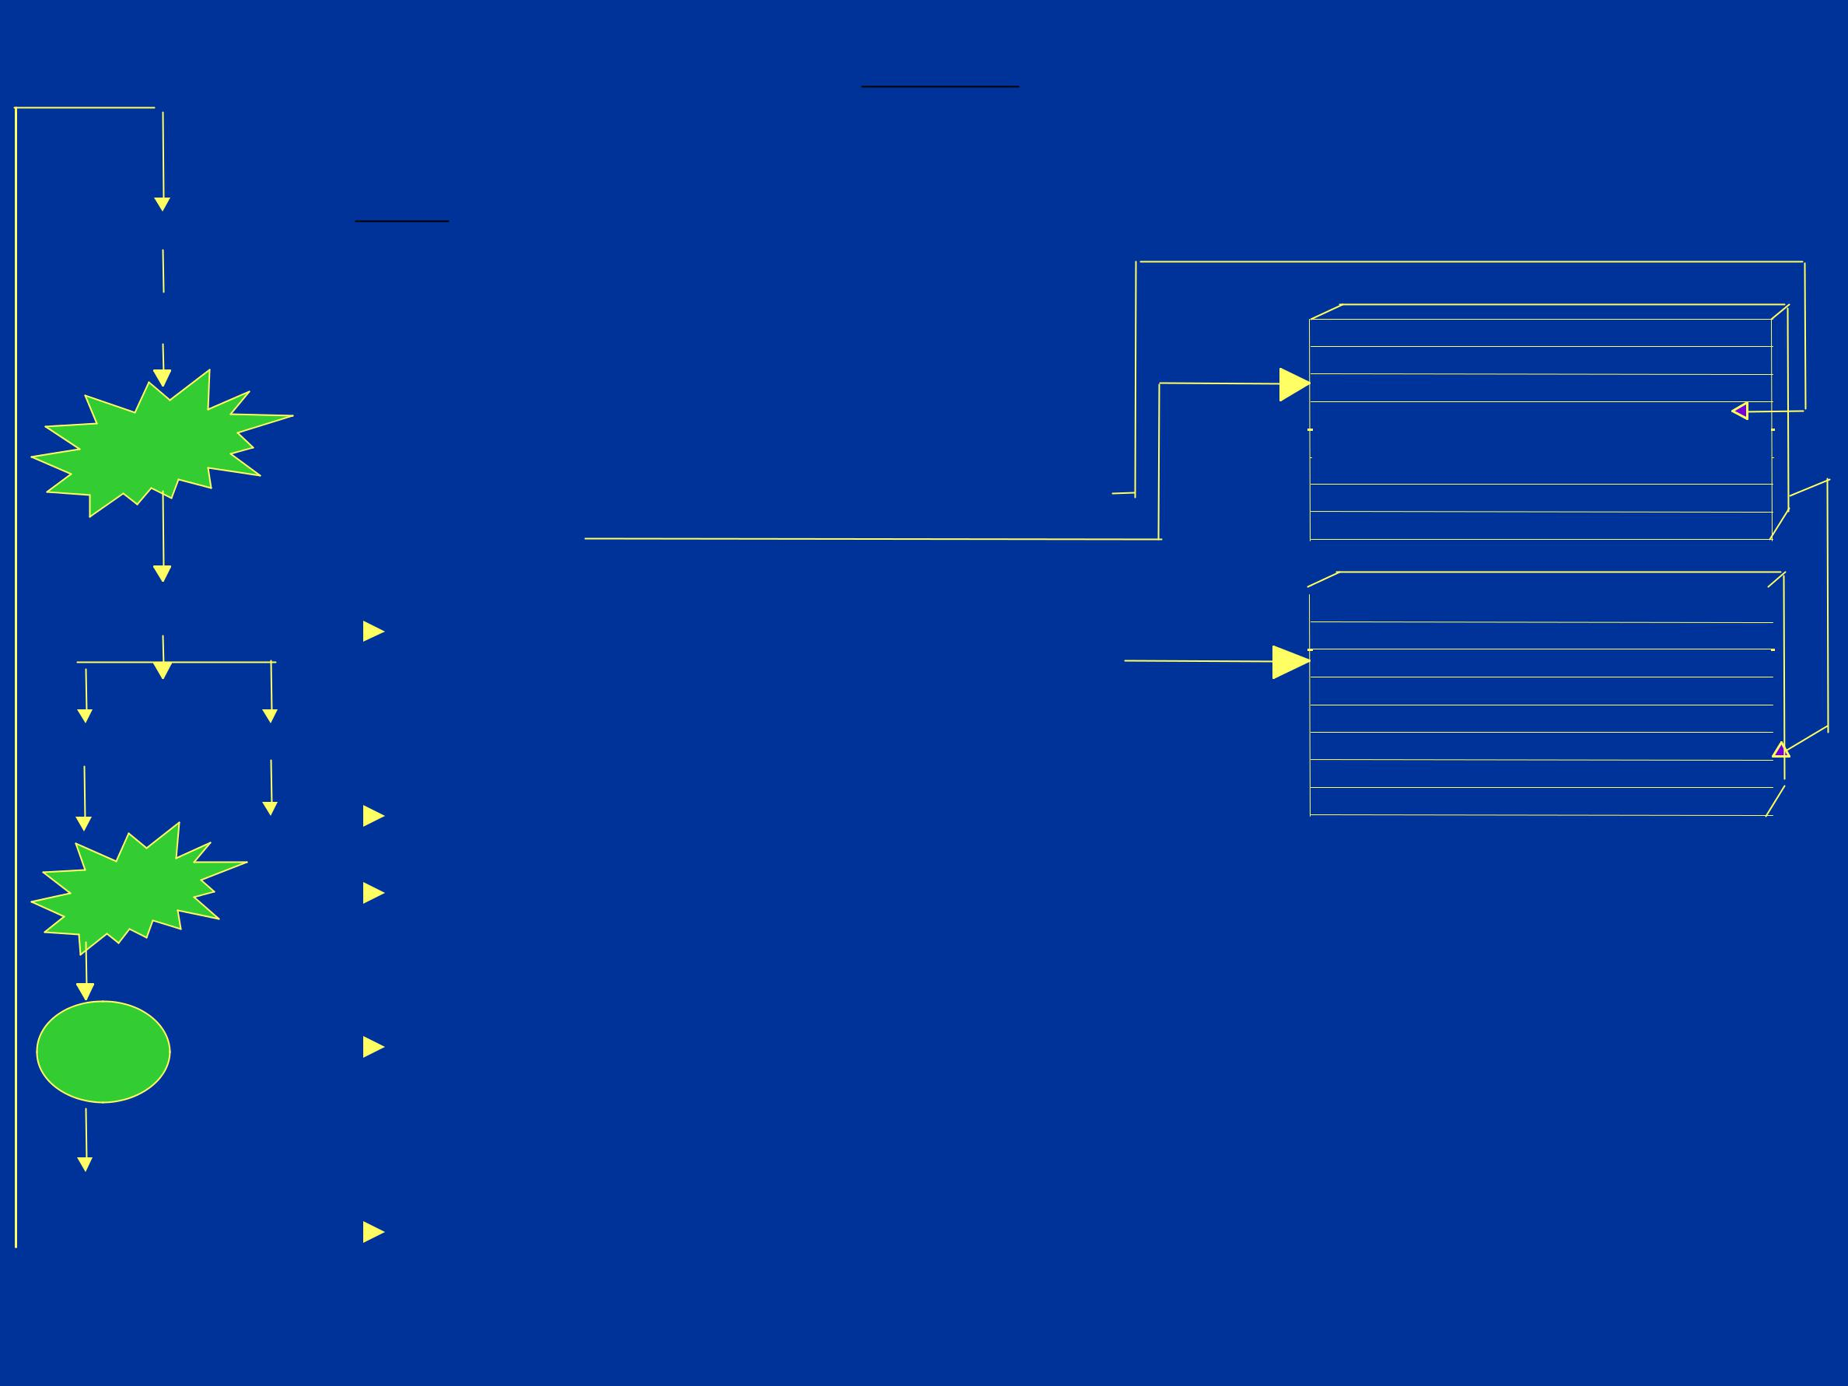
Raw materials - Super Market

- Activity Flow

Receipt

Unloading

Storage 

After locating in a storage place, Kanban card prepared and kept in the Under Inspection level with location detail and lot number

FRONT SIDE

 | MATERIAL |  |  |  | BAYPRENE 210
 | STOCK QTY 200 |  |  |  | ISSUE QTY 25
 |  | LOCATION A1-II |  |  | NO. OF BAGS 8
 | LAB TEST OK |  |  |  | LOT NO. 26365
 | 1 | 2 | 3 | 4 | 5 | 6 | 7 | 8

BACK SIDE

Inspection |  |  |  | Material status described in the
 |  |  |  | Kanban card
Ok | Not Ok
 |  |  |  | Returned to supplier

 | STOCK QTY 200 |  | ISSUE QTY 25
 | LOCATION A1-II |  | NO. OF BAGS 8
 | LAB TEST | DATE | LOT NO | QTY
 | OK | 16.03.2003 | 26365 | 200
 | UNDER INSPECTION |  | 14.03.2003
 | OK | 16.03.2003
 | REJECTION

 | Stock |  |  | Stock position visible in the Kanban card for monitoring
 |  |  |  | Spiderman picks the required material and strikes in the qnty in
Issue |  |  |  | the issue kanban card

 | Order |  |  |  | Once stock reaches re order level,purchase staff orders the lot qnty.

9 - 30

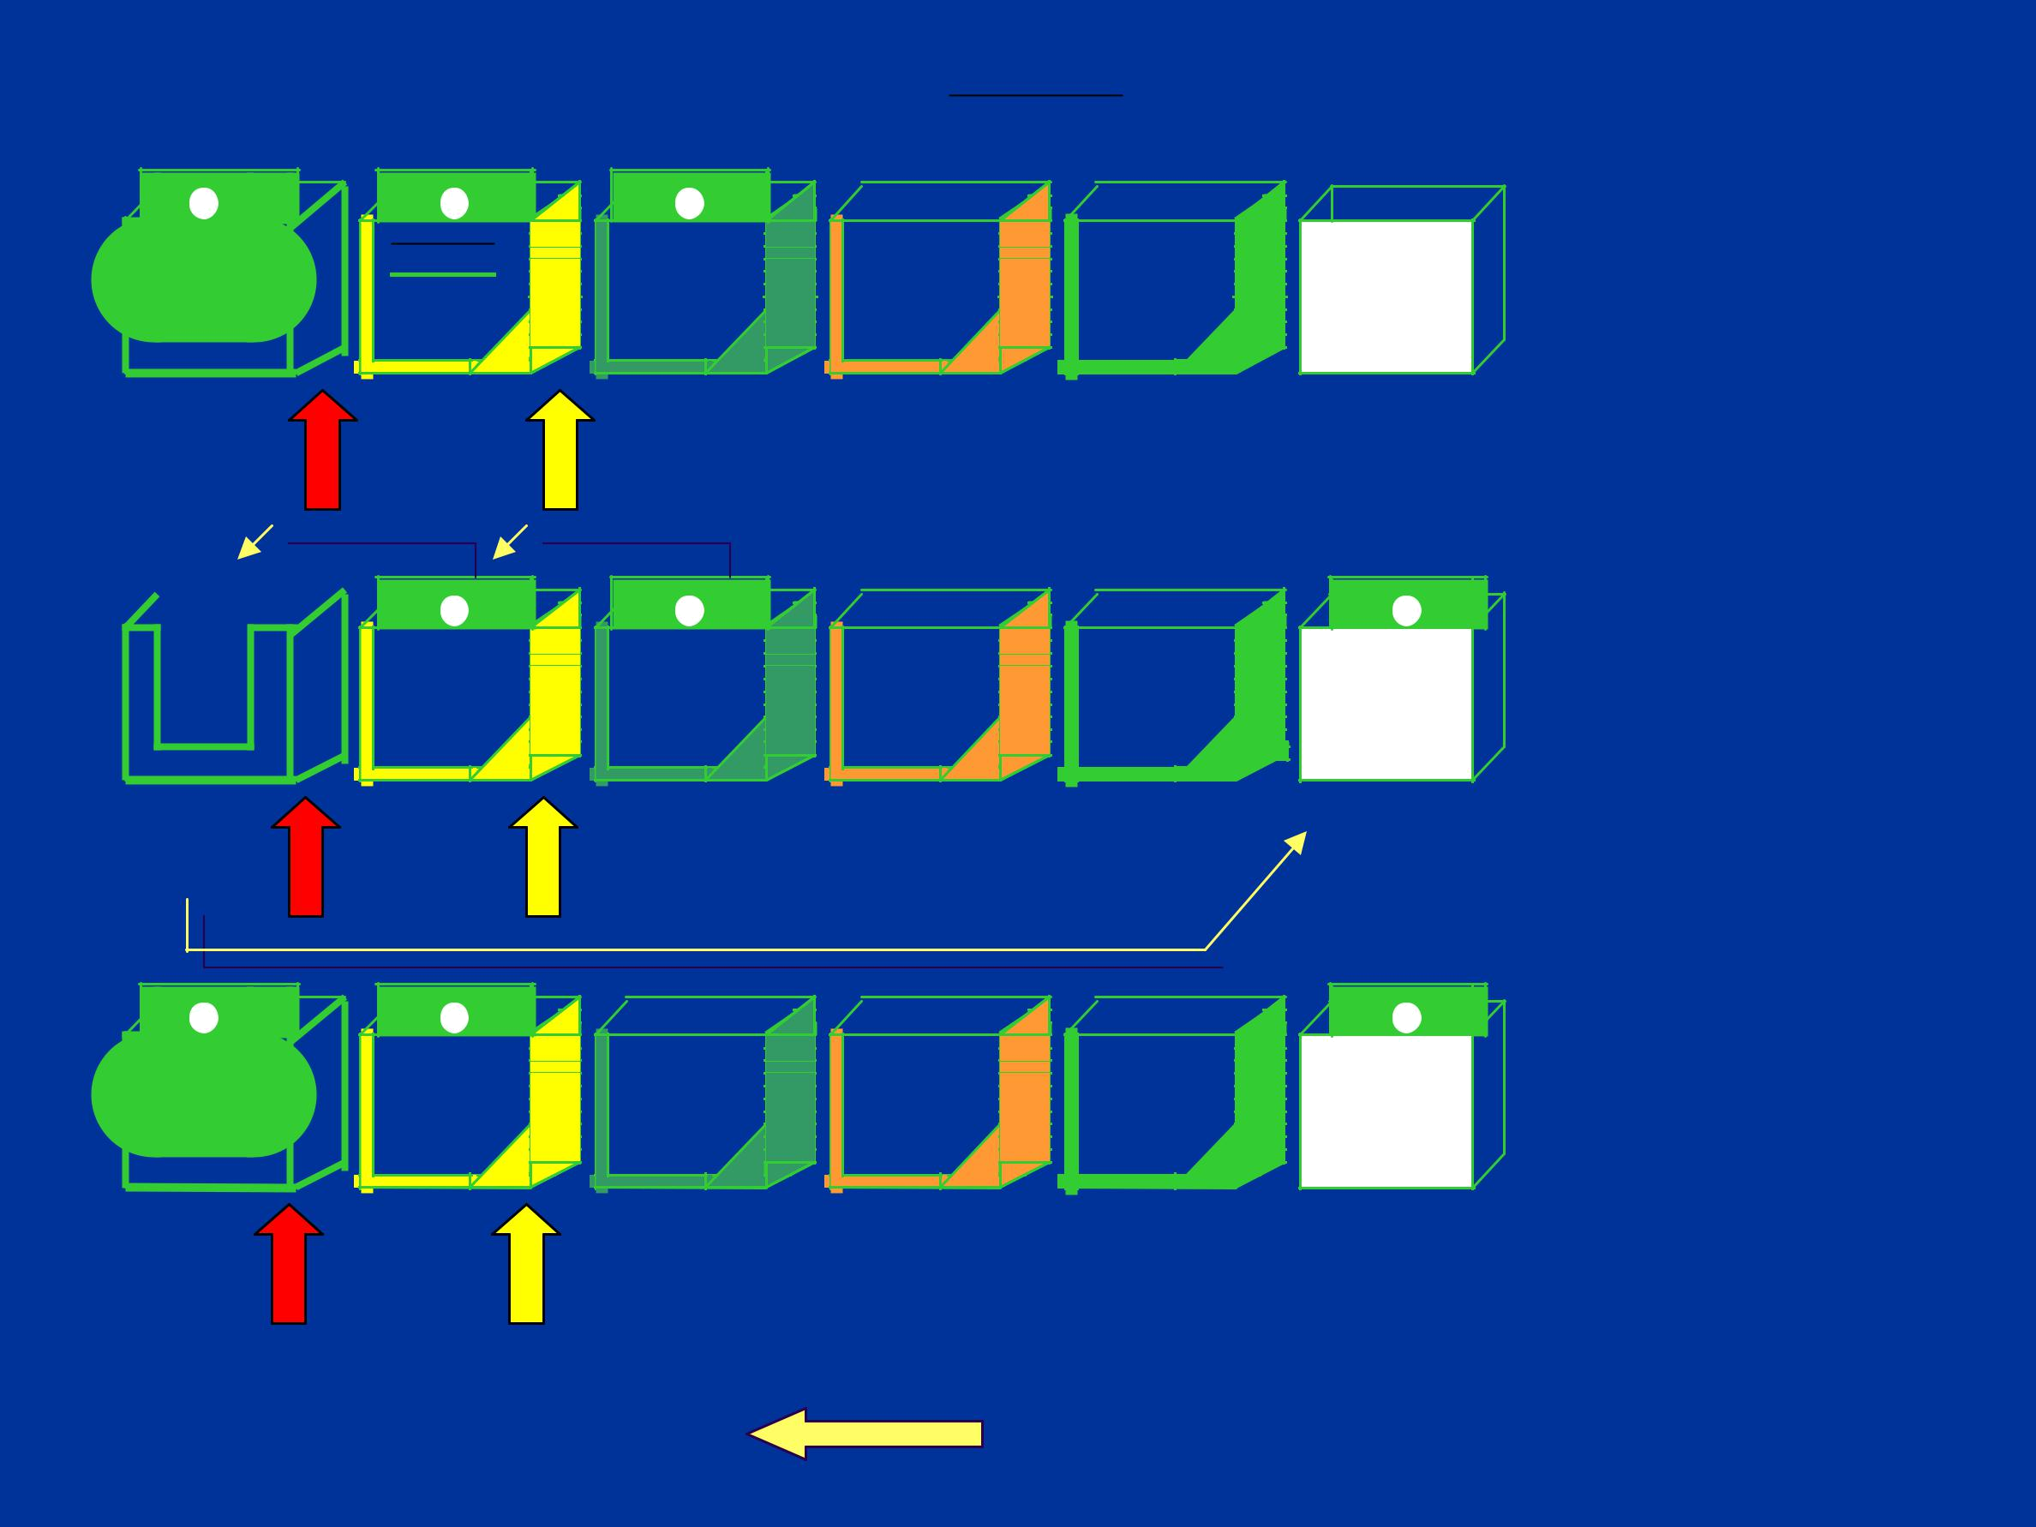
Kanban and visual management

A | B | C

STAGE-1

CARD IN |  |  | REORDER |  |  | READY FOR |  |  | UNDER |  | ORDERED | TO
 | USE |  | LEVEL |  |  | USE |  |  | INSPECTION |  | STATUS | ORDER
 |  |  |  | B |  |  | C |  |  | A

STAGE-2

CARD IN REORDER READY FOR UNDER ORDERED TO

USE LEVEL USE INSPECTION STATUS ORDER

B | C | A

STAGE-3

CARD IN | REORDER | READY FOR | UNDER | ORDERED | TO
 |  |  |  |  | ORDER
USE | LEVEL | USE | INSPECTION | STATUS | ORDER

DIRECTION OF
CARD MOVEMENT

Kanban cards A,B & C are in accepted level. Spiderman uses material in card “A” to adopt First-in-First-out method.

Spiderman moves card “A” to order status level after completion of card quantity.

Spiderman moves forward the cards B & C to adopt First-in-First-out method.

When the card “C” moved to reorder level, card “A” ordered to the lot quantity by purchase.

10 - 30

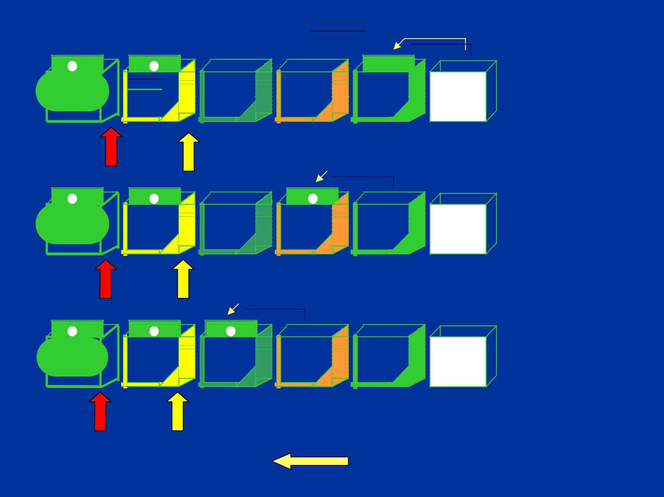
Kanban and visual management

B | C | A

STAGE-4

CARD IN | REORDER | READY FOR | UNDER |  | ORDERED |  | TO
USE | LEVEL | USE | INSPECTION |  | STATUS |  | ORDER

B | C | A

STAGE-5

CARD IN | REORDER | READY FOR |  | UNDER |  | ORDERED | TO
USE | LEVEL | USE |  | INSPECTION |  | STATUS | ORDER

B | C | A

STAGE-6

CARD IN REORDER READY FOR UNDER ORDERED TO

USE LEVEL USE INSPECTION STATUS ORDER

Follow-up Re-order

Point Point DIRECTION OF

CARD MOVEMENT

Purchase person after ordering moves card ‘A’ to order status

On receipt of material stores person moves card ‘A’ to under inspection level

On acceptance stores person moves the card ‘A’ to accepted level

11 - 30

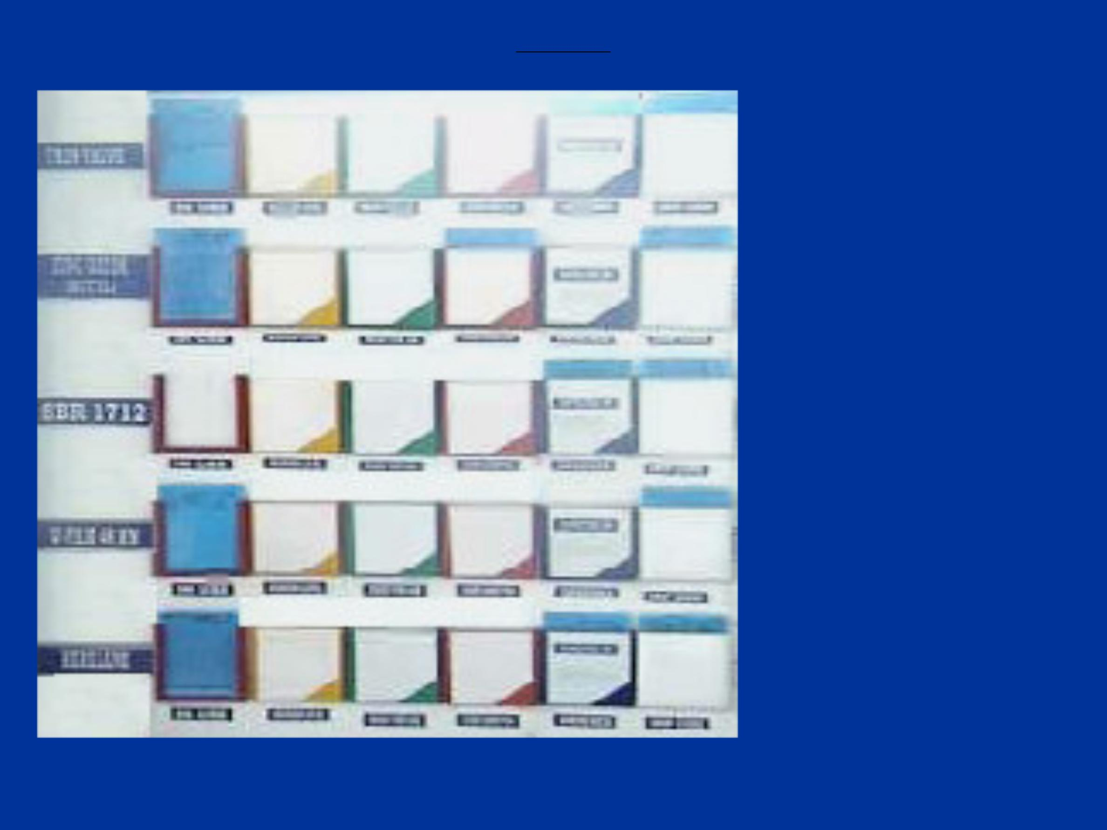
Raw materials - Super Market

RM kanban as in the shop floor.

12 - 30

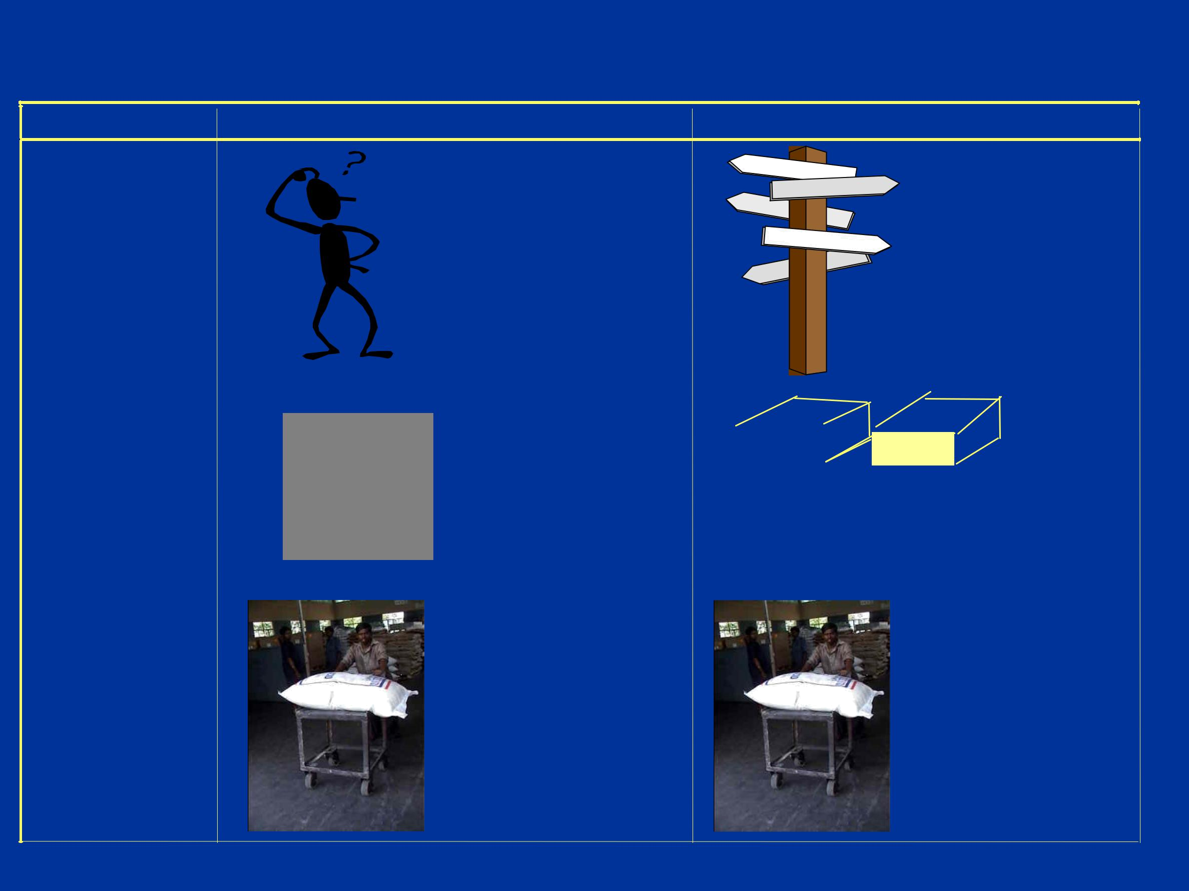
Raw Material Supply System

Description | Before | Now
RM Storage | Random Storage / | Address System /
 | Searching | No searching.

Requisition |  | Pick sheet | : Pick sheet from
Requisition |  | Pick sheet |  |  |  | I bin
 |  | 1. …….. |  | manufacturing |  | I bin |  |  |  | II bin
 |  | 1. …….. |  | through
 |  | 1. …….. |  | through |  |  |  |  |  | Two bin in Mfg.
 |  | 2. …….. |  | through
 |  | 2. …….. |  | computer
 |  | 3. …….. |  | computer

Preparation | Issue of items | Taken by Mfg.
 | by stores | at the required
 |  | quantity and
 |  | pitch.

13 - 30


Raw Material Supply System

Description

Weighing

Recording

Delivery

Before

De-bagging /

Weighing

^{Pick sheet :} Entry for shift
1. CBS - 23.5 kgs.
quantity
- TDQ - 20.5 kgs.

- ……..

4……….

 Delivery by Stores

to the point of

usage

Now

No Weighment

Entry for pull quantity

Pulling from

manufacturing

on need basis

14 - 30

Raw Material Supply System

BENEFITS :

User friendly visual management system.

Storage space optimized.

Easy to store and retrieve, First In and First Out regulated.

15 - 30

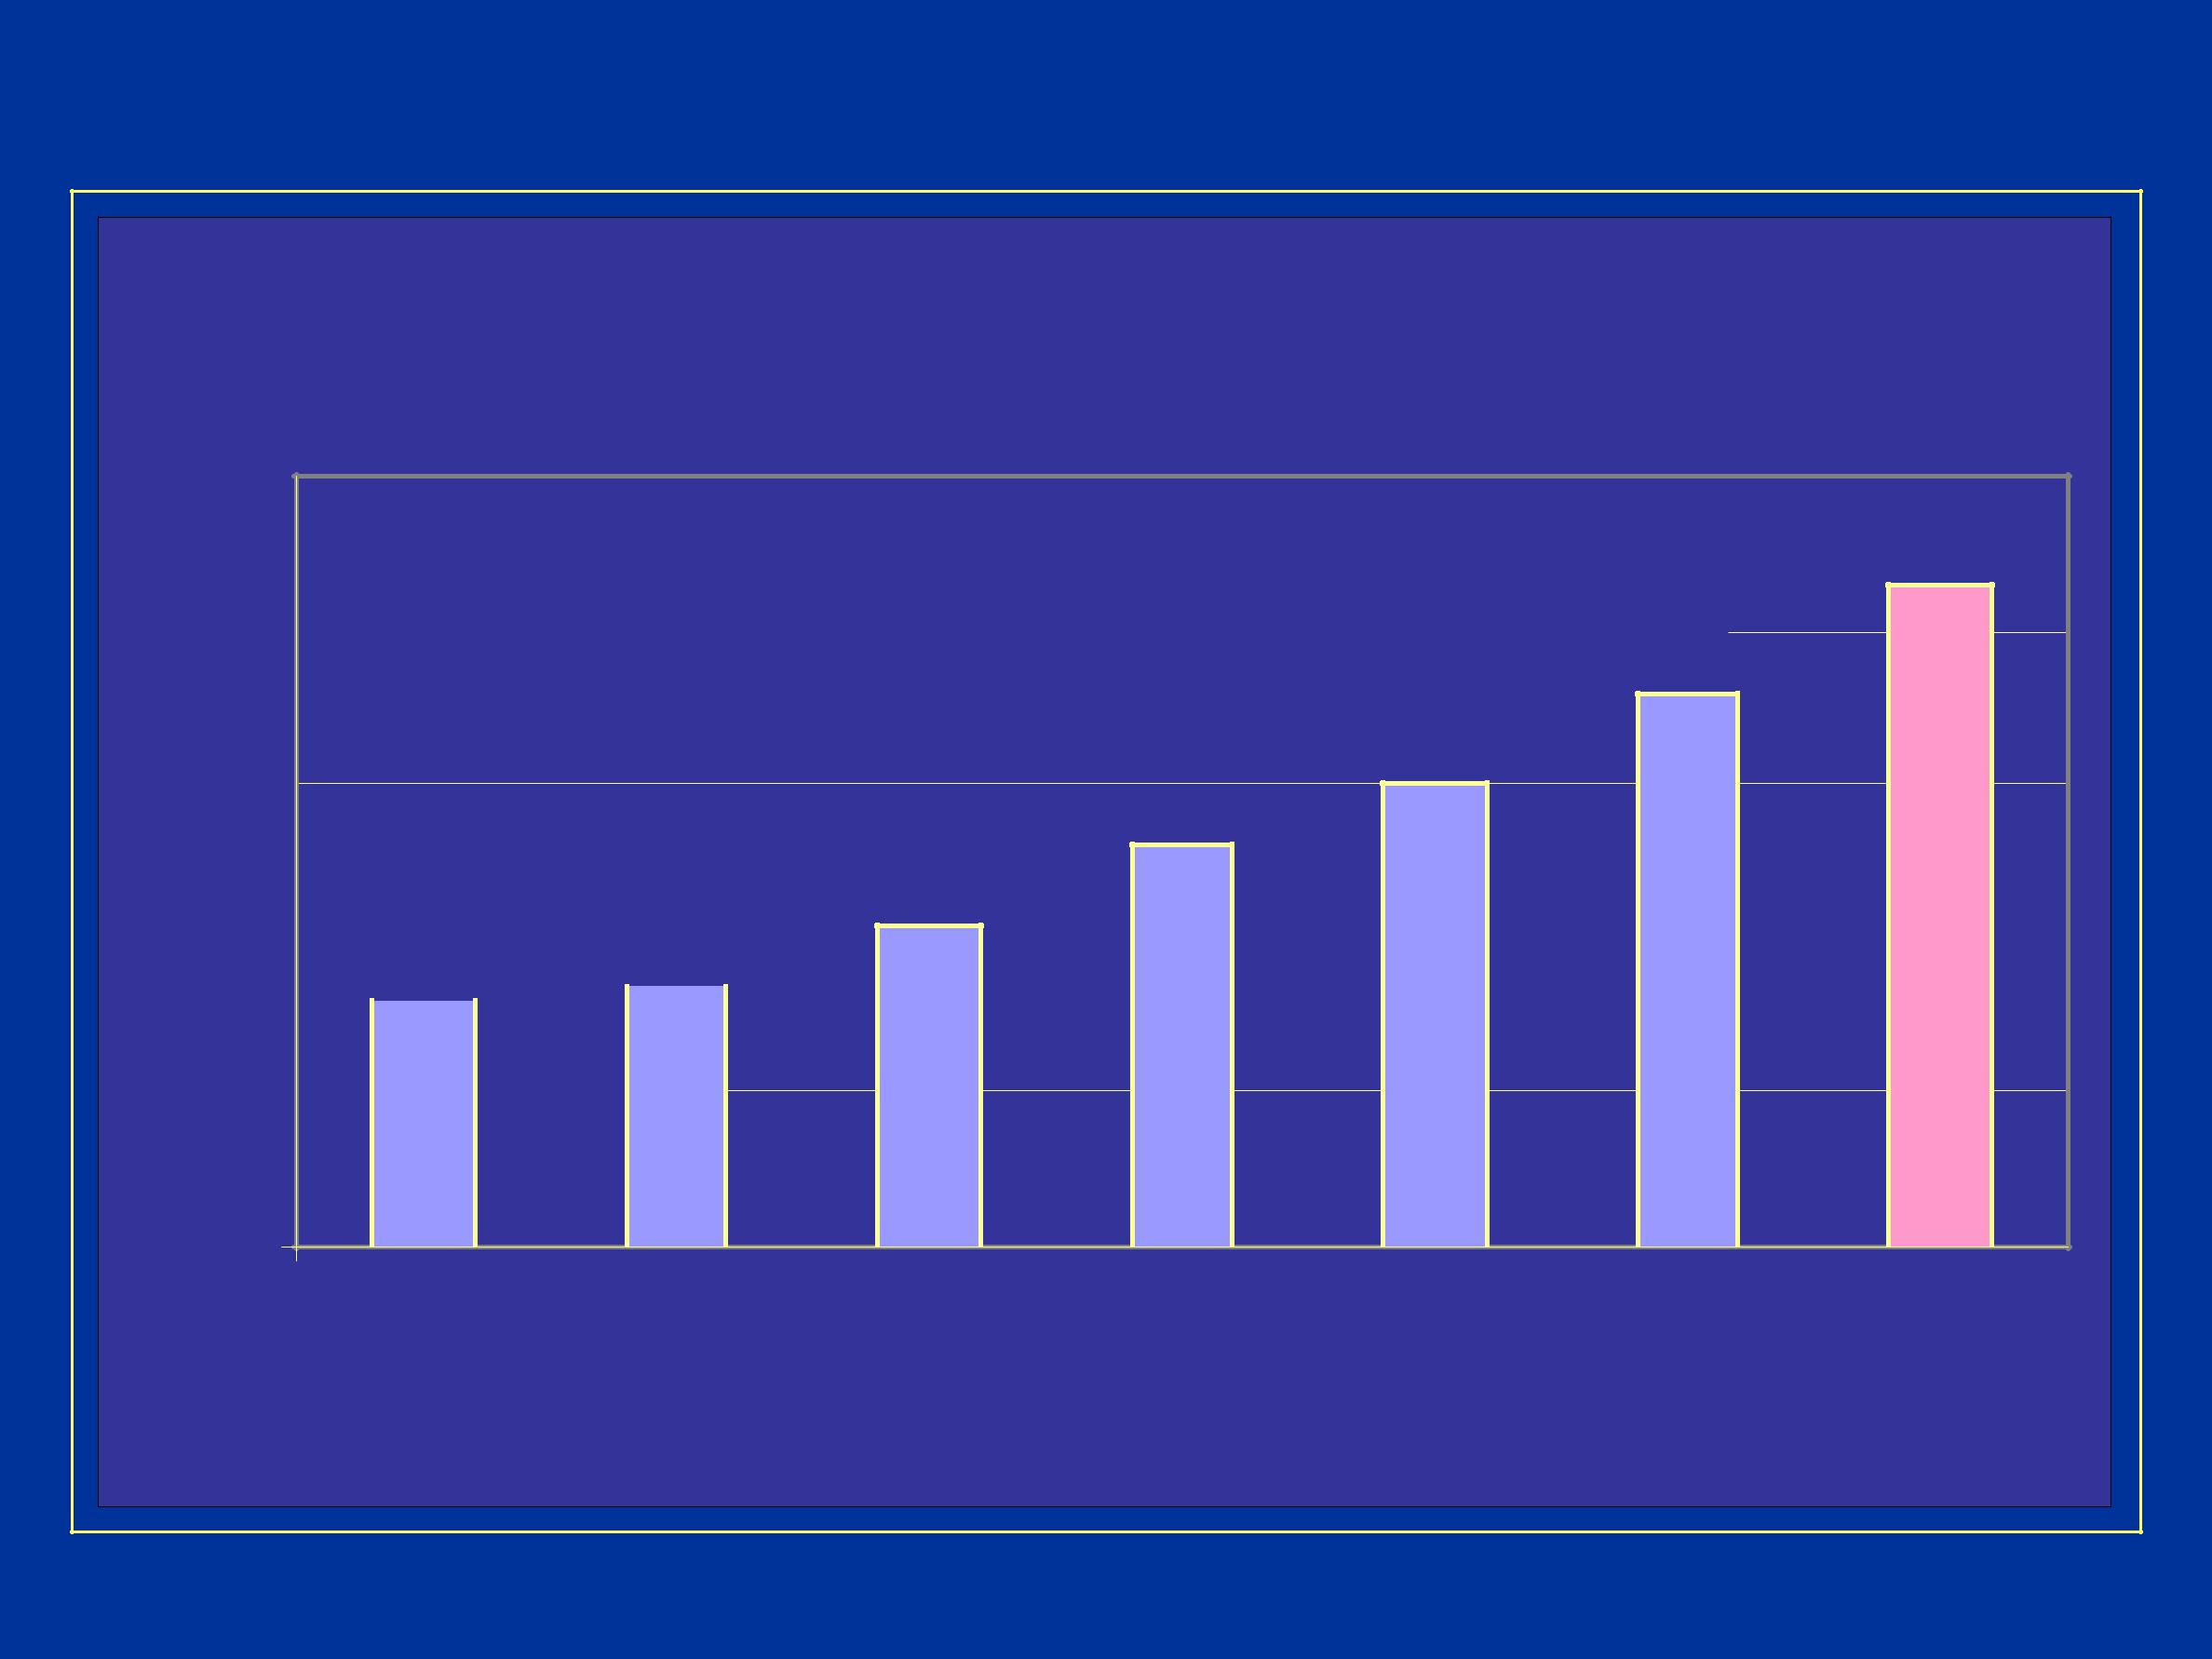
Raw Material Stock Turn Ratio

RM- STOCK TURN RATIO

50
43

40 |  | 36

30
³⁰ 26

21

20 |  |  |  |  |  |  |  | 17
10 | 16

0

99-00 00-01 01-02 02-03 03-04 A 04- O TARGET

04

16 - 30

 |  |  |  |  |  |  |  |  |  |  |  |  | RM INVENTORY
 |  |  |  |  |  |  |  |  | BEFORE
 |  | 800 |  |  |  |  |  |  |  |  |  |  |  |  |  |  |  |  |  |  |  | 800
 |  | 800 | 650
 | LACS | 600 |  |  |  |  |  |  |  |  |  |  |  |  |  |  |  |  |  |  | LACS | 600 |  |  |  |  |  |  | 450
 | LACS | 600 |  |  |  |  |  |  | 450 |  |  |  |  |  |  |  |  |  |  |  |  |  |  |  |  |  |  |  | 450
 | LACS | 400 |  |  |  |  |  |  |  |  |  |  |  |  |  |  |  |  |  |  | LACS | 400 |  |  |  |  |  |  | 450
 | LACS | 400 |  |  |  |  |  |  |  |  |  |  | 350 |  |  |  |  |  |  |  | LACS
 | IN |  |  |  |  |  |  |  |  |  |  |  |  |  |  |  |  |  |  |  | IN
 |  | 200 |  |  |  |  |  |  |  |  |  |  |  |  |  |  |  |  |  |  |  | 200
 |  | 0 |  |  |  |  |  |  |  |  |  |  |  |  |  |  |  |  |  |  |  | 0
 |  | 0 |  |  | MAX |  |  |  |  |  | MIN |  | TARGET |  |  |  |  |  |  |  |  |  |  |  |  |  |  |  | MAX
 |  |  |  |  |  |  |  |  |  |  |  |  | RM STOCK OUT
 |  |  |  |  |  |  |  |  |  | BEFORE
 |  |  |  |  | 4
 | Nos | 4 |  |  |  |  |  |  |  |  |  |  |  |  |  |  |  |  |  |  |  | 4
 | Nos | 3 |  |  |  |  |  |  |  |  |  |  |  |  |  |  |  |  |  |  | Nos | 3 |  |  |  |  |  |  | 1
 |  | 2 |  |  |  |  |  |  |  |  |  |  |  |  |  |  |  |  |  |  |  | 2
 |  | 1 |  |  |  |  |  |  | 0 |  |  |  |  |  |  |  |  |  |  |  |  | 2
 |  | 1 |  |  |  |  |  |  |  |  |  |  |  |  |  |  |  |  |  |  |  | 1
 |  | 0 |  | ACTUAL |  |  |  |  |  |  | TARGET |  |  |  |  |  |  |  |  |  |  | 0
 |  | 0 |  |  |  |  |  |  |  |  |  |  |  |  |  |  |  |  |  |  |  | 0 |  |  |  | ACTUAL

NOW

- 350

MINTARGET

NOW

0

TARGET

17 - 30

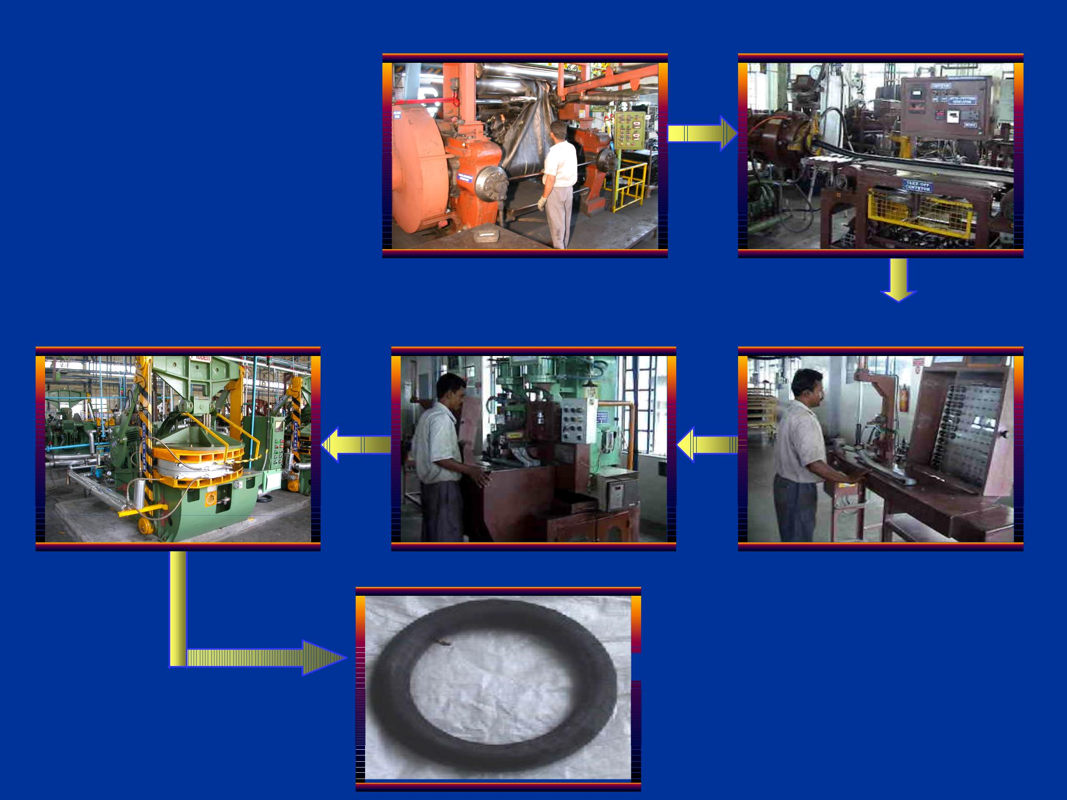
Mixing Extrusion

PROCESS FLOW TUBE

Curing Splicing Valve Fixing

Tube

18 - 30

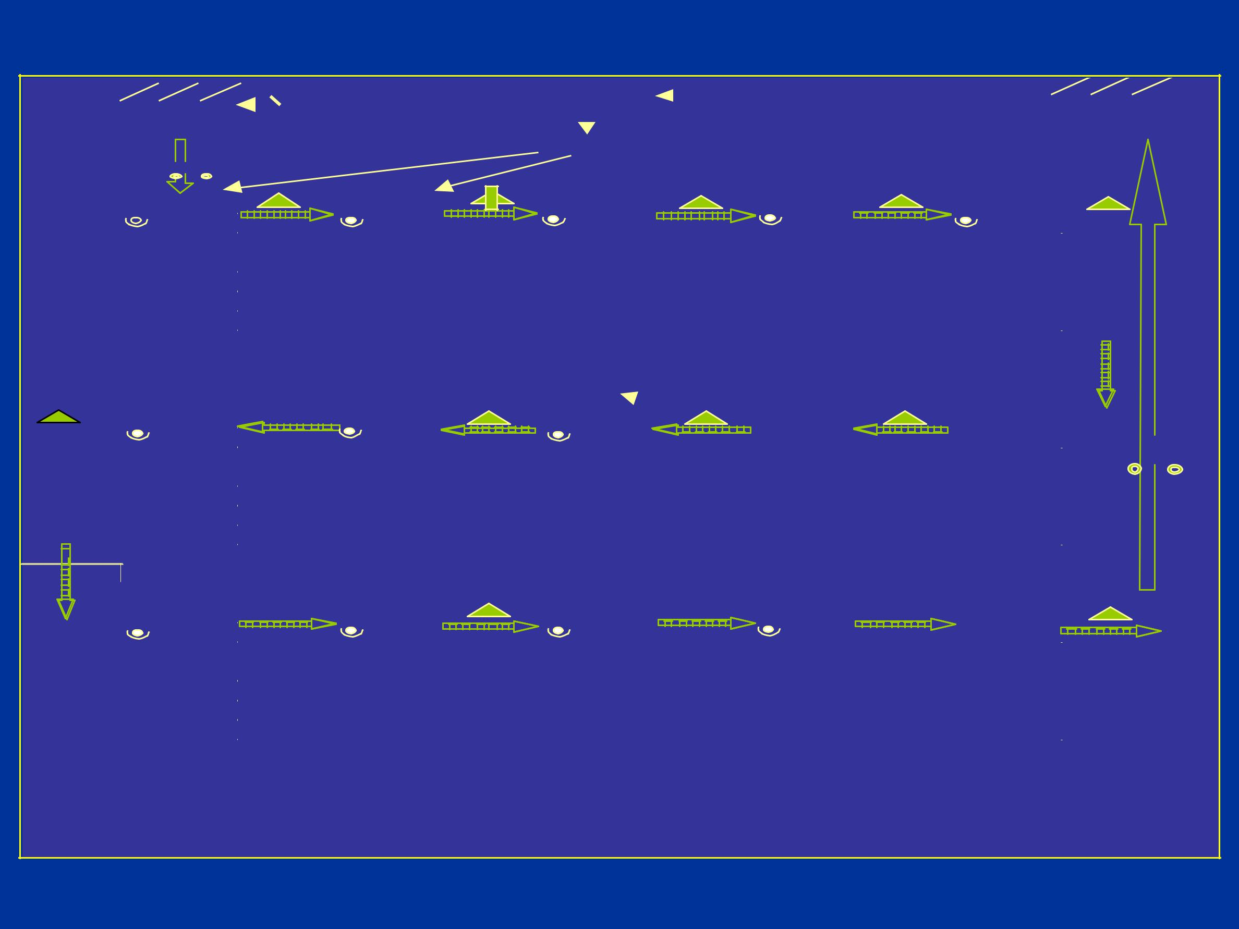
Past state map -Tube

NOR-42

LUN -221

0.7 Hr

 |  |  |  |  |  |  |  |  |  |  |  |  |  | Monthly |  |  |  | Producn |  |  |  |  | Orders
 |  | Rubber |  |  |  |  |  |  |  |  |  |  |  | RM Reqt. |  |  |  | Control |  |  |  |  | months |  |  |  | OE+Repl.
 | Compound |  |  |  |  |  |  |  |  |  |  |  |  |  |  |  |  |  |  |  |  |  |  |  |  |  | Customers
 |  |  |  |  |  |  |  |  |  |  |  |  |  |  |  |  |  | Shift plan
 | Mixing |  |  |  |  |  |  |  |  |  |  |  |  | Extrusion |  |  |  | Powdering |  |  |  |  | Valve Fix |  | Splicing
 | 6 |  |  |  |  |  |  |  |  |  |  |  | 5 |  |  |  |  | 1 |  |  |  |  | 3 |  | 6
 |  |  |  |  |  |  |  |  | 5 TONS |  |  |  |  |  | 3500 NOS |  |  |  |  |  | 325 NOS |  |  | 166 NOS |  |  | 194 NOS
 | CT-45,7 MIN |  |  |  |  |  |  |  |  |  |  |  |  | CT-10SEC |  |  |  | CT-3SEC |  |  |  |  | CT-14SEC |  | CT-60SEC
 | M/C -1 |  |  |  |  |  |  |  |  |  |  |  |  | M/C -2 |  |  |  | M/C -1 |  |  |  |  | M/C -3 |  | M/C -4
 | C/O -15 MIN |  |  |  |  |  |  |  |  |  |  |  |  | C/O -8 MIN |  |  |  | C/O -0 |  |  |  |  | C/O -0 |  | C/O -0
 | U/T -95% |  |  |  |  |  |  |  |  |  |  |  |  | U/T -85% |  |  |  | U/T -100% |  |  |  |  | U/T -100% |  | U/T -95%
 | Aging 3 HR
 | MS 45 min 24 Hrs |  |  |  |  |  |  |  |  |  |  |  |  |  | 5.8 Hr |  |  |  |  |  | 0.5 Hr |  |  | 0.27 Hr |  |  | 0.3 Hr
 | FB 7 min |  |  |  |  |  |  |  |  |  |  |  |  | 10 SEC |  |  |  | 3 SEC |  |  |  |  | 14 SEC |  | 60 SEC
 | Core Fix |  |  |  |  |  |  |  |  |  |  |  |  | Collecn. |  |  |  | Curing |  |  |  |  | Forming |  | Freezing
 | 1 |  |  |  |  |  |  |  |  |  |  |  | 1 |  | 164 |  |  | 8
 |  |  |  |  |  |  |  |  |  |  |  |  |  |  | LUN-221 |  |  |  |  |  | 38 NOS |  |  | 72 NOS
 | CT- 4 SEC |  |  |  |  |  |  |  |  |  |  |  |  | CT-2.5SEC |  |  |  | CT-3.75 MIN |  |  |  |  | CT-14SEC |  | CT-7 SEC
 | M/C -1 |  |  |  |  |  |  |  |  |  |  |  |  | M/C -0 |  |  |  | M/C -22 |  |  |  |  | M/C -0 |  | M/C -0
 | C/O -0 |  |  |  |  |  |  |  |  |  |  |  |  | C/O -0 |  |  |  | C/O -4 |  |  |  |  | C/O -0 |  | C/O -0
 | U/T -100% |  |  |  |  |  |  |  |  |  |  |  |  | U/T - 100% |  |  |  | U/T -95% |  |  |  |  | U/T -94% |  | U/T -94%
 |  |  |  |  |  |  |  |  |  |  |  |  |  |  | 0.27 hr |  |  |  |  |  | 0.06 Hr |  |  | 0.12 Hr
 | 4 SEC |  |  |  |  |  |  |  |  |  |  |  |  | 2.5 SEC |  |  |  | 3.75 MIN |  |  |  |  | 14SEC |  | 7 SEC
 | Inspecn-I |  |  |  |  |  |  |  |  |  |  |  |  | Vaccum |  |  |  | Inspecn-II |  |  |  |  | Packing |  | Distribun.
 | 4 |  |  |  |  |  |  |  |  |  |  |  | 4 |  |  |  |  | 1 |  |  |  |  | 1
 |  |  |  |  |  |  |  |  |  |  |  |  |  |  | 5000 NOS |  |  |  |  |  |  |  |  |  |  |  | 60000 NOS
 | CT-22SEC |  |  |  |  |  |  |  |  |  |  |  |  | CT-24SEC |  |  |  | CT-42SEC |  |  |  |  | CT-4.25SEC |  | CT-0.72SEC
 | M/C -0 |  |  |  |  |  |  |  |  |  |  |  |  | M/C -0 |  |  |  | M/C -0 |  |  |  |  | M/C -0 |  | M/C -0
 | C/O -0 |  |  |  |  |  |  |  |  |  |  |  |  | C/O -0 |  |  |  | C/O -0 |  |  |  |  | C/O -0 |  | C/O -0
 | U/T -94% |  |  |  |  |  |  |  |  |  |  |  |  | U/T -94% |  |  |  | U/T -94% |  |  |  |  | U/T -94% |  | U/T -94%

0.7 Hr |  |  |  | 8.3 Hr
 | 22 SEC |  | 24 SEC |  | 42 SEC |  | 4.25SEC |  | 0.72 SEC
Lead time |  | 41.2 Hr |  | Process Ratio |  |  | 14.6
e added time |  | 6 hr |  |  | Takt time |  | 6 sec

19 - 30

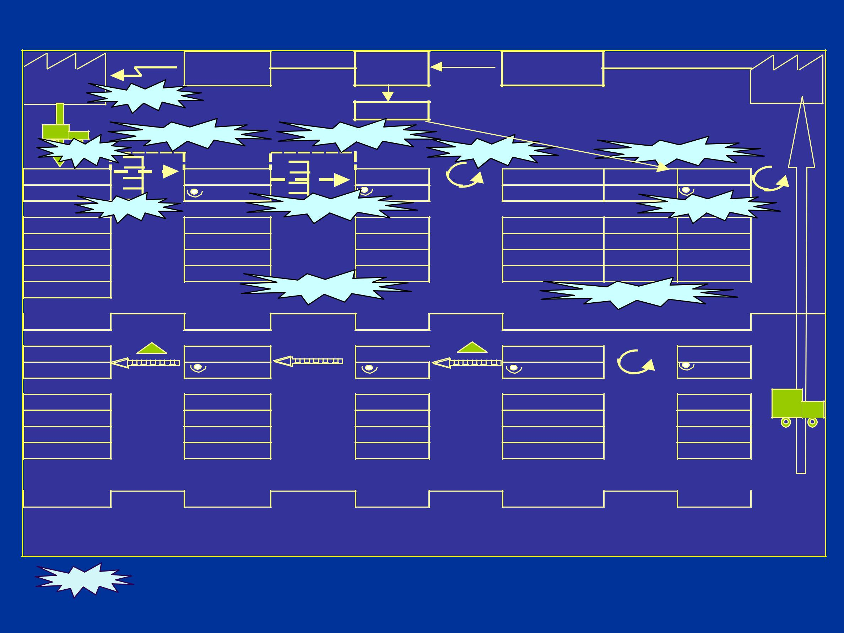
Current state map -Tube

 |  | Monthly |  | Producn | Orders
Rubber |  | RM Reqt. |  | Control | months |  | OE+Repl.
Compound | Kanban |  |  |  |  |  | Customers
 |  |  |  | Shift plan
 | Super Market |  | Super Market
Two Bins |  |  |  | P ace s etting |  | Setup reductio n
Mixing |  | Ext./V-Fix |  | Splicing | Freezing | Forming | Curing
MS 45min |  | 3 |  | 4 |  |  | 6
Auto Wt |  |  | Online s plicing-1 |  |  |  | I do I ins pect
CT-45,7 min |  | CT-10SEC |  | CT-60SEC | CT- | CT- 14 | CT-3.75 min
M/C -1 |  | M/C -2 |  | M/C -2 | M/C | M/C | M/C -25
C/O -15 MIN |  | C/O -5 MIN | Aging-2 Hrs | C/O -8 MIN | C/O | C/O | C/O -8 MIN
U/T -95% |  | U/T -85% |  | U/T -95% | U/T -95% | U/T -95% | U/T -95%
Aging3 Hr |  |  | Online s plicing-2 |  | P aced Withdrawel
45 min | 8 Hr |  | 2.6 Hr | 0.3 hr |  |  | 0.3 hr
7 min |  | 10SEC |  | 60 sec |  |  | 3.75 min
Distribun. |  | Packing |  | Inspecn-II | Cor+Ins+Vac |  | Collecn.
 |  | 1 |  | 1 | 5 |  | 1
 |  |  |  | 5500 nos
CT-0.72SEC |  | CT-4.25SEC |  | CT-42SEC | CT-24SEC |  | CT-2.5SEC
M/C |  | M/C |  | M/C | M/C |  | M/C
C/O |  | C/O - |  | C/O - | C/O - |  | C/O -
U/T - 94% |  | U/T -94% |  | U/T -94% | U/T -94% |  | U/T -94%
 |  |  |  | 8.3 hr |  |  | Distribun.
0.72 SEC |  | 4.25 SEC |  | 42 SEC | 24 SEC |  | 2.55 SEC
Lead time |  | 25.5 hr |  | Process Ratio | 23.50%
Value added time |  | 6 hr |  | Takt Time | 5.3 sec

- Areas where pull type system is employed.

20 - 30

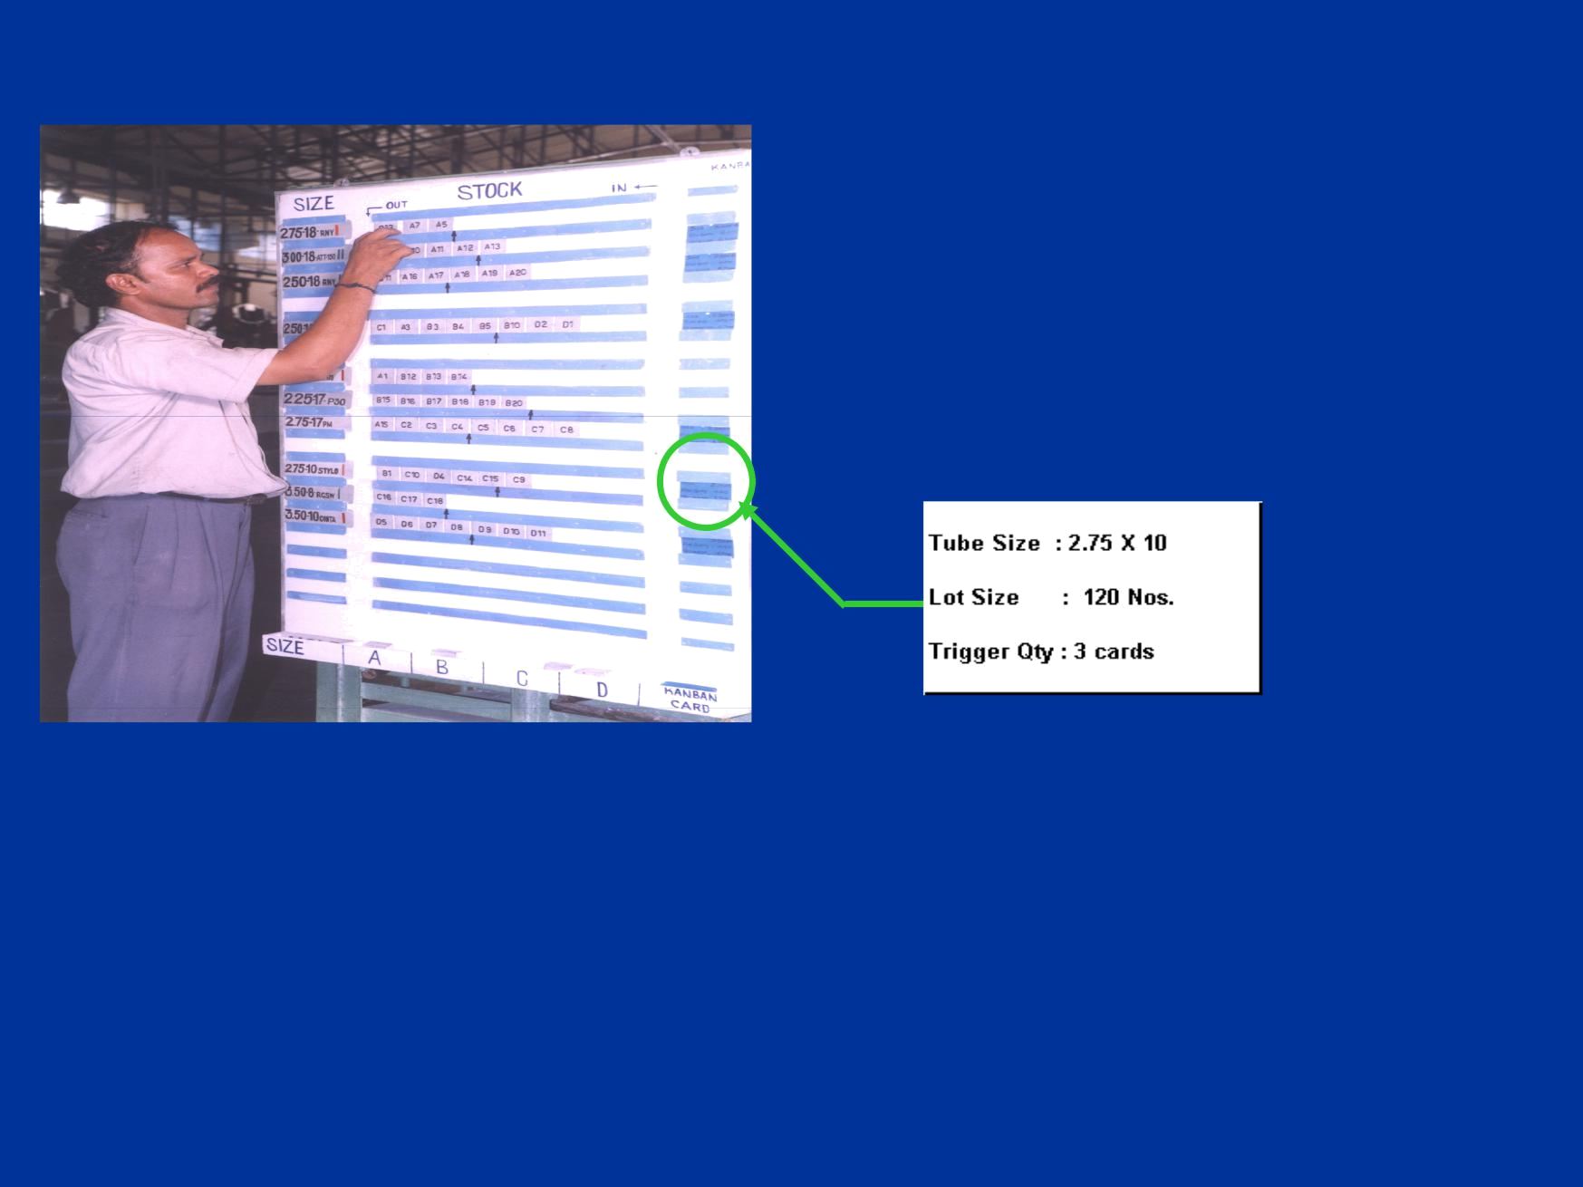
Super market - Tube extrusion

The signal kanban board

Tube extrusion to splicing

IMPROVEMENTS

Production regulated through KANBAN. No of set ups regulated.

Stock out of Green tubes eliminated. Material flow made visual.

21 - 30

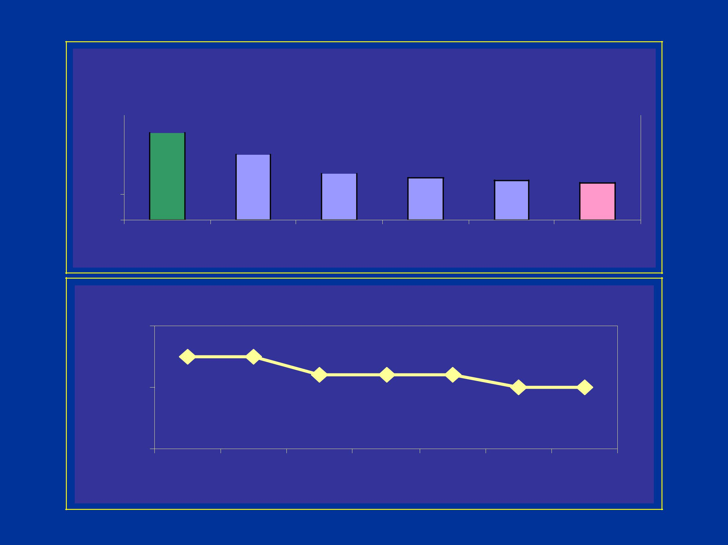
Inventory -Tube

INVENTORY

120
120 | 100
90 |  | 75 |  |  |  |  |  | 48 | 45
60 |  |  |  |  |  |  |  | 48 | 45 | 42
60 |  |  |  |  |  | 52 |  | 48 | 45 | 42

30

0

Bm | 00 - 01 | 01 - 02 | 02 - 03 | 03 - 04 A 0 4 - O 04

IN %

50

40

30

INVENTORY
45 ⁴⁵
42 42 42
40 40

Apr- May- Jun- Jul-04 Aug- Sep- Oct-04
04 04 04 04 04

22 - 30

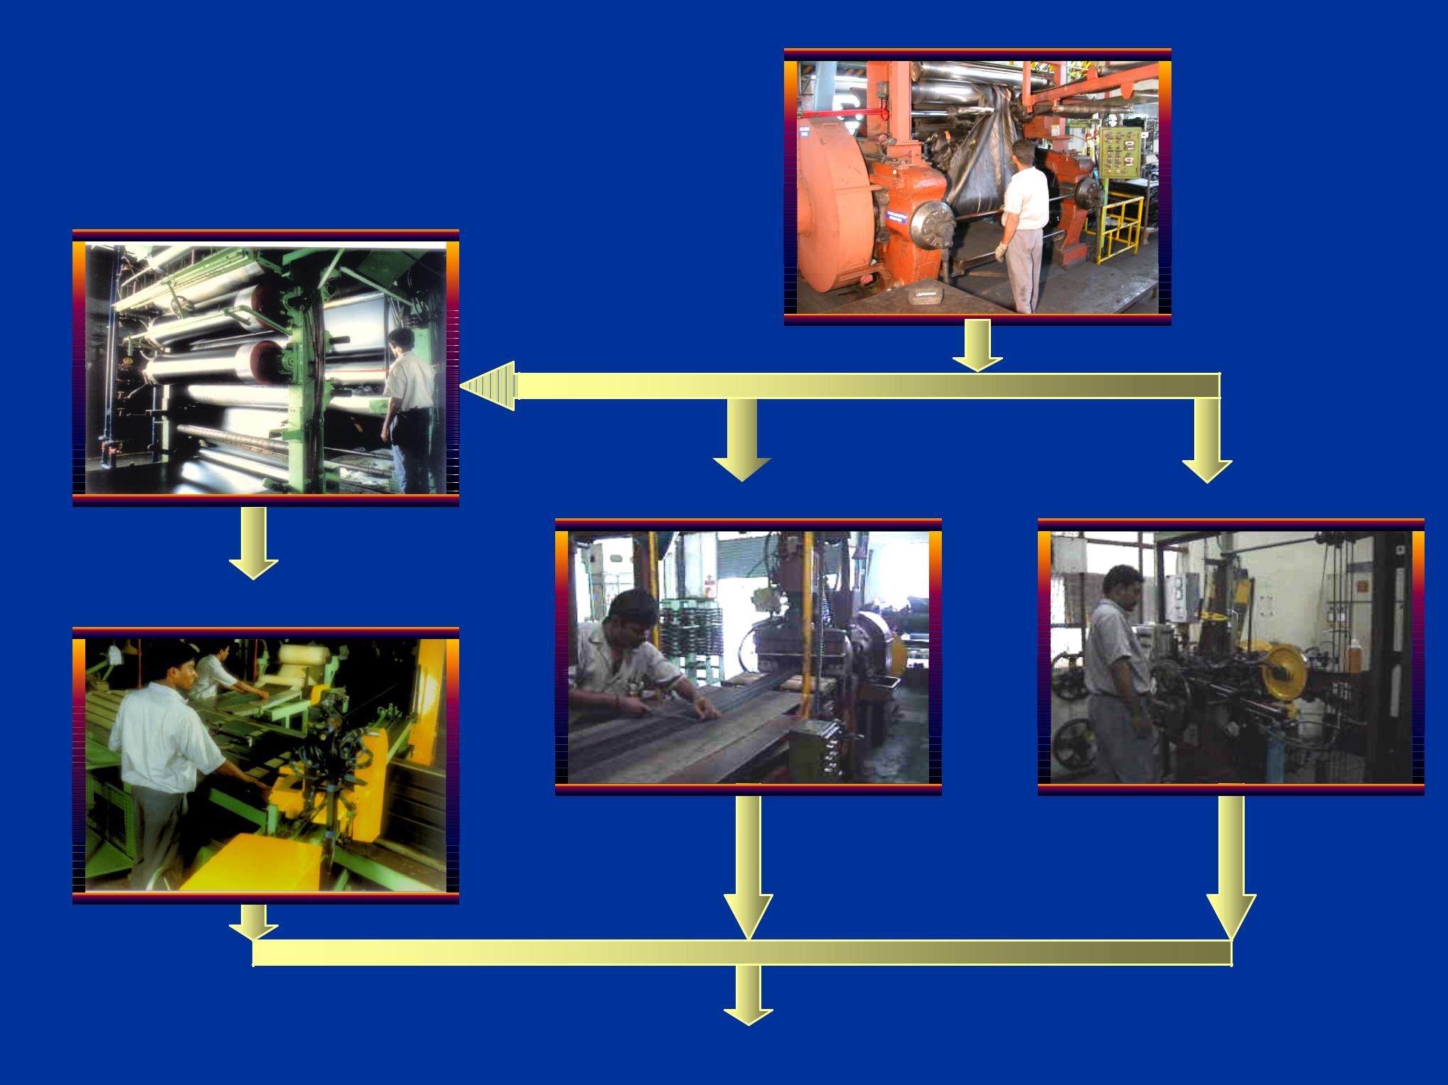
Mixing

PROCESS FLOW -TYRE

Calendering

Tread Extrusion Bead winding

Bias cutting

A 23 - 30

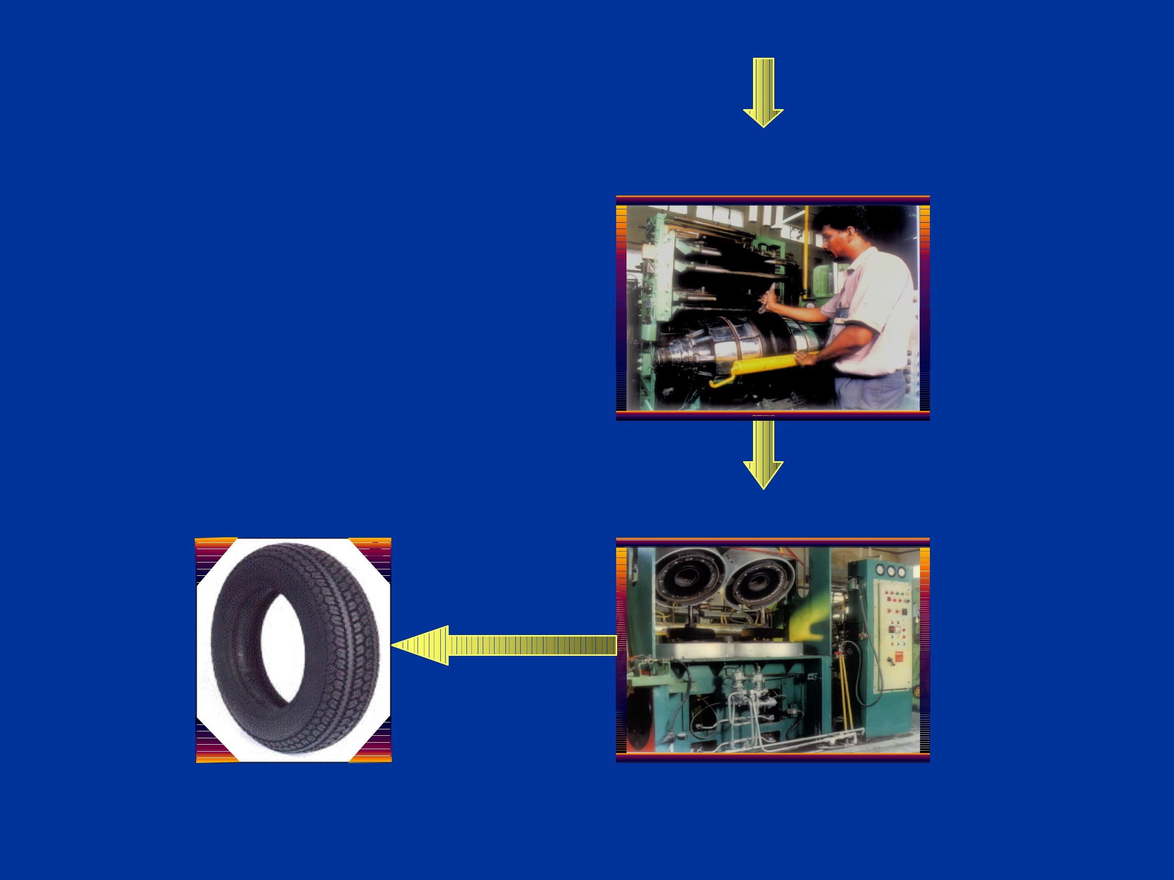
A

PROCESS FLOW - TYRE

Tyre Building

Tyre Curing

Tyre

24 - 30

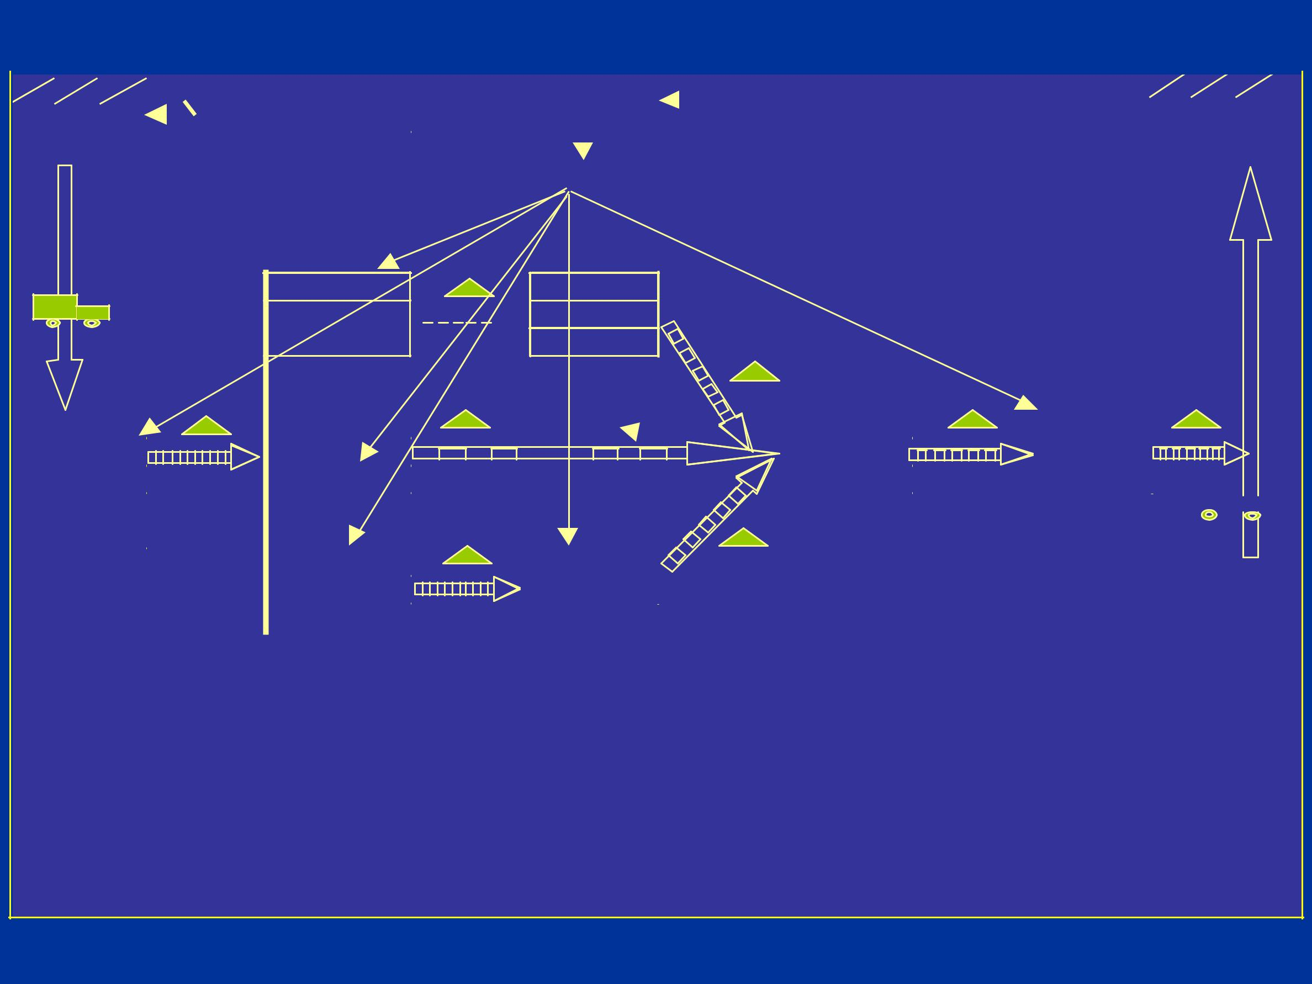
Past state map -Tyre
 |  |  |  |  |  |  |  |  | Monthly |  | Producn |  |  |  |  | Orders
 |  | RM |  |  |  |  |  |  | RM Reqt. |  | Control |  |  |  |  | months |  |  | OE+Repl.
 | suppliers |  |  |  |  |  |  |  |  |  |  |  |  |  |  |  |  |  | Customers
 |  |  |  |  |  |  |  |  |  |  | Shift plan

Bead Bead

Winding  Wrapping

 | Mixing |  |  | Extrusion |  |  |  |  |  | Tyre |  |  | Tyre
 | MS 45 min |  |  |  |  |  |  |  |  | building |  |  | Curing
 | PM | 4 min |  | Aging 2 hrs |  |  |  |  |  | Aging 2 hrs
 | FB | 7 min
 | Aging 4 hrs
 |  |  |  | Calendering |  |  | Bias
 |  |  |  |  |  |  | Cutting
 |  |  |  | Aging 4 hrs
 |  |  |  |  |  |  |  |  | Bead winding
 |  |  |  |  | 3 Hrs |  |  |  | 5 Hrs
 | 45 Min |  |  | 4.5 Sec |  |  | 40 Sec
 |  | 4 Min | 24 Hrs |  | 12 Hrs |  |  |  | Extrusion |  |  | 3.5 Hrs |  |  | 3 Hrs
 |  | 7 Min |  | 8 Sec |  |  |  |  |  | 3 min |  |  | 8.75 Min
 |  |  |  |  | 16 Hrs |  |  |  | 4 Hrs
 |  |  |  | 18 min |  |  | 2.5 Min
 |  |  |  |  |  |  |  |  | Calendering
 | Lead time |  |  | 52 Hr | 52 Hr |  |  |  |  | Takt Time |  |  | 5 Sec | 5 Sec
 | Value added time |  |  | 13.5 Hr | 1.5 Hr |  |  |  | Process Ratio |  |  |  | 26% | 2.8%

25 - 30

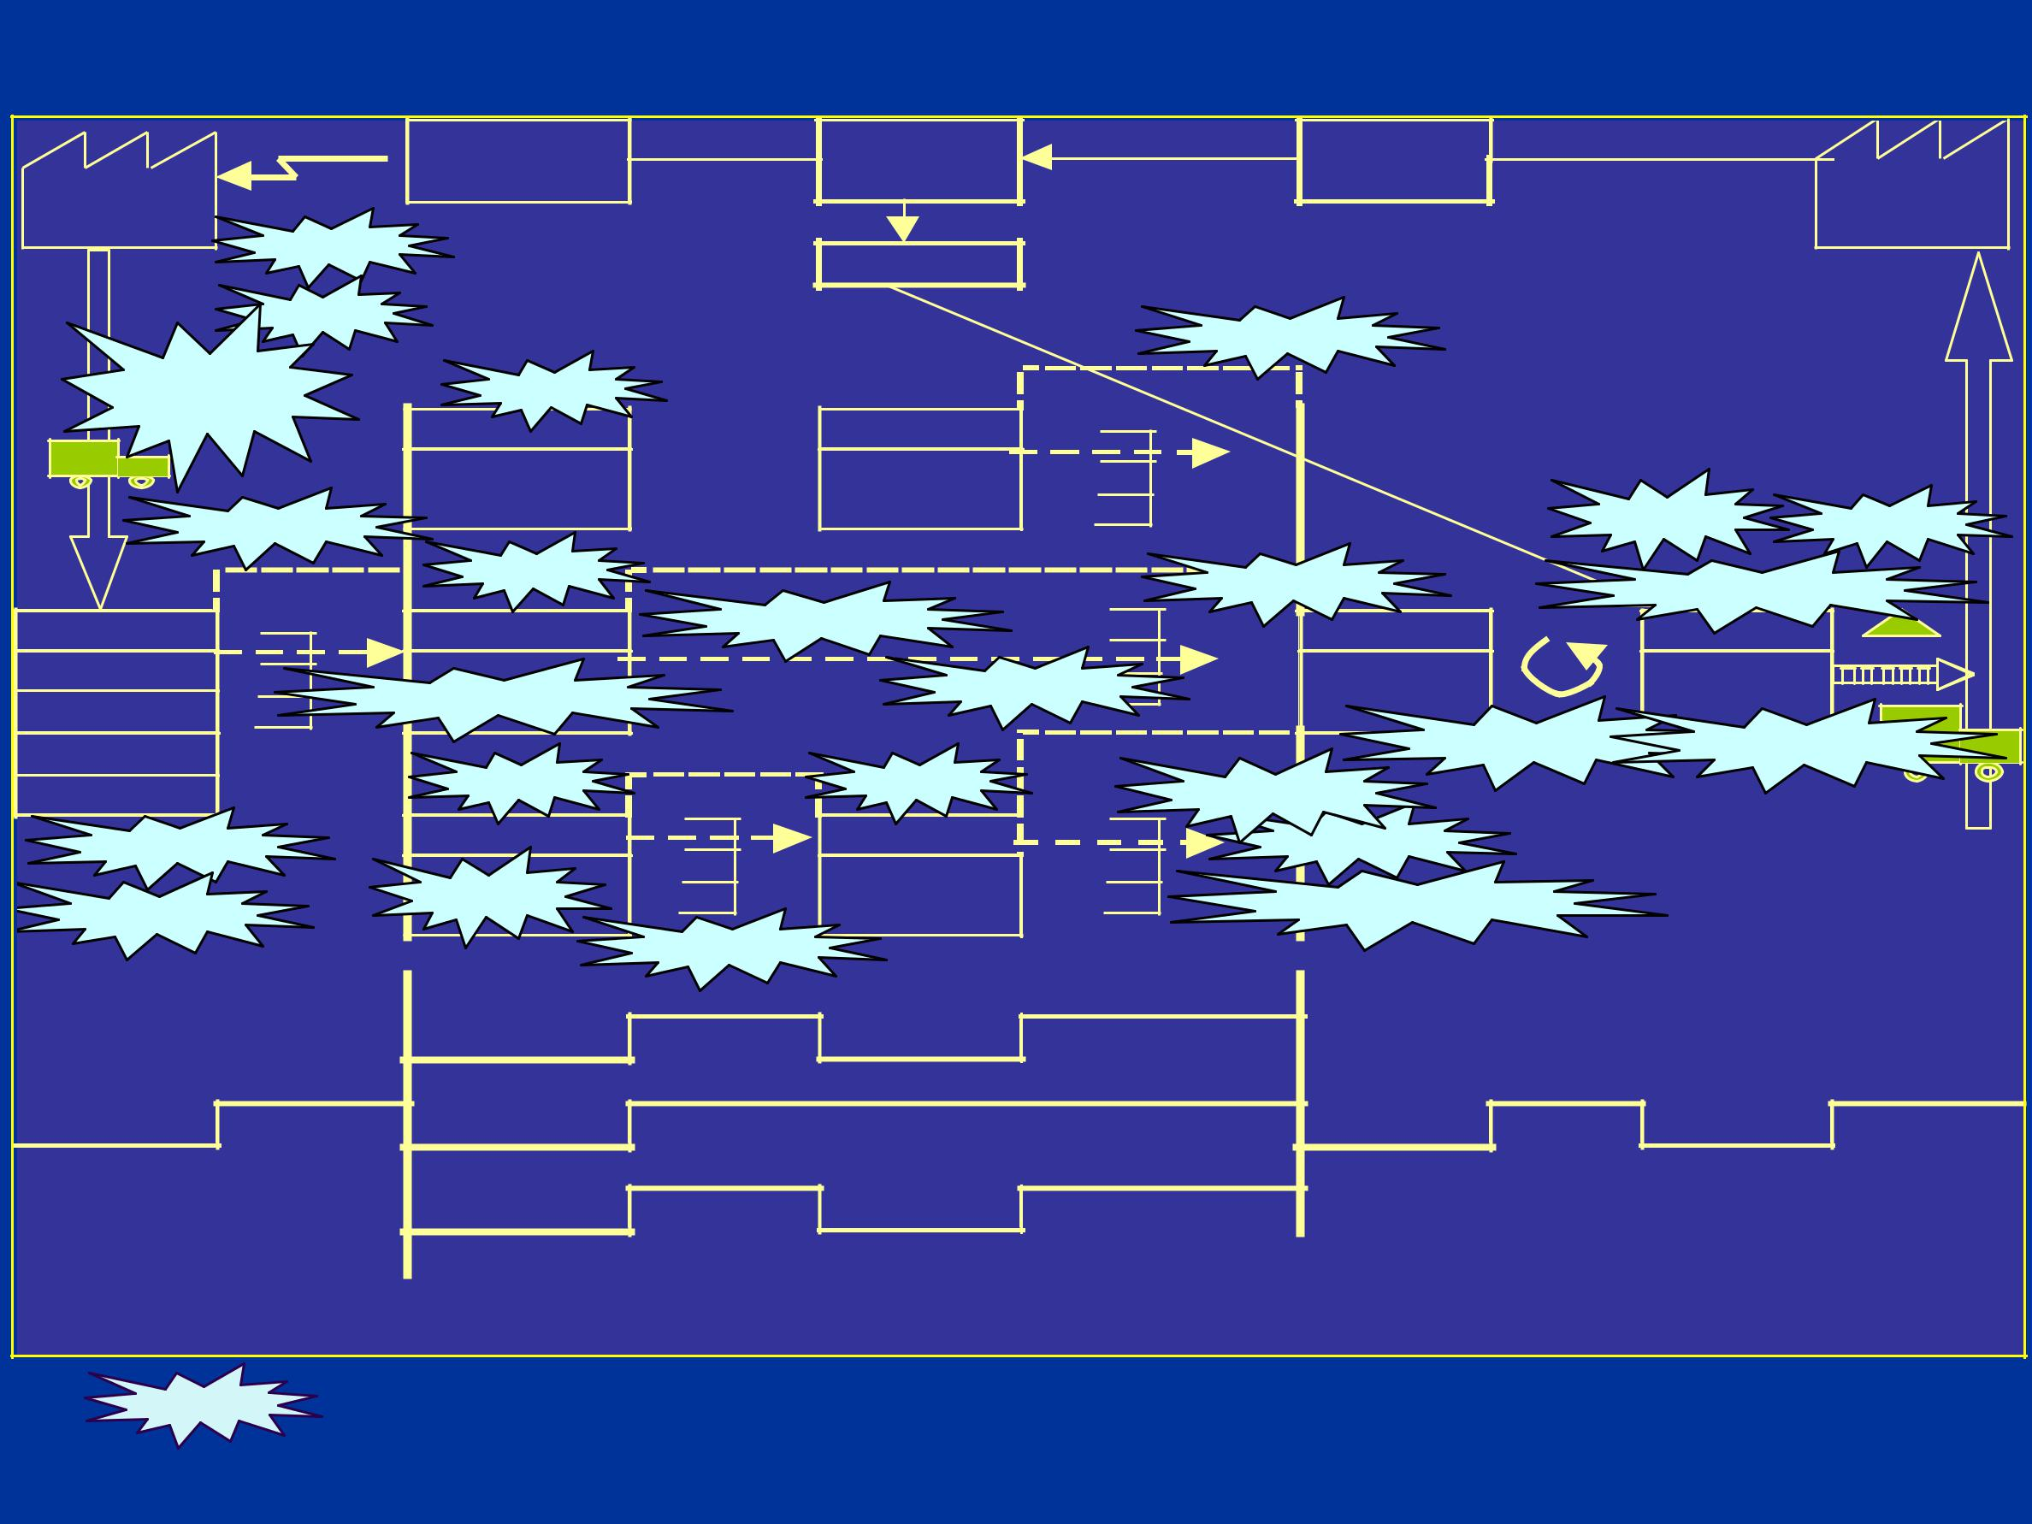
Current state map -Tyre

 | Monthly | Producn | Orders
RM | RM Reqt. | Control | months | OE+Repl.
suppliers | Kanban |  |  | Customers
 | Kanban | Shift plan
 | Milkrun |  | Su. market

Carbon
handling

Su. market

Mixing

MS 45 min
PM 4 min
FB 7 min

Aging 4 hrs

Tw o Bin

Auto Wt

45 Min

4 Min 8Hrs

7 Min

Lab.bal
Bead Bead
Winding Wrapping

 |  |  |  | Setup |  | Lab.bal
Lab.bal |  |  | Su. market |  | S / M Bladder
Extrusion | Rew ork red. |  |  | Tyre | Tyre
 |  | Su. market |  | building | Curing
Withdl. kanban
 |  |  |  | Pace setting | Online inspn.
Lab.bal |  | Lab.bal | PS -pocket
Calendering |  | Bias |  | Su. market
Setup |  | Cutting
Setup |  |  |  | Su. Market-Expt
 | Su. market |  | Bead winding
 |  |  | 3Hrs
4.5 Sec |  | 40 Sec
 | 3Hrs |  | Extrusion | 0.5 Hr |  | 0.5Hr
8 Sec |  |  |  | 3 min | 8.75 Min
 | 8Hrs |  | 1 Hrs
18 min |  | 2.5 Min
 |  |  | Calendering

Lead time | 19.3 Hr | 19.3 Hr | Takt Time | 5 Sec | 5 Sec
Value added time | 11.5 Hr | 1.5 Hr | Process Ratio | 53% | 7.8%

- Areas where pull type system is employed.

26 - 30

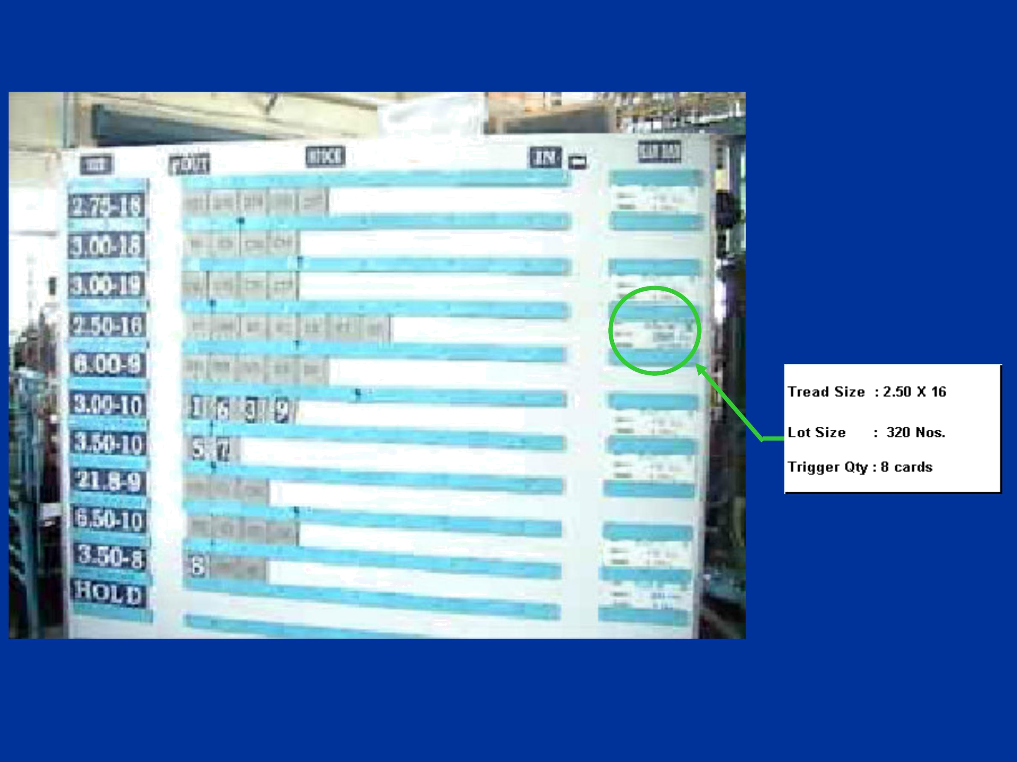
Super market - Tread extruder

Signal Kanban

27 - 30

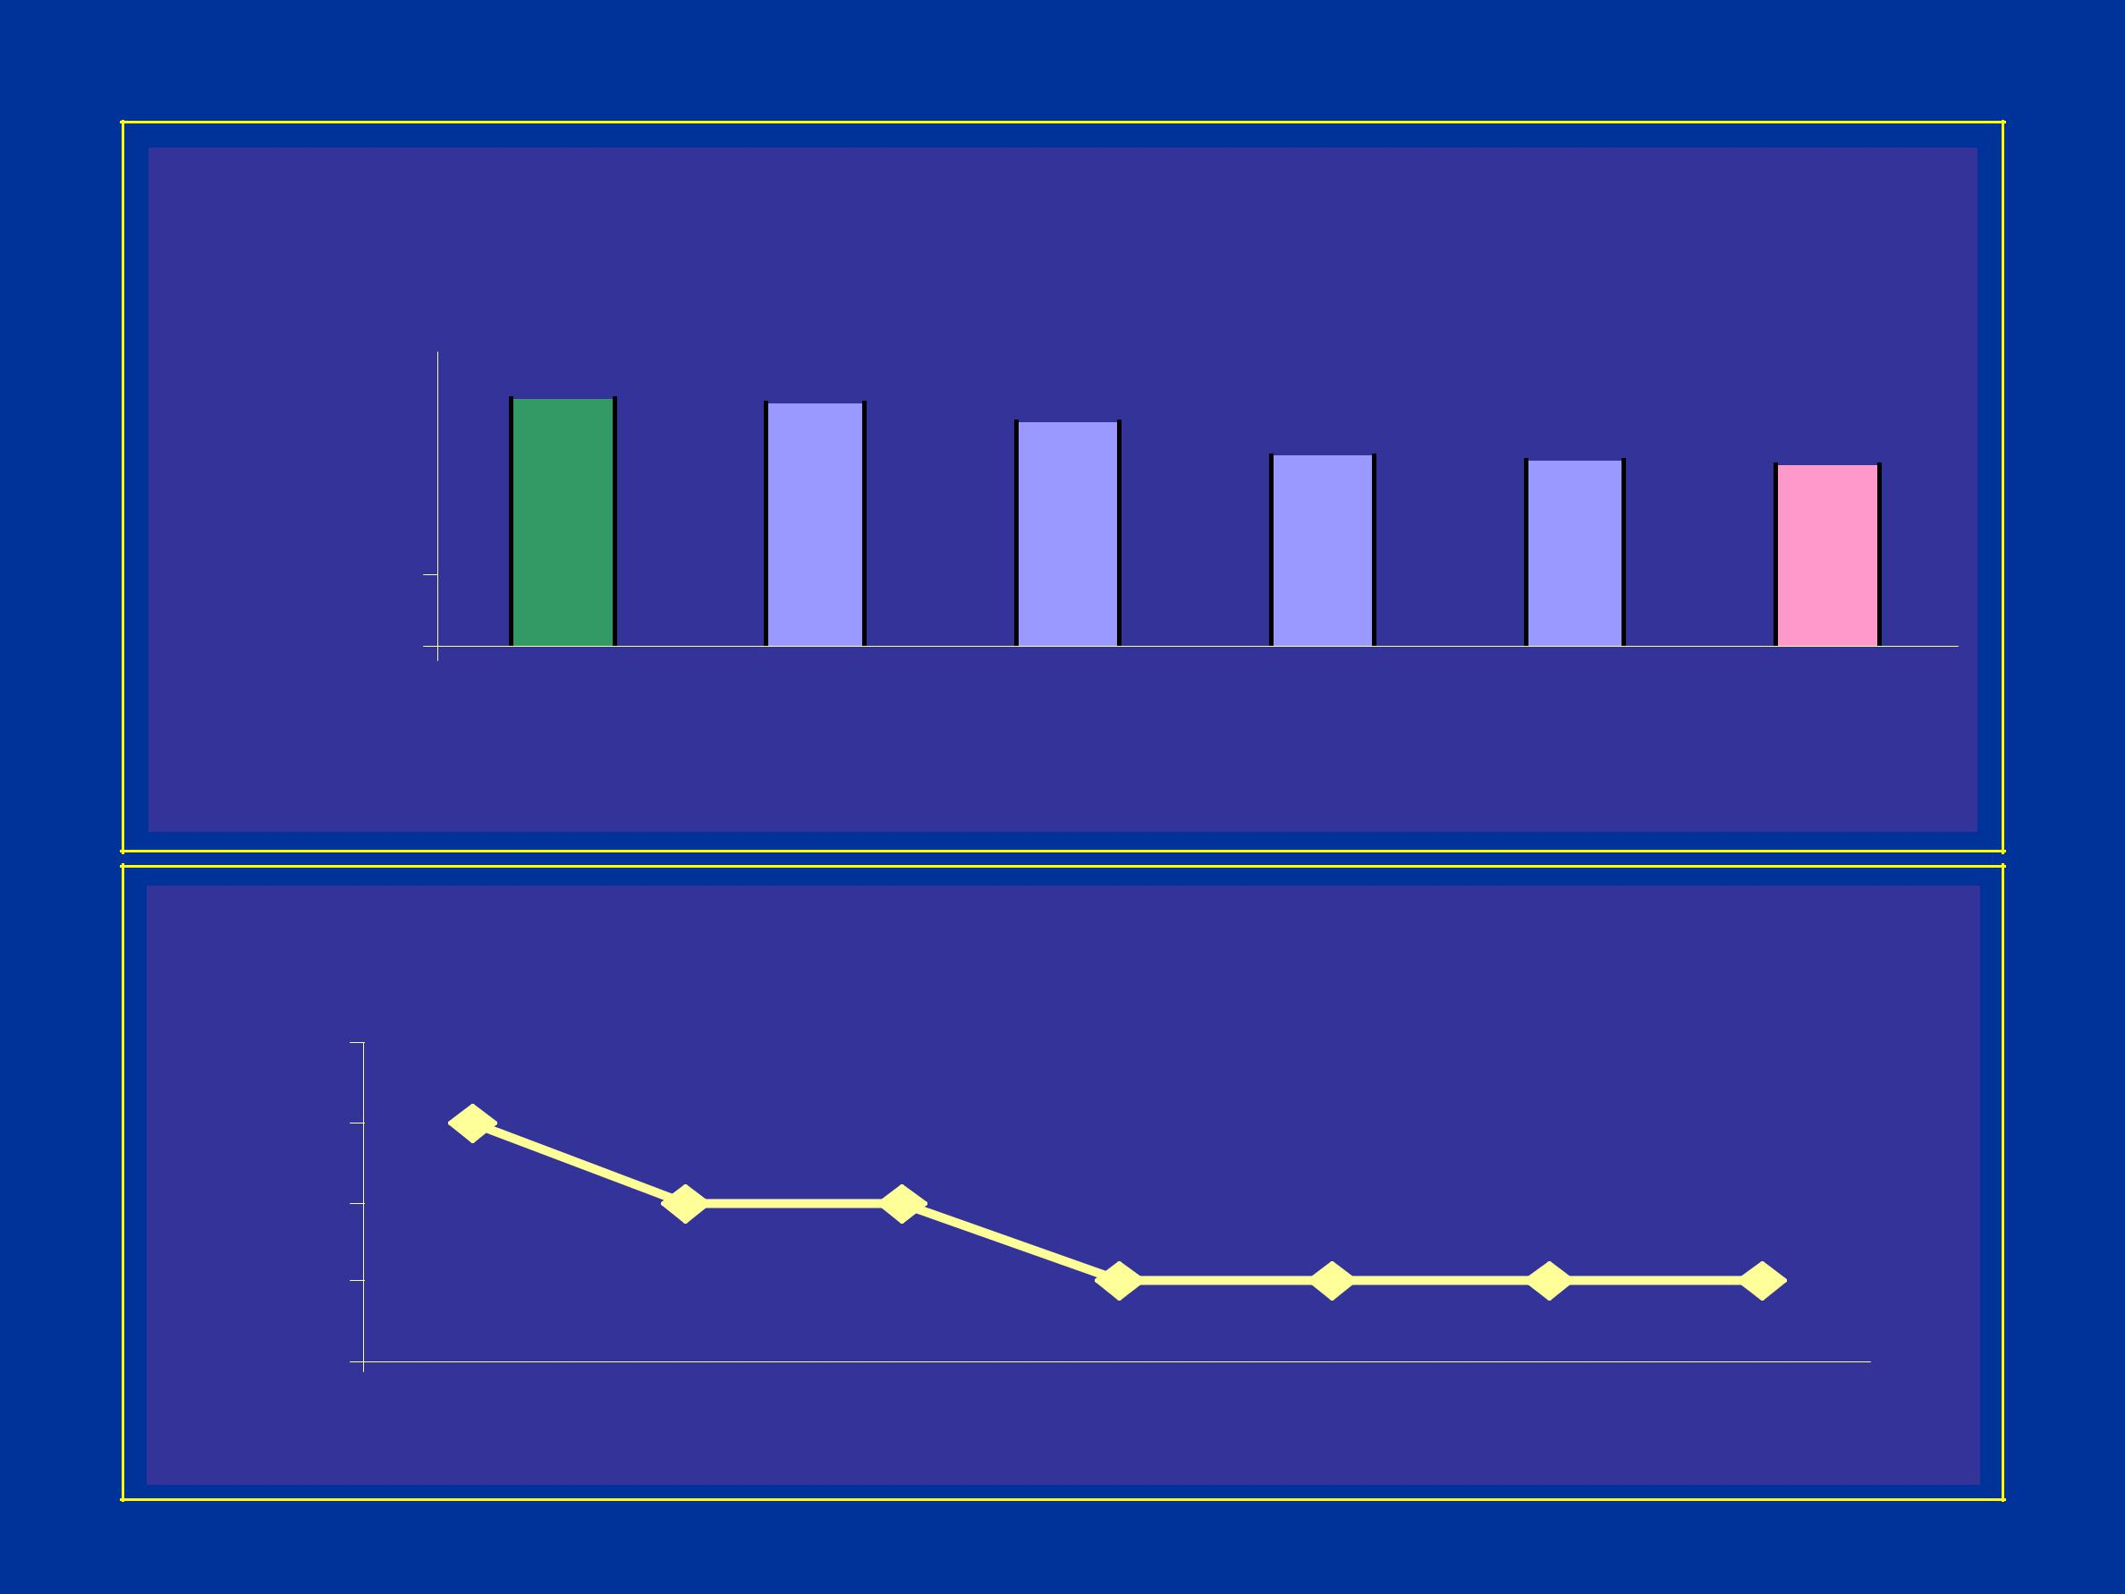
Inventory -Tyre

INVENTORY

%

120 |  | 100 |  | 99 |  | 90 |  | 78 |  | 75 |  | 73
90
60

30

0 BM 00 - 01 01 - 02 02 - 03 03 - 04 A 04 - O

04

%

INVENTORY

76 | 74
74 | 72 | 72
72 |  | 70 | 70 | 70 | 70
70

68 Apr-04 May-04 Jun-04 Jul-04 Aug-04 Sep-04 Oct-04

28 - 30

INTANGIBLE BENIFITS

Reduction in planning time.

Minimized inventory - Maximum utilization of space

Elimination of losses in overall production due to non-balanced WIP in different areas.

29 - 30

THANKS

30 - 30

