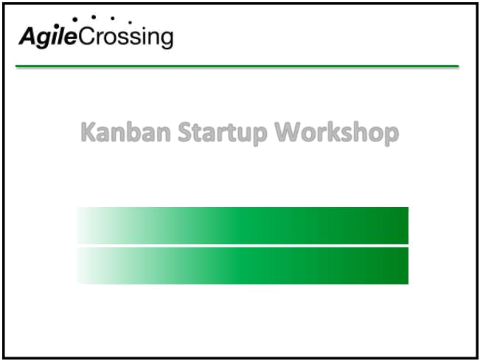
Training

Transition

Transformation

Kanban Startup Workshop

Instructor – Roger Brown CST, CSC

All slides © 2013 Roger W. Brown ^{www.AgileCrossing.com}
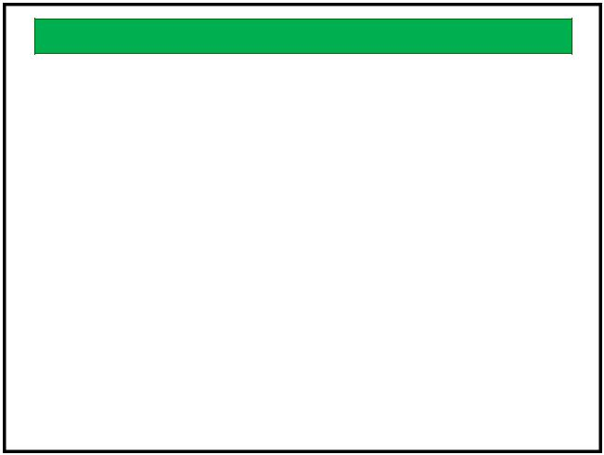

Topics

• Lean and Agile Principles • Systems Thinking

• Kanban Framework • How Kanban Works

• Waste • Starting Your Kanban

• Value Stream Mapping • Standard Sizing

• Queuing Theory • Prioritization

• Work in Progress • Make Policies Explicit

• Flow • Evolving with Kanban

• Flow Enhancers • Lean Leadership

• Measuring Flow • Seeking Perfection

• Pull Systems • Next Steps

3
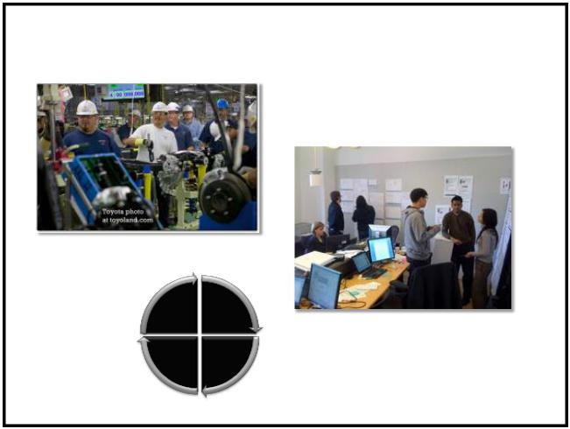

Course Objectives
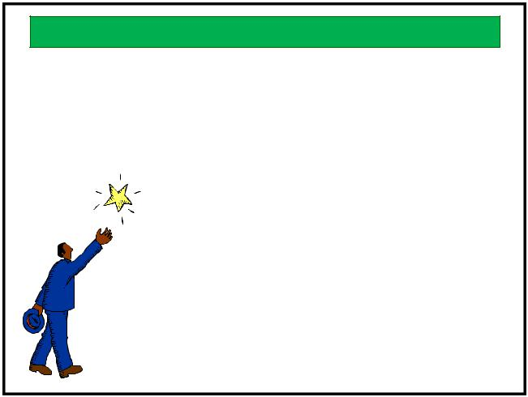

- Learn about Lean principles and concepts

- Experience the Lean concepts in action

- Implement Lean principles in your
work through Kanban

• Explore Management’s role in a Lean operation

- What other objectives do you have?

2
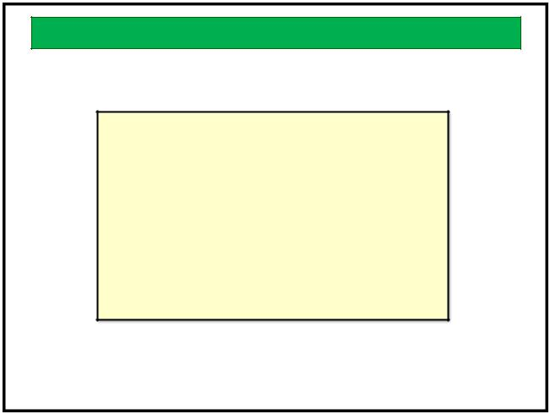

Lean and Agile Principles

- Agile Software Development utilizes Lean principles.

- Understanding Lean and Agile principles and values is essential to success

- There are several implementations of available

4
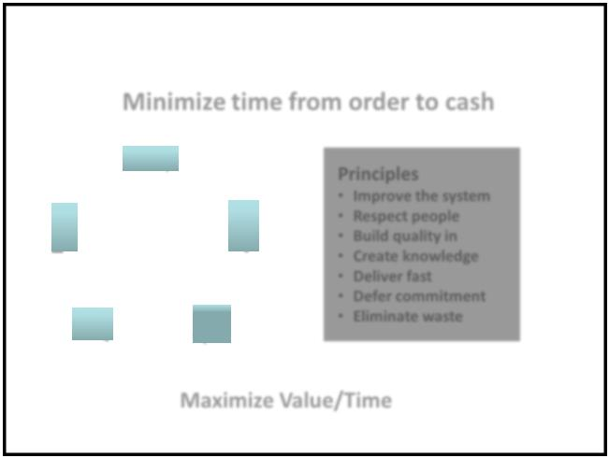

Lean and Agile |  | Lean Principles

 |  |  |  |  |  | Minimize time from order to cash
 |  | Agile Software Development |  |  |  | 2. Map
 |  |  |  |  | 1. | the | Principles
 |  |  |  |  | Identify | the
 |  |  |  |  | Identify | Value
 |  |  |  |  | Value | Value | • | Improve the system
 |  |  |  |  | Value | Stream | • | Improve the system
 |  |  |  |  |  |  | • | Respect people
 |  |  |  |  |  |  | • | Build quality in
Lean Manufacturing |  |  |  |  |  | 3. | • | Create knowledge
 |  |  |  |  | 5. Seek | 3. | • | Deliver fast
 |  |  |  |  | 5. Seek | Create | • | Deliver fast
 |  |  |  |  | Perfection | Create | • | Defer commitment
 |  |  |  |  | Perfection | Flow | • | Defer commitment
 |  |  |  |  |  |  | • | Eliminate waste
Act | Plan |  |  |  | 4. Establish
 |  |  |  |  |  | Pull
Check | Do
 |  | Deming Cycle |  |  |  | Maximize Value/Time
 |  | 5 |  |  | 5 |  |  | 6

Kanban Startup Workshop | 1
www.agilecrossing.com

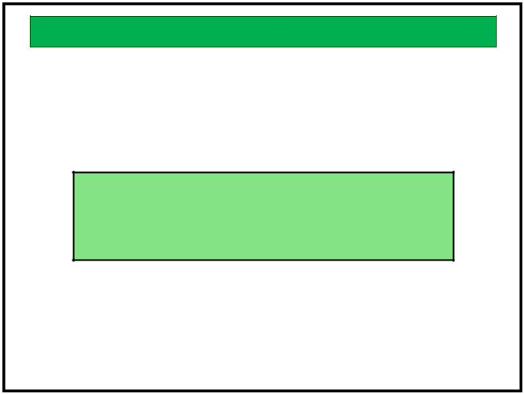
Agile Manifesto

Manifesto for Agile Software Development 2001

We are uncovering better ways of developing
software by doing it and helping others do it.
Through this work we have come to value:

Individuals and interactions over processes and tools

Working software over comprehensive documentation
Customer collaboration over contract negotiation
Responding to change over following a plan

That is, while there is value in the items on
the right, we value the items on the left more.

www.agilemanifesto.org

7
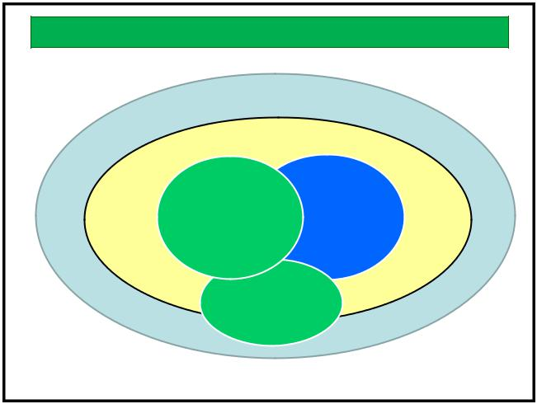

Agile “Brands”

Lean

Agile

Scrum XP
collaboration ^{development}
^{framework} practices

Kanban

workflow management

9
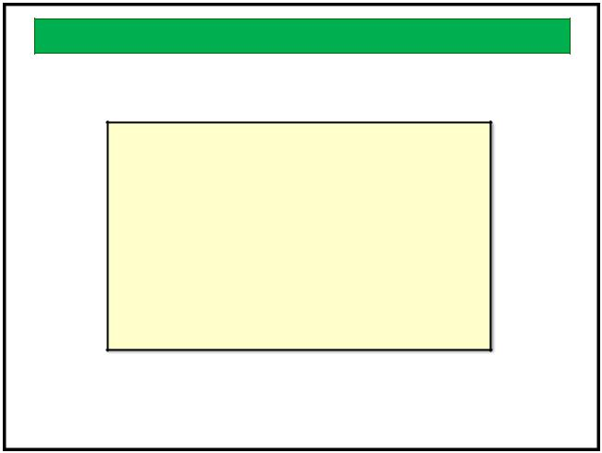

Kanban Framework

- Kanban comes from the Lean manufacturing practice of using kanban cards to pull work

- Kanban has few rules and no specific roles defined

- Kanban is flow-based rather than iterative

11

What is Agile Software Development?
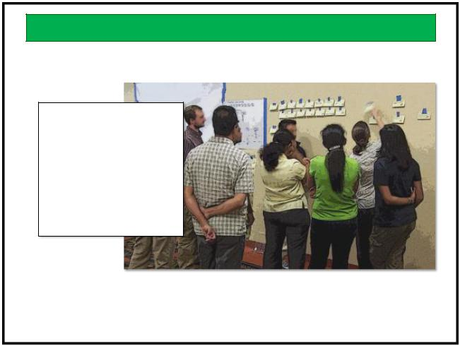

- Team Based

- Incremental

- Iterative

- Value Driven

- Frequent Delivery

- Production Quality

- Inspect and Adapt

8
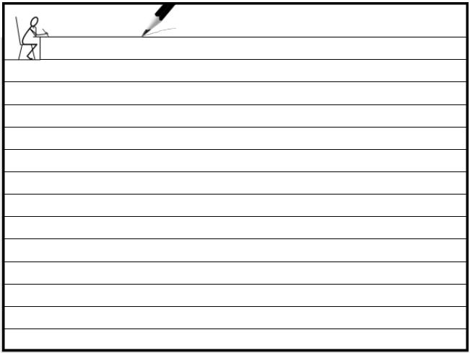

notes

10
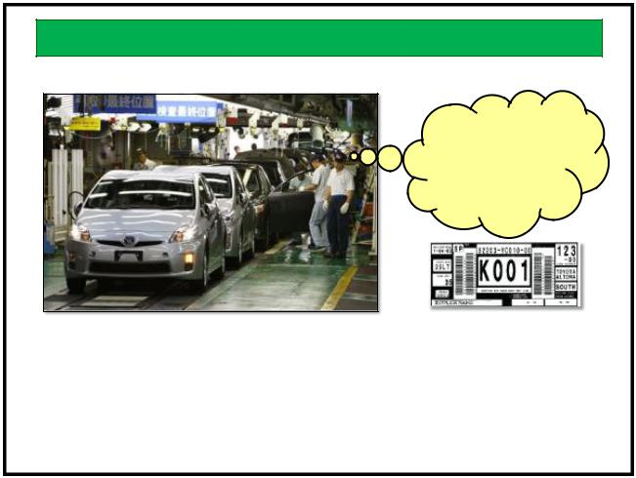

Kanban

Time to order
more doors!

Good for 10 doors

Kanban is a lean tool for managing inventory

The Kanban Board represents the Team’s shared vision in how inventory and information flows in a value stream

12

Kanban Startup Workshop | 2
www.agilecrossing.com

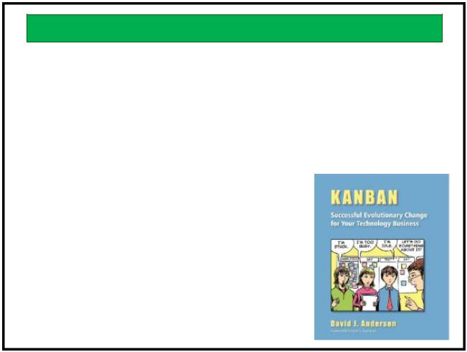
Kanban Principles

- Start with what you do now

- Agree to pursue incremental, evolutionary change
• Respect the current process, roles, | 2010
responsibilities and titles

13
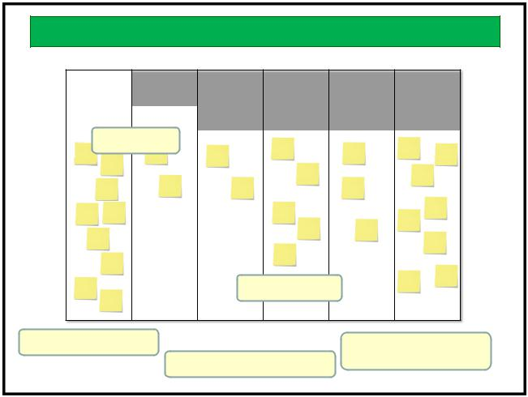

Kanban Board

Ready | Analysis | Develop | Code | Test | Release
 |  |  | Review
8 | 4 | 3 | 5 | 4 | 8
WIP Limits

Self Assignment

Prioritization
Visual Management
Incremental Improvement
15

Kanban Core Properties
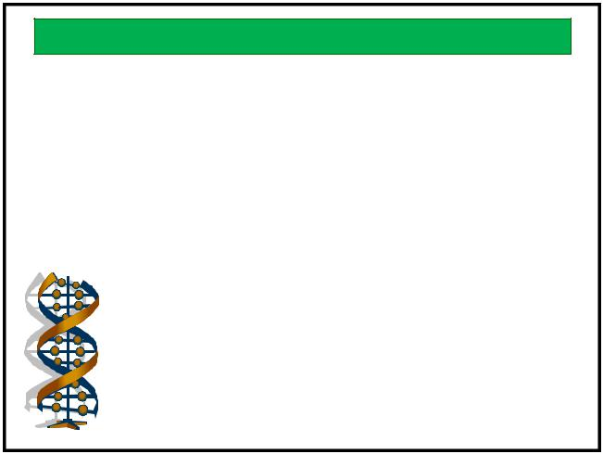

- Visualize the workflow
- Limit WIP
- Measure and manage flow
- Make process policies explicit

- Improve collaboratively using models and the
scientific method
- Theory of Constraints
• Systems Thinking
• Deming
• Toyota Product System

14

notes

16
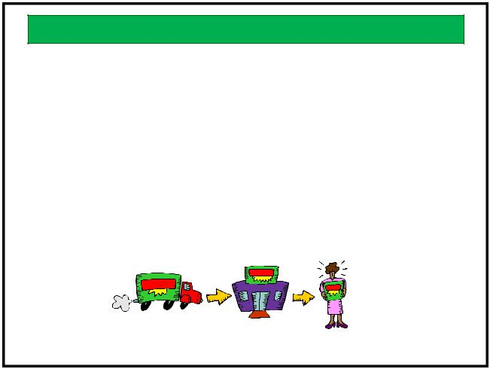

Waste

- Lean has an ethic of continuously looking for waste in the process

- The major types of waste identified in manufacturing have analogs in software development

Process, not People

- Traditional management focuses on people when things go wrong

- Lean says that 90% of problems are due to the system we have created

- It is much easier to reduce delays and other wastes than to get better at the activities we do

17 | 18

Kanban Startup Workshop | 3
www.agilecrossing.com

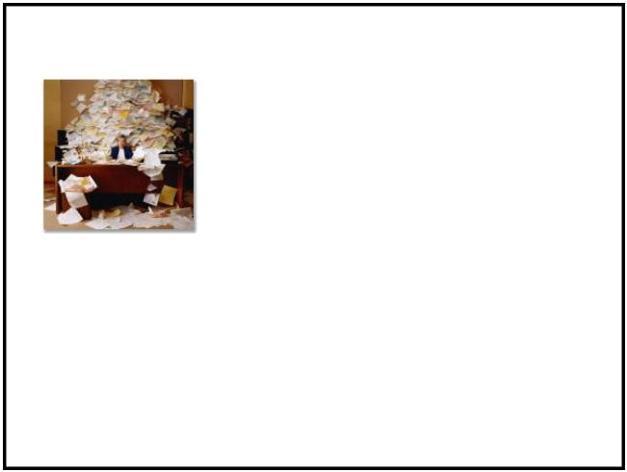
 |  |  |  | Wastes are Costs
 |  |  |  | The single word “waste” in English is
 |  |  |  | described more richly in Japanese by
 |  |  |  | these terms used in the Lean
 |  |  |  | literature:
 |  | Waste |  | Description
 |  | Muda | non-value-added activity
 |  | Mura | “unevenness” and interpreted as “variability in flow”
 |  | Muri | “overburdening” or “unreasonableness”

19
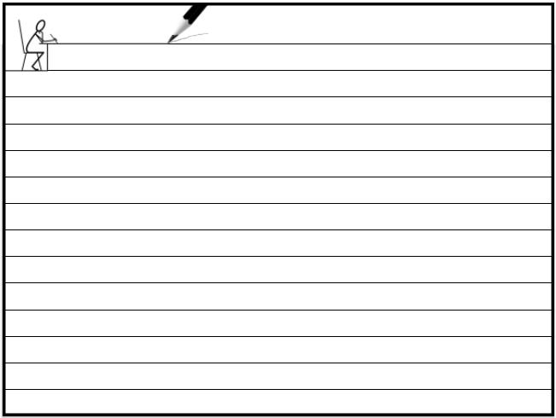

notes

21
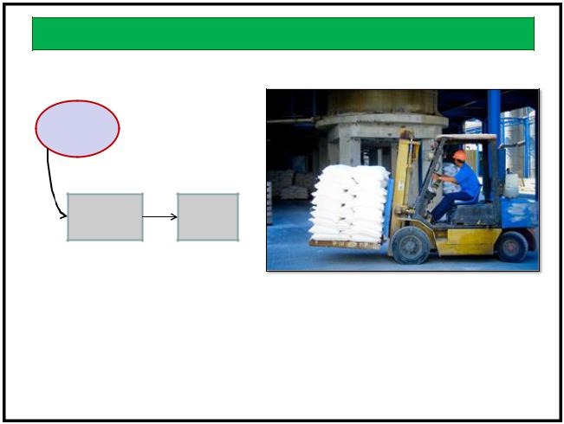

Value Stream Mapping

Flour
Arrives

Shipment Flour
Logged Stacked

In general out of the gate Value Streams include all activities, both those that create value and those that add no value, to complete the service defined by the value stream.

The map is not the territory - Alfred Korzybski

23

 |  |  | Types of Waste
 |  | Waste | Description
 |  | Inventory | Partially done work, not yet delivered
 |  | Extra processing | Non value adding work, unnecessary meetings, redundant
 |  |  | approvals, premature documentation
 |  | Overproduction | Features not requested by the customer, complex
 |  |  | implementation, gold-plating
 |  | Transportation | Moving work, people or focus. Task switching
 |  | Waiting | Delays in delivery of dependencies, not enough skilled
 |  |  | people available
 |  | Motion | Handoffs due to specialization, log in to multiple systems to
 |  |  | test or research
 |  | Defects | Unexpected behavior, lost knowledge, mis-applied fixes,
 |  |  | out-of-date scripts, addressing symptoms instead of root
 |  |  | causes, bugs
 |  |  | 20 | 20

Value Stream Mapping

- A Value Stream Map describes the flow of a unit of work

- We can use it to clarify our mental model of the work

- And to find opportunities to reduce waste

22
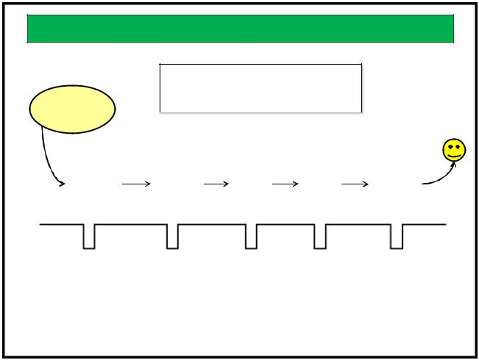

Value Stream Map

- What are the process steps?
- How much calendar time is required?
 | Feature |  |  | • How much work time is required?
prioritized
 |  | Specs |  | Design |  | Code |  | Test |  |  | Deploy
Wait |  |  | 3 days |  | 2 days | 3 days |  |  | 5 days |  | = 13 days
Value |  | 3 hr |  | 2 hr |  | 12 hr |  | 6 hr |  |  | 1 hr = 1 day

Process Cycle Efficiency = 1/13 = 7.7%

24

Kanban Startup Workshop | 4
www.agilecrossing.com

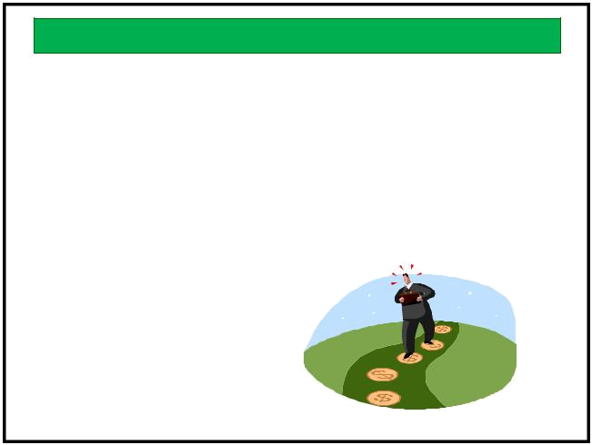
Mapping the Value Stream

- How do you create value?

- What are the effective boundaries of your system?
- What steps do each unit of value go through?

- What is the average process time for each step?
- What is the average wait time between steps?
- Are there any back flows?

25

notes

27
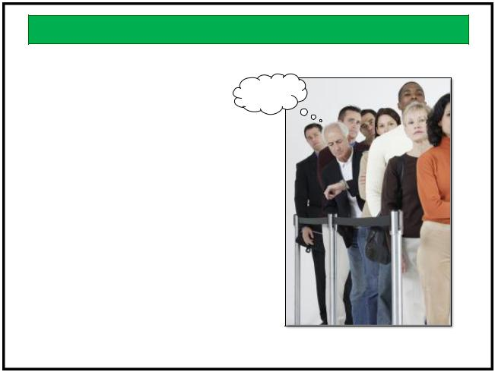

What do we do with the Map?
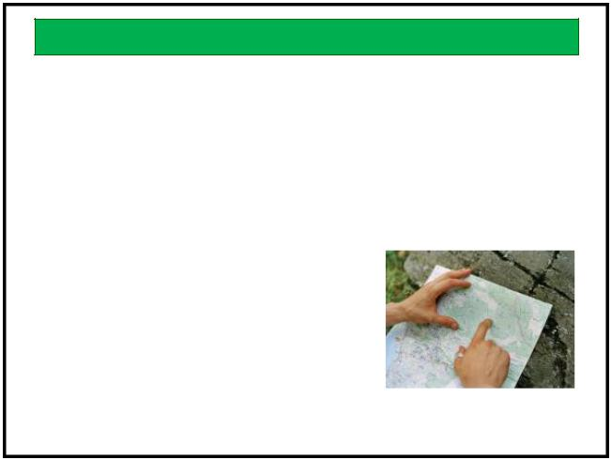

- Better understand our work flow
  - It is likely different than our mental model

- Create improvement targets
  - Current state
  - Future state

  - Ideal state
- Find opportunities to reduce waste

  - Delays

  - Unnecessary steps

  - Bottlenecks
- Use it to build our kanban board

26

Queuing Theory

- Work queues are more efficient that big piles

- We learned a lot about managing queues when we built the telecom networks

- Queuing theory helps us to improve work flow in complex systems

28
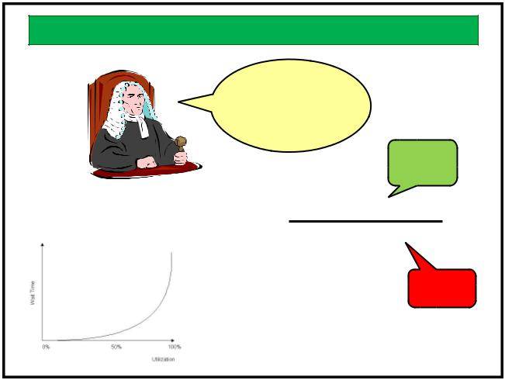

Queues

^%@#!

A queue is the line of requests waiting to be processed

Little’s Law

The more things
in the pipe, the
longer it takes to
get one through

Easier to
decrease

Number of things in progress
Cycle Time =
Average completion rate

Harder to
increase

And it increases exponentially
as the system fills up
29 | 30

Kanban Startup Workshop | 5
www.agilecrossing.com

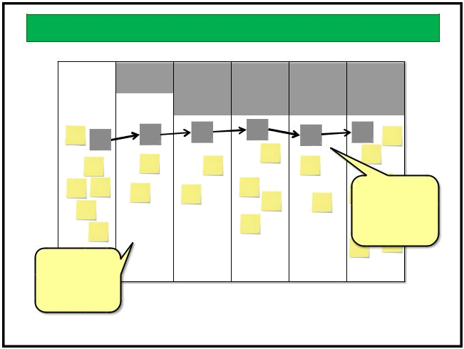
Batch Size

Ready | Analysis | Develop | Code | Test | Release
 |  |  | Review
8 | 4 | 3 | 5 | 4 | 8
 |  |  |  |  | Single-piece-
 |  |  |  |  | flow reduces
 |  |  |  |  | the wait time

Small batches
move through

- system quicker

31

notes
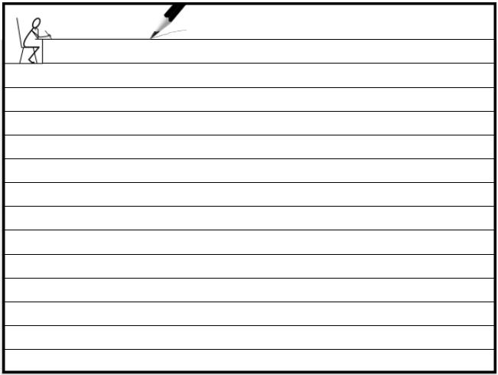

32
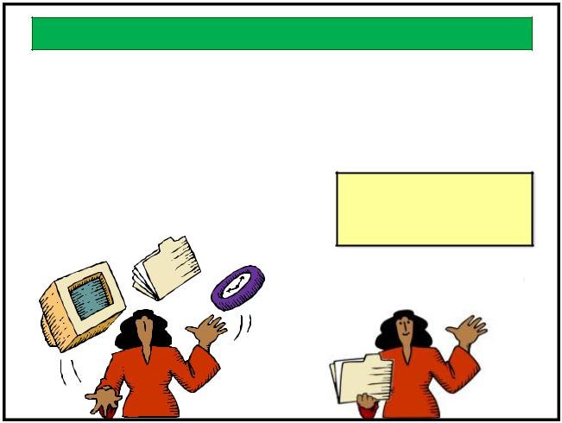

Work in Progress

- Multitasking increases the time required to do all of the tasks in progress

- Limiting Work In Progress is one of Lean’s most effective practices
- Applies to individuals and teams

33
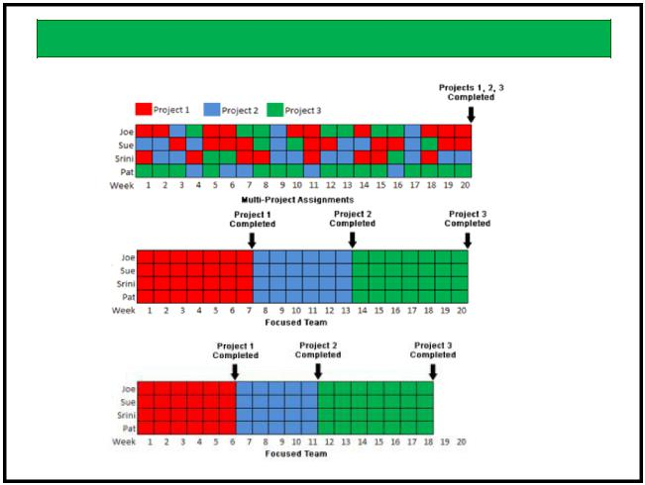

Cost of Multitasking

35

Kanban Startup Workshop

www.agilecrossing.com

Limit WIP

- Unfinished work is a cost
- Context switching is expensive
- Zeigarnik’s Effect
- All items finish later
Stop starting
Start finishing

34 ³⁴
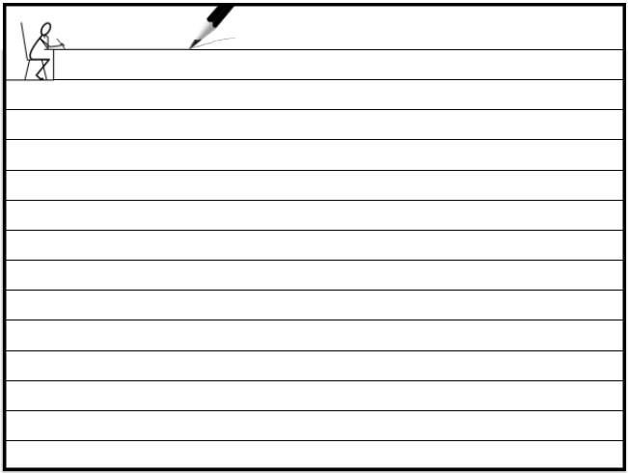

notes

36

6

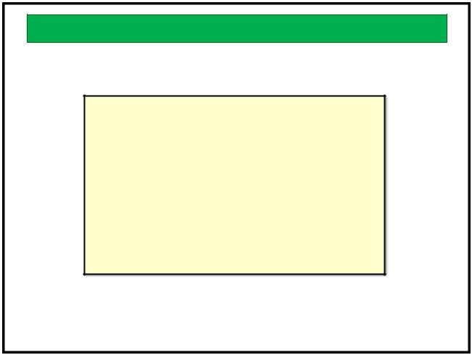
Flow

- The overall goal of Lean is to establish a steady, efficient flow of work items from start to end

- We can recognize flow but have not emphasized it in our sequential, hurried work styles

37

Impediments to Flow

- Other work in progress
- Waiting for information
- Waiting for decisions

- High variability
- Large work items
- External dependencies
- Rework

- What else?

39
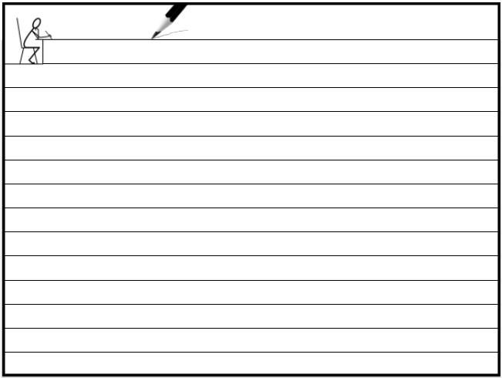

notes

41

Flow Benefits
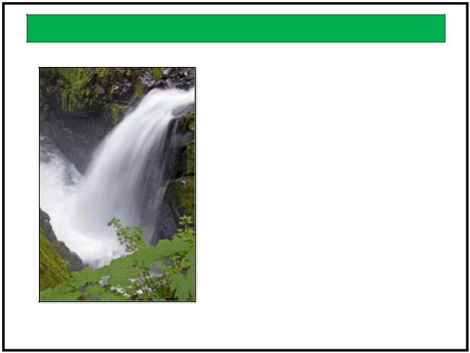

- Sustainable Pace
- Focus
- Predictability
- Risk Reduction
- Agility
- Trust

38 ³⁸
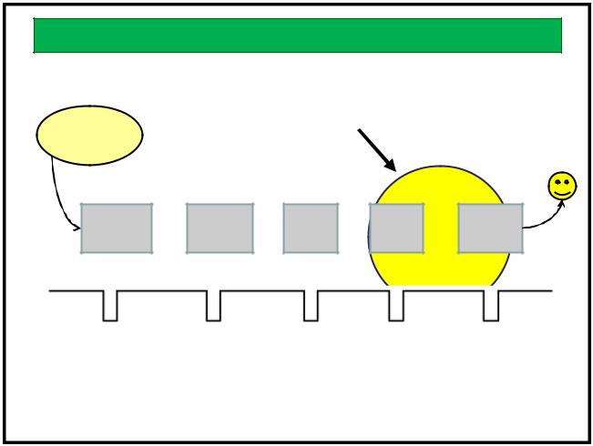

Flow Example

Look for ways to improve the flow
ex. continuous release process
Feature
prioritized

Specs Design Code Test Deploy

Wait |  | 3 days | 2 days | 3 days | 5 days | = | 13 days
 |  |  |  |  | 1 day |  | 9 days
Value | 3 hr | 2 hr |  | 12 hr | 6 hr | 1 hr = 1 day

Process Cycle Efficiency = 1/13 = 7.7%

1/9 = 11%

40

Flow Enhancers

- We can improve flow by managing bottle necks, decentralizing control, using teams and establishing a cadence

42

Kanban Startup Workshop | 7
www.agilecrossing.com

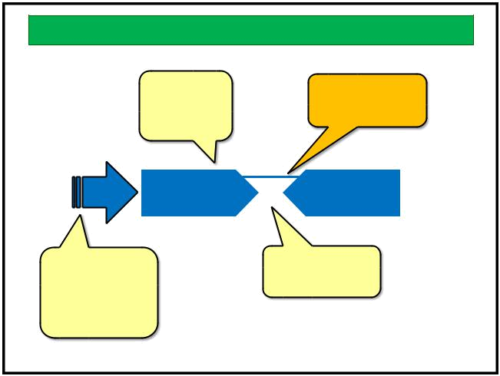
Constraints

Buffering is |  | Adding capacity
WIP but may |  | may be expensive
smooth the |  | and take time
flow

Can we reduce | Can we automate
Can we reduce | some of the
input of
input of | processing?
non-value-added
work at the
bottleneck? | Bottleneck management is typically
 | done away from the bottleneck
 |  | 43 | 43
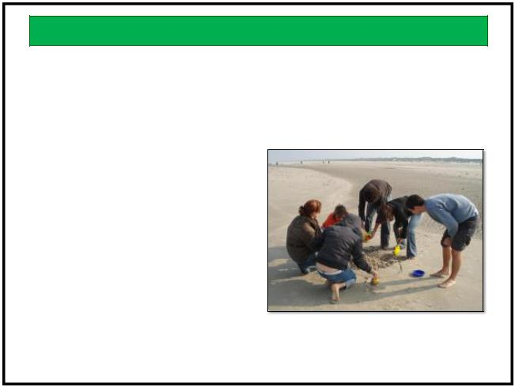

Dedicated Teams

- Swarming on blockages

- Sharing work

- Shared learning

- Informed decisions

- Retrospection

- Innovation

- Reduce backflow

45 ⁴⁵

notes

47

Kanban Startup Workshop

www.agilecrossing.com

Decentralized Control
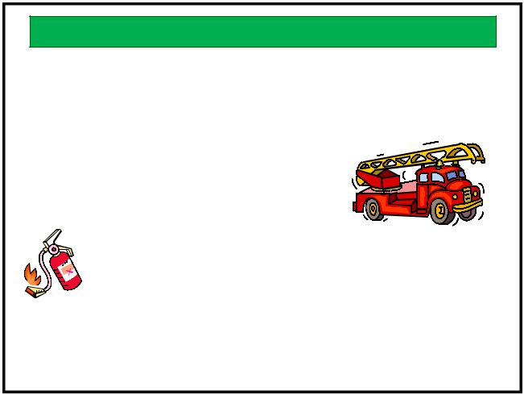

Change comes from both
the top and the bottom

Strategy and large-scale
planning are centralized

Individuals and teams have responsibility, authority and tools for tactical work

- Micromanagement impedes flow

44 ⁴⁴
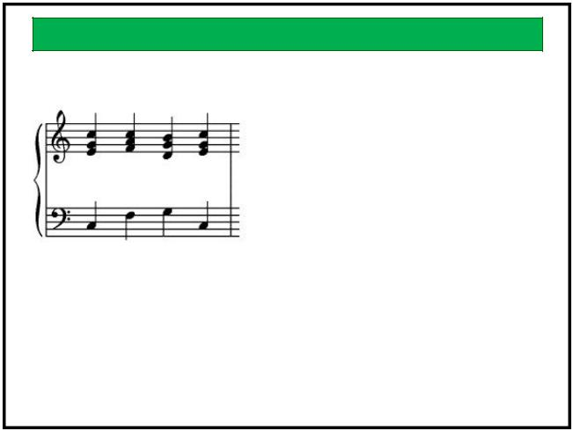

Cadence

- Input cadence
  - variability
- Output cadence
  - SLAs

- Team cadence
  - Parkinson’s Law

Cadence enhances flow and
enhances predictability

46 ⁴⁶

Measuring Flow

- We can measure the flow of work to assess improvement actions

- Flow measures can be used to predict work completion times

- SLAs become predictions rather than promises

48

8

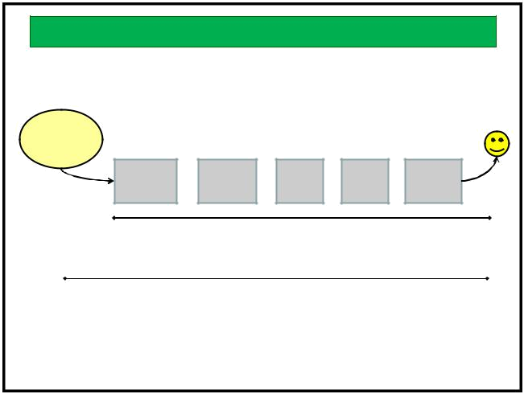
Flow Metrics

Takt time is the pace of customer demand. ex. 1 feature/week

Customer
request

Specs Design Code Test Deploy

Cycle Time is the average time from start of processing to
delivery for a unit of value. ex. 9 days

Lead Time is the average time from customer request to
delivery for a unit of value. ex. 45 days

Throughput is the amount of value delivered in a period of time ex. 5 features/week
49
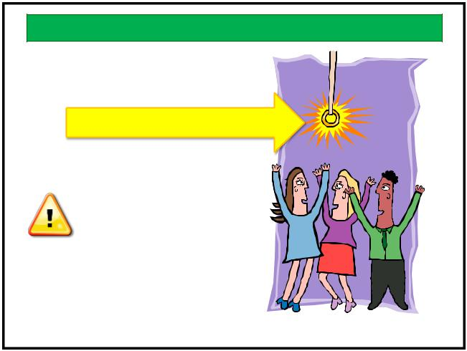

Goodhart’s Law

Tickets closed per week

The moment a measure
becomes a target,

it ceases to be a measure.

51


Visualizing Flow
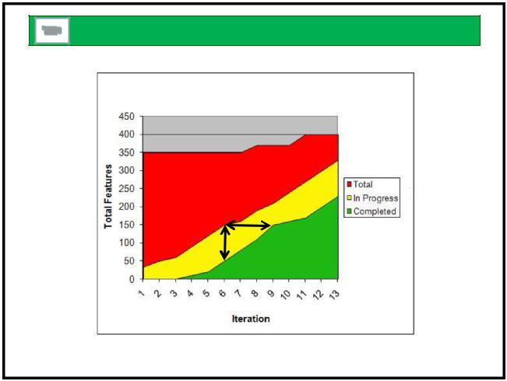

Cumulative Flow Diagram

Cycle
Time

WIP

50 ⁵⁰

notes

52
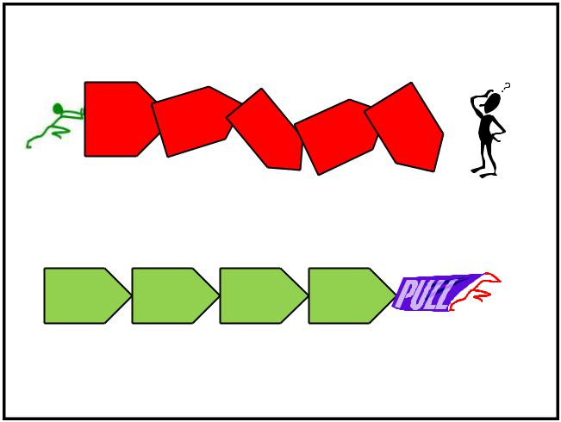

 |  | Pull Systems |  |  | Pull Systems
 |  |  |  |  | Push
 | • | Pushing leads to unpredictable outcomes |  |  | Push
 | • | When the system responds to customer
 |  | pull, it works more efficiently

Push systems overwhelm capacity, creating

turbulence, rework, waste and delay

♫

Pull systems have a steady flow that
provides predictability

53 | 54

Kanban Startup Workshop | 9
www.agilecrossing.com

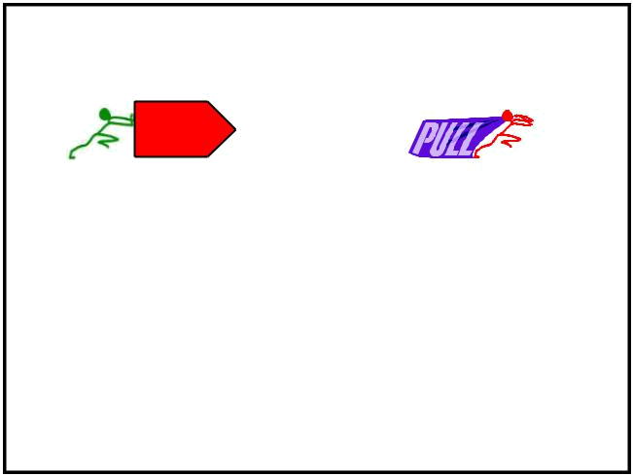
 | Push vs. Pull
 | Push
 | Make a plan | Have a queue of work and a goal
 | Track % completion of plan | Measure throughput and work done
 | Buffer plan for contingencies | Small, frequent tasks to manage variety
 | Plan decides what to do next | People decide what to do next
 | Long feedback delay to affect plan | Continuous short feedback loops for
 |  | improvement
 | Demand exceeds capacity | Demand limited to capacity
 | Fixed scope and time | Fixed WIP

55 | 55

Systems Thinking

- We create systems too complex for our instinctive understanding

- Optimizing part of the system may adversely impact the larger system

57
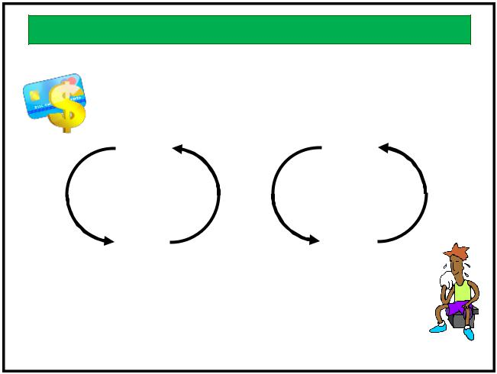

notes

56
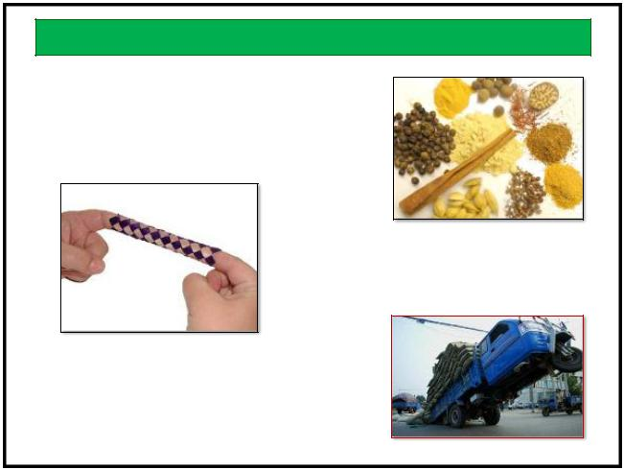

Systems Principles

The whole is greater than
the sum of it’s parts

Complex systems have emergent, counterintuitive behaviors

A focus on one property can
have unintended impact
on the system as a whole

58 ⁵⁸
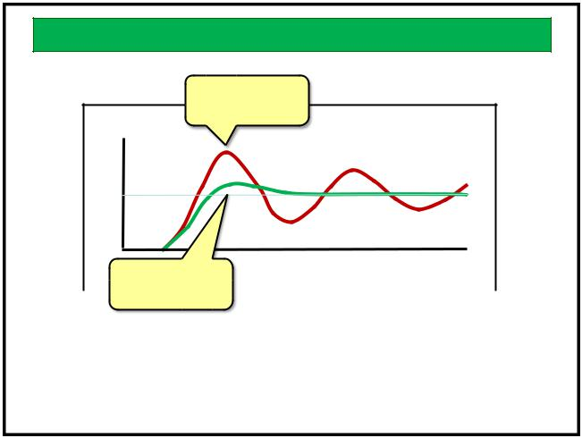

Feedback Mechanisms

Credit Card | + | Body | -
Balance | + | Temp | -
Credit Card |  | ₊ Sweat
₊ Interest |  | ₊ Sweat
Reinforcing feedback |  | Balancing feedback

59

Kanban Startup Workshop

www.agilecrossing.com

Feedback Delay

Long delay causes
wider swings

Desired State

Short delay | Time
converges sooner

The Lean goal is to reduce
the delay time for feedback

60

10

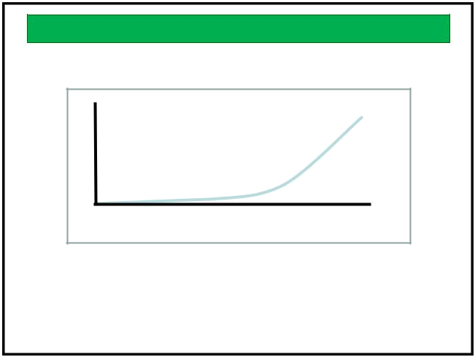
Cost of Delay

Cost of Fixing Defect

Time Since Code Was Written

Knowing is one thing
Acting is another

61

How Kanban Works

- The Kanban practices reinforce Lean Principles

- The Kanban guidelines create a Lean environment

63
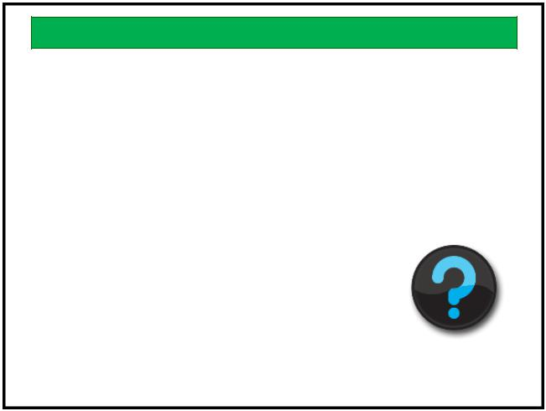

What else can we get from it?

- What about quality?
- What about predictability?
- What about continuous improvement?

65

Kanban Startup Workshop

www.agilecrossing.com

notes
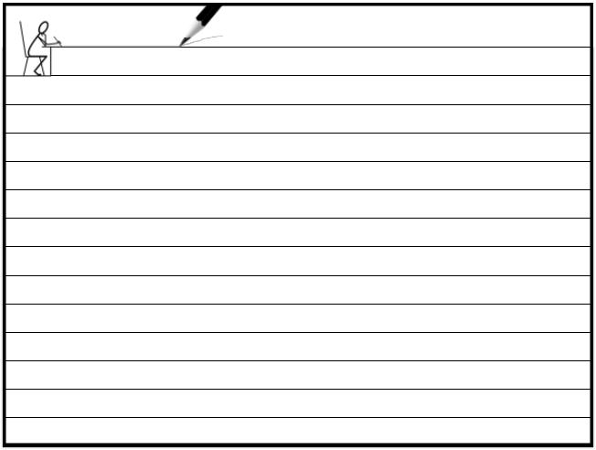

62
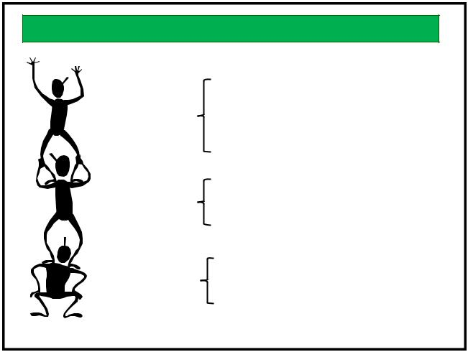

Reinforcement

- Enforce Pull
- Force Prioritization
^{WIP Limits} • Keep batch size small
- Encourage single-piece flow

Kanban | • Visualizes the Value Stream
Kanban | • | Radiates current status
Board | • | Radiates current status
Board | • | Reveals constraints
Self | •
Assignment | • | Reinforces decentralized control
 |  | 64

notes

66

11

Starting your Kanban

Customer
request

Visualize the Work
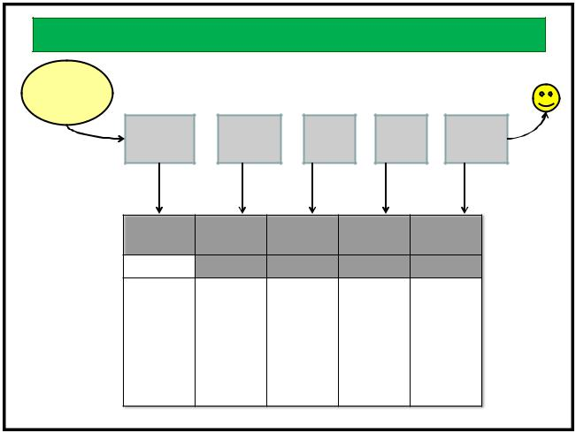

Map the Current Value Stream to Your Board

- Create the Kanban board from the current value stream map and work in progress

- Guess at the initial WIP limit

- Establish your initial policies

67
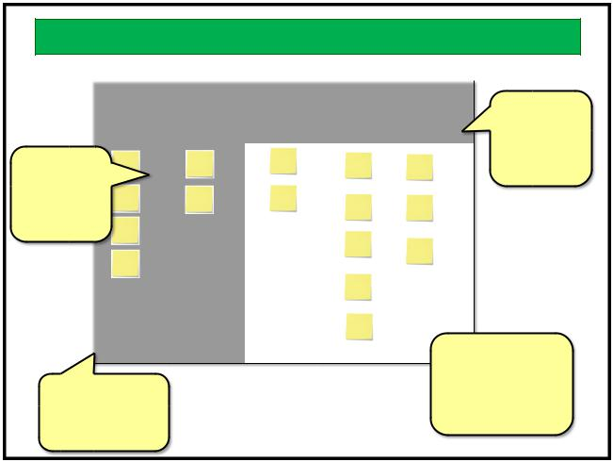

Prime the Pump

 | Ready | Analysis | Develop | Test | Release
 |  |  |  |  |  |  | Guess your
 | 4 | 2 | 3 | 3 | 5 |  | Guess your
 |  |  |  |  |  |  | initial WIP
Put your |  |  |  |  |  |  | Limits
current
work on
the board
 |  |  |  |  |  | Lower initial
 |  |  |  |  |  | WIP will give
Everything |  |  |  |  |  | you faster
 |  |  |  |  |  | feedback for
else stays in
 |  |  |  |  |  | adjustment
the backlog
 |  |  |  |  |  | 69

Specs Design Code Test Deploy

Spec | Design | Develop | Test | Release
Ready

68

notes

70
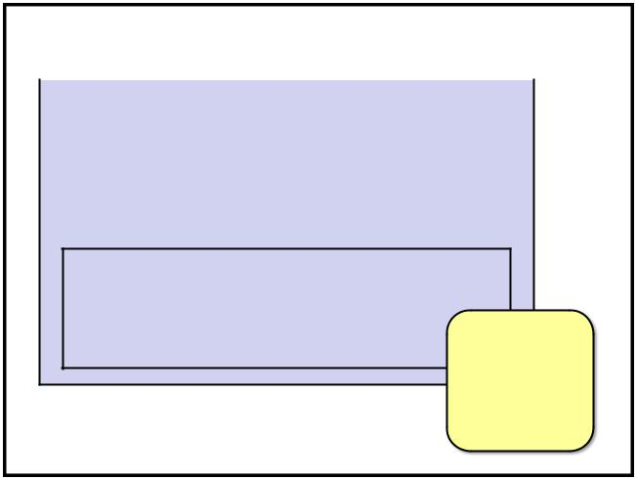

Standard Sizing

- Kanban handles variations in item size

- The flow is smoother when variation is least

- We can choose the size of some types of work by breaking it down

 |  | Kanban Ticket
 | Item |  |  | Started
 | 10782452 |  |  | 2/3/12 9:30
 | Current Owner |  |  | Completed
 | Joe Dokes

Notes

Provisioning request for new distribution partner in Retail eCommerce System.

Need data specs.
Other possible
annotations:
“blocked”
“expedite”
“MMF”

71 | 72 | 72

Kanban Startup Workshop | 12
www.agilecrossing.com

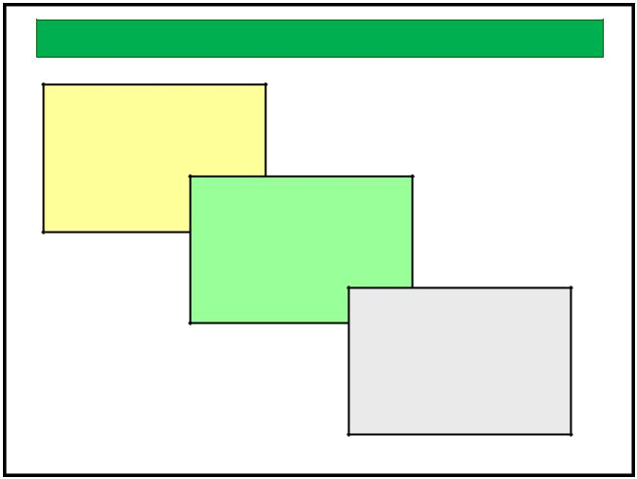
Item Size Hierarchy

MMF
(Minimally Marketable

Feature)

User Story
Refactor

Infrastructure

Engineering Task

73
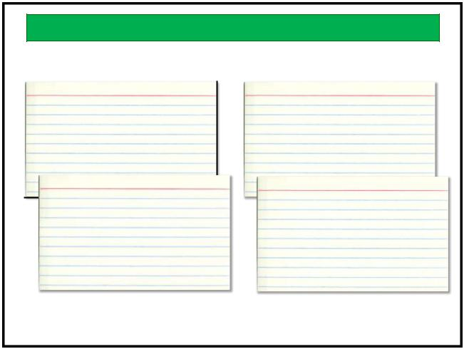

Sample User Stories

As a registered user, I can |  |  |  | As a purchaser, I can
purchase OTC products on- |  |  |  | search for generic
line so that I do not have to |  |  |  | equivalents of name-brand
drive to the store |  |  |  | items so I can save money
 | As a purchaser, I can get a
 | As a purchaser, I can get a |  |  |  | As a vendor, I can see
 | receipt for a past |  |  |  | monthly sales reports so I
 | transaction so that I can |  |  |  | can see which products are
 | keep my own off-line |  |  |  | selling best
 | records
 |  |  | 75

User Story Template
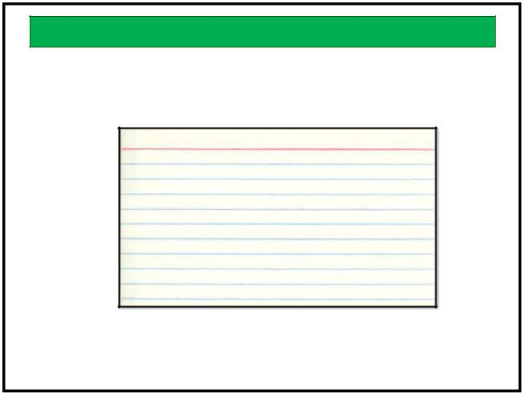

As a <user role>,
I can <functionality>
so that <value>.

74

notes

76
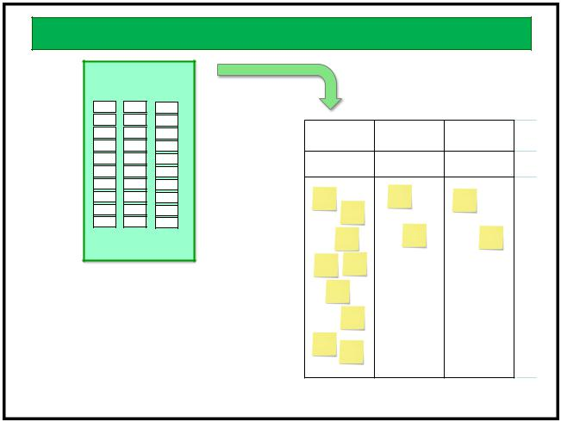

Prioritization

- Priorities belong to Management

- Smaller work items allow for more priority choices

- Many factors inform priorities

Prioritization

Backlog

Ready Analysis Develop

8 4 3

Management meets

periodically to prioritize

the backlog and fill the

ready queue

77 | 78

Kanban Startup Workshop | 13
www.agilecrossing.com

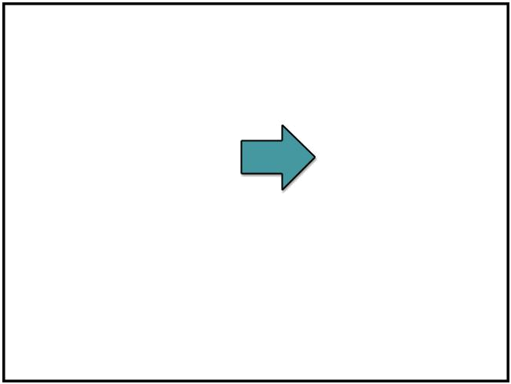
 | Inputs to Priority
• | Business value
• | Business value | Must
• | New knowledge | Should
• | Risk/Complexity | Should
• | Desirability | Could
• | Customer pull | Won’t
• | Technical dependency | Won’t

79

Make Policies Explicit

- Policies are clearly stated descriptions of how we make decisions

- Policies save us time

- Reviewing and adjusting policies is part of seeking continuous improvement

81

notes

83

notes

80
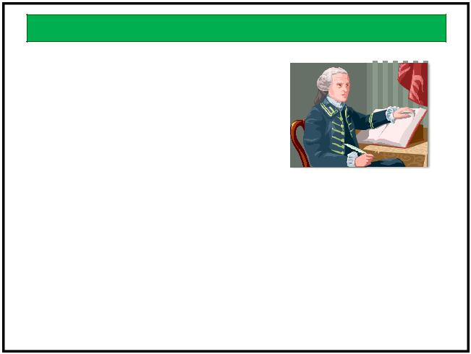

Policy Examples

• WIP Limits
- How often we prioritize
- When it is OK to break a limit?
- Classes of Service?
- SLAs?
- How we handle defects
- When we retrospect

82

Evolving with Kanban

- Kanban is a framework for continuous improvement

- Your implementation will evolve with practice

- Some known enhancements may help in time

84

Kanban Startup Workshop | 14
www.agilecrossing.com

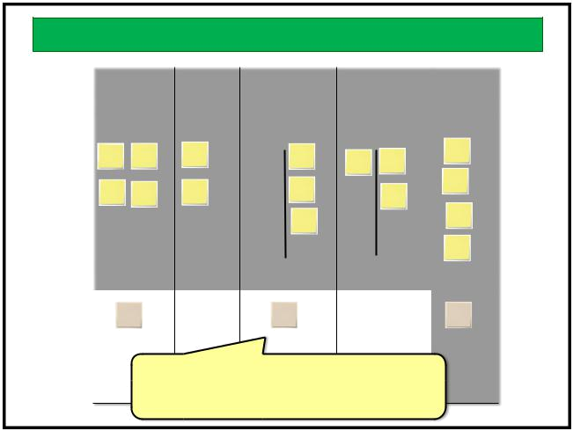
Classes of Service

 | Ready | Analysis | Develop | Test |  | Release
 | 4 | 2 | 3 | 3 |  | 5
New Feature |  |  | In Prog Done | In Prog Done
 | 2 | 1 | 1 | 2 |  | 2
Defect
 | Work | items may fall into |  | different groups
 |  | with different characteristics that
 |  | require different policies
 |  |  |  |  |  | 85
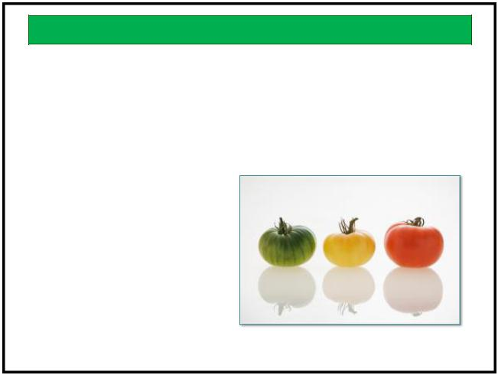

Managing Variability

- Buffers

- Higher WIP Limits

- Problem Management

  - root cause analysis

- Cadence

  - Team

  - Organizational

  - Business

- Bucketing

  - Queues

87

Lean Leadership

- Leaders provide purpose

- Leaders have a systems view

- Leaders set the tone and tempo

- Leaders help others be better

89

Buffers
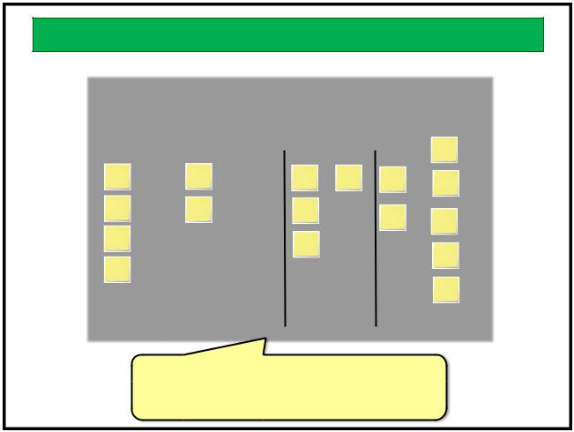

Ready | Analysis | Develop | Test | Release
4 | 2 | 3 | 3 | 5
 |  | In Prog Done | In Prog Done

Sub-columns give us more details on
possible bottlenecks by showing when the
WIP is actually done but waiting | 86

notes

88
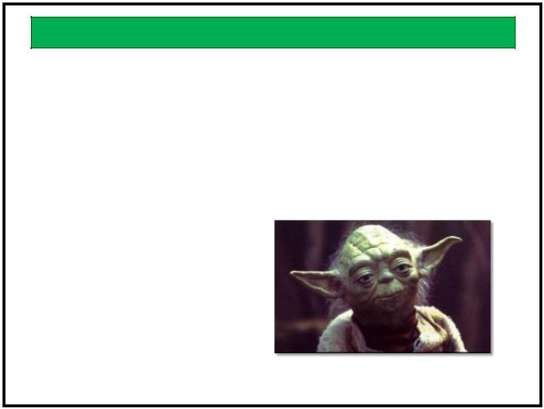

Servant Leader

- Lead vs. Manage

- Lead to make others better

- Increase teamwork and personal involvement

- Lead by example

90

Kanban Startup Workshop | 15
www.agilecrossing.com

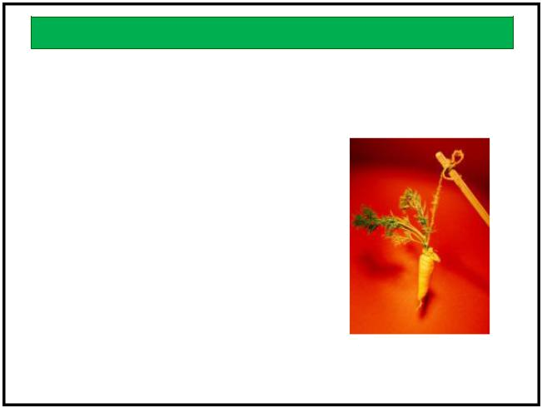
Motivation

- Financial rewards often give poor results
- Intrinsic vs. extrinsic motivation
- People are motivated by
  - autonomy
  - mastery
  - purpose

See Dan Pink, TED.com and Drive

91
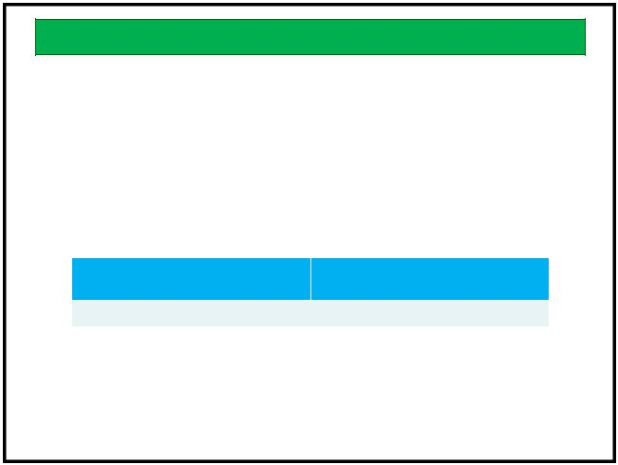

Natural Work Cadence

8:00 | 9:00 | 10:00 | 11:00 | 12:00 | 1:00 | 2:00 | 3:00 | 4:00 | 5:00

Manager’s Schedule

Morning Afternoon

Maker’s Schedule

Source: http://www.paulgraham.com/makersschedule.html

93

notes

95

The Gemba – Go See
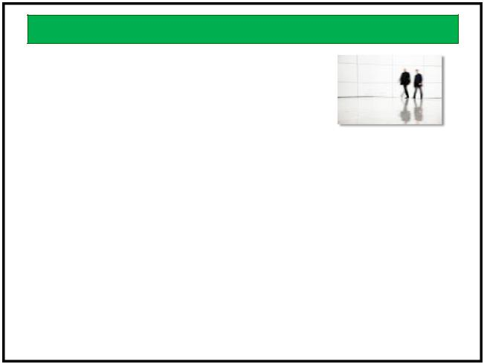

Go See is a management technique to help

- develop judgment by testing hypotheses if we are right or have some misconception

- build consensus by getting people to agree on the problem before jumping into solve space

- achieve goals at the desired level by checking regularly where people are with their implementation

- empowering people by involving them, from vision, roadmap, releases to sharing what the customers have to say

92
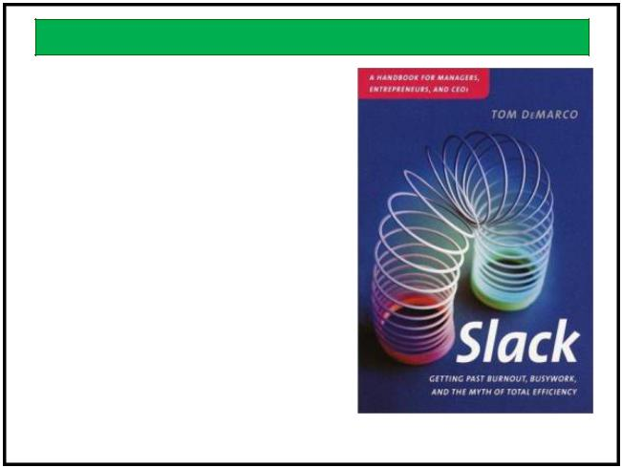

Slack

Tom DeMarco

“By intentionally creating downtime, or ‘slack’, management will find a much-needed opportunity to build a ‘capacity to change’ into an otherwise strained enterprise that will help companies respond more successfully to constantly evolving conditions.”

94

Seeking Perfection

- Perfection is a constant goal

- Continuous improvement will never result in perfection because we look for more opportunities as our work changes

96

Kanban Startup Workshop | 16
www.agilecrossing.com

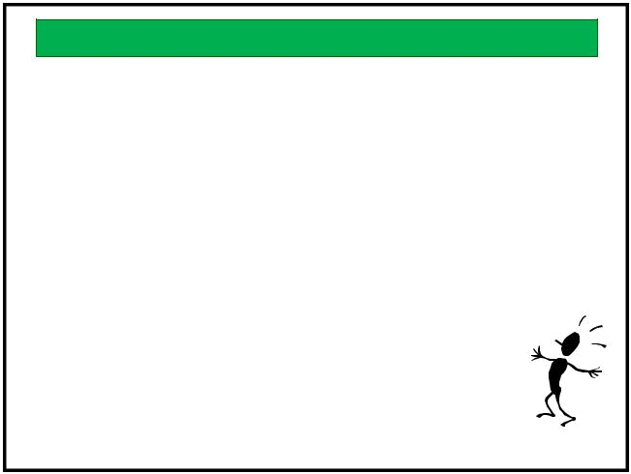
Continuous Improvement

3 basic principles of Continuous Improvement

- Challenge (long-term vision)

what we need to learn as opposed what we want to do?

- Kaizen (strive for perfection) look at ways of improvement

- Genchi genbutsu (“Go see” or the gemba) go to the source to see the facts for oneself

The Lean Manager, Balle Michael; Balle, Freddy

97

When do we get time to improve?

Prioritize your |  |  | Urgent |  | Not Urgent
time using |  |  | I |  | II
Steven Covey’s | Important | • | Crises | • | Preparations
If we don’t spend any | Important |  | Projects, |  | Building
four quadrants: |  | • | Pressing | • | Learning
 |  |  | Problems | • | Kaizen Events
 |  | • | Deadline Driven | • | Relationship
time sharpening the |  |  | Meetings, etc. | • | True Recreation
saw, we will have to
work harder and harder
to get the same results. | Important |  | III |  | IV
 | Important | • | Some email | • | Time wasters
 |  | • | Interruptions | • | Trivia
 |  | • | Some phone calls | • | Busy work
 | Not | • | Someone else’s | • | “Escape” activities
 |  |  | emergency
 |  |  |  |  | 99

Action Plan

- What is our overall plan from this point?

- What are the next steps for us to take?

- What are the next steps for me to take?

101

Tools for Improvement
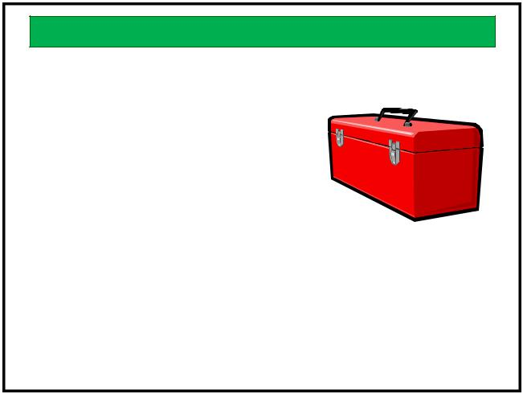

- Reduce WIP Limits

• To find constraints faster

• Build in slack

• To innovate and solve

- Retrospectives

  - Regular focused discussions

- Improvement Events

  - Spontaneous and continuous improvement (Kaizen)

- Problem Management

  - Tracking, analysis, recording and policies

98 ⁹⁸

notes

100
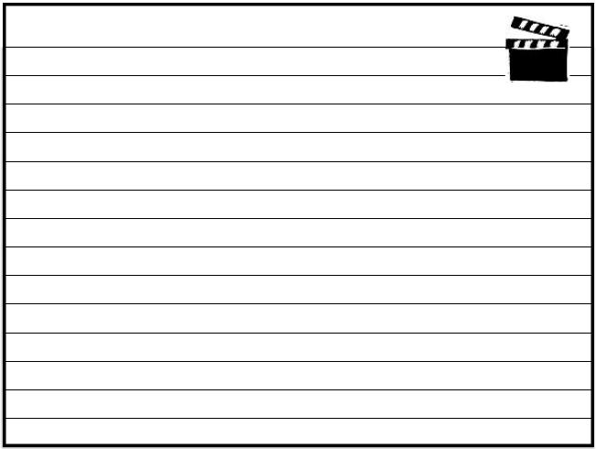

Action Plan

actions

102

Kanban Startup Workshop | 17
www.agilecrossing.com

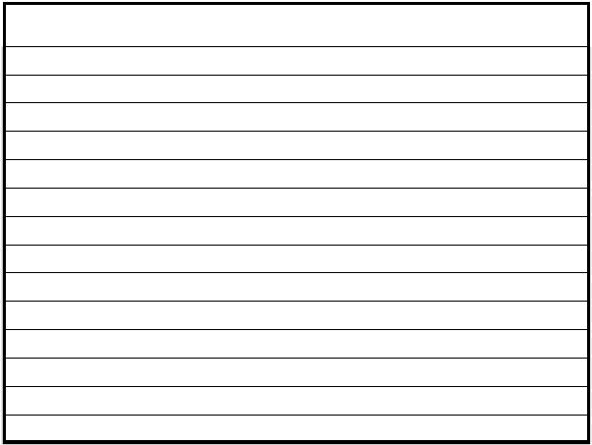

103
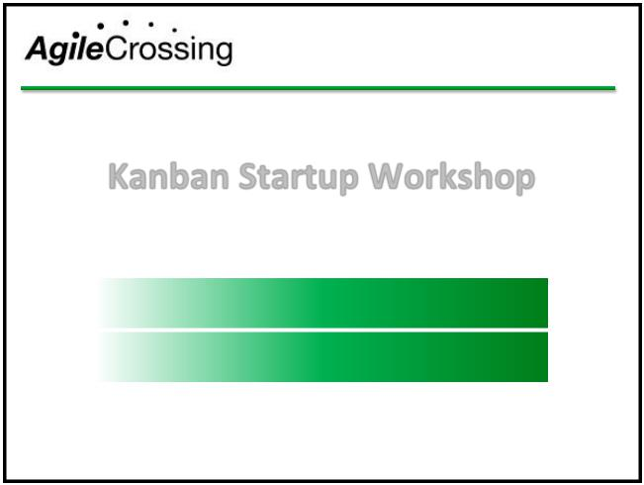

Training

Transition

Transformation

Kanban Startup Workshop

Instructor – Roger Brown CST, CSC

All slides © 2013 Roger W. Brown www.AgileCrossing.com

Scrum Framework

- Scrum has 4 meetings and 3 artifacts

- Scrum has 3 roles that share the responsibility of creating value in small increments

- The roles complement each other to create a balanced team

107

Instructor
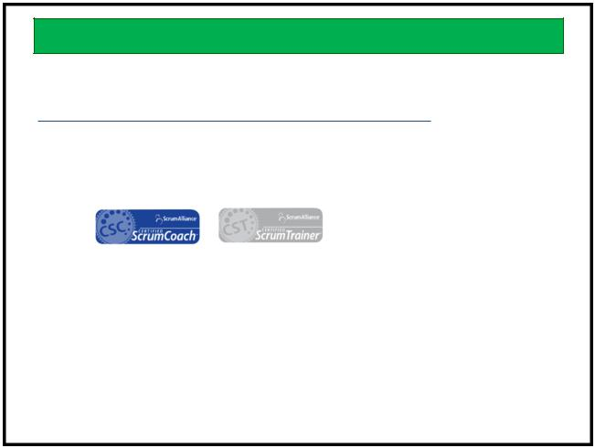

Roger Brown

- Agile Coach

- Scrum Alliance

- Contact
  - Email: roger.brown@agilecrossing.com

  - Twitter: rwbrown

  - Blog: www.agileCoachJournal.com

  - LinkedIn: http://www.linkedin.com/in/rogerwbrown

V 1.2

104
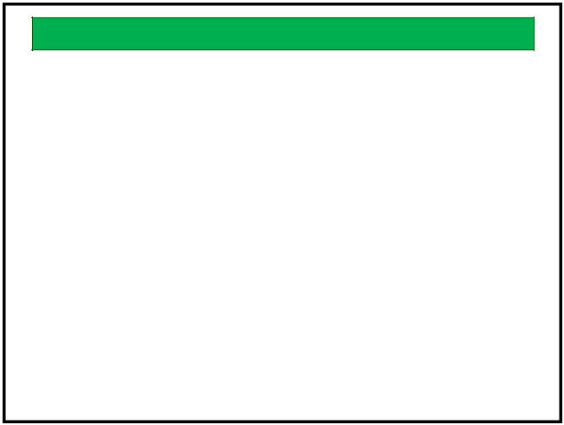

Adenda

106
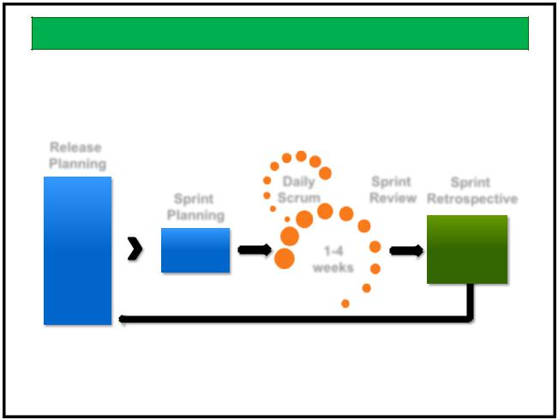

Scrum Framework

Release
Planning
 |  |  | Daily | Sprint | Sprint
 |  | Sprint | Scrum | Review | Retrospective
 |  | Planning |  |  | Potentially
Product |  | Sprint | 1-4 |  | Shippable
Backlog |  | Backlog | 1-4 |  | Product
Backlog |  | Backlog | weeks |  | Product
 |  |  | weeks |  | Increment

108

Kanban Startup Workshop | 18
www.agilecrossing.com

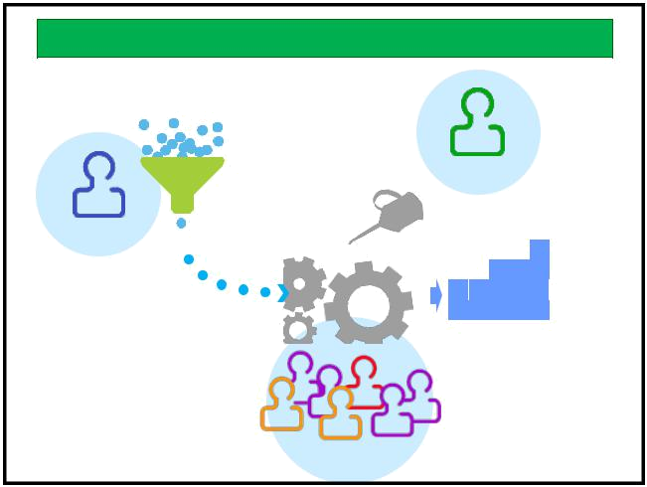
The Scrum Team

Desired Features

ScrumMaster

Product Owner

Product

Development Team 109

Which to Use?

- We compare Scrum, Kanban and XP to see when each is applicable

111

Scrum vs. Kanban

Scrum | Kanban
Teams required | Teams may emerge
Explicit roles | No new roles
Sync input and output cadence | Input and output cadence are
 | independent
Defined artifacts, meetings, | Start with current work flow,
teams | evolve process
Quick estimation | No estimation
Measure velocity | Measure throughput
Sprint-sized batches | Continuous flow with WIP
 | limits
Iteration cadence | Continuous flow
113

notes

110
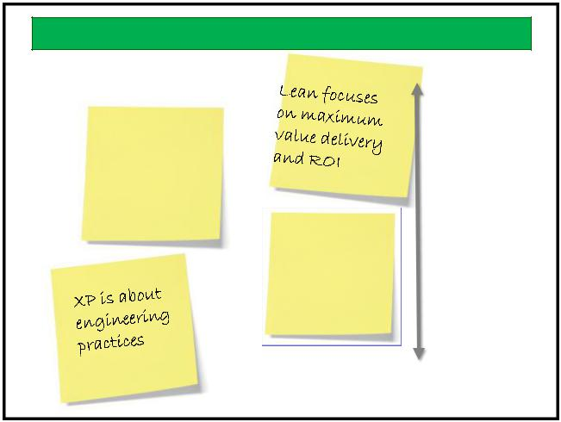

Scope of Use

Business

Scrum is for
managing
the work of a
team
Kanban is for | Team
small teams
or highly
variable work
 | Individual
 | 112

Extreme Programming

- XP practices are applicable to individuals, pairs and teams

- As defined, are specific to software development
- Complement both Scrum and Kanban

114

Kanban Startup Workshop | 19
www.agilecrossing.com

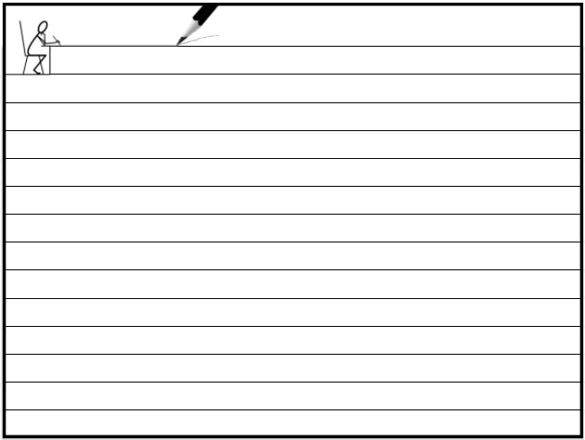
notes

115

Kanban Startup Workshop | 20
www.agilecrossing.com

