

Chapter 8

Pull Production Systems

1


USA Snapshots

- Strongest union states

Nationally, 13.9% of nonagricultural workers are union members. States with the largest number of workers who belong to unions.

Hawaii | 26.5%
New York | 25.4%
New Jersey | 22.0%
Michigan | 21.6%
Washington | 21.2%
Alaska | 20.4%

Source: Bureau of Labor Statistics data for 1998, most recent available By Suzy Parker, USA Today ²

Feats of Engineering

- Engineers picked the following as the 20th century’s greatest engineering achievements

Electrification | 100%
Automobile | 95%
Airplane | 88%
Safe water/supply/treat | 86%
Electronics | 80%
Radio and TV | 73%
Agricultural mechanization | 70%
Computers | 63%
Telephone | 62%
Air conditioning/refrigeration | 54%

Source: National Academy of Engineering | By Anne R. Carey and Quin Tian, USA Today | 3

USA Snapshots

- The percentage of workers belonging to unions stayed at 13.9% in 1999 (16.5 M), ending a decade of decline.

1979 | 24.1%
1989 | 16.4%
1990
1999 | 13.9%

Source: Bureau of Labor Statistics By Anne R. Carey and Sam Ward, USA Today

4

Lowest Union Membership

- States with the lowest percent of workers who belong to unions:

North Carolina | 4.2%
South Carolina | 4.5%
Mississippi | 5.6%
Texas | 5.9%
Arkansas | 6.2%
South Dakota | 6.4%

Source: Bureau of Labor Statistics data for 1998, most recent available By Gary Visgaitis, USA Today

5

Sources of Waste

- Overproduction

- Inventories

- Transportation

- Delays

- Defective Products

- Processing

- Motion

6

Causes of Waste

- Departmental layouts

- Processes not capable

- No standard practices

- No adherence to standard practices

- Poorly performing suppliers

- Ineffective maintenance

- Long setup times

- Unaligned performance measures

- Lack of workplace organization

- Poor forecasting and production planning/scheduling

- Lack of training

7

Objective

Products are to be made:

- In the required quantities

- At the right time


v With the highest quantity

v At the lowest cost




Results from:

v The least non-value added activity

- Production problems easily identified and remedied

The greater the demand variation and the larger the number of product configurations, the more difficult this task becomes

8

Push Production System

- Schedule is based on when an order is to arrive at an operation (or due date priority of items in WIP)

- Production is generally performed in batches (MRP lot sizing rules)

- Routing sheets, schedules, and work instructions follow the jobs Or work instructions could be maintained at a given operation

- A schedule is generated for each operation

- Processing time is typically less than 10% of total lead time

- Priorities change at each operation

- Process and transfer batches could change the batch size

- Control process is costly and wasteful

- Expediting causes problems

- As some jobs move up in priority, others must move down

9

Push Production System (cont.)

- Schedules for every job at every workstation could be centrally prepared (possibly by MRP)

- Schedule at each operation is dependant on:

– Lead time (could be estimated LT from this point to finish)

– Critical Ratio (time to due date / expected flow time to finish)

– # of operations

– Capacity at workstation

Supplier | 1 | A | 2 | B | 3 | C | Customer
 |  |  |  |  |  |  | (Finished
(Raw Material)
(Raw Material) |  |  |  |  |  |  | Product)
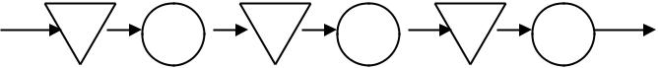

10


Pull Production Systems

- Detailed production schedules at each operation are eliminated

- Schedule is placed at most downstream operation that can achieve continuous flow (or close to continuous flow) - e.g., an assembly line

- Quantities and timing of work should migrate to workers instead of being retained within a central scheduling group

- Signals by downstream operation requests upstream producer to replenish goods (consumption signals replenishment)

- Downstream operation keeps enough in stock to satisfy demand during replenishment lead time

- Uses small buffers for imbalance of production and demand

11


Flow of material and signals in a pull
system
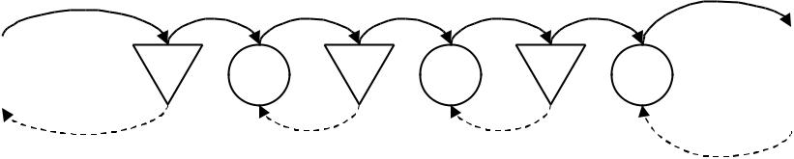

Supplier | 1 | A | 2 | B | 3 | C | Customer
 |  |  |  |  |  |  | (Finished
(Raw Material)
(Raw Material) |  |  |  |  |  |  | Product)

Material Flow

Order Signal Information
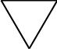


1 | In-Process Buffer | A Operation

12
Buffer

- Pull production is considered stockless

- Impossible to produce in a lean environment with no inventory Zero inventory equals zero output

- Must hold inventory in the process to meet lead times desired

– For example, if I can meet the customer lead time and still flow through operations B and C, then inventory is held in front of B, but not between B and C.
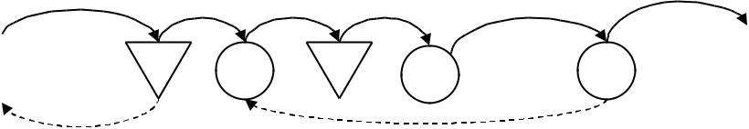

Supplier | 1 | A | 2 |  |  | C | Customer
 |  |  |  | B | FIFO | C | (Finished
(Raw Material)
(Raw Material) |  |  |  |  |  |  | Product)

13

Buffer (cont.)

- Need a buffer for each kind of part in kanban pull systems

- Difference from push – less inventory in each buffer

- Size of buffers dependant on demand rate and replenishment times (time from generating signal to replenishment of the inventory).

- Replenishment times are often a function of setup times.

 |  |  |  |  |  |  |  |  | Upstream
 |  |  |  | Order |  |  |  |  | Operation |  |  | Container emptied
 |  |  |  | Queue |  |  |  |  |  |  | 2
 |  |  |  |  |  |  |  |  | 1 | I
 |  |  |  |  |  |  |  |  |  |  |  | Downstream
 |  |  |  |  |  |  |  |  |  |  |  | Operation
 |  |  |  |  |  |  |  |  | Consumption Signal
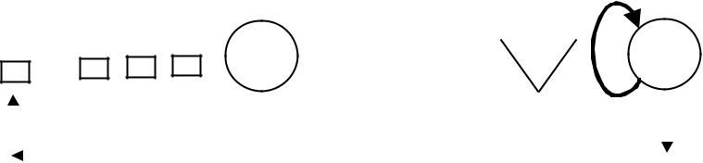

14


Pull vs. Push Production

Push |  | Pull
1) Schedules order releases based on |  | 1) Order releases occur when the
lead times and the master schedule. |  | downstream buffer reaches a given
 |  | level.
2) Lot sizes are based on lot sizing |  | 2) Lot sizes are determined at the
rules from the master schedule. |  | shop-floor level and are based on
 |  | demand and replenishment
 |  | requirements of downstream
 |  | inventory buffers.
3) Priorites based on rules (ex: |  | 3) Priorities are determined by
earliest due date, SPT, FIFO) but are |  | operators using a sequence board.
often changed on the floor according
to the work schedule.
4) Expedited orders will be prioritized |  | 4) Expedited orders will be prioritized
according to capacity and urgency. |  | according to capacity and urgency.

15


Containers and Cards

- Standard-sized containers are used to control inventory buffers

- Kanban cards are used to differentiate containers

- Kanbans include:

– Kind of material

– Quantity of material

– Origin or producer of the material (upstream source)

– Consumer of material (downstream customer)

– Could be bar-coded to ease the pain of inventory transactions

16

Containers and Cards (cont.)

- Rules for kanbans:

– No material may be placed in a container without a card

– No container moved without a card

– The quantity of material produced will never exceed the amount on the card

– No material may be processed without a card

17

Rules for Pull Production

- Downstream operations withdraw only the quantity of items they need from upstream operations. The quantity is controlled by the number of cards.

- Each operation produces items in the quantity and sequence indicated by the cards.

- A card must always be attached to a container. No withdrawal or production is permitted without a kanban.

- Only non-defective items are sent downstream. Defective items are withheld and the operation is stopped until the source of defect is remedied.

- The production process is smoothed to achieve level production. Small demand variations are accommodated in the system by adjusting the number of cards.

- The number of cards (for a given part, subassembly, etc.) is gradually reduced to decrease WIP and expose areas that are wasteful and in need of improvement.

18

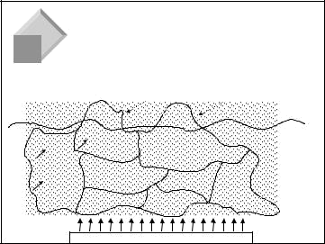
Continuous Improvement

- Goal: To continually reduce inventory buffers to expose sources of waste and eliminate them.

Initial Visible Productivity Savings ($)

 | PRODUCTION | MATERIAL
 |  | CONTROL
 | PRODUCT QUALITY =
 | LOYAL CUSTOMERS | SUPPLIER BASE
FLEXIBILITY |  | SAVINGS
=
COMPETITIVE
ADVANTAGE | DISTRIBUTION SAVINGS
= | DISTRIBUTION SAVINGS |  | ACTIVITY-
= | INVENTORY $ + TIME | ENGINEERING | ACTIVITY-
 | INVENTORY $ + TIME | ENGINEERING | BASED
MARKET |  | DESIGN SAVINGS | BASED
MARKET |  | DESIGN SAVINGS | COSTING
SHARE + |  | TIME + $ | COSTING
SHARE + |  | TIME + $ | &
NEW MARKETS |  |  | &
NEW MARKETS |  |  | PROCESS
 | STREAMLINED | RESPONSIVE | PROCESS
 | STREAMLINED | RESPONSIVE | COSTING
 | BUSINESS PROCESSES | INFORMATION SYSTEMS | COSTING

SURFACE POTENTIAL GAINS ACROSS THE VALUE STREAM

Necessary Conditions for Pull

19

- Shop supervisors and teams of workers must have more planning and control responsibility.

- Must produce to only meet demand; no overproduction(major component of waste).

- Company goal must be to reduce excess buffers.

- Preventive maintenance must be used to decrease process variation and increase capacity.

- Prevent defects from occurring by using quality assurance methods.

- Reduce setup times for quick changeovers.

- Link all operations in the process and level the capacity.

- Production plans and schedules must be somewhat uniform.

- Develop cooperative work attitudes and teamwork!

20

How to Achieve Pull Production

- Issues to address:

– How do we signal production?

– How do we signal movement of materials?

– How large should our lot sizes be?

– How do the workers know what to do next?

21

Reorder Point System

- Uses fixed quantities

- Reorder point – when the buffer falls below a critical level

ROP = D * LT + SS

D = Average demand rate (units / time)

LT = average lead time between order and replenishment

LT = P + C

- = Production time C = Conveyance time
P and C are also both averages

22

Reorder Point System

- Example:

Demand is 1500 per month. There are twenty work days in a month. A

safety stock of 50 units is needed because of high demand variation.

Setup takes 1/10 of a day, production requires half the day, and the lot

waits 4/10 of the day. When an order is generated, it is received by the

supplier in 1/4 of the day and then requires one day to receive the

shipment. What is the ROP?

23

Number of Containers

- Number of containers depends on ROP and capacity of containers

= D * (P + C) + SS

K
Q

Q = capacity of the container (units per container)

K = max number of full containers

(K may represent the number of kanbans)

**Note: Too many containers may cause complications**

Using the previous example, how many containers do we need if each container

holds 50 units?

24

Container Size

- The smaller the container:

– The shorter the reach for parts

– The less space taken up

– The closer the container may be placed to the workstation

– The shorter the assembly line (POU WIP)

– The easier to tilt the parts toward the worker (ergonomics)

- Try to keep the size of the containers similar

- Rule of thumb – containers should hold about 10% of daily demand

- May need material handlers to move containers (in contrast to operators doing their own material handling)

25

Outbound and Inbound Buffers

 | Outbound | Inbound
 | Buffers | Buffers
 | M | M | 2 | Buffers
1 | S | S |  | Movement of parts
 |  |  | 3 | Movement of parts
 | V | V |  | and containers
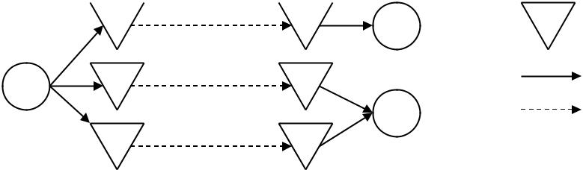

- Due to distance between operations, buffers may be needed after the upstream station and before the downstream station.

- Need a signal to move material from the outbound buffer to the inbound buffer (withdrawal kanban).

- Need a signal to produce at the upstream station (production kanban).

26

KANBAN ~means Visual Signal

There are two basic types of Kanban Signals:

- In-Process Kanban ~ a visual signal to pace the movement of products in a flow manufacturing process
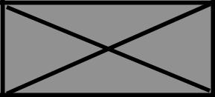

- Material Kanban ~ a visual signal to replenish materials consumed in a lean production process

 |  |  |  |  | RED
KANBAN CARD ID: 0 | Production |  |  |  | PRINT DATE:
*0* | Unit of Lot |  |  |  | 3/16/95
LOTSIZE NUMBER: | PART NO: |  | 12-00327-09 |  | REF. DRAWING NO.:
1 of 4 | 12-00327-09 |  |  |  | dw1234
PART NAME: | KANBAN QUANTITY: 3 |  |  |  | REVISION NO.:
PART NAME: |  |  | *3* |  | REVISION NO.:
PART NAME: |  |  | *3* |  | dr987
MODULE 69NT | CONTAINER TYPE: BOX
Supply Point: Supply B
*Supply B*
USAGE POINT: USAGE C |  |  | Notes:
*USAGE C* |  |  | NOTE 1

27

Types of Material Kanbans

- Production kanban – enables processing of parts

– No production is allowed without it

- Withdrawal (conveyance or move) kanban – enables transportation of parts

– No container may be moved downstream from an outbound buffer without it

- Supplier kanban – enables procurement of parts

– links the facility with its suppliers

– Another form of withdrawal kanban

28


How Three Types of Kanban
Work Together

Blue = Withdrawal Kanban (WK)
 | Red = Production Kanban (PK) |  | IB = Initial Buffer
 |  |  | FB = Final Buffer
 | Green = Supplier Kanban (SK)
supplier
planner | IB | FB | IB | FB
(fax) | SK | PK | WK | PK
 |  | Process | attach | Process
 |  | Process | WK | Process
 |  | #1 | WK | #2
FIFO
 | Kanban | Kanban
 | Order Post | Receiving Post
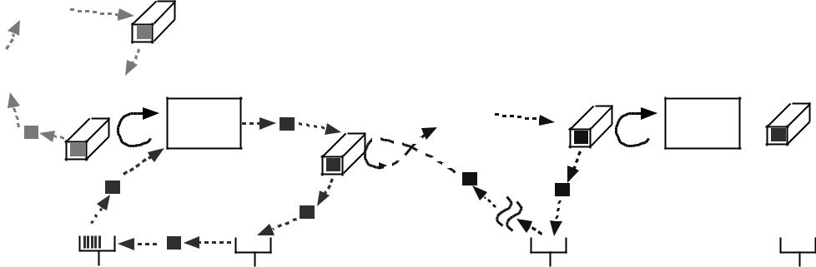

29

How Three Types of Kanban
Work Together (Cont.)

- When container in the initial buffer is opened or is empty, the withdrawal kanban is removed from the container (or container and card positioned in signaling location) and used to requisition material from final buffer of previous operation.

- The withdrawal kanban is placed on the container pulled from the outbound buffer (production kanban taken off container to trigger production, placed on receiving post) of upstream operation and taken to initial buffer of next operation.

- The production kanban is placed in the receiving post (FIFO) and acts to schedule production.

- The supplier kanban acts just like a withdrawal kanban, except that the upstream operation is an external supplier.

30

Kanban Calculations

 | D x (1 + SF) x LT |  |  | Signal =
Number of Kanbans = |  |  |  | Full Container
Number of Kanbans = | Kanban Size |  |  | Full Container
 | Kanban Size |  |  | Opened
 | D x (1 + SF) x LT |  |  | Signal =
= |  |  | +1 | Container
= | Kanban Size |  | +1 | Container
 | Kanban Size |  |  | Empty

D = Average Demand
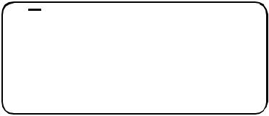
SF = Safety Factor
LT = Kanban Cycle Time (time for
material to be replenished once
a signal has been received)

Signal could be: empty container
container opened
full container taken away

Number of kanbans = number of cards (not necessarily full containers)
required for system to work

D x (1 + SF) x LT
If the number of kanbans = 2, then: Kanban Size =

2

31

Interaction Between Production Kanban
and Withdrawal Kanban

Operation #1
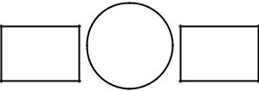

Withdrawal Production

Kanban Kanban

Production Rate = 12 units/minute

- 0.2 units / second

Kanban Size = 6 units

Operation #2

Withdrawal Production

Kanban Kanban

Demand Rate = 6 units/minute

- 0.1 units / second

Kanban Size = 6 units Let Safety Factor = 10% Lead Time = 30 seconds

32

Interaction Between Production Kanban
and Withdrawal Kanban

Withdrawal kanban - signal when container is opened

Number of Kanbans = ^{D (1+SF) LT}

Kanban Size

=

Withdrawal kanban - signal when container is empty

Number of Kanbans =

=

Withdrawal kanban - signal when container is empty & LT = 120 seconds

Number of Kanbans =

=

33

Interaction Between Production Kanban
and Withdrawal Kanban

Production Kanban

Production Rate = 12 units/minute

Demand Rate = 6 units/minute

(a) Waiting time to work into schedule

Time (sec.) | % Total
60 | 40
70 | 30
80 | 30

Wait Time = ?

(b) Run Time = ?

Number of Kanbans = ^{D (1+SF) LT}

Kanban Size

=

34

How else can I make the
D = average demand SF = safety factor
LT = kanban replenishment time
pull system work?

Interchange the production kanban and withdrawal kanban.
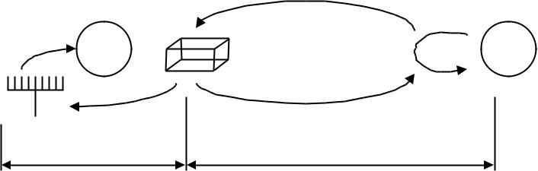

Production KCT | Withdrawal KCT
 |  | Withdrawal
Do not interchange the production kanban and withdrawal kanban. |  | kanbans for
 |  | materials
 |  | pull from
 |  | warehouse
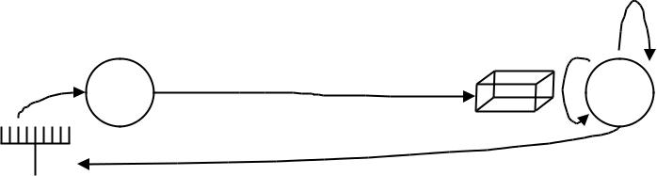

Production Kanban Flow

Likely greater variability in KCT!
35


Flow of Materials and
Production Kanbans

Initial Buffer |  |  |  |  |  |  |  |  |  |  |  |  |  |  |  | Final Buffer |  |  |  |  |  |  |  |  |  | withdrawal
 |  |  |  |  |  |  |  |  |  | Process |  |  |  |  |  |  | 6 |  |  |  |  |  |  |  |  |  |  | kanban
 |  |  |  |  |  |  |  |  | 4 |  |  |  |  |  |  |  |  |  |  |  |  |  |  |  |  | attached
 |  |  |  |  |  |  |  |  |  |  |  |  | 5 |  |  |  |  |  |  |  |  |  |  | production
 |  |  |  |  |  |  |  |  |  |  |  |  |  |  |  |  |  |  |  |  |  |  |  | kanban
 |  |  |  |  |  |  |  |  |  |  |  |  |  |  |  |  |  |  |  |  |  |  |  | removed
3 |  |  |  |  |  |  | 2 |  |  |  |  |  |  |  |  | 1
 | Kanban |  |  |  |  |  |  |  |  |  |  |  |  |  |  |  |  | Kanban
 | Order Post
 |  |  |  |  |  |  |  |  |  |  |  |  |  |  |  | Receiving Post
 |  |  |  |  |  |  |  |  |  | Material Flow |  |  |  |  |  |  |  |  |  |  |  |  |  |  | Number of |  |  | = | D x (1+SF) x LT
 |  |  |  |  |  |  |  |  |  | Production Kanban Flow |  |  |  |  |  |  |  |  |  |  |  |  |  |  | Kanbans |  |  | = | Kanban Size
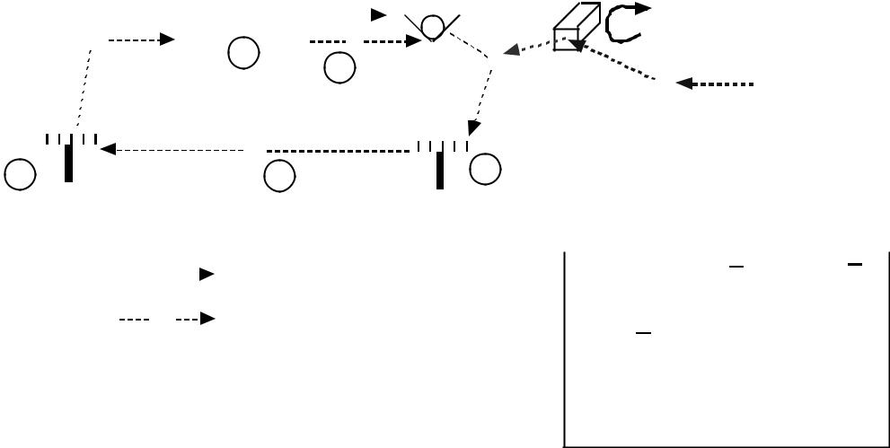

Kanban Cycle Time =
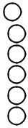

11 kanban waiting time in the receiving post +

2 kanban transfer time to ordering post +

- kanban waiting time in ordering post +

- lot processing time (internal setup time + run time + in-process waiting time) +

- container transfer time to final buffer +

6 container waiting time in final buffer | 36

Flow of Materials and
Production Kanbans

Example:

D = 200 units/hr

SF = 10%

LT = 3 hours

Do not need to consider whether

To add one or not with production

Kanban - signal will always occur

When container is full.

D x (1+SF) x LT
Number of Kanbans =

Kanban Size

= | 200 x (1.10) x 3 | = 6.6
 | 100

Round up to 7!

KCT = | 100 x | 7 |  | = 3.5 hours
KCT = | 200 |  |  | = 3.5 hours

Container will be received in outbound buffer 30 minutes before

needed

37

Flow of Materials and
Withdrawal Kanbans
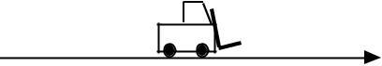
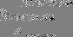

Upstream Process |  | Downstream Process
Final Buffer | 3 | Initial Buffer
 |  | 4
 | 2 |  | 1
 |  | Ordering
 |  | Post
 | Material Flow |  | D x (1+SF) x LT
 |  | Number of Kanbans = | D x (1+SF) x LT
 | Material Kanban Flow | Number of Kanbans = | Kanban Size
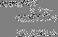
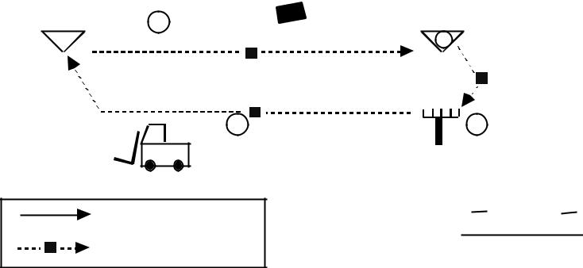

Kanban Cycle Time =
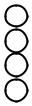

- kanban waiting time in receiving post +

- kanban conveyance time to upstream buffer +

- container conveyance time to downstream buffer +

- container waiting time in downstream buffer

Note: Formula assumes the LT begins when container is opened at the downstream buffer. If the
discipline assumes it begins when container is empty, must add one. | 38

Supplier Kanbans with
Constant Order Cycle

- Permit withdrawal from suppliers finished goods inventory and follow the product until they are processed at one of the companies operations.

- Product ordering and withdrawal occur at fixed times.

- Quantity ordered may vary.

- Withdrawal times and frequencies of deliveries are negotiated between the supplier and the company.

39

Supplier Kanban Cycle Time
(An Example)

Negotiated number of deliveries = 1 daily

Negotiated delay = 24 hrs. (from day one 1 PM to day two 1 PM)

Kanban conveyance time to supplier = 5 hrs. (from 8 AM to 1 PM)

Truck waiting time at supplier plant = 1 hr. (from 1 PM to 2 PM)

Material conveyance time from supplier to company = 5 hrs.

(from 2 PM to 7 PM)

Kanban minimum lead time = 24 + 5 + 1 + 5 = 35 hours

Lead time must be expressed in days 2 days

Number of kanbans delivered depends on demand generated during the last kanban
cycle.

40

Kanban Calculations
Example

Number kanbans for part Z.

Product Z used for models A, B and C as follows:
 | Model |  |  |  |  |  |  |  |  |  |  | Number Part Z(Q)
 | A |  |  |  |  |  |  | 1
 | B |  |  |  |  |  |  | 3
 | C |  |  |  |  |  |  | 2
Daily rate at capacity, Dc:
 | Model |  |  |  |  |  |  |  |  |  |  | Dc
 | A |  |  |  |  |  |  | 21
 | B |  |  |  |  |  |  | 16
 | C |  |  |  |  |  |  | 32
LT = Replenishment Time (fraction of days) = 0.25
SF = Safety Factor = 1.10
K = Kanban Size = 15
Number of
Number of | = |  |  |  | [(21 x 1) + (16 x 3) + (32 x 2)] x 0.25 x 1.10
Kanbans | = |  |  |  |  |  |  | 15
 | = | 36.58 |  |  |  |  | = 2.44 |  | 3
 | = | 15 |  |  |  |  | = 2.44 |  |  |  |  |  |  |  |  | 41

Signal Kanban

- Special type of production kanban.

- SP-kanban is for ordering batches or quantities in excess of one container.

- Batch size can be any multiple number of containers.

- Using SP-kanban is like collecting several production kanbans before production occurs (also called unit of lot by some).

- SP-kanban works well in cases where containers are stacked and stored.

- SM-kanban is used in conjunction with an SP-kanban to order materials required to produce the product.

42

Signal Kanbans and Their Locations

 | Part No. |  |  | D-411
 | Part |  |  | Housing
 | Name
 | Lot |  | 18 |  | Reorder | 9
 | Size |  | 18 |  | Point | 9
 |  |  |  |  | Point | 9 |  |  |  | SP-kanban
 | Material |  | J5 |  | Storage | No. 18 |  | Lot Size |  |  | Reorder Point
 |  |  |  |  | Area
 |  |  | SM |  |  |  |  |  | 18 |  | 6
SM
 |  |  | kanban |  |  |  |  |  |  |  | Part No.
 |  |  |  |  |  |  |  |  |  |  | D-411
 | SP |  |  |  | Go get material
 |  |  |  |  |  |  |  |  |  |  | Process
 |  |  |  |  | signal |  |  |  |  |  | Mold
 |  |  |  |  |  |  |  |  |  |  | #3
Signals production
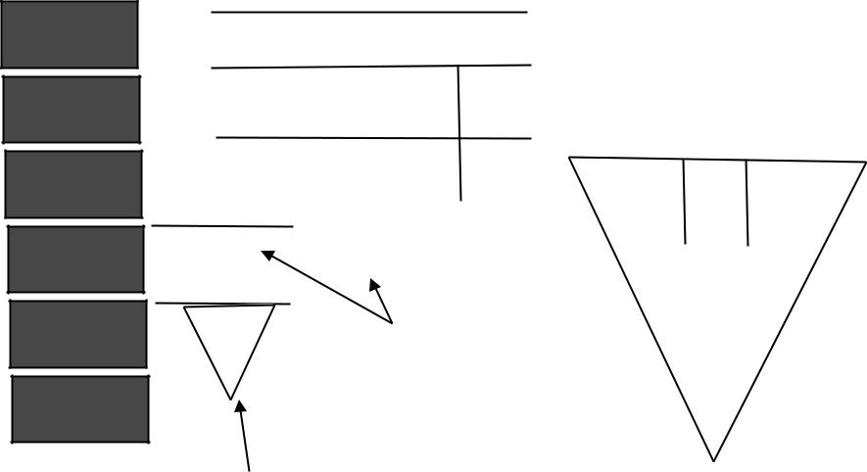
43

Positioning the Signals

^{K} SP | = Number of full containers in the stack where the card is located.
^{K} SP | = |  | D |  |  |  |  |  |  |  |  |  | (LT) + S S ,
 |  |  |  |  |  |  |  |  |  |  |  |  | Q
where |  | D = average demand
 | LT = Replenishment time
 |  |  |  |  | Q = kanban size
^{K} SM | = location of the SM- kanban
 |  |  |  |  |  |  |  |  |  |  |  |  | '
^{K} SM | = |  |  |  |  | D ( C - P) |  |  |  |  |  |  |  | + K _{SP}
 |  |  |  |  |  |  |  |  |  |  |  |  | Q
C = Total time between when the materials are ordered and when they arrive for usage.

P' = Time between when production is first ordered and when setup begins.

I f ( C - 'P) p 0 then round to the lowest negative integer (e.g., - 0 . 3 = -1)

44


Example 6 - Calculation of SP - Kanbans

D = 30 units per day

Q = 3 units

Batch size = 18 units

P = 75 minutes (includes time spent at ordering post, setup, run product and back to buffer.

Getting into schedule =16 minutes

Setup = 16 minutes

Processing time = 2 (18) = 36 minutes

In-process wait and time to move to buffer = 2 + 5 =7 minutes; Total = 75 minutes

P = 7 5 minute s = 75/48 0 = . 1562 5 days

_{K} ₌ 30 (.15625) _{= 1 . 5625}

SP | 3

Must be an integer, round up to 2. Safety stock is 28% (.4375/1.5625 x 100%)

When buffer reaches two full containers, a production order for a new batch of six containers will be placed in the kanban mailbox.

45

Example 7 - Calculations for SM- Kanbans

D = 3 0 u n i t s / d a y , Q = 3

Time to obtain raw materials for the run, produce and move to inventory buffer includes:

Move to order post, travel to location where materials are stored, wait for order accumulation, time to operation, setup, and production.

C = 42 minutes

P' = Time for SP- kanban to sit in mailbox,move to order post, and wait in order post before setup occurs.

P' = 16 minutes

( C - P') = 26 minutes = 26/480 = .0542 days

K |  | = |  | 30 (.0542) | + 2 = 2.542, Round up puts K at three containers.
K | SM | = |  |  | + 2 = 2.542, Round up puts K at three containers.
 | SM |  | 3 |  | SM

46

CONstant Work In Process (CONWIP)

- Process:

– Product leaves operation D and the card is removed

– Card is sent to operation A

– A product on the schedule is paired up with the card

– The product and card are pushed through the operations in FIFO order
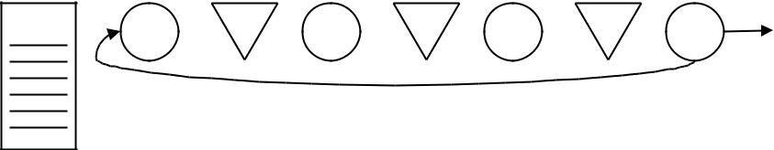

Schedule

A ¹ B ² C ³ D

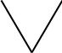 In-Process Buffer Operation

47

CONWIP (cont.)

- Card authorizes production

- Advantages:

– Card Count

    - Card is not product or part specific

    - Product, accompanying the card, is specified by the schedule

    - Reduces the overall number of cards

    - Good for products with lower demand (job shop: hours out = hours in)

    - Easy to remove cards

– Floating Bottlenecks

    - Tolerates changes in product mix and volume easier than Kanban

    - Bottleneck may move for various products

Automatically buffers the bottleneck

- Products sharing operations, but moving through different routing sequences, must use traditional kanban
-Conwip could be used for a segment of the routing

48

Other Scheduling Techniques

- Wheeled carts - empty cart or space on the floor signals replenishment

– Used to move large objects or large batches

- Kanban squares - replenishment occurs when signal mark appears

– ex: stack of staples is replenished on a shelf if inventory falls below a certain point

- Golf balls - colored golf ball signals which product to replenish (good when there are only a few products)
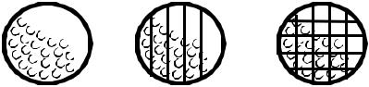

49

Other Scheduling Techniques

- Electronic kanban – uses keyboards and monitors to convey what should be replenished

- Clothespin Clips – Each clothespin clip is associated with a product and has its SKU number on it

– When a product is used, the clip is removed and placed on a wire designated for the SKU

– The product with the most clips on one wire has priority

- Milkrun – material handler makes periodic rounds to drop off empty containers and pick up full containers

- Kanban Sequence Board – cards are posted on a board so the next product in the sequence may be found easily

50

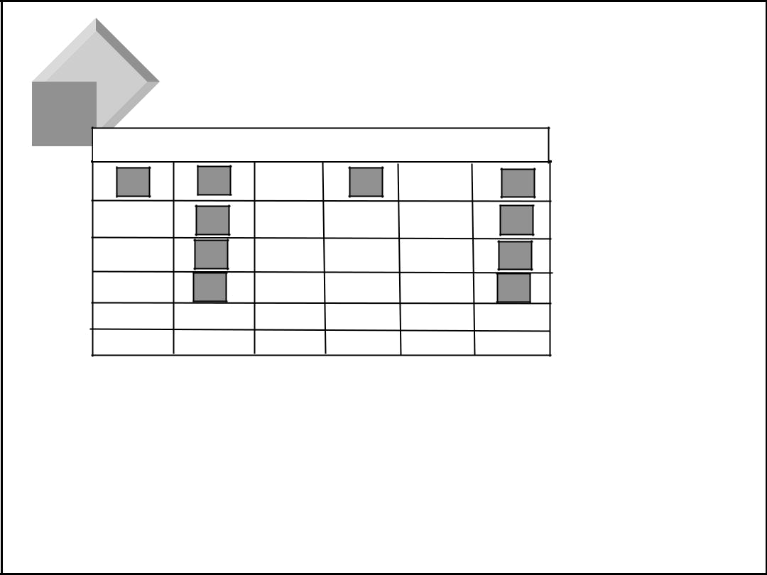
Kanban Sequence Board

R14 R19 R20 S5 S6 S9

Green

Yellow

Red

- When cards arrive they are sorted and hung on the board by item

- Cards are hung from the top of the board

- As items move from green to yellow and on to red they grow in priority

51

To Pull or Not to Pull

- Pull systems need fairly stable, continuous demand

- Most pull systems need every kind of material to be held in a buffer

- Pull works better for repetitive, standardized products

- Pull is easier if products are very similar

- Pull needs to operate in an environment with few defects

52

Lean Enterprise: Hybrid Execution
System
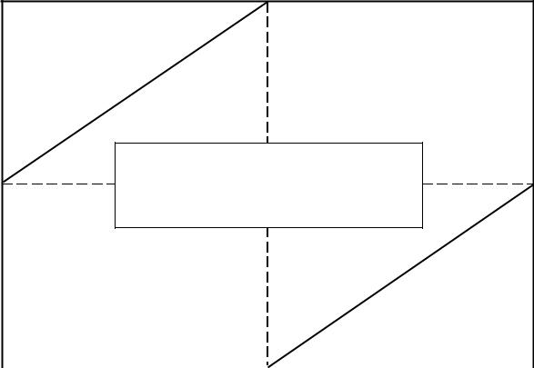

Volume

High PULL

Hybrid Control Systems:

MRP Plan/Pull Execution

Low | MRP Plan | Traditional MRP
Low | Pull Execution |  | PUSH
 | Low | Product Variety | High

Third

Dimension:

Constraint

Management

53

