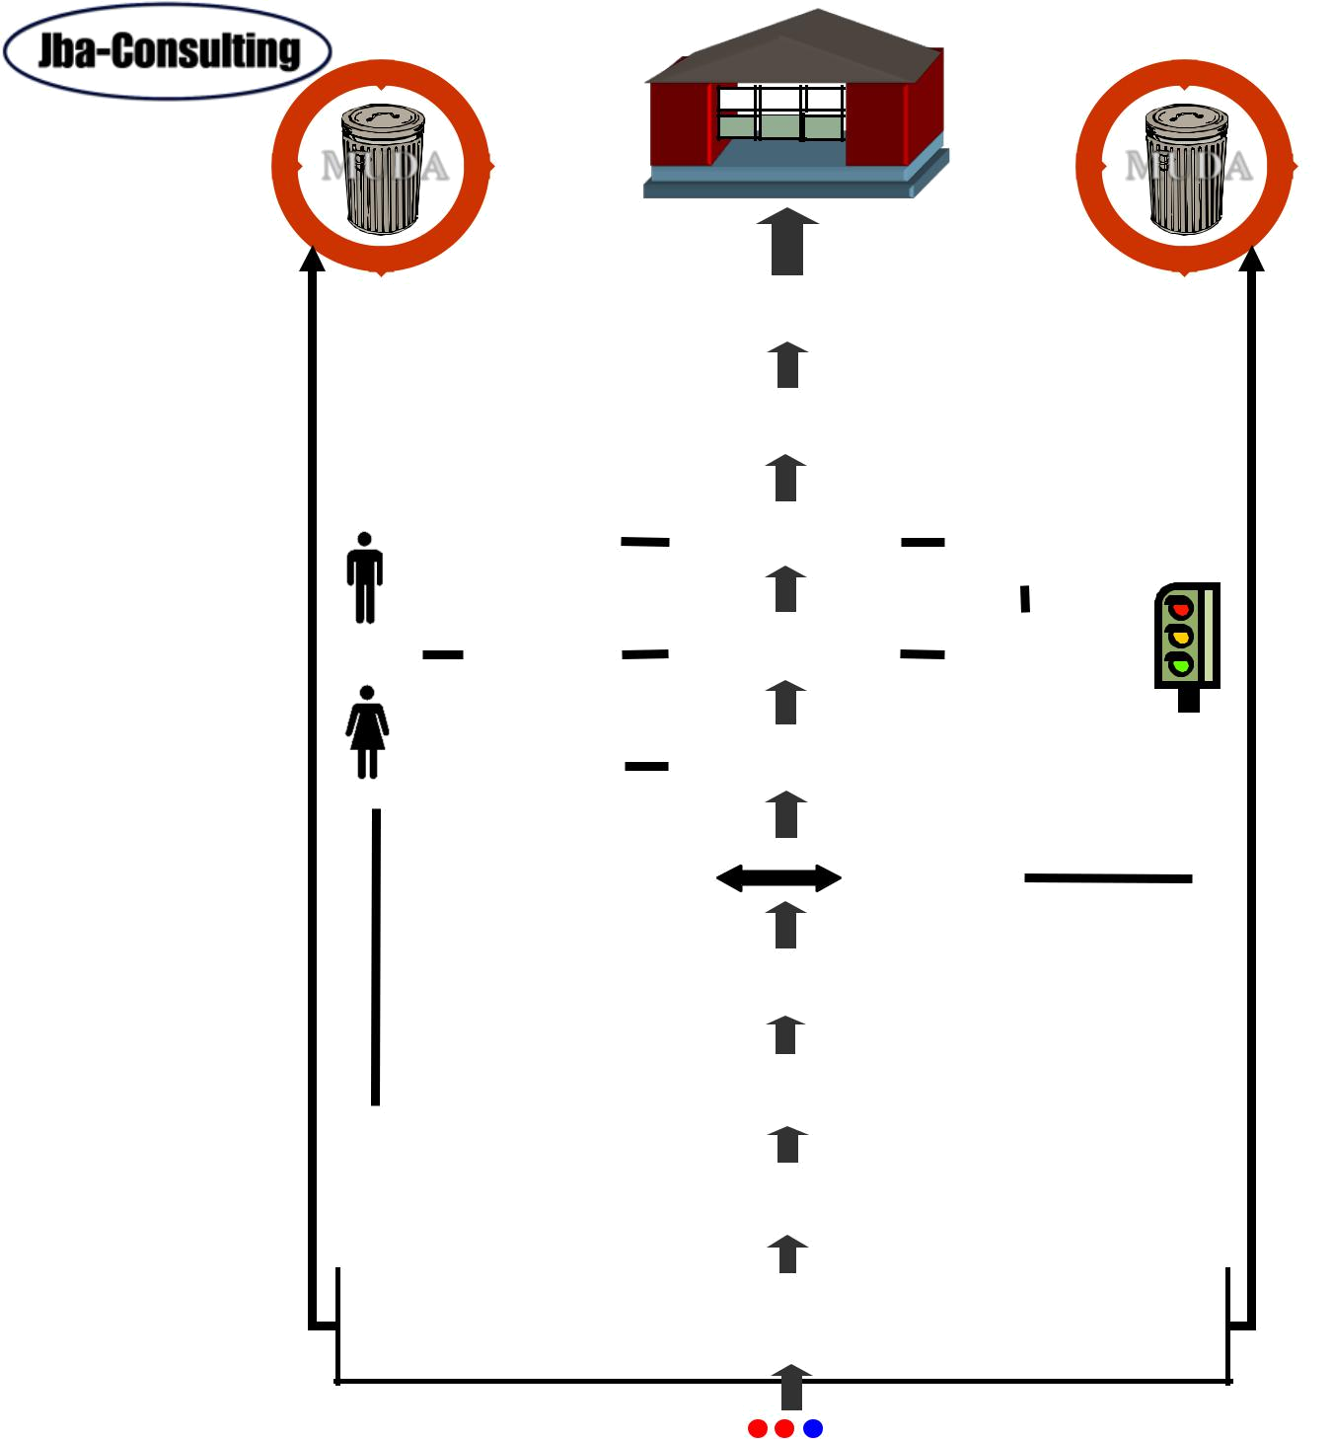  GPS | Mod 9 – Kanban

MUDA 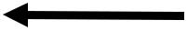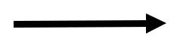 MUDA

 |  | Cost Reduction |  |  |  |  |  |  |  |  |  | Just-in-Time |  |  |  |  |  |  |  |  |  | Profit =
 |  | By Eliminating Waste |  |  |  |  |  |  |  |  |  |  |  |  |  |  |  |  |  |  | Price - Cost
 |  | GPS Depth Study |  |  |  |  |  |  |  | Quality |  |  | CostDelivery |  |  |  |  |  |  |  | TAKT Time Map
 |  |  | NVA/VA- |  |  |  |  |  |  |  |  | Measures
 |  |  |  |  |  |  |  |  |  |  |  |  |  |  |  |  |  |  |  |  | Capacity Tables
 |  | Functions/Mgrs |  |  |  |  |  |  |  | Safety |  |  | Morale
 |  | R |  | Jidoka |  |  |  |  |  |  |  |  | Standard |  |  |  |  |  |  | Total |  |  |  |  | Visual
 |  | e |  | (human |  |  |  |  |  |  |  |  | Operations |  |  |  |  | Productive |  |  |  |  |  |  | Control
 |  | e |  | automation) |  |  |  |  |  |  |  |  | Operations |  |  |  |  | Maintenance
 |  | d
 |  | e
 |  | p |  | Setup Reduction |  |  |  |  |  |  |  |  | Heijunka |  |  |  |  | Poka-yoke
 |  | l |  |  |  |  |  |  |  |  |  |  | Heijunka
 |  | l |  |  |  |  |  |  |  |  |  |  | Heijunka |  |  |  |  | (mistake
 |  | o |  | Changeover |  |  |  |  |  |  |  |  | (Leveling)
 |  | y |  |  |  |  |  |  |  |  |  |  | (Leveling) |  |  |  |  | proofing)
 |  | m
 |  | e |  |  |  |  |  |  |  |  |  |  | Continuous
 |  | n |  | Multi-process |  |  |  |  |  |  |  |  | Continuous |  |  |  |  | Kanban
 |  | t |  | Operations |  |  |  |  |  |  |  |  | Flow |  |  |  |  |  |  |  |  |  |  |  | Andon
 |  |  | RPIW |  |  |  | Kaizen |  |  |  |  |  | Kaikuku |  |  |  |  |  |  |  |  | 3P
 |  |  |  |  |  |  |  |  |  |  |  |  |  |  |  |  |  |  |  |  |  | Prod
 |  |  |  |  |  |  |  |  |  |  |  |  |  |  |  |  |  |  |  |  |  | Prep
 |  |  | 7 Flows |  |  |  | Product/Patient Quantity Analysis |  |  |  |  |  |  |  |  |  |  |  |  |  |  | 7 Flows
 |  |  | Factory |  |  |  |  |  |  |  |  |  |  |  |  |  |  |  |  |  |  | Medicine
 |  |  | 4 No’s |  |  | • Sorting |  |  |  |  |  |  | 5S | • Sweeping |  |  |  |  |  |  |  | 7
 |  |  |  |  |  |  |  |  |  |  |  |  | 5S | • Standardizing
 |  |  |  |  |  | • Simplifying |  |  |  |  |  |  | 5S |  |  |  |  |  |  |  |  | Wastes
 |  |  |  |  |  |  |  |  |  |  |  |  | 5S | • Self Discipline
 |  |  |  |  |  |  | Value Stream Mapping
ONE PIECE FLOW |  |  |  |  |  |  |  |  |  |  |  |  | TAKT TIME |  |  | PULL PRODUCTION

Global Production System

Kanban I Study Version Module 9-A

© 1996-2013, John Black and Associates LLC (modified from Hiroyuki Hirano, Productivity Press).

09 Kanban v20130529

Committed Leaders | 1 | ©1996-2013, John Black and Associates LLC
Committed Leaders |  | Licensed Materials – USA Copyright Laws Apply


Mod 9 – Kanban

Kanban: Key Points

The kanban system keeps information with resources, utilizing visual control and reducing wastes

The main functions of the kanban system are:

- To enable and enhance JIT operations.

- To provide a signaling system .

- To improve and strengthen the delivery of services to the patient.

To effectively introduce kanbans, 5S needs to be done on the area, and processes need to be identified and documented.

The four types of kanban are the ordinary kanban, the signal kanban, the transport kanban, and the purchase kanban.

There are eight rules of kanban use.


09 Kanban v20130529 | 2 | ©1996-2013, John Black and Associates LLC
 |  | Licensed Materials – USA Copyright Laws Apply

Mod 9 – Kanban
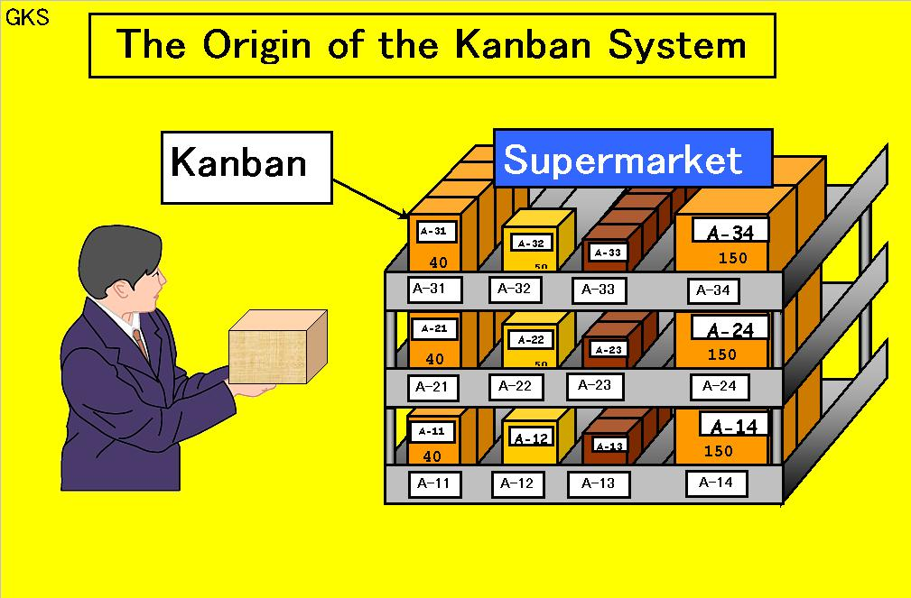

The Kanban System is sometimes referred to as the Supermarket System. At a supermarket, a shopper can get what he needs, in the quantity he needs, at the time he needs it. On the other hand, the supermarket has to stock its shelves with merchandise in such a way that it can cater to the shopper’s needs in whatever quantity at whatever time. The Kanban System is a system in which this supermarket concept is applied to a healthcare service production line. The Kanban System makes clear the function of work-in-process inventory.

09 Kanban v20130529 | 3 | ©1996-2013, John Black and Associates LLC
 |  | Licensed Materials – USA Copyright Laws Apply

Mod 9 – Kanban

The Kanban System

The Kanban System is:

- A tool for effectively implementing the Just-In-Time (JIT) Production System so that what is needed in the quantity you need it is available when and where you need it.

- It is a signaling system that reduces wastes, builds in reliability, and ensures smooth operations.

- A system of control that helps strengthen and improve production efficiency and capability.

- A system that integrates different areas

09 Kanban v20130529 | 4 | ©1996-2013, John Black and Associates LLC
 |  | Licensed Materials – USA Copyright Laws Apply

Mod 9 – Kanban

The Kanban System

This system builds in reliability by regulating the flow of materials, staff and patients.

It regulates without having any patients or staff wait between processes by following the concept that the following process is always the driver, and that nothing the following process does not need should be produced or delivered there.

You need to use a top-down approach in order to introduce the Kanban System into your operations, because it will completely change the organization’s system of control and management of inventory and processes.

09 Kanban v20130529 | 5 | ©1996-2013, John Black and Associates LLC
 |  | Licensed Materials – USA Copyright Laws Apply

Mod 9 – Kanban

The Waste of Defects

Sending defects down the line can cause the following

Muda or waste:

GKS

Muda (waste) produced by defects:

- Inventory between processes.

- Extra space necessary for storing items.

- Extra manpower.

- Extra equipment capacity.

- Extra manpower and equipment to rework rejects.

- Complications in management


09 Kanban v20130529 | 6 | ©1996-2013, John Black and Associates LLC
 |  | Licensed Materials – USA Copyright Laws Apply

Mod 9 – Kanban

The Waste of Defects

Producing defective items is the worst waste because of the combined cost of materials, equipment and labor to turn out something you cannot use.

If a defect is discovered, you have to take action to prevent recurrences.

The Kanban System will collapse unless there are only 100% good quality products flowing through each process.

If a defect is produced, you will have to carry more inventory than necessary between processes.

For example, if one in every three surgical instrument sets has dirty, dull, or an incorrect number of instruments, teams will routinely open two sets to ensure getting a correct set.

More instruments will need to be cleaned, sharpened, sterilized and transported to meet the demand. More surgical instrument inventory is required to keep the process going.

09 Kanban v20130529 | 7 | ©1996-2013, John Black and Associates LLC
 |  | Licensed Materials – USA Copyright Laws Apply

Mod 9 – Kanban

The Pull System
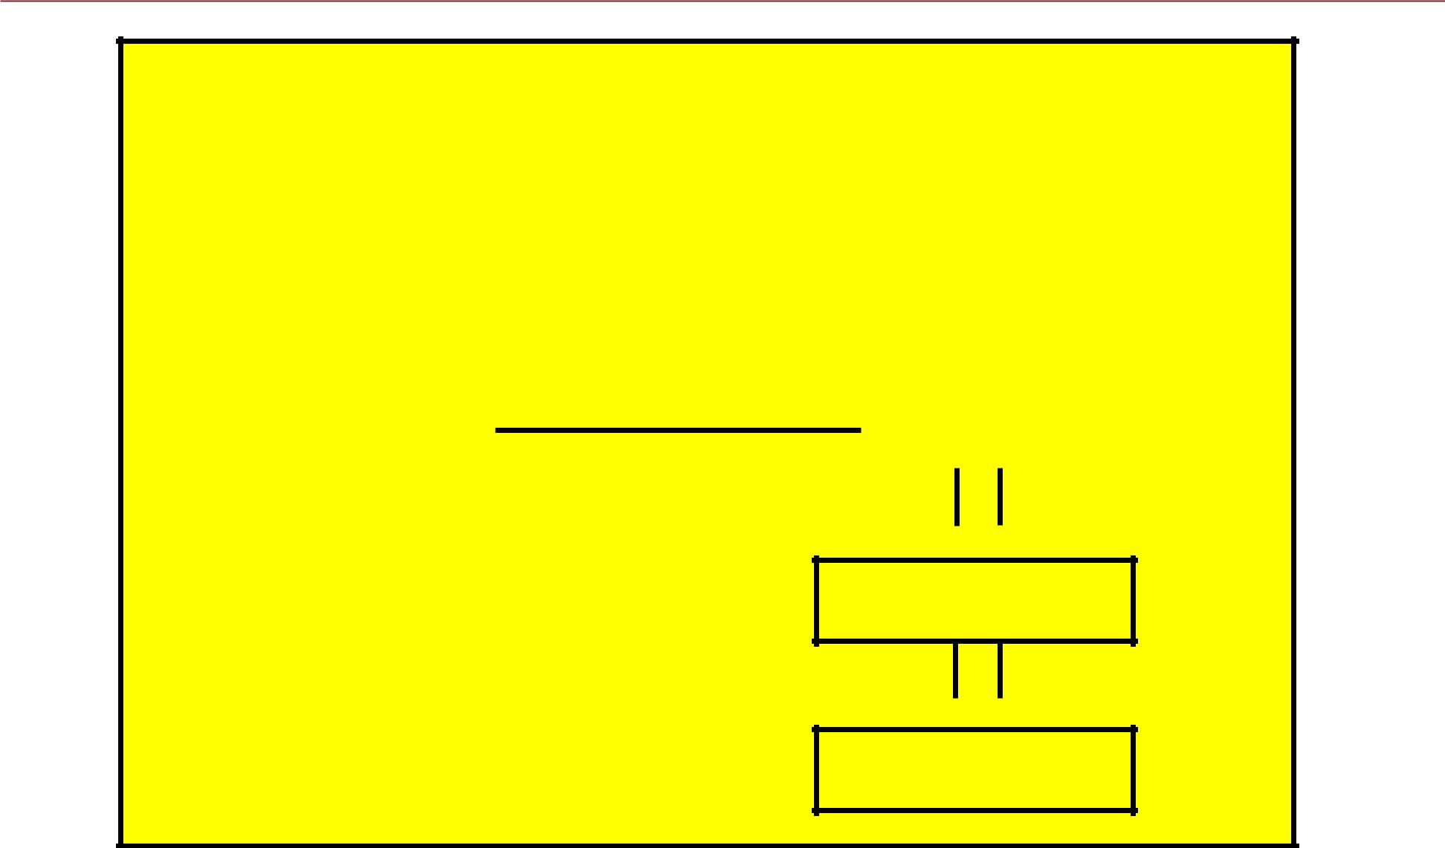

GKS

Just-In-Time Production

1. | Takt Time | Use as tool
2. | One-Piece Flow | Use as tool
2. | One-Piece Flow | Kanban
3. | Pull System | Kanban

What

When

How many

Information

Instruction

09 Kanban v20130529 | 8 | ©1996-2013, John Black and Associates LLC
 |  | Licensed Materials – USA Copyright Laws Apply

Mod 9 – Kanban
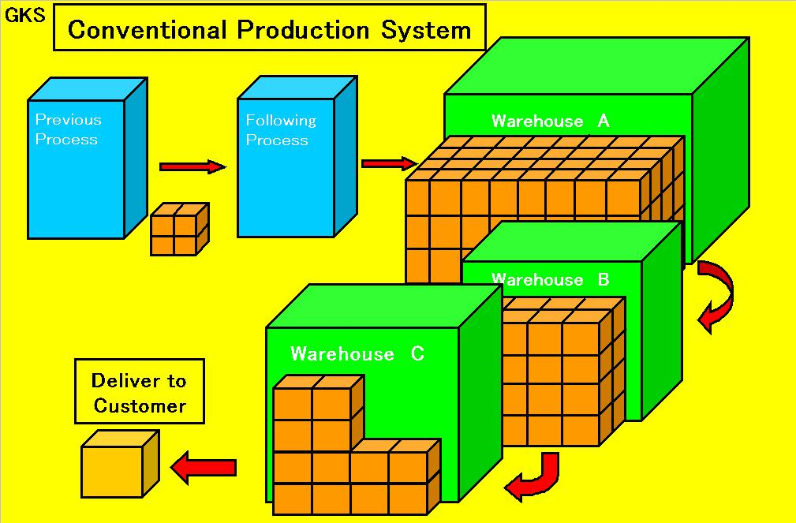

Many problems arise in a conventional production system where the previous process keeps on producing and sending finished pieces over to the following process simply according to a production schedule.

The previous process is producing things that the following process does not need at the moment, without any regard to what is happening at the following process.

In healthcare, patients are often sent from one process to another, such as imaging or lab, where they wait for that process step to be ready for them.

Or many blood draws are completed and either wait on the floor in a batch or at the lab because the lab is not ready to process the samples.

09 Kanban v20130529 | 9 | ©1996-2013, John Black and Associates LLC
 |  | Licensed Materials – USA Copyright Laws Apply

Mod 9 – Kanban

Outcomes of Conventional Production

- An inventory of unneeded parts piles up.

Patients waiting; sterilized surgical instruments waiting to be used; lab samples waiting to be processed.

- The following process cannot produce what it needs to

produce because it does not have the parts it needs.

Samples not delivered to lab on a consistent basis so that staff are waiting between periods of work.

- Deliveries are missed and overtime work has to be carried out

unnecessarily.

Lab samples arrive to be processed in a large batch at the end of the day so staff stay late.

As a result, more problems are created such as:

- Need for additional people and equipment.

- Difficulty in identifying bottlenecks.

- Problems are hidden and not visible.

09 Kanban v20130529 | 10 | ©1996-2013, John Black and Associates LLC
 |  | Licensed Materials – USA Copyright Laws Apply

Mod 9 – Kanban
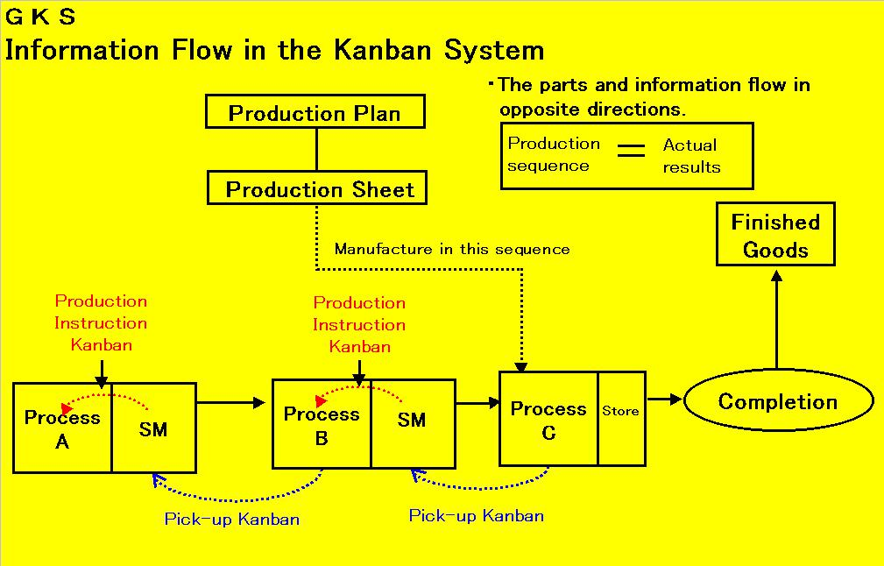

It is important that when using Kanban you pass along accurate information and carry out production according to the needs of the following process. This diagram shows the flow of information and materials under a Kanban system.

09 Kanban v20130529 | 11 | ©1996-2013, John Black and Associates LLC
 |  | Licensed Materials – USA Copyright Laws Apply

Mod 9 – Kanban
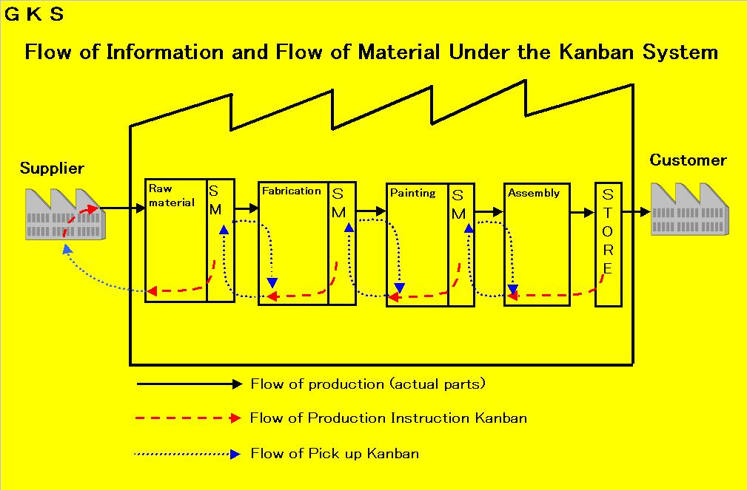

The chain of kanbans and materials spans the whole length from end to end: the customer, the various processes in delivering the healthcare service and the supplier.

09 Kanban v20130529 | 12 | ©1996-2013, John Black and Associates LLC
 |  | Licensed Materials – USA Copyright Laws Apply

Mod 9 – Kanban
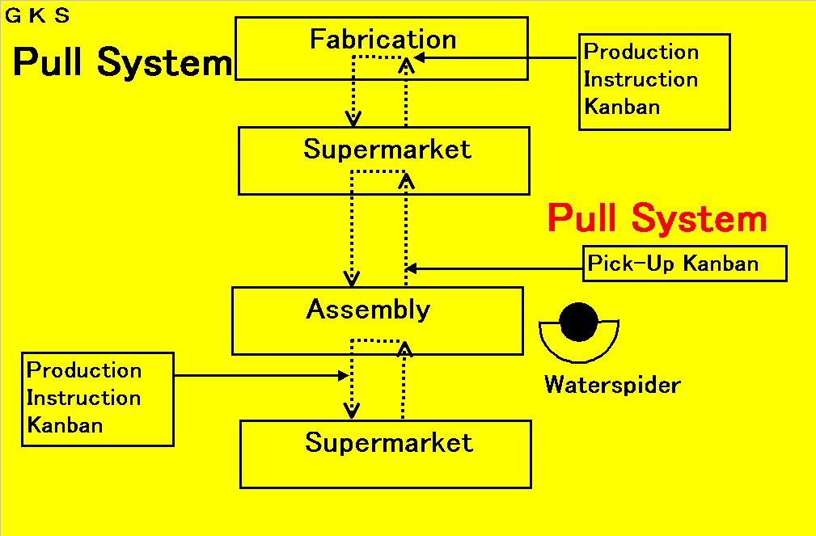

The following process goes to the previous process to fetch what it needs when it needs it. The previous process produces only to replenish what has been withdrawn by the following process.

09 Kanban v20130529 | 13 | ©1996-2013, John Black and Associates LLC
 |  | Licensed Materials – USA Copyright Laws Apply

Mod 9 – Kanban
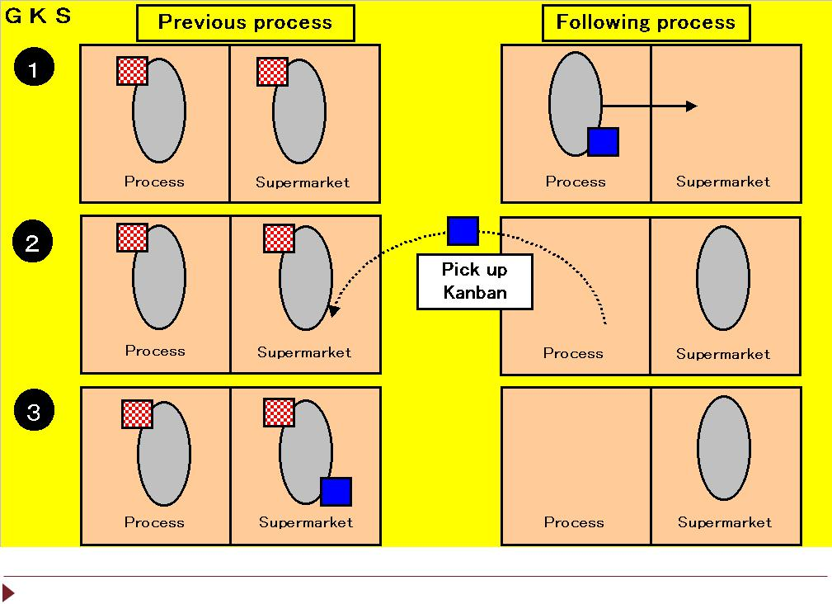

09 Kanban v20130529 | 14 | ©1996-2013, John Black and Associates LLC
 |  | Licensed Materials – USA Copyright Laws Apply

Mod 9 – Kanban

Flow of Kanban

- To indicate which parts the following process needs to pick up, information is attached to the parts in the form of a pick-up kanban.

- When parts are used, the pick-up kanban is removed from the parts container and taken to the previous process.

- At the previous process, information is again used to indicate what has been withdrawn and what needs to be produced (production kanban).

09 Kanban v20130529 | 15 | ©1996-2013, John Black and Associates LLC
 |  | Licensed Materials – USA Copyright Laws Apply

Mod 9 – Kanban

- When parts are withdrawn by a pick-up kanban, the production kanban is removed.

- The production kanban moves to the process. The finished parts that are still at the process move to the supermarket.

- The process begins to produce as many as have been withdrawn by following the instructions as given by the production kanban.
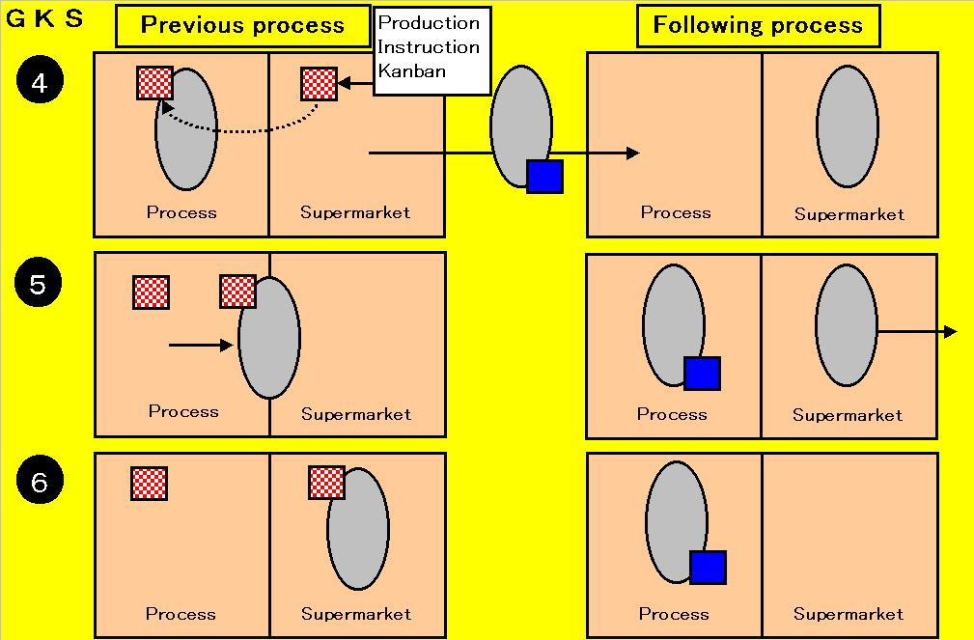

09 Kanban v20130529 | 16 | ©1996-2013, John Black and Associates LLC
 |  | Licensed Materials – USA Copyright Laws Apply

Mod 9 – Kanban

Function of the Kanban System

You need a good understanding of the following three ideas in order to effectively implement the Kanban System:

- How to choose the type of kanban you need.

- How to calculate the number of kanbans needed.

- How to determine where to place the kanban in the process.

09 Kanban v20130529 | 17 | ©1996-2013, John Black and Associates LLC
 |  | Licensed Materials – USA Copyright Laws Apply

Mod 9 – Kanban

Types of Kanban Cards
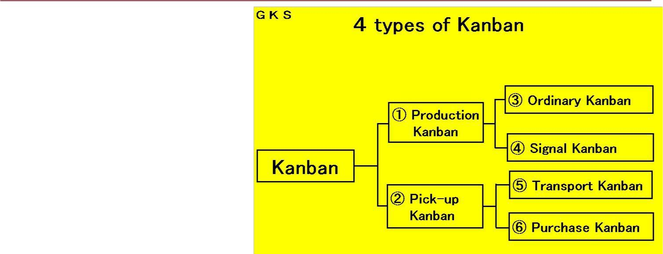

Kanbans can be categorized broadly into two kinds:

Production kanban Pick-up kanban

The production kanban specifies the type of product and quantity the previous process has to produce.

The production kanban can be divided into:

Ordinary kanban.

Signal kanban, depending on the type of the process concerned

09 Kanban v20130529 | 18

The pick-up kanban can be divided into:

Transport kanban

Purchase kanban

©1996-2013, John Black and Associates LLC Licensed Materials – USA Copyright Laws Apply

Mod 9 – Kanban

Ordinary Kanban
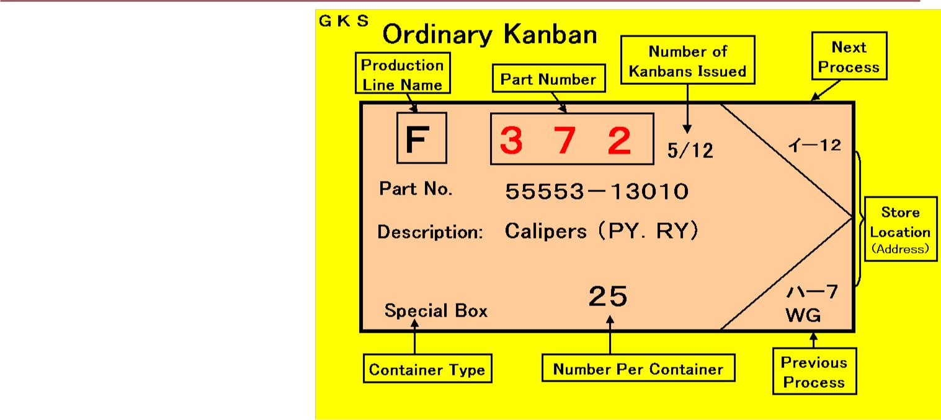

This kanban is used to give an instruction for the process to produce.

This kanban serves as a trigger for the previous process to start producing the same parts in the same quantity and in the same sequence as have been withdrawn for the purpose of replenishment.

09 Kanban v20130529 | 19 | ©1996-2013, John Black and Associates LLC
 |  | Licensed Materials – USA Copyright Laws Apply

Mod 9 – Kanban

UOM = Unit of Measure. Description of how the medication is supplied (i.e., 1 box of 10 vials, 1-30 ml bottle, or 1 syringe, etc)
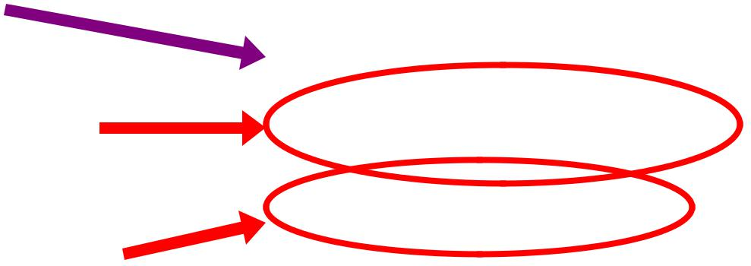

- = Safety Stock. The “buffer” stock on hand behind the kanban card. After the par level is depleted, the safety stock is used until the next shipment arrives.
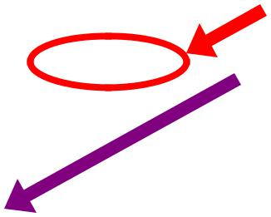

 |  |  | UOM: 1 Box of 10 vials |  |  |  | SS: 2 |  | Sr Loc = Store Room
 |  |  | HEPATITIS B – ENERGIX |  |  |  |  |  | Location. This is utilized
Drug Name |  |  |  |  |  |  |  |  | more often by Material
 |  |  |  |  |  |  |  |  | Services to track where
 |  |  | Fl Loc: SLP-IMFA0103A |  |  | Sr Loc: PHARM |  |  | the inventory is in their
Fl Loc = Floor |  |  |  |  |  |  |  |  | store rooms. For
Location. Where the |  |  | Item#: | Vendor: |  |  | Par: |  | medication purposes it
 |  |  | Item#: |  |  |  |  |  | shows where the
medication is located. |  |  | N/A | GSK |  | 4 boxes
This kanban card |  |  | N/A |  |  |  |  |  | medication originates
shows the med is |  |  |  |  |  |  |  |  | from in the system, in
located at the St. Louis |  |  |  |  |  |  |  |  | this case, the pharmacy.
located at the St. Louis |  |  | Item # = The identifier on a |  | Vendor = The name of
Park clinic (SLP), |  |  | Item # = The identifier on a
Park clinic (SLP), |  |  | Item # = The identifier on a |  |  |  |  | Par = The number of units
Internal Medicine (IM) |  |  | product. Used more often |  | the vendor we usually
Internal Medicine (IM) |  |  | product. Used more often |  |  |  |  | of the item to be ordered
department, |  |  | by Material Services to |  | receive the product
department, |  |  | by Material Services to |  |  |  |  | with each shipment. Par is
refrigerator A (FA), |  |  | track supplies that have the |  | from, if known. If a
refrigerator A (FA), |  |  | track supplies that have the |  |  |  |  | determined after knowing
shelf 1 (01), third bin |  |  | same ordering number |  | generic is utilized where
shelf 1 (01), third bin |  |  | same ordering number |  |  |  |  | usage history and delivery
(03), section A of the |  |  | regardless of lot (such as |  | more than one vendor
(03), section A of the |  |  | regardless of lot (such as |  |  |  |  | cycle status. It can fluctuate
bin (A). |  |  | latex gloves). Perishable |  | could be our supplier
bin (A). |  |  | latex gloves). Perishable |  |  |  |  | with seasonal medications
 |  |  | items like medications do |  | (based on cost), use the
 |  |  | items like medications do |  |  |  |  | such as flu vaccine.
 |  | not have the same number |  |  | vendor “Generic”.
 |  | every order cycle.
Park Nicollet Health Services/Used with Permission
09 Kanban v20130529 |  |  |  | 20 |  |  |  | ©1996-2013, John Black and Associates LLC
 |  |  |  |  |  |  |  | Licensed Materials – USA Copyright Laws Apply




Mod 9 – Kanban
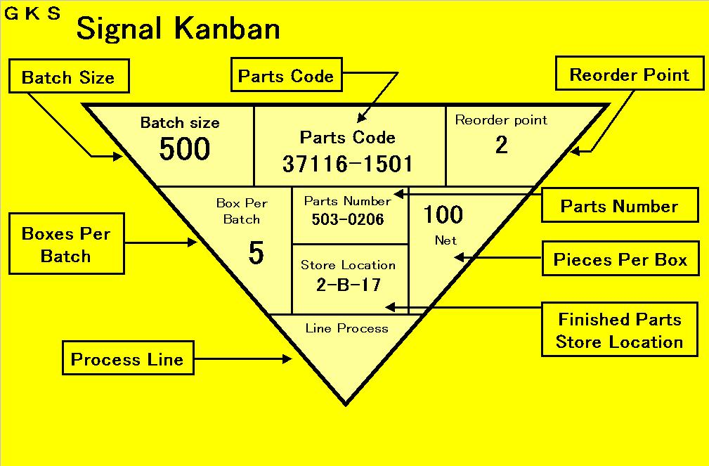

This is the type of kanban that is used as a production trigger for a process, a line, or a machine where many different kinds of items are produced in batches requiring changeovers that take certain amounts of time.

09 Kanban v20130529 | 21 | ©1996-2013, John Black and Associates LLC
 |  | Licensed Materials – USA Copyright Laws Apply

Mod 9 – Kanban

Signal Kanban
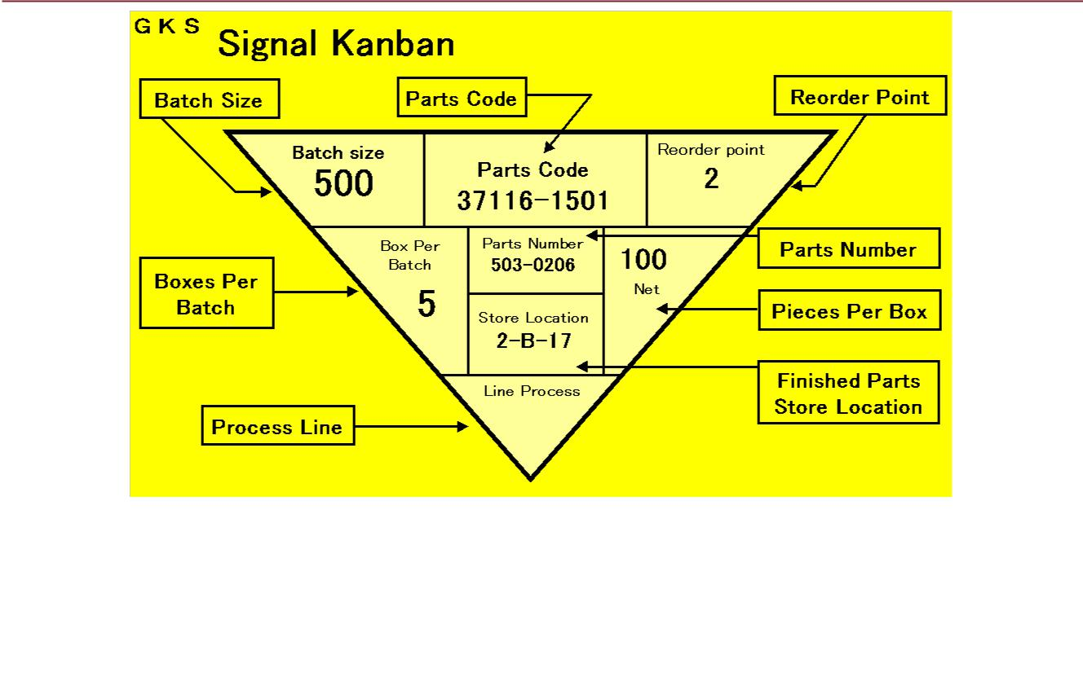

This is the type of kanban that is used as a production trigger for a process, a line, or a machine where many different kinds of items are produced in batches requiring changeovers that take certain amounts of time.

09 Kanban v20130529 | 22 | ©1996-2013, John Black and Associates LLC
 |  | Licensed Materials – USA Copyright Laws Apply

The Reorder Point of the | Mod 9 – Kanban
Signal Kanban

The signal kanban reorder point is a key element.
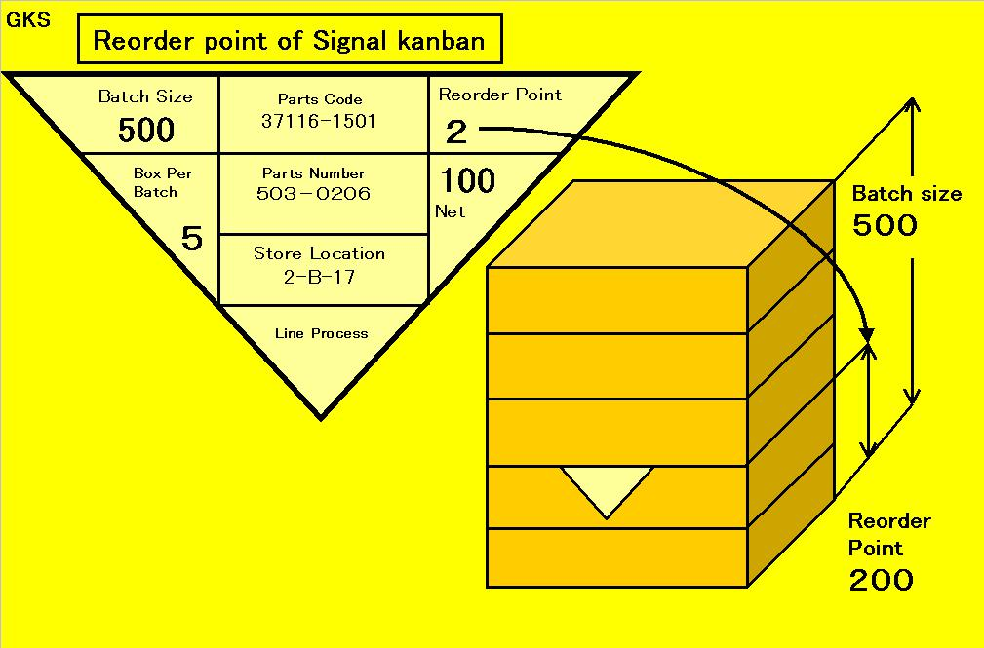

It is essential to minimize the reorder quantity by continuously working to reduce the changeover time through kaizen.

It is important to stay focused on reducing the batch size to a minimum by continuous kaizen so that you can save on the space that is required to accommodate racks, palettes, containers, etc.

09 Kanban v20130529 | 23 | ©1996-2013, John Black and Associates LLC
 |  | Licensed Materials – USA Copyright Laws Apply

Mod 9 – Kanban

Transport Kanban
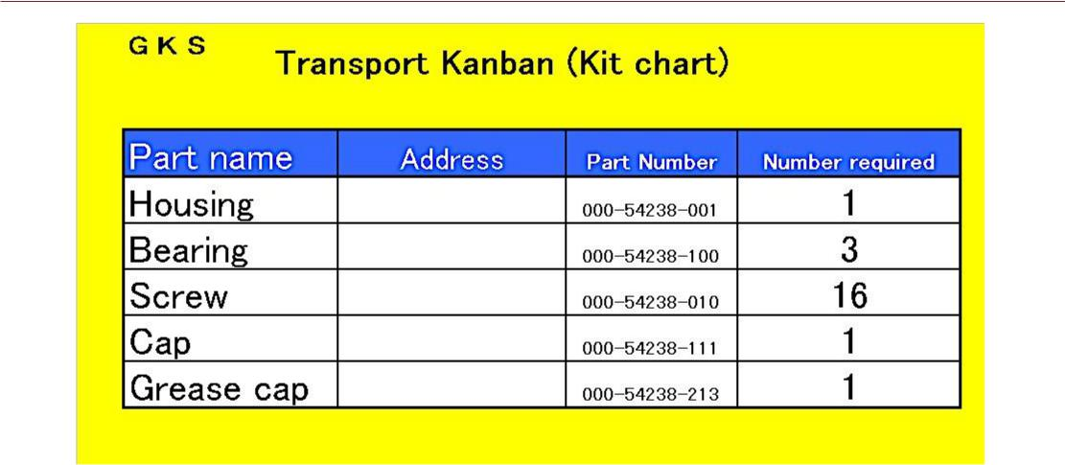

This kanban is used when you have to collect many different parts from different preceding processes rather than pick up work-in-process as it

comes off a process line.

The transport kanban serves as the instructions for the collection step.

09 Kanban v20130529 | 24 | ©1996-2013, John Black and Associates LLC
 |  | Licensed Materials – USA Copyright Laws Apply

Mod 9 – Kanban

Purchase Kanban
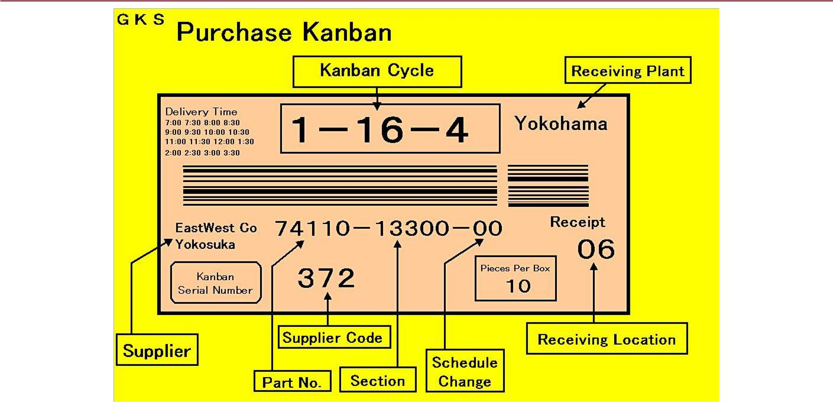

This kanban is used for delivering outsourced parts.

It serves a similar purpose as the transport kanban.

The difference is in this case the previous process is an outside vendor.

09 Kanban v20130529 | 25 | ©1996-2013, John Black and Associates LLC
 |  | Licensed Materials – USA Copyright Laws Apply

Mod 9 – Kanban

Kanban Cycle

The kanban cycle is shown on the face of the purchase kanban (the kanban for delivering outsourced parts).

It refers to the part’s delivery frequency (how many deliveries in how many days) as well as the length of the interval between the deliveries.

The kanban is picked up, and the time the parts are actually delivered is expressed in terms of the number of intervening deliveries.
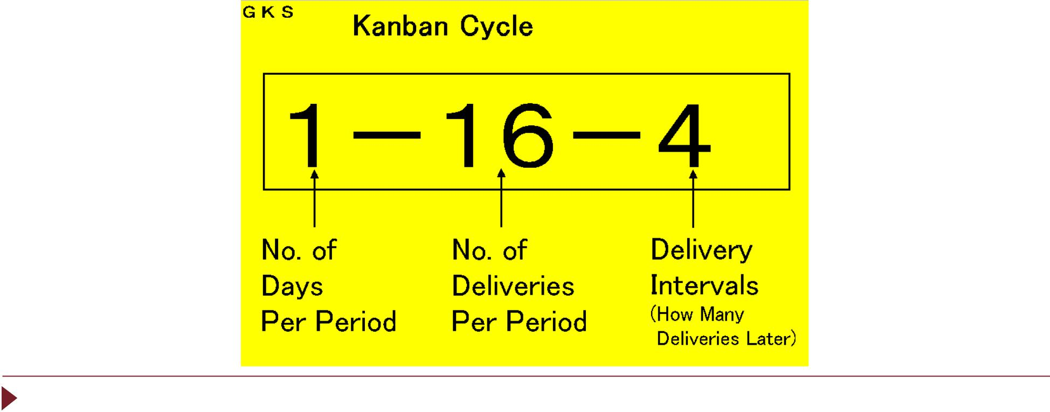

09 Kanban v20130529 | 26 | ©1996-2013, John Black and Associates LLC
 |  | Licensed Materials – USA Copyright Laws Apply

Mod 9 – Kanban


How to Determine the Number of KANBAN to be Issued

(General Rule)


Number of KANBAN used at Scheduled Time

in Unscheduled Quantity

Number of | = | Day’s Requirement (in Pieces) | x ( A x | 1 + C | +α | )
KANBAN |  |  | x ( A x |  | +α | )
KANBAN |  | The Number of Pieces | x ( A x | B | +α | )
 |  | per Container

- = Number of Days Delivered (How many days?)

- = Number of Deliveries (How many deliveries?)

- = Delivery Intervals (So far how many times?)

Note: Always try to reduce the lot size, depending on the level of remaining in-process stock.

09 Kanban v20130529 | 27 | ©1996-2013, John Black and Associates LLC
 |  | Licensed Materials – USA Copyright Laws Apply

Mod 9 – Kanban

Japanese Factory Kanban
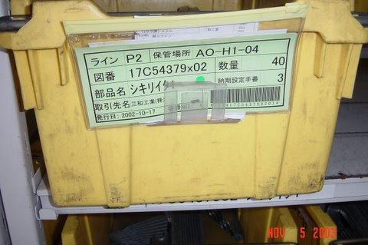

 |  | Source: Shingijutsu Co, Ltd.
09 Kanban v20130529 | 28 | ©1996-2013, John Black and Associates LLC
 |  | Licensed Materials – USA Copyright Laws Apply

Medication Kanban
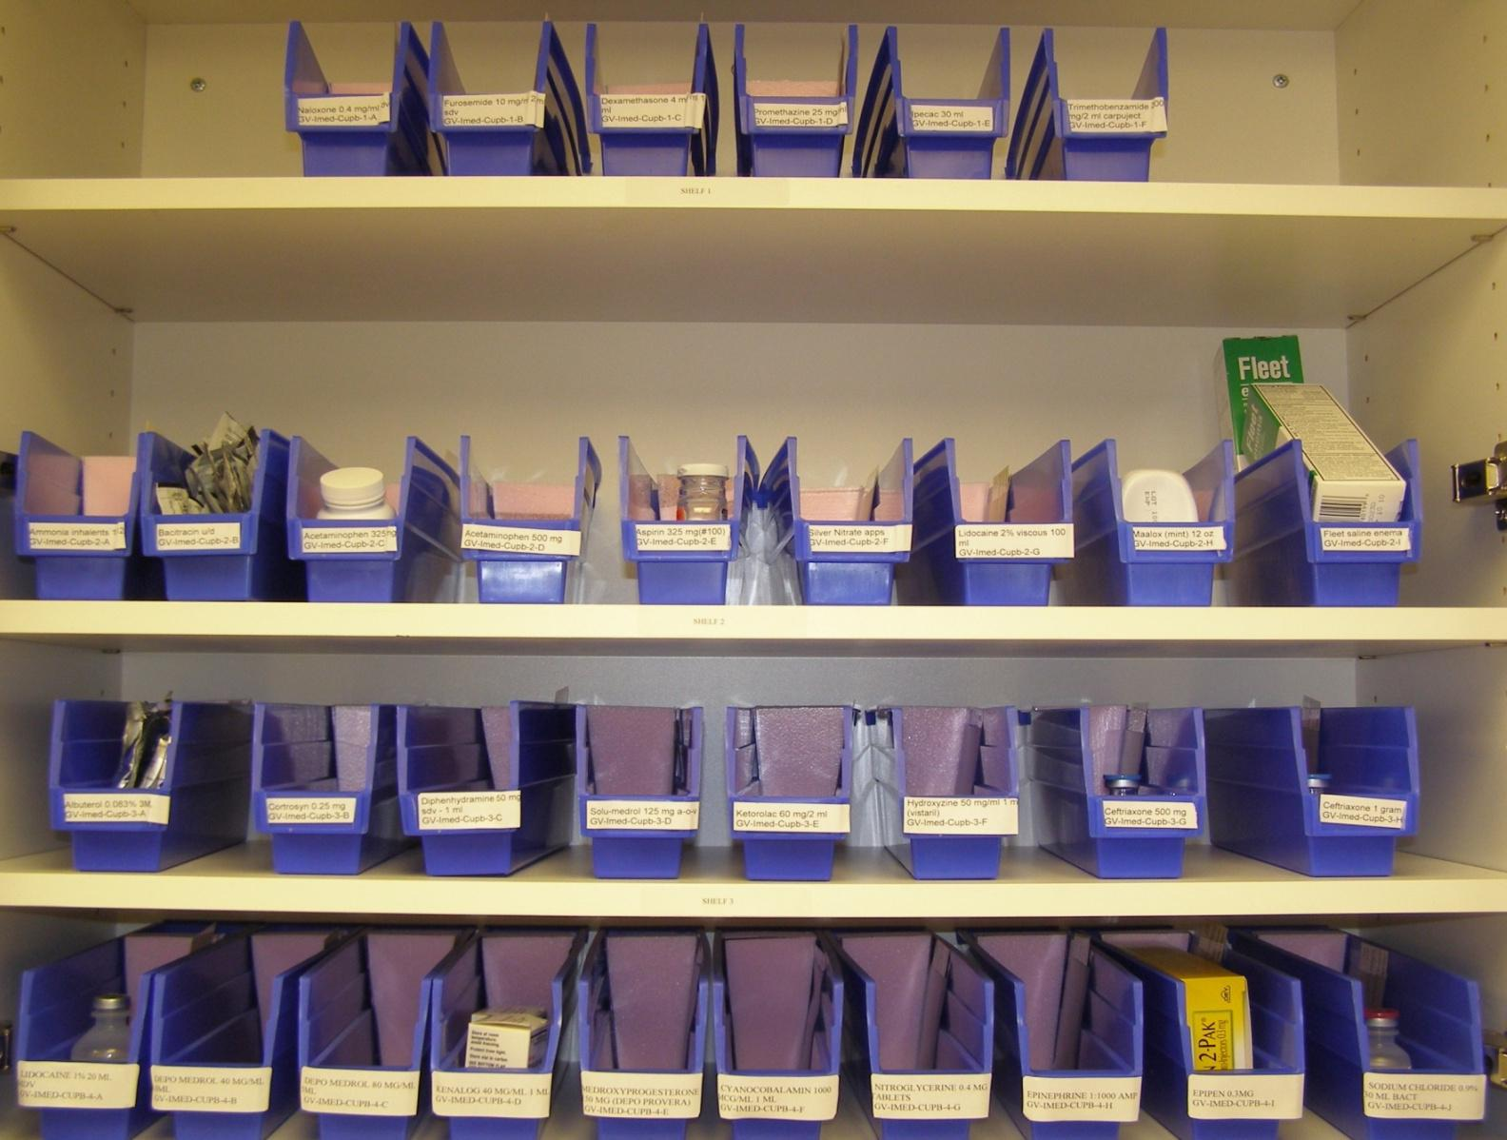

Mod 9 – Kanban

 |  | Park Nicollet Health Services/Used with Permission
09 Kanban v20130529 | 29 | ©1996-2013, John Black and Associates LLC
 |  | Licensed Materials – USA Copyright Laws Apply

Kanban Two-Bin System Mod 9 – Kanban
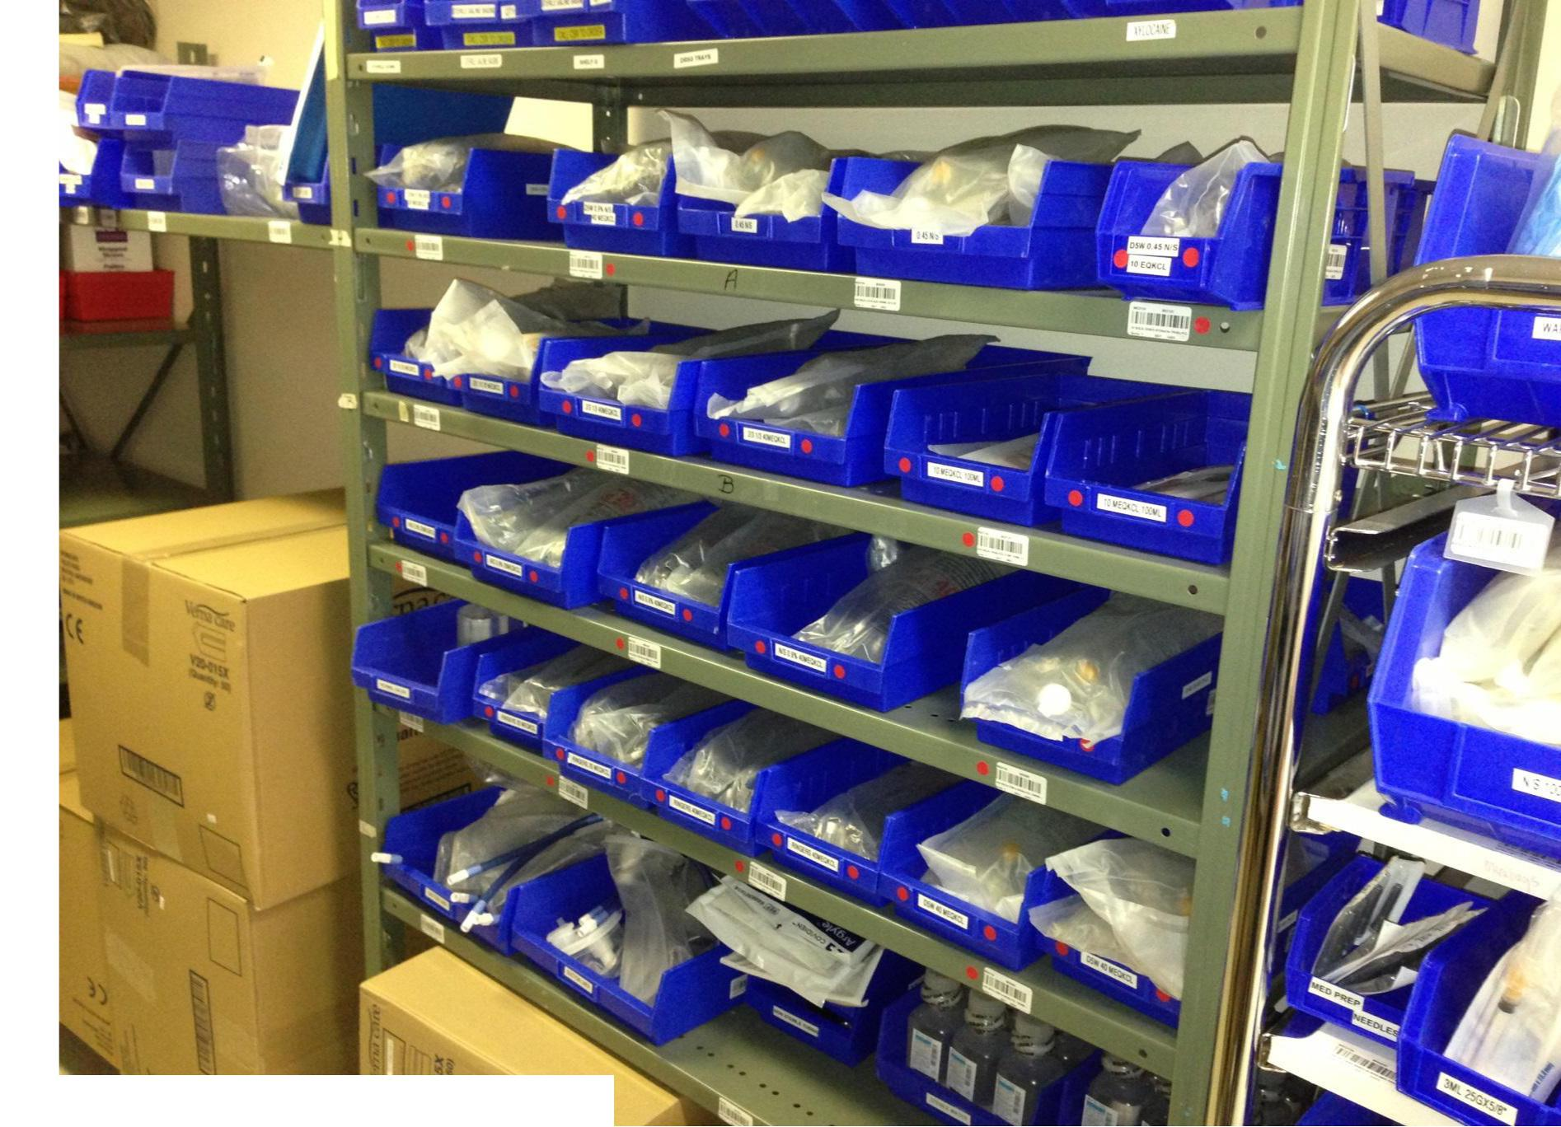

Five Hills Health Region/Used with Permission

09 Kanban v20130529 | 30 | ©1996-2013, John Black and Associates LLC
 |  | Licensed Materials – USA Copyright Laws Apply

Kanban Two-Bin System Mod 9 – Kanban
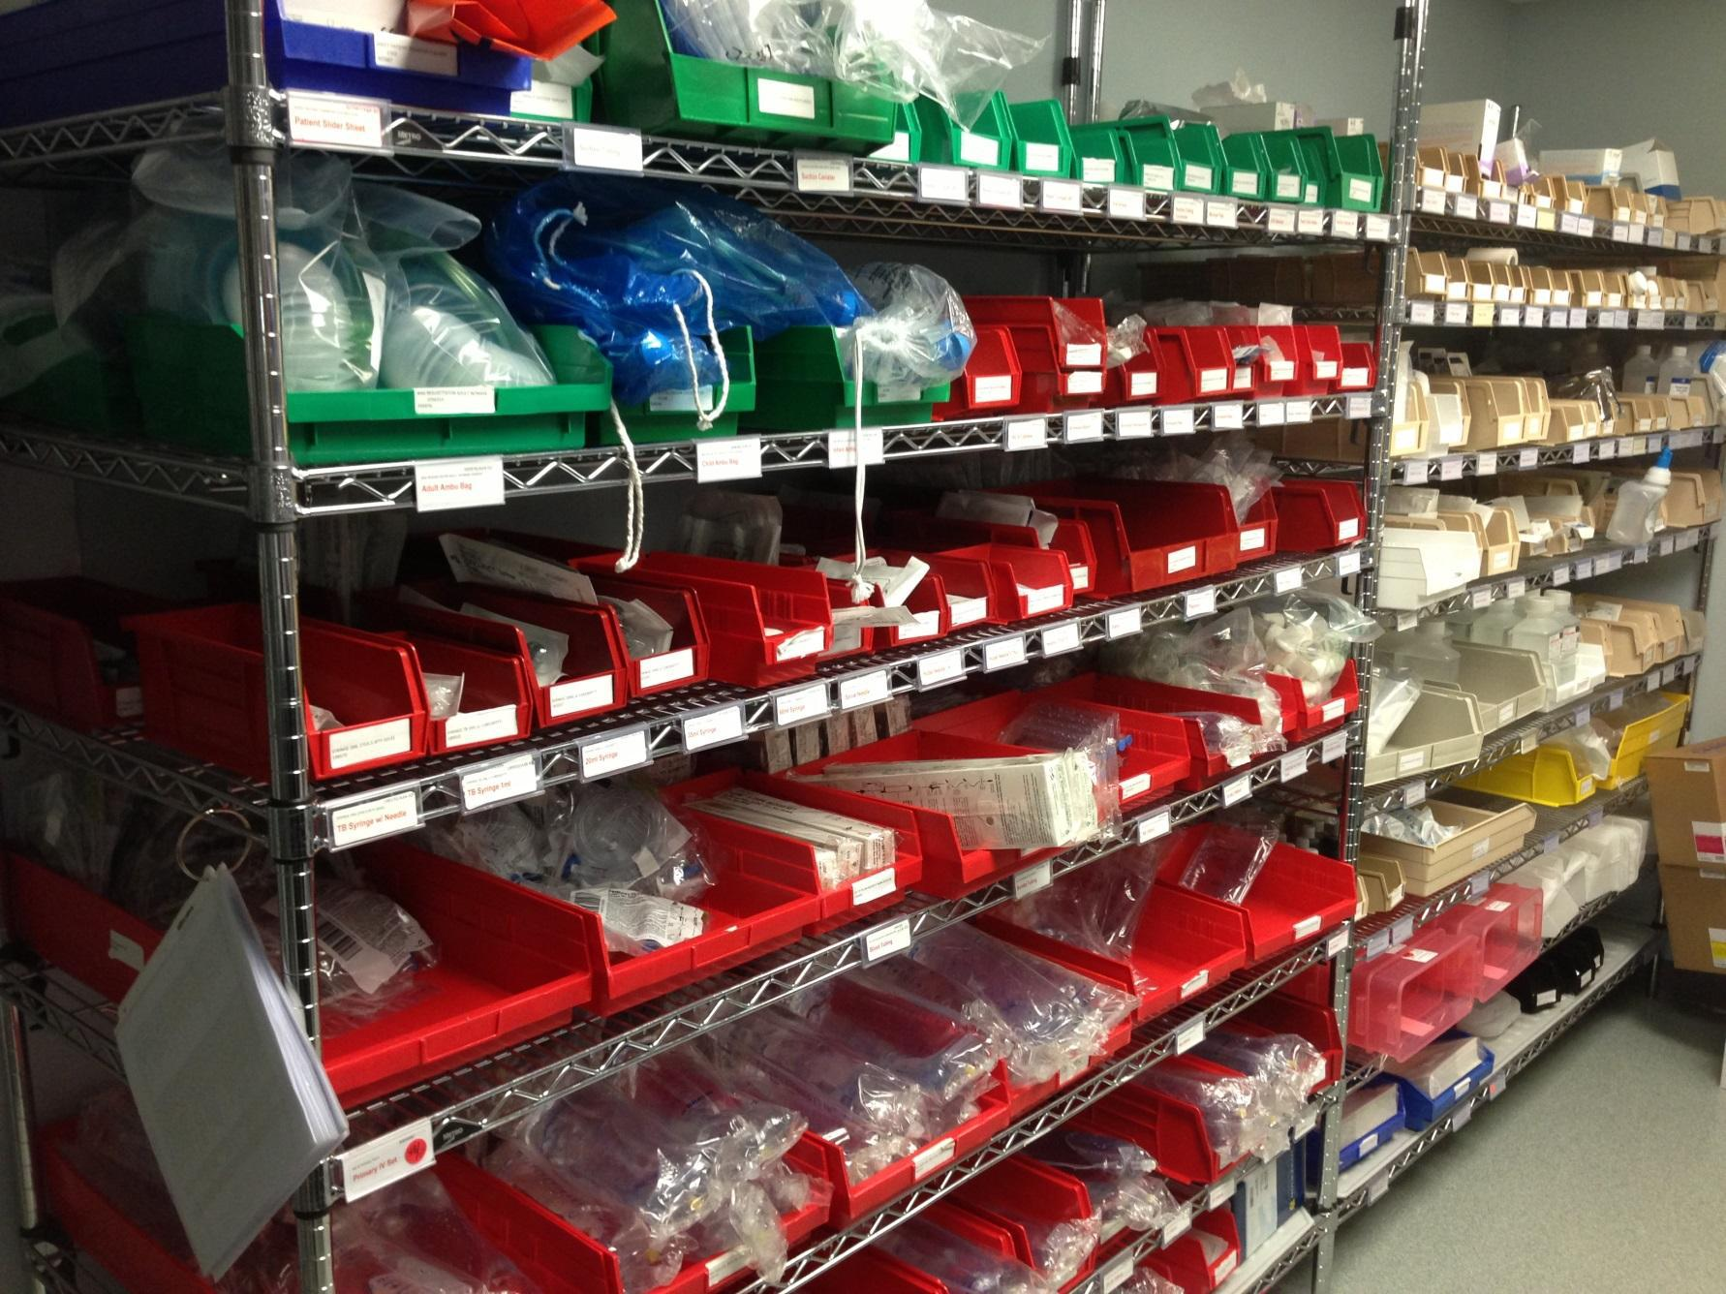

 |  | Florida Hospital Zephyrhills/Used with Permission
09 Kanban v20130529 | 31 | ©1996-2013, John Black and Associates LLC
 |  | Licensed Materials – USA Copyright Laws Apply

OR Kanban
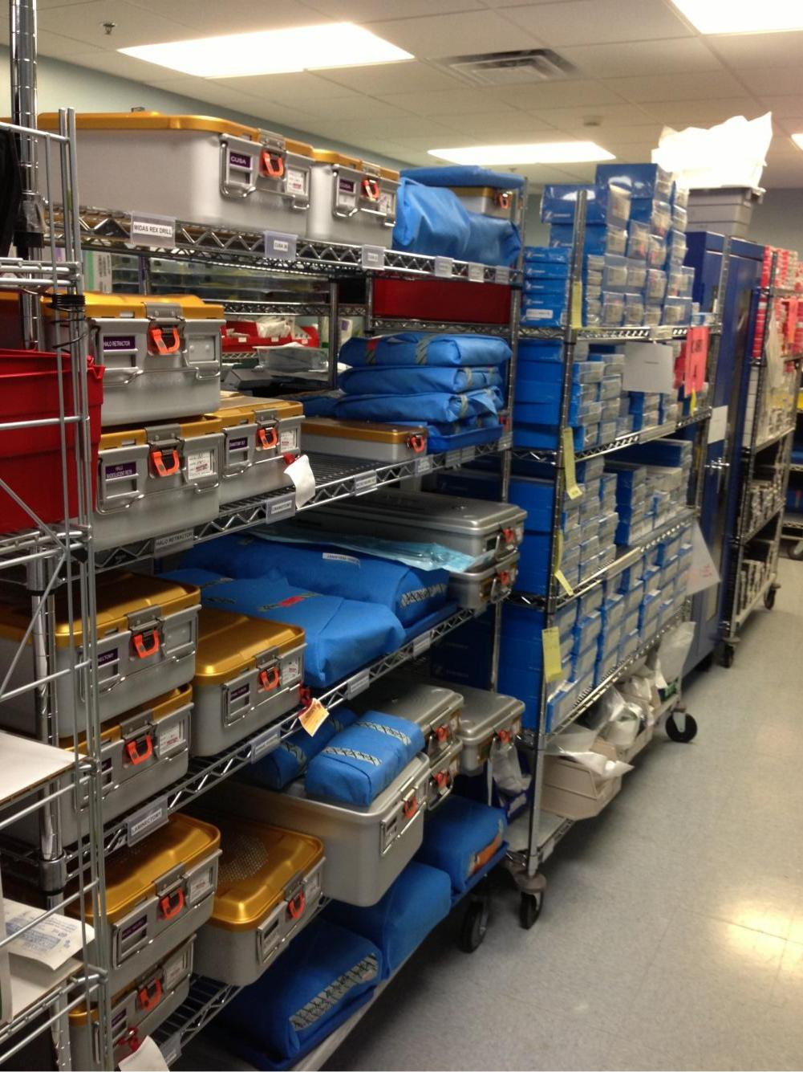

Mod 9 – Kanban

 |  | Florida Hospital Zephyrhills/Used with Permission
09 Kanban v20130529 | 32 | ©1996-2013, John Black and Associates LLC
 |  | Licensed Materials – USA Copyright Laws Apply

Standard Work for Ordering

OR Supplies
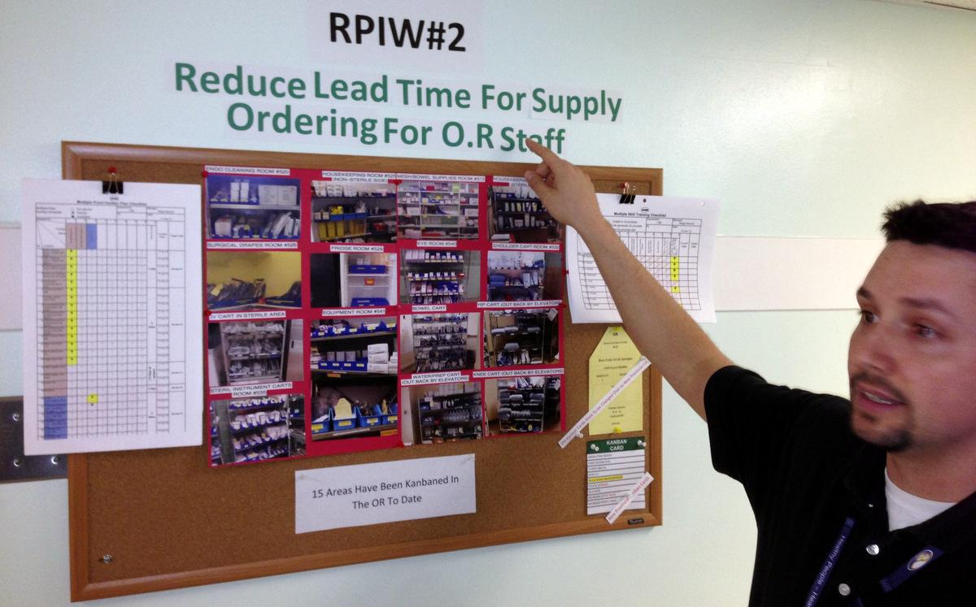

Mod 9 – Kanban

 |  | Five Hills Health Region/Used with Permission
09 Kanban v20130529 | 33 | ©1996-2013, John Black and Associates LLC
 |  | Licensed Materials – USA Copyright Laws Apply

Multiple Point Kanban Plan

Checklist
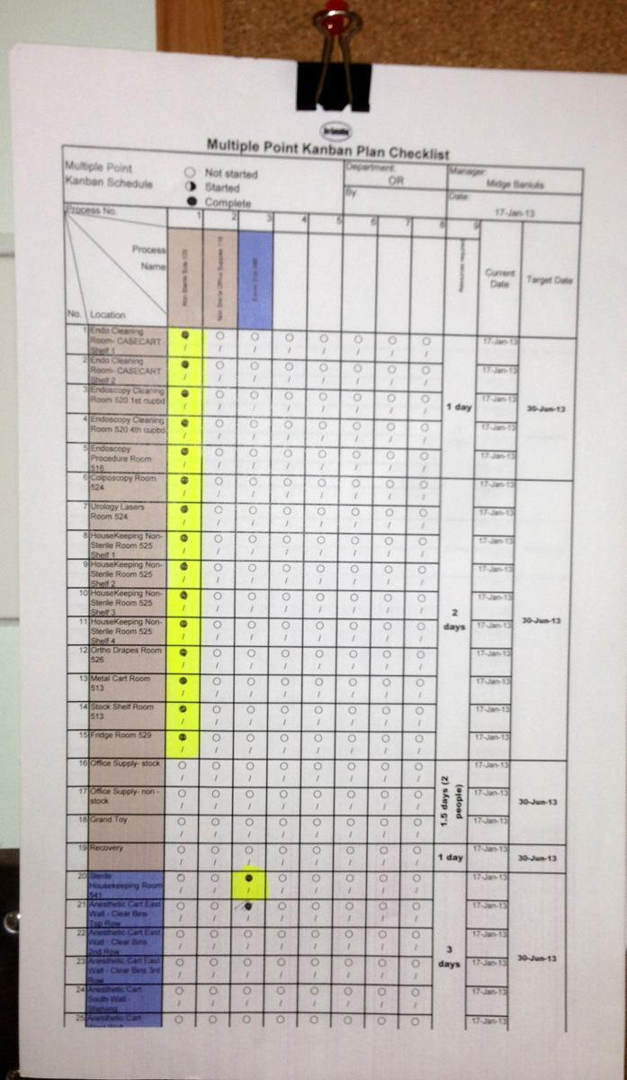

Mod 9 – Kanban

 |  | Five Hills Health Region/Used with Permission
09 Kanban v20130529 | 34 | ©1996-2013, John Black and Associates LLC
 |  | Licensed Materials – USA Copyright Laws Apply

Multiple Skill Training Checklist
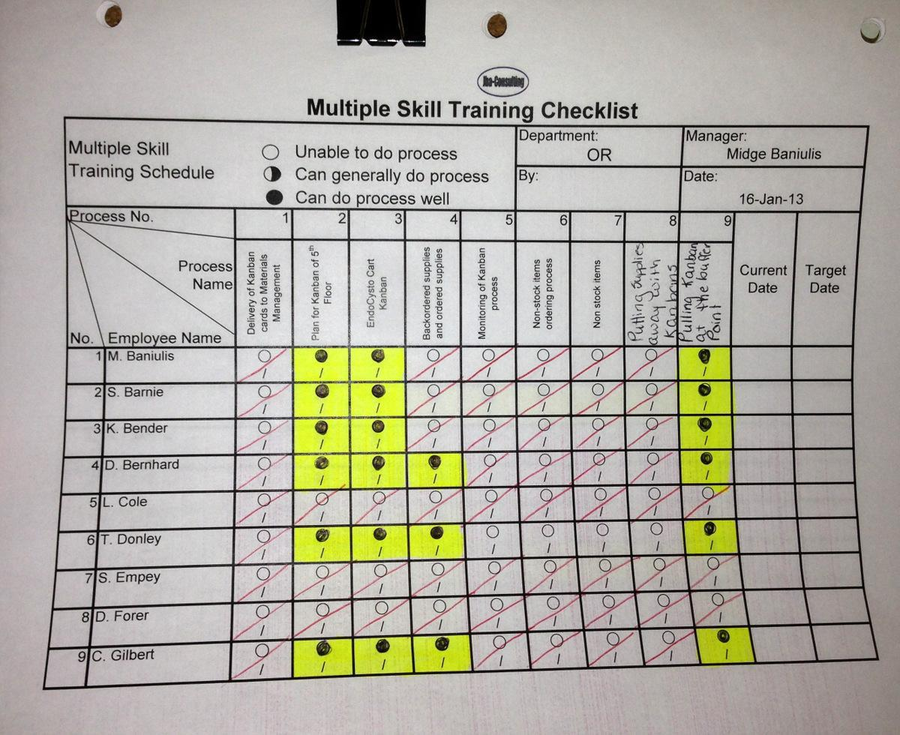

Mod 9 – Kanban

 |  | Five Hills Health Region/Used with Permission
09 Kanban v20130529 | 35 | ©1996-2013, John Black and Associates LLC
 |  | Licensed Materials – USA Copyright Laws Apply

Mod 9 – Kanban

How to Install Kanbans
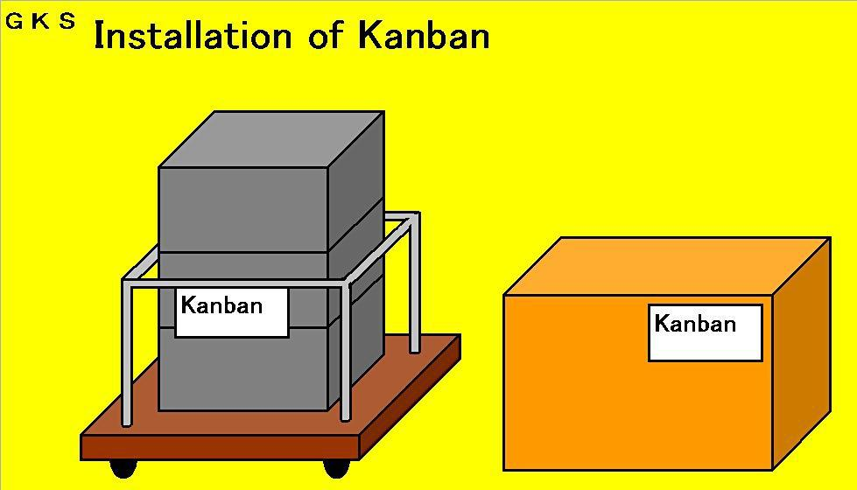

When you implement a kanban system, you affix kanban cards to those products and parts that get moved.

However, you do not attach a kanban to every one. In principle, you

assign one kanban card to one unit of movement for one kind of product or part that gets moved through the processes.

For example, you attach one kanban card to one pallet, one cart or one recyclable container box.

09 Kanban v20130529 | 36 | ©1996-2013, John Black and Associates LLC
 |  | Licensed Materials – USA Copyright Laws Apply

Mod 9 – Kanban

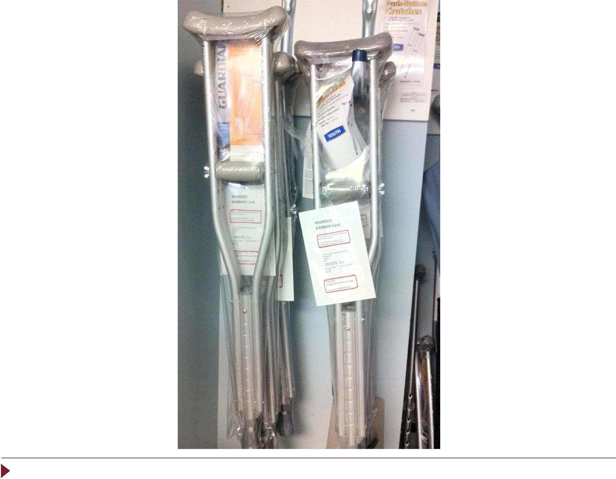

09 Kanban v20130529 | 37 | ©1996-2013, John Black and Associates LLC
 |  | Licensed Materials – USA Copyright Laws Apply

Mod 9 – Kanban
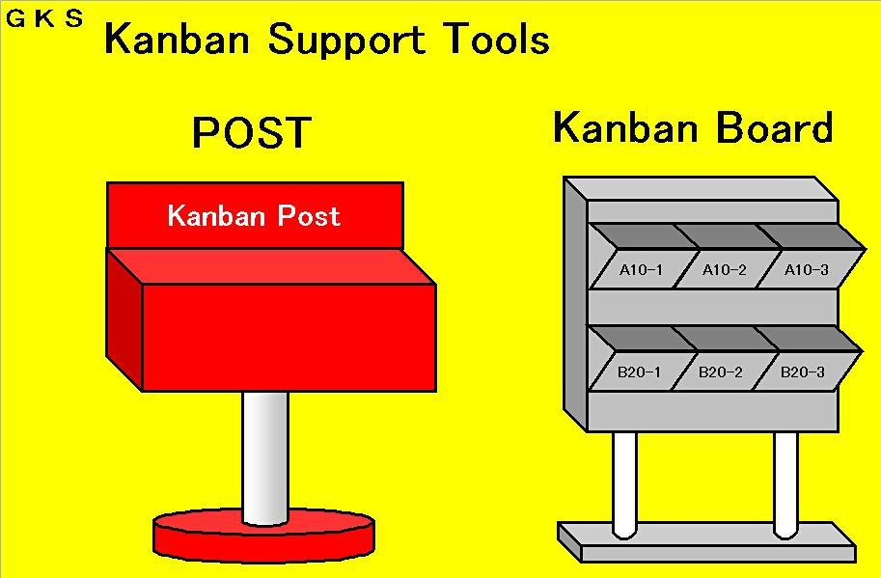

This picture shows some tools necessary for implementing a kanban system.

- The kanban post is a box where removed and collected kanban cards are kept temporarily.

- The kanban board is a tool for placing kanbans collected from the kanban post in a well-organized way, and for giving work instructions.

09 Kanban v20130529 | 38 | ©1996-2013, John Black and Associates LLC
 |  | Licensed Materials – USA Copyright Laws Apply

Mod 9 – Kanban
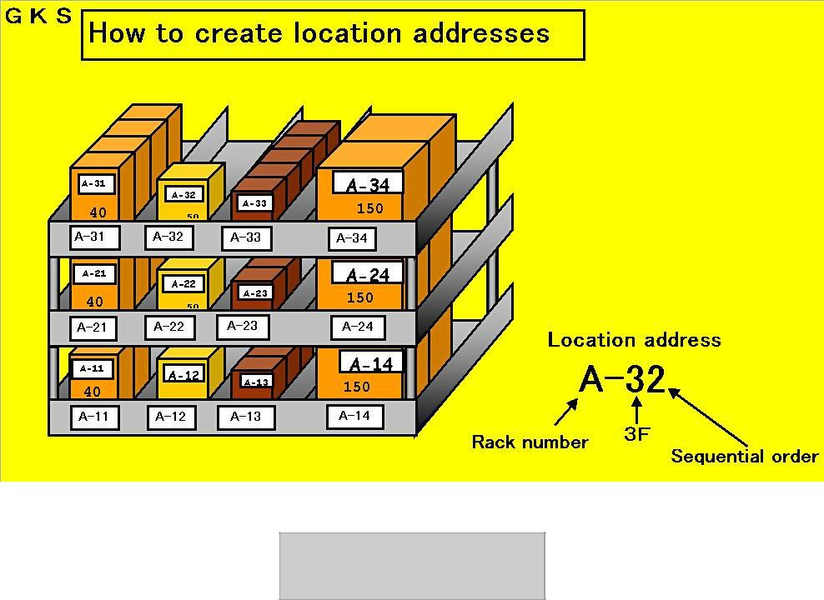

Rack Number A

 | A-31 | A-32 |  | A-33 | A-34
 | A-21 | A-22 |  | A-23 | A-24
 | A-11 | A-12 |  | A-13 | A-14
09 Kanban v20130529 |  |  | 39 |  | ©1996-2013, John Black and Associates LLC
 |  |  |  |  | Licensed Materials – USA Copyright Laws Apply

Mod 9 – Kanban
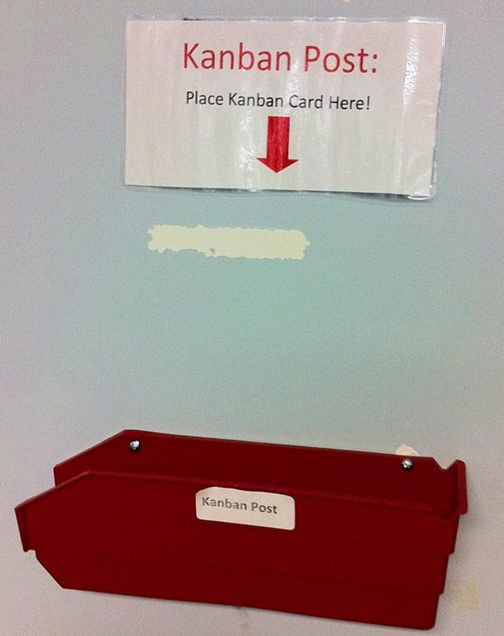

 |  | Florida Hospital Zephyrhills/Used with Permission
09 Kanban v20130529 | 40 | ©1996-2013, John Black and Associates LLC
 |  | Licensed Materials – USA Copyright Laws Apply

Mod 9 – Kanban

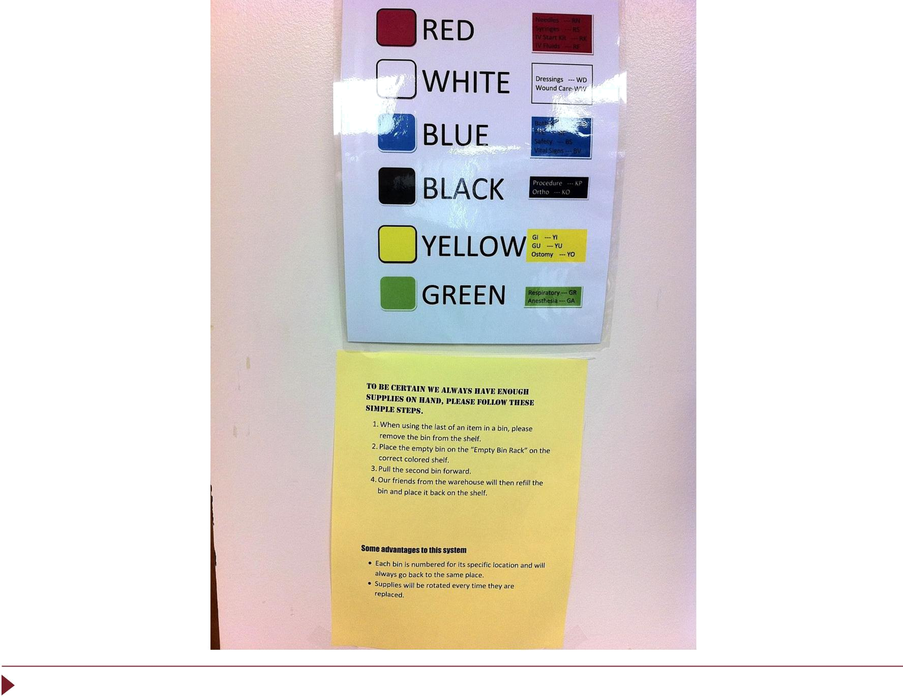

09 Kanban v20130529 | 41 | ©1996-2013, John Black and Associates LLC
 |  | Licensed Materials – USA Copyright Laws Apply

Mod 9 – Kanban

The Rules of Kanban Use

- A kanban must always be attached to a real, physical object.

- When you pick the first piece from the box, remove the kanban and put it in the kanban post.

- Have a designated person collect kanbans from the kanban post.

- Produce in the same sequence as the kanban were removed.

- All the operations must be carried out according to the kanbans.

- The kanbans must not be lost.

- Whenever there is a significant change in production, review the status of kanban in circulation.

- Take inventory of the kanbans at least once a month.

It requires great effort to observe these eight rules. However, if you try to implement a kanban system without adhering to these rules, the kanban will not bring about the desired benefits nor can you promote just-in-time production. Observation of the rules is essential to achieve all the benefits of the kanban system.

09 Kanban v20130529 | 42 | ©1996-2013, John Black and Associates LLC
 |  | Licensed Materials – USA Copyright Laws Apply

Mod 9 – Kanban

Use of Kanban and the Water Strider

The key principle of the kanban system is for the following process to go to the previous process to withdraw parts. Therefore, it is necessary to transport parts at short, frequent intervals.

The person who is acting as a mizusumashi, or “water strider,” is not simply a material handler but also an information carrier.

09 Kanban v20130529 | 43 | ©1996-2013, John Black and Associates LLC
 |  | Licensed Materials – USA Copyright Laws Apply

Mod 9 – Kanban

Mizusumashi (Water Strider)


“Mizusumashi” in Japanese is an insect that skates about swiftly on the water surface of a pond or stream. It can change directions quickly and then continue to move on.

GKS

The purpose of Water Strider Operations

The work of Water Strider (characterized by frequent pulls) is to supply to multiple processes all the necessary parts in kits (that make up finished products) on a Just-In-Time basis using Pick-Up Kanbans. The person who performs this task is called mizusumashi, or water strider.

Something analogous to this movement is carried out on the clinic or hospital floor. Let us think for a moment about the work of a water
strider.

You need to pay attention to the following three points in conducting water spider operations:
- Purpose

- Prerequisites
- Setting up a routine.

09 Kanban v20130529 | 44 | ©1996-2013, John Black and Associates LLC
 |  | Licensed Materials – USA Copyright Laws Apply

Mod 9 – Kanban

The Prerequisites of Water Strider Operations

You need to satisfy the following prerequisite conditions to build an effective Water Strider system.

GKS

Prerequisites for Water Strider

- Secure space and build a store equipped with racks and shelves.

- Build a Water Strider picking cart.

- Set a format for the picking list and develop a system for creating picking lists.

- Install Andons if possible.

- Picking in kits according to Takt Time is the principle.

- Should have the skills and experience to be a candidate for promotion to team leader.

09 Kanban v20130529 | 45 | ©1996-2013, John Black and Associates LLC
 |  | Licensed Materials – USA Copyright Laws Apply

Setting Up a Routine for the | Mod 9 – Kanban
Water Strider

The picture shows a sample routine of water strider’s picking and delivering operations.
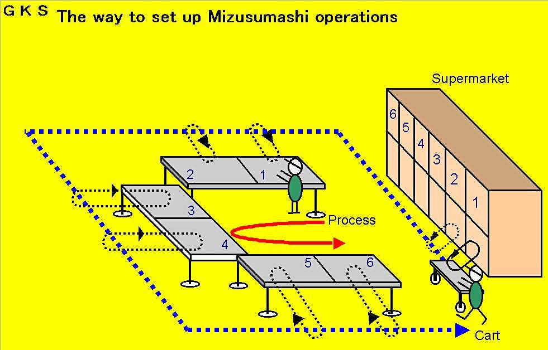

The water strider should not stop too long at each point.

Bear in mind the economy of motion in setting up the routine.

Deliver parts to the line in a kit as much as possible.

Establish standard work for the water strider.

09 Kanban v20130529 | 46 | ©1996-2013, John Black and Associates LLC
 |  | Licensed Materials – USA Copyright Laws Apply

Mod 9 – Kanban

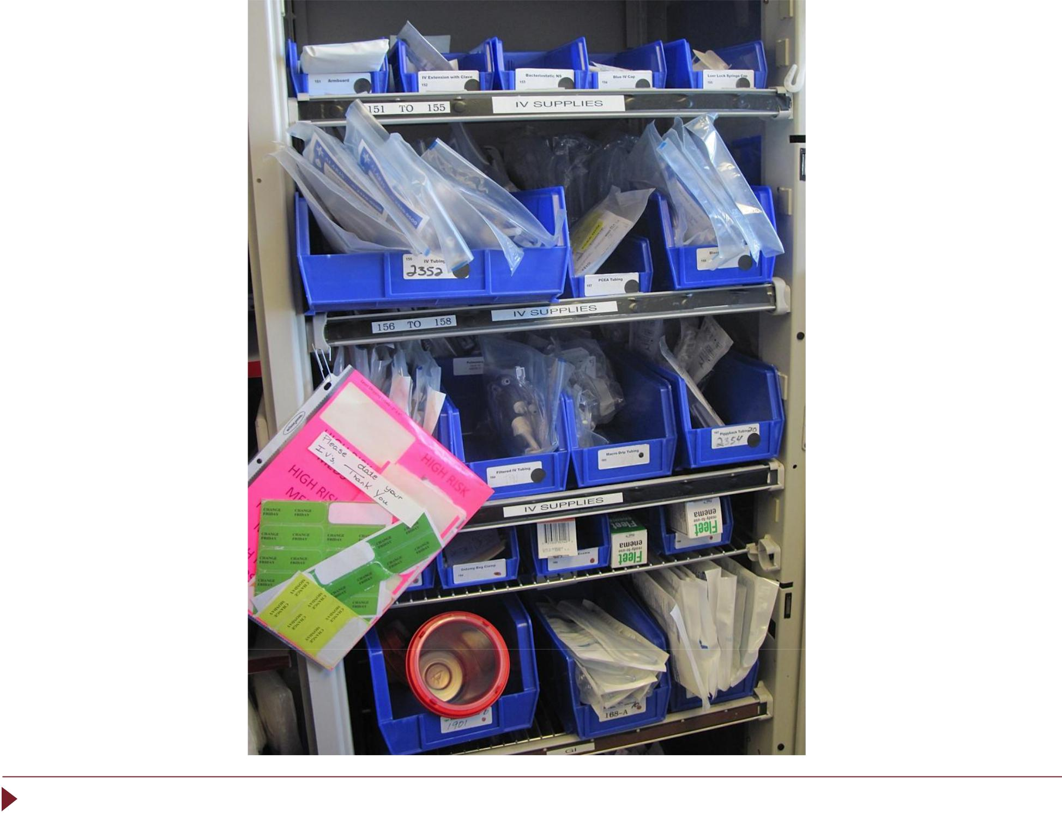

09 Kanban v20130529 | 47 | ©1996-2013, John Black and Associates LLC
 |  | Licensed Materials – USA Copyright Laws Apply

Mod 9 – Kanban

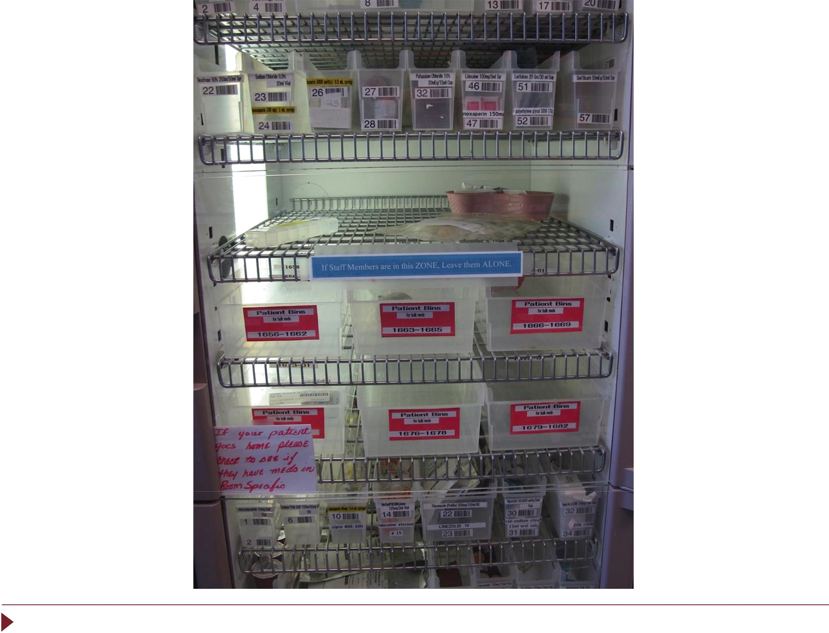

09 Kanban v20130529 | 48 | ©1996-2013, John Black and Associates LLC
 |  | Licensed Materials – USA Copyright Laws Apply

Mod 9 – Kanban

Kanban Summary

The Kanban System provides signals for supplying

to the following process only “what is needed, in

the quantity needed, at the time it is needed.”

It provides the capability to keep the inventory under a certain level without having any work pieces stagnating between processes.

The following process is always the driver and nothing the following process does not need should be produced or delivered there.

09 Kanban v20130529 | 49 | ©1996-2013, John Black and Associates LLC
 |  | Licensed Materials – USA Copyright Laws Apply

