Kanban Card

Item Description:

Product Number:

Location:

(Room #) – (Cabinet/Rack #) (Shelf) (Position)

Reorder Point:

Order Quantity:

(number) (unit of measurement)

Cost Center:

Special Instructions:

Kanban Card

Item Description:

Product Number:

Location:

(Room #) – (Cabinet/Rack #) (Shelf) (Position)

Reorder Point:

Order Quantity:

(number) (unit of measurement)

Cost Center:

Special Instructions:

Kanban Card

Item Description:

Product Number:

Location:

(Room #) – (Cabinet/Rack #) (Shelf) (Position)

Reorder Point:

Order Quantity:

(number) (unit of measurement)

Cost Center:

Special Instructions:

Kanban Card

Item Description:

Product Number:

Location:

(Room #) – (Cabinet/Rack #) (Shelf) (Position)

Reorder Point:

Order Quantity:

(number) (unit of measurement)

Cost Center:

Special Instructions:

6S Department Audit Sheet
(Minimally includes 2 exam rooms, 1 supply area, labs, front office, and patient areas)

 | Date: |  |  |  |  |  | Auditor: |  |  |  |  |  | Department:
 | Instructions: Assess the entire practice and score based on the lowest result of all areas (does not include private offices)
 |  |  |  | 5 Points |  |  | 4 Points |  |  | 3 Points |  | 2 Points |  |  | 1 Point |  |  | 0 Points
 |  |  |  | World Class |  |  | Very Good |  |  | Minimum Acceptable |  | Marginal |  |  | Unacceptable |  |  | Poor
 |  |  |  | No clutter and every item* |  | Very little clutter with only |  |  |  | Some clutter with only (2) |  | Some clutter with only (3) |  |  | Some clutter with only (4) |  |  | Area extremely cluttered
 |  |  |  | in the area is needed and |  | (1) item* in each area that is |  |  |  | items in each area that are |  | items in each area that are |  |  | items in each area that are |  |  | with many items (5+) in
 | Sort |  |  | functional. |  | not needed or not functional. |  |  |  | not needed or not functional. |  | not needed or not functional. |  |  | not needed or not functional. |  |  | each area that are not
 |  |  |  |  |  |  |  |  |  |  |  |  |  |  |  |  |  | needed or not functional.
 |  |  |  | 100% of areas are very well |  | 90% of areas are well |  |  |  | 75% of areas are well |  | 50% of areas are well |  |  | 25% of areas are well |  |  | No organization and
 |  |  |  | organized. All items have |  | organized. 90% of items |  |  |  | organized. 75% of items |  | organized. 50% of items |  |  | organized. 25% of items have |  |  | clutter. Items are not
 | Straighten |  |  | designated labeled locations |  | have labeled locations, |  |  |  | have labeled locations, |  | have labeled locations, |  |  | labeled locations, which are |  |  | labeled or stored properly.
 |  |  |  | which are convenient. All |  | which are convenient and |  |  |  | which are convenient and |  | which are convenient and |  |  | convenient and items are
 |  |  |  | items are stored properly. |  | items are stored properly. |  |  |  | items are stored properly. |  | items are stored properly. |  |  | stored properly.
 |  |  |  | 100% of the areas are in |  | 100% of areas are clean. |  |  |  | 75% of areas are clean. |  | 50% of areas are clean. |  |  | 25% of areas are clean. |  |  | Areas are very dirty.
 |  |  |  | “like new” condition (no |  | Floors, walls, partitions and |  |  |  | Floors, walls, partitions and |  | Floors, walls, partitions and |  |  | Floors, walls, partitions and
 |  |  |  | stains, tears, up-to-date). |  | posted documentation are |  |  |  | posted documentation are |  | posted documentation are |  |  | posted documentation are
 | Shine |  |  | Floors, walls, partitions and |  | clean, free of dust, dirt, and |  |  |  | clean, free of dust, dirt, and |  | clean, free of dust, dirt, and |  |  | clean, free of dust, dirt, and
 |  |  |  | posted documentation are |  | visible tape. |  |  |  | visible tape. |  | visible tape. |  |  | visible tape.
 |  |  |  | clean, free of dust, dirt, and
 |  |  |  | visible tape.
 |  |  |  | 100% of audits are |  | 100% of audits are |  |  |  |  |  |  |  |  |  |  |  | No evidence of audits
 |  |  |  | completed weekly and |  | completed weekly and |  |  |  |  |  |  |  |  |  |  |  | being completed or
 |  |  |  | randomly (audits completed |  | Kanban cards are used for |  |  |  |  |  |  |  |  |  |  |  | Kanban cards being used
 | Standardize |  |  | throughout the week) and |  | supply ordering. |  |  |  |  |  |  |  |  |  |  |  | for supply ordering.
 |  |  |  | Kanban cards are used for
 |  |  |  | supply ordering and
 |  |  |  | resupply levels are updated
 |  |  |  | regularly with changes.
 |  |  |  | MDI board is used daily to |  |  |  |  |  |  |  | MDI board is used weekly |  |  | MDI board is used |  |  | MDI board is not used.
 | Sustain |  |  | track performance, solve |  |  |  |  |  |  |  | to track performance, solve |  |  | sporadically.
 |  |  |  | problems and complete |  |  |  |  |  |  |  | problems and complete
 |  |  |  | improvement actions. |  |  |  |  |  |  |  | improvement actions.
 |  |  |  | No expired supplies present, |  |  |  |  |  |  |  |  |  |  |  |  |  | Not meeting safety
 |  |  |  | approved single used items, |  |  |  |  |  |  |  |  |  |  |  |  |  | expectations.
 |  |  |  | and meeting sterilized
 |  |  |  | instrument protocols.
 | Safety |  |  | Managing sharp containers
 |  |  |  | and, hazardous materials
 |  |  |  | out child’s reach. All aisles
 |  |  |  | are clear and emergency
 |  |  |  | equipment and/or exits are
 |  |  |  | not blocked.

* Items include: Supplies, Equipment, Furniture, Documents, Bulletin board postings, Walls and Partitions

# of 5’s circled: | ____ X 5 = ____
# of 4’s circled: | ____ X 4 = ____
# of 3’s circled: | ____ X 3 = ____
# of 2’s circled: | ____ | X 2 = ____
# of 1’s circled: | ____ | X 1 = ____

6S Rating

/30

6S Audit Department Goal: 27/30 = 90%



Kanban Inventory Control

Malissa A. Becksvoort, MHA Director of Operations – Primary Health Spectrum Health Medical Group

Exercise

- Sit down if you only have one person in your office that knows how to order clinical supplies

- Sit down if you only have one person in your office that knows how to order clerical supplies

- Sit down if you have to search for a supply because you do not know where it is stored

- Sit down if you have run out of any supply in your office
Learning Objectives

- 6S

- What is Kanban?

- Benefits of Kanban

- How to successfully set up your office for Kanban

6S

A place for everything, and everything in its place
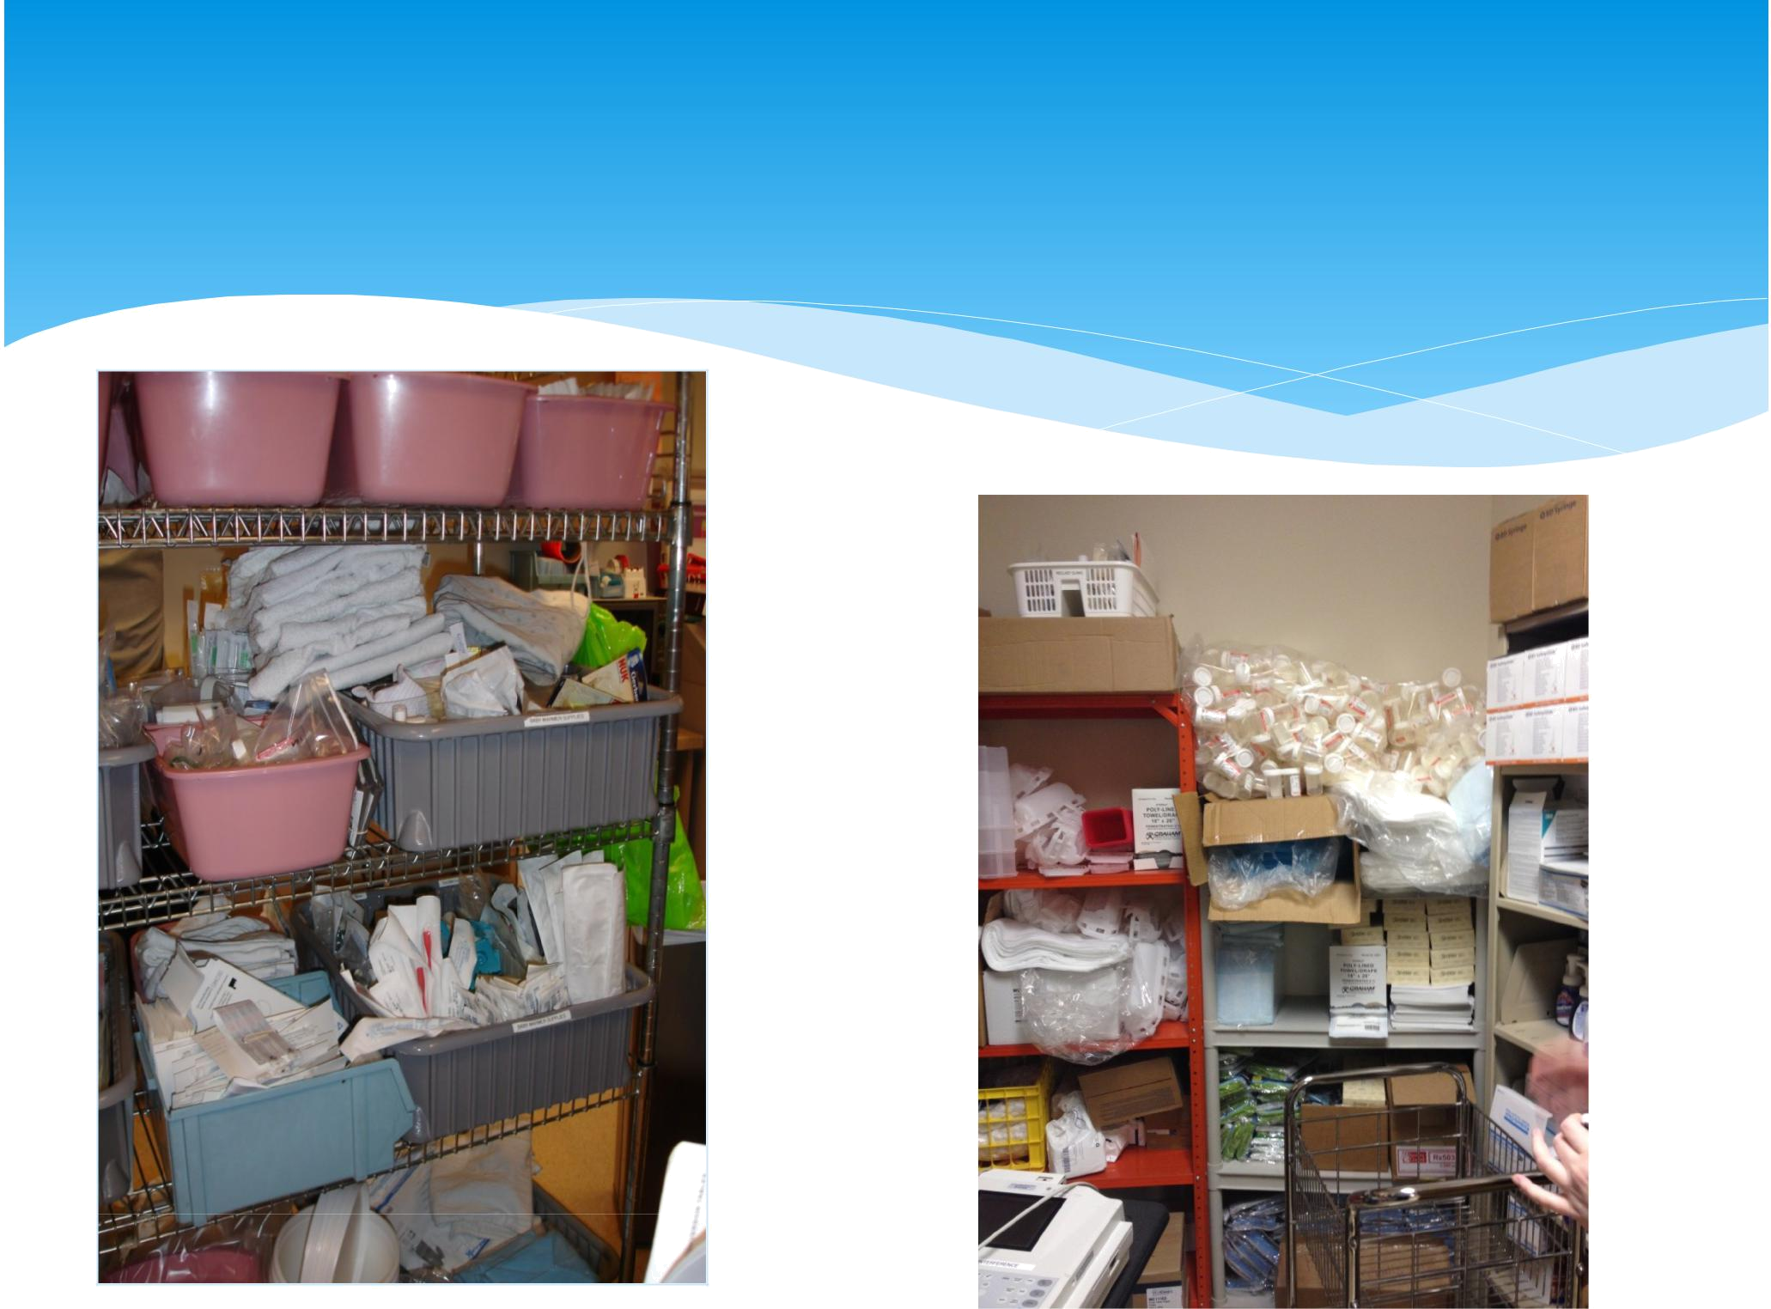
How much time is spent every day looking for something that is needed?

How often do we reorder something because we can’t locate it?
Benefits of 6S Implementation

Provides an opportunity for staff to provide input:

- How the work area should be laid out

- How best to organize it

- How best to set up workflow


Makes your workplace more pleasant

Makes your job more satisfying


Removes obstacles and frustrations

Elements of a 6S Program

• Sort

- Straighten

- Shine

- Standardize

- Sustain

- Safety
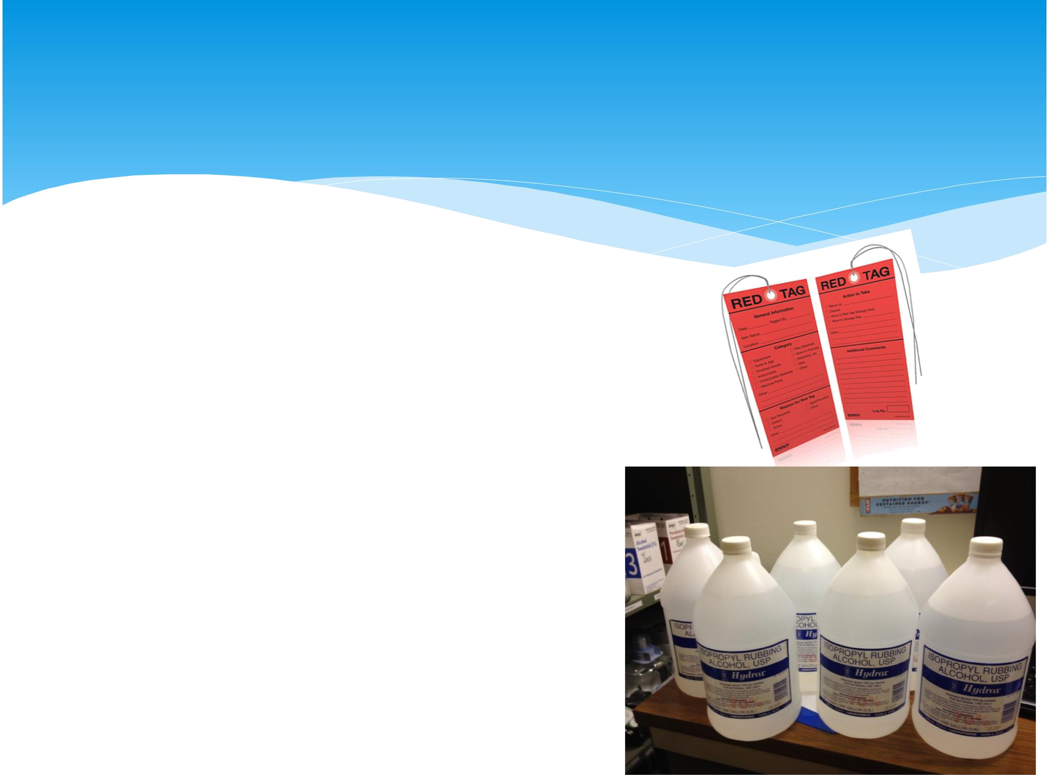
Sort

- Sort and touch every item

- Remove items not required for the process

- Separate unnecessary from the necessary

- Red Tag items not necessary or not sure if needed

- When in doubt – move it out!

Straighten

- Label containers, supplies, files and drawers as necessary

- Use visual controls

- Organize the workplace so “value” can flow freely

- Think of flow in the process

- Think of safety in the process
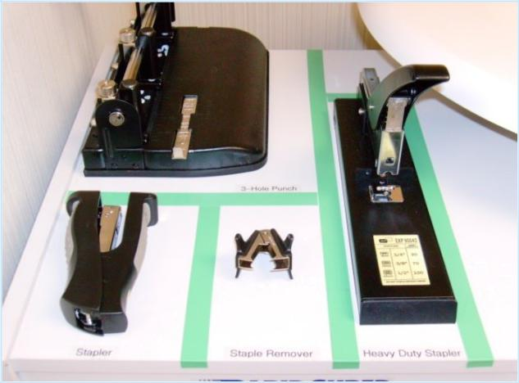
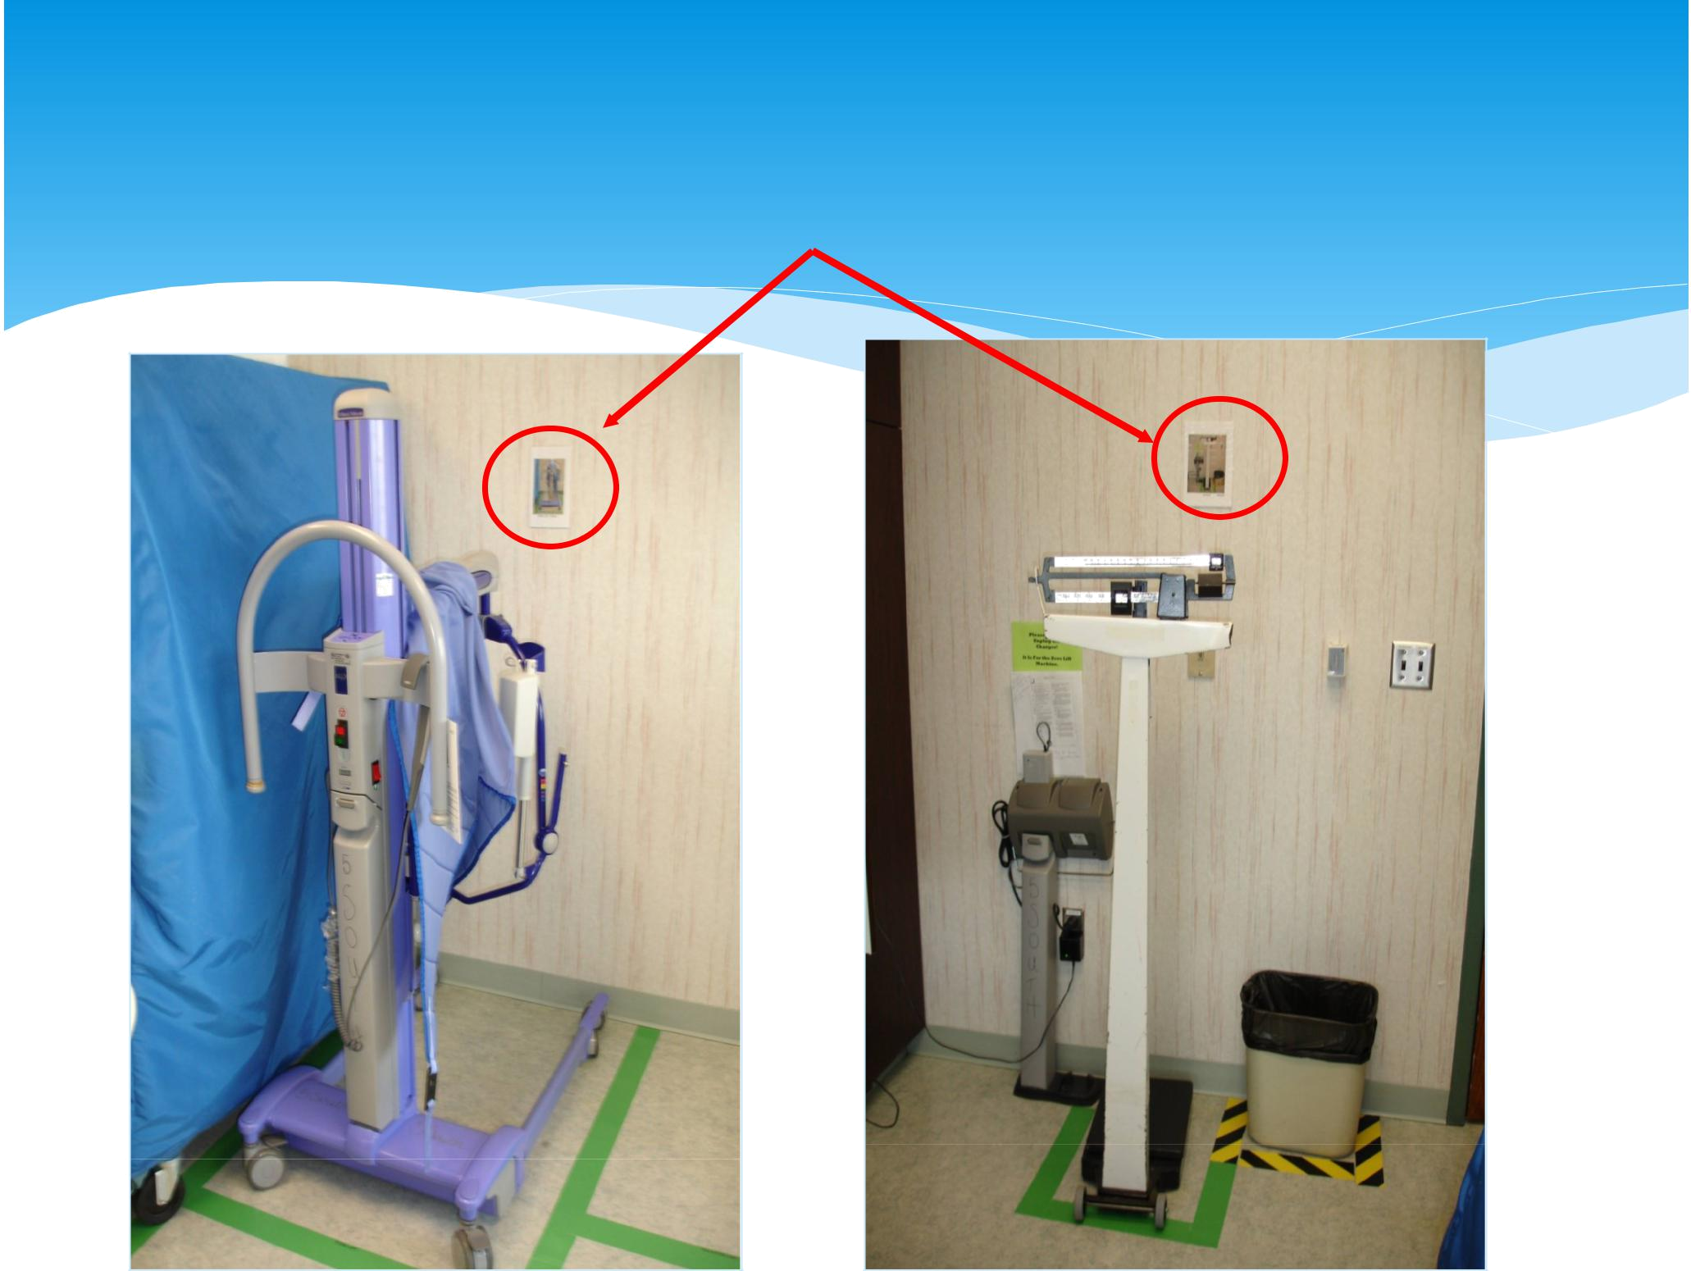
Visual Cues
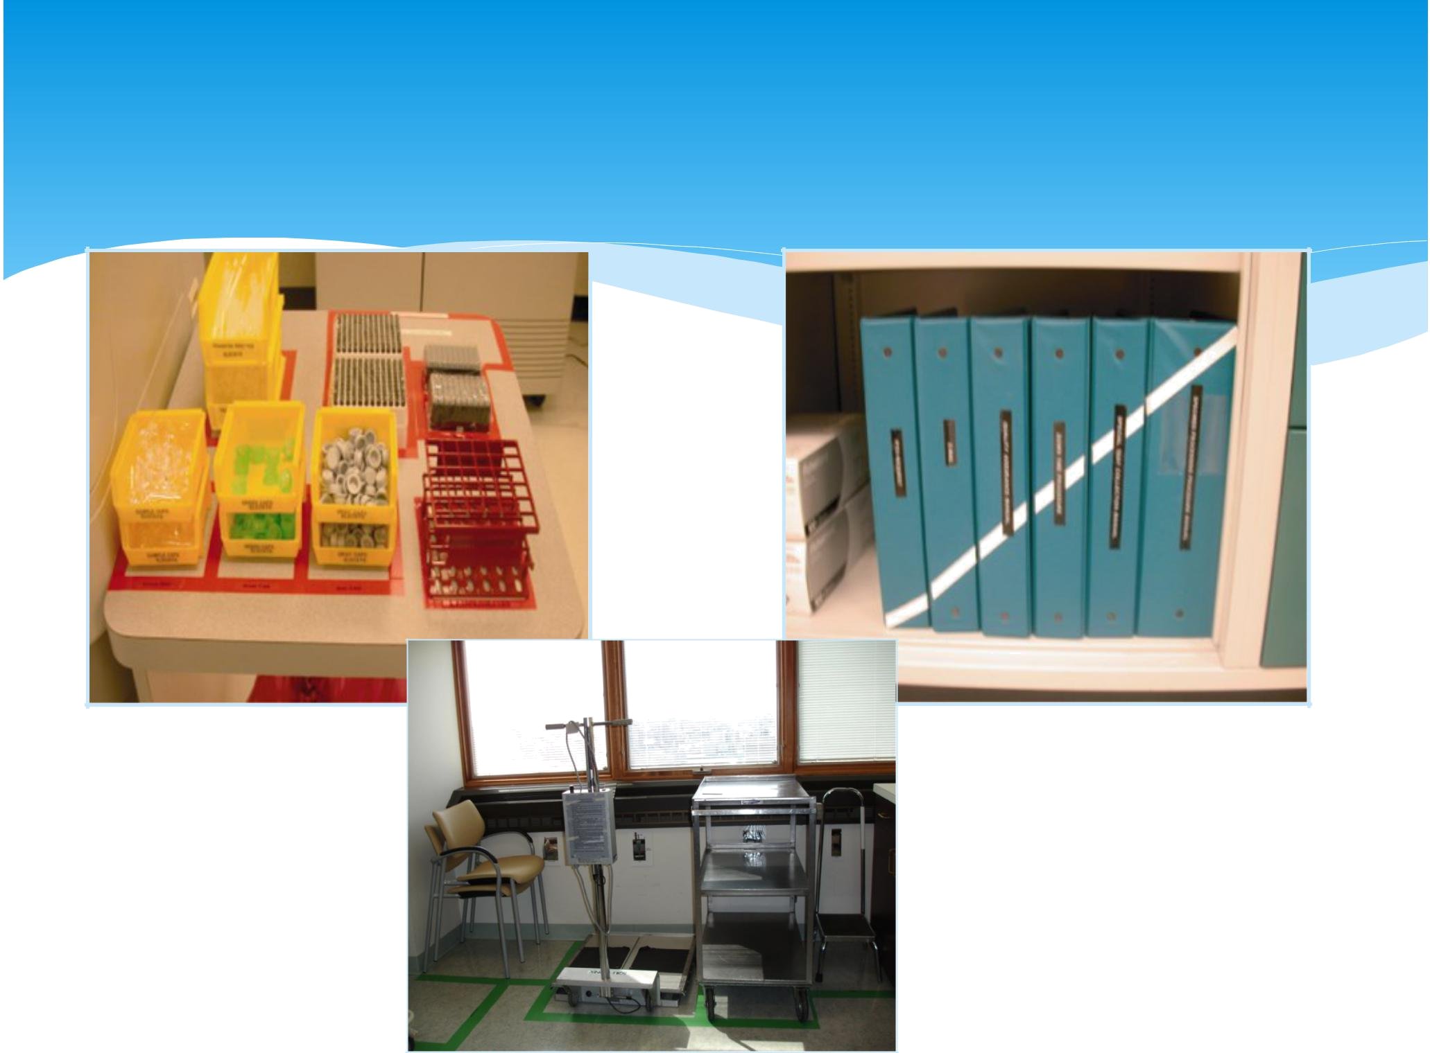
Visual Controls
Shine

Clean the workplace and its equipment


Clean everything

Re-paint and repair

Make abnormal conditions obvious at-a-glance
Standardize

• Make 6S a habit

- Prevent conditions from going back

- Maintain supply storage organization

- Maintain inventory levels

- Develop a cleaning and inspection checklist

- Determine root causes for 6S abnormalities

- Set the standard for all

Standardize Exam Rooms

- Set up one exam room first with provider and clinical staff input

- One rule: each item needs “one designated home”

- Have all providers and clinical staff sign off on the standard exam room before spreading to the other exam rooms
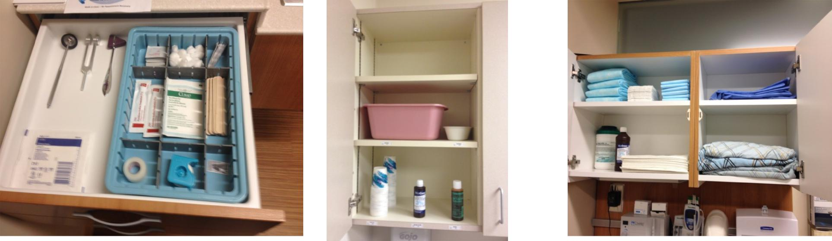
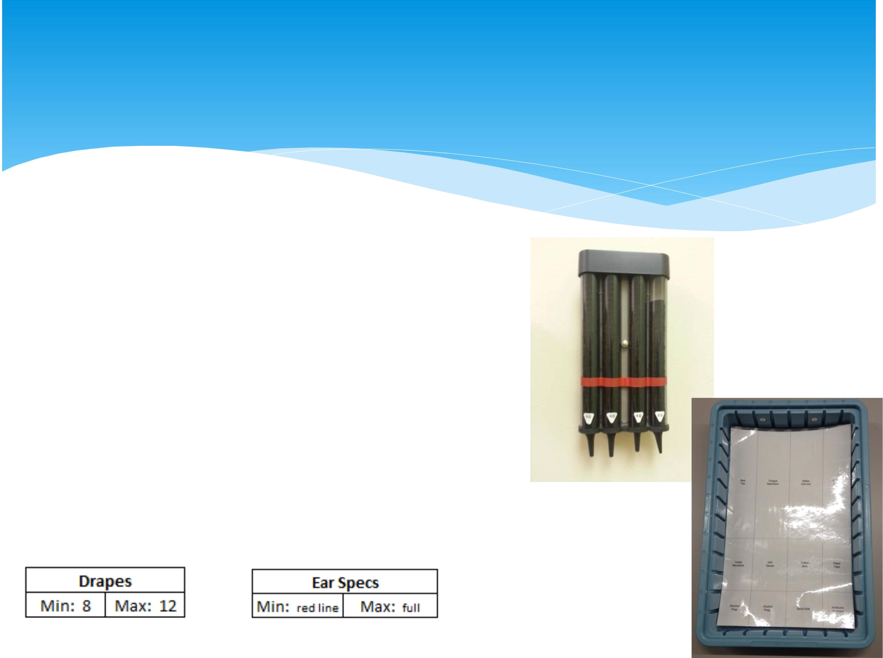
Label Standard Exam Rooms

- Label with:

- Supply name

- Minimum level = one day use

- Maximum level = 1 ½ day use (safety stock)

- Minimum can also be signified with a red line
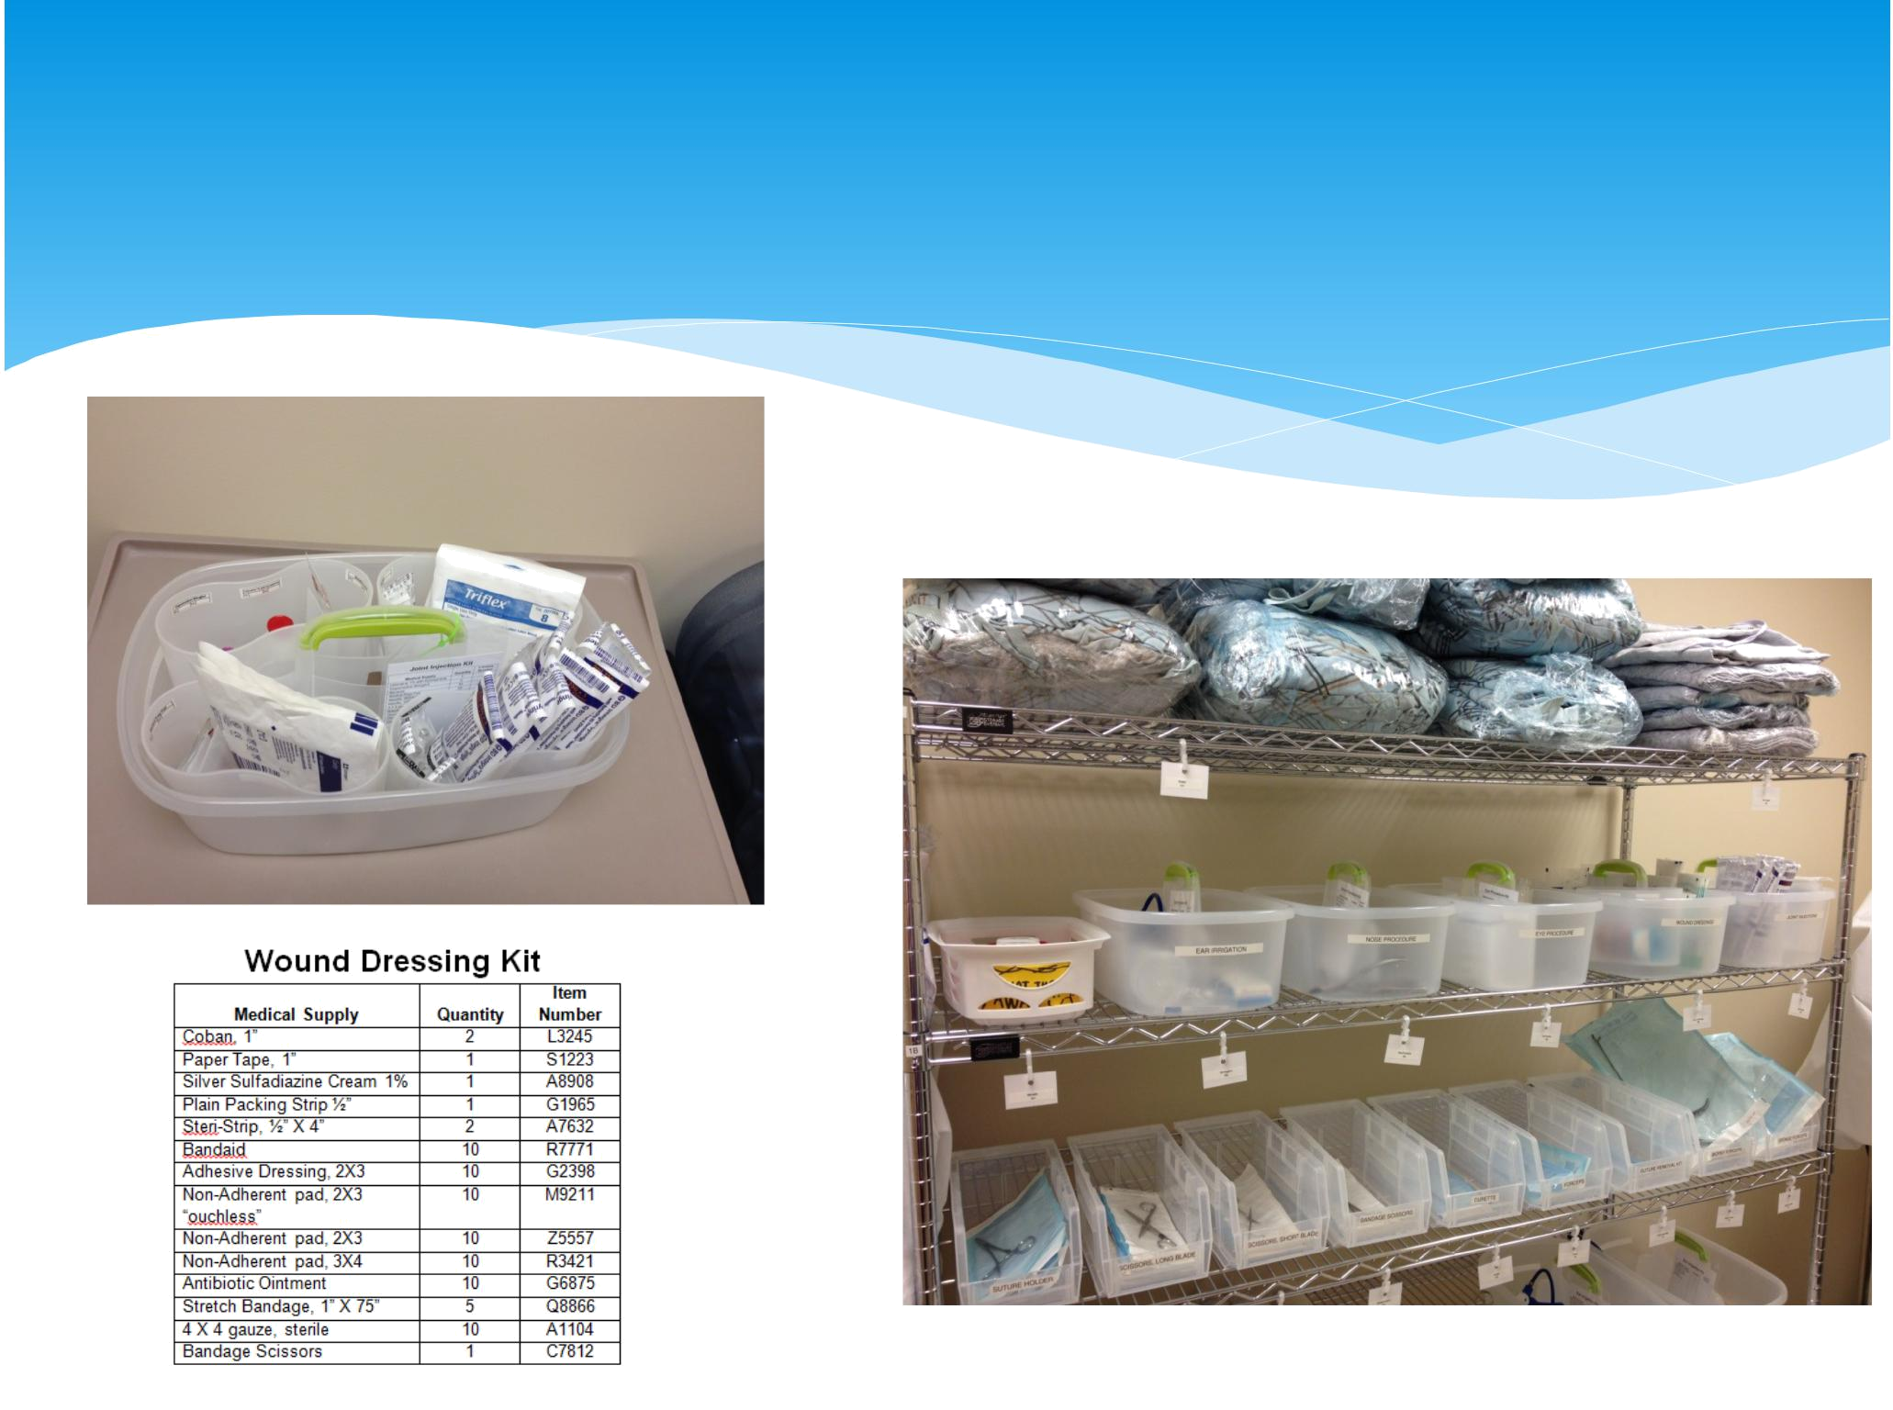
Procedure Caddy

Restock Exam Rooms and Procedure

Caddies Daily


Sustain

- Take “before” photos and post as a reminder of where you started before the improvements

- Assign responsibilities

- Measure (audit) frequently

- GEMBA walks to observe
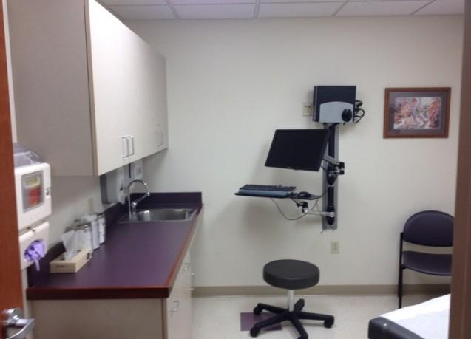

Before

After
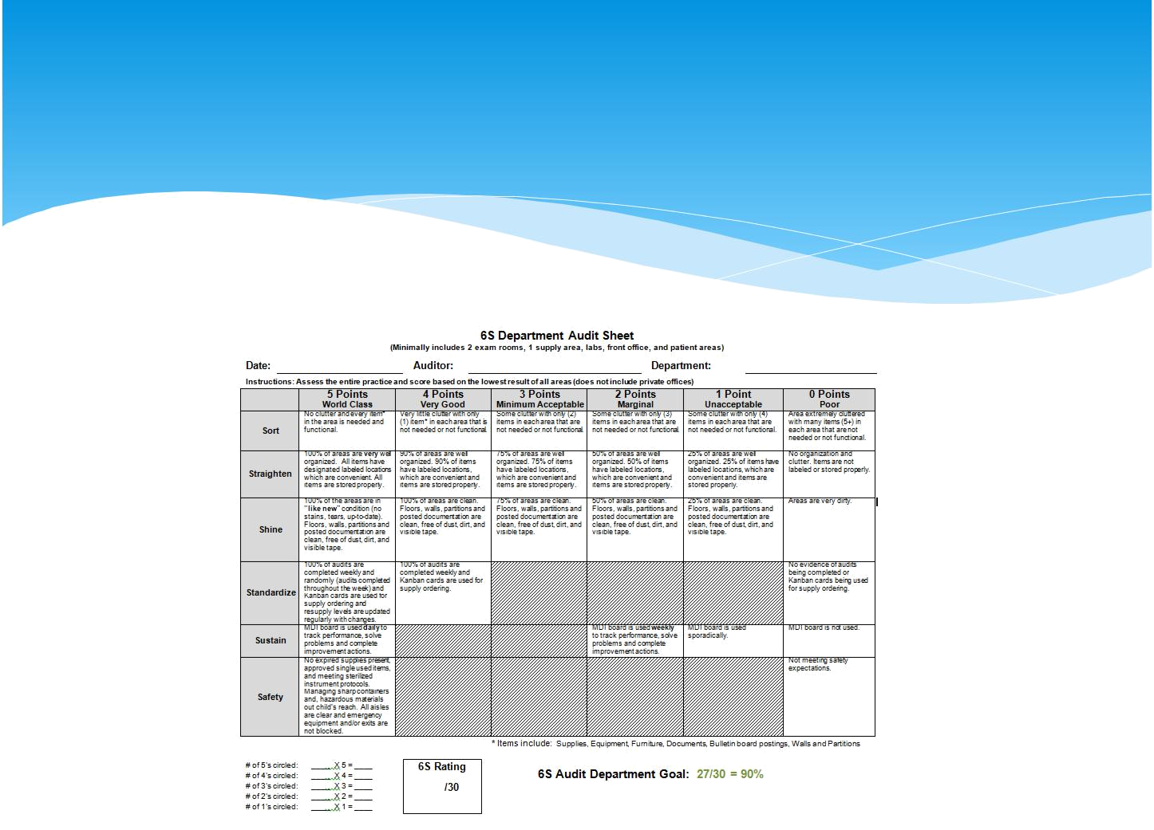
6S Audit Tool

Safety

- Resolve all safety issues

- Change things likely to cause injury, stress or overburden

- Ensure safety equipment is readily available

Safety – The Tale of Two Bottles

Formalin vs. Acetone

- Acetone mistakenly stocked in place of formalin

- “Good catch” occurred at one hospital, but not shared in time at other

- Acetone was used on a tissue sample in place of formalin
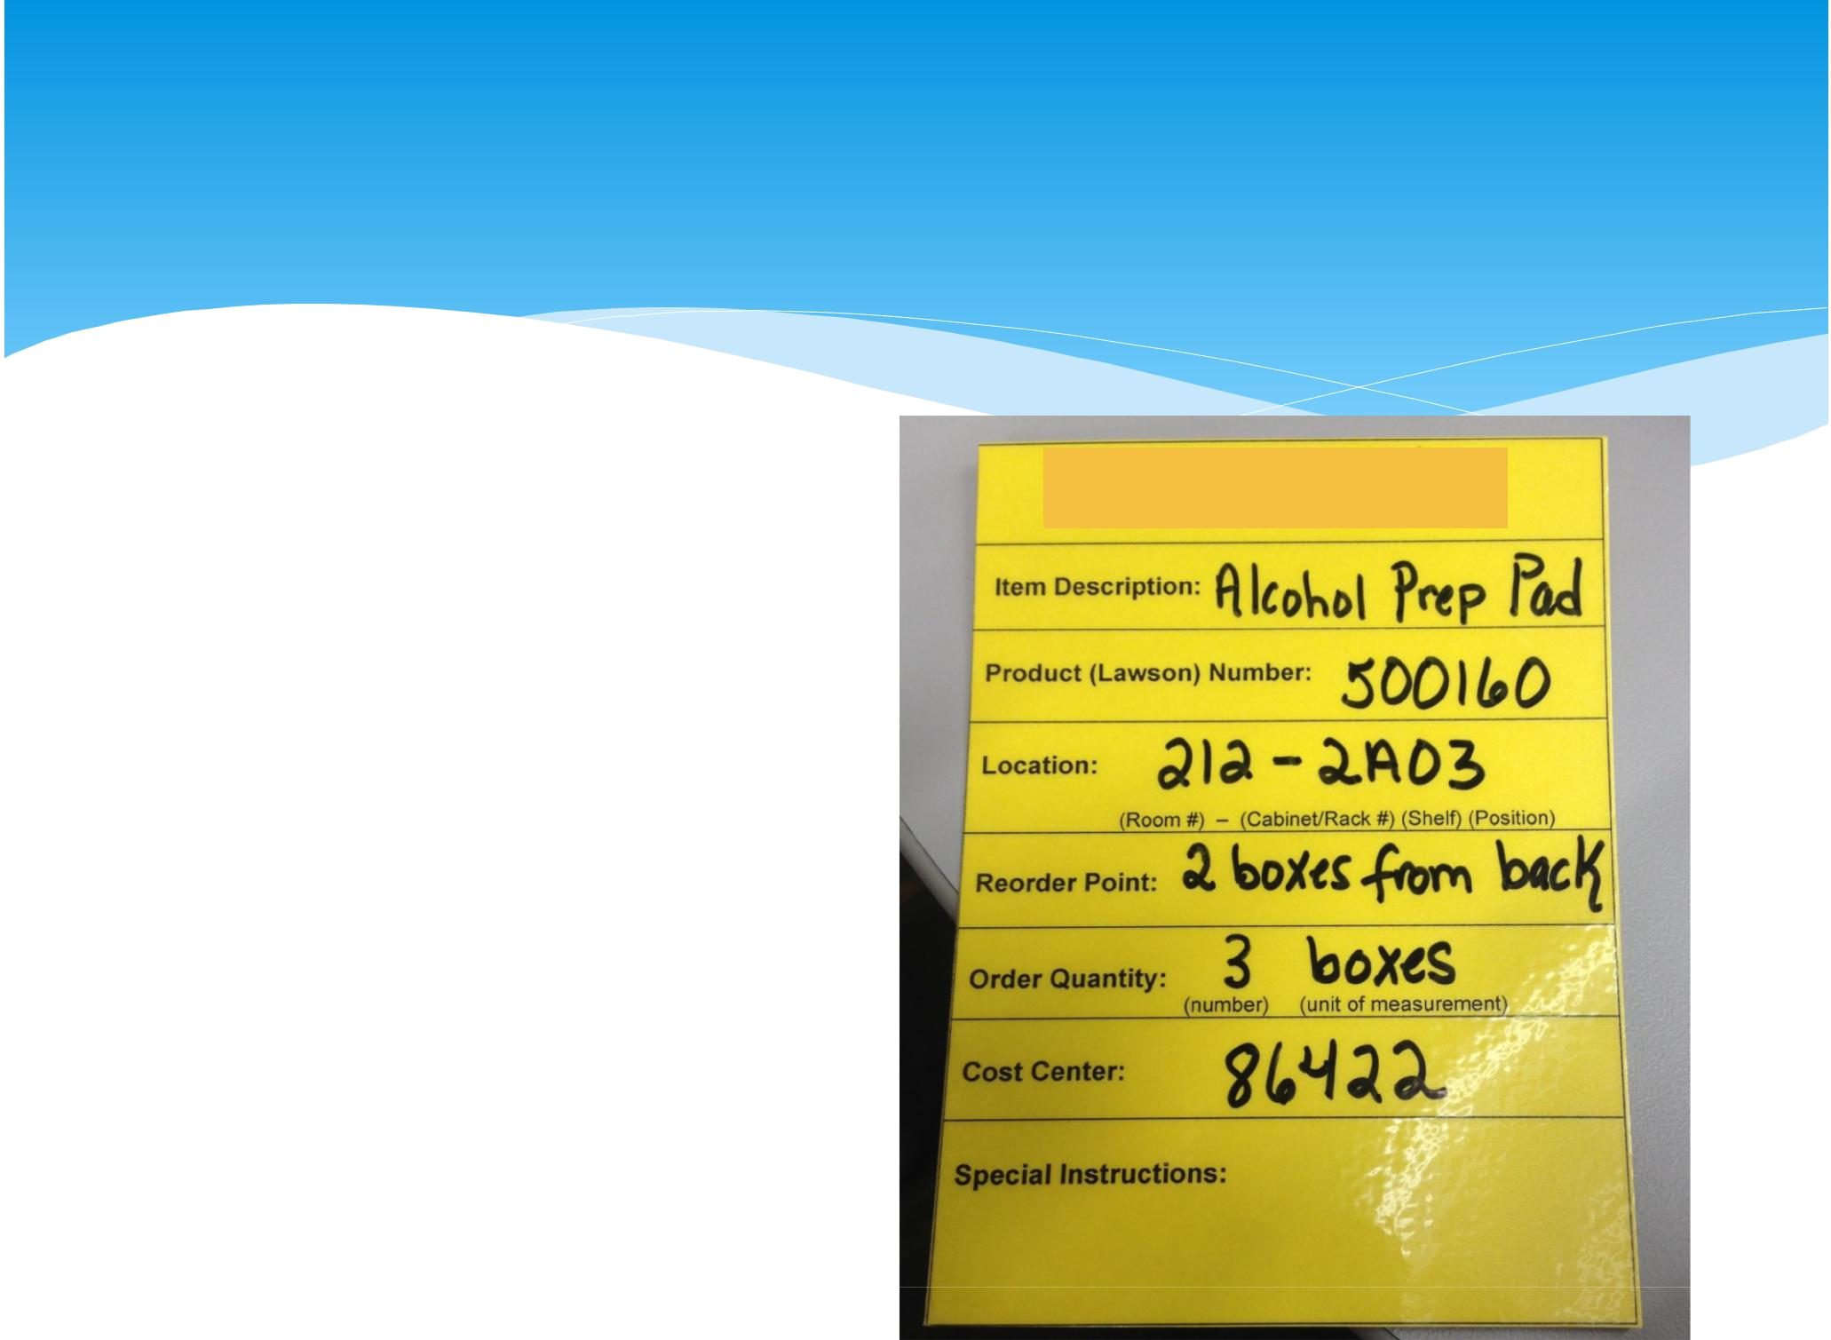
What is “Kanban”

- Signals - visual

- Typically a card or flag

- Used to regulate ordering

- Describes supply needed

- Supply location on card for easy restocking
Benefits of Kanban

• Eliminate “stock-outs”

- Reduce inventory costs

- Reduce time looking for supplies

- More than 1 person trained to order supplies

- Anyone can restock supply shelves and knows exactly where to place it

Resupply Terms

- Restocking Cycle (Delivery)

- Regular process where POU are stocked

  - i.e. daily exam room stocking

- Restocking Method

  - FIFO means First In First Out
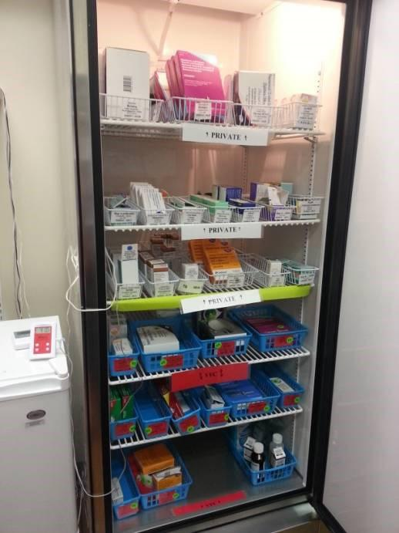

- Newer items are placed in the back or under and used after the older items

- i.e. method for restocking milk in a grocery store
POU Triggers to Restock

Techniques

- Time based
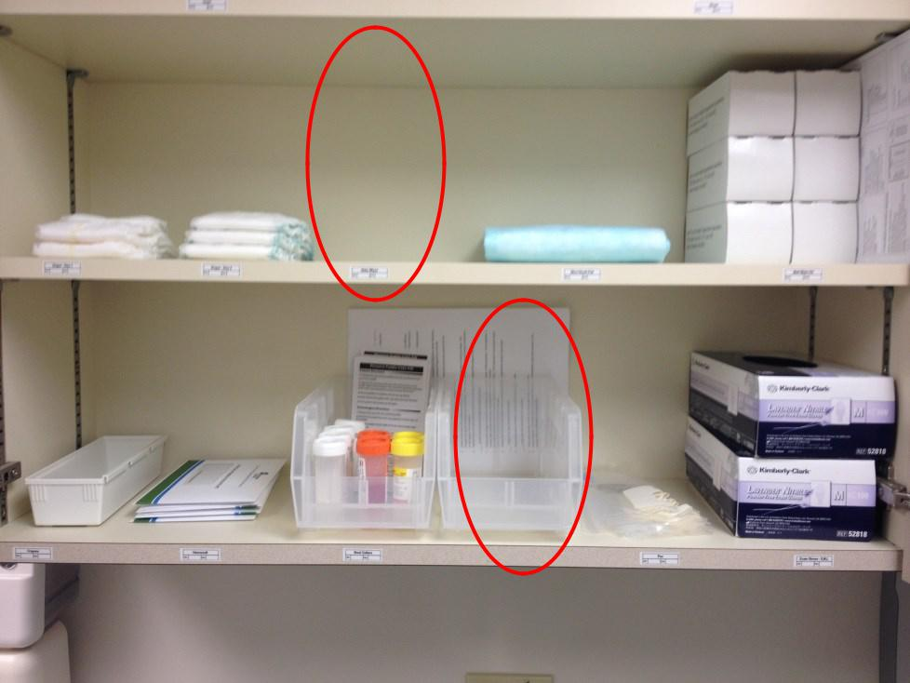

  - End of clinic

- Minimum level reached

o Resupply when below red line

- Empty containers/sections

- Replace/replenish empty containers/sections

Supply Room “Supermarket”

Area where supplies are stored for resupplying POU (i.e. storage room)

May be one or more areas and include:

- Clinical Supplies

- Forms

- Office Supplies

- Cleaning Supplies

- Lunch Room Supplies
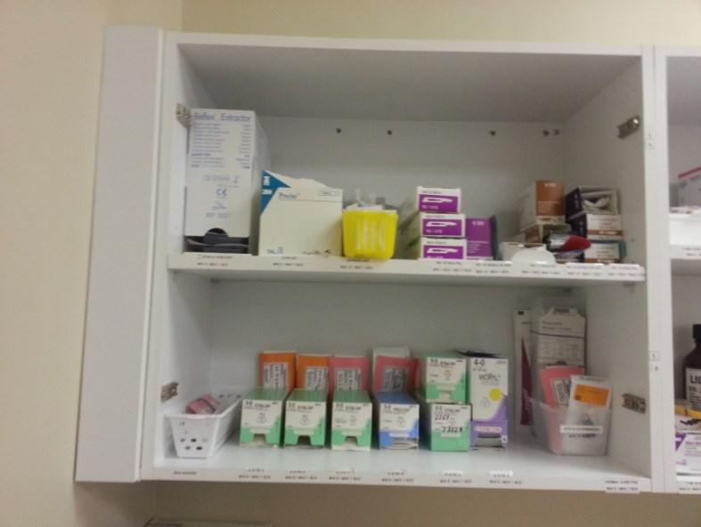

Tips
- Group like items

- High usage items are placed at easier to reach places

- Heavy items are placed lower shelves
Setting up your Supermarket

- 6S supply areas

- Group like items together and in appropriate areas based on usage

- Label all cupboards, drawers, and fridges with a number. Start on one side of the room and work your way around

- Label shelves/inside of drawers with a letter

- Label supplies on shelves with supply name/address with position number Ex:

- Write and position Kanban cards

- Hang Kanban board
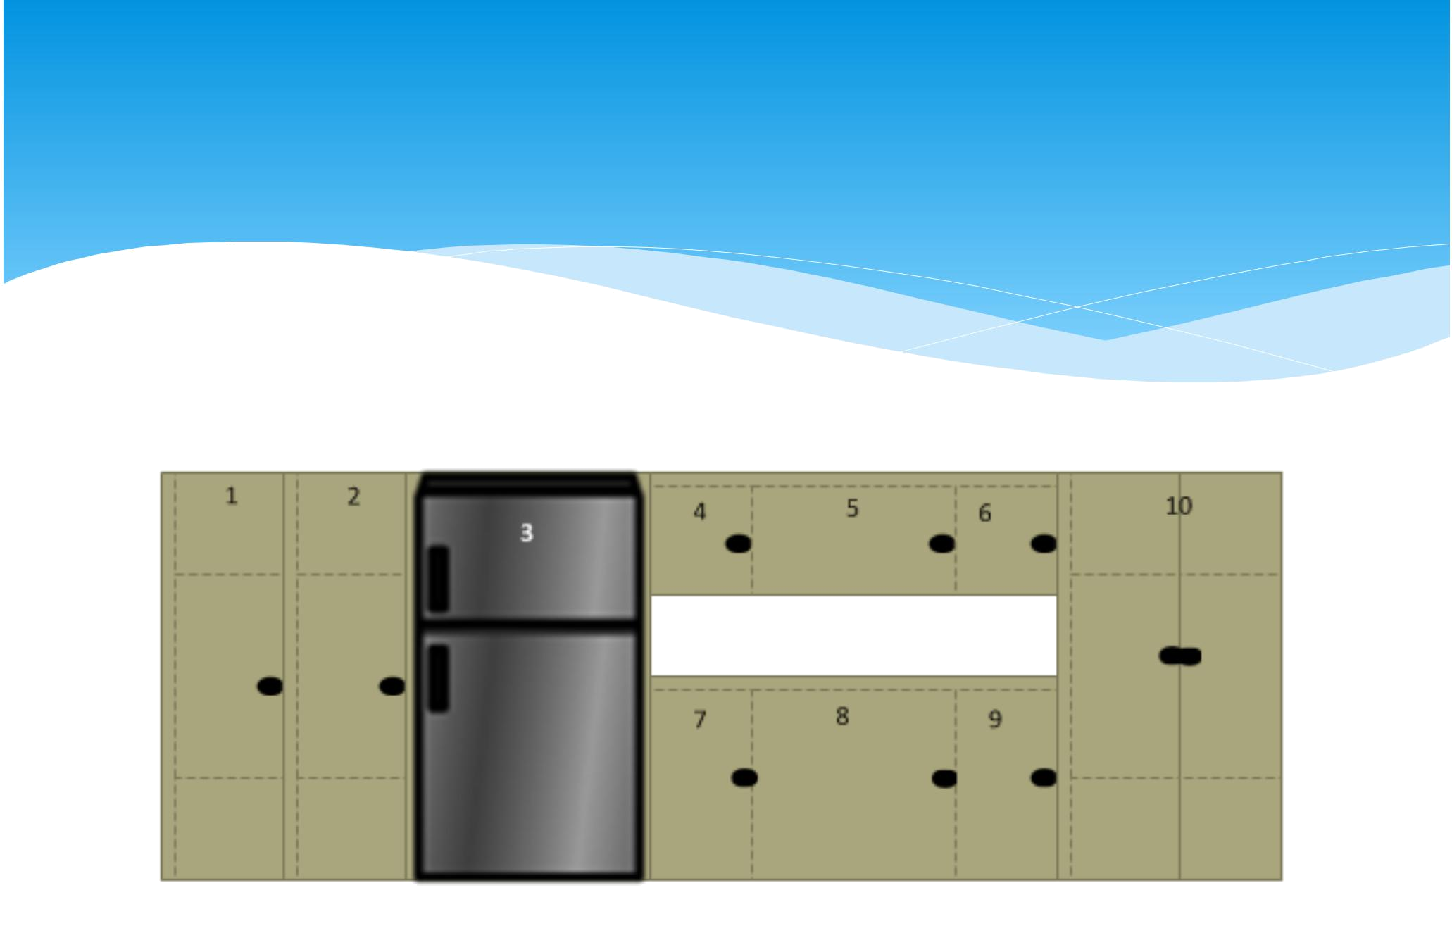
Labeling Supermarket

Kanban Drawers

One Designated Home

Cabinet 1
42 U

Shelf A

Shelf B
1 U | 01 | 02

Shelf C | 01
1 U | 01

1 U | 01
Shelf D

Shelf E | 01
1 U | 01

ROOM 125
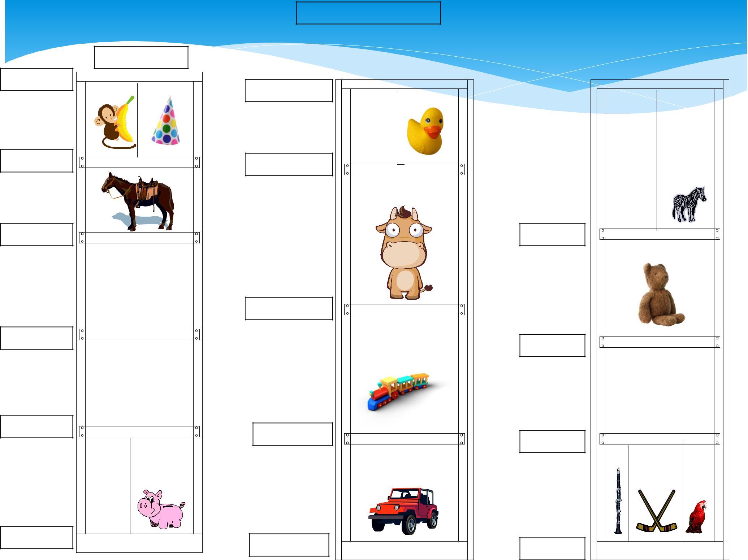

Cabinet 2 |  | Cabinet | 3
42 U |  | 42 U

Shelf A

Shelf B_{1 U} | 01 | 02

Shelf 1AU | 01 | 02

Shelf C1 U | 01

1 U | 01
Shelf B

Shelf D | 01 | 1 U | 01
1 U | 01 | 1 U | 01
 |  | Shelf C

Shelf F | 01 | 02 | Shelf E | 01 | Shelf D
 |  |  |  |  |  | 01 | 02 | 03

Material Flow Rules

- Every item has a designated home (i.e. work done with 6S)

- Items are stocked to the right levels

  - Exam room stock filled to max level daily

  - Supply Supermarket maintained with kanban cards

- Schedules for ordering, delivery, and putting away stock are rigorously adhered (i.e. your normal order and delivery days)

- Signals are acted on immediately

- Incoming inspections for quantity received, quality checks if needed, and expiration. If supermarket holds four weeks and FIFO maintained, then item expiration must exceed four weeks.
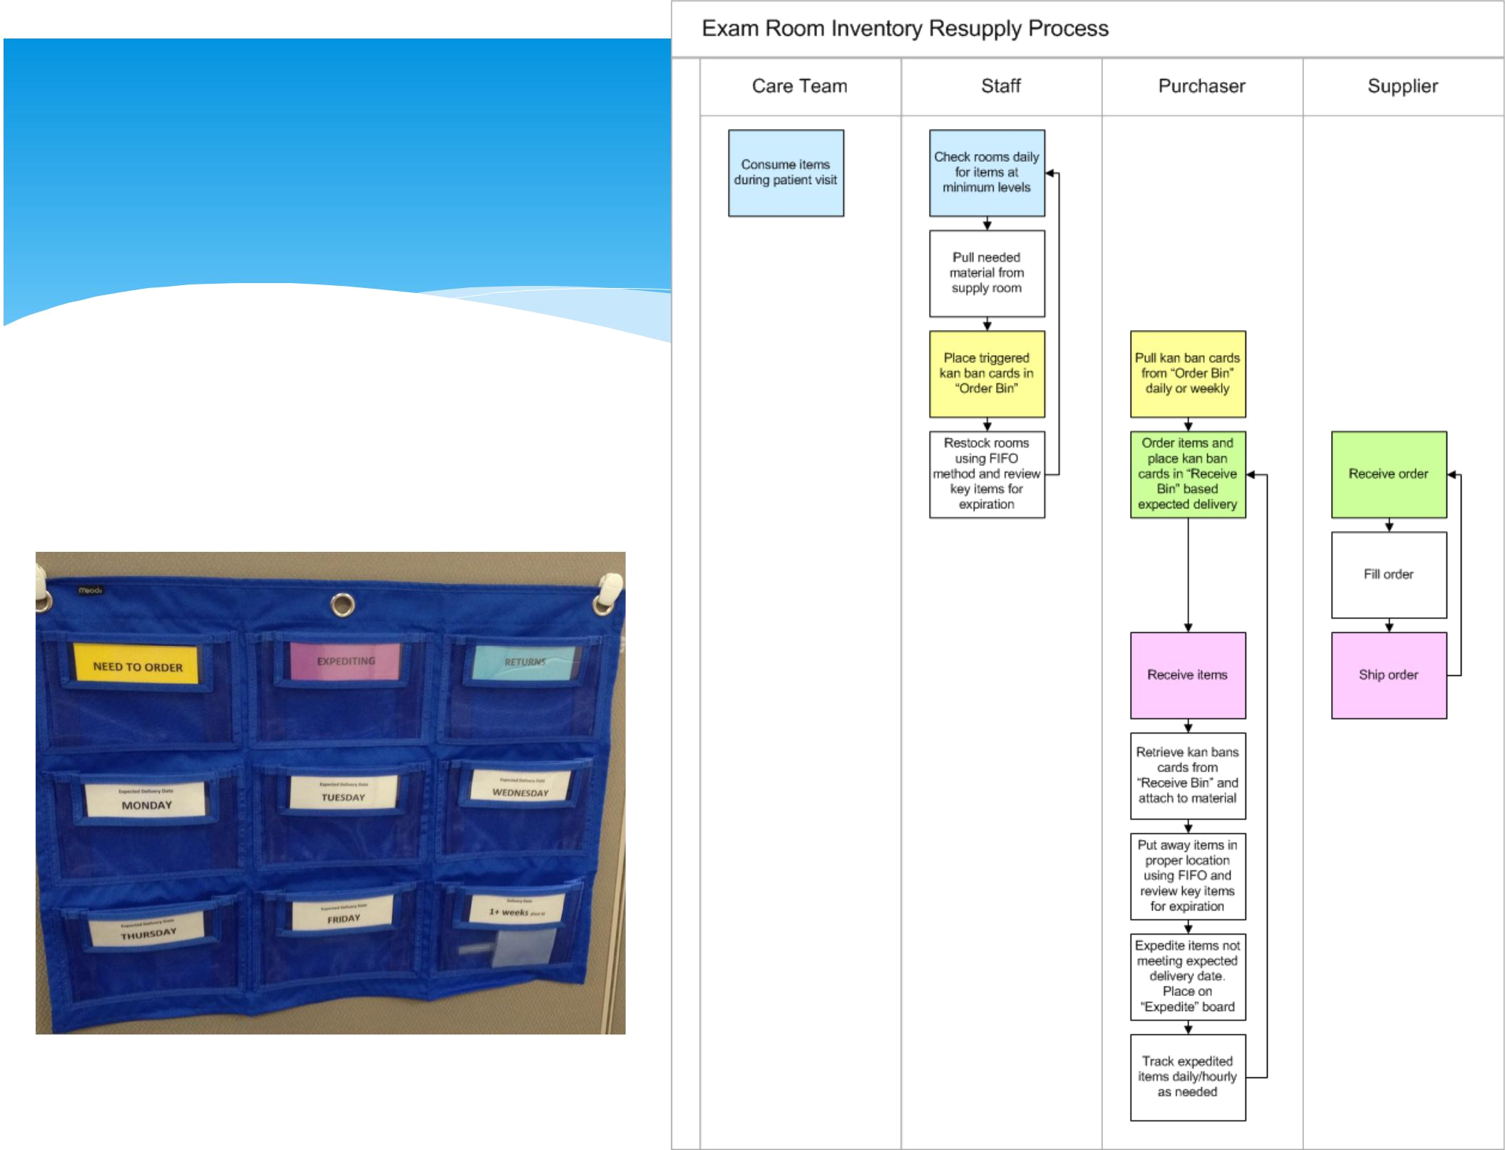
Material Flow Process

Kanban Board

.


Material Flow Calculations

- Demand is measured and known

- Ordering and supplier delivery is known and accurate

- Packaging and minimum order quantities are known

- Small amount of safety stock are added

Filling out Kanban Cards

- Description of the item

- Product Number – vendor order number

- Location – supermarket address

- Reorder point – where you place the kanban card in the supply based on consumption demand

- Order quantity: 1.5 X reorder point

Example: Alcohol Prep Pad
- Site receives deliveries every Wednesday

- Daily Consumption: 25 pads (weekly 125 pads = 1 box)

- Reorder point: 2 boxes (need one week of safety
stock) 125 pads/box

Kanban Card Placement

***Rules***

- Do not place the kanban card in the stock loosely

- Either:

  - Rubberband with kanban card around reorder point stock

  - For small items, place items in ziploc bag with kanban card

  - For large boxes, tape kanban card to the top of the box
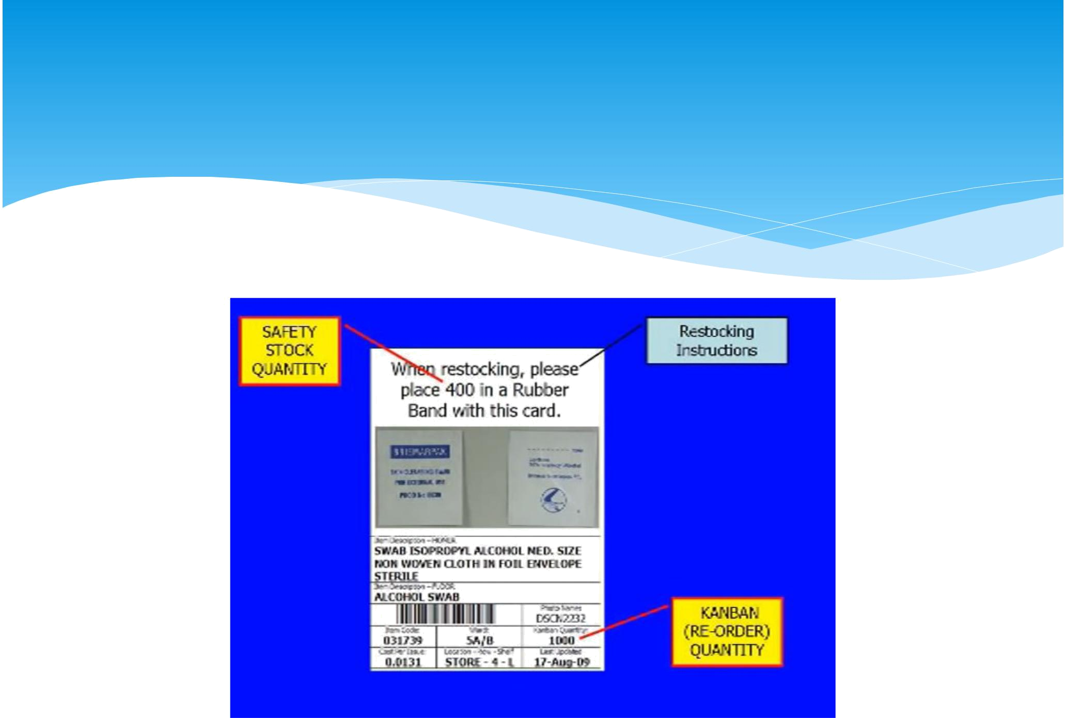
Video

Questions

