Lindsay Borman
September 29th, 2018
IARD 4960
Reflection Paper
My time in Thailand was marked by extreme anguish—being alone in an apartment in Chiang Mai for two weeks without knowing a single soul while recovering from a mild concussion, which is the most alone I have ever felt in my life—and absolute joy. Joy was laughing till my sides hurt with my Karen Grandmother in Moo Ban Mod Ta Noi.
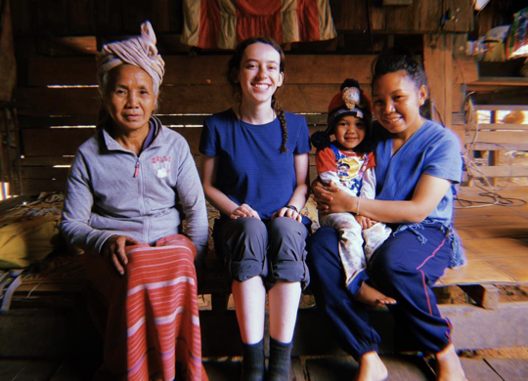
The experience was divided into four courses-- called Foundations, Fields (Agriculture), Forests, and Oceans, each with its own lessons, challenges, and unique rewards.
Foundations, the longest of the four courses, included mostly intensive Thai language learning and introduction to Thai culture. During foundations, I lived with a host sister named Pi Joy, who was in her mid-thirties, single, and had dreadlocks. We got along fantastically. Taking the “rot dang” (“red car”, a truck with no back that represents one of the many public transit routes in the Chiang Mai area) from her tiny home in a rural hamlet to school, closer to the old city of Chiang Mai, every morning at 6:30 am, was always forty minutes of pure thrill. Slowly but surely adding Thai vocabulary and improving my pronunciation of tones had immediate rewards on weekend adventures to street markets and Wats (temples). Thai tests were absolutely nerve-crushing, as my Ajaan (professor), named Ajaan Sidthorn, was a forest fire of an eighty-something year old tiny woman. She had nerves of steel, high standards, and was not afraid of voicing her disappointment in you. During Foundations, we also got to visit an elephant camp, learn how to cook some important Thai dishes, visit NGO’s, museums, and small businesses, and go on many exciting outings. My favorite thing to do on weekends was visit the Old Walled City of Chiang Mai and explore the coffee shops and restaurants and old temples. I also loved going to the “organic market” on Sundays, which was full of local vendors selling their crafts and organic produce. Because of the traffic in the city and my very long commute from my homestay to school, I was eager for foundations to end and to begin Fields.
Unfortunately, at the end of Foundations, I hit my head very hard and suffered from a mild concussion (my second concussion in three months). I had to take the first half of Fields off, living alone in an apartment in Chiang Mai. This part of my Thailand experience was extremely challenging. I felt absolutely alone in the world, and very, very unsupported. Due to my concussion symptoms, just going down stairs and ordering food from a street vendor was extremely challenging. I spent many days alone, hungry, and with absolutely nothing to do because mental stimulation was out of the question. Ultimately, this portion of experience in Thailand forced me to grow immeasurably. By the end of this chapter, when my head was in better health, I impressed myself by taking walking excursions to Wats (temples), participating in “monk chats,” exploring different parts of the city, making new friends, and using my Thai confidently. I must have walked a hundred miles during that time. I didn’t realize it then, but this experience instilled within me an unwavering sense of self-sufficiency, confidence, and tolerance for adversity.
I got to join my friends in a small agricultural village for the remainder of Fields. In this village, I learned about how a community got itself out of cyclical debt to large seed and pesticide corporations by switching to organic farming. It was incredibly inspiring to hear the stories of the villagers and learn about their seed-saving initiatives.
During Forests, much joy came from being completely immersed in the agrarian culture of the Karen people of Northern Thailand, which were a privilege to learn from. Most of the villages I visited practiced successful community based forest resource management, the stuff of Ostram’s dreams. Many households were elevated on wood posts and had chickens and water oxen roaming freely beneath. Many households engaged in farming a large quantity of the rice they consumed, and engaged in foraging forest resources such as fern, mushrooms, and wood. I also had the privilege of observing first-hand swidden agriculture practices, and learning from villagers about the tension swidden agriculture causes between the central thai government and marginalized hill tribe people. My general takeaways from Forests were that there is a massive population of stateless people living in Southeast Asia termed “Zomia,” people who are actively resisting the state and living by anarchist values. The central Thai government is working to absorb people who live at the margins by homogenizing them into Thai culture and taking away their food sovereignty. An example of this is heavy restrictions on land usage and agricultural rights, and the handing out of welfare cards that can only be used to buy food from corporate grocery stores in the nearest cities. Forests left me feeling critical of governments, surprised at how wrong everything I’d learned about “slash-and-burn agriculture” was, and deeply touched by the human connections I made in Karen homestays.
My Oceans experience, which took place in the south of Thailand, where it is extremely hot, humid, and the main religion is Islam, was encapsulated by chronic morning diarrhea due to eating too much spicy shellfish. During oceans, I got to scuba dive and sea kayak through mangrove forests, sea grass fields, and coral reefs. I learned about fish stock patterns, changing species populations, the effects of climate change and overfishing, and weather patterns. I learned about the harrowing effects of development, destruction of mangrove forests, and climate change on small fishing villages. I also learned about “sea gypsies,” Urak Lawoi, and how they have been taken advantage of and mistreated by central Thai people. Unfortunately, Oceans was also clouded by a serious injury. This time, I got a corneal abrasion which became horribly infected. The feeling of bacteria actively eating an ulcer out of my eyeball will possibly prove to be the most terrible feeling I will ever feel in this lifetime. However, like the adversity that came before, my injury only gave depth to my experience and forced me to rise to meet the occasion.
Overall, my experience in Thailand was a wonderful yin-yang. I got to learn the mechanisms of learning another culture, of overcoming culture shock, and of integrating oneself to mesh with local etiquette. I learned about the importance of forming a sense of place based on local knowledge and local connections. I learned more than I thought I ever could, made better friends than I ever thought I would in such a short time, became proficient in conversational Thai, and got to push the boundaries of my comfort zone in ways that were unprecedented for me. I deeply value the academic experiences I gained, the insights into agrarian life, and the opportunity to learn so deeply about the facets of another culture. I continue to write about experiences I had in Thailand for reflection essays in my classes, practice Thai speaking and reading with peers, and cook Thai food. It was an indelible experience that will forever shape the way I view the world and the way I view culture.

