AVONDALE ARTS ALLIANCE
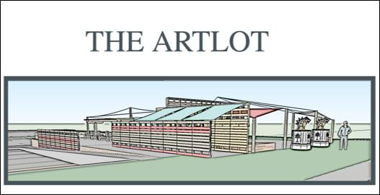

The ArtLot - Startup Budget

Prepared for: Avondale Estate Board of Mayor and Commissioners & Downtown Development Authority

Prepared by: Avondale Estates Art Alliance - ARTLOT Committee June 21, 2016
AVONDALE ARTS ALLIANCE

STARTUP BUDGET - THREE MONTHS

The ArtLot Startup Budget for first three months - Summer 2016

This budget is for the initial cleanup, site prep, building materials, landscaping, insurance and other costs associated with converting currently unsightly and unused city property into a temporary community gathering space. The ArtLot. This budget also includes the first three months of event and art programing costs.
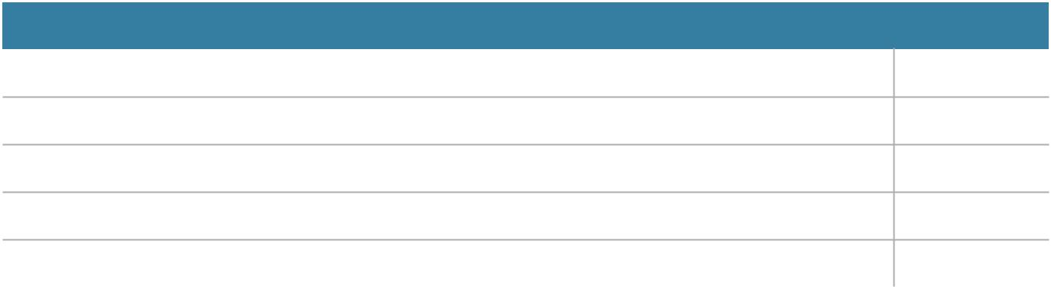

Description | Unit Price
Site Prep, Building Materials and Trades | $ 15,592
Plants and Pots | $ 2,844
Insurance | $ 600
Community Cleanup Day | $ 195
Three months of art and event programming costs | $ 6,000
Total | $25,231
AVONDALE ARTS ALLIANCE

Appendix

Programming may include the following:

Magic show

Movie night

Yoga class

Puppet show

Video installation

Pinhole photography exhibit

DSA dance performance

Avondale Children’s Choir performance

Aikido demonstration

Tai chi

Live music: string quartet, acoustic music, bands

Craft mornings for kids

Juggler

Maker faire

Pet-a-truck

Local chef demos

AE Summer Games Event: ping pong table, corn

hole tournaments, shuffleboard, etc.

Silent disco

Craft beers

Wine stroll

Water slides for a day

Programming | Monthly Cost
ArtLot Curator | $500
Talent (artists, musicians, | $1,000
other)
Event specific costs - (varies | $500
by event) Portapotties, A/V,
movie license, art materials
and misc.
Total | $2,000
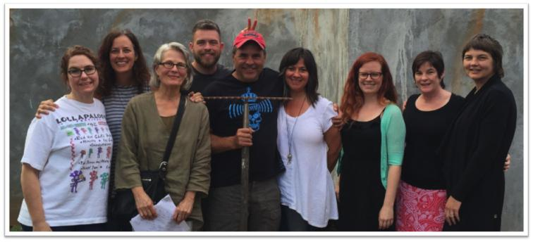

Pavement to Park Concept, a project presented by the Avondale Arts Alliance

Project Title: The Art Lot

Location: E. College/N. Avondale Rd, City owned property (formerly Avondale Pizza Café)

The Avondale Arts Alliance in collaboration with the City of Avondale Estates, artists, local citizens and businesses, is planning to create a temporary city park in an underutilized space fronting N. Avondale near the Tudor Village.

The concept is taking currently unused—and ugly—land and turning it into a pop-up art park. The vision is to create a temporary public space where locals and visitors alike can explore a creative experience that would involve sculptures and visual art installations, green walls and a performance space. It could also be used for many other daily uses from families picnicking to office workers using it for a coffee break.

The project aims to support and increase pedestrian safety, neighborhood identity, and beautification along the busy 4-lane corridor. Activating this area of the downtown will help shape and define plans for a more permanent future development investment by the City. The project is intended to be a public experiment for the City, supported by City funding, to work with local communities and organizations to temporarily test new ideas in the public realm.

Goals

-Attract new visitors to the Central Business District to support businesses -Develop and test arts-related programming on a consistent basis to build a catalog of successful events for the downtown area

-Reimagine the potential of downtown city streets and park spaces

-Highlight and grow the awareness of the unique artistic character of Avondale Estates

-Encourage non-motor transportation

-Enhance pedestrian safety & activities

-Engage neighbors, schools and community to contribute and participate

Materials and design installations are meant to be curated, attractive, temporary, easily moveable, be open to the need for design changes and offer a unique artist-driven design aesthetic. The Art Lot would remain in place on a trial basis as an “ongoing festival” where a variety of arts programming would occur on a weekly or monthly basis. Over time, the space could be reclaimed permanently as public open spaces or be developed into other projects.
The ArtLot Timeline & Updates

- The Avondale Arts Alliance has been organizing groups of artists and professionals to assist in the implementation of The ArtLot.

- 2 public relations professionals have agreed to assist the Arts Alliance and the DDA with media and art procurement on a pro bono basis.

- Several community organizations and municipalities have contacted the Arts Alliance with support and interest in The ArtLot.

- The Arts Alliance has registered with Grants.gov as a local arts agency, and currently in the process of applying for a grant through the National Endowment for the Arts (NEA). However, grants from these organizations require matching financial support.

- The Arts Alliance has been contacted by a representative of CBS local news who may be at The ArtLot to shoot video and conduct interviews during the cleanup day on July 23rd.

- Upon waiting approval of the IGA, and upon signing a contract between the Arts Alliance and the DDA, The ArtLot committee will formulate a contract for services and expectations. A site buildout and art installation day will be scheduled. The Arts Alliance will expand its marketing program and work towards a grand opening.

ADA Parking

- According to Federal Government guidelines, the property of the old Avondale Pizza Café and the immediate parking area surrounding is in compliance. It exceeds Federal guidelines with two separate handicap spaces and a handicap ramp. (See attached.)

Security

Attached find a picture document taken at Willis Park and the ArtLot at 9:30 pm last week. It is obvious from the images that The ArtLot has ample lighting.

-According to multiple crime prevention publications, dark and secluded areas are more prone to crimes, especially crimes involving physical assault.

-The ArtLot is on a busy street which discourages various criminal activities due to high visibility. According to NCIC (National Crime Information Center) the majority of crimes committed in Avondale Estates are property crimes. The majority of those crimes were committed in the residential areas bordering the Memorial Drive corridor.

-During the sampling period between 2005 -2012 Avondale Estates had a total of 7 assaults. None of those assaults involved sexual assault.
In an informal observation of patrol activities over four different nights divided equally between

Willis Park and the ArtLot for one hour after dusk the following results were noted:

-Over two nights the police travelled by Willis Park three times. During the same time period the police drove by the ArtLot no less than 11 times.

-More often than not the police sit near the lot in the center lane running traffic. The police patrol the ArtLot location far more than Willis Park.

All fixtures and structures on the ArtLot allow people visiting to see around and through installations. This exceeds industry standards in park design for safety.

Sanitation

The Arts Alliance would like to request the City provide two trashcans and one recycling bin to be maintained at The ArtLot. The area is already on the normal schedule of sanitation routes.

Liability

According to City Manager Clai Brown, the City carries a one million dollar liability limit insurance policy. The Avondale Arts Alliance has a two million dollar liability limit. (See attached)

Artist Waiver

Attached find a sample waiver which could be presented to an Artist who exhibit their works. This is not a final form recommendation. It is simply a form commonly used in such venues including the Belt Line and the NYC Highline.

Utilities

-When discussing the placement of electrical and water on The ArtLot, the DDA reinforced the need to obtain and submit quotes prior to any disbursement of cash. According to GA Power, the cost to drop a power line to a temporary meter is $50. Attached see the current bid for electrical site work.

-Generators, though an option, are not economically feasible or safe. A small 5000-watt generator running at half load will burn approximately a one-half a gallon of gas every hour. As generators burn fuel, they present a fire hazard and are also extremely noisy. Additionally, in order to run media or music productions the generator is not efficient enough to provide sufficient power output. It will be more economical to have an onsite electrical source.

-Permitting with the City will cost $200 (we hope this can be waived as a cost savings).

-The water tap bids are still in process.
Budget

The anticipated budget for the ArtLot is $18,500.

- The Arts Alliance gave a presentation at the June 14th DDA meeting. The DDA, as recorded, voted and approved $12,500 for the ArtLot project.

- The DDA stated they would represent the Arts Alliance at the next BOMC meeting in June and request matching funds from the BOMC. There was no contingency placed on the allocated funds from the DDA with the exception that the DDA would provide oversight and administration of the ArtLot.

- The budget requested presented originally to the DDA was for the amount of $22,000. The DDA built-in an additional $3000 for costs overrun. Thus, the figure of $25,000 was presented as the proposed total budget.

-The Arts Alliance, through the language of the IGA, would receive approved funding through the DDA specific to the ArtLot.

-At no time, as published in the AJC, was the Arts Alliance or the ArtLot project awarded

$49,000. At the subsequent BOMC special called meeting, and the regular meeting in June, the BOMC earmarked $6000 for the ArtLot as part of an IGA which purchased services from the DDA. This brought the ArtLot budget to $18,500.

-All costs overruns would be the liability of the Arts Alliance. As mentioned in the opening paragraph, the Arts Alliance immediately set out to obtain not only grants but also set up a link on the Arts Alliance website for donations.

-The amount of money allocated to the ArtLot by the BOMC is approximately .002% of the total revenues generated by the City of Avondale Estates.

-For reference, the City spends approximately $6000 on the Labor Day race that lasts only a couple of hours and $22,000 on fireworks that last less than 30 minutes.

-The ArtLot is designed to help increase a focal point on the main thoroughfare into the downtown area of Avondale Estates. This kind of exposure and subsequent programming will bring more people into the “central business district” and allow for more exploration.

-Though previous events such as Autumn Fest had great success in drawing large numbers of people into the city it detracted from businesses. Autumn Fest was a weekend festival.

-The ArtLot will be maintained for a longer period of time (12 months) with a greater diversity of programming appealing to a larger population.
-Business participation and partnerships will provide sorely needed marketing for the business district.

-Attached you will find our budget proposal for $25,000. We have successfully aligned our budget with the earmarked funds from both the DDA and the BOMC.

-Upcycling materials and creative use of donated objects has helped to get our budgetary goals in line with the $18,500. Positive exposure of the ArtLot through the media has also helped draw in professionals from other fields willing to donate large portions of their expertise.

-All labor involved in the structural build out of ArtLot has been 100% donated. The Arts Alliance was fortunate to be able to access craftsmen willing to help develop a better Avondale Estates downtown.
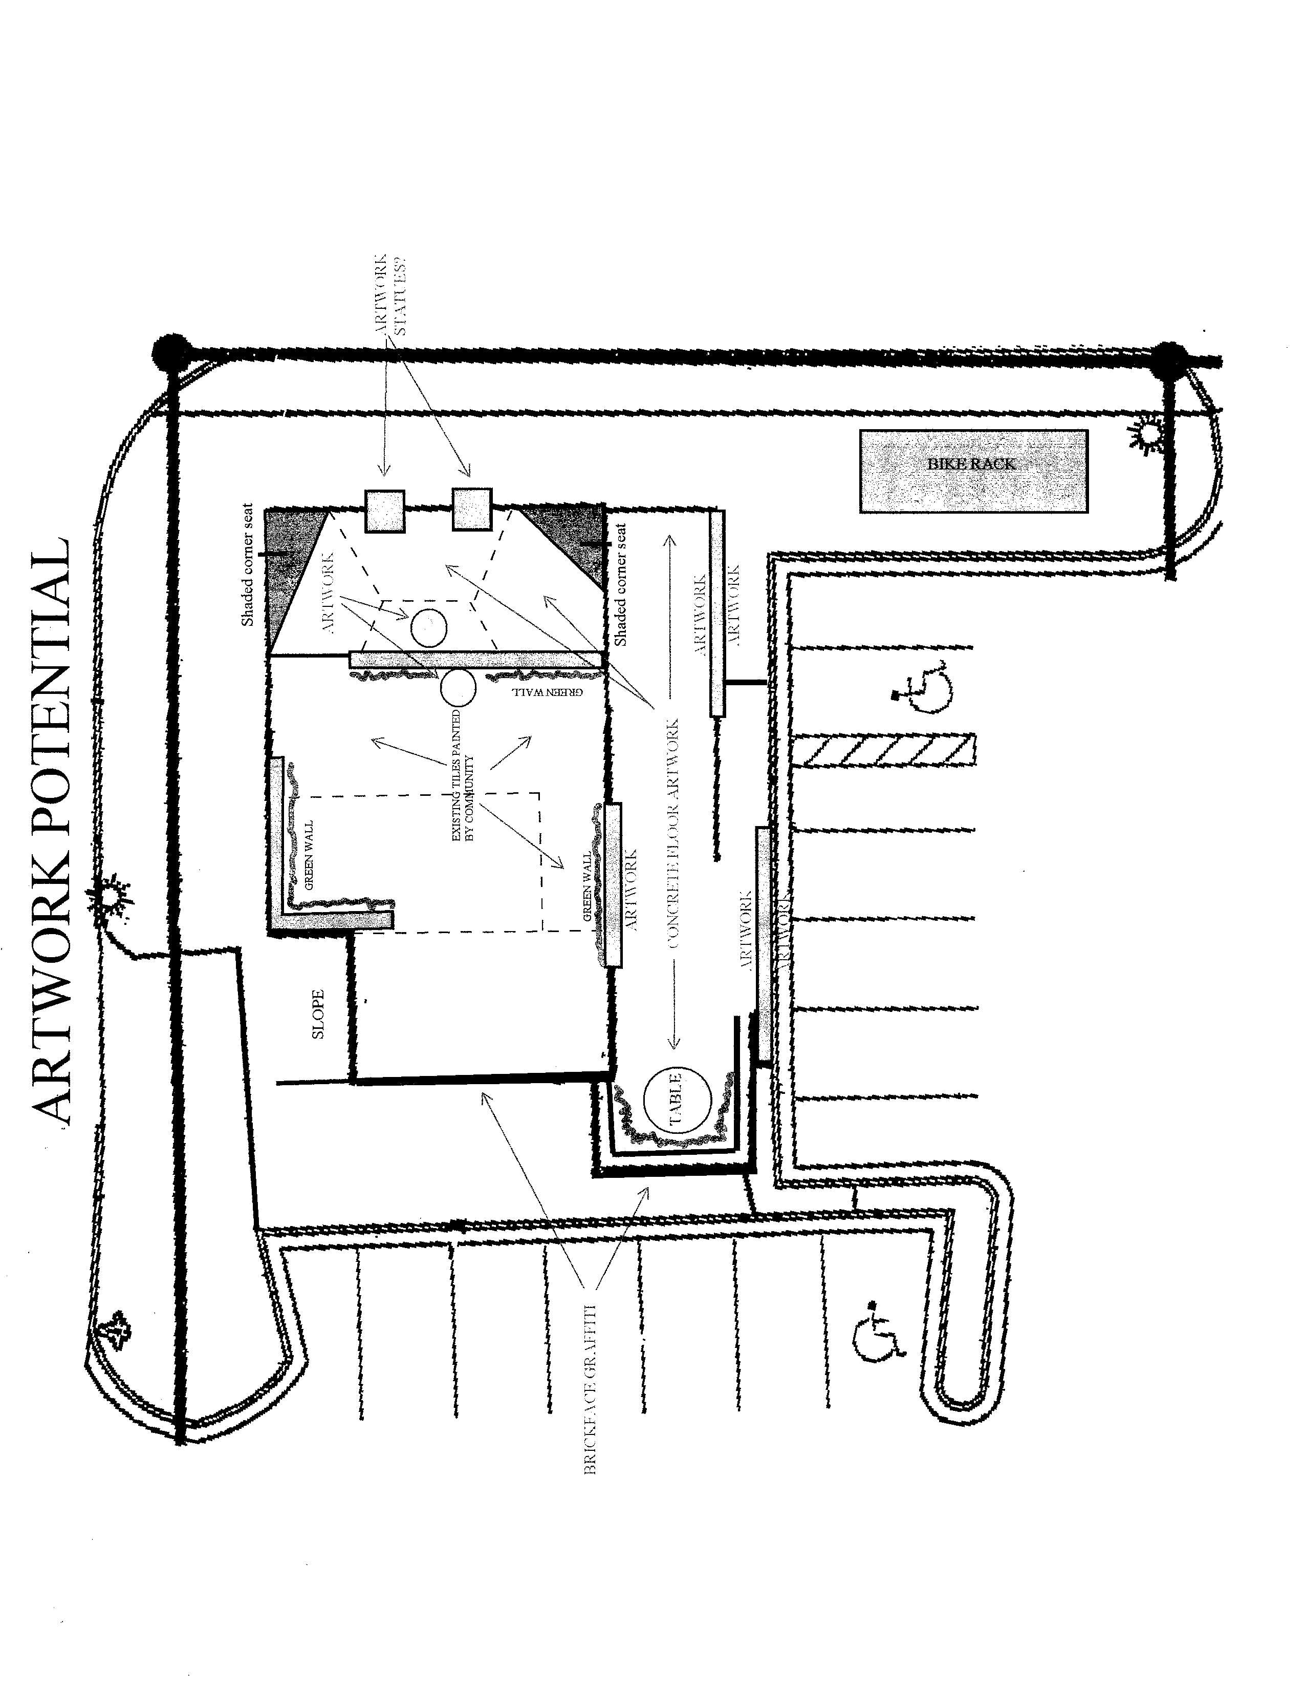


Title II and Title III Revised Regulations: Accessible Parking
National Network

Information, Guidance and Training on the Americans with Disabilities Act
Call us toll-free

1-800-949-4232 V/TTY

Find your regional center at

www.adata.org

Accessible Parking

The U.S. Department of Justice (DOJ) issued new regulations under the Americans with Disabilities Act (ADA) in 2010. The new rules affect state and local governments (Title II of the ADA), as well as public accommodations and commercial facilities (Title III). The regulations include the new 2010 ADA Standards for Accessible Design, outlining minimum accessibility requirements for buildings and facilities.

Existing Facilities

New construction projects must meet minimum standards with very few exceptions; alterations are also subject to strict requirements, although they may be more affected by existing structural conditions. Existing buildings and facilities which are not undergoing planned alterations are viewed a little differently.

Title II: Program Access

State and local government agencies that offer programs, services, or activities in existing facilities need to make sure that people with disabilities can gain access and participate in these activities. There are a variety of ways that agencies can ensure access to programs, but making structural improvements is often necessary.

Title III: Barrier Removal

Both commercial facilities and public accommodations must follow standards for new construction and alterations. Additionally, public accommodations (private businesses that are open to the general public, like retail stores, restaurants, banks, parking garages, and many others) must remove barriers when it is “readily achievable” to do so; readily achievable means

“easily accomplishable and able to be carried out without much difficulty or expense.” Designating accessible parking is often readily achievable, and is considered a top priority because it enables many people with disabilities to “get in the door.”

Safe Harbor

The 2010 regulations include a “safe harbor” for features that already comply with the 1991 standards, but may not meet the new 2010 standards. For example: A retail store’s parking lot has a total of 250 parking spaces; in compliance with 1991 standards, the lot includes seven accessible spaces, one of which is van-accessible. The 2010 standards would require two van-accessible spaces, but the store does not have to modify its parking lot to provide the additional space until the lot undergoes a planned alteration (re-striping, re-surfacing, etc.) after March 15, 2012. If the lot is altered after that time, it will then be brought into compliance with the 2010 standards, to the maximum extent feasible.

How many accessible parking spaces are needed?

One of every six accessible parking spaces, or fraction thereof, must be “van-accessible.” For example: A parking lot with 400 total spaces needs eight accessible spaces, and two of those eight spaces must be van-accessible.

Accessible spaces must connect to the shortest possible accessible route to the accessible building entrance or facility they serve.

www.adata.org | 1 | 2014


Title II and Title III Revised Regulations: Accessible Parking

What do accessible parking spaces look like?

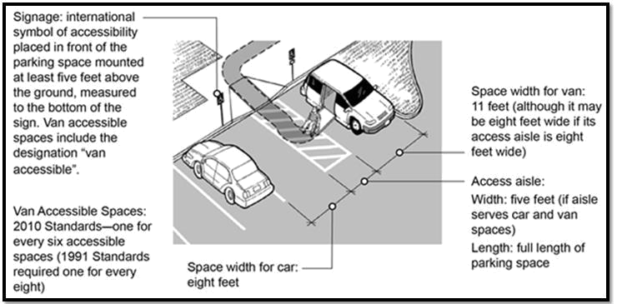

Dimensions (all dimensions are minimums): Accessible parking spaces are eight (8) feet wide; van-accessible spaces are eleven (11) feet wide. Access aisles for either type of space are five (5) feet wide. These adjacent aisles, which can be shared between two spaces, provide room for individuals to deploy vehicle-mounted wheelchair lifts and/or unload and use mobility devices such as wheelchairs, walkers, etc. An alternate design allows a van-accessible space to be eight (8) feet wide if the adjacent access aisle is also eight (8) feet wide.

Access aisles must be marked (e.g., painted with hatch marks) to discourage parking in them. This is especially important where the alternate design is used and an access aisle at a van-accessible space is the same size as the space.

The surface of accessible spaces and access aisles must be smooth, stable, and virtually level in all directions to ensure safe use for people with disabilities, including those who must load, unload, and use wheeled mobility devices.

Additionally, van-accessible spaces, their associated access aisles, and the vehicular routes serving them must provide vertical clearance of at least 98 inches to allow for the height of typical wheelchair lift-equipped vehicles.

Signs

Accessible parking spaces must be identified by signs that include the International Symbol of Accessibility. Signs at van-accessible spaces must include the additional phrase “van-accessible.”

Signs should be mounted so that the lower edge of the sign is at least five (5) feet above the ground. This helps ensure visibility both for motorists and local enforcement officials.

Exceptions

- Parking lots that have four or fewer total spaces do not need to designate the accessible space with a sign. This means that for the purposes of local enforcement (at least in most jurisdictions), anyone, with or without a disability, can park in the accessible space. This is intended to excuse very small entities from having to reserve 25% to 100%

www.adata.org | 3 | 2014

Title II and Title III Revised Regulations: Accessible Parking

Total Number of |  | Minimum Number of
Parking Spaces in |  | Minimum Number of
 |  | Accessible Parking
Parking Facility (Lot |  | Accessible Parking
 |  | Spaces Required
or Garage) |  | Spaces Required
1 - 25 |  | 1
26 | - 50 | 2
51 | - 75 | 3
76 - 100 |  | 4
101 | - 150 | 5
151 | - 200 | 6
201 | - 300 | 7
301 | - 400 | 8
401 | - 500 | 9
501 - 1000 |  | 2% of total
 |  | 20, plus 1 for each
1001 and over |  | 100, or fraction
 |  | there-of, over 1000

Where a parking facility serves multiple buildings or accessible entrances, accessible parking spaces should be dispersed to enable people to park near as many accessible entrances as possible. For example: A shopping center has fifteen stores, each with a separate entrance. There is one large parking lot with 1000 spaces. The twenty accessible parking spaces should be dispersed to provide some options for people to park close to the different stores.

Where separate parking facilities serve the same building or entrance, accessible spaces may be grouped together, as long as the number of spaces provided is determined according to each of the separate parking facilities. For example: A sports stadium has an adjacent parking lot with 1000 spaces and a separate parking lot several blocks away with an additional 1500 spaces. The

adjacent lot needs 20 accessible spaces (four of which need to be van-accessible), and the remote lot needs 25 accessible spaces (five of which need to be van-accessible). Since accessible spaces need to be as near as possible to the facilities they serve, the 45 accessible spaces (including nine van-accessible) can be located in the lot adjacent to the stadium.

Medical Facilities

Certain types of medical facilities need more accessible parking.

- Hospital outpatient facilities need 10% of patient/visitor spaces to be accessible.

- Rehabilitation facilities that specialize in treating mobility-related conditions and outpatient physical therapy facilities need 20% of patient/visitor spaces to be accessible.

The number of van-accessible spaces is still one of every six accessible parking spaces, or fraction thereof.

For example: An outpatient physical therapy facility has a parking lot with 50 total spaces for employees only. Following basic requirements, that lot will need two accessible spaces, one of which will be van-accessible. A separate lot with 200 total spaces is provided for patients and visitors; this lot will need 40 accessible spaces, seven of which will be van-accessible.

Exceptions

- Parking facilities that are used exclusively for buses, trucks, delivery vehicles, law enforcement vehicles, and vehicular impound are not required to include accessible spaces, but if such lots are accessed by the public (e.g. impounded vehicle retrieval) then an accessible passenger loading zone must be provided.

www.adata.org | 2 | 2014

Title II and Title III Revised Regulations: Accessible Parking

of their available parking for individuals with disabilities.

- Residential facilities where parking spaces are assigned to specific dwelling units are also exempt from the requirement to post signs at accessible spaces.

Note that these two exemptions are only related to signs; accessible parking spaces must still be provided in appropriate numbers and with other required features (minimum width, etc.).

Maintenance

It is important that accessible features be maintained, and outdoor spaces can be especially challenging because of weather and other conditions. Accessible parking spaces, aisles, and routes should be maintained in good repair and kept clear of snow, ice, or fallen leaf build-up.

have their own requirements, which may be more specific or more stringent in some ways.

Each state also establishes criteria and procedures to issue accessible parking permits (often in the form of distinctive license plates or placards) to individuals with disabilities. Enforcement activities related to these issues (fraudulent use of permits, illegal parking in accessible spaces, etc.) are typically carried out by state and local authorities, such as city police departments.

Other requirements may be relevant in different situations or under different laws. For example, the Fair Housing Act requires covered housing providers to make “reasonable accommodations” for residents with disabilities, which could mean reserving a parking space for a specific individual.

Other Laws, Other

Requirements

The ADA establishes these requirements to
ensure that when parking facilities are provided
by entities covered by Title II or Title III,
accessible spaces with certain features are
available. Many state and local governments

Content was developed by the Mid-Atlantic ADA Center, and is based on professional consensus of ADA experts and the ADA National Network.



401 North Washington Street, Suite 450 Rockville, MD 20850

Toll Free: 800-949-4232 V/TTY (DC, DE, MD, PA, VA, WV)
Local: 301-217-0124 V/TTY
Fax: 301-251-3762
http://www.adainfo.org/

This information product was developed under grants from the Department of Education, NIDRR grant numbers H133A110014 and H133A110017. However, the contents do not necessarily represent the policy of the Department of Education, and you should not assume endorsement by the Federal Government.



© Copyright 2014 ADA National Network. All Rights Reserved.
May be reproduced and distributed freely with attribution to ADA National Network (www.adata.org).

www.adata.org | 4 | 2014

Crime rates in Avondale Estates by year

 | Murders |  |  | 0 |  |  | 0 |  |  | 0 |  |  | 1 |  |  | 1 |  |  | 0 |  |  | 0
 | (per |  |  | (0.0) |  |  | (0.0) |  |  | (0.0) |  |  | (35.0) |  |  | (35.9) |  |  | (0.0) |  |  | (0.0)
 | 100,000)
 | Rapes |  |  | 0 |  |  | 0 |  |  | 0 |  |  | 0 |  |  | 0 |  |  | 0 |  |  | 0
 | (per |  |  | (0.0) |  |  | (0.0) |  |  | (0.0) |  |  | (0.0) |  |  | (0.0) |  |  | (0.0) |  |  | (0.0)
 | 100,000)
 | Robberie |  |  | 1 |  |  | 2 |  |  | 3 |  |  | 1 |  |  | 3 |  |  | 2 |  |  | 2
 | s |  |  | (37.1) |  |  | (73.9) |  |  | (106.5) |  |  | (35.0) |  |  | (107.6) |  |  | (66.7) |  |  | (66.1)
 | (per
 | 100,000)
 | Assaults |  |  | 0 |  |  | 0 |  |  | 2 |  |  | 0 |  |  | 0 |  |  | 4 |  |  | 1
 | (per |  |  | (0.0) |  |  | (0.0) |  |  | (71.0) |  |  | (0.0) |  |  | (0.0) |  |  | (133.4) |  |  | (33.0)
 | 100,000)
 | Burglarie |  |  | 19 |  |  | 14 |  |  | 25 |  |  | 18 |  |  | 8 |  |  | 9 |  |  | 25
 | s |  |  | (704.0) |  |  | (517.2) |  |  | (887.5) |  |  | (630.7) |  |  | (286.9) |  |  | (300.1) |  |  | (825.9)
 | (per
 | 100,000)
 | Thefts |  |  | 52 |  |  | 55 |  |  | 73 |  |  | 56 |  |  | 82 |  |  | 74 |  |  | 93
 | (per |  |  | (1,926.6) |  |  | (2,031.8) |  |  | (2,591.4) |  |  | (1,962.2) |  |  | (2,941.2) |  |  | (2,467.5) |  |  | (3,072.3)
 | 100,000)
 | Auto |  |  | 8 |  |  | 9 |  |  | 6 |  |  | 8 |  |  | 8 |  |  | 9 |  |  | 5
 | thefts |  |  | (296.4) |  |  | (332.5) |  |  | (213.0) |  |  | (280.3) |  |  | (286.9) |  |  | (300.1) |  |  | (165.2)
 | (per
 | 100,000)
 | Arson |  |  | N/A |  |  | N/A |  |  | 0 |  |  | 0 |  |  | 0 |  |  | 0 |  |  | 0
 | (per |  |  |  |  |  |  |  |  | (0.0) |  |  | (0.0) |  |  | (0.0) |  |  | (0.0) |  |  | (0.0)
 | 100,000)
 | City- |  |  | 166.7 |  |  | 172.0 |  |  | 236.9 |  |  | 233.4 |  |  | 273.9 |  |  | 197.0 |  |  | 228.0
 | data.com
 | crime
 | index(high
 | er means
 | more
 | crime,
 | U.S.
 | average =
Crime rates in Avondale Estates by year
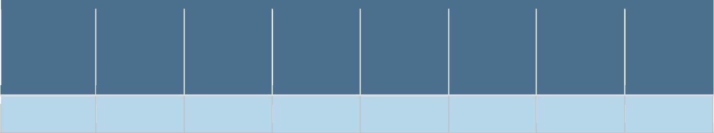

284.9)

The majority of crimes according to the Uniform Crime Report are property theft. Of those thefts the majority occurred in the residential areas adjoining Memorial Drive.
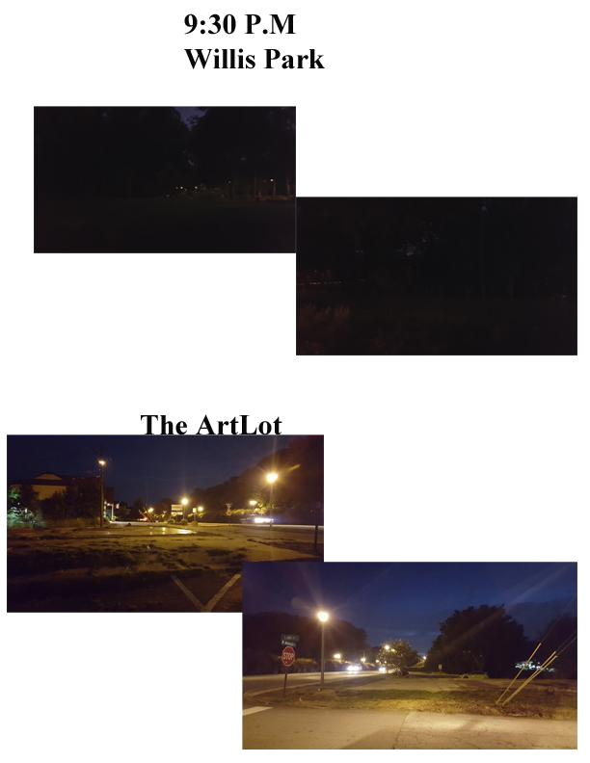

CATEGORY | ITEM | BUILDING MATERIALS | COST | QTY | Total per Unit | Total Units | Sub Total Expense
Sea@ng
 | Bench Seats
 |  | Pallets | Free
 |  | 2X4-10' | $5.57 | 4 | $22.28
 |  | 1x4-10' | $4.27 | 4 | $17.08
 |  | 4x4-8' | $12.57 | 4 | $50.28
 |  | Deck Screws 2" | $29.98 | 1 | $29.98
 |  | Deck Screws 3" | $29.98 | 1 | $29.98
 |  | Angle Brackets | $4.91 | 4 | $19.64
 |  | Concrete Anchors | $9.67 ea | 4 | $38.68
 |  | Lag Screws | $1.31 ea | 4 | $5.24
Per Unit cost |  |  |  |  | $213.16 | 6 | $1,278.96
 | Concrete Block Sea@ng
 |  | 8x8-16" Concrete Block | $1.22 | 10 | $12.20
 |  | 4x4-6 | $6.47 | 5 | $32.35
Per Unit cost |  |  |  |  | $44.55 | 3 | $133.65
 | Bar Height Chair
 |  | Pallets | Free
 |  | 4x4-8' | $12.57 | 1 | $12.57
 |  | 2X4-10' | $5.57 | 1 | $5.57
 |  | Deck Screws 2" | $29.98 | 1 | $29.98
 |  | Deck Screws 3" | $29.98 | 1 | $29.98
 |  | Concrete Anchors | $9.67 | 2 | $19.34
 |  | Angle Brackets | $4.91 | 2 | $9.82
 |  | Lag Screws | $1.31 | 2 | $2.62
Per Unit cost |  |  |  |  | $109.88 | 10 | $1,098.80
Tables
 | Fixed 2 Top Bar Height Table
 |  | Pallets | Free | 1
 |  | 2X4-10' | $5.57 | 1 | $5.57
 |  | Deck Screws 2" | $29.98 | 1 | $29.98
 |  | Deck Screws 3" | $29.98 | 1 | $29.98
 |  | Concrete Anchors | $9.67 | 4 | $38.68
 |  | 4" Diameter Metal Posts 40" L | $71 | 1 | $71
 |  | 4" Metal Flange | $25 | 1 | $25
Per Unit cost |  |  |  |  | $200.21 | 5 | $1,001.05
 | Small coﬀee tables
 |  | Pallets | Free | 1
 |  | 4x4-8' | $12.57 | 1 | $12.57
 |  | 2X4-10' | $5.57 | 2 | $11.14
 |  | Deck Screws 2" | $29.98 | 1 | $29.98
 |  | Deck Screws 3" | $29.98 | 1 | $29.98
 |  | Concrete Anchors | $9.67 ea | 2 | $19.34
 |  | Angle Brackets | $4.91 | 2 | $9.82
 |  | Lag Screws | $1.31 ea | 2 | $2.62
Per Unit cost |  |  |  |  | $115.45 | 3 | 346.35
Walls
 | 12'x21' pallet walls
 |  | Pallets | Free | 16
 |  | carriage Bolts | $1.56 | 30 | $46.80
 |  | Washers | $4.95 Box | 1 | $4.95
 |  | Nuts | 0.22 | 30 | $6.60
 |  | 2x4-12' | $6.87 | 6 | $41.22
 |  | Concrete Anchors | $9.67 | 21 | $203.07
Per Unit cost |  |  |  |  | $302.64 | 1 | $302.64
 | 16'x8' pallet wall
 |  | Pallets | Free | 10
 |  | carriage Bolts | $1.56 | 20 | $31.20
 |  | Washers | $4.95 Box | 1 | $4.95
 |  | Nuts | 0.22 | 20 | $4.40
 |  | 2x4-12' | $6.87 | 4 | $27.48
 |  | Concrete Anchors | $9.67 | 15 | $145.05
Per Unit cost |  |  |  |  | $213.08 | 1 | $213.08
 | 13'x8' pallet wall

 |  |  | Pallets | Free | 8
 |  |  | carriage Bolts | $1.56 | 12 | $18.72
 |  |  | Washers | $4.95 Box | 1 | $4.95
 |  |  | Nuts | 0.22 | 12 | $2.64
 |  |  | 2x4-12' | $6.87 | 4 | $27.48
 |  |  | Concrete Anchors | $9.67 | 13 | $125.71
Per Unit cost |  |  |  |  |  | $179.50 |  | $179.50
 | Plexiglass Windows
 |  |  | 4x4 Plexi Sheet | $108.99 | 1 | $108.99
 |  |  | 2X4-10' | $5.57 | 1 | $5.57
 |  |  | Deck Screws 2" | $29.98 | 1 | $29.98
 |  |  | 1x1-6' | $1.87 | 1 | $1.87
Per Unit cost |  |  |  |  |  | $146.41 | 1 | $146.41
Planters
 | Locking Casters |  | 2" | $3 | 4 | $12
 | Landscape Fabric |  | 4'x100' | $45 | 1 | $45
 | 2x6-8' |  | PT | $5.77 | 7 | $40.39
 | Chicken wire |  | 7'x100' | $18.48 | 1 | $18.48
Per Unit cost |  |  |  |  |  | $116 | 5 | $580
Ligh@ng
 | DecoraRve Acrylic Tube lights
 |  |  | Red 2" diameter x 6' | $39 | 2 | $78
 |  |  | Orange 2" diameter x 6' | $39 | 2 | $78
 |  |  | Blue 2" diameter x 6' | $39 | 2 | $78
 |  |  | Green 2" diameter x 6' | $39 | 2 | $78
 |  |  | Dusk to dawn sensor | $16 | 1 | $16
 |  |  | LED Light Sockets | $3 | 8 | $24
 |  |  | LED Bulbs | $9 | 8 | $72
 |  |  | outdoor low voltage wire | $27 | 1 | $27
 |  |  | Low voltage regulator | $100 | 1 | $100
 |  |  | GFCI Receptacels | $47 | 5 | $235
 |  |  | 12-2 UF-B Wiring 250' | $91 | 2 | $182
 |  |  | Conduit | $39 | 3 | $117
Per Unit cost |  |  |  |  |  | $1,084 | 1 | $1,084
 | Overhead LighRng
 |  | Commercial grade string lights, 100 |  | $229.95 | 1 | $229.95 |  | $229.95
 |  |  | Bright White, Transparent Glass | $247.50 | 1 box | $247.50 |  | $247.50
 |  |  | Bulbs | $247.50 | 1 box | $247.50 |  | $247.50
 | Accent LighRng |  | Bulbs
 |  |  | LED Landscape Spot Lights | $140 | 6 | $247.50 |  | $247.50
Canopy
 | Sun Shade |  | 18'x18' | $51 | 2 | $247.50 |  | $247.50
General Tools and Supplies
 | Tie Wraps |  |  | 1 pack of 50 | 1 | $5.00 |  | $5.00
 | Paint |  |  | $37.98 gal | 3 | $113.94 |  | $113.94
 | Plywood |  | 19/32 4x8 | $17.47 | 5 | 87.35 |  | 87.35
 | Blackout 12'x8' Movie Screen |  |  | $65 | 1 | $65 |  | $65
 | 4" Dia Metal Post 8' |  |  | $142 | 8 | $1,136 |  | $1,136
 | 4" Dia Metal Post 10' |  |  | $172 | 2 | $344 |  | $344
 | 4" ID Post Flange |  |  | $25 | 10 | $250 |  | $250
 | Eyehooks |  |  | $3.28 | 10 | $32.80 |  | $32.80
 | 10'x20' White Tarp |  |  | $34.00 | 2 | $64.00 |  | $64.00
 | Vinyl coated wire rope |  |  | $12.87 | 7 | $90.09 |  | $90.09
 | Rollaway dumpster |  |  | $400.00 | 1 | $400.00 |  | $400.00
Labor | Electricians and Plumbers |  |  |  |  | $5,000.00 |  | $5,000
Sales Tax |  |  |  |  |  |  |  | $666.76
Grand Total |  |  |  |  |  |  |  | $15,591.83
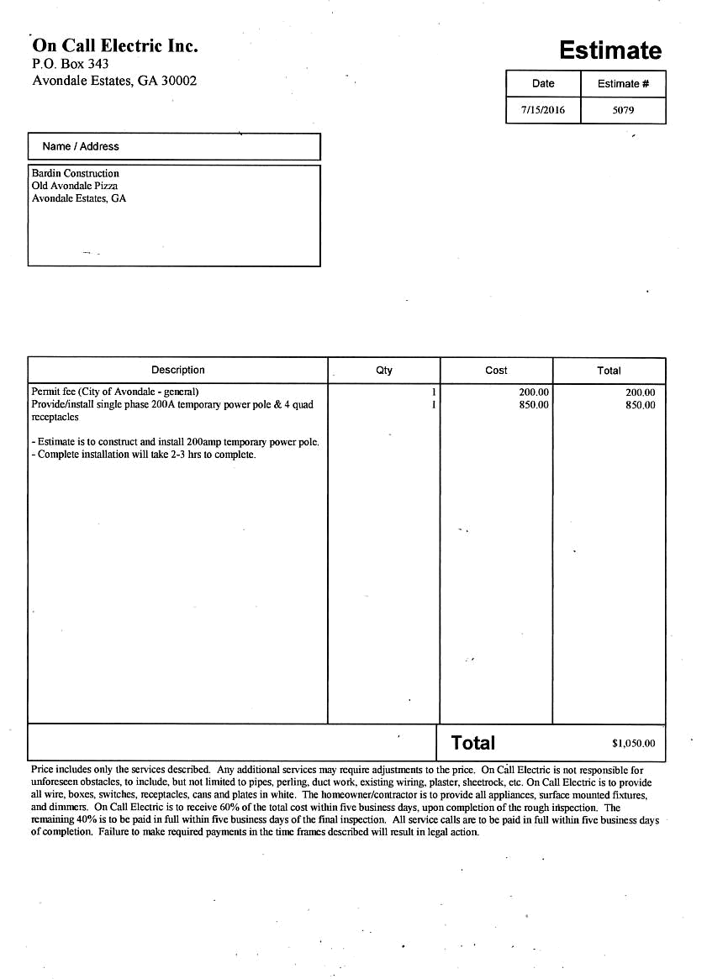
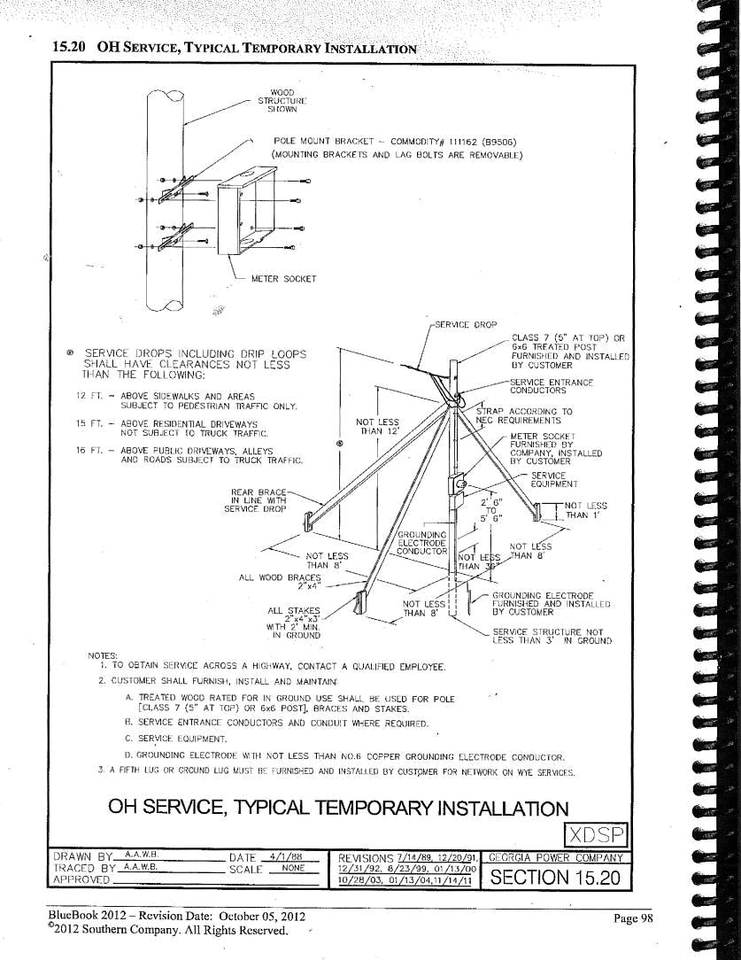
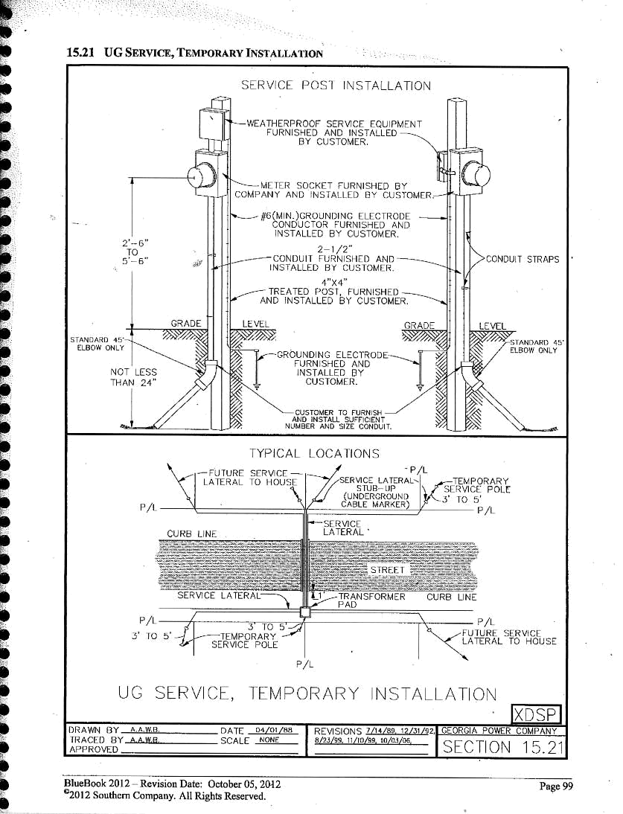
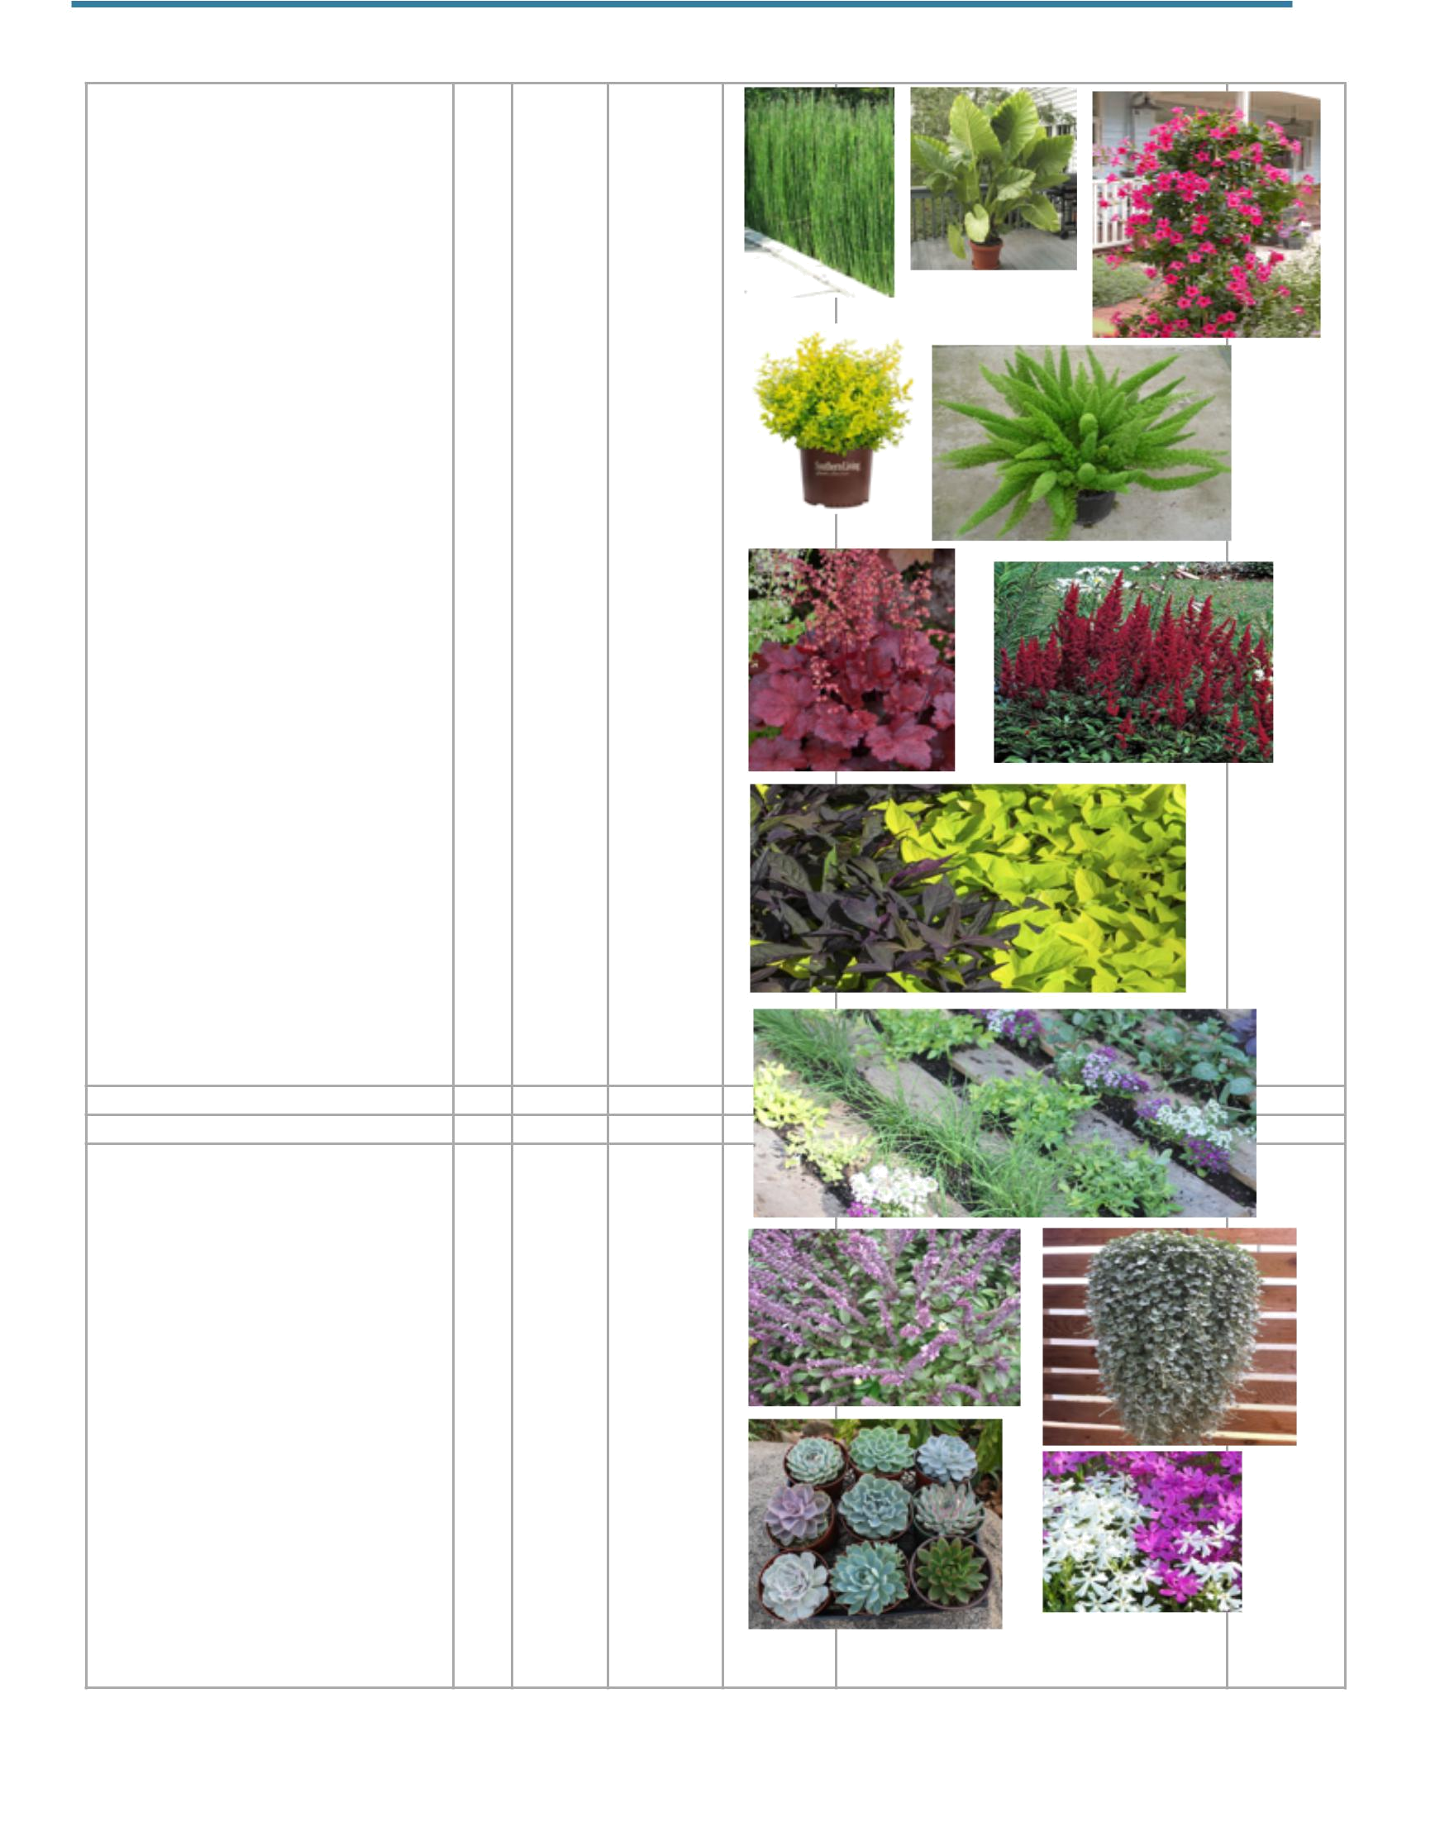
5' Troughs | QTY | Price Ea | Total
Equisedum - Horsetail - 3 Gal | 4 | $18.00 | $72.00
Colocasia - Elephant Ears - 1 gal | 4 | $10.00 | $40.00
Arbor / Climbing Area
Mandevilla - 3 gallon | 4 | $25.00 | $100.00
Front Entrance / Art Gallery
Papryus | 6 | $25.00 | $150.00
Pots - Misc. Locations
Ligustrum 'Sunny' | 2 | $20.00 | $40.00
Foxtail Fern | 2 | $27.00 | $54.00
Phlox 'Thrift' White | 2 | $3.50 | $7.00
Huchera | 2 | $6.50 | $13.00
Ogon | 6 | $1.75 | $10.50
Lavender | 2 | $11.50 | $23.00
Variegated ginger | 2 | $20.00 | $40.00
Butterfly Garden
Ruellia brittonia - Mexican Petunia - 1gal | 3 | $5.00 | $15.00
African Blue Basil - 1gal | 3 | $5.00 | $15.00
Lantana - 1gal | 3 | $8.00 | $24.00
Astibe - 1gal | 3 | $4.00 | $12.00
Loosestrife Guara - 1gal | 3 | $3.50 | $10.50
Pallet Wall
Various Herbs | 15 | $1.50 | $22.50
Hen + Chicks | 15 | $2.00 | $30.00
Various Succulents | 10 | $3.50 | $35.00
Hanging Baskets
Dichondria 'Silver Falls' | 3 | $22.50 | $67.50
Sweet Potato Vine | 3 | $18.00 | $54.00
Sedum 'Purple Heart' | 3 | $18.00 | $54.00

Plants Total | $889.00
Add 10% for tax | $90.00
Add 10% in case of substitution | $90.00
 | $1,069.00
Potting Mix | $455.00
Mulch 5 yards | $150.00
Gravel 2 yards | $80.00
Fill dirt 4 yards | $60.00
Delivery | $160.00
Soil and Mulch Total | $905.00
(5) 60" x 24 x 24 troughs | $300.00
(6) Hanging Baskets | $120.00
(10) 24" pots | $450.00
Pots Total | $870.00
Total for Plants/Pots | $2,844.00

CATEGORY | ITEM | BUILDING MATERIALS | COST | QTY | Total per Unit | Total Units | Sub Total Expense
Seating
 | Bench Seats
 |  | Pallets | Free
 |  | 2X4-‐10' | $5.57 | 4 | $22.28
 |  | 1x4-‐10' | $4.27 | 4 | $17.08
 |  | 4x4-‐8' | $12.57 | 4 | $50.28
 |  | Deck Screws 2" | $29.98 | 1 | $29.98
 |  | Deck Screws 3" | $29.98 | 1 | $29.98
 |  | Angle Brackets | $4.91 | 4 | $19.64
 |  | Concrete Anchors | $9.67 ea | 4 | $38.68
 |  | Lag Screws | $1.31 ea | 4 | $5.24
Per Unit cost |  |  |  |  | $213.16 | 6 | $1,278.96
 | Concrete Block Seating
 |  | 8x8-‐16" Concrete Block | $1.22 | 10 | $12.20
 |  | 4x4-‐6 | $6.47 | 5 | $32.35
Per Unit cost |  |  |  |  | $44.55 | 3 | $133.65
 | Bar Height Chair
 |  | Pallets | Free
 |  | 4x4-‐8' | $12.57 | 1 | $12.57
 |  | 2X4-‐10' | $5.57 | 1 | $5.57
 |  | Deck Screws 2" | $29.98 | 1 | $29.98
 |  | Deck Screws 3" | $29.98 | 1 | $29.98
 |  | Concrete Anchors | $9.67 | 2 | $19.34
 |  | Angle Brackets | $4.91 | 2 | $9.82
 |  | Lag Screws | $1.31 | 2 | $2.62
Per Unit cost |  |  |  |  | $109.88 | 10 | $1,098.80
Tables
 | Fixed 2 Top Bar Height Table
 |  | Pallets | Free | 1
 |  | 2X4-‐10' | $5.57 | 1 | $5.57
 |  | Deck Screws 2" | $29.98 | 1 | $29.98
 |  | Deck Screws 3" | $29.98 | 1 | $29.98
 |  | Concrete Anchors | $9.67 | 4 | $38.68
 |  | 4" Diameter Metal Posts 40" L | $71 | 1 | $71
 |  | 4" Metal Flange | $25 | 1 | $25
Per Unit cost |  |  |  |  | $200.21 | 5 | $1,001.05
 | Small coffee tables
 |  | Pallets | Free | 1
 |  | 4x4-‐8' | $12.57 | 1 | $12.57
 |  | 2X4-‐10' | $5.57 | 2 | $11.14
 |  | Deck Screws 2" | $29.98 | 1 | $29.98
 |  | Deck Screws 3" | $29.98 | 1 | $29.98
 |  | Concrete Anchors | $9.67 ea | 2 | $19.34
 |  | Angle Brackets | $4.91 | 2 | $9.82
 |  | Lag Screws | $1.31 ea | 2 | $2.62

Per Unit cost |  |  |  | $115.45 | 3 | 346.35
Walls
12'x21' pallet walls
 | Pallets | Free | 16
 | carriage Bolts | $1.56 | 30 | $46.80
 | Washers | $4.95 Box | 1 | $4.95
 | Nuts | 0.22 | 30 | $6.60
 | 2x4-‐12' | $6.87 | 6 | $41.22
 | Concrete Anchors | $9.67 | 21 | $203.07
Per Unit cost |  |  |  | $302.64 | 1 | $302.64
16'x8' pallet wall
 | Pallets | Free | 10
 | carriage Bolts | $1.56 | 20 | $31.20
 | Washers | $4.95 Box | 1 | $4.95
 | Nuts | 0.22 | 20 | $4.40
 | 2x4-‐12' | $6.87 | 4 | $27.48
 | Concrete Anchors | $9.67 | 15 | $145.05
Per Unit cost |  |  |  | $213.08 | 1 | $213.08
13'x8' pallet wall
 | Pallets | Free | 8
 | carriage Bolts | $1.56 | 12 | $18.72
 | Washers | $4.95 Box | 1 | $4.95
 | Nuts | 0.22 | 12 | $2.64
 | 2x4-‐12' | $6.87 | 4 | $27.48
 | Concrete Anchors | $9.67 | 13 | $125.71
Per Unit cost |  |  |  | $179.50 |  | $179.50
Plexiglass Windows
 | 4x4 Plexi Sheet | $108.99 | 1 | $108.99
 | 2X4-‐10' | $5.57 | 1 | $5.57
 | Deck Screws 2" | $29.98 | 1 | $29.98
 | 1x1-‐6' | $1.87 | 1 | $1.87
Per Unit cost |  |  |  | $146.41 | 1 | $146.41
Planters
Locking Casters | 2" | $3 | 4 | $12
Landscape Fabric | 4'x100' | $45 | 1 | $45
2x6-‐8' | PT | $5.77 | 7 | $40.39
Chicken wire | 7'x100' | $18.48 | 1 | $18.48
Per Unit cost |  |  |  | $116 | 5 | $580
Lighting
Decorative Acrylic Tube lights
 | Red 2" diameter x 6' | $39 | 2 | $78
 | Orange 2" diameter x 6' | $39 | 2 | $78
 | Blue 2" diameter x 6' | $39 | 2 | $78
 | Green 2" diameter x 6' | $39 | 2 | $78

 |  | Dusk to dawn sensor | $16 | 1 | $16
 |  | LED Light Sockets | $3 | 8 | $24
 |  | LED Bulbs | $9 | 8 | $72
 |  | outdoor low voltage wire | $27 | 1 | $27
 |  | Low voltage regulator | $100 | 1 | $100
 |  | GFCI Receptacels | $47 | 5 | $235
 |  | 12-‐2 UF-‐B Wiring 250' | $91 | 2 | $182
 |  | Conduit | $39 | 3 | $117
Per Unit cost |  |  |  |  | $1,084 | 1 | $1,084
 | Overhead Lighting
 |  | Commercial grade string lights, 100' | $229.95 | 1 | $229.95 |  | $229.95
 |  | Bright White, Transparent Glass | $247.50 | 1 box | $247.50 |  | $247.50
 |  | Bulbs | $247.50 | 1 box | $247.50 |  | $247.50
 | Accent Lighting | Bulbs
 |  | LED Landscape Spot Lights | $140 | 6 | $247.50 |  | $247.50
Canopy
 | Sun Shade | 18'x18' | $51 | 2 | $247.50 |  | $247.50
General Tools and Supplies
 | Tie Wraps |  | 1 pack of 50 | 1 | $5.00 |  | $5.00
 | Paint |  | $37.98 gal | 3 | $113.94 |  | $113.94
 | Plywood | 19/32 4x8 | $17.47 | 5 | 87.35 |  | 87.35
 | Blackout 12'x8' Movie Screen |  | $65 | 1 | $65 |  | $65
 | 4" Dia Metal Post 8' |  | $142 | 8 | $1,136 |  | $1,136
 | 4" Dia Metal Post 10' |  | $172 | 2 | $344 |  | $344
 | 4" ID Post Flange |  | $25 | 10 | $250 |  | $250
 | Eyehooks |  | $3.28 | 10 | $32.80 |  | $32.80
 | 10'x20' White Tarp |  | $34.00 | 2 | $64.00 |  | $64.00
 | Vinyl coated wire rope |  | $12.87 | 7 | $90.09 |  | $90.09
 | Rollaway dumpster |  | $400.00 | 1 | $400.00 |  | $400.00
Labor | Electricians and Plumbers |  |  |  | $5,000.00 |  | $5,000
Sales Tax |  |  |  |  |  |  | $666.76
Grand Total |  |  |  |  |  |  | $15,591.83

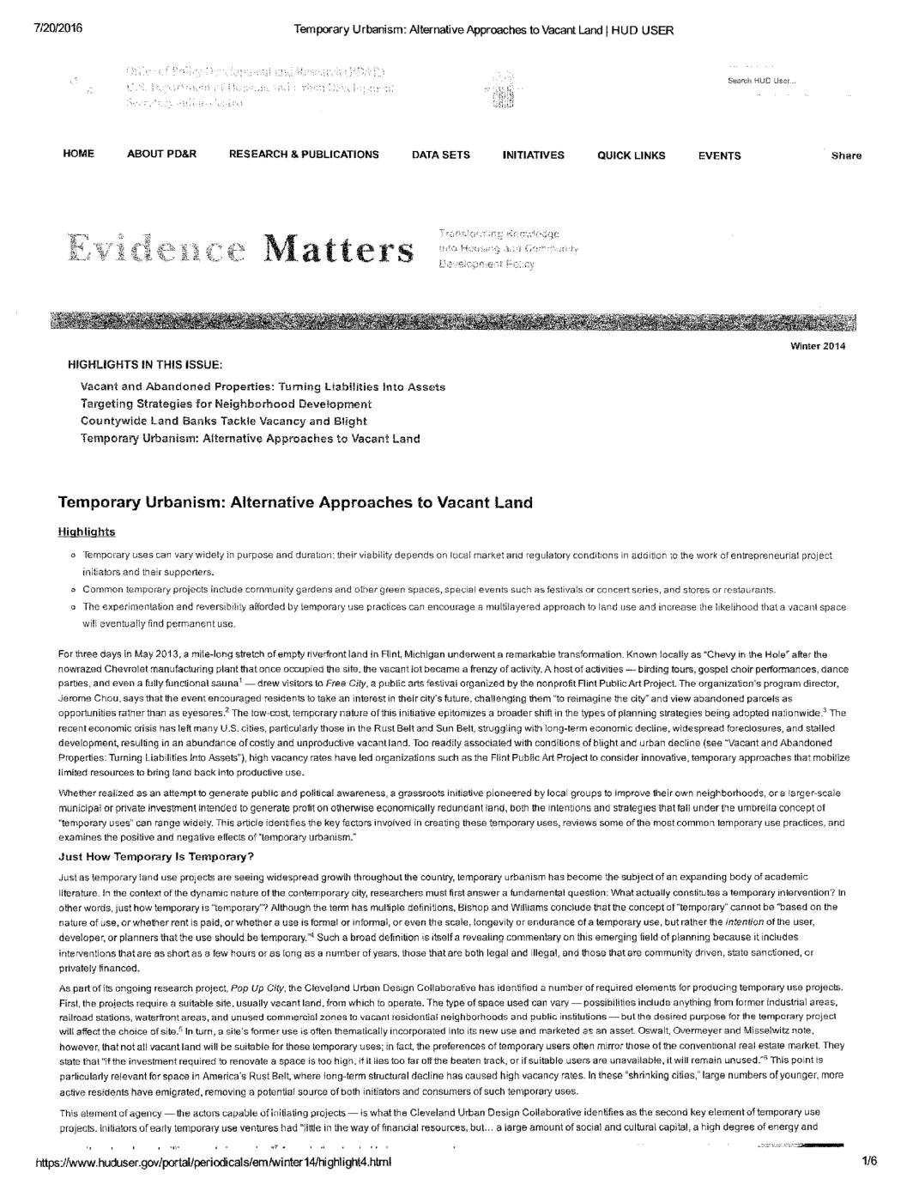
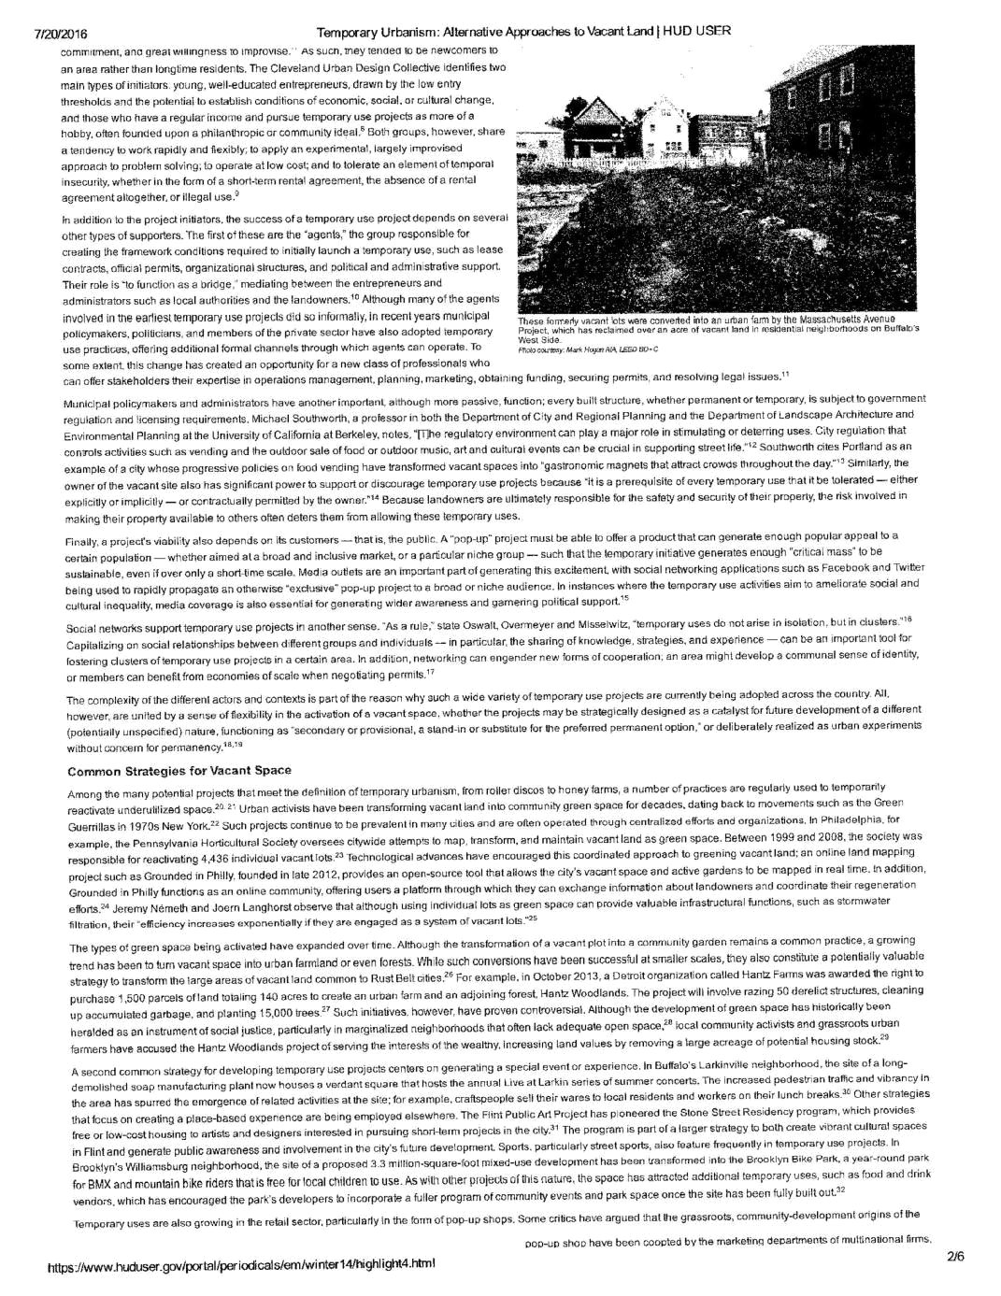
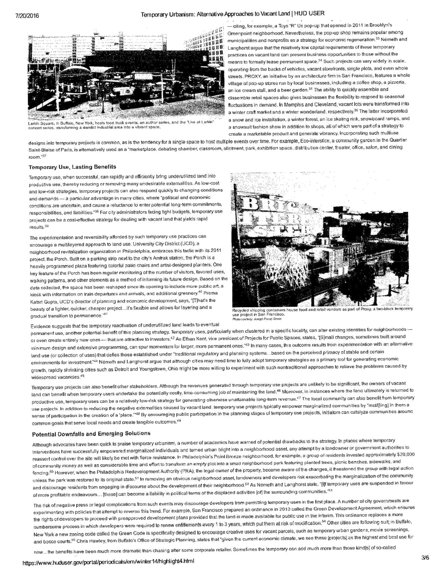
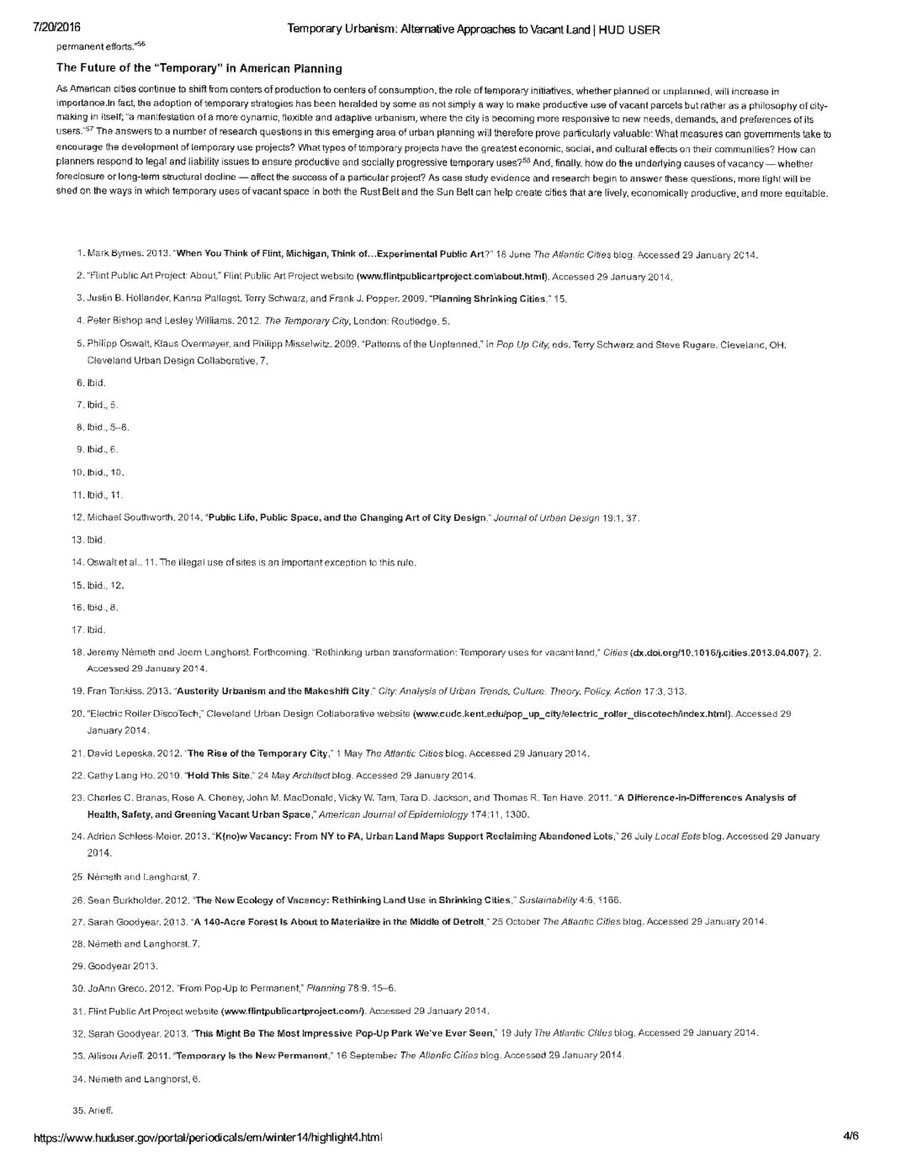
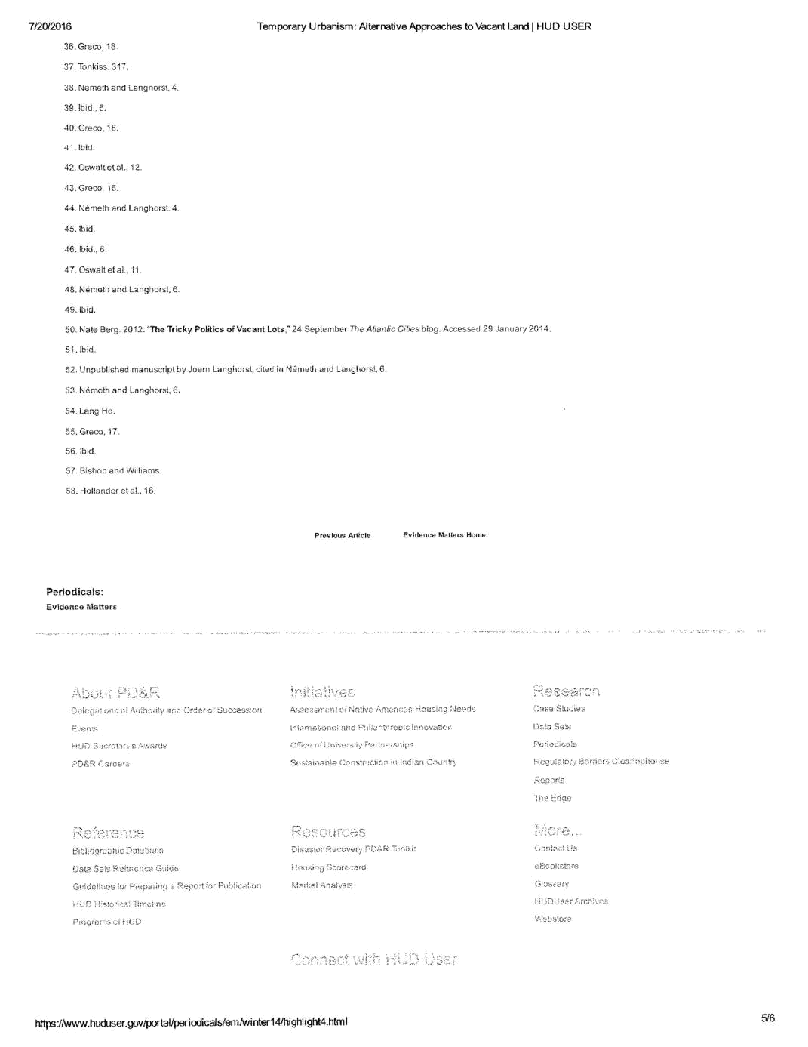
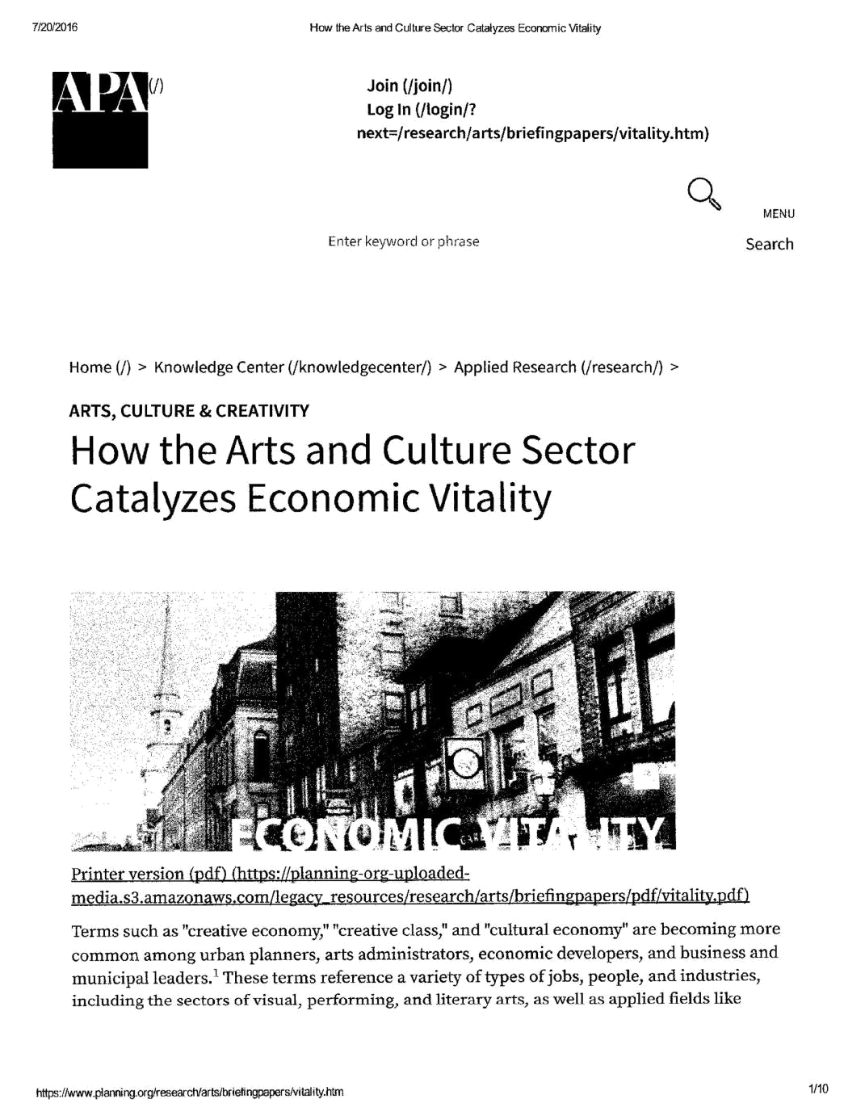
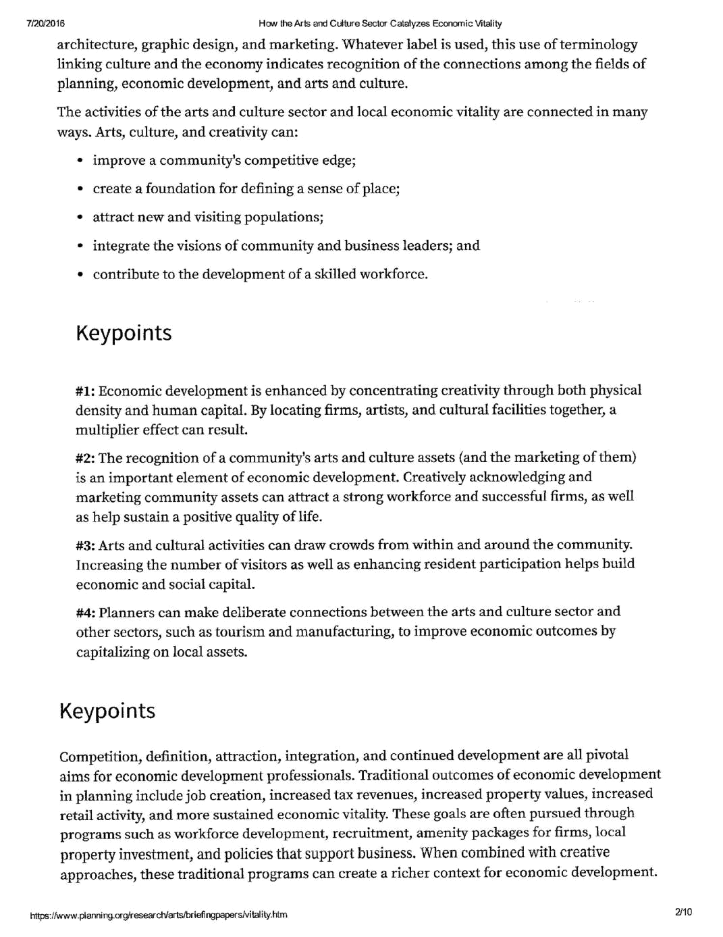
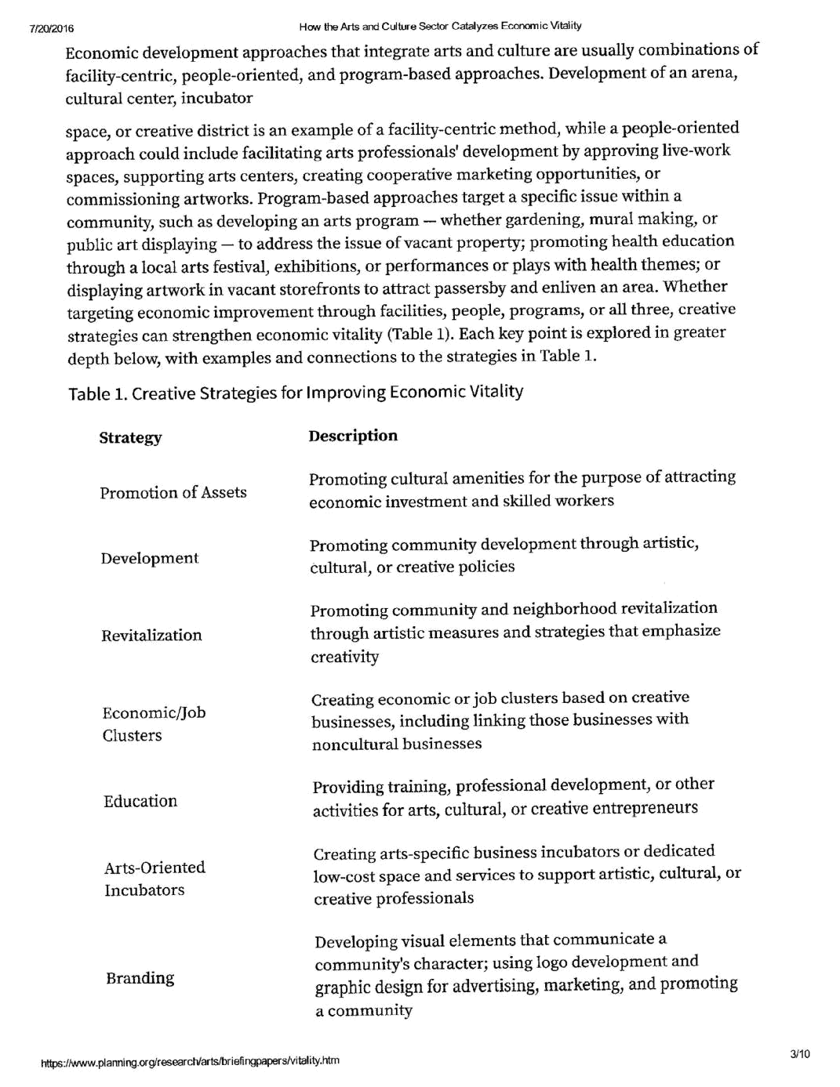
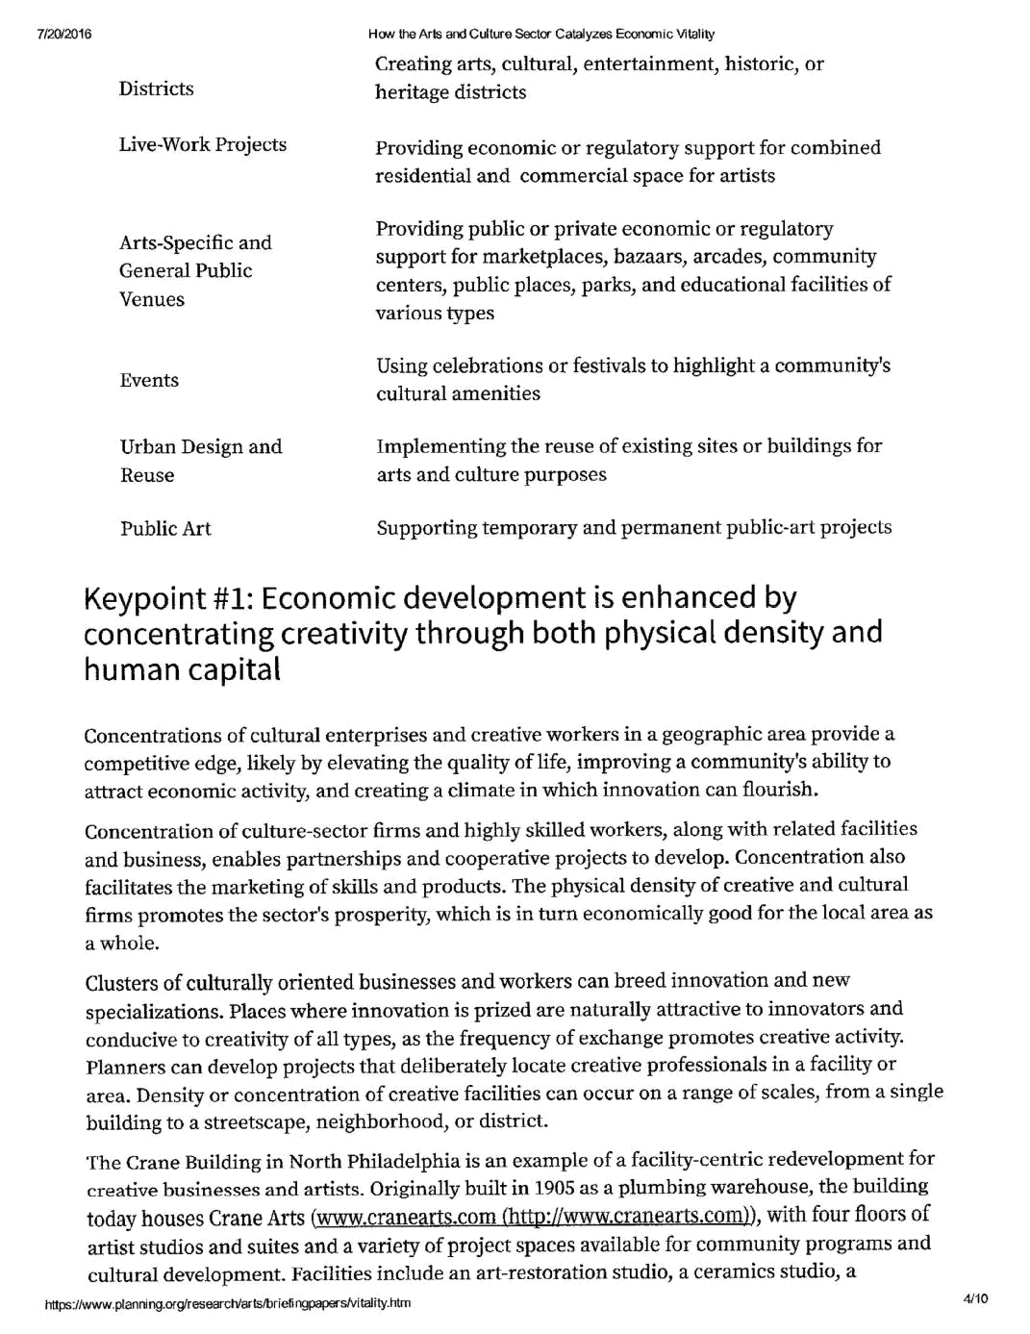
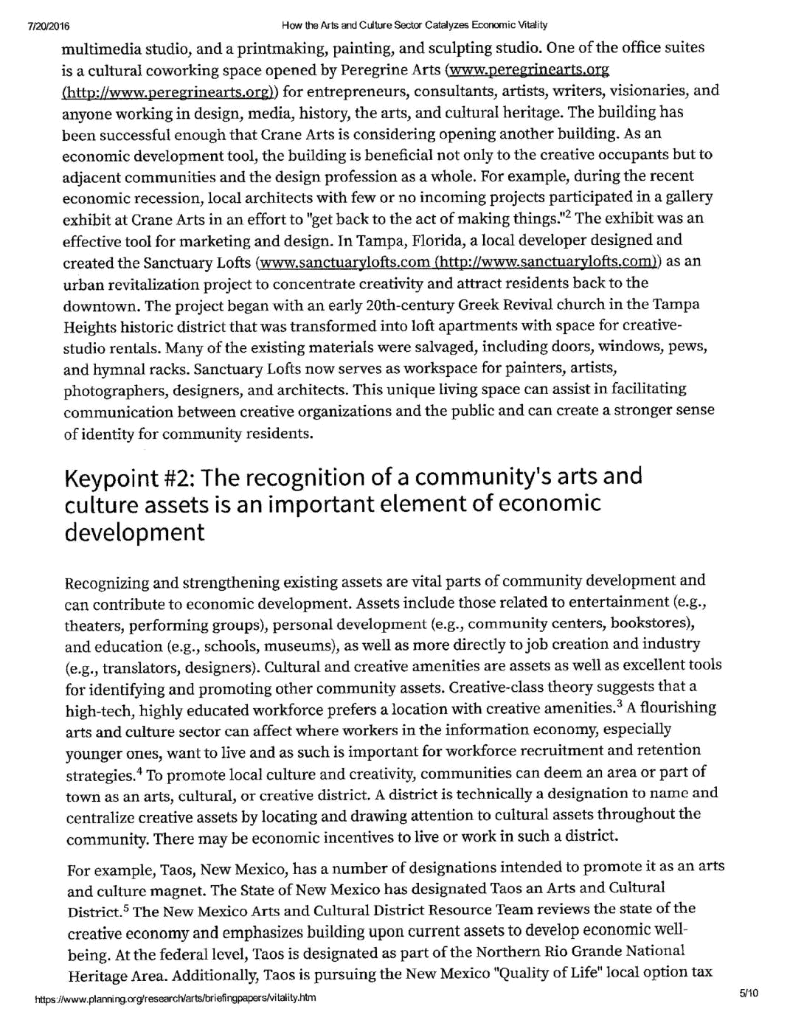
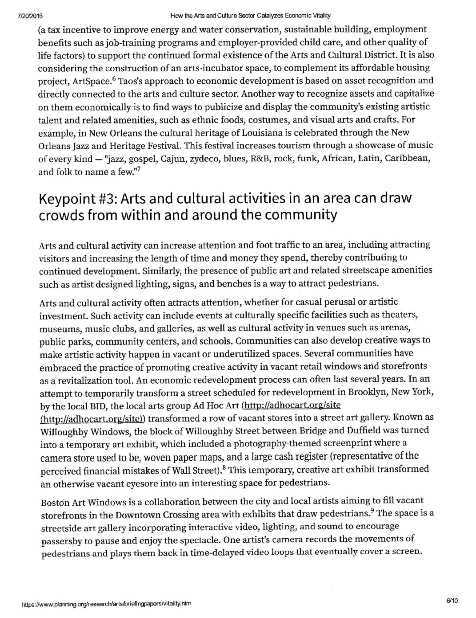
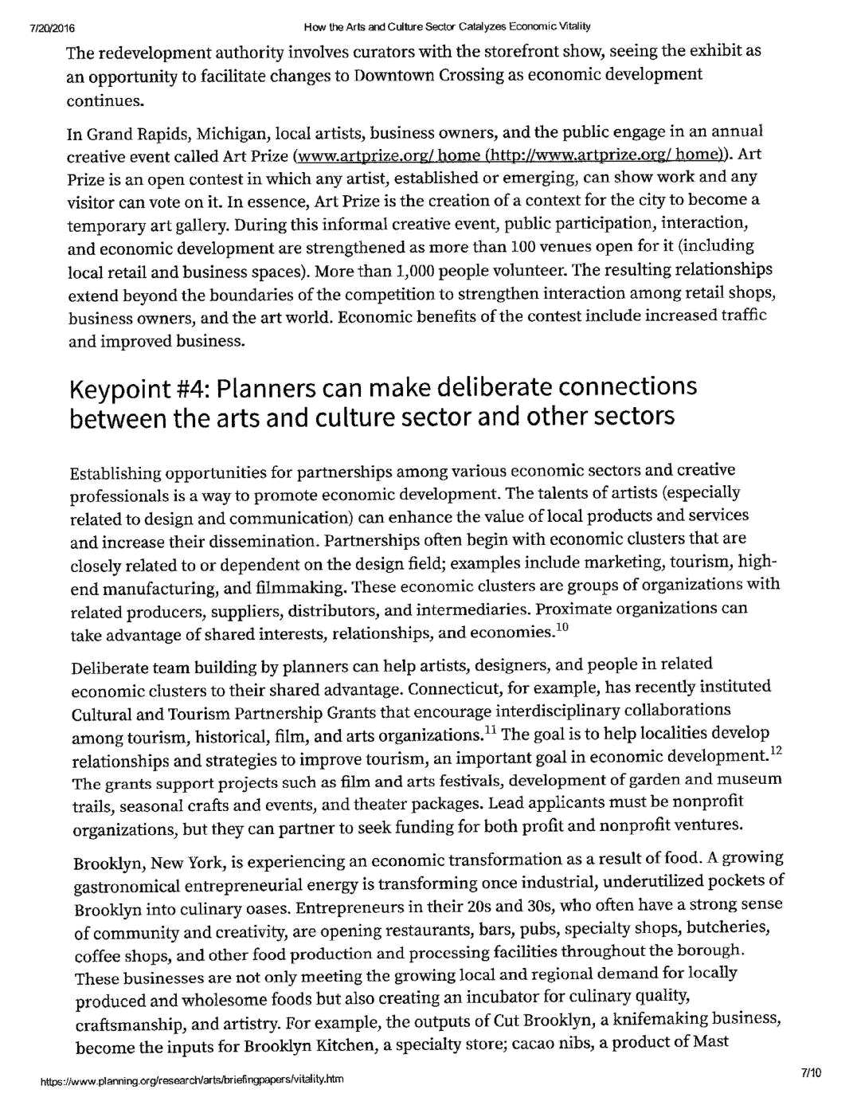
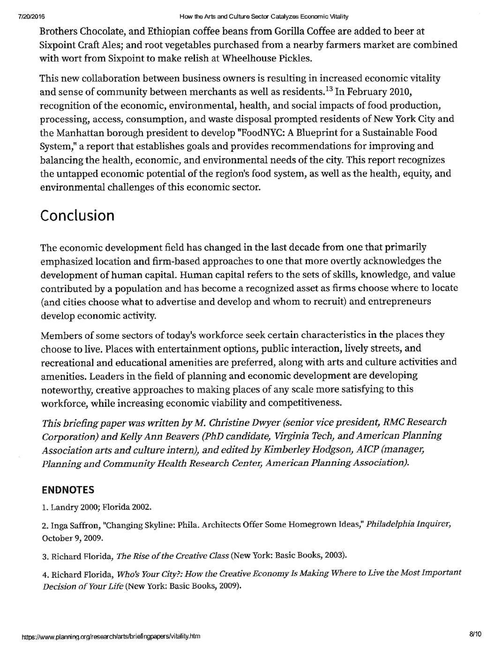
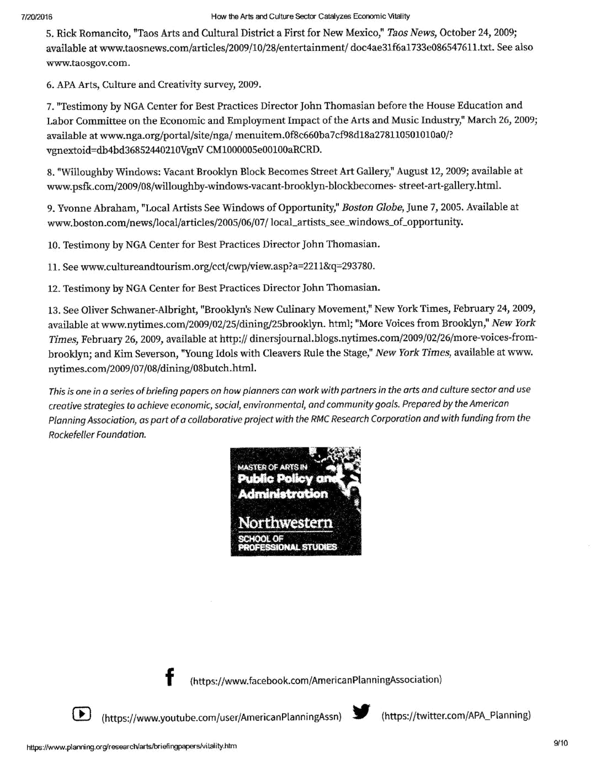
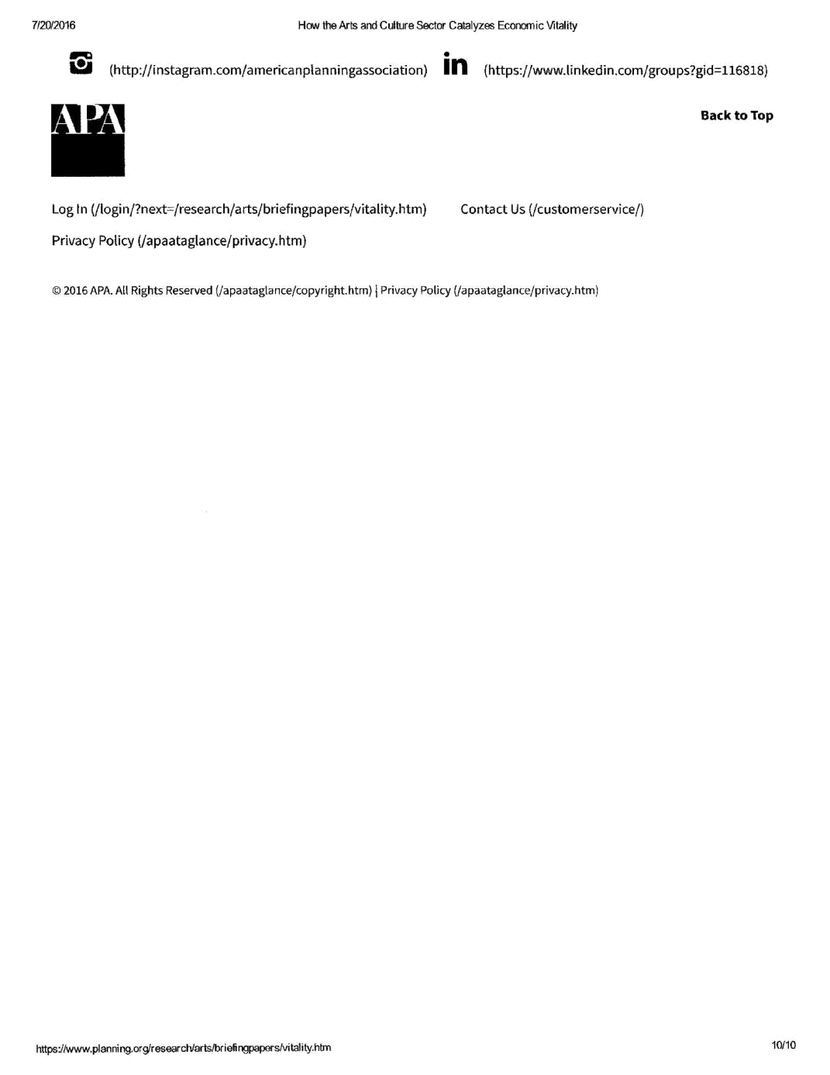
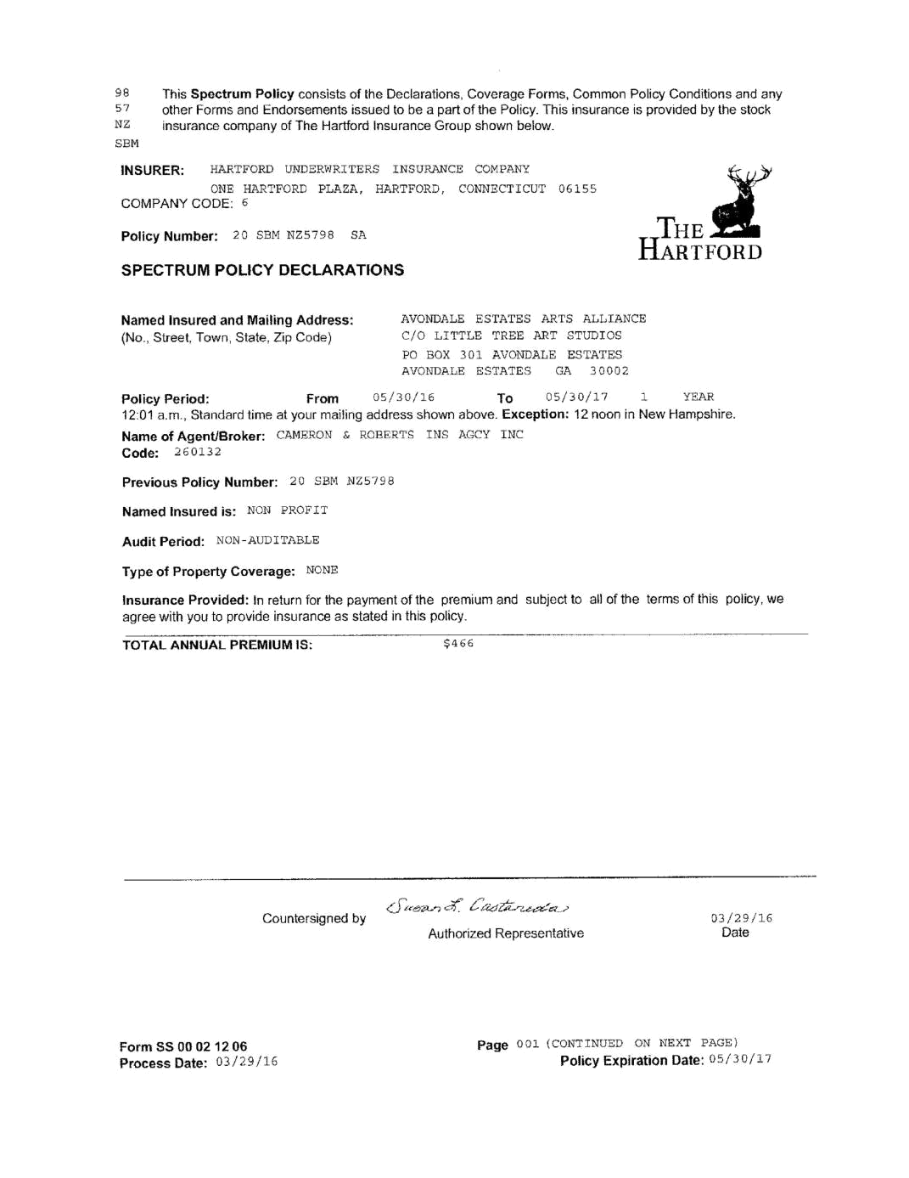
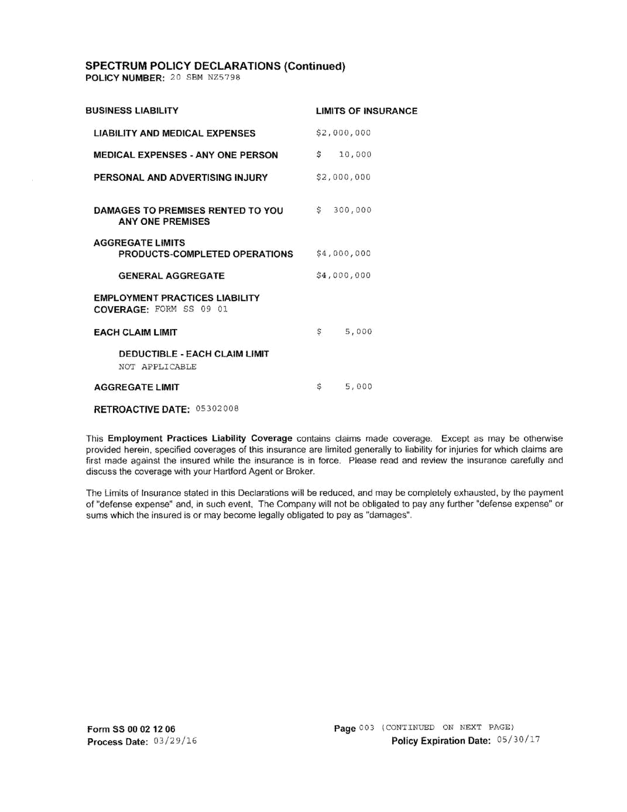

RESOURCES & REFERENCES

The Venice Pop Up Park:

72U designed and built a temporary pop up park on Abbott Kinney to inspire the Venice community. The grand opening was on August 15, 2015. The space will be around for 9+ months. We hope you enjoy the good vibes, free wifi and entertainment (from time to time).

https://www.youtube.com/watch?v=CVj5SbUuFZw

Art Lot Dublin is a project funded by local businesses which has transformed a previously derelict site in Dublin’s City Centre into an outdoor exhibition space for contemporary art, interventions and performances.
https://artlotdublin.wordpress.com/

How One Weekend in Dallas Sparked a Movement for Urban Change
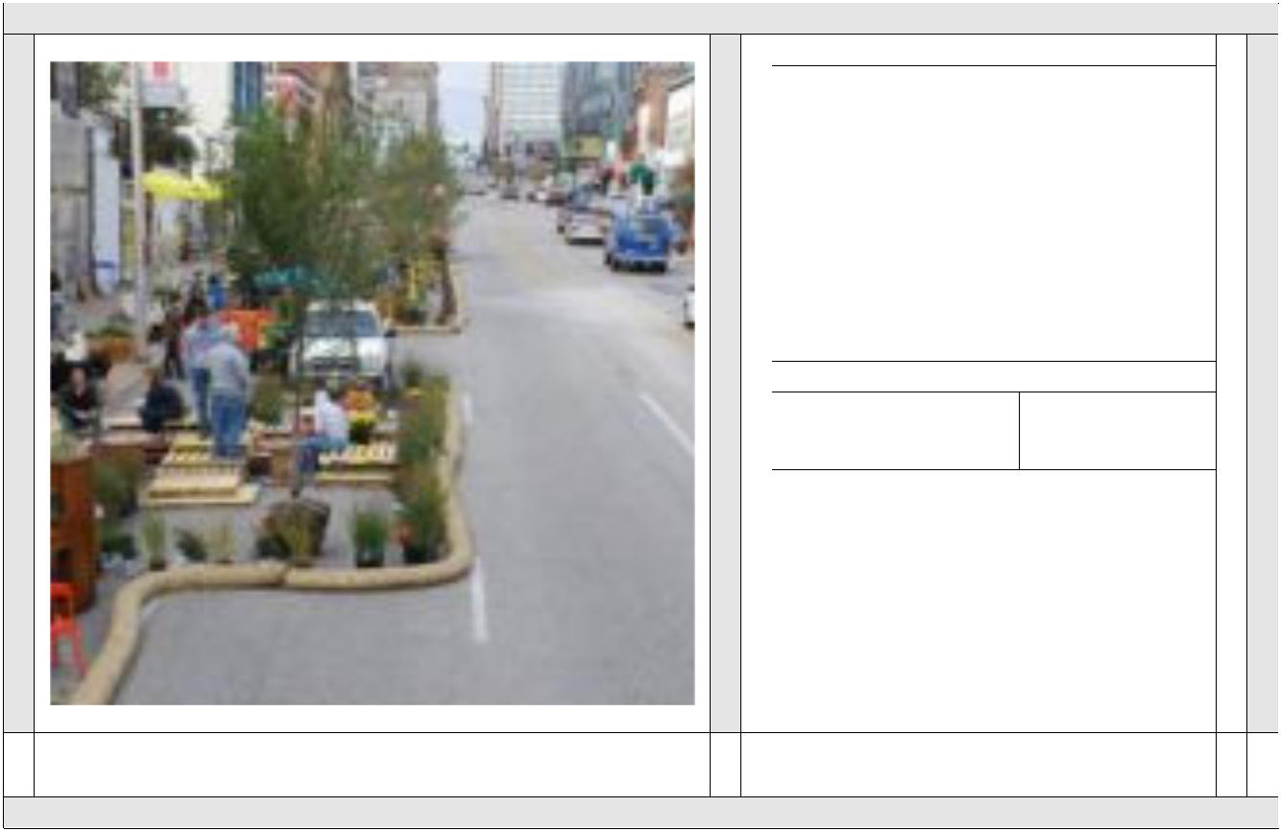

How One Weekend in Dallas Sparked a Movement for Urb...

An excerpt from Tactical Urbanism: Short-Term Action for Long-Term Change

View on nextcity.org Preview by Yahoo

New Kensington Better Block Results in 10 New Businesses
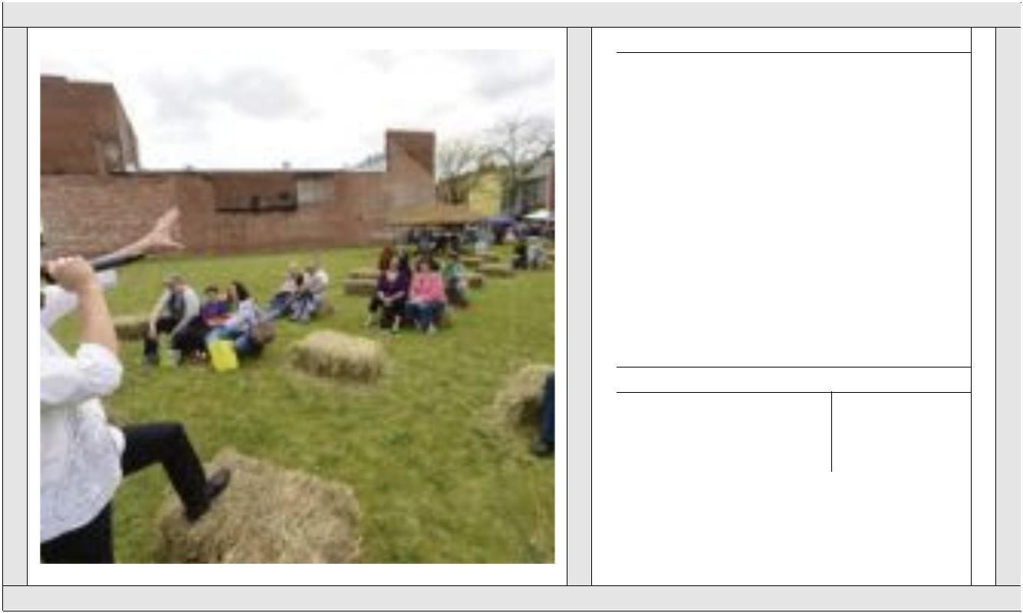

New Kensington Better Block Results in 10 New Businesses

Better Blocks may start over a weekend, but their impact lasts much longer. Last year, New Kensington, Pennsylvania, asked Team Better Block co-founder Andrew How...

 | View on betterblock.org |  | Preview by
 |  |  | Yahoo

http://bettercities.net/sites/default/files/Tactical%20Urbanism%20Final.pdf

How Tactical Urbanism Can Help Build a #BetterMainStreet


How Tactical Urbanism Can Help Build a #BetterMainStreet

So you want to transform your downtown but don't have the financial resources? Not a big deal. Government at all levels has no money? No problem. Developers can’t g...

 |  |  |  | View on |  |  | Preview by
 |  |  |  | www.preservationnati... |  |  | Yahoo

How the Pop-Ups can actually prop up their neighbors
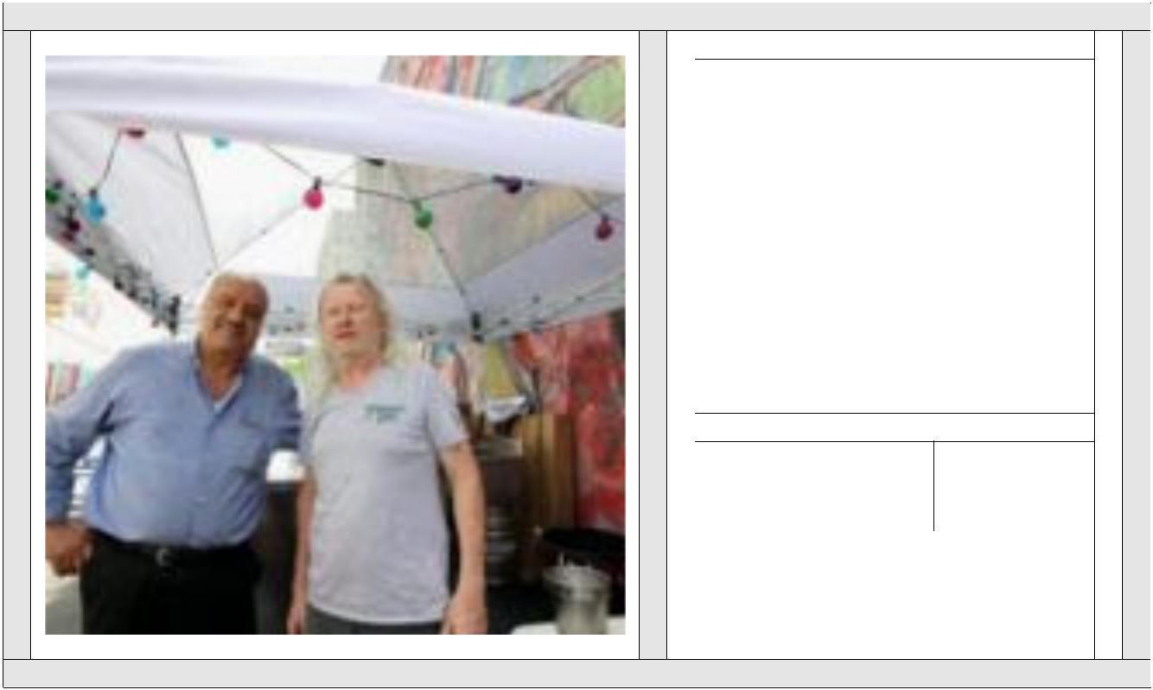

How the Pop-Ups can actually prop up their neighbors

This summer, beer gardens have been popping up like dandelions, causing some legislators to say they are ready to start pulling weeds. But most…

 | View on planphilly.com |  | Preview by
 | View on planphilly.com |  | Yahoo

Pop-Up Parks Take Over Big City Parking Spaces « All About America
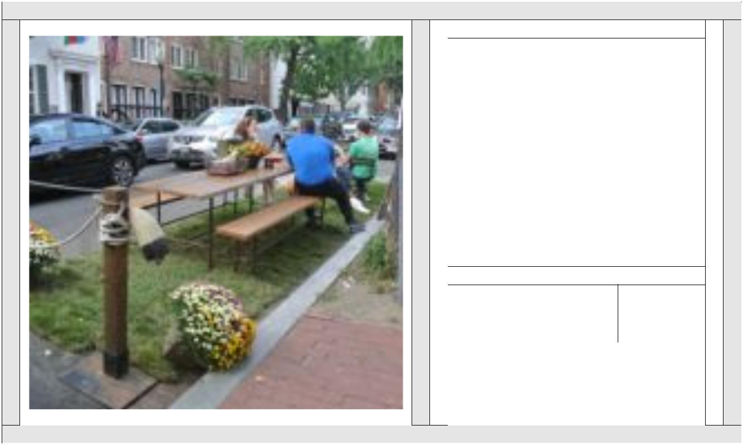

Pop-Up Parks Take Over Big City Parking Spaces « All Abo...

People in the big city sometimes yearn for a little green space to break up all of that concrete. Temporary “parklets” might be just the thing to satisfy that cravi...

 |  |  |  | View on |  |  | Preview by
 |  |  |  | blogs.voanews.com |  |  | Yahoo

