Commonwealth Open Educational Resources (OER) Policy Brief
Policy Brief
November 2016
Who is this aimed at
- Education policy makers and planners in government and institutions

Key messages
- OER are freely available
- OER can help access free, high quality, learning materials
- OER can help governments to achieve the SDGs and increase access to education
- Costs of the reproduction of quality educational resources may be reduced

Policy options
- Existing OER may be considered before investing in new materials development
- Licensing new materials as OER can help reduce the cost of reproduction and service delivery to learners

Executive Summary
Open Educational Resources (OER) are educational materials that are freely available and can be legally used and modified by anyone. Properly leveraged, OER can help everyone in the world access free, high quality, learning materials. OER can help governments meet the aims set out in the United Nations’ Sustainable Development Goals (SDGs), especially with regard to SDG4: ensuring inclusive and equitable quality education, and promoting lifelong learning opportunities for all. This policy brief describes open educational resources, open licenses, open education licensing policies, and actions governments may take to support open education in their countries.

What are Open Educational Resources (OER)?
OER are educational materials that are shared at no cost, with legal permissions for the public to freely modify the content. The Hewlett Foundation defines OER as: “teaching, learning, and research resources that reside in the public domain or have been released under an intellectual property license that permits their free use and re-purposing by others.”
The development and sharing of OER is possible because:
- Almost all educational resources are “born digital,” and digital resources can be stored, copied and distributed for near zero cost.
- The internet makes it simple for the public to share digital content via the web, social media, email, and other online publishing and communication technologies.
- Open licenses (e.g., Creative Commons licenses) make it simple and legal to keep one’s copyright and legally share OER with the world.
Educators and governments supporting public education can use OER to share effective educational materials with their citizens (and beyond) for near zero cost. Because education is fundamentally about sharing knowledge and ideas, many argue governments should actively support OER. Shifting to this model will generate more equitable education opportunities globally, and promote social benefits without sacrificing the quality of educational content.

Why is OER needed?
OER are needed to ensure all students and teachers, in all countries, of all income levels, have access to high quality educational materials. In many countries, students in tertiary / higher education are required to purchase expensive textbooks for University courses. These students often cannot afford - and so do not purchase these textbooks. In primary / secondary (K-12) schools, governments usually purchase the educational resources. In 2012, in one country, there was only 1 reading textbook for 12 students, and only 1 mathematics textbooks for 14 students. Because of high purchasing and/or licensing fees, educational materials might be bought and kept for 10 years or more; resulting in out-of-date educational resources that are not adaptable due to their all-rights-reserved copyright status.
Some of the most typical reasons for moving to OER include, but are not limited to:
- Reducing barriers to education, including access, cost, language and format.
- Ensuring educators have the legal rights to retain, reuse, revise, remix and redistribute educational resources as they determine – without having to ask permission.
- Increasing the efficiency and effectiveness of public funds spent on education.
- Transforming teaching and learning and enabling effective, open pedagogy.
- Connecting communities of educators and learners around open content.
- Expanding the use of internet and digital technologies in education.
- Empowering educators to have more capability in the classroom.

How do OER help educators and students?
OER give educators the ability to adapt instructional resources to the individual needs of their students, to ensure that resources are up-to-date, and to ensure that cost is not a barrier to accessing high-quality educational resources. OER are already being used in primary, secondary and tertiary traditional education, workforce training, and informal learning around the world.

What is the difference between ‘free’ and ‘open’ educational resources?
OER are and always will be free, but not all free resources are OER. Free resources may be temporarily free or may be restricted from use at some time in the future (including, by the addition of fees to access those resources). Moreover, free-but-not-open resources may not be modified, adapted or redistributed without obtaining special permission from the copyright holder.
OER are released under open licenses that permit recipients of the materials to engage in “5R” legal permissions:
- Retain - the right to make, own, and control copies of the content (e.g., download, duplicate, store, and manage).
- Reuse - the right to use the content in a wide range of ways (e.g., in a class, in a study group, on a website, in a video).
- Revise - the right to adapt, adjust, modify, or alter the content itself (e.g., translate the content into another language).
- Remix - the right to combine the original or revised content with other material to create something new (e.g., incorporate the content into a mashup).
- Redistribute - the right to share copies of the original content, your revisions, or your remixes with others (e.g., give a copy of the content to a friend).

Are all OER digital?
Like most educational resources these days, most OER start as digital files. But like traditional resources, OER can be made available to students in both digital and printed formats. Of course, digital OER are easier to share, modify, and redistribute, but being digital is not what makes something an OER or not. This flexibility is important, because it no longer makes print and digital a choice of one or the other. OER textbooks, for example, can typically be printed for a low fee while still being available free in digital form.

Are OER high quality?
Studies at both the primary/secondary and tertiary education levels show that students who use OER do as well, and often better than their peers using traditional resources. Also, many OER are developed through rigorous peer review and production processes that mirror the methods used by traditional education publishers. However, it is important to note that being open or closed does not inherently affect the quality of a resource.
Being open enables educators to use the resource more effectively, which can lead to better learning and student outcomes. For example, OER can be updated, tailored and improved locally to fit the needs of students - translating the OER into a local language, adapting a Biology open textbook to align it with local science standards, modifying an OER simulation to make it accessible for a student who cannot hear, etc.
There are also multiple “quality frameworks / rubrics” such as the COL TIPS framework and the Achieve OER rubrics that are useful in evaluating the quality of educational resources (open or closed).

Do OER require special technology to use?
No. A benefit of OER is that users have the right to transform the materials into any format they wish (e.g., changing a non-editable PDF to an editable HTML document), which is almost always prohibited when dealing with traditional resources that carry an all rights reserved notice. Therefore, OER are not tied to a particular type of device or software, which gives students and institutions more freedom to choose the technology they which to use. In cases where technology such as computers or smartphones are not available, there is always the option to print resources.

How do you tell if an educational resource is an OER?
The key distinguishing characteristic of OER is its copyright license, which communicates the permissions to share and adapt the educational content, while ensuring that the author receives credit for the work. If a lesson plan or activity is not clearly marked with an open license, or already in the public domain, it is not OER. The most common way to release materials as OER is through applying Creative Commons licenses, which have been created with input from copyright experts. The CC licenses are standardized, free to use, and adopted by millions of people around the world.
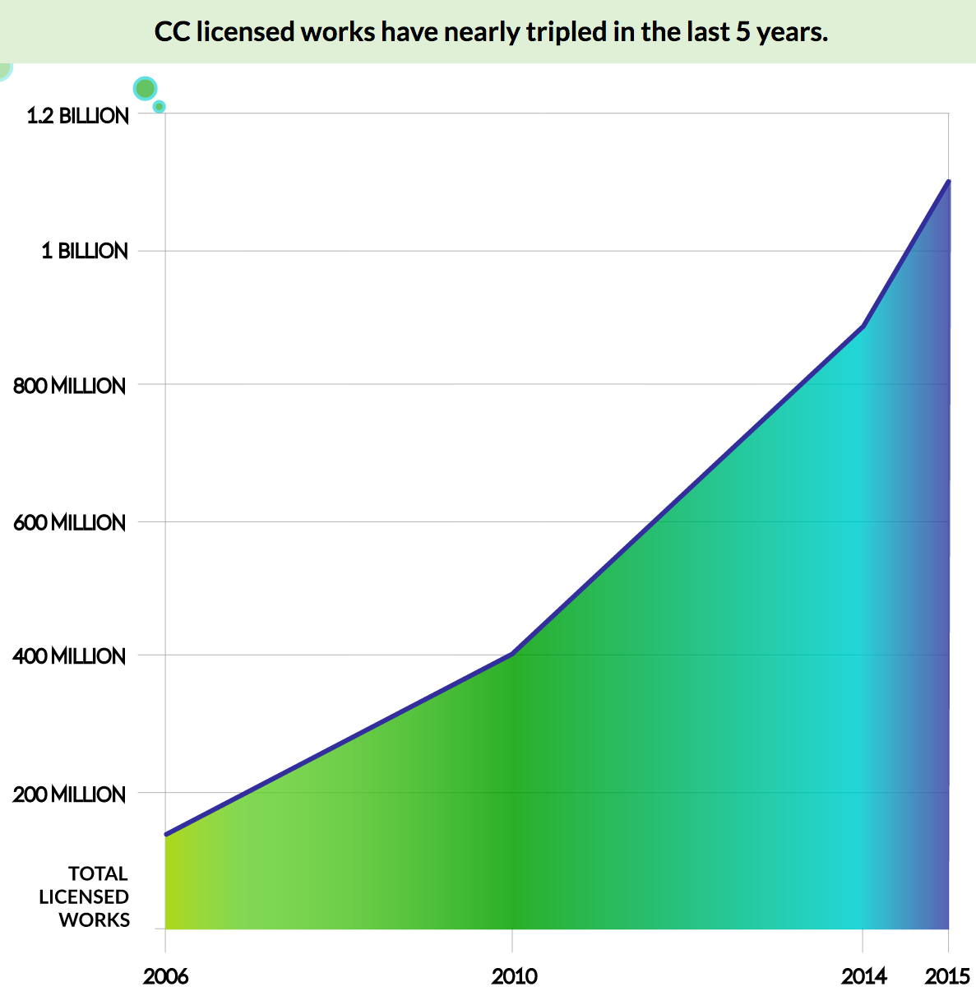
2015 State of the Commons Report / CC BY 4.0

What is Creative Commons?
Creative Commons (CC) is a non-profit organization founded in 2001 that develops and maintains the open copyright licenses and legal tools the world uses to share content on more open terms that the default “all rights reserved” of copyright. CC consists of an international network of affiliates who provide legal, educational, and outreach support to creators and users in over 85 countries.

What is Creative Commons?
Creative Commons licenses are central to OER, as most OER are CC licensed.
Creative Commons publishes six open copyright licenses and technology that permits CC-licensed works to be searched for and found on the Internet. All of the CC licenses grant a standard set of legal permissions to:
- make copies of the work
- distribute, display, share the work
- change copies from one medium to another
- incorporate the work into a collection
All of the CC licenses require a standardized set of conditions. These include:
- retain copyright and licensing info attached to the work
- give credit to the author or rightsholder
- do not imply a use is endorsed by the author
- identify if changes were made to the work
- do not add technical restrictions to access the work
The Creative Commons licenses are expressed via an innovative 3-layer approach:
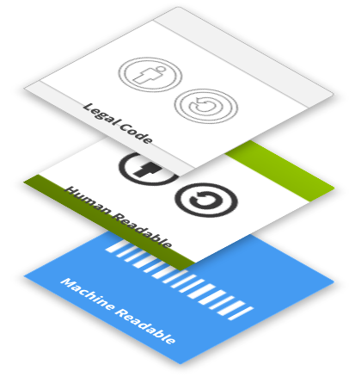
- “lawyer-readable” layer is the legal text that makes the license enforceable in court;
- “human-readable” layer is a simple summary of the legal text that communicates the main permission and conditions of the work to a general audience; and
- “machine-readable” layer is metadata expressed in ways computers and search engines can understand that permits CC-licensed works to be searched for and discovered online.

Can all Creative Commons licenses be used for OER?
No. For OER, the use of CC licenses looks like this:
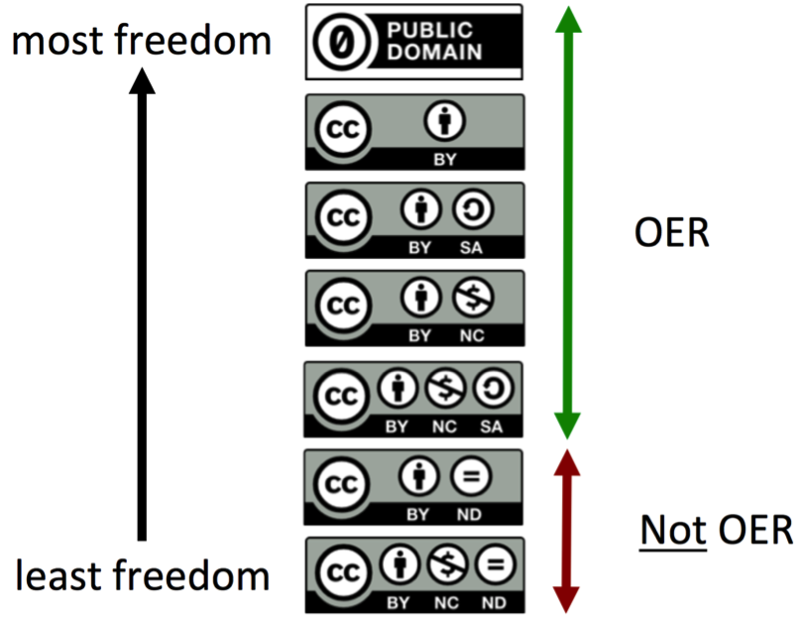
The two CC licenses that do not permit adaptations to be made (hence “No Derivatives”, or “ND”) are not OER compatible licenses because they do not allow the public revise or remix the educational resource. Because the ND licenses violate the 5Rs and every major OER definition, the open education community does not use ND licenses for OER.

Where can I find OER?
Because OER is created, adapted and used around the world, there are multiple places to find OER. This is a short, non-exhaustive, list of OER projects and repositories:
- The Commonwealth Education Hub maintains a search mechanism of millions of
Open Education Resources: www.thecommonwealth-educationhub.net/practice-centre/find-tools-and-resources
- Commonwealth of Learning OASIS (oasis.col.org) and DOER (doer.colfinder.org)
- Open Education Consortium (Global): oeconsortium.org/courses
- OER World Map (Global): oerworldmap.org
- Creative Commons (Global): creativecommons.org/about/program-areas/education-oer/education-oer-resources
- OER Universitas (New Zealand): oeru.org
- WikiEducator (New Zealand): wikieducator.org
- OpenLearn (UK): open.edu/openlearn
- BCcampus Open Textbooks (Canada): bccampus.ca/open-textbook-project
- OER Africa (Africa): oerafrica.org
- Siyavula (South Africa): siyavula.com
- MIT OpenCourseware (US): ocw.mit.edu
- OpenStax (US): openstax.org
- Pratham Books (India): prathambooks.org
- TESS-India (India): www.tess-india.edu.in
- National Programme on Technology Enhanced Learning (India): nptel.ac.in
- Smartcopying (Australia): www.smartcopying.edu.au/open-education/open-education-resources/where-to-find-oer-materials/oer-in-australia

What is an Open Education Licensing Policy?
Open education licensing policy is the idea that publicly funded education resources (i.e. paid for by taxpayers’ money) should be openly licensed by default. Specifically, an open education licensing policy is an open licensing requirement in a government grant or contract that requires publicly funded educational resources be openly licensed. The acceptance of public funds requires grantees (or recipients of taxpayers’ funds) to share content developed with those funds broadly under an open license.
For example, the US Department of Labor required a Creative Commons Attribution (CC BY) license on all educational resources created in a US$2 billion grant for community colleges to “expand and improve their ability to deliver education and career training programs.” Because of this open education licensing policy, all of these publicly funded educational resources are openly licensed and shared in an OER repository.

Why might governments want to require open licenses on publicly funded educational resources?
Because the bulk of education and research funding comes from taxpayer funds, it is essential to create, adopt, and implement open education licensing policies. The public should have access to what it paid for, and should not be required to pay twice (or more) to access and use publicly funded educational resources. Every taxpayer in every country has a reasonable expectation of access to educational materials and research products whose creation was made possible through public funding.
While governments typically retain a nonexclusive and irrevocable license to reproduce, publish, or otherwise use their grant-funded project materials for government purposes, government ministries / departments rarely exercise that government license to provide the public free and legal access to those publicly funded resources. The adoption of Creative Commons licensing clarifies to the public how they may access, use, and adapt publicly funded resources.
What are the benefits of requiring open licenses on publicly funded resources?
- Government increases the impact, reach and scalability of its grants and contracts;
- Government creates conditions for maximum potential value created from of all resources it funds, more efficiency, and better stewardship of public funds;
- Public has access to the educational resources it funded;
- Innovative and entrepreneurial uses of openly licensed materials are enabled; and
- Resources are available for reuse and value-add by anyone, including individual citizens, educators, scientists, public sector employees, entrepreneurs, and commercial businesses.

Do intergovernmental organizations support national-level adoption of open education licensing policies?
Yes. In June 2012, UNESCO and the Commonwealth of Learning convened the World OER Congress and released a 2012 Paris OER Declaration, which included a call for governments to “encourage the open licensing of educational materials produced with public funds.” Slovenia, UNESCO, Commonwealth of Learning, Creative Commons and other partners will be convening a second World OER Congress in Slovenia in September, 2017.
OECD recently released its 2015 report: “Open Educational Resources: A Catalyst for Innovation,” which provides policy options to governments such as: “Regulate that all publically funded materials should be OER by default. Alternatively, the regulation could state that new educational resources should be based on existing OER, where possible (“reuse first” principle).”
The Commonwealth of Learning helps national governments, provinces and education institutions create, adopt and implement open licensing policies - and has adopted its own open licensing policy whereby all COL created resources are shared under the Creative Commons Attribution-ShareAlike (BY-SA) license.

Do open licensing policies respect copyright and the author?
Yes. Creative Commons licenses are built on top of and encourage respect for copyright and copyright holders. CC licenses are public copyright licenses that grant permission to the public to reproduce, distribute, perform, display or adapt the licensed materials for any purpose, and typically contain a minimal set of conditions, such as the requirement that a user provide attribution to the author.

Do open licensing policies respect copyright and the author?
Governments and other funders typically use standard (as opposed to custom) open licenses in policies to:
- garner all of the benefits of a standard, global open copyright license;
- ensure interoperability across and consistency within a government agency, foundation, and/or a community of users (e.g., open education); and
- prevent grantees or recipients from writing their own custom licenses that are not interoperable with other existing openly licensed works.
While custom copyright licenses can be developed to facilitate the development and use of OER, it may be easier to apply free-to-use, global standardized licenses for that purpose. Creative Commons licenses are an example of free-to-use, open copyright licenses that have already been applied to more than 1 billion copyrighted works across 9 million websites.

Where have open education licensing policies been adopted?
A number of countries, provinces, and states have also adopted or announced open education policies relating to the creation, review, remix and/or adoption of OER. The OER Policy Registry lists over 130 national, state, province, and institutional policies relating to OER, including policies like a national open licensing framework and a policy explicitly permitting public school teachers to share materials they create in the course of their employment under a CC license.
New open policy projects like the Open Policy Network and the Institute for Open Leadership are well-positioned to foster the creation, adoption and implementation of open policies and practices that advance the public good by supporting open policy advocates, organizations and policy makers, connecting open policy opportunities with assistance, and sharing open policy information.

What can governments do to support OER?
Governments can incorporate the recommendations in the 2012 Paris OER Declaration. It recommends that States, within their capacities and authority:
a) Foster awareness and promote the use of OER to widen access to and quality of education.
b) Facilitate information and communications technologies to access, develop and use digital OER.
c) Promote the development of policies for the production and use of OER within wider strategies for advancing education.
d) Promote the understanding and use of open licensing frameworks (e.g., Creative Commons).
e) Support capacity building for the sustainable development of high quality OER.
f) Foster strategic alliances for OER among the education, industry, library, media and telecommunications sectors.
g) Encourage the development and adaptation of OER in local languages and cultural contexts.
h) Encourage research on OER.
i) Facilitate finding, retrieving and sharing of OER.
j) Encourage the open licensing of educational materials produced with public funds.

Conclusion
OER is slowly moving into mainstream education.
Governments have an opportunity to leverage OER to help all of their citizens access free, high quality, learning materials. Broad support for an adoption of OER will also help governments meet the goals of SDG4: ensuring inclusive and equitable quality education, and promoting lifelong learning opportunities for all.
When all educators are committed to free and open access to their educational resources, when the default on all publicly funded educational resources is “open” and not “closed”, we will live in a world where everyone can attain all the education they desire.

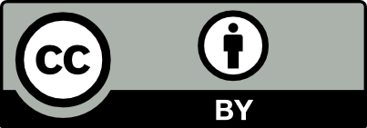
This work is licensed under a Creative Commons Attribution (CC BY) 4.0 International License.
Authors: Cable Green and Tim Vollmer (Creative Commons)
Contributions by: Paul West (The Commonwealth), Sanjaya Mishra (Commonwealth of Learning)

https://sustainabledevelopment.un.org/sdg4
Hewlett Foundation: Open Educational Resources page: http://www.hewlett.org/programs/education/open-educational-resources
UNESCO 2012 Paris OER Declaration: http://www.unesco.org/new/en/communication-and-information/access-to-knowledge/open-educational-resources/what-is-the-paris-oer-declaration
UNESCO (2016). Every Child Should Have a Textbook (Policy Paper 23), Global Monitoring Report, available at http://unesdoc.unesco.org/images/0024/002433/243321E.pdf
Foundations for OER Strategy Development: http://www.oerstrategy.org/home/read-the-doc
Several of the questions in this brief were adapted from “FAQ: OER for Policymakers” adapted by Nicole Allen of SPARC from “#GoOpen: OER for K-12 Educators” (www.tinyurl.com/GoOpen) by Doug Levin, also available under a CC BY license. It was adapted by Nicole Allen of SPARC (nicole@sparcopen.org) from “#GoOpen: OER for K-12 Educators” (www.tinyurl.com/GoOpen) by Doug Levin, also available under a CC BY license.
https://oerworldmap.org
http://www.opencontent.org/definition/
http://openedgroup.org/review
See: https://phet.colorado.edu/en/simulations/category/html
https://www.col.org/resources/quality-assurance-guidelines-open-educational-resources-tips-framework
http://www.achieve.org/publications/achieve-oer-rubrics
https://creativecommons.org/licenses/by/4.0
https://doleta.gov/taaccct
see: https://www.skillscommons.org
2012 Paris OER Declaration: http://www.unesco.org/new/en/communication-and-information/events/calendar-of-events/events-websites/World-Open-Educational-Resources-Congress
OECD Open Educational Resources: A Catalyst for Innovation: http://www.oecd.org/edu/open-educational-resources-9789264247543-en.htm
ibid. page 131
http://oasis.col.org/handle/11599/2360
http://oasis.col.org/handle/11599/2361
https://www.col.org/intellectual-property
2015 State of the Commons report: https://stateof.creativecommons.org/2015/
http://oerpolicies.org
https://openpolicynetwork.org
http://www.unesco.org/new/en/communication-and-information/access-to-knowledge/open-educational-resources/what-is-the-paris-oer-declaration
https://sustainabledevelopment.un.org/sdg4

