**Land Rights & Community Forestry Program**

**Policy Brief** #1, July 2011

**Should Neighboring Communities Be Permitted to Legally Harvest Non-Timber Forest Products in Protected Areas?**

**by Solomon Mombeshora,**

LRCFP Senior Advisor on Land Tenure and Property Rights

**Introduction**

**Policy Options**

**Option 1: ENNR is managed as a strict Nature Reserve**

This option prohibits the harvesting of NTFPs in the ENNR. This option is problematic because ENNR does not seem to meet IUCN criteria which say a Strict Nature Reserve should be “large enough to ensure the integrity of its ecosystems…” and that “the area should be significantly free of direct human intervention and capable of remaining so.” The ENNR is 13,569 hectares and the ecosystem has over time been shaped by fire used in shifting cultivation and hunting.

**Option 2: Some regulated harvesting of NTFPs is allowed in ENNR**

By allowing regulated harvesting of NTFPs the management of ENNR will benefit through improved community relations, reduced law enforcement effort and a reduction of poaching and illegal use. On the basis of comparative evidence from Uganda, we conclude that NTFPs can be managed sustainably in a Nature Reserve.

There is an on-going debate on whether local communities should harvest non-timber forest products (NTFPs) in Protected Areas (PAs) in general and the East Nimba Nature Reserve in particular.[1] Some conservationists believe in strict protection and argue that the state should prohibit local communities from harvesting NTFPs in PAs because harvesting impacts negatively the populations and communities of plants and animals as well as ecosystems. Other conservationists believe in sustainable use and argue that local communities should not only be given regulated access to NTFPs but that they should be included in the management of PAs because they have ancestral claims to the forestlands concerned and they are best placed to protect the forest resources on which they depend for livelihoods.[2] This paper focuses on the problem of Gba and Zor’s lack of access to NTFPs in East Nimba Nature Reserve. The paper examines the origins and implications of this problem. In looking at policy options for addressing the problem we provide a comparative case from Uganda’s protected areas. The policy options considered have relevance to other protected areas in Liberia and indeed West Africa. We conclude by recommending that NTFPs can be managed sustainably in a Nature Reserve.

The Land Rights and Community Forestry Program is a USAID project in support of the Government of the Republic of Liberia

**The policy question and its origins**

The core thrust of this policy brief is to ascertain whether Gba and Zor communities should be allowed legally to harvest NTFPs in the East Nimba Nature Reserve? This policy question arises from the overlapping and competing claims to forestlands and resources in northern Nimba whose roots lie in Liberia’s history. From 1847 to 1955, the Government of Liberia codified a set of laws (e.g. Hinterland Law of 1923-49) and regulations that largely recognized the jurisdiction of indigenous people in the hinterland over tribal areas and acknowledged their ‘*right and title*” to those domains in the form of tribal reserves.[3] The 1956 Aborigines Law changed all that by describing tribal rights and title to the land as firmly limited to *right of use* and possession *of state-owned (public) land*. In the eyes of government, the distinction between *tribal* and *public* land ceased to exist; it all became state land and the state could allocate economically important resources in the Hinterland to whosoever it chose.[4] From the 1950s onwards, the government encouraged foreign investment and conversion of customary forestlands (with no evidence of due compensation to the local communities) to national forests, timber and mining concessions and cash crop plantations.

**Overlapping claims to forest land and resources**

In northern Nimba this resulted in the creation of the government designated East and West Nimba National Forests managed by the Forestry Development Authority (FDA) and the Liberian-American Minerals Company’s (LAMCO) iron-ore mining concession which is now operated by the multi-national corporation, Arcelor Mittal. In 2003, the 13,569 hectare East Nimba Nature Reserve (ENNR) was created through an Act of the Legislature. National Forests, the ENNR and mining concessions were overlaid on areas of existing customary land tenure. The Gba and Zor communities who are neighbors to these entities consider these lands to be their customary lands. Despite this assertion, they are currently prohibited from harvesting NTFPs from the ENNR. The map below shows the overlaps between the ENNR and the Gba and Zor customary lands.

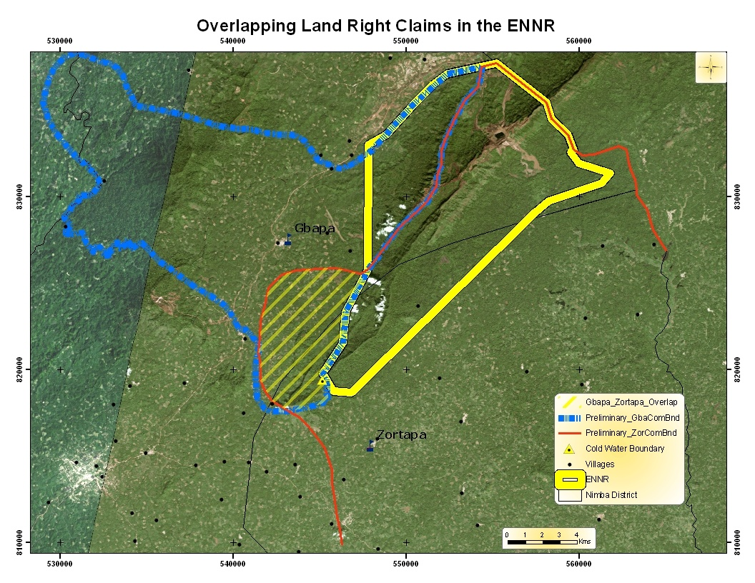

The map shows the following distinctive land use and tenure features:

* The ENNR falls within Gba and Zor customary lands with overlap between them in the reserve;
* There is overlap of customary lands claimed southwest of the ENNR covering the Blei forest and Bassa village.[5]

Source: LRCFP (2009

These overlaps in land and resource tenure have given rise to competing claims of rights of access, use, exclusion, transfer and enforcement. The rival claims between the FDA and the two communities over the forestland constituting the ENNR climaxed in 2008 when community people resisted the demarcation of the ENNR boundary and threatened FDA staff with cutlasses.

**Co-Management of the ENNR**

As the USAID-funded Land Rights and Community Forestry Program (LRCFP) was finalizing its choice of pilot sites in Nimba county, the FDA requested LRCFP to work near the ENNR and assist in finding a solution to its stand-off with Gba and Zor communities. In consultations facilitated by LRCFP in 2009, Zor and Gba communities indicated that they would recognize the ENNR provided that: FDA would agree to its co-management; they would derive benefits from ENNR such as sustainable access to and use of NTFPs, employment in the reserve and a share in revenues from tourism; the boundary demarcation line could be adjusted a little, by 0.9 kilometers, to give the Zor community some land for farming; FDA would use local labor to demarcate the reserve’s boundary; and FDA would help to create awareness about demarcation in the communities. Meanwhile, LRCFP facilitated the formation of community forest management bodies to oversee the management of Gba and Zor community forests. The two communities formed a Joint Forest Management Committee (JFMC) for the Blei forest over which they both claim rights of ownership.

In subsequent workshops, the FDA and the two communities acknowledged that co-management of ENNR is a promising way to reduce tensions over competing land tenure and resource rights and that it could help to effectively manage the protected area. After a round of negotiations in 2010, the two communities, with support from LRCFP and Fauna and Flora International (FFI), agreed to work with the FDA to demarcate the ENNR boundary and on September 18, 2010 at a formal ceremony, the FDA and the JFMC signed a co-management agreement. Some FDA officials are supportive of co-management while others remain skeptical of the two communities’ motives and ability to co-manage the protected area for conservation purposes.[6] These contrasting positions have become salient with regard to the issue of communities’ access to and use of NTFPs in the ENNR.

**Implications of the current policy**

If the issue of NTFP harvesting in ENNR is not addressed urgently conservation of biodiversity in ENNR and development of neighboring communities will suffer.

* The network of relationships, reciprocity and trust that exist in the ENNR co-management committee and between the FDA and Gba and Zor communities will be eroded. Relations between the FDA and the two communities could return to what they were in the past. Before co-management some community people had carved up parts of the ENNR for shifting cultivation. Others harvested NTFPs illegally including hunting vulnerable and endangered wildlife. If community people revert to these activities, this will make biodiversity conservation increasingly difficult for the FDA staff at ENNR.
* If the subject of NTFP harvesting is not addressed opportunities to tackle rural poverty and rural empowerment will be missed. NTFPs harvesting is generally done by the poorest members of rural society because it is their only means of livelihood and they have no other sources of income. Therefore NTFP harvesting for subsistence and commercial use is important to poverty alleviation.
* If the issue of NTFP harvesting is not addressed, Gba and Zor communities may find it difficult to cooperate with FDA to control poaching by people from neighboring Guinea and Ivory Coast. By allowing Gba and Zor communities to have regulated extractive rights to NTFPs in the ENNR they will want to protect these resources from encroachment and abuse by others.
* Attempts by the ENNR staff to enforce the exclusion of local communities are facing challenges and this has resulted in a situation of on-going open access to the reserve’s forestland and resources.

This leads us to a consideration of potential policy options to address these concerns.

**Policy options**

We identify two courses of policy action – one which opposes and another which supports the harvesting of NTFPs by communities neighboring ENNR. These arguments resonate with wider debates in the conservation and development communities.

**Option 1: ENNR is managed as a Strict Nature Reserve**

Some conservationists prefer this course of policy action. The arguments in support of this option are as follows:

* Protected areas necessarily exclude people as residents and prohibit consumptive uses (see signpost on Sapo National Park );
* Communities neighboring protected areas are a threat to the forest and biodiversity and in need of strict control;
* Biodiversity can only be conserved in protected areas that are free of all human influence except scientific study and limited ecotourism;
* 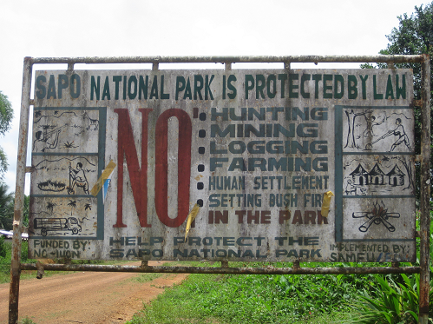Protected areas are best managed by centralized authorities who closely police marked boundaries and apply appropriate sanctions on people who violate borders particularly those who enter to harvest NTFPs or to hunt, fish, and gather plant products and materials.[7]
* Community people want to use government property anyway they want including harvesting NTFPs in protected areas;
* Liberian communities have not reached a level of compliance that can enable the harvesting of NTFPs in protected areas; *“If you give them an inch they will take a mile.”* They will overharvest NTFPs and this will adversely impact plant and animal populations, communities and ecosystems. Worse still local people will start farming and building camps and villages in protected areas as is happening in Sapo National Park and such actions degrade wildlife habitats (*pers. comm.*);

Photo credit: Landesa

* Patrols in the ENNR have occasionally identified bullet shells which show that community people are hunting illegally (*pers. comm.*). If ENNR allows them to hunt this will open floodgates and contribute to the accelerated extinction of vulnerable and endangered species. Vulnerable faunal species include, among others the African elephant *(Loxodonta africana)*, Jentink’s duiker *(Cephalophus jentinki)*, Pygmy hippopotamus *(Hexaprotodon liberiensis)*, Zebra duiker *(Cephalophus zebra)* and some of the endangered species include the chimpanzee *(Pan troglodytes)*, Liberian mongoose *(Liberiictis kuhni)*, Nimba otter shrew *(Micropotamogale lamottei)* and Red Colobus monkey *(Procolobus badius)*.[8]
* Finally, those who advocate for a strict nature reserve often invoke section 9.10 b of the National Forestry Reform Law which states that: *‘no person shall, in a national park, nature reserve or game reserve, prospect, mine, farm hunt, fish, extract timber or non-timber forest products or take any other action* except those for management *or non-consumptive uses such as tourism, recreation and research* (our emphasis).*[9]*

These seem compelling arguments but protectionist conservation faces a number of challenges:

* Although some protectionist conservationists in and outside the FDA see the ENNR as a Strict Nature Reserve, it does not seem to meet one of the IUCN criteria which state that a Strict Nature Reserve should be “large enough to ensure the integrity of its ecosystems…” [10] At less than 13,565 hectares, the ENNR does not appear to be large enough in scale to meet this criterion.[11]
* IUCN also says that “the area should be significantly free of direct human intervention and capable of remaining so.”[12] As pointed out above, the ENNR has evolved in interaction with Gba and Zor communities and the ecosystem has over time been shaped by fire used in shifting cultivation and hunting.[13]
* The ENNR experience shows that the state does not have the institutional, human resource and financial capacity to police and enforce its claims of ownership of land and natural resources in ENNR. Without these things, the state’s claim will result in a situation of open access. The cooperation and participation of Gba and Zor communities whose livelihoods are tied to NTFP resources is, therefore, crucial to the viability of the ENNR.
* The Gba and Zor communities have consistently pointed out that they will cooperate to sustainably manage ENNR forest resources if they benefit from harvesting these resources. Therefore, the challenge facing protectionist conservationists is to move beyond human exclusion to imagining a conceptual and material place[14] for Gba and Zor people using NTFPs in the ENNR in a regulated and sustainable manner.

**Option 2: Sustainable regulated harvesting of NTFPs in ENNR is permitted for neighboring communities**

We have already noted that Section 9.10 b of the NFRL of 2006 allows harvesting of NTFPs for management purposes. The FDA and ENNR Co-Management Committee (ENNR CMC) could interpret the harvesting of NTFPs from ENNR as consistent with the management objectives of the reserve. Moreover, the 2003 Act of the Legislature which created the ENNR gives the FDA latitude to manage the reserve in accordance with rules and regulations which it may promulgate from time to time.[15]

By taking this option, the FDA and community members in the ENNR CMC could work together to enforce regulated and sustainable use of NTFPs in PAs. In other words, the FDA will be pioneering sustainable use of NTFP resources by communities in protected areas in the West African Region. Sustainable use is the dictum that states that humans can use resources in ways that they can keep using them indefinitely. Using renewable natural resources such as NTFPs means doing so in a manner that does not threaten a species by over-use, yet optimizes benefits to both the environment and people.[16] Reasons for allowing regulated harvesting are as follows.

* Sustainably using natural resources, including plants, bush meat and fish in the ENNR provides Gba and Zor communities with incentives that motivate them to continue to engage in the co-management arrangement thus benefiting people and biodiversity. The ENNR CMC will have a strong reason to work closely with the FDA to protect the resources from which they are benefitting.

Photo credit: Arcelor Mittal

* The practice of conservation on the part of local communities is a careful balance of short-term and long-term benefits and costs. The challenge now is for the FDA and the ENNR CMC to understand how the harvesting of NTFPs in the ENNR, and other protected areas, can contribute to livelihoods and the conservation of wild living resources.

The experience of the Uganda Wildlife Authority provides an instructive example showing the ‘disentangling’ of protected areas from the old protectionist approach to a more ‘open’ and collaborative management style.

In sum, protected areas in Uganda have benefitted through improved community relations, reduced law enforcement effort and a reduction of poaching and illegal use. UWA has recognized that although the authority to manage protected areas lies with it, the ultimate success of its conservation efforts depends on sustainable use and the support and positive attitude of the people who live on the boundaries of protected areas. Kibale and Mt. Elgon National Park wardens attend meetings with Resource Use Committees to discuss problems as they surface and the means by which they might be resolved. UWA have gone to considerable lengths to address human-wildlife conflicts by scare shooting elephants and buffaloes which damage crops, property and pose a threat to human life. [17] Communities responded by fulfilling their responsibilities to protect the park areas and to regulate resource harvesting. Now community people cooperate with park rangers to arrest poachers, remove snares, put out wild fires and sensitize community members about the importance of biodiversity.

**Box 1: Community resource use in Kibale and Mt. Elgon National Parks, Uganda**

After years of conflict between neighboring communities and Kibale and Mt. Elgon National Parks, the Uganda Wildlife Authority (UWA) took the following measures:

* the legal and policy framework for protected area management in Uganda was modified to make provision for local communities to harvest resources in protected areas and to be involved in the management of those areas;
* a legal instrument provided for the sharing with local communities 20% of gate receipts from National Parks;
* UWA reoriented the protected area management from traditional protectionism which alienated rural people to a partnership model which puts people at the centre of conservation policies and practice.

Collaborative Resource Management Agreements between the two parks and local communities enabled the communities to organize themselves into resource user groups which gained access to much needed NTFP resources. The following products are utilized by local communities for: (a) building - spear grass (*Imperata cylindrical);* reeds (*Pennisetum purpureum);* (b) crafts - phoenix *(Phoenix reclinata)*; rattan *(Calamus exilis* and *Calamus zollingeri);* papyrus; (c) firewood - *(Sena spectabilis)*; (d) food - wild coffee, mushrooms, *Tilapia*, lung fish and mud fish; (e) medicinal plants - vermonia *(Vermonia amagdalene, Lantana camara, Warbugia ugandensis,* black jack *(Bidens pilosa)*; and (f) honey. In addition to providing forest products, the parks provive a range of services such as water, carbon sequestration, ecotourism, soil protection and the protection of fauna and flora (Sources: Chhetri *et al.* 2003; SGS South Africa 2008).

**Recommendation**

In conclusion, protectionist conservationists have argued that the ENNR should be managed as a Strict Nature Reserve but this policy option faces a number of challenges. The ENNR does not seem to meet IUCN criteria in terms of size and freedom from all human influence with the exception of scientific study and ecotourism. Furthermore, the state does not have the institutional, human resource and financial capacity to police and enforce its claims of ownership of land and natural resources in ENNR. Without such capacity, situations of open access arise which are detrimental to biodiversity conservation. The viability of the ENNR therefore hinges on the cooperation and participation of Gba and Zor communities whose livelihoods are tied to NTFP resources. In view of the comparative evidence from Uganda, the arguments for sustainable use that we have made above and in keeping with the letter and spirit of the ENNR Act of 2003 and the Co-Management Agreement between the FDA and Gba and Zor communities, our recommendation is that NTFPs can be sustainably managed and legally harvested sustainably in a Nature Reserve.

Thanks go to Dan Whyner of USAID, Vaneska Litz LRCFP’s Chief of Party, and Dr. Samuel N. Koffa LRCFP’s Senior Advisor on Community Forestry for insightful and constructive comments and to Justin Prudhomme of USAID for layout assistance.

**Endnotes**

1. NTFPs are *all biological materials, other than timber, which are extracted from forests for human use* (Neumann and Hirsh, 2000) and protected areas are defined as “*areas of land and/or sea especially dedicated to the protection and maintenance of biological diversity, and of natural and associated cultural resources, and managed through legal or other effective means”* (IUCN, 1994).
2. Neumann, R. P. and E. Hirsch. 2000. *Commercialization of Non Timber Forest Products: Review and analysis for research.* Bogor, Indonesia, CIFOR; Chhetri, P. *et al.* 2003. Community resource use in Kibale and Mt. Elgon National Parks, Uganda. *Parks* 13(1): 28-38; UNDP. 2003. *Human Development Report 2003, Millennium Development Goals: A compact among nations to end human poverty.* Oxford University Press for UNDP.
3. Wily, L. A. 2007. *“So who owns the forest” An investigation into forest ownership and customary land rights in Liberia.* Monrovia, SDI.
4. *ibid*
5. LRCFP. 2009. *Concept note: Co-Management of forest resources in northern Nimba County.* Monrovia.
6. Litz, V. 2009. *Report on the development of a co-management agreement for East Nimba Nature Reserve.* USAID-LRCFP.
7. Hutton, J. *et al.* 2005. Back to the barriers: Changing narratives in biodiversity conservation. *Forum for development studies* 2-2005.
8. http://www.animalinfo.org/country/liberia.htm; Accessed 3 June 2011.
9. Republic of Liberia. 2006. *An Act adopting the National Forestry Reform Law of 2006.* Monrovia.
10. IUCN. 1994. *Guidelines for protected area management categories*. Gland, Switzerland, IUCN.
11. Litz. V. 2009. *op cit.* 
12. IUCN. 1994. *op cit.*
13. Litz. V. 2009. *op cit.*
14. Adams, W and J. Hutton. 2007. People, parks and poverty: Political ecology and biodiversity conservation. *Conservation & Society* 5(2): 147-183.
15. Ministry of Foreign Affairs. 2003. *An Act establishing the East Nimba Nature Reserve*. Monrovia, Liberia.
16. <http://iucn.org/themes/ssc/>; Accessed 4 June 2011.
17. SGS South Africa (Qualifor Programme). 2008. *Forest Management Certification Report.* <http://www.sgs.com/forestry>; Accessed July 15, 2011.