CALIFORNIA ENERGY COMMISSION


Golden Eagles In A Perilous Landscape: Predicting The Effects Of Mitigation For Wind Turbine Blade-Strike Mortality

CONSULTANT REPORT

JULY 2002

P500-02-043F


Gray Davis, Governor

CALIFORNIA

ENERGY
COMMISSION

Prepared By:

Grainger Hunt,

University of California, Santa Cruz

Contract No. 500-97-4033,

Prepared For:

PIER – Environmental Area

Kelly Birkinshaw,

Program Lead

Linda Spiegel and

Richard Anderson,
Project Managers

Terry Surles,

Deputy Director
Technology Systems Division

Steve Larson,

Executive Director
Legal Notice

This report was prepared as a result of work sponsored by the California Energy Commission (Commission). It does not necessarily represent the views of the Commission, its employees, or the State of California. The Commission, the State of California, its employees, contractors, and subcontractors make no warranty, express or implied, and assume no legal liability for the information in this report; nor does any party represent that the use of this information will not infringe upon privately owned rights. This report has not been approved or disapproved by the Commission nor has the Commission passed upon the accuracy or adequacy of this information in this report.

i

Acknowledgements

Tom Cade of the Peregrine Fund conceived of this project and provided advice and encouragement throughout. Dick Anderson and Linda Spiegel of the California Energy Commission provided valuable support and assistance throughout the project. We thank Peter Law and Alan Franklin for mathematical and statistical assistance. Chris Gill performed GIS mapping and data organization. Hans Peeters supplied information on nests, productivity and behavior of golden eagles in the study region. Wally Erickson, Bryan Manly, Dale Strickland, and an anonymous reviewer provided valuable comments and insight.

Teresa Hunt and Craig Himmelwright conducted the nest surveys. Daniel Driscoll, Ron Jackman, and Brian Latta captured eagles for transmitter attachment and climbed nests to tag young. Greg Doney, Victor Garcia-Matarranz, Dan Hansen, Christopher Kuntzsch, Stan Moore, and Lynn Polacca provided assistance during trapping efforts and nest climbs. Lois Culp and Karen Lougheed performed ground squirrel surveys and located eagle fatalities. Patti Leiberg-Clark and Randolf Skrovan assisted with data collection on telemetry flights. Brian Walton, Janet Linthicum, Tery Drager, and James Gilardi provided technical assistance and support.

We thank Tara Dinman, Dick Curry, Joan Stewart, Karen Lougheed, and the field maintenance and operations staff of Green Ridge Services; Larry Barr of Enexco, Joe DiDonato, Steve Bobzien, Ray Budzinski, Ken Burger, Roger Epperson, Dan Reasor, Laura Comstock, Louis Delacruz, Ron Mueller, and the dispatchers and staff of the East Bay Regional Parks Department; Bob Snow of the U.S. Fish and Wildlife Service Enforcement Branch; Tim Koopman, Frank Marino, and Joe Naras of the San Francisco Water Department; David Sterner, Mick Klasson, and Ed Stewart of the Contra Costa Water District; Susan Heckley from the Lindsay Museum; Jim Woolett, Jim Lane, and Milt Grissom of Lawrence Livermore National Laboratory; Larry Ferri, Dave Matthews, and Jess Cooper of Mount Diablo State Park; Reece Currant, Phil Teresi, Rebecca Black, Carolyn Stephens, Mike Bomberger, Don Rocha, Ed Tanaka, Donna Logan, Craig Bryson, and Bill Ventura of the Santa Clara County Parks and Recreation Department; Tom Gaines and Jerry Mattson of SRI International; State Park employees at Carnegie State Vehicular Recreation Area; the Livermore Airport staff workers and flight controllers; Jim Estep and Stephanie Myers of Jones & Stokes Associates, Inc.; Mark Fuller, Karen Steenhof, Mike Kochert, and Mary Beth Cowing of the Raptor Research Technical Center; Ron Jurek, Debbie Osborn, Joe Powell, and Hugh Rutherford of the California Department of Fish and Game; Gary Falxa, Gary Taylor, and Ken Sanchez of the U.S. Fish and Wildlife Service; Jim Grier of North Dakota State University; Dan Cather and Ron White of the Walnut Creek Open Spaces District; and Kent Carnie of the World Center for Birds of Prey. We thank Gary Beeman, Bob Richmond, and Colleen Lenihan for valuable information on eagle nest locations; Eric Concannon, Pamela Swan, and the Cygnus volunteers who assisted with nest surveys; Stephanie Gauthier, Brian Murphy, Jan Maxstadt, Gardiner Smith, and Matt Brown for volunteer help; and Pam and Julian Peeters for their help and support. For postmortem examination of eagle fatalities, we thank Dr. Robert Hosea of the California Department of Fish and Game, Dr. Michael Murray, and Dr. Craig Himmelwright.

Don and Kathy Krump cared for eagles that suffered debilitating injuries from turbine blade-strikes. Jim Smith of the Alameda County Agricultural Department provided knowledge of ground squirrels and control methods. Tony Owens of the Alameda County Animal Shelter

ii

provided deer killed along roadways for eagle trapping efforts. We thank the personnel from Parks Reserve Forces Training Area for access to radio-tag eagles, especially Sgt. Steven Jenny, Richard Fielder, Col. Thomas Black, and Marshall Marick.
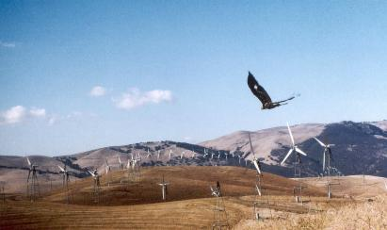

Figure 1. Juvenile Golden Eagle in the WRA (photo by Daniel Driscoll)

Special thanks to the many landowners who helped us with information about eagles and/or let us visit their property. They include: Joe Aljoe and Art Cherry of the N3 Cattle Co., Paul Banke of the Patterson Ranch, Joe Betchart, the Bonavitos, Rene and Mary Meyers, Jim Cox, Mick Dover, Mr. and Mrs. Wayne Calhoun, Pat, Mark, and Matt Connolly, Loree Cornwell, Reese and Ilene Cowden, Don and Mimi Devani, Russ, Steve, and Tony Fields, John Ginochio, John Gomez, Joe Jesse, John and Ann Lindl, Cathy West of Diablo Grande, Peggy Thompson, Hugh Walker and Lois Walker, Cindy and Richard White, and Ernie, Bart, and Jeff Wool, Danny and Nancy Sachau, Sheldon Berz, the Pruitts, and the land owners associated with the Altamont Pass Wind Resource Area.

iii

 |  | Table of Contents
Section |  |  | Page
Preface ................................................................................................................................................ |  |  | viii
Executive Summary ........................................................................................................................... |  |  | 1
Abstract................................................................................................................................................ |  |  | 5
1.0 | Introduction.......................................................................................................................... |  | 6
 | 1.1. | Project Objectives ........................................................................................................... | 7
 | 1.2. | Report Organization....................................................................................................... | 7
2.0 | Background and Project Approach................................................................................... |  | 9
 | 2.1. | Study Area....................................................................................................................... | 10
 | 2.2. | The Repowering Plan..................................................................................................... | 12
 | 2.3. | Study Species................................................................................................................... | 13
 | 2.4. | Other Studies of Avian Fatalities ................................................................................. | 15
3.0 | Project Outcomes ................................................................................................................. |  | 16
 | 3.1. | Evidence for a Change in Eagle Distribution ............................................................. | 16
 | 3.2. | Eagle Mortality................................................................................................................ | 19
 | 3.2.1. Turbine Blade-strike Mortality among the Four Life-stages............................... |  | 19
 | 3.2.1.1. Juvenile Mortality ................................................................................................ |  | 20
 | 3.2.1.2. Subadult and Floater Mortality ......................................................................... |  | 20
 | 3.2.1.3. Breeder Mortality................................................................................................. |  | 21
 | 3.3. | Seasonal Differences ...................................................................................................... | 22
 | 3.4. | Turbine Configuration and Lethality .......................................................................... | 23
 | 3.5. | Are the Type-13 Turbines in the WRA Particularly Dangerous to Eagles? ........... | 29
 | 3.5.1. Tower-Height............................................................................................................. |  | 30
 | 3.5.2. | Tower Spacing ........................................................................................................... | 32
 | 3.5.3. | Wind and Terrain ...................................................................................................... | 33
 | 3.5.4. | Tower Perchability .................................................................................................... | 34
 | 3.6. | Eagles and Ground Squirrels in the WRA .................................................................. | 35
 | 3.7. | Eagle Population Trend................................................................................................. | 38
 | 3.7.1. | The Alpha Model....................................................................................................... | 39
 | 3.7.2. A Better Trend Model ............................................................................................... |  | 40
 | 3.7.3. | Survival Estimates..................................................................................................... | 41
 | 3.7.4. | Estimate of Reproduction......................................................................................... | 41
 | 3.7.5. The Population Trend Estimate and What it Means............................................ |  | 42
 | 3.7.6. Is there Evidence of a Decline?................................................................................ |  | 44
 | 3.7.7. The Net Effect of Blade-strike Deaths .................................................................... |  | 44

iv
4.0 Conclusions and Recommendations 46

4.1. Conclusions 46

4.2. Recommendations 47

5.0 References 48

Appendices

Appendix I: Types of Turbines in the Altamont Pass WRA

Appendix II: General Information on California Ground Squirrels

Appendix III: Potential Growth Model

v

List of Figures

Figure Page

Figure 1. Juvenile Golden Eagle in the WRA (photo by Daniel Driscoll) iii

Figure 2. Subadult Golden eagle (photo by Daniel Driscoll) 4

Figure 3. Southeast Portion of the Altamont Pass WRA (photo by Daniel Driscoll) 5

Figure 4. The Diablo Range Study Area 11

Figure 5. Examples of the Three Basic Wind Turbine Designs in the Altamont Pass WRA:

Tubular Tower (Type-8), Vertical Axis (Type-9), and Lattice Tower (Type-13) 12

Figure 6. Distribution of the basic Turbine Configurations in the WRA 13

Figure 7. Ages of golden eagles captured in 1994-1996 versus 1998-2000 16

Figure 8. Fates of Tagged Juveniles from September of the Tagging Year through the following

September 17

Figure 9. Fates of Subadult and Floater Eagles during the 12 Months Following Radio-Tagging

18

Figure 10. Distribution of 42 Turbine Blade-Strike Casualties of Uncensored, Radio-Tagged

Golden Eagles in the WRA 22

Figure 11. Relocations of Breeders 24

Figure 12. Relocations of Floaters 24

Figure 13. Relocations of Subadults 25

Figure 14. Relocations of Juveniles 25

Figure 15. These two sets of polygons enclose the areas containing Type-13 turbines (totaling

62.3 km2) versus those containing only other types of turbines (40.9 km2) occurring

within the WRA (see text) 27

Figure 16. Relocations of Radio-Tagged Subadults and Floaters in the WRA during the Four

Months Preceding the Death of Subadult No. 52M27 29

Figure 17. These Two Polygons in the Northern Region of the WRA are the Largest of those

Depicted in Figure 19 30

Figure 18. A Windwall consisting of a Row Type-13 Turbines and another row of the Taller

Type-23 Turbines (photo by Daniel Driscoll) 31

Figure 19. A 15 km2 circle containing 16 of the 19 blade-strike kills in Polygon-A 35

Figure 20. Eagle Relocations in Areas of Differing Ground Squirrel Densities as Estimated from

Road Surveys 38

Figure 21. In a Hypothetical Population Declining from Moffat’s Equilibrium, the Breeding

Segment is Exposed to Decline only after the Loss of the Floating Segment 40

vi

List of Tables

Table Page

Table 1. Relocations of Radio-Tagged Subadults and Floaters in the Previous versus the Current

Study 18

Table 2. Causes of Death among 100 Radio-Tagged Golden Eagles 20

Table 3. Wind Turbine Configurations Responsible for killing 42 Radio-Tagged Golden Eagles

in the WRA 26

Table 4. Densities (km2) of Turbine Types versus the Densities of Subadult/Floater Relocations

and Blade-Strike Fatalities in the WRA 26

Table 5. Relocation Counts within Areas Containing Type-13 Turbines versus Areas with other

Turbine Types as Recorded during the Last Four Months of Life among 21 Subadult and

Floater Eagles 28

Table 6. Twelve Golden Eagle Blade-Strike Fatalities that occurred in Polygon-A, together with

Counts of Subadult and Floater Relocations occurring within the Previous Four Months

in both Polygon-A and Polygon-B (See text) 31

Table 7. Changes in the Proportion of Subadult and Floater Relocations in the Northern and

Southern Areas of the WRA (North and South of Interstate 580) 36

Table 8. Results of Golden Eagle Nest Surveys in the Study Area 42

vii

Preface

The Public Interest Energy Research (PIER) Program supports public interest energy research and development that will help improve the quality of life in California by bringing environmentally safe, affordable, and reliable energy services and products to the marketplace.

The PIER Program, managed by the California Energy Commission (Commission), annually awards up to $62 million to conduct the most promising public interest energy research by partnering with Research, Development, and Demonstration (RD&D) organizations, including individuals, businesses, utilities, and public or private research institutions.

PIER funding efforts are focused on the following six RD&D program areas:

- Buildings End-Use Energy Efficiency

- Industrial/Agricultural/Water End-Use Energy Efficiency

- Renewable Energy

- Environmentally-Preferred Advanced Generation

- Energy-Related Environmental Research

- Strategic Energy Research.

What follows is the final report for the “Golden Eagles in a Perilous Landscape: Predicting the

Effect of Mitigation for Wind Turbine” project, Contract Number: 500-97-4033, conducted by

Predatory Bird Research Group, University of California, Santa Cruz. The report is entitled

“Golden Eagles in a Perilous Landscape: Predicting the Effect of Mitigation for Wind Turbine.”

This project contributes to the Energy-Related Environmental Research program.

For more information on the PIER Program, please visit the Commission's Web site at: http://www.energy.ca.gov/research/index.html or contact the Commission's Publications Unit at 916-654-5200.

viii

Executive Summary

The Predatory Bird Research Group, University of California, Santa Cruz, has been conducting

- long-term study of golden eagles (Aquila chrysaetos) in the Diablo Mountains of west-central California. The initial work (1994-1997), funded by the wind industry and by the National Renewable Energy Laboratory (NREL), used aerial tracking of radio-tagged eagles to address the question of whether eagle deaths resulting from wind turbine blade strikes at the Altamont Pass Wind Resource Area (WRA) were seriously affecting the population. Estimates are that wind turbines kill 40-60 subadult and adult golden eagles each year, on average. Golden eagles, being naturally slow to reproduce, are particularly sensitive to changes in adult and subadult survival rates. For this reason, and because of its popularity, the species is afforded special protection by both federal and state governments. There is no legal provision for the killing of golden eagles.

Wind turbine blades also kill other protected species in the WRA, including several hundred red-tailed hawks (Buteo jamaicensis) and American kestrels (Falco sparvarius) each year. The fatalities have caused adverse public perception of wind power plants, and the threat of fines and lawsuits has delayed, modified, or even stopped wind energy development in some states, including California. Alameda County, for example, has imposed a moratorium on increase over current electrical production (~580 MW) until progress is made toward resolving the bird-strike issue. To address the problem, research must determine whether the fatalities threaten the birds on a population basis, what kinds of turbine/tower configurations are most destructive, and what management actions could reduce the number of fatalities.

We began the current investigation in June of 1998 under the support of the California Energy Commission’s Public Interest Energy Research (PIER) Program. At that time, extensive repowering appeared imminent in the WRA. Of particular interest was the intended replacement of some 1300 turbines with a larger and possibly more benign type, at an approximate ratio of seven removed for every one replaced. Our objectives were to increase the samples of radio-tagged eagles and to continue monitoring them for the purpose of (1) further understanding the demographics, (2) tracking the net result of repowering, and (3) exploring other measures that might effectively reduce the incidence of golden eagle mortality. As time passed, it became apparent that difficulties within the wind industry would delay the repowering process beyond the scope of the study. We therefore focused upon eagle deaths relative to existing turbine configurations in an attempt to identify the factors contributing most to blade-strike mortality. This approach, with its emphasis on radio-telemetry, a technique with virtually no distributional bias, offered a measure of prediction regarding the efficacy of expected changes in the WRA.

Our earlier (1994-1997) study, which focused primarily on the demographic question, was based on the aerial monitoring of survival within a sample of 179 radio-tagged golden eagles and an annual survey of 60-70 pairs nesting within about 30-km of the WRA. Two population dynamics models yielded widely different estimates of population trend. One of them, developed by an NREL-appointed panel of scientists, concluded that the population was declining rapidly during the period of study. In fall 1998, when we began capturing additional eagles for radio-tagging, we encountered significantly fewer subadults and nonbreeding adults (“floaters”) in the study area than previously, an observation that supported the demographic

1

predictions of the NREL model. However, our telemetry data on the movements of both juveniles and older eagles suggested a greater tendency than before to leave the study area. Possible reasons were that (1) prolonged periods of rainfall in winter 1997-1998 had reduced overall prey density, and (2) land-use changes had reduced habitat and prey abundance.

We recorded the deaths of 100 radio-tagged eagles during the seven-year study. Wind turbine blades killed at least 42, the actual number being higher because the blades occasionally destroyed the transmitter. Adding 12 electrocutions, all outside the WRA, at least 54 percent of all fatalities were attributed to electrical generation or transmission. Wire strikes, vehicle strikes, and poisoning brought human-related fatalities to at least 68 percent of the total.

Blade-strike mortality did not affect all golden eagle life-stages equally. Only one juvenile eagle was struck among a radio-tagged sample of 117 free-ranging individuals (juveniles are 3-15 months of age). In contrast, there were 31 blade-strike deaths among 155 subadults (ages 1-3 years) and floaters (4+ years). We attribute the apparent immunity of juveniles to their lesser tendency to hunt live prey, a fact suggesting that eagles tend to be struck while hunting. Radio-tagged breeders were rarely killed by turbines (2 among 47) because their relatively small home ranges kept most of them out of the WRA.

Five of the 42 blade-strike casualties wandered away from the turbines that had rendered them flightless, leaving 37 for an analysis of their distribution relative to the 25+ types of turbines in the WRA. At least 27 (73%) of these eagles were killed by Type-13 (Kenetech 56-100 on an 18.3-meter lattice tower), not surprising because 56 percent of all turbines were Type-13. However, a comparison of the distribution of radio-tagged eagles and that of fatalities revealed that disproportionate numbers of eagles died in areas containing Type-13 turbines. We then focused on two areas where relocations of radio-tagged eagles were of high density, one containing Type-13 turbines and the other containing other types. Eagle distribution during the 10-month period prior to each of 21 fatalities in the Type-13 area showed comparable numbers of relocations in the two areas but highly disproportionate numbers of Type-13 kills. We concluded from this circumstantial evidence that conditions in the Type-13 area were more hazardous to eagles than conditions in the area occupied by other types of turbines.

Our data did not reveal whether the perceived lethality stemmed from the Type-13 configuration itself or from other factors such as spacing between the turbines or extraneous environmental differences between the areas we compared. Type-13s were on relatively short towers, so their blades passed closer to the ground than 95 percent of the other turbine types. However, Type-13s in the WRA were set closer together than all other turbine types we measured. The distance between blade and wing-tip of a golden eagle passing exactly between two adjacent, wind-aligned Type-13 rotors of normal placement was less than three meters. Turbulence associated with high winds and steep terrain in the WRA, and the fact that golden eagles there typically hunt by actively coursing over long distances within a few meters of the ground, give reason to suspect that flight control difficulties for eagles trying to pass between or under Type-13 turbines may sometimes have lethal consequences.

These circumstantial data suggest that the planned removal of 644 Type-13s as part of the repowering project in the WRA may benefit eagles, especially if the removals were to occur in areas where eagles concentrate. Observations of foraging eagles suggest that the new, larger (Type-28) turbines might be safer than the Type-13 turbines they are intended to replace.

2

However, even if Type-28 were to prove more lethal on a per-turbine basis, its far greater generating capacity may render it preferable because few are necessary to match the generating capacity of many Type-13s, that is, assuming that overall energy production does not increase in the WRA.

The California ground squirrel (Spermophilus beecheyii) was the principal prey of golden eagles in the WRA throughout our study, and we found significantly higher numbers of radio-tagged eagles in areas of high squirrel concentration. A primary reason for squirrel density differences was that some ranchers controlled them while others did not. No control program was in effect within a large area of Type-13 turbines in the northwest portion of the WRA and, not surprisingly, this area contained high eagle relocation densities and the highest concentration of blade-strike fatalities. We conclude from this that ground squirrel control throughout the WRA could profoundly reduce the incidence of blade strike mortality among golden eagles.

However, even though ground squirrel control is a well known and frequent practice, it is not without secondary environmental costs. Animals, including many sensitive species, prey upon ground squirrels in the WRA, and some depend upon their burrows. Another downside of ground squirrel control is the collateral destruction of non-target species which eat the poison grain. We therefore recommend less destructive control methods, for example, trapping ground squirrels in areas near turbines where the squirrels exceed a threshold density. If ground squirrel control becomes more widespread in the WRA, it would be appropriate to mitigate the loss for all affected wildlife, including eagles, by encouraging ground squirrels outside the WRA. This might take the form of conservation easements purchased from ranchers in areas of open grassland.

We resolved the paradox of the two population models that earlier gave such widely divergent estimates of population trend. The first (NREL-supplied model), which incorporated a parameter (alpha) for the rate at which floaters acquired breeding territories, and computed a precipitous decline, proved defective. The computation by matrix algebra of the annual rate of change in population size, requires that all parameters remain constant in time, a feature that produces a stable stage distribution, regardless of trend. However, alpha is a parameter whose value responds to changes in floater numbers such that, during a decline, alpha increases in value, thereby compromising both the computation of the population change rate and its variance. Both the model and its alarming result must therefore be discarded.

A better and more parsimonious model is the traditional one describing the maximum potential rate of population change under the hypothetical assumption that all eagles acquire breeding territories upon maturity. A growth prediction by this model would yield a population at equilibrium in which a stable contingent of floaters buffers the breeding population against decline, whereas a decline estimate predicts the loss of floaters altogether. The parameters of this model, refined by our recent data on eagle survival and reproduction, yielded a point estimate approximating the condition of no annual rate of change in population size, but no production of a floater buffer. The variance of this estimate falls more or less equally into the alternatives of increase and decrease. If the point estimate of the model is correct, any further decrease in survival or reproduction, e.g., as might accompany increasing human development, would be mitigated only by immigrant floaters from outside the study area.

3

Several current (Spring 2000) indicators of population health are apparent. First, the number of breeding pairs in the broad region surrounding the WRA has remained unchanged, i.e., virtually all territories occupied by pairs in one year have remained occupied in the next, a clear sign that floaters quickly filled vacancies. Second, we observed very few subadults as members of breeding pairs. A high proportion of subadults in the breeding population would suggest a paucity of floaters. Whether the floaters currently buffering the breeding population are generated within the study area or arrive as immigrants is unknown. We recommend a continuation of the nesting surveys every two or three years as a system of early warning, should a decline actually be occurring.
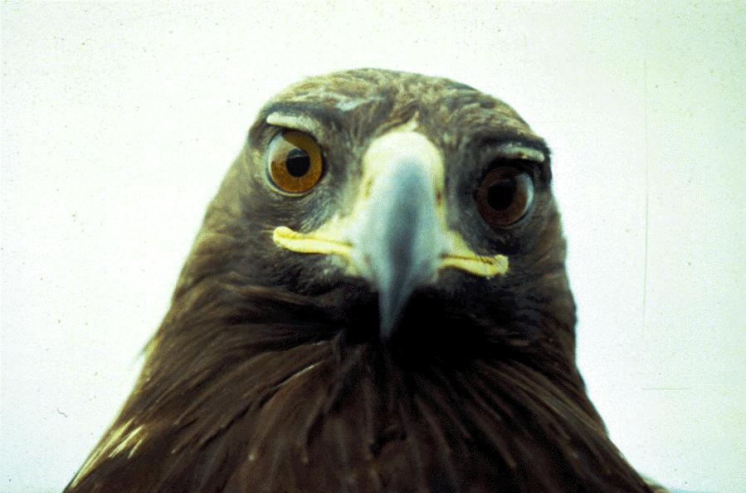

Figure 2. Subadult Golden eagle (photo by Daniel Driscoll)

4

Abstract

The Predatory Bird Research Group, University of California, Santa Cruz, has been conducting a long-term field investigation of the ecology of golden eagles (Aquila chrysaetos) in the vicinity of the Altamont Pass Wind Resource Area (WRA) where turbine blade strikes kill an estimated 40-60 eagles per year. Our seven-year study was based on the aerial tracking of 257 radio-tagged eagles and an annual nesting survey of 60-70 pairs within about 30-km of the WRA. Of 100 deaths recorded among the tagged eagles, 42 were attributed to wind turbines, although the actual number was higher because the blades occasionally destroyed the transmitter. Comparisons of eagle location data with the distribution of blade-strike fatalities in the WRA showed that conditions within areas containing Type-13 turbines (the Kenetech 56-100 on an 18.3-meter lattice tower) were more dangerous to eagles than those in areas containing other types of turbines. It is unknown whether this lethality arose from the Type-13 configuration itself or from other factors such as spacing between turbines or extraneous environmental influences. Type-13s are set closer together than other turbines in the WRA, and eagles may have particular difficulty passing between (or under) them, especially in conditions of high winds and turbulence. California ground squirrels were the principal prey of golden eagles in the WRA, and eagles were attracted to areas of high squirrel concentration. Reduction of ground squirrel numbers around the wind turbines would reduce the incidence of blade strike deaths. Squirrel control would impact other wildlife in the WRA, but could be partially mitigated by off-site conservation easements. A demographic analysis produced a point estimate of no annual change in population size, but the variance fell equally into the alternatives of increase and decrease. If the point estimate of the model is correct, the population is failing to maintain a contingent of nonbreeding adults (floaters) which buffer the breeding sector in healthy populations. However, throughout the study, virtually all nesting territories occupied by adult pairs in one year were reoccupied the next, suggesting either a demographic balance in the local population or buffering by immigrant floaters.
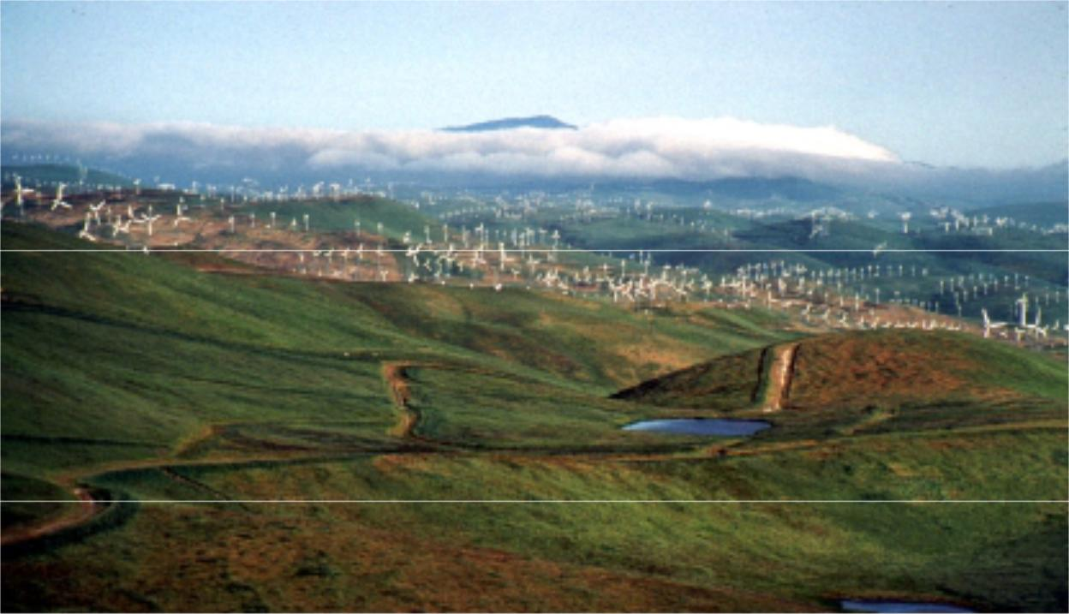

Figure 3. Southeast Portion of the Altamont Pass WRA (photo by Daniel Driscoll)

5

1.0 Introduction

Powering of the Altamont Pass Wind Resource Area (WRA) began in 1982 and produced about 6,500 wind turbines by 1987. At some point during this growth period, the U.S. Fish and Wildlife Service began receiving reports of raptors killed by turbine blade strikes. The most numerous fatalities encountered were red-tailed hawks (Buteo jamaicensis), American kestrels (Falco sparvarius), and golden eagles (Aquila chrysaetos), with lesser numbers of turkey vultures (Cathartes aura), common ravens (Corvus corax), barn owls (Tyto alba), and others. In 1994 alone, 348 raptor fatalities in the WRA were reported to Alameda County, 35 of which were golden eagles and 194 red-tailed hawks (Alameda County 1998).

On the basis of foot surveys conducted along the rows of turbines, Orloff and Flannery (1992) estimated in their report to the Commission that about 40 golden eagles and several hundred other raptors died in the WRA each year. During a six-year period (1994-1999), the general magnitude of that estimate was reaffirmed by wind industry employees who, while servicing the turbines, happened upon 21-42 dead golden eagles per year (mean=28). However, these likely represented only a fraction of the total fatalities present, considering the lack of surveys and the incidental nature of the reports. All of these considerations suggested that Orloff and Flannery’s estimate of 40 golden eagle fatalities was conservative.

The golden eagle is of particular concern, not only because it is less abundant than most of the other species killed at the WRA, but because it is also naturally slow to mature and reproduce, characteristics that render its populations especially sensitive to increases in adult and subadult mortality. The species has declined in southern California as a result of urban encroachment (Scott 1985, Harlow and Bloom 1987), and the California Fish and Game Department (1992) lists it as a Fully Protected Species and a Species of Special Concern. Moreover, the federal government affords the golden eagle special protection under the Eagle Protection Act as amended in 1963. There are no provisions within the Act that would allow the killing (“taking”) of golden eagles.

During 1994-1997, the Predatory Bird Research Group (PBRG) sought to determine the extent to which eagle deaths resulting from wind turbine blade strikes were influencing the trend of the population. The work, funded by the wind industry and by the National Renewable Energy Laboratory (NREL), involved placing radio-transmitters on 179 golden eagles in the vicinity of the WRA and tracking their movements in weekly surveys by airplane over a 48-month period. Each transmitter contained a sensor indicating whether the eagle was alive or dead. Results of the aerial surveys showed that eagles killed by turbines were primarily from a local resident population whose density, as determined in annual nest surveys, was among the highest known in the world. Sixty-nine territorial pairs have been found within 30 km of the WRA boundary (Hunt et al. 1995, 1996, 1999).

The majority of deaths recorded among radio-tagged eagles during the 1994-1997 study resulted from electrical generation or transmission. Most of these were caused by wind turbine blade strikes, the remainder by electrocutions on distribution lines outside the WRA. Additional turbine-related fatalities went unrecorded because blade strikes destroyed the transmitter in an estimated 25 percent of cases. These data on mortality within a continuously monitored sample, together with estimates of golden eagle reproduction in the study area, were sufficiently precise for modeling experts from Colorado State University (Franklin et al. 1998) to estimate

6

(incorrectly, as we shall show) that, during the four-year period, the population was declining at an annual rate of 9.3 percent (SE=3.2 percent). A second, more parsimonious model proposed by PBRG, produced a decline rate of 1.2 percent, a value indistinguishable from a condition of no persistent decline by its standard error (3.9 percent). Neither model precluded the possibility that immigrants from less lethal environments buffered the population. PBRG predicted that, in the absence of turbine-related mortality, the population would be self-sustaining and a source of recruits to the surrounding landscape.

1.1. Project Objectives

In addition to the question of which of the two population models most accurately described the trend of the population, the demographic study also left unanswered that of how eagle deaths in the WRA might be mitigated. At the time of the study’s conclusion, it appeared that extensive changes within the WRA were imminent and that these changes might effect a reduction in blade-strike mortality among golden eagles. Of particular interest were industry plans to replace the Kenetech 56-100 turbines on 18.3-meter lattice towers (Type-13) with larger turbines on tubular towers (Section 2.2). The latter, producing far more electrical energy, would replace the Type-13 turbines at a ratio of one new structure for every seven or eight removed. Whether the new, larger turbines were individually more benign was unknown, but biologists noted that eagles were less apt to perch on the tubular towers and speculated that their blades, being higher off the ground, would allow eagles to more easily pass under them. Moreover, the slower rotation of larger turbines might render their blades more visible and more negotiable (Tucker 1996a, b).

PBRG proposed to continue the radio-tagging and tracking of golden eagles as a way of determining the efficacy of these changes, specifically, by comparing new data on eagle distribution and mortality with those recorded during the earlier study. As it turned out, difficulties within the industry postponed the repowering program beyond the time frame of this study. However, as we proceeded, it became clear that factors affecting eagle distribution and mortality could still be investigated, and that we could explore the distribution of eagle deaths relative to existing turbine configurations in an attempt to identify those conditions most lethal. Such an approach offers a measure of prediction of the effects of changes expected to occur in and around the WRA and adds to the scientific foundation upon which regulators and industry can make management decisions. The work is consistent with the mission of PIER funding, namely to “… conduct public interest energy research that seeks to improve the quality of life for California’s citizens by providing environmentally sound, safe, reliable, and affordable energy services and products.”

1.2. Report Organization

We begin by describing the study area, our general methods, and those aspects of golden eagle life history that pertain to our study. We then explain our findings in the context of the entire investigation dating from 1994. We discuss the numerical and distributional changes we observed within our samples of radio-tagged eagles and detail the numbers and sources of mortality recorded throughout the study area. We then focus on mortality within the WRA and its relationship to the various kinds of wind turbines, with emphasis on those features, including placement that contribute to their lethality. We discuss the relationship of eagles to

7

prey distribution within the WRA. We examine two population models that would predict the population trend, discarding one in favor of another. We end our report with an overview discussion of our findings and recommendations. For further details on methodology and overall findings, we recommend that the reader have on hand copies of our earlier reports to NREL (Hunt et al. 1995, 1996, 1999).

8

2.0 Background and Project Approach

This study centers on the use of radio-telemetry to monitor the survival and movements of golden eagles in and around the WRA. This approach overcomes the bias associated with observer location and visibility within differing terrain and vegetation typical of other methods. All radio-tagged eagles are equally detectable from an airplane so that virtually all are accounted for within the study area (Hunt 1987). GPS enhances the precision of establishing the location of tagged eagles, and GIS electronic mapping facilitates the comparison of eagle distribution with that of wind turbines and other landscape features.

During the earlier study (1994-1997), we radio-tagged 179 golden eagles within ca. 40 km of the WRA with backpack-style transmitters (Hunt et al. 1995) designed to last four years. The sample included 79 juveniles, 45 subadults, 17 floaters (nonbreeding adults), and 39 breeders. Effective sample sizes in the older stages increased as eagles matured or became territorial. Thus, by the end of the study, we had obtained telemetry data on 106 subadults, 40 floaters, and 43 breeders, in addition to the 79 juveniles. Some of these transmitters were still operating when we began the current study and, to increase the overall sample, we tagged an additional 78 eagles during 1998-1999, including 53 juveniles, 19 subadults, four floaters, and two breeders. Each transmitter contained a motion (mortality) sensor yielding a recognizably faster pulse rate when the instrument was motionless for four or more hours. We monitored eagle movements and fatalities by means of fixed-wing aircraft surveys conducted one to four times per month (weather permitting) through October 2000. We performed final surveys in spring 2001 to determine the number of eagles still residing in and near the study area. We used GPS to fix and record eagle relocations (accuracy within ca. 0.6 km). We traveled without delay to sites where fatalities were detected, collected data on cause of death, and, where possible, identified the responsible turbine. Wounds and/or dismemberment easily identified blade-strike kills, and, in most cases, the latter were in immediate proximity to turbine towers, the location of which was substituted for the less accurate GPS fixes recorded from the airplane. In a few cases, eagles struck by turbine blades survived the event and were encountered and saved, though they remain flightless in animal care facilities. We regarded these casualties as deaths because they were permanently lost to the population.

We used the Kaplan-Meier estimate of stage-specific survival rates as developed by Pollock et al. (1989) for staggered entry of radio-tagged individuals. Assumptions were that (1) individuals were sampled randomly, (2) survival time was independent for each eagle, (3) the radio-tag did not influence survival, and (4) censoring was not related to the eagle’s fate (Heisey and Fuller 1985, Bunck 1987). Censored eagles (those suspended from analysis when their fate was unknown) fell into two classes: those carrying failed transmitters and those absent from the study area, the two possibilities being indistinguishable. Possible causes of transmitter failure included battery discharge, component malfunction, and transmitter destruction, all but the latter fairly regarded as occurring independently of the eagle's fate. The assigned date of deletion was midway between the date of last detection and that of the first indication of signal disappearance. The first assumption that of random sampling, is problematic to the extent that tagging sites were chosen opportunistically. However, the very high mobility of nonbreeding eagles throughout the study area and the long duration of the tracking study render this bias negligible.

9

Our estimate of reproductive rate was based on the number of fledged young per territorial pair, the latter being only those observed during or before incubation. This method avoids the bias relating to the fact that successful pairs are easier to locate and identify late in the breeding season than pairs that have failed (Steenhof and Kochert 1982, Steenhof 1987). We therefore began our surveys in January and February of each year when eagles were conspicuously engaged in territorial (undulation) displays prior to egg laying. We revisited areas to see whether eagles were incubating, and later returned to nests where we had observed incubation to determine whether broods were present and to count the number and ages of young. Young were considered to have fledged if they reached approximately eight weeks of age.

We used GIS (ArcView™) software to map ranch boundaries and the positions of the 5,382 operational wind turbines in the WRA. Some of the wind companies had electronic data while others provided contour maps of varying scale showing turbine positions. We scanned these and manipulated the resulting images to correspond to electronic topographical maps (Maptech™). We verified the accuracy of turbine positions in the field by spot-checking. Information provided by the wind-energy companies and attached to each data point included turbine serial number, turbine type, tower type, and tower height.

2.1. Study Area

The 9,000 km2 study area, selected on the basis of the overall movements of radio-tagged eagles, is bounded on the north by the Sacramento River delta, to the east by the San Joaquin Valley, to the west by the urban area along San Francisco Bay, and to the south by State Highway 152 between Morgan Hill and San Luis Reservoir (Figure 4). This largely pastoral region of the Diablo Mountains supports grasslands, oak savanna, oak woodland, chaparral/scrub, and contains a band of urban communities extending from Livermore to Concord.

10

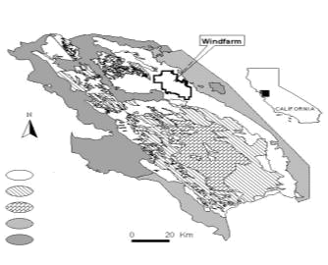

Grassland

Woodland

Sage/Chaparral

Farmland

Figure 4. The Diablo Range Study Area

The WRA itself is a 160-km2 tract of privately owned cattle ranches in hilly grassland (elevation 60-550 m) covered almost entirely by European annual grasses and with occasional oaks (Quercus spp.), eucalyptus (Eucalyptus spp.), and California buckeye (Aesculus californica). Terrain is generally less steep in the eastern portion of the WRA, giving way to continuous farmland. A valley containing urban sprawl lies below the hilly western boundary. Running west to east through the Diablo Mountains and the WRA is Altamont Pass, through which strong winds are drawn from the ocean to the Central Valley, especially during the warmer months.

The California ground squirrel (Spermophilus beecheyii), the principal prey of golden eagles in the region, was abundant in portions of the WRA, particularly during the early years of our study (Hunt et al. 1995). Ranchers throughout the region control ground squirrel numbers with summer applications of anticoagulant rodenticides (Section 3.6). Two other important prey species, the black-tailed jackrabbit (Lepus californicus) and cottontail rabbit (Sylvilagus auduboni) occur within the WRA.

The WRA contains about 5,400 wind turbine structures of about 27 types (Appendix I) operated by a variety of energy companies. Principal differences among the turbines include the degree of power generation (40-750 kW), tower type (e.g., tubular versus lattice structure), blade number (2 or 3), rotor-swept diameter (13-46 m), tower height (14-43 m), and blade rotation axis (horizontal versus vertical) (Figure 5). The most common type is the Kenetech 56-100 on an 18.3 m lattice tower (Type-13) of which there are currently about 3000 (56 percent of total) in service (Figure 6).

11

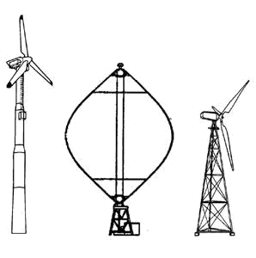

Figure 5. Examples of the Three Basic Wind Turbine Designs in the Altamont Pass WRA: Tubular Tower (Type-8), Vertical Axis (Type-9), and Lattice Tower (Type-13)

2.2. The Repowering Plan

When we proposed this study, the plan for repowering of the Altamont Pass WRA involved the replacement of existing turbines with a lesser number of larger, more energy-productive turbines by three wind-energy developers (Alameda County 1998). Green Ridge Services and Altamont Power proposed to replace existing turbines with NEG-Micon 700 kwh turbines on either 114-foot (34.7 m) or 131-foot (40 m) tubular towers (Type-28). The new turbines would have a 157-foot-rotor-diameter (48 m) and a 22 rpm maximum rotational speed. Green Ridge Services would replace 644 Type-13 (100 kwh lattice tower) turbines, including all those associated with more than one known raptor fatality, with 92 Type-28 turbines, a ratio of seven removed to one constructed. Altamont Power proposed to replace all 194 Flowind Vertical Axis turbines (Type-9) with 45 Type-28 turbines (ratio = 4.3 to 1), and possibly replace 25 Danwin 110 kwh turbines (Type-17) with five of the new turbines (ratio = 5 to 1). Sea-West would replace 432 of the 433 existing turbines with 42-50 NedWind 500 kwh or NEG-Micon 750 kwh or MHI-MWT 600 kwh turbines, replacement ratios from 8.6 to 1 to 10.3 to 1.

12
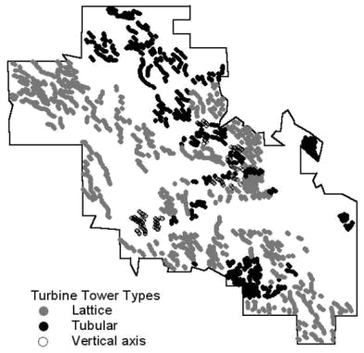

Figure 6. Distribution of the basic Turbine Configurations in the WRA

2.3. Study Species

Golden eagles occur throughout the Northern Hemisphere and are among the largest of raptors, with wingspans of up to 2.2 m and weights approaching 5 kg (Watson 1997). Females are about 25 percent heavier than males, an evolutionary adaptation relating to their divergent roles during the breeding season. Golden eagles in our study area forage primarily on live mammals in open grassland habitats, but in winter may rely heavily on carrion, including deer and cattle carcasses, and may exploit waterfowl concentrations. California ground squirrels are the main prey in the study area. Among 339 prey items from collections made at golden eagle nests in the study area in 1994, we estimated that the California ground squirrel represented 69 percent of prey numbers and 64 percent of prey biomass (Hunt et al. 1995). The second most important species was the black-tailed jackrabbit at 8 percent biomass, and the third was the black-tailed deer (Odocoileus hemionus) at 6 percent. In all, mammals accounted for 92 percent of prey biomass, followed by 7 percent for birds, and 1 percent for reptiles.

Although these figures represent only a single breeding season, numerous subsequent observations have verified the predominant role of California ground squirrels in the diet of

13
golden eagles in the WRA and its environs. The reason doubtless relates to the abundance of squirrels in the region and their availability to eagles throughout the year. In this respect, they differ from many other ground squirrel species that aestivate and/or hibernate for long periods. California ground squirrel populations do not appear to cycle in abundance over multi-year periods as do, for example, jackrabbits, the main prey of golden eagles in most western states. However, prolonged winter rainfall in some years may reduce ground squirrel availability and overall numbers (Grinnell and Dixon 1918; this study).

Golden eagles in the interior central coast ranges of California occur primarily in grazed, open grasslands and oak savanna, with lesser numbers in oak woodland and open shrub lands. With increasing urbanization, much of the remaining golden eagle habitat in central and southern California is located within private ranches used for livestock grazing. Over much of their range, golden eagles prefer cliffs for nesting, but these are scant in the Diablo Range study area, and all but a few pairs nest in trees, including four oak species (Quercus lobata, Q. douglasii, Q. agrifolia, and Q. wislizenii), three pines (Pinus sabiniana, P. radiata, and P. coulteri), California bay laurel (Umbellularia californica), eucalyptus (Eucalyptus spp.), and western sycamore (Platanus racemosa). The Diablo Range eagles nest mainly in oak savanna and oak woodland. Open grasslands are generally unsuitable for nesting due to lack of structures, but a few pairs of eagles nest on electrical transmission towers traversing grasslands. Golden eagle pairs in the Diablo Range participate in courtship and nest building in December and January, lay 1–3 eggs in February and March (incubation lasts 6.5 weeks), and fledge their 10- to 11-week-old young from mid-May to late June. Fledglings usually stay within their natal territories until mid-August, although some individuals may remain in the vicinity until December.

Healthy golden eagle populations contain four population segments: breeders, juveniles, subadults, and floaters. Differing environmental and behavioral factors may influence the numbers of each within a population. Breeders are individuals four years old or older that defend breeding territories. Because golden eagle pairs partition the landscape into a mosaic of territories from which other adults are excluded, there is an upper limit to the number of breeders and therefore the number of young produced in any defined area. Territorial boundaries tend to remain fairly stable from year to year (Marzluff et al. 1997, this study), and, in years of low prey availability, eagles may forgo breeding but still occupy and maintain their territories. This tendency for the number of territories to remain somewhat constant, together with the limit on area productivity, form the basis for stability in overall population size, i.e., Moffat’s equilibrium (Hunt 1998).

Juveniles are eagles less than one year old, and subadults are one, two, and three years of age. Floaters are adults without breeding territories (Brown 1969), and their existence implies that territorial pairs occupy all habitat suitable for breeding (Hunt 1988,1998). Floaters effectively safeguard the breeding segment by quickly replacing breeders that have died, but if the proportion of floaters is very large, competition for nesting territories may reduce the reproductive rate and breeder survival (Hansen 1987, Haller 1996). For further information on golden eagle natural history and population ecology, we refer the reader to Haller (1996), Tjernberg (1985), Watson (1997), Kochert et al. (in press), and to Section 3.0 in Hunt et al. 1995 and our other NREL-sponsored reports (Hunt et al. 1997, 1999).

14

2.4. Other Studies of Avian Fatalities

Several investigations of wind-energy-related bird fatalities have been conducted at Altamont Pass after Anderson and Estep (1988) brought attention to the issue. Howell and DiDonato (1991a) surveyed 359 turbines biweekly from September 1988 to August 1989 and found 42 avian fatalities. They noted that fatalities tended to be associated with topographical features such as swales and the shoulders of hills (Howell and DiDonato 1991b). Howell (1995) compared the Type-13 and the larger more energy-productive Type-12 (33 meter rotor diameter) turbines and found the number of raptor kills per turbine to be equal, i.e., 0.264 and 0.278, respectively.

Orloff and Flannery (1992) documented 182 fatalities in two years, of which 119 (65 percent) were raptors. They found that kills were related to turbine location (end-of-row turbines), topography (near canyons), and tower type (lattice towers). They estimated annual raptor mortality at 164 to 403 birds. They reported that turbine-related mortality did not appear to be related to species abundance, and suggested that other factors such as behavior or flight characteristics may contribute to collisions. Further analysis of their data suggested that some factors specific to turbine types (tip speed, tower type, and the percent of time the turbine was in operation) were significantly correlated with fatalities, while others (rotor diameter, rotor swept area, turbine height, turbine spacing, and rotor orientation) were not (Orloff and Flannery 1996).

Curry and Kerlinger (1998) examined the fatality data submitted to Alameda County and noted that golden eagle and red-tailed hawk fatalities were correlated with turbine location and topography. They determined that end-of-row and second-from-end turbines accounted for 46 and 44 percent of all the golden eagles and red-tailed hawks killed, respectively. Mid-string turbine fatalities of the two species appeared to be associated with topographical features (dips and notches) and gaps (irregular spacing) between turbines. In an analysis of multiple-kill turbines, Kerlinger and Curry (1997a) found that 439 (91 percent) of golden eagle and red-tailed hawk fatalities were at single-kill turbines, 36 (7.5 percent) at turbines responsible for two kills, and 7 (1.5 percent) at turbines connected with three kills.

15

3.0 Project Outcomes

3.1. Evidence for a Change in Eagle Distribution

Our earlier study showed that subadults and floaters were by far the most frequently killed by turbine blade strikes. We therefore targeted these life-stages for radio-tagging in the current study. However, when we resumed our capture program in fall 1998, it was soon apparent that fewer subadults and floaters were present in the study area than previously encountered. In the early sampling period (January 1994 – July 1996) we had captured 54 subadults/floaters in 100 trapping days for an average of 0.540 individuals per day, whereas later (November 1998 – January 2000) we caught only 28 subadults/floaters in 168 trapping days, or 0.167 eagles per day, a highly significant difference (Χ 2=28.5, d.f.=1, p<0.001). Trapping techniques, locations, and months of fieldwork were similar during the two periods, so our results could not have arisen from differences in sampling.

Not only were attempts to capture subadults and floaters less successful, but we caught more juvenile eagles (n=28 in 168 days) in the current study than in the earlier one (n=7 in 100 days). The disproportion between the two periods in the number juveniles trapped per day (Χ 2=3.77, d.f.=1, p=0.052 with Yates’ correction) suggests a change in density, but may have resulted not from a greater number of juveniles present overall but from less competition with older eagles for access to the bait stations. The ratios of juveniles to older itinerants (non-territorial eagles) in the capture samples between the two study periods were significantly different: 7:54 (12.9 percent) during 1994-1997 versus 28:28 during 1998-2000 (Χ 2=20.6, d.f.=1, p<0.001). Figure 7 shows these age-class ratios.

% Total Captures

60
50 |  |  |  |  |  |  |  |  |  |  |  |  |  |  |  | 1994-1996 (n=61)
40 |  |  |  |  |  |  |  |  |  |  |  |  |  |  |  | 1998-2000 (n=56)
30
20
10
0

0-1 1-2 2-3 3-4 4+

Ages of Captured Eagles

Figure 7. Ages of golden eagles captured in 1994-1996 versus 1998-2000

We thought that annual differences in reproduction (range=0.46–0.90 fledglings per occupied site) might explain the change in age ratios between the trapped samples. However, we found no correspondence. Reproduction was far above average in spring 1994 and yet, among the 19 free-ranging eagles we captured the following spring, only 4 (20 percent) were juveniles. The year 1998 was one of below average reproduction, and yet 18 (47 percent) of 38 itinerants captured the following winter and spring were juveniles (Χ 2=3.70, d.f.=1, p=0.0544, though p=0.1020 with Yates’ correction).

16

The weight of evidence therefore implies that far fewer free-ranging subadults and floaters existed in the study area during 1998-2000 than were present during 1994-1996, a finding consistent with the modeled (point estimate) predictions of an overall-declining trend in population as reported by Hunt et al. (1999). However, an alternative hypothesis is that free-ranging eagles may have had a greater tendency to emigrate in the later period, e.g., in response to possible changes in prey availability in the study area or elsewhere. Let us examine this possibility.

Figure 8 graphs the behavior of four yearly cohorts of golden eagles (tagged as fledglings) from September of the natal year through the following September. Note the suggestion of an increasing tendency to leave the study area by comparing the proportions of eagles that remained with those that either disappeared or left and returned, the latter being those gone two months or more. Disregarding the proportion of deaths and combining the two classes of emigrants in Figure 8, the difference between the apparent behavior of cohorts in the earlier study (1994-1997) and that fledging in 1999 is significant (Χ 2=4.72, d.f.=1, p=0.0299, with Yates’ correction). The suggestion of a change in tenure is even more convincing when one compares the activities of the 1994–1995 cohorts with those of 1996–1999 (Χ 2=7.46, d.f.=1, p=0.0063, with Yates’ correction). We surmise that, although most of the juvenile eagles not detected in the surveys eventually returned, conditions in the study area were less hospitable during the later years of study.

Percent

 |  |  |  |  |  |  | Juveniles Tagged as Fledglings
100 |  |  |  |  |  |  |  |  |  |  |  |  |  |  |  |  |  |  |  |  |  |  |  |  |  |  | Died
80 |  |  |  |  |  |  |  |  |  |  |  |  |  |  |  |  |  |  |  |  |  |  |  |  |  |  | Disappeared
80 |  |  |  |  |  |  |  |  |  |  |  |  |  |  |  |  |  |  |  |  |  |  |  |  |  |  | Left and Returned
60
60 |  |  |  |  |  |  |  |  |  |  |  |  |  |  |  |  |  |  |  |  |  |  |  |  |  |  | Remained
40
20
0
1994 |  |  |  |  |  |  | 1995 |  |  |  |  |  |  | 1996 |  |  |  |  |  |  | 1999

Cohort

Figure 8. Fates of Tagged Juveniles from September of the Tagging Year through the following September
Sample sizes are as follows: 1994 (n=22), 1995 (n= 19), 1996 (n=18), and 1999 (n=26). Some eagles remained continually within the study area throughout the 13 month period while some temporarily departed. The disappeared category includes eagles that departed the study area and did not return within the year or those whose radios failed, the two possibilities being indistinguishable. Deaths include only those occurring within the study area.

The trend of tenure among radio-tagged subadults and floaters between the earlier study and the current one appears similar to that of the juveniles. Figure 9 graphs the tenure categories of subadult/floater eagles over the 12 months following radio-tagging. Although sample sizes were small in the current study owing to the increased difficulty of catching subadults and

17

floaters for radio-tagging, a comparison between the two study periods yielded a nearly significant difference in behavior between the two periods (Χ 2=3.03, d.f.=1, p=0.0818, with

Percent

80

60

40

20

0

Subadults and Floaters During the

Year Following Radio-tagging

1994-1996 (n=60)

1998-2000 (n=23)

Died Disappeared Left and Remained

Returned

Yates’ correction). Again, there is the suggestion that a change in habitat quality (e.g., prey densities) has affected golden eagle tenure within the study area.

Figure 9. Fates of Subadult and Floater Eagles during the 12 Months Following Radio-Tagging

Sample sizes are as follows: 1994 (n=24), 1995 (n= 22), 1996 (n=14), 1998 (n=12), and 1999

(n=11).See the Figure 8 legend for explanation of categories.

We conclude from these findings that fewer subadult and floater eagles existed within the study area during 1998-2000 than during 1994-1997. Although one would expect this on the basis of the predictions of population decline detailed in our report to NREL (Hunt et al. 1999, but see Section 3.7), our data suggest a greater tendency for itinerant eagles to leave the study area. Because the overall distribution of radio-tagged subadults and floaters within the study area was somewhat similar between the two study periods (Table 1), one may hypothesize that the difference in itinerant numbers related to broad-scale changes in prey availability.

Table 1. Relocations of Radio-Tagged Subadults and Floaters in the Previous versus the Current Study

 |  |  | Percent of Relocations
 |  | Within WRA | Within 5 km | Within 10 km | Within 20 km
1994-1997 | (n= 4851) | 19.6% | 42.0% | 58.1% | 75.8%
1998-2000 | (n= 859) | 23.7% | 40.7% | 53.5% | 74.6%

These data include only those aerial surveys during which we recorded the positions of all tagged eagles.

Exploring this and other explanations for why greater proportions of nonbreeding eagles left the area during the second period of our study, we note that a number of habitat alterations and land use changes occurred that may have reduced habitat suitability for foraging eagles. These changes included (1) the creation near the WRA boundary of the 6.3 km2 Los Vaqueros Reservoir (which filled in winter 1997-1998), an area that had supported high densities of ground squirrels, (2) the conversion of grasslands to vineyards and housing developments in the Livermore Valley and elsewhere, and (3) prolonged rains during winter 1997-1998. The latter may have significantly reduced ground squirrel numbers throughout the study area, i.e.,

18

114 days of rainfall were reported during January – May 1998. Jim Woollett, wildlife biologist for Lawrence Livermore Laboratories told us in 2001 that squirrel numbers had yet to recover at Site-300 along the southeast border of the WRA after the 1997-1998 winter rains flooded the burrows. Jim Smith, biologist for the Alameda County Agricultural Department (ACAD) affirmed that rainfall caused a drastic reduction in ground squirrel numbers throughout the county in early 1998.

3.2. Eagle Mortality

We recorded 113 deaths over 88 months among a radio-tagged sample of 257 eagles. Fifty-two were attributed to wind turbine blade strikes. However, the total sample must be reduced by five deaths occurring after radio failure or censoring, three with transmitters destroyed by turbine blades and found by industry workers, and by five other eagles that died outside the study area. The latter included one killed by a wind turbine blade at the Solano WRA, some 35 km from the Altamont WRA. In all, at least 68 (68 percent) of the 100 uncensored deaths were human-related (Table 2), the unknown category likely containing additional human-caused fatalities, though none were turbine-related. Two of the unknowns were in the WRA but neither involved trauma. Figure 10 shows the distribution of the 42 uncensored blade-strike casualties in the WRA.

3.2.1. Turbine Blade-strike Mortality among the Four Life-stages

The four population segments, i.e., juveniles, subadults, floaters, and breeders, may be expected to experience different mortality regimes owing to differences in life style and experience. Juveniles must learn to survive, and in doing so, they rely more heavily on carrion and piracy than do the older age classes more proficient at capturing live prey. California ground squirrels, the principal prey in the area, reproduce in spring, but it is not until September that most juvenile eagles become independent of their parents, a time when ground squirrels are fully-grown and wary. We believe that juveniles transition to hunting ground squirrels about eleven months after fledging, when an abundance of young, somewhat easy-to-catch squirrels appears above ground. We have also observed numerous young cottontails in portions of the WRA in spring.

19

Table 2. Causes of Death among 100 Radio-Tagged Golden Eagles

 | Ju veniles | Su bad u lts | Floaters | Breed ers | Total
Mortality Agent | (17 fatalities) (49 fatalities) (22 fatalities) (12 fatalities) |  |  |  | Fatalities
Turbine Blade Strike | 5.9% | 63.3% | 36.4% | 16.7% | 42
Electrocution | 23.5% | 10.2% | 13.6% | - | 12
Fledging Mishap | 35.3% | - | - | - | 6
Hit by Car | - | 6.1% | 4.5% | - | 4
Wire Strike | 5.9% | 4.1% | 4.5% | - | 4
Eagle | - | - | 9.1% | 16.7% | 4
Lead Poisoning | - | 4.1% | - | 8.3% | 3
Botulism | - | - | - | 8.3% | 1
Brodificoum Poisoning | - | - | - | 8.3% | 1
Shot | - | - | 4.5% | - | 1
Hit by Train | 5.9% | - | - | - | 1
Unknown | 23.5% | 12.2% | 27.3% | 41.7% | 21

3.2.1.1. Juvenile Mortality

The apparent latency in the onset of active hunting by juvenile golden eagles may confer an immunity to wind turbine interaction, i.e., we found only one turbine blade-strike fatality (0.9 percent) among 117 radio-tagged (free-ranging) juveniles, a profoundly lower incidence than that recorded among subadults and floaters (see below). The single fatality occurred in the last month of the juvenile year. This very low incidence occurred despite the common appearance of juveniles within the WRA, i.e., 264 (13.7 percent) of 1921 relocations during September through May when almost all juveniles had become independent (Hunt et al. 1999).

3.2.1.2. Subadult and Floater Mortality

Unlike juveniles, radio-tagged subadults and floaters are highly vulnerable to turbine blades. We recorded 31 blade-strike fatalities (20.0 percent) within our sample of 155 subadults with working radios and 8 such fatalities (14.8 percent) among 54 floaters. We attribute this susceptibility both to their frequent occurrence in the WRA and their greater tendency, compared with juveniles, to hunt live prey.

Many of these itinerants were originally tagged as fledglings (n=102), and we were able to monitor those remaining in the study area through the three-year period of subadulthood and, in some cases, beyond. The numbers of blade-strike deaths among these subadults and floaters were large among some cohorts. We tagged 25 fledgling eagles in 1994, and a year later, six of these had died or disappeared (emigration plus radio-failure), leaving 19 in the study area as first-year subadults. From January 1995 to November 1999, turbine blades killed 11 of these eagles (including censored ones), an attrition rate of at least 57.9 percent arising from this single mortality agent. Only one was known to have died of other causes within the study area during this period. Of 16 radio-tagged eagles from the 1995 cohort detected in the study area as subadults, six (37.5 percent) were eventually killed by wind turbines (March 1997 – May 1999). There were five blade-strike deaths among 13 subadults and floaters remaining in the study area from the 1996 cohort, a kill rate of 38.5 percent. We have only short-term information for the 1999 cohort, i.e., only one year of subadulthood. Among 19 of these eagles detected in the study area as subadults, four (21.0 percent) have thus far been killed by turbine blades. Note

20

that all these figures on turbine-related mortality represent minimum incidence because the blades destroy the transmitters in a proportion of cases.

We were interested to know if eagles fledging from nests near the WRA were more likely to be killed there than those originating from more distant sites. To test this, we considered only those eagles tagged as fledglings in 1994, 1995, and 1996, the reason being that we were able to monitor them through all subadult years. Our results showed no difference in median or mean distance from the WRA between those killed by turbines and those that were not. The median distance from the natal site to the WRA for 22 turbine-killed subadults and floaters was 11.3 km (mean=13.2, SD=9.1), while the median for 38 such eagles not killed by wind turbines was 11.7 km (mean=13.3, SD=9.1), a near-perfect match.

3.2.1.3. Breeder Mortality

Breeding golden eagles are less exposed to wind turbines than subadults and floaters because of the tendency of breeders to remain within and near their breeding territories, only some of which are near the WRA. There were 12 fatalities among the 47 radio-tagged breeders in the study area, two of which (16.7 percent) were killed by turbine blade strikes. The nesting territory of one of the turbine fatalities was adjacent to the WRA, while the other was some 12.7-km distant. As a matter of interest, we know of 18 regularly occupied golden eagle territories within 10 km of the WRA (minimum density = 1 pair per ca. 30 km2), 30 in the 10-20 km range, 21 at 20-30 km, 15 at 30-40 km, and 9 territories 40-50 km from the WRA. Our surveys doubtless account for a greater proportion of the actual number of territories in areas closest to the WRA than in zones of greater distance where logistical, landowner, and budgetary restrictions hampered detailed searches.

Thus, in contrast with the other eagle life-stages, the relatively small home ranges of breeding eagles keep most of them out of the WRA (Figure 11, Figure 12, Figure 13, and Figure 14). Only 42 (1.0 percent) of 3986 breeder detections were within the WRA boundary; these visits were by 12 (25.5 percent) of the 47 tagged breeders. This contrasts with 14 percent of juvenile detections being in the WRA (n=1917), 18 percent for floaters (n=2063), and 20 percent for subadults (n=4693). The tendency of breeders to remain within their territories is of particular benefit to the population because the trend in the latter is much more sensitive to adult survival rates than to any other demographic parameter (Hunt 1998, Hunt et al. 1999). We calculate, for example, that a chronic change of two percent in adult survival in this population may exert the same effect on the population trend as a change of about 13 percent in juvenile survival or reproduction.

21

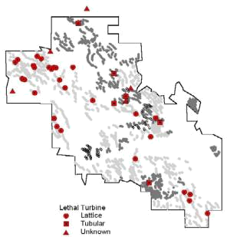

Figure 10. Distribution of 42 Turbine Blade-Strike Casualties of Uncensored,

Radio-Tagged Golden Eagles in the WRA

(See Figure 6 and Figure 15 for distribution of turbine configurations.)

The ratio of blade-strike deaths to total relocations within the WRA among breeders (2/42 =

0.05), though imprecise as a measure of risk, is comparable with that observed among subadults and floaters (42/1412 = 0.03) and suggests that breeders are similarly vulnerable when in the vicinity of wind turbines. Circumstantial evidence suggests that breeding pairs living very close to the WRA experience higher mortality than those living further away. Despite the high apparent suitability as breeding habitat of those portions of the WRA containing trees or small cliffs, we observed very few pairs and those only temporarily.

3.3. Seasonal Differences

One would expect the frequency of blade-strike fatalities to rise and fall in correspondence with the windy season at Altamont Pass which extends from the end of March to the end of September. Indeed, turbines killed 27 tagged eagles in spring and summer (21 March to 21 September) compared with 15 in fall and winter (Χ 2=3.43, d.f.=1, p=0.064). The latter figure appears (to us) surprisingly high, considering that Green Ridge Services (personal communication) generates only about 20 percent of its power outside the windy season. A goodness-of-fit calculation based on the hypothesis that 80 percent of fatalities would occur during the windy season differed significantly from the expected (Χ 2=6.48, d.f.=1, p=0.011). Our first thought was that a greater proportion of tagged eagles might visit the WRA outside the windy season, but such was not the case, the proportions being identical, i.e., 23.8 percent of relocations during the windy season were inside the WRA and 23.7 percent during the non-

22
windy season. These findings suggest the possibility of seasonal differences in eagle hunting behavior, although we know of none, or perhaps that the turbines, spinning only occasionally and therefore unexpectedly in fall and winter, are more likely perceived benign by eagles in their vicinity. The cooler seasons are also times when bad weather, e.g., fog and rain, often obscure visibility.

3.4. Turbine Configuration and Lethality

A variety of considerations reflect upon whether one turbine/tower configuration is more likely to kill golden eagles than another. The first step of inquiry is to determine the kinds of turbines that actually killed the radio-tagged eagles in our sample, considering that there is likely no detection bias associated with the distribution of the 42 uncensored blade-strike casualties. We find that only four or possibly five kinds of turbines are on the list (Table 3) and that, among them, Type-13 accounted for at least 27 (73 percent) of the 37 deaths in which eagles died in the vicinities of the turbines that struck them. Referring to Figure 5 and Appendix I, we see that Type-13 is the Kenetech 56-100 turbine on an 18.3-meter lattice tower.

We are first tempted to compare the allocation of deaths with the relative abundance of Type-13 turbines (n=ca. 2997) versus that of all the other turbines combined (n= ca. 2385), assuming (probably incorrectly) that none of the eight ambiguous fatalities (no assigned turbine type in Table 3) was attributable to Type-13. The result of the comparison is not significant, therefore suggesting that the relative abundance of Type-13 is sufficient to explain its lethality (Χ 2=1.26, d.f.=1, p=0.26). Also not significant is a comparison of the abundance of Type-13 with the subset of only those types of turbines that killed the eagles in our sample (Χ 2=0.74, d.f.=1, p=0.38).

However, in looking for differences, we must also consider the distribution of live eagles within the WRA, that is, the pattern of their exposure in relation to the distribution of turbines. For example, a high kill rate by a certain type of turbine would imply a high degree of lethality were eagles known to only rarely visit areas containing it. To examine this possibility we drew a crude set of polygons (Figure 15) around the areas containing Type-13 turbines and another set enclosing the other types (n=1917 turbines), 79 percent of which were of tubular tower configuration, 20.5 percent lattice towers, and less than one percent vertical axis machines. The Type-13 area contains several other types of lattice-tower turbines, making up 12.3 percent of the total.

Figure 11, Figure 12, Figure 13, and Figure 14 compares aerial relocation distributions between breeders, floaters, subadults, and juveniles These distributions represent only those surveys in which we determined the positions of all tagged eagles in the study area. See Figure 4 for habitat types.

23

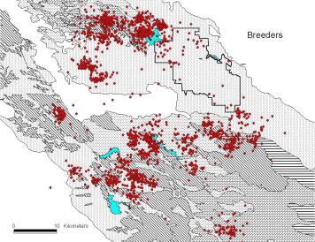

Figure 11. Relocations of Breeders
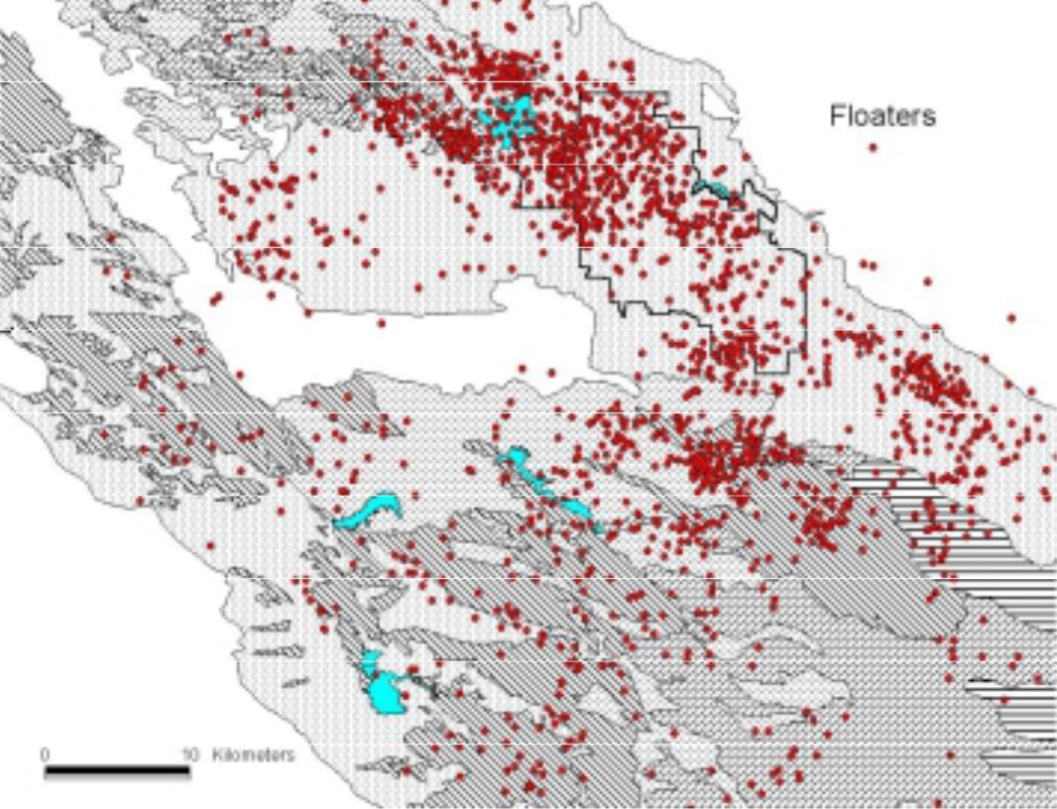

Figure 12. Relocations of Floaters

24
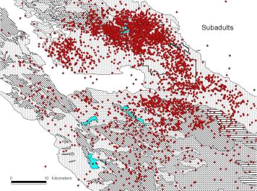

Figure 13. Relocations of Subadults
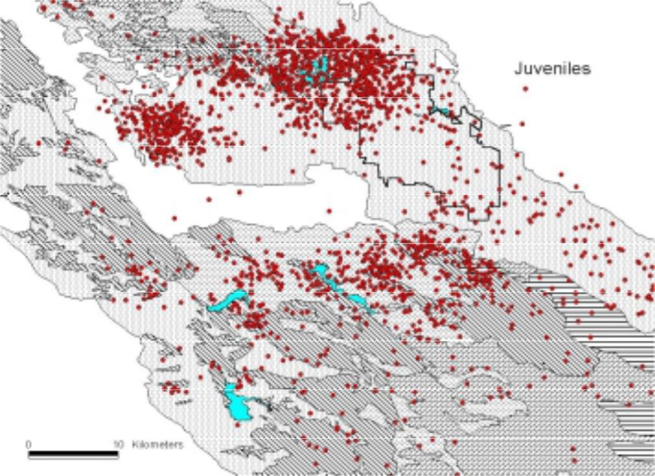

Figure 14. Relocations of Juveniles

25

Table 3. Wind Turbine Configurations Responsible for killing 42 Radio-Tagged Golden Eagles in the WRA

(See Appendix I, Table 3.)

Type |  | Turbine | kW | Rotor | Tower | Height | Approx. | Fatalities
 |  | Turbine | kW | Dia. (ft.) | Tower | (ft.) | Number | Fatalities
4 |  | Micon | 60 | 52' | tubular | 60 | 219 | 1
5 |  | Nordtank | 65 | 52' | tubular | 80 | 312 | 2
8 |  | Dangren Vind/Kraft Bonus | 150 | 76' | tubular | 80 | 100 | 2
8 |  | Dangren Vind/Kraft Bonus | 120 | 63' | tubular | 80 | 230 | 1
13 |  | Kenetech 56-100 | 100 | 59' | lattice | 60 | 2997 | 27
23 |  | Kenetech 56-100 | 100 | 59' | lattice | 140 | 195 | 1
13 or | 23 | -- | -- | -- | -- | -- |  | 1
12 or | 13 | -- | -- | -- | -- | -- |  | 1
8 or | 9 | -- | -- | -- | -- | -- |  | 1
Unknown |  | -- | -- | -- | -- | -- |  | 5

Table 4 summarizes our calculations of polygon areas, the numbers of turbines they contained, and the overall number of subadult/floater relocations falling within polygon boundaries. We find that turbine and relocation densities are somewhat comparable between the two sets of polygons (84.3 percent and 84.8 percent parity, respectively), whereas the fatality distribution is highly disproportionate (Χ 2=6.3, d.f.=1, p=0.010). This suggests that eagle distribution is not the sole predictor of blade-strike risk, and that the areas occupied by Type-13 may be more dangerous to eagles than those of other turbines.

Table 4. Densities (km²) of Turbine Types versus the Densities of Subadult/Floater Relocations and Blade-Strike Fatalities in the WRA
(See Table 3 and Figure 15.)

 | Polygons Containing
 | Type-13 | All Other Turbines
Area (km²) | 62.3 | 40.9
Turbines | 3460 | 1917
Turbine Density (per km²) | 55.5 | 46.9
Relocations | 588 | 455
Relocation Density (per km²) | 9.4 | 11.1
Fatalities | 30 | 7
Fatality Density (per km²) | 0.5 | 0.2

There is bias in these calculations to the extent that the distribution of radio-tagged eagles recorded since the beginning of the study cannot be expected to correspond very well with the distribution of eagles around the time of each fatality. To overcome this, we plotted the distribution within the WRA of 21 eagles killed within the Type-13 area. We then plotted the relocations of those corresponding samples of subadult/floater relocations during the four-

26

month period prior to each fatality that were sufficient in number to provide a ratio of relocations between the two arrays of turbine-specific polygons. Figure 16 provides an example by showing the data layout for one of these eagles, and Table 5 summarizes the results of all 21 comparisons. Note in the table that there is no suggestion of greater use by eagles of the Type-13 areas versus those occupied by other types of turbines. In the months prior to fatalities, relocation density, on average, was actually lower in the Type-13 polygons (median=44.7 percent, mean=44.2 percent) than the others. If these data represent the behavior of eagles comprising the larger sample of 30 fatalities in the Type-13 areas, we would again conclude that conditions there are more hazardous to eagles than conditions in areas occupied by other types of turbines.
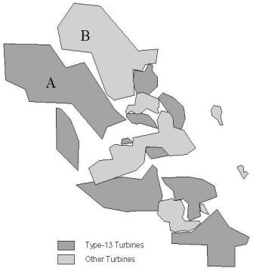

Figure 15. These two sets of polygons enclose the areas containing Type -13 turbines (totaling 62.3 km²) versus those containing only other types of turbines (40.9 km²) occurring within the WRA (see text)

Focusing on the entire northern section of the WRA, note in Figure 11, Figure 12, Figure 13, and Figure 14 the high density of subadult and floater relocations there, and then in Figure 10 that the great majority of fatalities lie within the region of lattice (principally Type-13) turbines, while only a few are within the comparable area of other turbines to the northeast. These two adjacent regions are represented in Figure 15 by the two largest polygons (labeled A and B), together containing 71 percent of all WRA relocations. Overall, we find that the Type-13

27

polygon (Polygon-A, 24.4 km2) contained 358 relocations, a density over time of 14.7 relocations per km2, whereas the area of other turbines Polygon-B, 21.7 km2) contained 455 relocations, a density of 21.0 relocations per km2. Polygon-A had a higher density of turbines, i.e., there were 47.2 turbines per km2 as compared with 27.1 per km2 in Polygon-B (Figure 17). Whereas these comparisons can be regarded as pseudoreplicative to the extent that the relocations of individual eagles are not completely independent, the effect is slight, given the small size and adjacency of the polygons relative to the considerable vagility of these non-territorial eagles (Hunt et al. 1995).

Table 5. Relocation Counts within Areas Containing Type-13 Turbines versus Areas with other Turbine Types as Recorded during the Last Four Months of Life among 21 Subadult and Floater Eagles

 |  |  | Relocations of Subadults and Floaters |  |  |  | Relative
 |  | Lethal | Type-13 | Density | Other | Density | Density in
Fatality | Stage | Turbine | Area | (km2) | Area | (km2) | Type-13 Area
55M51 | sub | Type-13 | 6 | 0.096 | 14 | 0.342 | 22.0%
97F92 | sub | Type-13 | 19 | 0.305 | 28 | 0.685 | 30.8%
55M54 | floater | Type-13 | 23 | 0.369 | 33 | 0.807 | 31.4%
88M111 | juv | Type-13 | 23 | 0.369 | 33 | 0.807 | 31.4%
66M85 | sub | Type-13 or -23 | 27 | 0.433 | 38 | 0.929 | 31.8%
52M34 | sub | Type-13 | 42 | 0.674 | 53 | 1.296 | 34.2%
51F46 | floater | Type-12 or -13 | 33 | 0.530 | 33 | 0.807 | 39.6%
5AM41 | floater | Type-13 | 66 | 1.059 | 62 | 1.516 | 41.1%
51M68 | floater | Type-23 | 66 | 1.059 | 62 | 1.516 | 41.1%
52M38 | floater | Type-13 | 11 | 0.177 | 10 | 0.244 | 41.9%
42M03 | sub | Type-13 | 16 | 0.257 | 13 | 0.318 | 44.7%
44M28 | sub | Type-13 | 82 | 1.316 | 64 | 1.565 | 45.7%
42M02 | sub | Type-13 | 74 | 1.188 | 57 | 1.394 | 46.0%
53M39 | sub | Type-13 | 78 | 1.252 | 57 | 1.394 | 47.3%
44F16 | sub | Type-13 | 26 | 0.417 | 15 | 0.367 | 53.2%
44M27 | sub | Type-13 | 74 | 1.188 | 41 | 1.002 | 54.2%
44F22 | sub | Type-13 | 90 | 1.445 | 46 | 1.125 | 56.2%
64F50 | sub | Type-13 | 90 | 1.445 | 46 | 1.125 | 56.2%
41F08 | sub | Type-13 | 32 | 0.514 | 16 | 0.391 | 56.8%
44M19 | sub | Type-13 | 79 | 1.268 | 35 | 0.856 | 59.7%
44F19 | sub | Type-13 | 64 | 1.027 | 24 | 0.587 | 63.6%

We recorded 19 blade-strike deaths in Polygon-A and only two in Polygon-B. Deaths in Polygon-A included one attributable to a Type-23. The latter, of which there are some 66 machines, representing only 1.9 percent of the turbines in Polygon-A, has the same generator and blades as Type-13 but is situated on a 43-meter lattice tower, rather than the 18-meter tower characteristic of Type-13. Type-23s are virtually always placed parallel and adjacent to Type-13s in a windwall configuration (Figure 18). Polygon-A contains seven windwalls, three of which were associated with eagle fatalities. Table 6 provides data on the relocations of 12 eagles killed in Polygon-A for which subadult/floater relocation samples during the four months prior to each death were sufficient to construct area-use ratios. Again, we calculate a higher average density of relocations in Polygon-B and a higher number of deaths in Polygon-A.

28

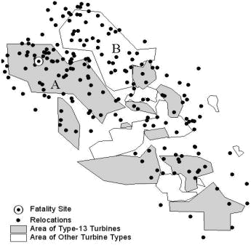

Figure 16. Relocations of Radio-Tagged Subadults and Floaters in the WRA during the Four Months Preceding the Death of Subadult No. 52M27 This example is one of 21 such comparisons.

3.5. Are the Type-13 Turbines in the WRA Particularly Dangerous to Eagles?

Circumstantial evidence presented thus far in our analysis offers grounds for suspecting that Type-13 may be more lethal to eagles than the other turbines, albeit certain types within the latter category might have been suspect were their numbers and the overall sample of fatalities greater. At present, we must ask what features, besides their abundance, distinguish Type-13s from the aggregate of other types and, in particular what features might explain a higher degree of lethality, if such is the case. Our data, being specific to conditions within the WRA, necessarily reflect its peculiarities, and so we must consider that other factors besides the configuration of the turbine itself may contribute to, or even solely account for, its lethality, i.e., we must also acknowledge the possible role of turbine spacing and that of environmental differences between areas containing differing types of turbines.

29
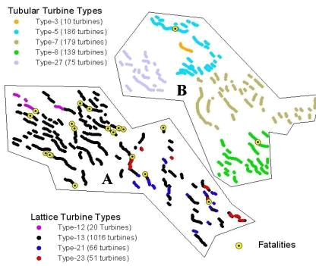

Figure 17. These Two Polygons in the Northern Region of the WRA are the Largest of those Depicted in Figure 19

Polygon-A contains only lattice tower turbines (n=1153), 88 percent of which are of the Type-13 configuration. Polygon-B contains only tubular tower turbines (n=589).

3.5.1. Tower-Height

The Type-13 turbine is positioned on an 18.3-meter tower, shorter than most tubular turbines, 90.5 percent of which are on 24.4-meter structures. Of the 821 lattice turbines other than the 2997 Type-13s, only 33 are on shorter (13.7 m) towers, whereas 171 are on towers of equal size (18.3 m), 422 are on 24.4-meter towers, and 195 are on 42.7-meter towers. Thus, considering that Type-13 turbine towers are shorter than 85 percent of all other towers in the WRA, we should consider whether turbines on short towers might be inherently more lethal than those on taller ones.

30
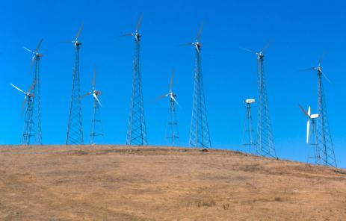

Figure 18. A Windwall consisting of a Row Type-13 Turbines and another row of the Taller Type-23 Turbines (photo by Daniel Driscoll)

Table 6. Twelve Golden Eagle Blade-Strike Fatalities that occurred in Polygon -A, together with Counts of Subadult and Floater Relocations occurring within the Previous Four Months in both Polygon-A and Polygon-B (See text)

 |  | Subadult and Floater Relocations |  |  |  | Relative Density
Fatality | Lethal Turbine | Area A | Density A | Area B | Density B | in Area A
55M54 | Type-13 | 11 | 0.451 | 28 | 1.290 | 25.9%
88M111 | Type-13 | 11 | 0.451 | 28 | 1.290 | 25.9%
97F92 | Type-13 | 10 | 0.410 | 25 | 1.152 | 26.2%
66M85 | Type-13 or -23 | 15 | 0.615 | 32 | 1.475 | 29.4%
51F46 | Type-12 or -13 | 17 | 0.697 | 29 | 1.336 | 34.3%
51M68 | Type-23 | 33 | 1.352 | 54 | 2.488 | 35.2%
42M02 | Type-13 | 45 | 1.844 | 48 | 2.212 | 45.5%
44M28 | Type-13 | 47 | 1.926 | 49 | 2.258 | 46.0%
53M39 | Type-13 | 46 | 1.885 | 45 | 2.074 | 47.6%
44M27 | Type-13 | 45 | 1.844 | 33 | 1.521 | 54.8%
44F22 | Type-13 | 57 | 2.336 | 39 | 1.797 | 56.5%
44F19 | Type-13 | 42 | 1.721 | 23 | 1.060 | 61.9%
 |  |  | 31

Our observations in the WRA and elsewhere in the study area confirm that contour hunting is the principal mode by which golden eagles hunt ground squirrels. This well-known behavior involves flying or gliding very low over the ground (1-5 m), often over considerable distances, hugging the terrain and concealing their approach so as to surprise unsuspecting squirrels at close quarters (Carnie 1954, Bergo 1987, Dekker 1985, Watson 1997). Eagles approaching prey may sometimes use fences and other overt objects to hide their approach (Dixon 1937). Golden eagles are particularly apt to contour hunt during windy conditions (Dekker 1985), and in a sample of 41 hunting flights observed in the WRA in spring 1994, 34 (83 percent) were contour hunts (Hunt et al. 1995). Eight of these ended in attempts to seize prey, four of which were successful. Contour hunts may originate from soaring flight, from elevated perches or from the ground. In a sample of 94 sightings of perched eagles in the WRA, 33 (35 percent) were on the ground and 61 (65 percent) were on elevated perches.

Consequently, golden eagles in the WRA are often very close to the ground, especially when hunting. It follows that eagles may occasionally attempt to pass low under the spinning blades of turbines, and although we have not observed this, we should consider the space available for this maneuver. We calculate that the blades of Type-13 pass within about 9.3 meters of the ground. Only 125 (5.4 percent) of 2304 other turbines (for which we have data) have blades that pass closer to the ground than those of Type-13. Of the remainder, 918 (40 percent) pass within 11-15 meters and 1336 (58 percent) more than 15 meters from the ground (Appendix I). While, at most approach angles, the position of the tower likely prevents an eagle from passing below the lowest point of the rotor, the Type-13 turbine is nonetheless among the most likely of turbines in the WRA to strike a low-flying eagle.

3.5.2. Tower Spacing

We observed golden eagles occasionally flying between turbines within a turbine string, a factor suggesting an examination of their spacing. Spacing, though not a property of the turbine itself, may be a component of eagle mortality. Let us examine to what extent the spacing of Type-13 turbines differs from that of other turbines in the WRA.

Using GIS, we measured the distance in meters between 912 Type-13 turbines within 88 strings in Polygon-A. The median distance between them was 25.3 meters (mean=27.1, S.D.=3.9). Likewise, we measured distances between 589 tubular turbines in 100 strings in polygon-B, representing five types. The median spacing was 47.0 meters (mean=48.4, S.D.=13.9). All five types of turbines in Polygon-B were more widely spaced than the Type-13s: the measurements included 10 Type-3s (median spacing=57.3 m), 186 Type-5s (31.8 m), 179 Type-7s (56.6 m), 139 Type-8s (Bonus Mark-150) (41.4 m), and 75 Type-27s (57.5 m) (Appendix I).

The relevant measure of risk to a golden eagle trying to fly between turbines is the distance between the spinning blades rather than the distance between turbine towers. The rotor diameter of Type-13 is 18 meters (59 feet rather than 56 feet as sometimes reported), meaning that the rotor tips of two adjacent, wind-aligned turbines are roughly 18 meters closer together than the vertical centerlines of their towers. Under such conditions, the interblade distance between two Type-13s in Polygon-A is about 7.3 meters. Considering that the wingspan of a female golden eagle is about 2.1 meters (Watson 1997), the distance between blade and wingtip of an eagle flying exactly between two adjacent, wind-aligned rotors of average spacing is 2.6 meters. For the four tubular turbine types we measured in Polygon-B, the average blade-to-

32

wingtip distances would be 5.9 meters (Type-5), 7.0 meters (Type-8), 10.8 meters (Type-27), and 13.7 meters (Type-7), spacing ranging from over twice to more than five times the average of Type-13 clearance.

We measured the spacing from 27 Type-13 turbines that killed radio-tagged eagles to the nearest neighbor turbines in the string. Five (18.5 percent) of the lethal turbines were at the ends of rows (Orloff and Flannery 1992), meaning that the eagle may have been on the outside of the string rather than between turbines when the strike occurred. Of the remainder, nine (33 percent) were killed by the second turbine, two (7.4 percent) by the third, one (3.2 percent) by the fourth, and 10 (37 percent) in the central region (5th to 21st position) of the string. Excluding the five end-of-row kills, we found no difference between a sample of 44 space measurements between lethal Type-13 turbines and adjacent turbines and a sample of 471 spaces between Type-13 turbines that did not kill tagged eagles (t-test, p=0.579). As a matter of interest, the mean number of Type-13 turbines in strings where fatalities occurred was 20.6 (SD=11.4 turbines, range 8-48), as compared with 9.0 for all other Type-13 strings occurring in Polygon-A (SD=7.1, range=2-48) (t-test, p=0.010).

3.5.3. Wind and Terrain

We may conclude from the foregoing that an eagle trying to pass under or through a typical Type-13 turbine string must do so with precision. Strong winds in areas of steep terrain may present additional problems for eagles attempting to negotiate wind turbines. Consider a string of turbines along the top of a ridge, the latter oriented at a right angle to the direction of the wind. A low-flying eagle approaching fast from upwind first encounters an updraft, but as the ridge levels out, downdrafts and turbulence develop, factors that strongly reduce flight control. Even in more gentle terrain, deflected wind almost always produces near-ground turbulence, but all other things being equal, the steeper the terrain, the stronger are the forces affecting eagle flight.

As an example of terrain effects, we quote from the field notes of PBRG biologist Daniel Driscoll:

“22 April….Wind 35-40 mph from the west…1000 hrs. Pigeons, red-tails, and

gulls … having trouble flying in this wind …flying very low to the ground, and when they crest a ridge, the updraft pushes them skyward out of control…1321 hrs. I observed a red-tail flying into the wind above turbine row 4286-4294… was grounded below a powerline, then when it lifted from the ground, it was thrown up and nearly struck the line [being blown]sideways… 1422 hrs. Subadult golden [eagle] slowly slope-soaring [westward] into the wind below [downslope of] turbine row 2950-2972. The eagle appeared to be having difficulty [flying] and was being harassed by a red-tail… [the eagle] was hit by a gust of wind [as it crested the next ridge] and shot up [being blown backwards], just missing the blades of turbine 2915.” Note that this ridge slopes very steeply westward some 400 feet to a canyon bottom.

With GIS software, we calculated an index of the overall degree of terrain steepness within Polygon-A (n=19 blade-strike fatalities) and Polygon-B (n=2 fatalities) by measuring contour line density. We began by extending twelve equally-spaced lines from the approximate center

33

of each polygon in a directional rose toward the edges of the polygon. We then counted the number of 20-foot contour intervals encountered by each line and measured line length in kilometers. Our results showed Polygon-A with 29.9 contour-line crossings per kilometer (911 crossings in 30.44 linear km) and Polygon-B with 25.3 per kilometer (756 crossings in 29.92 km). This difference reflects only a 15.6 percent disparity in the relief index between the two polygons.

Figure 19 focuses on a 15 km2 circle containing 16 of the 19 blade-strike kills in Polygon-A. Note that four turbine strings killed ten (62 percent) of the 16 tagged eagles and that five eagles in the eastern quadrant died within a radius of only about 250 meters. We cannot speculate on why these kill sites are so distributed, but no consistent relationship with distinctive terrain features is apparent, nor is the distribution of kills associated with high eagle relocation densities that might suggest, for example, corresponding prey concentrations.

3.5.4. Tower Perchability

It has been proposed that lattice tower turbines like Type-13 are more perilous to eagles than those on tubular towers because eagles can perch more easily on the former. Indeed, in our experience, eagles often perch on lattice towers and only rarely on tubular towers. From May through November 1994 we conducted weekly road surveys of the entire WRA to determine the extent of perching on wind turbines (Hunt et al. 1995). We recorded 23 incidents of eagles perching on lattice towers, 17 (74 percent) of which were Type-13 turbines, and none on tubular towers. Similarly, of 651 observations of red-tailed hawks perched on turbine towers, 633 (97 percent) were on lattice towers, 513 (79 percent) of which were Type-13s. Of the remaining 18 perchings (three percent of total), 14 hawks perched on the rail cages of non-functional tubular turbines (Type-16), three on Type-9 (vertical axis turbines), and one on a Type-4 tubular tower turbine. These data only partly reflect the greater abundance of lattice towers in the WRA. We constructed perchability indices for both species based on the total numbers of perchings and types of turbine towers surveyed. The results showed that both species conspicuously avoided perching on the 723 tubular tower turbines in our survey (Hunt et al. 1995).

Golden eagles and red-tailed hawks appeared to avoid perching on the towers of spinning turbines. In the only observed instance involving an eagle, the latter had perched on the third cross-member (half-way up the tower) of an end-of-row turbine that was not operating. The turbine powered-up and reached operating speed before the eagle dropped off, flying beneath the arc of the blades. Only 15 (2 percent) of 651 red-tailed hawks were observed perched on operating turbines (Hunt et al. 1995).

One attractive hypothesis that perchable towers present increased risk involves the idea that eagles may grow accustomed to them during the days of little or no wind characteristic of fall and winter. Eagles may thus fail to appropriately regard them as dangerous when the blades begin spinning on windy days. Indeed, the perception of danger is illusive because death or debilitating injury are virtually the only avenues of negative reinforcement, i.e., there is no way to learn. At this time, the question of whether these considerations are factors in eagle mortality remains unanswered.

34

3.6. Eagles and Ground Squirrels in the WRA

The large size and conspicuousness of both golden eagles and their prey in the open landscape of the WRA made it relatively easy to ascertain which prey species were most important. Numerous field observations of foraging eagles and examination of prey remains (Hunt et al. 1995) quickly led us to conclude that California ground squirrels were the principal prey of golden eagles in and around the WRA during the period of our investigation. Although eagles preyed to some extent on jackrabbits and cottontails, and these may be expected to increase in importance in some years, we hypothesize that the occurrence and distribution of golden eagles in the WRA during the years of our study mainly correlated with the occurrence and distribution of ground squirrels.
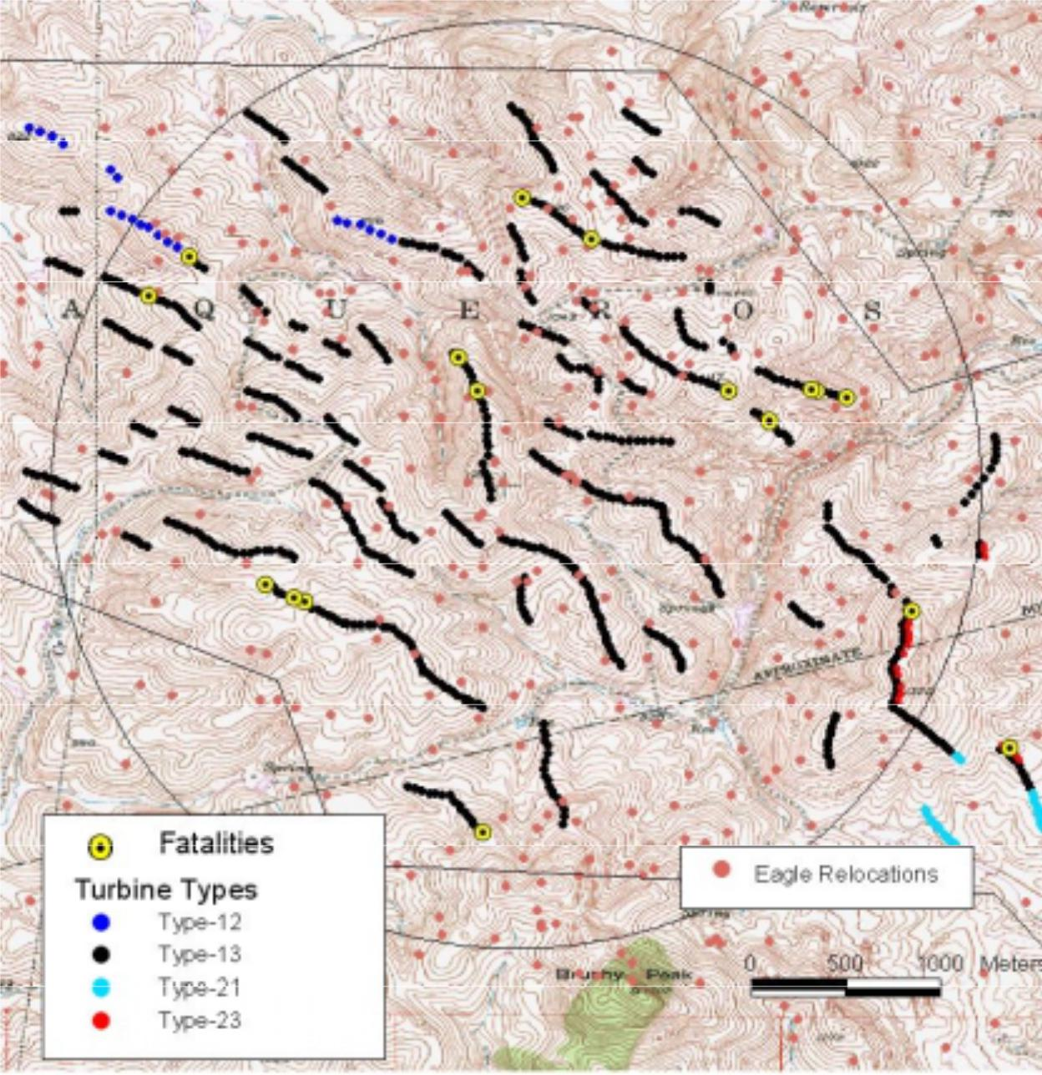

Figure 19. A 15 km² circle containing 16 of the 19 blade-strike kills in Polygon-A

35

To test this, we first examined the eagle relocation data to determine whether gross changes in eagle distribution had taken place in the WRA. Table 7 suggests that the proportional distribution of relocations of subadults and floaters in the northern (108 km2) versus the southern (51 km2) section of the WRA (north and south of Interstate 580) did indeed change over the years of our study. Note that the percentages of relocations in the southern portion of the WRA diminished during the 1996-1997 period. The difference between individual eagle use of the southern portion of the WRA in 1994-1995 (n=47 individuals, mean proportional use = 0.27) versus 1996-1997 (n= 72, mean use = 0.16) was significant (t-test, p=0.03), although a comparison between 1996-1997 and 1998-2000 (n=47, mean use = 0.21) was not (p=0.19).\

Table 7. Changes in the Proportion of Subadult and Floater Relocations in the Northern and Southern Areas of the WRA (North and South of Interstate 580)

 |  | Eagle Relocations |  |  | Turbine Kills
Year | North | South | % in South | North | South | % in South
1994-1995 | 284 | 84 | 22.8% | 3 | 1 | 25%
1996-1997 | 631 | 96 | 13.2% | 16 | 1 | 6%
1998-1999 | 149 | 34 | 18.6% | 12 | 1 | 8%
2000-2001 | 92 | 44 | 32.4% | 4 | 3 | 43%

Wondering if these differences might be related to ground squirrel densities, we visited two large ranches on June 4, 1997, one in the northern and one in the southern section of the WRA. Beginning at 1248 hrs.(cloudy, temperature 71-76 degrees F), we conducted a 22-minute visual survey for ground squirrels on all major roads of a 12.6 km2 ranch south of Patterson Pass Road and observed one ground squirrel. We quickly traveled to a 3.7 km2 ranch in the north zone and, beginning our survey at 1330 hrs, we counted 136 ground squirrels in 21 minutes (partly cloudy, temperature 71-74 degrees F). Subadult/floater relocations within the boundaries of the southern ranch during the ten months prior to the survey totaled four (0.3 relocations per km2), as compared with 26 relocations (7 per km2) on the northern ranch. The manager of the southern ranch explained that a ground squirrel control program normally in place had lapsed in 1994, but had been resumed in late summer 1995.

Encouraged by these observations, we conducted a visual survey of ground squirrels in the area administered by Kenetech Windpower, Inc., comprising about one-half of the WRA. Green Ridge Services provided funding for the survey, conducted over a 13-day period in mid-June. Two teams, each with two persons, counted ground squirrels by driving all accessible roads at 10-15 mph during periods of highest above-ground activity i.e., in the morning (once sunlight was upon burrows) and early evening (after midday temperature declined), and only when temperatures remained below 32.2°C (Appendix II). The purpose of the survey was not to estimate the numbers of ground squirrels present, but to identify areas within the WRA containing high and low ground squirrel densities.

We began by surveying the entire area twice. Each survey segment was then categorized as containing high, moderate, or low numbers of ground squirrels, while areas of poor visibility, e.g., due to high, dense vegetation, were excluded from categorization. We defined high-density areas as those where more than 12 ground squirrels were counted per 0.3 mile, and low-density areas as those with less than three seen per 0.3 mile. We repeated surveys (3-5 repetitions) in

36

segments scored as medium-density and some in low-density segments to validate designations. For example, a high-density population might have initially been scored at a lower value because an unseen disturbance (predator, car) prior to our arrival caused squirrels to go into burrows. Thus, we based final determinations on the highest numbers observed, irrespective of a lower count on a different day.

From ground squirrel survey data, we identified five ranches of high squirrel density and four of low density (Figure 20). In gross data on subadult/floater eagle relocations (n=39 eagles) during the 10-month period prior to the surveys, there were 3.5 relocations per km2 on ranches scoring high in ground squirrel density (93 relocations in 26.5 km2) and 0.51 per km2 on the low density ranches (14 in 27.6 km2), a ratio of seven to one. Note in Figure 20 that areas with medium density scores showed intermediate relocation densities (2.2 per km2). To correct for pseudoreplication, we compared the relocation frequencies among each of 38 eagles visiting the high- and low-scoring ranches (relocations weighted for the slight difference in ranch areas) and found that 33 (87 percent) favored the ranches with high squirrel density (Χ 2=19.1, d.f.=1, p=0.0001).

We learned that the distribution of ground squirrels within the WRA has largely to do with whether or not ranchers control their numbers, a practice occurring throughout the pastoral and agricultural regions of California (Alameda County Agriculture Department). The principal control method involves either broadcasting or setting up bait stations of grain laced with the anticoagulants diphacinone and chlorophacinone. The Alameda County Agriculture Department and those of many other counties within California’s central valley region have voluntary programs in place for ranchers who wish to control ground squirrels on their lands. Ranchers in Alameda County may receive poison grain from the county for a 50-cent per pound surcharge which supports research on ground squirrels and control methods. The county maintains records of the quantity of grain received annually by each rancher. The ranchers may broadcast the grain themselves, although the county also offers this service. The grain is scattered over the entire ranch, or in selected areas of squirrel abundance, with a subsequent survey to determine effectiveness.

According to Jim Smith (Alameda County Agriculture Department), the county was not highly involved in ground squirrel control on the WRA until the summer of 1996, when rancher awareness of the control program became widespread. In summer 1997, Kenetech, working with Alameda County, initiated a ground squirrel control program on the WRA to assure uniformity of treatment and broad-based rancher participation (Kerlinger and Curry 1997b, Curry and Kerlinger 1998). Since then, the county control agent has regularly treated many ranches within the WRA, although there are large areas of the WRA not included in the program, including the Los Vaqueros watershed extending into the northwest portion of the WRA. Overall, the Department distributes an average of about 42 tons of treated grain annually throughout the county (Jim Smith, Alameda County Agriculture Department, pers. comm.).

Expecting an inverse relationship between the history of rodenticide use and our squirrel density surveys, we consulted the county agriculture departments who provided data on the amount of rodenticide acquired by each ranch in the WRA from 1990-99. Inferring that these purchases reflected use levels, we categorized the ranches based on number of assumed treatments from 1994-1997 as (1) not treated consistently (0-2 years of treatment), and (2) treated

37

consistently (three or more years of treatment). The distributions of ground squirrel density scores (Figure 20) corresponded with the distributions of ranches within these categorical designations as follows: 93.2 percent of the area of high squirrel density was within Category 1, and none in Category 2, whereas 98.5 percent of the area of low squirrel scores was within Category 2.
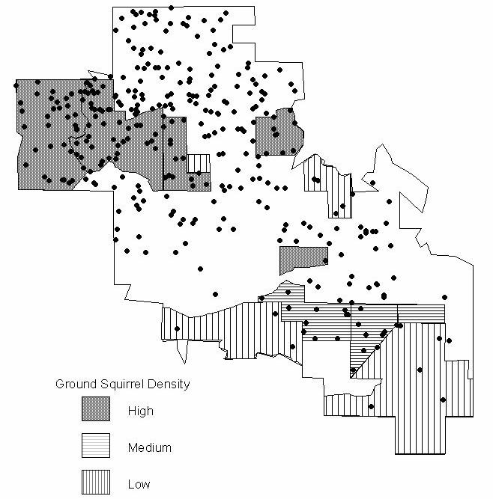

Figure 20. Eagle Relocations in Areas of Differing Ground Squirrel Densities as

Estimated from Road Surveys

Relocations are those of subadults and floaters during the ten month period prior to the ground squirrel survey. Undelineated regions of the WRA (in white) were those either not surveyed (outside Kenetech area) or areas of poor visibility or access, the latter comprising ca. 16.3 km² (10.2 percent of total area).

3.7. Eagle Population Trend

Our final report to NREL, completed in early 1998, was directed solely toward analyzing the extent to which wind turbines at the WRA were affecting the trend of the golden eagle population inhabiting the surrounding region. Included in the analyses were our estimates of

- the reproductive rate, as based on annual surveys of the nesting population, (2) survival rates of juveniles, subadults, floaters, and breeders, as obtained from radio-tagging and aerial surveys, and (3) the rate at which floaters became breeders.

38

3.7.1. The Alpha Model

The last-mentioned parameter was required for a trend analysis model developed especially for our project by a team of researchers at Colorado State University at Fort Collins (CSU) under separate support and direction from NREL (Shenk et al 1996, Franklin et al. 1998). The equations of the Alpha Model (Model #1 in Hunt et al. 1999), solved by matrix algebra, described the eagle life cycle in a graph of transition probabilities from one life-stage to another. This model was intended to produce an estimate of the annual rate of population change (λ ). According to its authors, “…λ =1 indicates a stationary population, λ >1 an increasing population, and λ <1 a decreasing population” (Franklin et al. 1998). The Alpha Model, when supplied with data we obtained during 1994-1997, yielded a λ estimate of 0.9068 (SE=0.0322). The 95 percent confidence interval of this estimate (0.8437 - 0.9699) did not include λ =1.0, the minimum value for stability (see below). This meant that, if the model and its assumptions were valid, the population was declining during the period of our study, and if the point estimate for

- was correct, the decline rate was 9.3 percent per annum, an alarming value.

We have since determined that the Alpha Model is fundamentally flawed and therefore invalid. We first observe that the model, typical of Leslie matrix projections, requires that none of its parameters vary over time, a condition that would, in standard models, produce a stable age distribution regardless of population trend. However, one of the parameters of the Alpha Model cannot remain constant in the presence of floaters unless the population is at Moffat’s equilibrium (Hunt 1998, Hunt and Law 2000, and see below). This parameter is α , the floater-to-breeder transition rate.

Using an idealized scenario to explain our reasoning, consider a remote island where there is nowhere else to go and only ten places to nest. Each nest is occupied by a pair of adult eagles who produce, on average, one fledgling per year or, collectively, an annual cohort of ten for the entire island. Natural attrition allows only 5 of these to survive the four-and-one-half years to adulthood. Two (10 percent) of the 20 breeders die annually, although a few live as long as 20 years. This means that only two vacancies are available each year for occupancy by the accumulating contingent of nonbreeding adults. However, these do not continue to increase indefinitely because 20 years after all sites are filled, the annual loss comes to match the annual gain, and the population is at Moffat’s equilibrium (Hunt 1998). If survival and reproductive rates remain constant, our island population will stabilize at 42 adults and 31 younger eagles at fledging time. As usual, twenty of the adults will be breeders, but 22 will be floaters, unable to obtain a territory until a vacancy appears. In this idealized example of Moffat’s equilibrium where vital rates remain constant over time, the proportions of age- and stage-classes will themselves remain constant from year to year.

Note that α is unnecessary in the formulation of Moffat’s equilibrium, although the value of α can be easily calculated from the equilibrium number of floaters and the proportion acquiring breeding sites. We must therefore conclude, in this instance that α is not an independent parameter, but rather is determined entirely by the other parameters of the model.

Let us now suppose that our island, where the eagles have for many years been at equilibrium, has acquired through human misadventure a destructive pesticide that attacks eagle eggs to the extent that the annual cohort of fledglings is reduced by 70 percent, i.e., only three appear each spring. If this new reproductive rate remains constant, the population declines at an initial rate

39

of about 16 percent per year (λ =0.84), annually losing a few floaters (some to the breeding segment and some to mortality) until the supply runs out about 14 years after the change in the reproduction. In, say, the fifth year of decline, two of 20 floaters (10 percent) acquire a territory, but by the tenth year, two of only seven remaining floaters (29 percent) so transition (Figure 21).

Individuals

80

70
60

50

40

30

20

10

0

Juveniles

Subadults

Floaters

Breeders

0 | 3 | 6 | 9 | 2 | 15 | 18 | 21 | 24 | 7 | 30 | 33 | 36 | 9 | 42 | 5 | 48 | 1 | 54 | 7 | 60 | 3 | 66 | 9 | 72 | 75 | 78 | 81 | 84 | 87 | 90 | 93 | 96 | 99
 |  |  |  | 1 |  |  |  |  | 2 | 30 | 33 | 36 | 3 | 42 | 4 | 48 | 5 | 54 | 5 | 60 | 6 | 66 | 6

Years

Figure 21. In a Hypothetical Population Declining from Moffat’s Equilibrium, the Breeding Segment is Exposed to Decline only after the Loss of the Floating Segment

Obviously, α fails to remain constant in either a declining or an increasing population when floaters are present. The Alpha Model incorporates α , even though, by the nature of the model’s mathematics, parameter constancy over time is both assumed and required. A projection from the matrix model based on a particular “snapshot” value of α discounts any further adjustment that true α may make in response to changes in the floater-to-breeder ratio. By placing α within the mathematical context of fixed parameters that effect rather than respond to population change, the Alpha Model is intractable and must be discarded.

3.7.2. A Better Trend Model

A healthy population at Moffat’s equilibrium maintains a supply of floaters that buffers the breeding segment against decline. Our island scenario demonstrates that floaters accumulate in populations where (1) breeding opportunities are limited and (2) reproduction and/or survival are robust. The first of these criteria most assuredly applies to the nesting population of golden eagles in the Diablo Mountains where almost every territory known occupied in one year has remained occupied the next, where vacancies arising from breeder deaths have been immediately filled, and where a tightly-packed mosaic of nesting territories in favorable habitat remains virtually constant in structure from year to year (Hunt et al. 1999).

However, the second criterion, that of robust vital rates, cannot be satisfied on the basis of having recently observed floaters, because these may, in reality, be in gradual, collective decline (Figure 21) or may have arrived as immigrants from outside the study area. The question we ask, therefore, is whether the studied population is self sustaining, i.e., whether reproduction and survival are sufficient to generate more adults than there are places for them to nest. If this is not the case, the eagle population is either in decline (λ <1) or poised (if at equilibrium) at its brink (λ =1), although the second of these alternatives has an important exception we shall soon discuss.

40

It follows that the model we are looking for is one that can distinguish between λ >1 and λ <1 by estimating the growth potential (λ p), i.e., a model that assumes territory acquisition by all maturing eagles. This model is a standard age-based growth model (Model #2 of Franklin et al. 1998) as proposed by PBRG as an alternative to the Alpha Model and discussed by Hunt et al. (1999). As in our island example, parameters include the reproductive rate and the survival rates of juveniles, subadults, and breeders. If these parameters remain constant at all stages of growth or decline, any value for λ p exceeding 1.0 will predict a current or eventual population at Moffat’s equilibrium, and we will then switch to an alternative model to estimate its stable stage distribution (Hunt 1998, Hunt et al. 1999, Hunt and Law, unpublished manuscript). λ p <1, on the other hand, predicts that the supply of floaters will be exhausted (without immigration), and at that point, both α and floater survival (f) become moot as model parameters. We therefore maintain that the correct way of estimating λ p is to ignore both of them, i.e., why wait to dispense with α and f in a declining population when their demise is inevitable? This leaves a model with fewer parameters than the Alpha Model, and we can therefore expect a more precise estimate of population trend, considering that the variance of every parameter adds to the variance of the model estimate (Appendix III).

3.7.3. Survival Estimates

The additional samples of radio-tagged eagles and continued aerial monitoring during 1998-2000 increased the precision of survival estimates and slightly altered their values from those reported by Hunt et al. (1999). For the latter study, the CSU team used Program Mark (White and Burnham 1999) to select the most parsimonious groupings of life-stages and sexes from which to calculate Kaplan-Meier survival estimates. The solution was a pooling of data from juveniles, subadults, and floaters of both sexes to produce a single estimate of annual survival for non-territorial eagles at 0.7867 (SE=0.0263). The estimate for territory-holders (breeders) was 0.8964 (SE=0.0371). In calculating estimates for the current study, which considers all data collected back through 1994, we departed from the CSU grouping in one respect: we considered juveniles separately. We did so because of differences between their lifestyle and that of older eagles (Section 3.2.1) and because the mortality regime for juveniles in our study area is also quite different, i.e., they are rarely killed by wind turbines (Table 2). The new Kaplan-Meier survival estimates are as follows: juveniles = 0.8397 (SE=0.0367), subadults/floaters = 0.7944 (SE=0.0215), and breeders = 0.9087 (SE=0.0246).

3.7.4. Estimate of Reproduction

The current study adds two additional years of data with which to calculate a natality estimate (Table 8). Even though the overall sample of years remains small, these new values reveal greater natural variation than previously observed, i.e., a comparatively high reproductive rate in 1999 (0.90 fledglings per occupied site) and a low one in 2000 (0.46). Parenthetically, 1994 was also a year of high productivity, despite our inability to meet Steenhof’s (1987) criteria for a reproductive estimate (Section 2.0). Both 1994 and 1999 were characterized by a lack of prolonged winter rainfall, a factor we believe influences egg laying, egg survival, and ground squirrel availability (Appendix II).

For modeling purposes, the reproductive estimate of this particular golden eagle population must be tempered by the sex ratio. Measurements of eagles tagged as fledglings have indicated

41

a consistent male bias. During the four years of radio-tagging (1994, 1995, 1996, and 1999), the ratios were 18:13, 13:9, 16:9, and 21:8, the aggregate of 107 fledglings for the years of sampling showing a ratio (proportion of males) of 0.63 (males/both sexes), a significant departure from unity (G=7.96, d.f.=1, p=0.005). The samples of free-ranging, nonterritorial eagles showed a similar preponderance of males. Among the eagles captured for radio-tagging in the current study were 34 males and 20 females (0.61 males), and in previous years, the ratio was 42 males and 27 females (.63 males), the pooled samples significantly departing from 1:1 (G=6.90, d.f.=1, p=0.009). The fact that the ratios calculated for fledglings and free-ranging eagles were almost identical gives support to earlier results in Program MARK detecting no sex bias in overall survival rates (Franklin et al. 1998, Hunt et al. 1999). Note that we cannot attest to the perfect accuracy of the ratios we report for these samples because all these sexing data were obtained from body measurements (e.g., hallux, tarsus, culmen, wing chord, etc). While most of these age-specific measurements are virtually non-overlapping between the sexes, and we used a combination of measurements in each case, blood analysis is the unequivocal method.

Table 8. Results of Golden Eagle Nest Surveys in the Study Area
 | 1994 | 1995 | 1996 | 1997 | 1998 | 1999 | 2000
Pairs surveyed | - | - | 59 | 59 | 64 | 69 | 67
Total young | 47 | 25 | 39 | 35 | 37 | 62 | 31
Young per pair | - | - | 0.66 | 0.59 | 0.58 | 0.90 | 0.46
Broods | 29 | 17 | 27 | 22 | 29 | 40 | 22
Brood size | 1.62 | 1.47 | 1.44 | 1.59 | 1.28 | 1.55 | 1.41
Success rate | - | - | 0.51 | 0.37 | 0.45 | 0.65 | 0.33

The reader, possibly wondering what sex ratio has to do with reproductive rate, may again consider Moffat’s equilibrium. Recall that a healthy population of golden eagles fills all serviceable breeding locations, and that floaters of both sexes fill territory vacancies as they become available. As floater numbers dwindle in a declining population, the sex represented by the least number of floaters is depleted first, at which point the number of occupied territories, no longer buffered by floaters of that sex, begins to decline. In most other studied populations of raptors, females have been in surplus to males thereby rendering males the limiting sex (Ian Newton, pers. comm.), whereas our data imply that females, being fewest among the nonbreeding segment, are the limiting sex among golden eagles in the Diablo Range.

We calculated the overall natality estimate for the model by first averaging the annual number of 8-week-old fledglings per territorial pair (Table 8), and then multiplying by the average proportion of females each year. We calculated the standard error of the estimate by the Delta Method applied to the product of the two variables (Appendix III). The resulting productivity estimate was 0.2313 (SE=0.040) female fledglings per female territory-holder.

3.7.5. The Population Trend Estimate and What it Means

With these data on survival and reproduction, the λ p model projects a potential growth rate of 1.0047 (SE=0.0240, 95 percent CI=0.9577-1.0517), a more encouraging point estimate than that in our previous study where λ p was 0.9880. The current estimate, with its variance easily falling into the alternatives of both increase and decrease, is ambiguous to the extent that it can firmly

42

predict neither Moffat’s equilibrium nor decline (Appendix III). The matrix model overestimates λ p to the extent that it cannot account for finite longevity, i.e., the oldest band-recovered golden eagle in North America was 23 years 10 months, and the oldest two such eagles in Europe were 26 and 32 years (Watson 1997). To test the effect on λ p, we employed an age-based Moffat model that truncated longevity at 25 years and calculated λ p = 0.9982. Again, both these point estimates, being so near 1.0, must remain ambiguous with respect to indicating the direction of population trend.

We observe that λ p=1.0 does not imply stability, the latter being the effect of a floater reserve sufficient to comfortably buffer the breeding segment against decline. As explained above, a true value of λ p=1.0 means that, at equilibrium, the population generates no floater buffer.

However, that does not imply that no internally-generated floaters currently exist in the population, i.e., the model cannot ascertain if the population has so recently declined that it retains a remnant of a formerly robust floating segment. All that can be said is that, if λ p is truly 1.0, the population is unable to maintain a floater buffer and is therefore vulnerable to any decrease in survival or reproduction that might, for example, accompany increasing human development in the landscape.

If, in reality, the population trend is currently negative, an important biological consideration must be taken into account, and that is the likely tendency of adult golden eagles in a reduced population to gravitate toward high quality breeding sites. In a 32-year study of a growing population of a related species, the Spanish imperial eagle (Aquila adalberti), Ferrer and Donozar (1996) found that average annual productivity of all occupied territories decreased as the number of territories increased. The reason for the overall decrease in fecundity was that the original pairs had selected sites in the best habitat, leaving new pairs to settle in those of lower quality (see also Dohndt et al. 1992). If golden eagles are similarly proficient in habitat selection, we would expect per capita productivity to increase in a declining population such that the trend might, at some point, stabilize (λ =1), albeit at lower level. Such a population would contain no floaters and yet be at equilibrium. Hunt and Law (2000) refer to this as the “recruitment wave limit” of site occupancy, a condition that derives from the restricted extent to which sites producing surplus recruits can augment those failing to meet that criterion. The alternative, of course, is the “site-serviceability limit” in which all sites that are adaptively suitable (in the evolutionary sense) are occupied, and floaters accumulate, this limit being the natural state for golden eagles.

To illustrate the effect of breeding site preemption (if our golden eagles are so disposed), let us suppose that the population is declining and that remaining breeders perfectly select those territories yielding the highest numbers of offspring (the “ideal preemptive distribution” of Pulliam and Danielson 1991). In our study area, the upper 50th percentile of breeding sites have produced about 0.39 female fledglings per territorial females as compared with 0.10 for the lower 50th percentile. If the breeding segment in this idealized scenario declined to one half its number but perfectly gravitated to the best sites, then λ p would equal 1.03, a figure that would ordinarily predict a healthy state of Moffat’s equilibrium with 0.62 female floaters per female breeder. Of course, this scenario could not obtain in nature because those hypothetical floaters would be occupying that fringe area of low quality sites describing the recruitment wave limit, and λ p would be 1.0.

43

3.7.6. Is there Evidence of a Decline?

All this discussion leads to the conclusion that a healthy golden eagle population generates adults in excess of those required to fill breeding vacancies. Without floaters, the breeding segment of a population at the recruitment wave limit responds more or less immediately to vital rate changes, while a population at the site-serviceability limit may be comfortably buffered against change by its floater reserve. We must ask, therefore, if there are signs of breeding site saturation and a floating segment.

Our nesting surveys give no indication of a decline in territory occupancy. Only one nesting territory among 59-69 surveyed became vacant, this one close to activity associated with the development of Los Vaqueros Reservoir and both pair members killed by wind turbines within an 8-month period. Otherwise, throughout our study, all surveyed territories found occupied by pairs in one year have remained occupied by pairs in the next, a sign that floaters filled vacancies. Field evidence of rapid mate replacement include the reoccupancy of a territory where both adults died within two months of one another, and several cases where breeders were killed and replaced by floaters. We observed no nesting territories held by lone adults.

A clear sign of a reduced floating segment would be a high incidence of subadults as members of breeding pairs (Newton 1979, Watson 1997). For example, Bergo (1984) recorded a high proportion of subadult pair members in a Norwegian population of golden eagles that he believed was below carrying capacity. In Idaho, Steenhof et al. (1983) observed more subadult golden eagles as pair members when winter adult densities were low and concluded that subadults were less capable than adults of obtaining and holding territories. We are thus encouraged by a low overall 2.9 percent incidence of territory-holding subadults per surveyed pair in our study area over five breeding seasons (1996-2000) and no apparent trend (2.7 percent, 0.0 percent, 3.1 percent, 4.4 percent, and 1.5 percent in the five years, respectively). Were no adults available to fill vacancies, we would expect the incidence of subadult territory-holders to approximate the breeder mortality rate, about ten percent in our study area. The smaller observed incidence suggests either that floaters are being produced in the study area or they are arriving as immigrants, the number required per year being about 20 per hundred pairs.

3.7.7. The Net Effect of Blade-strike Deaths

In our last report to NREL (Hunt et al. 1999), we modeled the state of the population in the absence of wind turbines. To do this, we recalculated the subadult/floater survival rate after removing all blade-strike kills from consideration, i.e., we censored the eagles killed by the turbine strikes on their estimated death dates. This method has been generally avoided in other survival studies because of the bias of competing risk factors, a reasonable assumption if, for example, the risk were that of predation. The elimination of a predator might simply provide opportunity for another, or for other sources of mortality, such as starvation, associated with increased numbers (Heisey and Fuller 1985). We reasoned that these considerations would apply in the case of eagles and wind turbines only if causal density-dependent (crowding) factors came into play. For example, in the absence of wind turbines, a larger population of eagles might experience increased food competition such that the proportion starving would be comparable to those otherwise lost to wind turbines. Another and more plausible possibility is that increasing numbers of floaters might interfere with nesting success (Haller 1996).

44

We are skeptical that blade-strike mortality is compensatory. While it is true that density-feedback will inevitably influence vital rates at some point in the course of unlimited growth, the eagle population may settle into Moffat’s equilibrium before that point is reached (Hunt and Law 2000). Free-ranging golden eagles have no obvious predators (the role of parasites in eagle demography is poorly known), and insofar as starvation is concerned, golden eagles are highly mobile, have a wide food-niche, and there are large areas of grasslands without trees for nesting (survival habitat), although, admittedly, the latter is being reduced by development. Floater interference with reproductive success might occur if there were large numbers of floaters, and so we must ask what would the floater-to-breeder ratio be in the absence of wind turbines.

Censoring the blade-strikes, the point estimate of subadult/floater survival increases from

0.7944 to 0.8997, and that of breeders from 0.9093 to 0.9240. If these and the other vital rates remained constant, λ p becomes 1.036, meaning that a population of 100 pairs would reach Moffat’s equilibrium at about 241 females at fledging time, and there would be about 61 floaters per 100 female breeders (F:B=0.61). Such a population would be considered intrinsically stable, and it is unlikely, in our opinion that a floater reserve of this magnitude would grossly interfere with the reproductive rate. Going a step further, with the censoring of all the known human-related mortality we recorded in our telemetry study, the Moffat model projects an F:B of 0.99. For comparison, vital estimates for a bald eagle population in Alaska by Bowman et al. (1995) yielded F:B=1.0 at Moffat’s equilibrium (Hunt 1998).

45

4.0 Conclusions and Recommendations

The golden eagle population in our study area is part of a larger population inhabiting the mid-coastal mountains of California, and that population is part of yet a larger one, and so on. This is not to say we chose the dimensions of our study area randomly. In the first two years of study, the movements of subadults and floaters we radio-tagged in the WRA vicinity revealed that the region surrounding the Livermore valley retained the vast majority of them, as well as those eagles we tagged as fledglings (Figure 11, Figure 12, Figure 13, and Figure 14). The urban and delta regions to the west and north gave the appearance of containment, and relocation density attenuated rapidly in the area south of San Luis Reservoir and Hollister, ca. 75 km to the southeast of the WRA. Some eagles emigrated, and we believe a greater proportion did so after 1996 or 1997 (Section 3.1), although the overall proportion of those permanently leaving the study area was obscured by an unknown rate of transmitter failure. Some eagles returned after being away for months, and a few appeared to alternate between widely separated areas.

Wind turbine destruction of golden eagles at Altamont Pass might therefore be regarded as local in its effect on the health of the population of west-central California, the direct influence of the WRA extending southeastward perhaps 60 km and affecting the issue of perhaps 180 pairs. Thus far, no decrease is apparent in the number of territories occupied by adults. However, any reduction in survival or reproduction must decrease the floater-to-breeder ratio, and while it is conceivable that lowering competition might be mitigating this effect, the modeled scenario of life in the absence of turbines increases F:B to only 0.61, an unexceptional value when compared with studies of other raptor species (Newton 1979, Bowman et al. 1995, Watson 1990, Kenward et al. 2000). Our study shows a prevalence of human-related mortality in our study area (Table 2), a situation also expected in many other regions of California. Whereas the annual loss of 50 or more golden eagles to wind turbines, added to other human influences, has the net affect of reducing the overall floater buffer, the latter, whether originating from inside or outside the WRA, has yet to be eliminated, even in areas fairly close to the WRA.

4.1. Conclusions

Regardless of the population impact of blade strike mortality, society nevertheless regards the killing of golden eagles as an impropriety that should be mitigated, an attitude reflected in both state and federal law. While the evidence we report is circumstantial rather than experimental, our findings do suggest solutions, some of which would almost certainly reduce the incidence of golden eagle mortality in the WRA. A prime example would be the reduction of ground squirrel numbers in the vicinities of the turbines. Section 3.6 gives evidence that areas of high ground squirrel density attract golden eagles. The fact that eagles hunt ground squirrels and other prey by gliding close to the ground (contour hunting) brings them well within the horizon of the rotor blades, these being more difficult to avoid when the wind is strong and turbulent near the ground.

Even though ground squirrel control is a well known and frequent practice and would reduce golden eagle blade-strike mortality in the WRA, it is not without secondary environmental costs. Animals, such as badgers, foxes, coyotes, bobcats, rattlesnakes, gopher snakes, and others, prey upon ground squirrels in the WRA. Species such as burrowing owls and snakes depend on their burrows. If, on behalf of eagles, ground squirrel control becomes more widespread in the WRA, it would be proper to mitigate the loss of prey for all predators, including eagles, by

46

encouraging ground squirrels outside the WRA. This might take the form of purchasing conservation easements from ranchers in areas of open grasslands (without suitable nest trees) to attract nonbreeding eagles. An example of such an area is the military installation known as Camp Parks near Dublin, whose policy is to protect ground squirrels and other prey species, and where our telemetry surveys have revealed a concentration of nonbreeding eagles.

Another downside of ground squirrel control is the collateral destruction of non-target species such as mice and rabbits which eat the poison grain. Perhaps the way to reduce ground squirrel numbers in the WRA is to trap them in areas near turbines where the squirrels exceed a threshold density. Such mitigation might be strengthened were repowering to proceed as planned (Section 2.2). Our density comparisons of eagle relocations and fatalities in the two northern polygons, both of which contained relatively high numbers of relocations, suggested that the one containing Type-13 turbines (Polygon-A) was more lethal than that containing other types of turbines (Polygon-B). Whereas we were unable to differentiate the lethal aspects of Type-13’s configuration from its spacing, length of strings, or its relationship to terrain features, an absolute reduction in the number of Type-13s as part of the repowering would very likely benefit eagles, especially if the removal of the 644 Type-13s were to occur in areas where eagles concentrate.

Our observations of foraging eagles suggest that the new Type-28 turbines may be safer for eagles than the Type-13 turbines they are intended to replace. The turbines in Polygon-B that killed only two tagged eagles differed from Type-13s (19 died in Polygon-A) in the following ways: (1) the blades of the turbines in Polygon-B were higher off the ground, (2) the towers were more widely-spaced, and (3) their tubular towers offered little perching opportunity. The new Type-28 turbines are expected to have all these characteristics, in addition to a slower rotational speed which may allow eagles to more easily avoid the blades (Tucker 1996 a, b). Whereas the absolute relationship of any one of these factors to eagle mortality is unknown, we can say that eagles attempting to pass between or underneath the Type-28s would have far more room to maneuver. However, even if Type-28 were to prove more lethal on a per-turbine basis, its far greater generating capacity might render it preferable because few are necessary to match the generating capacity of many Type-13s, that is, assuming that overall energy production does not increase in the WRA. Tucker (1996b) incorporates such considerations within his safety index of turbine characteristics.

4.2. Recommendations

For further research, we recommend a continuation of the breeding surveys for golden eagles, perhaps every two or three years, with the purpose of monitoring territory reoccupancy, reproduction, the proportion of subadults as members of breeding pairs, and verification of sex ratio by blood sampling. An increase in the number of subadult territory holders can be expected as an early warning of a decline in territory occupancy and so must be regarded as primary among these objectives. Numerous land-use changes occurring during our studies have had the effect of reducing the overall amount of habitat for both breeding and nonbreeding eagles. Annual field work should include an assessment of these developments in relation to the eagle population to provide insight into ways of accommodating golden eagles within the changing landscape.

47

5.0 References

Alameda County. 1998. Draft Environmental Impact Report. Repowering a portion of the Altamont Pass Wind Resource Area. Alameda County Community Development Agency, Hayward, CA.

Anderson, R.L. and J.A. Estep. 1988. Wind energy development in California: impact, mitigation, monitoring, and planning. California Energy Commission, Sacramento, California.

Bergo, G. 1984. Population size, spacing and age structure of golden eagle (Aquila chrysaetos L.) in Hordaland, West Norway. Fauna norv. Ser. C, Cinclus 7:106-108.

Bergo, G. 1987. Territorial behavior of golden eagles in western Norway. Brit. Birds 80:361-376.

Boellstorff, D.E. and D.H. Owings. 1995. Home range, population structure, and spatial organization of California ground squirrels. Journal of Mammalogy 76(2):551-561.

Boellstorff, D.E., D.H. Owings, M.C.T. Penedo and M.J. Hersek. 1994. Reproductive behavior and multiple paternity of California ground squirrels. Animal Behavior 47:1056-1064.

Bowman, T.D., P.F. Schempf, and J.A. Bernatowicz. 1995. Bald eagle survival and population dynamics in Alaska after the Exxon Valdez oil spill. Journal of Wildlife Management 59:317-324.

Brown, J.M. 1969. Territorial behavior and population regulation in birds: A review and re-evaluation. Wilson Bulletin 81:293-329.

Wildlife Management, 59, 317-324.

Bunck, C.M. (1987) Analysis of survival data from telemetry projects. Journal of Raptor Research, 21, 132-134.

California Fish and Game Department. 1992. Special Animals List. Natural Diversity Data Base.

Sacramento.

Carnie, S.K. 1954. Food habits of nesting golden eagles in the coast ranges of California. Condor 56(1):3-12.

Curry, R.C. and P. Kerlinger. 1998. Avian Mitigation Plan: Kenetech model wind turbines, Altamont Pass WRA, CA. Prepared for Kenetech Windpower, San Francisco, California.

Dekker, D. 1985. Hunting behavior of golden eagles, Aquila chrysaetos, migrating in southwestern Alberta. Can. Field-Natur. 99(3):383-385.

Dhondt, A.A., B. Kempenaers, and F. Adriaensen. 1992. Density-dependent clutch size caused by habitat heterogeneity. Journal of Animal Ecology 61:643-648.

Dixon, J.B. 1937. The golden eagle in San Diego County, California. Condor 39(2):49-56.

Dobson, F.S. and D.E. Davis. 1986. Hibernation and sociality in the California ground squirrel.

Journal of Mammalogy 67(2):416-421.

Evans, F.C. and R. Holdenried. 1943. A population study of the Beechey ground squirrel in central California. Journal of Mammalogy 24:231-260.

48

Ferrer, M. and J.A. Donazar. 1996. Density-dependent fecundity by habitat heterogeneity in an increasing population of Spanish imperial eagles. Ecology 77:69-74.

Fitch, H.S. 1948. Ecology of the California ground squirrel on grazing lands. American Midland Naturalist 39(3):513-596.

Franklin, A.B., K.R. Wilson, and T.M. Shenk. 1998. Estimated annual rate of change in a golden eagle population at the Altamont Pass Wind Resource Area, California. Report to National Renewable Energy Laboratory, Golden, Colorado.

Grinnel, J. and J. Dixon. 1918. Natural history of the ground squirrels of California. Monthly Bulletin of the State Commission of Horticulture 1:597-708.

Haller, H. 1996. Der steinalder in Graubunden. Der Ornithologische Beobacter (Biheft) 9:1-167.

Hansen, A.J. 1987. Regulation of bald eagle reproductive rates in southeast Alaska. Ecol.

68(5):1387-1392.

Harlow, D.L. and P.H. Bloom. 1987. Status report: Buteos and the golden eagle. Pp. 102-110 in B.G. Pendleton [ed.], Proc. of the Western Raptor Management Symposium and Workshop. Natl. Wildl. Fed. Sci. and Tech. Ser. No. 12, Washington, D.C.

Heisey, D.M. and T.K. Fuller. 1985. Evaluation of survival and cause-specific mortality rates using telemetry data. Journal of Wildlife Management 49:668-674.

Holekamp, K.E. and S. Nunes. 1989. Seasonal variation in body weight, fat, and behavior of California ground squirrels. Canadian Journal of Zoology 67(6):1425-1433.

Howell, J.A. 1995. Avian mortality at rotor swept area equivalents, Altamont Pass and Montezuma Hills, California. Prepared for Kenetech Windpower, San Francisco, California.

Howell, J.A. and J.E. DiDonato. 1991a. Assessment of avian use and mortality related to wind turbine operations, Altamont Pass, Alameda and Contra Costa counties, California, September 1988 – August 1989. Final Report. Prepared for U.S. Windpower, Inc., Livermore, California.

Howell, J.A. and J.E. DiDonato. 1991b. Assessment of avian use monitoring related to wind turbine siting, Altamont Pass, Alameda and Contra Costa counties, California, September 1988 – August 1989. Prepared for U.S. Windpower, Inc., Livermore, California.

Hurlbert, S.H. 1984. Pseudoreplication and the design of ecological field experiments. Ecological Monographs 54:187-211.

Hunt, W.G. 1987. Radio telemetry in the study of raptor habitat selection. Raptor Res. 21(4):144-146.

Hunt, W.G. 1988. The natural regulation of peregrine populations. Pp. 667-676 in T.J. Cade, J.H. Enderson, C.G. Thelander and C.M. White [eds.], Peregrine Falcon Populations, Their Management and Recovery. Boise, Idaho, The Peregrine Fund, Inc.

Hunt, W.G. 1998. Raptor floaters at Moffat’s equilibrium. Oikos 82(1):191-197.

Hunt, W.G. and P.R. Law. 2000. Site-dependent regulation of population size: comment.

Ecology 81:1162-1165.

49

Hunt, W.G. R.E. Jackman, T.L. Brown, J. G. Gilardi, D.E. Driscoll and L. Culp. 1995. A pilot golden eagle population study in the Altamont Pass Wind Resource Area, California. Report to National Renewable Energy Laboratory, Subcontract No. XCG-4-14200 to the Predatory Bird Research Group, University of California, Santa Cruz.

Hunt, W.G. R.E. Jackman, T.L. Brown, D.E. Driscoll and L. Culp. 1996. A Population study of golden eagles in the Altamont Pass Wind Resource Area: Second-year progress report. Report to National Renewable Energy Laboratory, Subcontracts XAT-5-15174-01 and XAT-6-16459-01 to the Predatory Bird Research Group, University of California, Santa Cruz.

Hunt, W.G. R.E. Jackman, T.L. Brown, and L. Culp. 1999. A population study of golden eagles in the Altamont Pass Wind Resource Area: Population trend analysis 1994-1997. Report to National Renewable Energy Laboratory, Subcontracts XAT-5-15174-01, XAT-6-16459-01 to the Predatory Bird Research Group, University of California, Santa Cruz.

Kenward, R.E., S.S. Walls, K.H. Hodder, M. Pahkala, S.N. Freeman, and V.R. Simpson. 2000. The prevalence of non-breeders in raptor populations: evidence from ringing, radio-tagging and transect surveys. Oikos 91:271-279.

Kerlinger, P. and R. Curry. 1997a. Analysis of golden eagle and red-tailed hawk fatalities on the Altamont Ownership Consortium Property within the Altamont Wind Resource Area (AWRA). Prepared by Richard Curry Associates, McLean, Virginia. Prepared for The Altamont Ownership Consortium.

Kerlinger, P. and R. Curry. 1997b. Altamont Avian Plan: Status report to the U.S. Fish and Wildlife Service. Prepared by Richard Curry Associates, McLean, Virginia. Prepared for The Consortium of Altamont Owners.

Kochert, M.N., K. Steenhof, C.L. McIntire, and E.H. Craig. Golden eagle Aquila chrysaetos. In The Birds of North America (A. Poole and F. Gill, Eds.). Philadelphia: The Academy of Natural Sciences; Washington, D.C.: The American Ornithologist’s Union. In press.

Linsdale, J.M. 1946. The California Ground Squirrel. University of California Press, Berkeley.

475 pp.

Marzluff, J.M, S.T. Knick, M.S. Vakesy, L.S. Schueck, and T.J. Zarriello. 1997. Spatial use and habitat selection of golden eagles in southwestern Idaho. Auk 114:673-687.

Newton, I. 1979. Population Ecology of Raptors. Buteo Books. Vermillion, SD. 399 pp.

Orloff, S. and A. Flannery. 1992. Wind turbine effects on avian activity, habitat use, and mortality in Altamont Pass and Solano County wind resource areas. Prepared by

BioSystems Analysis, Inc. Tiburon, California. Prepared for the California Energy Commission, Sacramento, California.

Orloff, S. and A. Flannery. 1996. A continued examination of avian mortality in the Altamont Pass Wind Resource Area. Prepared by BioSystems Analysis, Inc. Tiburon, California. Prepared for the California Energy Commission, Sacramento, California.

50

Owings, D.H. and M. Borchert. 1975. Correlates of burrow location in Beechey ground squirrels.

Great Basin Naturalist 35(4):402-404.

Owings, D.H., M. Borchert and R. Virginia. 1977. The behavior of California ground squirrels.

Animal Behavior 25(1):221-230.

Pollock, K.H., S.R. Winterstein, C.M. Bunck and P.D. Curtis. 1989. Survival analysis in telemetry studies: the staggered entry design. J. Wildl. Manage. 53(1):7-15.

Powell, K.L., R.J. Robel, K.E. Kemp and M.D. Nellis. 1994. Above ground counts of black-tailed prairie dogs: temporal nature and relationship to burrow entrance density. Journal of Wildlife Management 58(2):361-366.

Pulliam, H.R. and B.J. Danielson. 1991. Sources, sinks, and habitat selection: a landscape perspective on population dynamics. The American Naturalist 137(supplement):S50-S66.

Scott, T.A. 1985. Human impacts on the golden eagle population of San Diego County from 1928 to 1981. M.S. thesis, San Diego State Univ. 101 pp.

Shenk, T.M., A.B. Franklin, and K.R. Wilson. 1996. A model to estimate the annual rate of golden eagle population change at the Altamont Pass Wind Resource Area. Pages 47-56 in Proceedings of the National Avian – Wind Power Planning Meeting II, Palm Springs Calif., 22-22 Sept. 1995. Prepared for the Avian Subcommittee of the National Wind Coordinating Committee by RESOLVE Inc., Washington D.C., and LGL Ltd., King City, Ont. 152 pages.

Snyder, L.L. 1923. Rate of reproduction in Citellus beecheyi. Journal of Mammalogy 4:58.

Steenhof, K. 1987. Assessing raptor reproductive success and productivity. Pages 157-170 in B.A. Giron-Pendleton, B.A. Millsap, K.W. Cline and D.M. Bird [eds.], Raptor Management Techniques Manual. Natl. Wildl. Fed., Washington, D.C.

Steenhof, K. and M.N. Kochert. 1982. An evaluation of methods used to estimate raptor nesting success. Journal of Wildlife Management 46:885-893.

Steenhof, K., M.N. Kochert and J.H. Doremus. 1983. Nesting of subadult golden eagles in southwestern Idaho. Auk 100:743-747.

Storer, T.I. 1930. Summer and autumn breeding of the California ground squirrel. Journal of Mammalogy 11(2):235-237.

Stroud, D.C. 1983. Seasonal activity, demography, dispersal, and a population simulation model of the California ground squirrel. University of California, Davis. PhD dissertation.

Tjernberg, M. 1985. Spacing of golden eagle Aquila chrysaetos in relation to nest site and food availability. Ibis 127:250-255.

Tomich, P.Q. 1962. The annual cycle of the California ground squirrel. University of California Publications in Zoology 65(3):213-282.

Trulio, L.A. 1996. The functional significance of infanticide in a population of California ground squirrels. Behavioral Ecology and Sociobiology 38(2):97-103.

51

Tucker, V.A. 1996a. A mathematical model of bird collisions with wind turbine rotors. Journal of Solar Energy Engineering 118:253-262.

Tucker, V.A. 1996b. Using a collision model to design safer wind turbine rotors for birds.

Journal of Solar Energy Engineering 118:263-269.

Van Horne, B., G.S. Olson, R.L Schooley, J.G. Corn and K.P. Burnham. 1997b. Effects of drought and prolonged winter on Townsend’s ground squirrel demography in shrubsteppe habitats. Ecological Monographs 67(3):295-315.

Van Horne, B., R.L Schooley, S.T. Knick, G.S. Olson and K.P. Burnham. 1997a. Use of burrow entrances to indicate densities of Townsend’s ground squirrels. Journal of Wildlife Management 61(1):92-101.

Watson, R.T. 1990. Population dynamics of the Bateleur in the Kruger National Park. Ostrich 61:5-12.

Watson, J. 1997. The Golden Eagle. T. Poyser and A.D. Poyser, London.

White, B.C. and K.P. Burnham. 1999. Program MARK − survival estimation from populations of marked animals. Bird Study 46: Supplement: 120-139.

52

Appendix I

Types of Turbines in the Altamont Pass WRA

I-1

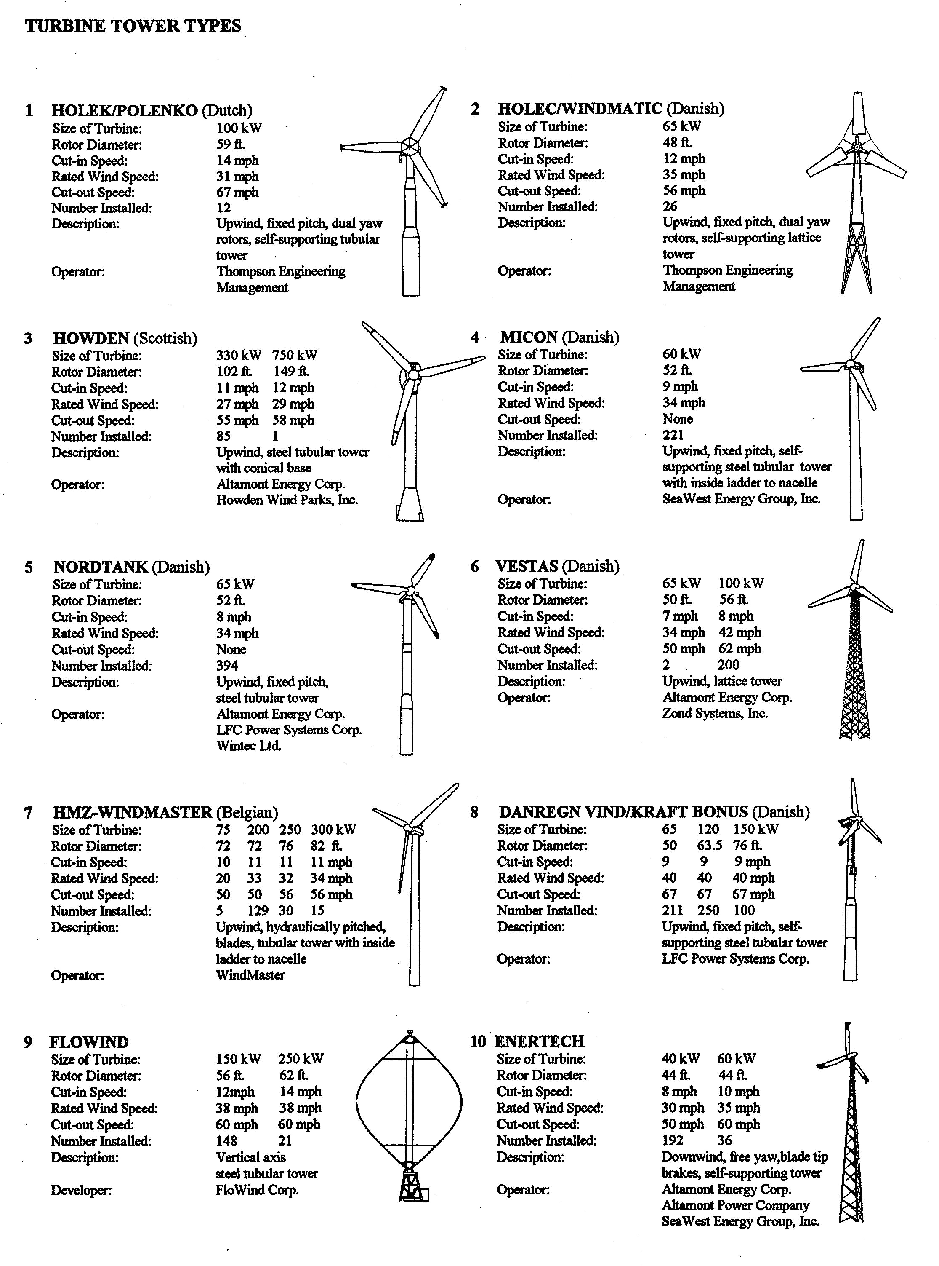

I-2
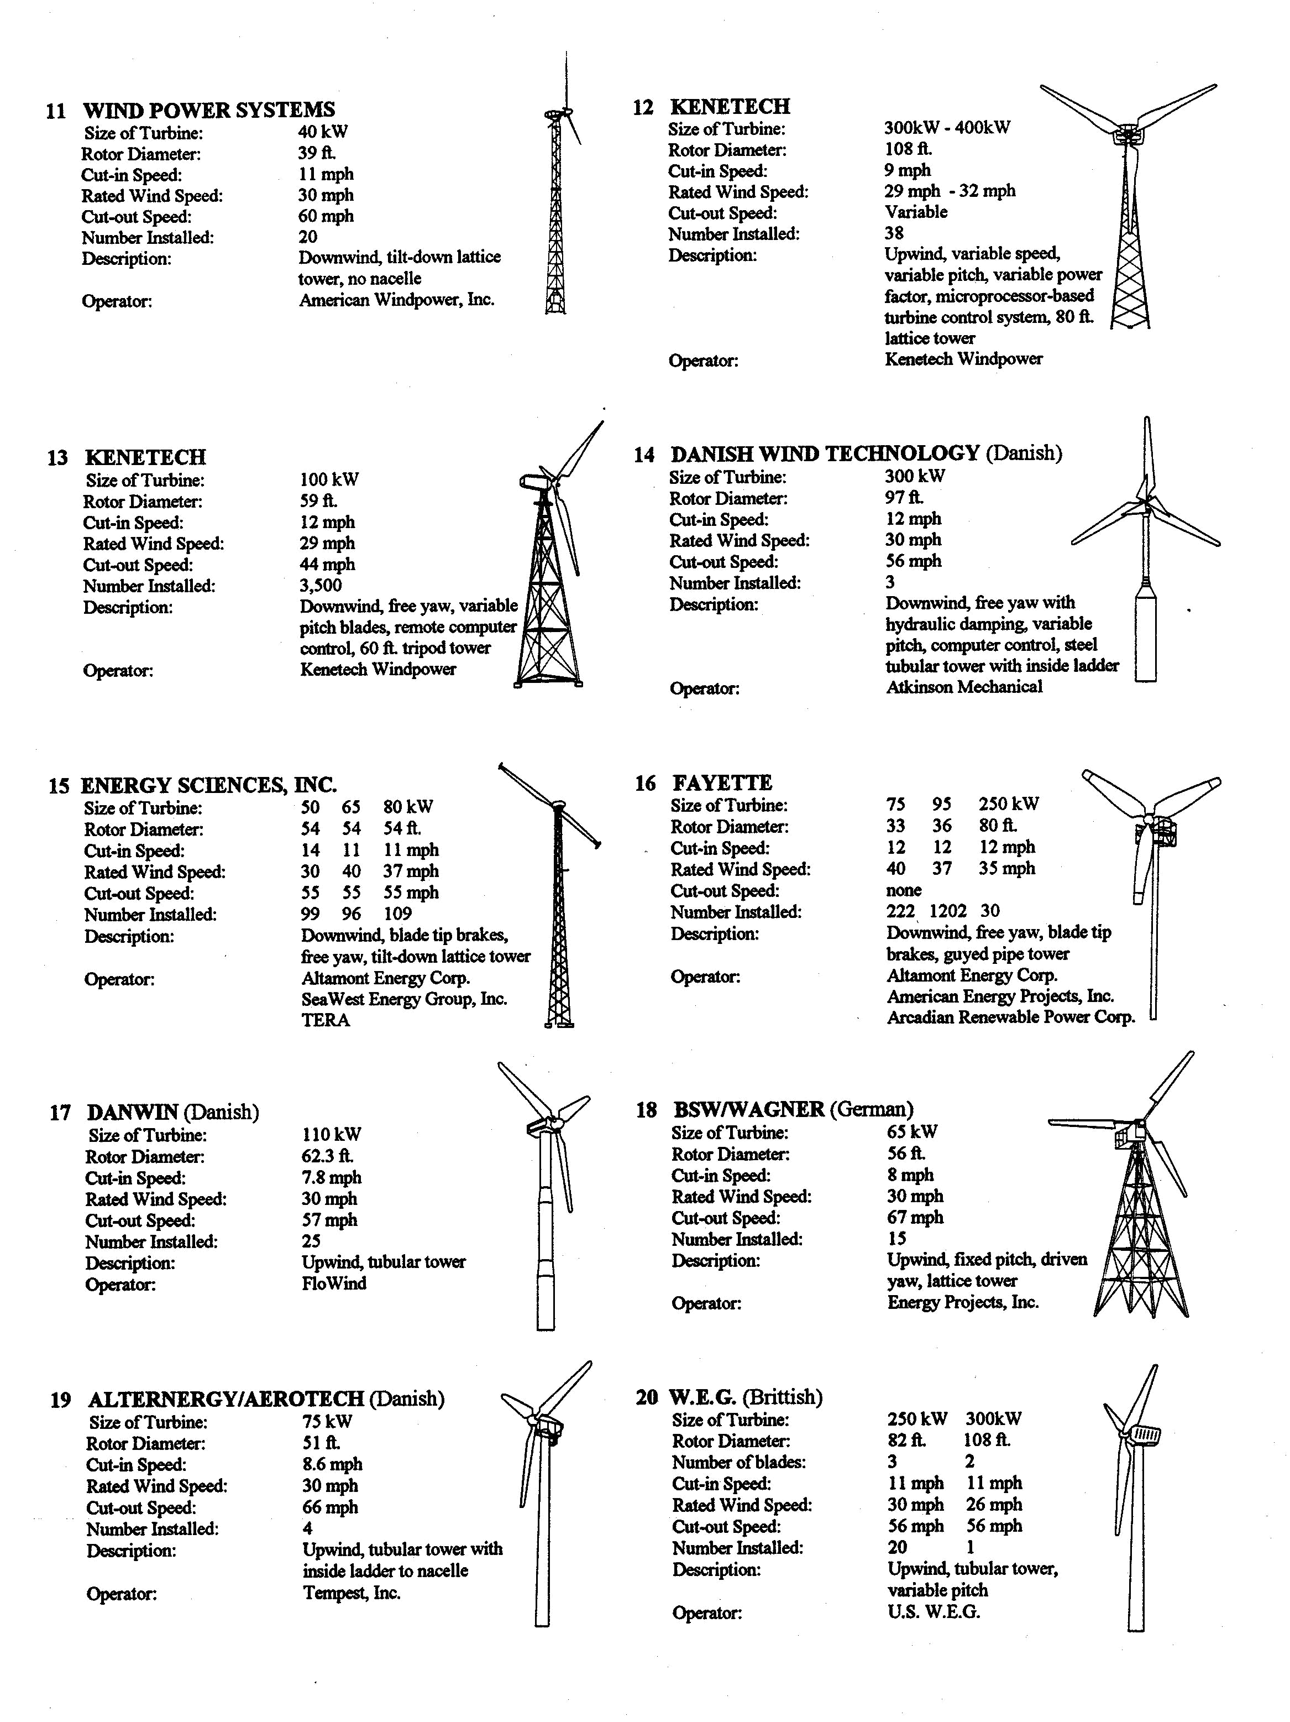

I-3
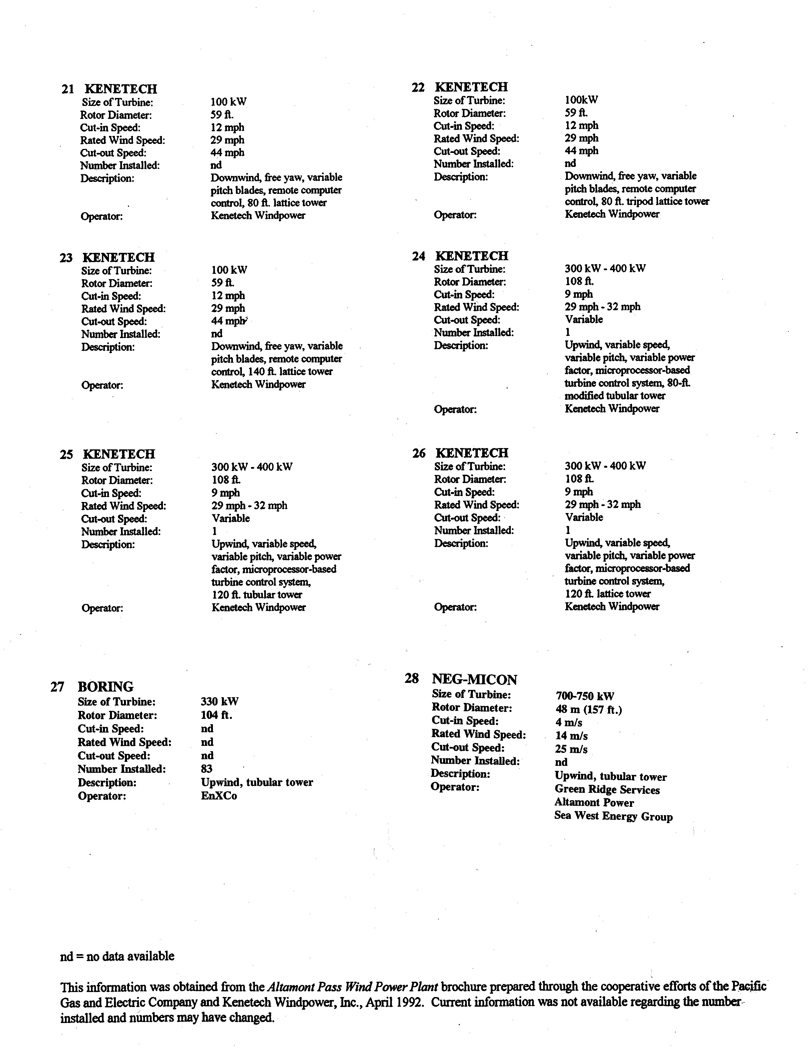

I-4
Appendix II

General Information on California Ground Squirrels

Early research on the California ground squirrel largely focused on eradication efforts associated with bubonic plague and the cattle industry’s concern over the loss of forage to squirrels (Grinnel and Dixon 1918, Snyder 1923, Storer 1930, Evans and Holdenried 1943, Linsdale 1946, Fitch 1948). As knowledge accumulated, it became apparent that geographical variation in temperature and precipitation regimes strongly affected the annual cycles of ground squirrel breeding, aestivation, hibernation, daily activity, and even demography. These and other life history traits indeed vary between populations in different geographic regions of California. Fortunately, in attempting to understand the ecology of the California ground squirrel population at Altamont Pass, we found that many studies were conducted within that region.

Grinnel and Dixon (1918) studied California ground squirrels at various elevations, from sea-level to about 6,000 feet ASL. Variations in the reproductive cycle were reported by Snyder (1923) in Tulare County, and Storer (1930) in a range extending from Ventura and Tulare counties north to Contra Costa and San Joaquin counties. Detailed population and behavior studies were conducted by Evans and Holdenried (1943) at Calaveras Reservoir in Alameda County, Linsdale (1946) at the Hastings Wildlife Reservation, and Fitch (1948) at the San Joaquin Experimental Range near Madera. These early works on ground squirrel life history continue to provide the basis of our ecological understanding of the species, whereas later research has focused largely on specific aspects of behavior. Tomich (1962) studied ground squirrels in the agricultural region near Davis (Yolo and Solano counties), Owings and Borchert (1975) and Owings et al. (1977) at the University of California Davis Wildlife Area, Stroud (1983) at the University of California Hopland Field Station in Mendocino County, Holekamp and Nunes (1989) at the University of California campus in Santa Cruz, and Boellstorff et al. (1994), Boellstorff and Owings (1995) and Trulio (1996) at Camp Ohlone, in Alameda County.

Population Survey Methods

When we began our study of golden eagles in the Altamont Pass area in 1994, we observed ground squirrels throughout the WRA. Our observations of foraging eagles quickly revealed their importance as a prey base and our need of a method to quantify their relative density in the various parts of the WRA. Ground squirrel survey methods varied in the literature, and some promised more accuracy than others.

Social behavior and alarm calls of the ground squirrel make visual surveys difficult. Grinnel and Dixon (1918) and Fitch (1948) noted that when walking transects across study areas, squirrels would call and run into burrows at distances over 100m away and remain underground for extended periods. Emergent young were less conspicuous than older squirrels in visual counts and sometimes retired to burrows for days, making them unavailable to surveys (Fitch 1948). Burrow entrance counts have been found inaccurate when sampling numbers of California ground squirrels and similar species (Fitch 1948, Van Horne et al. 1997a, Powell et al. 1994). For example, Fitch (1948) found burrow systems had an average of 17.2 holes per squirrel. The most accurate population estimates have been obtained by mark-recapture techniques (Evans and Holdenried 1943, Fitch 1948, Van Horne et al. 1997a). Fitch

II-1

(1948) noted that virtually every adult squirrel was trapped each year, during late winter and spring, and the numbers trapped approximated the breeding population. The road surveys we conducted in our study were more practical as a means of indexing the relative density of ground squirrels in various regions of the WRA (to compare with eagle use) than to precisely estimate the number of ground squirrels in specific areas.

Daily Activity and Foraging

In regions with annual snowpack, all California ground squirrels hibernate during winter (Fitch 1948, Dobson and Davis 1986), whereas ground squirrels may aestivate where summer food is scarce. However, in milder climates and in habitats offering diverse food sources, such as in our study area, conditions may be favorable for surface activity throughout the year. More, accurately, in such regions, not all sexes or age-classes are simultaneously dormant (Fitch 1948). On a population level, there are great differences from year to year in the frequency and duration of dormancy, correlated with feeding conditions and weight gain in early summer.

In our study area, periods of daily activity can vary according to temperature and other weather conditions. During winter, some activity occurs every day unless rain is continuous.

Squirrels often do not emerge until mid-morning, when the sun is on their burrows, but then remain active until mid-afternoon. The normal winter surface activity period is 1000-1600 hours (Fitch 1948); however, squirrels may become active as early as 0830 hrs. (Holekamp and Nunes 1989). Wind, cold fog, and rain limit surface activity, and if squirrels do emerge, foraging periods are short and hurried. On a warm clear winter day following several cold and stormy ones, squirrel activity is at a peak, each animal foraging ravenously after the period of fasting. Food is usually abundant in winter due to the new growth of herbaceous species, so squirrels forage closer to their burrows than in summer months (Fitch 1948).

Foraging periods lengthen during spring with increased daylight and warmer temperatures. Surface activity becomes bimodal as summer temperatures increase, with squirrels retiring to their burrows or to shaded areas during the mid-day heat. The normal summer surface activity periods are 0500-0900 hrs. and 1600 hrs. to dusk. Squirrels may be active throughout cloudy or unseasonably cool days.

Breeding and Productivity

In Alameda County, the ground squirrel breeding season usually commences in February (Evans and Holdenried 1943). Holekamp and Nunes (1989) found that the gestation period spanned 28-30 days, followed by a lactation interval of six weeks. Young squirrels emerge from burrows during March through June at 6-7 weeks of age. Litter size, averaging about seven, varies with food supply, female condition, and age (Snyder 1923, Van Horne et al. 1997b, Holekamp and Nunes 1989).

Almost all female squirrels in the population breed (Grinnel and Dixon 1918, Evans and Holdenried 1943, Fitch 1948, Tomich 1962), and few are reproductively unsuccessful (Holekamp and Nunes 1989). The period of behavioral estrus for each adult female is 4-5 hours, and she mates with an average of seven males (Beollstorff et al. 1994). Generally, females produce only one litter per year; however, second litters may be produced following the loss of first litters (Grinnel and Dixon 1918, Evans and Holdenried 1943, Fitch 1948, Tomich 1962, Holekamp and

II-2

Nunes 1989). Evans and Holdenried (1943) found no evidence of females giving birth during the first year of life.

Timing of the breeding cycle within a population of ground squirrels can vary. Most pregnant females have been captured during January to May, although Storer (1930) found pregnant females in every month of the year. We documented emergent juveniles in the WRA as late as 22 October.

There is some evidence that productivity may be higher in areas where control measures are enforced. Snyder (1923) found consistently larger litters in areas where control operations had been in place for two or more years. He attributed the increase in productivity to increased food availability, resulting from relaxed competition.

Mortality and Survival

Males fight constantly during the breeding season, defending their territory and entering those of others to mate with receptive females. The males often forgo foraging during this period, and their weight drops drastically (Fitch 1948). Weakness and injuries are common, making the males particularly susceptible to predation.

The cohort of emerging young are vulnerable to bobcats, coyotes, foxes, badgers, rattlesnakes, gopher snakes, golden eagles, red-tailed hawks, prairie falcons, northern harriers, great horned owls, and others (Grinnel and Dixon 1918, Evans and Holdenried 1943, Fitch 1948). Fitch (1948) found annual juvenile survival ranged from 36 to 50 percent and that of adults from 40 to 58 percent. Squirrels died most frequently after periods of unusually cold and wet weather in winter and spring. California ground squirrels have been diagnosed with pneumonia and bubonic plague (Pasteurella pestis) ( Storer 1930, Evans and Holdenried 1943). Grinnel and Dixon (1918) estimated maximum life-span at five to six years.

Population Density

The California ground squirrel population studied by Fitch (1948) was stable, exhibiting an annual cycle of sudden appearance and subsequent gradual attrition of each year’s crop of young. During the six years of his study, there was no extensive reduction by disease, plague, or starvation. Grinnel and Dixon (1918) found that, under natural conditions the factors apparently limiting a population of ground squirrels, in order of importance were (1) food supply in summer and fall, (2) predators, (3) weather (especially inundation of burrows), (4) disease, and (5) physiological longevity. Evans and Holdenried (1943) reported a total population density (adults and young) of seven per acre, and Boellstorff et al. (1994) found densities of 70 to 92 adult squirrels per hectare; both studies were in Alameda county.

Home Range and Dispersal

The home ranges of California ground squirrels vary with habitat and food supply, often overlapping the ranges of neighbors (Evans and Holdenried 1943, Fitch 1948, Holekamp and Nunes 1989, Boellstorff and Owings 1995). A male’s range is relatively exclusive of other males, wheras the ranges of females overlap extensively (Evans and Holdenried 1943, Owings et al. 1977). The range of an adult male may overlap that of 2-4 adult females (Holekamp and Nunes

1989), while the range of an adult female (100 m2, versus 50m2 for males) can overlap that of seven males (Boellstorff and Owings 1995).

II-3
Young males disperse to new areas from July - September (Grinnel and Dixon 1918, Evans and Holdenried 1943), usually remaining within about one km of their natal site. Young females; however, establish burrows in areas overlapping or adjacent to their mother’s home range (Boellstorff and Owings 1995). This behavior leads to groups of related females (siblings and daughters) with adjacent ranges. In a study where squirrels were marked for visual identification, core areas of unrelated females never overlapped (Boellstorff and Owings 1995).

Boellstorff and Owings (1995) found multi-year site fidelity for both sexes at established burrow systems. However, in locations where populations have been depleted by poisoning, squirrels will move from areas of high density toward those of low density, but there is no indication of large-scale emigration over great distances (Evans and Holdenried 1943). Linsdale (1946) noted that ground squirrels disappeared from the Hastings Reservation when grazing was terminated, and Evans and Holdenried (1943) reported ground squirrels were rarely seen in heavy tree and brush growth, or on ungrazed land where grass was dense and exceeded one meter in height.

II-4

Appendix III

Potential Growth Model

To write a matrix model for the computation of λ _{p} , we parameterize the model as a

postbreeding-census, birth-pulse model. In this case, the population is presumed censused immediately after “breeding” and so the youngest age class included in the census is that of 0-year olds. With J(t), S₁ (t) , S₂ (t) , S₃ (t) , and B(t) the number of juveniles, one-, two-, and three-
year-old subadults, and breeders in year t, respectively, and with f the birth rate, and j, s, and b the juvenile, subadult and breeder survival rates, respectively, one has

J (t + 1) =

S₁ (t + 1) =

S₂ (t + 1) =

fB(t + 1) = f [S₃ s + bB(t)]

J (t) j

S₁ (t)s (1)

S₃ (t + 1) = S₂ (t)s

B(t + 1) = S₃ (t)s + B(t)b

and so the matrix model is
0 |  | 0 | 0 | fs | fb
 | j | 0 | 0 | 0 | 0
 | 0 | s | 0 | 0 | 0 | . | (2)
 |  | 0 | s | 0 | 0
0
 | 0 | 0 | 0 | s | b

Note that the term fs presumes that subadults surviving to adulthood are immediately effective as breeders. While this assumption may be biologically unrealistic, the model thereby produces the largest value of λ _{p} .

The eigenvalue equation for the matrix (2) is
− λ (λ ⁴ − bλ ³ − | jfs³ ) = 0 | (3)
and so λ _{p} solves
λ ⁴ − bλ ³ − jfs³ | = 0 . | (4)

Hence, the value of λ _{p} for this model is the largest solution of this equation. Equation (4) was solved with MATLAB to yield λ _{p} = 1.0047 when

III-1

f = 0.2313 j = 0.8397 s = 0.7944 b = 0.9087

The corresponding stable-stage distribution, scaled so that its components sum to one, is

(J, S₁ , S₂ , S₃ ,B) = (0.136199,0.113801,0.090028,0.071134,0.588839).

Note that when 1.0047 is substituted into (4) the result is zero to four decimal places, this calculation serving as a check on the value for λ _{p} .

To compute the variance of λ _{p} by the delta method, one requires the partial derivatives of λ

with respect to each of the other parameters. These partial derivatives may be computed easily by implicit differentiation of equation (4). One obtains:

∂ λ | = | js ³
∂ f | = | λ ² (4λ − |  | 3b)
∂ λ | = | fs ³
∂ j | = | λ ² (4λ − |  | 3b)
∂ λ | = | 3 fjs ²
∂ s | = | λ ² (4λ − |  | 3b)
∂ λ | = | λ |  | .
∂ b | = | 4λ − 3b |  | .

The variance-covariance matrix is diagonal since the parameters are independent:

 |  |  |  |  |  |  |  | Σ | = diag(Var( f ),Var( j),Var(s),Var(b)) .
If V | = ( | ∂ λ | , | ∂ λ | , | ∂ λ | , | ∂ λ | ) the delta method asserts that
If V | = ( | ∂ f | , | ∂ j | , | ∂ s | , | ∂ b | ) the delta method asserts that
 |  |  |  |  |  |  |  |  | Var(λ ) = VΣ V ^{T} ,

where V ^{T} denotes the transpose of the row vector V. Consequently,

 |  | ∂ λ
Var(λ ) = | Var( f ) | ∂ λ
 | ∂ f

2 |  |  | ∂ λ | 2 |  | ∂ λ |  | ² |  | ∂ λ |  | ²
 | + | Var( j) |  |  | + | Var(s) |  |  | + | Var(b)
 |  |  |  |  |  | ∂ s |  |  |  | ∂ b
 |  |  | ∂ j

Computation yields Var(λ ) = 0.00057 and SE(λ ) = 0.0240. Hence the confidence interval for λ _{p} , λ _{p} ± (1.96)SE(λ ), is the interval (0.9577,1.0517).

III-2

