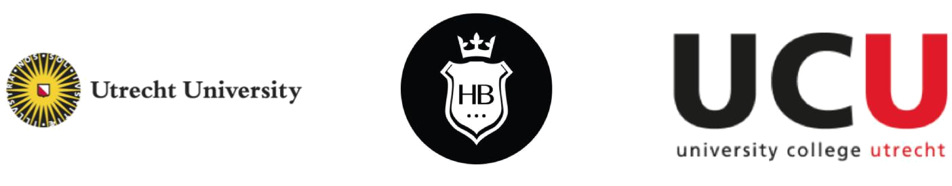

Governing the Herenboeren farm in Soest:

A Consultancy Report
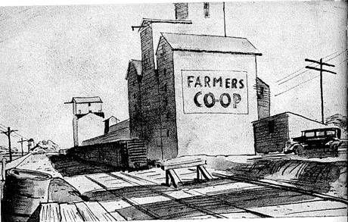

UCINTSUS31: Implementing Sustainability

Dr. B. Dermody

Filippo Bezzi, Brenda Gonzalez Martin, Geofrey Mushibi, Aneeqah Tariq, Jorn

Krijgsman

30 November 2018



Table of contents

Summary | 2
Introduction | 3
Challenges of decision-making for farmers | 3
Motivation for consultancy: unique farm structure | 4
Background to the case study | 5
Herenboeren | 5
Herenboeren Netherlands | 5
Current Governance farm Boxtel | 6
Planned governance system in Soest | 6
Ideological Objectives of Herenboeren | 7
Theoretical framework and literature review | 8
Transition Management: the Emergence of the Hereboeren | 8
Decision Types | 12
Herenboeren as a socio-ecological system | 13
Adaptive governance systems | 14
Participatory aspect | 15
Advice based on analysis | 16
Primary and Secondary Board | 16
Holistic Decision-Making Analyses | 16
Adaptive Governance: Participatory focus | 17
Conclusion | 18
Advice in the form of deliverable | 19
Figure 6: Conceptual flowchart outlining the primary board (on the right), and the
secondary board on the left. | 19
References | 20

1

Summary

The following report gives an advice to the Herenboeren in Soest to fit the farm’s objectives to its governance system. As it is a unique organization, an entirely novel governance model is proposed, embedded in literature. We found that a tradeoff exists between a focus on participatory democracy on the one hand, and decision making efficiency on the other. The model as proposed finds a balance on this continuum, based on holistic decision making, and through emphasizing participation by adaptive governance. The governance model as proposed can be taken as a starting point, and used as inspiration to design a board, way of working, and according statutes in collaboration with the members. The proposed model consists of a primary board consisting of the farmer, a secretary, and a treasurer, along with another general member of the board, and a rotating member that comes from the pool of farm members. This primary board will concern itself with practical, emergency, and day-to-day decisions while the secondary board, consisting of a larger pool of stakeholders, concerns itself with long term decisions on a more ideological basis.

2
Introduction

Challenges of decision-making for farmers

Already in 1984 Boehlje and Eidman highlighted the relevance of management styles in farms, attributing differences in economic results between farms working under similar production condition to it. (Boehlje & Eidman, 1985​)​. Governance is essential to management as it is concerned with creating conditions for ordered rule and collective action. (Stoker, 1998) This is why we will look at governance and decision making, within the Herenboeren concept. Decisions in farms and their governance systems form a complex system themselves and are on top of that interdependent on many environmental and societal systems. The graph below (figure 1) illustrates the complexity of the internal farm system as well as its relation to external systems such as the economy, the government and consumer behaviour.
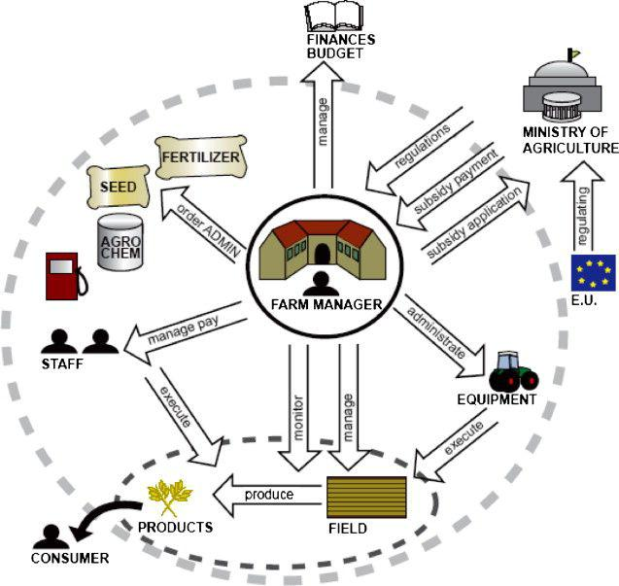

Figure 1 (Rougoor, Tripb, Huirne, Renkema, 1998)

The current situation seen from the farm manager's point of view and the farm activity system for production of crops (the dotted circle). The dashed line defines the farm system boundaries.

On top of the ‘regular’ external systems that need to be taken into account, farms following the the Herenboeren concept need to consider additional systems involving

3
sustainable principles and the attitudes of their investors. Considering the complexity involved in farm management, an effective governance system is crucial for decision making.

Highlighting the importance of this matter, we would like to investigate how decisions are made in the currently operating Herenboeren farm in Boxtel and propose an efficient governance model for the future farm in Soest. We will base our potential model on a translation into governance of the principles the Herenboeren concept is based on as well as on existing governance approaches and structures found in a literature review.

As with any governance system, a tradeoff exists between efficiency in decision-making, as well as democracy. On the one hand, a good management model is democratic and incorporates every member’s point of view. On the other hand, this is time inefficient and requires a lot of effort. This is especially true for the case of the Herenboeren: with 200 investors, it is hard to have every voice heard. On the other hand, democracy is very important as the community aspect of the Herenboeren is one of its main attributes (this will be further elaborated upon). This report will end with an advice that seeks to balance this tradeoff that fits the organization’s objectives.

Motivation for consultancy: unique farm structure

As stated before, the Herenboeren operates with a unique model where consumers are simultaneously investors in the farm. For consumers, this provides a sense of ownership over their subsistence, as they get to choose what they produce and what environmental impact their food has. This is a unique selling point that no other player has in the market segment of organic food suppliers.

The table below depicts some big players in organic food subscriptions in Utrecht, such as the Herenboeren along with the services they provide. Our research shows that all providers, (to different extents) provide organic, fresh, sustainable, and local food. Herenboeren Soest will not be the only provider where customers have the option to harvest their own produce, but is the only provider that also offers the option of delivery at the same time. The community feel is also not unique to Herenboeren Soest, as Zelfoogsttuin De Moestuin also offers some community aspects, but to a smaller extent than what is envisioned for the Herenboeren Soest. Note that competition is not the point here, rather every customer has a different set of requirements and levels of involvement.

4
Table 1: Overview of different organic food providers, with services provided.
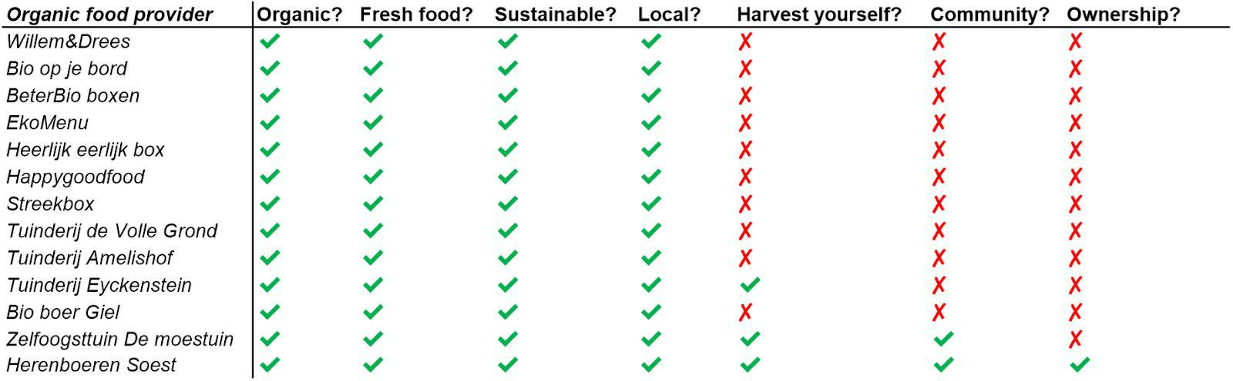

The Herenboeren in Soest has the potential to make a lasting, meaningful, sustainable impact on the Netherlands’ food system. However, in order to do so, it still requires a number of investors. Furthermore, since the organization is unique and one of the first of its kind, there is no governance model available in the current literature nor are there any known best practices. Its objectives are also unique in the segment. Since a governance model should follow the objectives, and not vice versa, this calls for a tailored governance structure that fits these objectives.

This report aims to provide exactly that: a governance structure that ensure both the decision making efficiency needed to sustain a farm, as well as the feeling of democracy investors need in order to stay interested. We argue that Herenboeren’s unique structure of consumer/investors is a unique selling point, which should be reflected in this governance system.

Background to the case study

Herenboeren

Herenboeren Netherlands

The Herenboeren movement supports the development of nature inclusive Herenboeren farms in the Netherlands. Right now there is one running nature inclusive farm owned by the Herenboeren in Boxtel and there are already 7 foundations established in order to realise other farms throughout the Netherlands, one of which is the farm in Soest. As a movement, the Herenboeren is involved in many wider projects and initiatives in the domain of bottom-up sustainable food production or farming communities. Their ideal farming community is set up from three main principles: Driven by nature, Socially connected and economically supported.

5
Through bottom-up change in the form of small farming communities, Herenboeren hopes to initiate wider structural change in the food production system. In order to empower these farming communities to assist each other, they are involved in developing several knowledge sharing platforms and coalitions, as well as reports and guides that will ease the first stages for new farming communities. The Herenboeren embrace the idea of learning by doing and encourage the farming communities to experiment with new and alternative practices. The current running farm has been granted a ‘Green Deal’ by the government, which entails that certain laws can be temporarily put aside in order to experiment with alternative methods. The future Herenboeren farms will also be able to make use of this deal since they are part of the Herenboeren movement.

Because of this focus on learning by doing and experimental approaches, the individual Herenboeren farms have freedom to implement their own vision based on the needs of the investors and local community present. This also means that terms of governance there is no pre-decided structure and that the structures will differ. In the next paragraphs we will give an overview of the current governance system of the Herenboeren farm in Boxtel as well as an outline of the (preliminary) plan of the future governance system in Soest.

Current Governance farm Boxtel

The first Herenboeren farm has already been in operation for three seasons, and is located in Boxtel. The farm measures 20 hectare, with currently 171 members working together to gain around 60% of their weekly dietary needs.

The farm on Boxtel is governed by a board, but most decisions lie with a general assembly of all investors, ensuring every investor has a voice. A general assembly meeting is held every month, where decisions are made. Attendance to this meeting is not mandatory, but since members are invested in the farm, attendance usually is quite high. Even though the decisions are made by a general assembly of all members, the last say is with the farmer; who is on the farm every day. He is also in charge of the day-to-day operations of the farm. On the Boxtel farm, there is an evident focus on democracy: there is decision-making power within all of the investors, on nearly all decisions.

Planned governance system in Soest

One of the first steps in setting up a cooperative farm in Soest is finding investors. In total, 200 investors are necessary to meet financial obligations. The Herenboeren team work with an “Intentieverklaring”: A contract drawn up that states the intended investor will invest as soon as the required 200 investors are collected.

6
Currently, there are about 70 individuals who have signed it. Once 150 intended investors are found, the Herenboeren Soest will start renting land and setting up the farm.

The governance system of the potential farm in Soest is not officially determined yet, since the farm will want to engage all stakeholders in establishing it. There are however potential structures that are being considered, such as a board consisting of at least three persons, including a chairperson and a treasurer. Currently, there are 11 people involved in setting up the project, including agricultural experts (such as a veterinarian) and particularly involved investors who have shown interest in taking initiative. Furthermore, the future farm will aim to involve all stakeholders in the making of growing plans (‘teeltplan’, in Dutch). This ensures consumers are involved in choosing their diet.

Ideological Objectives of Herenboeren
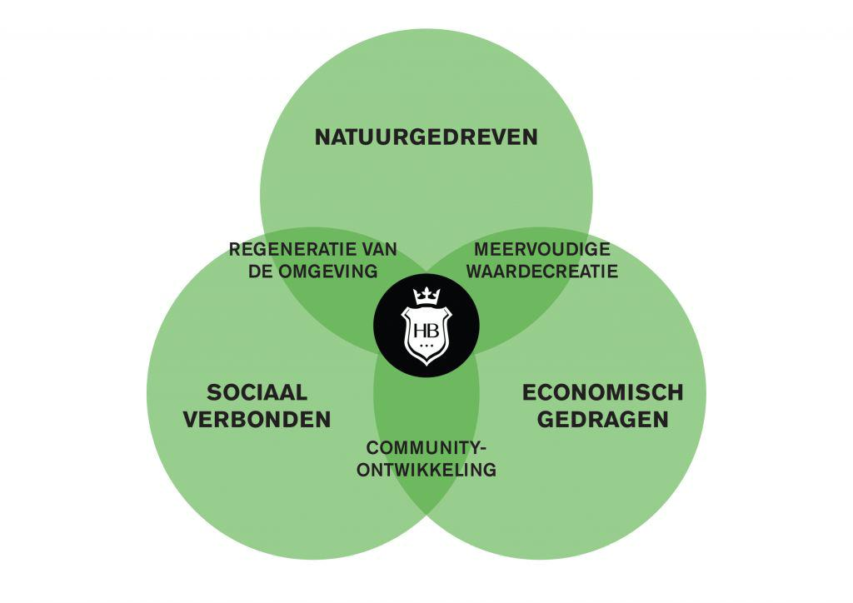
All farms of the Herenboeren aim to be more than solely environmental friendly food suppliers to their stakeholders. Ultimately all Herenboeren farms hope to create an farming community embedded in the local area: A community that is

environmentally |  | driven, socially
connected | and | economically
carried. | Through |  | social
connectivity | they |  | hope to

actively contribute to the way the local area is used and shaped and to the residents of the area. They hope to be connected to the

different cultures present and to add to the local capital (including knowledge, attention, money and more). Through becoming a place where people can meet they hope to increase environmental awareness, but also connect the people of the area. As we have shown before, we think that Herenboeren provides a unique feature within the alternative organic food initiatives.

7
Theoretical framework and literature review

In order to provide a tailored governance model, a theoretical framework is needed. In this chapter, the types of decisions are outlined, as well as a description of transition management literature, and an application of socio-ecological systems theory to the Herenboeren farm. In order to provide a fitting governance model, the farm must be better understood from a theoretical perspective.

Transition Management: the Emergence of the Hereboeren

We expressed earlier how the Herenboeren is one of the first movements aiming at realising nature-inclusive farms in the Netherlands. This puts the Herenboeren in a pioneer position, with the goal of implementing means to a sustainable food production system in the current Dutch societal system. The Herenboeren, despite its small scale, is a fundamental element of the large-scale societal change necessary to solve the unsustainability of the current food system and the (nowadays too many) notorious issues that it is causing. These “large-scale societal changes” considered necessary to solve “grand societal changes” are referred to as the term sustainability transitions.

In transitions research it is described how the process of change can lead from one system to another via a period of nonlinear disruptive change. The notion of transition is a recurring concept in many scientific disciplines, however, in the context of sustainability, it refers to a qualitative, shock-wise rather than gradual, change in the state of a complex system. Transitions occur in the four phases of predevelopment, take-off, acceleration and stabilization. The state of a complex system and the change brought about are not part of a one dimensional structure. On the contrary, they are a result of agents acting and interacting on levels of different dimensionality. The multi level perspective divides local practices in three structures of different dimensionalities: the landscape, the regimes, and the niches. The regime is the dominant and stable configuration in the societal system, and is understood in the context of its interactions with the landscape (the context made of external factors, preferences, and pressures) and the niches (the emerging novelties, innovations, and alternatives). The societal regimes of today (dominant technologies, institutions, routines, cultures) have emerged from historical transitions and have developed through processes that were deemed necessary (Loorbach 2010). Some of these processes though are deeply rooted in the current hegemonic structure of unsustainable food production and new alternatives need to develop and emerge.

An example of this hegemonic structure is the current legislature of the Dutch government in agriculture, which is designed in such a way that it mostly benefits the

8
traditional ways of farming and even can be said to suppress new nature inclusive farming concepts such as the Herenboeren in its original form. Currently, Herenboeren Boxtel can only operate on the basis of an agreement with the government that allows them to temporarily set aside certain laws in order to experiment with alternative methods.

Through starting their initiative and showing that the current legislature doesn’t fit with their new way of farming, the Herenboeren have been able to impact the current government. In this way Herenboeren can be seen as the emergence of an alternative that stresses the equilibrium of the regime and destabilized it. By doing this the herenboeren makes it easier for other alternative farming systems to start and follow their way. In short, alternative initiatives for food production like the Herenboeren, but also for example the other initiatives we have mentioned in our comparison earlier can fill in niches that are not fulfilled in the current regular way of farming. Through the increase of these initiatives, regulatory systems in the government are confronted and need to adapt their existing models. This opens up the system, making it easier for more initiatives to start up. In the long term this could contribute to to a systemic reconfiguration in favor of the emerged alternatives. This highlights the importance of alternative initiatives in achieving transition and hereby the relevance of developing effective governance systems for the Herenboeren in order for them to become a resilient system.

The emergence of such alternatives inevitably stresses the equilibrium of the regime that is destabilized and will have to undergo a systemic reconfiguration in favor of the emerged alternatives. [​Figure 3​] provides a descriptive representation of the multilevel and multiphase perspective on transitions (Loorbach, Frantzeskaki, Avelino, 2017).

9
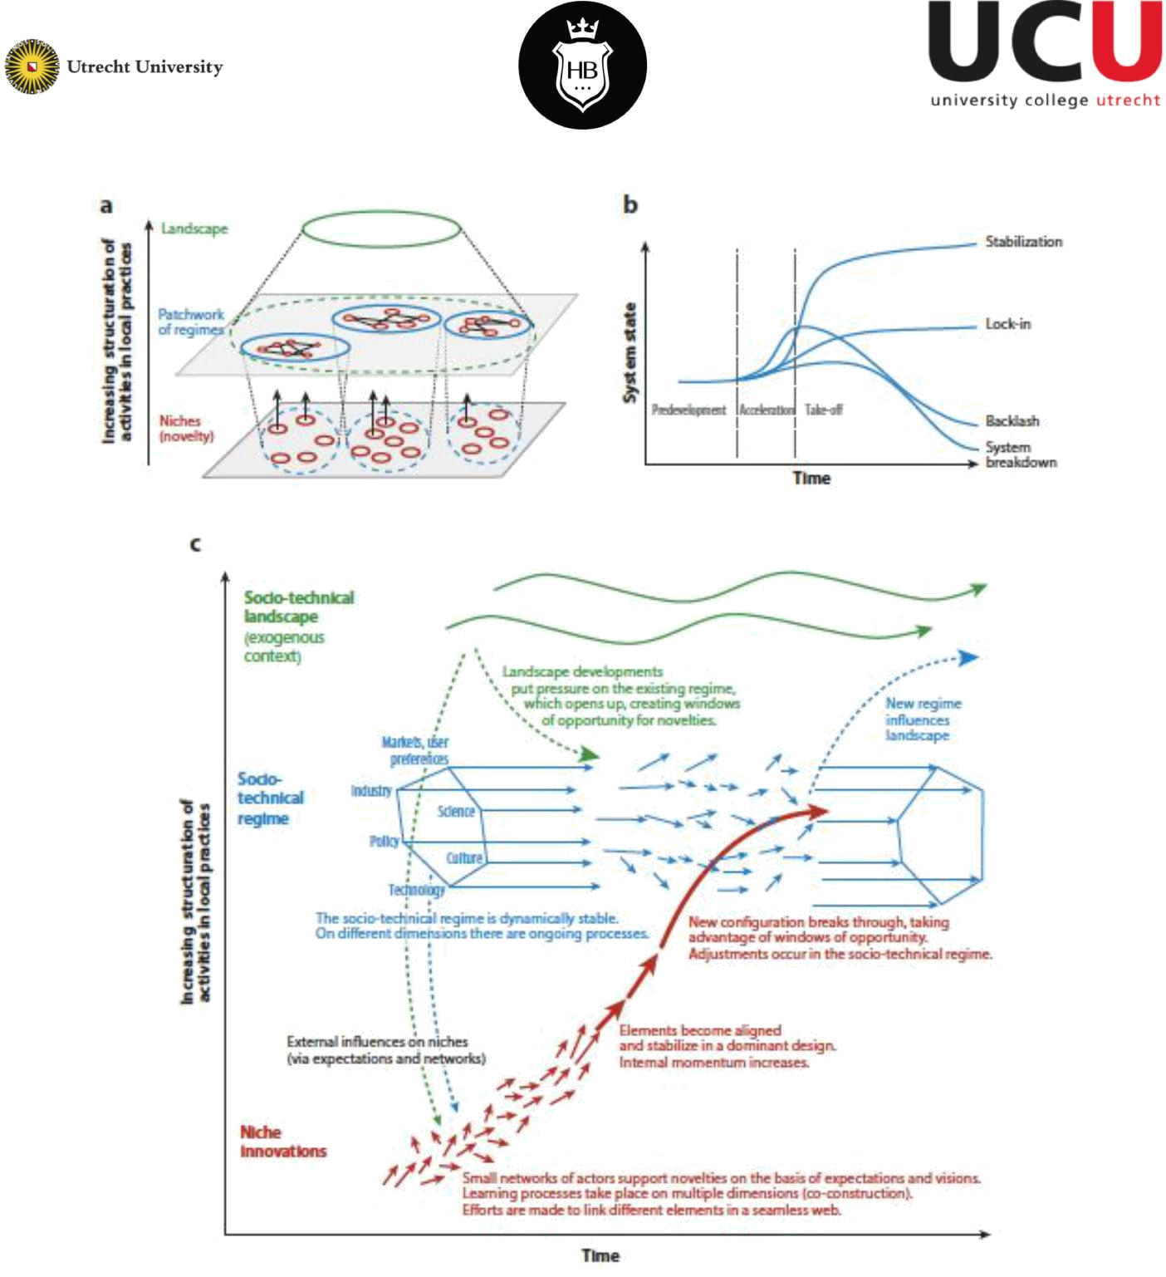

Figure 3: a)the multilevel model and coevolution; b)the regime as result of coevolution with landscape and niches interactions; c)the multiphase concept. ​(Loorbach, Frantzeskaki, Avelino, 2017).

For the project brought forth by the Herenboeren, the actualization of a transition to a sustainable food system is extremely important for the validation of the values that it advocates as much as the consolidation of a business that will long last in the future. Conventional farming has been the dominant structure (regime) of the food system in Europe since the late 1970s (Maye, Duncan, 2017). Through processes of optimization and consistent innovation the food system has developed path-dependencies that leave little space for new projects which (sub)systems are not in line with the regime. The

10
Herenboeren is then a niche player which, with the aid of the transition management approach, can lead to a disruption of the regime, accelerate and guide social innovation processes, as well as ensuring the long-term success of the project.

Transition management was firstly introduced as official government policy in the fourth Dutch National Environmental Policy Plan (​Loorbach, Rotmans, 2010). Even though it aimed at breaking those existing path-dependencies and therefore create new space for transition management, learn-by-doing, experiments, it did not set specific goals. The operational model for the implementation of transition management, the transition management cycle, summarizes the general principles which transition management based on (see ​Figure 4​) (​Loorbach, Rotmans, 2010). Transition arenas are networks of niche players with the same interest. As shown in [​Figure ​4​] such networks, constituted of diverse actors that share ideals can overall goal can create conditions for reinforcement of the niche and disruption of the current regime. The Dutch government has failed to effectively promote a transition such as the one the Hereboeren is advocating, consequently, reinforcement of the Herenboeren as a niche can expose those policies that are counterproductive to small-scale inclusive farming initiatives. In the context of societal transitions, such actors are said to behave via tactical-governance activities, that is ‘activities at the level of subsystems that relate to build up and break-down of system structures’ (​Loorbach, Rotmans, 2010). Transition management can be considered a meta-governance and the main objective of the Herenboeren is to create arenas of coalitions, partnerships and networks that exert growing pressure on the political and market arena to ensure the continuation of the transition process and therefore the protection of its long-term goals.
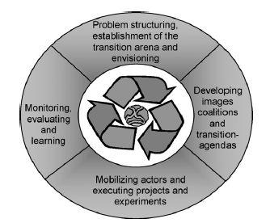

Figure 4: the transition cycle.​(​Loorbach, Rotmans,​2010).

11
Decision Types

Before the governance system is proposed, we give an overview of the types of decisions that need to be made at a farm as our proposed governance system hinges on the types of decisions. This is by no means an exhaustive list of the types of decision that have to be made by when running a farm.

1. Ecological and Agricultural decisions

The Herenboeren farm is built on the principle of farming in a environmentally sustainable manner. As such, careful decisions have to be made concerning what is farmed so that it is in line with the farm’s vision. The decision is also likely to be shaped by seasons are some crops are better grown in certain seasons that other. Sustainable farming calls expert knowledge on subjects such as strategies of crop rotation that enrich the soil. Therefore, we argue these decisions should be made by or at least in consultancy with experienced experts on these matters. In the context of the Herenboeren the most evident actor that is suited for this role is the farmer himself.

2. Teeltplan: What to grow?

As we already mentioned before, both the Herenboeren farm in Boxtel and Soest aim to involve their stakeholders in choosing the crop types since they are both the consumers and the owners. However, of course this decision is also dependent on what crops are the most suited for the environment. Furthermore, in order to enhance the sustainability on the farm it should also be taken into account in which way resources can be used in a circular manner. In this way there should be a negotiation between the dietary wishes of the stakeholders and the environmentally best options. Therefor the decision of what crops to grow should be made in a collaboration of both the stakeholders and the farmer.

3. Future of the Farm

Once the farm is running, decisions will need to be made concerning the adoption of new (productive) technologies. For example it could be considered what kind of machinery could be purchased to help with the production of products at the farm. Instead of purchasing, it might be more ideal to get machinery on lease from another firm. Another decision that should be considered while setting up the farm is the way in which there will be dealt with overproduction. It would probably be most effective if big decisions like this are debated and agreed on at the beginning stage of the farm. They could for example be taken up in constitutes.

12
4. Short-term practical decisions

All the decisions discussed above are those that can be planned for well in advance before the action is executed. However, there are unexpected circumstances that might come and will need to be made within a short period of time. This includes, but not limited to outbreak of disease or pests, prolonged summers leading to drought and unexpected changes in weather patterns which can have a negative impact. The farm needs to be able to handle all these cases in order to guarantee the long term operation of the farm. This type of decisions should be made efficiently while based on adequate expert knowledge, since a fast response is required in emergency situations. There is always a tradeoff between full democracy and efficiency. Since all the investors invest the same amount of money, giving each of them an equal voice brings about full democracy but decisions made this way may not be the most efficient. We aim to incorporate a system that is both focused on democracy and participation while remaining efficient.

Herenboeren as a socio-ecological system

As a nature-inclusive farm, the Herenboeren farm is best understood as a socio-ecological system. A social-ecological system is defined in different ways, but comes down to a system consisting of multiple biophysical and social factors interacting in a complex manner. This description is used to emphasize the fact that the delineation between humans and nature is arbitrary, and the processes between the two are often interlinked. The different types of biophysical and social processes, and the larger scale conditions that they are based on, are outlined in the figure below (Virapongse et al., 2016).

13
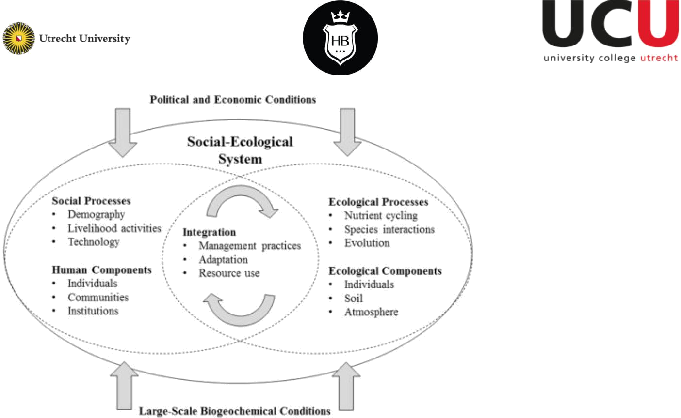

Figure 5 (Virapongse et al., 2016). Schematic description of social-ecological systems.

Farm governance occurs at the intersection between social and ecological processes. In the figure above, it would appear in the circle labelled ‘integration’. For this reason, agricultural decisions need to be based on expertise in both fields. Therefor, a board is needed with experts in many different fields, and a focus should be on the interactions between in the decision making process.

Adaptive governance systems

A complex social-ecological system calls for a complex governance system. Much research has been done on these governance systems, from different orientations and with different regional focuses. Karpouzoglou, Dewulf and Clark (2016) did a comparative study of initially 300 studies, which they narrowed down to 60 articles that describe ways to govern a social-ecological system. Most of the papers were case studies, studying real-life examples of social-ecological governance systems. The rest were either conceptual or a comparative case study, with examples from both the developing and developed world. By comparing all these different articles, they found a number of common denominators. Based on their literature review, they found that the most important adaptive governance features are adaptive capacity, collaboration, knowledge and learning, and scaling. Adaptive capacity refers to the capacity of a board to adapt and self-organize, meaning participants of an organization organize themselves. Collaboration refers to the networks and partnerships created, and the collective search for problems that arise. Knowledge and learning refers to the integration of indigenous knowledge and science, meaning learning by doing. It also

14
means viewing policy and management as experiments, rather than descriptive devices. This results in a dynamic management system, where changes can be made. Lastly, scaling refers to linking the scale of an ecosystem that is managed to the scale of governance that relates to it.

Participatory aspect

Feagan and Henderson (2009), have studied the idealized view of community supported agriculture versus how shareholders view it. Their case study, Devon Acres, is an collectively owned organic farm in Ontario, Canada. According to this paper, CSAs set themselves apart from the dominant food-system by focussing on short versus long distance transportation, profits for the farmer instead of for middle operations, small versus large scale, organic practices versus energetic and chemically intensive practices, local knowledge versus standardized production techniques, biodiversity versus monoculture, and self-reliance versus corporate dependence. Additionally, CSAs are characterized by farmers forming a distinct connection to their land, and their customers based on a relationship of ‘care’. They identify three levels in which a CSA is organized:

- Instrumental

- Functional,

- Collaborative.

These three levels are characterized by the relationship between the farmer and farm members, respectively

- A business relationship,

- A relationship of camaraderie, the community supports the farmer, and

- A relationship of partnership: the member shares responsibility with the farmer. Feagan and Henderson found that in the third case, support and sharing narratives were strongest and most consistent. These narratives are characterized by sentiments such as ‘a farmer should earn a living wage’, or ‘farmers should not be penalized for bad weather or pests that destroy crops’. Other characteristic sentiments are ‘eaters should take an interest and responsibility for food production’.

Based on a survey of members of the Devon Acres farm, it was found that with increased participation, members were more likely to adhere to the third relationship of partnership. They were more likely to share the sentiments described above, leading to a more effective collaborative farm, with more commitment.

15
Advice based on analysis

Primary and Secondary Board

As we have described in our analysis of decision making and socio-ecological system there are many long and short-term decisions to be made in the farm in different domains that require different kinds of expertise. We propose that it would be most efficient to separate long-term and influential from short-term and practical decisions. In practice this separation would be operated through the creation of a primary and and a secondary board. The primary board would be more focused on the short term, practical and emergency decisions, while the secondary board (consisting of all the stakeholders) would be more focused on the long term decisions.

Holistic Decision-Making Analyses

We argue that a local governance system for the Herenboeren can be based on the same principles and ‘holistic analysis’ that are used for environmental governance on a larger level. The economic, social, and environmental dimensions of sustainable development have become the dominant rhetorical device of environmental governance. Thus environmental decisions and governance on local, national and international scale involve questions of economic efficiency, environmental effectiveness, equity, and political legitimacy. In addition to these four dimensions, an in-depth analysis of environmental decisionmaking should also recognise and examine the part played by institutions, scale, and context. (W Neil Adger, 2002) In the Herenboeren we see that governance is related to all these different domains as well. A governance system for the Herenboeren should focus on a wide participation of the stakeholders (the social domain), nature inclusivity (environmental domain) and the economic efficiency and financial expenses (economic domain). While the governance system also needs to have effectivity in dealing with legislation and policies coming from the government and other involved institutions. A thick analysis of environmental decision-making demands that these aspects are all incorporated, which emphasises a governmental system that is flexible and has the capacity of working with all these different domains.

We argue that this could be achieved within a governance system that includes a diverse primary board with members that each focus on one of these specific topics.

16
This doesn’t mean the members will be only specialised in this area and won’t have a say in anything else or that the expert can make decisions about his domain on his own, but it does allow the board to have more expertise specific knowledge if this is necessary. Thus we propose a primary board that consists of an ecological/agricultural expert (farmer), a representative of the stakeholders, a financial expert (treasurer), legislature expert (secretary) and a general board member.

Adaptive Governance: Participatory focus

A widely used governance approach used in socio-ecological settings on a larger scale is adaptive governance. Adaptive governance involves devolution of management rights and power sharing that promotes participation. Through participation it promises to reduce uncertainty by improving the knowledge base for decision making. On top of this it also enhances the social system in terms of resilience. (Karpouzoglou, Dewulf, & Julian Clark, 2016) We argue that a governance system of the Herenboeren therefor would benefit from maximising the participation of their stakeholders. Through involving more individuals in the decision making process, insights can be provided from a larger knowledge pool which will benefit the outcomes of decision making processes. Therefor we argue for a participatory focus in both the development of a governance system and the governance system itself. On top of these benefits that a governance system with a focus on participation brings, we have also seen that participation and community building are important aspects particularly for the herenboeren concept. In a comparison with other initiatives for organic food supply, we have seen that Herenboeren has a unique position within this domain. Not only are they the only ones that provide the possibility of ownership of the land, but they also have a strong focus on community building. This can also be concluded from the ideological foundations the Herenboeren concept itself identifies with.

All of this argues for a maximization of the participation of the stakeholders through a governance system that still remains efficient. We propose this focus on participation can be incorporated in the governance system in different ways. First of all, the stakeholders can be involved in the development of a governance system through participation in setting up the statutes and the governance structure. This means eventually the governance structure is proposed by the stakeholders themselves. In this way more participation at an early stage can be achieved. By inviting the investors to have a say in the writing of the statutes, investors do not only feel involved from the start of the initiative, investors have a lasting, direct impact on the governance structure. Secondly, we argue the stakeholders should be incorporated in both the short term and

17
long term decision making process, in both the primary and secondary board. We argue that the stakeholders should make up a secondary board which has large influence on all long term decisions. A primary board will be needed for more practical, emergency and short term decisions, in this board we would like to include the stakeholders through a representative. In this proposed system the stakeholders are involved at every level, while still maintaining efficiency.

Conclusion

In conclusion, in this report we have aimed to create a governance model for the future Herenboeren farm in Soest. Because of the unique structure of the Herenboeren, there is currently no best practice vis-a-vis governance systems. This is why we came up with a tailored governance model, that finds a balance on the trade-off between democracy and efficiency in decision-making. The recommended model focuses on enabling holistic decision making processes and emphasising participation of stakeholders through adaptive governance. Evidently eventually the decision lies with the founders and stakeholders of the potential Herenboeren farm in Soest, but we have designed a possible recommendation of a governance system that could potentially function as a starting point. We argue that the stakeholders should make up a secondary board which has large influence on all long term decisions. A primary board will be needed for more practical, emergency and short term decisions, in this board we propose to include the stakeholders through a representative. In this proposed system the stakeholders are involved at every level, while still maintaining efficiency.

18
Advice in the form of deliverable
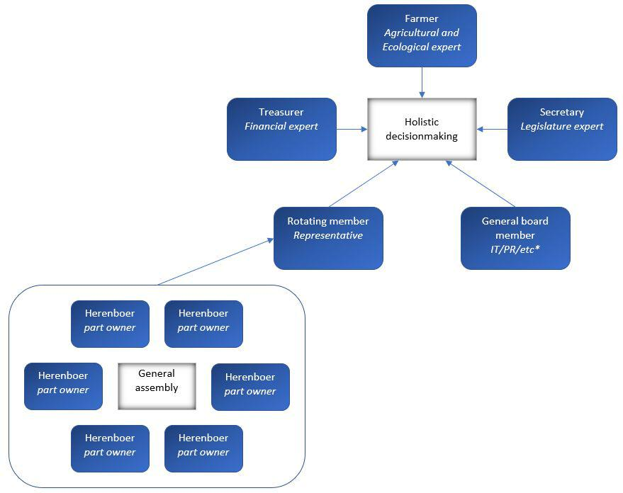

Figure 6: Conceptual flowchart outlining the primary board (on the right), and the secondary board on the left.

19
References

Boehlje & Eidman, 1985. Farm Management. Agricultural Systems, 18(1), pp. 61-65.

Feagan, R., & Henderson, A. (2009). Devon Acres CSA: Local struggles in a global food system. ​Agriculture and human values​, ​26​(3), 203-217.

Loorbach, D. (2010). Transition management for sustainable development: a prescriptive, complexity-based governance framework. ​Governance​, 23​(1),161-183.

Loorbach, D, Frantzeskaki, N, Avelino, F. (2017). Sustainability Transitions Research: Transforming Science and Practice for Societal Change. ​Annual Review of Environment Resources​, 42, 599-626.

Karpouzoglou, T., Dewulf, A., & Julian Clark. (2016). Advancing adaptive governance of social-ecological systems through theoretical multiplicity. Environmental science and policy, 57, 1-9.

Rougoor, Trip, Huirne, Renkema, 1998. How to define and study farmers management capacity: theory and use in agricultural economics, Agricultural Economics, 18(3), pp. 261-272

Stoker, 1998. Governance as theory: five propositions, International Social Science Journal, 50(155), pp. 17-28

Virapongse, A., Brooks, S., Metcalf, E. C., Zedalis, M., Gosz, J., Kliskey, A., & Alessa, L. (2016). A social-ecological systems approach for environmental management. Journal of Environmental Management​, ​178​, 83-91.

W Neil Adger, K. B. (2002). Governance for sustainability: towards a `thick' analysis.

Environment and Planning, 35, 1095 - 1110.

Maye, D, Duncan, J. (2017). Understanding Sustainable Food System Transitions:

Practice, Assessment and Governance. Sociologia Ruralis, 57(3), 267-273.

20

