
FIFA Council

For decision

From: FIFA administration

Item 8: Feasibility study on the increase of the number of teams from 32 to 48 in the FIFA

World Cup Qatar 2022™

Feasibility study on the increase of the number of teams from 32 to 48 in the FIFA World Cup Qatar 2022™

Background:

In April 2018, a proposal was made by the ten member associations of CONMEBOL to carry out a feasibility study into increasing the number of teams for the final competition of the FIFA World Cup Qatar 2022™ from 32 to 48. The proposal was also placed on the agenda of meeting no. 7 of the FIFA Council, which took place in Moscow on 10 June 2018, where the matter was discussed at length. At the conclusion of the discussion, it was agreed that the proposal be withdrawn from the agenda of the 68th FIFA Congress in order to allow the FIFA administration to examine the matter in close cooperation with the key stakeholders in the appointed host country – Qatar – and provide a report to the FIFA Council.

Accordingly, a report has been prepared by the FIFA administration, in cooperation with Qatar, to consider the feasibility of increasing the number of teams participating in the final competition of the FIFA World Cup Qatar 2022™ from 32 to 48.

Based on the analysis contained in this report, and in particular the key findings as set out in Section 1.3 therein, the FIFA administration has concluded that the expansion of the FIFA World Cup Qatar 2022™ from 32 to 48 teams would be feasible, provided the requirements mentioned in the report are met.

For decision:

The FIFA Council is kindly requested to decide on the following points:

- Whether or not the FIFA Council agrees to the conclusion of the report that expanding the FIFA World Cup Qatar 2022™ to 48 teams is feasible provided that neighbouring countries host some matches (with Qatar as the main host country).

- Whether or not the FIFA Council agrees to proceed to the next stage of the process, whereby FIFA and Qatar (represented by the Supreme Committee for Delivery & Legacy and the Qatar Football Association (QFA)) shall jointly submit to the FIFA Council and the FIFA Congress respectively a valid proposal on expanding the tournament to 48 teams with one or more additional co-host countries (with Qatar as the main host country).

- Whether or not the FIFA Council acknowledges that the final decision on the expansion of the FIFA World Cup Qatar 2022™ to 48 teams is a Congress decision.

FIFA Council meeting no. 9 1


FIFA Council

List of enclosures:

1. FIFA World Cup Qatar 2022™ – Feasibility Study: Expansion of Format to 48 Teams

FIFA Council meeting no. 9 2

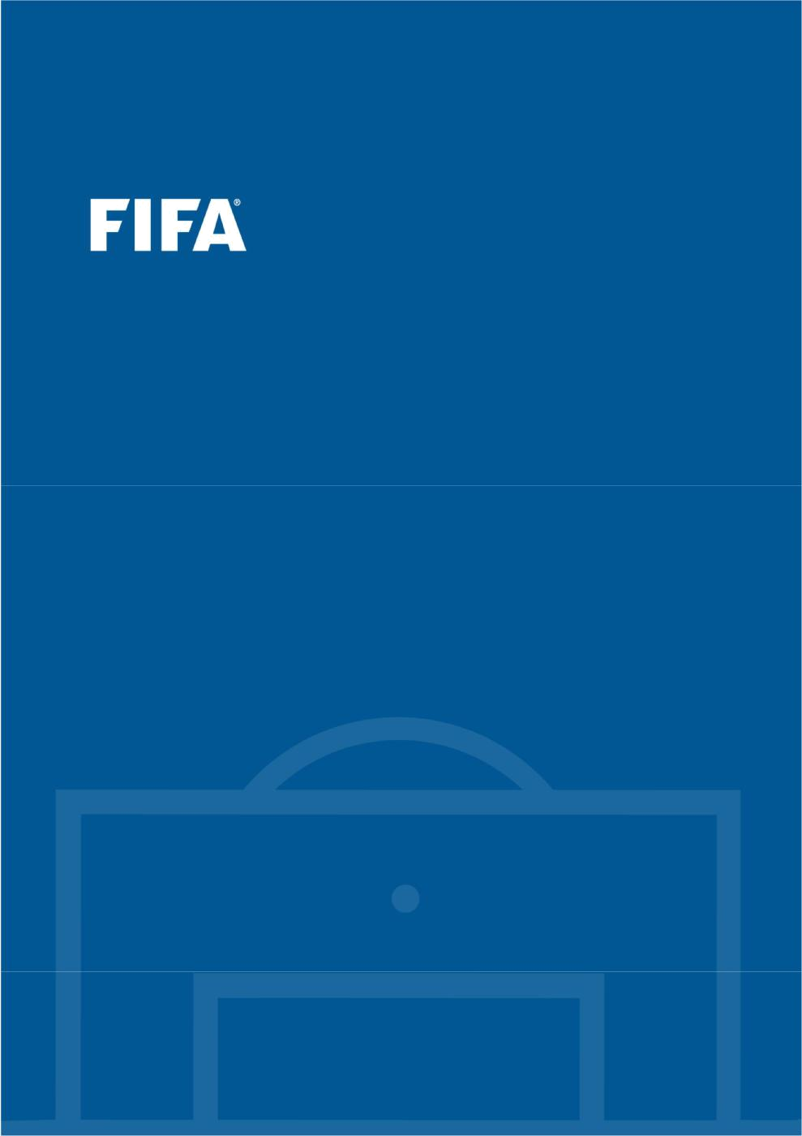

FIFA World Cup Qatar 2022™

Feasibility Study: Expansion of Format to 48 Teams

Contents

1 | Overview ............................................................................................................................................................ |  | 2
 | 1.1 | Background ................................................................................................................................................ | 2
 | 1.2 | Outline of this document .......................................................................................................................... | 2
 | 1.3 | Conclusion and key findings .................................................................................................................... | 3
2 | Expansion of the FIFA World Cup Qatar 2022: Context................................................................................ |  | 6
 | 2.1 | Representation ........................................................................................................................................... | 6
 | 2.2 | Participation and football development .................................................................................................. | 9
3 | Feasibility: A 48-team FIFA World Cup Qatar 2022 ..................................................................................... |  | 13
 | 3.1 | Format and duration ............................................................................................................................... | 13
 | 3.2 | Slot allocation and preliminary competition ......................................................................................... | 19
 | 3.3 | Legal considerations ................................................................................................................................ | 24
4 | Feasibility: A 48-team FIFA World Cup Qatar 2022 in Qatar alone ............................................................ |  | 27
 | 4.1 | Assessing host country feasibility ........................................................................................................... | 27
 | 4.2 | Key hosting requirements ....................................................................................................................... | 28
 | 4.3 | Overview of Qatar and a compact FWC ............................................................................................... | 33
 | 4.4 | Infrastructural considerations ................................................................................................................. | 42
 | 4.5 | Legal matters ........................................................................................................................................... | 44
5 | Feasibility: Mitigation options and key challenges ....................................................................................... |  | 45
 | 5.1 | Additional capacity .................................................................................................................................. | 45
 | 5.2 | Potential co-hosting ................................................................................................................................ | 47
 | 5.3 | Geopolitical considerations .................................................................................................................... | 50
 | 5.4 | Commercial considerations .................................................................................................................... | 52
 | 5.5 | Financial considerations .......................................................................................................................... | 60
 | 5.6 | Legal matters ........................................................................................................................................... | 66
6 | Feasibility study: Next steps and timeline ...................................................................................................... |  | 69
 | Annexe 1: Working options – 28-day match schedules .................................................................................. |  | 71
 | Annexe 2: Current estimations regarding timings for preliminary competition ............................................ |  | 75
 | Annexe 3: List of relevant stadiums currently known to FIFA in potential co-host countries ...................... |  | 76

FIFA World Cup Qatar 2022™ – Feasibility Study: Expansion of Format to 48 Teams | 1

1 Overview

1.1 Background

In April 2018, a proposal was made by the ten member associations of CONMEBOL to carry out a feasibility study into increasing the number of teams for the final competition of the FIFA World Cup Qatar 2022 from 32 to 48. This proposal was initially included as part of the agenda for the 68th FIFA Congress in Moscow on 13 June 2018 under Item 12.2.

The proposal was also placed on the agenda of meeting no. 7 of the FIFA Council, which took place in Moscow on 10 June 2018, where the matter was discussed at length. At the conclusion of the discussion, it was agreed that the proposal be withdrawn from the agenda of the 68th FIFA Congress in order to allow the FIFA administration to examine the matter in close cooperation with the key stakeholders in the appointed host country – Qatar - and provide a report to the FIFA Council at a subsequent meeting.

Accordingly, the FIFA administration has prepared this report.

1.2 Outline of this document

This report has been prepared by the FIFA administration to consider the feasibility of increasing the number of teams participating in the final competition of the FIFA World Cup Qatar 2022 from 32 to 48 and adopts the following structure:

- Section 2 examines an expansion to 48 teams in 2022 within the context of existing representation levels and highlights the benefits associated with increased participation in the FIFA World Cup.

- Section 3 assesses the feasibility of a 48-team tournament in the current conditions and independent of any host country considerations. It focuses primarily on the format in the context of a 28-day tournament duration, sporting balance and sporting quality considerations, slot allocations and impacts on the FIFA international match calendar (“FIMC”) and the confederation qualification processes (otherwise known as the “preliminary competition”), as well as any legal impacts associated with a change in format due to the existing legal framework already established.

- Section 4 assesses the feasibility of a 48-team tournament in the context of the appointed host country – Qatar. It outlines the key infrastructural requirements for hosting a 48-team FIFA World Cup and examines the potential capacity of Qatar to meet those requirements.

- Section 5 explores mitigation options to address any shortfall in capacity in the case of a 48-team tournament, including the potential co-hosting of the tournament with Qatar. In this respect, it also considers the geopolitical context as well as all relevant commercial, financial and legal implications arising from such a model.

- Finally, Section 6 outlines the proposed next steps and timeline in light of the key findings resulting from this feasibility study.

FIFA World Cup Qatar 2022™ – Feasibility Study: Expansion of Format to 48 Teams | 2

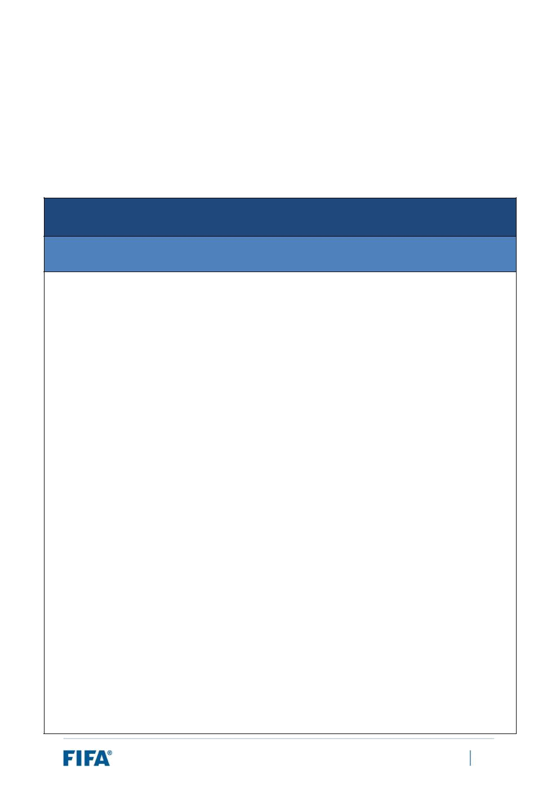
1.3 Conclusion and key findings

Set out in the table below is a summary of the key findings resulting from the detailed analysis contained in this report.

Based on the analysis contained in this report, and in particular the key findings as set out in this section, the FIFA administration has concluded that the expansion of the FIFA World Cup Qatar 2022 from 32 to 48 teams would be feasible, provided the requirements mentioned below are met.

Expansion of Format to 48 Teams for FIFA World Cup Qatar 2022

Key Findings of Feasibility Study

- The expansion of the FIFA World Cup – which has already been decided as of 2026 – would greatly increase the representation and inclusion of member associations, which would in turn increase the representation and inclusion of all stakeholders of football and the public at large, helping to promote the game globally in line with FIFA’s statutory objectives. In terms of representation levels, it would also be consistent with past expansions of the FIFA World Cup, as well as fully in line with recent expansions of confederation tournaments.

- A competition of the standard of the FIFA World Cup can lead to an improved performance of the participating teams in the future. Exposure to the FIFA World Cup also provides teams with higher revenues to reinvest in football development, such as enhancing the youth’s access to the sport. By bringing forward the expansion by one edition (i.e. from 2026 to 2022), it would give more member associations an earlier opportunity to realise the potential benefits in the area of football development that are associated with participation in a FIFA World Cup.

- An expansion of the tournament to 48 teams would see FIFA adopt the format approved for the FIFA World Cup 2026™ and would see no major concessions to the sporting quality of the tournament. Implementing this format under the reduced tournament duration of 28 days would require some adjustments to aspects of the match schedule, such as the number of rest days for teams and venues. However, these adjustments are consistent with the principles observed at confederation competitions or in the top leagues around the world. Furthermore, based on its analysis, FIFA believes that the challenges can be sufficiently mitigated, including by increasing the number of venues and matches per day.

- Implementing a 48-team tournament in 2022 would see each confederation guaranteed a higher slot allocation four years earlier than originally foreseen. Due to this sizeable increase, it is expected that most confederations would likely modify their qualification formats. Moreover, FIFA is aware that some confederations are already considering qualification format options for a 48-team tournament and developing workable proposals. To that end, clarity on a few key points should be obtained as soon as possible to enable the qualification formats to be finalised, approved by FIFA and communicated to qualifying member associations, in particular:

a. Confirmation of the format and slot allocation (as per the 2026 format).

FIFA World Cup Qatar 2022™ – Feasibility Study: Expansion of Format to 48 Teams | 3


  - In the event of a co-hosted tournament, confirmation as to whether some or all new co-hosts would automatically qualify (Qatar would qualify automatically as the main host).

- In terms of any legal considerations:

  - As the change in format would not result in a devaluation of the commercial rights in a material and substantial way, there is little risk in terms of legal exposure under FIFA’s commercial rights agreements.

  - With regard to the previously administered bidding process, the process did not exclude joint bids and the possibility of co-hosting was an option for all bidders from the outset. Therefore, there is little risk arising from bidders (or even other member associations) claiming that they could have bid for the hosting rights had they known that FIFA would contemplate co-hosting scenarios. Moreover, based on FIFA’s analysis and previous legal analysis, there is little risk of claims by bidders due to the change in format.

- With regard to host country feasibility, FIFA’s analysis demonstrates that hosting a 48-team FIFA World Cup in 2022 in Qatar alone would not be feasible.

In order to consider a 48-team tournament, FIFA and Qatar should explore a co-hosted tournament involving one or more neighbouring host countries. Based on parameters such as confederation membership, geographical proximity, stability, infrastructure and experience organising football tournaments, FIFA has identified the following countries that could potentially co-host the tournament alongside Qatar:

  - Bahrain

  - Kuwait

  - Oman

  - Saudi Arabia

  - The United Arab Emirates (UAE)

Any final selection and inclusion of such potential co-hosts alongside Qatar as the main host country would require the consent of Qatar and its key stakeholders. Such a proposal shall be developed jointly between FIFA and these key Qatari stakeholders.

- Due to the geopolitical situation in the region and the recent blockade that Bahrain, Egypt, Saudi Arabia, the UAE have imposed on Qatar, the involvement of such countries in organising a co-hosted tournament with Qatar would require the lifting of such blockade, in particular the lifting of all restrictions relating to the movement of people and goods between these countries. Ideally, this should be evidenced as a precondition to the appointment of such co-hosts and should cover all aspects related to the FIFA World Cup Qatar 2022.

- In financial terms, an expansion to 48 teams would generate an anticipated surplus of USD 262m, although a substantial part of that would be used to pay contributions to the additional 16 teams who would participate in the tournament. This is not so much an operational cost element as a financial benefit that goes directly back into football, via contributions to the additional participating member associations.

FIFA World Cup Qatar 2022™ – Feasibility Study: Expansion of Format to 48 Teams | 4



- FIFA’s analysis indicates that the decision to appoint any co-hosts alongside Qatar for the FIFA World Cup Qatar 2022 as proposed jointly by FIFA and Qatar would lie with the FIFA Congress and that the FIFA Congress, as FIFA’s supreme legislative body, would have the right to take such a decision. It is also acknowledged that Qatar, as the appointed host and main host in any co-hosted tournament, would jointly propose with FIFA such potential additional co-host countries to the FIFA Congress. Therefore, the

appointment of any co-host countries should be taken at the 69th FIFA Congress in June 2019. The FIFA administration has devised a potential four-step process and timeline for completing the feasibility exercise, with a final decision on expansion and co-hosts to be taken in June 2019 – see Section 6 of this report.

Next steps

As mentioned in Key Finding 9, further details on the next steps envisioned are outlined in Section 6 of this report. In particular, it is recommended that:

- At its upcoming meeting in March 2019, the FIFA Council should:

- Agree to the conclusion of this report that expanding the FIFA World Cup Qatar 2022 to 48 teams is feasible provided that neighbouring countries host some games (with Qatar as the main host country);

- Agree to proceed to the next stage of this process, whereby FIFA and Qatar (represented by the Supreme Committee for Delivery & Legacy and the Qatar Football Association (QFA)) shall jointly submit to the FIFA Council and the FIFA Congress respectively a valid proposal on expanding the tournament to 48 teams with one or more additional co-host nations (with Qatar as the main host country);

  - Acknowledge that the final decision on the expansion of the FIFA World Cup Qatar 2022 to 48 teams is a Congress decision.

- At its meeting in June 2019, the FIFA Council should:

  - Take a final decision either approving or rejecting the proposal for expansion of the tournament to 48 teams jointly submitted by FIFA and Qatar;

- In the case of approval of the jointly submitted proposal by the FIFA Council, the FIFA Council shall also then confirm the key competition aspects of the tournament, such as:

  - The format (as per the 2026 edition);

  - The slot allocation (as per the 2026 edition);

- Recommend – or not – to the FIFA Congress the additional appointment of any co-host countries

included in the proposal jointly submitted by FIFA and Qatar at the 69th FIFA Congress.

- The FIFA Congress should vote on whether to expand the FIFA World Cup Qatar 2022 to 48 teams with the appointment of co-host countries based on the proposal jointly submitted by FIFA and Qatar.

FIFA World Cup Qatar 2022™ – Feasibility Study: Expansion of Format to 48 Teams | 5

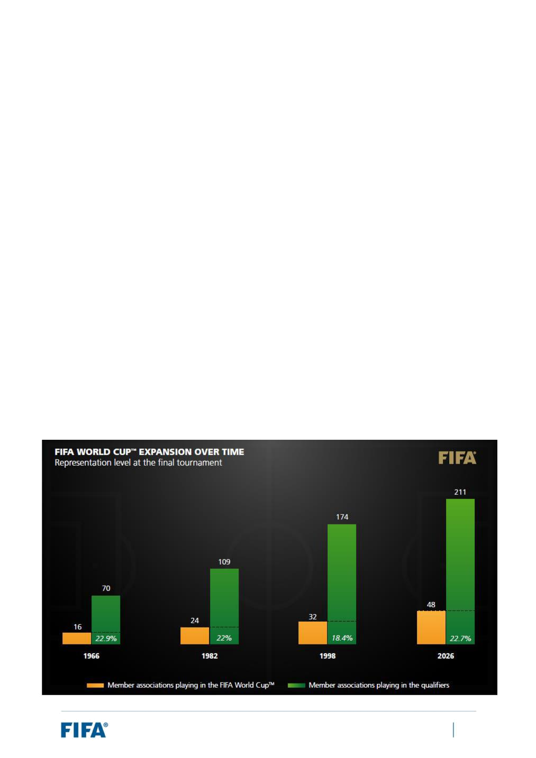
2 Expansion of the FIFA World Cup Qatar 2022: Context

2.1 Representation

Impact of expansion on representation levels: Previous analysis

The impacts of expanding the FIFA World Cup on representation levels were considered in detail as part of the report issued to the FIFA Council in December 2016, which analysed the expansion of the FIFA World Cup 2026.

For ease of reference, some of the key analysis from the 2016 report is provided below. FIFA’s methodology involved examining the trends in expansion, in particular taking into account the two preceding cases of expansion, occurring in:

- 1982 at the FIFA World Cup in Spain, where FIFA increased the number of teams from 16 to 24.

- 1998 at the FIFA World Cup in France, where FIFA increased the number of teams from 24 to 32.

FIFA then considered the impact of an expansion of the FIFA World Cup to 48 teams in reference to FIFA’s size (in terms of number of member associations).

The main results are illustrated below. The chart depicts the trend in the growth in the number of teams relative to the growth in the number of member associations participating in the FIFA World Cup qualification process, as well as the representation levels over time and after each expansion. The chart makes reference to teams participating in the qualifiers because there have been exceptional cases in the past where member associations have not participated in a FIFA World Cup qualification process.

FIFA World Cup Qatar 2022™ – Feasibility Study: Expansion of Format to 48 Teams | 6

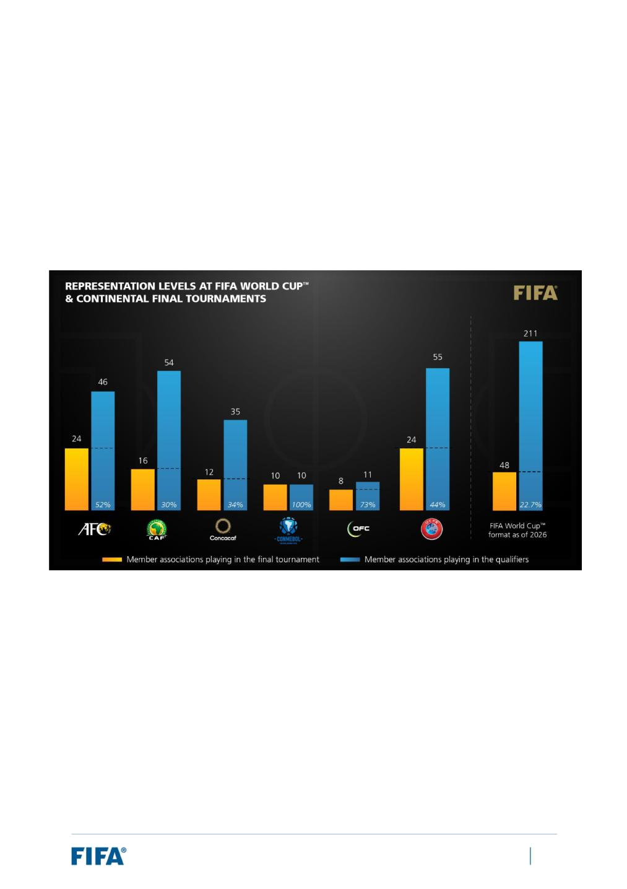
The analysis above illustrates that, in terms of representation, an expansion of the FIFA World Cup to 48 teams would be well in line with previous expansions made by FIFA – leaving representation levels in the range of 20%.

The proposition to expand became even more compelling when comparing the representation levels of the FIFA World Cup with the final competitions for each of the confederations (AFC Asian Cup, CAF Africa Cup of Nations, Concacaf Gold Cup, CONMEBOL Copa América, OFC Nations Cup and UEFA European Championship).

The chart below shows the representation levels of the confederation competitions as at 2016, compared against the expanded format:

Comparatively speaking, the analysis demonstrated that with an expansion of the FIFA World Cup to 48 teams, the representation levels would still be lower than for any of the confederation competitions, where representation ranges from around 30% to full representation.

Based in part on the observations above, the main conclusions drawn were that:

- The expansion of the tournament would increase the representation and inclusion of member associations in the final competition, which would in turn increase the representation and inclusion of all football stakeholders and the public at large, helping to promote the game globally in line with FIFA’s statutory objectives.

- In terms of representation, an expansion to 48 teams would be generally consistent with past expansions of the final competition (i.e. 1982 and 1998) in terms of representation of overall qualifying member associations (approximately 20%).

FIFA World Cup Qatar 2022™ – Feasibility Study: Expansion of Format to 48 Teams | 7


- When compared with the representation levels of member associations at the final competitions of each confederation (e.g. AFC Asian Cup, CAF Africa Cup of Nations, Concacaf Gold Cup, CONMEBOL Copa América, OFC Nations Cup and UEFA European Championship), an expansion to 48 teams would still equate to an underrepresentation of member associations.

These conclusions helped support the decision of the FIFA Council in January 2017 to expand the FIFA World Cup 2026 to 48 teams.

Impact of expansion on representation levels: FIFA World Cup Qatar 2022

Whilst the analysis conducted above related to the expansion of the 2026 edition of the FIFA World Cup and was conducted in 2016, it is equally applicable now and to the expansion of the FIFA World Cup Qatar 2022.

Indeed, the parameters either remain the same or further support an expansion in the number of teams to 48:

- FIFA still has 211 member associations.

- The size of the confederation tournaments has only increased or remained the same. For instance:

- The 2019 edition of the Concacaf Gold Cup will see an increase from 12 to 16 teams.

- The 2019 edition of the CAF Africa Cup of Nations will see an increase from 16 to 24 teams.

- The 2019 edition of the AFC Asian Cup saw an increase from 16 to 24 teams1.

Moreover, to expand the FIFA World Cup four years earlier than originally foreseen (2022 instead of 2026) is by no means an undue advancement of the expansion process when considering the fact that the last expansion (from 24 to 32 teams) took place in 1998, 24 years prior. For reference, there was an interval of only 16 years between FIFA’s expansion of the FIFA World Cup from 16 to 24 teams and the subsequent expansion from 24 to 32 teams.

These observations all strongly support the proposition that, in terms of representation levels of member associations, an expansion of the FIFA World Cup to 48 teams in 2022 would be consistent with past expansions of the FIFA World Cup as well as fully in line with recent expansions of confederation tournaments.

- This was already accounted for in the analysis regarding the expansion of the FIFA World Cup 2026 – see earlier chart.

FIFA World Cup Qatar 2022™ – Feasibility Study: Expansion of Format to 48 Teams | 8


2.2 Participation and football development

Impact of expansion on football development: Previous analysis

FIFA’s study into the expansion of the FIFA World Cup 2026 in 2016 also looked at the extent to which increasing the number of teams could impact upon football development, particularly in those countries and regions that would have an increased opportunity to participate in FIFA’s flagship event.

The analysis involved performing detailed case studies of countries. These case studies relied principally upon data related to member associations’ player registration systems and the FIFA/Coca-Cola World Ranking.

The results generally supported the statement that the FIFA World Cup presents a massive reward and recognition platform for investment in football that ultimately leads to stronger national team performances. Participation in the FIFA World Cup can also potentially unlock new avenues for development: increased funds for development (through the participation bonus), increased visibility of the national team providing additional opportunities for commercial partnerships, and enhanced participation in the sport locally prior to and following the competition.

For ease of reference, a summary of these case studies is provided below2.

Japan

Japan first qualified for a FIFA World Cup in 1998. Since then, their men’s national team have qualified for every FIFA World Cup. Following their first FIFA World Cup qualification, they steadily improved their ranking from 57th in 1999 to 15th in 2005. Since then, Japan have also consistently been a top performer in Asian football, most recently reaching the final of the 2019 AFC Asian Cup and having won the tournament on several occasions. Moreover, following their qualification for the 1998 edition, participation figures based on male player registrations showed a sharp increase in youth-level participation, from grassroots to U-19.

The next upswing, particularly in terms of participation at grassroots level, was observed in the period immediately following the 2002 FIFA World Cup, which Japan co-hosted with South Korea, a trend that was repeated after Japan’s 2010 FIFA World Cup™ participation, with the categories ranging from U-15 to U-19 recording consistently high participation. In fact, the FIFA Big Count 20063 ranked Japan among the top ten associations in the world in terms of participation in the game, with over a million registered players (male and female combined).

In Japan, the opportunity to participate in a FIFA World Cup for the first time generated a massive youth participation effect and overall interest in the game. Participation in the FIFA World Cup later helped to sustain this popularity, breeding new resources for investment in the development of football and leading to increased grassroots participation.

- Updated information, if considered relevant, has been included.

- https://www.fifa.com/mm/document/fifafacts/bcoffsurv/bigcount.statspackage_7024.pdf

FIFA World Cup Qatar 2022™ – Feasibility Study: Expansion of Format to 48 Teams | 9

Australia

Football’s popularity in Australia has traditionally faced staunch competition from other codes such as Australian Rules football and rugby, as well as several other sports (e.g. cricket). Australia’s second participation in the FIFA World Cup in 2006 (their first appearance in over 30 years) fuelled widespread popularity of the game and led to increased participation rates among young people. An important element in this was the role of the FIFA World Cup as a factor in the pre- and post-participation timeline, as illustrated by data covering the 2003-2009 period.

Football participation in the age categories of 15 years and above, for both males and females, grew by 31% between 2003 and 2009. The season immediately following the qualification for the 2006 FIFA World Cup™ saw an increase in participation of 10%, while more modest, grassroots participation also increased. In some parts of the country, grassroots participation has increased by almost 50% and has seen a growing number of football programmes in schools – heightened demand has led to an increase from one programme per year to two or three.

Ghana

According to the Ghana Football Association (GFA), Ghana’s first participation in the FIFA World Cup (in 2006), as in Australia, generated a significant boost in the popularity of the sport among young people. Ghana’s success at youth level, being the first African country to win the FIFA U-17 World Cup in 1991, also had a significant catalytic effect.

Since 2006, Ghana has participated in all FIFA World Cups with the exception of Russia 2018, and the GFA today struggles to keep up with the registration of the large numbers of youth players entering the system – starting at U-12 level. In 2016, the association began to track youth participation as a critical component of football development through its registration system.

Algeria

Between 2006 and 2010, the Algerian men’s national team rose from 80th to 26th in the FIFA/Coca-Cola World Ranking. This culminated in their participation in the 2010 FIFA World Cup. They then qualified for the FIFA World Cup again in 2014, when they were ranked 18th in the world. The opportunities presented by participating in the FIFA World Cups also trickled down to the Algerian domestic league, which is widely recognised as very competitive. For example, USM Alger were the runners-up in the 2015 CAF Champions League.

Today, Algeria presents ample opportunities for sound player pathways from grassroots to the top domestic league. The prospects offered by the FIFA World Cup helped cement efforts aimed at strengthening local football development through sustained commercial resources and the popularity of the game.

FIFA World Cup Qatar 2022™ – Feasibility Study: Expansion of Format to 48 Teams | 10

To conclude, the case studies helped highlight that:

- A competition of the standard of the FIFA World Cup can lead to an improved performance of the participating teams in the future. Exposure to the FIFA World Cup also provides teams with higher revenues to reinvest in football development, such as enhancing young people’s access to the game.

- The pre- and post-participation periods are critical when analysing the impact of the FIFA World Cup on football development in a country, such as through participation at youth level. The FIFA World Cup as a pull factor for development, offering a reward for increased investment and focus on football development locally, is significant.

Of course, it goes without saying that to fully capitalise on and harness the value of participating in a FIFA World Cup in achieving tangible development results, critical framework conditions need to be in place. This offers further opportunities for FIFA’s development work to generate an impact from countries’ participation in the tournament.

Impact of expansion on football development: FIFA World Cup Qatar 2022 and updated analysis

As with the analysis relating to representation levels, the analysis is equally applicable to the expansion of the FIFA World Cup Qatar 2022 as it is to the FIFA World Cup 2026. This is because it does not depend on the timing of the expansion. If anything, bringing forward the expansion by one edition (i.e. from 2026 to 2022) would give more member associations an earlier opportunity to realise the potential benefits in the area of football development that are associated with participation in a FIFA World Cup.

Furthermore, with regard to the analysis conducted, the case studies continue to be relevant examples of the potential impacts that participation in a FIFA World Cup can have on football development in a country. Indeed, there are also more recent cases that, for instance, further reinforce the assertion that participation in a FIFA World Cup can lead to an improved performance of the participating teams in the future.

Two obvious examples include the previous and upcoming hosts, Russia and Qatar:

Russia

The 2018 FIFA World Cup™ Debrief Report issued to the FIFA Council in October 2018 highlighted the tremendous impact that participating in the 2018 FIFA World Cup had on the Russian national team. From a footballing perspective, the national team had an outstanding tournament despite initially modest expectations following performances at UEFA EURO 2016 and in the friendly matches preceding the tournament, which culminated in a FIFA/Coca-Cola World Ranking of 70th (the lowest of all 32 participating teams). However, spurred on by a passionate fan base and their home advantage, the Sbornaya quickly exceeded those expectations and became the Cinderella story of the tournament. They hit the ground running with a 5-0 victory in the opening match against Saudi Arabia, which set the tone for the tournament, qualified for the knockout stage and then upset heavily favoured Spain in the round of 16, before finally crashing out in the quarter-finals after a thrilling penalty shoot-out loss to eventual finalists Croatia. There is no doubt that the team’s performances galvanised the home nation and captured the hearts of football fans around the globe.

FIFA World Cup Qatar 2022™ – Feasibility Study: Expansion of Format to 48 Teams | 11

It is expected that these exploits, combined with the various legacy-related projects during and after the tournament, will help inspire the next generation of Russian footballers to build on the platform established during the 2018 FIFA World Cup. As a consequence of their strong FIFA World Cup campaign and some of the positive results that have followed since the competition, Russia have already risen to 50th in the FIFA/Coca-Cola World Ranking, up 20 places from the start of the 2018 FIFA World Cup.

Qatar

The selection of Qatar as the host of the FIFA World Cup Qatar 2022 has had a conspicuous impact on the development of football in the country. The investments in the sport, both in terms of infrastructure and from a technical perspective, have been noteworthy, ranging from the eight world-class stadiums currently under construction (or already built) to the state-of-the-art training facilities which will serve as team base camps for participating teams and are already used frequently by top football clubs (i.e. the Aspire Academy).

All of this investment in infrastructure and football development has already translated into results on the pitch. Since 2010, when Qatar was appointed to host the FIFA World Cup Qatar 2022, the national team have risen 57 places in the FIFA/Coca-Cola World Ranking, from 112th up to 55th as at February 2019. The team’s recent success in winning their first AFC Asian Cup in the UAE earlier this year was a clear sign of the country’s continued growth as a football nation at the elite level, with the national team playing an attractive attacking style resulting in 19 goals scored (the most of any competing nation) and only one conceded across seven games. With the FIFA World Cup Qatar 2022 slightly under four years off, the potential is indeed promising.

FIFA World Cup Qatar 2022™ – Feasibility Study: Expansion of Format to 48 Teams | 12

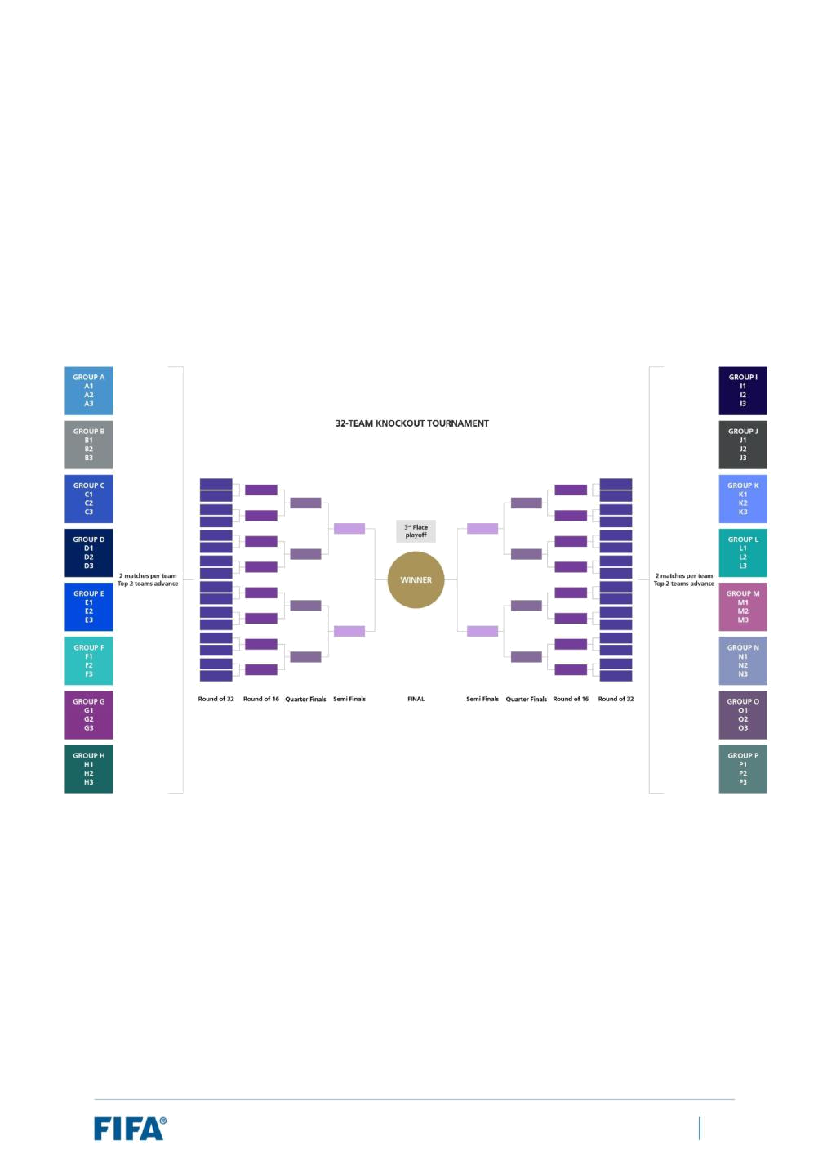
3 Feasibility: A 48-team FIFA World Cup Qatar 2022

3.1 Format and duration

Overview of format

With respect to the proposed format of a 48-team FIFA World Cup in 2022, the logical starting point for this feasibility study is to consider the format which was approved by the FIFA Council on 10 January 2017 in respect of the FIFA World Cup 2026.

For reference, a visual representation of the format is set out below:

In summary, it consists of two stages:

- Group stage:

- 48 teams are divided into 16 groups of three teams each.

- Within each group, each team plays each other once – two matches per team in total.

- A total of 48 matches are played during the group stage – the same as under the current 32-team format.

FIFA World Cup Qatar 2022™ – Feasibility Study: Expansion of Format to 48 Teams | 13

- Knockout stage:

- The top two teams of each group advance to the knockout stage – 32 teams from 16 groups.

- Each round of the knockout stage involves a single-leg knockout match. The rounds proceed as follows: round of 32, round of 16, quarter-finals, semi-finals and final. The knockout stage is therefore lengthened to begin with a round of 32.

- As under the current 32-team format, the two losers of the semi-final matches play a single-leg match to determine the third-placed team.

- A total of 32 matches are played during the knockout stage – 16 more than under the current 32-team format.

Overall, there are 80 matches played – 16 more matches than under the 32-team format. All 16 additional matches take place during the knockout stage (see table below):

 | Features |  |  | 32-team FWC - |  |  | 48-team FWC -
 | Features |  |  | 2018 |  |  | 2026
 | Matches (group) |  | 48 |  |  | 48
 | Matches (knockout) |  | 16 |  |  | 32
 | Matches (total) |  | 64 |  |  | 80

The sporting balance considerations of the 48-team format, as compared with the 32-team format, were described in detail in the report issued to the FIFA Council in December 2016. For ease of reference, a summary of these considerations can be seen below, applying a 28-day tournament duration:

 | Sporting Balance Considerations |  |  |  |  |  |  |  | 32-team FWC (2018 format) |  |  |  | 48-team FWC
 | Equal | number | of | matches | per |  |  |  | Each team plays 3 matches in the group |  |  | Each | team plays |  | 2 | matches | in | the
 |  |  |  |  |  |  |  |  | stage, and 1 match in each round of the |  |  | group | stage, | and | 1 | match | in | each
 | team
 | team |  |  |  |  |  |  |  | knockout stage |  |  | round of the knockout stage
 |  |  |  |  |  |  |  |  |  |  |  | Each team plays a maximum of 7
 | Same | number | of | matches | per |  |  |  |  |  |  | matches. Minimum of 2 matches per
 |  |  |  |  |  |  |  |  | N/A (as this is the current format) |  |  | team instead of 3 (this applies to only
 | team as under current format
 |  |  |  |  |  |  |  |  |  |  |  | 16 of the 48 teams since they are
 |  |  |  |  |  |  |  |  |  |  |  | eliminated during the group stage)
 | Even rest days for knockout-stage |  |  |  |  |  |  |  | Opponents have 3-4 rest days between |  |  | Apart | from | the |  | round | of | 32,
 |  |  |  |  |  |  |  |  |  |  |  | opponents |  | have | 3-4 rest |  |  | days
 | opponents |  |  |  |  |  |  |  | matches
 |  |  |  |  |  |  |  |  |  |  |  | between matches

FIFA World Cup Qatar 2022™ – Feasibility Study: Expansion of Format to 48 Teams | 14

 | Simultaneous kick-offs for the |  |  | Teams from the same group play their | This is not possible due to the odd
 | final group-stage match |  |  | final group match at the same time | number of teams per group
 |  |  |  | Winners/2nd-placed teams from each | Winners/2nd-placed teams from each
 | Non-comparison of results across |  |  | Winners/2nd-placed teams from each | group qualify, | regardless | of points
 | Non-comparison of results across |  |  | group qualify, regardless of points total | group qualify, | regardless | of points
 | groups |  |  | group qualify, regardless of points total | total compared | across the | different
 | groups |  |  | compared across the different groups | total compared | across the | different
 |  |  |  | compared across the different groups | groups
 | Fair allocation of opponents in the |  |  | In the round of 16, group winners play | In the round of 32, group winners play
 | next stage of the competition |  |  | 2nd-placed teams, and vice versa. | 2nd-placed teams, and vice versa.

The only sporting balance issues to consider were the uneven rest days for opponents during the group stage and round of 32 (as has been previously mentioned) and the lack of simultaneous kick-offs for the final match of the group stage (although there are possible mitigation measures to address this4).

In terms of sporting quality, this too was examined as part of the 2016 report to the FIFA Council examining expanded format options, with the current 32-team format and the approved 48-team format for the FIFA World Cup 2026 both analysed at length.

Whilst it was acknowledged from the outset that the “quality” perception of a format is highly subjective and difficult to measure, an objective approach to measuring sporting quality was applied in reference to the following three criteria:

- Absolute quality – the “quality” of the teams involved (which was measured by calculating the average quality/ranking of the teams per match);

- Competitive balance – the “uncertainty” of the result (which was measured by calculating disparity in team strength/ranking in the matches, thereby giving an indication of whether a match is more or less uncertain);

- Competition progress – the “importance” or “significance” of the match in the context of the competition (which was measured by calculating the extent to which a match has something “at stake” or is a “dead rubber” match).

As part of its methodology, FIFA measured the impacts of the approved 48-team format on the three components by performing approximately 10,000 simulations. The study ultimately concluded that expanding the format to 48 teams is feasible without any major concessions on the sporting aspects of the tournament.

- For instance, clear results at the end of each match through penalty shoot-outs, etc.

FIFA World Cup Qatar 2022™ – Feasibility Study: Expansion of Format to 48 Teams | 15

Tournament duration

In 2014, FIFA established a dedicated Task Force – the Task Force for the International Match Calendar 2018-2024 and the 2022 FIFA World Cup Qatar™ (”Task Force”) – to perform a detailed review of the FIMC for the 2018-2024 period. The primary objective of the Task Force was to examine viable options for the window designated for the FIFA World Cup Qatar 2022 and submit a proposal to the FIFA Executive Committee.

The Task Force comprised football’s key stakeholders, with representatives from the confederations, leagues, clubs, players and the host country all participating. Several meetings were held between September 2014 and February 2015, where a number of timing options were first raised and assessed to understand the potential impact on the conditions and wellbeing of players and spectators, the organisation of leagues and their calendars and the timings of future FIFA and confederation competitions as well as other major sporting events (e.g. Winter Olympics). Throughout the course of the discussions, all parties were required to make compromises on their interests in order to achieve a general consensus.

The stakeholder consultation process, administered through the Task Force, culminated in an initial proposal to the FIFA Executive Committee in February 2015. The Task Force recommended that the tournament be staged in the months of November and December 2022, with the final match to be played on 18 December (Qatar National Day). It also recommended that the tournament be played over a reduced timeframe compared to the typical 32-day duration. The FIFA Executive Committee followed the recommendations of the Task Force and confirmed both matters at its meeting on 19 March 2015.

Following further deliberations regarding the FIMC and the precise timing of the tournament, on 25 September 2015 the FIFA Executive Committee formally approved the FIMC for the 2018-2024 period, including the tournament dates for the FIFA World Cup Qatar 2022 – 21 November to 18 December 2022 (a 28-day period).

Given the extensive consultation process undertaken to reach a proposal on the tournament duration and start/end dates, it has been assumed that these approved dates will remain. In other words, for the purposes of assessing the feasibility of a 48-team FIFA World Cup Qatar 2022, it is assumed that the tournament will be played over 28 days between 21 November and 18 December 2022, as currently stipulated in the FIMC.

Match schedule considerations

FIFA’s analysis suggests that combining an increase in the number of matches with a shorter tournament duration would require some adjustments to aspects of the match schedule – see the table below:

 | :Match Schedule Principles |  |  | 32-team FWC - 2018 |  |  | 48-team FWC - 2026
 | :Match Schedule Principles |  |  | (28 days) |  |  | (28 days)
 | Number of rest days between matches |  |  | Adjusted |  |  | Adjusted
 | Teams from same group cannot meet |  |  | Observed |  |  | Observed
 | until the final/3rd-place play-off

FIFA World Cup Qatar 2022™ – Feasibility Study: Expansion of Format to 48 Teams | 16

 | Even rest days for knockout stage |  | Observed | Adjusted
 | opponents |  | Observed | Adjusted
 | Teams do not play in same stadium |  | Adjusted | Observed
 | twice during group stage |  | Adjusted | Observed
 | Max. matches per day |  | Observed | Observed/Adjusted*
 | Min. days between matches in venue |  | Adjusted | Adjusted

* This depends upon the match schedule option adopted.

Annexe 1 to this report presents the match schedule options devised for this 48-team format. The options include 12-stadium and ten-stadium scenarios, as opposed to an 8-stadium set-up for the 32-team format.

With regard to the number of rest days for teams, it is important to note that the 48-team format may result in reduced rest days between some matches for teams. For illustrative purposes, the match schedule options in Annexe 1 show the occasions where only two rest days are afforded to one or both teams (see the teams marked in red).

Nonetheless, it is worth noting that:

- Whether under the 32-team or 48-team format, teams are essentially playing a maximum of seven matches over a period of 28 days. In this aspect, there is no difference between the formats.

- Likewise, whether under the 32-team or 48-team format, teams essentially receive an average of three full rest days per match over the 28-day period (seven matches; 21 rest days).

- Due to the compact nature of the FIFA World Cup Qatar 2022 (see Section 4.3), team travel would be minimised and therefore allow for added rest time between matches.

- Scheduling can also be optimised to further add rest time between matches where necessary.

Moreover, there are various top professional leagues throughout the world (e.g. the English Premier League) and confederation tournaments where teams are sometimes afforded limited rest days between matches. In terms of confederation tournaments, we have seen cases where one finalist was only afforded two rest days between the semi-final and the final, such as at the following tournaments:

- UEFA EURO 2016

- AFC Asian Cup 2019

- CAF Africa Cup of Nations 2015

- OFC Nations Cup 2016

Notwithstanding, one measure to help address this aspect would be to increase the number of matches per day to a maximum of six in the early rounds of the tournament (as per the options included in Annexe 1). This would enable the group stage to be shortened and mitigate potential impacts during the knockout stage. Teams would have less rest between matches during the group stage (potentially two days), but would

FIFA World Cup Qatar 2022™ – Feasibility Study: Expansion of Format to 48 Teams | 17

also be significantly fresher. As can be seen from the 12-stadium and ten-stadium options in Annexe 1, 12 stadiums would be preferable in order to avoid matches in the same venue on consecutive days. In any event, with the implementation of world-class hybrid pitch technology, as is planned already in Qatar and would be expected at any proposed venue, the benefits of the additional stadiums relate primarily to alleviating the operational demands of achieving venue readiness on consecutive days.

A further option which was also considered was to remove the round of 32 altogether, thereby reducing the tournament back to 64 matches. However, due largely to the lack of commercial attractiveness of such a format, it was ultimately discounted. In conclusion, implementing the 48-team format with the reduced tournament duration of 28 days would require some adjustments to aspects of the match schedule, such as the number of rest days for teams and venues. However, these adjustments are consistent with the principles observed at confederation competitions or in the top leagues around the world. Furthermore, based on its analysis, FIFA is confident that any challenges can be sufficiently mitigated, including by increasing the number of venues and matches per day.

FIFA World Cup Qatar 2022™ – Feasibility Study: Expansion of Format to 48 Teams | 18

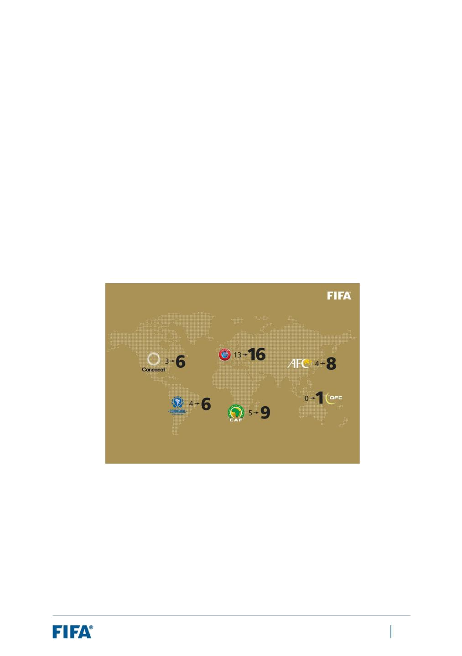
3.2 Slot allocation and preliminary competition

Overview of slot allocation

As an introductory remark, it should be noted that the FIFA Executive Committee confirmed the slot allocation for the FIFA World Cup Qatar 2022 on 30 May 2015 on the basis of a 32-team format. It is the same slot allocation as for the 2018 FIFA World Cup. Therefore, should there be a decision to increase the number of teams from 32 to 48, a new slot allocation would need to be formally confirmed by the FIFA Council.

In this respect, for the purposes of this feasibility study, it is assumed that an expansion of the FIFA World Cup Qatar 2022 to 48 teams would involve FIFA applying the slot allocation which was ratified by the FIFA Council on 9 May 2017 in respect of the FIFA World Cup 2026, with Qatar qualifying for a slot automatically as the main host nation. This would be the logical position and to assume otherwise would unduly complicate this study, as FIFA would need to then consider different slot allocations and the resulting impacts on the preliminary competition, commercial potential, etc.

For ease of reference, a summary of the slot allocation which was approved by the FIFA Council in May 2017 is set out below:

The diagram above illustrates the increase in direct slots awarded to each confederation based on the expansion of the tournament from 32 to 48 teams. The AFC and CAF receive four more slots, Concacaf and UEFA three more slots, CONMEBOL two more slots and OFC one slot to guarantee their participation in FIFA’s flagship tournament.

With regard to the host country, the host country automatically qualifies and its slot is taken from the quota of its confederation. In the case of co-hosting, the number of host countries to qualify automatically is to be determined by the FIFA Council.

The distribution accounts for 46 of the 48 slots, with an intercontinental play-off tournament to determine the remaining two participating teams (see next page):

FIFA World Cup Qatar 2022™ – Feasibility Study: Expansion of Format to 48 Teams | 19

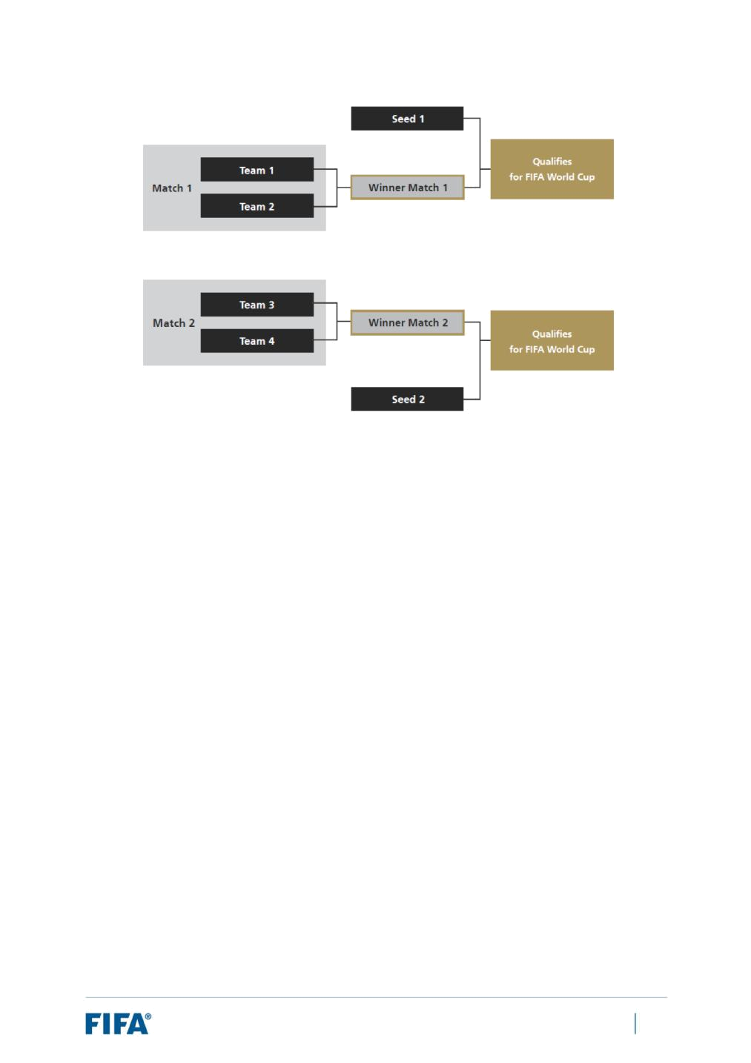

The play-off tournament is structured as follows:

- The tournament involves six teams:

- One team per confederation (with the exception of UEFA); and

  - One additional team from the confederation of the host country.

- Two of the teams are to be seeded based on the FIFA/Coca-Cola World Ranking (see “Seed 1” and “Seed 2” in the diagram above). The seeded teams will play for a FIFA World Cup berth against the winners of the first two knockout games involving the four unseeded teams.

- This play-off tournament is expected to be played in the host country and to be used as a test event for the FIFA World Cup.

Impacts: Confederation qualification formats

First and foremost, implementing a 48-team tournament in 2022 would see 16 additional slots distributed amongst the confederations on the basis set out above. Each confederation would increase its allocation. This adjustment to the slot allocations (whether direct slots or play-off slots) would naturally have a flow-on effect on the qualification formats of each confederation.

With the qualification formats for the FIFA World Cup Qatar 2022 (on the basis of a 32-team tournament) not yet confirmed for all confederations, FIFA has used the qualification formats for the 2018 FIFA World Cup as a reference point.

The change in slot allocation, together with the anticipated impact on the previous qualification process, is summarised on the next page – confederation by confederation:

FIFA World Cup Qatar 2022™ – Feasibility Study: Expansion of Format to 48 Teams | 20

 |  |  |  | 32-team |  |  |  |  |  | 48-team |  |  |  |  |  | Anticipated impact on qualification process
 | Confederations |  |  | FWC |  |  |  |  |  | FWC |  |  |  |  |  | Anticipated impact on qualification process
 | Confederations |  |  |  |  |  |  |  |  |  |  |  |  |  |  | (based on 2018 FWC)
 |  |  |  | Direct |  |  | PO |  |  | Direct |  |  | PO
 | AFC |  | 4 |  |  |  | 1 |  | 8 |  |  |  | 2 |  | Should be able to generally retain its existing qualification
 | AFC |  |  |  |  |  | 1 |  |  |  |  |  | 2 |  | structure if desired, however a new format is expected
 | CAF |  | 5 |  |  |  | 0 |  | 9 |  |  |  | 1 |  | Should be able to generally retain its existing qualification
 | CAF |  |  |  |  |  | 0 |  |  |  |  |  | 1 |  | structure if desired, however a new format is expected
 | Concacaf |  | 3 |  |  |  | 1 |  | 6 |  |  |  | 1 |  | Would likely need to develop a new format (in particular due
 | Concacaf |  |  |  |  |  | 1 |  |  |  |  |  | 1 |  | to impact on hexagonal round)
 | CONMEBOL |  | 4 |  |  |  | 1 |  | 6 |  |  |  | 1 |  | Should be able to retain its existing qualification format
 | CONMEBOL |  |  |  |  |  | 1 |  |  |  |  |  |  |  | (league system) if desired and would be expected to do so
 | OFC |  | 0 |  |  |  | 1 |  | 1 |  |  |  | 1 |  | Should be able to generally retain its existing qualification
 | OFC |  |  |  |  |  | 1 |  |  |  |  |  | 1 |  | format if desired and would be expected to do so
 | UEFA |  | 13 |  |  |  | 0 |  | 16 |  |  |  | 0 |  | Should be able to generally retain its existing qualification
 | UEFA |  |  |  |  |  | 0 |  |  |  |  |  | 0 |  | format if desired

In the case of Concacaf, the final round of qualifying for the 2018 FIFA World Cup (round 5 – known as the “hexagon”, where six teams participate in a round-robin competition home and away over the course of one year) would be needless for the FIFA World Cup Qatar 2022 as seven teams would need to qualify from the process (six automatically and one for the play-off tournament). With respect to CAF qualifying, it may be feasible to adopt a similar structure to the process applied for the 2018 FIFA World Cup as there are ten teams which would need to qualify (nine automatically and one for the play-off tournament) instead of five, and the final round of qualifying involved five groups of four teams each. Nonetheless, an update to the format would be expected, also addressing how to distinguish between the nine direct slots and one play-off slot.

With respect to the AFC, the substantial increase in slots is expected to lead to a change in at least the final round of the previous qualification format. Previously, 12 teams competed for five slots (four direct and one play-off). The top two teams from each group of six would qualify automatically and the two third-placed teams in each group would play off for a spot in the intercontinental play-off. With eight direct slots and two play-off slots (by virtue of being the host confederation), 12 teams competing for ten slots may lack the competitiveness desired. Additionally, in the event of a co-hosted tournament (see Section 5), the FIFA Council should confirm whether all host countries would automatically qualify, as these slots would be taken from the quota for the AFC and thereby impact upon the number of open slots and the optimal qualification format.

Finally, whilst qualification formats for the FIFA World Cup Qatar 2022 have not been confirmed, FIFA is aware that some confederations (e.g. AFC, CAF and Concacaf) are developing/have developed their proposed qualification processes. Based on initial information shared, some of these proposals would need to be amended due to the issues raised above.

FIFA World Cup Qatar 2022™ – Feasibility Study: Expansion of Format to 48 Teams | 21


To conclude, implementing a 48-team tournament in 2022 would see each confederation guaranteed a higher slot allocation four years earlier than originally foreseen. Due to this significant increase in slots allocated, it is expected that most confederations would likely modify their qualification formats, in particular AFC, CAF and Concacaf. Moreover, FIFA is aware that some confederations are already considering qualification format options for a 48-team tournament and developing workable proposals.

Impacts: Timing of Preliminary Competition

As explained above, the confederations are yet to formally confirm their proposed qualification processes for the FIFA World Cup Qatar 2022, and therefore no qualification processes have commenced. Moreover, whilst the FIMC currently stipulates that the preliminary draw shall be staged in July 2019, the timing is currently under review, with both the structure and timing of the draw expected to change. Notwithstanding, FIFA has sought to use the latest available information provided by the confederations regarding timing as a reference point. Where such information has not been made available, FIFA has relied upon the timings of the confederation qualification processes for the 2018 FIFA World Cup5 as a base.

Set out in Annexe 2 to this report is an extrapolation of the potential timings for the qualification processes of the confederations.

As can be seen from the chart:

- The process for UEFA is expected to commence during 2021;

- The processes for Concacaf, CONMEBOL and the OFC are expected to commence during 2020; and

- The processes for the AFC and CAF are expected to commence during 2019.

In relation to the processes expected to commence in 2019, CAF is not forecast to begin until late 2019 (i.e. in or around the September 2019 window). In the case of the AFC, its qualification process for the 2018 FIFA World Cup commenced in the March 2015 window, which is currently expected to translate to the June 2019 window in respect of the FIFA World Cup Qatar 20226. Moreover, it is anticipated that its qualification format would change due to the sizeable increase in slots, whilst a co-hosted tournament scenario would also require confirmation from the FIFA Council as to whether all host countries would automatically qualify. That said, there may be the flexibility to commence round 1 of the qualification process without final confirmation of the confederation slots, and then amend subsequent rounds once confirmed.

- With adjustments made due to the fact that the FIFA World Cup 2018 took place in June/July whilst the FIFA World Cup 2022 will take place in November/December, some five months later.

- The later date accounts for the later start due to the November/December 2022 timing of the tournament

FIFA World Cup Qatar 2022™ – Feasibility Study: Expansion of Format to 48 Teams | 22

The result of the above analysis is that:

- Clarity on a few key points should be obtained sooner rather than later to enable the qualification formats of each confederation to be finalised, approved by FIFA and communicated to qualifying member associations, in particular:

- confirmation of the format and slot allocation (as per the 2026 format);

  - in the event of a co-hosted tournament, confirmation as to whether some or all co-hosts would automatically qualify.

- In terms of timing, each confederation would ideally need such clarity in advance of the following dates:

  - AFC – the June 2019 window (round 1) or otherwise potentially the September 2019 window (round 2);

- CAF – the September 2019 window;

- CONMEBOL – the March 2020 window;

- Concacaf and OFC – the September 2020 window;

- UEFA – the March 2021 window.

Finally, with respect to the play-off tournament for the final two slots under the 48-team format, a window within the FIMC would need to be identified for this tournament, prior to the final draw currently scheduled to take place in April 2022. The window currently scheduled for 21-29 March 2022 may serve as a suitable option.

FIFA World Cup Qatar 2022™ – Feasibility Study: Expansion of Format to 48 Teams | 23

3.3 Legal considerations

Introduction

As alluded to in Section 1.2 of this report, an expansion of the FIFA World Cup Qatar 2022 from 32 to 48 teams has legal implications in terms of the existing legal framework established for the tournament. A bidding process for the selection of host was conducted, the hosting structure was defined, and relevant commercial agreements have been concluded.

Each of these matters was considered by FIFA. A summary of the analysis can be found below.

Previously administered bidding process

As previously mentioned, the hosting rights of the FIFA World Cup Qatar 2022 were awarded in accordance with a bidding process administered by FIFA between 15 January 2009 and 2 December 2010, concluding with the appointment of Qatar as the host country. As such, it is necessary to consider whether there are any legal constraints to expanding the tournament to 48 teams arising from the previously administered bidding process.

One consideration to take into account is that Qatar, on the basis of its appointment in December 2010 as the host of the FIFA World Cup Qatar 2022, has invested significantly in the preparation of the tournament. As such, any decision on the alteration of the FIFA World Cup Qatar 2022 shall be agreed together with Qatar as the appointed host nation, and any new proposals must be prepared jointly between FIFA and Qatar.

As concerns the potential issue of whether bidding member associations (from the original bidding process) not selected to host the FIFA World Cup Qatar 2022 and/or any third parties (in particular bid sponsors appointed by such bidding member associations) could have any claims against FIFA for a decision to expand the tournament to a 48-team format, it should be noted that FIFA previously undertook an in-depth study, in consultation with external legal counsel, on the similar issue of whether such bidding member associations and/or any third parties would have any claims against FIFA. This study examined, inter alia, the potential scope of claims FIFA could face from bidding member associations and/or any third parties on contractual grounds, quasi-contractual grounds and under tort.

In short, the conclusion of the study as concerns the bidding member associations was:

- that the Bid Registrations and Bidding Agreements have expired;

- that the bidding member associations agreed to the eventual outcome of the bidding process and to waive any claims against FIFA in such regard;

- that the bidding member associations agreed that FIFA could make changes to the bidding process;

- that the Hosting Agreement was a unilaterally signed document (for all bidding member associations other than Qatar) and therefore would not have contractual effect.

FIFA World Cup Qatar 2022™ – Feasibility Study: Expansion of Format to 48 Teams | 24

As concerns the sponsors of such bidding member associations, although their sponsorship agreements may not have expired, FIFA would argue that such agreements do not constitute valid contractual grounds for claims because such documents do not stipulate any obligations that FIFA could have breached.

Therefore, whilst one cannot rule out the possibility of contractual claims from any such parties, the study concluded that the risk was low. The study furthermore determined that the risk from bidding member associations and associated third parties under quasi contractual headings (culpa in contrahendo) and under tort (pursuant to Swiss law) was also low.

Consequently, it is FIFA’s view that these principles and positions would similarly apply to any decision to amend the format of the competition to 48 teams, resulting in a low level of legal risk to FIFA.

Impacts: Commercial rights

Another relevant legal consideration concerns the extent to which an expansion from 32 to 48 teams and the resulting change in format gives rise to any legal exposure under FIFA’s various agreements with its Commercial Affiliates, Media Rights Licensees (“MRLs”) and other counterparties to agreements concerning FIFA’s commercial rights. This is discussed below, split on the basis of revenue stream.

Media rights

The media rights agreements (“MRAs”) do not contemplate a renegotiation of the rights fee in the event of a change to the format of the FIFA World Cup Qatar 2022. Instead, FIFA is generally contractually prevented from amending the format of the FIFA World Cup Qatar 2022 to the extent that such changes serve to devalue the media rights in a material and substantial way.

It should be noted that FIFA has yet to confirm the match schedule for the FIFA World Cup Qatar 2022. On that basis, a 48-team format would not represent an amendment (i.e. to the existing format) but rather a formal confirmation of FIFA’s chosen format for the FIFA World Cup Qatar 2022. However, it should be acknowledged that, to date, the media rights have been tendered, sold and valued on the basis of the current format of 32 teams playing 64 matches.

With the above in mind, broadcasters could seek to protect the value of their investments by seeking to prevent, on a contractual level, a move to a 48-team format in the event that it was perceived to devalue their rights. It is fundamental, therefore, to understand the potential impact on the value of the media rights presented by the format under consideration.

As previously noted, the perceived quality of a tournament format is highly subjective and difficult to measure. However, it was noted earlier in this report (see Section 3.1) that FIFA’s analysis in 2016 ultimately concluded that expanding the format to 48 teams is feasible without any major concessions on the sporting aspects of the tournament. Indeed, FIFA believes that the introduction of an additional round during the knockout stage (and with it an additional 16 high-profile matches) serves to increase the value of the acquired rights. Therefore, it would be difficult for a broadcaster to argue that the value of its rights had been substantially and materially devalued as a result of this format. Actually, the contrary is the case.

FIFA World Cup Qatar 2022™ – Feasibility Study: Expansion of Format to 48 Teams | 25

With regard to existing agreements entered into between FIFA and MRLs, it should be noted that the media rights are granted in relation to all matches of a given competition. Any amendments to the format must not alter the basic principle that FIFA has granted the media rights to the broadcasters. For this reason, for the purposes of this feasibility study, FIFA has not assumed that it could command additional rights fees from its existing broadcasters, even if this is obviously subject to further discussions with broadcast partners who would receive additional games to broadcast. This is reflected in Section 5.4 of this report when considering the potential additional revenue that could be generated from an expansion of the tournament.

In relation to the option of condensing the early rounds by increasing the number of matches per day up to six, the introduction of six separate kick-off slots may widen FIFA’s opportunity to place matches during windows of time that are optimal to the audience of the territories of the participating teams. This would need to be carefully considered and assessed on a market-by-market basis. FIFA would also need to explore the delivery of six matches per day with broadcasters as some may face challenges to accommodate as many as six separate kick-off times per day and FIFA may need to consider revisions to its broadcast obligations with respect to the additional matches.

Marketing rights

From a purely legal perspective, the general base position under the Commercial Affiliate agreements is that FIFA has a general right to amend the format of the FIFA World Cup Qatar 2022.

However, it should be noted that in certain Commercial Affiliate agreements there is on paper a restriction on FIFA’s ability to make changes to the format of the tournament after a certain date (which has already passed - in 2012). On this basis, on an academic level, this could be argued as acting as an outright bar to changing the format (irrespective of which option is selected). However, in reality the situation is that the relevant Commercial Affiliates would be very unlikely to oppose a change in the format which is perceived to be to their benefit. As such, the perception of the Commercial Affiliates towards the value of the format option selection (relative to the current 32-team format) would be determinative in whether any objection is raised.

Notwithstanding FIFA’s general right to make changes to the format of the FIFA World Cup Qatar 2022 (subject to the above-mentioned cut-off date, by which Commercial Affiliates would have had to be informed of changes), the broad position under the Commercial Affiliate agreements (and the safest position to assume in terms of analysis) is that, where FIFA implements a change to the format of the FIFA World Cup Qatar 2022 and such a change represents a material reduction of the value of any of the rights and benefits granted to the relevant commercial affiliate, there is an obligation to discuss a potential amendment to the consideration to be paid under the respective agreement or to grant additional rights in compensation. However, that is not expected to be the case here, given that the 48-team format would increase the value of the Commercial Affiliates’ rights.

Hospitality rights

Based on FIFA’s analysis, there would appear to be no express provisions under the hospitality rights holder agreement that require the FIFA World Cup to follow a particular format.

FIFA World Cup Qatar 2022™ – Feasibility Study: Expansion of Format to 48 Teams | 26

- Feasibility: A 48-team FIFA World Cup Qatar 2022 in Qatar alone

4.1 Assessing host country feasibility

Section 3 of this report examined the feasibility of expanding the FIFA World Cup Qatar 2022 to 48 teams irrespective of the host country. In other words, is it feasible to organise a 48-team FIFA World Cup in 2022 over 28 days and in light of the status of the confederation qualification processes (and the changes to the slot allocation)? This question must be considered first because, should it not be feasible to organise a 48-team FIFA World Cup in such conditions, then any discussion regarding the host country conditions becomes irrelevant.

Based on the analysis outlined in Section 3, a conclusion of this feasibility study is that to organise a 48-team FIFA World Cup in 2022, applying the format approved for the 2026 edition and staging the competition over 28 days, would be feasible.

In assessing the host country’s feasibility to organise an expanded FIFA World Cup, FIFA has sought to measure the infrastructural capacity of Qatar against the requirements for hosting a 48-team FIFA World Cup. Whilst FIFA has not yet organised a 48-team FIFA World Cup, it has recently defined its high-level hosting requirements for such a tournament as part of the bidding process for the FIFA World Cup 2026, which was administered between May 2017 and June 2018. These requirements will serve as the basis for assessing Qatar’s capacity for organising a 48-team FIFA World Cup and are outlined in Section 4.2. In terms of evaluating the capacity of Qatar, FIFA has taken the planned capacity in Qatar as at 2022, generally assuming the timely completion of planned and ongoing major infrastructure projects. Section 4.3 provides a detailed overview of Qatar’s planned capacity.

Also relevant to the host country’s feasibility are the legal risks and impacts, if any, associated with an expansion of tournament to 48 teams given the existing legal framework established between FIFA and all key local stakeholders over the period between Qatar’s appointment on 2 December 2010 and the present (i.e. the QFA; the Supreme Committee for Delivery & Legacy; the national government; host cities; stadium and training site authorities; third parties, etc.).

FIFA World Cup Qatar 2022™ – Feasibility Study: Expansion of Format to 48 Teams | 27


4.2 Key hosting requirements

Introduction

As mentioned above, FIFA defined its high-level hosting requirements for the FIFA World Cup 2026 as part of the bidding process for the tournament which was conducted between May 2017 and June 20187. The 2026 edition of the FIFA World Cup will be a 48-team tournament and as such its hosting requirements can serve as a benchmark for considering the infrastructural and operational capacity of Qatar to host a 48-team FIFA World Cup.

It should be noted that because of the reduced tournament duration (28 days instead of a minimum of 32 days), some of the peak requirements regarding infrastructure and operations would be elevated due to the greater intensity of activities. For instance, an increased frequency of matches can result in increased movement/lodging of FIFA constituent groups and the general public, translating to greater peak demands for guest rooms in hotels and passenger traffic at airports and on public transport.

Requirements: Inventory of Key Sites

The table below summarises the high-level hosting requirements for the FIFA World Cup 2026 in terms of the minimum inventory of key official sites needed – otherwise referred to as the “tournament footprint”. This is important, since one of the starting points for assessing feasibility from an infrastructural perspective is to understand the pool of large-scale sites required to deliver a FIFA World Cup. Any absence of existing sites would involve either the construction of new sites or otherwise a reformulation of the approach for the delivery of the tournament.

 | Key sites |  |  | Requirements: 48-team FWC (2026)
 | Key sites |  |  | Proposed Inventory |  |  |  | Min. Required Inventory
 | Host Cities* |  |  | 14-16 |  |  |  | 12
 | Stadiums |  |  | 14-16 |  |  |  | 12
 | Team and Referee Base Camps |  |  | 74 |  |  |  | 49
 | Venue-Specific Facilities |  |  | 48 |  |  |  | 36
 | Accommodation (Guest rooms) |  |  |  | 65,000
 | IBC |  |  | 2 |  |  |  | 1
 | FIFA Fan Fests** |  |  | 28-32 |  |  |  | 12

- Number of Host Cities may be lower where Host Cities have multiple stadiums.

- Number of FIFA Fan Fest sites required is one per Host City. Fewer are required if any Host Cities have multiple stadiums.

The table above includes two different columns: “Min. Required Inventory” and “Proposed Inventory”. The “Min. Required Inventory” column refers to the number of sites that must be provided by the host country/host countries in order to meet FIFA’s minimum requirements for delivering the tournament. The

- At its meeting in May 2017, the FIFA Council approved the document entitled “2026 FIFA World Cup™: Process for Selection of Member Associations” (“Overview Document”), which contained a high-level description of certain key hosting requirements. FIFA subsequently elaborated its tournament hosting requirements in the bidding and hosting documents issued to the bidding member associations in October 2017. Lastly, FIFA published the “Overview of the scoring system for the technical evaluation of bids” (“Scoring System Document”) in March 2018, which identified the minimum hosting requirements for the purposes of assessing all bids received. These various documents were used as sources for the information contained in this section.

FIFA World Cup Qatar 2022™ – Feasibility Study: Expansion of Format to 48 Teams | 28


“Proposed Inventory” column refers to the number of sites which must be proposed by the host country/host countries to ensure that FIFA can conduct a competitive selection process. For instance, FIFA expects to select a minimum of 12 stadiums at the conclusion of its stadium selection process, however the host country/host countries must propose a minimum of 14 stadiums to enable FIFA to conduct its selection process8. Similarly, FIFA requires a minimum of 49 team and referee base camps9 and 36 venue-specific team facilities10; however, the host country/host countries are required to propose a minimum of 74 team and referee base camps11 and 48 venue-specific team facilities12.

You will notice that in the case of accommodation, there is no distinction drawn between requirements for the proposed number of sites and the minimum final number of sites. This is because FIFA does not conduct a formal selection process in respect of this area.

Requirements: Capacities of Key Sites

Also relevant to assessing feasibility is not only the number of sites required but their minimum scale or capacity. For example, prospective host countries may have a sufficient number of stadiums or training sites; however, these sites may not be suitable in terms of their capacity for hosting the FIFA World Cup (i.e. insufficient seating capacity, insufficient number of pitches at a training site, etc.).

The table below summarises some of the key information relating to site capacity based on the high-level hosting requirements for the FIFA World Cup 2026:

 | Component |  |  | Requirements
 |  |  |  | Stadiums
 |  |  |  | Opening match |  |  |  | 80,000
 |  |  |  | Remaining group-stage matches |  |  |  | 40,000
 |  |  |  | Round of 32 |  |  |  | 40,000
 | Minimum Net Seating Capacities |  |  | Round of 16 |  |  |  | 40,000
 | Minimum Net Seating Capacities |  |  | Quarter-finals |  |  |  | 40,000
 |  |  |  | Semi-finals |  |  |  | 60,000
 |  |  |  | 3rd-place play-off |  |  |  | 40,000
 |  |  |  | Final |  |  |  | 80,000

- The Overview Document and bidding/hosting documents describe the requirements relating to the number of stadiums. They explain that a host (or hosts) can confirm its/their intent to host the tournament in more than 12 stadiums, in which case an additional 2-4 stadiums must always be proposed to preserve the ability to conduct a selection process. Where a host (or hosts) confirm its/their intent to host the tournament in fewer than 12 stadiums, an additional 2-4 stadiums must also be proposed, along with a feasibility and impact study based on a risk and opportunity assessment. However, the Scoring System Document applies a minimum requirement of 12 stadiums.

- One per team + one for the referees.

- Three per stadium (one per team + one back-up) and assuming a 12-stadium tournament. The final number of venue-specific team facilities is to be determined by FIFA based on the training site concept developed on the basis of the competition format and match schedule.

- Seventy-two team base camps and two referee base camps.

- Four per stadium and assuming a 12-stadium tournament.

FIFA World Cup Qatar 2022™ – Feasibility Study: Expansion of Format to 48 Teams | 29

 |  |  |  | Team & Referee Facilities
 | Team Base Camp Training Sites |  |  | 48 (min. 2 pitches)
 | Team Base Camp Hotels |  |  | 48 (min. 80 guest rooms per proposed hotel)
 | Venue-Specific Training Sites |  |  | 48 (min. 2 pitches)
 | Venue-Specific Team Hotels |  |  | 48 (min. 80 guest rooms per proposed hotel)
 | Referee Base Camp Training Sites |  |  | 1 (min. 2 pitches)
 | Referee Base Camp Hotels |  |  | 1 (min. guest 200 rooms per proposed hotel)
 |  |  |  | Accommodation
 |  |  |  | Opening match and FIFA Congress |  |  |  | 5,010
 |  |  |  | Remaining group-stage matches |  |  |  | 1,760
 | FIFA Constituent Groups |  |  | Round of 32 |  |  |  | 1,760
 | Accommodation: Peak
 | Accommodation: Peak |  |  | Round of 16 |  |  |  | 1,760
 | Requirements (Guest Rooms per
 | Requirements (Guest Rooms per |  |  | Quarter-finals |  |  |  | 3,060
 | Proposed Host City) |  |  | Quarter-finals |  |  |  | 3,060
 |  |  |  | Semi-finals |  |  |  | 6,280
 |  |  |  | 3rd-place play-off |  |  |  | 3,060
 |  |  |  | Final |  |  |  | 8,080
 |  |  |  | Opening Match and FIFA Congress |  |  |  | 6,499
 |  |  |  | Remaining group-stage matches |  |  |  | 3,824
 | General Accommodation: Peak |  |  | Round of 32 |  |  |  | 3,824
 | General Accommodation: Peak |  |  | Round of 16 |  |  |  | 3,824
 | Requirements (Guest Rooms per |  |  | Round of 16 |  |  |  | 3,824
 | Proposed Host City) |  |  | Quarter-finals |  |  |  | 3,694
 |  |  |  | Semi-finals |  |  |  | 6,372
 |  |  |  | 3rd-place play-off |  |  |  | 3,694
 |  |  |  | Final |  |  |  | 6,192
 | Accommodation User Groups: |  |  | Host City with proposed IBC |  |  |  | 4,000
 | Additional Guest Rooms |  |  | location |  |  |  | 4,000
 |  |  |  | IBC
 | Indoor Space (m2) |  |  | 45,000

FIFA World Cup Qatar 2022™ – Feasibility Study: Expansion of Format to 48 Teams | 30

 |  |  |  | FIFA Fan Fests
 |  |  |  | Host Cities for all matches |  |  | 15,000
 | Site Capacity (Occupancy) |  |  | (except final) |  |  | 15,000
 |  |  |  | Host City for final |  |  | 40,000

In some areas, FIFA sets minimum capacities based on match categorisation. For instance, FIFA sets a minimum net seating capacity of at least 80,000 for the stadiums hosting the opening and/or final matches, whilst all other matches only require a minimum net seating capacity of 40,000 up until the semi-finals, when the number increases to 60,000. Accommodation is another area where match categorisation affects capacity, with the Host Cities hosting the opening and/or final matches requiring significantly more guest rooms to cater for both FIFA constituent groups and the general public than Host Cities hosting matches during the earlier rounds of the tournament (i.e. group stage, round of 32, round of 16, etc.). Accommodation capacity is also heavily affected by the location of the FIFA Congress and IBC, both of which require added inventory to service the FIFA Congress delegates, media, etc.

Taking the topic of stadiums as an area for further discussion, the net seating capacity of a FIFA World Cup stadium reflects the seating capacity after the deduction of seat kills and seats with view obstructions and excludes the media and VIP tribunes. In respect of seat kills/view-obstructed seats, FIFA applies a contingency of 5% based on its experience from previous FIFA World Cups, although the final number will be determined by FIFA and depends upon factors such as the stadium design and match category. Combined with the deductions for the media and VIP tribunes, the gross seating capacity of a stadium represents a figure somewhere in the order of 15% above the net seating capacity. So, in the example of a stadium hosting only group-stage matches, FIFA calculates that for a stadium to meet a minimum net seating capacity of 40,000, it would need to have a gross seating capacity of approximately 45,290.

Detailed hosting requirements

The information presented above is only a snapshot of the requirements in terms of inventory and capacities for key sites used during the tournament. It is important to bear in mind that they only represent a very small part of the overall requirements for hosting a 48-team FIFA World Cup. FIFA defines detailed requirements and specifications across a number of components with respect to all relevant sites and activities relating to the delivery of the tournament.

Taking the topic of stadiums as an example, when considering a stadium’s suitability, FIFA applies a number of requirements across various aspects of a stadium, including:

- Exclusive use and clean site obligations;

- Stadium orientation;

- Stadium roofing;

- Competition areas (e.g. field of play and pitch areas, dressing rooms, warm-up areas, medical and doping control rooms, etc.);

FIFA World Cup Qatar 2022™ – Feasibility Study: Expansion of Format to 48 Teams | 31

- Space requirements (e.g. media spaces, VIP/VVIP spaces, indoor and outdoor hospitality spaces, commercial display areas, broadcast compounds, ICT compounds, accreditation centres, volunteer centres, logistics compounds, waste compounds, etc.);

- Technical installations/services (e.g. power, cabling, floodlighting, giant screens, etc.);

- Transport and parking;

- Accessibility and sustainability;

- Human rights requirements.

FIFA World Cup Qatar 2022™ – Feasibility Study: Expansion of Format to 48 Teams | 32

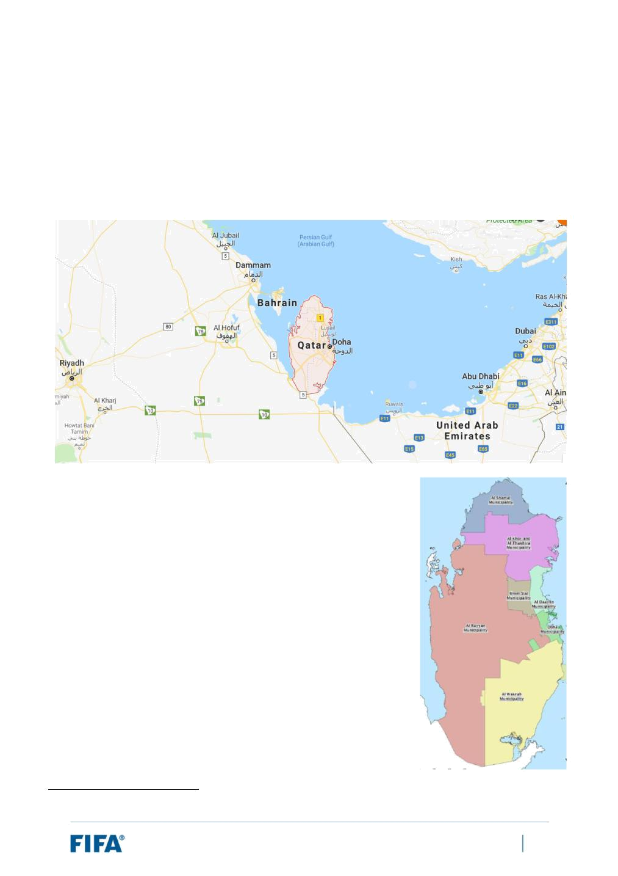
4.3 Overview of Qatar and a compact FWC

General information

Geographically, Qatar is located on the north-eastern coast of the Arabian Peninsula (see map below). Its sole land border is shared with Saudi Arabia to the south, with the rest of its territory surrounded by the Persian/Arabian Gulf, which also separates Qatar from nearby Bahrain. Qatar’s capital and largest city is Doha, positioned on the eastern coast of the country.

The country is divided into eight administrative municipalities. These municipalities are listed below and illustrated in the map to the right13. In total, they cover a surface area of approximately 11,600km2.

- Al Shamal (BLUE)

- Al Khor and Al Thakhira (PURPLE)

- Al Rayyan (RED)

- Umm Slal (OLIVE GREEN)

- Al Daayen (LIGHT GREEN)

- Al Wakrah (YELLOW)

- Doha (GREEN)

- Al Shahaniya (not shown on map)

- Al Shahaniya municipality, which is not pictured above, was created in 2014 and is formed from the largely rural western area of the Al Rayyan municipality.

FIFA World Cup Qatar 2022™ – Feasibility Study: Expansion of Format to 48 Teams | 33

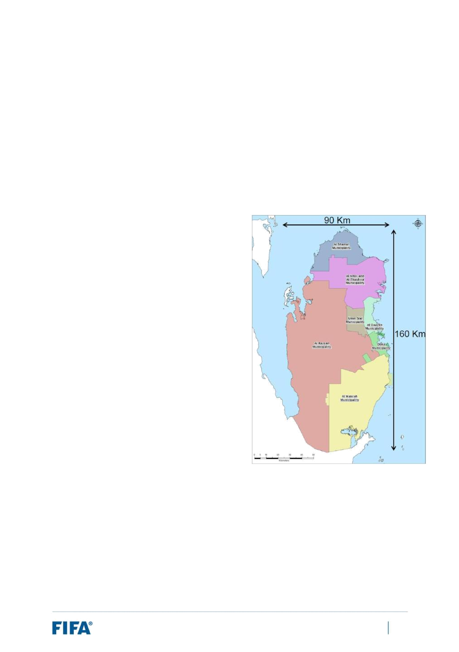
In terms of national demographics, the country’s total population was estimated at 2,744,000 as at October 2018. The population is forecast to reduce in the next few years and is projected to reach 2,421,417 by the middle of 2022. Roughly half of Qatar’s population live in the capital and largest city – Doha – with an estimated population of approximately 1.4 million in the metropolitan area. Qatari nationals represent a relatively small percentage of the country’s inhabitants; there is a proportional split of approximately 10:90 between Qatari and non-Qataris, and the majority of non-Qataris originate from countries in South Asia (i.e. India, Nepal, Bangladesh, Pakistan and Sri Lanka).

Politically, Qatar declared its independence in 1971. It is recognised as a constitutional monarchy, with executive power controlled by the Emir – H.H. Sheikh Tamim bin Hamad bin Khalifa al Thani.

A compact FIFA World Cup

Qatar is a small country geographically, with a total surface area of approximately 11,600km2. As the map to the right illustrates, the country spans 160km from north to south and 90km from east to west. The vast majority of infrastructure and services are concentrated in the capital city of Doha and the surrounding areas.

In terms of distances between venues, the maximum distance between stadiums is 70km by road. This means that there will be no need for air travel between venues and that all stakeholders (constituent groups and fans) will be able to travel to/from and between venues and sites having only had to cover short distances along the way.

Furthermore, all stadiums are within a 50km radius from central Doha. With the entire tournament footprint based in and around Doha, there will be a high level of interconnectivity between the different infrastructure and services provided.

For comparative purposes, the image on the following page illustrates the difference in size between Qatar and the most recent host countries of the FIFA World Cup. Qatar very much reverses the recent trend of larger host countries.

FIFA World Cup Qatar 2022™ – Feasibility Study: Expansion of Format to 48 Teams | 34

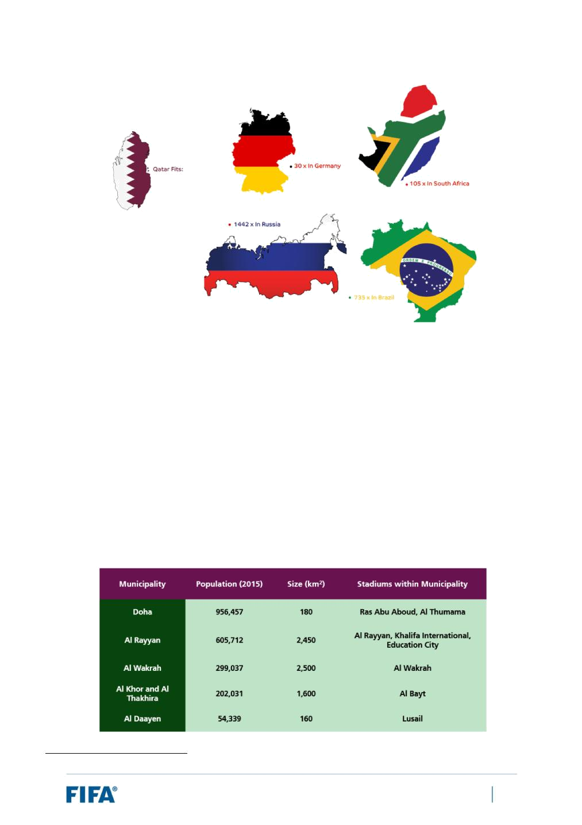

Implementing a geographically compact tournament concept can give rise to various opportunities for efficiencies (ease of movement, reduced infrastructure, centralised operations, simplified logistics and processes).

Overview of key sites and capacities

The following is a summary of the inventory of key sites in Qatar and their capacities based on the information available to FIFA.

- Host Cities

Qatar has proposed five of the eight administrative municipalities as its Host Cities for the FIFA World Cup Qatar 2022. The table below provides an overview of each of the municipalities proposed, including their population size14, geographical size and the stadiums located within their municipality:

- As at April 2015, based on the census conducted by the Ministry of Development, Planning and Statistics.

FIFA World Cup Qatar 2022™ – Feasibility Study: Expansion of Format to 48 Teams | 35

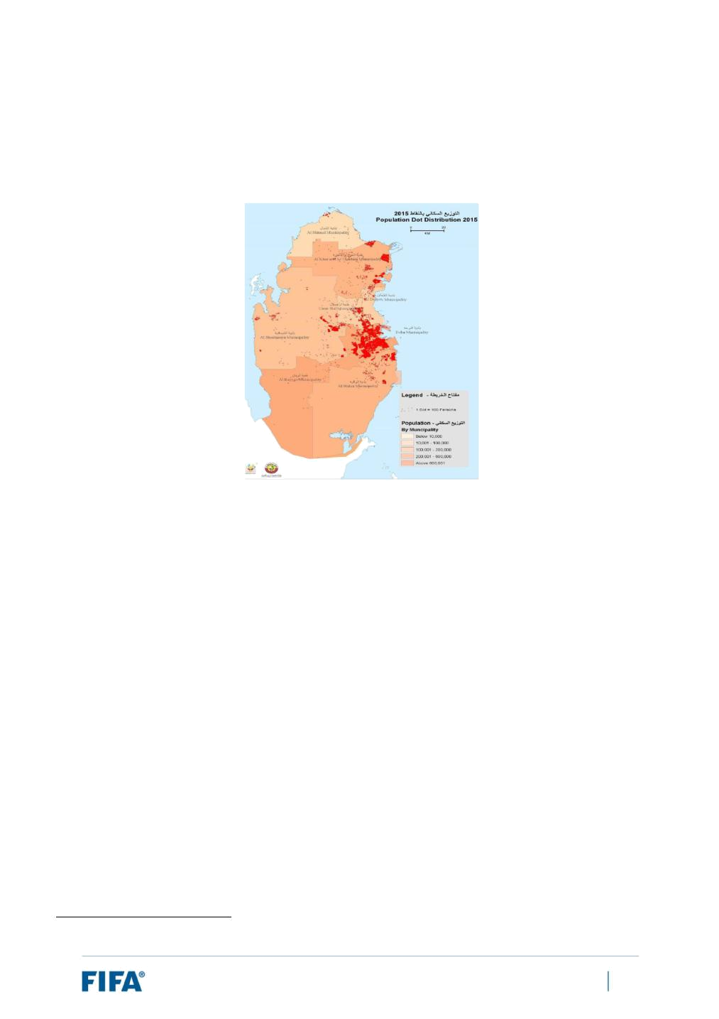
The two largest municipalities are Doha and Al Rayyan, with populations in the order of one million and 600,000 respectively. Five of the eight stadiums proposed for the tournament are located within the boundaries of these two municipalities. However, as the map below demonstrates, in terms of population density, the majority of Qatar’s inhabitants are concentrated in the urban agglomeration of metropolitan Doha:

The remaining three municipalities are smaller in size (in particular Al Daayen) and house one stadium each.

Each stadium is part of, or relatively close to, metropolitan Doha.

Regarding the three municipalities not included as proposed Host Cities - Umm Slal, Al Shamal and Al Shahaniya – it is worth noting that when developing the Host City proposal:

- Al Shamal’s remote location to the north and the fact that it is largely uninhabited15 were cited as reasons for its non-inclusion.

- Umm Slal was deemed inappropriate due to the limited availability of land for development and the fact that a substantial part of the municipality was designated as an Aquifer Protection Zone. Its population is also relatively small16.

- Al Shahaniya was not considered as the municipality had not yet been created and is largely rural and sparsely populated.

Moreover, none of the stadiums identified in section (b) below, whether FIFA World Cup stadiums or existing stadiums not currently planned to be used for the tournament, are located in these three municipalities. Taking all of the above factors into consideration, these three municipalities are considered unsuitable to serve as additional FIFA World Cup Host Cities.

- A population of 8,794 as at April 2015.

- A population of 90,835 as at April 2015.

FIFA World Cup Qatar 2022™ – Feasibility Study: Expansion of Format to 48 Teams | 36

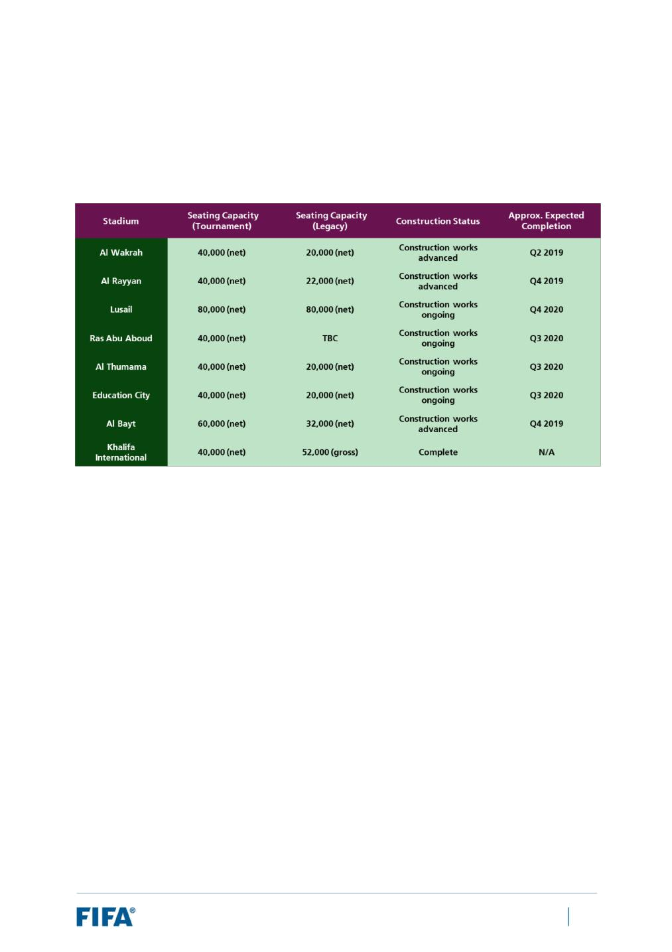
- Stadiums

The Supreme Committee, working closely with all relevant government departments and stakeholders, is currently overseeing the construction of eight stadiums in Qatar to be used as venues for the FIFA World Cup Qatar 2022. The table below provides an overview of the stadiums, including their respective seating capacities and construction statuses:

Lusail, with a planned net seating capacity of 80,000, is expected to stage the opening and final matches. It is also expected to host a semi-final match, with Al Bayt hosting the other, as they are the only two stadiums with sufficient seating capacities.

One stadium (Khalifa International) has already been completed, whilst construction work on the seven remaining stadiums is well under way. All seven are due to be finalised before the end of 2020, with some nearing completion in the upcoming quarters (e.g. Al Wakhrah and Al Bayt). FIFA continues to conduct a regular review of stadium plans in order to monitor the progress and ensure that the construction and overlay reflect the hosting requirements for a FIFA World Cup stadium.

FIFA World Cup Qatar 2022™ – Feasibility Study: Expansion of Format to 48 Teams | 37

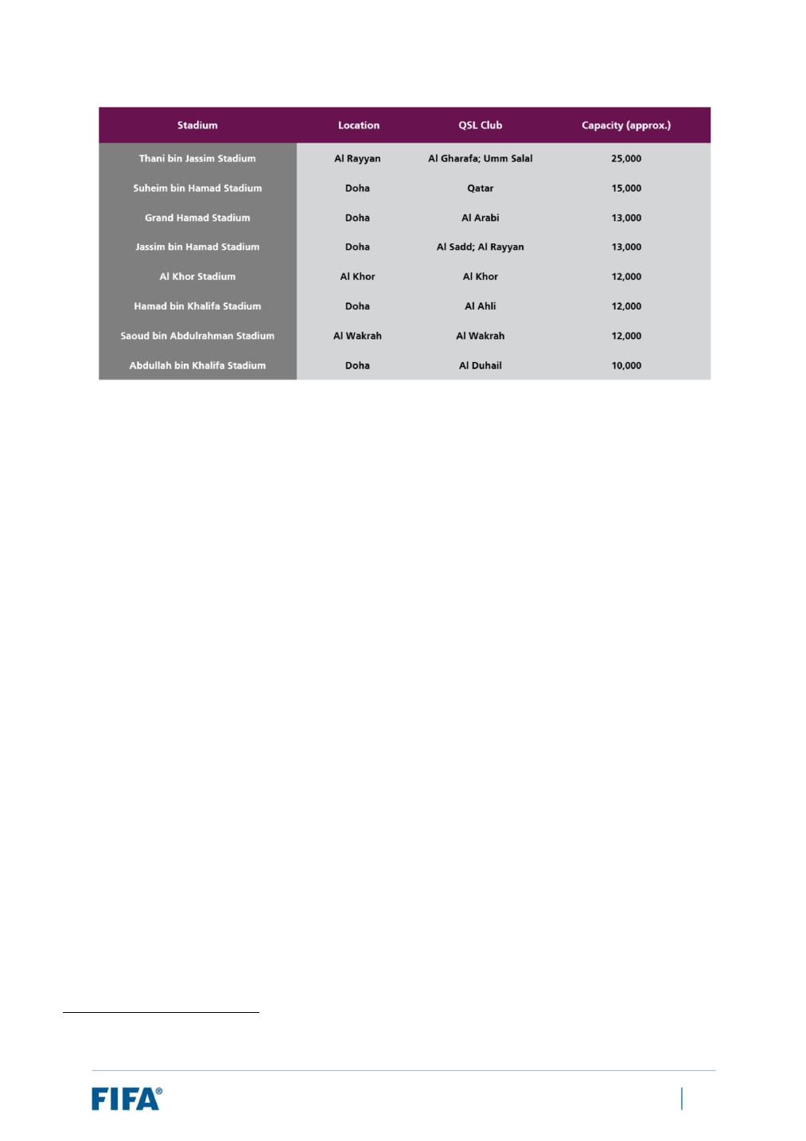

In addition to the eight FIFA World Cup stadiums, FIFA also surveyed the remaining stadiums which exist in the country. A summary of those stadiums with a capacity of 10,000 or more seats is listed in the table above. As can be seen, these stadiums are currently well below the requisite capacity for a FIFA World Cup stadium, and they are also unlikely to be configured in accordance with FIFA’s stadium requirements. Moreover, all of these stadiums are proposed to be used as training sites and therefore contribute towards the inventory of training sites reserved for teams (see section below).

- Team and Referee Facilities

In July 2017, the Qatari LOC presented its proposal for the team and referee base camps to be used during the FIFA World Cup Qatar 2022. In summary, it contained the following information:

- 46 pairings of hotels and training sites.

- Six additional training sites (unpaired) + two additional training sites (unpaired and proposed to host only open-to-public training sessions), bringing the total number of training sites proposed to 54.

- Two “back-up” hotels (unpaired), bringing the total number of team hotels proposed to 48.

In terms of the construction status of the sites, at the time of submitting the proposal:

- Of the 54 training sites referenced above, 38 were existing and 16 were planned17.

- Of the 38 existing training sites, the construction of a second pitch was planned for two of them. Six others (all of which were unpaired with a team hotel18) do not have a second pitch and there were no plans to build one.

- Of the 48 team hotels referenced above, 27 were existing and 21 were under construction.

- Since the time of the proposal, one of the training sites (Al Sailiya Sports Club 2) has been completed, reducing the number of planned training sites to 15 instead of 16.

- One is an open-to-public training site and the other five are unpaired sites.

FIFA World Cup Qatar 2022™ – Feasibility Study: Expansion of Format to 48 Teams | 38

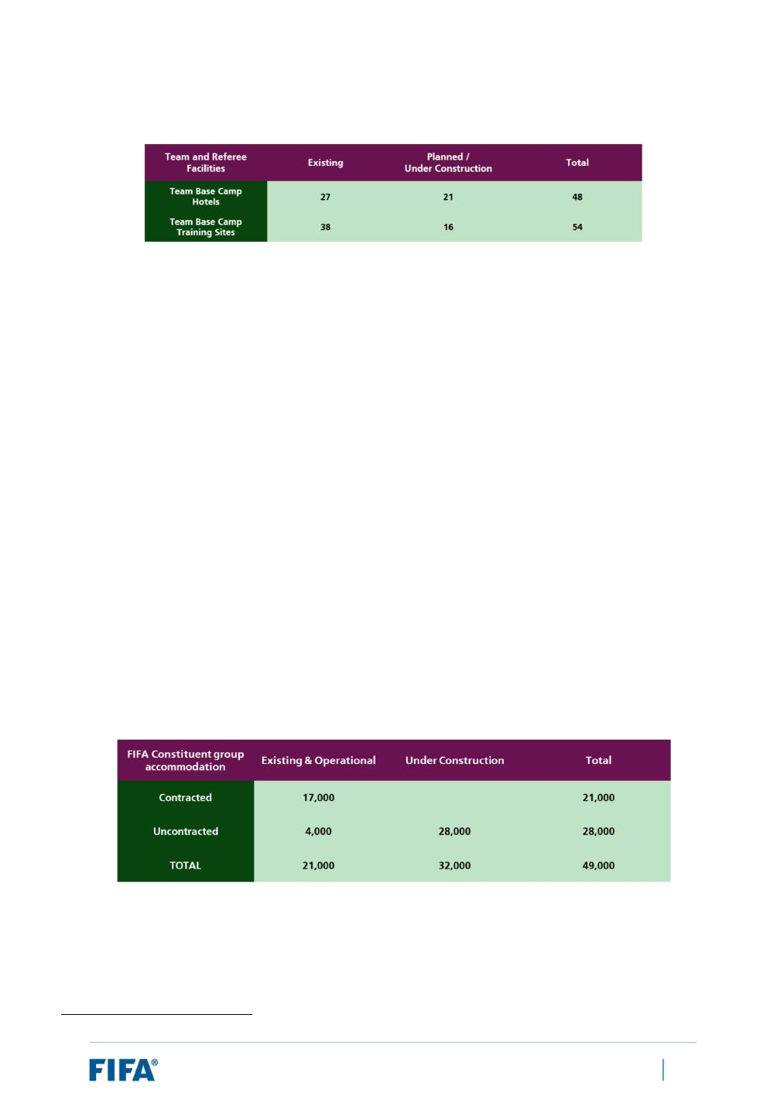
The above information is summarised in the following table:

With respect to venue-specific team facilities, on the basis of a compact tournament whereby all teams would be based in, or in relatively close proximity to, the Doha metropolitan area (and therefore within easy reach of all eight stadiums), and in light of the limited availability of sites in Qatar, FIFA agreed to forgo the requirement to provide venue-specific team facilities for the tournament. All teams will instead be housed in their Team Base Camps for the duration of their participation in the tournament. As such, no sites have been identified as potential venue-specific team facilities.

- Accommodation

With regard to constituent group accommodation, which concerns those groups that are “mission-critical” to the successful delivery of a FIFA World Cup (e.g. teams, referees, staff, VIPs/VVIPs, Commercial Affiliates, media and MRLs, etc.), the Qatari LOC provided the following figures19:

- Contracted rooms:

  - There are 17,000 contracted rooms across 78 operating 4* and 5* hotels.

- Non-contracted rooms:

  - There are 32,000 non-contracted rooms across 167 hotels and hotel apartments.

- 28,000 rooms across 108 properties are currently under construction. This information is summarised in the table below:

- This assumes 80% occupancy of hotels based on FIFA’s experience in organising past FIFA World Cups

FIFA World Cup Qatar 2022™ – Feasibility Study: Expansion of Format to 48 Teams | 39

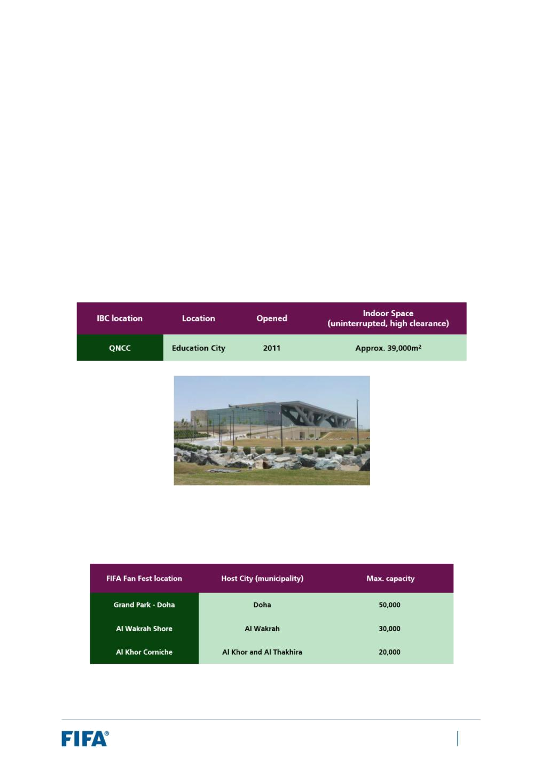
- IBC

In February 2017, the Supreme Committee developed its preliminary proposal for the location of the IBC.

Following further consultation with FIFA, an updated proposal was submitted in November 2017.

The proposed site for the IBC is the Qatar National Convention Centre (“QNCC”). It was officially opened in December 2011 and is located in Education City, to the west of Doha, near the Education City Stadium.

At a glance, it has a total gross internal area in the order of 200,000m2, with seven exhibition halls providing 35,000m2 of net internal space, two multipurpose halls with 4,100m2 of net internal space, 3,100m2 of outdoor exhibition space, a 2,230-seat theatre, three large auditoriums, 50 meeting rooms ranging from 10-260 in seat capacity, six VIP lounges and seven hospitality suites. The question of whether the QNCC could house both the IBC and a centralised media centre is under consideration.

The information regarding the QNCC, including the indoor space capacity, is presented below, together with a visual of the QNCC building:

- FIFA Fan Fests

The current proposal includes the following three sites with a combined capacity of up to 100,000 people:

FIFA World Cup Qatar 2022™ – Feasibility Study: Expansion of Format to 48 Teams | 40

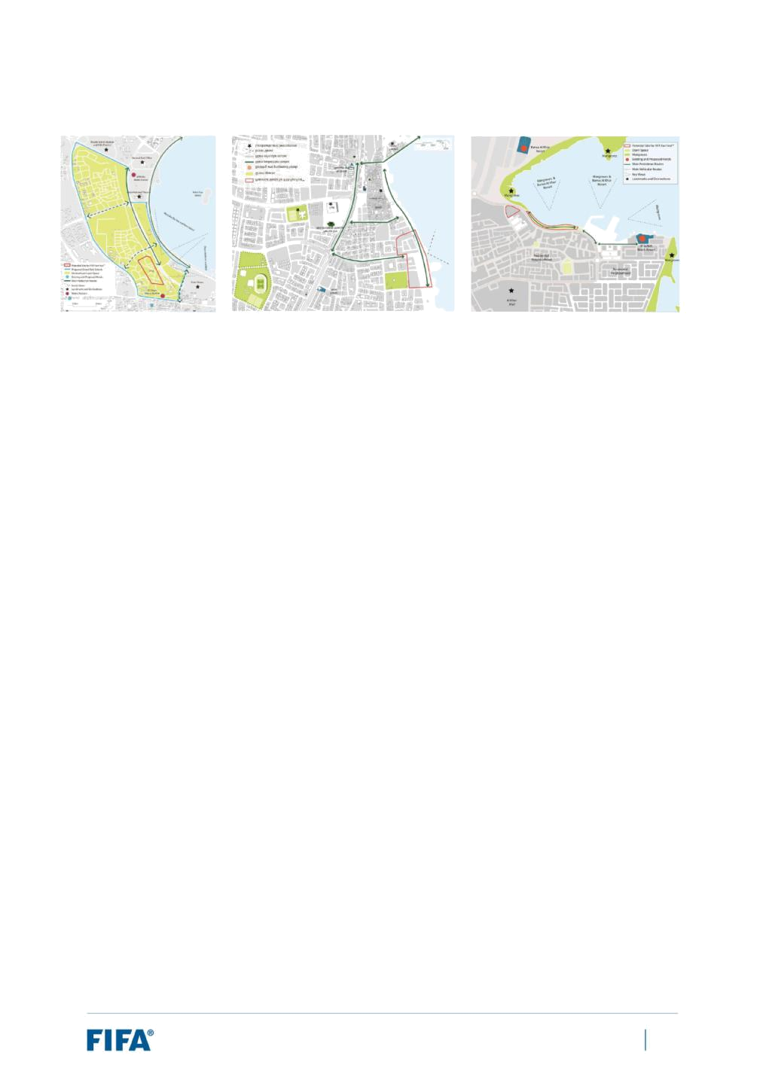
The specific locations are presented in the images below:

FIFA World Cup Qatar 2022™ – Feasibility Study: Expansion of Format to 48 Teams | 41


4.4 Infrastructural considerations

Infrastructural capacity vs tournament requirements

From an infrastructural perspective, the methodology employed for assessing the feasibility of hosting a 48-team FIFA World Cup in 2022 in Qatar is to measure the infrastructural capacity of Qatar against the requirements for hosting a 48-team FIFA World Cup. In Section 4.2, this report outlined some of the high-level requirements for hosting a 48-team FIFA World Cup, with particular attention paid to the inventory of key sites required and their respective capacities. In Section 4.3, FIFA highlighted the compact nature of the tournament and summarised the existing and planned infrastructural capacity in Qatar.

The table below compares the high-level requirements with the capacity in Qatar:

 | Component |  |  | Requirements: |  | Qatar Capacity
 | Component |  |  | 48-team FWC |  | (Estimated)
 | Host Cities* |  |  | 10-12 |  | 3 HCs (5 municipalities)
 | Stadiums |  |  | 10-12 |  | 8
 | Team and Referee Base |  |  | 49 |  | Up to 48
 | Camps (H+TS) |  |  | 49 |  | Up to 48
 | Venue-Specific Facilities |  |  | 36 |  | 0
 | (H+TS) |  |  | 36 |  | 0
 | Accommodation (Guest |  |  | 65,000 |  | Approx. 50,000**
 | rooms) |  |  | 65,000 |  | Approx. 50,000**
 | FIFA Fan Fests*** |  |  | 10-12 |  | 3-5

- A ten-stadium scenario may be feasible in the event that FIFA accepts matches in venues on consecutive days. Also, the number of Host Cities may be lower where Host Cities have multiple stadiums.

- This estimate takes into account planned properties and assumes these would be completed, operated and contracted.

- Number of FIFA Fan Fest sites required is one per Host City. Fewer are required if any Host Cities have multiple stadiums.

The minimum number of stadiums required is 1220 under the 48-team format for the 2026 edition. As noted above, a ten-stadium scenario could be considered in the event that up to six matches per day were played during the group stage and matches could be held in the same venue on consecutive days; however, 12 stadiums would be preferable. Qatar has planned for eight stadiums to be used as venues for the FIFA World Cup Qatar 2022, two to four fewer than the minimum required for a 48-team tournament, with one stadium complete (Khalifa International) and the remaining seven under construction. Moreover, based on the review performed by FIFA, there do not appear to be any stadiums in the country with the potential to serve as additional FIFA World Cup venues. This is because they are far too small, unlikely to be capable of configuration to FIFA’s stadium requirements and are already allocated as proposed team and referee base camp training sites.

In relation to team and referee base camp facilities, the minimum number of required pairings is 4921 (with 7422 to be proposed to allow for a selection process). Based on the proposal submitted by the Qatari LOC in

- With 14-16 to be proposed to allow for a selection process.

- 48 for the teams, plus one for the referees.

- 72 for the teams, plus two for the referees.

FIFA World Cup Qatar 2022™ – Feasibility Study: Expansion of Format to 48 Teams | 42

July 2017, Qatar has proposed 46 pairings. Taking into account the back-up hotels included in the proposal, the number of pairings may rise to 48 at most.

With regard to venue-specific team facilities, Qatar was released from FIFA’s requirement to provide a minimum of three facilities per Host City23. This is due to the compact nature of the tournament and the concept of having teams lodge in base camps for the duration of their participation in the tournament.

With regard to the accommodation inventory, if the tournament were to be expanded to 48 teams, the additional demand generated by a 50% increase in teams (which would increase the demand from all constituent groups and international fans) is expected to elevate the accommodation inventory required up to 65,000 rooms, compared to the currently planned 50,000 rooms.

Finally, FIFA requires a minimum of one FIFA Fan Fest site per Host City (with two to be proposed to allow for choice). Assuming a ten-stadium or 12-stadium scenario where each stadium is located in a different city, this would translate to a minimum of ten or 12 FIFA Fan Fests. The latest FIFA Fan Fest proposal shared by the Qatari LOC envisaged three FIFA Fan Fests.

- With a minimum of four per city to be proposed to allow for a selection process.

FIFA World Cup Qatar 2022™ – Feasibility Study: Expansion of Format to 48 Teams | 43

4.5 Legal matters

As noted earlier in this report, the expansion of the tournament to a 48-team format would require the consent of key stakeholders in Qatar, most notably the Supreme Committee for Delivery & Legacy, the QFA and ultimately the state of Qatar.

Provided that such consent is obtained, FIFA regards the legal risks associated with its ability to implement any required changes to the Hosting Agreement for the FIFA World Cup Qatar 2022 or as regards governmental support as relatively low. The parties would be expected to enter into negotiations in good faith.

FIFA World Cup Qatar 2022™ – Feasibility Study: Expansion of Format to 48 Teams | 44


5 Feasibility: Mitigation options and key challenges

5.1 Additional capacity

Based on the analysis outlined in Section 4, a conclusion of this feasibility study is that there would appear to be insufficient infrastructural and operational capacity in Qatar alone to organise a 48-team FIFA World Cup in 2022 under the conditions defined in Section 3 to the requisite standard for FIFA’s flagship tournament and the world’s premier major sporting event.

From an infrastructural standpoint, Section 4.4 highlighted the foreseen extra requirements in capacity by reference to the inventory of key official sites required, otherwise commonly known as the “tournament footprint”. FIFA compared the requirements for a 48-team tournament24 with the infrastructural capacity (both existing and planned) in Qatar – see the table below:

 | Component |  |  | Requirements: |  | Qatar Capacity
 | Component |  |  | 48-team FWC |  | (Estimated)
 | Host Cities* |  |  | 10-12 |  | 3 HCs (5 municipalities)
 | Stadiums |  |  | 10-12 |  | 8
 | Team and Referee Base |  |  | 49 |  | Up to 48
 | Camps (H+TS) |  |  | 49 |  | Up to 48
 | Venue-Specific Facilities |  |  | 36 |  | 0
 | (H+TS) |  |  | 36 |  | 0
 | Accommodation (Guest |  |  | 65,000 |  | Approx. 50,000**
 | rooms) |  |  | 65,000 |  | Approx. 50,000**
 | FIFA Fan Fests*** |  |  | 10-12 |  | 3-5

- A ten-stadium scenario may be feasible in the event that FIFA accepts matches in venues on consecutive days. Also, the number of Host Cities may be lower where Host Cities have multiple stadiums.

- This estimate takes into account planned properties and assumes these would be completed, operated and contracted.

- Number of FIFA Fan Fest sites required is one per Host City. Fewer are required if any Host Cities have multiple stadiums.

The analysis reveals the need for at least the following:

- At least two to four additional stadiums.

- Further team and referee facilities, although the extent is unknown and depends upon the suitability of the pairings proposed. Moreover, in the event that each of the two to four additional stadiums required is located outside of Doha, there will be a requirement for venue-specific team facilities. The extent of these further requirements would depend upon the final structure of the match schedule and team movement concept.

- Additional accommodation inventory.

- Additional FIFA Fan Fest locations.

- As stipulated in the 2026 FIFA World Cup Hosting Requirements (Initial Version) issued to bidding member associations during the FIFA World Cup 2026 bidding process

FIFA World Cup Qatar 2022™ – Feasibility Study: Expansion of Format to 48 Teams | 45

Furthermore, these additional sites would need to be configured to FIFA’s requirements and specifications in time for the tournament. For example, in the case of each stadium, this would entail meeting requirements with respect to:

- Exclusive use and clean site obligations

- Seating capacity

- Stadium orientation

- Stadium roofing

- Competition areas

- Space requirements

- Technical installations/services

- Transport and parking

- Accessibility and sustainability

- Human rights

- Etc.

Additionally, Qatar, as part of its commitment since entering into the Hosting Agreement with FIFA, has invested significantly in infrastructure and on tournament planning on the basis that that the FIFA World Cup Qatar 2022 would take place in Qatar as a 32-team tournament only. Therefore, any additional investment by Qatar as the host country would not be justified from a legal or logistical perspective.

In summary, it can be concluded that:

- Organising a 48-team tournament would require a co-hosting model with one or more neighbouring host countries alongside Qatar, as the main host country.

- Hosting 80 matches at only eight stadiums over 28 days is not possible; therefore, for a successful delivery of a 48-team FIFA World Cup, a co-hosting model with one or more neighbouring host countries alongside Qatar, as the main country, shall be analysed.

FIFA World Cup Qatar 2022™ – Feasibility Study: Expansion of Format to 48 Teams | 46

5.2 Potential co-hosting

In order for it to be feasible to organise a 48-team FIFA World Cup in 2022, there will be a need for extra infrastructural and operational capacity. Specifically, further options for at least the following sites would be required:

- Stadiums

- Team facilities

- Accommodation

- Airports and transport networks

- FIFA Fan Fest locations

Moreover, as explained above, these sites would also need to be capable of meeting FIFA’s requirements and be completed sufficiently in advance of the tournament to be properly tested in event-time conditions.

As the infrastructural and operational capacity in Qatar has been planned and is being constructed for a 32-team tournament, it logically follows that the only means of sourcing additional infrastructural and operational capacity would be to explore options outside of Qatar. This would therefore require involving additional neighbouring host countries alongside Qatar, resulting in a co-hosting arrangement between FIFA, Qatar and these additional co-hosts.

The involvement of additional neighbouring host countries would require certain conditions to be met, in particular the consent of the relevant authorities in the main host country, Qatar. Therefore, FIFA cannot conclusively stipulate which host countries would be part of a co-hosting arrangement with FIFA and Qatar at this moment. Notwithstanding, for the purposes of this feasibility study (which requires a degree of certainty regarding potential co-hosts in order to assess the associated geopolitical, commercial, financial and legal impacts of such a co-hosting arrangement), FIFA has identified certain parameters in order to develop a shortlist of potential co-host countries.

These parameters include:

- Candidate co-hosts would need to be part of the same confederation as Qatar – the AFC.

- Candidate co-hosts would need to be of sufficient proximity to be considered neighbouring. FIFA has applied a radius which includes places in the region within reasonable proximity to Qatar as a limit in considering neighbouring host countries (see map below).

- Candidate co-hosts would need to be regarded as sufficiently stable regions - free from armed conflicts and not considered subject to major international sanctions.

- Candidate co-hosts would need to be regarded as sufficiently cooperative – such co-hosts would not sanction or boycott economically or otherwise any other potential co-host country, including the main host, Qatar.

FIFA World Cup Qatar 2022™ – Feasibility Study: Expansion of Format to 48 Teams | 47

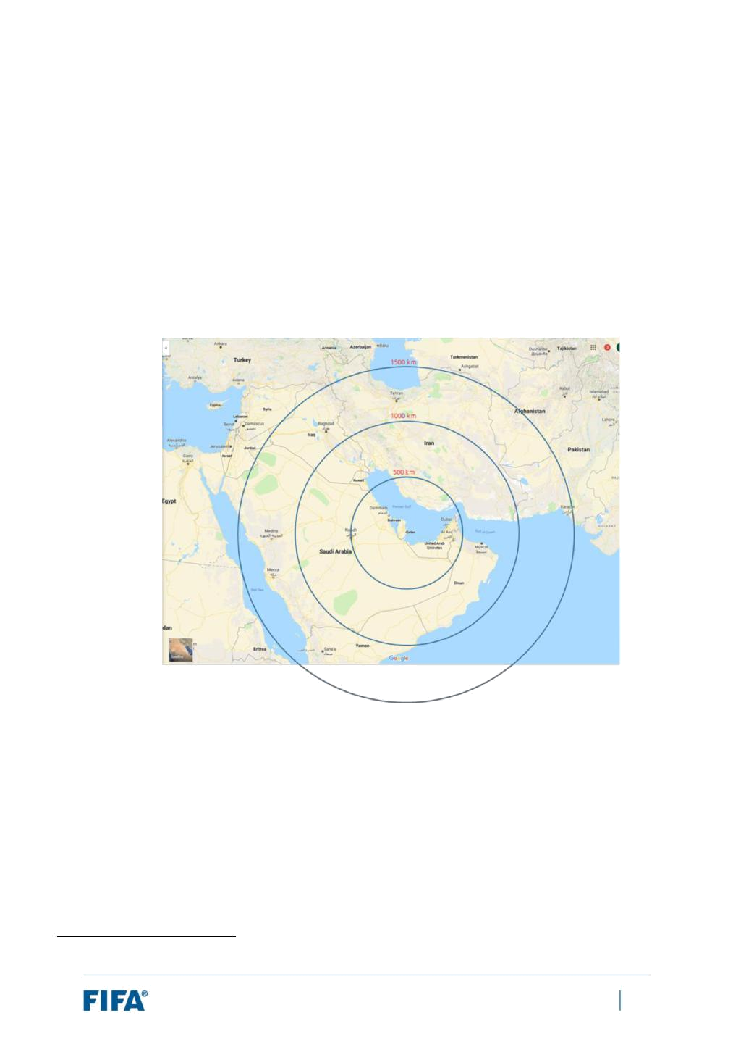
- Candidate co-hosts would need to have key sporting and non-sporting infrastructure (i.e. stadiums, team facilities, accommodation, airports and transport networks, etc.) to address the requirements in infrastructural and operational capacity. FIFA performed a preliminary review based on internal data25 and open-source information to ascertain whether such infrastructure exists or is planned in the neighbouring countries.

- Candidate co-hosts would ideally have some experience of organising FIFA and/or confederation tournaments in the past, in particular senior competitions.

- Potential willingness to contribute to offsetting any additional costs in connection with the expansion of the tournament.

Applying the parameters listed in the previous page, FIFA has developed the following shortlist of potential co-host countries for the purposes of this feasibility study (listed in alphabetical order):

- Bahrain

- Kuwait

- Oman

- Saudi Arabia

- The UAE

- For instance, FIFA reviewed the inventory of stadiums used during qualifiers for the 2018 FIFA World Cup in the neighbouring countries and examined their characteristics.

FIFA World Cup Qatar 2022™ – Feasibility Study: Expansion of Format to 48 Teams | 48

For reference, set out in Annexe 3 to this report is a list of existing stadiums known to FIFA which may be worth potentially exploring in the event that these countries were integrated into a co-hosting model with Qatar. It is important to stress that this list is based on a preliminary search only and is non-exhaustive. Moreover, the potential suitability of these and other stadiums could only be conclusively determined following a comprehensive inspection process, in which such stadiums were closely scrutinised against FIFA’s requirements for FIFA World Cup stadiums as well as assessed for their availability, construction plans, etc. In this respect, it is worth noting that any construction works which would be required would need to be completed prior to the tournament. For reference, FIFA generally requires that stadiums be completed 12 months prior to the tournament in order to ensure venue readiness and testing.

FIFA World Cup Qatar 2022™ – Feasibility Study: Expansion of Format to 48 Teams | 49

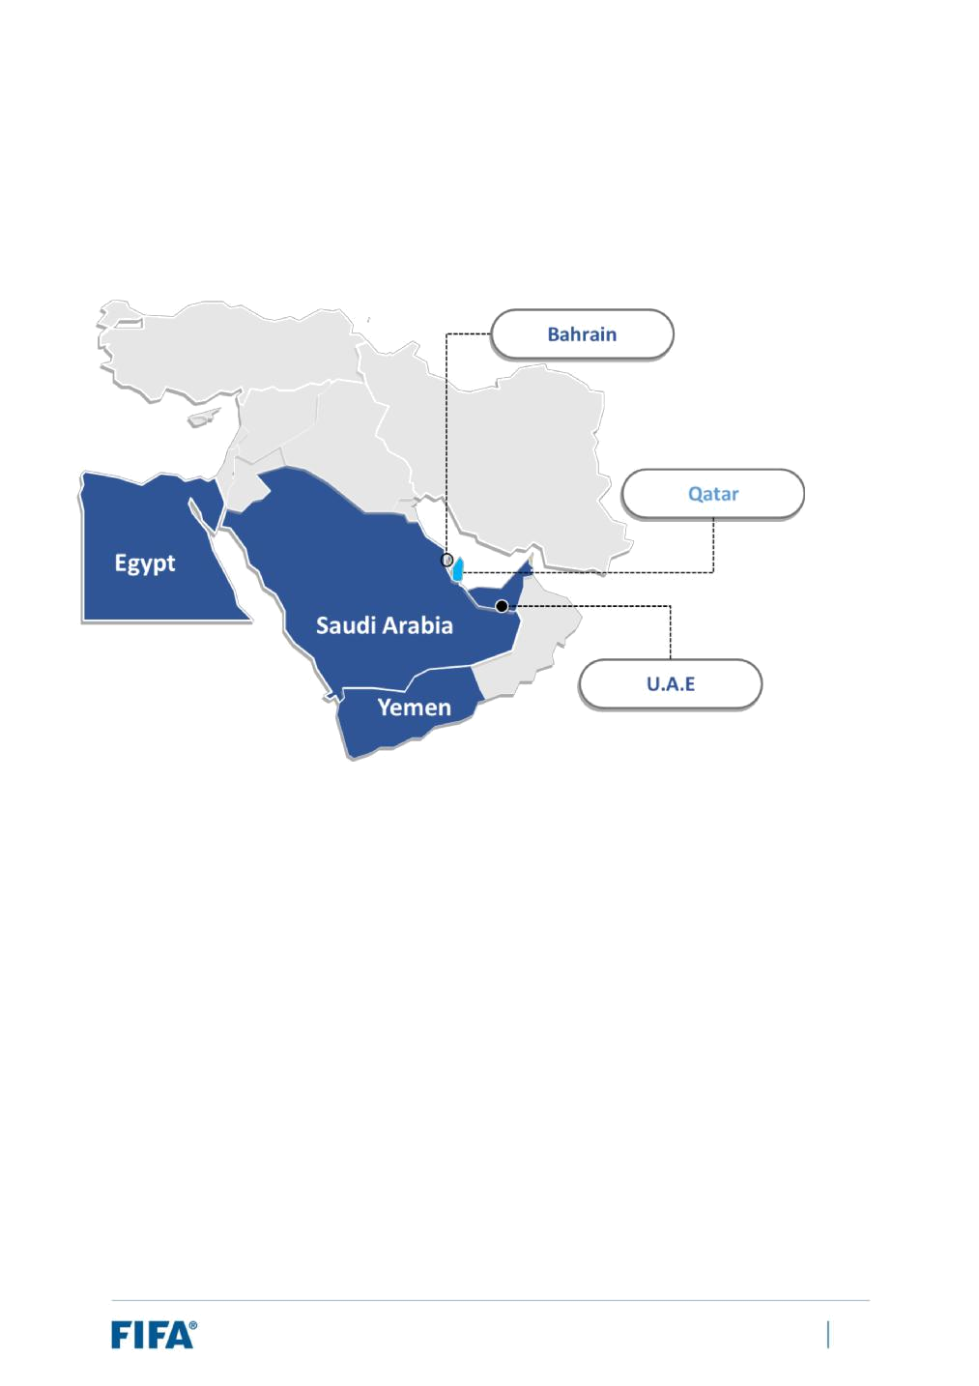
5.3 Geopolitical considerations

Diplomatic relations between Qatar and its neighbouring countries

In June 2017, Bahrain, Egypt, Saudi Arabia and the UAE imposed a blockade on Qatar. For illustrative purposes, the map set out below highlights Qatar and the neighbouring countries involved:

As part of this blockade, restrictive measures were imposed on Qatar across the following areas:

- Land transport

- Air transport

- Sea transport

- Movement of people

- Media

- Movement of goods

As at the time of writing this report, the blockade is ongoing and the restrictive measures remain in place. Kuwait and Oman have maintained their strong relationships with Qatar and the other GCC countries, and Kuwait has acted as the principal mediator in any dialogue between the parties.

FIFA World Cup Qatar 2022™ – Feasibility Study: Expansion of Format to 48 Teams | 50

Impacts: Geopolitical considerations

As it currently stands, the nature of Bahrain, Saudi Arabia and the UAE’s relations with Qatar is such that it would be challenging to organise a co-hosted tournament between Qatar and one or more of these countries. Specifically:

- The organisation of a FIFA World Cup under a co-hosting model generally requires cooperation between the governments of each respective host country in certain areas and projects.

- The blockade imposed by the abovementioned countries on Qatar prevent the movement of, among other things, people between Qatar and these countries. This is important to the organisation of a FIFA World Cup, as the tournament involves the constant movement of organisers, teams, referees, Commercial Affiliates, spectators, etc.

In order to address these challenges, FIFA believes that any potential co-host countries alongside Qatar would have to allow the free movement of people and goods between the abovementioned countries and Qatar.

FIFA World Cup Qatar 2022™ – Feasibility Study: Expansion of Format to 48 Teams | 51

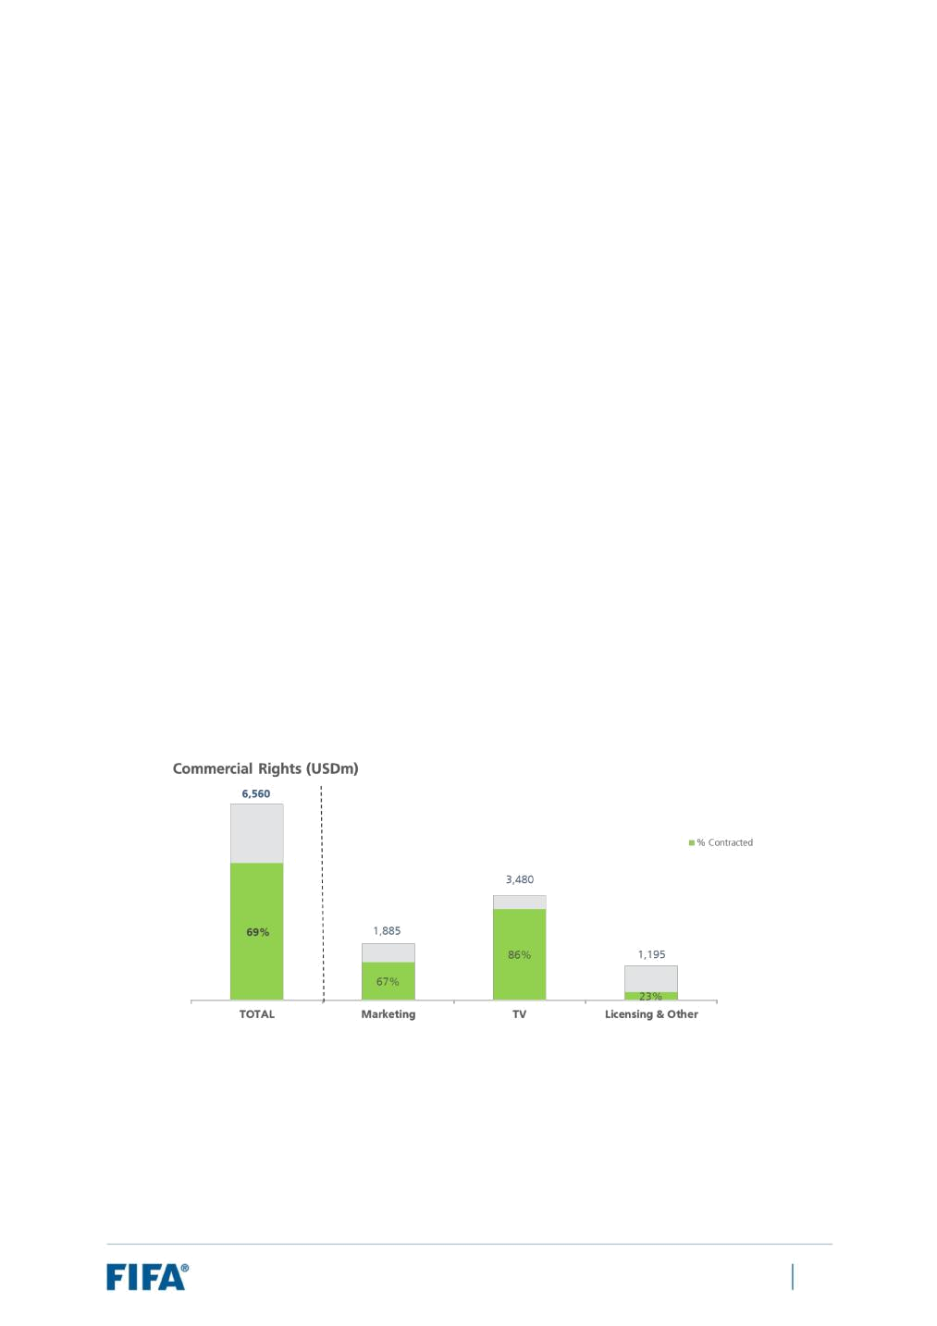
5.4 Commercial considerations

Introduction

In assessing the commercial impacts of expanding the format of the FIFA World Cup Qatar 2022 to 48 teams,

FIFA focused on the organisation’s five key revenue streams:

- Media rights

- Marketing rights

- Ticketing

- Hospitality rights

- Licensing rights

First and foremost, the budgeted revenue forecast for the 2019-2022 period – which amounts to USD 6,560m – has been used as the baseline for the theoretical assessment of the potential revenue growth that could be attained from the expanded format. Relevantly, FIFA has already secured 69% of its commercial budgeted revenue for the 2019-2022 cycle and for the purpose of this report, it is assumed that these deals will not be further influenced by an expansion of the format. Consequently, incremental revenues attributed to an expansion of the format can only be applied to the remaining 31% of commercial budgeted revenue and associated rights. This 31% figure represents USD 2,034m in commercial budgeted revenue. The baseline figures for budgeted revenue at both an overall and revenue-stream level are presented in the graph below, along with the percentage of revenue already contracted:

FIFA’s analysis considered many factors and variables to determine how the proposed format would influence commercial revenue. However, three key drivers have been identified that most significantly influence value:

- Market representation: The benefits associated with wider member association participation boosting local, regional and global interest and value. In this regard, FIFA assumed the slot allocation referenced in Section 3.2 of this report and relied upon the official FIFA/Coca-Cola World Ranking for the purpose of understanding additional member associations that may potentially qualify.

FIFA World Cup Qatar 2022™ – Feasibility Study: Expansion of Format to 48 Teams | 52

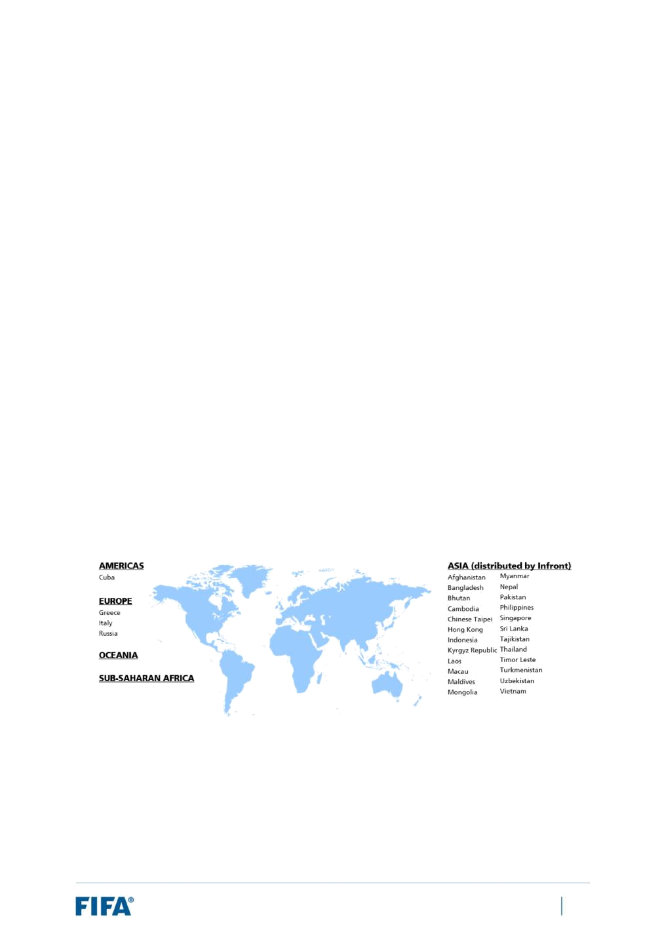
- Live match opportunities: The revenue impact of increased live match opportunities and associated exposure.

- Minimum number of matches per team: The number of guaranteed matches for each participating team. This is relevant when determining the domestic value for competing teams (including value that could potentially be derived from the 16 additional markets) but also for the widespread appeal and interest when considering the volume of guaranteed matches involving the “big teams”.

Any evaluation of potential FIFA World Cup expansion opportunities must take into consideration these factors, all of which have the potential to amplify or diminish the benefits and risks of altering the competition’s format.

Set out below is an analysis of the impact on each key revenue stream individually.

(i) Media

FIFA has signed MRAs accounting for 86% of TV revenue budget for the 2019-2022 cycle. Any incremental revenues attributed to the expansion of the format to 48 teams – for the purpose of this report – will only be applied to the remaining 14% of 2022 MRAs.

Market dynamics in many of the territories where rights remain unsold are currently not considered favourable (e.g. South East Asia). Notwithstanding, after evaluating the market situation/dynamics, the analysis suggests that there would be the potential to generate an increase in revenue from 20 of the remaining unsold markets. These markets represent 47% of the revenue which could potentially be affected

– amounting to USD 245.3m.

- Market representation

Whilst the expansion of the FIFA World Cup Qatar 2022 would result in additional qualification slots for each confederation, the expected timing of the calendar for the preliminary competition (see Section 3.2 above) suggests that, in several cases, it may be unclear which teams are guaranteed to participate in the FIFA World Cup Qatar 2022 until early 2022. This leaves only a relatively short

FIFA World Cup Qatar 2022™ – Feasibility Study: Expansion of Format to 48 Teams | 53

window to capitalise on any confirmed domestic interest from national team participation, with uncertainty remaining over whether such teams will or will not qualify. Delaying a market tender process until after the preliminary competition is concluded may not increase value as the optimum competitive dynamics within the market could be missed.

The potential domestic value of the additional slots is heavily dependent on which teams ultimately qualify and on questions such as: have these rights already been sold? Is the team from a strong/high-value media market with capacity for growth?

- Additional live match opportunities

Theoretically, additional live match opportunities would lead to positive incremental revenues, with the knockout drama inherent in the proposed 48-team format offering more valuable, high-quality matches that would attract a greater viewership.

- Minimum number of matches per team

The format would result in fewer (two rather than three) guaranteed matches for all participating teams. Consequently broadcasters from each participating nation will make valuations based upon two guaranteed (high-value) domestic-interest matches rather than three.

Increases in live match opportunities would lead to positive incremental revenues. If the additional matches were taken as an absolute factor, then an uplift of 25% (16/64=25%) could be applied to the outstanding revenue budget which can be affected.

The proposed 48-team format offers additional live match opportunities, including the knockout-stage drama of 16 matches during the round of 32, offering more valuable, high-quality matches that traditionally attract a greater viewership.

If we consider the full group of unsold territories – including the unsold markets previously excluded for reasons of market dynamics – an uplift to the full USD 487.2m of potential revenue budgeted can be projected. By taking the increase in matches as an absolute factor, without applying any discount factor, a 25% uplift could be applied. By applying the uplift of 25% to the maximum outstanding budgeted revenue figure (USD 487.2m), an amount in the order of USD 121.8m could be generated from the expansion of the format to 48 teams.

(ii) Marketing

Commercial Affiliates partner with FIFA and the FIFA World Cup for both tangible and intangible reasons. These include the worldwide brand exposure provided by the event’s global distribution, the association value provided by the quality of the event, and the promotional value resulting from the opportunities provided to activate on site and around the world. To date, FIFA has signed six FIFA Partners and three FIFA World Cup Sponsors for the FIFA World Cup Qatar 2022, which represents 67% of the 2019-2022 marketing revenue budget. Therefore, any incremental revenues attributed to expansion would be applied to the remaining 33% of the revenue budget – USD 622m.

FIFA World Cup Qatar 2022™ – Feasibility Study: Expansion of Format to 48 Teams | 54

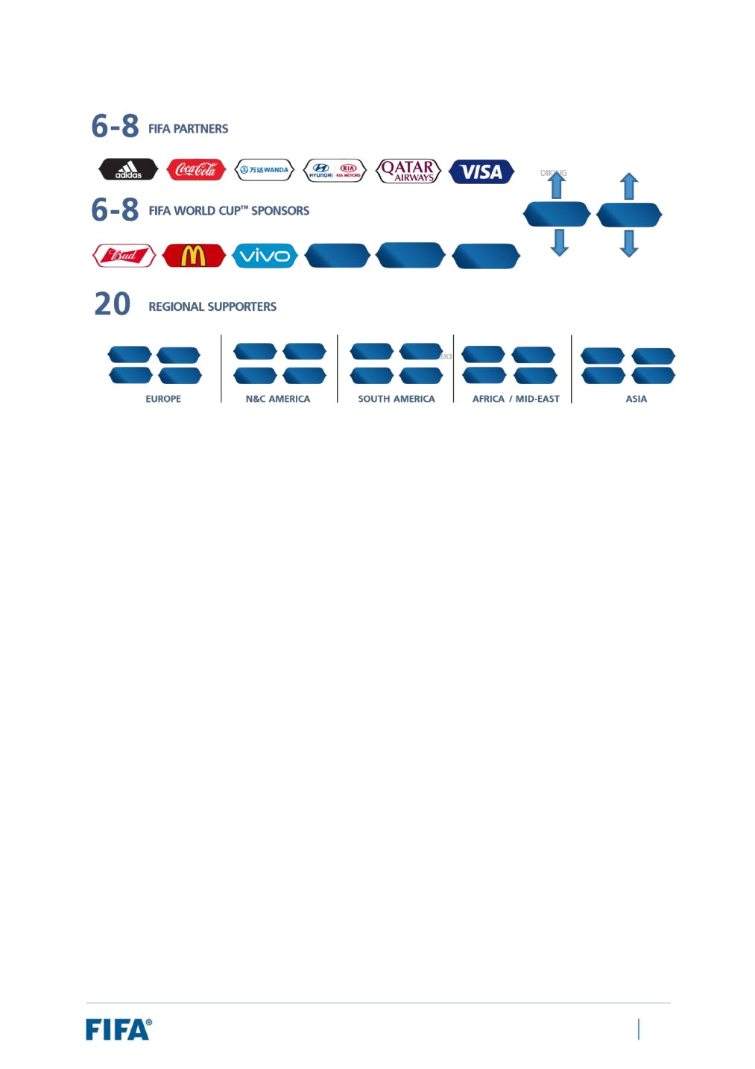

The diagram above illustrates the three-level sponsorship tier structure: FIFA Partners, FIFA World Cup Sponsors and Regional Partners. There are 6-8 FIFA Partner slots and 6-8 FIFA World Cup Sponsor slots available, with a maximum of 14 across both tiers. FIFA also offers 20 Regional Supporter slots, all of which are currently open.

- Market representation

The potential for additional hosts from the region would assist the sponsorship appeal on a regional and global level due to higher levels of regional interest and activation opportunities. Introducing additional teams would also expand the number of territories with which current and future partners could engage. Therefore, expanding the pool of participants would likely generate additional interest from corporations from, or with an interest in, these markets.

The increase in demand from key territories may ultimately lead to an uplift in marketing revenue. Audience figures (as a proxy for value) from the 2010 FIFA World Cup and the 2018 FIFA World Cup were used to analyse the potential uplift in audience and value due to the similar time zones to Qatar and to each other, thus eliminating the ”time of broadcast” factor in the respective markets. However, after examining a number of examples, there was no consistent trend of impact between national team participation and broadcast audience, with large fluctuations in a number of markets. Furthermore, the late conclusion of the preliminary competition would result in a restricted activation window for brands looking to capitalise on specific local/regional interest as a result of national team participation, and thus temper the extent of the possible increase in value. Considering the extent of unknown variables, it is not possible to accurately determine the direct revenue impact from additional market representation.

- Additional live match opportunities

An increase in the number of matches would provide Commercial Affiliates with heightened brand exposure on-site and through broadcast displays of in-stadium signage elements, including

FIFA World Cup Qatar 2022™ – Feasibility Study: Expansion of Format to 48 Teams | 55

advertising boards, media backdrops, etc. On the other hand, each additional match may not generate the same average audience per match and therefore brand exposure/value.

- Minimum number of matches per team

With each national team only guaranteed to play two matches, there is a reduced opportunity to garner interest from brands looking to take advantage of specific national team participation as brands would need to consider having a more limited activation window to exploit domestic interest in their priority markets.

In consideration of the above-mentioned variables, FIFA has taken the additional 16 live match opportunities as the sole factor when calculating an uplift in marketing revenue as the ”national team participation” influence is not quantifiable. In that respect, the additional matches under this format are expected to add incremental audiences to the tournament and thus deliver increased brand exposure and media value for Commercial Affiliates. Taking average audiences from the 2018 FIFA World Cup Russia group stage and round of 16 as a basis for assessing the impact of the additional 16 round-of-32 knockout matches, a 23% global TV audience uplift has been forecast.

This forecast increase in global audiences would have a direct impact on the media value generated from the brand exposure and the value of the sponsorship packages. After adjusting the audience inputs into the package valuation models, FIFA calculated the following uplifts in package prices across each of the sponsorship tiers:

- FIFA Partner: 8.34% uplift

- FIFA World Cup Sponsor: 14.34% uplift

- Regional Supporter: 7.93% uplift

Taking an average across the three sponsorship tiers, a commercial uplift of 10.2% is reached. Applying this average commercial uplift to the scope of additional revenue available (USD 622m), it is assumed that additional marketing revenue in the order of USD 63.4m could be generated from the expansion of the format to 48 teams.

If we applied an estimated uplift based on the potential market representation, this could yield a further USD 95m in potential marketing revenue. In order to achieve this scenario, a number of factors would be beneficial, such as qualification of additional teams of high commercial value.

(iii) Ticketing

FIFA will evolve its ticketing function in time for the FIFA World Cup Qatar 2022, shifting from paper ticketing in favour of mobile ticketing. In the interest of examining the incremental benefits attributed to the 48-team format, however, the organisation based its ticketing analysis on the existing business model.

FIFA World Cup Qatar 2022™ – Feasibility Study: Expansion of Format to 48 Teams | 56

- Market representation

On the assumption that a 48-team FIFA World Cup would be co-hosted, there would be additional revenue opportunities for ticket sales in neighbouring countries with a higher demand from football hungry locals interested in attending matches in their home market. Furthermore, the additional 16 teams represented at the FIFA World Cup Qatar 2022 should positively affect global ticket sales to travelling fans.

- Additional live match opportunities

The potential inclusion of an additional 16 knockout-stage matches would lead to additional ticketing revenue for FIFA, as the additional matches inherently provide increased ticket-sale opportunities: with more matches, there are more tickets to sell. From a commercial perspective, the expansion of the FIFA World Cup to 48 teams is the single biggest way to directly and positively impact ticketing revenues.

When evaluating the impacts on ticketing revenues of expanding the FIFA World Cup Qatar 2022 to 48 teams, FIFA has made the following assumptions:

- All additional stadiums used to play these additional matches will have a minimum net seating capacity of 40,000 seats (in line with FIFA’s hosting requirements).

- The ticket price list applied is taken from the 2018 FIFA World Cup (as the price list for the FIFA World Cup Qatar 2022 has yet to be established).

- A stadium utilisation rate of 98% (as recorded during the previous two FIFA World Cups) is considered.

Please note, however, that the following potential impacting factors have not been taken into consideration:

- The profiles of the specific additional 16 qualifying teams and their respective fan bases, as this information is not available.

- The specificities of the Host Cities/host countries and their available transport and accommodation infrastructure.

- Initial stadium categorisation and subsequent re-categorisations.

- Any potential ticket-price increases.

The estimation of additional ticketing revenues is based on the ticketing revenue calculation conducted for the 2018 FIFA World Cup, which leads to an overall FIFA World Cup Qatar 2022 ticketing revenue projection of approximately USD 451m. For group stage matches, each match was estimated at contributing approximately USD 4.3m, whilst for the round-of-16 matches, each match was estimated at contributing approximately USD 6.9m. Taking an average or midpoint between a group-stage match and a round-of-16 match in order to calculate the additional ticketing revenue generated by each of the 16 additional matches under this 48-team format (all of which are round-of-32 matches), a valuation of USD 5.6m per match is

FIFA World Cup Qatar 2022™ – Feasibility Study: Expansion of Format to 48 Teams | 57

arrived at. Applying this to all 16 additional matches, it is assumed that additional ticketing revenue in the order of USD 89.9m could be generated.

(iv) Hospitality

Historical data suggests that hospitality revenues are heavily dependent on the host country. Unlike other revenue streams, hospitality revenues have not experienced consistent growth over the past 20 years, largely due to inconsistencies in the host country’s favourability as a tourist and sporting destination.

Considering a positive impact of a co-hosting arrangement in the region combined by favourable accommodation and transportation factors, FIFA could potentially generate up to USD 20m in additional revenue for hospitality.

(v) Licensing

FIFA maintains relationships with licensees that operate in markets all over the world. Licensing revenues are overwhelmingly generated in local markets, which produce 95% of the income compared to just 5% of overall licensing revenues sourced on-site in venues at the FIFA World Cup.

- Additional live match opportunities

The inclusion of additional matches during the knockout stage would lead to additional licensing revenue for FIFA, as the additional matches inherently provide increased on-site merchandising sales opportunities for the added matches.

- Market representation

Expanding the pool of participants would introduce new consumer markets to the FIFA World Cup. However, the profiles of the national teams which would qualify would again play a central role in assessing the impact on licensing revenue, as they affect the propensity of consumer markets to purchase merchandise for FIFA World Cup events. Where the countries that qualify are considered key licensing territories, the impact would be significant. On the other hand, in non-key territories, the increased potential from the perspective of retail and licensing would not be significant. On the assumption that a 48-team FIFA World Cup in 2022 would be co-hosted, there would be additional revenue opportunities for off-site (non-stadium) sales in neighbouring countries; however, the increase would depend largely on the structure of the off-site merchandising operation.

If the countries that qualify are considered key licensing territories, combined with the additional off-site sales opportunities from neighbouring countries, this could potentially lead to an increase of USD 10m in licensing revenue.

FIFA World Cup Qatar 2022™ – Feasibility Study: Expansion of Format to 48 Teams | 58

Summary: Commercial revenue impacts

A breakdown of the additional revenues by revenue streams is detailed below:

 | Forecast additional |  |  | 48-team FWC
 | revenues (USDm)
 |  |  |  | 121.8
 | Media |  |  | 121.8
 |  |  |  | 158.4
 | Marketing |  |  | 158.4
 |  |  |  | 89.9
 | Ticketing |  |  | 89.9
 | Hospitality |  |  | 20
 |  |  |  | 10
 | Licensing |  |  | 10
 |  |  |  | 400.1
 | TOTAL |  |  | 400.1

In summary, having assessed the impacts of expanding the format of the FIFA World Cup Qatar 2022 to 48 teams on each of the five key commercial revenue streams, it is currently estimated that additional revenues in the order of USD 400m could be generated, based on a positive forecast. Even considering a more conservative assessment with a reduction of 25%, the additional revenues would still be in the range of USD 300m.

FIFA World Cup Qatar 2022™ – Feasibility Study: Expansion of Format to 48 Teams | 59

5.5 Financial considerations

Introduction

In Section 5.4, FIFA examined the effects on commercial revenue. In order to perform a holistic assessment of the financial impact of expanding the FIFA World Cup Qatar 2022 from 32 to 48 teams, FIFA has also analysed the related cost implications. Indeed, the costs associated with organising a FIFA World Cup represent one of the key cost drivers in FIFA’s overall expenditure.

In seeking to measure the potential incremental costs associated with an expansion of the tournament to 48 teams, FIFA used as its baseline the consolidated expenditure budget approved by the 68th FIFA Congress on 13 June 2018. This figure represents approximately USD 1.656 billion.

Key assumptions

A number of important assumptions were also made for the purposes of the incremental cost analysis. However, FIFA has been careful to ensure that these assumptions are consistent with all previous assumptions and/or findings made throughout this feasibility study so as to preserve the integrity of the analysis.

The assumptions include the following:

- The 48-team format would be that approved for the FIFA World Cup 2026.

- The tournament duration would remain the same (i.e. 28 days).

- The match schedule would generally resemble those presented in Annexe 1.

- The minimum number of stadiums required would be 1226.

- Additional infrastructure (in particular additional stadiums) would be sourced from outside of Qatar and involve a co-hosted tournament. In that respect, it is assumed that the governmental guarantees applicable for the neighbouring countries would be equivalent to those for Qatar, in particular in the area of tax guarantees.

- The operational model currently developed for the FIFA World Cup Qatar 2022, with a joint venture based in Qatar as main operational body of the tournament, and any key assumptions made in the budgeting process for the tournament would continue to apply.

- Whilst a 10-stadium tournament could be considered in the event that up to six matches are played per day during the group stage and matches are held in the same venue on consecutive days, 12 stadiums would still be preferable.

FIFA World Cup Qatar 2022™ – Feasibility Study: Expansion of Format to 48 Teams | 60

Those assumptions mentioned above which are quantifiable are summarised in the table below and compared against a 32-team FIFA World Cup:

 | Parameters |  |  | 32-team FWC |  |  | 48-team FWC
 | No. of Teams |  | 32 |  |  | 48
 | No. of Matches |  | 64 |  |  | 80
 | No. of Days |  | 28 |  |  | 28
 | No. of Stadiums |  | 8 |  |  | 12

Methodology

In terms of methodology, FIFA’s Finance Division performed a centralised “top-down” incremental cost assessment. This assessment was conducted at the Work Breakdown Structure (WBS) level across the 36 projects which together comprise the FIFA World Cup expenditure budget.

Each budget item was analysed to determine the possible impacts of an expansion of the tournament. The main types of impacts identified (linked to the parameters referenced above) were:

- Impact of additional teams (multiplying of cost item by a factor of 48/32).

- Impact of additional matches, if relevant (multiplying of cost item by a factor of 80/64).

- Impact of additional stadiums (multiplying of cost item by a factor of 12/8).

- “Other impact”, where there is a specific impact that does not directly follow a systematic calculation referable to the quantifiable parameters referenced above (e.g. assumptions regarding the operational model, assumptions made during the original budgeting process, etc.).

- No impact despite change in format.

The results of the analysis are summarised below, with a focus on the key cost drivers.

Key cost drivers

- Contributions to teams

According to FIFA’s analysis, the main cost impact resulting from an expansion of the FIFA World Cup Qatar 2022 to 48 teams would be the increased contributions to teams.

FIFA World Cup Qatar 2022™ – Feasibility Study: Expansion of Format to 48 Teams | 61

The key cost drivers affected are:

- Prize money

- Club benefits

- Preparation costs

- Travel (international)

- Accommodation

- Workshops

The table below summarises the incremental costs associated with each cost driver:

 | Contributions to teams
 | (incremental costs - |  | 48-team FWC
 | USDm)
 | Prize money |  | 86
 | Club benefits |  | 98.8
 | Preparation costs |  | 24
 | Travel (Int’l) |  | 7
 | Accommodation |  | 17.2
 | Workshops |  | 1
 | Club Protection |  | 1.6
 | Programme |  | 1.6
 | TOTAL |  | 235.6

Prize money is calculated on the basis of the existing structure per match and per team. Teams will receive between USD 3m and USD 6.3m per match depending on the round of the tournament and their final position. The expanded 48-team format would see incremental costs arising from the new round-of-32 stage, resulting in an overall increase of USD 86m in prize money.

With regard to club benefits, the additional teams and matches increase the number of player days. With the payment per player day fixed, additional player days translate into increased benefits paid to professional clubs and additional funds allocated to the FIFA Club Protection Programme.

Lastly, the addition of 16 more teams has a proportionate impact on all team services costs, ranging from travel to lodging, preparation costs and official activities such as workshops.

Additional costs which should also be considered are the further funds allocated to the FIFA Club Protection Programme in relation to official preparation matches for the 16 more teams which would qualify for the FIFA World Cup Qatar 2022. Assuming an average of two official preparation matches per team and an

FIFA World Cup Qatar 2022™ – Feasibility Study: Expansion of Format to 48 Teams | 62


allocation of USD 25,000 per match, the additional funds allocated to the FIFA Club Protection Programme would be USD 1.6m.

- Operational costs

FIFA’s operational costs are comprised of FIFA’s direct costs in connection with the tournament, whether incurred by FIFA or the joint venture between FIFA and Qatar, as well as the costs relating to the performance of the hosting obligations allocated to the host association(s) in connection with co-organising the tournament.

An expansion of the tournament to 48 teams would see increased costs across a number of projects. The vast majority of these additional costs fall under three main groups of activities:

  - Commercial (e.g. TV production, ticketing, hospitality, etc.)

  - Venue-related operations and services (e.g. ICT, technical services, stadium dressing, transport, etc.)

  - Support functions (e.g. workforce, insurance, guest management, etc.)

- Commercial

The majority of cost drivers under commercial operations are linked to the number of matches and venues. The key contributor to incremental costs is TV operations and in particular Host Broadcast production, with an estimated USD 56m required to equip the four additional stadiums and broadcast the 16 additional matches. A further USD 12m would be needed to operate the additional four FIFA Fan Fest sites, whilst the 16 additional matches would result in higher operating costs (forecast at USD 10m) with respect to ticketing and hospitality.

 | Operational costs:
 | Commercial (incremental costs - |  | 48-team FWC
 | USDm)
 | TV operations |  | 56
 | FIFA Fan Fests |  | 12
 | Hospitality |  | 5
 | Ticketing |  | 5
 | TOTAL |  | 78

(b) Venue-related operations and services

ICT infrastructure is a significant cost driver for the tournament and represents around 40% of additional costs in this group of activities. Other areas which would experience an increase in costs include technical services/stadium management/maps, stadium dressing and signage, transport, venue management/access management and logistics. With the exception of transport, these are all primarily linked to the increase in the number of venues.

FIFA World Cup Qatar 2022™ – Feasibility Study: Expansion of Format to 48 Teams | 63

 | Operational costs:
 | Venue-related Ops and Services |  | 48-team FWC
 | (incremental costs – USDm)
 | ICT |  | 29
 | Technical Services / Stadium |  | 10
 | Management/Maps & Plans |  | 10
 | Dressing & Signage |  | 8
 | Transport |  | 12
 | Venue Management, Accreditation |  | 4
 | & Access Management |  | 4
 | Logistics |  | 4
 | Media Operations |  | 2
 | Medical & Anti-Doping |  | 1
 | Ceremonies |  | 1
 | Training Sites |  | 0.4
 | TOTAL |  | 71.4

(c) Support functions

Key overhead costs (i.e. workforce, legal and services) are the main contributors to the overall increase in operational costs for support functions. There are also additional costs linked to the management of key stakeholders (guest management, referees, etc.) and insurance costs linked to the additional matches.

 | Operational costs:
 | Support Functions |  | 48-team FWC
 | (incremental costs - USDm)
 | Workforce |  | 15
 | Guest Management |  | 9
 | Insurances |  | 8
 | Referees |  | 0.3
 |  |  | 4
 | Legal |  | 4
 | Volunteers |  | 2
 | TOTAL |  | 38.3

FIFA World Cup Qatar 2022™ – Feasibility Study: Expansion of Format to 48 Teams | 64

Summary: Cost impacts

In summary, having performed an incremental cost assessment of expanding the format of the FIFA World Cup Qatar 2022 to 48 teams, it is currently estimated that additional costs in the order of USD 374m could be incurred (including potential savings and contingency adjustments).

The overview table below captures the key costs drivers as detailed above:

 | Cost Components (USD) |  |  | 48-team FWC
 | 32-team FWC budget (approved) |  | 1,656
 | Additional contribution to teams* |  | +236
 | Additional operational costs |  | +213
 | Less savings/contingencies |  | -75
 | Additional costs/contributions |  | +374
 | 48-team FWC budget (forecast) |  | 2,030

* Including the Club Protection Programme (CPP).

In terms of the overall net financial position, it is important to note that the lion’s share of the additional costs relate to contributions to the additional teams that would participate in the tournament, such as prize money, club benefits, preparation costs, etc. The 48-team format would cover all incremental costs.

 | Overall Financial Impact (USDm) |  |  | 48-team FWC
 | Forecast additional revenues |  | 400
 | Forecast additional operational costs |  | 138
 | (less savings/contingencies)
 | Net Position (excluding |  | 262
 | contributions/costs for PMAs)

Expanding the FIFA World Cup Qatar 2022 to 48 teams is forecast to result in a surplus of USD 26m. In case revenues would be lower than expected, additional savings would have to be made to ensure a break-even situation.

 | Overall Financial Impact (USDm) |  |  | 48-team FWC
 | Forecast additional revenues |  | 400
 | Forecast additional costs |  | 374
 | Net Position |  | 26

FIFA World Cup Qatar 2022™ – Feasibility Study: Expansion of Format to 48 Teams | 65

5.6 Legal matters

There are additional legal considerations to consider which would relate specifically to adopting a co-hosted model. This is because, for the same reasons as with any change to the format of the tournament, there is an existing legal framework already established for the FIFA World Cup Qatar 2022. In addition, adopting a co-hosted model for the tournament would require the appointment of additional host countries by FIFA.

These matters were also considered by FIFA. A summary of the analysis can be found below.

Previously administered bidding process

This report has already examined whether there are any potential issues stemming from the previously administered bidding process with regard to changing the format of the tournament. In the context of a co-hosted tournament, where one or more additional host countries would be appointed alongside Qatar, there is also the question of whether permitting a co-hosted tournament also raises any issues with regard to the previously administered bidding process. On this point, it should be noted that, given that the original bidding process did not exclude joint bids, the bidders (or even other member associations) would arguably have little basis to state that they could have bid for the co-hosting rights had they known that FIFA would contemplate co-hosting scenarios. The possibility of co-hosting was an option for all bidders from the outset.

It is worth noting that Qatar has relied upon the Hosting Agreement entered into with FIFA and the assumptions thereunder, including a 32-team tournament. Therefore, it would not make sense for Qatar to invest more than that originally anticipated in the event that a 48-team tournament is approved.

Appointment of co-hosts

The decision on the appointment of the host of the FIFA World Cup is regulated by the FIFA Statutes. In this regard, any move to appoint a host of the FIFA World Cup Qatar 2022 in addition to Qatar would be precisely that – an appointment of a host. The question would then arise as to what measures and decisions would be required in order to appoint such additional hosts of the FIFA World Cup Qatar 2022 in accordance with the FIFA Statutes.

FIFA’s analysis suggests that, notwithstanding the fact that the original appointment of Qatar as the host of the FIFA World Cup Qatar 2022 was made in accordance with article 76 of the 2010 edition of the FIFA Statutes, article 69 of the current FIFA Statutes in force at today’s date is the applicable provision as concerns the addition of any new co-hosts. In this regard, FIFA’s analysis indicates that the decision to appoint additional co-hosts for the FIFA World Cup Qatar 2022 would lie with the FIFA Congress (as opposed to the FIFA Council) and that the FIFA Congress, as the supreme legislative body of FIFA, would have the right to take such a decision (to appoint additional hosts).

It is important to note that an ordinary FIFA Congress takes place only once a year. The next scheduled FIFA Congress – the 69th edition – is due to take place on 5 June 2019 in Paris, France. It is therefore important that the process and timeline regarding the feasibility study and any next steps work around this milestone. This has indeed been factored into the process and timeline described in Section 6 of this report.

FIFA World Cup Qatar 2022™ – Feasibility Study: Expansion of Format to 48 Teams | 66

Impacts: Commercial rights

Section 3.3 of this report examined the extent to which an expansion from 32 to 48 teams and the resulting change in format give rise to any legal exposure under FIFA’s various agreements with its Commercial Affiliates, MRLs and other counterparties to agreements concerning FIFA’s commercial rights.

Likewise, it is important to consider the legal impact on these same agreements of including any additional co-host countries. This matter is discussed below, split on the basis of revenue stream.

Media rights

The MRAs are generally silent on whether FIFA has the right to change the location of the FIFA World Cup.

Nevertheless, based on the shortlist presented in Section 5.2 above (with Bahrain, Kuwait and Saudi Arabia having the same time zone as Qatar whilst Oman and the UAE being only one hour ahead), the risk is very low that broadcasters would take issue with the adoption of a co-hosted tournament on the basis that it would negatively affect their rights related to the FIFA World Cup Qatar 2022.

Marketing rights

The general position under the Commercial Affiliate agreements provides that FIFA has a right to change the venue of the FIFA World Cup Qatar 2022 (which would include the addition of co-host(s)) but should keep the Commercial Affiliates updated as to the venue in this regard.

Certain agreements deviate from the base position that FIFA is able to change the venue (without consequence to FIFA) and provide that a change of host would potentially allow for a right of termination or for a discussion on an amendment to the consideration to be paid under the relevant sponsorship agreement.

Where the deviation from the base position is such that there is a right to discuss an amendment to the consideration to be paid, then such position only applies to the extent that the change has a negative impact on the value of the rights granted.

On a commercial level, based on FIFA’s analysis, it is expected that the Commercial Affiliates would view the addition of host(s) within the region as providing for a potential increase in the value of their existing rights and certainly not a reduction thereof.

Hospitality rights

In the event that further host(s) are appointed, FIFA should consider that its incumbent hospitality rights holder may assert that it is entitled under its agreement to enter into discussions concerning the rights fee to be paid with regard to the FIFA World Cup Qatar 2022 and a potential adjustment thereof based on and calculated taking into account a contractual mechanism stipulated in the agreement. At this stage, without knowing the exact additional host(s), it is difficult to assess the impact in this regard.

FIFA World Cup Qatar 2022™ – Feasibility Study: Expansion of Format to 48 Teams | 67

Potential issues concerning Intellectual Property

From an intellectual property registration perspective, there would be a significant increase in registration costs – as well as significantly higher operational costs – for the Brand Protection programme under a co-hosting scenario, with a resultant name change and presumably additional intellectual property (i.e. logos/claims/word marks) which would need to be registered.

Implementation of revised hosting structure

The process of integrating any additional hosts into the current hosting structure (i.e. a Hosting Agreement with the LOC under a joint venture set-up) will require some time to implement.

Any additional hosts appointed would be required to submit documentation to ensure the necessary contracts and guarantees are in place (i.e. the Hosting Agreement, Host City Agreements, Stadium Agreements and Training Site Agreements), as well as securing the necessary government assurances and guarantees, including on human rights requirements. Such documentation would have to be drafted internally at FIFA to cater for the new co-hosting structure and the joint venture position which is to be implemented. Moreover, as concerns the government assurances and guarantees, sufficient lead time would be required in order to transfer such guarantees into legislation within the relevant additional host country such that the measures are enforceable.

FIFA World Cup Qatar 2022™ – Feasibility Study: Expansion of Format to 48 Teams | 68

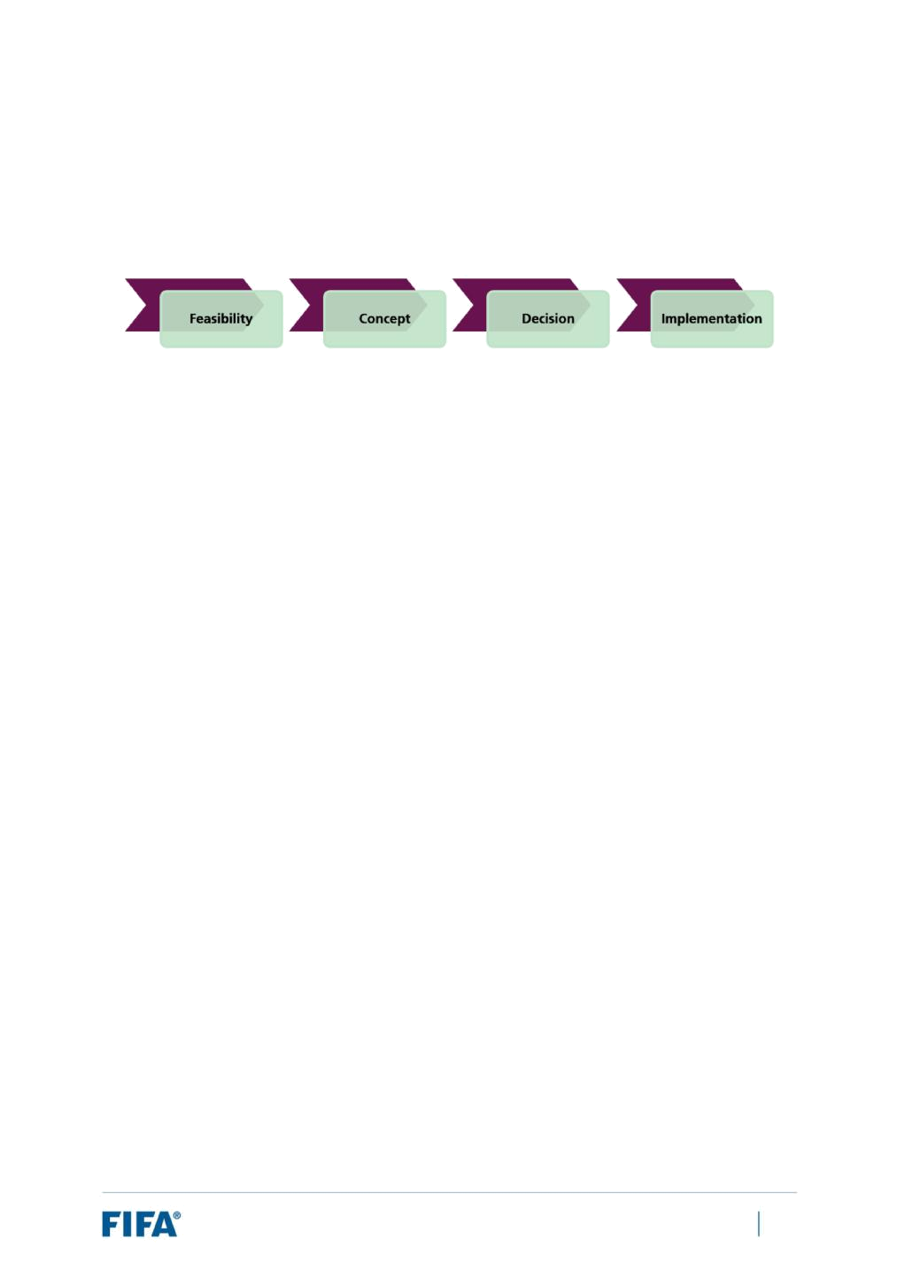
6 Feasibility study: Next steps and timeline

To enable an expansion of the FIFA World Cup Qatar 2022 from 32 to 48 teams, some key decisions and actions should be taken in a timely manner. In this context, the FIFA administration suggests the following process for completing the feasibility exercise:

Stage 1: Feasibility (by 15 March 2019)

In the first stage, the FIFA Council should:

- Agree to the conclusion of this report that expanding the FIFA World Cup Qatar 2022 to 48 teams is feasible provided that neighbouring countries host some games (with Qatar as the main host country).

- Agree to proceed to the next stage of this process, whereby FIFA and Qatar (represented by the Supreme Committee for Delivery & Legacy and the QFA) shall jointly submit to the FIFA Council and the FIFA Congress respectively a valid proposal on expanding the tournament to 48 teams with one or more additional co-host nations (with Qatar as the main host country).

Stage 2: Concept (by end of May 2019)

In the second stage, FIFA and Qatar shall jointly proceed to develop a viable operating model. Such operating model must include the following:

- A proposed logistical plan for operation of the tournament led from Qatar by the established joint venture between FIFA and Qatar, the QFA and the Supreme Committee for Delivery & Legacy.

- Identifying one or more co-hosting countries alongside Qatar as main host country through the evaluation of such potential co-hosts on conditions such as:

- Technical assessment (transportation infrastructure, accommodation etc.) and acceptability of such potential co-host nations.

- Agreement of any such potential co-host countries in principle via binding documentation on the terms of the Hosting Agreement.

- Agreement by any such potential co-hosting countries in binding terms to the Government Guarantees required from relevant governments of such potential co-hosting nations.

- A confirmed fulfilment of FIFA’s hosting requirements and all applicable FIFA regulations by any new co-host country.

FIFA World Cup Qatar 2022™ – Feasibility Study: Expansion of Format to 48 Teams | 69

- An overview of proposed co-host nations and additional venues/sites allocated for use during the tournament and how they will meet FIFA’s high-level hosting requirements for the FIFA World Cup Qatar 2022.

- The proposed match allocation split between Qatar and other co-host countries.

Stage 3: Decision (by 5 June 2019)

In the third stage:

- The FIFA Council should:

- Take a final decision either approving or rejecting the proposal jointly submitted by FIFA and Qatar as described in Stage 2.

- In the case of approval of the jointly submitted proposal by the FIFA Council, the FIFA Council shall also then confirm the key competition aspects of the tournament, such as:

  - The format (as per the 2026 edition)

  - The slot allocation (as per the 2026 edition)

  - Recommend – or not – to the FIFA Congress the additional appointment of any co-host countries included in the proposal jointly submitted by FIFA and Qatar at the 69th FIFA Congress.

- The FIFA Congress should vote on whether to expand the FIFA World Cup Qatar 2022 to 48 teams with the appointment of co-host countries based on the proposal jointly submitted by FIFA and Qatar.

Stage 4: Implementation

In the fourth stage, FIFA and Qatar shall oversee one or more new co-host countries’ work on delivering all set-up activities under the approved co-hosting model, such as:

- Securing any outstanding government support and contractual hosting documents; and

- Putting in place the agreed operational model.

In parallel, FIFA would need to work closely with the confederations to finalise all formats for the preliminary competition in order to deliver the preliminary draw in a timely manner.

If FIFA and Qatar do not submit a joint proposal as described in Stage 2, or the FIFA Council or the FIFA Congress does not accept the joint proposal submitted by FIFA and Qatar, then the FIFA World Cup Qatar 2022 shall continue to use the 32-team format and to be held solely in Qatar, as has currently been committed to. The same shall apply in the event that either FIFA or Qatar decides at any stage throughout the process to withdraw such proposal for an expanded tournament.

FIFA World Cup Qatar 2022™ – Feasibility Study: Expansion of Format to 48 Teams | 70

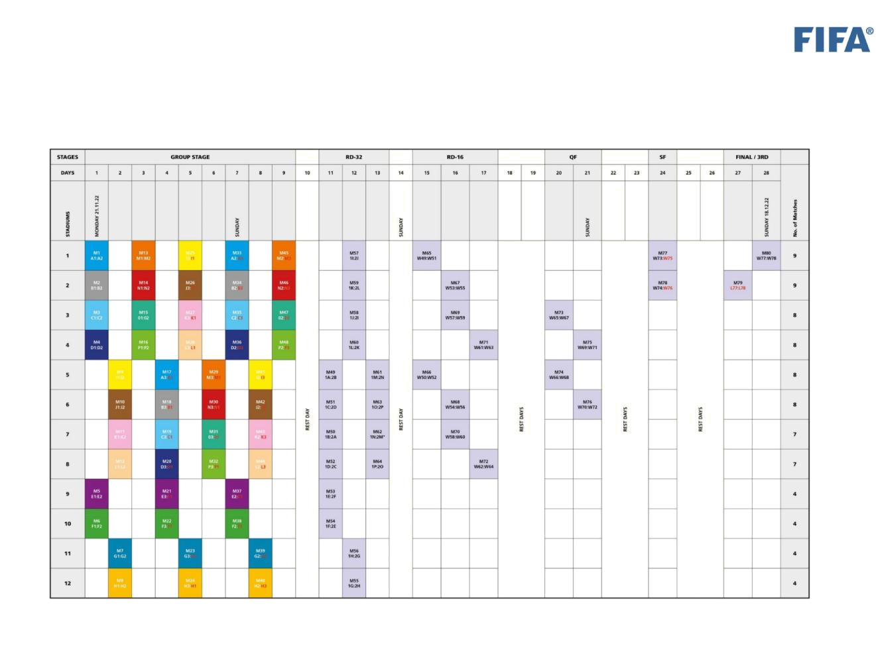
Annexe 1: Working options – 28-day match schedules

(a) 12-Stadium Scenario (Option A)

FIFA World Cup Qatar 2022™ – Feasibility Study: Expansion of Format to 48 Teams | 71

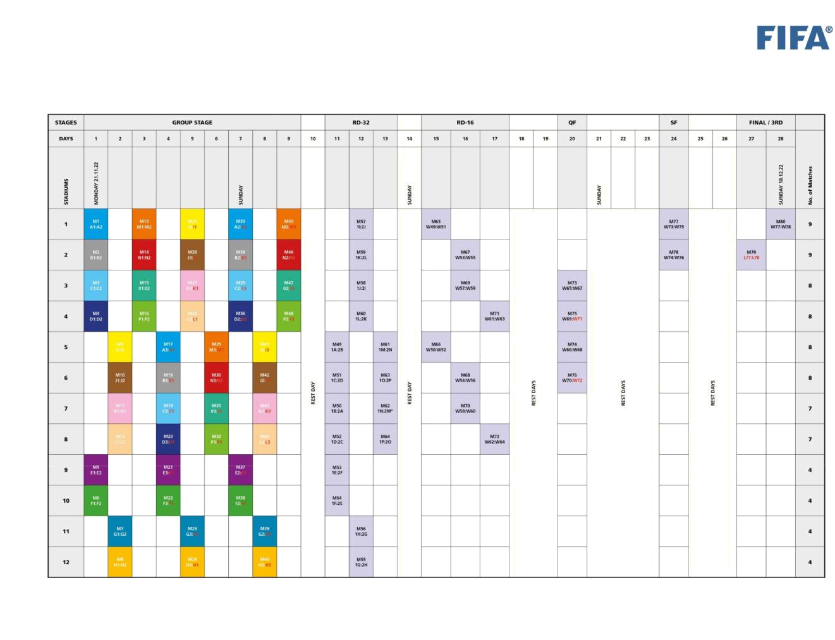
(b) 12-Stadium Scenario (Option B)

FIFA World Cup Qatar 2022™ – Feasibility Study: Expansion of Format to 48 Teams | 72

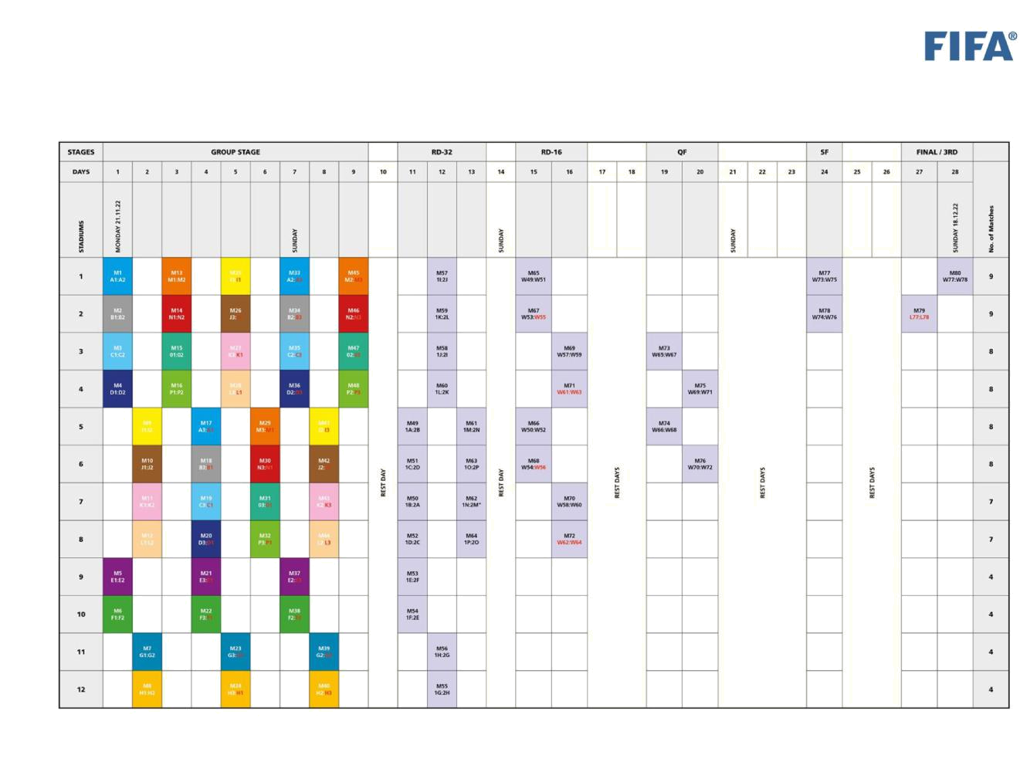
(c) 12-Stadium Scenario (Option C)

FIFA World Cup Qatar 2022™ – Feasibility Study: Expansion of Format to 48 Teams | 73

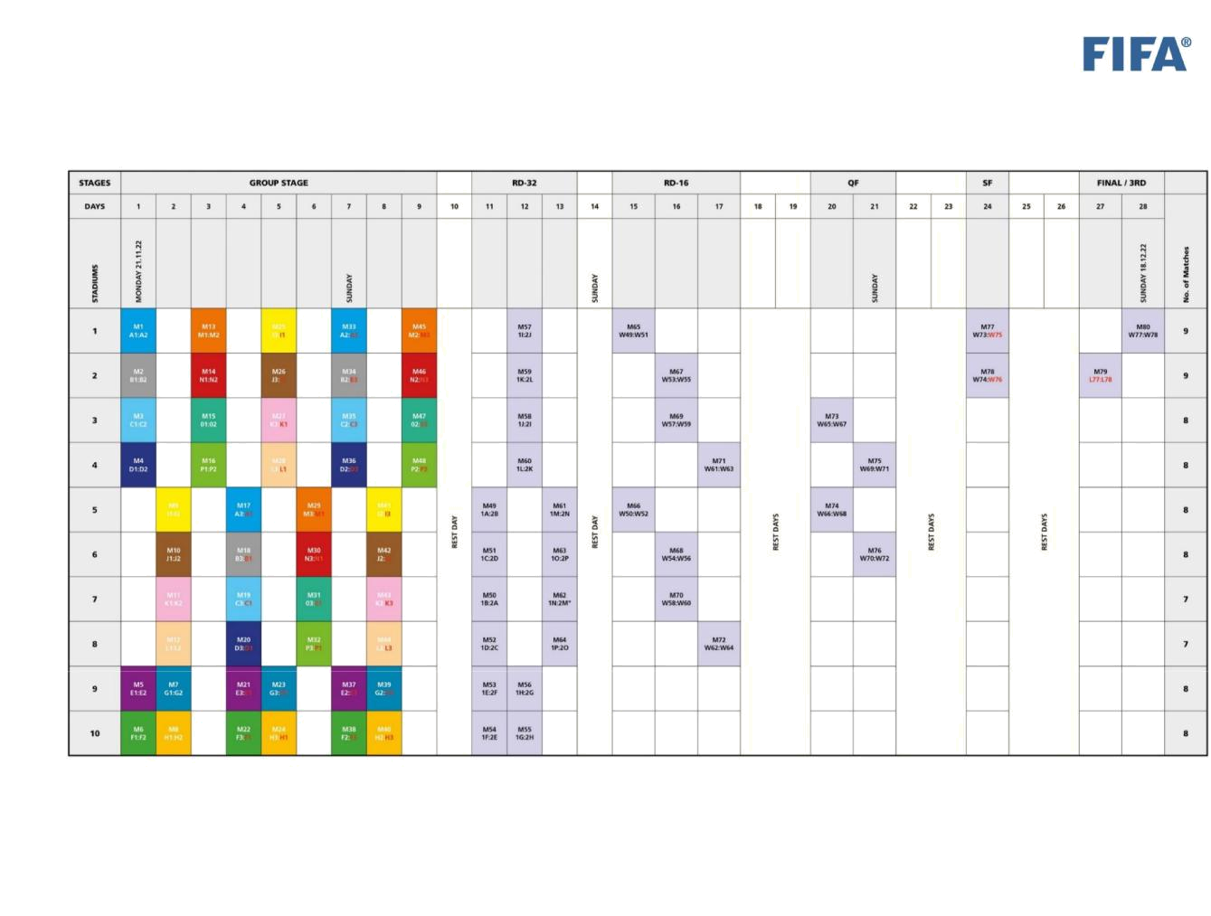
(d) 10-Stadium Scenario (Option D)

FIFA World Cup Qatar 2022™ – Feasibility Study: Expansion of Format to 48 Teams | 74

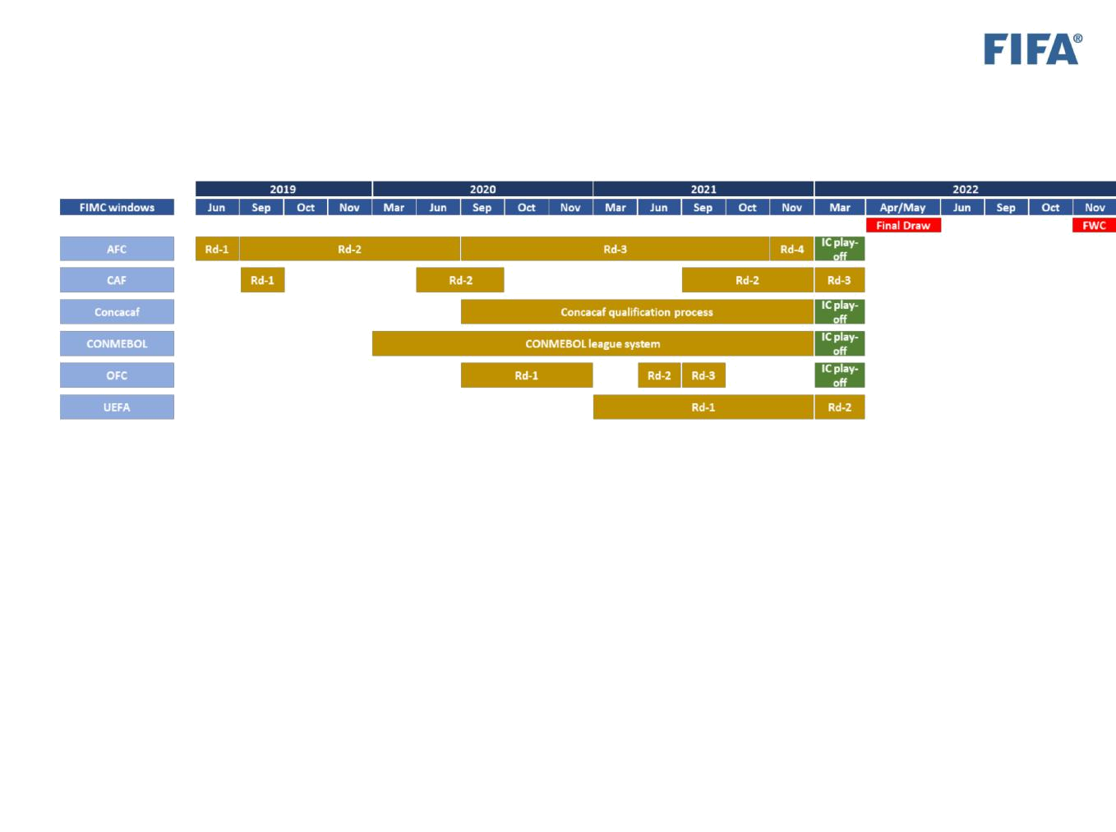
Annexe 2: Current estimations regarding timings for preliminary competition

FIFA World Cup Qatar 2022™ – Feasibility Study: Expansion of Format to 48 Teams | 75

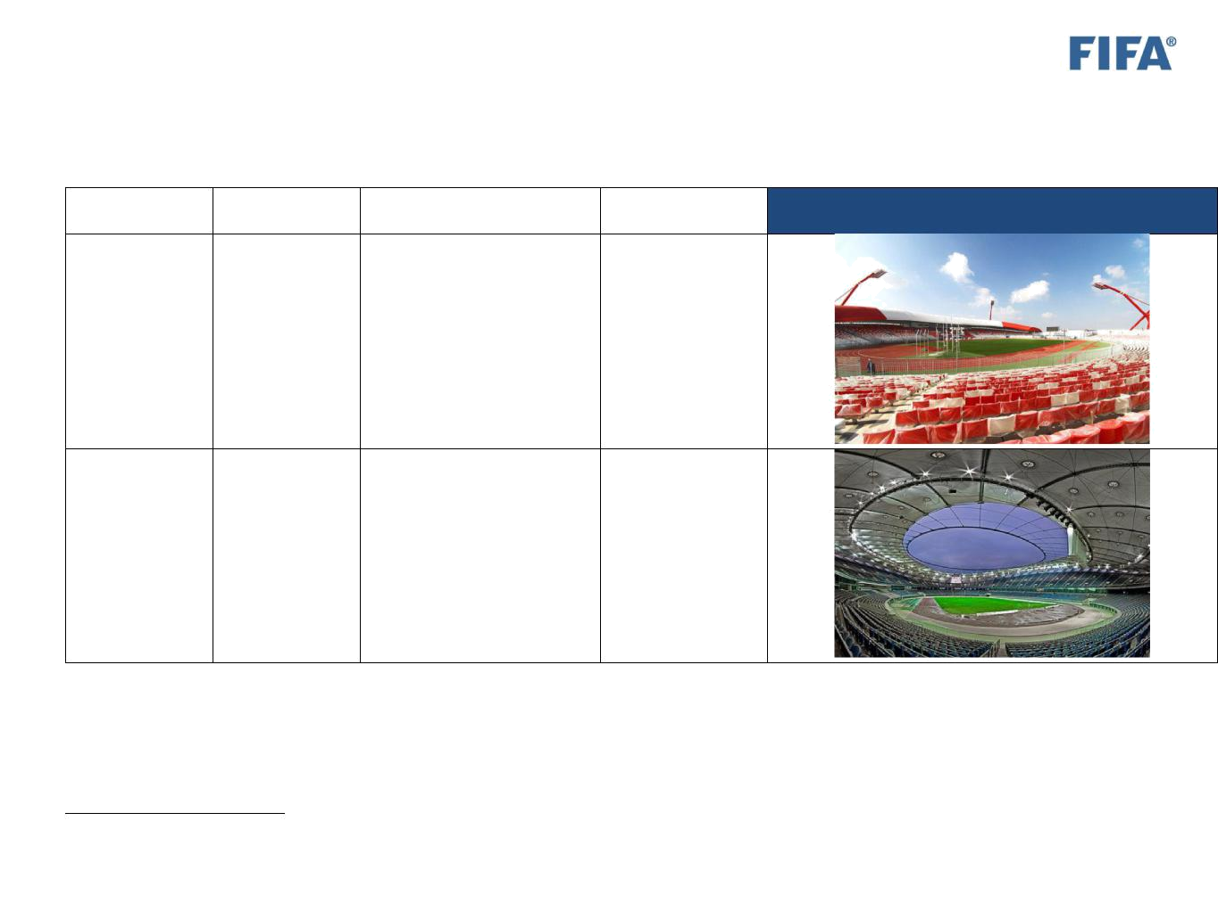
Annexe 3: List of relevant stadiums currently known to FIFA in potential co-host countries

Country | City | Stadium |  | Capacity27

Bahrain | Riffa | Bahrain National Stadium | 30,000

Kuwait | Kuwait City | Jaber Al-Ahmad | 60,000
 |  | International Stadium

- Approximate figures only and based on information publicly available or internal records obtained from organising previous FIFA tournaments.

FIFA World Cup Qatar 2022™ – Feasibility Study: Expansion of Format to 48 Teams | 76

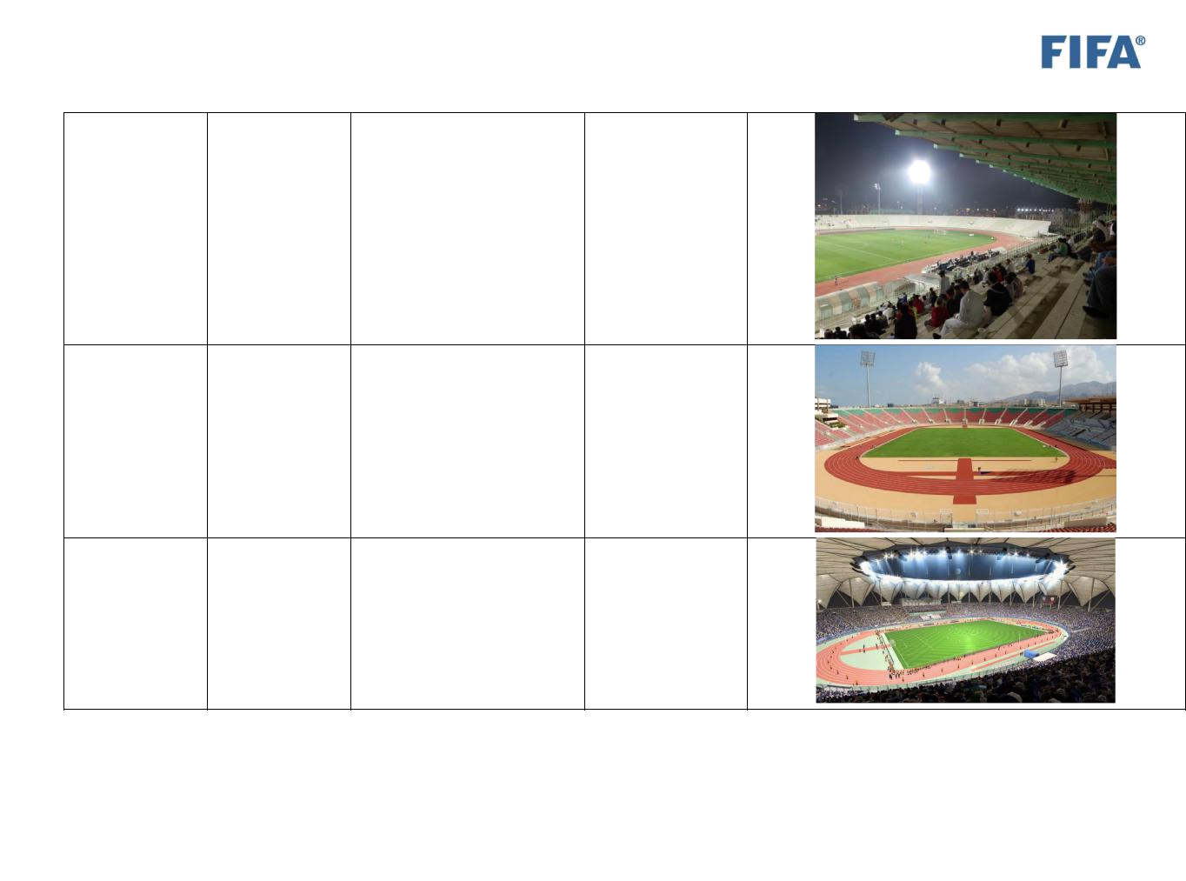

Kuwait | Kuwait City | Sabah Al-Salem Stadium | 26,000

Oman | Muscat | Boshar - Sultan Qaboos | 34,000
 |  | Sports Complex

Saudi Arabia | Riyadh | King Fahd International | 68,000
 |  | Stadium

FIFA World Cup Qatar 2022™ – Feasibility Study: Expansion of Format to 48 Teams | 77

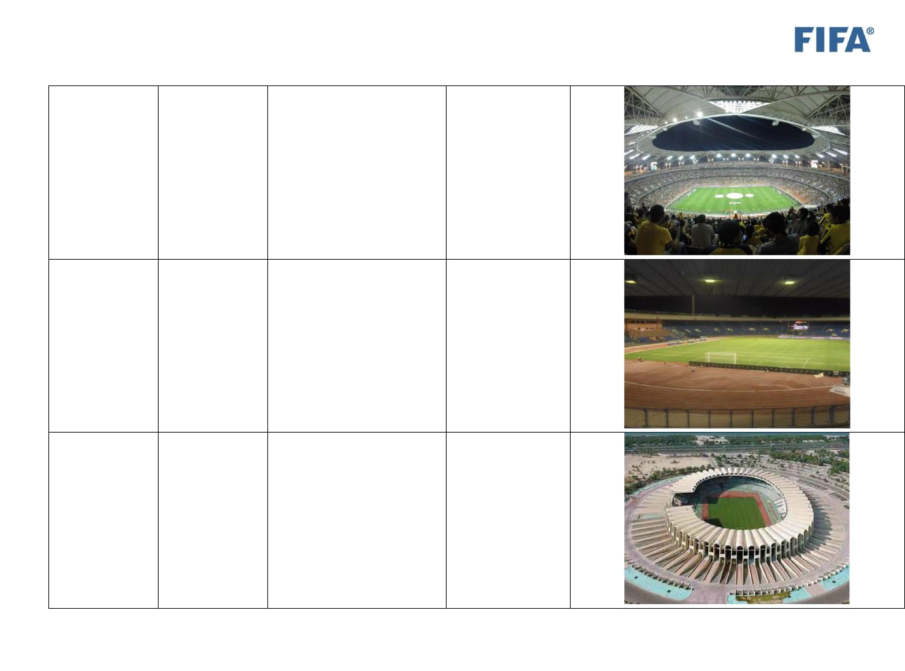

Saudi Arabia | Jeddah | King Abdullah Sports City | 62,000
 |  | Stadium

Saudi Arabia | Dammam | Prince Mohammed Bin | 26,000
 |  | Fahad Bin Abdul Aziz

UAE | Abu Dhabi | Zayed Sports City Stadium | 43,000

FIFA World Cup Qatar 2022™ – Feasibility Study: Expansion of Format to 48 Teams | 78

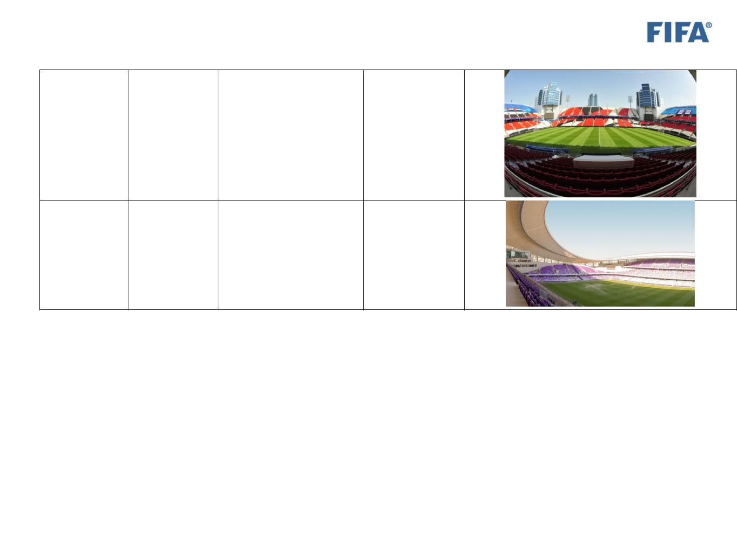

UAE | Abu Dhabi | Mohammad Bin Zayed | 42,000
 |  | Stadium

UAE | Al Ain | Hazza Bin Zayed Stadium | 23,000

FIFA World Cup Qatar 2022™ – Feasibility Study: Expansion of Format to 48 Teams | 79

