1. Full title of the Project

Feasibility Study on the Construction of a New Bridge Across River Nile at Jinja

- Type of the study Preparatory Study

- Categorization and its reason Category: A
Reason:

Every proposed new bridge construction route has a resettlement as a result of this

preparatory study. Some proposed route has a slightly large-scale resettlement. And the influence on the existing social infrastructures (e.g. power generation and substation facilities, resort hotel, resort center) is also considered. Therefore, category should be set to A.

4. Agency or institution responsible for the implementation of the project

The Uganda National Roads Authority (UNRA) has been inaugurated on July 1, 2008. The competent authority of the government level is MOWT. However, UNRA serves as a counterpart in actual.

Organization chart of UNRA is shown in Figure 4-1.
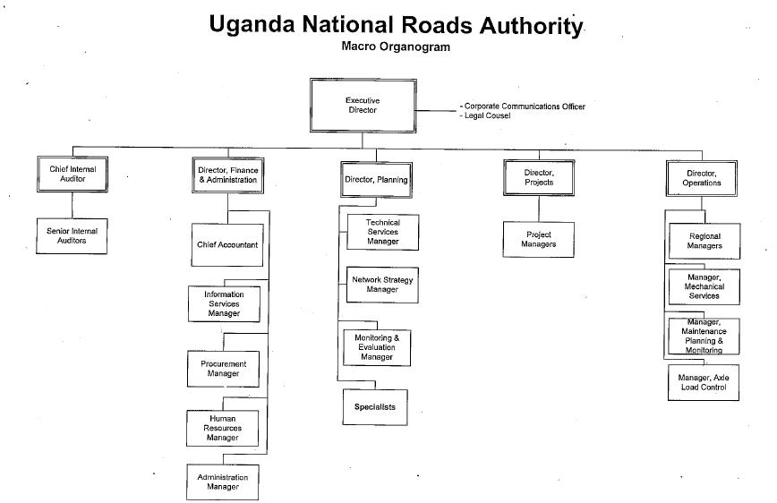

Figure 4-1 Organization Chart of UNRA

- Outline of the Project

(1) Objectives

The Republic of Uganda is roughly divided into eastern and western part in the country by the Nile River which flows out from the Lake Victoria. Northern corridor, which borders Kenya on the east side of Uganda, passes Kampala the capital of Uganda and is connected with Tanzania and Rwanda in southwest of Uganda. The Northern corridor is a main artery of the traffic in the East Africa whole region and crosses the Nile River near the Jinja district which located about 80km east from the capital Kampala.

For Uganda which is a landlocked country, impassable of the Northern corridor is serious problem on transportation of life substances and traffics etc.

is However, Nalubale Bridge built over the Nile River is not only a narrow bridge as 2 lanes total, but also its deterioration due to aging remarkable, because this bridge has passed over 50 years from its completion ( this bridge was constructed in 1954). And latest survey of the bridge indicates that Nalubale Bridge is in a critical situation on its durability.

The necessity for construction of a new bridge which replace with the present Nalubale Bridge has been pointed out.

Concerning construction of a new bridge, the World Bank carried out Pre-Investment Study. In this investment, selection of the bridge construction site was proposed. However, detailed addition of construction costs etc. was not performed. Therefore, both of Uganda and World Bank accepted the necessity for conducting F/S investigation before construction of a new bridge.

Under such situations, examination about construction of a new Nile Bridge replaced with Nalubale Bridge was advanced by the Uganda government. And government of Uganda requested for an implementation of feasibility study to government of Japan.

This preparatory study was carried out based on the request of the Government of Uganda. As main purpose of this preparatory study, a feasibility study was conducted regarding the new Nile River bridge construction site (Suburbs of Jinja District).

(2) Justification

Results of the field survey of the Nalubale Dam and Nalubale Bridge, it became clear that the structural deterioration due to aging of the existing Nalubale Bridge is remarkable. Nalubale Bridge is in the very serious situation as the possibility and danger of collapse cannot be denied. If the danger of collapse of the existing bridge takes

into consideration, it is clear that immediate repair of existing bridge or an alternative way should be secured.
Based on these situations, necessity to construct of New Nile Bridge which replace to the existing bridge is very high, and there is no room of doubt about the validity of project implementation.

- Description of the project site Location
The project site is shown in Figure 6-1. And Figure 6-2 shows survey area of this study.
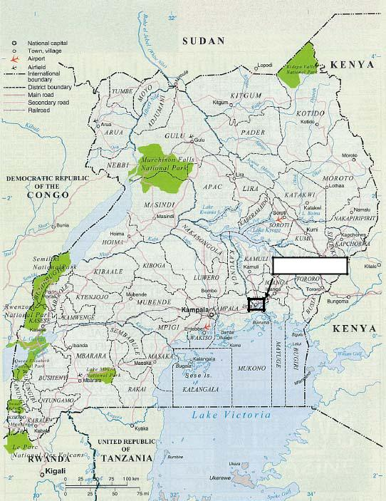

Survey area

Figure 6-1 Location Map
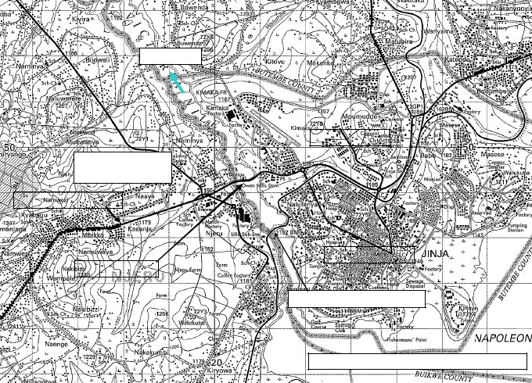

River Nile

Jinja District

Mukono District

Njeru Town

Northern Corridor

Jinja Municipal

Nalubale Dam

Existing Railway Bridge

Lake Victria（ Water Level EL.1,132m）

Figure 6-2 Survey area

Outline of Natural Condition

(1) Topographical Feature

Study area is bisected by the Nile River. Mukono district is located in the west side of the Nile River, and Jinja district is located in the east side of the Nile River.
Whole study area consists of a flat area which has an altitude 1,150m to 1,200m. The Nile River cuts the flat area and flows in the direction of north-northwest in general.

(2) Geological Feature

The geology of the basement rock of Uganda, most of basement rocks was formed Pre-Cambrian period. These basement rocks is consisted on metamorphic rocks and are considered that fresh and weak weathered portion of rocks has hard condition. And these basement rocks are adequate to utilize as the basement rock of the planned bridge abutments and piers.

(3) Meteorology

Uganda belongs to the Savanna climate.

In capital Kampala, average annual lowest temperature is about 17.3 ℃ and average annual maximum temperature is about 26.4 ℃.

On the other hand, the average annual lowest temperature is 16.7 ℃ and the average annual maximum temperature is about 28 ℃ in Jinja district of the study area.

(4) Precipitation

Annual precipitation of Uganda ranges from 900mm to 1,600mm. Except southwest part of Uganda which has low precipitation, average annual precipitation is about 1,200mm or more in general. This precipitation is lower than annual precipitation of Japan. Annual precipitation of Japan is about 1,700mm. However, Precipitation of Uganda is not extremely small.

On the other hand, annual precipitation of Jinja Municipal Council from 1996 to 2007 is about 1,400mm. Moreover, high precipitation is identified in April and November. And also, no clear dry season and rainy season is identified through the year.

(5) Hydrology

There are two hydrological stations around study area. One is Victoria Jinja hydrological station located in Jinja district near the proposed bridge site. The other one is Mbulamuti hydrological station located at 40km down stream from Nalubale dam.

Table 6.2.1 shows discharge, water level and flow velocity of Nile River which observed at hydrological stations above.

Table-6.2.1 Discharge, water level and flow velocity of Nile River around study area

Items | Mbulamuti station | Victoria Jinja station | Note
Discharge | 1,200m3/ sec(by 2005) | Not observed
 | 700 m3/sec(2006 and 2007)
Water | Average 11m | Average 11.5ｍ
Level | Maximum 12.5ｍ | Maximum 13.3m
 | Minimum 10.5ｍ | Minimum 11.0ｍ
Flow | Average 0.9ｍ/sec | Not observed
Velocity | Maximum 1.1ｍ/sec
 | Minimum 0.7ｍ/sec

(6) Earthquake

Near the proposed bridge site, earthquake has hardly occurred in 1996 and afterwards.

(7) Fauna and Flora

According to National environment management authority (hereinafter: NEMA), in the study area, investigation of the animals and plants by the present EIA process has not been carried out until now. Therefore, it is unknown whether endangered species inhabits around the study area or not. The Makerere University owns the list of endangered species of Uganda. Procedure of list acquisition was performed by study

team during this preparatory study. However, it was not able to obtain the list within the consultation period. In addition, the environmental division of UNRA is taking charge about this list acquisition.

On the other hand, pre-investigation study report issued by World Bank says that animals, such as monitor lizards, were observed in the vicinity of the proposed road reserve, their habitants and those of other animals on riverbanks should be identified and protected. Moreover, the report says that “some trees will be impacted and possibly removed especially Eucalyptus. These have been planted by residents who would be compensated. Compensation would be done according to the proposals made in the environmental management plan. In the case of native trees, where possible, efforts would be made to avoid removing them. Top soil materials stockpiled on site would be used to restore exposed surface spreading to improve on soil fertility.”

In the World Bank report, there is no description about animals and plants, insects and the reptiles except above mentioned items.

Outline of Social Condition

(1) General

１）Topographical feature

Latitude:N4°12’～S１°29‘

Longitude:E29°34’～E35°

Elevation: Max 5,110m、Lowest 620m

Area: 241,551km2

Area of ground: 199,807km2

Area of the surface of the water: 41,743km2

２）Economic index of ２００７

GDP at current market prices: 23,009billion Shs

GDP per capita at current market prices: 821,029 Shs

GDP growth rate at constant (2002) market prices: 9.0 percent

GDP per capita growth rate at constant (2002) market prices: 5.5 percent

Contribution of agriculture to GDP at market prices: 21 percent

Balance of payments surplus: 663.54 million US$

Inflation rate: 6.0 percent

Budget deficit as a percentage of GDP (2006/07): 11.7 percent ３）Population

Total( middle of 2008）:29,600,000

Kampala district: 1,500,000

(2) Jinja District(Jinja Municipal Council)

- Outline

Jinja district is composed from Kagoma county, Butembe county and Jinja Municipal Council. Jinja M.C. is the second city after capital Kampala.
Economic activities:

The rural areas of Jinja District are agricultural producers while a great deal of

industrial activity takes place in Jinja M.C.

Food crops: Beans, cassava, maize, finger, etc.

Cash crops: Coffee, cotton and sugar cane.

The export and import of the goods are transported via the wharf in Jinja by the steamship from Kenya and Tanzania. These goods are transported to inside of Uganda, such as Kampala, by the steamship which the Uganda railroad public corporation manages and tracks. Jinja serves as an important point of the physical distribution in Uganda.

Along the Nile River down stream portion of Jinja district, there is the Jinja Nile Resort Hotel. Circumference of the hotel serves as starting points of leisure, such as a rafting, a boating trip down a river in Nile River. And it is one of the hot spots of the Nile River sightseeing.

ｂ) Population

Whole Jinja District:387,573（Male:190,329, Female:197,244）

Jinja Municipal:71,213（Male:36,325, Female:34,888）

JInja Central Division:26,698（Male:13,184 人, Female:13,514）

- People/ Religion Basogo
Anglican / Protestant: 42%, Catholic: 23%, Muslim: 26% ｄ) Livelihood

Agriculture: 43%

Salaried worker: 55%

Many of salaried worker depend on industries of Jinja municipality.

(3) Mukono District

- Outline

Mukono district is composed from Buikwe county, Mukono county, Nakifuma county and Buvama county. Proposed bridge sites are located in Nijeru Town Council.

Economic activities:

Food crops: Beans, cassava, maize, finger, etc.

Cash crops: Coffee, cotton and sugar cane.

On the other hand, the factory of Nytil, Lugazi Sugar Works, and Nile Breaeries are located in the Mukono district, and there are also many employees of these factories.
- Population

- People/ Religion Baganda
Anglican / Protestant: 33%, Catholic: 37%, Muslim: 21%

- Livelihood

Agriculture: 50%

Salaried worker: 36%

- Legal Framework of Environmental and Social Consideration

(1) Laws and Regulations

Main laws/ regulations related to environment and social consideration of Uganda are shown in table-7.1.

Table 7-1 Main laws/regulations related to environment and social consideration of Uganda
No. | Name of Raws/Regulations | Note
1 | The Constitution of the Republic of Uganda -1995
2 | The National Environment Statute, 1995
3 | The National Environment Act, Cap 153- 1995
4 | The Environment Impact Assessment Regulations, 1998
5 | Guideline for Environmental Impact Assessment in Uganda, 1997
6 | The National Environment(Conduct and Certification of Environmental
 | Practitioners) Regulations, 2003
7 | The Land Acquisition Act, Cap 226 -1965
8 | The Land Act, Cap 227- 1998
9 | The Land (Amendment) Act - 2004
10 | Land Regulations - 2004
11 | The Mining Act -9/2003
12 | The National Forestry and Tree Planting Act -8/2003
13 | The National Environment Act Cap 153
14 | The National Environment (Standards for Discharge of Effluence into
 | Water or on Land) Regulations, S.I. No.5/1999
15 | The national Environment (Waste Management) Regulations
 | S.I. No.52/1999.
16 | The National Environment (Delegation of Waste Discharge Functions)
 | Instrument. S.I. No.56/1999
17 | The National Environment (Hilly and Mountainous Area Management)
 | Regulations, S.I. No.2/2000
18 | The National Environment (Wetlands, River Banks and Lake Shores
 | Management) Regulations, S.I. No.3/2000
19 | The National Environment (Minimum Standards for Management of Soil

 | Quality) Regulations, S.I. No.59/2001
20 | The National Environment (Management of Ozone Depleting Substances
 | and Products) Regulations, S.I. No.63/2001
21 | The National Environment (Noise Standards and Control) Regulations, S.I.
 | No.30/2003
22 | The National Environment (Conduct and Certification of Environmental
 | Practitioners) Regulations, S.I. No.85/2001
23 | The Water Act, Cap 152
24 | The Water Resources Regulations, S.I. No.33/1998
25 | The Water(Waste Discharge) Regulations, S.I. No.32/1998
26 | The Uganda Wildlife Act, Cap 200
27 | The Plant Protection Act, Cap 31
28 | The Animal Breeding Act, 2001
29 | The Control of Agricultural Chemicals Act, Cap 28
30 | The Agricultural Seeds and Plant Act, Cap 29
31 | The Prohibition of Burning of Grass Act, Cap 33
32 | The Fish Act, Cap 197

According to NEMA, except these laws and regulations above, a regulation concerning air pollution has been drawing up. Draft of that regulation has already made at the time of this preparatory study. NEMA said that “Publication of this regulation will be within this year.”

Moreover, there are no regulations and laws concerning vibration and offensive odor in Uganda up to now.

(2) EIA process of Uganda

Guideline for Environmental Impact Assessment in Uganda 1997 indicates the process of the EIA. Figure-7.1 shows the EIA process of Uganda.

(3) Relative agencies and institution

In Uganda, NEMA takes charge of the system management about EIA, and examination of individual matters about EIA.
NEMA is a governmental organization which takes charge of the planning, monitoring and regulation, etc. about the environmental issues in Uganda.
The team which takes charge of EIA is in the Department of Environment Monitoring and Compliance, as shown in Figure-7.2.
There are three sections in the Department of Environment Monitoring and Compliance. Examination, etc. of environmental impact assessment is enforced by the section of Environmental Impact Assessment. This section consists of a total of four persons of one EIA Co-oodinator and three EIA Officer.
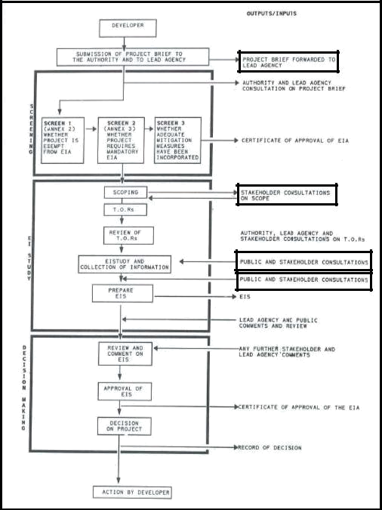

Figure 7.1 Process of EIA of Uganda

NEMA
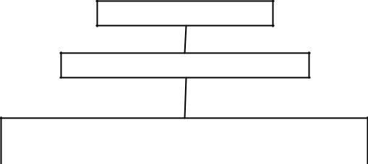

Exective Director

Deputy Exective Director

Department of Environment monitoring

and Compliance

Environmental Impact |  |  |  | Natural Resource |  |  | Environmental Audit
Assessment |  |  |  | Management |  |  | and Inspection
(4 officers) |  |  |  | (3 officers) |  |  | (4 officers)

Figure 7.2 Organization chat of NEMA(relate to environmental-impact-assessment)

There is also an environmental-related post in MOWT and UNRA which are counterpart organizations of this proposed project as shown in Table 7.2.
These departments perform creation of the EIA related guidelines, decision of policies and planning of each organization and each project, etc. Therefore, actual examination and evaluation of EIA is executed by NEMA.

Table 7.2 The environmental related post of MOWT and UNRA

Organization | Name of the post | Implementation items
MOWT | Environmental Unit | Policy making
 |  | Making EIA Guideline for Road section, etc.
UNRA | Environment Section | １）Responsible to Environmental and Social issues
 |  | management in UNRA projects.
 |  | ２）Monitor all UNRA project to see environmental
 |  | conditions are followed.
 |  | ３）Prepare plans for EIA on all UNRA project
 |  | ４）Screening of UNRA’s upcoming projects.
 |  | ５） Forms link with MOWT, NEMA on matters of
 |  | environmental issues in UNRA projects.

8. Provisional Scoping

Results of provisional scoping are as follows.
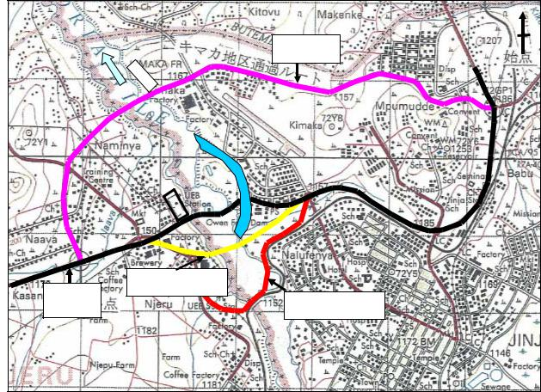

IDI H11route

World Bank A route

Existent

natinal road | World Bank B route

Figure 8.1 Map of Alternative route

Table 8.1 Matrix for Scoping

 | Name of Cooperration Project |  |  |  |  | Construction of a New Bridge across River Nile
 |  |  |  |  | Plannning |  |  | Construction Phase |  |  |  |  | Oparation
 |  |  |  |  |  | Phase |  |  |  |  |  |  |  | Phase
 |  | No. | Likely Impacts | OverallRating | LandAcquisition | ChangeofLanduseplan,Control of variousactivitiesbyregulationsfortheconstruction | ReclamationofWetland,etc. | Deforestation | Alterationtogroundbycutland, filling,drilling,tunnel,etc. | OperationofConstructionEquipment andVehicles | ConstructionofRoads,Tollgates,Parkinglots,Accessroadsforbridgesandotherrelatedfacilities | TrafficRestrictioninconstruction area | IncreaseofThroughTraffic | Appearance/OccupancyofRoadsandrelatedbuildingstructure | Increasinginfluxofsettlers
 |  |  |  |  |  |  |  |  |  |  |  |  |  |  |  | Note
might |  | 1 | Involuntary Resettlement | Ａ | Ａ |  |  |  |  |  | Ａ
might |  | 2 | Local economy such as | Ｄ
SocialEnvironment:Regardingtheimpactson"Gender"and"Children'sRight",berelatedallcriteriaofSocialEnvironment. |  | 2 | employment and liveihood, etc | Ｄ
 |  | 3 | Land use and utilization of | Ｂ |  | Ｂ |  |  | Ｂ |  | Ｂ
 |  | 3 | local resources | Ｂ |  | Ｂ |  |  | Ｂ |  | Ｂ
 |  |  | Social institutions such as
 |  | 4 | social infrastructure and | Ｄ
 |  | 4 | local decision-making | Ｄ
 |  |  | institutions
 |  |  | Existing social |  |  |  |  |  |  |  | Ａ |  |  |  |  | Plan of WB
 |  | 5 | Existing social | Ａ |  |  |  |  |  |  | （Existing |  |  |  |  | is A, others
 |  | 5 | infrastructure and services | Ａ |  |  |  |  |  |  | power |  |  |  |  | is A, others
 |  |  | infrastructure and services |  |  |  |  |  |  |  | plant） |  |  |  |  | are B
 |  | 6 | The poor, indigenous and | Ｂ | Ｂ |  |  |  |  |  | Ｂ |  |  |  |  | Plan of ＩＤＩＨ
 |  | 6 | ehnic people | Ｂ | Ｂ |  |  |  |  |  | Ｂ |  |  |  |  | 11
 |  | 7 | Misdistribution of benefit | Ｃ |  |  |  |  |  |  |  |  |  |  |  | ditto
 |  | 7 | and damage | Ｃ |  |  |  |  |  |  |  |  |  |  |  | ditto
 |  | 8 | Cultural heritage | Ｄ
 |  | 9 | Local conflict of interests | Ｃ
 |  | 10 | Water usage or Water Rights | Ｂ
 |  | 10 | and Rights of Common | Ｂ
 |  | 11 | Sanitation | Ｄ
 |  | 12 | Infectious diseases such as | Ｂ
 |  | 12 | HIV/AIDS | Ｂ
 |  | 13 | Gender | Ｄ
 |  | 14 | Children's Right | Ｄ
 |  | 15 | Topography and Geographical | Ｃ |  |  |  |  | Ｃ |  | Ｃ
 |  | 15 | features | Ｃ |  |  |  |  | Ｃ |  | Ｃ
Environment |  | 16 | Soil Erosion | Ｃ |  |  |  |  | Ｃ | Ｃ | Ｃ
Environment |  | 19 | (Mangroves, Coral reefs, | Ｄ
 |  | 17 | Groundwater | Ｄ
 |  | 18 | Hydrological Situation | Ｂ |  |  |  |  |  |  | Ｂ
 |  |  | Coastal Zone
Natural |  |  | Tidal flats,etc.)
Natural |  | 21 | Meteorology | Ｄ
 |  | 20 | Floara, Fauna and | Ｂ |  |  |  |  | Ｂ |  | Ｂ
 |  | 20 | Biodiversity | Ｂ |  |  |  |  | Ｂ |  | Ｂ
 |  | 22 | Landscape | Ｂ |  |  |  |  |  |  |  |  |  | Ｂ
 |  | 23 | Global Warming | Ｄ
 |  | 24 | Air Pollution | Ｂ |  |  |  |  | Ｂ | Ｂ | Ｂ |  | Ｂ
 |  | 25 | Water Pollution | Ｂ |  |  |  |  | Ｂ | Ｂ | Ｂ
Pollution |  | 26 | Soil Contamination | Ｃ |  |  |  |  | Ｃ | Ｃ | Ｃ
Pollution |  | 27 | Waste | Ｃ |  |  |  |  | Ｃ | Ｃ | Ｃ |  | Ｃ
 |  | 28 | Noise and Vibration | Ｂ |  |  |  |  |  | Ｂ |  |  | Ｂ
 |  | 29 | Ground Subsidence | Ｄ
 |  | 30 | Offensive Odor | Ｄ
 |  | 31 | Bottom sediment | Ｂ |  |  |  |  | Ｂ |  | Ｂ
 |  | 32 | Accidents | Ｂ |  |  |  |  |  |  |  |  | Ｂ
Rating |  | A: | Serious impact is expected.

- Some impact is expected.

- Extent of impact is unknown(Examination is needed.Impacts may become clear as study progresses.)

No Mark No impact is expected.

 | Table 8.2 | Check List for Scoping |  |  | (World Bank A site)
 | Name of Site |  |  |  | World Bank A Site
 | Impacts |  | Rating |  | a Brief Description
Social Environment:
1 | Involuntary Resettlement |  | Ｂ | Jinja on the right side bank of the river, residences are under
1 | Involuntary Resettlement |  | Ｂ | construction.Stakeholder meeting is required in early stages.
2 | Local economy such as employment |  | Ｄ
2 | and livelihood, etc. |  | Ｄ
3 | Land use and utilization of local |  | Ｂ | Demolition of a portion of buildings of Nytile factory. Because access
3 | resources |  | Ｂ | road to bridge plans to go through the site of the facility.
4 | Social institutions such as social
4 | infrastructure and local decision- |  | Ｄ
 | making institutions
 |  |  |  | The water and sewage system by NWSC (water service public corporation)
5 | Existing social infrastructures and |  | Ｃ | are distributed in the area. Temporary restrictions of water use and
 | services |  |  | relocation of these system are needed in connection with an access road
 |  |  |  | building.
6 | The poor, indigenous and ethnic |  | Ｄ
6 | people |  | Ｄ
7 | Misdistribution of benefit and |  | Ｃ | Extent of impact is unknown(Examination is needed.Impacts may become
7 | damage |  | Ｃ | clear as study progresses.)
8 | Cultural heritage |  | Ｄ
9 | Local conflict of interests |  | Ｃ | Extent of impact is unknown(Examination is needed.Impacts may become
9 | Local conflict of interests |  | Ｃ | clear as study progresses.)
 |  |  |  | There are no residents using groundwater (also include irrigation).
10 | Water Usage of Water Rights and |  | Ｂ | The residents, who cannot use water and sewage system, use water of the
10 | Rights of Common |  | Ｂ | Nile River directly, but when the construction of a new bridge, river
 |  |  |  | water contamination can be considered.
11 | Sanitation |  | Ｄ
12 | Infection diseases such as HIV/AIDS |  | Ｂ | There is inflow of the construction persons concerned and a risk can be
12 |  |  | Ｂ | considered.
13 | Gender |  | Ｄ
14 | Children's Right |  | Ｄ
Natural Environment
15 | Topography and Geolographical |  | Ｃ | Change of the geographical feature accompanying construction of
15 | features |  | Ｃ | abutments of a bridge and a bridge pier occurs.
16 | Soil Erosion |  | Ｃ | It is possible that slight soil erosion occurs with artificial change of
16 | Soil Erosion |  | Ｃ | the geographical feature under construction.
17 | Groundwater |  | Ｄ | There is no groundwater use around proposed site.
18 | Hydrological Situation |  | Ｂ | When construction of a bridge pier in a river channel, the influence on
18 | Hydrological Situation |  | Ｂ | flow condition can be considered.
19 | Coastal Zone(Mangroves, Coral |  | Ｄ
19 | reefs, Tidal flats,etc.) |  | Ｄ
 |  |  |  | Although based on the result of |  | EIA carried out from now on, a
20 | Flora, Fauna and Biodiversity |  | Ｂ | possibility of inhabitation of |  | precious species is assumed to be low.
20 |  |  | Ｂ | However, the influence on the existing animals and plants by
 |  |  |  | construction of an access road can be considered.
21 | Meteolorogy |  | Ｄ
22 | Landscape |  | Ｂ | It is thought that a construction of the big artificial structure of a
22 | Landscape |  | Ｂ | scale will accompany with a landscape change..
23 | Global Warming |  | Ｄ
Pollution
24 | Air Pollution |  | Ｂ | It is expected that sand dust and an exhaust gas increase temporarily by
24 | Air Pollution |  | Ｂ | heavy industrial machine use during a construction period.
25 | Water Pollution |  | Ｂ | Contamination by the outflow of sand ,dust and fuel can be considered
25 | Water Pollution |  | Ｂ | during construction.
26 | Soil Contamination |  | Ｃ | There are any possibilities of contamination by the outflow of the oils
26 | Soil Contamination |  | Ｃ | and fats,etc. during a construction period.
27 |  |  |  | There is a problem about disposal of the garbage and waste during a
27 | Waste |  | Ｃ | construction period, moreover, consideration of temporary storage space
 |  |  |  | of digged soil and sand are required.
28 | Noise and Vibration |  | Ｂ | There is a possiblity that noise and vibration occurs by heavy
28 | Noise and Vibration |  | Ｂ | industrial machine use during construction period.
29 | Ground Subsidence |  | Ｄ
30 | Offensive Odor |  | Ｄ
31 | Bottom sediment |  | Ｃ | In the case a bridge pier is built in the river bed, a disturbance of
31 | Bottom sediment |  | Ｃ | the quality of a bottom sediment can be considered.
32 | Accidents |  | Ｂ | The danger of a traffic accident can be considered with speedup of
32 | Accidents |  | Ｂ | traffic after new bridge construction.
Ratin | A: |  | Serious impact is expected.

- Some impact is expected.

- Extent of impact is unknown(Examination is needed.Impacts may become clear as study progresses.)

No Mark: No impact is expected.

 | Table 8.3 | Check List for Scoping |  | (World Bank B site)
 | Name of Site |  |  | World Bank B Site
 | Impacts | Rating |  | a Brief Description
Social Environment:
1 |  |  | Some of residents resettlement is required in a part of residential section
1 | Involuntary Resettlement | Ｂ | of the railroad side in Jinja. Stakeholder meeting is required in early
 |  |  | stages.
2 | Local economy such as employment | Ｄ
 | and livelihood, etc.
3 | Land use and utilization of | Ｂ | As for the Njeru side, proposed access road will pass along the existing
3 | local resources | Ｂ | industrial area.
4 | Social institutions such as
4 | social infrastructure and local | Ｄ
 | decision-making institutions
 |  |  | There is a medical center the starting point of Jinja side and relocation of
5 | Existing social infrastructures | Ａ | this medical center is required. Proposed access road passes a transformer
5 | and services | Ａ | substation in Njeru side. It is very difficult to enforce relocation of this
 |  |  | facility.
6 | The poor, indigenous and ethnic | Ｄ
6 | people | Ｄ
7 | Misdistribution of benefit and | Ｃ | Extent of impact is unknown(Examination is needed.Impacts may become clear as
7 | damage | Ｃ | study progresses.)
8 | Cultural heritage | Ｄ
9 | Local conflict of interests | Ｃ | Extent of impact is unknown(Examination is needed.Impacts may become clear as
9 | Local conflict of interests | Ｃ | study progresses.)
 |  |  | There are no residents using groundwater (also include irrigation).
10 | Water Usage of Water Rights and | Ｂ | The residents, who cannot use water and sewage, use water of the Nile River
 | Rights of Common |  | directly, but when the construction of a new bridge, river water contamination
 |  |  | can be considered.
11 | Sanitation | Ｄ
12 | Infection diseases such as | Ｂ | There is inflow of the construction persons concerned and a risk can be
12 | HIV/AIDS | Ｂ | considered.
13 | Gender | Ｄ
14 | Children's Right | Ｄ
Natural Environment
15 | Topography and Geolographical | Ｃ | Artificial change of the geographical feature accompanying construction of
15 | features | Ｃ | abutments of a bridge and a bridge pier will occur.
16 | Soil Erosion | Ｃ | It is possible that slight soil erosion occurs with artificial change of the
16 | Soil Erosion | Ｃ | geographical feature under construction.
17 | Groundwater | Ｄ
18 | Hydrological Situation | Ｂ | When construction of a bridge pier in a river channel, the influence of flow
18 | Hydrological Situation | Ｂ | condition can be considered.
19 | Coastal Zone(Mangroves, Coral | Ｄ
19 | reefs, Tidal flats,etc.) | Ｄ
 |  |  | Although based on the result of EIA carried out from now on, a possibility of
20 | Flora, Fauna and Biodiversity | Ｂ | inhabitation of precious species is assumed to be low.
20 | Flora, Fauna and Biodiversity | Ｂ | However, the influence on the existing animals and plants by construction of
 |  |  | an access road can be considered.
21 | Meteolorogy | Ｄ
22 | Landscape | Ｂ | It is thought that a construction of the big artificial structure of a scale
22 | Landscape | Ｂ | will accompany with a landscape change.
23 | Global Warming | Ｄ
Pollution
24 | Air Pollution | Ｂ | It is expected that sand dust and an exhaust gas increase somewhat temporarily
24 | Air Pollution | Ｂ | by heavy industrial machine use during a construction period.
25 | Water Pollution | Ｂ | Contamination by the outflow of sand ,dust and fuel can be considered during
25 | Water Pollution | Ｂ | construction.
26 | Soil Contamination | Ｃ | There is possibility of some contamination by the outflow of the oils and
26 | Soil Contamination | Ｃ | fats,etc. under construction.
27 |  |  | There is a problem about disposal of the garbage and waste during a
27 | Waste | Ｃ | construction period, moreover, consideration of temporary storage space of
 |  |  | digged soil and sand are required.
28 | Noise and Vibration | Ｂ | It is thought to be possible that noise and vibration occur by heavy
28 | Noise and Vibration | Ｂ | industrial machine use during construction.
29 | Ground Subsidence | Ｄ
30 | Offensive Odor | Ｄ
31 | Bottom sediment | Ｃ | In the case a bridge pier is built in the river bed, the disturbance of the
31 | Bottom sediment | Ｃ | quality of a bottom sediment can be considered.
32 | Accidents | Ｂ | The danger of a traffic accident can be considered with speedup of traffic
32 | Accidents | Ｂ | after new bridge construction.
Ratin | A: | Serious impact is expected.

- Some impact is expected.

- Extent of impact is unknown(Examination is needed.Impacts may become clear as study progresses.)

No Mark: No impact is expected.

 | Table 8.4 |  | Check List for Scoping |  |  | (IDIH11 site)
 | Name of Site |  |  |  |  | IDI H11 Site
 | Impacts |  |  | Rating | a Brief Description
Social Environment:
1 |  |  |  |  | Resettlement of some redsidents is required in Njeru, left side of Nile River.
1 | Involuntary Resettlement |  |  | Ａ | Stakeholder meeting is required in early stages. The poor is also contained in
 |  |  |  |  | the candidates of a resettlement.
2 | Local economy such as employment |  |  | Ｄ
2 | and livelihood, etc. |  |  | Ｄ
 |  |  |  |  | Since most of the present road section in Jinja side is consisted of an
3 | Land use and utilization of local |  |  | Ｂ | unpaved road, extension of the road of this section is required.
3 | resources |  |  | Ｂ | In present condition, grassy place distrributes along the most of existing
 |  |  |  |  | road in general, and change of land use by
4 | Social institutions such as social
4 | infrastructure and local decision- |  |  | Ｄ
 | making institutions
 |  |  |  |  | Nile Resort Hotel(private) is located at near the proposed site in Jinja side.
5 | Existing social infrastructures |  |  | Ａ | Moreover, there is a private resort center in Njeru side. It is assumed that
5 | and services |  |  | Ａ | trafic on new bridge and road will cause noise, and new bridge itself will
 |  |  |  |  | affect landscape around
6 | The poor, indigenous and ethnic |  |  | Ｂ | The poor lives in Njeru side.
6 | people |  |  | Ｂ | The resettlement of the poor is needed.
7 | Misdistribution of benefit and |  |  | Ｃ | Extent of impact is unknown(Examination is needed.Impacts may become clear as
7 | damage |  |  | Ｃ | study progresses.)
8 | Cultural heritage |  |  | Ｄ
9 | Local conflict of interests |  |  | Ｃ | Extent of impact is unknown(Examination is needed.Impacts may become clear as
9 | Local conflict of interests |  |  | Ｃ | study progresses.)
 |  |  |  |  | There are no residents using groundwater (also include irrigation).
10 | Water Usage of Water Rights and |  |  | Ｂ | The residents who cannot use water and sewage use water of the Nile River
10 | Rights of Common |  |  | Ｂ | directly, but when the construction of a new bridge, river water contamination
 |  |  |  |  | can be considered.
11 | Sanitation |  |  | Ｄ
12 | Infection diseases such as |  |  | Ｂ | There is inflow of the construction persons concerned and a risk can be
12 | HIV/AIDS |  |  | Ｂ | considered.
13 | Gender |  |  | Ｄ
14 | Children's Right |  |  | Ｄ
Natural Environment
15 | Topography and Geolographical |  |  | Ｃ | Artificial change of the geographical feature accompanying construction of
15 | features |  |  | Ｃ | abutments of a bridge and a bridge pier will occur.
16 | Soil Erosion |  |  | Ｃ | It is possible that slight soil erosion occurs accompany with artificial
16 | Soil Erosion |  |  | Ｃ | change of the geographical feature during construction.
17 | Groundwater |  |  | Ｄ
18 | Hydrological Situation |  |  | Ｂ | When construction of a bridge pier in a river channel, the influence of flow
18 | Hydrological Situation |  |  | Ｂ | condition can be considered.
19 | Coastal Zone(Mangroves, Coral |  |  | Ｄ
19 | reefs, Tidal flats,etc.) |  |  | Ｄ
20 |  |  |  |  | It is thought that a construction of the big artificial structure of a scale
20 | Flora, Fauna and Biodiversity |  |  | Ｂ | will accompany with a landscape change, although becoming better than the
 |  |  |  |  | present condition is assumed.
21 | Meteolorogy |  |  | Ｄ
22 |  |  |  |  | It is thought that a construction of the big artificial structure of a scale
22 | Landscape |  |  | Ｂ | will accompany with a landscape change, although becoming better than the
 |  |  |  |  | present condition is assumed.
23 | Global Warming |  |  | Ｄ
Pollution
24 | Air Pollution |  |  | Ｂ | It is expected that sand dust and an exhaust gas increase somewhat temporarily
24 | Air Pollution |  |  | Ｂ | by heavy industrial machine use during a construction period.
25 | Water Pollution |  |  | Ｂ | Contamination by the outflow of sand ,dust and fuel can be considered during
25 | Water Pollution |  |  | Ｂ | construction.
26 | Soil Contamination |  |  | Ｃ | There is possibility of some contamination by the outflow of the oils and
26 | Soil Contamination |  |  | Ｃ | fats,etc. during a construction period.
27 |  |  |  |  | There is a problem about disposal of the garbage and waste during a
27 | Waste |  |  | Ｃ | construction period, moreover, consideration of temporary storage space of
 |  |  |  |  | digged soil and sand are required.
28 | Noise and Vibration |  |  | Ｂ | It is thought to be possible that noise and vibration occur by heavy
28 | Noise and Vibration |  |  | Ｂ | industrial machine use during a construction period.
29 | Ground Subsidence |  |  | Ｄ
30 | Offensive Odor |  |  | Ｄ
31 | Bottom sediment |  |  | Ｂ | In the case a bridge pier is built in the river bed, the disturbance of the
31 | Bottom sediment |  |  | Ｂ | quality of a bottom sediment can be considered.
32 | Accidents |  |  | Ｂ | The danger of a traffic accident can be considered with speedup of traffic
32 | Accidents |  |  | Ｂ | after new bridge construction.
Ratin | A: |  |  | Serious impact is expected.

- Some impact is expected.

- Extent of impact is unknown(Examination is needed.Impacts may become clear as study progresses.)

No Mark: No impact is expected.

9. Alternatives to the project activities including ‘without project’ option.

Existing Nile Bridge (Nalubale Bridge) has passed over 50 years from its completion (this bridge was constructed in 1954) and aging of bridge has been remarkable.
If any repair of existing bridge would not be done and new bridge would not be constructed around existing bridge site there is high possibility of unable to use of the existing bridge. Moreover all traffics (including passenger and goods) can not cross the Nile River around existing bridge site. At that case, all traffics must take a detour to Kamalu Bridge, which located north of existing bridge, in order to cross the Nile River. And the passengers and traffics will be burdened an excess of more than 500km in order to cross the Nile River. Economical loss caused by this is thought to be very large.

On the other hand, in the case of repair of existing bridge as an alternative, investigations below are required.

- Soundness investigation of existing Nalubale Bridge (crest of the Nalubale Bridge is used as a portion of existing bridge)
- Soundness investigation of the abutments and piers of existing Nalubale Bridge. (section where piers of the bridge are installed in the reservoir)

And then, reinforcement of dam itself and overall reconstruction of existing bridge will be required. In that case, the most serious problem is that long term all- out traffic stop during restoration work of the existing bridge is needed.

From the above viewpoint, based on the result of feasibility study which will be conducted from now on, an overall evaluation should be done. Overall evaluation needs to estimate synthetically the environmental and social impact, economical efficiency, and construction efficiency. Moreover, it is very important to select an optimal bridge construction site from the three alternatives, which selected by this preparatory study, and select a suitable bridge form.

