Feasibility Study on Development of Intermodal Freight Transport Between Belgium and Bulgaria
Prof. Marchal Jean Leon Jerom
ANAST, ULG, Liege, Belgium
Dr. Zhang Zhaomin
ANAST, ULG, Liege, Belgium
Res. Eng. Kisheva Diana
BSHC, Varna, Bulgaria

Introduction
This paper summarizes major results obtained by the joint Belgian – Bulgarian project “Development of new strategies of intermodal transportation chains along the Rhine – Main – Danube corridors”, implemented under the frames of B-B bilateral cooperation program.
The aim of the project was to perform a feasibility study for possible development of freight intermodal transport links between Belgium and Bulgaria, between North and Black sea and vice versa, taking inland waterways (iww) transport mode as basic one. The key focus is assessment of benefits in adopting an intermodal manner for transferring cargo instead of the single transport mode currently in use.
The paper comprises short description of trans-continental infrastructure between Belgium and Bulgaria and its abilities to serve for different transport alternatives, definitions and choice of appropriate scenarios for realising predicted cargo flows, as well as cost calculations. Comparative analysis of the considered transport alternatives has been made.

The most important results obtained are transport cost evaluation and benefit assessment for investigated transport scenarios.

1. Description of various transport alternatives
The trans-European infrastructure for four transport alternatives (river, highway, rail and sea) is described based on detailed investigation of great number of technical materials and geographical maps [1], [4], [6], [9],[10], [12].

Transport Infrastructure along the Rhine -Main-Danube corridor
Following the main project concept - development of intermodal transport on the basis of inland waterways transport, this infrastructure is considered in extreme details, including all cartographic and technical data for rivers, canals and hydro technical facilities in disposal.
The annual cargo capacity per direction and annual number of convoys/ships per direction for every one section along the corridor is calculated for the whole inland waterway destination.
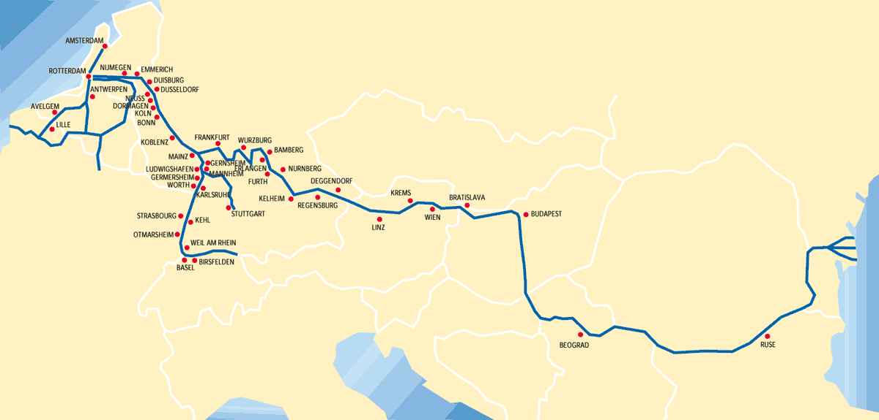
Fig. 1 is one of multitude maps of trans-European Rhine – Main – Danube corridor. Fig. 2 contains, besides usual map parameters, locations of main hydro technical facilities along the Main –Danube Cannel also.

Fig.1 The inland waterways between Black sea and North sea
Fig.2 Map of Main – Danube canal infrastructure

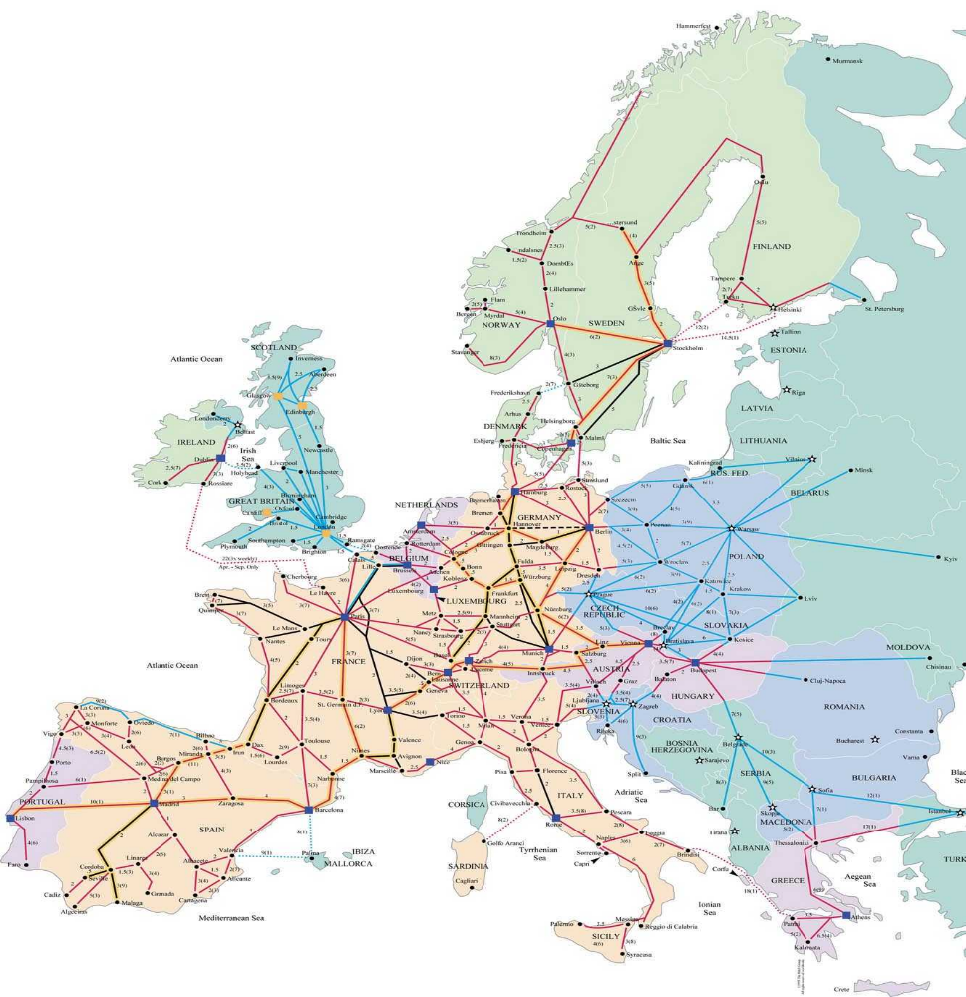
Fig.3

Railways and highways infrastructure between Belgium and Bulgaria
By analogy of inland waterways, assessment of railroad ways infrastructure between Belgium and Bulgaria has been performed too. Fig. 3 shows the assembly map of European railroad ways.
All main nodes along destination are considered. As it is well known, they are practically identical for rail- and highways, which explains small differences in the distancesbetween them along the destination.

Sea shipping transport alternative
The sea routеs (fig.4) exist since ancient time and they hadn’t changed. The shipping line Black sea – North sea is also very old. With years, however, strong changes occur in vehicles operating those routes, as well as in the infrastructure and port organization.

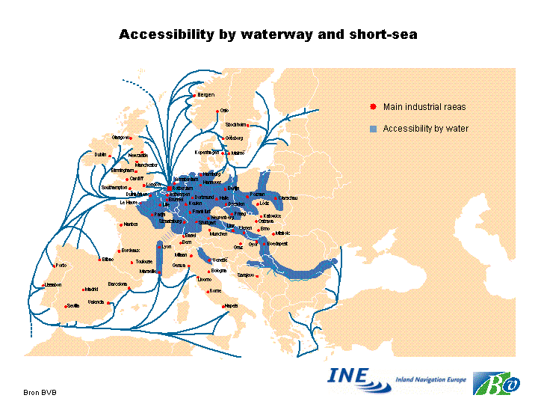

Fig.4

Intermodal Terminals
At present, the implementation of intermodal transport conception is the most important goal of united Europe in the field of transport. Nevertheless that practically not more than 10% of all exchanged cargo flows in European regione are transported by intermodal manner, constructing of intermodal chains is already under way.
One of the main prerequisites to achieve the goal is availability of special technical facilities and depots, in which easy and quick change of the transport mode for containerized cargoes is possible.

Data for container terminals of significance along the destination have been accumulated. Location, entrances, exits and contact co-ordinates (phone, fax, e-mail, etc. communications) for more then 60 container terminals are available so far.
Above-mentioned description of the various transport alternatives has been summarized in tables containing main nodes along the destination and distances between them. They serve like input for transport cost calculations.

2. Cargo traffic between Belgium and Bulgaria

Existent Transport Demands
The cargo flows for 1992 [11] between Bulgaria and Belgium and vise versa, as shown in Fig 5, are used as a basis for assessment.
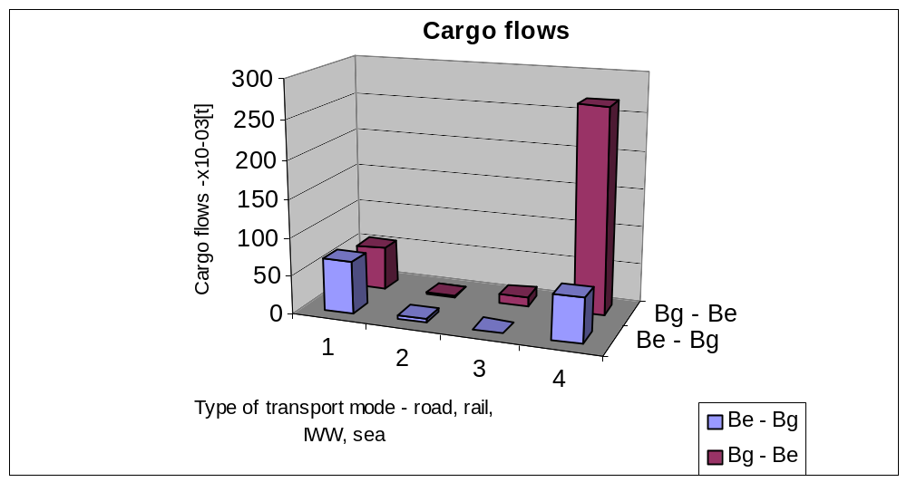
Fig. 5

Considering the strategic geographical situation of Bulgaria along the road between Western Europe and the Middle East, reported cargo flows can be judged modest. This is most probably caused by the Bulgarian registration regime, which until recently differed by that adopted in West Europe. As a consequence, cases of transit haulage with reloading on another type of transport (i.e. ship - truck), or transit with depositing (i.e. ship – store – outgoing transport) have been probably excluded from the total number of shipped cargo volume and have been calculated into international import/export cargo flows.
After analyzing the data, is possible to conclude, that:
- Substantial part of trade between Bulgaria and Belgium and vice versa is realized by sea, using ports of Oostende, Antwerp, Rotterdam and Amsterdam, and ports of Varna and Burgas respectively.
- Right in second place come cargo flows transported by road.
- The volumes of goods transported by rail and especially by inland waterways are insignificant.
- The most important initial stations (almost equipollent) for admittance of Bulgarian goods for road, rail and IWW transport modes are Rotterdam, Groningen, Antwerp, Amsterdam and Eindhoven.

Demands Forecasts
On the base of existing traffic between Belgium and Bulgaria, a middle-term forecast of tendency nature has been developed.
The future goods exchange volumes are expected to be, as follows:
- The export from Benelux to Bulgaria will increase till 2010 with some 95 percents, at this:
  - The road transport will remain one of the most utilized modes of transportation, and it is expected its importance to increase even further, to occupy the first place in shares;
  - The transportation by sea, even if yielding its first priority, will keep significant share in total freight;
  - Regardless the tendency in EU transport policy of increase in rail and waterway transport utilization, their share will remain insignificant.
  - The import in Benelux from Bulgaria is also expected to increase till 2010 with about 50 percents, at this:
  - The sea borne transport will keep its leading position, whilst about 80% of the total freight will continue to be shipped by sea;
  - The share of all other modes of transport, namely road, rail and inland waterways, will remain almost unchanged.
Considering the cargo flow in unified cargo units, transported from Western Europe eastward and backward via Bulgaria or via other alternative routes across Balkan Peninsula, it should be emphasized, that so far it has been realized mainly by autonomous motor transport, which is not a subject of the intermodal technology. The lack of circumstances for application of the classical intermodal technology of continental type by using rail transport for trunk shipment across former East-block countries, makes the variant of main freight along Danube River the only alternative.

3 Definition of Scenarios
The economic efficiency, capacity reserves of the ships, terminals and waterways, environmental impacts, traffic safety and external costs has to be taken into account to compare transport modes used. The decisive parameters for the selection of the means of transportation are reliability, speed and price.
It is well known, that the building of the transport scenario depends to a great degree on its target.
The scenarios in present development are built on forecast of back costs and the basic parameter for comparison is the transport cost, i.e. economic efficiency.

3.1 Existent Modal Shares - Basic scenario
We assume the four single transport modes, described in it.1, (rails, highways, iww and maritime) as the basic scenario.

3.2 Shift Scenarios
The characteristics of the cargo being transported (so called “transportation sensitivity”, i.e. perish ability, fragility, sensitivity to cold, heat of water), as well as the demands of the recipient (technical or market specific requirements such as delivery time limits, as well as subjective preferences) define the shift ability of certain cargo between means of transportation.
There is a possibility to shift cargoes from road transport to rail or to inland waterway. The preliminary investigations show that rail transport mode has a comparatively high price and inland waterway is more attractive transport mode for present development.
The circumstances defining the shifting possibility are:
- the availability of inland waterways and ports near to the location of cargo origin and destination;
- the quantity of cargo for transportation – it is necessary to be of big enough volume;
- the transport cost for two modes used by customers must be less or near to the road transport cost;
- the time needed for transport has to be satisfactory for the customers;
- the infrastructure of inland waterway has to permit regular and safe navigation.
- the transport chain with integration of the inland waterway mode has to be integrated in the customer logistic chain.
In present development the hypothetic shifting possibility for 10%, 20% and 30% of cargo’s volume from road to inland waterways is considered. As in the Item 3.1, only single transport modes are considered – road and iww.

3. 3 Container scenario
To make comparison more clear, we assume that 90% of road transport cargo is packed in containers and is transported by trucks. All trucks are fully loaded (100% weight of one container is assumed 22 tons).

3.4 Intermodal Logistical Chains
If necessary infrastructure is available, the choice of transport modes used for intermodal transportation depends of all above mentioned parameters and additionally on time and charges for container (trailer) trans-shipment.
For intermodal transportation in our case (Bulgaria – Belgium and vise versa), inland waterway and road transport modes are suitable.
- First assumption is that 90% of transferred cargo volumes are situated in 20ft containers.
- Second assumption is that for all containers the intermodal transport share for the road portion Cologne – Rouse is affected by waterway. Cologne is assumed the point of transport mode interchange (mainly road transport) to different cities in Belgium and the Netherlands.

4. Comparative Analysis of Freight Transfer Costs for Several Transport Alternatives

Transport Cost Computation

Direct Transport Costs
There are numerous developments for transport cost calculation of every single transport mode and for its minimizing. All these costs are so called direct or internal costs. Their structure can be divided into two main groups – fixed taxes and costs and variable taxes and costs. The structure of transport cost is similar for all transport modes [5], [6], [7], [8].
In according with the world trends and governmental policy following them (most clearly expressed in highly developed countries) nowadays, the most numerous are developments in the field of container cost calculations on the base of some different transport modes. [5]
It is well known, that the transport cost is different for different transport providers. Because our aims are comparative qualitative calculations, we take average values of transport cost.

External Transport Cost
All transport modes (water, rail, air, truck) affects the environmental components of sustainability. The cost of transport not always includes the entire costs associated with the environmental aspects of the transport system.
Those costs, for which the user of goods or service (such as infrastructure) does not pay, or costs imposed on others and not borne by the party responsible for the cost, are external.
For example, direct transport cost of 1t*km for road transport is possible to be less in comparison with those for inland water transport, but external costs created by road traffic is much higher than those created by waterway traffic (up to 5.5 times higher per t*km). Waterway transport is most often the transport mode, which is friendliest for the environment and is often the most economical mode of transport.
The external costs of transport are large (estimated at about 8% of EU GDP (INFRAS, 2000), but the estimates are uncertain. The most important categories of external costs are: climate change, air pollution and accidents. Congestion is one of the highest components mainly for urban transport.
Road transport, which dominates all mobility volumes, is responsible for more than 90% of total external costs. Road vehicles usually also show relatively higher average external costs per passenger*km than other modes – although the newest vehicles perform better from this point of view.

Published in different issues studies on the external costs, including, type of effect, cost components and most important assumptions for their estimation are summarized and deeply analyzed in [1].
The significant components evaluated for the whole external cost value are respectively:
costs for accidents, noise, air pollution, and climate change congestion, nature and landscape, separation in urban areas, space scarcity in urban areas, additional costs from up and downstream processes. External costs can be also classified as fixed and variable.
We have got the real data for road and inland waterway transport external costs.
To evaluate the influence of external cost additional scenario has been developed on the base of collected data – transport expenses calculations for cargo volumes transferred by road and inland waterways transport modes.
Transport cost calculations are developed on the basis of scenarios described above and accepted average costs – fig.6.

Analysis of the calculated transport expenses
After transport cost calculations for above mentioned scenarios (it.3) and real average single transport cost (without considering of other transport service parameters), is evident, that:
- The transport expenses at waterborne transport service are more than 5 times less in comparison less than road and rail transport for one and the same cargo tonnage.
- Еxternal costs influence – Fig. 7 and Fig. 8
External costs inclusion for the road and iww transport expenses increase them with more than 80% (85% for road and 82% for iww). The relationship between single cost (1tkm) remains almost the same – decrease with 1%.
- c) Shifting scenario – Fig.9 and Fig.10
Shifting of every 10% of cargoes leads to 8% total amount decreasing of transport expenses.
- d) Container scenario
The haulage of one and the same quantity cargoes in containers instead in vrac decrease significant the funds necessary for transferring – If If 90% of road cargoes are in containers - not bulk in, we will economize 15% of road transport expenses – Fig. 11.
- e) intermodal scenario-
If 90% of road cargoes are in containers and these cargo volumes are transferred by intermodal manner using two modes – road in the BENELUX and IWW from Cologne to port of Russe, Bulgaria, the transport expenses decrease with 65% - Fig.12.

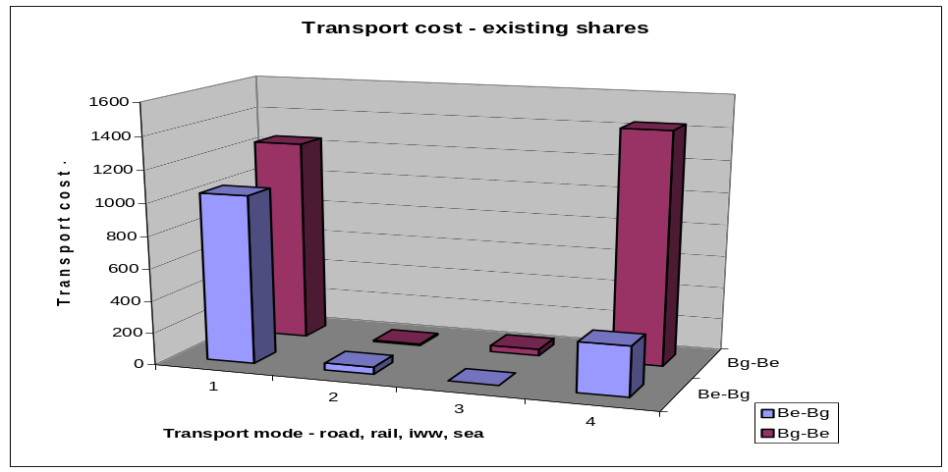
Fig.6
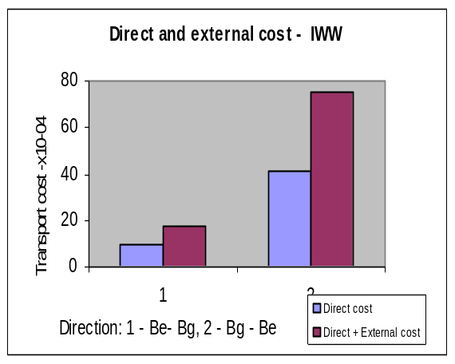
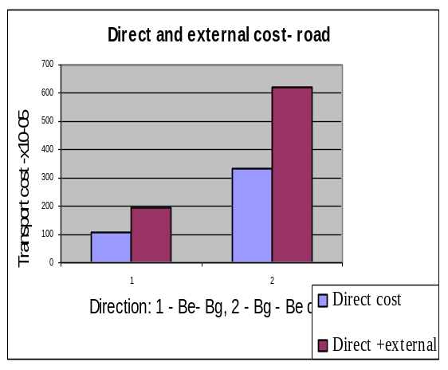
Fig.7 Fig.8

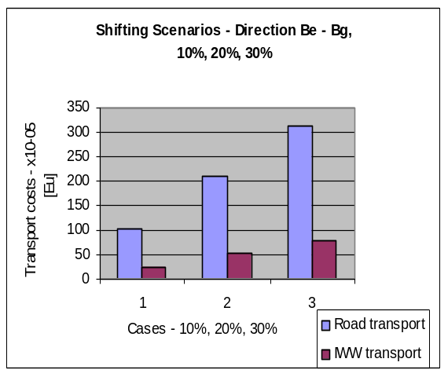
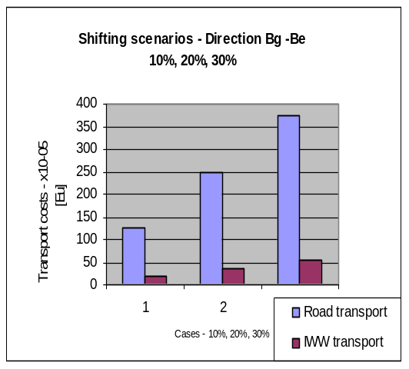

Fig.9 Fig.10

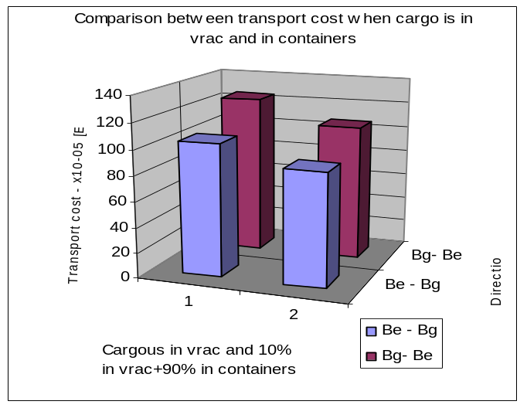

Fig. 11
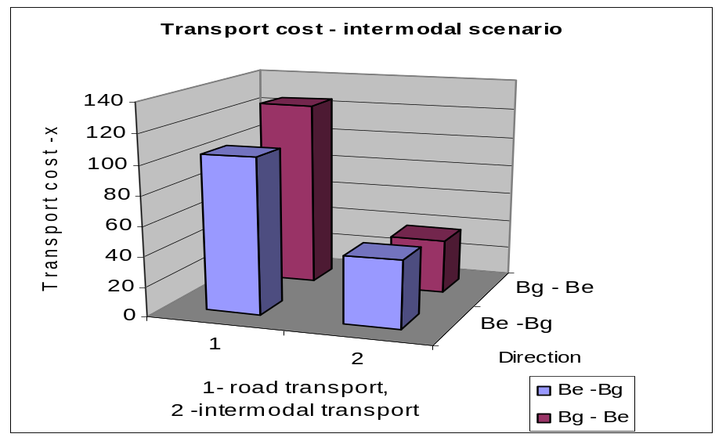

Fig. 12

5. Conclusions and recommendations
In continuation of a number of previous developments at ANAST –ULG [1], [5], [6], [7], [8], [10], [12] etc., a feasibility study on possibilities of different transport alternatives between Bulgaria and Belgium was performed under the terms of bilateral cooperation agreement between both countries.
Within the frames of the project, detailed description of the transcontinental transport infrastructure has been made.
On the basis of middle term transport demand forecast the following scenarios have been investigated:
  - Four single transport modes;
  - shifting scenarios;
  - container scenario for road transport;
  - intermodal scenario – iww+road.
The operational transport cost for every one scenario has been calculated and analysis of the results has been made. Following conclusions have been drawn in this respect:
  - If 10%, 20% or 30% of cargo transported by road is shifted to iww, the amount of both transport expenses will decrease with 8%, 16% and 24% respectively;
  - If 90% of road cargos are in containers - not bulk in, 15% of road transport expenses will be spared.
  - If 90% of road cargos are in containers and these cargo volumes are transferred by intermodal manner using two modes – road in the BENELUX and IWW from Cologne to port Ruse, Bulgaria, the transport expenses decrease with 65%.
Additionally, the influence of the external costs on the transport expenses of the road and iww transport mode has been evaluated. Taking it into account results in increasing of transport expenses with 85% for road and 82 % for IWW.
The results obtained are based on many assumptions and restrictions including availability of large stable and regular cargo flows, and couldn’t be taken as pure quantitative evaluation, but they show the great possibilities and capacity of development of inland waterways and intermodal transport.
The results of present analysis give hints for continue studies on trans-continent intermodal transport toward
level of details – quantitative analysis;
level of practice –market investigation;
level of involvements-actors / operators; and
level of usable – concrete strategies and measures to develop the
intermodal transport with integration of IWT mode.

References
1. Comparaison des coùts externes entre les modes de transport fluvial et routier. Analyse comparative de la jonction Seine – Escautet du transport routier, Travail de fin d’études présenté par Vangustaine Éric (En vue de l’obtention du grade d’Ingenieur Civil de Constructions Année académique 1998-1999
2. European Environment Agency, Indicateur: External costs of transport - policy issue: Reduction of external costs of transports
3. Investigations for Multimodal transport in Bulgaria – existing situation and forecast (prediction), by Appointment of Bulgarian Ministry of Transport in collaboration with the Netherlands Governmental Department for public building and water resources, Transproect Ltd - Bg, NEA, GROESE and LOGION - NL, November 1994.
4. Kisheva D., Contemporary Concepts in Development of European Inland Transportation and their Reflection in Bulgarian River Transport, II EIWN Conference, Budapest, June 2001
5. Marchal J.L.J., Short sea shipping from Hinterland Ports by Sea – river Going Vessels: Study of the Influence of a Free Cabotage Policy, 29th PIANC
6. Marchal J.L.J, Short sea shipping from hinterland ports by sea-river hoingg vessels: study of the influence of a free cabotage policy Round table Conference, Athena, Greece, and June 94
7. Marchal J.L.J, Portier G., The Impact of Energy on the cost of transport by inland waterways: an Example of Bulk Transport EEC Meeting, Luxemburg 95
8. Marshal J.L.J, Kisheva D., Development of Cost Calculation Computer Module for Sea – River going Vessels, Gdansk, 1996
9. Program for Transport Infrastructure Development for the Period 2001-2005 of Ministry of Transport and Communications, Republic of Bulgaria (computer version), http://www.mtc.government.bg/transport/
10. Shifting cargo to inland waterways, Commission of the European Union, DIRECTORATE GENERAL FOR Transport The 4-th Framework Programme for RTD, Contract N WA-95—SC.062
11. Statistical Yearbooks 1989 – 2000, Republic of Bulgaria
12. Z. Zhang, J.L.J.Marchal, Ships, Ports and Inland Waterways - An analysis of their compatibility with the transport demand, 29th PIANC International Navigation Congress 6-11 September 1998 The Hague, The Netherlands Section I – Session 5

