APPENDIX C: SAMPLES OF ASSESSMENT TOOLS

Appendix C

Samples of Assessment Tools

PHYSICAL EDUCATION CURRICULUM GUIDE - INTERMEDIATE 117

APPENDIX C: SAMPLES OF ASSESSMENT TOOLS

Developing a Rubric

Check the Quality Level of Your Rubric

Assess Your Rubric

Consider the following questions as you develop a rubric to assess the quality of a student’s performance.

- What are the specific curriculum outcomes addressed in the task?

- What does an excellent level performance look like? What are the qualities that distinguish an excellent response from the rest?
- What do other responses along the performance quality continuum look like?

- What are the criteria for assessing a student’s performance on an assessment task?

- What are the written descriptions of each quality level of the continuum? Is each description qualitatively different from the others? Are there an equal number of descriptors at each level of quality? Are the differences clear and understandable to the student and others?

- A level 5 is the excellent level. It should include descriptions that indicate work beyond what you expect for the grade/ program/unit. This is WOW!

- A level 4 is the proficient level. Your description should indicate what it is you really want students to be able to demonstrate for the grade/program/unit.

- A level 3 is the adequate level. This level should indicate minimal competencies that you will accept for the grade/ program/unit.

- A level 2 is the partial level. This level should indicate what you are not yet meeting for the grade/program/unit.

- Level 1 is the novice level. The learner has just barely begun to demonstrate any level of knowledge or competency.

Is it:

- Clear?

- Consistent in the number of descriptors across the levels of quality?

- Based on curriculum outcomes at the grade level?

- Providing challenge for students?

118 PHYSICAL EDUCATION CURRICULUM GUIDE - INTERMEDIATE

APPENDIX C: SAMPLES OF ASSESSMENT TOOLS

Student Tracking Chart

Date

Unit:

Class:

Student Name |  |  |  |  |  |  |  |  |  |  |  |  |  | Total

Codes:

ga = good attitude | eq = helped with equipment | nc = not prepared (gym clothes)
pe = performance - excellent | ar = acting responsibility | ip = impolite
pa = performance - acceptable | en = excused with note | ib = inappropriate behaviour
pu = punctual | md = excused (medical) | ot = off task
tp = top personal achievement | np = not participating | uc = uncooperative

- points for positive observed behaviour - points for negative observed behaviour

Use the provided codes to keep records of students.

Combined with - points and + points, scores can be provided to students

PHYSICAL EDUCATION CURRICULUM GUIDE - INTERMEDIATE 119

APPENDIX C: SAMPLES OF ASSESSMENT TOOLS

Sample Participation Rubric

Level 1 | Level 2 | Level 3 | Level 4 | Level 5
Very Limited | Limited | Accomplished | Strong | Outstanding
Seldom or never | Occasionally | Frequently | Usually | Consistently

 | Criteria
 | Readiness | is fully prepared for |  | is fully prepared |  | is only missing one |  | is missing some |  | is not prepared and
 | Proper Attire (shirt, | class in acceptable |  | but not ready for |  | item of attire, is |  | attire and is late, |  | is late, does not
 | gym pants, shorts, | time (5 minutes), |  | class in acceptable |  | late but participates |  | minimally |  | participate
 | court shoes, punc- | participates fully |  | time, participates |  | fully |  | participates
 | tuality) |  |  | fully
 | Warm-up | takes initiative |  | fully completes |  | completes most |  | completes about |  | completes very little
 |  | to fully complete |  | warm-up, but must |  | of the warm-up |  | half of warm-up |  | (less than half) of
 |  | warm-up without |  | be prompted |  | activities |  | activities |  | warm-up activities
 |  | prompting
 | Skill/Movement | displays excellent |  | displays good |  | displays adequate |  | displays some |  | displays very little
 | Development | understanding/ |  | understanding/ |  | understanding/ |  | understanding/ |  | understanding/
 |  | demonstration of |  | demonstration of |  | demonstration of |  | demonstration of |  | demonstration of
 |  | movements/skills |  | movements/ skills |  | movements/skills |  | movements/skills |  | movements/skills
 | Time on Task | always on task |  | usually on task |  | frequently on task |  | occasionally on task |  | rarely on task
 | Group Interaction | always cooperates, |  | interacts |  | occasionally |  | occasionally |  | rarely cooperates
 | (including respect | student always |  | responsibly most |  | cooperates, |  | cooperates, takes |  | (uncooperative),
 | for others and self) | interacts |  | of the time, |  | occasionally |  | some responsibility, |  | does not interact
 |  | responsibly with |  | demonstrates |  | interacts responsibly, |  | shows some respect |  | responsibly, lacks
 |  | others, exhibits |  | respect most of |  | acceptable level of |  |  |  | respect for others
 |  | leadership and role |  | the time |  | respect shown
 |  | modelling
 | Understands Con- | shows excellent |  | shows good |  | shows acceptable |  | shows minimal |  | shows no
 | cepts | understanding of |  | understanding of |  | understanding of |  | understanding of |  | understanding of
 |  | concepts taught |  | concepts taught |  | concepts taught |  | concepts taught |  | concepts taught,
 |  |  |  |  |  |  |  |  |  | unable to assess
 | Positive/Appropriate | • | excellent | • | good | • | acceptable | • | minimal | • | no
 | Behaviours |  | demonstration |  | demonstration |  | demonstration |  | demonstration |  | demonstration
 | Effort |  | of willingness to |  | of willingness to |  | of willingness to |  | of willingness to |  | of willingness to
 |  |  | perform to the |  | perform to the |  | perform to the |  | perform to the |  | perform to the
 |  |  | best of his/her |  | best of his/her |  | best of his/her |  | best of his/her |  | best of his/her
 |  |  | ability |  | ability |  | ability |  | ability |  | ability
 |  | • | always displays | • | usually displays | • | occasionally | • | minimal display | • | never displays
 |  |  | positive attitude |  | positive attitude |  | displays positive |  | of positive |  | positive attitude
 |  | • | always displays | • | usually displays |  | attitude |  | attitude | • | never displays
 |  |  | open- |  | open- | • | occasionally | • | minimal display |  | open-mindedness
 |  |  | mindedness to |  | mindedness |  | displays |  | of |  | to new activities
 |  |  | new activities |  | to new activities |  | open-mindedness |  | open-mindedness
 |  |  |  |  |  |  | to new activities |  | to new activities
 | Equipment set-up | • | always | • | good | • | acceptable | • | minimal | • | no
 | Respect for equip- |  | demonstrates |  | demonstration of |  | demonstration of |  | demonstration of |  | demonstration
 | ment and facility |  | respect and care |  | respect and care |  | respect and care |  | respect and care |  | of respect and
 |  |  | equipment and |  | for equipment |  | for equipment |  | for equipment |  | care for
 |  |  | facility |  | and facility |  | and facility |  | and facility |  | equipment and
 |  |  |  |  |  |  |  |  |  |  | facility

120 PHYSICAL EDUCATION CURRICULUM GUIDE - INTERMEDIATE

APPENDIX C: SAMPLES OF ASSESSMENT TOOLS

Sample Participation Record

 | Level 1 | Level 2 |  |  | Level 3 |  | Level 4 |  | Level 5
 | Very Limited | Limited |  |  | Accomplished |  | Strong |  | Outstanding
 | Seldom or never | Occasionally |  |  | Frequently |  | Usually |  | Consistently
 |  |  |  | Skill/ |  |  |  |  | Positive/ | Equip. Set-up
 |  |  |  | Skill/ |  |  |  |  | Positive/ | Respect for
 | Name | Attire |  | Movement | Time on | Group | Understands | Appropriate |  | Equip. &
 | Name | Attire | Warm-up | Dev. | Task | Interaction | Concepts |  | Behaviours | Safety

PHYSICAL EDUCATION CURRICULUM GUIDE - INTERMEDIATE 121

APPENDIX C: SAMPLES OF ASSESSMENT TOOLS

Sample Physical Education Assessment Tool: Domains Rubric (K-12)

 |  | Moving/Doing |  |  | Understanding/Applying |  | Cooperation/Responsibility
Participates in a variety of |  |  |  | Understands and has the ability to |  |  | Demonstrates cooperative and
activities |  |  |  | pose and solve movement challenges |  |  | socially responsive behaviors
comes prepared to participate |  |  |  | understands the task |  |  | cares for the safety of others
• | wears appropriate clothing |  |  | can demonstrate the task (individually |  |  | respects personal and public property
• is ready and on time |  |  |  | and with others |  |  | respects others
gets involved in the activities |  |  |  | assists other students
 |  |  |  |  |  |  | encourages appropriate behaviours
is active
Applies body mechanics in |  |  |  | Understands and applies games and |  |  | Demonstrates Personal
movement activities |  |  |  | movement concepts |  |  | Responsibility
applies developmentally |  |  |  | understands the instructions |  |  | shows care for personal safety
appropriate technique(s) for the |  |  |  | follows instruction |  |  | cares for personal health and
activities |  |  |  | uses skills and ideas taught in activities |  |  | hygiene
• | hand/eye coordination |  |  |  |  |  | respects oneself
 | (throwing and catching)

- basic movement skills

Engaged in movement, motor | Understands and applies group | Demonstrates leadership and
and athletic skill development | dynamics and concepts of fair play | group dynamic skills
activities | contributes to the group | works with and includes others
uses movement and activity skill | is a team player | during activity
in a variety of activities | practises fair play | considers the views of others during
works to the best of his/her ability | practises sportsmanship | games and play
is on task |  | leads by positive example
works on skill development |  | values the contributions of all

 | Engages in personal fitness |  | Understands the application and |  |  | Demonstrates and applies an
 | activities |  | impact of a lifelong and active |  |  | active and healthy lifestyle
 | participates in personal fitness |  | healthy lifestyle |  |  | demonstrates that good eating leads
 | activities |  | understands the importance of being |  |  | to health
 | works to remain physically active |  | active |  |  | demonstrates that regular physical
 | works on his/her health related |  | is active |  |  | activity leads to good health
 | fitness components |  | takes responsibility for his/her health |  |  | takes part in regular fitness
 | works on his/her skill related |  | understands that good health |  |  | activities
 | fitness components |  | involves numerous factors (physical,
 |  |  | mental, social, etc)
 | Level 1 | Level 2 |  | Level 3 |  | Level 4 | Level 5
 | Very Limited/ | Limited/ |  | Accomplished/ |  | Strong/Usually | Outstanding/
 | Seldom or Never | Occasionally |  | Frequently |  |  | Consistently

122 PHYSICAL EDUCATION CURRICULUM GUIDE - INTERMEDIATE

APPENDIX C: SAMPLES OF ASSESSMENT TOOLS

Sample Physical Education Assessment Tool: Domains Rubric
Source: Rebecca Fewer - Physical Education Teacher (ESD)

 |  |  |  |  |  |  | Moving and Doing |  |  |  |  |  |  |  | Understanding |  |  |  |  |  |  |  |  |  |  | Cooperation and |  |  |  |  |  |  |  |  |  | Final
 |  |  |  |  |  |  | (50%) |  |  |  |  |  |  |  | and Applying (25%) |  |  |  |  |  |  |  |  |  |  | Responsibility (25%)
 |  |  | NAME |  |  |  | P1 | A1 | E1 |  | E2 | AVG. |  |  | U1 | U2 | U3 | U4 |  |  | AVG. |  |  |  |  | D1 | D2 | D3 |  | D4 |  | AVG.
 | 1
 | 2
 | 3
 | 4
 | 5
 | 6
 | 7
 | 8
 | 9
 | 10
 | 11
 | 12
 | 13
 | 14
 | 15
 | 16
 | 17
 | 18
 |  | Moving and Doing |  |  |  |  |  |  |  |  | Understanding & Applying |  |  |  |  |  |  |  |  |  |  |  | Cooperation & Responsibility
 |  | P1 - Participates in a variety of |  |  |  |  |  |  |  |  | U1 - Poses and solves movement |  |  |  |  |  |  |  |  |  |  |  | D1 - Demonstrates cooperative and
 |  | activities |  |  |  |  |  |  |  |  | challenges |  |  |  |  |  |  |  |  |  |  |  | socially responsive behaviors
 |  | A1 - Applies body mechanics in |  |  |  |  |  |  |  |  | U2 - Applies game and movement |  |  |  |  |  |  |  |  |  |  |  | D2 - Demonstrates leadership and
 |  | movements |  |  |  |  |  |  |  |  | concepts |  |  |  |  |  |  |  |  |  |  |  | group dynamic skills
 |  | E1 - Engages in movement, motor |  |  |  |  |  |  |  |  | U3 - Applies group dynamics and |  |  |  |  |  |  |  |  |  |  |  | D3 - Demonstrates and applies an
 |  | and athletic skill development |  |  |  |  |  |  |  |  | fair play |  |  |  |  |  |  |  |  |  |  |  | active and healthy lifestyle
 |  | activities |  |  |  |  |  |  |  |  | U4 - Aware of the impact of a |  |  |  |  |  |  |  |  |  |  |  | D4 - Demonstrates and applies an
 |  | E2 - Engages in personal fitness |  |  |  |  |  |  |  |  | life-long active healthy lifestyle
 |  |  |  |  |  |  |  |  |  |  |  |  |  |  |  |  |  |  |  |  |  |  | active and healthy lifestyle
 |  | activities
 |  |  |  | Level 1 |  |  |  | Level 2 |  |  |  |  |  |  | Level 3 |  |  |  |  |  |  | Level 4 |  |  |  |  |  |  |  |  | Level 5
 |  | Very Limited/ |  |  |  |  | Limited/ |  |  |  |  |  | Accomplished/ |  |  |  |  |  |  |  | Strong/Usually |  |  |  |  |  |  |  |  | Outstanding/
 |  | Seldom or Never |  |  |  |  | Occasionally |  |  |  |  |  |  |  | Frequently |  |  |  |  |  |  |  |  |  |  |  |  |  |  | Consistently

PHYSICAL EDUCATION CURRICULUM GUIDE - INTERMEDIATE 123

APPENDIX C: SAMPLES OF ASSESSMENT TOOLS

Sample Physical Education Evaluation and Assessment
Source: Bern Baker - Physical Education Teacher (NCSD)
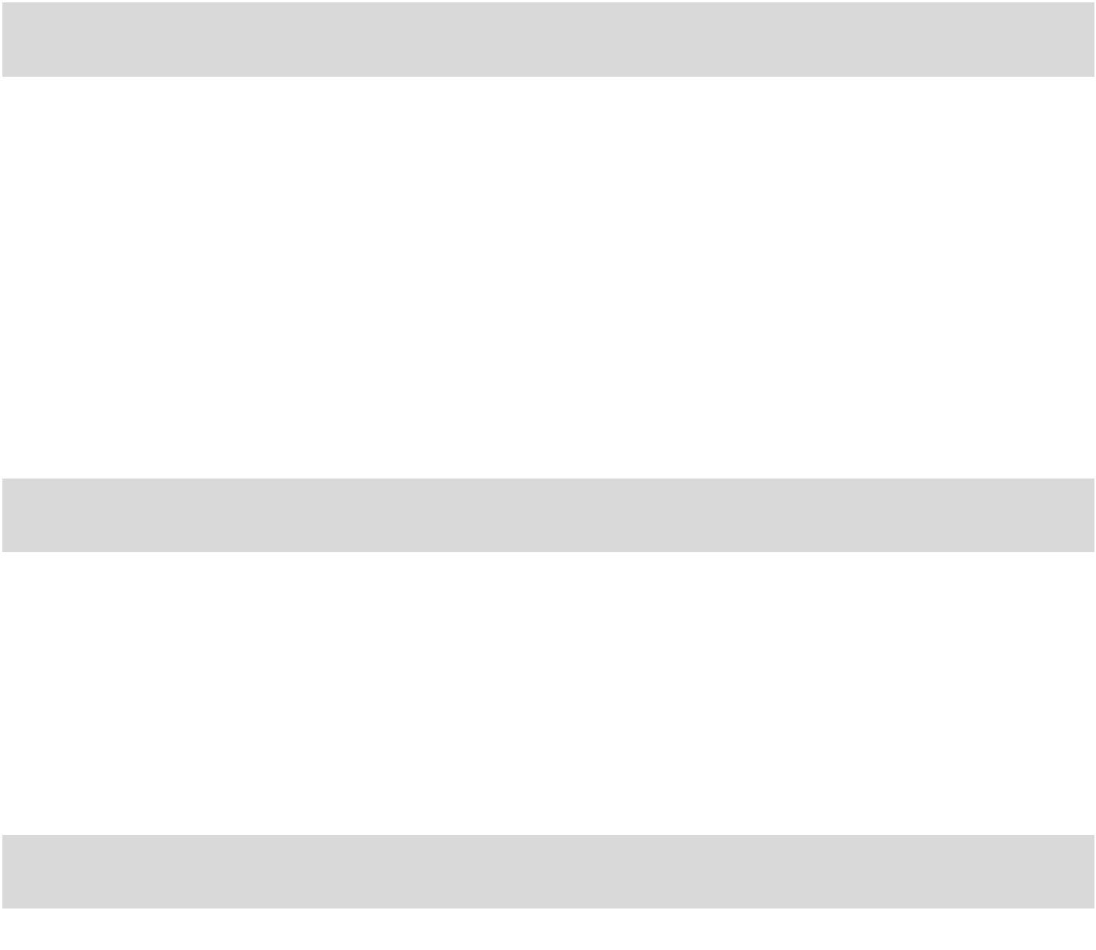

 |  |  |  | Domain: Moving and Doing (50 %) |  |  |  |  |  |  |  |  |  | 1 |  | 2 | 3 | 4 | 5
 | Evaluation Criteria:
 | Attendance & Punctuality (comes prepared for class, on time and has
 | proper attire)
 | Participates in a variety of activities
 | Applies body mechanics in movement activities
 | Engages in movement, motor and athletic skill development activities
 |  |  |  |  | Fitness (25% of the 50%)
 | Participates in personal fitness activities
 | Works to remain physically active
 | Works on his/her health related fitness (cardiovascular, strength, flexibility,
 | muscular endurance)
 |  |  | Domain: Understanding and Applying (25%) |  |  |  |  |  |  |  |  |  |  | 1 |  | 2 | 3 | 4 | 5
 | Evaluation Criteria:
 | Understands & has the ability to pose/solve movement challenges
 | Understands and applies game and movement concepts
 | Understands and applies group dynamics and concepts of fair play
 | Understands the application and impact of a lifelong active healthy lifestyle
 | Domain: Cooperation & Responsibility (25%) |  |  |  |  |  |  |  |  |  |  |  |  | 1 |  | 2 | 3 | 4 | 5
 | Evaluation Criteria:
 | Demonstrates cooperative and socially responsible behaviors
 | Demonstrates personal responsibility
 | Demonstrates leadership and group dynamic skills
 | Demonstrates and applies an active healthy lifestyle
 | Level 1 |  |  |  |  | Level 2 | Level 3 |  |  |  |  | Level 4 |  |  |  | Level 5
 | Very Limited/ |  |  |  |  | Limited/ | Accomplished/ |  |  | Strong/Usually |  |  |  |  | Outstanding/
 | Seldom or Never |  |  |  | Occasionally |  | Frequently |  |  |  |  |  |  |  | Consistently

124 PHYSICAL EDUCATION CURRICULUM GUIDE - INTERMEDIATE

APPENDIX C: SAMPLES OF ASSESSMENT TOOLS

Sample Physical Education Assessment Tracking Sheet
Source: Luke Neville - Physical Education Teacher (ESD)

Date (s): ______________________ |  |  |  | Activity: _______________________________
Name | C | A | P
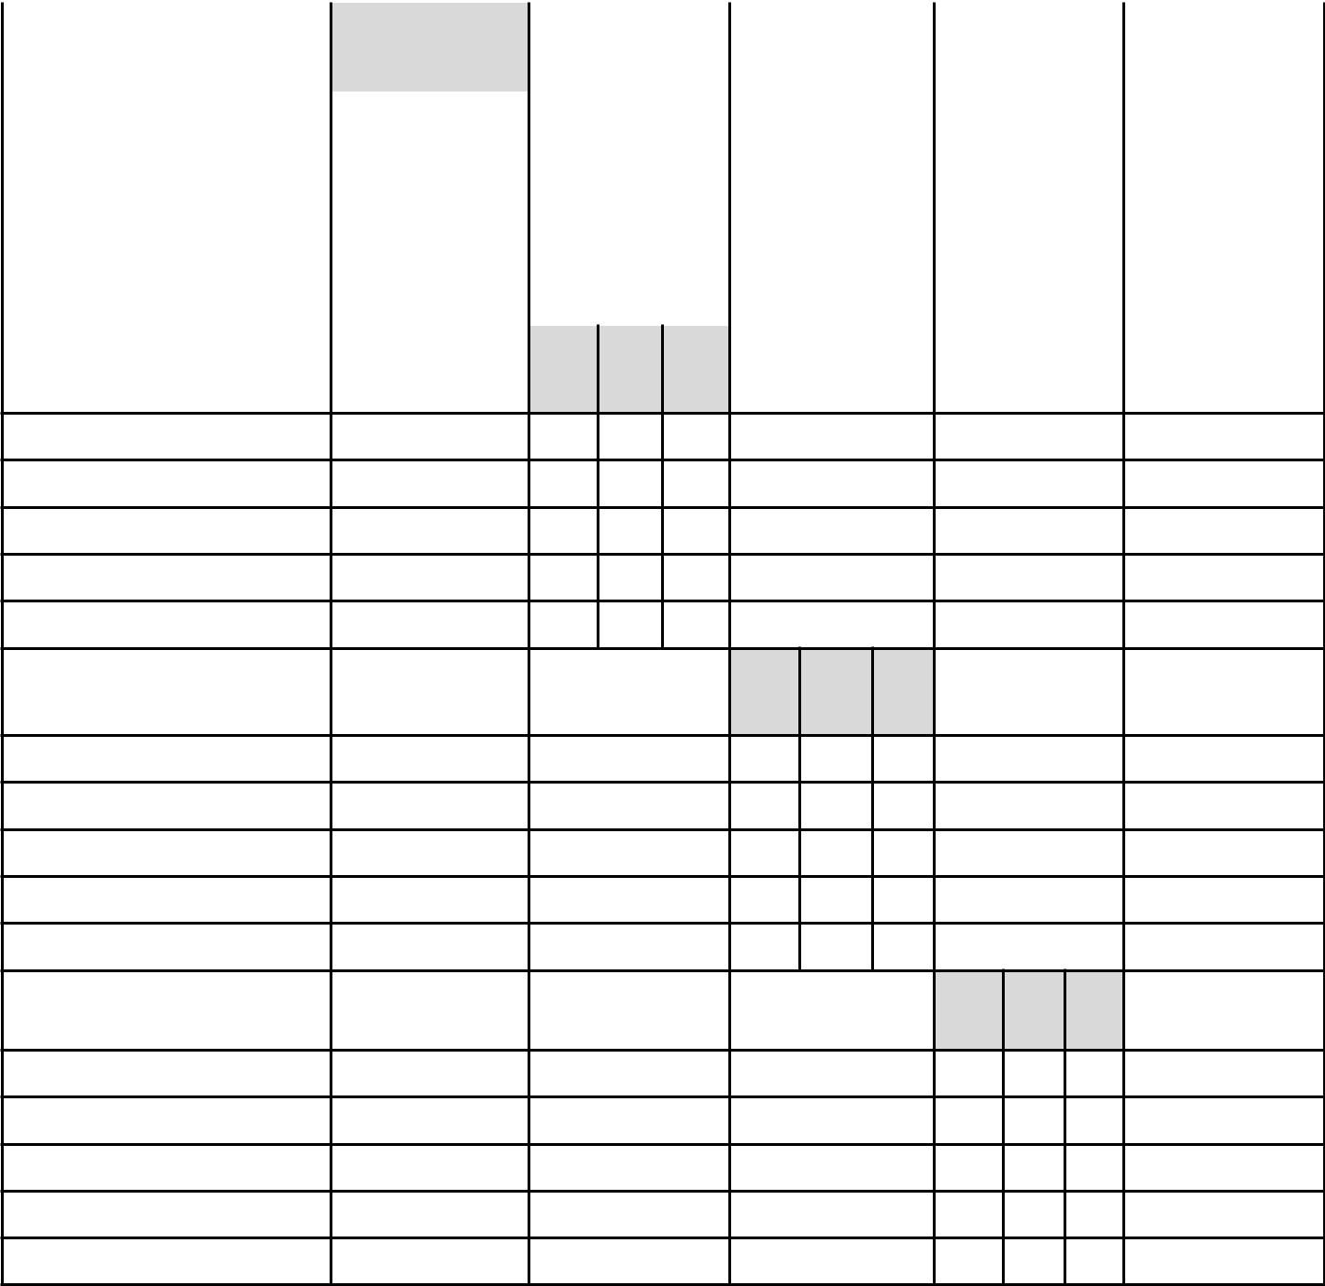

C A P

C A P

C A P

C = Cognitive |  | A = Affective |  | P = Psychomotor
Level 1 | Level 2 | Level 3 |  | Level 4 | Level 5
Very Limited/ | Limited/ | Accomplished/ |  | Strong/Usually | Outstanding/
Seldom or Never | Occasionally | Frequently |  |  | Consistently

PHYSICAL EDUCATION CURRICULUM GUIDE - INTERMEDIATE 125

APPENDIX C: SAMPLES OF ASSESSMENT TOOLS

Sample Physical Education Teacher Reflection/Exit Poll
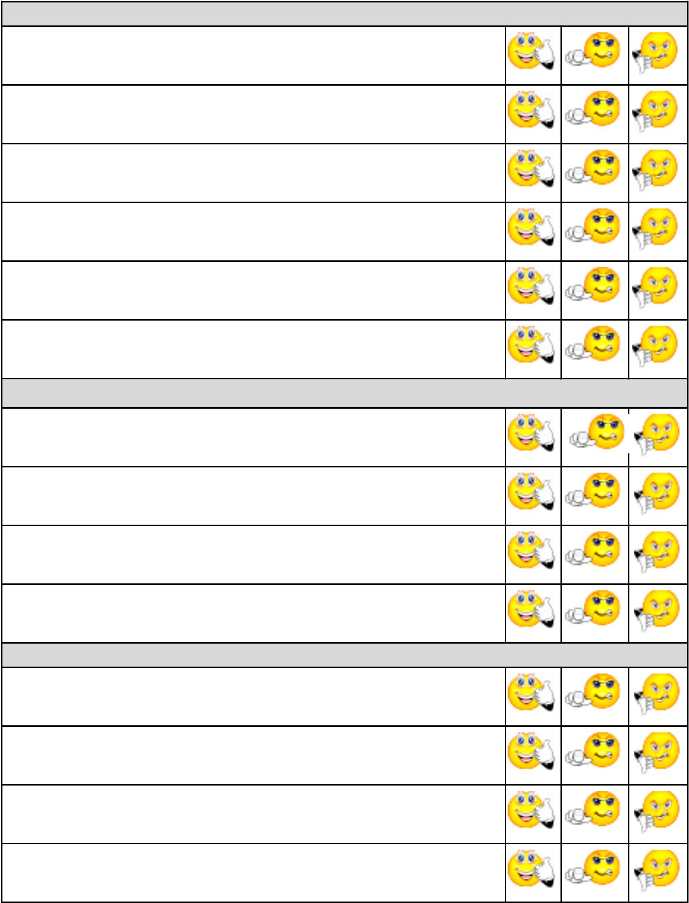

Domain: Moving and Doing (50 %)

Attendance & Punctuality (comes prepared for class, on time and has proper attire)

Participates in a variety of activities

Applies body mechanics in movement activities

Engages in movement, motor and athletic skill development activities

Participates in personal fitness activities

Works on his/her health related fitness (cardiovascular, strength, flexibility, muscular endurance)

Domain: Understanding and Applying (25%)

Understands & has the ability to pose/solve movement challenges

Understands and applies game and movement concepts

Understands and applies group dynamics and concepts of fair play

Understands the application and impact of a lifelong active healthy lifestyle

Domain: Cooperation & Responsibility (25%)

Demonstrates cooperative and socially responsible behaviors

Demonstrates personal responsibility

Demonstrates leadership and group dynamic skills

Demonstrates and applies an active healthy lifestyle

126 PHYSICAL EDUCATION CURRICULUM GUIDE - INTERMEDIATE

APPENDIX C: SAMPLES OF ASSESSMENT TOOLS

Sample: Physical Assessment Tracking Sheet - General Guide

Source: John Elkins – P.E. and Healthy Living Program Specialist (ESD)

This assessment tracking sheet is one possible way to record your observations of a student throughout the course of an activity unit. The design of the tracking sheet allows you to enter text into each box and simply save the changes to store your data.

- Example: At the end of a class you would record the number value in each of the following positions.

- The values used are as follows:

1 = Seldom – Rarely

2 = Emerging – Occasionally

3 = Effective – Usually

4 = Strong – Frequently

5 = Outstanding – Consistently
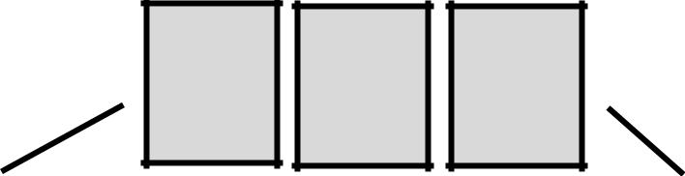

Moving and Doing |  |  |  |  | Cooperation and
Assessment Box |  |  |  |  | Responsibility Assessment
 |  | Understanding and |  |  | Box
 |  | Applying Assessment Box

- Note: It would be unrealistic to think that a teacher could assess every student during every class. One suggestion might be to try to focus in on 4-5 students each class. While you are focusing on these 4-5, you are still making general observations of the whole group and therefore you could record any unusual occurrences that are outside your focus group.

- See the next page for a sample tracking sheet.

PHYSICAL EDUCATION CURRICULUM GUIDE - INTERMEDIATE 127

APPENDIX C: SAMPLES OF ASSESSMENT TOOLS

Continued from previous page

Source: John Elkins – P.E. and Healthy Living Program Specialist (ESD)

Activity: ________________________________

Starting Date: ____________________________

Name: __________________________

Name: __________________________

Name: __________________________

Class 1 |  |  |  | Class 2 |  |  |  | Class 3 |  |  |  | Class 4
Class 5 |  |  |  | Class 6 |  |  |  | Class 7 |  |  |  | Class 8

 | Class 1 |  |  |  | Class 2 |  |  |  | Class 3 |  |  |  | Class 4
 | Class 5 |  |  |  | Class 6 |  |  |  | Class 7 |  |  |  | Class 8

Class 1 |  |  |  | Class 2 |  |  |  | Class 3 |  |  |  | Class 4
Class 5 |  |  |  | Class 6 |  |  |  | Class 7 |  |  |  | Class 8

 |  |  | Class 1 |  |  |  | Class 2 |  |  |  | Class 3 |  |  |  | Class 4
Name: | __________________________
Name: | __________________________ |  | Class 5 |  |  |  | Class 6 |  |  |  | Class 7 |  |  |  | Class 8

 |  |  |  | Class 1 |  |  |  | Class 2 |  |  |  | Class 3 |  |  |  | Class 4
 | Name: __________________________
 |  |  |  | Class 5 |  |  |  | Class 6 |  |  |  | Class 7 |  |  |  | Class 8

128 PHYSICAL EDUCATION CURRICULUM GUIDE - INTERMEDIATE

APPENDIX C: SAMPLES OF ASSESSMENT TOOLS

Sample Physical Education Participation and Effort Record

Grade/Level:___________________________________

Date Date Date Date Date Date

Student

KEY: Teachers may wish to develop their own codes.

PP = Present and Participating |  |  |  | PPNC = Present and Participating but not changed
NP = Not Participating |  |  |  | E = Excused |  |  |  |  |  |  | S = Sick |  |  |  | I = Injury
AAE = Above Average Effort |  |  |  | AE = Average Effort |  |  |  |  |  |  |  |  | ME = Minimal Effort
 | M = Medical |  |  |  |  |  | TE = Travel Excused

PHYSICAL EDUCATION CURRICULUM GUIDE - INTERMEDIATE 129

APPENDIX C: SAMPLES OF ASSESSMENT TOOLS

Sample Checklist

Place the skills to be measured in the spaces below

Student Name | 1. |  | 2. |  | 3. |  | 4.

Level 1 | Level 2 | Level 3 | Level 4 | Level 5
Very Limited/ | Limited/ | Accomplished/ | Strong/Usually | Outstanding/
Seldom or Never | Occasionally | Frequently |  | Consistently

130 PHYSICAL EDUCATION CURRICULUM GUIDE - INTERMEDIATE

APPENDIX C: SAMPLES OF ASSESSMENT TOOLS

Sample Observation Checklist for Self Confidence
Source: Pangrazzi

Theme: _____________________________ | Class: _____________________________
Date: _______________________
Level of | Level of | Level of | Comments
Self-Confidence | Self-Confidence | Self-Confidence
when | when | when
_____________ | _____________ | ______________
(Pre-Unit) | (Mid-Unit) | (Post-Unit)
Skill | Skill | Skill

Student Name

Level 1 | Level 2 | Level 3 | Level 4 | Level 5
Very Limited/ | Limited/ | Accomplished/ | Strong/Usually | Outstanding/
Seldom or Never | Occasionally | Frequently |  | Consistently

PHYSICAL EDUCATION CURRICULUM GUIDE - INTERMEDIATE 131

APPENDIX C: SAMPLES OF ASSESSMENT TOOLS

Sample: Your Wellness Intelligence

Do you: |  |  | Rarely |  |  | Sometimes |  |  | Often
Participate in regular physical activity? |  | 1 |  |  |  | 2 |  |  | 3
Participate in everyday leisure activities? |  | 1 |  |  |  | 2 |  |  | 3
Participate in sports/activities 3-5 days/week? |  | 1 |  |  |  | 2 |  |  | 3
Participate in aerobic activities 3-5 days/week? |  | 1 |  |  |  | 2 |  |  | 3
Participate in muscle strength and endurance 2-4
days/week? |  | 1 |  |  |  | 2 |  |  | 3
Participate in flexibility exercises 4-5 days/week? |  | 1 |  |  |  | 2 |  |  | 3
Limit computer time daily |  | 1 |  |  |  | 2 |  |  | 3
Choose foods from the milk group? |  | 1 |  |  |  | 2 |  |  | 3
Drink more than 2 glasses/day of milk/juice? |  | 1 |  |  |  | 2 |  |  | 3
Eat breakfast? |  | 1 |  |  |  | 2 |  |  | 3
Limit drinking of soft drinks? |  | 1 |  |  |  | 2 |  |  | 3
Eat raw vegetables? |  | 1 |  |  |  | 2 |  |  | 3
Eat fruit? |  | 1 |  |  |  | 2 |  |  | 3
Walks instead of drive? |  | 1 |  |  |  | 2 |  |  | 3
Limit eating candy? |  | 1 |  |  |  | 2 |  |  | 3
Limit use of salt in food? |  | 1 |  |  |  | 2 |  |  | 3
Choose whole grain cereal or bread? |  | 1 |  |  |  | 2 |  |  | 3
Maintain ideal weight? |  | 1 |  |  |  | 2 |  |  | 3
Limit fried foods? |  | 1 |  |  |  | 2 |  |  | 3
Limit the skipping of meals? |  | 1 |  |  |  | 2 |  |  | 3
Try new sports? |  | 1 |  |  |  | 2 |  |  | 3
Try new foods? |  | 1 |  |  |  | 2 |  |  | 3
Drink water? |  | 1 |  |  |  | 2 |  |  | 3
Eat healthy snack foods? |  | 1 |  |  |  | 2 |  |  | 3
Eat a variety of protein foods? |  | 1 |  |  |  | 2 |  |  | 3
Get adequate sleep? |  | 1 |  |  |  | 2 |  |  | 3
Limit TV viewing each day |  | 1 |  |  |  | 2 |  |  | 3
Read food labels for nutrition content? |  | 1 |  |  |  | 2 |  |  | 3
Total |  |  |  |  |  |  |  |  |  |  |  |  | Total Score:
Scoring: | 70 or above ..........you're a winner
 | 50-69...................doing great
 | 35-49....................you're in the running
 | below 35................try harder

132 PHYSICAL EDUCATION CURRICULUM GUIDE - INTERMEDIATE

 |  |  | APPENDIX C: SAMPLES OF ASSESSMENT TOOLS
Sample: Physical Education Goals Agreement
 | During the time of the physical education course , I |  |  | agree to work towards achieving
 | the following:

- Physical activity goals during work/school time

  - I will walk instead of taking transportation to places within walking distance.
b) | I will spend |  |  |  |  |  |  |  |  |  |  |  |  | minutes a day standing instead of sitting during lunch/recess hour.
c) | I will walk up |  |  |  |  |  |  |  |  |  |  |  |  |  |  | flights of stairs at work/school.
d) | I will spend |  |  |  |  |  |  |  |  |  |  |  |  | minutes during each school/work break walking.
e) | I will spend |  |  |  |  |  |  |  |  |  |  | minutes during each lunch break walking outdoors.
2. Physical activity goals during recreational or free time:
a) | I will spend |  |  |  |  |  |  |  |  |  |  |  |  | minutes daily doing stretching activities to increase my flexibility.
b) | I will spend |  |  |  |  |  |  |  |  |  |  |  |  |  | minutes at least four times per week doing aerobic activities to improve my
 | cardiovascular fitness.
c) | I will spend |  |  |  |  |  |  |  |  |  |  |  |  | minutes at least three times per week doing strength fitness activities.
d) | I will spend |  |  |  |  |  |  |  |  |  |  |  |  |  | minutes Saturday and Sunday in active recreational activities.

- Summarize your fitness or wellness goals for this course/semester: a)

b)

c)

d)

e)

f)

g)

- My reward for achieving my goals will be: a)

b)

c)

d)

e)

f)

I agree to follow this contract until I reach my goals.

Signed

Student: Date:

Teacher: Date:

Witness: Date:

PHYSICAL EDUCATION CURRICULUM GUIDE - INTERMEDIATE 133

APPENDIX C: SAMPLES OF ASSESSMENT TOOLS

Sample: Student Portfolio

A portfolio is a purposeful collection of a student’s work that shows his/her effort, progress, and achievement over time. Items in a portfolio can be suggested by the teacher or selected by the student. Portfolios provide information for a comprehensive assessment of student development. Criteria for evaluation can be established for each reporting period. Entries should be dated so the teacher can track each student’s development over time.

Active living portfolios could include the student’s planning and goal-setting worksheets and activities, photographs of a student’s participation in healthy physical activities, journal entries, documents sharing out-of-school accomplishments in physical activity or student-generated art pieces reflecting on active lifestyle experiences. Entries should be dated so the teacher can track each student’s development over time.

Student Reflection on the Activity Student Name: _________________________________

Date: ________________________________

Activity/Project Title: ____________________________

Student Comments | Teacher Comments
Two reasons I chose this activity are: | Two positive things I noticed are:

I want you to notice: | One specific thing to work on is:

Next time I might: | Other Comments:

Other Comments:

Signature:___________________________ | Signature: ____________________________
Date:_______________________________ | Date: ________________________________

134 PHYSICAL EDUCATION CURRICULUM GUIDE - INTERMEDIATE

APPENDIX C: SAMPLES OF ASSESSMENT TOOLS

Sample: Portfolio Checklist

Entry # | Date | Class/Topic | Teacher: Checked | Points (1-5)

PHYSICAL EDUCATION CURRICULUM GUIDE - INTERMEDIATE 135

APPENDIX C: SAMPLES OF ASSESSMENT TOOLS

Sample: Student Journal Writing

Assessment of student performance may also be supported through the use of journals. Student journals are a powerful tool for encouraging students to reflect on their experiences.

Journals may be structured or a general review of the events of the week in the physical education class. Entries may comment on a specific activity or topic or provide a broad reflection on progress or an issue. Journals are an important aspect of communication between the student and teacher. Students may ask questions, indicate successes, or identify areas where they need further assistance to develop skills.

Teachers can respond to student journals in a letter, with a short comment in the journal or verbally to the student.

Prompts for Daily Journal Reflection

- Today we talked/learned/participated…

- I tried to…

- I asked…

- I found out…

- I wish I had…

- One question I’m taking away to think more about is…

- The steps I took to participate effectively were…

- To solve these problems I…

- The resources and people I used to help me were…

136 PHYSICAL EDUCATION CURRICULUM GUIDE - INTERMEDIATE

 |  |  |  |  | APPENDIX C: SAMPLES OF ASSESSMENT TOOLS
 | Sample: Journal Entry
 | Name: |  |  |  | Class:
 | Date: |  |  |  | Journal Entry Number:
 | Today in physical education class we

Something new I learned today (cognitive or understanding and applying) was

Today I felt

How did I interact (affective or cooperation and responsibility domain) with classmates today?

How do I rate my psychomotor (moving and doing) performance?

My goals for next class are:

Teacher response:

PHYSICAL EDUCATION CURRICULUM GUIDE - INTERMEDIATE 137

APPENDIX C: SAMPLES OF ASSESSMENT TOOLS

Sample: Daily Physical Activity/Exercise Journal

Name: Date:

Time of Day:

Cardiorespiratory activities:

Weight/Resistance Exercises

Body Part/Muscle | Type of Exercise

Heart Rate:

Distance (km):

Time spent exercising:

Repetitions of exercises:

(the number of times a specific exercises is completed)

Sets of exercises:

(a set is a group of repetitions for a particular exercise)

Positive comments on the routine:

Challenge/difficulty with the exercise routine:

138 PHYSICAL EDUCATION CURRICULUM GUIDE - INTERMEDIATE

APPENDIX C: SAMPLES OF ASSESSMENT TOOLS

Sample: Fitness Journal

Name:

- What do you think of your fitness appraisal results? Are you where you want to be? Elaborate.

- What are your personal workout goals?

3. What changes do you need to make?

4. How does fitness relate to any other subject you now study in school?

5. What do you need to do to increase your fitness (1-5 priority order)?

PHYSICAL EDUCATION CURRICULUM GUIDE - INTERMEDIATE 139

APPENDIX C: SAMPLES OF ASSESSMENT TOOLS

Sample: Student Reflections

Student Reflections on the Activity/Project

Student Name:___________________________

Date:_______________________

Activity/Project Title:_______________________

Activity/Project Description

- The most surprising aspect of this activity/project for me was:

- I would like to find out more about:

- If I were to do this activity/project again I would:

- I could help a student doing a similar activity/project by:

- The biggest problem I had was:

- I solved this problem by:

- What I enjoyed most about this activity/project was

140 PHYSICAL EDUCATION CURRICULUM GUIDE - INTERMEDIATE

APPENDIX C: SAMPLES OF ASSESSMENT TOOLS

Sample: The Interview

Interviews can provide valuable information about the understanding, thoughts and feelings of students about physical education. Interviews may give students an opportunity to reflect on the unit of study and the teacher a chance to gather information about the student’s knowledge and attitudes as well as diagnose student needs. Interviews may take the form of a planned sequence of questions which lead to open-ended discussions, or they may require independent completion of specific questions. Informal interviews between the teacher and student should take place on a regular basis throughout instruction.

Questions |  | Teacher Notes

- How did you feel about your participation in this activity?

- What did you think about ___________?

- How do your team members feel about you?

- Did you have any new thoughts when____________________?

- How did you go about _______________?

- Tell me another way of doing_________?

- What would happen if______________?

- Why did you _________________?

- What did or did not work?

- Tell me what you learned from?

- What else would you like to know?

- Is there anything you would like to change?

- How well do you think you've done?

- Tell me how, when, or where you may use

______________________?

- What physical education skills were taught or learned?

PHYSICAL EDUCATION CURRICULUM GUIDE - INTERMEDIATE 141

APPENDIX C: SAMPLES OF ASSESSMENT TOOLS

Sample: Daily Observation Sheet 1

Observation sheets may be used to assess an individual student or a cooperative activity. It is recommended that teachers focus their assessment by selecting only a few attributes for each observation. In any one class time, teachers will find time to be a limiting factor and may only observe a small portion of the students in the class. This information is useful when reporting on individual student progress.

Student: __________________________________________

Week: _________________________

Observation Notes:

____________________________________________________________________________

____________________________________________________________________________

____________________________________________________________________________

____________________________________________________________________________

____________________________________________________________________________

____________________________________________________________________________

____________________________________________________________________________

____________________________________________________________________________

____________________________________________________________________________

____________________________________________________________________________

____________________________________________________________________________

____________________________________________________________________________

____________________________________________________________________________

____________________________________________________________________________

____________________________________________________________________________

____________________________________________________________________________

____________________________________________________________________________

____________________________________________________________________________

____________________________________________________________________________

____________________________________________________________________________

____________________________________________________________________________

____________________________________________________________________________

____________________________________________________________________________

____________________________________________________________________________

____________________________________________________________________________

____________________________________________________________________________

142 PHYSICAL EDUCATION CURRICULUM GUIDE - INTERMEDIATE

APPENDIX C: SAMPLES OF ASSESSMENT TOOLS

Sample: Daily Observation Sheet 2

Name(s):________________________________________________________________

 | Date |  |  | Activity |  |  | Observed Behaviour |  |  |  | Program Suggestions

PHYSICAL EDUCATION CURRICULUM GUIDE - INTERMEDIATE 143

APPENDIX C: SAMPLES OF ASSESSMENT TOOLS

Sample: Social Skills Observation Sheet
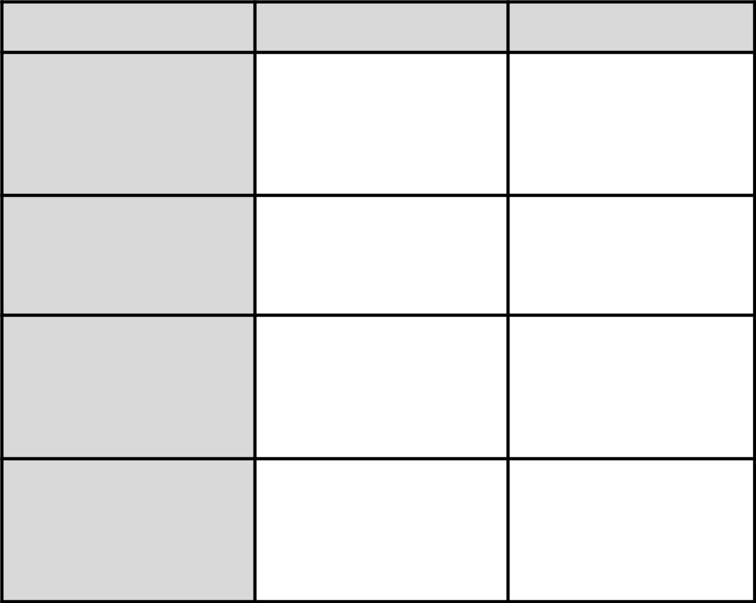

Criteria | Occurrence | Reflection (List Examples)

Were any put downs used?

Were you encouraged?

Is it unusual to praise another

individual?

Is it unusual to receive praise

from another individual?

144 PHYSICAL EDUCATION CURRICULUM GUIDE - INTERMEDIATE

APPENDIX C: SAMPLES OF ASSESSMENT TOOLS

Sample: Class Self-Evaluation of Engagement

Name: Date:

Level 1 | Level 2 | Level 3 | Level 4 | Level 5
Very Limited | Limited | Accomplished | Strong | Outstanding
Seldom or never | Occasionally | Frequently | Usually | Consistently

Positive Statements |  | Yes |  | No
1. | I arrived in class on time.
2. | I was properly dressed for participation in physical education
 | class.
3. | I participated in today's warm-up activities.
4. | I attained a positive attitude and enjoyed today's lesson.
5. | I was polite to my classmates and teacher today.
6. | I worked hard today. I stayed on task today. I did all that was asked
 | of me.
7. | I wrote in my journal today and remembered to bring it to class.
8. | I reached my target heart rate zone today.
9. | I assisted others today.
Bonus: Points for good jokes, personal records or cool fitness activities
you participated in outside of school, (see the teacher)
Total mark for today's lesson: |  |  | /50

PHYSICAL EDUCATION CURRICULUM GUIDE - INTERMEDIATE 145

APPENDIX C: SAMPLES OF ASSESSMENT TOOLS

Sample: Affective (Cooperation and Responsibility) Evaluation Criteria

Rating |  | Student Self-Evaluation Rubric
Level 5 | • Always concentrates on activities at hand - always on task
Level 5 | • Works well and is polite and positive with all members of the group
Outstanding/
Outstanding/ | • Works at a challenging level
Consistently
Consistently | • | Always uses good judgement, always displays honesty
 | • Responsible and cooperative beyond teacher expectations
 | • | Always comes prepared
Level 4 | • Almost always concentrates on activities at hand - almost always on task
Level 4 | • Usually works well and is positive with most classmates
Strong/Usually
Strong/Usually | • Almost always works at a challenging level
 | • Almost always uses good judgement; almost always displays honesty
 | • Displays cooperative and responsible behaviour consistent with teacher expec-
 |  | tations
 | • Almost always comes prepared
Level 3 | • | Concentrates on activities at hand most of the time - on task most times
Accomplished/ | • | Requires teacher input/motivation to attempt to be positive and work well
Frequently |  | with classmates
 | • When supervised displays good judgement and good behaviour
 | • Requires teacher reminders to follow-up on responsibilities
Level 2 | • Often off task, unless closely supervised
Level 2 | • Frequently does not attempt to work well with others
Limited/
Limited/ | • | Does not put forth a reasonable effort
Occasionally | • | Does not work at a challenging level
 | • Displays poor judgement when not supervised by teacher
 | • Is not cooperative; avoids responsibility for actions and duties
Level 1 | • | Almost never concentrates on activities at hand - usually off task
Seldom or Never | • Continually displays uncooperative behaviour; is rude to teacher and class-
Seldom or Never |  | mates
 | • Consistently makes little or no effort
 | • Frequently displays irresponsible and uncooperative behaviour

146 PHYSICAL EDUCATION CURRICULUM GUIDE - INTERMEDIATE

APPENDIX C: SAMPLES OF ASSESSMENT TOOLS

Sample: Assessing Group Presentations

Topic:

Date:

Activity:

Group members:
 |  | High |  |  |  |  | Low
• the group was organized and prepared | 5 | 4 | 3 | 2 | 1 | 0
• worked well together as a team |  | 5 | 4 | 3 | 2 | 1 | 0
• demonstrated knowledge of topic |  | 5 | 4 | 3 | 2 | 1 | 0
• used a variety of presentation techniques |  | 5 | 4 | 3 | 2 | 1 | 0
• clearly communicated ideas and concepts |  | 5 | 4 | 3 | 2 | 1 | 0
• provided opportunities for questions |  | 5 | 4 | 3 | 2 | 1 | 0
• provided opportunities for class involvement |  | 5 | 4 | 3 | 2 | 1 | 0
• adhered to allotted class time |  | 5 | 4 | 3 | 2 | 1 | 0

Comments:

PHYSICAL EDUCATION CURRICULUM GUIDE - INTERMEDIATE 147

APPENDIX C: SAMPLES OF ASSESSMENT TOOLS

Sample: Teacher/Student Conference

Sample: Portfolio: Student/Teacher Conference

Student Name: ______________________________________

Date(s): ________________________________

Topic 1: Development of a fitness program following the FITT principle

Topic 2: ___________________________________________________________________

Sample Student Response:

- Provide a ten minute cardiovascular workout

2.

3.

Sample Teacher Comments:

- Did not provide a warm-up/cool down

2.

3.

Portfolio: Student/Teacher Conference

Student Name: ______________________________________

Date(s): ________________________________

Topic 1: ___________________________________________________________________

Topic 2: ___________________________________________________________________

Sample Student Response: |  | Sample Teacher Comments:

1. 1.

2. 2.

3. 3.

148 PHYSICAL EDUCATION CURRICULUM GUIDE - INTERMEDIATE

APPENDIX C: SAMPLES OF ASSESSMENT TOOLS

Sample: Setting FITT Goals

Frequency |  | Intensity |  |  |  | Time |  |  |  | Type
How many times do |  | What type(s) of |  |  | In order to remain |  |  | Record the exercise
you feel exercise is |  | exercise are you most |  |  | healthy you need to |  |  | sessions you want to
required per week? |  | comfortable with? Start |  |  | exercise! |  |  | participate in over the
Always start easy and |  | with light |  |  | Light/Moderate/ |  |  | next three weeks:
remember SMART |  | intensity and work your |  |  | Vigorous: 60 minutes
goals. |  | way up slowly. |  |  | (4-6 days per week)
(Specific, Measurable,
Achievable, Realistic
and Timely)
How many exercise |  | The # of exercise |  |  | How long do you want |  |  | Week 1:
sessions will you |  | sessions you will |  |  | to work at each |  | __________________
complete? |  | complete for each |  |  | intensity? |  | __________________
 |  | intensity |  |  |  |  | __________________
Week 1: ___________ |  | Week 1: |  |  | Week 1: |  | __________________
 |  |  |  |  |  |  | __________________
 |  | Light:____________ |  |  | Light:____________
 |  |  |  |  |  |  | __________________
 |  | Moderate:_________ |  |  | Moderate:_________
 |  | Vigorous:__________ |  |  | Vigorous:__________
Week 2: ___________ |  | Week 2: |  |  | Week 2: |  |  | Week 2:
 |  | Light:____________ |  |  | Light:____________ |  | __________________
 |  | Moderate:_________ |  |  | Moderate:_________ |  | __________________
 |  | Vigorous:__________ |  |  | Vigorous:__________ |  | __________________
 |  |  |  |  |  |  | __________________
 |  |  |  |  |  |  | __________________
Week 3: ___________ |  | Week 3: |  |  | Week 3: |  |  | Week 3:
 |  | Light:____________ |  |  | Light:____________ |  | __________________
 |  |  |  |  |  |  | __________________
 |  | Moderate:_________ |  |  | Moderate:_________
 |  |  |  |  |  |  | __________________
 |  | Vigorous:__________ |  |  | Vigorous:__________
 |  |  |  |  |  |  | __________________
 |  |  |  |  |  |  | __________________
 |  |  |  |  |  |  | __________________
Total exercise sessions: |  | Light:____________ |  |  | Total time at each |  |  | Achieve your goals?
 |  | Moderate:_________ |  |  | intensity: |  |  | Yes - Make sure you
__________________ |  | Vigorous:__________
__________________ |  |  |  |  | Light:____________ |  |  | aren't making them
 |  |  |  |  | Moderate:_________ |  |  | too easy
 |  |  |  |  | Vigorous:__________ |  |  | No - Don't make them
 |  |  |  |  |  |  |  | too hard

PHYSICAL EDUCATION CURRICULUM GUIDE - INTERMEDIATE 149

APPENDIX C: SAMPLES OF ASSESSMENT TOOLS

Sample: Creating Your Own Workout

Muscle | Exercise Ball | Stretch | Free Weights | Own Body |  |  | Purpose of exercise
Group |  | Tubing/ |  | Weight |  |  | NOTE: these
 |  | Resistance |  |  |  |  | descriptions can be
 |  | Bands |  |  |  |  | applied to any of the
 |  |  |  |  |  |  | body parts
Chest | - Push- up | - Chest Press | - Bench Press | - Push-up |  |  | Power: to explosively
 |  | - Flies | - Incline | - Chest Pass |  |  | move as much weight
 |  |  | Bench Press | - Power Drop |  |  | as you can one or two
 |  |  | - Flies |  |  |  | times.
Back | - Prone Row | - Bent Over | - Pull Downs | - Back |  |  | • | Reps: 1-3
 | - Extension | Row |  | Extensions |  |  | •
 | - Extension | Row |  | Extensions |  |  | • | Sets: 3-5
 | - Back | - Pull Downs |  |  |  |  | •
 | - Back | - Pull Downs |  |  |  |  | • Load: 85% of Max
 | Extensions
 |  |  |  |  |  |  | • Rest between sets: 3
Biceps | - Bicep Curls | - Biceps Curls | - Bicep Curls | - Chin-ups
 |  |  |  |  |  |  |  | minutes
 |  | - Hammer | - Hammer
 |  | Curls | Curls |  |  |  | Strength: to increase
 |  | - Twist Curls | - Twist Curls |  |  |  | overall strength.
Triceps | - Triceps Ex- | - Triceps Curl | - Triceps | - Push-up |  |  | • Reps: 6 or less
 | tension |  | Extension | - Dips
 | tension |  | Extension | - Dips |  |  | • | Sets: 2-6
 | - Punch-up |  |  |  |  |  | •
 | - Punch-up |  |  |  |  |  | • Load: 90% of Max
Shoulders | - Prone Row | - Lateral Raise | - Flies
 |  |  |  |  |  |  | • Rest between sets: 2
 | - Extensions | - Frontal Raise | - Military Press
 | - Extensions | - Frontal Raise | - Military Press |  |  |  |  | minutes
 |  | - Flies | - Lateral Raise
 |  |  | - Shoulder |  |  |  | Hypertrophy: to
 |  |  | Raise |  |  |  | increase muscle growth.
 |  |  |  |  |  |  | • | Reps: 6-12
Legs | - Split Squat/ | - Leg | - Hamstring | - Lunges |  |  | • | Sets: 3-6
 | - Lunge | Extensions | Curl | - Squats/Squat |  |  | • Load: 75% of Max
 | - Wall Squats | - Squat | - Leg | Jumps |  |  | • | Rest between sets:
 | - Split Squat |  | Extensions | - Leg Lifts |  |  |  | 30 seconds - 1
 | - Lunge |  | - Squats | - Calf Raises |  |  |  | minute
 |  |  | - Calf | - Lateral Leg
 |  |  | - Calf | - Lateral Leg |  |  | Muscular
 |  |  | Extensions | Raises
 |  |  | - Calf Press | - Tuck Jump |  |  | Endurance: to
 |  |  | - Abductors | - Split Squat |  |  | repeatedly move more
 |  |  | - Adductors | Jump |  |  | weight over an extended
 |  |  |  | - Lateral |  |  | period of time.
 |  |  |  | Barrier Hop |  |  | • Reps: 12 or more
 |  |  |  | - Power Skip
 |  |  |  | - Power Skip |  |  | • | Sets: 2-3
 |  |  |  | - Squat Box |  |  | •
 |  |  |  | Jump |  |  | • Load: 66% of Max
 |  |  |  |  |  |  | • | Rest between sets:
Core (i.e. | - Crunch |  |  | - Crunch |  |  |  | 30 seconds or less
abdominals) | - Side Crunch |  |  | - Chest Pass
 | - Roll Out |  |  | - 45 Degree
 |  |  |  | sit-up

150 PHYSICAL EDUCATION CURRICULUM GUIDE - INTERMEDIATE

APPENDIX C: SAMPLES OF ASSESSMENT TOOLS

Sample: Exercise and Percentage of Maximum Heart Rate

Name: Date:

Your maximum pulse is determined by subtracting your age from 220.

220 - (your age) = (maximum heart rate)

90% is |  |  |  |  |  |  |  | beats per minute
80% is |  |  |  |  |  |  |  | beats per minute
70% is |  |  |  |  |  |  |  | beats per minute
60% is |  |  |  |  |  |  |  | beats per minute
50% is |  |  |  |  |  |  |  | beats per minute
Target Heart-Rate Zone
 |  |  |  |  |  |  |  | (60% of maximum |  |  | (80% of maximum
 |  |  |  |  |  |  |  |  | heart rate) |  |  | heart rate)

- To gain aerobic or cardiovascular benefits, you must exercise at an intensity that makes your heart beat at a pace somewhere in your target heart zone.

PHYSICAL EDUCATION CURRICULUM GUIDE - INTERMEDIATE 151

APPENDIX C: SAMPLES OF ASSESSMENT TOOLS

Sample: Pulse Records

Keep track of how often and how well you engage in beneficial aerobic activity

Name:

Target Heart Rate Zone =
 | (60% of maximum |  |  | (80% of maximum
 |  | heart rate) |  |  | heart rate)
 |  |  |  |  |  |  | In Your Target Heart
 |  |  |  |  |  |  | Rate?
Date |  | Activity |  |  | Pulse Rate |  | Yes or No

152 PHYSICAL EDUCATION CURRICULUM GUIDE - INTERMEDIATE

APPENDIX C: SAMPLES OF ASSESSMENT TOOLS

Sample: Aerobic Fitness 12 Minute Run/Jog/Walk

Name: Date:

Instructions: The objective is to cover the greatest possible distance in a 12 minute period.

Participants should perform on a track, in a gym, on a field or other accurately measured course.

A. Prior to the Run:

- Establish the distance of one lap of the gym, track or field to calculate total distance (i.e. one lap of the gym = 100 metres, 20 laps = 2000 metres or 2 km).

- No eating or drinking (except water) immediately prior to taking the test.

- Avoid intense physical activity.

- Notify the teacher before the test of any concerns you have or medications you may be taking.

- Wear appropriate clothes (i.e. shorts, t-shirt, etc.) and running shoes.

B. Administration of the Run:

- Divide participants into two groups.

- Participants in the first group should choose a partner from the second group.

- Participants complete a thorough warm-up session and slowly walk a lap around the track.

- Partners keep track of the distance covered during the 12 minute period (count number of laps).

- Partners give the time when each lap is completed.

- Teacher or designate should announce the time each minute or so.

- The partners write the distance run in 12 minutes in fractions of a kilometre (the distance for each lap will need to be known).

- Group 2 now completes the 12 minute run/jog/walk.

C. Interpreting the Results

- The results of the run/jog/walk are not to be used directly in establishing student grades or percentages (i.e. number of laps = a certain grade).

Number of Laps Completed: |  |  |  |  |  |  |  |  |  |  |  |  | Goal Setting:
Distance Covered:
Target Heart Rate Zone:
 |  |  | 60% of |  |  |  |  | 80% of
 |  |  | max. |  |  |  |  | max.
Target Heart Rate Zone Maintained?
 |  |  |  |  |  | yes |  |  |  |  |  | no

PHYSICAL EDUCATION CURRICULUM GUIDE - INTERMEDIATE 153

APPENDIX C: SAMPLES OF ASSESSMENT TOOLS

Sample: Cardiorespiratory Fitness Tests
Submitted by: Jason Desai, Physical Education Teacher (ESD)

12 Minute Run

 | Date: |  |  | Date: |  |  | Date: |  | Date:
 | _____ Laps |  |  |  | _____ Laps |  | _____ Laps |  | _____ Laps
 | X 60 m = ________ |  |  |  | X 60 m = ________ |  | X 60 m = ________ |  | X 60 m = ________
 | Shuttle Run (Beep Test)
 | Date: |  |  | Date: |  |  | Date: |  | Date:
 | Level: ___________ |  |  |  | Level: ___________ |  | Level: ___________ |  | Level: ___________
 | Skipping Test
 | Date: | 2 min. |  | Date: |  | 3 min. | Date: | 4 min. | Date: | 5 min.
 |  | Heart Rate: |  |  | Heart Rate: |  | Heart Rate: |  | Heart Rate:
 | _________bpm |  |  |  | _________bpm |  | _________bpm |  | _________bpm

Student Name:_____________________________________________

Term: ____________________________

Date(s):

__________________________

__________________________

__________________________

__________________________

154 PHYSICAL EDUCATION CURRICULUM GUIDE - INTERMEDIATE

APPENDIX C: SAMPLES OF ASSESSMENT TOOLS

Sample: Physical Fitness Goals and Monitoring
Submitted by: Jason Desai, Physical Education Teacher (ESD)

Exercises | Date: _________ |  | Date: _________ |  | Date: _________ |  | Date: _________
Push-ups | Max |  | Max |  | Max |  | Max
Partial Curl-Up | Max |  | Max |  | Max |  | Max
Vertical Jump
Flexibility
Front Plank | Goal: 1:00 min. |  | Goal: 1:30 sec. |  | Goal: 1:45 min. |  | Goal: 2:00 min.
Side Plank | Goal: 1:00 min. |  | Goal: 1:30 sec. |  | Goal: 1:45 min. |  | Goal: 2:00 min.
Mountain Climbers | Goal: .30 sec. |  | Goal: 30 sec. |  | Goal: .30 sec. |  | Goal: .30 sec.
Medicine Ball Slams | Goal: 20 reps. |  | Goal: 20 reps. |  | Goal: 20 reps. |  | Goal: 20 reps.
Prisoner Squats | Goal: 15 reps. |  | Goal: 20 reps. |  | Goal: 25 reps. |  | Goal: 30 reps.
Lunges | Goal: 20 reps. |  | Goal: 20 reps. |  | Goal: 20 reps. |  | Goal: 20 reps.
TRX Lat Pull | Goal: 10 reps. |  | Goal: 15 reps. |  | Goal: 18 reps. |  | Goal: 20 reps.
Downs

Place scores/time in the respective circles. For side planks, place a score in one half of the circle for the left side and the other for the right side.

PHYSICAL EDUCATION CURRICULUM GUIDE - INTERMEDIATE 155

APPENDIX C: SAMPLES OF ASSESSMENT TOOLS

Sample: Body Weight Exercises Chart

Name:

Date | Push Ups | Chin Ups: | Push Ups | Squats: | Alternate
 | Wide Grip: | # of reps | Narrow: | # of reps | Leg Kneel:
 | # of reps |  | # of reps |  | # of reps

156 PHYSICAL EDUCATION CURRICULUM GUIDE - INTERMEDIATE

APPENDIX C: SAMPLES OF ASSESSMENT TOOLS

Sample: Exercise Ball Workout Record Chart

Name:

Date | Exercise Used | Body Parts Targeted | Time | Sets and Reps

PHYSICAL EDUCATION CURRICULUM GUIDE - INTERMEDIATE 157

APPENDIX C: SAMPLES OF ASSESSMENT TOOLS

Sample: Upper Body Exercises Chart

Name:

Date | Walk Out Push | Push Up on | Kneeling | Curls using
 | Ups on a Swiss | a Swiss Ball: | Straight Arm | a Resistance
 | Ball: | # of reps | Pull on a Swiss | Band:
 | # of reps |  | Ball: | # of reps
 |  |  | # of reps

158 PHYSICAL EDUCATION CURRICULUM GUIDE - INTERMEDIATE

APPENDIX C: SAMPLES OF ASSESSMENT TOOLS

Sample: Chest Exercises Chart

Name:

Date | Push Ups with | Swiss Ball | Prone Straight | Curl Ups | Single Arm
 | Feet on the | Walk | Arm Pull: | using the | Resistance
 | Swiss Ball: | Around: | # of reps | Resistance | Rope Fly:
 | # of reps | # of reps |  | Band: | # of reps
 |  |  |  | # of reps

PHYSICAL EDUCATION CURRICULUM GUIDE - INTERMEDIATE 159

APPENDIX C: SAMPLES OF ASSESSMENT TOOLS

Sample: Arm Exercises Using Resistance Bands Chart

Name:

Date | Bicep Curl: | Tricep Curl: | Lateral Raise: | Frontal Raise:
 | # of reps | # of reps | # of reps | # of reps

160 PHYSICAL EDUCATION CURRICULUM GUIDE - INTERMEDIATE

APPENDIX C: SAMPLES OF ASSESSMENT TOOLS

Sample: Back Exercises Using Resistance Bands Chart

* Loop resistance band around a solid object to perform exercises

Name:

Date | T-Bar Row: | Bent Over | Bent Fly: | Lateral
 | # of reps | Row: | # of reps | Pull-Downs:
 |  | # of reps |  | # of reps

PHYSICAL EDUCATION CURRICULUM GUIDE - INTERMEDIATE 161

APPENDIX C: SAMPLES OF ASSESSMENT TOOLS

Sample: Abdominal Exercises Chart

Name:
Date |  | Crunches: | Oblique | Side | Supine |  | Leg Raise:
 |  | # of reps | Crunch: | Crunch: | V-up: |  | # of reps
 |  |  | # of reps | # of reps | # of reps

162 PHYSICAL EDUCATION CURRICULUM GUIDE - INTERMEDIATE

APPENDIX C: SAMPLES OF ASSESSMENT TOOLS

Sample: Lower Body Exercises Chart

Name:

Date | Wall Squat | Prone Leg | Alternate | Standing | Lateral Leg | Prone
 | using a Swiss | Curl using | Leg Lunges: | Calf- | Raise with a | Opposite
 | Ball: | a Swiss | # of reps | Raise: | Swiss Ball: | Arm and
 | # of reps | Ball: |  | # of reps | # of reps | Leg Raise:
 |  | # of reps |  |  |  | # of reps

PHYSICAL EDUCATION CURRICULUM GUIDE - INTERMEDIATE 163

APPENDIX C: SAMPLES OF ASSESSMENT TOOLS

Sample: Leg Exercises Chart

Name:

Date | Squat: | Seated Leg | Prone Leg | Calf | Back Foot
 | # of reps | Raises: | Curl using a | Raises: | on a Swiss
 |  | # of reps | Swiss Ball: | # of reps | Ball Squat
 |  |  | # of reps |  | # of reps

164 PHYSICAL EDUCATION CURRICULUM GUIDE - INTERMEDIATE

APPENDIX C: SAMPLES OF ASSESSMENT TOOLS

Sample: Movement Skills Rubric (# 1)

Activity: _____________________________________________

Student Name |  | Moving and Doing /5 |  |  |  |  | Cues for Suggestions
 |  | Understanding and Applying /5
 |  | M/D | /5 | U/A | /5
 |  | M/D | /5 | U/A | /5
 |  | M/D | /5 | U/A | /5
 |  | M/D | /5 | U/A | /5
 |  | M/D | /5 | U/A | /5
 |  | M/D | /5 | U/A | /5
 |  | M/D | /5 | U/A | /5
 |  | M/D | /5 | U/A | /5
 |  | M/D | /5 | U/A | /5
 |  | M/D | /5 | U/A | /5
 |  | M/D | /5 | U/A | /5
 |  | M/D | /5 | U/A | /5
 |  | M/D | /5 | U/A | /5
 |  | M/D | /5 | U/A | /5
 |  | M/D | /5 | U/A | /5
 |  | M/D | /5 | U/A | /5
 |  | M/D | /5 | U/A | /5
 |  | M/D | /5 | U/A | /5
 |  | M/D | /5 | U/P | /5
 |  | M/D | /5 | U/A | /5
 |  | M/D | /5 | U/A | /5
 |  | M/D | /5 | U/A | /5
 |  | M/D | /5 | U/A | /5
 |  | M/D | /5 | U/A | /5
Level 1 | Level 2 |  |  | Level 3 |  | Level 4 |  | Level 5
Very Limited/ | Limited/ |  | Accomplished/ |  |  | Strong/Usually |  | Outstanding/
Seldom or Never | Occasionally |  |  | Frequently |  |  |  | Consistently

PHYSICAL EDUCATION CURRICULUM GUIDE - INTERMEDIATE 165

APPENDIX C: SAMPLES OF ASSESSMENT TOOLS

Sample: Movement/Skill Assessment (#2)

Activity:

Students should be able to perform the required skills in a game situation while under teacher observation. If the student can only demonstrate the skill in a drill scenario, he/she remains in the lowest stage of skill development.

 |  | Needs Improvement and cues
Skill: __________________ | Level | for Suggestions

Level 1 | Level 2 | Level 3 | Level 4 | Level 5
Very Limited/ | Limited/ | Accomplished/ | Strong/Usually | Outstanding/
Seldom or Never | Occasionally | Frequently |  | Consistently

166 PHYSICAL EDUCATION CURRICULUM GUIDE - INTERMEDIATE

APPENDIX C: SAMPLES OF ASSESSMENT TOOLS

Sample: Movement Skills Rubric (#3)

Theme:_________________________________________________

Class: __________________________________________________

Term: ________________________________

 | SKILL 1 | SKILL 2 | SKILL 3
Name |  |  |  | Comment

 | Level 1 | Level 2 | Level 3 | Level 4 | Level 5
 | Very Limited/ | Limited/ | Accomplished/ | Strong/Usually | Outstanding/
 | Seldom or Never | Occasionally | Frequently |  | Consistently

PHYSICAL EDUCATION CURRICULUM GUIDE - INTERMEDIATE 167

APPENDIX C: SAMPLES OF ASSESSMENT TOOLS

Sample Scoring Rubric for Receiving Objects

Receiving Objects Rubric

Theme: ______________________________________________________

Students | Stage 1: The | Stage 2: | Stage 3: Contact | Stage 4: Caught
 | arms are held out | Anticipatory | made with the | with the hand/
 | and the object is | movement made | hands first | hands and the full
 | trapped against | to catch the |  | force of the ball is
 | the body | object |  | absorbed

Level 1 | Level 2 | Level 3 | Level 4 | Level 5
Very Limited/ | Limited/ | Accomplished/ | Strong/Usually | Outstanding/
Seldom or Never | Occasionally | Frequently |  | Consistently

Source: Pangrazzi

168 PHYSICAL EDUCATION CURRICULUM GUIDE - INTERMEDIATE

APPENDIX C: SAMPLES OF ASSESSMENT TOOLS

Sample Scoring Rubric for Projecting Objects

Projecting Objects Rubric

Theme: ______________________________________________________

Students | Steps with the | Turns the hips to | Turns the chest | Brings the
 | opposite foot | face the target | and shoulders to | throwing arm
 |  |  | face the target | forward and
 |  |  |  | follows
 |  |  |  | through to the
 |  |  |  | target

Level 1 | Level 2 | Level 3 | Level 4 | Level 5
Very Limited/ | Limited/ | Accomplished/ | Strong/Usually | Outstanding/
Seldom or Never | Occasionally | Frequently |  | Consistently

Source: Pangrazzi

PHYSICAL EDUCATION CURRICULUM GUIDE - INTERMEDIATE 169

APPENDIX C: SAMPLES OF ASSESSMENT TOOLS

Sample: Teaching and Learning Strategies Checklist

Rhythmics

Theme: ______________________________________________________

Students | Responds | Demonstrates | Responds | Travels | Participates | Cooperates
 | to teacher | movement to | using | Safely | in | with others
 | signals | a beat | Locomotor |  | movement
 |  |  | and non- |  | activities
 |  |  | locomotor
 |  |  | movements

Level 1 | Level 2 | Level 3 | Level 4 | Level 5
Very Limited/ | Limited/ | Accomplished/ | Strong/Usually | Outstanding/
Seldom or Never | Occasionally | Frequently |  | Consistently

170 PHYSICAL EDUCATION CURRICULUM GUIDE - INTERMEDIATE

APPENDIX C: SAMPLES OF ASSESSMENT TOOLS

Sample: Skills Rubric - Badminton/Pickle Ball/Short Tennis

Name: ___________________________________________________

Students should be able to perform the required skills in a game situation while under teacher observation. If the student can only demonstrate the skill in a drill scenario, he/she remains in the lowest stage of skill development.

 | Skill: Ready Position |  |  |  | Competent |  | Needs Improvement and
 |  |  |  |  | Competent |  | Cues for Suggestions
 | Weight on the balls of |  | the feet
 | Knees are relaxed
 | Feet are slightly apart
 | Hand is relaxed on the grip
 | Elbows are slightly bent
 | Racket is in front of the body
 | Racket head is higher than the
 | grip
 | Level 1 |  | Level 2 |  | Level 3 |  | Level 4 | Level 5
 | Very Limited/ |  | Limited/ |  | Accomplished/ | Strong/Usually |  | Outstanding/
 | Seldom or Never |  | Occasionally |  | Frequently |  |  | Consistently

PHYSICAL EDUCATION CURRICULUM GUIDE - INTERMEDIATE 171

APPENDIX C: SAMPLES OF ASSESSMENT TOOLS

Sample: Assessing Dance

Name: |  |  |  |  |  |  |  |  |  |  |  |  |  |  |  |  |  | Date:
Class:
 |  |  |  |  |  |  |  |  |  |  |  |  | Dance 1 |  |  |  |  |  |  |  |  | Dance 2
 |  |  |  | Criteria
 |  |  |  |  |  |  |  |  | Self |  | Peer |  | Teacher |  | Comments |  |  | Self | Peer |  | Teacher |  |  | Comments
 | Dance Skills
 | • | sequence of movement |  |  |  |  |  |  | /5 |  | /5 |  | /5 |  |  |  |  | /5 | /5 |  |  | /5
 | • | synchronization with |  |  |  |  |  |  | /5 |  | /5 |  | /5 |  |  |  |  | /5 | /5 |  |  | /5
 |  | partner or group |  |  |  |  |  |  | /5 |  |  |  | /5 |  |  |  |  | /5
 | • | time (on beat) |  |  |  |  |  |  | /5 |  | /5 |  | /5 |  |  |  |  | /5 | /5 |  |  | /5
 | • | posture |  |  |  |  |  |  | /5 |  | /5 |  | /5 |  |  |  |  | /5 | /5 |  |  | /5
 | • start and finish positions |  |  |  |  |  |  |  | /5 |  | /5 |  | /5 |  |  |  |  | /5 | /5 |  |  | /5
 | • | specific dance
 |  | movements |  |  |  |  |  |  | /5 |  | /5 |  | /5 |  |  |  |  | /5 | /5 |  |  | /5
 |  | (i.e. turns, steps) |  |  |  |  |  |  | /5 |  |  |  | /5 |  |  |  |  | /5
 | • | pathways/lines of dance |  |  |  |  |  |  | /5 |  | /5 |  | /5 |  |  |  |  | /5 | /5 |  |  | /5
 | Group Behaviours
 | • | cooperation |  |  |  |  |  |  | /5 |  | /5 |  | /5 |  |  |  |  | /5 | /5 |  |  | /5
 | • listen actively to one |  |  |  |  |  |  |  | /5 |  | /5 |  | /5 |  |  |  |  | /5 | /5 |  |  | /5
 |  | another |  |  |  |  |  |  | /5 |  |  |  | /5 |  |  |  |  | /5
 | • | offers and accepts |  |  |  |  |  |  | /5 |  | /5 |  | /5 |  |  |  |  | /5 | /5 |  |  | /5
 |  | feedback appropriately |  |  |  |  |  |  | /5 |  |  |  | /5 |  |  |  |  | /5
 |  |  |  | Level 1 |  |  |  | Level 2 |  |  |  |  |  | Level 3 |  |  |  | Level 4 |  |  |  |  | Level 5
 |  | Very Limited/ |  |  |  |  | Limited/ |  |  |  |  |  | Accomplished/ |  |  |  | Strong/Usually |  |  |  |  |  | Outstanding/
 |  | Seldom or Never |  |  |  | Occasionally |  |  |  |  |  |  | Frequently |  |  |  |  |  |  |  |  |  | Consistently

172 PHYSICAL EDUCATION CURRICULUM GUIDE - INTERMEDIATE

