The WeatherBug Schools Program:

Enhancing Community Safety, Math, Science, Geography, and Technology Education at <<school name>>

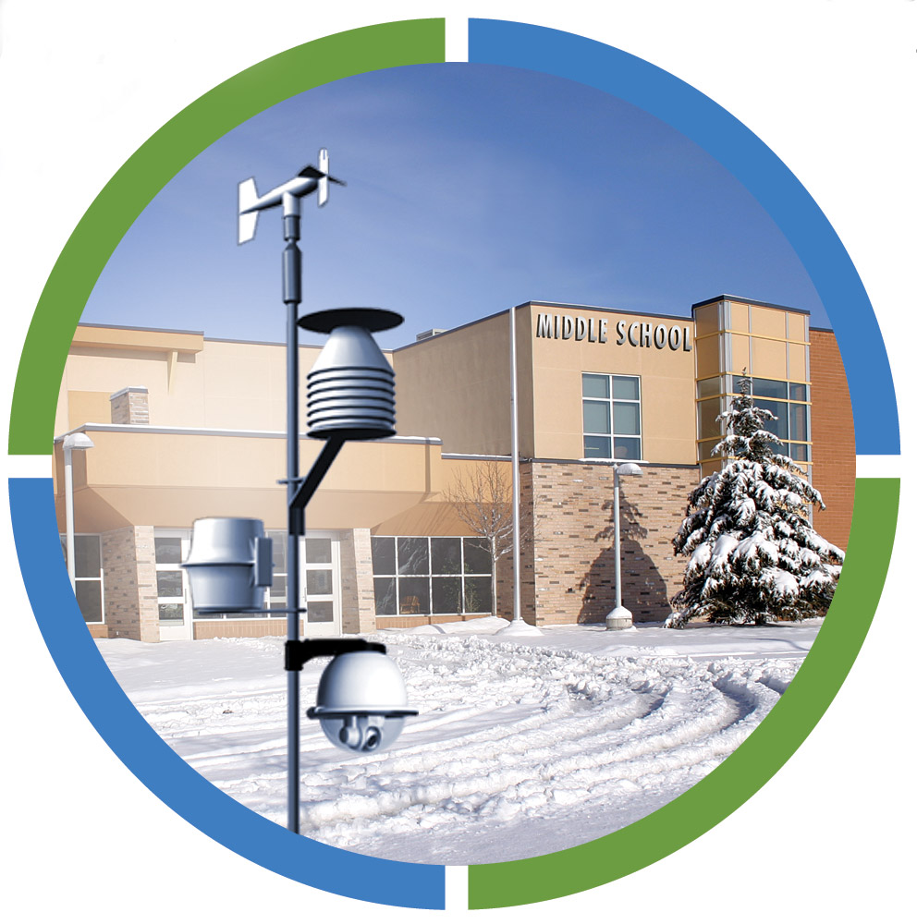

Proposed to:

<<Insert Grant Name>>

<<Date>>

A Proposal for State Farm Good Neighbors Grant to Enhance Math, Science in

West Miami Dade when Carroll High School Becomes a

WeatherBug Site.

A Proposal for <<Insert Grant Name>> Grant to Enhance Community Safety and Improve Learning Concepts in Science and Math at <<school name>>.

1.0 Introduction

The WeatherBug Program is truly innovative and supports improved learning and STEM (Science, Technology, Engineering and Math) concept connections and skills development for students. Beyond the classroom benefits, the WeatherBug Program will provide <<school name>> with live weather data and advanced warning capabilities for lighting and other severe weather. It will also serve as a valuable weather information resource that will be available to local television and accessible to the community on smartphones and via the Internet. In addition to the PR recognition our school will receive, local businesses who are sponsors will gain long term and substantive recognition as a committed community and education partner.

The WeatherBug Program will place a commercial-grade, state-of-the-art WeatherBug weather station <<Motion Camera, HDCam and WeatherBug Achieve online software>>, at a school site, community site, or multiple school sites. The live weather data is fed into interactive lessons, tools and activities that will be used for enhanced mathematics, science, geography, and technology education in the school. Students and teachers will have access to the live data from the station on all school computers. They will also have access to the entire WeatherBug network, comprised of more than 8,000 sites across the country which will allow students to make comparisons of the data.

The WeatherBug Program can be used in all grades and will be available to all students and teachers both at school and at home. It supports National and State Education Standards, EETT (Enhancing Education Through Technology), STEM concept developments and will be an integral part of a school’s push to improve academic initiatives.

- School Background

<< Insert school description: e.g. grade levels, mission statement, unique classes or activities, other information about your school. >>

3.0 Statement of Need

A real challenge faced by the educational community is the identification and integration of application technologies that harness the power of the Internet, while also being designed to address student needs in core content areas, for ease of use and practicality in the classroom.

With No Child Left Behind, significant local, state and national attention has been placed on the education system’s goal to educate every student using best practices and the most current materials and content. However, funding can be challenging. A creative array of partnerships among educators, the community, government agencies and the private sector is needed to fulfill today’s educational goals.

- Project Goals

There are several tangible benefits for <<Insert Grant Name>> to partner with << school >>. This initiative will provide <<Insert Grant Name>> with recognition and local students with practical application programs. In addition, the entire community where your employees live and work can benefit from this community resource.

The goal of the proposed WeatherBug Program project is three-fold:

- Enhance math, science, geography, and technology education for students by joining the WeatherBug Schools Program.
- Provide the entire community with a unique and valuable resource for live, local weather conditions and safety alerts via multiple ways.
- Increase a sponsor’s community presence in the area through a visible, long-term program that benefits all participants.

5.0 The Approach

The WeatherBug Schools Program was developed and is operated by WeatherBug, a division of AWS Convergence Technologies, Inc., based in Germantown, Maryland.

The WeatherBug Program offers all participants a rewarding opportunity. Schools benefit from state-of-the-art educational technology designed to enhance math, geography, science and technology education. The campus will also benefit from advanced warning for lightning and severe weather. Local communities benefit from unique real-time local weather information. Business partners benefit by long term, substantive recognition for their efforts to support their local school and community.

The WeatherBug Program concept (See Figure 1) combines a number of components that together provide: (1) a potent science, math, geography, and technology learning tool, (2) advanced warning to lightning and severe weather, (3) an excellent community information resource and (4) an exceptional public and community relations vehicle for sponsors.

Figure 1 - WeatherBug Program Concept

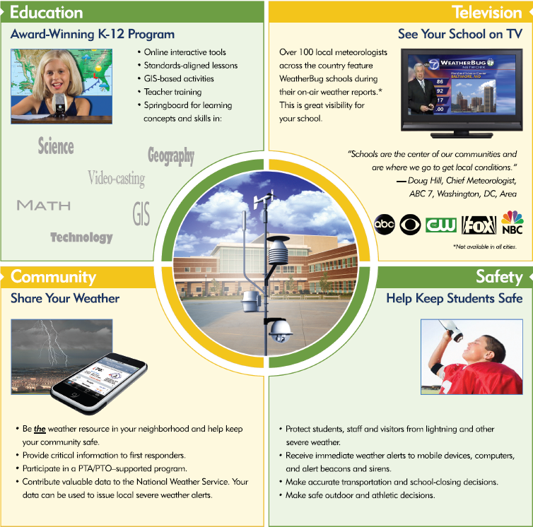

5.1 A Valuable Classroom Tool

We all relate to the weather on a daily basis. Students, in particular, take a keen interest in it. The WeatherBug Program uses the universally engaging topic of weather as a “window” to interdisciplinary curriculum in core content areas.

The WeatherBug weather station records 27 weather parameters including outdoor temperature, relative humidity, wind speed and direction, barometric pressure, rainfall and light intensity. The interactive web-based software allows students to access real-time, up-to-the-second weather information from any participating school. The data is then displayed in a number of formats, including color graphical displays, images, maps and line graphs (See Figure 2). The comprehensive K-12 teacher-developed and classroom-tested lessons, activities, tools and features are found in WeatherBug Achieve, and online education software tool, which can be integrated into the existing school curriculum with ease.

Figure 2

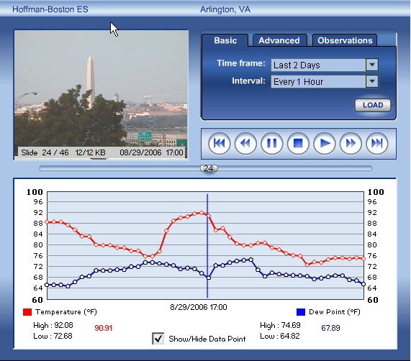
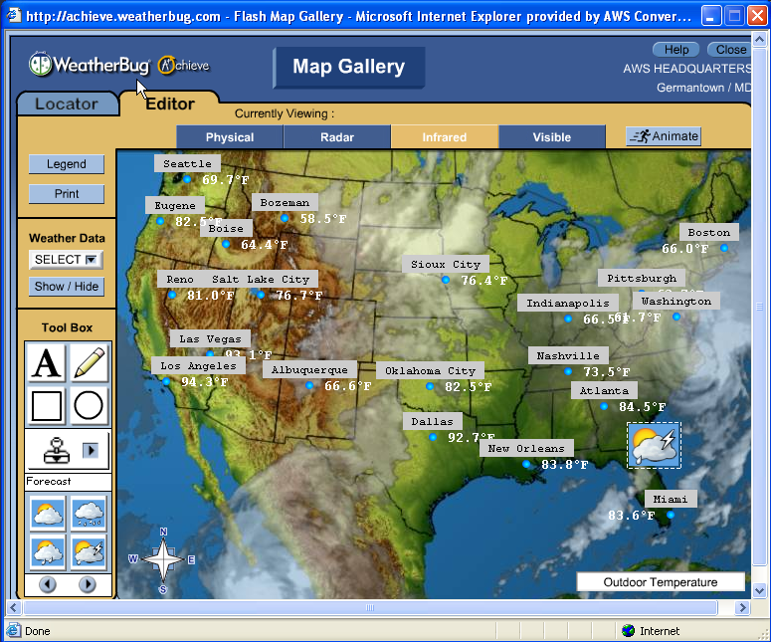

The system and network have been specifically designed for education and present numerous opportunities for interdisciplinary studies. The system fits naturally into science, math, geography, and technology curricula, and includes problem solving, statistics, graphing, data analysis and interpretation applications, just to mention a few. Beyond science math, geography and technology, the school can integrate the weather station and network into daily morning announcements, writing exercises, and social studies lessons. For example, students can research the effects of weather history, business or the economy. They can also study the impact of local weather conditions on the school’s energy consumption.

The WeatherBug Program also provides excellent opportunities for students to analyze and interpret real world data. Students learn to appreciate environmental awareness through monitoring of meteorological parameters that are critical to our environment. Overall, the WeatherBug Schools Program becomes an information resource that is available for use in all classrooms for all students at all times.

One of the most innovative aspects of the WeatherBug Schools Program is the ability to integrate “live” data into school website pages. Not only can schools share real-time weather data with other participating schools, but also the school weather stations and cameras become a community resource. Students, teachers, parents and the community can retrieve live neighborhood weather conditions via the school’s Internet home page, on smartphones and in the WeatherBug application and websites. (See in Figure 3.)

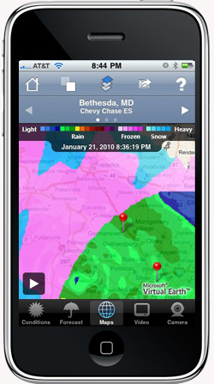
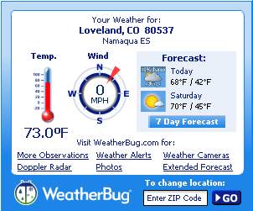
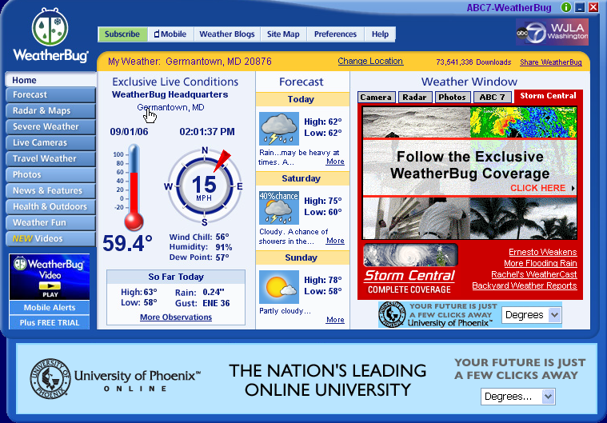

Figure 3 - Real-time WeatherBug Data on the Internet and Smartphones

  - A Valuable Community Resource-Broadcast Television Participation

Another innovative component of the WeatherBug Program is the participation by television broadcasters. Meteorologists from a television station in each area participate in the WeatherBug Program by routinely integrating data and high-definition imagery generated from local schools into the news weathercast by airing live, real-time weather conditions from neighborhood locations, like << school >>. The broadcast exposure increases the interest and enthusiasm of students, teachers, parents and the community at large.

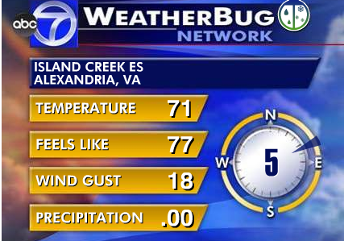


Figure 4 - Real-time weather display as seen on TV

The benefits of the WeatherBug Schools Program extend beyond the classroom. Weather impacts people’s lives on a daily basis, and the school’s WeatherBug Program will serve as the source for real-time local weather information for local TV.

In most situations large regional airports are the only public source of weather information. However, most people do not live in close proximity to the airport and often find that the airport conditions are not representative of weather conditions in their neighborhood. Accessible via the Internet and TV, the WeatherBug Schools Program is a reliable source for real-time, local weather conditions.

  - Increased Community Presence

A WeatherBug network school will be a very visible community resource, providing an opportunity to maximize public and community relations for any sponsor. In coordination with <<Insert Grant Name>>’s public relations staff, a press release can be issued upon initiation of the WeatherBug Program. A “kickoff” event can be organized and local press can be invited. The agenda will allow <<Insert Grant Name>> to address the participants.

6.0 Program Initiation and Implementation

Schools use a two-phased plan to implement the WeatherBug Schools Program.
- Installation of the hardware
- Professional development for teachers who will be using the program in their classrooms.

Support for all phases of implementation will be provided by expert WeatherBug staff.

6.1 Installation

Installation of the WeatherBug weather station and components can be provided by either the school or WeatherBug contractors. In either case, WeatherBug’s technical support team will test the system through remote communications to ensure that the system has been properly installed, calibrated and is fully operational. Following installation, technical support monitors every system around the clock.

6.2 Professional Development

Professional Development is of critical importance in achieving maximum use and only benefits the teachers and students that will use the WeatherBug Schools Program in the classroom. WeatherBug has significant experience in the development, coordination and execution of teacher training workshops. The training sessions will include: (1) system and software demonstration, (2) hands-on software training, and (3) curriculum applications and classroom implementation. The training session are held on the school site.

Additionally, WeatherBug will develop and maintain a school weather web page that will feature “live” data from the site and can be linked to all school, community and your company website.

6.3 Program Evaluation

Program evaluation is a critical step to ensure that the desired program goals are being achieved, including value in the classroom and community, and in terms of community relations. School staff can conduct an evaluation of the proposed WeatherBug Schools Program and provide a written summary of the results to your business.

The program assessment should be completed six months following program initiation and can document progress relating to system installation and initial integration into classroom curriculum.

6.4 Program Schedule

The following is the proposed project implementation schedule. Be assured that WeatherBug will continue to find new and innovative methods of integrating WeatherBug data into classroom curriculum year after year.

WeatherBug Achieve Software Implementation

Week 1: Lead Teacher Content and AYC Training
• The first week is a great time to log on and get to know WeatherBug Achieve and all the new features.
• Achieve has added special content just for Lead Teachers to help them become the school expert on the product.
• AYC Training sessions, prerecorded training, can be viewed at teachers’ convenience. They are in the
“Support” section of WeatherBug Achieve.

Week 2: Get the Word Out!
The more we get the word out, the more successful the WeatherBug Schools Program will be! There is a Word document version of a press release template included in the Lead Teacher Kit. It can be customized with school information and be included in as many communication vehicles as possible: local newspapers, morning announcements, school newsletters, PTA/PTO correspondence and of course the school and company sponsor websites!

Week 3: Professional Development for All Teachers
WeatherBug will host a hands-on, minds-on learning session for teachers at our school. Training will include:
• An overview of the program.
• Explanation of all features.
• Materials - “WeatherBug Achieve at Your Fingertips” User Manuals

Week 4: Start the Meteorologist of the Day Program
The Meteorologist of the Day program was designed to get teachers and students involved with WeatherBug Achieve right away. Soon, students will become weather experts giving daily forecasts for the school and teaching and learning every day.

Weeks 5-6: Follow-up Training
Now is the time to follow up with registered teachers, go over any AYC training sessions they have not seen and review the program answering any questions.

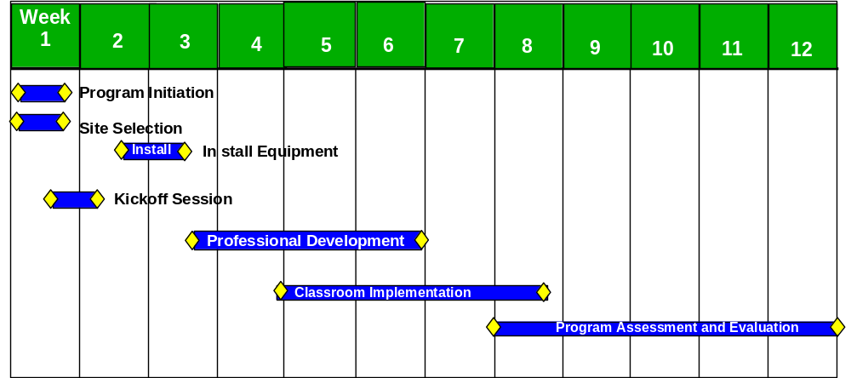
Note: This is a sample project calendar.

7.0 Costs

The program costs on the following page allow a school to participate in the WeatherBug Schools Program. Installation costs shown are for installation by WeatherBug contractors. Optionally, the weather station can be installed by the school facilities.

