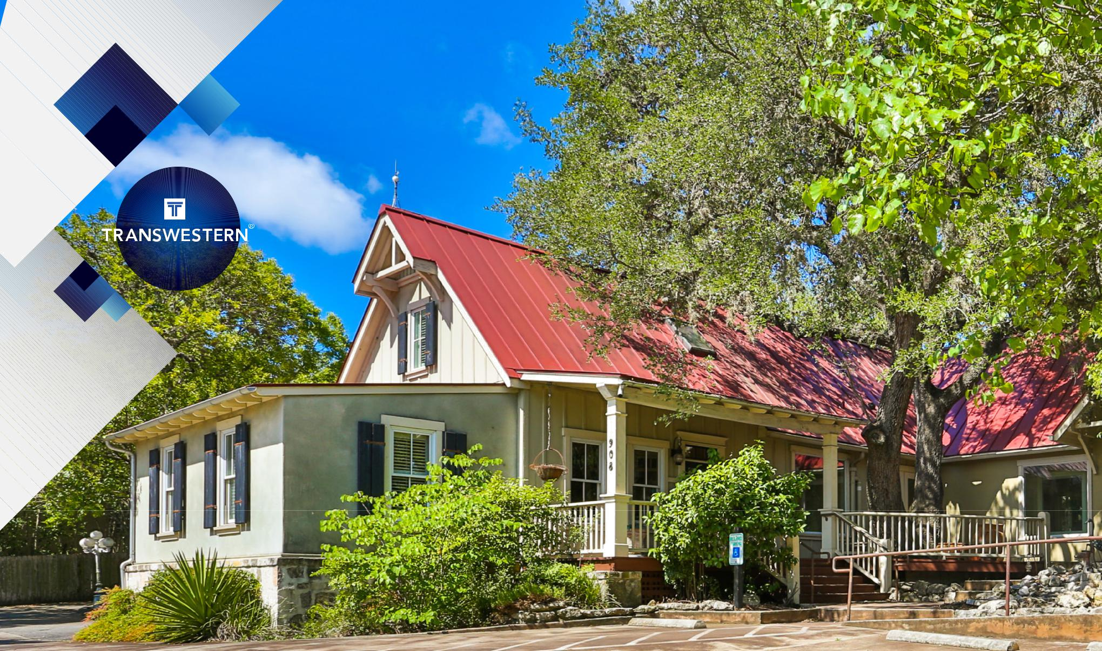

FOR SALE OR LEASE
908 S MAIN STREET | RUSSELL T. NOLL, CCIM, CPM®
BOERNE, TX 7806 | 210.253.2945 | russell.noll@transwestern.com

FOR SALE OR LEASE
908 S MAIN STREET

BOERNE, TX 7806
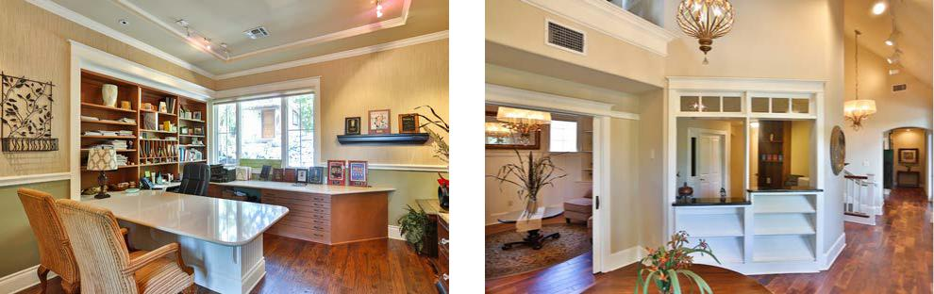

8200 IH-10 West


Suite 800

San Antonio, Texas 78230

- 210.341.1344 F 210.377.2797
www.transwestern.com
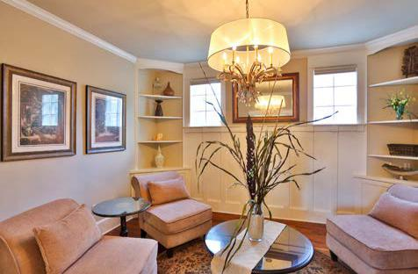

ABOUT THE PROPERTY

E

ADLER ROAD
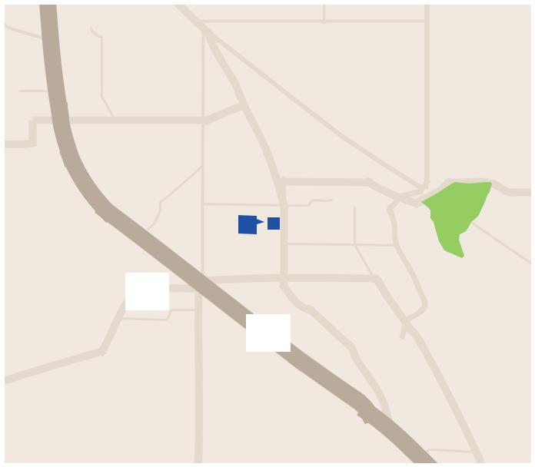

ROAD

High visibility on Main St | Main Building: 3,448± SF | Asking Price: $977,000
Recently renovated | Stand Alone Building: 400± SF | Quoted Rental Rate: $22.00 NNN
Flexible layout | Possible Leasing Income

JOHNS RD

BOERNE

SCHOOLSTREET

MAIN

STREET

HOSACK STREET

SITE

OLD | NUMBER 9
 | GREENWAY

RIVER ROAD

OAK PARK DRIVE

ESSER

HERFF PARK

CITY | PARK
 | R

Tranquil setting | Opportunity
Built in 2001

46 |  | BANDERA ROAD
 | ROAD | 10
 | BALCONES
 | UPPER

OLD

SAN

ANTONIO

ROAD

CONTACT INFORMATION

RUSSELL T. NOLL, CCIM, CPM ®

210.253.2945

russell.noll@transwestern.com

The information provided herein was obtained from sources believed reliable;

however, Transwestern makes no guarantees, warranties or representations as

to the completeness or accuracy thereof. The presentation of this property is

submitted subject to errors, omissions, change of price or conditions, prior sale or

lease, or withdrawal without notice. Copyright © 2019 Transwestern.

FOR SALE OR LEASE
908 S MAIN STREET

BOERNE, TX 7806

PROPERTY PHOTOS
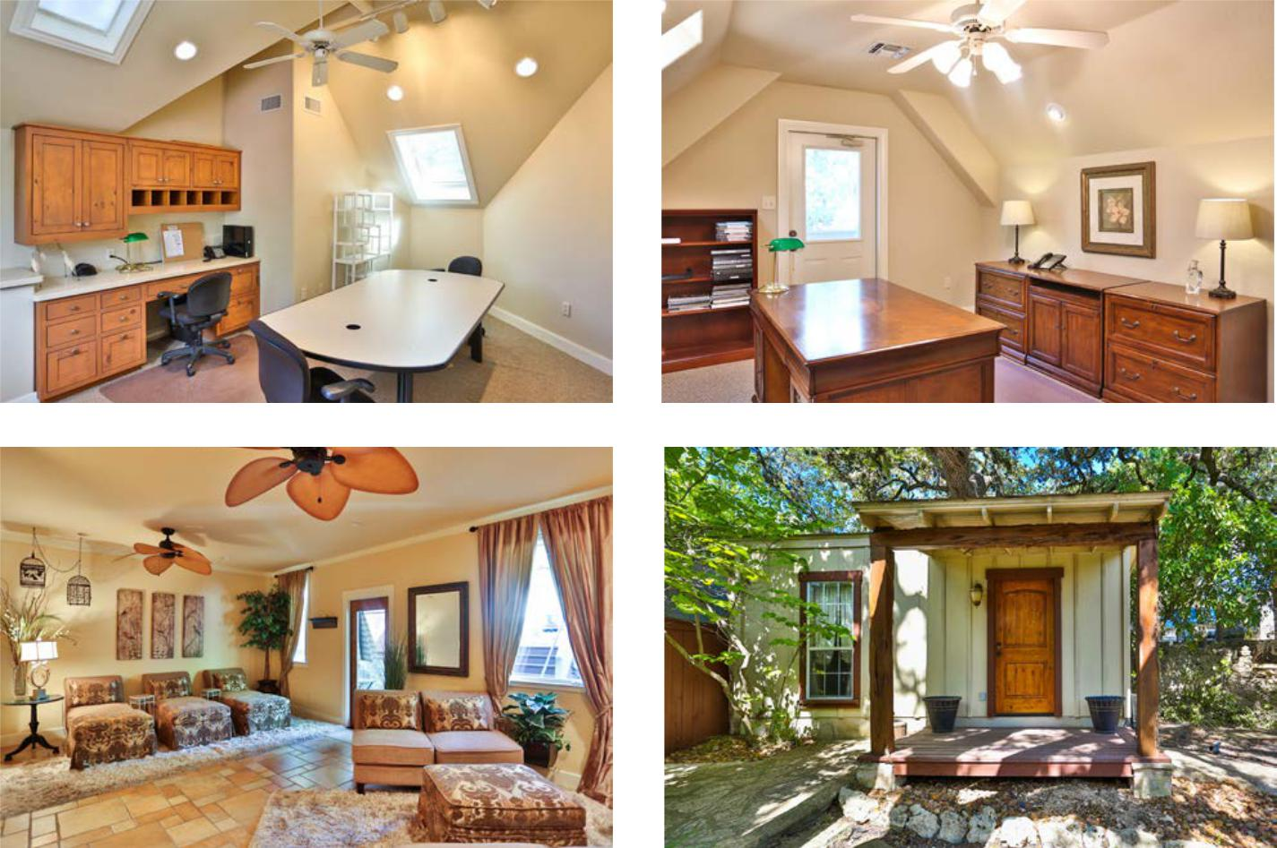

CONTACT INFORMATION

RUSSELL T. NOLL, CCIM, CPM ®

210.253.2945

russell.noll@transwestern.com

8200 IH-10 West

Suite 800

San Antonio, Texas 78230

T 210.341.1344

F 210.377.2797

www.transwestern.com
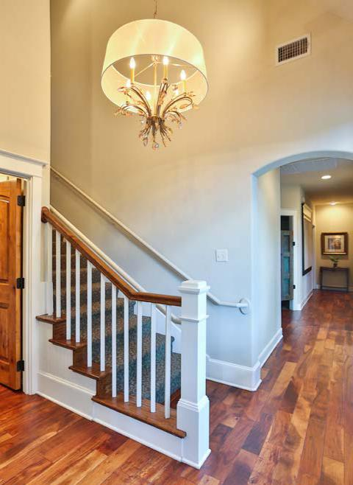

The information provided herein was obtained from sources believed reliable; however, Transwestern makes no guarantees, warranties or representations as to the completeness or accuracy thereof. The presentation of this property is

submitted subject to errors, omissions, change of price or conditions, prior sale or lease, or withdrawal without notice. Copyright © 2019 Transwestern.
FOR SALE OR LEASE | CONTACT INFORMATION
908 S MAIN STREET | CONTACT INFORMATION
908 S MAIN STREET | 210.253.2945
 | RUSSELL T. NOLL, CCIM, CPM ®
BOERNE, TX 7806 | russell.noll@transwestern.com

FLOOR PLAN
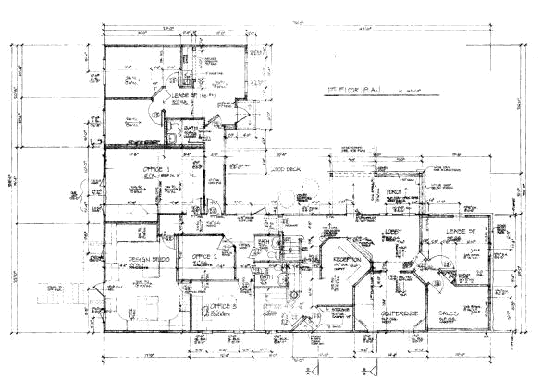


The information provided herein was obtained from sources believed reliable; however, Transwestern makes no guarantees, warranties or representations as to the completeness or accuracy thereof.


The presentation of this property is submitted subject to errors, omissions, change of price or conditions, prior sale or lease, or withdrawal without notice. Copyright © 2019 Transwestern.

FOR SALE OR LEASE | CONTACT INFORMATION
908 S MAIN STREET | CONTACT INFORMATION
908 S MAIN STREET | 210.253.2945
 | RUSSELL T. NOLL, CCIM, CPM ®
BOERNE, TX 7806 | russell.noll@transwestern.com

SITE PLAN
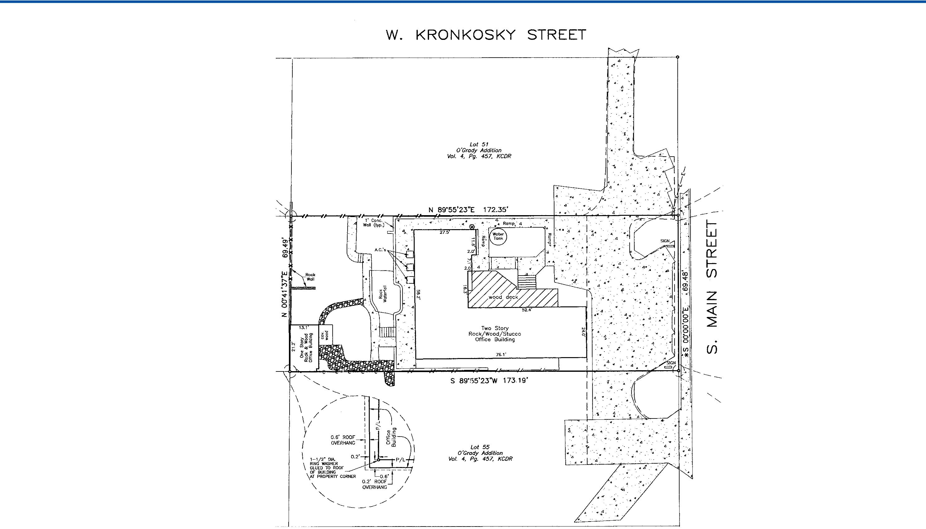

The information provided herein was obtained from sources believed reliable; however, Transwestern makes no guarantees, warranties or representations as to the completeness or accuracy thereof.


The presentation of this property is submitted subject to errors, omissions, change of price or conditions, prior sale or lease, or withdrawal without notice. Copyright © 2019 Transwestern.

FOR SALE OR LEASE
908 S MAIN STREET

BOERNE, TX 7806

AERIAL
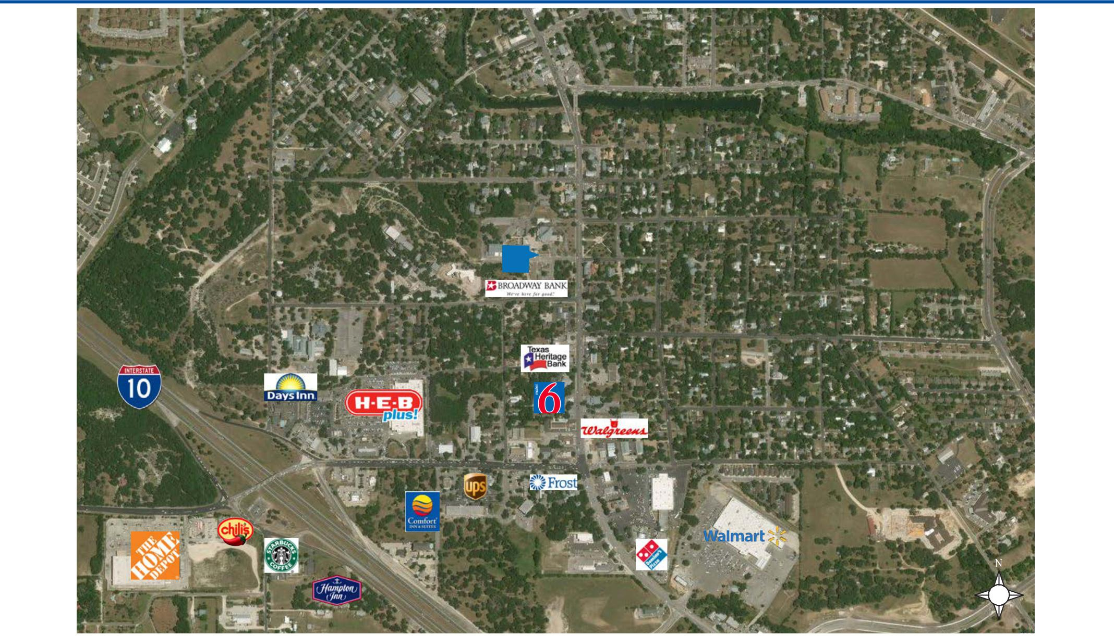

RIVER RD

S | W HOSACK ST
STSCHOOL |  |  |  |  | STMAINS
 |  |  |  |  | HICKMAN ST
 |  | SITE
 | W HIGHLANDDR
 |  |  |  |  | OAK
 |  |  |  |  | PARK DR
 | BESS ST
 |  |  |  |  | ROOSEVELT AVE
 | BANDERA RD

CONTACT INFORMATION

RUSSELL T. NOLL, CCIM, CPM ®

210.253.2945

russell.noll@transwestern.com

F
R
EY
S
T

The information provided herein was obtained from sources believed reliable; however, Transwestern makes no guarantees, warranties or representations as to the completeness or accuracy thereof.

The presentation of this property is submitted subject to errors, omissions, change of price or conditions, prior sale or lease, or withdrawal without notice. Copyright © 2019 Transwestern.

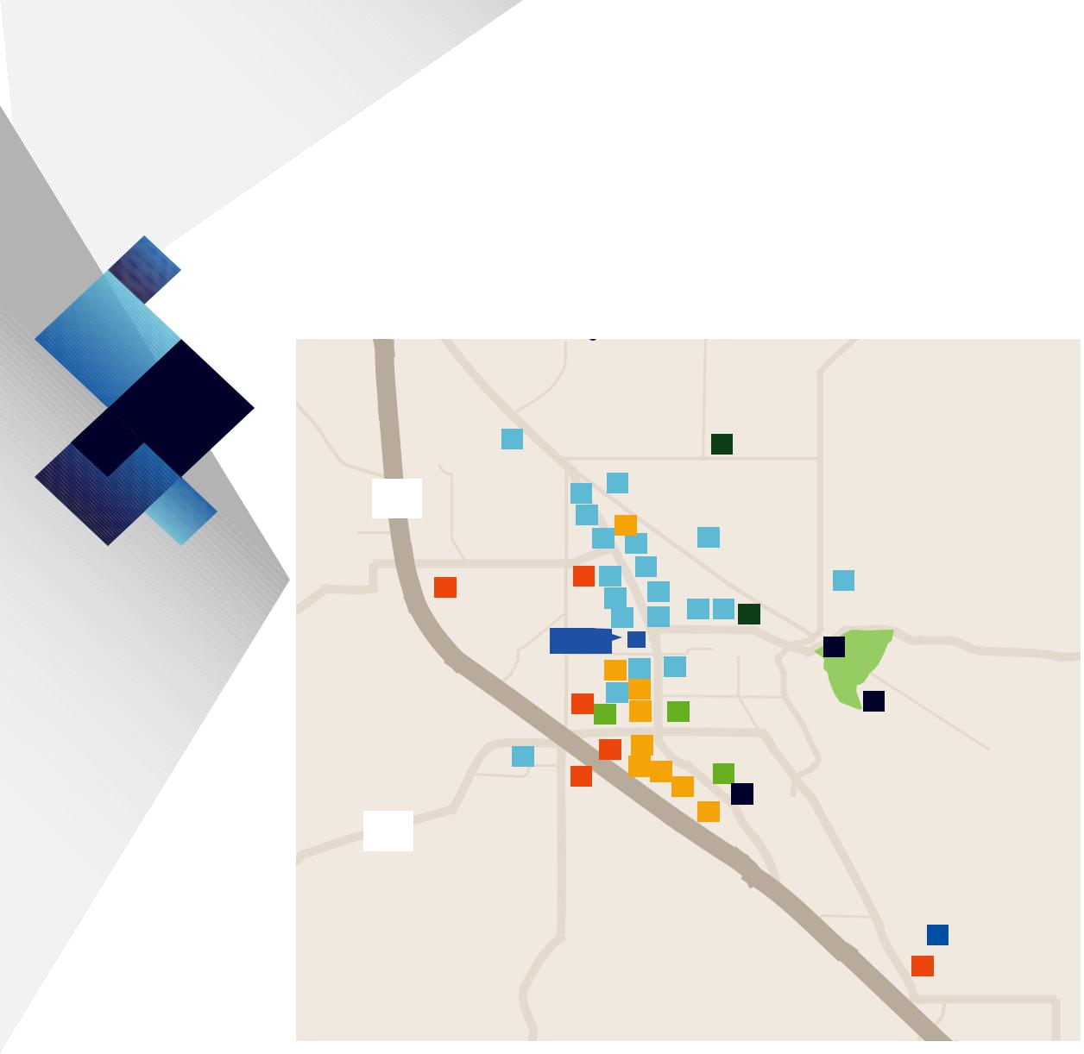
FOR SALE OR LEASE
908 S MAIN STREET

BOERNE, TX 7806

AMENITIES MAP

RANGER

DRIVE

10

46

 | ROAD | 1376 | ROAD
RANCH | ROAD |  | TOPPERWEIN

1 |  |  |  |  |  |  |  | 39
 |  |  | ADLER ROAD |  |  |  |  | 39
 |  | 2 | 19
 |  | 2 | OLD
 | STREET |  | OLD |  |  |  | 6
 | STREET | 3 | 4 33NUMBER9 |  |  |  | 6
 |  | 3 |  |  | GREENWAY
 | SCHOOL |  | MAIN | 7
 | SCHOOL | 25 | MAIN
 | SCHOOL | 25 | 5STREET
24 BOERNE |  |  |  | 9
24 BOERNE |  |  | 8 |  | 10
 |  |  | 8 |  |  | 13 |  | 14 | 40
 |  |  | 12 |  | 11 |  |  | 14 | 40
 |  |  | 12 |  | 11 | RIVER ROAD
 | SITE
 |  | HOSACK STREET |  |  | 16
 |  |  | 35 | 18
 |  | 23 | 17 ³⁰ |  |  | OAK PARK DRIVE
 |  | 23 | 27 | 32 |  | 29
 |  |  | BANDERA ROAD
20 |  |  | 22 | 31
20 |  |  |  | 38 ₃₇
 |  | 21 |  |  |  | 36 |  | 28
 |  |  |  |  |  | 36 |  |  | 43
ROAD |  |  |  |  |  |  | 34
BALCONES
UPPER

ROAD

ESSER

15

44

HERFF PARK

42 | CITY | PARK
42 |  | PARK | ROAD

OLD

SAN

ANTONIO

ROAD

41

26

CASCADE CAVERNS

DINING GROCERY & PHARMACY

1 Broken Stone Pizza 27 HEB Plus

2 Magues Café 28 Walgreens

3 Fritze’s BBQ & Catering 29 Walmart

4 Bella Sera

5 Peggy’s on the Green BANKING

6 Mary’s Tacos 30 Texas Heritage Bank

7 Soda Pops Partio Grill & Bar 31 Frost Bank

8 Cypress Grille 32 Sonora Bank

9 The Daily Grind 33 Jefferson Bank

10 259 Brantley’s Bistro 34 BBVA Compass

11 Bear Mood Bakery and Café 35 Broadway Bank

12 The Creek Restaurant 36 Randolph Brooks Federal

13 The Dodging Duck Credit Union

14 Little Gretel 37 Frost (ATM)

15 Longhorn Café 38 Wells Fargo (ATM)

16 La Mansion FITNESS CENTERS

17 Guadalajara Mexican Grill 39 YMCA

18 Cibolo Creek Brewing Co 40 Anytime Fitness

19 Hungry horse

20 Chili’s ENTERTAINMENT

41 Starplex Cinemas

LODGING POINTS OF INTEREST

21 Hampton Inn & Suites 42 Cibolo Nature Center

22 Comfort Inn & Suites 43 Convention Center

23 Americas Best Value Inn 44 Agricultural Heritage

24 La Quinta Inn & Suites Museum

25 Ye Kendall inn

26 Fairfield Inn & Suites

The information provided herein was obtained from sources believed reliable; however, Transwestern makes no guarantees, warranties or representations as to the completeness or accuracy thereof.

The presentation of this property is submitted subject to errors, omissions, change of price or conditions, prior sale or lease, or withdrawal without notice. Copyright © 2019 Transwestern.

11-2-2015

Information About Brokerage Services

Texas law requires all real estate license holders to give the following informaƟon about
brokerage services to prospecƟve buyers, tenants, sellers and landlords.

TYPES OF REAL ESTATE LICENSE HOLDERS: |  | .
• | A BROKER is responsible for all brokerage acƟviƟes, including acts performed by sales agents sponsored by the broker.
• | A SALES AGENT must be sponsored by a broker and works with clients on behalf of the broker.

A BROKER’S MINIMUM DUTIES REQUIRED BY LAW (A client is the person or party that the broker represents):
- Put the interests of the client above all others, including the broker’s own interests;
- Inform the client of any material informaƟon about the property or transacƟon received by the broker;
- Answer the client’s quesƟons and present any oīer to or counter-oīer from the client; and
- Treat all parƟes to a real estate transacƟon honestly and fairly.

A LICENSE HOLDER CAN REPRESENT A PARTY IN A REAL ESTATE TRANSACTION:

AS AGENT FOR OWNER (SELLER/LANDLORD): The broker becomes the property owner's agent through an agreement with the owner, usually in a wriƩ en lisƟng to sell or property management agreement. An owner's agent must perform the broker’s minimum duƟes above and must inform the owner of any material informaƟon about the property or transacƟon known by the agent, including informaƟon disclosed to the agent or subagent by the buyer or buyer’s agent.

AS AGENT FOR BUYER/TENANT: The broker becomes the buyer/tenant's agent by agreeing to represent the buyer, usually through a wriƩen representaƟon agreement. A buyer's agent must perform the broker’s minimum duƟes above and must inform the buyer of any material informaƟon about the property or transacƟon known by the agent, including informaƟon disclosed to the agent by the seller or seller’s agent.

AS AGENT FOR BOTH - INTERMEDIARY: To act as an intermediary between the parƟes the broker must Įrst obtain the wriƩ en agreement of each party to the transacƟon. The wriƩen agreement must state who will pay the broker and, in conspicuous bold or
underlined print, set forth the broker's obligaƟons as an intermediary. A broker who acts as an intermediary:
- Must treat all parƟes to the transacƟon imparƟally and fairly;
- May, with the parƟes' wriƩen consent, appoint a diīerent license holder associated with the broker to each party (owner and buyer) to communicate with, provide opinions and advice to, and carry out the instrucƟons of each party to the transacƟon.

- Must not, unless speciĮcally authorized in wriƟng to do so by the party, disclose:
  - that the owner will accept a price less than the wriƩen asking price;
  - that the buyer/tenant will pay a price greater than the price submiƩed in a wriƩen oīer; and
  - any conĮdenƟal informaƟon or any other informaƟon that a party speciĮcally instructs the broker in wriƟng not to disclose, unless required to do so by law.

AS SUBAGENT: A license holder acts as a subagent when aiding a buyer in a transacƟon without an agreement to represent the buyer. A subagent can assist the buyer but does not represent the buyer and must place the interests of the owner Įrst.

TO AVOID DISPUTES, ALL AGREEMENTS BETWEEN YOU AND A BROKER SHOULD BE IN WRITING AND CLEARLY ESTABLISH:
- The broker’s duƟes and responsibiliƟes to you, and your obligaƟons under the representaƟon agreement.
- Who will pay the broker for services provided to you, when payment will be made and how the payment will be calculated.

LICENSE HOLDER CONTACT INFORMATION: This noƟce is being provided for informaƟon purposes. It does not create an obligaƟon for you to use the broker’s services. Please acknowledge receipt of this noƟce below and retain a copy for your records.

 | Transwestern Property Company SW GP LLC |  |  | 466196 |  |  |  |  |  |  |  |  |  |  |  |  |  |  |  |  |  | 210-341-1344
 | Licensed Broker /Broker Firm Name or |  |  |  |  |  |  |  |  |  |  | License No. |  |  |  |  |  |  |  |  | Email |  |  |  |  |  |  |  |  |  | Phone
 | Primary Assumed Business Name
 | Steve Ash |  |  | 392519 |  |  |  |  |  |  |  |  |  |  |  |  |  |  | steve.ash@transwestern.com 713-270-7700
 | Designated Broker of Firm |  |  |  |  |  |  |  |  |  |  | License No. |  |  |  |  |  |  |  |  | Email |  |  |  |  |  |  |  |  |  | Phone
 | Leah Gallagher |  |  | 526657 |  |  |  |  |  |  |  |  |  |  |  |  |  |  | leah.gallagher@transwestern.com 210-341-1344
 | Licensed Supervisor of Sales Agent/ |  |  |  |  |  |  |  |  |  |  | License No. |  |  |  |  |  |  |  |  | Email |  |  |  |  |  |  |  |  |  | Phone
 | Associate |  |  | 386386 |  |  |  |  |  |  |  |  |  |  |  |  |  |  | russell.noll@transwestern.com 210-341-1344
 | Russell Noll
 | Sales Agent/Associate’s Name |  |  |  |  |  |  |  |  |  |  | License No. |  |  |  |  |  |  |  |  | Email |  |  |  |  |  |  |  |  |  | Phone
 |  | Buyer/Tenant/Seller/Landlord Initials |  |  |  |  |  |  |  |  |  |  |  |  |  |  |  |  |  |  |  | Date
 | Regulated by the Texas Real Estate Commission |  |  |  |  |  |  |  |  |  |  |  |  |  |  |  |  |  |  |  |  | InformaƟon available at www.trec.texas.gov

IABS 1-0

