
FOR SALE

3432 to 3434 SW Kelly Street Portland, Oregon 97239

THE NATIONAL HISTORIC MILTON W. SMITH MANSION

INVESTMENT OR RESIDENTIAL POTENTIAL
$1,200,000


MELE
TAYLOR
WESTERDAHL

REAL ESTATE

308 SW First Avenue
Portland, OR 97204

FAX: (503) 223-7615

223-2588

CURRENTLY OCCUPIED BY A GROUP OF MEDICAL PROFESSIONALS PLEASE DO NOT DISTURB EXISTING TENANTS
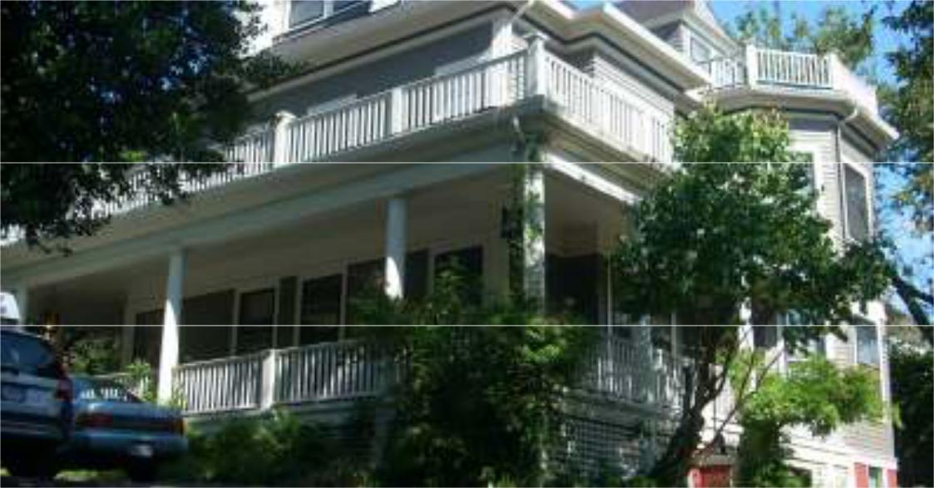

On the registry of National Historic Places, this mansion built in 1890 is an example of the “Colonial Revival” in the same taste and design as the nationally famous “Newport Houses” of the east coast. Architect: William M. Whidden of Whidden & Lewis, the most significant architectural firm of the era. Sited on 10,000 sf of land.

- Eight + offices available

- Features include six fireplaces, many with original mill work and tile hearths.

- Seven on-site parking spaces.

- Conveniently located in the South Portland Historic District in the Laird Hill Neighborhood with great access to freeways, walking distance to South Waterfront area and OHSU.

- Property is zoned R2, a multifamily zone with a conditional use as professional related offices.

County Assessor’s Records: |  | Assessed Valuation/Taxes:
First and second floors: | 3,350 sf | Market Value: | $ | 1,152,270.00
Basement (two apartments): | 1,675 sf | 2013-2014 Taxes: | $ | 15,495.00
Total per Assessor: | 5,025 sf
Attic information by Seller | 750 sf
not included in County Records:


Experience. Integrity. Results. Serving the Pacific Northwest for over 30 years!

Don Mele, Principal Broker
Office: (503) 223-2588
Cell: (503) 778-1178
Fax: (503) 223-7615
Email: DON@MTWRE.COM

Information regarding this property has either been supplied to our firm by the owner of the property or obtained from sources deemed reliable. A prospective Purchaser/Tenant is expected to verify the above information.

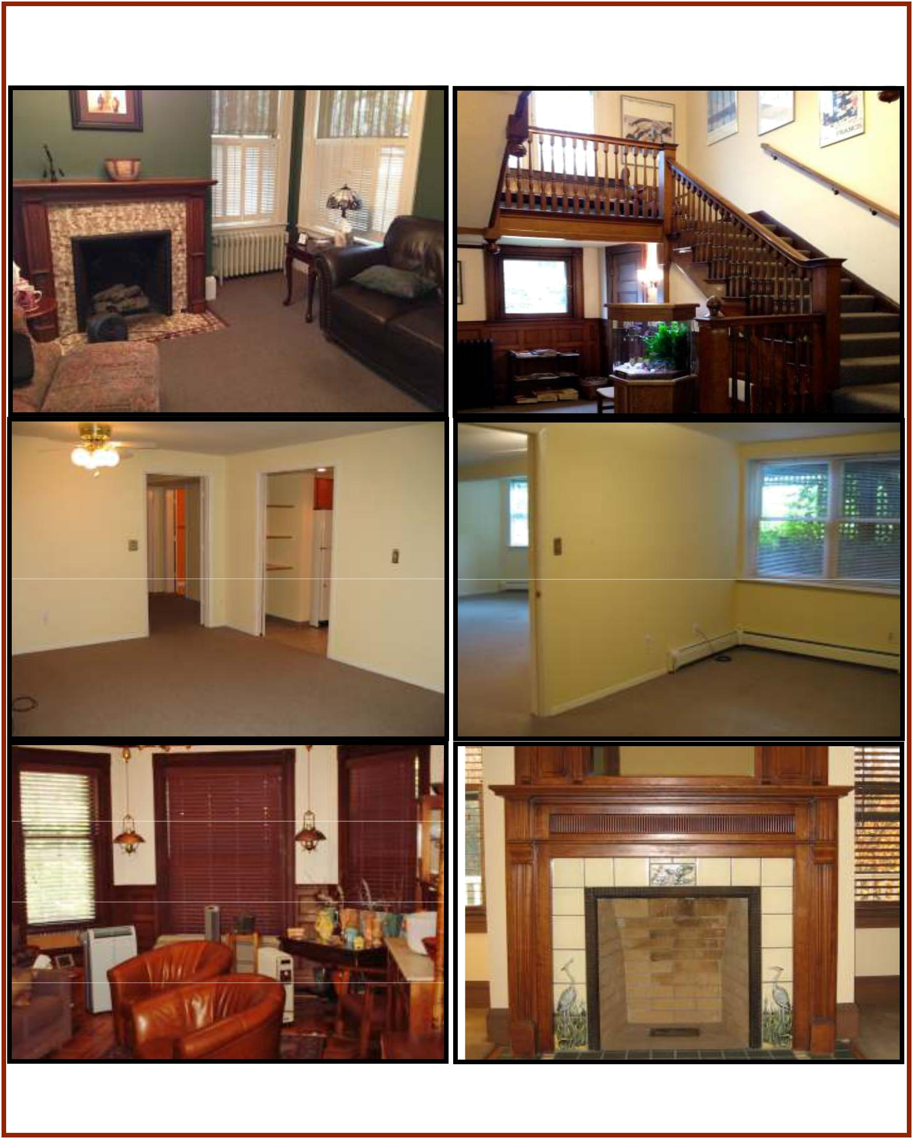

Information regarding this property has either been supplied to our firm by the owner of the property or obtained from sources deemed reliable. A prospective Purchaser/Tenant is expected to verify the above information.
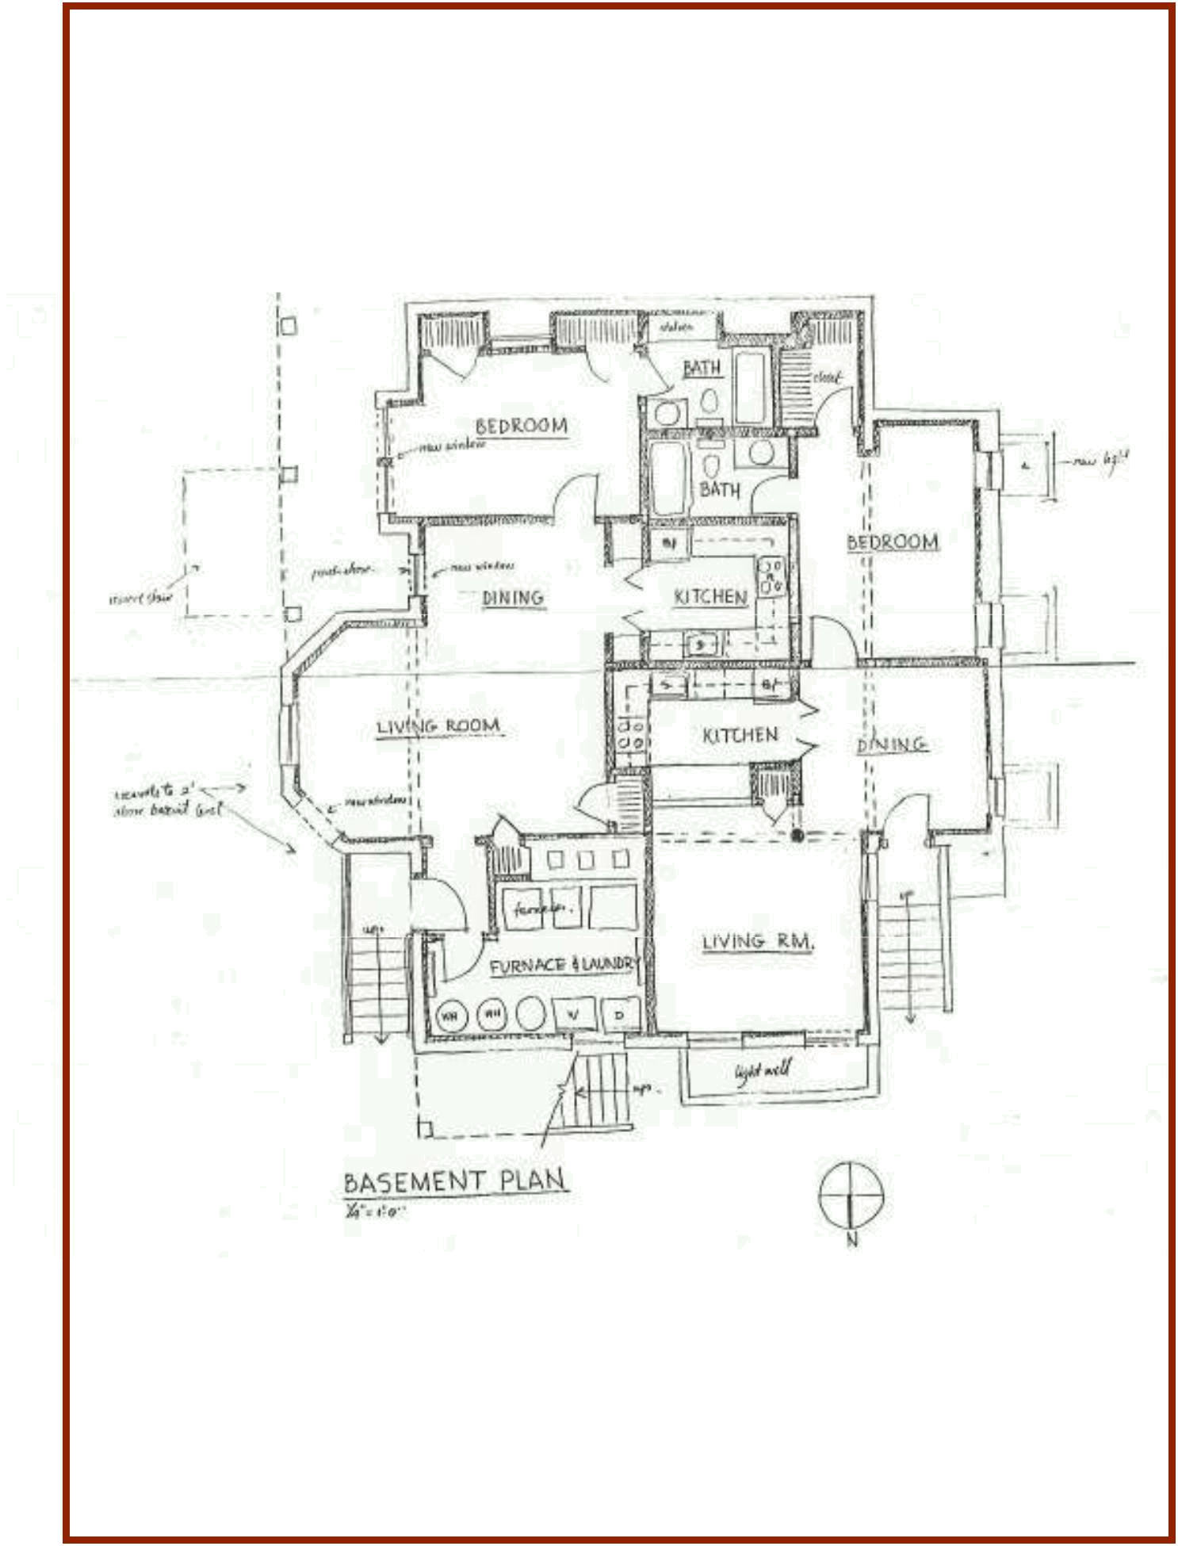

Basement

Floor Plan

Information regarding this property has either been supplied to our firm by the owner of the property or obtained from sources deemed reliable. A prospective Purchaser/Tenant is expected to verify the above information.
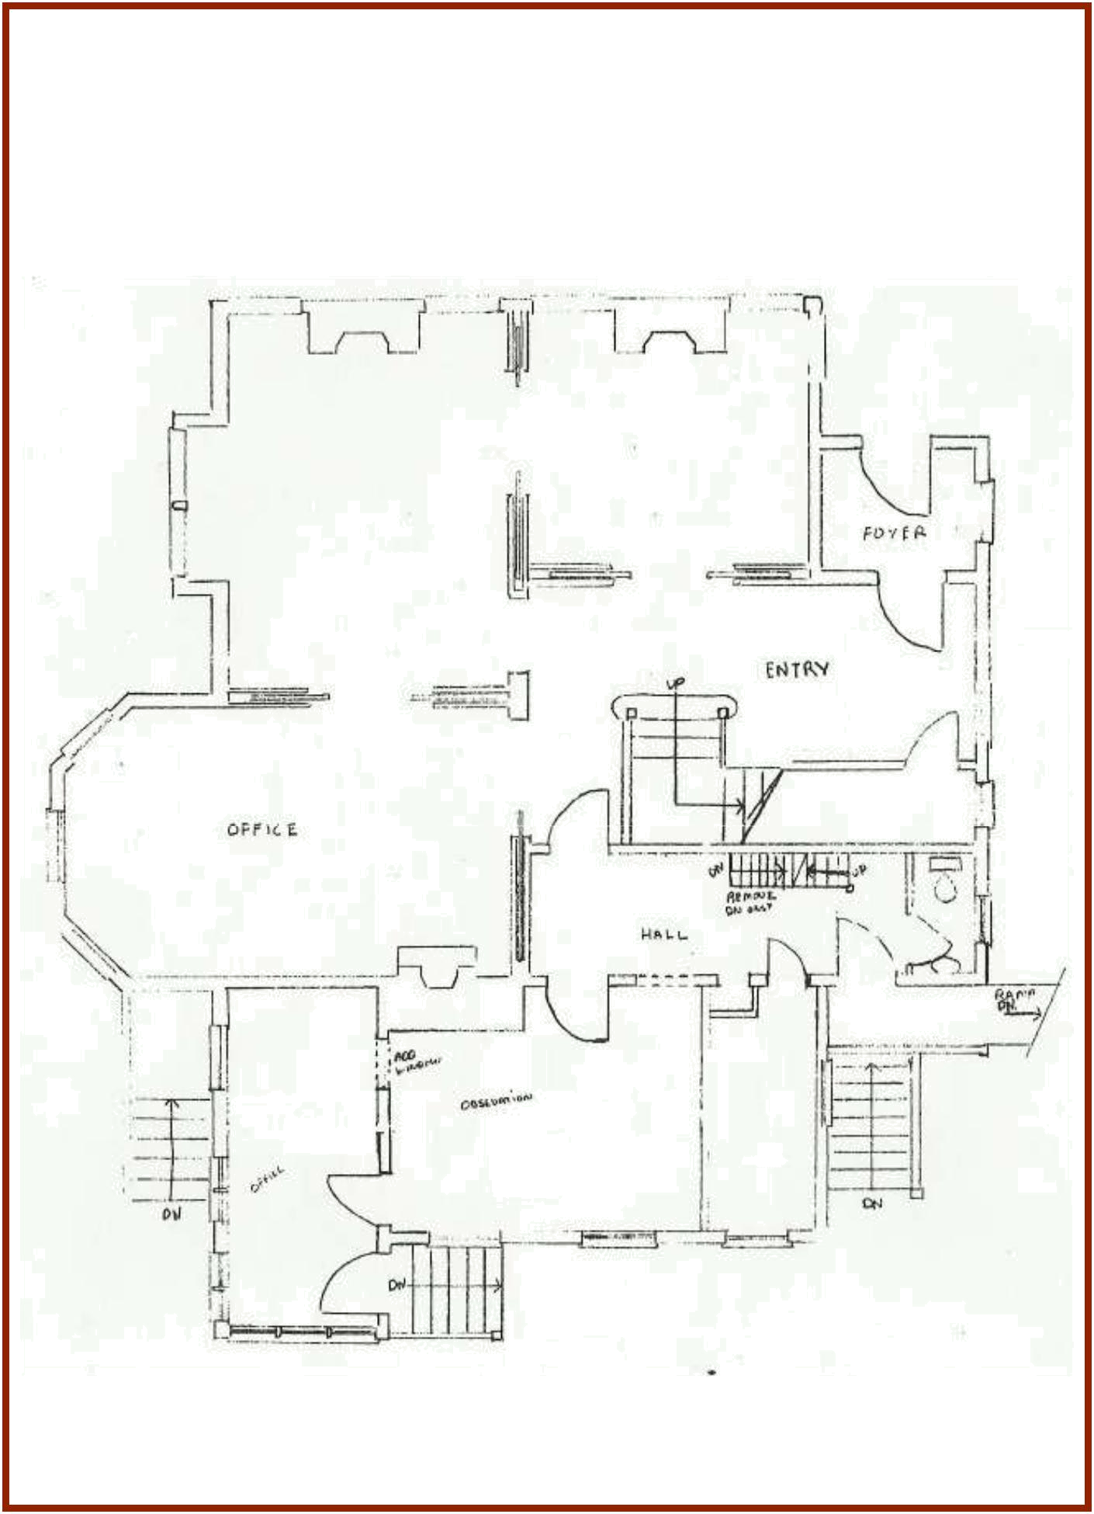

First Floor

Floor Plan

Information regarding this property has either been supplied to our firm by the owner of the property or obtained from sources deemed reliable. A prospective Purchaser/Tenant is expected to verify the above information.
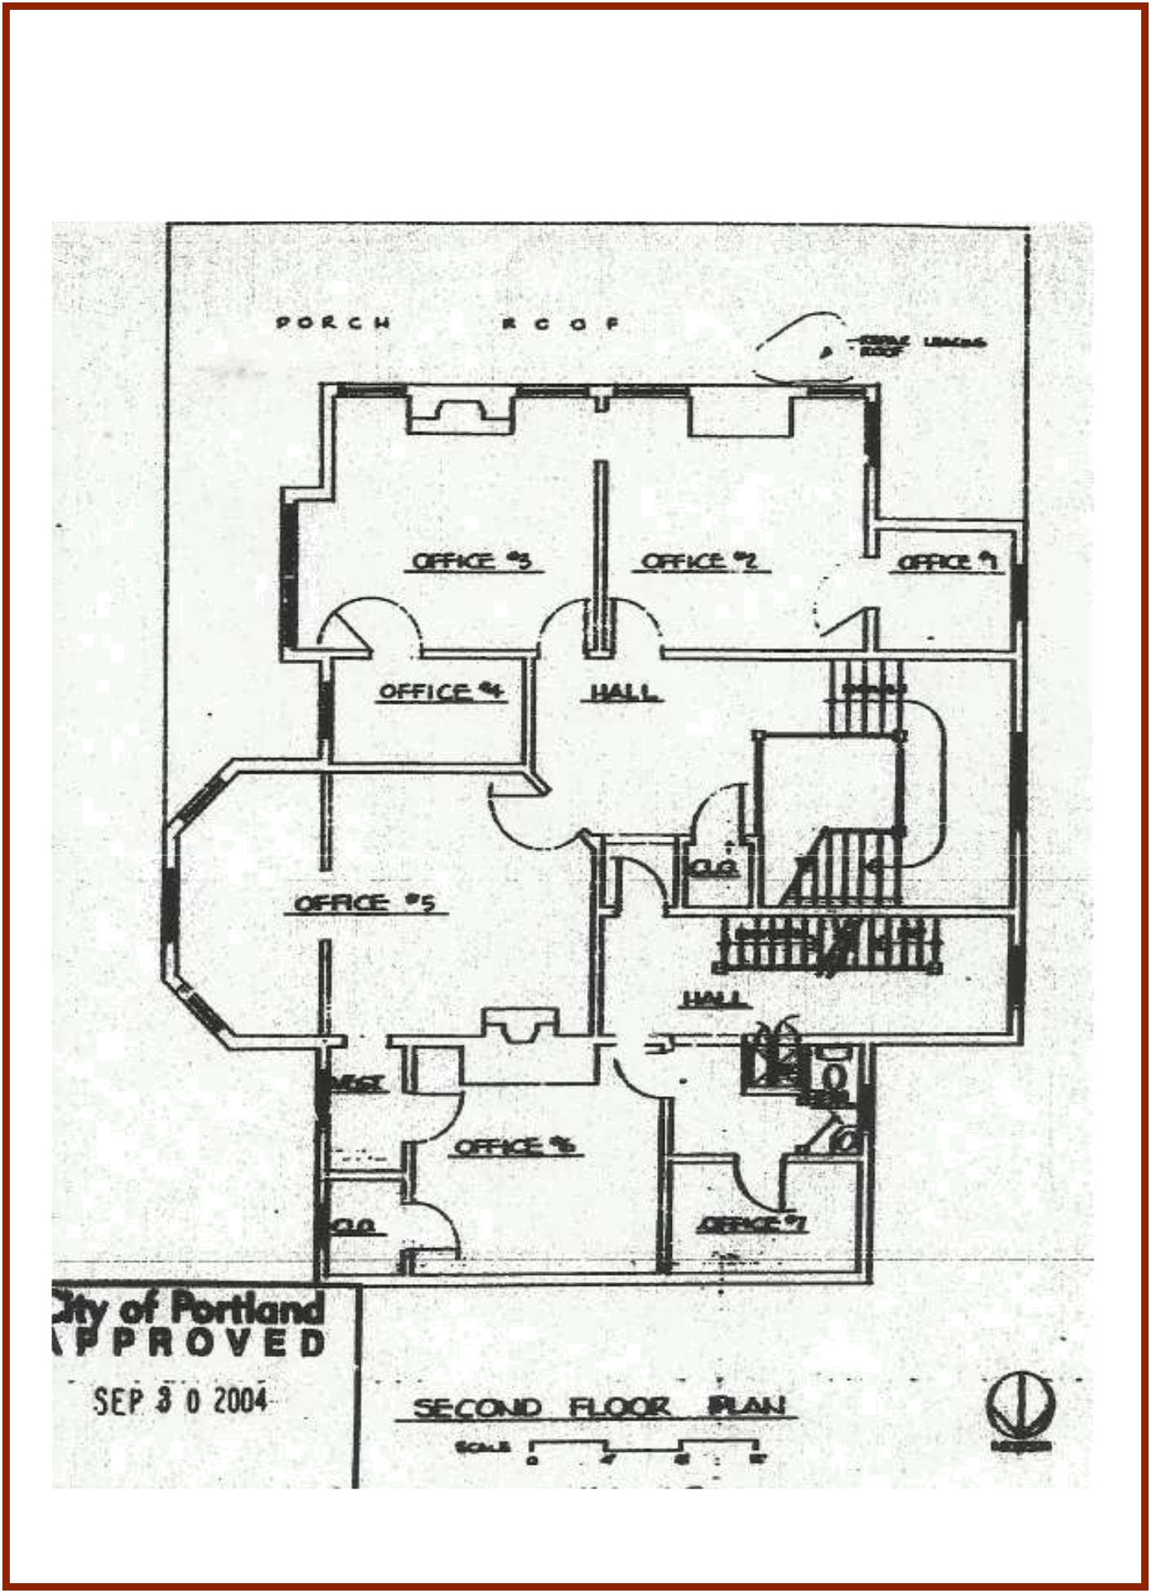

Second Floor

Floor Plan

Information regarding this property has either been supplied to our firm by the owner of the property or obtained from sources deemed reliable. A prospective Purchaser/Tenant is expected to verify the above information.
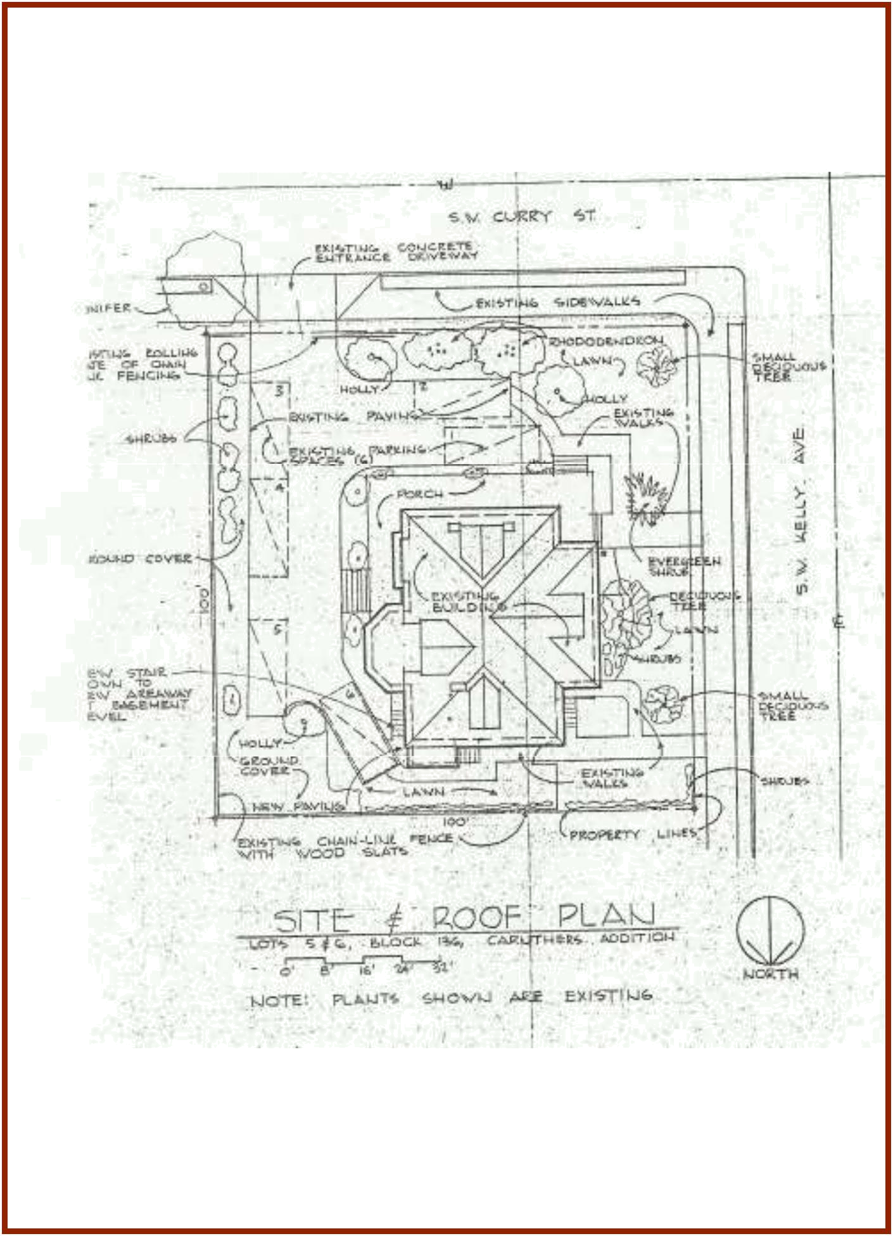

Site & Roof

Floor Plan

Information regarding this property has either been supplied to our firm by the owner of the property or obtained from sources deemed reliable. A prospective Purchaser/Tenant is expected to verify the above information.
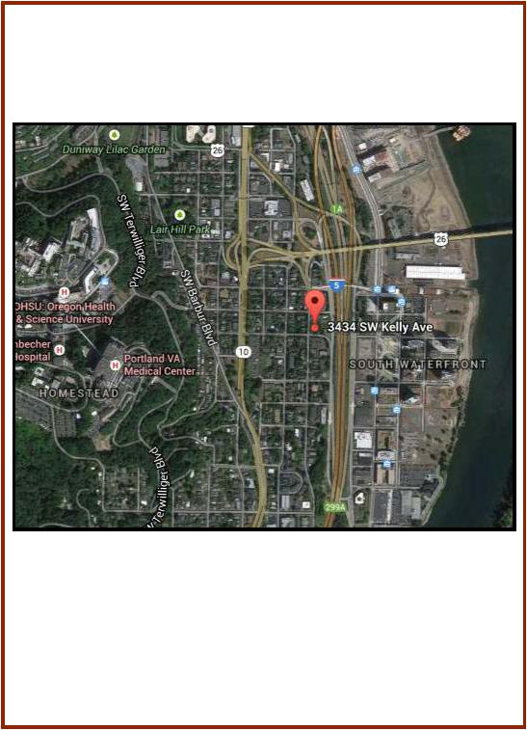
3434 SW Kelly Avenue

Portland, Oregon

Information regarding this property has either been supplied to our firm by the owner of the property or obtained from sources deemed reliable. A prospective Purchaser/Tenant is expected to verify the above information.

