OFFERED FOR SALE

For more

information

or to

schedule

- showing please contact Tony Utter,

Calvin Klaassen

or Rod Stewart.

Updated 5/2018

THE AMIDON HOUSE
A Prestigious Landmark in the Midtown Neighborhood

BUILDING ADDRESS
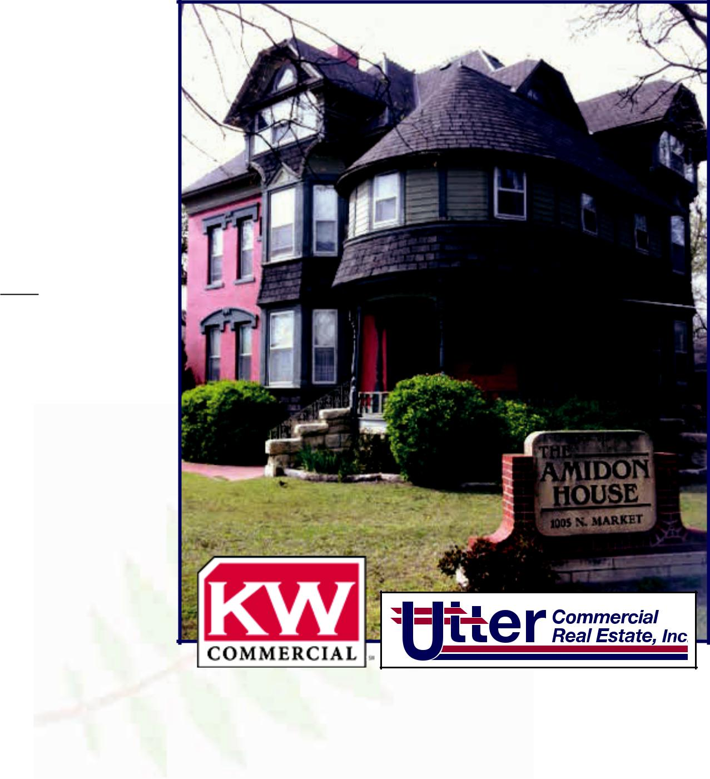

1OO5 N. Market (North of downtown)

SIZE

Bldg: Approx. 3,440 sq. ft.

Site: 16,135 sq. ft.

BUILT

Late 1880s

2017 REAL ESTATE TAXES $4,196.11 general
5.58 special

$4,201.69

SALE PRICE

$275,000

LEGAL DESCRIPTION

Lot 1 The Amidon

House Addition

FLOOR PLAN

- Up to twelve offices with secretarial areas

- Reception area

• Conference room

• Break room / work area

• Storage and file space

COMMENTS & FEATURES

- Enclosed, covered four-car garage and on-site surface parking

- Historic mansion converted to professional offices since 1977

- Beautiful hardwood floors, stained glass windows, leaded glass, carved woodwork, multiple fireplaces

- Attention to detail not found in contemporary, modern offices

Tony Utter, CCIM, JD | Calvin Klaassen | Rod M. Stewart, SEC
tony@utterproperties.com | calvin@utterproperties.com | rstewartrealtor@sbcglobal.net
316.263.2448 office | 316.263.2448 office | 316.651.0041 office
316.990.8710 cell | 316.641.5174 cell | 316.992.5246 cell
316.263.2845 fax | 316.263.2845 fax | 316.681.3606 fax

The information contained herein was obtained from sources believed reliable, however, Utter Commercial Real Estate, Inc. and KW Commercial make no guarantees, warranties or representations as to the completeness or accuracy thereof. The presentation of this property is submitted subject to errors, omissions, change of price or conditions prior to sale or lease, or withdrawal without notice.

Amidon House / Interior
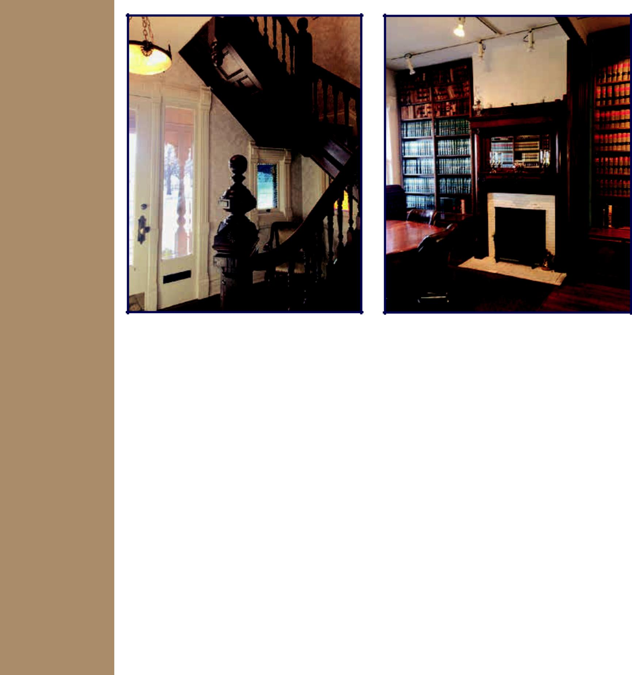

For more

information

or to

schedule

- showing please contact Tony Utter,

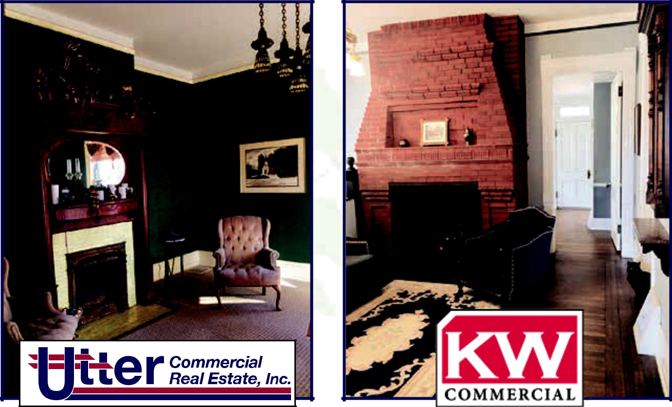
Calvin Klaassen or Rod Stewart.

 | Tony Utter, CCIM, JD | Calvin Klaassen | Rod M. Stewart, SEC
 | tony@utterproperties.com | calvin@utterproperties.com | rstewartrealtor@sbcglobal.net
 | 316.263.2448 office | 316.263.2448 office | 316.651.0041 office
 | 316.990.8710 cell | 316.641.5174 cell | 316.992.5246 cell
 | 316.263.2845 fax | 316.263.2845 fax | 316.681.3606 fax

Amidon House / Interior
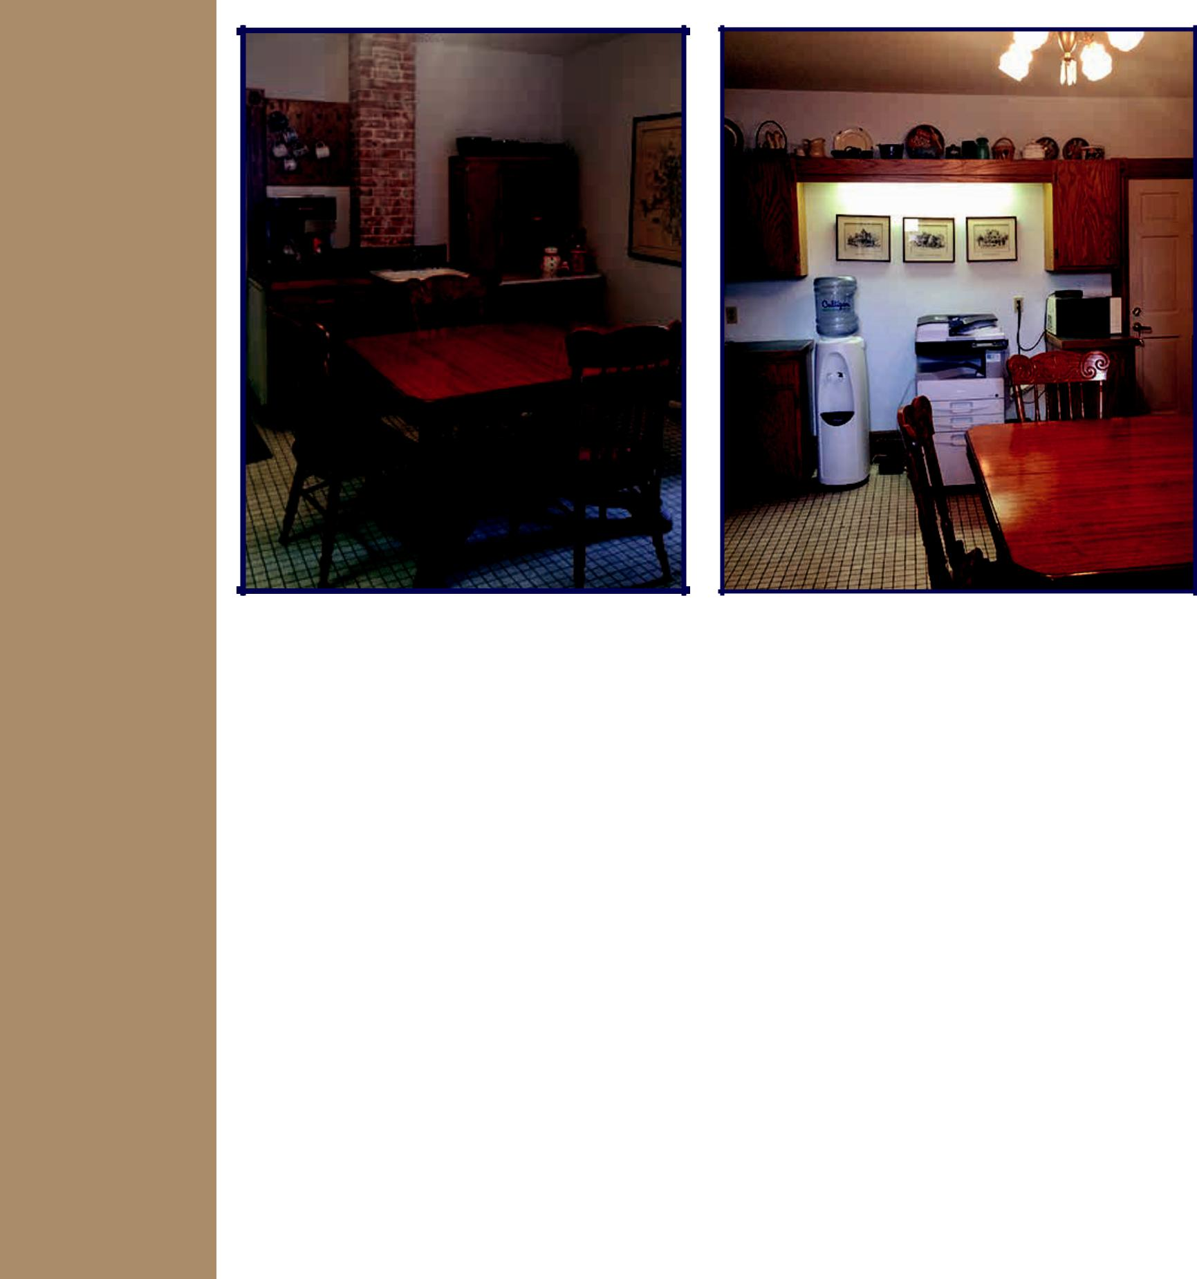

For more

information

or to

schedule

- showing please contact Tony Utter,

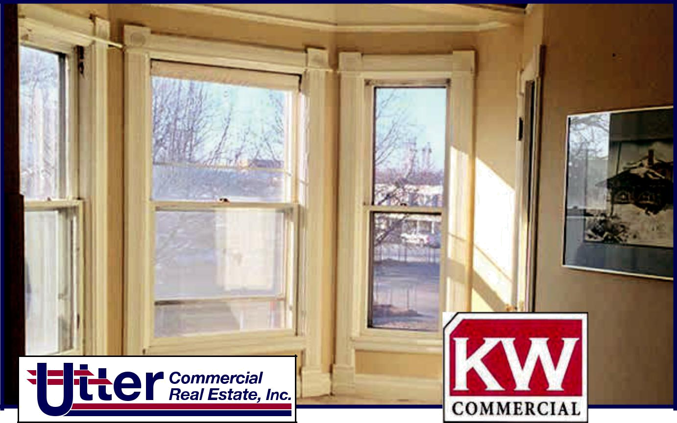
Calvin Klaassen or Rod Stewart.

 | Tony Utter, CCIM, JD | Calvin Klaassen | Rod M. Stewart, SEC
 | tony@utterproperties.com | calvin@utterproperties.com | rstewartrealtor@sbcglobal.net
 | 316.263.2448 office | 316.263.2448 office | 316.651.0041 office
 | 316.990.8710 cell | 316.641.5174 cell | 316.992.5246 cell
 | 316.263.2845 fax | 316.263.2845 fax | 316.681.3606 fax

Amidon House / Aerial
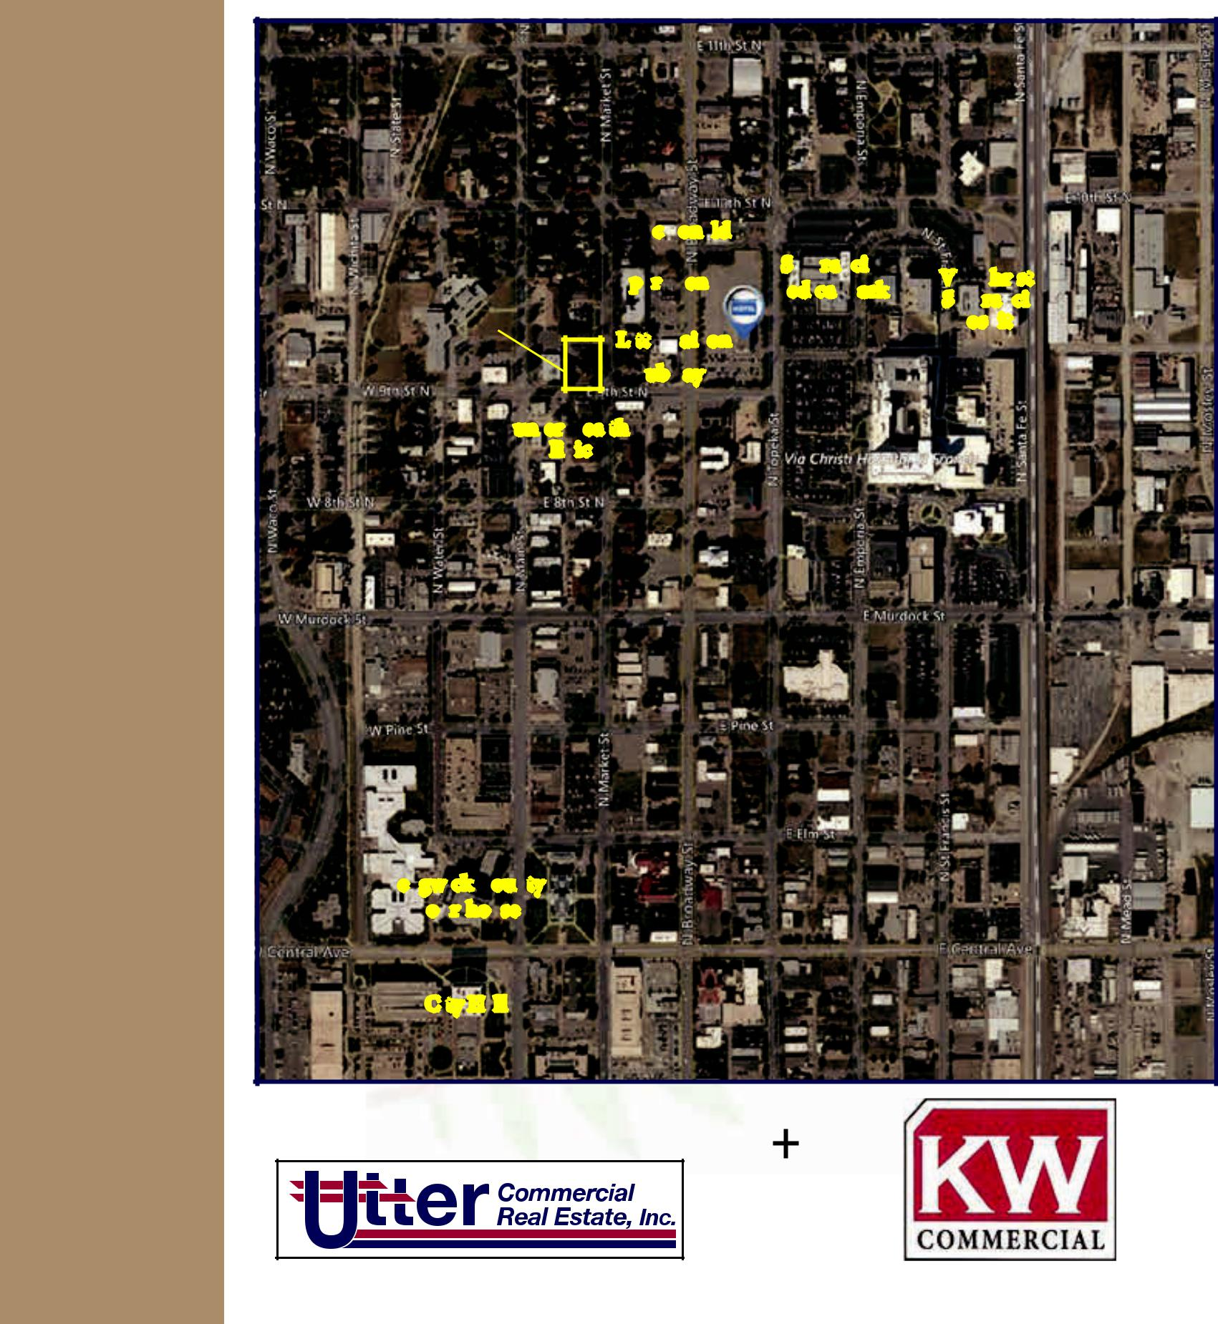

For more

information

or to

schedule

- showing please contact Tony Utter,

Calvin Klaassen or Rod Stewart.

McDonald’s
Apartments | St. Francis | Via Christi
Apartments | Medical Park | Via Christi
AMIDON HOUSE | Medical Park | St. Francis
AMIDON HOUSE |  | Hospital
Little Saigon
Subway
Hunter Health
Clinic

Sedgwick County

Courthouse

City Hall

N

W E

S

 | Tony Utter, CCIM, JD | Calvin Klaassen | Rod M. Stewart, SEC
 | tony@utterproperties.com | calvin@utterproperties.com | rstewartrealtor@sbcglobal.net
 | 316.263.2448 office | 316.263.2448 office | 316.651.0041 office
 | 316.990.8710 cell | 316.641.5174 cell | 316.992.5246 cell
 | 316.263.2845 fax | 316.263.2845 fax | 316.681.3606 fax

