
PARISH HOUSE INN

103 S. HURON STREET, YPSILANTI, MI 48197
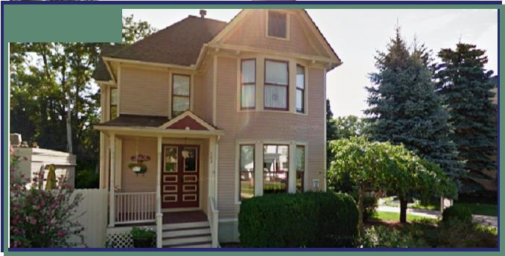

FOR SALE

SUMMARY
Sale Price: | $485,000
Lot Size: | 0.28 Acres
Zoning: | HC - HISTORIC CORRIDOR
Uses: | Investment Multi-Family, Private
 | Residence or Duplex
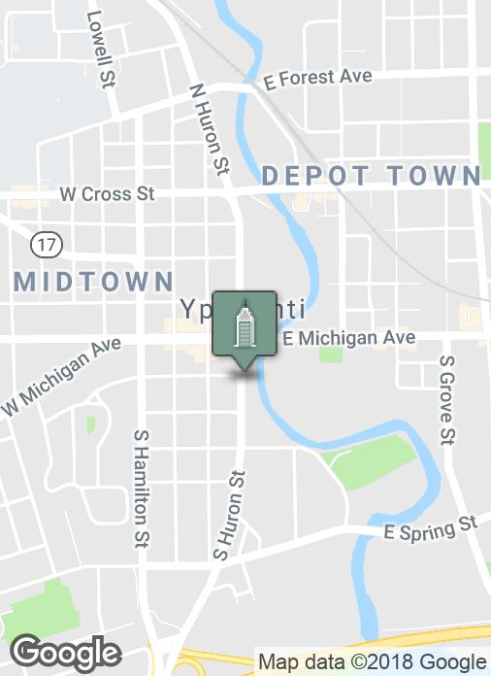

PROPERTY OVERVIEW

Meticulously restored and modernized historic residence that has been a highly regarded Bed & Breakfast the last 25 years. Owner/ operator is retiring.

This outstanding property is being offered as an income/ investment property, and would also be a beautiful private residence or duplex in the heart of Ypsilanti's business district.

Visit www.ParishHouseInn.com for more information.

Building relationships.

208 East Washington Street Ann Arbor, MI 48104 | 734.663.0501

Tony Caprarese | TONYC@SWISHERCOMMERCIAL.COM
 | SWISHERCOMMERCIAL.COM

PARISH HOUSE INN - For Sale

103 S. HURON STREET, YPSILANTI, MI 48197

PROPERTY OVERVIEW

Up to Twelve (12) Bedrooms with private baths that can easily be subdivided into Three or Four apartments.

There are 10 & 1/2 Baths including 2 Barrier Free. Whole-House Fire Suppression System, Central Air & Heat, Hardwood floors & carpeting. Seven on-site parking spots and a beautiful view of Huron River in backyard.

Furniture, Fixtures & Appliances available separately.

PRIVATE SHOWINGS BY APPOINTMENT ONLY!

Visit www.ParishHouseInn.com for more information.

AREA OVERVIEW

THE HOUSE.

The old Queen Anne style house stood six blocks from the current location, when it served as the home for the ministers and their families of the First Congregational Church.

It had been used as the Sunday School and office space since the 1950’s, but due to the passage of the American Disabilities legislation in the 1980’s, it’s usefulness was over. The logical thing to do was tear it down and build a new building.

Because it was in the Historic District, which has strict rules in place to preserve these buildings, it had to be moved.

So it was offered for sale in 1987 with the condition that it had to be moved off the property. It was purchased, by a man who had the vision of turning it into a bed and breakfast.

He had purchased a vacant lot near-by and the house was moved there in September of 1987. Local architects designed the building and the renovation began. Unfortunately, life intervened, and it was not finished for five more years.

It officially opened in August of 1993, and was named the Parish House Inn to honor its past life.

Landscaping for the front and side yard was also done in 1993, and the patio constructed, adjacent to the parking area. Only dining tables and chairs were provided. Breakfast was served there occasionally for a couple of years.

In 1998, when the Mason's became the owners, the back patio was totally re-designed. By surrounding the area with a lattice fence for climbing roses and clematis, it has become a private space for guests. Large pots of geraniums and herbs, add color. A table and chairs are there for guests to relax and enjoy the view.

The backyard is about thirty feet above the Huron River. At a strategic place above the river, there’s a bench where guests like to sit, watch the birds flying around the trees and the ducks floating by.

In the breakfast area, the is a collection of photographs that show the house being moved. It was quite a process. Guest are always fascinated and the owners love to tell the story.

Building relationships.

208 East Washington Street Ann Arbor, MI 48104 | 734.663.0501
Tony Caprarese | TONYC@SWISHERCOMMERCIAL.COM

SWISHERCOMMERCIAL.COM

PARISH HOUSE INN - For Sale

103 S. HURON STREET, YPSILANTI, MI 48197
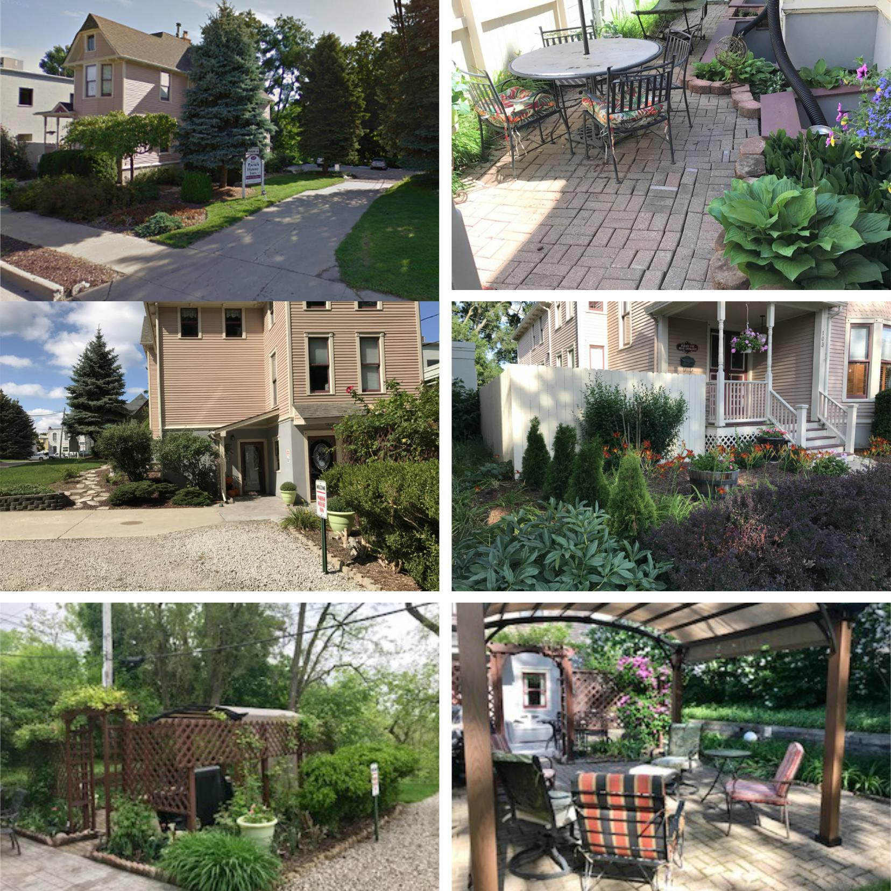

Building relationships.

208 East Washington Street Ann Arbor, MI 48104 | 734.663.0501
Tony Caprarese | TONYC@SWISHERCOMMERCIAL.COM

SWISHERCOMMERCIAL.COM

PARISH HOUSE INN - For Sale

103 S. HURON STREET, YPSILANTI, MI 48197
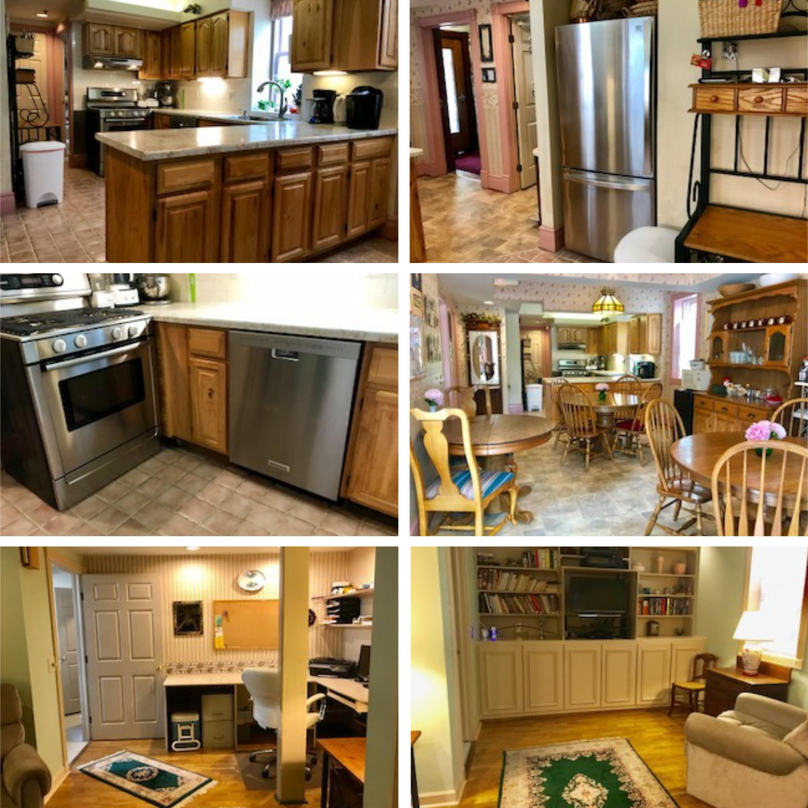

Building relationships.

208 East Washington Street Ann Arbor, MI 48104 | 734.663.0501
Tony Caprarese | TONYC@SWISHERCOMMERCIAL.COM

SWISHERCOMMERCIAL.COM

PARISH HOUSE INN - For Sale

103 S. HURON STREET, YPSILANTI, MI 48197
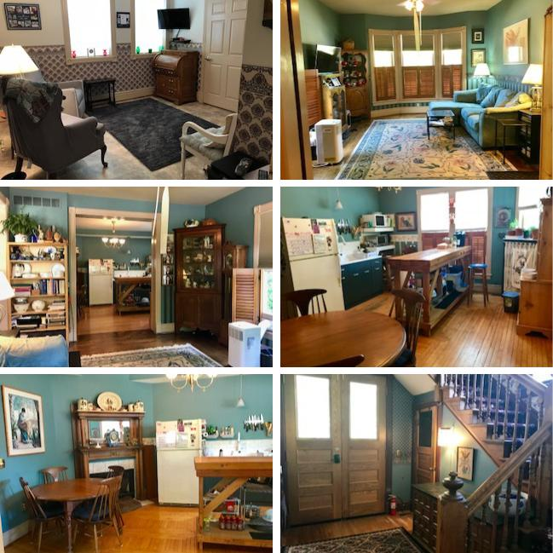

Building relationships.

208 East Washington Street Ann Arbor, MI 48104 | 734.663.0501
Tony Caprarese | TONYC@SWISHERCOMMERCIAL.COM

SWISHERCOMMERCIAL.COM

PARISH HOUSE INN - For Sale

103 S. HURON STREET, YPSILANTI, MI 48197
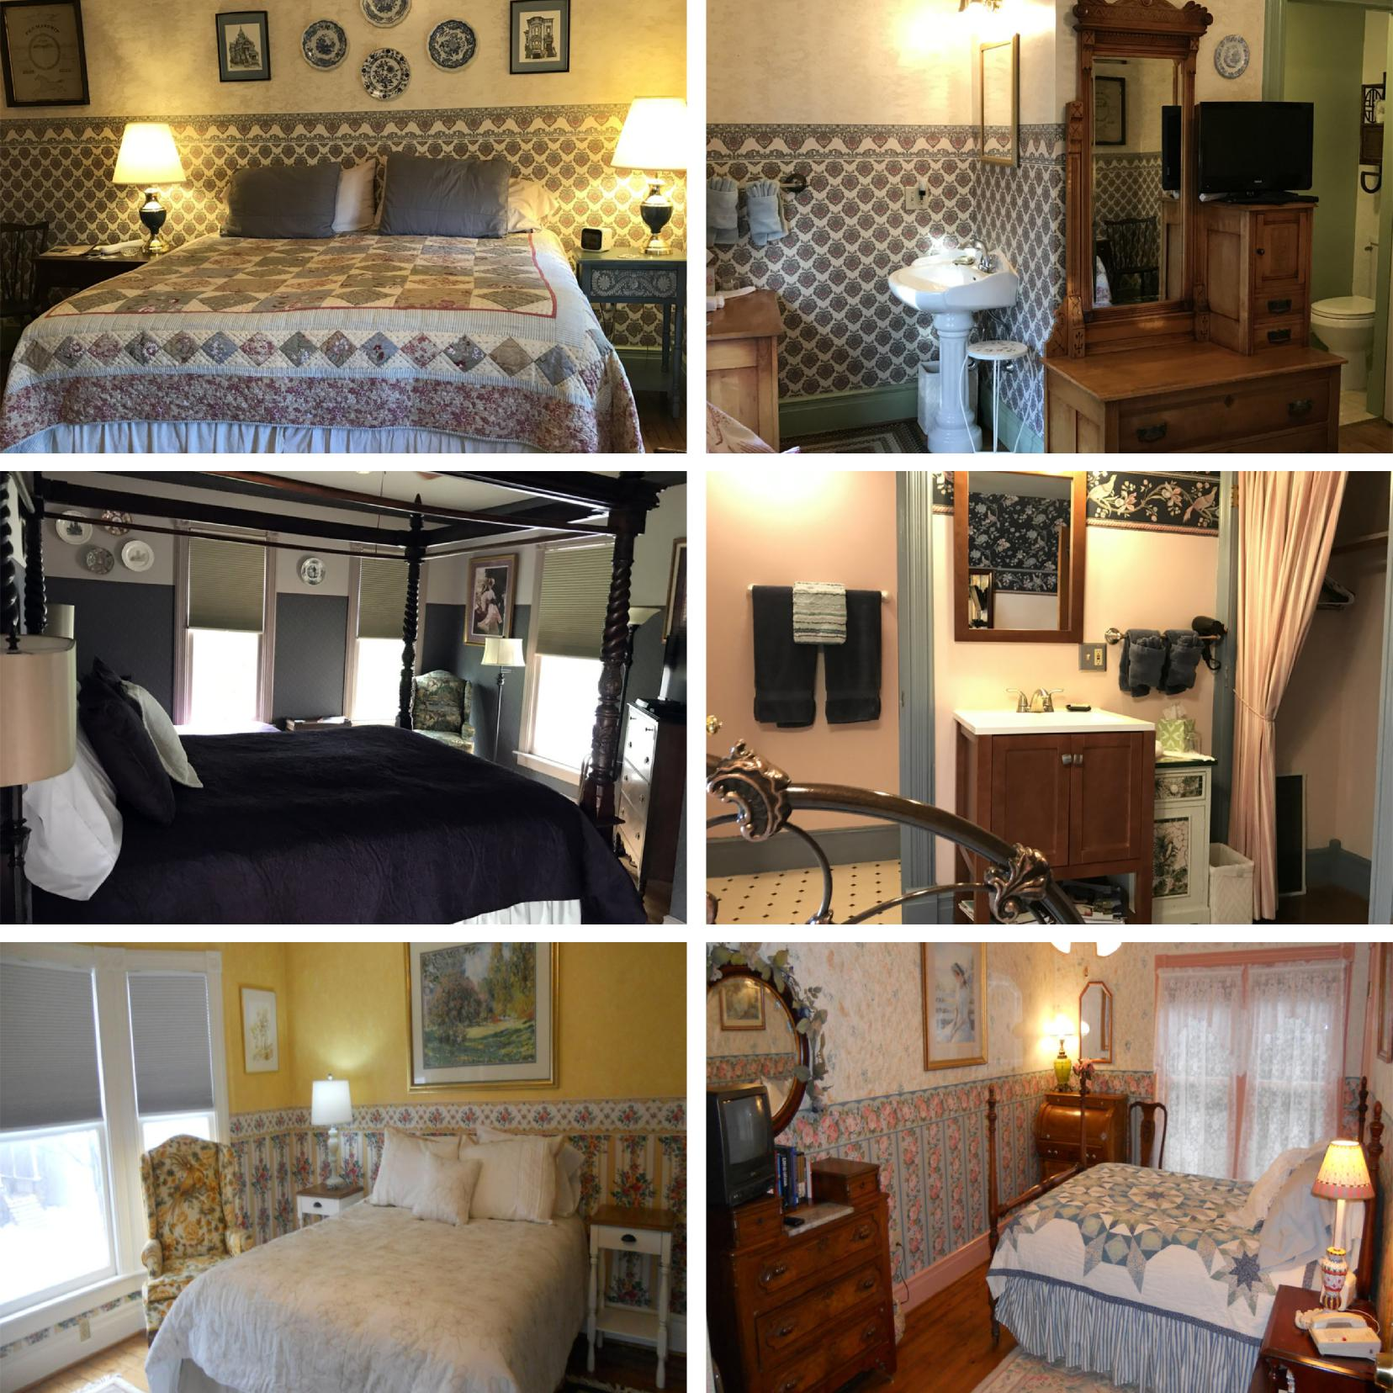

Building relationships.

208 East Washington Street Ann Arbor, MI 48104 | 734.663.0501
Tony Caprarese | TONYC@SWISHERCOMMERCIAL.COM

SWISHERCOMMERCIAL.COM

PARISH HOUSE INN - For Sale

103 S. HURON STREET, YPSILANTI, MI 48197
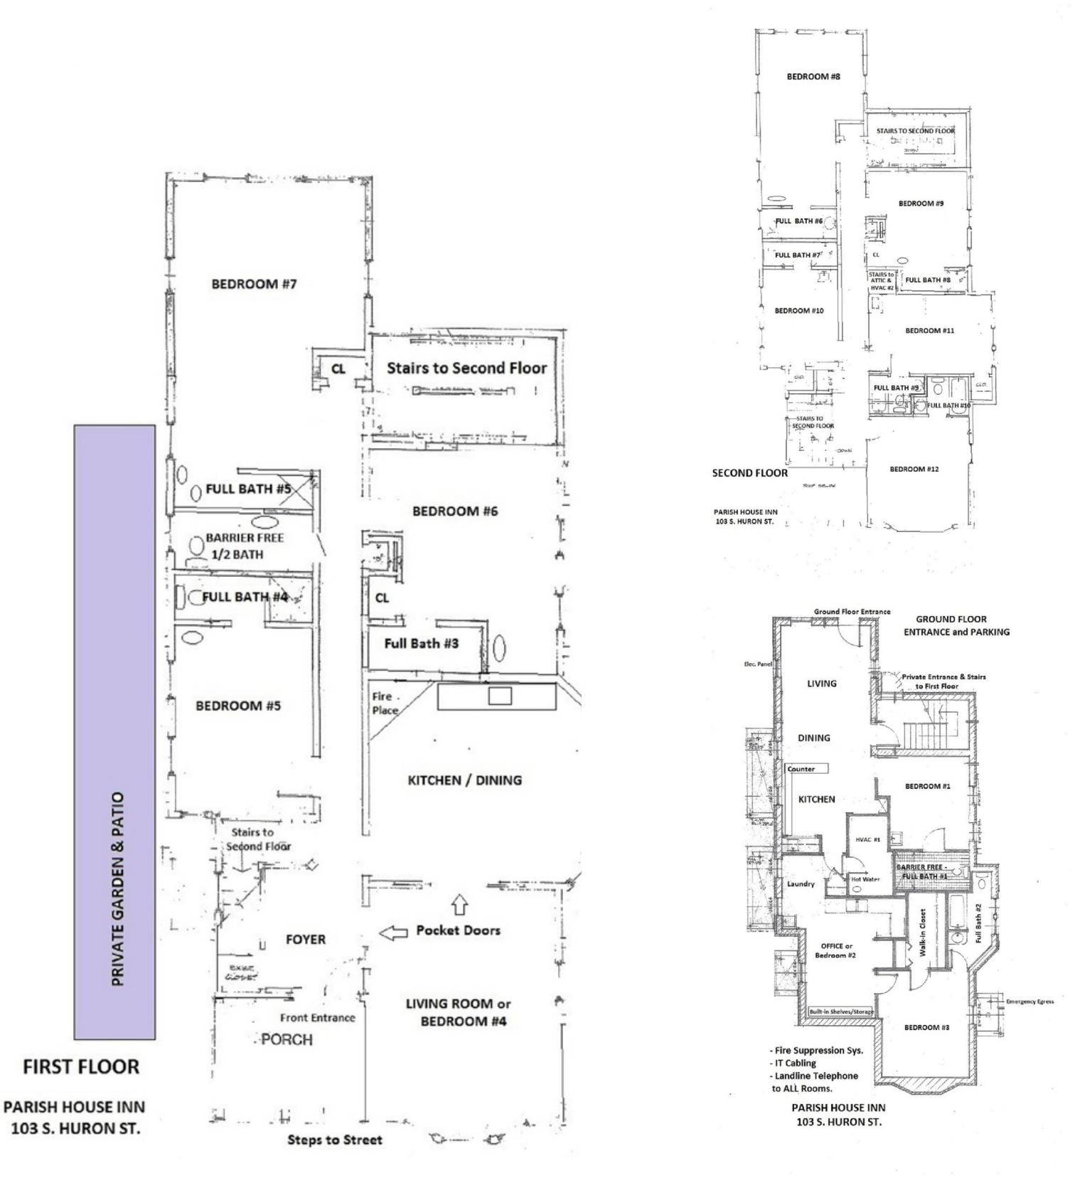

Building relationships.

208 East Washington Street Ann Arbor, MI 48104 | 734.663.0501
Tony Caprarese | TONYC@SWISHERCOMMERCIAL.COM

SWISHERCOMMERCIAL.COM

PARISH HOUSE INN - For Sale

103 S. HURON STREET, YPSILANTI, MI 48197
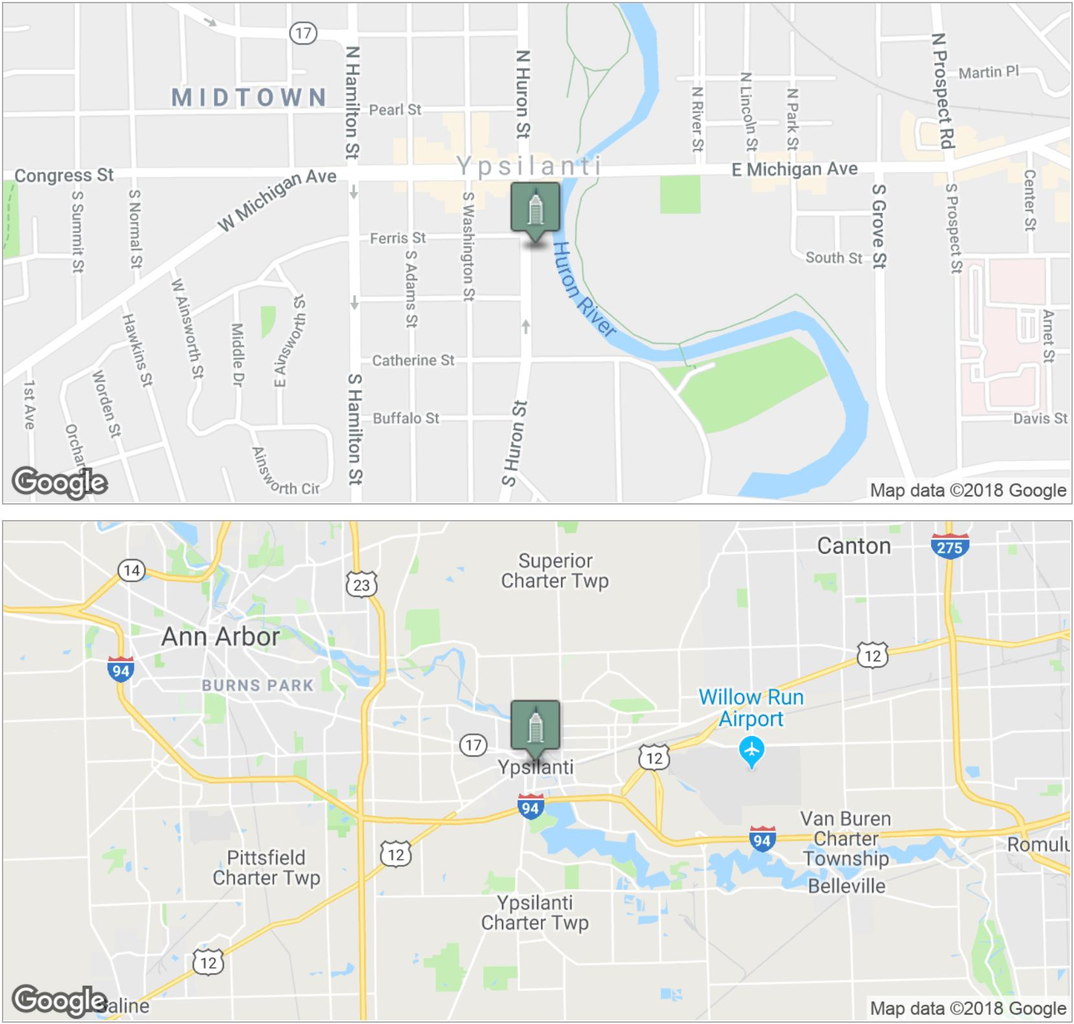

Building relationships.

208 East Washington Street Ann Arbor, MI 48104 | 734.663.0501
Tony Caprarese | TONYC@SWISHERCOMMERCIAL.COM

SWISHERCOMMERCIAL.COM

PARISH HOUSE INN - For Sale

103 S. HURON STREET, YPSILANTI, MI 48197
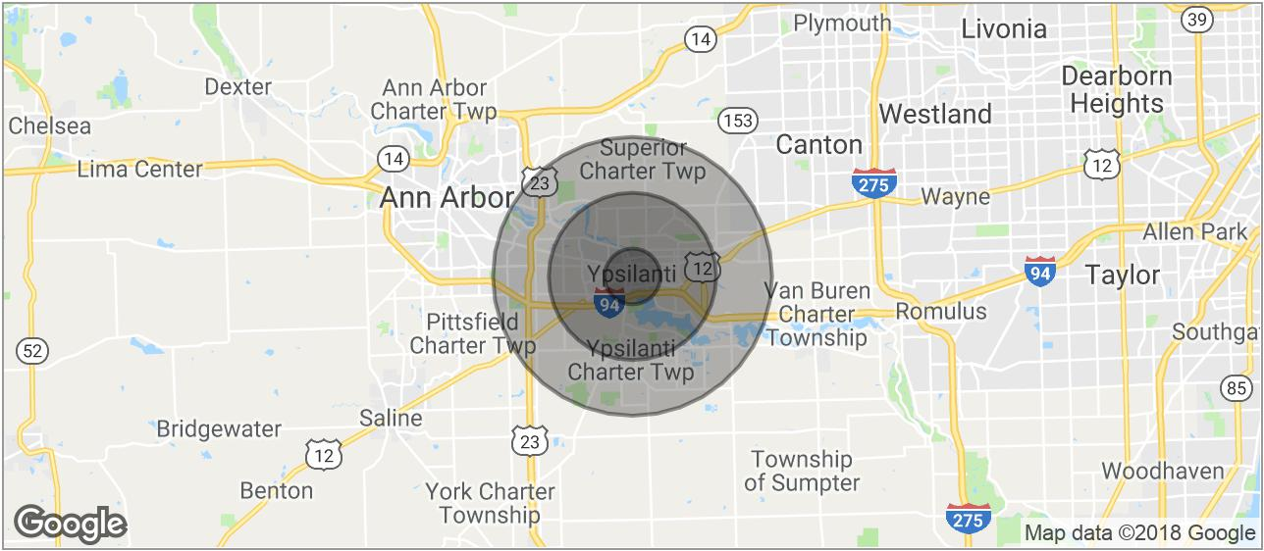

POPULATION | 1 MILE | 3 MILES | 5 MILES
TOTAL POPULATION | 13,445 | 68,002 | 130,895
MEDIAN AGE | 30.9 | 32.0 | 32.6
MEDIAN AGE (MALE) | 29.9 | 31.0 | 31.9
MEDIAN AGE (FEMALE) | 32.1 | 33.7 | 33.7

HOUSEHOLDS & INCOME | 1 MILE | 3 MILES | 5 MILES
TOTAL HOUSEHOLDS | 5,686 | 27,456 | 53,334
# OF PERSONS PER HH | 2.4 | 2.5 | 2.5
AVERAGE HH INCOME | $45,129 | $53,396 | $58,827
AVERAGE HOUSE VALUE | $136,598 | $161,363 | $167,894

* Demographic data derived from 2010 US Census

Building relationships.

208 East Washington Street Ann Arbor, MI 48104 | 734.663.0501
Tony Caprarese | TONYC@SWISHERCOMMERCIAL.COM

SWISHERCOMMERCIAL.COM

