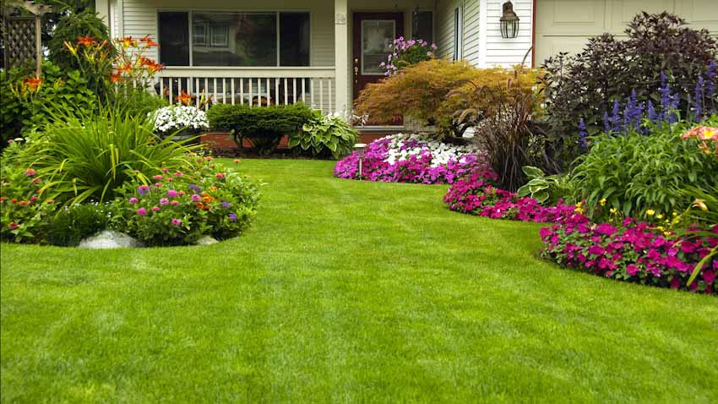

We are more than 20 years experienced in design and construction both local and international arena. we guaranty practicality, quality, sustainability, safety ,durability and cost effective using value engineering, review and management.

* **General Clean-up**
* **Mowing**
* **Shrub Trimming**
* **Bush Trimming**
* **Tree Trimming**
* **Flower Bed Installations**
* **Irrigation systems repair**
* **Landscape design & installations**

**Lawn care service**