[](https://www.myperfectresume.com/membership/RegisterGuestUser.aspx?wizard=true&productid=17&utm_source=hloom-com&utm_medium=referral&utm_campaign=word-template)  
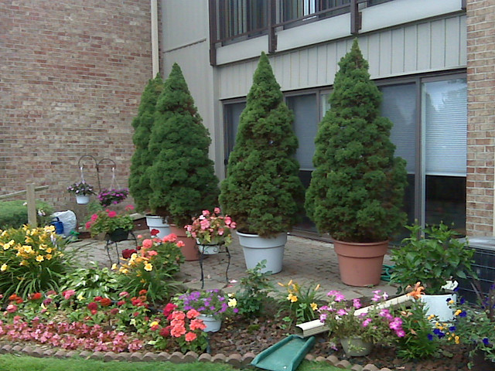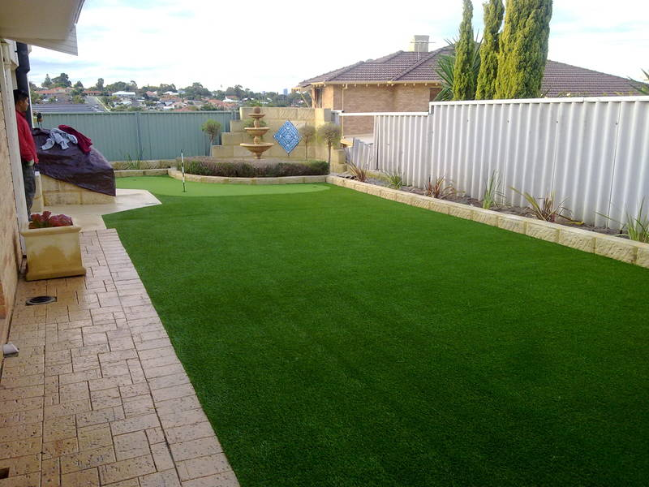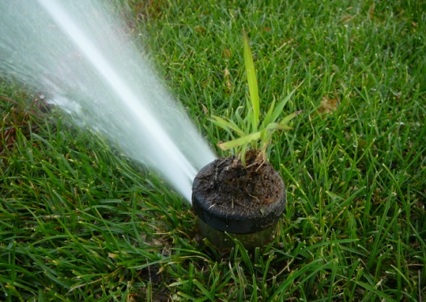

**Hanging**

**Gardens Landscapers**

**WE KNOW THE ART OF DECORATING YOUR LAWNS WITH PRECISIONS**