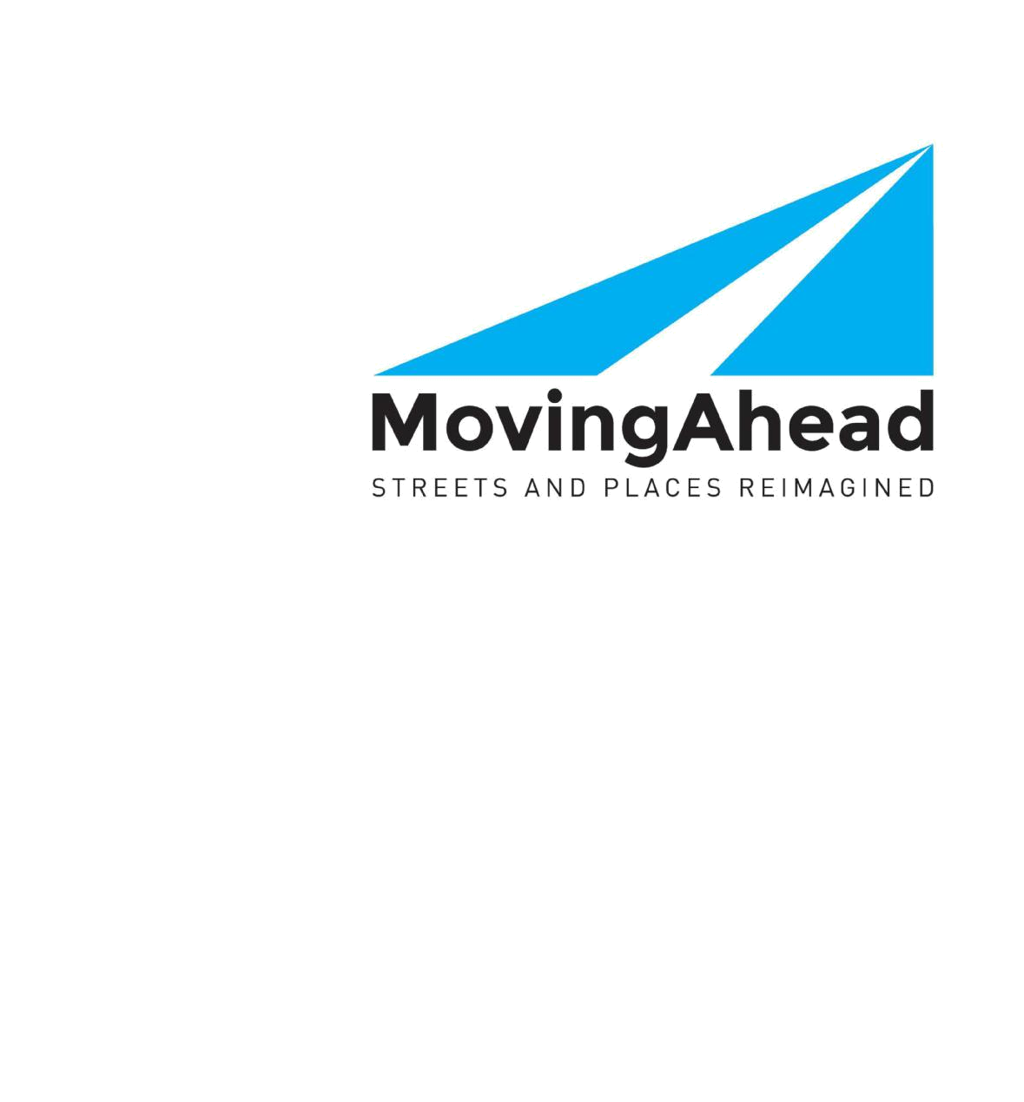

DRAFT FINAL Cultural

Resources

Technical Report

Lane Transit District

City of Eugene

In cooperation with

Lane Council of Governments

Lane County

Oregon Department of Transportation

July 7, 2017

DRAFT FINAL Cultural Resources Technical Report

MovingAhead Project

Prepared in accordance with the

National Environmental Policy Act of 1969, as amended 42 U.S.C. 4322

and the

Federal Transit Act of 1964, as amended 49 U.S.C. 1601 et. seq.

July 7, 2017

Prepared for

Federal Transit Administration

Lane Transit District

City of Eugene

Prepared by

Heritage Research Associates and CH2M HILL, Inc.

Americans with Disabilities Act (ADA) Information

If you would like copies of this document in an alternative format – large print, Braille, cassette tape, or

on computer disc – or are deaf or hard of hearing, please contact

Sasha Luftig, Project Manager for the MovingAhead Project, at

(541) 682-6135 or (800) 735-2900 TTY or Sasha.Luftig@ltd.org.

Title VI

Lane Transit District ensures full compliance with Title VI of the Civil Rights Act of 1964 by prohibiting discrimination against any person on the basis of race, color, national origin, or sex in the provision of benefits and services resulting from its federally assisted programs and activities. For questions regarding the project’s Title VI compliance, please contact Sasha Luftig, Project Manager for the MovingAhead Project, at
- 682-6135 or Sasha.Luftig@ltd.org.

Blank Page

Table of Contents

Acronyms, Abbreviations, and Terms ....................................................................................... |  |  | ix
Cultural Resources Summary ................................................................................................ |  |  | S-1
S.1. | Affected Environment ...................................................................................................... |  | S-2
 | S.1.1. | Highway 99 Corridor ........................................................................................... | S-5
 | S.1.2. | River Road Corridor ............................................................................................ | S-5
 | S.1.3. 30th Avenue to Lane Community College Corridor ............................................ |  | S-6
 | S.1.4. | Coburg Road Corridor ......................................................................................... | S-6
 | S.1.5. Martin Luther King, Jr. Boulevard Corridor ......................................................... |  | S-6
S.2. | Environmental Consequences ......................................................................................... |  | S-6
 | S.2.1. Direct and Short-Term Impacts Approach .......................................................... |  | S-7
 | S.2.2. Indirect Impacts Analysis Approach .................................................................... |  | S-8
 | S.2.3. Cumulative Impact Analysis Approach ............................................................... |  | S-8
S.3. | Mitigation Options ........................................................................................................... |  | S-8
S.4. | Conclusions ...................................................................................................................... |  | S-9

1. | Introduction .............................................................................................................. |  |  | 1-1
 | 1.1. | MovingAhead Technical Reports ..................................................................................... |  | 1-1
 | 1.2. | Cultural Resources Technical Report and Purpose .......................................................... |  | 1-2
 | 1.3. | Discipline Experts ............................................................................................................. |  | 1-2
 | 1.4. | Study Background ............................................................................................................ |  | 1-3
 | 1.5. | Screening and Evaluation of Multimodal Options ........................................................... |  | 1-4
 |  | 1.5.1. | Fatal Flaw Screening ........................................................................................... | 1-4
 |  | 1.5.2. Level 1 Screening Evaluation .............................................................................. |  | 1-6
 |  | 1.5.3. Level 2 Alternatives Analysis ............................................................................... |  | 1-7
 | 1.6. | Purpose and Need ............................................................................................................ |  | 1-7
 |  | 1.6.1. | Purpose ............................................................................................................... | 1-7
 |  | 1.6.2. | Need .................................................................................................................... | 1-8
Lane Transit District |  |  | DRAFT FINAL Cultural Resources Technical Report | July 7, 2017
City of Eugene |  |  | MovingAhead Project | i

 |  |  | Table of Contents (continued)
 |  | 1.6.3. | Goals and Objectives .......................................................................................... | 1-8
 |  | 1.6.4. | Evaluation Criteria .............................................................................................. | 1-9
2. | Alternatives Considered ............................................................................................. |  |  | 2-1
 | 2.1. | No-Build Alternative Transit Network ............................................................................. |  | 2-4
 |  | 2.1.1. | Capital Improvements ........................................................................................ | 2-4
 |  | 2.1.2. | Transit Operations .............................................................................................. | 2-4
 | 2.2. | Enhanced Corridor Alternatives ....................................................................................... |  | 2-6
 | 2.3. | EmX Alternatives .............................................................................................................. |  | 2-6
 | 2.4. | Highway 99 Corridor ........................................................................................................ |  | 2-6
 |  | 2.4.1. | No-Build Alternative ........................................................................................... | 2-6
 |  | 2.4.2. | Enhanced Corridor Alternative ........................................................................... | 2-7
 |  | 2.4.3. | EmX Alternative .................................................................................................. | 2-7
 | 2.5. | River Road Corridor.......................................................................................................... |  | 2-7
 |  | 2.5.1. | No-Build Alternative ........................................................................................... | 2-8
 |  | 2.5.2. | Enhanced Corridor Alternative ........................................................................... | 2-8
 |  | 2.5.3. | EmX Alternative .................................................................................................. | 2-8
 | 2.6. | 30th Avenue to Lane Community College Corridor ......................................................... |  | 2-9
 |  | 2.6.1. | No-Build Alternative ........................................................................................... | 2-9
 |  | 2.6.2. | Enhanced Corridor Alternative ........................................................................... | 2-9
 |  | 2.6.3. | EmX Alternative .................................................................................................. | 2-9
 | 2.7. | Coburg Road Corridor .................................................................................................... |  | 2-10
 |  | 2.7.1. | No-Build Alternative ......................................................................................... | 2-10
 |  | 2.7.2. | Enhanced Corridor Alternative ......................................................................... | 2-10
 |  | 2.7.3. | EmX Alternative ................................................................................................ | 2-10
 | 2.8. | Martin Luther King, Jr. Boulevard Corridor .................................................................... |  | 2-11
 |  | 2.8.1. | No-Build Alternative ......................................................................................... | 2-11
 |  | 2.8.2. | Enhanced Corridor Alternative ......................................................................... | 2-11

July 7, 2017 | DRAFT FINAL Cultural Resources Technical Report | Lane Transit District
ii | MovingAhead Project | City of Eugene

 |  |  | Table of Contents (continued)
3. | Methods and Data ..................................................................................................... |  |  | 3-1
 | 3.1. | Introduction ..................................................................................................................... |  | 3-1
 | 3.2. | Relevant Laws and Regulations ....................................................................................... |  | 3-1
 |  | 3.2.1. | Federal ............................................................................................................... | 3-1
 |  | 3.2.2. | State .................................................................................................................... | 3-2
 |  | 3.2.3. | Local .................................................................................................................... | 3-3
 | 3.3. | Analysis Area .................................................................................................................... |  | 3-3
 | 3.4. | Contacts and Coordination .............................................................................................. |  | 3-4
 | 3.5. | Level 2 Alternatives Analysis ............................................................................................ |  | 3-5
 | 3.6. | National Environmental Policy Act Compliance .............................................................. |  | 3-5
 |  | 3.6.1. | Data Collection .................................................................................................... | 3-6
 |  | 3.6.2. | Significance Thresholds ....................................................................................... | 3-6
 |  | 3.6.3. | Impact Analysis ................................................................................................... | 3-6
 | 3.7. | National Environmental Policy Act Documentation ........................................................ |  | 3-7
 |  | 3.7.1. | Impact Analysis ................................................................................................... | 3-7
4. | Highway 99 Corridor Environmental Consequences ...................................................... |  |  | 4-1
 | 4.1. | Affected Environment ...................................................................................................... |  | 4-1
 |  | 4.1.1. Archaeological Background and Records Review ............................................... |  | 4-1
 |  | 4.1.2. | Archaeological Survey Results ............................................................................ | 4-2
 |  | 4.1.3. Historical Background and Records Review ....................................................... |  | 4-5
 |  | 4.1.4. | Historical Reconnaissance Results ...................................................................... | 4-6
 | 4.2. | Environmental Consequences ....................................................................................... |  | 4-14
 |  | 4.2.1. | Long-Term Direct Impacts ................................................................................ | 4-14
 |  | 4.2.2. Indirect and Cumulative Effects ........................................................................ |  | 4-14
 |  | 4.2.3. | Short-Term Construction-Related Impacts ....................................................... | 4-15
 | 4.3. | Potential Mitigation Measures ...................................................................................... |  | 4-15
5. | River Road Corridor Environmental Consequences ....................................................... |  |  | 5-1
 | 5.1. | Affected Environment ...................................................................................................... |  | 5-1

Lane Transit District | DRAFT FINAL Cultural Resources Technical Report | July 7, 2017
City of Eugene | MovingAhead Project | iii

Table of Contents (continued)

 |  | 5.1.1. Archaeological Background and Records Review ............................................... |  | 5-1
 |  | 5.1.2. | Archaeological Survey Results ............................................................................ | 5-4
 |  | 5.1.3. Historical Background and Records Review ....................................................... |  | 5-6
 |  | 5.1.4. | Historical Reconnaissance Results ...................................................................... | 5-9
 | 5.2. | Environmental Consequences ....................................................................................... |  | 5-19
 |  | 5.2.1. | Long-Term Direct Impacts ................................................................................ | 5-19
 |  | 5.2.2. Indirect and Cumulative Effects ........................................................................ |  | 5-19
 |  | 5.2.3. | Short-Term Construction-Related Impacts ....................................................... | 5-20
 | 5.3. | Potential Mitigation Measures ...................................................................................... |  | 5-20
6. | 30th Avenue to Lane Community College Corridor Environmental Consequences ........... |  |  | 6-1
 | 6.1. | Affected Environment ...................................................................................................... |  | 6-1
 |  | 6.1.1. Archaeological Background and Records Review ............................................... |  | 6-1
 |  | 6.1.2. | Archaeological Survey Results ............................................................................ | 6-5
 |  | 6.1.3. Historical Background and Records Review ....................................................... |  | 6-7
 |  | 6.1.4. | Historical Reconnaissance Results ...................................................................... | 6-8
 | 6.2. | Environmental Consequences ....................................................................................... |  | 6-21
 |  | 6.2.1. | Long-Term Direct Impacts ................................................................................ | 6-21
 |  | 6.2.2. Indirect and Cumulative Effects ........................................................................ |  | 6-21
 |  | 6.2.3. | Short-Term Construction-Related Impacts ....................................................... | 6-22
 | 6.3. | Potential Mitigation Measures ...................................................................................... |  | 6-22
7. | Coburg Road Corridor Environmental Consequences .................................................... |  |  | 7-1
 | 7.1. | Affected Environment ...................................................................................................... |  | 7-1
 |  | 7.1.1. Archaeological Background and Records Review ............................................... |  | 7-1
 |  | 7.1.2. | Archaeological Survey Results ............................................................................ | 7-6
 |  | 7.1.3. Historical Background and Records Review ....................................................... |  | 7-8
 |  | 7.1.4. | Historical Reconnaissance Results .................................................................... | 7-10
 | 7.2. | Environmental Consequences ....................................................................................... |  | 7-15
 |  | 7.2.1. | Long-Term Direct Impacts ................................................................................ | 7-15

July 7, 2017 | DRAFT FINAL Cultural Resources Technical Report | Lane Transit District
iv | MovingAhead Project | City of Eugene

Table of Contents (continued)

 |  | 7.2.2. Indirect and Cumulative Effects ........................................................................ |  | 7-15
 |  | 7.2.3. | Short-Term Construction-Related Impacts ....................................................... | 7-16
 | 7.3. | Potential Mitigation Measures ...................................................................................... |  | 7-16
8. | Martin Luther King, Jr. Boulevard Corridor Environmental Consequences ...................... |  |  | 8-1
 | 8.1. | Affected Environment ...................................................................................................... |  | 8-1
 |  | 8.1.1. Archaeological Background and Records Review ............................................... |  | 8-1
 |  | 8.1.2. | Archaeological Survey Results ............................................................................ | 8-6
 |  | 8.1.3. Historical Background and Records Review ....................................................... |  | 8-6
 |  | 8.1.4. | Historical Reconnaissance Results ...................................................................... | 8-9
 | 8.2. | Environmental Consequences ......................................................................................... |  | 8-9
 |  | 8.2.1. | Long-Term Direct Impacts .................................................................................. | 8-9
 |  | 8.2.2. Indirect and Cumulative Effects ........................................................................ |  | 8-11
 |  | 8.2.3. | Short-Term Construction-Related Impacts ....................................................... | 8-11
 | 8.3. | Potential Mitigation Measures ...................................................................................... |  | 8-11
9. | References ............................................................................................................... |  |  | 9-1

Lane Transit District | DRAFT FINAL Cultural Resources Technical Report | July 7, 2017
City of Eugene | MovingAhead Project | v

 | Table of Contents (continued)
Tables
Table S.4-1. | Summary of Cultural Resources Environmental Consequences by Corridor and
 | Alternativeª ....................................................................................................................... | S-10
Table 1.3-1. | Discipline Experts ................................................................................................................ | 1-2
Table 1.5-1. | Results of the Fatal Flaw Screening..................................................................................... | 1-6
Table 1.5-2. | Corridors and Transit Alternatives Advanced to the Level 2 Alternatives Analysis ............ | 1-7
Table 1.6-1. | Evaluation Criteria ............................................................................................................... | 1-9
Table 4.1-1. | Previous Investigations Conducted within 1 Mile of Highway 99 Corridor ........................ | 4-4
Table 4.1-2. | Archaeological Sites Recorded Within 1 Mile of Highway 99 Corridor ............................... | 4-5
Table 4.1-3. | Inventory of Identified Historic Resources Along the Highway 99 Corridor with
 | Anticipated Effects for Enhanced Corridor Alternative ...................................................... | 4-8
Table 4.1-4. | Inventory of Identified Historic Resources Along the Highway 99 Corridor with
 | Anticipated Effects for EmX Alternative ............................................................................ | 4-10
Table 5.1-1. Previous Investigations Conducted within 1 Mile of River Road Corridor .......................... |  | 5-2
Table 5.1-2. Archaeological Sites Recorded Within 1 Mile of River Road Corridor ................................ |  | 5-4
Table 5.1-3. | Inventory of Identified Historic Resources along River Road Corridor with Anticipated
 | Effects for Enhanced Corridor Alternative .......................................................................... | 5-9
Table 5.1-4. | Inventory of Identified Historic Resources along River Road Corridor with Anticipated
 | Effects for EmX Alternative ............................................................................................... | 5-14
Table 6.1-1. Previous Investigations Conducted within 1 Mile of 30th Avenue to LCC Corridor ........... |  | 6-2
Table 6.1-2. Archaeological Sites Recorded Within 1 Mile of 30th Avenue to LCC Corridor .................. |  | 6-4
Table 6.1-3. | Inventory of Identified Historic Resources along 30th Avenue to LCC Corridor with
 | Anticipated Effects for Enhanced Corridor Alternative .................................................... | 6-10
Table 6.1-4. | Inventory of Identified Historic Resources along 30th Avenue to LCC Corridor with
 | Anticipated Effects for EmX Alternative ............................................................................ | 6-16
Table 7.1-1. Previous Investigations Conducted within 1 Mile of Coburg Road Corridor ...................... |  | 7-2
Table 7.1-2. Archaeological Sites Recorded Within 1 Mile of Coburg Road Corridor ............................. |  | 7-5
Table 7.1-3. | Potential NRHP-Eligible Properties Identified Along Coburg Road Corridor, Enhanced
 | Corridor Alternative .......................................................................................................... | 7-11
Table 7.1-4. | Potential NRHP-Eligible Properties Identified Along Coburg Road Corridor,
 | EmX Alternative ................................................................................................................. | 7-13
Table 8.1-1. | Previous Investigations Conducted within 1 Mile of Martin Luther King, Jr. Boulevard
 | Corridor ............................................................................................................................... | 8-2
Table 8.1-2. | Archaeological Sites Recorded Within 1 Mile of Martin Luther King, Jr. Boulevard
 | Corridor ............................................................................................................................... | 8-5
Table 8.1-3. | Inventory of Identified Historic Resources along Martin Luther King, Jr. Boulevard
 | Corridor with Anticipated Effects for Enhanced Corridor Alternative ................................ | 8-9
Table A-1. | Acronyms and Abbreviations ............................................................................................. | A-1
Table A-2. | Terms .................................................................................................................................. | A-9

July 7, 2017 | DRAFT FINAL Cultural Resources Technical Report | Lane Transit District
vi | MovingAhead Project | City of Eugene

Table of Contents (continued)

Figures

Figure S.1-1. Enhanced Corridor Alternatives Overview .......................................................................... | S-3
Figure S.1-2. EmX Alternatives Overview ................................................................................................. | S-4
Figure 1.4-1. Lane Transit District's Bus Rapid Transit (BRT) System ....................................................... | 1-3
Figure 1.5-1. MovingAhead Phase 1 Steps ............................................................................................... | 1-5
Figure 2.1-1. Enhanced Corridor Alternatives Overview .......................................................................... | 2-2
Figure 2.1-2. EmX Alternatives Overview ................................................................................................. | 2-3
Figure 4.1-1. Location of Proposed Terminus Station on Cubit Street near Winco Supermarket ........... | 4-3
Figure 4.1-2. Location of Proposed Station at Existing Bus Pull Out North of Elmira Road;
Note Buried Utility Covers in the Sidewalk ......................................................................... | 4-3
Figure 4.1-3. Location of the Highway 99 Corridor on the USGS Eugene 15’ Quadrangle, 1910 ............ | 4-7
Figure 4.1-4. Location of the Highway 99 Corridor on the USGS Eugene 15’ Quadrangle, 1940 ............ | 4-7
Figure 4.1-5. Alignment of the Highway 99 Corridor as Shown on the USGS Eugene East and
Eugene West 7.5’ Quadrangle, 1976 (Reduced) ................................................................. | 4-8
Figure 4.1-6. Highway 99 Enhanced Corridor Alternative Cultural Resources Area of Potential
Effect ................................................................................................................................. | 4-12
Figure 4.1-7. Highway 99 EmX Alternative Cultural Resources Area of Potential Effect ....................... | 4-13
Figure 5.1-1. Location of Proposed Station at Existing Bus Pull Out North of Park Street ...................... | 5-5
Figure 5.1-2. Area Surveyed for Terminus Station South of Hunsaker Lane, Paved Parking Lot Left
from Santa Clara Elementary School is Visible in the Middle of the Photograph ............... | 5-5
Figure 5.1-3. Location of the River Road Corridor on the USGS Eugene 15’ Quadrangle, 1910 .............. | 5-7
Figure 5.1-4. Location of the River Road Corridor on the USGS Eugene 15’ Quadrangle, 1940 .............. | 5-8
Figure 5.1-5. Alignment of the River Road Corridor as Shown on the USGS Eugene East and Eugene
West 7.5’ Quadrangles, 1976 (Reduced) ............................................................................ | 5-8
Figure 5.1-6. River Road Enhanced Corridor Alternative Cultural Resources Area of Potential
Effect ................................................................................................................................. | 5-13
Figure 5.1-7. River Road EmX Alternative Cultural Resources Area of Potential Effect ......................... | 5-18
Figure 6.1-1. Location of Proposed Station on Pearl Street at East 18th Avenue .................................... | 6-6
Figure 6.1-2. Raised Roadbed and Drainage Swale East of Amazon Parkway ......................................... | 6-6
Figure 6.1-3. Location of 30th Avenue to LCC Corridor on the USGS Eugene 15’ Quadrangle, 1910 ...... | 6-9
Figure 6.1-4. Location of 30th Avenue to LCC Corridor on the USGS Eugene 15’ Quadrangle, 1940 ...... | 6-9
Figure 6.1-5. Alignment of 30th Avenue to LCC Corridor as Shown on the USGS Eugene East 7.5’
Quadrangle, 1976 (Reduced) ............................................................................................ | 6-10
Figure 6.1-6. 30th Avenue to Lane Community College Enhanced Corridor Alternative Cultural
Resources Area of Potential Effect .................................................................................... | 6-15
Figure 6.1-7. 30th Avenue to Lane Community College EmX Alternative Cultural Resources Area of
Potential Effect .................................................................................................................. | 6-20
Figure 7.1-1. Location of Proposed Station North of Harlow Road .......................................................... | 7-7
Figure 7.1-2. Property on South Side of Chad Drive with No Existing Sidewalk; Note Manhole Cover
and Electrical Box Reflecting Buried Utilities ...................................................................... | 7-7
Figure 7.1-3. Location of the Coburg Road Corridor on the USGS Eugene 15’ Quadrangle, 1910 .......... | 7-9
Figure 7.1-4. Location of the Coburg Road Corridor on the USGS Eugene 15’ Quadrangle, 1940 .......... | 7-9

Lane Transit District | DRAFT FINAL Cultural Resources Technical Report | July 7, 2017
City of Eugene | MovingAhead Project | vii

Table of Contents (continued)

Figure 7.1-5. Alignment of the Coburg Road Corridor as Shown on the USGS Eugene East 7.5’
 | Quadrangle, 1976 (Reduced) ............................................................................................ | 7-10
Figure 7.1-6. | Coburg Road Enhanced Corridor Alternative Cultural Resources Area of Potential
 | Effect ................................................................................................................................. | 7-12
Figure 7.1-7. | Coburg Road EmX Alternative Cultural Resources Area of Potential Effect ..................... | 7-14
Figure 8.1-1. | Location of the Martin Luther King, Jr. Boulevard Corridor on the USGS Eugene 15’
 | Quadrangle, 1910 ................................................................................................................ | 8-7
Figure 8.1-2. | Location of the Martin Luther King, Jr. Boulevard Corridor on the USGS Eugene 15’
 | Quadrangle, 1940 ................................................................................................................ | 8-8

Figure 8.1-3. Alignment of the Martin Luther King, Jr. Boulevard Corridor as Shown on the USGS Eugene

East 7.5’ Quadrangle, 1976 (Reduced) | ................................................................................ 8-8
Figure 8.1-4. Martin Luther King, Jr. Boulevard Enhanced Corridor Alternative Cultural Resources Area
of Potential Effect ............................................................................................................. | 8-10

Appendices

Appendix A: Glossary and Naming Conventions .................................................................. | A-1
Acronyms and Abbreviations ........................................................................................................ | A-1
Terms ............................................................................................................................................ | A-9
Appendix B: Construction Activities ................................................................................... | B-1
General Construction Methods .................................................................................................... | B-1
Coordination with Businesses and Residents ............................................................................... | B-1

July 7, 2017 | DRAFT FINAL Cultural Resources Technical Report | Lane Transit District
viii | MovingAhead Project | City of Eugene

Acronyms, Abbreviations, and Terms

 | Acronyms and
 | Abbreviations | Definitions
 | AA | Alternatives Analysis
 | APE | Area of Potential Effect
 | API | area of potential impact
 | BAT | business access and transit
 | BRT | bus rapid transit
 | c | circa
 | CFR | Code of Federal Regulations
 | City | City of Eugene
 | DLC | Donation Land Claim
 | EC | eligible contributing
 | EmX | Emerald Express, Lane Transit District’s Bus Rapid Transit System
 | ES | eligible significant
 | FOE | Finding of Effect
 | FTA | Federal Transit Administration
 | FTN | Frequent Transit Network
 | GLO | General Land Office
 | HPNW | Historic Preservation Northwest
 | I-5 | Interstate 5
 | LCC | Lane Community College
 | LCOG | Lane Council of Governments
 | LOS | level of service
 | LTD | Lane Transit District
 | m | meter(s)
 | Metro Plan | Eugene-Springfield Metropolitan General Area Plan (LCOG et al., 2015, December 31)
 | MOA | Memorandum of Agreement
 | MPO | Metropolitan Planning Organization
 | NEPA | National Environmental Policy Act of 1969, as amended, 42 U.S.C. 4321-4347
 | NR | National Register
 | NRHP | National Register of Historic Places
 | OAR | Oregon Administrative Rules
 | OARRA | Oregon Archaeological Records Remote Access
 | ORS | Oregon Revised Statutes
 | Lane Transit District | DRAFT FINAL Cultural Resources Technical Report | July 7, 2017
 | City of Eugene | MovingAhead Project |  | ix
Acronyms and
Abbreviations | Definitions
ROW | right of way
RTP | Regional Transportation Plan (Central Lane MPO, 2011, December)
S-H | City of Eugene’s S-H Historic Zoning designation
Section 106 | Section 106 of the National Historic Preservation Act of 1966 (36 CFR 800.5)
SHPO | State Historic Preservation Office or Oregon State Historic Preservation Office
U.S.C. | United States Code
USGS | U.S. Geological Survey
WEEE | West Eugene EmX Extension

Terms

Definitions

Area of Potential Effect

A term used in Section 106 to describe the area in which historic resources may be affected by a federal undertaking.

Section 106

Section 106 of the National Historic Preservation Act of 1966 requires federal agencies to take into account the effects of their undertakings on historic properties, and afford the Advisory Council on Historic Preservation a reasonable opportunity to comment (36 CFR 800.5).

July 7, 2017 | DRAFT FINAL Cultural Resources Technical Report | Lane Transit District
x | MovingAhead Project | City of Eugene

Cultural Resources Summary

This Cultural Resources Technical Report presents results for the historical and archaeological resource assessment for the Lane Transit District (LTD) and City of Eugene’s MovingAhead Project in Eugene, Oregon. The purpose of the MovingAhead Project is to determine which high-capacity transit corridors identified in the adopted Emerald Express (EmX) System Plan, Lane Transit District Long‐Range Transit Plan (LTD, 2014) and the Frequent Transit Network (FTN) are ready to advance to capital improvements programming in the near term. LTD and the City of Eugene (City) initiated the MovingAhead Project in 2014 to identify and examine alternatives for improving multimodal safety, mobility, and accessibility in key transit corridors in the City. A main theme of the City’s vision is to concentrate new growth along and near the City’s key transit corridors and core commercial areas while protecting neighborhoods and increasing access to services for everyone. LTD and the City are jointly conducting the project to facilitate a more streamlined and cost-efficient process through concurrent planning, environmental review, and design and construction of multiple corridors.

LTD and the City of Eugene examined multimodal transit alternatives in five key transit corridors identified in the Draft Envision Eugene Comprehensive Plan (Envision Eugene, 2016, July) and the DRAFT Eugene 2035 Transportation System Plan (City of Eugene, 2016; Draft Eugene 2035 TSP), the region’s highest growth centers, and downtown Eugene:

- Highway 99 Corridor

- River Road Corridor

- 30th Avenue to Lane Community College (LCC) Corridor

- Coburg Road Corridor

- Martin Luther King, Jr. Boulevard Corridor

No-Build, Enhanced Corridor, and EmX Alternatives were developed for each corridor, except the Martin Luther King, Jr. Boulevard Corridor, for which only No-Build and Enhanced Corridor Alternatives were developed. Each corridor location is shown on Figure S.1-1. The MovingAhead Level 2 Definition of Alternatives (CH2M et al., 2016) contains a detailed description of the project alternatives. The following items summarize the project alternatives evaluated.

- The No-Build Alternatives serve as a reference point to gauge the benefits, costs, and effects of the Enhanced Corridor and EmX Alternatives in each corridor. Each No-Build Alternative is based on the projected conditions in 2035. Capital projects are derived from the financially constrained project lists in the Draft Eugene 2035 TSP, the Lane County Transportation System Plan (Lane County Public Works, Engineering Division Transportation Planning, 2004, update in progress), the Lane Transit District Capital Improvement Plan (LTD, 2015), and the Lane Transit District Long-Range Transit Plan (LTD, 2014).

- Enhanced Corridor Alternatives are intended to address the project’s Purpose, Need, Goals, and Objectives without major transit capital investments, instead focusing on lower-cost capital improvements, operational improvements, and transit service refinements, including 15-minute service frequency. Features can include transit queue jumps (lanes for buses that allow the bus to “jump” ahead of other traffic at intersections using a separate signal phase), stop consolidation, and

Lane Transit District | DRAFT FINAL Cultural Resources Technical Report | July 7, 2017
City of Eugene | MovingAhead Project | S-1

enhanced shelters. These features can improve reliability, reduce transit travel time, and increase passenger comfort, making transit service along the corridor more attractive.

- EmX Alternatives are characterized by sections of exclusive guideway, branded multi-door 60-foot-long bus rapid transit vehicles, and enhanced stations with level boarding platforms instead of bus stops; off-board fare collection; transit signal priority; wider stop spacing; and 10-minute service frequencies. In general, EmX is a transit mode positioned between fixed-route bus service operating in mixed traffic and urban rail service operating in a separate right of way. EmX service is intended to improve transit speed, reliability, and ridership.

- Figure S.1-1 shows the proposed corridors for the Enhanced Corridor Alternatives and Figure S.1-2 shows the proposed corridors for the EmX Alternatives.

The purpose of the cultural resources evaluation is to ensure that the proposed project complies with laws, regulations, and policies set forth at the federal, state, and local levels for the protection of archaeological and historical resources. This report provides information on the methods used for the cultural resources analysis and presents a preliminary identification of cultural resources potentially affected, as well as an initial analysis of anticipated direct and indirect effects for comparative purposes for each of the corridors under consideration. For those corridors selected for further consideration, a final phase of documentation will be conducted for National Environmental Policy Act (NEPA) compliance with the goal of avoiding or minimizing project effects on cultural resources.

This report was prepared in compliance with the National Environmental Policy Act (NEPA) and applicable state environmental policy legislation, as well as local and state planning and land use policies and design standards.

S.1. Affected Environment

The project’s five corridors are primarily located within the City of Eugene, with a portion of the River Road and 30th Avenue to LCC Corridors located within unincorporated Lane County, and a portion of the Coburg Road Corridor located in the City of Springfield.

An Area of Potential Effect (APE) for Section 106 of the National Historic Preservation Act of 1966 resources was established for each corridor for analysis and comparative purposes. Because existing cultural resources inventories were not comparable from corridor to corridor, and because the project design is still at a preliminary stage, focus for this study was given to closer inspection of a restricted APE in order to provide a more comparable baseline from which all the corridors could be compared. Background research was still conducted for all the corridors to provide a context, but a formal study boundary was not defined. Due to the substantial length of the study corridors—and because the vast extent of impacts is anticipated to be confined to the existing roadway ROW—the APE for this phase of investigation was defined as the area immediately adjacent to the proposed improvements for each corridor. For the archaeological investigations, the focus was on the unpaved portion of the existing ROW on both sides of the roadway. For historical resources, the APE was defined as the ROW plus the tax lot on each side of the centerline. This definition of the APE allowed for a reconnaissance of each corridor to identify previously unidentified historical resources. In addition, due to the limited extent of anticipated impacts, the depth of the tax lot on either side of the roadway is considered likely to encompass at least 95 percent of likely direct, indirect and cumulative impacts to resources along these corridors.

July 7, 2017 | DRAFT FINAL Cultural Resources Technical Report | Lane Transit District
S-2 | MovingAhead Project | City of Eugene

Figure S.1-1. Enhanced Corridor Alternatives Overview
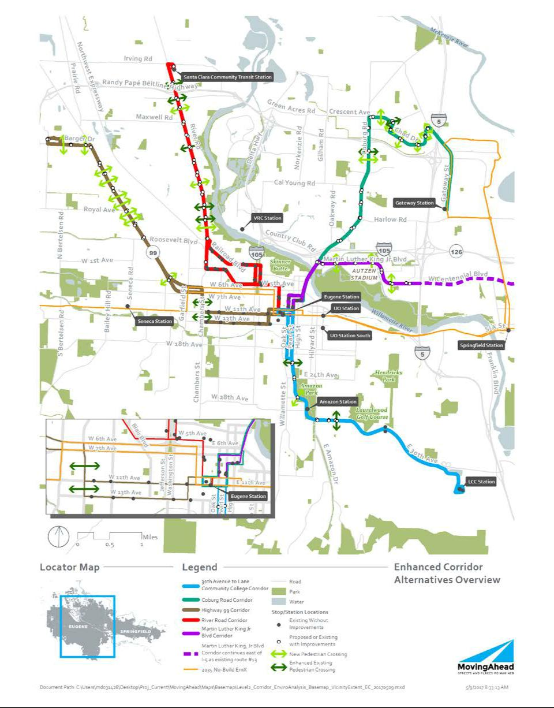

Lane Transit District | DRAFT FINAL Cultural Resources Technical Report | July 7, 2017
City of Eugene | MovingAhead Project | S-3

Figure S.1-2. EmX Alternatives Overview
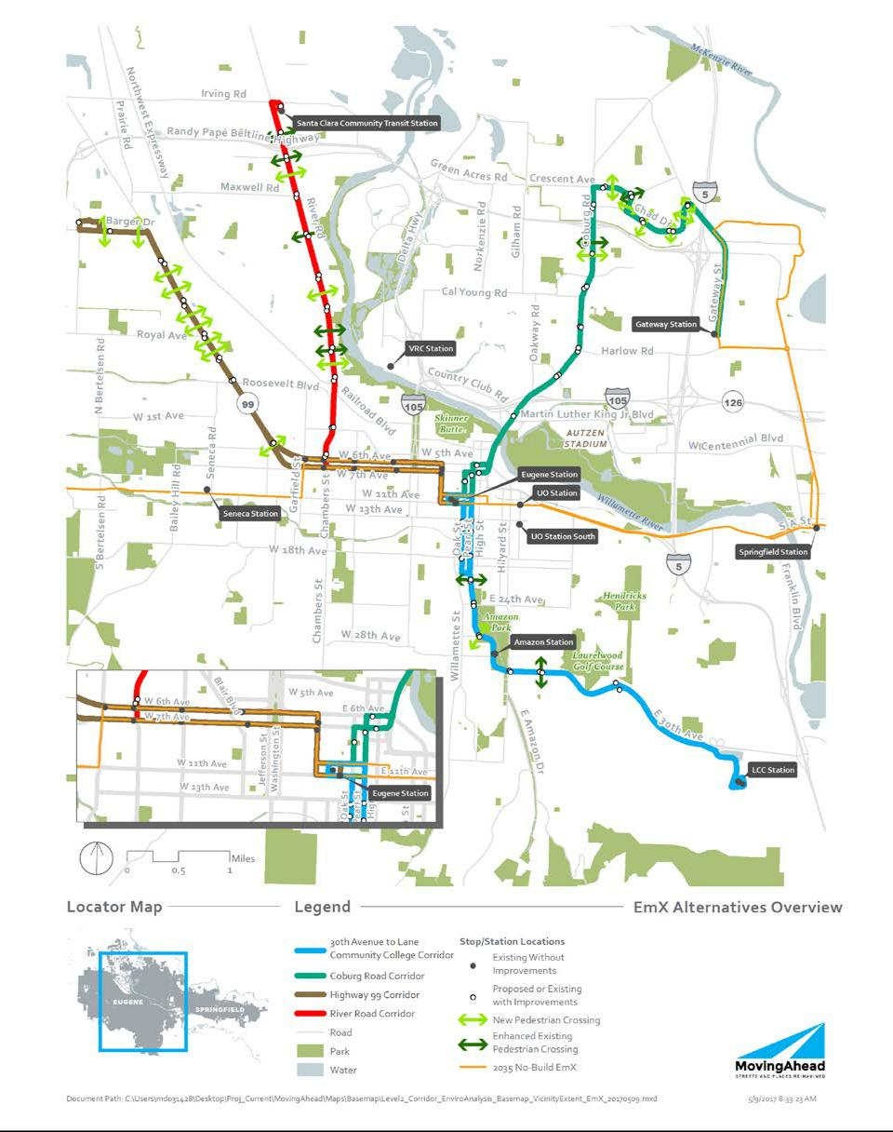

July 7, 2017 | DRAFT FINAL Cultural Resources Technical Report | Lane Transit District
S-4 | MovingAhead Project | City of Eugene

The next and final phase of documentation for NEPA compliance will review the APE implemented for the Level 2 Alternatives Analysis and revise it as needed. Based on this two-step process—a narrow APE definition at the Phase 2 AA level and the potential for an expanded APE at the final NEPA level—LTD and FTA will review and finalize a proposed APE for Section 106 analysis. FTA will seek concurrence of the proposed APE from the Oregon State Historic Preservation Office (SHPO) once the extent of direct landscape alterations and the indirect impacts to traffic patterns of the project are known.

The APE for archaeological resources will be confined to locations that will be directly impacted by the project, but it will include locations where historical structures would be removed by the proposed project.

A records review and archaeological survey conducted for each of the five corridors did not result in the identification of any archaeological resources within the APE.

Eligible or potentially eligible historic resources include those that are formally listed on the National Register (noted as ES NR in the resource summary tables), have been approved as City Landmarks, are considered to meet National Register of Historic Places (NRHP) eligibility standards individually (eligible significant or ES), or could be considered contributing properties in a potential historic district or grouping (eligible contributing or EC) under one or more NRHP criteria. Eligible or potentially eligible historic resources were identified as follows along the corridors and summarized in the sections that follow:

- Highway 99 Corridor (42 resources)

- River Road Corridor (25 resources)

- 30th Avenue to LCC Corridor (90 resources)

- Coburg Road Corridor (24 resources)

- Martin Luther King, Jr. Boulevard Corridor (4 resources)

S.1.1. Highway 99 Corridor

No archaeological sites are currently recorded within the Highway 99 Corridor APE. One site has been recorded in the larger 1-mile study area, along with some discoveries of isolated artifacts.

A review of the Oregon SHPO database and the NRHP database for listed properties along the Highway 99 Corridor resulted in the identification of no historic resources that are formally listed on the NRHP at present. Two historic resources are inventoried in the Oregon SHPO historic resources database as eligible for the NRHP. During the windshield survey, 40 additional historic properties, including three resource groupings, were identified as potentially eligible.

S.1.2. River Road Corridor

No archaeological sites are recorded within the River Road Corridor APE. Three sites are present in the larger 1-mile study area.

Based on the Oregon SHPO database and the windshield survey, a total of 75 properties was identified as potentially eligible for the NRHP. Four of the properties are city landmarks listed by the City of Eugene.

Lane Transit District | DRAFT FINAL Cultural Resources Technical Report | July 7, 2017
City of Eugene | MovingAhead Project | S-5

S.1.3. 30th Avenue to Lane Community College Corridor

No archaeological sites are documented within the 30th Avenue to LCC Corridor APE, although site 35LA1109 is just north of 30th Avenue near LCC and may extend south into the APE.

Reviews of the Oregon SHPO database and the NRHP database for listed properties along the 30th Avenue to LCC Corridor resulted in the identification of four historic resources along the proposed APE corridor (between 11th and 17th Avenues, along Oak and Pearl Streets) that are formally listed on the NRHP at present. Two city landmarks (one of which is also listed in the NRHP) have also been recognized in the same neighborhood along the proposed corridor.

S.1.4. Coburg Road Corridor

The Coburg Road Corridor APE passes through three archaeological sites. These are site 35LA1329, the community trash dump, on the north side of the Ferry Street Bridge; and sites 35LA1277 and 35LA1466 are on either side of the south end of the bridge.

A review of the Oregon SHPO database and the NRHP database for listed properties along the Coburg Road Corridor resulted in the identification of only one historic resource—the Ferry Street Bridge—along the proposed APE corridor north of the Willamette River. No resources are formally listed on the NRHP, and no city landmarks appear to be close to the proposed corridor.

Because the portion of the corridor north of the river was developed primarily in recent decades, most of the potentially eligible historic resources identified during the reconnaissance of the APE were constructed between 1940 and 1968. Based on the SHPO database and the windshield survey, a total of 23 individual properties and one potential historic district was identified f as eligible or potentially eligible for the NRHP.

S.1.5. Martin Luther King, Jr. Boulevard Corridor

The portion of the corridor APE along Coburg Road passes through site 35LA1329, the community trash dump, on the north side of the Ferry Street Bridge; and sites 35LA1277 and 35LA1466 are on either side of the south end of the bridge.

The Martin Luther King, Jr. Boulevard Corridor north of the river was constructed relatively recently (after World War II), at which time this area began its transition from agricultural lands to incorporate more commercial and residential use. Based on the Oregon SHPO database and the windshield survey, four historic resources were identified f as eligible or potentially eligible for the NRHP.

S.2. Environmental Consequences

A high-level determination of impacts and effects to historic resources was conducted for screening purposes for both above ground and below ground resources (see Table S.4-1). This preliminary analysis was based upon the findings of the data collection and significance assessment of historic resources. A final impact analysis for the final project design will be conducted during the NEPA documentation.

July 7, 2017 | DRAFT FINAL Cultural Resources Technical Report | Lane Transit District
S-6 | MovingAhead Project | City of Eugene

S.2.1. Direct and Short-Term Impacts Approach

Construction impacts within the APE may result in the loss, destruction, or alteration of the historic character or integrity of significant cultural or historical resources and would be evaluated in the Section 106 process in the Findings of Effect and be mitigated for in a Memorandum of Agreement (MOA).

Aside from these direct impacts, it is assumed that the short-term impacts (noise, air, change in access, etc.) on historic resources associated with construction.

Potential direct and short-term impacts to historic resources are enumerated in Table S.4-1 and discussed in more detail in Chapters 5 through 9 of this report and summarized in the following subsections.

S.2.1.1. Highway 99 Enhanced Corridor Alternative

Four resources and one resource grouping (of four lots) may be affected by direct, long-term impacts.

S.2.1.2. Highway 99 EmX Alternative

Four resources may be affected by direct, long-term impacts under this alternative.

S.2.1.3. River Road Corridor Enhanced Corridor Alternative

Under the Enhanced Corridor Alternative, four resources may be affected by direct, long-term impacts.

S.2.1.4. River Road Corridor EmX Alternative

Up to 12 historic resources may be affected by direct, long-term impacts under the EmX Alternative, potentially resulting in adverse effects.

S.2.1.5. 30th Avenue to LCC Enhanced Corridor Alternative

Under the Enhanced Corridor Alternative, three resources are anticipated to sustain direct, long-term impacts based on the current design.

S.2.1.6. 30th Avenue to LCC Corridor EmX Alternative

Direct impacts to historic resources are outlined in Table 6.1-4. Up to four historic resources may be affected by direct, long-term impacts under the EmX Alternative.

S.2.1.7. Coburg Road Enhanced Corridor Alternative

Under the Enhanced Corridor Alternative, seven resources are anticipated to be affected by direct, long-term impacts based on the current design.

S.2.1.8. Coburg Road Corridor EmX Alternative

Up to eight historic resources may be affected by direct, long-term impacts under the EmX Alternative.

Lane Transit District | DRAFT FINAL Cultural Resources Technical Report | July 7, 2017
City of Eugene | MovingAhead Project | S-7

S.2.1.9. Martin Luther King, Jr. Boulevard Enhanced Corridor

Under the Enhanced Corridor Alternative, no resources are anticipated to sustain direct, long-term effects based on the current design.

S.2.2. Indirect Impacts Analysis Approach

Determination of impacts and effects to historic resources during the NEPA documentation depend on the findings of ancillary studies, including but not restricted to traffic, noise, air and aesthetics. The effects of traffic levels on historic properties are determined by the findings pertaining to indirect impacts of traffic on noise levels and air quality. The visual effects of the project on historic resources are based on the visual resources impact analysis. Beneficial effects may include improved access to historic community resources. The thresholds used for determining significant impacts in these other disciplines are the same as those used for Section 106 assessments.

Potential indirect impacts to historic resources are enumerated in Table S.4-1 and discussed in more detail in Chapters 5 through 9 of this report. However, of the indirect impacts identified under any of the alternatives, none are anticipated to result in adverse effect findings under Section 106.

S.2.3. Cumulative Impact Analysis Approach

Other past, current and future transportation projects in the vicinity of the APE, as defined for the project, are reviewed for additive impacts to historic and cultural resources. For indirect (secondary) effects, the APE is re-assessed if historic structures are removed or if structures are removed and expose historic structures not previously visible. Notable trends in degradation of housing, neighborhoods, commercial or industrial areas containing historic resources, as identified by local planning officials are also considered in the cumulative analysis.

Overall, the alternatives did not result in substantial direct or indirect impacts. Indirect impacts would not result in a physical impact to the resource, but may include the construction of enhanced stops or road widening sufficiently close to affect the visual character of the historical setting of the property or other attributes that contribute to its NRHP eligibility. Under Section 106, the impacts may affect a property, but are not likely to result in an adverse effect determination. Therefore, the proposed alternatives would not substantially contribute to a cumulative impact.

Potential cumulative impacts to historic resources are enumerated in Table S.4-1 and discussed in more detail in Chapters 5 through 9 of this report.

S.3. Mitigation Options

If, in future phases, adverse effects determinations are made on historic resources, then mitigation plans will be designed and drafted in cooperation with LTD, SHPO, local jurisdictions, and FTA. Mitigation measures may include interpretive panels, photo documentation, Historic American Building Survey/Historic American Engineering Record reporting, historic context statements, and/or other measures as agreed upon. FTA will also consult with SHPO and entities with jurisdiction (historic societies, property owners, and local agencies) over the resource to develop specific cultural resource

July 7, 2017 | DRAFT FINAL Cultural Resources Technical Report | Lane Transit District
S-8 | MovingAhead Project | City of Eugene

mitigation measures. These measures would then be recorded in a MOA as part of the NEPA documentation.

Potential mitigation measures are listed in Table S.4-1 and discussed in more detail in Chapters 5 through 9 of this report.

S.4. Conclusions

This preliminary analysis was based upon the findings of the data collection and significance assessment of historic resources. Although some historic resources are likely to be affected by property acquisitions, modifications to property access, changes to parking strips and historic treescapes, and construction of stops or stations in the immediate vicinity of the resources, it is anticipated that changes to project design on all corridor alternatives can eliminate or minimize adverse effects, as listed in Table S.4-1. Final impact analysis for the final project design will be conducted during the NEPA documentation. There are no anticipated effects to known archaeological resources as none have been identified within the project APE for any of the corridors.

Lane Transit District | DRAFT FINAL Cultural Resources Technical Report | July 7, 2017
City of Eugene | MovingAhead Project | S-9

Table S.4-1. Summary of Cultural Resources Environmental Consequences by Corridor and Alternativeª

 | Temporary / Short-Term | Long-Term Direct | Indirect / Cumulative |  | Unavoidable
 | Construction-Related | Long-Term Direct | Indirect / Cumulative | Mitigation Measures | Unavoidable
 | Construction-Related | Impacts / Benefits | Effects | Mitigation Measures | Adverse Effects
Alternatives | Impacts / Benefits | Impacts / Benefits | Effects |  | Adverse Effects

Highway 99 Corridor

No-Build Alternative | • | No impact
Enhanced Corridor | • | None anticipated
Alternative |  | beyond long-term
 |  | direct impacts

EmX Alternative • None anticipated

beyond long-term

direct impacts

• | No impact | • | No impact | • | None | • | None
• | Impacts to 4 | • | Impacts to 5 | • | Reduce ROW | • | Adverse effects
 | individual |  | resources |  | acquisitions |  | can likely be
 | resources and one |  |  | • | Move stop locations |  | avoided through
 | grouping |  |  |  | away from historic |  | project design
 |  |  |  |  | resources
 |  |  |  | • | Mitigation plan
 |  |  |  |  | under MOA to offset
 |  |  |  |  | impacts
 |  |  |  |  | (interpretation,
 |  |  |  |  | documentation, etc.)
• | Impacts to 4 | • | Impacts to 6 | • | Reduce ROW | • | Adverse effects
 | resources |  | individual resources |  | acquisitions |  | can likely be
 |  |  | and one grouping | • | Move station |  | avoided through
 |  |  |  |  | locations away from |  | project design
 |  |  |  |  | historic resources
 |  |  |  | • | Mitigation plan
 |  |  |  |  | under MOA to offset
 |  |  |  |  | impacts
 |  |  |  |  | (interpretation,
 |  |  |  |  | documentation, etc.)

July 7, 2017 | DRAFT FINAL Cultural Resources Technical Report | Lane Transit District
S-10 | MovingAhead Project | City of Eugene

Table S.4-1. Summary of Cultural Resources Environmental Consequences by Corridor and Alternativeª

 | Temporary / Short-Term | Long-Term Direct | Indirect / Cumulative |  | Unavoidable
 | Construction-Related | Long-Term Direct | Indirect / Cumulative | Mitigation Measures | Unavoidable
 | Construction-Related | Impacts / Benefits | Effects | Mitigation Measures | Adverse Effects
Alternatives | Impacts / Benefits | Impacts / Benefits | Effects |  | Adverse Effects

River Road Corridor

No-Build Alternative | • | No impact
Enhanced Corridor | • | None anticipated
Alternative |  | beyond long-term
 |  | direct impacts

EmX Alternative • None anticipated

beyond long-term

direct impacts

• | No impact | • | No impact | • | None | • | None
• | Impacts to 4 | • | Impacts to 22 | • | Reduce ROW | • | Adverse effects
 | resources |  | resources |  | acquisitions |  | can likely be
 |  |  |  | • | Move stop locations |  | avoided through
 |  |  |  |  | away from historic |  | project design
 |  |  |  |  | resources
 |  |  |  | • | Mitigation plan
 |  |  |  |  | under MOA to offset
 |  |  |  |  | impacts
 |  |  |  |  | (interpretation,
 |  |  |  |  | documentation, etc.)
• | Impacts to 12 | • | Impacts to 8 | • | Reduce ROW | • | Adverse effects
 | resources |  | resources |  | acquisitions |  | can likely be
 |  |  |  | • | Move station |  | avoided through
 |  |  |  |  | locations away from |  | project design
 |  |  |  |  | historic resources
 |  |  |  | • | Mitigation plan
 |  |  |  |  | under MOA to offset
 |  |  |  |  | impacts
 |  |  |  |  | (interpretation,
 |  |  |  |  | documentation, etc.)

Lane Transit District | DRAFT FINAL Cultural Resources Technical Report | July 7, 2017
City of Eugene | MovingAhead Project | S-11

Table S.4-1. Summary of Cultural Resources Environmental Consequences by Corridor and Alternativeª

 | Temporary / Short-Term | Long-Term Direct | Indirect / Cumulative |  | Unavoidable
 | Construction-Related | Long-Term Direct | Indirect / Cumulative | Mitigation Measures | Unavoidable
 | Construction-Related | Impacts / Benefits | Effects | Mitigation Measures | Adverse Effects
Alternatives | Impacts / Benefits | Impacts / Benefits | Effects |  | Adverse Effects

30th Avenue to Lane Community College Corridor

No-Build Alternative | • | No impact
Enhanced Corridor | • | None anticipated
Alternative |  | beyond long-term
 |  | direct impacts

EmX Alternative • None anticipated

beyond long-term

direct impacts

• | No impact | • | No impact | • | None | • | None
• | Impacts to 3 | • | Impacts to 23 | • | Reduce ROW | • | Adverse effects
 | resources |  | resources |  | acquisitions |  | can likely be
 |  |  |  | • | Move stop locations |  | avoided through
 |  |  |  |  | away from historic |  | project design
 |  |  |  |  | resources
 |  |  |  | • | Mitigation plan
 |  |  |  |  | under MOA to offset
 |  |  |  |  | impacts
 |  |  |  |  | (interpretation,
 |  |  |  |  | documentation, etc.)
• | Impacts to 4 | • | Impacts to 10 | • | Reduce ROW | • | Adverse effects
 | resources |  | resources |  | acquisitions |  | can likely be
 |  |  |  | • | Move station |  | avoided through
 |  |  |  |  | locations away from |  | project design
 |  |  |  |  | historic resources
 |  |  |  | • | Mitigation plan
 |  |  |  |  | under MOA to offset
 |  |  |  |  | impacts
 |  |  |  |  | (interpretation,
 |  |  |  |  | documentation, etc.)

July 7, 2017 | DRAFT FINAL Cultural Resources Technical Report | Lane Transit District
S-12 | MovingAhead Project | City of Eugene

Table S.4-1. Summary of Cultural Resources Environmental Consequences by Corridor and Alternativeª

 | Temporary / Short-Term | Long-Term Direct | Indirect / Cumulative |  | Unavoidable
 | Construction-Related | Long-Term Direct | Indirect / Cumulative | Mitigation Measures | Unavoidable
 | Construction-Related | Impacts / Benefits | Effects | Mitigation Measures | Adverse Effects
Alternatives | Impacts / Benefits | Impacts / Benefits | Effects |  | Adverse Effects

Coburg Road Corridor

No-Build Alternative | • | No impact
Enhanced Corridor | • | None anticipated
Alternative |  | beyond long-term
 |  | direct impacts

EmX Alternative • None anticipated

beyond long-term

direct impacts

• | No impact | • | No impact | • | None | • | None
• | Impacts to 7 | • | Impacts to 5 | • | Reduce ROW | • | Adverse effects
 | resource |  | resources |  | acquisitions |  | can likely be
 |  |  |  | • | Move stop locations |  | avoided through
 |  |  |  |  | away from historic |  | project design
 |  |  |  |  | resources
 |  |  |  | • | Mitigation plan
 |  |  |  |  | under MOA to offset
 |  |  |  |  | impacts
 |  |  |  |  | (interpretation,
 |  |  |  |  | documentation, etc.)
• | Impacts to 8 | • | Impacts to 4 | • | Reduce ROW | • | Adverse effects
 | resources |  | resources |  | acquisitions |  | can likely be
 |  |  |  | • | Move station |  | avoided through
 |  |  |  |  | locations away from |  | project design
 |  |  |  |  | historic resources
 |  |  |  | • | Mitigation plan
 |  |  |  |  | under MOA to offset
 |  |  |  |  | impacts
 |  |  |  |  | (interpretation,
 |  |  |  |  | documentation, etc.)

Lane Transit District | DRAFT FINAL Cultural Resources Technical Report | July 7, 2017
City of Eugene | MovingAhead Project | S-13

Table S.4-1. Summary of Cultural Resources Environmental Consequences by Corridor and Alternativeª

 | Temporary / Short-Term | Long-Term Direct | Indirect / Cumulative |  | Unavoidable
 | Construction-Related | Long-Term Direct | Indirect / Cumulative | Mitigation Measures | Unavoidable
 | Construction-Related | Impacts / Benefits | Effects | Mitigation Measures | Adverse Effects
Alternatives | Impacts / Benefits | Impacts / Benefits | Effects |  | Adverse Effects

Martin Luther King, Jr. Blvd. Corridor

No-Build Alternative | • | No impact | • | No impact | • | No impact | • | None | • | None
Enhanced Corridor | • | None anticipated | • | None anticipated | • | None anticipated | • | None anticipated | • | None
Enhanced Corridor | • | None anticipated |  |  |  |  |  |  |  | anticipated
Alternative |  |  |  |  |  |  |  |  |  | anticipated

Note: No anticipated effects to known archaeological resources (for all corridors and alternatives).

- Impact analysis is preliminary, pending more detailed study for NEPA clearance.

July 7, 2017 | DRAFT FINAL Cultural Resources Technical Report | Lane Transit District
S-14 | MovingAhead Project | City of Eugene

- Introduction

1.1. MovingAhead Technical Reports

A total of 20 technical reports have been prepared for the MovingAhead Project. The technical reports have been prepared to support the selection of preferred alternatives for the MovingAhead Project and subsequent environmental documentation. The technical reports assume that any corridors advanced for environmental review will require a documented categorical exclusion under the National Environmental Policy Act (NEPA). Any corridors requiring a higher level of environmental review would be supported by the technical evaluation but might not be fully covered by the technical evaluation.

Technical reports have been prepared for the following disciplines:

- Acquisitions and Displacements

- Air Quality

- Capital Cost Estimating

- Community Involvement, Agency and Tribal Coordination

- Community, Neighborhood, and Environmental Justice

- Cultural Resources

- Ecosystems (Biological, Fish Ecology, Threatened and Endangered Species, Wetlands and Waters of the U.S. and State)

- Energy and Sustainability

- Geology and Seismic

- Hazardous Materials

- Land Use and Prime Farmlands

- Noise and Vibration

- Operating and Maintenance Costs

- Parklands, Recreation Areas, and Section 6(f)

- Section 4(f)

- Socioeconomics and Environmental Justice

- Street and Landscape Trees

- Transportation

- Utilities

- Visual and Aesthetic Resources

- Water Quality, Floodplain, and Hydrology

In general, each technical report includes the following information for identifying effects:

- Relevant laws and regulations

- Contacts and coordination

- Summary of data sources and analysis methods described in the MovingAhead Environmental Disciplines Methods and Data Report (CH2M HILL, Inc. [CH2M] et al., 2015)

- Affected environment

- Adverse and beneficial effects including short-term, direct, indirect and cumulative

Lane Transit District | DRAFT FINAL Cultural Resources Technical Report | July 7, 2017
City of Eugene | MovingAhead Project | 1-1

- Mitigation measures

- Permits and approvals

- References

1.2. Cultural Resources Technical Report and Purpose

This technical report describes the analysis methodologies and initial results of the Cultural Resources assessment for the MovingAhead corridor alternatives. Cultural resources include both archaeological and historical sites. The purpose of the cultural resources evaluation is to ensure that the proposed project complies with laws, regulations, and policies set forth at the federal, state, and local levels. This report represents a preliminary identification of cultural resources potentially affected, as well as an initial analysis of those effects for comparative purposes for each of the corridors under consideration. For those corridors selected for further consideration, a final phase of documentation will be conducted for NEPA compliance with the goal of avoiding or minimizing project effects on cultural resources.

This report describes the potential Cultural Resources impacts of the alternatives, and address possible mitigation measures for impacts, if needed. The report includes a discussion of the following elements:

- Existing Cultural Resources conditions in areas potentially affected by the alternatives

- Regulations and policy governing evaluation of impacts and mitigation

- Methodology used in the analysis

- Impacts of the alternatives (short-term, long-term, cumulative, and indirect)

- Potential mitigation measures

1.3. Discipline Experts

Discipline experts who contributed to the preparation of this report are identified in Table 1.3-1, including their areas of expertise, affiliated organizations, titles, and years of experience.

Table 1.3-1. | Discipline Experts
 |  |  | Affiliated
Discipline |  | Technical Expert | Organization | Title / Years of Experience
Cultural Resources |  | Kathryn Toepel | Heritage Research | Cultural Resource Principal / 36 years
 |  | Albert C. Oetting | Heritage Research | Senior Archaeologist / 30 years
 |  | Liz Carter | Heritage Research | Senior Historic Preservationist/ 23 years
Editors
 |  | Lynda Wannamaker | Wannamaker | President / 33 years
 |  |  | Consulting
 |  | Scott Richman | CH2M | Senior Project Manager / 24 years
 |  | Sasha Luftig | LTD | Development Project Manager / 9 years
 |  | Zach Galloway | City of Eugene | Senior Planner / 10 years

Source: MovingAhead Project Team. (2017).

July 7, 2017 | DRAFT FINAL Cultural Resources Technical Report | Lane Transit District
1-2 | MovingAhead Project | City of Eugene

1.4. Study Background

The purpose of the MovingAhead Project is to determine which high-capacity transit corridors identified in the adopted Central Lane Metropolitan Planning Organization Regional Transportation Plan (Lane Council of Governments [LCOG], 2011, December; RTP) and the Lane Transit District Long Range Transit Plan (Lane Transit District [LTD], 2014) as part of the Frequent Transit Network (FTN) are ready to advance to capital improvements programming in the near term. The study is being conducted jointly with the City of Eugene and LTD to facilitate a streamlined and cost-efficient process through concurrent planning, environmental review, and design and construction of multiple corridors. The study area includes Eugene and portions of unincorporated Lane County.

The Lane Transit District Long-Range Transit Plan (LTD, 2014) identifies the full Martin Luther King, Jr. Boulevard / Centennial Boulevard Corridor as a future part of the FTN. Initially, MovingAhead considered options on Centennial Boulevard to serve Springfield as part of this corridor. Because Springfield does not have the resources available to consider transit enhancements on Centennial Boulevard at this time, MovingAhead will only develop Emerald Express (EmX) and Enhanced Corridor Alternatives within Eugene. Figure 1.4-1 presents LTD’s existing and future bus rapid transit (BRT) system.

Figure 1.4-1. Lane Transit District's Bus Rapid Transit (BRT) System
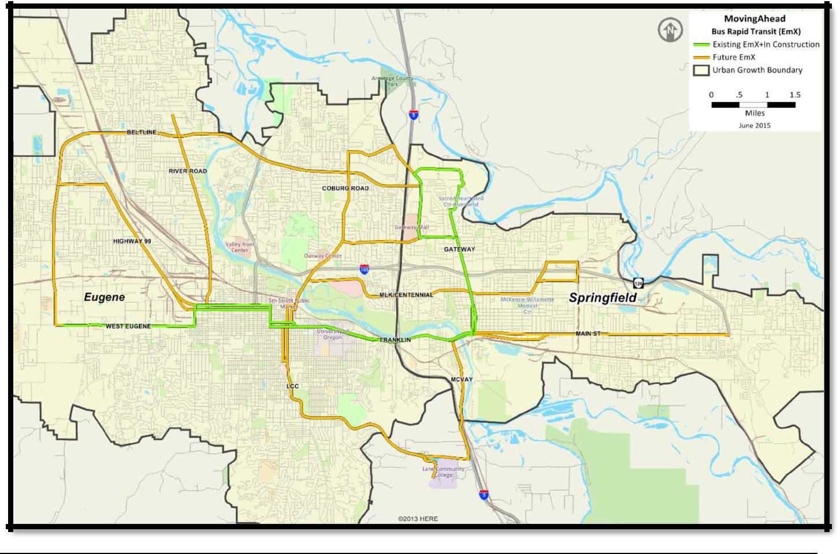

Source: LTD. (2015, Amended 2015, June).

Lane Transit District | DRAFT FINAL Cultural Resources Technical Report | July 7, 2017
City of Eugene | MovingAhead Project | 1-3

1.5. Screening and Evaluation of Multimodal Options

The MovingAhead Project process includes two phases. This first phase has three discrete but closely related tasks: identifying transit improvements; identifying improvements for bicyclists, pedestrians, and users of mobility devices; and preparing a NEPA-compliant evaluation of alternatives focused on the region’s transportation system. Corridor options identified as part of the first phase were developed using multimodal cross sections that include variations on automobile, truck, and bus travel lanes; bicycle lanes; landscaping strips; and sidewalks. At the end of the first phase, the City of Eugene and LTD will select the corridors that are most ready for near-term capital improvements and prioritize improvements for funding. The selected corridors will be advanced to the second phase, which will focus on preparing NEPA environmental reviews (Documented Categorical Exclusions), and initiating the Federal Transit Administration (FTA) project development process.

1.5.1. Fatal Flaw Screening

The project team conducted a fatal flaw screening in February 2015 to identify which of the 10 corridors should not move forward to the Level 1 Screening Evaluation (Figure 1.5-1). This high-level evaluation used criteria based on MovingAhead’s Purpose, Need, Goals, and Objectives (LTD, 2015, Amended 2015, June) and existing data to determine which corridors were not ready for capital investment in BRT or multimodal infrastructure in the next 10 years. The screening was conducted with local, regional, and state agency staff. Of the 10 corridors identified, the following three corridors were not advanced from the fatal flaw screening to the Level 1 Screening Evaluation: 18th Avenue, Bob Straub Parkway, and Randy Papé Beltline Highway. Table 1.5-1 shows the results of the fatal flaw screening.

Although originally advanced from the fatal flaw screening, the Main Street-McVay Highway Corridor was also not advanced to the Level 1 Screening Evaluation because the Springfield City Council (on May 18, 2015) and LTD Board (on May 20, 2015) determined that the corridor is ready to advance to a study to select a locally preferred transit solution. At the time (May 2015), the Main Street-McVay Highway Corridor was on a schedule ahead of the MovingAhead Project schedule. If the Main Street-McVay Highway Corridor study schedule is delayed and its progress coincides with this project, the corridor could be reincorporated back into MovingAhead.

July 7, 2017 | DRAFT FINAL Cultural Resources Technical Report | Lane Transit District
1-4 | MovingAhead Project | City of Eugene

Figure 1.5-1. MovingAhead Phase 1 Steps
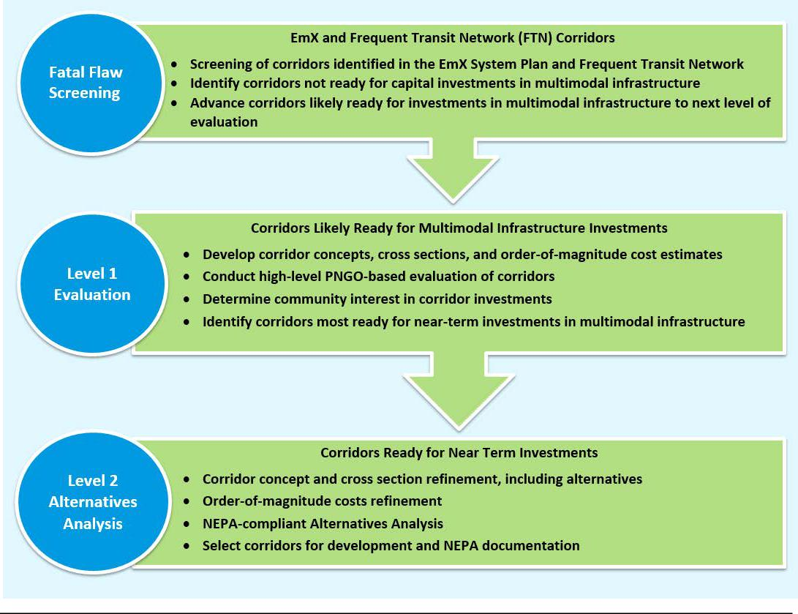

Source: Wannamaker Consulting. (2015).

Lane Transit District | DRAFT FINAL Cultural Resources Technical Report | July 7, 2017
City of Eugene | MovingAhead Project | 1-5

Table 1.5-1. | Results of the Fatal Flaw Screening
 | Corridor | Advanced to Level 1 | Consider Later
Highway 99 |  | ✓
River Road |  | ✓
Randy Papé Beltline |  |  | ✓
18th Avenue |  |  | ✓
Coburg Road |  | ✓
Martin Luther King, Jr. Boulevard / Centennial Boulevard |  | ✓
30th Avenue to Lane Community College |  | ✓
Main Street-McVay Highway |  | ✓
Valley River Center |  | ✓
Bob Straub Parkway |  |  | ✓


Source: LTD and City of Eugene. (2015, June).

The six remaining multimodal corridors were advanced to the Level 1 Screening Evaluation to determine how they compared with each other in meeting the Purpose, Need, Goals, and Objectives.

1.5.2. Level 1 Screening Evaluation

The Level 1 Screening Evaluation assessed how each corridor would perform according to the Purpose, Need, Goals, and Objectives of MovingAhead. The Level 1 Screening Evaluation used existing studies and readily available data to evaluate each corridor. Based on community input and technical analysis, the following corridors and alternatives were advanced from the Level 1 Screening Evaluation to the Level 2 Alternatives Analysis (AA) (Table 1.5-2):

- No-Build Alternatives: all corridors

- Enhanced Corridor and EmX Alternatives: o Highway 99 Corridor

o River Road Corridor

o 30th Avenue to Lane Community College (LCC) Corridor o Coburg Road Corridor

- Enhanced Corridor Alternative:

o Martin Luther King, Jr. Boulevard Corridor

The Valley River Center Corridor received the least public support during public outreach and was not carried forward to the Level 2 AA.

July 7, 2017 | DRAFT FINAL Cultural Resources Technical Report | Lane Transit District
1-6 | MovingAhead Project | City of Eugene

Table 1.5-2. Corridors and Transit Alternatives Advanced to the Level 2 Alternatives Analysis

Corridor | No-Build | Enhanced | EmX
Corridor | No-Build | Corridor | EmX
Highway 99 | ✓ | ✓ | ✓
River Road | ✓ | ✓ | ✓
30th Avenue to Lane Community College | ✓ | ✓ | ✓
Coburg Road | ✓ | ✓ | ✓
Martin Luther King, Jr. Boulevard | ✓ | ✓
Source: CH2M. (2016).


For a detailed discussion of alternatives and design options considered for each corridor, but not carried forward to the Level 2 AA, please refer to the MovingAhead Alternatives and Design Options Considered but Eliminated Technical Memorandum (CH2M, 2016).

1.5.3. Level 2 Alternatives Analysis

To guide the Level 2 AA, LTD is preparing new ridership forecasts and related evaluation measures using the LCOG regional model. Base-year and future-year forecasts are being prepared for corridor alternatives based upon updated inputs and transit networks specific to each corridor. The planning horizon year used for the Level 2 AA is 2035. The built and natural environments, transit operations, traffic, finance, historical resources, and other areas are also being evaluated as part of the Level 2 AA. The findings from the Level 2 AA will aid LTD and the City of Eugene in determining how corridors should be prioritized for capital investments over the next 5 years. Selected corridors will be advanced to Phase 2.

1.6. Purpose and Need

The prioritization of capital investments in multimodal transit corridors is a powerful tool for implementing local and regional comprehensive land use and transportation plans, agency strategic plans, and other community planning documents. Capital investments in multimodal transit corridors can have a substantial impact on patterns of growth and development. By coordinating the timing of, and prioritizing the funding for, strategic multimodal capital investments, the MovingAhead Project (a multimodal transit corridor study) helps ensure that future development is consistent with our region’s plans and vision.

The Purpose and Need Statement was refined based on public and agency input.

1.6.1. Purpose

The purpose of the MovingAhead Project is to:

Lane Transit District | DRAFT FINAL Cultural Resources Technical Report | July 7, 2017
City of Eugene | MovingAhead Project | 1-7

- Develop a Capital Improvements Program that forecasts and matches projected revenues and capital needs over a 10-year period
o Balance desired multimodal transit corridor improvements with the community’s financial resources
o Ensure the timely and coordinated construction of multimodal transit corridor infrastructure o Eliminate unanticipated, poorly planned, or unnecessary capital expenditures
- Identify the most economical means of financing multimodal transit corridor capital improvements

- Establish partnerships between LTD, City of Eugene, and other local agencies that prioritize multimodal transit infrastructure needs and promote interagency cooperation

- Ensure that multimodal transit corridor investments are consistent with local comprehensive land use and transportation plans

1.6.2. Need

The need for the MovingAhead Project is based on the following factors:

- LTD’s and the region’s commitment to implementing the region’s vision for BRT in the next 20 years consistent with the RTP that provides the best level of transit service in a cost-effective and sustainable manner.

- Need for streamlined environmental reviews to leverage systemwide analysis.

- Need to build public support for implementation of the systemwide vision.

- Selection of the next EmX / FTN corridors is based on long-range operational and financial planning for LTD’s service.

1.6.3. Goals and Objectives

Goal 1: Improve multimodal transit corridor service

Objective 1.1: Improve transit travel time and reliability

Objective 1.2: Provide convenient transit connections that minimize the need to transfer

Objective 1.3: Increase transit ridership and mode share in the corridor

Objective 1.4: Improve access for people walking and bicycling, and to transit

Objective 1.5: Improve the safety of pedestrians and bicyclists accessing transit, traveling in and along the corridor, and crossing the corridor

Goal 2: Meet current and future transit demand in a cost-effective and sustainable manner

Objective 2.1: Control the increase in transit operating cost to serve the corridor

Objective 2.2: Increase transit capacity to meet current and projected ridership demand

Objective 2.3: Implement corridor improvements that provide an acceptable return on investment

Objective 2.4: Implement corridor improvements that minimize impacts to the environment and,

where possible, enhance the environment

Objective 2.5: Leverage funding opportunities to extend the amount of infrastructure to be constructed for the least amount of dollars

Goal 3: Support economic development, revitalization, and land use redevelopment opportunities for the corridor

Objective 3.1: Support development and redevelopment as planned in other adopted documents

July 7, 2017 | DRAFT FINAL Cultural Resources Technical Report | Lane Transit District
1-8 | MovingAhead Project | City of Eugene

Objective 3.2: Coordinate transit improvements with other planned and programmed pedestrian and bicycle projects

Objective 3.3: Coordinate transit improvements with other planned and programmed roadway projects

Objective 3.4: Minimize adverse impacts to existing businesses and industry

Objective 3.5: Support community vision for high capacity transit in each corridor

Objective 3.6: Improve transit operations on state facilities in a manner that is mutually beneficial to vehicular and freight traffic flow around transit stops and throughout the corridor

Objective 3.7: Improve transit operations in a manner that is mutually beneficial to vehicular traffic flow for emergency service vehicles

1.6.4. Evaluation Criteria

Evaluation criteria will be used during the Trade-off Analysis, which is part of the Level 2 AA, to aid in determining how well each of the corridor alternatives would meet the project’s Purpose, Need, Goals, and Objectives. The evaluation criteria require a mix of quantitative data and qualitative assessment. The resulting data will be used to measure the effectiveness of each proposed corridor alternative and to assist in comparing and contrasting the alternatives and options. In Table 1.6-1, evaluation criteria are listed for each of the project’s objectives. Some objectives have only one criterion for measuring effectiveness, while others require several criteria.

Table 1.6-1. Evaluation Criteria

Goals and Objectives Evaluation Criteria

Goal 1: Improve multimodal transit corridor service

Objective 1.1: Improve transit travel time and reliability

Objective 1.2: Provide convenient transit connections that minimizes the need to transfer

Objective 1.3: Increase transit ridership and mode share in the corridor

- Round-trip p.m. peak transit travel time between select origins and destinations

- On-time performance (no more than 4 minutes late) of transit service

- Number of transfers required between heavily used origin-destination pairs

- Average weekday boardings on corridor routes

- Transit mode share along the corridor

- Population within 0.5 mile of transit stop

- Employment within 0.5 mile of transit stop

Objective 1.4: Improve access for people walking and bicycling, and to transit

Objective 1.5: Improve the safety of pedestrians and bicyclists accessing transit, traveling in and along the corridor, and crossing the corridor

- Connectivity to existing pedestrian facilities

- Connectivity to existing bicycle facilities

- Opportunity to provide a safe and comfortable environment for pedestrians and bicyclists in the corridor

Lane Transit District | DRAFT FINAL Cultural Resources Technical Report | July 7, 2017
City of Eugene | MovingAhead Project | 1-9

Table 1.6-1. | Evaluation Criteria
 | Goals and Objectives | Evaluation Criteria

Goal 2: Meet current and future transit demand in a cost-effective and sustainable manner

Objective 2.1: Control the increase in transit operating • Cost per trip

cost to serve the corridor • Impact on LTD operating cost

• Cost to local taxpayers

Objective 2.2: Increase transit capacity to meet current and projected ridership demand

Objective 2.3: Implement corridor improvements that provide an acceptable return on investment

Objective 2.4: Implement corridor improvements that minimize impacts to the environment and, where possible, enhance the environment

- Capacity of transit service relative to the current and projected ridership

- Benefit / cost assessment of planned improvements

- Results of screening-level assessment of environmental impacts of transit solutions

Objective 2.5: Leverage funding opportunities to extend the amount of infrastructure to be constructed for the least amount of dollars

- Number and dollar amount of funding opportunities that could be leveraged

- Meet the FTA’s Small Starts funding requirements

Goal 3: Support economic development, revitalization and land use redevelopment opportunities for the corridor

Objective 3.1: Support development and redevelopment as planned in other adopted documents

- Consistent with the BRT System Plan and FTN concept

- Consistent with the Regional Transportation System Plan (Central Lane Metropolitan Planning Organization [MPO], 2007)
- Consistent with local comprehensive land use plans

Objective 3.2: Coordinate transit improvements with other planned and programmed pedestrian and bicycle projects

- Capability of transit improvement to coordinate with other planned and programmed pedestrian and bicycle projects identified in adopted plans and Capital Improvements Programs

Objective 3.3: Coordinate transit improvements with other planned and programmed roadway projects

- Capability of transit improvement to coordinate with other planned and programmed roadway projects identified in adopted plans and Capital Improvements Programs

July 7, 2017 | DRAFT FINAL Cultural Resources Technical Report | Lane Transit District
1-10 | MovingAhead Project | City of Eugene

Table 1.6-1. Evaluation Criteria

Goals and Objectives Evaluation Criteria

Objective 3.4: Minimize adverse impacts to existing businesses and industry

- Impacts to businesses along the Corridor measured in number and total acres of properties acquired, parking displacements, and access impacts.
- Impact on freight and delivery operations for Corridor businesses

Objective 3.5: Support community vision for high capacity transit in corridor

Objective 3.6: Improve transit operations on state facilities in a manner that is mutually beneficial to vehicular and freight traffic flow around transit stops and throughout the corridor

- Community vision includes high capacity transit in corridor

- Impact on current and future year intersection level of service (LOS) on state facilities

- Impact on current and future year p.m. peak hour auto / truck travel times on state facilities

Objective 3.7: Improve transit operations in a manner that is mutually beneficial to vehicular traffic flow for emergency service vehicles

- Qualitative assessment of potential impacts to emergency service vehicle traffic flow and access

Source: LTD and City of Eugene. (2015, June).

BRT = bus rapid transit

FTA = Federal Transit Administration

LOS = level of service

LTD = Lane Transit District

Lane Transit District | DRAFT FINAL Cultural Resources Technical Report | July 7, 2017
City of Eugene | MovingAhead Project | 1-11

Blank Page

July 7, 2017 | DRAFT FINAL Cultural Resources Technical Report | Lane Transit District
1-12 | MovingAhead Project | City of Eugene

- Alternatives Considered

This section briefly reviews the major features of the alternatives considered in the Level 2 AA. For full details on each alternative and the five corridors described in this technical report – Highway 99, River Road, 30th Avenue to LCC, Coburg Road, and Martin Luther King, Jr. Boulevard – refer to the MovingAhead Level 2 Definition of Alternatives (CH2M et al., 2016). Each corridor location is shown on Figures 2.1-1 and 2.1-2 for the Enhanced Corridor Alternatives and the EmX Alternatives, respectively.

Lane Transit District | DRAFT FINAL Cultural Resources Technical Report | July 7, 2017
City of Eugene | MovingAhead Project | 2-1

Figure 2.1-1. Enhanced Corridor Alternatives Overview
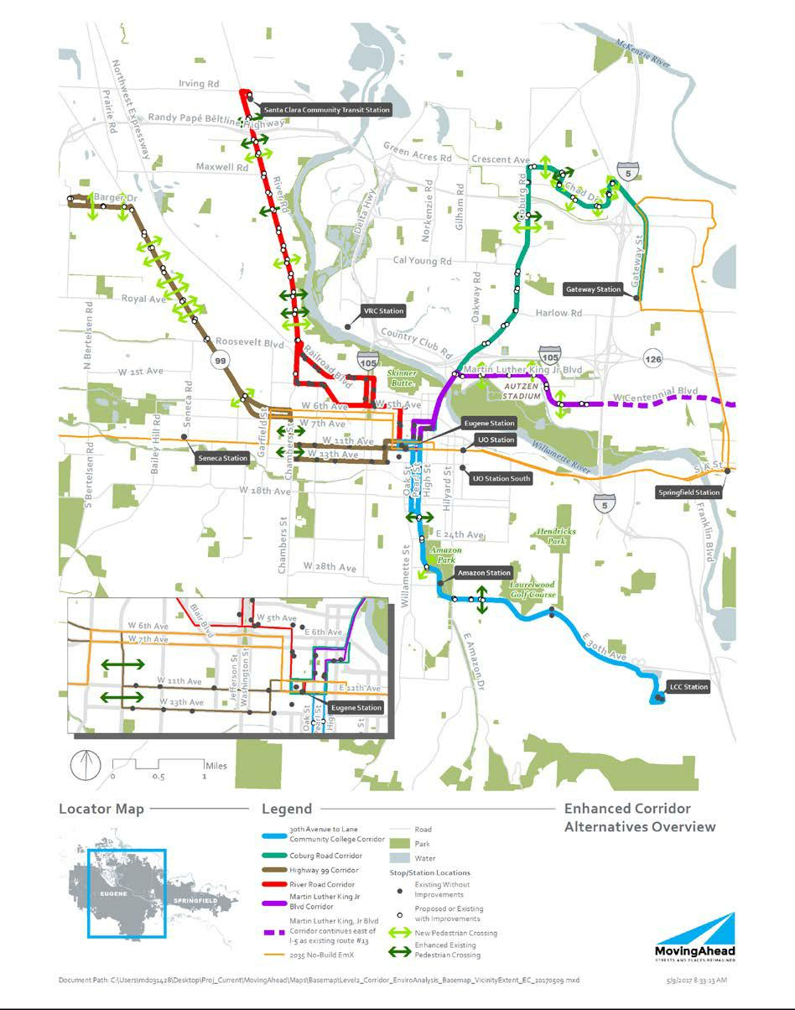

July 7, 2017 | DRAFT FINAL Cultural Resources Technical Report | Lane Transit District
2-2 | MovingAhead Project | City of Eugene

Figure 2.1-2. EmX Alternatives Overview
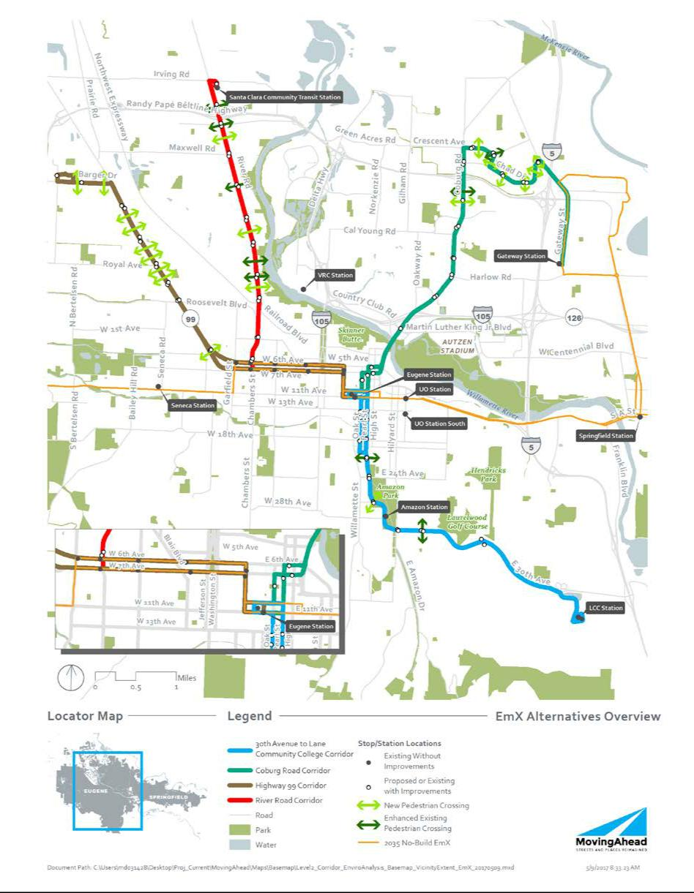

Lane Transit District | DRAFT FINAL Cultural Resources Technical Report | July 7, 2017
City of Eugene | MovingAhead Project | 2-3

2.1. No-Build Alternative Transit Network

This section describes the No-Build Alternative transit network, which is based on projected conditions in the year 2035, the project’s environmental forecast year. For each corridor, the No-Build Alternative serves as a reference point to gauge the benefits, costs, and effects of the build alternatives.

2.1.1. Capital Improvements

Under the No-Build Alternative, the following capital improvements are anticipated by 2035:

- West Eugene EmX Extension. Currently under construction, the West Eugene EmX Extension (WEEE) project and its associated capital improvements will be completed in 2017.

- Santa Clara Community Transit Center. The existing River Road Station is located at the southeast corner of the River Road / Randy Papé Beltline Highway interchange between the eastbound on-ramp and River Avenue. To meet growing demand and avoid the impacts of increasing congestion, LTD plans to relocate the River Road Station to a site north of the Randy Papé Beltline Highway at the southeast corner of River Road and Hunsaker Lane. Once relocated to the new site, the River Road Station would be renamed the Santa Clara Community Transit Center. This new transit center is planned to include a mix of uses including a park and ride lot, residential housing, community space, and commercial uses. The River Road Station relocation to the new site is anticipated to be completed by the end of 2018.

- Main Street EmX Extension. Included in the RTP and currently under study, the extension of the existing Franklin EmX line on Main Street from Springfield Station to Thurston Station and associated capital improvements (e.g., stations, bicycle and pedestrian facilities, and signal modifications) is anticipated to be completed within the 20-year planning horizon (2035). The No-Build Alternative transit network assumes EmX service on Main Street. However, the outcome of this study, and the ultimate improvements chosen, are uncertain at this time.

- McVay Highway Enhanced Corridor. Included in the RTP and currently under study, Enhanced Corridor service from Springfield Station on McVay Highway to LCC and associated capital improvements (e.g., improved stops, transit queue jumps, and improved bicycle and pedestrian crossings) is anticipated to be completed within the 20-year planning horizon (2035).

2.1.2. Transit Operations

The No-Build Alternatives for each corridor include changes to transit service anticipated as a result of the WEEE project, Main Street EmX Extension project, development of the Santa Clara Community Transit Center, and other changes to fixed route service. The following changes to the existing 2016 fixed route services are anticipated by 2035:

- Eliminated routes:

o Route 11 (replaced by Main Street EmX service) o Route 32 (replaced by WEEE service)
o Route 76 (replaced by WEEE service)

o Route 85 (replaced by Enhanced Corridor service on the McVay Highway) o Route 43 (replaced by WEEE service)

July 7, 2017 | DRAFT FINAL Cultural Resources Technical Report | Lane Transit District
2-4 | MovingAhead Project | City of Eugene

- Other route modifications:

o Add WEEE service (replaces Route 43 service on W. 11th Avenue) as extension of existing EmX service
o Add Main Street EmX service from Springfield Station to Thurston Station

o Add Route 2 with service from Barger Drive / Echo Hollow Road to Eugene Airport o Add Route 16 to connect north and south of Main Street with EmX service
o Add Enhanced Corridor service on McVay Highway from Springfield Station to LCC (replaces Route 85)

o Reroute Route 33 and extend to Amazon Parkway

o Reroute Route 36 to extend north of W. 11th Avenue to Barger Drive (replaces Route 43) o Reroute Route 41 via Highway 99 / Royal Avenue / W. 11th Avenue
o Reroute Route 40 via Royal Avenue / Elmira Road / Roosevelt Boulevard / Chambers Street /

- Add Route 44 paralleling Route 40 above to serve West Eugene

- Reroute Route 55 to extend to Santa Clara Community Transit Center

  - Reroute Route 93 with service continuing to Eugene Station via Seneca Station and service terminating at the WEEE terminus

- Change in service frequencies:

  - Increase service on Route 24 from 30-minute peak frequencies to 15-minute peak frequencies

  - Increase service on Route 28 from approximately 30-minute peak frequencies (varying 20- to 30-minute intervals) to 15-minute peak frequencies

  - Increase service on Route 41 from 30- and 15-minute peak frequencies to 15-minute peak frequencies

  - Increase service on Route 51 from 60-minute off-peak frequencies to 30-minute off-peak frequencies

  - Increase service on Route 52 from 60-minute off-peak frequencies to 30-minute off-peak frequencies

  - Increase service on Route 66 from 30- and 15-minute weekday a.m. peak, off-peak, and p.m. peak frequencies to 15-minute weekday a.m. peak, off-peak, and p.m. peak frequencies

  - Increase service on Route 67 from approximately 30-minute weekday a.m. peak, off-peak, and p.m. peak frequencies to 15-minute weekday a.m. peak, off-peak, and p.m. peak frequencies

  - Increase service on Route 78 from approximately 60-minute frequencies from 8 a.m. to 6 p.m. to 30-minute weekday a.m. peak, off-peak, and p.m. peak frequencies

  - Increase service on Route 79x from 30-minute peak frequencies to 10-minute peak frequencies, and modify off peak frequencies to 15 minutes from between 10 and 30 minutes currently

  - Decrease a.m. peak service on Route 93 from 60-minute frequencies to 120-minute frequencies during a.m. peak hours, and increase from no service between Veneta and the WEEE terminus to 120-minute frequencies during p.m. peak hours (off-peak service is 120-minute frequencies between Veneta and the WEEE terminus)

  - Decrease a.m. peak service on Route 96 from 30-minute frequencies to 60-minute frequencies, and increase off-peak service from no service between 8:20 a.m. and 3:40 p.m. to 60-minute off-peak frequencies

Key transportation improvements specific to each corridor are described under each corridor’s No-Build Alternative.

Lane Transit District | DRAFT FINAL Cultural Resources Technical Report | July 7, 2017
City of Eugene | MovingAhead Project | 2-5

2.2. Enhanced Corridor Alternatives

Enhanced Corridor Alternatives are intended to address the project’s Purpose, Need, Goals, and Objectives without major transit capital investments, instead focusing on lower-cost capital improvements, operational improvements, and transit service refinements. Features could include transit queue jumps (lanes for buses that allow the bus to “jump” ahead of other traffic at intersections using a separate signal phase), stop consolidation, enhanced shelters, and redesigned service to improve cross-town connectivity. These features improve reliability, reduce transit travel time, and increase passenger comfort.

Enhanced Corridor service would run from 6:45 a.m. to 11:30 p.m. weekdays, 7 a.m. to 11 p.m. Saturdays, and 8 a.m. to 8 p.m. Sundays. Service frequencies are assumed to be 15 minutes during all periods.

2.3. EmX Alternatives

EmX (BRT) Alternatives are characterized by exclusive guideways (business access and transit lanes [BAT] or bus-only lanes); branded, multi-door 60-foot-long BRT vehicles; enhanced stations with level boarding platforms instead of stops; off-board fare collection; signal priority; wider stop spacing; and frequent and redesigned service to improve cross-town connectivity.

EmX service is assumed to run from 6:45 a.m. to 11:30 p.m. weekdays, 7 a.m. to 11 p.m. Saturdays, and 8 a.m. to 8 p.m. Sundays. Service frequencies are assumed to be 10 minutes during all periods.

2.4. Highway 99 Corridor

The Highway 99 Corridor begins at the Eugene Station, travels through downtown, then extends northwest along Highway 99 to Barger Drive, turning west at Barger Drive to terminate on Cubit Street north of the intersection of Barger Drive and Cubit Street east of the Randy Papé Beltline Highway. This corridor is approximately 10.5 round-trip miles.

2.4.1. No-Build Alternative

The Highway 99 Corridor No-Build Alternative includes existing roadway, bicycle, pedestrian, and transit facilities in the corridor, as well as planned improvements in the Draft Eugene 2035 Transportation System Plan (City of Eugene, 2016; Draft Eugene 2035 TSP). The No-Build Alternative would not include capital improvements on Highway 99. As part of the Draft Eugene 2035 TSP, the following transportation improvements are planned along or adjacent to the corridor:

- Upgrade Bethel Drive, from Highway 99 to Roosevelt Boulevard, to a two-lane urban facility with sidewalks on both sides of the road, bicycle lanes, and planting strips

- Widen Barger Drive immediately west of the Randy Papé Beltline Highway interchange to include an additional travel lane in each direction

- Add a shared-use path on the west side of Highway 99 from Roosevelt Boulevard south to the intersection of W. 7th Avenue and Garfield Street (the section of this project from Roosevelt to W. 5th Avenue has been completed)

- Add bicycle lanes on Garfield Street from Roosevelt Boulevard south to W. 6th Avenue

July 7, 2017 | DRAFT FINAL Cultural Resources Technical Report | Lane Transit District
2-6 | MovingAhead Project | City of Eugene

- Add a bicycle lane on W. 6th Avenue from Garfield Street to W. 5th Avenue

- Complete the sidewalk network on Highway 99 from Roosevelt Boulevard south to Garfield Street

- Add a shared-use path on Roosevelt Boulevard from Maple Street to Highway 99

- Add a bicycle lane on Roosevelt Boulevard from Highway 99 east to railroad tracks

Under the No-Build Alternative, Highway 99 Corridor service would remain at 15-minute headways during peak periods and 30-minute headways during off-peak periods and evenings. Under the No-Build Alternative, a slight change is also made to Route 93, which would stop at the Pearl Buck Center in the absence of Route 44.

2.4.2. Enhanced Corridor Alternative

Capital improvements under the Highway 99 Corridor Enhanced Corridor Alternative would include enhanced bicycle and pedestrian crossings; improvements to existing bus stops and the construction of new stops; construction of queue jumps at some intersections; traffic signal reconstruction; construction of bus-only left turn lanes; and roadway widening at some locations in the corridor.

Existing conventional fixed-service routes would remain the same as with the No-Build Alternative, with the exception of the elimination of Route 41. Service west of WinCo would also remain the same or be improved.

2.4.3. EmX Alternative

The Highway 99 Corridor EmX Alternative would include creating BAT lanes on segments of W. 7th Avenue and Highway 99; reconstructing the Highway 99 / Roosevelt Boulevard intersection (traffic signal, turn lanes, and queue jump); completing other intersection modifications in the corridor; roadway widening at some locations; and constructing nine new enhanced pedestrian and bicycle crossings, new sidewalks, and a pedestrian bridge across the railroad line from Highway 99 to the Trainsong neighborhood. Four existing bus stop locations would be improved to EmX stations, in addition to constructing new stations. Some existing EmX stations would be used for the Highway 99 Corridor EmX service.

Route 44 is a conventional service line added to this alternative only, providing coverage on 11th and 13th Avenues as well as service to the Pearl Buck Center on W. 1st Avenue, with 30-minute headways during all periods. This would be a decrease in service for the 11th and 13th Avenue corridors that currently have 15-minute peak service. Route 44 is primarily intended to replace conventional service lost with the removal of the existing Route 41. Route 41 would be replaced with the Highway 99 Corridor EmX service described in this alternative.

2.5. River Road Corridor

The River Road Corridor begins at the Eugene Transit Center, travels through downtown and then north to the Santa Clara Community Transit Center (intersection of Hunsaker Lane and River Road). This corridor is approximately 10.3 round-trip miles.

Lane Transit District | DRAFT FINAL Cultural Resources Technical Report | July 7, 2017
City of Eugene | MovingAhead Project | 2-7

2.5.1. No-Build Alternative

The River Road Corridor No-Build Alternative would include existing roadway, bicycle, pedestrian, and transit facilities in the corridor, as well as planned improvements in the Draft Eugene 2035 TSP. There would be no additional major bus capital improvements under the No-Build Alternative.

As part of the Draft Eugene 2035 TSP, the following transportation improvements are planned adjacent to and along the River Road Corridor:

- Upgrade the Hunsaker Lane / Beaver Street intersection to urban collector standards, including two travel lanes, a center turn lane, bicycle lanes, sidewalks on both sides of the road, and planting strips from River Road to Division Avenue

- Provide bicycle boulevards on Ruby Avenue, Horn Lane, Arbor Drive, and Park Avenue

- Include sidewalks on Hunsaker Lane, Howard Avenue, and Hilliard Lane

- Provide protected bicycle lanes on River Road from the Northwest Expressway to Division Avenue

Under the No-Build Alternative, River Road Corridor service would remain at 30-minute headways for both Routes 51 and 52 (which together effectively provide 15-minute service during peak periods) and off-peak periods. After 6:15 p.m., there is no longer a combined 15-minute frequency, and headways return to 30 minutes.

2.5.2. Enhanced Corridor Alternative

Capital improvements constructed as part of the River Road Corridor Enhanced Corridor Alternative would include BAT lanes on River Road approaching the Randy Papé Beltline Highway and other roadway improvements, like traffic signal reconstruction at certain locations along the corridor. Improvements to existing bus stops and the construction of new stops would also occur.

Routes 51 and 52 would be eliminated, and Enhanced Corridor service for River Road includes a split alignment in order to serve portions covered by those routes at 30-minute headways. In this arrangement, the area from Railroad Boulevard to W. 1st Avenue is served by one Enhanced Corridor service as a replacement for the Route 51 service, while the area along Blair Boulevard and W. 2nd Avenue is served by the other alignment to replace service lost with removal of Route 52. Those alignments meet at Railroad Boulevard and River Road to serve the River Road Corridor with consistent 15-minute headways.

2.5.3. EmX Alternative

New construction under the River Road Corridor EmX Alternative would include lane repurposing on River Road for BAT lanes, constructing short sections of exclusive bus lanes near the Randy Papé Beltline Highway, reconstructing traffic signals and intersections at several locations, constructing new bicycle and pedestrian crossings, improving existing stops to EmX stations, and constructing new stations. Some existing EmX stations would be used with the River Road EmX service.

Transit service changes would also include modifying headways on Route 40 during the a.m. and p.m. peak hours to 15 minutes, developing a new Route 50 “River Road Connector” with 30-minute headways all day, and eliminating Routes 51, 52, and 55. These replacements ensure no loss in existing coverage or service.

July 7, 2017 | DRAFT FINAL Cultural Resources Technical Report | Lane Transit District
2-8 | MovingAhead Project | City of Eugene

2.6. 30th Avenue to Lane Community College Corridor

The 30th Avenue to LCC Corridor begins at Eugene Station and travels south along Pearl Street (outbound) to Amazon Parkway, then on E. 30th Avenue to its terminus at the LCC Station. The return trip travels on Oak Street (inbound), which is the northbound couplet to Pearl Street. This corridor is approximately 10.2 round-trip miles.

2.6.1. No-Build Alternative

The 30th Avenue to LCC Corridor No-Build Alternative would include existing roadway, bicycle, pedestrian, and transit facilities in the corridor, as well as planned improvements in the Draft Eugene 2035 TSP. There would be no additional major bus capital improvements to the 30th Avenue to LCC Corridor under the No-Build Alternative.

The Draft Eugene 2035 TSP identifies the following transportation improvements along or adjacent to the corridor:

- Bicycle boulevard on Alder Drive

For the portion of E. 30th Avenue in unincorporated Lane County, Lane County does not plan to improve bicycle facilities along the road.

Under the No-Build Alternative, 30th Avenue to LCC Corridor service would remain at 30-minute headways on Route 81. The Route 82 service would remain at 10-minute headways during the

a.m. peak, 15-minute headways during off-peak periods, and 20-minute headways during the p.m. peak, with no weekend service.

2.6.2. Enhanced Corridor Alternative

Capital improvements as part of the 30th Avenue to LCC Corridor Enhanced Corridor Alternative would include the construction of new bus stops, capital improvements to some existing bus stops, a new traffic signal on Amazon Parkway at E. 20th Avenue, and new bike facilities on Oak and Pearl Streets.

Under the 30th Avenue to LCC Corridor Enhanced Corridor Alternative, service to LCC provided by Routes 81 and 82 would be eliminated and replaced by Enhanced Corridor service. The direct connection between LCC and the University of Oregon Station along Route 81 would be eliminated. It would be replaced by connecting the 30th Avenue to LCC Corridor Enhanced Corridor Alternative to the Franklin EmX line with a transfer at Eugene Station.

2.6.3. EmX Alternative

The 30th Avenue to LCC Corridor EmX Alternative would include repurposing parking and general-purpose lanes to BAT lanes on Oak and Pearl Streets, constructing queue jumps, extending E. 20th Avenue, adding a new traffic signal on Amazon Parkway, and adding a new cycle track on High Street. In addition to constructing new EmX stations, existing bus stops would be improved to EmX stations in certain locations.

Lane Transit District | DRAFT FINAL Cultural Resources Technical Report | July 7, 2017
City of Eugene | MovingAhead Project | 2-9

Service to LCC provided by Routes 81 and 82 would be replaced with EmX service. The direct connection between LCC and the University of Oregon Station along Route 81 would be eliminated. It would be replaced by connecting the 30th Avenue to LCC Corridor EmX Alternative to the Franklin EmX line with a transfer at Eugene Station.

2.7. Coburg Road Corridor

The Coburg Road Corridor begins at Eugene Station and continues to Coburg Road using the Ferry Street Bridge. The corridor continues north on Coburg Road to Crescent Avenue, east on Crescent Avenue and Chad Drive to N. Game Farm Road, and south on N. Game Farm Road and Gateway Street to the existing Gateway Station at the Gateway Mall. Although service extends from N. Game Farm Road to the Gateway Station, capital improvements for the corridor terminate at Interstate 5 (I-5). This corridor is approximately 11.2 round-trip miles.

2.7.1. No-Build Alternative

The Coburg Road Corridor No-Build Alternative includes existing roadway, bicycle, pedestrian, and transit facilities in the corridor, as well as planned improvements in the Draft Eugene 2035 TSP. There would be no additional major transportation improvements to the Coburg Road Corridor under the No-Build Alternative.

Under the No-Build Alternative, the Coburg Road Corridor service would remain at 15-minute headways on Routes 66 and 67 at all weekday times, 30-minute headways on Saturdays, and 60-minute headways on Sundays.

2.7.2. Enhanced Corridor Alternative

The Coburg Road Corridor Enhanced Corridor Alternative would include new traffic signal construction, intersection reconstruction at several locations on Coburg Road, the addition of queue jumps, and the addition of BAT lanes south of the Interstate 105 (I-105) interchange. New crossings for bicyclists and pedestrians would be constructed. Existing bus stops would be improved and new stops would also be constructed.

Route 12 would be altered to serve Valley River Center and Marcola Road. A new route (Route 60) would be added to serve Valley River Center, and Routes 66 and 67 would be eliminated. This change would provide new service and coverage to the Cal Young neighborhood and along Hayden Bridge Way in Springfield. It would require current passengers along Harlow Road to transfer in order to get downtown.

2.7.3. EmX Alternative

Improvements to the corridor under the Coburg Road Corridor EmX Alternative would include construction of exclusive transit lanes at several locations on Coburg Road and intersection reconstruction at multiple locations. New bicycle and pedestrian crossings and EmX stations would be constructed, and some existing bus stops would be improved to EmX stations.

July 7, 2017 | DRAFT FINAL Cultural Resources Technical Report | Lane Transit District
2-10 | MovingAhead Project | City of Eugene

As in the Coburg Road Corridor Enhanced Corridor Alternative, Route 12 would be altered to serve Valley River Center and Marcola Road, and Route 60 would be added to serve Valley River Center, while Routes 66 and 67 would be eliminated. This change would provide new service and coverage to the Cal Young neighborhood and along Hayden Bridge Way in Springfield. It would require current passengers along Harlow Road to transfer in order to get downtown.

2.8. Martin Luther King, Jr. Boulevard Corridor

The Martin Luther King, Jr. Boulevard Corridor begins at Eugene Station and travels through downtown Eugene on Oak and Pearl Streets and on 7th and 8th Avenues. The corridor uses the Ferry Street Bridge to reach Martin Luther King, Jr. Boulevard and continues east on Martin Luther King, Jr. Boulevard past Autzen Stadium to Centennial Boulevard. Although transit service continues along Centennial Boulevard, capital improvements for the corridor terminate at I-5. The corridor is approximately 6.0 round-trip miles.

2.8.1. No-Build Alternative

The Martin Luther King, Jr. Boulevard Corridor No-Build Alternative includes existing roadway, bicycle, pedestrian, and transit facilities in the corridor, as well as planned improvements in the Draft Eugene 2035 TSP. The Draft Eugene 2035 TSP identifies the following transportation improvements along or adjacent to the Martin Luther King, Jr. Corridor:

- Add a center turn lane along sections of Martin Luther King, Jr. Boulevard from Club Road to Leo Harris Parkway

Under the No-Build Alternative, the Martin Luther King, Jr. Boulevard Corridor service would remain at 30-minute headways.

2.8.2. Enhanced Corridor Alternative

Capital improvements associated with the Martin Luther King, Jr. Boulevard Corridor Enhanced Corridor Alternative would include reconstructing traffic signals at the intersections of Coburg Road and Martin Luther King, Jr. Boulevard and of Martin Luther King, Jr. Boulevard and Centennial Loop; repurposing existing outside general-purpose lanes to BAT lanes on Martin Luther King, Jr. Boulevard; adding a new traffic signal at the intersection of Martin Luther King, Jr. Boulevard and Leo Harris Parkway; enhancing pedestrian crossings; constructing new bus stops; and improving existing bus stops. Existing Route 13 would be eliminated.

Lane Transit District | DRAFT FINAL Cultural Resources Technical Report | July 7, 2017
City of Eugene | MovingAhead Project | 2-11

Blank Page

July 7, 2017 | DRAFT FINAL Cultural Resources Technical Report | Lane Transit District
2-12 | MovingAhead Project | City of Eugene

- Methods and Data

3.1. Introduction

This section of the report summarizes the methods and data that were used to assess potential direct and indirect long-term effects of the alternatives under study in the MovingAhead Project. It describes the cultural resources-related methods and data the project team used for the MovingAhead Project’s Level 2 AA. The Cultural Resources-related methods and data are closely tied to the transportation methods and data that were prepared for the project, which are documented in the separate MovingAhead Transportation Analysis Methodology Report (DKS, John Parker Consulting, and CH2M, 2016).

3.2. Relevant Laws and Regulations

Several federal, state, and local environmental laws and regulations addressing historic resources may apply to the project. Legislative mandates and regulatory requirements that may apply include the following:

3.2.1. Federal

- National Environmental Policy Act of 1969, 42 United States Code (U.S.C.) 4321-4347. NEPA requires that federal agencies consider environmental impacts before taking actions that could significantly affect the human environment. As interpreted by the Council on Environmental Quality, NEPA requires that "reasonably foreseeable" direct, indirect, and cumulative effects of a proposed action be considered in the decision-making process. The term "effects" includes "aesthetic, historic, cultural, economic, social, or health" effects.

- National Historic Preservation Act of 1966, 16 U.S.C. 470

(http://www.law.cornell.edu/uscode/html/uscode16/usc_sec_16_00000470----000-.html). This act is the primary authority used in complying with the nation's cultural resources protection objectives.

- Antiquities Act of 1906, 16 U.S.C. 431-433 (http://www.cr.nps.gov/local-law/anti1906.htm). This act protects historic, prehistoric ruins, monuments, or objects of antiquity located on lands owned or controlled by the U.S. Government.

- Historic Sites Act of 1935, 16 U.S.C. 461-467 (http://www.cr.nps.gov/local-law/FHPL_HistSites.pdf). This act is a basic authority for the Secretary of the Interior to adopt rules and regulations concerning historic properties.

- Section 4(f), Department of Transportation Act of 1966, 49 U.S.C. 303, 23 U.S.C. 138

(http://www.environment.fhwa.dot.gov/projdev/pd5sec4f.asp). This act requires that there be no use by a highway project of historic sites, in addition to publicly owned parks, recreation areas, and wildlife and waterfowl refuges, unless there is no prudent and feasible alternative to the use of such land.

- Archeological and Historic Preservation Act of 1974, 16 U.S.C. 469 (http://www.cr.nps.gov/local-law/FHPL_ArchHistPres.pdf). This statute requires that federal agencies preserve historical and archaeological data (including relics and specimens) that might otherwise be irreparably lost or

Lane Transit District | DRAFT FINAL Cultural Resources Technical Report | July 7, 2017
City of Eugene | MovingAhead Project | 3-1

destroyed as the result of any alteration of the terrain resulting from any federal construction project or federally licensed activity or program. The act greatly expanded the number and range of federal agencies that must take archeological resources into account when executing, funding, or licensing projects.

- 36 Code of Federal Regulations (CFR) Part 800, Protection of Historic Properties

(http://www.achp.gov/regs-rev04.pdf). This regulation sets forth the process by which federal agencies account for the effects of their undertakings on historic properties eligible for the National Register of Historic Places (NRHP). It outlines the procedures for how federal agencies meet these statutory responsibilities.

- 36 CFR Part 63, Determinations of Eligibility for Inclusion in the National Register of Historic Places (https://www.gpo.gov/fdsys/granule/CFR-2011-title36-vol1/CFR-2011-title36-vol1-part63/content-detail.html). These regulations explain how federal agencies can identify and evaluate the eligibility of properties for inclusion in the NRHP.

- 40 CFR 1508.27, Significantly (https://www.gpo.gov/fdsys/granule/CFR-2012-title40-vol34/CFR-2012-title40-vol34-sec1508-27). This regulation provides guidance on defining significance thresholds for various environmental disciplines, specifically pertaining to project impacts.

- Executive Order 11593, Protection and Enhancement of the Cultural Environment

(http://www.gsa.gov/portal/content/101025). This order directs federal agencies to protect and enhance cultural sites, including those non-federally owned, through inventory and evaluation.

3.2.2. State

- Oregon Revised Statutes (ORS) 97.740-97.760 (Indian Graves and Protected Objects)

(https://www.oregonlaws.org/ors/97.740) 358.905-358.955 (Archaeological Objects and Sites)

(https://www.oregonlaws.org/ors/358.905), and 390.235 (Permit and Conditions for Excavation or Removal of Archaeological or Historical Material) (http://www.oregonlaws.org/ors/390.235). These statutes protect Native American artifacts and human remains, including prohibiting the destruction or alteration of archaeological sites and objects on private or public lands in Oregon without a state permit.

- ORS 358.653, Conservation Program Leases (https://www.oregonlaws.org/ors/358.653). This statute requires that any state agency or political subdivision responsible for real property of historic significance must, in consultation with the State Historic Preservation Officer, institute a program to conserve the property and assure that such property will not be inadvertently transferred, sold, demolished, substantially altered, or allowed to deteriorate.

- Oregon Statewide Planning Goal 5 (Oregon Administrative Rules [OAR] 660-015-0000) Natural Resources, Scenic and Historic Areas, and Open Spaces (http://www.oregon.gov/LCD/docs/goals/goal5.pdf). Under Goal 5, local governments throughout Oregon have adopted programs that will protect natural resources and conserve scenic, historic, and open spaces resources. Cultural areas, including historic and archaeological resources, are among the resources recommended for inventory by local governments and state agencies.

July 7, 2017 | DRAFT FINAL Cultural Resources Technical Report | Lane Transit District
3-2 | MovingAhead Project | City of Eugene

3.2.3. Local

- Historic Structures of Sites Combine Zone. The Lane County Code 16.233, Historic Structures or Sites Combine Zone, is an ordinance providing for review of building permits or demolition permits for historic structures or sites to ensure preservation. Permits are required for the alteration or demolition of a historic structure or site. Only minimum alteration of historic structures or sites or their environment shall be allowed in order to achieve the intended use, and the distinguishing original qualities or character of a historic building, structure, or site and its environment should not be destroyed.

- Article 30 (Historical Overlay District), Springfield Development Code. The purpose of Article 30 is to encourage the restoration, preservation, and adaptive use of Historic Landmark Structures and Sites within the City of Springfield. The Historic Overlay District implements the various historic policies of the Metro Plan, Eugene-Springfield Metropolitan General Area Plan (LCOG et al., 2015, December 31; Metro Plan), the Washburne Historic Landmark District, Chapter 1 of the Springfield Code (1965), and OAR Chapter 660.

- Springfield Historic Design Guidelines. These design guidelines, based on The Secretary of the Interior’s Standards for Rehabilitation (National Park Service, 1989), are intended to provide guidance for ways in which to appropriately maintain, rehabilitate, and use historic resources in the City of Springfield and their settings.

Guidelines for public works projects are relevant to the MovingAhead Project.

- Historic Zoning District (S-H). The City of Eugene’s S-H Historic Zoning designation (City of Eugene Code 9.3020 and 9.3450) is used selectively to help ensure the conservation of historic properties in the City of Eugene. Properties with the S-H Historic Zoning overlay are subject to the land use regulations appropriate to their underlying zoning district (e.g., medium density residential, light industrial). However, the S-H Historic overlay designation allows greater flexibility with allowable uses for the property, with a goal of finding a use that is compatible with the historic character of the property that will help ensure its continued productive use. An example of this is allowing a professional office in a historic house in a residential district where such an office would not normally be permitted. Before a property can receive the S-H Historic Zoning designation it must first be designated as a City Landmark or be listed in the NRHP.

3.3. Analysis Area

The MovingAhead Project encompasses five corridors throughout the city of Eugene, Oregon, and in unincorporated Lane County. An Area of Potential Effect (APE) for Section 106 resources was established for each corridor for analysis and comparative purposes.

Documentary research indicated that existing inventories were not comparable from corridor to corridor. For instance, one corridor included hundreds of inventoried resources and, in others, only one or two dozen. For that reason, and because the project design is still at a preliminary stage, analysts defined a restricted APE to provide a more comparable baseline from which all the corridors could be compared. Background research was conducted for all the corridors to provide a more generous context beyond the limited APE boundaries, with each context adapted to the unique history of the corridor rather than a prescribed geographic area.

Lane Transit District | DRAFT FINAL Cultural Resources Technical Report | July 7, 2017
City of Eugene | MovingAhead Project | 3-3

Because of the substantial length of the study corridors—and because the vast extent of impacts is anticipated to be confined to the existing roadway ROW—the APE for this phase of investigation was defined as the area immediately adjacent to the proposed improvements for each corridor. For the archaeological investigations, the focus was on the unpaved portion of the existing ROW on both sides of the roadway. For historical resources, the APE was defined as the ROW plus one tax lot on each side of the centerline. This narrow definition of the APE allowed for a reconnaissance of each corridor to identify previously unidentified historical resources. In addition, due to the limited extent of anticipated impacts, the depth of the tax lot on either side of the roadway is considered likely to encompass at least 95 percent of likely direct, indirect, and cumulative impacts to resources along these corridors.

The next and final phase of documentation for NEPA compliance will review the APE for the Level 2 Alternatives Analysis and revise it as needed. It is expected that a maximum APE for addressing the potential for all direct, indirect, and cumulative impacts to resources (e.g., property acquisition, demolition) would be established at approximately 350 feet from either side of each proposed alignment alternative. This APE is based on the FTA Transit Noise and Vibration Impact Assessment Manual (2006) and the Oregon Department of Transportation Traffic Noise Manual, (2007). The intent of the APE is to ensure that potential noise and visual impacts to historic resources are captured. All other impacts generally occur to tax lots directly adjacent to the proposed improvements (as defined for the Phase 2 AA), in an area substantially less than the 350-foot boundary.

Based on this two-step process—a narrow APE definition at the Phase 2 AA level and the potential for an expanded APE at the final NEPA level—LTD and FTA will review and finalize a proposed APE for Section 106 analysis. FTA will seek concurrence from the Oregon State Historic Preservation Office (SHPO) on the proposed APE once the extents of direct landscape alterations and the indirect impacts to traffic patterns of the project are known.

The APE for archaeological resources was confined to locations that the project would directly impact, including locations where the project would remove historical structures.

3.4. Contacts and Coordination

- Federal

o Federal Transit Administration (FTA), Region X

- State

o SHPO, Salem, Oregon

- Local

o City of Springfield, Oregon o City of Eugene, Oregon o Lane County, Oregon

- Other

o Project engineering and environmental team

July 7, 2017 | DRAFT FINAL Cultural Resources Technical Report | Lane Transit District
3-4 | MovingAhead Project | City of Eugene

3.5. Level 2 Alternatives Analysis

Historic resources tasks, conducted by cultural resource professionals meeting the qualification standards set forth by the Secretary of the Interior, included:

- Documentary research using primary and secondary source materials on file at Oregon SHPO (to identify properties designated as NRHP-listed or -eligible, or Statewide Planning Goal 5-protected historic resources), Lane County, City of Springfield, City of Eugene, and other appropriate archives

- Field survey to identify potential archaeological resources

- Field reconnaissance of historical resources within the APE (building, structures, objects, and sites)

- Preliminary assessments of significance according to the NRHP criteria; and preliminary findings of potential project effect in accordance with Section 106 (36 CFR 800.5)

3.6. National Environmental Policy Act Compliance

Properties identified in the APE that are of sufficient age to be eligible for the NRHP either currently or within the anticipated construction period (that is, properties that are currently more than 45 years of age will be 50 years of age by the anticipated construction period) will be identified in a historic resources existing conditions report in the next phase of study, the NEPA compliance phase. The existing conditions report will present resource information in a baseline format to include photographs, a brief description of each resource, and a map that identifies the location of each potential historic resource. The study will indicate recommendations on the potential eligibility of all identified properties.

FTA and SHPO will review the historic resources existing conditions report and, on the basis of the APE and the potential significance of the identified resources, will determine which resources will be recorded in the Oregon SHPO electronic historic resources database. Formally recorded resources will be reviewed by SHPO staff for concurrence on properties that are considered eligible for the NRHP. Staff will include location maps and photographs with the SHPO database submittals.

Once SHPO has concurred on the eligible historic properties, project staff will assess and evaluate the project's effects on these resources. Determination of Eligibility forms will only be prepared for all potentially eligible historic resources if requested by SHPO and FTA. For each resource within the APE that is formally determined eligible for the NRHP, a Finding of Effect (FOE) will be prepared using criteria set out in 36 CFR 800.5 for Effect and Adverse Effects to determine if there is "no effect," "no adverse effect," or an "adverse effect." If there are any "adverse effects," mitigation will be developed in a Memorandum of Agreement (MOA), and Section 4(f) documentation will be prepared, as appropriate.

Throughout the Section 106 process, FTA would coordinate and consult with the Oregon SHPO and with consulting parties that may include Certified Local Government Historic Preservation Commissions, local planners, historical societies, Native American tribes, and private interest groups. The project’s communications and coordination with Native American tribes will be conducted based upon FTA’s letter to the tribes, dated September 18, 2008. In summary, FTA will coordinate all substantive communications directly with Native American tribes where their coordination and consultation is required. LTD will conduct communications not requiring concurrence or concerning a finding or determination.

Lane Transit District | DRAFT FINAL Cultural Resources Technical Report | July 7, 2017
City of Eugene | MovingAhead Project | 3-5

3.6.1. Data Collection

The following data sources were consulted for historic, archaeological, and cultural resources impact analysis:

- Oregon SHPO NRHP and State Inventory files

- Lane County Inventory and Goal 5 Historic Resources

- City of Springfield Inventory and Goal 5 Historic Resources

- City of Eugene Inventory and Goal 5 Historic Resources

- Tax records from Lane County

- Field investigations (reconnaissance to confirm and/or modify existing data, and to locate and identify any previously un-inventoried historic resources)

- Sanborn Fire Insurance maps and other historical maps

- City of Eugene Planning Division (website, historic resource maps, and context statements)

- Conceptual Designs Set

- Visual Resources Impact Analysis Technical Report

- Noise Impact Analysis Technical Report

3.6.2. Significance Thresholds

Historic resources, including archaeological resources, were determined to be significant based on the criteria set forth in 36 CFR 63, including resources that are significant in their own rights (eligible significant or ES) and resources that contribute to the significance of a larger grouping of historic resources (EC). The goal of the project is to avoid adverse effects to significant historic resources to the maximum extent possible to minimize harm. Adverse effects occur on a Section 106 resource if: 1) the resource is eligible for the NRHP; and 2) if the project results in the direct loss, destruction, or alteration of the historic character or integrity of a significant cultural or historical resource. Indirect impacts (such as changes in visual setting including removal of visually prominent trees or alterations to the streetscape, aesthetics, noise, traffic, accessibility, or use) affecting the integrity of the property's location, setting, feeling, or association may also result in an adverse effect, as specified in 36 CFR 800.5.

Historic properties determined to be NRHP-eligible shall also be subject to compliance with the provisions of U.S.C., Title 49, Section 303 (hereinafter referred to as “Section 4(f)”). The historic resources analysis was closely coordinated with the Section 4(f) analysis (CH2M, 2017). Properties that are protected by state or local regulations (such as Oregon Statewide Planning Goal 5), but are determined by SHPO to be NRHP-ineligible, shall nonetheless be determined to be subject to Section 4(f) evaluation requirements.

3.6.3. Impact Analysis

A high-level determination of impacts and effects on historic resources was conducted for screening purposes for both above ground and below ground resources as presented in this report. Because project design is in an early stage, it is not feasible at this time to identify adverse effects on historic resources. Instead, this preliminary analysis identifies potential direct and indirect effects on historic

July 7, 2017 | DRAFT FINAL Cultural Resources Technical Report | Lane Transit District
3-6 | MovingAhead Project | City of Eugene

resources based upon the impacts associated with each corridor, as currently designed, and experience with similar transportation projects. A final impact analysis for the final project design will be conducted during the NEPA documentation.

3.7. National Environmental Policy Act Documentation

The NEPA documentation will build upon the report findings from the Level 2 AA and assumes a DCE.

This phase will focus on corridor-specific surveys and assessments as needed for engineering designs.

The preliminary findings of project effect will be refined in response to final design.

The following historic resources tasks will be accomplished by cultural resource professionals meeting the qualification standards set forth by the Secretary of the Interior:

- Continued coordination with the FTA and SHPO in finalizing the APE

- Update documentary research conducted for the Level 2 AA report as appropriate

- Field survey to ensure complete coverage of final APE to identify archaeological resources and preparation of final archaeological report for SHPO concurrence

- Intensive-level survey of historic resources within the APE (building, structures, objects, and sites)

- Supplementary assessments and determinations of significance according to the NRHP criteria

- Findings of project effect in accordance with Section 106 (36 CFR 800.5)

- SHPO concurrence for archaeological technical report and for historic resources inventory and assessment

- Preparation of MOA(s) if there is any adverse effect to listed or eligible historic resources

- Preparation of Section 4(f) evaluation(s) if there are any property "uses" that alter the characteristics that qualify a historic property for the NRHP

Throughout the Section 106 process, coordination and consultation will continue with the Oregon SHPO and with consulting parties that may include Certified Local Government Historic Preservation Commissions, local planners, historical societies, Native American tribes, and private interest groups.

3.7.1. Impact Analysis

3.7.1.1. Direct and Short-Term Impacts Approach

Construction impacts within the APE may result in the loss, destruction, or alteration of the historic character or integrity of significant cultural or historical resources and would be evaluated in the Section 106 process in FOEs and be mitigated for in an MOA.

Aside from these direct impacts, it is assumed that there would be no other short-term impacts associated with construction (noise, air, access, etc.) that would lead adverse effects on historic resources.

3.7.1.2. Indirect Impacts Analysis Approach

Determination of impacts and effects to historic resources are dependent upon the findings of ancillary studies, including but not restricted to traffic, noise, air, and aesthetics studies. The effects of traffic on historic properties are more accurately represented from indirect impacts, such as noise

Lane Transit District | DRAFT FINAL Cultural Resources Technical Report | July 7, 2017
City of Eugene | MovingAhead Project | 3-7

levels, and decreases in air quality, which may render the property less attractive for continued use, thereby leading to a degradation of the property. The effects of the project on the historic character of a resource is based on the findings in the visual resources impact analysis. Beneficial effects may include improved access to historic community resources. The thresholds used for determining significant impacts in these other disciplines are the same ones used for the Section 106 assessments.

3.7.1.3. Cumulative Impacts Analysis Approach

Other past, current, and future transportation projects in the vicinity of the APE, as defined for the project, have been reviewed for incremental impacts to historic and cultural resources. For indirect (secondary) effects, the APE was re-assessed where historic structures are anticipated to be removed and expose historic structures not previously visible. Notable trends in degradation of housing, neighborhoods, commercial, or industrial areas containing historic resources, as identified by local planning officials, are included.

3.7.1.4. Mitigation Measures Approach

Where potential substantial impacts are anticipated to result in an adverse effect on historic resources, mitigation plans are proposed. In future phases, mitigation measures would be designed and drafted in cooperation with LTD, SHPO, local jurisdictions, and FTA. Mitigation measures may include interpretive panels, photo documentation, Historic American Building Survey/Historic American Engineering Record reporting, historic context statements, and/or other measures as agreed upon. The FTA will consult with SHPO, and entities with jurisdiction over the resource, to develop specific mitigation measures, which would then be recorded in a MOA as part of the NEPA documentation.

July 7, 2017 | DRAFT FINAL Cultural Resources Technical Report | Lane Transit District
3-8 | MovingAhead Project | City of Eugene

- Highway 99 Corridor Environmental Consequences

4.1. Affected Environment

4.1.1. Archaeological Background and Records Review

Documentary research was conducted using primary and secondary source materials on file at the Oregon SHPO, Lane County, and other appropriate archives. The archaeological site and project records maintained by the Oregon SHPO were examined using the Internet-based Oregon Archaeological Records Remote Access (OARRA) system and reviewed to identify previous archaeological investigations conducted in the vicinity of the Highway 99 Corridor and archaeological sites previously recorded in this area. Projects, as well as individual historic and archaeological site data, were collected for an area within approximately 1 mile of the proposed corridor alternatives. This information was identified as being either within the APE--defined within 350 feet of the project corridor where changes are planned in the Enhanced Corridor or EmX Alternatives, or within 1 mile of this APE. Analysts gathered properties that were identified as NRHP listed or eligible, or identified as Statewide Planning Goal 5-protected historic resources within the APE to determine project impacts, and obtain information on properties in the general geographic area from which to develop a greater historical context. Historical maps (including General Land Office [GLO], Sanborn Insurance, and U.S. Geological Survey [USGS]), depicting the project vicinity were also inspected.

Twenty-four archaeological investigations have been conducted within 1 mile of the Highway 99 Corridor APE (Table 4.1-1). Most of the projects were conducted in advance of transportation improvement or utilities-related projects, totaling 11 projects and 7 projects, respectively. The remaining six projects included three miscellaneous property surveys, a description of the recovery of a prehistoric stone pestle at a public school, examination of prehistoric site 35LA649, and an archaeological overview document.

Six of the previous investigations have examined portions of the current Highway 99 Corridor APE, including a pedestrian survey of the entire Highway 99 portion of the corridor (O'Neill and Ruiz, 2008). No archaeological materials were found in these investigations. Subsurface probing in the area where Highway 99 divides into 6th and 7th Avenues yielded a few historical artifacts likely over 50 years old, but it was determined that these artifacts had likely been in earth fill that was brought into this area for previous road projects.

No archaeological sites are currently recorded within the Highway 99 Corridor APE. One site has been recorded in the larger one-mile study area (Table 4.1-2), along with some discoveries of isolated artifacts. Archaeological site 35LA649 is a prehistoric lithic scatter site consisting of numerous artifacts observed along a trail in a city park on the bank of the Willamette River. This site has not been evaluated for eligibility to the NRHP.

The GLO cadastral survey plat for T17S, R4W shows that the Highway 99 Corridor is on valley floor prairie land labeled "Land nearly level prairie, soil first rate." No structures or other cultural features are depicted in or near the APE. The T17S, R4W Plat of Claims shows that the corridor passes through the

Lane Transit District | DRAFT FINAL Cultural Resources Technical Report | July 7, 2017
City of Eugene | MovingAhead Project | 4-1

western portion of four Donation Land Claims (DLCs): from southeast to northwest, DLC No. 39 of Prior F. Blair, DLC No. 41 of Solomon Zumwalt, DLC No. 43 of Joseph Ogle, and DLC No. 44 of William McCabe.

4.1.2. Archaeological Survey Results

A pedestrian archaeological survey of the Highway 99 Corridor was conducted on September 26 and 27, 2016. The surface survey inspected the proposed station locations and the transit and roadway improvements of the MovingAhead EmX Alternative. This involved inspection of all proposed station locations along the route north from Roosevelt Boulevard and the proposed station locations at the W. 5th Avenue connector where W. 6th and W. 7th Avenues split, inspection of both sides of Highway 99N from Roosevelt Boulevard north to Barger Drive, both sides of Barger Drive from Highway 99N west to Cubit Street, and both sides of Cubit Street to the proposed EmX terminus station near the Winco supermarket (Figures 4.1-1 and 4.1-2). Most of the proposed stations are at or near existing bus stops, some with and some without current bus pull outs. The survey was conducted by one archaeologist walking on the sidewalks bordering both sides of each road and inspecting all patches of exposed mineral ground surface both in the planting strip between the road and the sidewalk, if present, and any ground on the opposite side of the sidewalk. The only segment without a bordering sidewalk was on the north side of Barger Drive for a short distance west of Highway 99N between Empire Park Drive and Century Drive. Here the surveyor walked along the street curb and inspected the narrow strip of ground between the curb and an adjacent fence.

Mineral ground surface visibility was relatively good along the inspected route, varying between

0 percent in planting strips and yards with maintained grass lawns to nearly 100 percent in some of the unused planting strips fronting commercial and industrial properties. Overall, mineral surface visibility averaged about 10 to 20 percent. However, it is very likely that much of the surface soil, particularly in the planting strips, is not native soil but instead is soil brought in for landscaping, since patches of underlying plastic sheeting or geotextile cloth were occasionally visible. In addition, utility vaults, manhole covers, and electrical junction boxes found all along the route reflect the presence of various buried utility lines and pipes.

No prehistoric or demonstrably historical artifacts, features, or sites were observed during this surface survey. Commercial and industrial properties line the entire length of Highway 99N, and residential and commercial properties border Barger Drive. The development of these properties and their buried utilities infrastructure, along with the construction and maintenance of the Highway 99N and Barger Drive roadbeds, have likely damaged and disturbed much, if not all, of the ground in and along the Highway 99 Corridor. The potential for intact archaeological materials, surface or buried, in the Highway 99 Corridor is low.

July 7, 2017 | DRAFT FINAL Cultural Resources Technical Report | Lane Transit District
4-2 | MovingAhead Project | City of Eugene

Figure 4.1-1. Location of Proposed Terminus Station on Cubit Street near Winco Supermarket
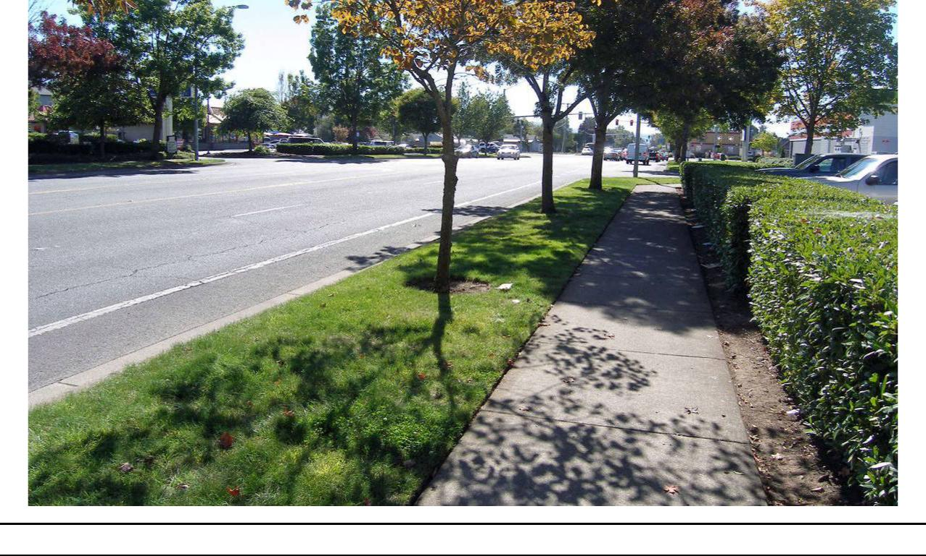

Figure 4.1-2. Location of Proposed Station at Existing Bus Pull Out North of Elmira Road; Note Buried Utility Covers in the Sidewalk
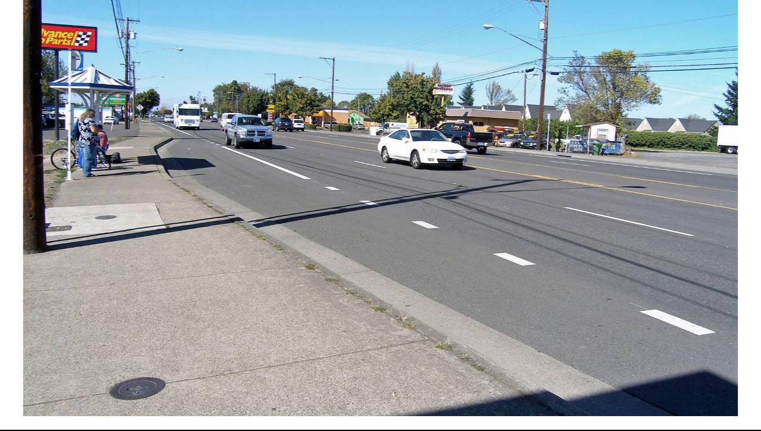

Lane Transit District | DRAFT FINAL Cultural Resources Technical Report | July 7, 2017
City of Eugene | MovingAhead Project | 4-3

Table 4.1-1. Previous Investigations Conducted within 1 Mile of Highway 99 Corridor

 | Project Description |  | Results | Reference
 | In Current APE
 | Roosevelt Boulevard, Beltline Highway |  | Negative | Pettigrew 1980 (SHPO #2229)
 | to Highway 99N
 | BPA Albany-Eugene transmission line, |  | Negative | McClintock and Bard 1998
 | southerly 9.3 miles survey |  |  | (SHPO #16589)
 | West 11th-Garfield, West Eugene |  | Negative in current area | O'Neill and Connolly 2006
 | Parkway survey |  |  | (SHPO #20818)
 | OR99, Barger Drive to Washington / |  | Negative | O'Neill and Ruiz 2008
 | Jefferson ramps survey |  |  | (SHPO #22097)
 | OR99, Barger Drive to Washington / |  | Isolated historical artifacts in | O'Neill 2009 (SHPO #22309)
 | Jefferson ramps, subsurface |  | imported fill
 | reconnaissance
 | Roosevelt Boulevard., Beltline |  | Negative | Carlisle 2008a (SHPO #22628)
 | Highway to Chambers Street survey
 | Within 1 Mile of APE
 | Proposed regional sewer line survey |  | Negative in current area | Benson et al. 1983
 |  |  |  | (SHPO #4973)
 | Metropolitan Wastewater |  | Isolated prehistoric artifact | Connolly 1983 (SHPO #4975)
 | Management Commission proposed
 | force sewer main survey
 | OR126, proposed West 11th Avenue |  | Negative | Pettigrew 1983 (SHPO #5411)
 | to Garfield Street section survey
 | Greenway Park archaeological site |  | Examined site 35LA649 | Connolly 1984a (SHPO #5938)
 | reconnaissance
 | River Road/Santa Clara sewerage |  | Negative in current area | Baxter and Connolly 1984
 | system survey |  |  | (SHPO #5939)
 | Testing three localities on the |  | Negative in current area | Connolly 1984b (SHPO #5940)
 | proposed River Road/Santa Clara
 | sewerage system
 | OR126, West 11th Avenue-Garfield |  | Negative | Connolly 1987 (SHPO #8213)
 | Street revised alignment survey
 | West Eugene Parkway / West 11th |  | Negative | Tveskov 1994 (SHPO #14452)
 | Avenue NCL wetland mitigation sites
 | survey
 | July 7, 2017 | DRAFT FINAL Cultural Resources Technical Report |  | Lane Transit District
4-4 |  |  | MovingAhead Project | City of Eugene

Table 4.1-1. Previous Investigations Conducted within 1 Mile of Highway 99 Corridor

Project Description | Results | Reference
Eugene/Springfield archaeological | Regional overview | Silvermoon et al. 1984
resources overview |  | (SHPO #16223)
Willamette National Forest Eugene | Isolated historical artifacts | Fields 2006 (SHPO #21040)
warehouse compound survey
LTD West Eugene EmX Extension and | Negative | Oetting 2011a (SHPO #24606)
locally preferred alternative survey
Fern Ridge Bike Path (Chambers Street | Isolated historical artifacts in | Oetting 2011b (SHPO #25111)
to Arthur Street) survey and probing | disturbed fill
BPA Eugene Substation LSN fiber | Negative | Ó Donnchadha and Schmidt
interconnection survey |  | 2013 (SHPO #25835)
Webb US Army Reserve Center survey | Negative | Brockington and Associates
 |  | 2013 (SHPO #26035)
Murphy Company Expansion Project | Negative | Musil 2013 (SHPO #26134)
survey
Recovery of a groundstone artifact at | Isolated prehistoric artifact found | Griffin 2014 (SHPO #26690)
Fairfield Elementary School | and collected
EUG Polk (Trileaf #612180) cell tower | Negative | Finley 2014 (SHPO #26747)
survey
Commerce St. Connector Path and | Negative | Oetting 2016 (SHPO #28181)
Bridge Project survey

Source: Oregon Archaeological Records Remote Access System, Oregon SHPO. (2016, August).

Table 4.1-2. Archaeological Sites Recorded Within 1 Mile of Highway 99 Corridor

Site Number/Name

Location

Description

NRHP Eligibility

35LA649

T17S, R4W, sec. 25 Prehistoric lithic scatter

Unevaluated

Source: Oregon Archaeological Records Remote Access System, Oregon SHPO. (2016, August).

4.1.3. Historical Background and Records Review

The area through which Highway 99 travels was, like most of the land surrounding Eugene, historically agricultural in character, and remained so until the construction of Highway 99 at this location. The early iteration of the Pacific Highway, established by the Oregon legislature in 1913, followed today’s Franklin Boulevard, Blair Boulevard, and north along River Road (Historic Preservation Northwest [HPNW], 2006: 3.5). In 1936, the alignment shifted west to Prairie Road for a brief time before it was re-designed to

Lane Transit District | DRAFT FINAL Cultural Resources Technical Report | July 7, 2017
City of Eugene | MovingAhead Project | 4-5

follow a 6th Avenue–7th Avenue couplet, and moved to its current location in 1946 (see Figures 4.1-3 and 4.1-4).

Businesses and services catering to auto travelers appeared all along the Pacific Highway/Highway 99 in the 1940s and 1950s, a number of which remain in place and in use within the APE for this project. These include at least one gas station, several markets, and a number of motels. While much of the farmland has been infilled with mid-century (and more recent) neighborhoods, remnants of farmland are still visible in places.

Documentary research was conducted using primary and secondary source materials on file at Oregon SHPO (to identify properties designated as NRHP-listed or -eligible, or Statewide Planning

Goal 5-protected historic resources) and using other appropriate records archives. This research included the following sources:

- Oregon SHPO NRHP and State Inventory files

- Lane County Inventory and Goal 5 Historic Resources

- City of Eugene Planning Division (Historic Resources)

- NRHP database for listed properties and districts

Analysts conducted a review of historic maps and records to identify potentially eligible historic resources along the Highway 99 Corridor. In addition to the above databases and listings, historic maps were also consulted. These included GLO survey plats, master title plats for early land claims, and USGS quadrangles (Figures 4.1-3 through 4.1-5).

4.1.4. Historical Reconnaissance Results

A review of the Oregon SHPO database and the NRHP database for listed properties along the Highway 99 Corridor resulted in the identification of no historic resources that are formally listed on the NRHP at present. Two historic resources are inventoried in the Oregon SHPO historic resources database as NRHP-eligible. During the windshield survey, 40 additional historic properties, including three resource groupings, were identified as potentially eligible for the NRHP (Tables 4.1-3 and 4.1-4 and Figures 4.1-6 and 4.1-7).

Resources that are eligible for listing on the NRHP must meet the National Register (NR) criteria. A resource is considered “eligible significant”, or ES, if the resource meets the NR criteria and is historically significant in its own right. A resource is considered “eligible contributing”, or EC, if the resource meets the NR criteria and is contributing to the significance of a larger grouping of historic resources.

The area has not been formally surveyed, presumably because the dates of the historic resources there are relatively recent (1930s and later), and possibly because the historic significance is perceived to be less than that of resources within the city’s core area and neighborhoods.

July 7, 2017 | DRAFT FINAL Cultural Resources Technical Report | Lane Transit District
4-6 | MovingAhead Project | City of Eugene

Figure 4.1-3. Location of the Highway 99 Corridor on the USGS Eugene 15’ Quadrangle, 1910
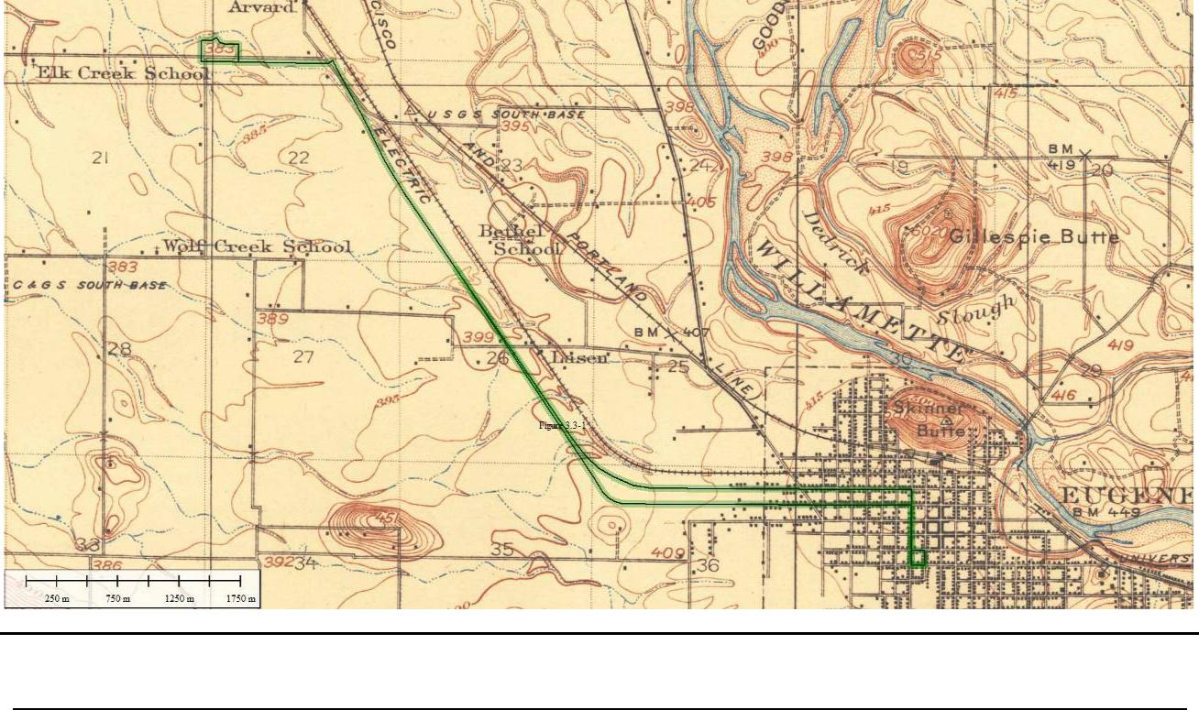

Figure 4.1-4. Location of the Highway 99 Corridor on the USGS Eugene 15’ Quadrangle, 1940
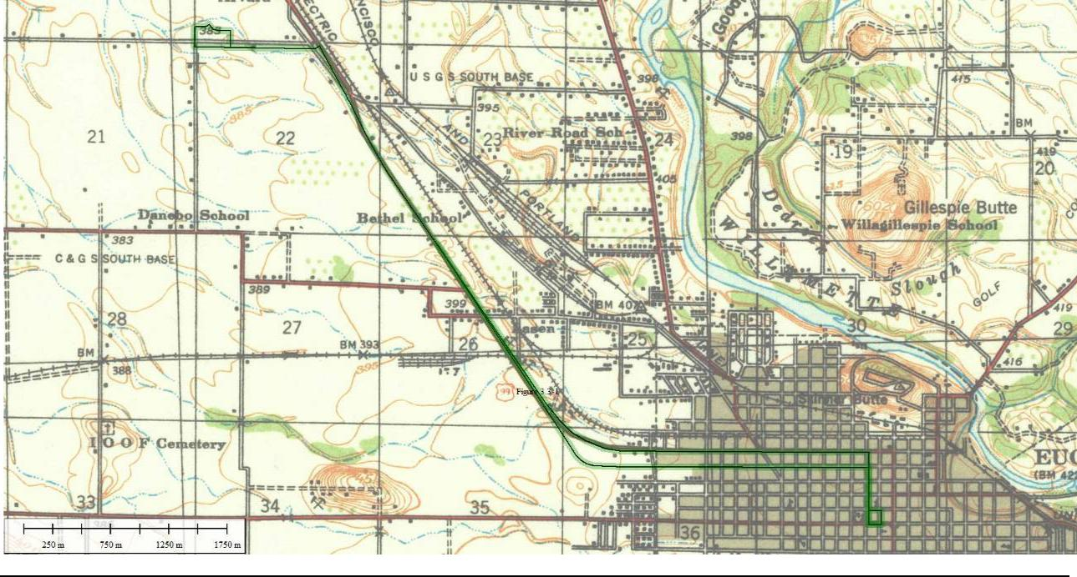

Lane Transit District | DRAFT FINAL Cultural Resources Technical Report | July 7, 2017
City of Eugene | MovingAhead Project | 4-7

Figure 4.1-5. Alignment of the Highway 99 Corridor as Shown on the USGS Eugene East and Eugene West 7.5’ Quadrangle, 1976 (Reduced)
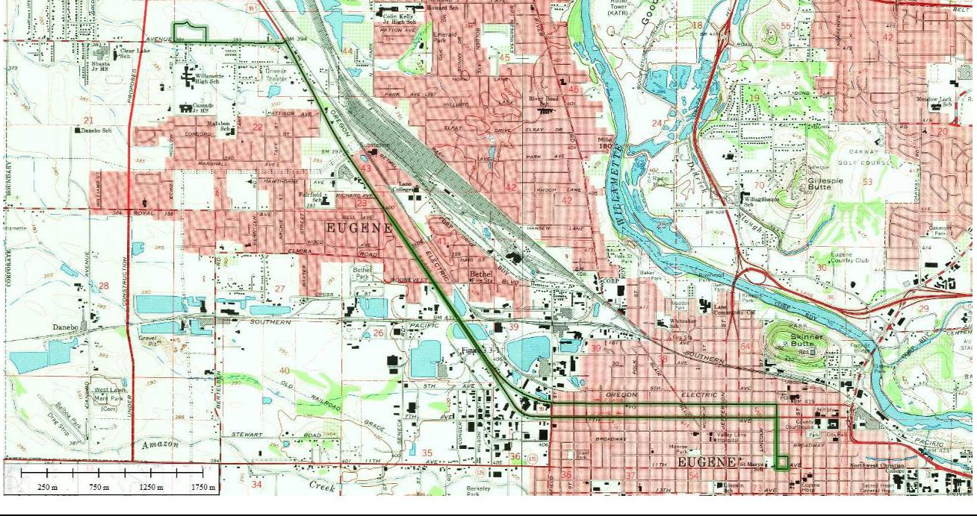

Table 4.1-3. Inventory of Identified Historic Resources Along the Highway 99 Corridor with Anticipated Effects for Enhanced Corridor Alternative
 |  |  |  | Preliminary | Long-term | Long-term
 |  |  |  | Preliminary | Long-term | Indirect /
 | Address | Tax Lot Number | Date | Evaluationª | Direct | Cumulative
 | 1286 Chambers | 1704363107900 | 1935 | EC
 | 1682 W. 8th Ave | 1704361304400
 | 837 Chambers | 1704361304500
 | 857 Chambers | 1704361304600
 | 1680 W. Broadway | 1704361304700
 | 925 Chambers | 1704361306200
 | 945 Chambers | 1704361305901 |  | EC
 | 955 Chambers | 1704361305902 | 1924-1950 | EC
 | 955 Chambers | 1704361305902 | 1924-1950 | (Grouping)
 | 1710 W. Broadway | 1704362406000 |  | (Grouping)
 | 924 Chambers | 1704362406100
 | 936 Chambers | 1704362406200
 | 950 Chambers | 1704362406300
 | 970 Chambers | 1704362406400
 | 980 Chambers | 1704362406500
 | July 7, 2017 | DRAFT FINAL Cultural Resources Technical Report |  |  |  | Lane Transit District
4-8 |  |  | MovingAhead Project |  |  | City of Eugene

Table 4.1-3. Inventory of Identified Historic Resources Along the Highway 99 Corridor with Anticipated Effects for Enhanced Corridor Alternative

 |  |  | Preliminary | Long-term | Long-term
 |  |  | Preliminary | Long-term | Indirect /
Address | Tax Lot Number | Date | Evaluationª | Direct | Cumulative
984 Chamber | 1704362406600
1698 W. 11th | 1704364205800 | 1948 | EC
630 Garfield | 1704362201600 | 1960 | EC
2300 W. 7th | 1704351100100 | 1965 | EC
362 Highway 99 | 1704262400500 | 1938 | EC
376 Highway 99 | 1704262400100 | 1955 | EC
450 Highway 99 | 1704262103800 | 1963/1985 | EC/altered | T | A
595 Highway 99 | 1704262101201 | 1940 | EC | T | V*
605 Highway 99 | 1704262100900 | 1946 | EC |  | V*
700 Highway 99 | 1704262102500 | 1940 | EC
723-795 Highway 99 | 1704262100200
 | 1704262100300 | 1930-1956 | EC | S, T, A
 | 1704262100500 | 1930-1956 | EC | S, T, A
 | 1704262102300
780 Highway 99 | 1704262102300 | 1945 | EC | T
800 Highway 99 | 170423330620 | 1955 | EC
969 Highway 99 | 1704233300700 | 1940 | EC
1175 Highway 99 | 1704233301000 | 1956 | EC |  | S, T
1291 Highway 99 | 1704233001200 | 1941 | EC
Bonneville Substation | 1704224100400 | c 1939 | ES | S, T, A
1740 Highway 99W | 1704221400500 | c 1930 | EC |  | T
 |  | (1941,
 |  | 1974)
4030 Barger | 1704222200400 | 1930 | EC
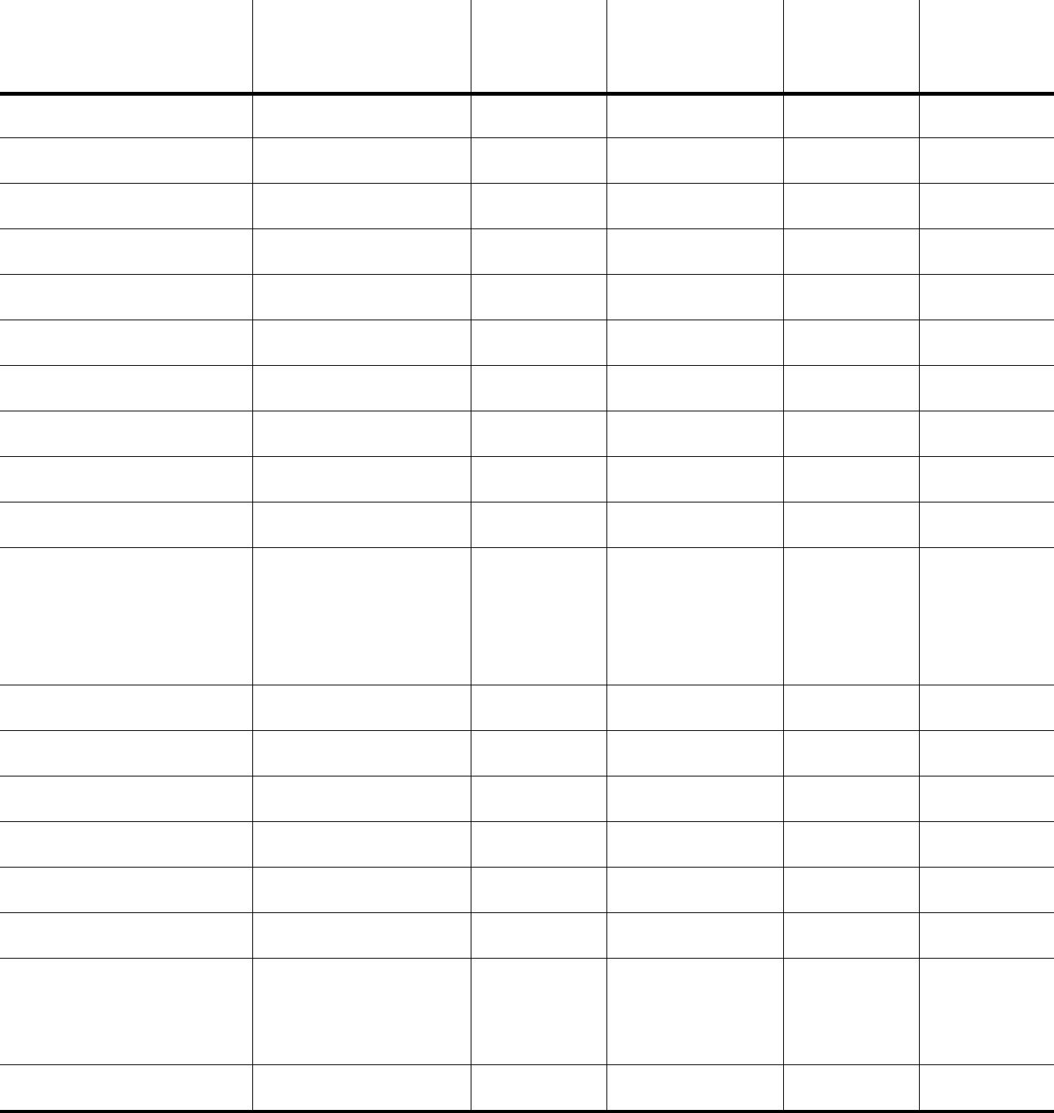

- Preliminary evaluation includes EC and ES; potential NRHP districts are noted.

Note: Does not include downtown, 6th, 7th, 11th, or 13th Avenue segments addressed in previous LTD studies and for which no changes are proposed.

KEY: S = Enhanced Shelter

T = Tax Lot Sliver Acquisition

A = Access Affected

V = Visual Effect (other than shelter)

- Visual Effect from Elevated Path to Bridge

c = circa

Lane Transit District | DRAFT FINAL Cultural Resources Technical Report | July 7, 2017
City of Eugene | MovingAhead Project | 4-9

Table 4.1-4. Inventory of Identified Historic Resources Along the Highway 99 Corridor with Anticipated Effects for EmX Alternative
 |  |  |  | Preliminary | Long-term | Long-term
 |  |  |  | Preliminary | Long-term | Indirect /
 | Address | Tax Lot Number | Date | Evaluationª | Direct | Cumulative
 | 1286 Chambers | 1704363107900 | 1935 | EC
 | 1682 W. 8th Ave | 1704361304400
 | 837 Chambers | 1704361304500
 | 857 Chambers | 1704361304600
 | 1680 W. Broadway | 1704361304700
 | 925 Chambers | 1704361306200
 | 945 Chambers | 1704361305901
 | 955 Chambers | 1704361305902 | 1924-1950 | EC
 | 1710 W. Broadway | 1704362406000 | 1924-1950 | EC
 | 924 Chambers | 1704362406100
 | 936 Chambers | 1704362406200
 | 950 Chambers | 1704362406300
 | 970 Chambers | 1704362406400
 | 980 Chambers | 1704362406500
 | 984 Chamber | 1704362406600
 | 1698 W. 11th | 1704364205800 | 1948 | EC
 | 630 Garfield | 1704362201600 | 1960 | EC
 | 2300 W. 7th | 1704351100100 | 1965 | EC
 | 362 Highway 99 | 1704262400500 | 1938 | EC
 | 376 Highway 99 | 1704262400100 | 1955 | EC
 | 450 Highway 99 | 1704262103800 | 1963/1985 | EC/altered | T | S
 | 595 Highway 99 | 1704262101201 | 1940 | EC | T | V*
 | 605 Highway 99 | 1704262100900 | 1946 | EC |  | V*
 | 700 Highway 99 | 1704262102500 | 1940 | EC
 | 723-795 Highway 99 | 1704262100200 | 1930-1956 | EC |  | S
 |  | 1704262100300 | 1930-1956 | EC
 | July 7, 2017 | DRAFT FINAL Cultural Resources Technical Report |  |  |  | Lane Transit District
4-10 |  |  | MovingAhead Project |  |  | City of Eugene


Table 4.1-4. Inventory of Identified Historic Resources Along the Highway 99 Corridor with Anticipated Effects for EmX Alternative

 |  |  | Preliminary | Long-term | Long-term
 |  |  | Preliminary | Long-term | Indirect /
Address | Tax Lot Number | Date | Evaluationª | Direct | Cumulative
 | 1704262100500
 | 1704262102300
780 Highway 99 | 1704262102300 | 1945 | EC | T | S
800 Highway 99 | 170423330620 | 1955 | EC
969 Highway 99 | 1704233300700 | 1940 | EC
1175 Highway 99 | 1704233301000 | 1956 | EC |  | S, T
1291 Highway 99 | 1704233001200 | 1941 | EC
1511 Highway 99 | 1704221400401 | 1965 | EC
Bonneville Substation | 1704224100400 | c 1939 | ES | S, T, A
 |  | c 1930 | EC |  | S
1740 Highway 99W | 1704221400500 | (1941,
 |  | 1974)
3850 Barger | 1704222100400
3890 Barger | 1704222100700 |  | EC
1930 Taney St | 1704222108400 | 1925-1950 | (Groups,
3920 Barger | 1704222110200 |  | 5 houses)
3930 Barger | 1704222110300
4030 Barger | 1704222200400 | 1930 | EC
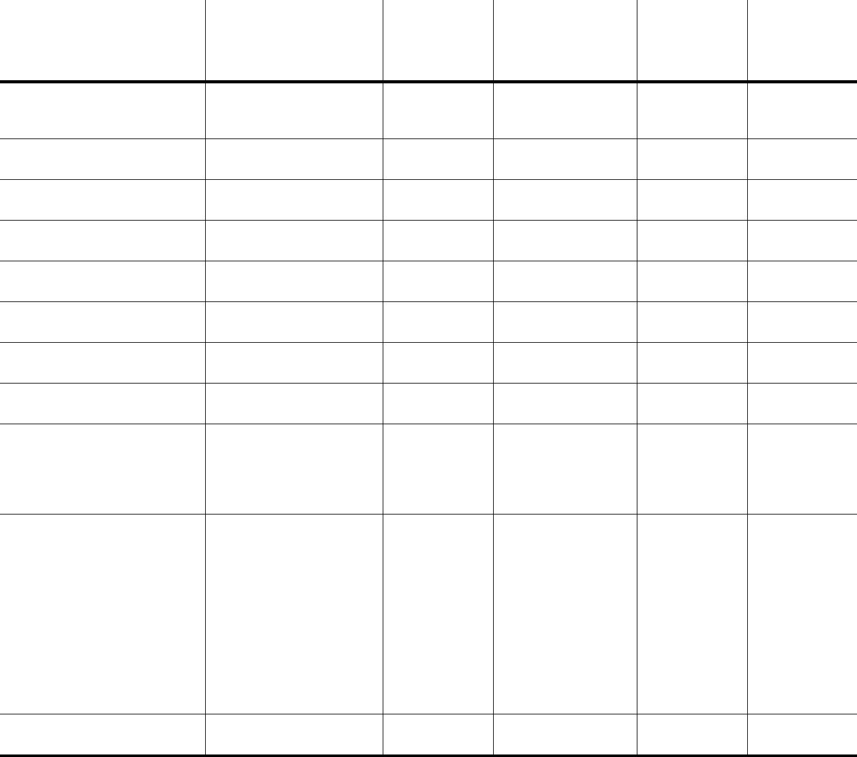

- Preliminary evaluation includes EC and ES; potential NRHP districts are noted.

Note: Does not include downtown, 6th, 7th, 11th, or 13th Avenue segments addressed in previous LTD studies and for which no changes are proposed.
KEY: S = EmX Station

T = Tax Lot Sliver Acquisition

A = Access Affected

V = Visual Effect (other than station)

- Visual Effect from Elevated Path to Bridge

c = circa

Lane Transit District | DRAFT FINAL Cultural Resources Technical Report | July 7, 2017
City of Eugene | MovingAhead Project | 4-11

Figure 4.1-6. Highway 99 Enhanced Corridor Alternative Cultural Resources Area of Potential Effect
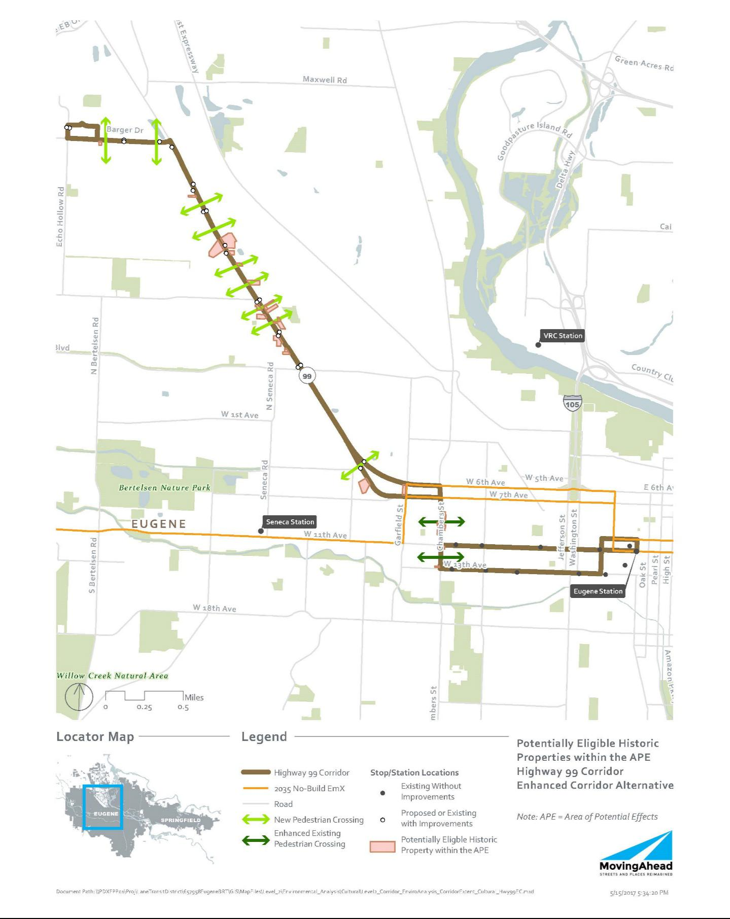

July 7, 2017 | DRAFT FINAL Cultural Resources Technical Report | Lane Transit District
4-12 | MovingAhead Project | City of Eugene

Figure 4.1-7. Highway 99 EmX Alternative Cultural Resources Area of Potential Effect
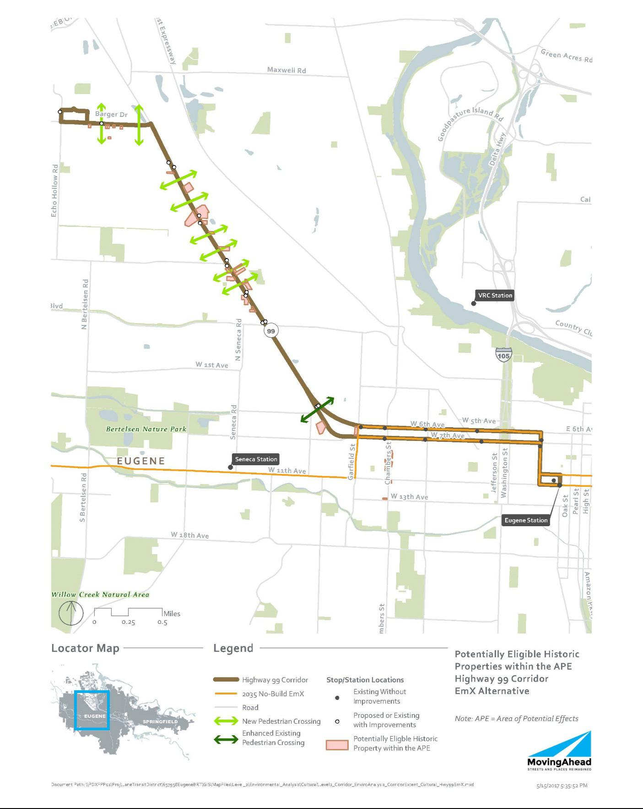

Lane Transit District | DRAFT FINAL Cultural Resources Technical Report | July 7, 2017
City of Eugene | MovingAhead Project | 4-13

4.2. Environmental Consequences

Forty-two NRHP-eligible or -listed (Section 106) historic resources were identified along the APE for the Highway 99 Corridor. No archaeological resources were identified. Potential effects are summarized below and in Tables 4.1-3 and 4.1-4.

4.2.1. Long-Term Direct Impacts

Only limited direct impacts are anticipated for the build alternatives. The impacts may originate from construction of stops / stations or road widening that may require a property acquisition from the tax lot or that may be constructed in a manner that will potentially obscure or otherwise interfere with the historic resource.

4.2.1.1. No-Build Alternative

No impacts to historic, archaeological or cultural resources are anticipated.

4.2.1.2. Enhanced Corridor Alternative

Direct impacts to historic resources are outlined in Table 4.1-3. Four resources and one resource grouping (of four lots) may be affected by direct, long-term impacts.

4.2.1.3. EmX Alternative

Direct impacts to historic resources are outlined in Table 4.1-4. Four resources may be affected by direct, long-term impacts under this alternative.

4.2.2. Indirect and Cumulative Effects

Only limited indirect impacts are anticipated for the build alternatives. The indirect impacts would not result in a physical impact to the resource, but may include the construction of stops / stations or road widening sufficiently close to affect the visual character of the historical setting of the property, or other attributes that contribute to its NRHP eligibility. Under Section 106, the impacts may affect a property, but may not necessarily result in an adverse effect.

4.2.2.1. No-Build Alternative

No impacts to historic, archaeological or cultural resources are anticipated under the No-Build Alternative.

4.2.2.2. Enhanced Corridor Alternative

Indirect impacts to historic resources are outlined in Table 4.1-3. Five resources may be affected by indirect impacts under this alternative. Under Section 106, the impacts may affect a property, but may not necessarily result in an adverse effect.

July 7, 2017 | DRAFT FINAL Cultural Resources Technical Report | Lane Transit District
4-14 | MovingAhead Project | City of Eugene

4.2.2.3. EmX Alternative

Indirect impacts to historic resources are outlined in Table 4.1-4. Six individual resources plus one grouping of four the tax lots may be affected by indirect impacts under this alternative. Under Section 106, the impacts may affect a property, but may not necessarily result in an adverse effect.

4.2.3. Short-Term Construction-Related Impacts

Aside from the direct impacts noted above, it is assumed that no additional short-term impacts (noise, air, access, etc.) to historic resources would be associated with construction.

4.3. Potential Mitigation Measures

As a part of Section 106 (36 CFR Part 800) and NEPA, federal transportation agencies are required to seek ways to avoid, minimize, or mitigate adverse effects on historic properties.

Minimization or avoidance of ROW needs would reduce or eliminate impacts. Reduction or elimination of property acquisition from historic properties in the project corridor that are eligible for NRHP would avoid or minimize adverse effects on Section 106 resources. Shifting new stop and station locations away from historic properties would reduce or eliminate impacts.

If it is not feasible to avoid historic properties, an FOE form should be prepared for each of the historic properties impacted by the project. Given the current project description and the types of activities and features that would be implemented, adverse effects to historic properties can likely be avoided for the Highway 99 Corridor.

Mitigation/conservation measures might be required for construction contractor compliance if the project plans change and project effects to the NRHP-eligible properties would be greater than stated in this report. An Inadvertent Discovery Plan should also be in place prior to construction. It would outline measures to be undertaken in the event of an unanticipated archaeological discovery.

Lane Transit District | DRAFT FINAL Cultural Resources Technical Report | July 7, 2017
City of Eugene | MovingAhead Project | 4-15

Blank Page

July 7, 2017 | DRAFT FINAL Cultural Resources Technical Report | Lane Transit District
4-16 | MovingAhead Project | City of Eugene

- River Road Corridor Environmental Consequences

5.1. Affected Environment

5.1.1. Archaeological Background and Records Review

Documentary research was conducted using primary and secondary source materials on file at the Oregon SHPO, Lane County, and other appropriate archives. The archaeological site and project records, which are maintained by the Oregon SHPO, were examined using the Internet-based OARRA system; these records were reviewed to identify previous archaeological investigations conducted in the vicinity of the River Road Corridor and archaeological sites recorded in this area. Projects, as well as individual historic and archaeological site data, were collected for an area within approximately 1 mile of the proposed corridor alternatives. This information was identified as being either within the APE (defined within 350 feet of the project corridor where changes are planned in the Enhanced Corridor or EmX Alternatives) or within 1 mile of this APE. Analysts gathered properties identified as NRHP listed or eligible, or identified as Statewide Planning Goal 5-protected historic resources within the APE, to determine project impacts as well as information on properties in the general geographic area from which to develop greater historical context. Historical maps, including GLO, Sanborn Insurance, and USGS, depicting the project vicinity were also inspected.

Thirty archaeological investigations have been conducted within 1 mile of the River Road Corridor APE (Table 5.1-1) and three archaeological sites are recorded in this area (Table 5.1-2). Eleven investigations were conducted in advance of transportation improvement projects, 10 were for utilities-related projects, 3 for residential developments, 2 were miscellaneous property surveys, 2 were wetlands related, 1 examined prehistoric site 35LA649, and 1 was an archaeological overview document.

Four of the investigations crossed into the River Road APE. No archaeological materials were found in the current APE by the investigations.

No archaeological sites are recorded within the River Road Corridor APE. Three sites are present in the larger 1-mile study area (Table 5.1-2). Site 35LA215, which is a prehistoric lithic scatter recorded north of the current APE, consists of obsidian flakes and a stone tool found while excavating for a septic tank. Site 35LA649, which is another prehistoric lithic scatter site, consists of several artifacts observed along a trail in a city park on the bank of the Willamette River. Site 35LA1589 is a late-nineteenth, early-twentieth century refuse scatter eroding from the bank of the Willamette River. The sites have not been evaluated for eligibility to the NRHP.

Modern River Road is the route of one of the earliest wagon roads in the southern Willamette Valley, part of the eastern branch of the Applegate Trail. The GLO cadastral survey plat for T17S, R4W depicts the road and labels it "Mary'sville to Umpqua Valley." Several cultivated fields are shown east of the road toward the Willamette River and several structures are labeled with names that reflect the DLC landowners, from south to north: "Lemuel Davis," "Benjn Davis," "J. Davis," and "Pointdexter." At the south end, the road turns to the east at the fields and residence of "P.F. Blair." The Plat of Claims for T17S, R4W shows that the corridor passes through four DLCs and the north end stops at the boundary of a fifth: from south to north, DLC No. 39 of Prior F. Blair, DLC No. 42 of L. E. Davis, DLC No. 45 of Benjamin Davis, DLC No. 48 of Joseph Davis, and DLC No. 52 of L. Pointdexter.

Lane Transit District | DRAFT FINAL Cultural Resources Technical Report | July 7, 2017
City of Eugene | MovingAhead Project | 5-1

Table 5.1-1. Previous Investigations Conducted within 1 Mile of River Road Corridor

Project Description | Results | Reference
 | In Current APE
Proposed regional sewer line survey | Negative in current area | Benson et al., 1983 (SHPO #4973)
Metropolitan Wastewater | Isolated prehistoric artifact | Connolly, 1983 (SHPO #4975)
Management Commission proposed
force sewer main survey
Roosevelt Boulevard, Beltline Highway | Negative | Carlisle, 2008a (SHPO #22628)
to Chambers Street, survey
River Road (EG13) cell tower survey | Negative | Holschuh, 2013a (SHPO #25927)
 | Within 1 Mile of APE
Valley River bike / pedestrian bridge | Negative | Pettigrew and Cole, 1977 (SHPO #188)
survey
Interceptor and sewage treatment | Negative | Follansbee, 1977 (SHPO #2522)
plant expansion project survey
Greenway Park archaeological site | Examined site 35LA649 | Connolly, 1984a (SHPO #5938)
reconnaissance
River Road / Santa Clara sewerage | Negative in current area | Baxter and Connolly, 1984 (SHPO
system survey |  | #5939)
Testing three localities on the | Negative in current area | Connolly, 1984b (SHPO #5940)
proposed River Road/Santa Clara
sewerage system
Valley River Village wetlands | Negative | Toepel, 1994a (SHPO #14587)
enhancement survey and probing
Valley River Village Parcel 4 survey | Negative | Toepel, 1994b (SHPO #14588)
Eugene / Springfield archaeological | Regional overview | Silvermoon et al., 1984
resources overview |  | (SHPO #16223)
Santa Clara Avenue property | Negative | Boersema, 1999 (SHPO #16814)
(TL 17-04-11-43-00800) survey
I-105 at Delta Highway on-ramp | Negative | Connolly, 2000 (SHPO #17193)
survey
Delta Ponds survey | Negative | Martin, 2002 (SHPO #18214)
I-105 (Willamette River to I-5) probing | Negative | Helzer and Dexter, 2004
 |  | (SHPO #19164)

July 7, 2017 | DRAFT FINAL Cultural Resources Technical Report | Lane Transit District
5-2 | MovingAhead Project | City of Eugene

Table 5.1-1. Previous Investigations Conducted within 1 Mile of River Road Corridor

Project Description | Results | Reference
West 11th Avenue-Garfield Street, | Negative in current area | O'Neill and Connolly, 2006 (SHPO
West Eugene Parkway survey |  | #20818)
Willamette National Forest Eugene | Isolated historical artifacts | Fields, 2006 (SHPO #21040)
warehouse compound survey
OR99 (Barger Drive to Washington / | Negative | O'Neill and Ruiz, 2008 (SHPO #22097)
Jefferson ramps) survey
Delta Ponds pedestrian bridge survey | Negative | Oetting, 2008a (SHPO #22303)
Delta Ponds pedestrian bridge probing | Negative | Oetting, 2008b (SHPO #22304)
OR99 (Barger Drive to Washington / | Isolated historical artifacts in | O'Neill, 2009 (SHPO #22309)
Jefferson ramps) subsurface | imported fill
reconnaissance
LTD West Eugene EmX Extension and | Negative | Oetting, 2011a (SHPO #24606)
locally preferred alternative survey
Fern Ridge bike path (Chambers to | Isolated historical artifacts in | Oetting, 2011b (SHPO #25111)
Arthur) survey and probing | disturbed fill
Goodpasture Island planned unit | Negative | Smith and Gall, 2010 (SHPO #25327)
development survey and probing
Patterson (EU08) cell tower survey | Negative | Holschuh, 2013b (SHPO #25905)
Webb U.S. Army Reserve Center | Negative | Brockington and Associates, 2013
survey |  | (SHPO #26035)
EUG Spearmint cell tower survey | Negative | Baker and Carter, 2014
 |  | (SHPO #26635)
EUG Polk (Trileaf #612180) cell tower | Negative | Finley, 2014 (SHPO #26747)
survey
EUG Tin cell tower survey | Negative | Castronuevo and Garrison, 2016
 |  | (SHPO #28201)

Source: Oregon Archaeological Records Remote Access System, Oregon SHPO. (2016, August).

Lane Transit District | DRAFT FINAL Cultural Resources Technical Report | July 7, 2017
City of Eugene | MovingAhead Project | 5-3

Table 5.1-2. Archaeological Sites Recorded Within 1 Mile of River Road Corridor

Site Number/Name | Location | Description | NRHP Eligibility
35LA215 | T17S, R4W, sec. 2 | Prehistoric lithic scatter | Unevaluated
35LA649 | T17S, R4W, sec. 25 | Prehistoric lithic scatter | Unevaluated
35LA1589 / Skinner's Lost | T17S, R3W, sec. 30 | Historical refuse scatter | Unevaluated

Source: Oregon Archaeological Records Remote Access System, Oregon SHPO. (2016, August).

5.1.2. Archaeological Survey Results

A pedestrian archaeological survey of the River Road Corridor was conducted on September 26, 2016. the surface survey inspected the proposed stations and the transit and roadway improvements of the Enhanced Corridor and EmX Alternatives. This involved inspection of all proposed stop and station locations on River Road and Chambers Street north of West 6th Avenue, inspection of both sides of Chambers Street between West 2nd Avenue and West 6th Avenue south of the Chambers Street-River Road railroad overpass, both sides of River Road from Northwest Expressway north to Hunsaker Lane, and the south side of Hunsaker Lane to and including the area south of Hunsaker to be used for the Corridor terminus (Santa Clara Community Transit Center) (Figures 5.1-1 and 5.1-2). Most of the proposed stops and stations are at or near existing bus stops and nearly all of the have bus pull outs, which may reduce new soil disturbance associated with construction. the survey was conducted by one archaeologist walking on the sidewalks bordering both sides of each road and inspecting all patches of exposed mineral ground surface both in the planting strip between the road and the sidewalk and any ground visible on the opposite side of the sidewalk. Sidewalks bordered all of Chambers Street and River Road, most with planting strips. the only segment without a bordering sidewalk was the south side of Hunsaker Lane from River Road to the planned entrance for the Corridor terminus. This short segment was walked in one direction about 2 meters (m) from the road edge and back about 5 m from the road. the planned terminus location south of Hunsaker Lane was surveyed using parallel transects at

15-minute intervals. This location is part of the former Santa Clara Elementary School site and includes a paved parking area that was part of the school site.

Mineral ground surface visibility was relatively good along the inspected route, averaging about 10 to 20 percent overall. While there was no surface visibility on a few properties with maintained grass lawns, patches of mineral soil were present in most of the planting strips and neighboring surfaces throughout the corridor. Of course, it is likely that much of the surface soil in the planting strips is not native soil but was brought in for landscaping, since patches of underlying plastic sheeting or geotextile cloth were occasionally visible. In addition, utility vaults, manhole covers, and electrical junction boxes were present all along the route, denoting various buried utility lines and pipes.

No prehistoric or demonstrably historical artifacts, features, or sites were observed during this surface survey. While many of the structures along River Road are historical in age, historical artifacts and features are most likely to be associated with the structures, set back from the street rather than on property edges that border the street. River Road has been a well-used transportation route for over 150 years and the immediate River Road area has been subject to continual population growth and residential development since the 1920s, with suburban residential and commercial development

July 7, 2017 | DRAFT FINAL Cultural Resources Technical Report | Lane Transit District
5-4 | MovingAhead Project | City of Eugene

Figure 5.1-1. Location of Proposed Station at Existing Bus Pull Out North of Park Street
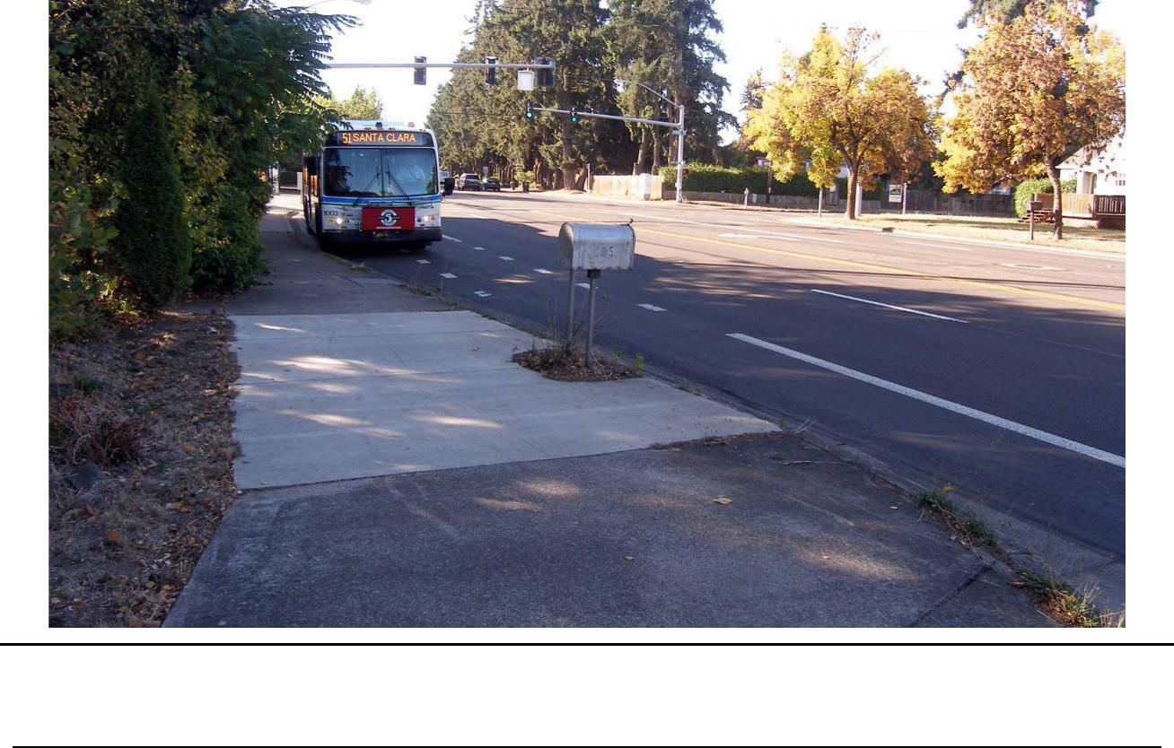

Figure 5.1-2. Area Surveyed for Terminus Station South of Hunsaker Lane, Paved Parking Lot Left from Santa Clara Elementary School is Visible in the Middle of the Photograph
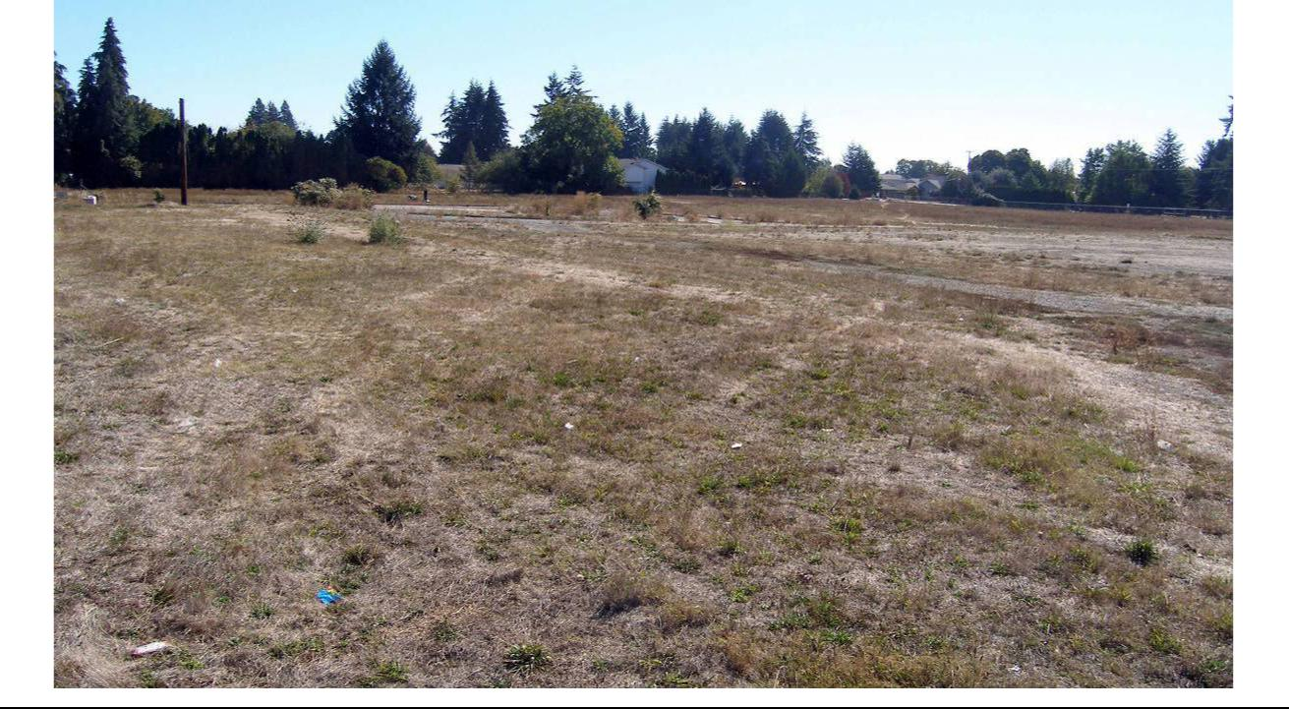

Lane Transit District | DRAFT FINAL Cultural Resources Technical Report | July 7, 2017
City of Eugene | MovingAhead Project | 5-5

increasing substantially in the 1950s. With this continual development, River Road itself has been resurfaced and widened several times, adjoining sidewalks and driveways have been built and revised, and the underlying buried utility infrastructure has been installed and augmented. This ongoing development of the streets has very likely displaced and disturbed most, if not all, of the ground along the River Road Corridor. Likewise, the construction, use, and the n demolition of Santa Clara Elementary School has similarly displaced and disturbed the soil in the terminus location off Hunsaker Lane.

The potential for intact archaeological materials, surface or buried, in the River Road Corridor is low.

5.1.3. Historical Background and Records Review

River Road follows the historic western path of the 1846 Applegate Trail, used by early settlers to enter the Willamette Valley from the south. From that time until well into the twentieth century, the River Road area was agricultural in nature, with large, early donation claims eventually divided into smaller farms where a variety of fruit, nut, and vegetable crops were grown. By the early twentieth century, the automobile made living outside of town more feasible, and larger farms continued to be divided and subdivided.

Since the time of its mid-nineteenth century establishment, the River Road route has been well-used by local residents and those traveling through the valley. The first automobiles appeared in Eugene around 1904, and the number of auto-related businesses in the Eugene area increased quickly. The early iteration of the Pacific Highway, established by the Oregon legislature in 1913, followed today’s Franklin Boulevard, Blair Boulevard, and north along River Road (HPNW, 2006: 3.5):

The designation of River Road as a state highway greatly impacted the appearance of the neighborhood’s agrarian landscape. In addition to an increase in the number of roadways were the business and services catering to the automobile itself. The improved road network allowed people to live fa[r]ther away from the established neighborhoods near the center of town (HPNW, 2006:3.5).

Around 1920, the first gas station along River Road appeared, a Richfield Gasoline outlet located at 420 River Road, and the route was paved by the mid-1920s (HPNW, 2006:3.1).

River Road served as the Pacific Highway until 1936, when the route was moved west of the Southern Pacific Railroad; in 1946 it was moved to its current Highway 99 location. “The construction of Highway 99N in 1946 increased the local traffic capacity of River Road and offered more opportunities for favorable commercial locations along it; this also had the effect of making it a more favorable residential site” (HPNW, 2006:3.9).

Neighborhoods were platted to accommodate the growing population, and the early agricultural character slowly shifted to that of suburbia, although remnants of the region’s agrarian history can still be seen in scattered orchard remnants, outbuildings, and open spaces.

Documentary research was conducted using primary and secondary source materials on file at Oregon SHPO (to identify properties designated as NRHP-listed or -eligible, or Statewide Planning

Goal 5-protected historic resources) and other appropriate records archives. This research included the following sources:

July 7, 2017 | DRAFT FINAL Cultural Resources Technical Report | Lane Transit District
5-6 | MovingAhead Project | City of Eugene

- Oregon SHPO NRHP and State Inventory files

- Lane County Inventory and Goal 5 Historic Resources

- City of Eugene Planning Division (Historic Resources)

- City of Springfield Historic Commission and Planning Department

- NRHP database for listed properties and districts

Analysts conducted a review of historical maps and records to identify potentially eligible historic resources along the River Road Corridor. In addition to the above databases and listings, historic maps were also consulted. The maps included GLO survey plats, master title plats for early land claims, and USGS quadrangles (Figures 5.1-3 through 5.1-5).

Figure 5.1-3. Location of the River Road Corridor on the USGS Eugene 15’ Quadrangle, 1910
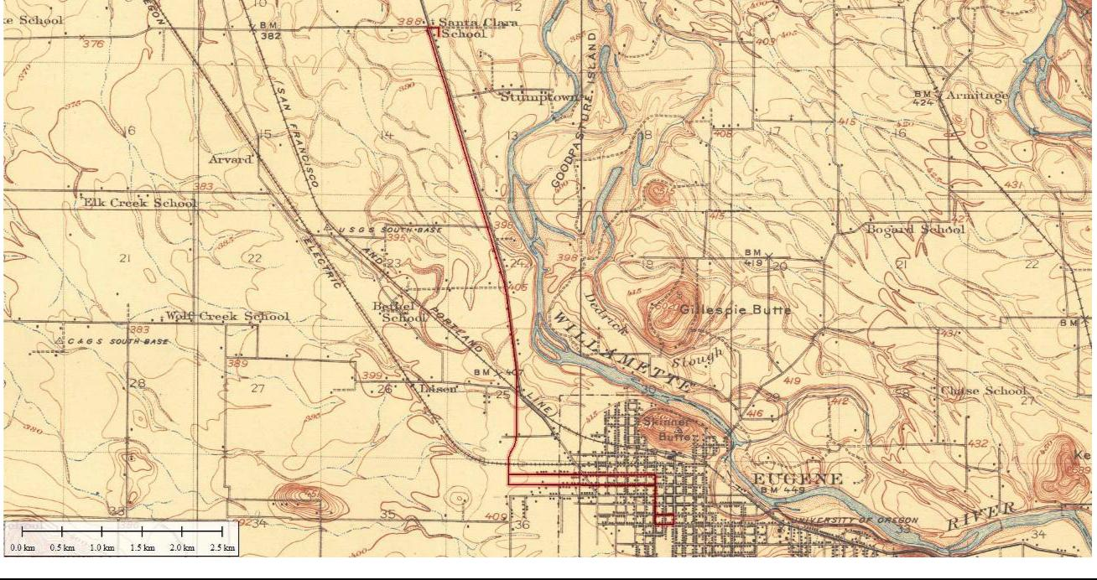

Lane Transit District | DRAFT FINAL Cultural Resources Technical Report | July 7, 2017
City of Eugene | MovingAhead Project | 5-7

Figure 5.1-4. Location of the River Road Corridor on the USGS Eugene 15’ Quadrangle, 1940
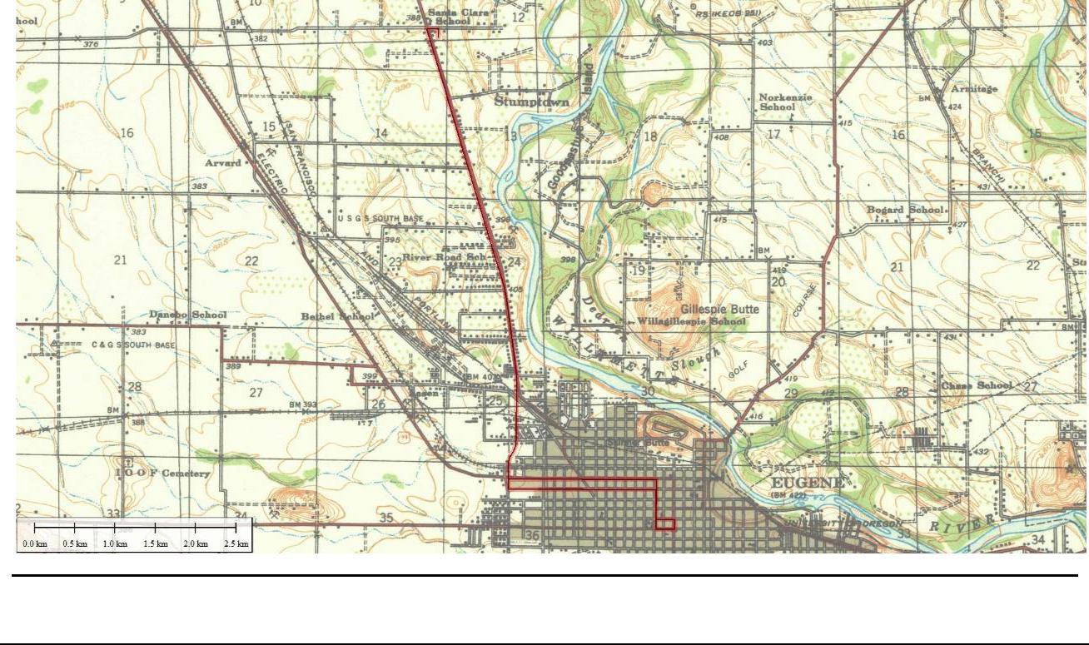

Figure 5.1-5. Alignment of the River Road Corridor as Shown on the USGS Eugene East and Eugene West 7.5’ Quadrangles, 1976 (Reduced)
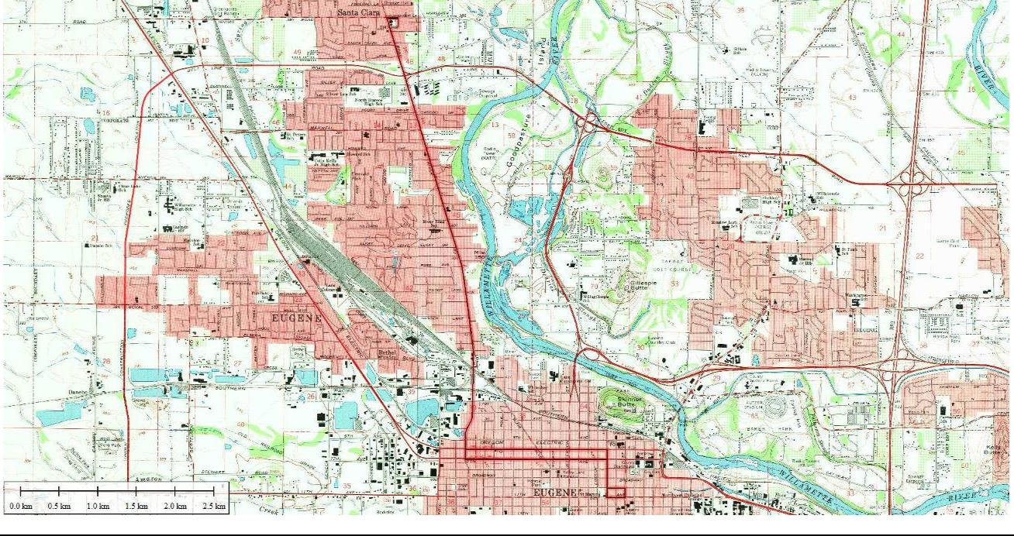

July 7, 2017 | DRAFT FINAL Cultural Resources Technical Report | Lane Transit District
5-8 | MovingAhead Project | City of Eugene

5.1.4. Historical Reconnaissance Results

Review of the Oregon SHPO database and the NRHP database for listed properties along the Highway 99 Corridor has resulted in the identification of no historic resources along the proposed APE corridor that are formally listed on the NRHP at present. Because the City of Eugene sponsored an inventory of the River Road area in 2005 that appears to have encompassed much of the APE, a number of historic resources are listed in the Oregon SHPO historic resources database as eligible. A total of 75 properties were identified from the Oregon SHPO database and during the windshield survey as potentially eligible (Tables 5.1-3 and 5.1-4 and Figures 5.1-6 and 5.1-7). Four of the properties are City Landmarks listed by the City of Eugene.

Table 5.1-3. Inventory of Identified Historic Resources along River Road Corridor with Anticipated Effects for Enhanced Corridor Alternative

 |  |  | Preliminary | Long-term | Long-term
Address | Tax Lot Number | Date | Preliminary | Long-term | Indirect /
Address | Tax Lot Number | Date | Evaluationª | Direct | Indirect /
 |  |  | Evaluationª | Direct | Cumulative
285 River Road | 1704251301901 | 1962 | EC |  | S
325 River Road | 1704251202700 | 1926 (1929) | EC
330 River Road | 1704252400200 | 1924 | EC
345 River Road | 1704251202400 | 1929 | EC
355 River Road | 1704251202300 | 1925 | EC
365 River Road | 1704251202000 | 1923 | EC
370 River Road |  |  | EC
(single-family | 1704252107404 | c 1890 | City
(single-family |  |  | Landmark
residential) |  |  | Landmark
375 River Road | 1704251201900 | 1920 | EC
385 River Road | 1704251201400 | 1926 | EC
390 River Road |  |  | EC
(single-family | 1704252105404 | c 1920 | City
residential) |  |  | Landmark
395 River Road | 1704251201300 | 1920 | EC
405 River Road | 1704251201200/ |  | EC
(single-family | 1704251201203 | 1910 | City
residential) | 1704251201203 |  | Landmark
450 River Road | 1704252104607 | C 1920 (1908) | EC
455 River Road | 1704251200800 | 1923 | EC
460 River Road | 1704252104500 | 1936 | EC
Lane Transit District | DRAFT FINAL Cultural Resources Technical Report |  |  |  | July 7, 2017
City of Eugene |  | MovingAhead Project |  |  | 5-9
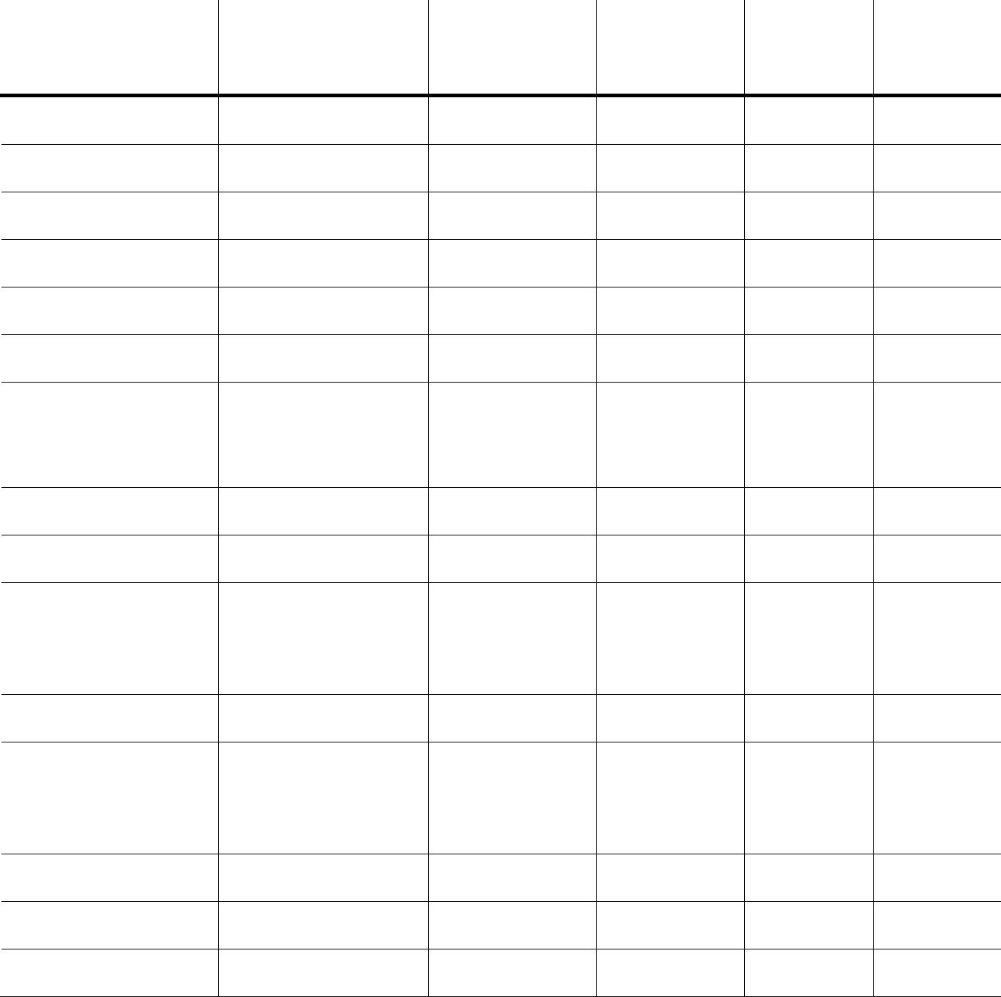

Table 5.1-3. Inventory of Identified Historic Resources along River Road Corridor with Anticipated Effects for Enhanced Corridor Alternative

 |  |  | Preliminary | Long-term | Long-term
Address | Tax Lot Number | Date | Preliminary | Long-term | Indirect /
Address | Tax Lot Number | Date | Evaluationª | Direct | Indirect /
 |  |  | Evaluationª | Direct | Cumulative
470 River Road | 1704252104400 | 1928 | EC |  | S
480 River Road | 1704252104300 | 1930 | EC | S, P
485 River Road | 1704251200500 | c 1920 | EC |  | S
65 Hansen Lane | 1704252100400 | 1950 | EC |  | S
100 Hansen Lane | 1704252104100 | 1946 | EC |  | S
501/505 River Road | 1704251200400 | 1920 | EC
530 River Road | 1704252100300 | 1918 | EC
570 River Road | 1704243407300 | 1936 | EC
600 River Road | 1704243404500 | c 1925 (1936) | EC
610 River Road | 1704243404400 | 1928 | EC |  | S
670 River Road | 1704243400502 | 1936 | EC
680 River Road | 1704243400400 | 1942 | EC
700 River Road | 1704243400300 | 1942 | EC
710 River Road | 1704243400200 | 1948 | EC
720 River Road | 1704243400100 | 1941 | EC
730 River Road | 1704243106600 | 1946 | EC
740 River Road | 1704243106500 | 1934 | EC
750 River Road | 1704243106400 | 1938 | EC
22 Park Avenue | 1704243106300 | 1880 | EC | S, P
755 River Road | 1704243106900 | 1932 | EC
800 River Road | 1704243104500 | 1928 | EC
805 River Road | 1704243107600 | 1912 | EC |  | S, A
840 River Road | 1704243104200 | 1927 | EC
865 River Road | 1704243101600 | 1941 | EC
901 River Road | 1704242407900 | 1954 | EC | T | S


July 7, 2017 | DRAFT FINAL Cultural Resources Technical Report | Lane Transit District
5-10 | MovingAhead Project | City of Eugene

Table 5.1-3. Inventory of Identified Historic Resources along River Road Corridor with Anticipated Effects for Enhanced Corridor Alternative

 |  |  | Preliminary | Long-term | Long-term
Address | Tax Lot Number | Date | Preliminary | Long-term | Indirect /
Address | Tax Lot Number | Date | Evaluationª | Direct | Indirect /
 |  |  | Evaluationª | Direct | Cumulative
930 River Road | 1704242409200 | 1931 | EC |  | S
931 River Road | 1704242406900 | 1949 | EC |  | S
940 River Road | 1704242409100 | 1926 | EC |  | S
988 River Road | 1704242409001 | 1964 | EC
1000 River Road | 1704242408501 | 1958 | EC
1015 River Road | 1704242404000802 | 1948 (1950) | EC |  | S
1020 River Road | 1704242408300 | 1922 | EC |  | S, A
1030 River Road | 1704242408302 | 1960 | EC |  | S
1065 River Road | 1704242107500 | 1941 | EC
1085 River Road | 1704242107400 | 1928 | EC
1105 River Road | 1704242107000 | c 1965 | EC
49 Arbor Drive | 1704242103300 | 1951 | EC |  | S
1220 River Road | 1704242202800 | 1927 | EC
1240 River Road | 1704242202700 | 1920 | EC
1245 River Road | 1704242101900 | 1935 | EC
1246-48 River Road | 1704242202701 | 1940 | EC
14 Greenleaf (SE) | 1704242101700 | 1953 | EC
39 Greenleaf (NE) | 1704242100500 | 1907 | EC
1270 River Road | 1704242201202 | 1924 | EC
1275 River Road | 1704242100400 | 1940 | EC
1298 River Road | 1704133308600 | 1955 | EC |  | S
1318 River Road | 1704133306300 | 1928 | EC | S | S
1350 River Road | 1704133306200 | 1940 | EC |  | S
1353 River Road | 1704133301700 | c 1920 (1933) | EC


Lane Transit District | DRAFT FINAL Cultural Resources Technical Report | July 7, 2017
City of Eugene | MovingAhead Project | 5-11

Table 5.1-3. Inventory of Identified Historic Resources along River Road Corridor with Anticipated Effects for Enhanced Corridor Alternative

 |  |  | Preliminary | Long-term | Long-term
Address | Tax Lot Number | Date | Preliminary | Long-term | Indirect /
Address | Tax Lot Number | Date | Evaluationª | Direct | Indirect /
 |  |  | Evaluationª | Direct | Cumulative
1410 River Road |  | c 1910 | ES
(single-family | 1704133304602 | c 1910 | City
(single-family | 1704133304602 | (1920-22) | City
residential) |  | (1920-22) | Landmark
1445 River Road | 1704133300901 | c 1960 | EC
1495 River Road | 1704133300801 | c 1965 | EC
1580 River Road | 1704133302100 | c 1960 (1952) | EC |  | S
1625 River Road | 1704133200400 | 1928 | EC
1630 River Road | 1704133202702 | 1930 | EC
1707 River Road | 1704133204700 | no date | EC |  | S
1920 River Road | 1704141401000 | 1945/1925 | EC |  | S
1925 River Road | 1704132300303 | 1967 | EC |  | S
1950 River Road | 1704141400800 | c 1950 | EC
2550 River Road | 1704114402300 | 1925 | EC


- Preliminary evaluation includes EC and ES; potential NRHP districts are noted. Bolded entry indicates City Landmark and

  - or NRHP listing.

KEY: S = Enhanced Shelter

T = Tax Lot Sliver Acquisition

A = Access Affected

P = Planting Strip (effect from tree removal, new parking bay, new sidewalk)

c = circa

July 7, 2017 | DRAFT FINAL Cultural Resources Technical Report | Lane Transit District
5-12 | MovingAhead Project | City of Eugene

Figure 5.1-6. River Road Enhanced Corridor Alternative Cultural Resources Area of Potential Effect
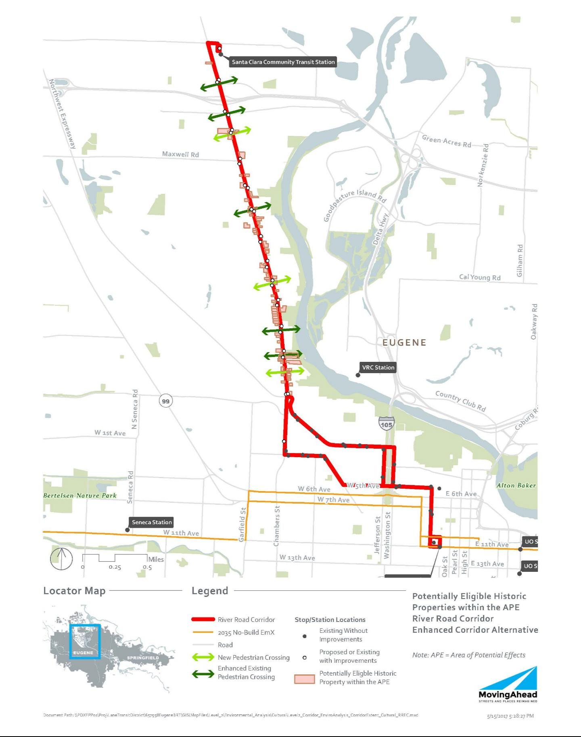

Lane Transit District | DRAFT FINAL Cultural Resources Technical Report | July 7, 2017
City of Eugene | MovingAhead Project | 5-13

Table 5.1-4. Inventory of Identified Historic Resources along River Road Corridor with Anticipated Effects for EmX Alternative

 |  |  | Preliminary | Long-term | Long-term
Address | Tax Lot Number | Date | Preliminary | Long-term | Indirect /
Address | Tax Lot Number | Date | Evaluationª | Direct | Indirect /
 |  |  | Evaluationª | Direct | Cumulative
285 River Road | 1704251301901 | 1962 | EC |  | S
325 River Road | 1704251202700 | 1926 (1929) | EC
330 River Road | 1704252400200 | 1924 | EC
345 River Road | 1704251202400 | 1929 | EC
355 River Road | 1704251202300 | 1925 | EC
365 River Road | 1704251202000 | 1923 | EC
370 River Road |  | c 1890
[single-family | 1704252107404 | City | EC
residential] |  | Landmark
375 River Road | 1704251201900 | 1920 | EC
385 River Road | 1704251201400 | 1926 | EC
390 River Road |  | c 1920
[single-family | 1704252105404 | City | EC
residential] |  | Landmark
395 River Road | 1704251201300 | 1920 | EC
405 River Road | 1704251201200/ | 1910 | EC
[single-family | 1704251201203 | City | EC
residential] | 1704251201203 | Landmark
450 River Road | 1704252104607 | c 1920 | EC
 | 1704252104607 | (1908) | EC
455 River Road | 1704251200800 | 1923 | EC
460 River Road | 1704252104500 | 1936 | EC
470 River Road | 1704252104400 | 1928 | EC | S, T
480 River Road | 1704252104300 | 1930 | EC | S, T
485 River Road | 1704251200500 | c 1920 | EC |  | S
65 Hansen Lane | 1704252100400 | 1950 | EC |  | S
100 Hansen Lane | 1704252104100 | 1946 | EC | S, T
501/505 River Road | 1704251200400 | 1920 | EC |  | S
July 7, 2017 | DRAFT FINAL Cultural Resources Technical Report |  |  |  | Lane Transit District
5-14 |  | MovingAhead Project |  |  | City of Eugene


Table 5.1-4. Inventory of Identified Historic Resources along River Road Corridor with Anticipated Effects for EmX Alternative

 |  |  | Preliminary | Long-term | Long-term
Address | Tax Lot Number | Date | Preliminary | Long-term | Indirect /
Address | Tax Lot Number | Date | Evaluationª | Direct | Indirect /
 |  |  | Evaluationª | Direct | Cumulative
530 River Road | 1704252100300 | 1918 | EC
570 River Road | 1704243407300 | 1936 | EC
600 River Road | 1704243404500 | c 1925 | EC
 | 1704243404500 | (1936) | EC
610 River Road | 1704243404400 | 1928 | EC
670 River Road | 1704243400502 | 1936 | EC
680 River Road | 1704243400400 | 1942 | EC
700 River Road | 1704243400300 | 1942 | EC
710 River Road | 1704243400200 | 1948 | EC
720 River Road | 1704243400100 | 1941 | EC
730 River Road | 1704243106600 | 1946 | EC
740 River Road | 1704243106500 | 1934 | EC
750 River Road | 1704243106400 | 1938 | EC
22 Park Avenue | 1704243106300 | 1880 | EC | S, T
755 River Road | 1704243106900 | 1932 | EC
800 River Road | 1704243104500 | 1928 | EC
805 River Road | 1704243107600 | 1912 | EC | S, T
840 River Road | 1704243104200 | 1927 | EC
865 River Road | 1704243101600 | 1941 | EC
901 River Road | 1704242407900 | 1954 | EC
930 River Road | 1704242409200 | 1931 | EC
931 River Road | 1704242406900 | 1949 | EC
940 River Road | 1704242409100 | 1926 | EC
988 River Road | 1704242409001 | 1964 | EC
1000 River Road | 1704242408501 | 1958 | EC
1015 River Road | 1704242404000802 | 1948 (1950) | EC |  | S
Lane Transit District | DRAFT FINAL Cultural Resources Technical Report |  |  |  | July 7, 2017
City of Eugene | MovingAhead Project |  |  |  | 5-15


Table 5.1-4. Inventory of Identified Historic Resources along River Road Corridor with Anticipated Effects for EmX Alternative
 |  |  | Preliminary | Long-term | Long-term
Address | Tax Lot Number | Date | Preliminary | Long-term | Indirect /
Address | Tax Lot Number | Date | Evaluationª | Direct | Indirect /
 |  |  | Evaluationª | Direct | Cumulative


1020 River Road | 1704242408300
1030 River Road | 1704242408302
1065 River Road | 1704242107500
1085 River Road | 1704242107400
1105 River Road | 1704242107000
49 Arbor Drive | 1704242103300
1220 River Road | 1704242202800
1240 River Road | 1704242202700
1245 River Road | 1704242101900
1246-48 River Road | 1704242202701
14 Greenleaf (SE) | 1704242101700
39 Greenleaf (NE) | 1704242100500
1270 River Road | 1704242201202
1275 River Road | 1704242100400
1298 River Road | 1704133308600
1318 River Road | 1704133306300
1350 River Road | 1704133306200
1353 River Road | 1704133301700
1410 River Road
[single-family | 1704133304602
residential]
1445 River Road | 1704133300901
1495 River Road | 1704133300801
1580 River Road | 1704133302100


1922
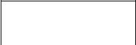

1960

1941

1928

- 1965

1951

1927

1920

1935

1940

1953

1907

1924

1940

1955

1928

1940


- 1920

(1933)


- 1910

(1920-22)

City

Landmark

- 1960 c 1965

- 1960

(1952)

EC | S
EC | S, A
EC
EC
EC
EC
EC
EC
EC
EC
EC
EC
EC
EC
EC |  | S
EC | T, A | S
EC | T, A
EC |  | S


ES
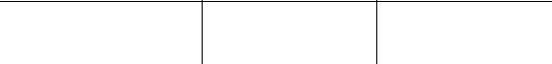

EC

EC
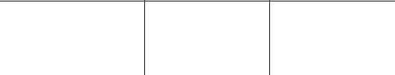

EC

July 7, 2017 | DRAFT FINAL Cultural Resources Technical Report | Lane Transit District
5-16 | MovingAhead Project | City of Eugene

Table 5.1-4. Inventory of Identified Historic Resources along River Road Corridor with Anticipated Effects for EmX Alternative

 |  |  | Preliminary | Long-term | Long-term
Address | Tax Lot Number | Date | Preliminary | Long-term | Indirect /
Address | Tax Lot Number | Date | Evaluationª | Direct | Indirect /
 |  |  | Evaluationª | Direct | Cumulative
1625 River Road | 1704133200400 | 1928 | EC
1630 River Road | 1704133202702 | 1930 | EC
1707 River Road | 1704133204700 | no date | EC | S, T
1920 River Road | 1704141401000 | 1945/1925 | EC
1925 River Road | 1704132300303 | 1967 | EC | T
1950 River Road | 1704141400800 | c 1950 | EC | T
2550 River Road | 1704114402300 | 1925 | EC
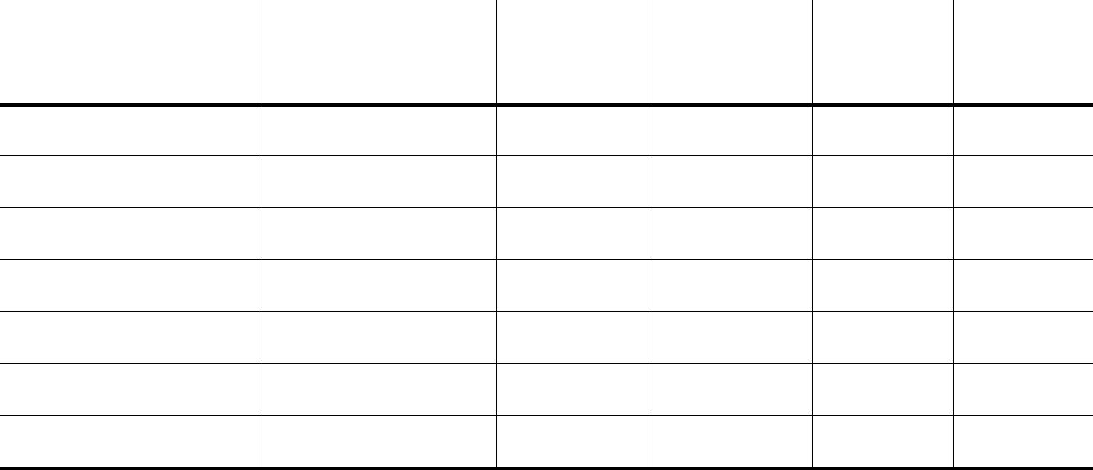

- Preliminary evaluation includes EC and ES; potential NRHP districts are noted. Bolded entry indicates City Landmark and/or NRHP listing.

KEY: S = EmX Station

T = Tax Lot Sliver Acquisition A = Access Affected

c = circa

Lane Transit District | DRAFT FINAL Cultural Resources Technical Report | July 7, 2017
City of Eugene | MovingAhead Project | 5-17

Figure 5.1-7. River Road EmX Alternative Cultural Resources Area of Potential Effect
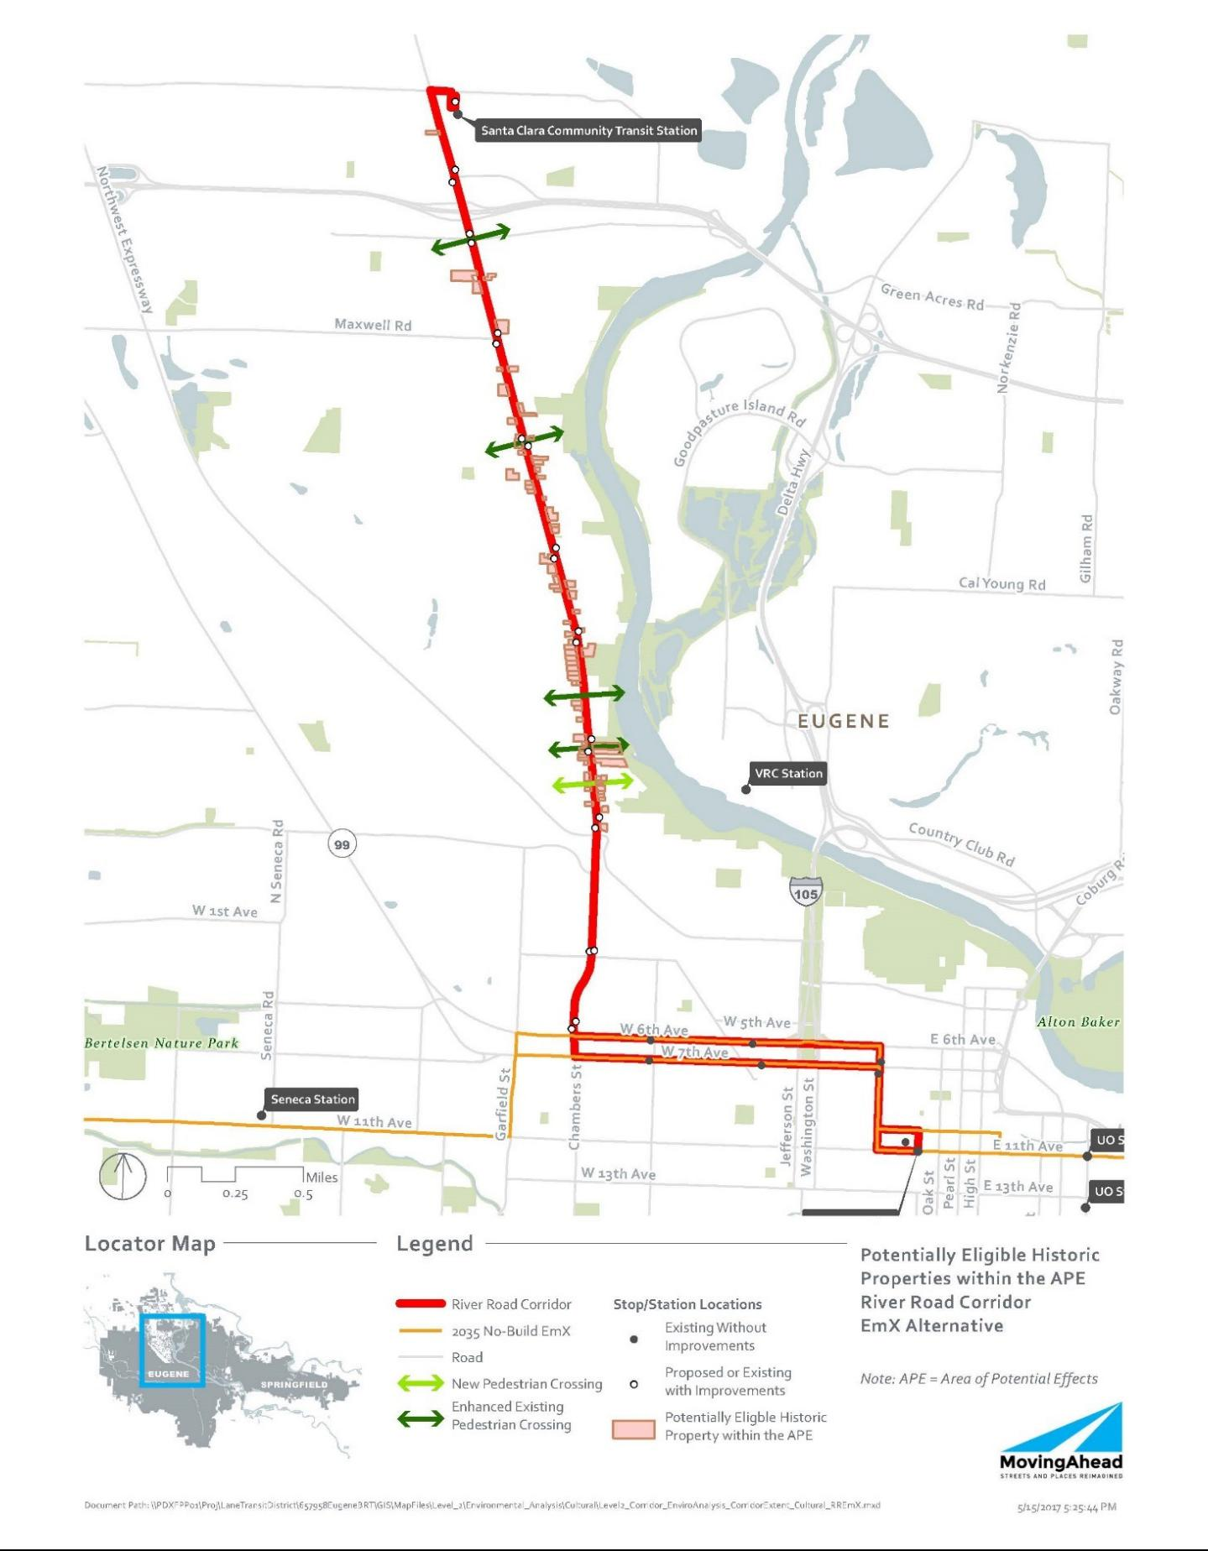

July 7, 2017 | DRAFT FINAL Cultural Resources Technical Report | Lane Transit District
5-18 | MovingAhead Project | City of Eugene

5.2. Environmental Consequences

The history of the River Road area has been recognized in an inventory conducted by the City of Eugene more than a decade ago, and consequently much of the APE has been previously inventoried. Approximately 30 percent of the historic resources along the River Road Corridor may be affected, directly or indirectly, by the proposed project.

Because of the already-widened character of River Road – which has impacted the historic resources along its route by bringing traffic closer to the buildings and diminishing the buffering effect of a number of formerly large front yards – the larger EmX stations may have more of an impact on some historic resources. There are four City Landmark sites along the route, and a number of other potential landmark properties that may be impacted, but none of the current City Landmarks would be affected by the proposed project under either build alternative.

5.2.1. Long-Term Direct Impacts

Direct impacts may originate from construction of stations or road widening that may require property acquisition from the tax lot or that may be constructed in a manner that would potentially obscure or otherwise interfere with the historic resource.

5.2.1.1. No-Build Alternative

No impacts to historic, archaeological or cultural resources would occur under the No-Build Alternative.

5.2.1.2. Enhanced Corridor Alternative

Direct impacts to historic resources are outlined in Table 5.1-3. Under the Enhanced Corridor Alternative, four resources may be affected by direct, long-term impacts.

5.2.1.3. EmX Alternative

Direct impacts to historic resources are outlined in Table 5.1-4. As many as 12 historic resources may be affected by direct, long-term impacts under the EmX Alternative, potentially resulting in adverse effects.

5.2.2. Indirect and Cumulative Effects

Indirect impacts are anticipated for the build alternatives. The impacts would not result in a physical impact to the resource, but may include the construction of stations or road widening sufficiently close to affect the visual character of the historical setting, or other attributes that contribute to its NRHP eligibility. Under Section 106, the impacts may affect a property, but may not necessarily result in an adverse effect.

5.2.2.1. No-Build Alternative

No impacts to historic, archaeological or cultural resources are anticipated to occur under the No-Build Alternative.

Lane Transit District | DRAFT FINAL Cultural Resources Technical Report | July 7, 2017
City of Eugene | MovingAhead Project | 5-19

5.2.2.2. Enhanced Corridor Alternative

Indirect impacts to historic resources are outlined in Table 5.1-3. Under the Enhanced Corridor Alternative, 22- of the 75 identified historic resources would likely be indirectly impacted. Under Section 106, the impacts may affect a property, but may not necessarily result in an adverse effect.

5.2.2.3. EmX Alternative

Indirect impacts to historic resources are outlined in Table 5.1-4. Potentially eight historic resources would be indirectly impacted under the EmX Alternative. Under Section 106, the indirect impacts would lead to an effect, but may not necessarily result in an adverse effect.

5.2.3. Short-Term Construction-Related Impacts

Aside from the direct impacts noted above, it is assumed that there would be no additional short-term impacts (noise, air, access, etc.) to historic resources associated with construction.

5.3. Potential Mitigation Measures

As a part of Section 106 (36 CFR Part 800) and NEPA, federal transportation agencies are required to seek ways to avoid, minimize, or mitigate adverse effects on historic properties.

Minimization or avoidance of ROW needs would reduce or eliminate impacts. Reduction or elimination of ROW needs from historic properties in the project corridor that are eligible for NRHP would avoid or minimize Section 106 impacts to the properties. Shifting new stop and station locations away from historic properties would reduce or eliminate impacts.

If it is not feasible to avoid historic properties, an FOE form should be prepared for each of the historic properties impacted by the project. Given the current project description and the types of activities and features that would be implemented, it is likely that the project can avoid adverse effects to historic properties.

Mitigation/conservation measures may be required for construction contractor compliance if the project plans change and project effects to the NRHP-eligible properties would be greater than stated in this report. An Inadvertent Discovery Plan should also be in place prior to construction, outlining measures to be undertaken in the event of an unanticipated archaeological discovery.

July 7, 2017 | DRAFT FINAL Cultural Resources Technical Report | Lane Transit District
5-20 | MovingAhead Project | City of Eugene

- 30th Avenue to Lane Community College Corridor Environmental Consequences

6.1. Affected Environment

6.1.1. Archaeological Background and Records Review

Documentary research was conducted using primary and secondary source materials on file at the Oregon SHPO, Lane County, and other appropriate archives. The archaeological site and project records maintained by the Oregon SHPO were examined using the Internet-based OARRA system; these records were reviewed to identify previous archaeological investigations conducted in the vicinity of the 30th Avenue to LCC Corridor and archaeological sites recorded in this area. Projects, as well as individual historic and archaeological site data, were collected for an area within approximately 1 mile of the proposed corridor alternatives. This information was identified as being either within the APE (defined as the area within 350 feet of the project corridor where changes are planned in the Enhanced Corridor or EmX Alternatives) or being within 1 mile of this APE. Analysts gathered properties identified as NRHP-listed or -eligible, or identified as Statewide Planning Goal 5-protected historic resources within the APE, to determine project impacts as well as information on properties in the general geographic area from which to develop greater historical context. Historical maps, including GLO, Sanborn Insurance, and USGS, depicting the project vicinity were also inspected.

Within 1 mile of the 30th Avenue to LCC Corridor APE (Table 6.1-1), 44 archaeological investigations have been conducted and 11 archaeological sites are recorded (Table 6.1-2). Thirteen of the investigations were associated with utilities-related projects, 12 were connected with projects in downtown Eugene, 7 were for transportation improvement projects, 6 were miscellaneous property surveys, 3 were associated with recreational projects at Dorris Ranch, 1 was for a residential development, 1 was an archaeological overview document, and 1 was a Master's thesis documenting the first African-American neighborhood in Eugene. The downtown Eugene projects include five associated with construction of the new federal courthouse, five with redevelopment of other downtown properties, and two with improvements to the Ferry Street Bridge.

Only one project included portions of the current APE. An archaeological survey for a fiber optic line paralleled 30th Avenue from Hilyard Street to LCC. No archaeological materials were found in the current APE by this survey.

No archaeological sites are documented within the 30th Avenue to LCC Corridor APE, although site 35LA1109 is just north of 30th Avenue near LCC and may extend south into the APE. The southern boundary of this prehistoric lithic scatter has not been fully defined. Overall, 11 archaeological sites are recorded in the 1-mile study area surrounding the APE (Table 6.1-2). Nine of these are historical sites in central Eugene, including six refuse scatters (35A1277, 35LA1320, 35LA1329, 35LA1334, 35LA1466, and 35LA1478), two foundations / footings with associated refuse (35LA1330 and 35LA1335), and a section of track from the Eugene street railway system (35LA1590). The remaining two sites are near LCC: 35LA1109 (as previously mentioned) and 35LA1173, a prehistoric lithic scatter in the hills south of LCC. None of the sites has been evaluated for eligibility to the NRHP.

Lane Transit District | DRAFT FINAL Cultural Resources Technical Report | July 7, 2017
City of Eugene | MovingAhead Project | 6-1

Table 6.1-1. Previous Investigations Conducted within 1 Mile of 30th Avenue to LCC Corridor

Project Description | Results | Reference
In Current APE
US Sprint fiber optic line survey | Negative in current area | Minor, 1987 (SHPO #8292)
Within 1 Mile of APE
Downtown Eugene survey of 12 lots | Negative | Minor, 1979 (SHPO #573)
Interceptor and sewer survey | Negative | Follansbee, 1977 (SHPO #2522)
Dorris Ranch survey | Isolated prehistoric artifacts | Lebow, 1987 (SHPO #9153)
LCC school forest property survey | Recorded 35LA1173 | Pettigrew, 1996 (SHPO #15569)
Ferry Street Bridge road improvement | Artifacts found in fill deposits | INFOTEC, 1992 (SHPO #16090)
survey and probing
Charnelton parking structure testing | Recorded 35LA1330 | Bowyer, 1997 (SHPO #16222)
and monitoring
Eugene / Springfield archaeological | Regional overview | Silvermoon et al., 1984
resources overview |  | (SHPO #16223)
TL 100 and TL 201 at 38th Avenue and | Negative | Boersema and Oetting, 1998
Hilyard Street survey |  | (SHPO #16503)
Eugene Library monitoring and | Recorded 35LA1335 | Minor, 2000 (SHPO #17531)
artifact recovery
Eugene-Springfield LTD Bus Rapid | Negative | Oetting, 2000 (SHPO #17775)
Transit survey
Alvey Substation survey and probing | Negative | Finley, 2002 (SHPO #17954)
Eugene Millrace Industrial District | Artifacts found in fill deposits | Minor, 1988b (SHPO #18496)
(Ferry Street Bridge) monitoring
Eugene Federal Courthouse | Recorded 35LA1277 | Maass and O'Bannon, 2003
archaeological investigations |  | (SHPO #18502 and #19013)
Federal Courthouse monitoring and | Recovered artifacts from | Byram, 2004a (SHPO #19337)
artifact recovery | 35LA1277
Federal Courthouse monitoring and | Recovered artifacts from | Byram, 2004b (SHPO #19342)
artifact recovery | 35LA1277
Bridge 08445, OR99 over I-5, survey | Negative | Edwards, 2004a (SHPO #19467)
Bridge 08870, I-5 over OR99 | Negative | Edwards, 2004b (SHPO #19500)
Connector survey

July 7, 2017 | DRAFT FINAL Cultural Resources Technical Report | Lane Transit District
6-2 | MovingAhead Project | City of Eugene

Table 6.1-1. Previous Investigations Conducted within 1 Mile of 30th Avenue to LCC Corridor

 | Project Description |  | Results | Reference
 | Bridge 06836A, I-5 over Franklin |  | Negative | Edwards, 2004c (SHPO #19506)
 | Boulevard and UPRR survey
 | BPA transmission tower relocation |  | Isolated prehistoric artifacts | Boynton et al., 2007
 | project survey |  |  | (SHPO #21163)
 | Federal Courthouse (Highway 99W, |  | Recovered artifacts from | Minor, 2006 (SHPO #21189)
 | High Street to Hilyard Street) |  | 35LA1277
 | monitoring
 | OR99 (Barger Drive to Washington / |  | Negative | O'Neill and Ruiz, 2008
 | Jefferson) survey |  |  | (SHPO #22097)
 | Federal Courthouse monitoring |  | Recorded 35LA1466 | Minor, 2008 (SHPO #22107 and
 |  |  |  | #22241)
 | I-5 Lane County Interstate sign |  | Negative in current area | Buchanan and Reese, 2008
 | replacement survey and probing |  |  | (SHPO #22141)
 | Middle Fork Willamette Loop Path |  | Negative in current area | Carlisle, 2008b (SHPO #22365)
 | (Dorris Ranch to Clearwater Park)
 | survey and testing
 | Eugene train depot monitoring |  | Recorded 35LA1478 | Hart, 2010 (SHPO #23211)
 | Dorris Ranch Early-House site test |  | Recovered scattered historical | Bowyer and Speulda, 1994
 | excavations |  | artifacts | (SHPO #23582)
 | LTD West Eugene EmX Expansion and |  | Negative | Oetting, 2011a (SHPO #24606)
 | locally preferred alternative survey
 | WestTown on 8th monitoring |  | Recorded 35LA1320 | Hart and McCornack, 2007
 |  |  |  | (SHPO #25822)
 | LCC cell tower survey |  | Negative | Stipe, 2013 (SHPO #25899)
 | Patterson (EU08) cell tower survey |  | Negative | Holschuh, 2013b (SHPO #25905)
 | Oak Hill School survey |  | Negative | McAlister, 2013 (SHPO #26084)
 | Fox Hollow and Amazon Road (EG46) |  | Negative | Holschuh, 2013c (SHPO #26143)
 | cell tower survey
 | Blanton Ridge (EG42) cell tower |  | Negative | Maceyko and Holschuh, 2013
 | survey |  |  | (SHPO #26203)
 | The Nature Conservancy's Willamette |  | Negative | Musil, 2012 (SHPO #26265)
 | Confluence Preserve survey
 | Laurel Hill (EG41) cell tower survey |  | Negative | Holschuh, 2014 (SHPO #26307)
 | Lane Transit District | DRAFT FINAL Cultural Resources Technical Report |  | July 7, 2017
 | City of Eugene |  | MovingAhead Project | 6-3

Table 6.1-1. Previous Investigations Conducted within 1 Mile of 30th Avenue to LCC Corridor

Project Description | Results | Reference
BPA Alvey-Fairview transmission line | Negative in current area | Ragsdale et al., 2014
survey |  | (SHPO #26324)
Cultural demolition of first Eugene | Master's thesis | Beckner, 2009 (SHPO #26630)
African-American neighborhood
Roosevelt Middle School replacement | Negative | Toepel, 2014 (SHPO #26808)
survey
PP&L Eugene-Medford 500 kV | Negative in current area | White et al., 1994 (SHPO #27425)
transmission line survey
Springfield Utility Board structure | Isolated prehistoric artifact | Teoh, 2015 (SHPO #27610)
replacement and fiber installation
project survey
Willamette Confluence Preserve three | Negative | Musil, 2015 (SHPO #27827)
additional parcels survey
Main Line Valve 78-1 to Winchester | Negative | Tisdale, 2016 (SHPO #27996)
Compressor Station facility
modifications survey
OR47638 Eugene cell tower survey | Negative | Finley, 2016 (SHPO #28009)

Source: Oregon Archaeological Records Remote Access System, Oregon SHPO. (2016, August).

Table 6.1-2. Archaeological Sites Recorded Within 1 Mile of 30th Avenue to LCC Corridor

Site Number/Name | Location | Description | NRHP
Site Number/Name | Location | Description | Eligibility
35LA1109 | T18S, R3W, sec. 10 Prehistoric lithic scatter |  | Unevaluated
35LA1173 / Sohnrey Site | T18S, R3W, sec. 14 Prehistoric lithic scatter |  | Unevaluated
35LA1277 / Agripac Site | T17S, R3W, sec. 32 Historical refuse scatter, probably |  | Unevaluated
 |  | residential
35LA1320 | T17S, R3W, sec. 31 Historical refuse scatter, probably |  | Unevaluated
 |  | residential trash pit
35LA1329 / Ferry Dump | T17S, R3W, sec. 29 Historical refuse scatter, Eugene community |  | Unevaluated
 |  | dump
35LA1330 / Hendricks | T17S, R3W, sec. 31 Historical foundation and refuse scatter |  | Unevaluated
House Lot
July 7, 2017 | DRAFT FINAL Cultural Resources Technical Report |  | Lane Transit District
6-4 |  | MovingAhead Project | City of Eugene

Table 6.1-2. Archaeological Sites Recorded Within 1 Mile of 30th Avenue to LCC Corridor

Site Number/Name | Location | Description | NRHP
Site Number/Name | Location | Description | Eligibility
35LA1334 | T17S, R3W, sec. 32 | Historical refuse scatter | Unevaluated
35LA1335 / New Eugene | T17S, R3W, sec. 31 | Historical architectural features (footings, | Unevaluated
Library Site |  | wells) and trash pits
35LA1466 / Eugene Iron | T17S, R3W, sec. 32 | Historical refuse scatter in documented iron | Unevaluated
Works |  | works location
35LA1478 / Eugene | T17S, R3W, sec. 30 | Historical refuse scatter in documented | Unevaluated
Train Depot |  | train depot location
35LA1590 / Eugene | T18S, R3W, sec. 6 | Section of historical electric street railway | Unevaluated
Street Railway |  | tracks, including rails, ties, spikes, joiners
(Willamette Street, 19th
to 24th Avenues)

Source: Oregon Archaeological Records Remote Access System, Oregon SHPO. (2016, August).

The GLO cadastral survey plats for T17S, R3W, and T18S, R3W depict general vegetation borders of timber with prairie or rolling prairie, but no indication of the hilly ridge separating central Eugene from LCC crossed by 30th Avenue is shown. Likewise, few cultural features are illustrated. The Plats of Claims for the townships show that the corridor passes through six DLCs: four in modern central Eugene (DLC No. 47 of Daniel Christian (in T17S, R3W this is DLC No. 72), DLC No. 49 of William Breeding, DLC No. 50 of Josiah M. Lackin, and DLC No. 51 of James M. Breeding); and two near modern LCC (DLC No. 43 of George M. Coryell and DLC No. 60 of William Moore).

6.1.2. Archaeological Survey Results

A pedestrian archaeological survey of the 30th Avenue to LCC Corridor was conducted on September 28, 2016. The surface survey inspected the proposed stops and stations and the transit and roadway improvements of the Enhanced Corridor and EmX Alternatives. This involved inspection of all proposed station locations on Oak and Pearl Streets between East 13th Avenue and East 18th Avenue, on Amazon Parkway, and on East 30th Avenue (including those at the Spring Boulevard interchange), inspection of the west side of Oak Street between 13th and 18th Avenues, the east side of Pearl Street between 13th and 18th Avenues, both sides of Amazon Parkway, and both sides of East 30th Avenue between Hilyard Street and University Street (Figures 6.1-1 and 6.1-2). Most of the proposed stops and stations are not at or near existing bus stops. The survey was conducted by one archaeologist walking on the sidewalks bordering each road and inspecting all patches of exposed mineral ground surface, both in the planting strip between the road and the sidewalk, and any ground visible on the opposite side of the sidewalk. The bus route would be northbound on Oak Street with all planned improvements on the west side of the street and southbound on Pearl Street with all improvements on the east side of the street, so only those sides of each street were surveyed. Sidewalks bordered both sides of East 30th Avenue.

Lane Transit District | DRAFT FINAL Cultural Resources Technical Report | July 7, 2017
City of Eugene | MovingAhead Project | 6-5

Figure 6.1-1. Location of Proposed Station on Pearl Street at East 18th Avenue
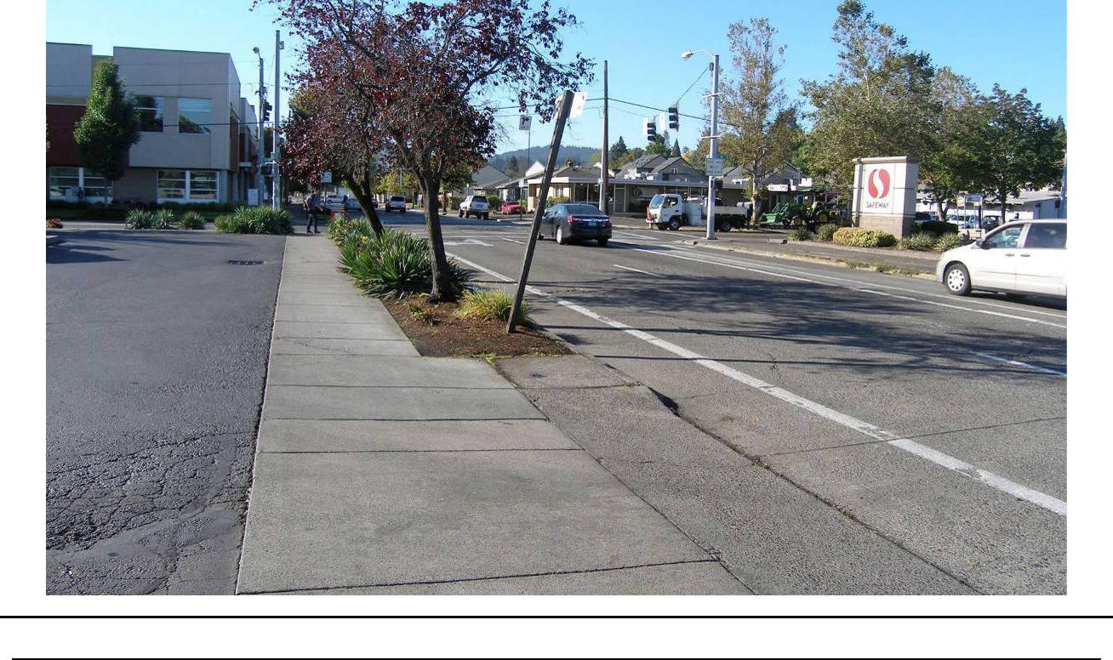

Figure 6.1-2. Raised Roadbed and Drainage Swale East of Amazon Parkway
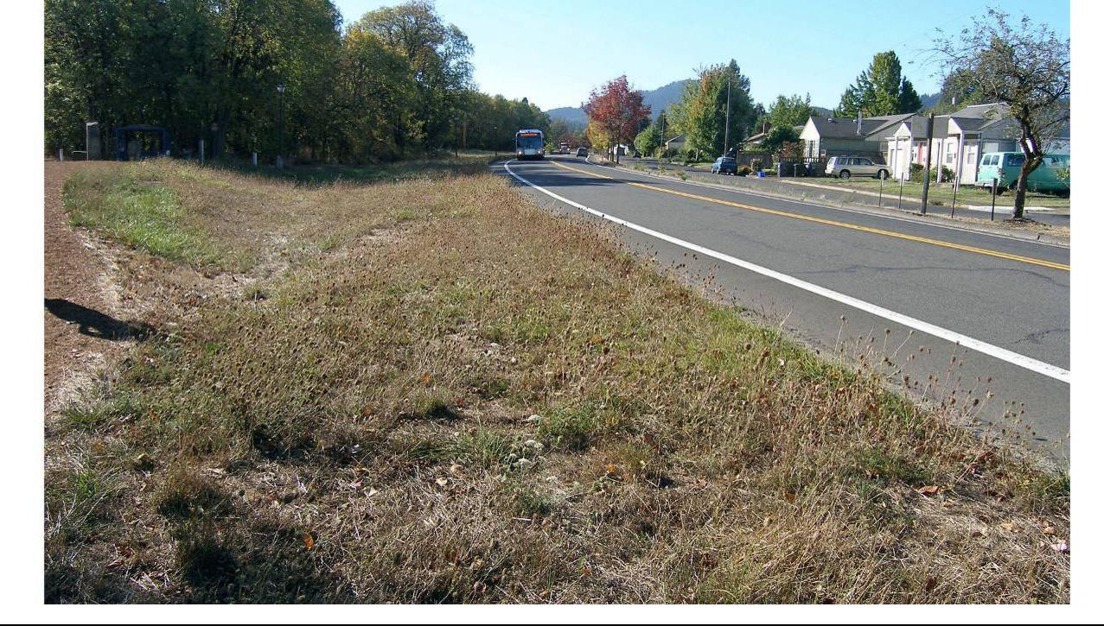

July 7, 2017 | DRAFT FINAL Cultural Resources Technical Report | Lane Transit District
6-6 | MovingAhead Project | City of Eugene

No sidewalks were present along most of Amazon Parkway. The archaeologist surveyed this segment by walking a slightly meandering transect 1 to 5 meters (3 to 15 feet) from the road curb to examine areas with the greatest ground surface visibility on both sides of the road. Mineral ground surface visibility was fair along the inspected route, averaging about 10 to 20 percent in the sections with sidewalks and about 5 to 10 percent in the thicker grasses bordering Amazon Parkway. Patches of mineral soil were present in most of the planting strips and neighboring surfaces along the sidewalks on Oak Street, Pearl Street, and East 30th Avenue, although much of the surface soil in the planting strips is probably not native soil, but is soil that was brought in for landscaping, since patches of underlying plastic sheeting or geotextile cloth were occasionally visible. Amazon Parkway is in the greenway natural area along Amazon Creek and so has denser surface vegetation, but some bare patches of mineral soil, along with rodent burrow backdirt, were visible alongside the road. Utility vaults, manhole covers, and electrical junction boxes were present along the route, denoting various buried utility lines and pipes.

No prehistoric or demonstrably historical artifacts, features, or sites were observed during this surface survey. Oak and Pearl Streets are part of the long-standing street grid of central Eugene. The makeup of this neighborhood has shifted over time and is currently mainly commercial with some residential properties, with an eclectic mix of older and newer structures. Development and redevelopment of the properties, with concomitant changes to adjoining sidewalks, driveways, and the underlying buried utility infrastructure has very likely disturbed most, if not all, of the ground along the city streets. Development and street improvements along East 30th Avenue have similarly disturbed the ground in this area. Less soil disturbance has likely occurred along Amazon Parkway, but even here disturbance likely occurred in clearing and grading the road area, which may have included cutting some depression areas for water runoff and constructing portions of the road a raised roadbed. The persistent annual flooding of Amazon Creek also limited development of south Eugene until flood control measures were taken in the 1940s, so historical use of the area was probably low. Likewise, Native American use of the area was also conditioned by this flooding, probably resulting in uses such as harvesting wetlands food resources that would leave few archaeological artifacts or features. The potential for intact archaeological materials, surface or buried, in the 30th Avenue-LCC Corridor is low.

6.1.3. Historical Background and Records Review

From its original 1852 and 1856 plats near Skinner Butte, nineteenth and early-twentieth century Eugene grew to the south, east, and west, with residential neighborhoods slowly expanding into areas historically used as farmland. South of the downtown core, the region between Willamette and Hilyard Streets is bisected by Amazon Creek, which was prone to seasonal flooding. Because of this, much of the land in south Eugene immediately adjacent to Amazon Creek remained undeveloped until the mid-twentieth century, when the U.S. Army Corps of Engineers manipulated the waterway for flood control purposes.

As late as 1936, Oak and Pearl Streets did not extend (in platted form) past about 17th Avenue, and the area south of about 23rd Avenue was predominantly rural, forming the edge of town until the post-World War II building boom resulted in many newly-platted neighborhoods farther south. 30th Avenue was formally established in the early 1960s, providing “a convenient and adequate route of travel from the easterly City Limits of . . . Eugene . . . on 30th Avenue East . . . to the Pacific Freeway, and . . . an additional highway for the safety and convenience of the traveling public . . .” (Surveyor Road File, 30th).

Lane Transit District | DRAFT FINAL Cultural Resources Technical Report | July 7, 2017
City of Eugene | MovingAhead Project | 6-7

Lane Community College, located at the southeastern end of 30th Avenue, was founded in 1964, and much of the residential development along 30th between Hilyard Street and LCC occurred during the late 1950s through the early 1970s.

Documentary research was conducted using primary and secondary source materials on file at Oregon SHPO (to identify properties designated as NRHP-listed or -eligible, or Statewide Planning

Goal 5-protected historic resources) and other appropriate records archives. This research included the following sources:

- Oregon SHPO NRHP and State Inventory files

- Lane County Inventory and Goal 5 Historic Resources

- City of Eugene Planning Division (Historic Resources)

- City of Springfield Historic Commission and Planning Department

- NRHP database for listed properties and districts

Analysts conducted a review of historical maps and records to identify potentially eligible historic resources along the River Road Corridor. The maps included GLO survey plats, master title plats for early land claims, and USGS quadrangles (Figures 6.1-3 through 6.1-5).

6.1.4. Historical Reconnaissance Results

Review of the Oregon SHPO database and the NRHP database for listed properties along the 30th Avenue to LCC Corridor has resulted in the identification of four historic resources along the proposed APE corridor (between 11th and 17th Avenues along Oak and Pearl Streets) that are formally listed on the NRHP at present. Two City Landmarks (one of which is also NRHP-listed) have also been recognized in the same neighborhood along the proposed corridor.

Because the portion of the corridor north of 17th Avenue was platted years before development expanded to the south of that street, there is a concentration of eligible and potentially eligible structures along the northern portion of the corridor that date from as early as 1855 up to the 1940s, and a bit later as well. There was a burst of post-World War II development south of 17th Avenue, particularly along the east side of Ferry Street where two blocks were identified as possible districts. A total of 89 properties was identified, from the Oregon SHPO database and the windshield survey, as eligible or potentially eligible (Tables 6.1-3 and 6.1-4 and Figures 6.1-6 and 6.1-7).

July 7, 2017 | DRAFT FINAL Cultural Resources Technical Report | Lane Transit District
6-8 | MovingAhead Project | City of Eugene

Figure 6.1-3. Location of 30th Avenue to LCC Corridor on the USGS Eugene 15’ Quadrangle, 1910
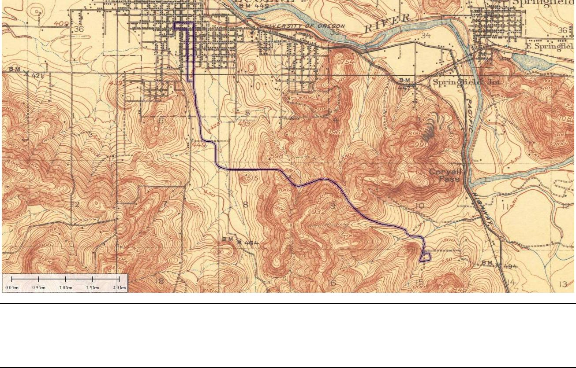

Figure 6.1-4. Location of 30th Avenue to LCC Corridor on the USGS Eugene 15’ Quadrangle, 1940
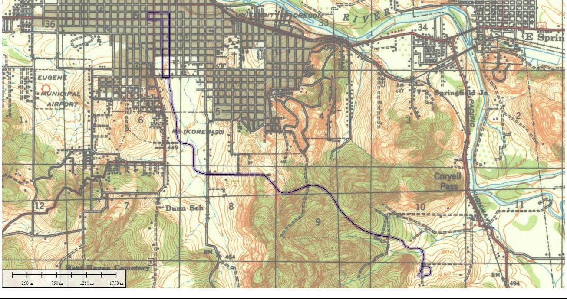

Lane Transit District | DRAFT FINAL Cultural Resources Technical Report | July 7, 2017
City of Eugene | MovingAhead Project | 6-9

Figure 6.1-5. Alignment of 30th Avenue to LCC Corridor as Shown on the USGS Eugene East 7.5’ Quadrangle, 1976 (Reduced)
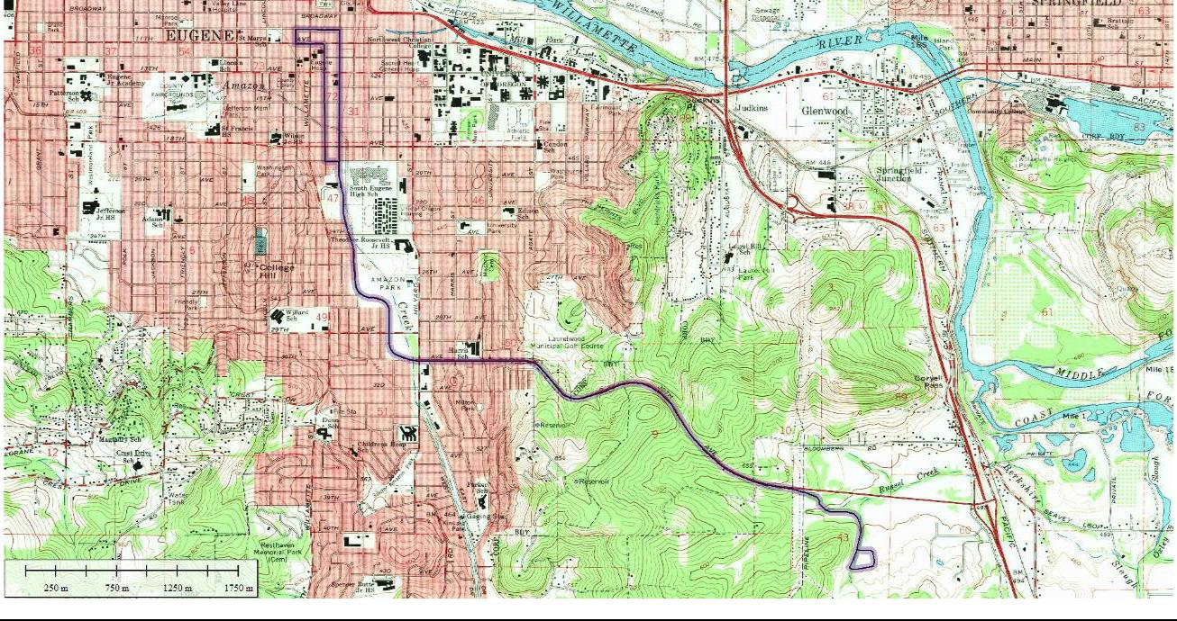

Table 6.1-3. Inventory of Identified Historic Resources along 30th Avenue to LCC Corridor with Anticipated Effects for Enhanced Corridor Alternative
 |  |  |  | Preliminary | Long-term | Long-term
 | Address | Tax Lot | Date | Preliminary | Long-term | Indirect /
 | Address | Tax Lot | Date | Evaluationª | Direct
 |  |  |  | Evaluationª | Direct | Cumulative
 | 32 E. 11th | 1703314114600 | c 1925 | EC
 | 50 E. 11th | 1703314114500 | c 1931 | EC
 | 185 E 11th | 1703311411200/ | 1930 | EC
 | 185 E 11th | 1703311411300 | 1930 | EC
 | 112 E 13th | 1703314111500 | 1930 | EC
 |  | 1703314111500 | 1930 | EC |  | P
 | 1143 Oak |  |  | ES NR
 | (Converted fraternity |  |  | ES NR
 | (Converted fraternity | 1703314110500 | 1910 | City
 | house; multi-unit | 1703314110500 | 1910 | City
 | house; multi-unit |  |  | Landmark
 | residential) |  |  | Landmark
 | 1166 Oak | 1703314114300 | 1911 | EC
 | 1230 Oak | 1703314113900 | 1908 | EC
July 7, 2017 |  | DRAFT FINAL Cultural Resources Technical Report |  |  |  | Lane Transit District
6-10 |  |  | MovingAhead Project |  |  | City of Eugene


Table 6.1-3. Inventory of Identified Historic Resources along 30th Avenue to LCC Corridor with Anticipated Effects for Enhanced Corridor Alternative

 |  |  | Preliminary | Long-term | Long-term
Address | Tax Lot | Date | Preliminary | Long-term | Indirect /
Address | Tax Lot | Date | Evaluationª | Direct | Indirect /
 |  |  | Evaluationª | Direct | Cumulative
1263 Oak | 1703314111100 | 1928 | ES NR
1281 Oak | 1703314113700 | c 1928 | ES NR
1287 Oak | 1703314111200 | 1950 | EC
1290 Oak | 1703314113600 | c 1940 | EC |  | P
1330 Oak | 1703314113300 | 1920 | EC
1339 Oak | 1703314111700 | 1966 | EC |  | P
1348 Oak | 1703314113200 | 1920 | EC
1358 Oak | 1703314113100 | 1965 | EC
1372 Oak | 1703314110300 | 1910 | EC |  | S
1390 Oak | 1703314112900 | c 1905 (1914) | EC |  | S
1483 Oak | 1703314402100 | c 1910 | EC |  | P
1495 Oak | 1703314402000 | c 1920 | EC
1699 Oak | 1703314411500 | 1930 | EC
1815 Oak | 1803061102100 | 1958 | EC
1850 Oak | 1803061103300 | 1962 | EC
1908 Oak | 1803061104500 | 1950 | EC
1911 Oak | 1803061107200 | 1947 | EC
1940 Oak | 1803061104700 | 1930 | EC
1945 Oak | 1803061107100 | 1947 | EC
1955 Oak | 1803061106900 | 1952 | EC
1193 Pearl | 1703314105900 | c 1920 | EC
1209 Pearl | 1703314106700 | 1920 | EC
1210 Pearl | 1703314109700 | 1920 | EC |  | P
1234 Pearl | 1703314109600 | 1924 | EC |  | P
1264 Pearl | 1703314109500 | 1921 | EC |  | P


Lane Transit District | DRAFT FINAL Cultural Resources Technical Report | July 7, 2017
City of Eugene | MovingAhead Project | 6-11

Table 6.1-3. Inventory of Identified Historic Resources along 30th Avenue to LCC Corridor with Anticipated Effects for Enhanced Corridor Alternative

 |  |  | Preliminary | Long-term | Long-term
Address | Tax Lot | Date | Preliminary | Long-term | Indirect /
Address | Tax Lot | Date | Evaluationª | Direct | Indirect /
 |  |  | Evaluationª | Direct | Cumulative
1280 Pearl | 1703314109400 | 1930 | EC |  | P
1290 Pearl | 1703314109300 | c 1935 | EC |  | P
1300 Pearl | 1703314109000 | 1938 | EC |  | P
1361 Pearl | 1703314107500 | c 1890 | EC |  | S
1375 Pearl | 1703314107600 | 1927 | EC |  | S
1389 Pearl | 1703314107700 | c 1905 | EC |  | S
1390 Pearl | 1703314108700 | 1948 | EC | S | P
1412 Pearl |  |  | EC
(Converted residential | 1703314108500 | 1915 | City |  | P
structure; commercial) |  |  | Landmark
1430 Pearl | 1703314108400 | 1915 | EC |  | P
1442 Pearl | 1703314108300 | c 1905 | EC |  | P
1454 Pearl | 1703314401500 | 1939, 1900 | EC
1478 Pearl | 1703314401600 | c 1905 | EC
1491 Pearl | 1703314401200 | c 1920 | EC
1492 Pearl | 1703314401700 | 1910 | EC
1531 Pearl | 1703314405800 | c 1905 | EC
1570 Pearl | 1703314405300 | 1957 | EC | T
1598 Pearl | 1703314405600 | 1927 (1935) | EC | T
1605 Pearl / 244 E. | 1703314410400 | 1911 | ES/NR
16th | 1703314410400 | 1911 | ES/NR
1627 Pearl | 1703314410200 | 1915 | EC
1648 Pearl | 1703314410800 | c 1925 | EC
Amazon Channel |  | 1940-1959 | ES
1733 Pearl | 1703314413600 | 1962 | EC
1846 Pearl | 1803061101800 | 1956 | EC
1850 Pearl | 1803061103100 | 1942 | EC
July 7, 2017 | DRAFT FINAL Cultural Resources Technical Report |  |  |  | Lane Transit District
6-12 |  | MovingAhead Project |  |  | City of Eugene


Table 6.1-3. Inventory of Identified Historic Resources along 30th Avenue to LCC Corridor with Anticipated Effects for Enhanced Corridor Alternative

 |  |  | Preliminary | Long-term | Long-term
Address | Tax Lot | Date | Preliminary | Long-term | Indirect /
Address | Tax Lot | Date | Evaluationª | Direct | Indirect /
 |  |  | Evaluationª | Direct | Cumulative
1912 Pearl | 1803061107700 | 1935 | EC
1940 Pearl | 1803061107800 | 1941 | EC |  | P
99 E. 17th | 1703314412000 | 1961 | EC
74 E 18th | 1803061103200 | 1957 | EC
90 E 20th | 1803061106600 | 1936 | EC
215 E 19th | 1803061101500 | 1946 | EC
81 E 23rd | 1803061404700 | 1957 | EC
90 E 23rd | 1803061404800 | 1953 | EC
2450 High | 1803064109000 | 1952 | EC
2460 High | 1803064109300 | 1962 | EC
2470 High | 1803064109400 | 1954 | EC
195 E 25th | 1803064110100 | 1946 | EC
180 E 25th | 1803064111500 | 1946 | EC
2800 block of Ferry, |  | 1950s | Possible
East side, continuous |  | 1950s | District
2805 Ferry | 1803053300200 | 1955 | EC
2815 Ferry | 1803053300300 | 1954 | EC
2825 Ferry | 1803053300400 | 1952 | EC
2835 Ferry | 1803053300500 | 1952 | EC
2845 Ferry | 1803053300600 | 1952 | EC
2855 Ferry | 1803053300700 | 1952 | EC
2865 Ferry | 1803053300800 | 1954 | EC
2875 Ferry | 1803053300900 | 1953 | EC
2885 Ferry | 1803053301000 | 1952 | EC
2900 block of Ferry, |  | Mid-1950s | Potential
East side, continuous |  | Mid-1950s | District
Lane Transit District | DRAFT FINAL Cultural Resources Technical Report |  |  |  | July 7, 2017
City of Eugene |  | MovingAhead Project |  |  | 6-13


Table 6.1-3. Inventory of Identified Historic Resources along 30th Avenue to LCC Corridor with Anticipated Effects for Enhanced Corridor Alternative

 |  |  | Preliminary | Long-term | Long-term
Address | Tax Lot | Date | Preliminary | Long-term | Indirect /
Address | Tax Lot | Date | Evaluationª | Direct | Indirect /
 |  |  | Evaluationª | Direct | Cumulative
2901 Ferry | 1803082200200 | 1953 | EC
2905 Ferry | 1803082200300 | 1953 | EC
2915 Ferry | 1803082200400 | 1955 | EC
2925 Ferry | 1803082200500 | 1953 | EC
2935 Ferry | 1803082200600 | 1954 | EC
2951 Ferry | 1803082200800 | 1950 | EC
North side 30th from |  | Late 1950s-ear | Potential
Alder Alley to Agate St., |  | Late 1950s-ear | Potential
Alder Alley to Agate St., |  | 1960s | District
continuous |  | 1960s | District
1150 E 29th | 1803081203800 | 1949 | EC/ES |  | S
2996 Harris | 1803082100900 | 1948 | EC
South side 30th from |  | Late 1950s- | Potential
Alder to Agate, |  | Late 1950s- | Potential
Alder to Agate, |  | 1960s | District
continuous |  | 1960s | District
3015 University | 1803081208800 | 1958 | EC |  | S
3005 Harris | 1803082112200 | 1957 | EC |  | S
4000 E. 30th | 1803100001400 | 1963, 1967 | EC
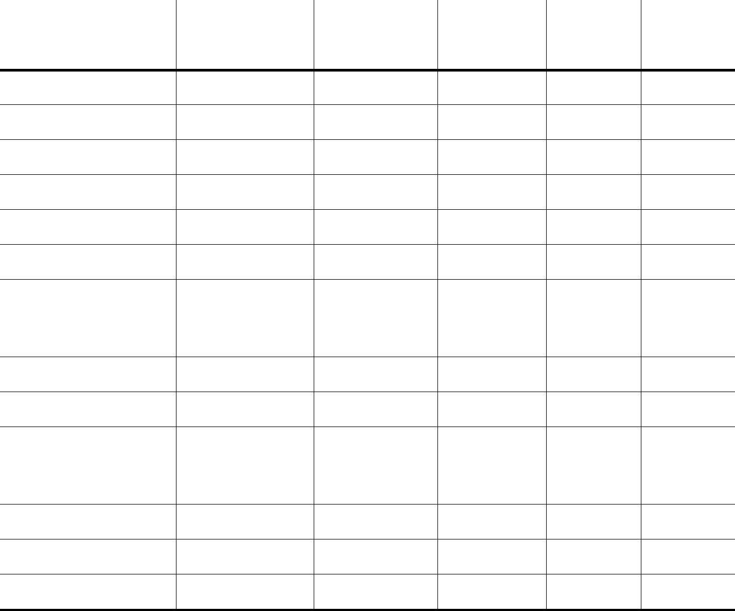

- Preliminary evaluation includes EC and ES; potential NRHP districts are noted. Bolded resources indicate City Landmarks and NRHP sites (ES NR).

KEY: S = Enhanced Shelter

T = Tax Lot Sliver Acquisition P = Planting Strip (effect from tree removal, new parking bay, new sidewalk) c = circa

July 7, 2017 | DRAFT FINAL Cultural Resources Technical Report | Lane Transit District
6-14 | MovingAhead Project | City of Eugene

Figure 6.1-6. 30th Avenue to Lane Community College Enhanced Corridor Alternative Cultural Resources Area of Potential Effect
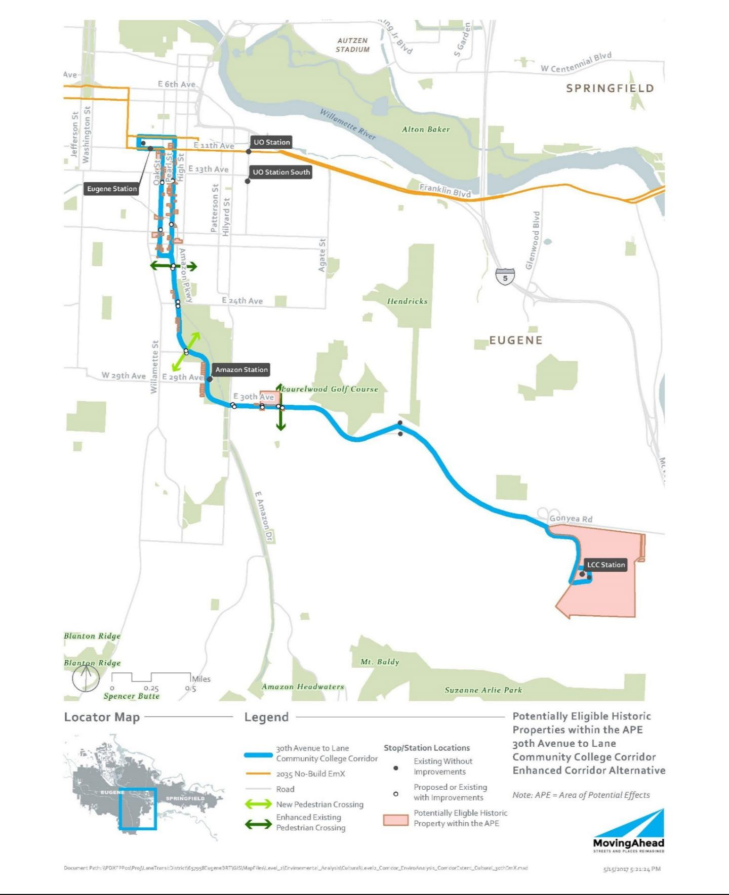

Lane Transit District | DRAFT FINAL Cultural Resources Technical Report | July 7, 2017
City of Eugene | MovingAhead Project | 6-15

Table 6.1-4. Inventory of Identified Historic Resources along 30th Avenue to LCC Corridor with Anticipated Effects for EmX Alternative

 |  |  | Preliminary | Long-term | Long-term
Address | Tax Lot | Date | Preliminary | Long-term | Indirect /
Address | Tax Lot | Date | Evaluationª | Direct | Indirect /
 |  |  | Evaluationª | Direct | Cumulative
32 E. 11th | 1703314114600 | c 1925 | EC
50 E. 11th | 1703314114500 | c 1931 | EC
185 E 11th | 1703311411200/ | 1930 | EC
 | 1703311411300 | 1930 | EC
112 E 13th | 1703314111500 | 1930 | EC
1143 Oak |  |  | ES NR
(Converted fraternity |  |  | ES NR
(Converted fraternity | 1703314110500 | 1910 | City
house; multi-unit | 1703314110500 | 1910 | City
house; multi-unit |  |  | Landmark
residential) |  |  | Landmark
1166 Oak | 1703314114300 | 1911 | EC
1230 Oak | 1703314113900 | 1908 | EC
1263 Oak | 1703314111100 | 1928 | ES NR
1281 Oak | 1703314113700 | c 1928 | ES NR
1287 Oak | 1703314111200 | 1950 | EC
1290 Oak | 1703314113600 | c 1940 | EC
1330 Oak | 1703314113300 | 1920 | EC | S, T
1339 Oak | 1703314111700 | 1966 | EC |  | S
1348 Oak | 1703314113200 | 1920 | EC | S, T
1358 Oak | 1703314113100 | 1965 | EC |  | S
1372 Oak | 1703314110300 | 1910 | EC
1390 Oak | 1703314112900 | c 1905 (1914) | EC
1483 Oak | 1703314402100 | c 1910 | EC
1495 Oak | 1703314402000 | c 1920 | EC
1699 Oak | 1703314411500 | 1930 | EC
1815 Oak | 1803061102100 | 1958 | EC |  | S
1850 Oak | 1803061103300 | 1962 | EC
1908 Oak | 1803061104500 | 1950 | EC
July 7, 2017 | DRAFT FINAL Cultural Resources Technical Report |  |  |  | Lane Transit District
6-16 |  | MovingAhead Project |  |  | City of Eugene

Table 6.1-4. Inventory of Identified Historic Resources along 30th Avenue to LCC Corridor with Anticipated Effects for EmX Alternative

 |  |  | Preliminary | Long-term | Long-term
Address | Tax Lot | Date | Preliminary | Long-term | Indirect /
Address | Tax Lot | Date | Evaluationª | Direct | Indirect /
 |  |  | Evaluationª | Direct | Cumulative
1911 Oak | 1803061107200 | 1947 | EC
1940 Oak | 1803061104700 | 1930 | EC
1945 Oak | 1803061107100 | 1947 | EC
1955 Oak | 1803061106900 | 1952 | EC
1193 Pearl | 1703314105900 | c 1920 | EC
1209 Pearl | 1703314106700 | 1920 | EC
1210 Pearl | 1703314109700 | 1920 | EC
1234 Pearl | 1703314109600 | 1924 | EC
1264 Pearl | 1703314109500 | 1921 | EC
1280 Pearl | 1703314109400 | 1930 | EC
1290 Pearl | 1703314109300 | c 1935 | EC
1300 Pearl | 1703314109000 | 1938 | EC |  | S
1361 Pearl | 1703314107500 | c 1890 | EC
1375 Pearl | 1703314107600 | 1927 | EC
1389 Pearl | 1703314107700 | c 1905 | EC
1390 Pearl | 1703314108700 | 1948 | EC
1412 Pearl |  |  | EC
(Converted residential | 1703314108500 | 1915 | City
structure; commercial) |  |  | Landmark
1430 Pearl | 1703314108400 | 1915 | EC
1442 Pearl | 1703314108300 | c 1905 | EC |  | S
1454 Pearl | 1703314401500 | 1939, 1900 | EC |  | S
1478 Pearl | 1703314401600 | c 1905 | EC |  | S
1491 Pearl | 1703314401200 | c 1920 | EC
1492 Pearl | 1703314401700 | 1910 | EC |  | S
1531 Pearl | 1703314405800 | c 1905 | EC
1570 Pearl | 1703314405300 | 1957 | EC
Lane Transit District | DRAFT FINAL Cultural Resources Technical Report |  |  |  | July 7, 2017
City of Eugene |  | MovingAhead Project |  |  | 6-17

Table 6.1-4. Inventory of Identified Historic Resources along 30th Avenue to LCC Corridor with Anticipated Effects for EmX Alternative

 |  |  | Preliminary | Long-term | Long-term
Address | Tax Lot | Date | Preliminary | Long-term | Indirect /
Address | Tax Lot | Date | Evaluationª | Direct | Indirect /
 |  |  | Evaluationª | Direct | Cumulative
1598 Pearl | 1703314405600 | 1927 (1935) | EC
1605 Pearl / 244 E. | 1703314410400 | 1911 | ES/NR
16th | 1703314410400 | 1911 | ES/NR
1627 Pearl | 1703314410200 | 1915 | EC
1648 Pearl | 1703314410800 | c 1925 | EC
Amazon Channel |  | 1940-1959 | ES
1733 Pearl | 1703314413600 | 1962 | EC |  | S
1846 Pearl | 1803061101800 | 1956 | EC
1850 Pearl | 1803061103100 | 1942 | EC
1912 Pearl | 1803061107700 | 1935 | EC
1940 Pearl | 1803061107800 | 1941 | EC
99 E. 17th | 1703314412000 | 1961 | EC
74 E 18th | 1803061103200 | 1957 | EC | S, T
90 E 20th | 1803061106600 | 1936 | EC
215 E 19th | 1803061101500 | 1946 | EC
81 E 23rd | 1803061404700 | 1957 | EC
90 E 23rd | 1803061404800 | 1953 | EC
2450 High | 1803064109000 | 1952 | EC
2460 High | 1803064109300 | 1962 | EC
2470 High | 1803064109400 | 1954 | EC
195 E 25th | 1803064110100 | 1946 | EC
180 E 25th | 1803064111500 | 1946 | EC
2800 block of Ferry, |  | 1950s | Possible
East side, continuous |  | 1950s | District
2805 Ferry | 1803053300200 | 1955 | EC
2815 Ferry | 1803053300300 | 1954 | EC
2825 Ferry | 1803053300400 | 1952 | EC
July 7, 2017 | DRAFT FINAL Cultural Resources Technical Report |  |  |  | Lane Transit District
6-18 |  | MovingAhead Project |  |  | City of Eugene

Table 6.1-4. Inventory of Identified Historic Resources along 30th Avenue to LCC Corridor with Anticipated Effects for EmX Alternative

 |  |  | Preliminary | Long-term | Long-term
Address | Tax Lot | Date | Preliminary | Long-term | Indirect /
Address | Tax Lot | Date | Evaluationª | Direct | Indirect /
 |  |  | Evaluationª | Direct | Cumulative
2835 Ferry | 1803053300500 | 1952 | EC
2845 Ferry | 1803053300600 | 1952 | EC
2855 Ferry | 1803053300700 | 1952 | EC
2865 Ferry | 1803053300800 | 1954 | EC
2875 Ferry | 1803053300900 | 1953 | EC
2885 Ferry | 1803053301000 | 1952 | EC
2900 block of Ferry, |  | Mid-1950s | Potential
East side, continuous |  | Mid-1950s | District
2901 Ferry | 1803082200200 | 1953 | EC
2905 Ferry | 1803082200300 | 1953 | EC
2915 Ferry | 1803082200400 | 1955 | EC
2925 Ferry | 1803082200500 | 1953 | EC
2935 Ferry | 1803082200600 | 1954 | EC
2951 Ferry | 1803082200800 | 1950 | EC
NS 30th from Alder |  | Late 1950s-ear | Potential
Alley to Agate St., |  | Late 1950s-ear | Potential
Alley to Agate St., |  | 1960s | District
continuous |  | 1960s | District
1150 E. 29th | 1803081203800 | 1949 | EC/ES |  | S
2996 Harris | 1803082100900 | 1948 | EC
SS 30th from Alder to |  | Late 1950s- | Potential
Agate, continuous |  | 1960s | District
3015 University | 1803081208800 | 1958 | EC | S
3005 Harris | 1803082112200 | 1957 | EC
4000 E. 30th | 1803100001400 | 1963, 1967 | EC


- Preliminary evaluation includes EC and ES; potential NRHP districts are noted. Bolded resources indicate City Landmarks and NRHP sites (evaluated as ES NR). KEY: S = EmX Station

T = Tax Lot Sliver Acquisition c = circa

Lane Transit District | DRAFT FINAL Cultural Resources Technical Report | July 7, 2017
City of Eugene | MovingAhead Project | 6-19

Figure 6.1-7. 30th Avenue to Lane Community College EmX Alternative Cultural Resources Area of Potential Effect
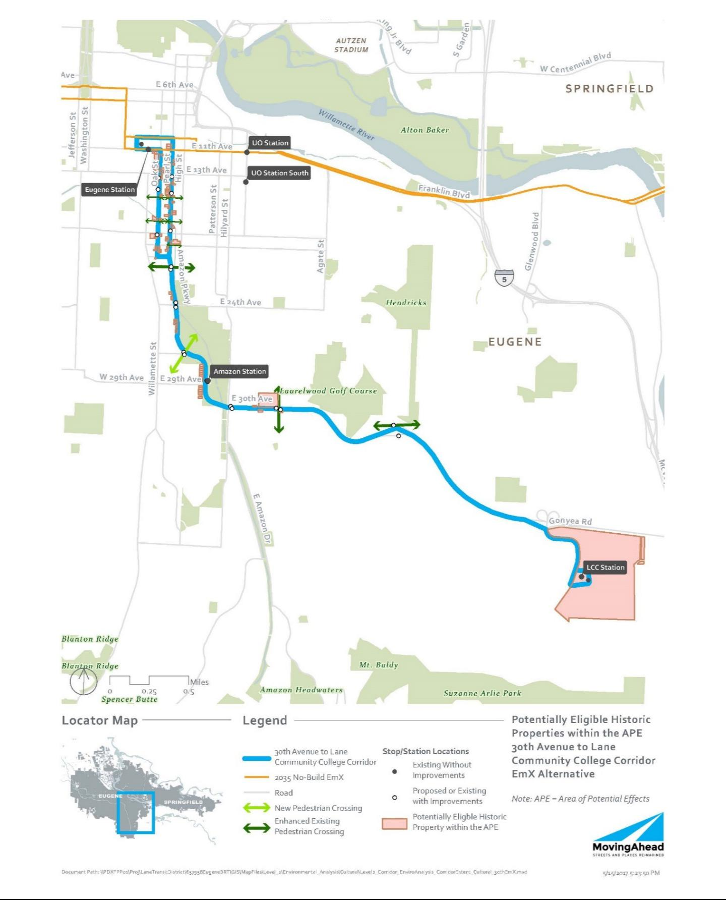

July 7, 2017 | DRAFT FINAL Cultural Resources Technical Report | Lane Transit District
6-20 | MovingAhead Project | City of Eugene

6.2. Environmental Consequences

The routes along this corridor, specifically along Pearl and Oak Streets, have the potential to negatively impact a number of individual or grouped historic resources, in part due to the density of historic properties. The limited space between the ROW and the resources also has the potential to result in adverse impacts with few options for avoidance. Approximately 15 to 30 percent of the historic resources along the 30th Avenue/LCC Corridor may be affected, primarily indirectly, by the proposed project.

The larger EmX stations would have more of an impact on historic resources, which is anticipated in three locations. None of the City Landmark sites or NRHP resources along the route would be affected by either alternative.

6.2.1. Long-Term Direct Impacts

Direct impacts are anticipated only for the EmX Alternative. the impacts would most likely originate from construction of stations or road widening that may require property acquisition from the tax lot or that may be constructed in a manner that would potentially obscure or otherwise interfere with the historic resource.

6.2.1.1. No-Build Alternative

No impacts to historic, archaeological or cultural resources are anticipated under the No-Build Alternative.

6.2.1.2. Enhanced Corridor Alternative

Direct impacts to historic resources are outlined in Table 6.1-3. Under the Enhanced Corridor Alternative, three resources are anticipated to sustain direct, long-term impacts based on the current design.

6.2.1.3. EmX Alternative

Direct impacts to historic resources are outlined in Table 6.1-4. As many as four historic resources may be affected by direct, long-term impacts under the EmX Alternative.

6.2.2. Indirect and Cumulative Effects

More extensive indirect impacts are anticipated for the build alternatives. The impacts would not result in a physical impact to the resource but may include the construction of stations or road widening sufficiently close to affect the visual character of the historical setting or other attributes that contribute to its NRHP eligibility. Under Section 106, the impacts may affect a property, but may not necessarily result in an adverse effect.

6.2.2.1. No-Build Alternative

No impacts to historic, archaeological, or cultural resources are anticipated under the No-Build Alternative.

Lane Transit District | DRAFT FINAL Cultural Resources Technical Report | July 7, 2017
City of Eugene | MovingAhead Project | 6-21

6.2.2.2. Enhanced Corridor Alternative

Indirect impacts to historic resources are outlined in Table 6.1-3. Under the Enhanced Corridor Alternative, 23 of the 89 identified historic resources (26 percent) may be indirectly impacted. The impacts may affect a property, but may not necessarily result in an adverse effect under Section 106.

6.2.2.3. EmX Alternative

Indirect impacts to historic resources are outlined in Table 6.1-4. It is expected that as many as

10 historic resources may be indirectly impacted under the EmX Alternative. Under Section 106, the impacts may affect a property, but may not necessarily result in an adverse effect.

6.2.3. Short-Term Construction-Related Impacts

Aside from the direct impacts noted above, it is assumed that there would be no additional short-term impacts (noise, air, access, etc.) to historic resources associated with construction.

6.3. Potential Mitigation Measures

As a part of Section 106 (36 CFR Part 800) and NEPA, federal transportation agencies are required to seek ways to avoid, minimize, or mitigate adverse effects on historic properties.

Minimization or avoidance of ROW needs would reduce or eliminate impacts. Reduction or elimination of property acquisition from historic properties in the project corridor that are eligible for NRHP would avoid or minimize adverse effects on Section 106 resources. One design strategy could involve shifting new stop and station locations away from historic properties to reduce or eliminate impacts.

If it is not feasible to avoid historic properties, an FOE form should be prepared for each of the historic properties impacted by the project. Given the current project description and the types of activities and features that would be implemented, adverse effects to historic properties can likely be avoided for the 30th Avenue to LCC Corridor.

Mitigation/conservation measures may be required for construction contractor compliance if the project plans change and project effects to the NRHP-eligible properties would be greater than stated in this report. An Inadvertent Discovery Plan should also be in place prior to construction, outlining measures to be undertaken in the event of an unanticipated archaeological discovery.

July 7, 2017 | DRAFT FINAL Cultural Resources Technical Report | Lane Transit District
6-22 | MovingAhead Project | City of Eugene

- Coburg Road Corridor Environmental Consequences

7.1. Affected Environment

7.1.1. Archaeological Background and Records Review

Documentary research was conducted using primary and secondary source materials on file at the Oregon SHPO, Lane County, and other appropriate archives. The archaeological site and project records maintained by the Oregon SHPO were examined using the Internet-based OARRA system and reviewed to identify previous archaeological investigations conducted in the vicinity of the Coburg Road Corridor and archaeological sites previously recorded in this area. Projects, as well as individual historic and archaeological site data, were collected for an area within approximately 1 mile of the proposed corridor alternatives. This information was identified as being either within the APE (the area defined within 350 feet of the project corridor where changes are planned in the Enhanced Corridor or EmX Alternatives) or within 1 mile of this APE. Analysts gathered properties identified as NRHP-listed or -eligible, or identified as Statewide Planning Goal 5-protected historic resources within the APE to determine project impacts, as well as information on properties in the general geographic area from which to develop greater historical context. Historical maps, including GLO, Sanborn Insurance, and USGS, depicting the project vicinity were also inspected.

Forty-nine archaeological investigations have been conducted within 1 mile of the Coburg Road Corridor APE (Table 7.1-1) and 12 archaeological sites are recorded in this area (Table 7.1-2). Nineteen of the investigations were associated with transportation improvement projects, 15 were part of projects in downtown Eugene, 9 were for utilities-related projects, 3 were miscellaneous property surveys,

1 documented test excavations at archaeological site 35LA264, 1 was an archaeological overview document, and 1 was a Master's thesis documenting the first African-American neighborhood in Eugene. The downtown Eugene projects include five associated with construction of the new federal courthouse, five with redevelopment of other downtown properties, and five with improvements to the Ferry Street Bridge.

The Coburg Road Corridor APE passes through 12 of the previous investigation areas. An archaeological survey for a fiber optic line paralleled the entire length of Coburg Road in the current APE. No archaeological materials were found in the APE by this survey. Archaeological surveys and probing were conducted for a portion of Chad Drive within the APE, and isolated historical artifacts were found in the investigations. Surveys for two sewer projects and five road improvement projects included the Beltline Highway / Coburg Road interchange area in the current APE, but no archaeological materials were identified. Two of the Ferry Street Bridge investigations focused on the Coburg Road area just north of the bridge and the resulted in the identification of archaeological site 35LA1329, an early twentieth century community trash dump. Finally, this area just north of the bridge was the locale of Eugene's first African-American neighborhood, documented in a Master's thesis.

The Coburg Road Corridor APE passes through site 35LA1329, the community trash dump, on the north side of the Ferry Street Bridge, and sites 35LA1277 and 35LA1466 are on either side of the south end of the bridge. Overall, 12 archaeological sites are recorded in the 1-mile study area surrounding the APE (Table 7.1-2). Ten are historical sites in central Eugene, including seven refuse scatters (35A1277,

Lane Transit District | DRAFT FINAL Cultural Resources Technical Report | July 7, 2017
City of Eugene | MovingAhead Project | 7-1

35LA1320, 35LA1329, 35LA1334, 35LA1466, 35LA1478, and 35LA1589), two foundations / footings with associated refuse (35LA1330 and 35LA1335), and a section of track from the Eugene street railway system (35LA1590). The remaining two sites are prehistoric lithic scatters (35LA45 south of Gillespie Butte and 35LA264 at the north end of the study area). Oregon SHPO has determined that site 35LA264 is eligible for inclusion in the NRHP. The other 11 sites have not been evaluated for eligibility to the NRHP.

Table 7.1-1. Previous Investigations Conducted within 1 Mile of Coburg Road Corridor

 | Project Description |  | Results | Reference
 |  |  | In Current APE
 | Interceptor and sewer survey |  | Negative | Follansbee, 1977 (SHPO #2522)
 | Proposed regional sewer survey |  | Negative in current area | Benson et al., 1983 (SHPO #4973)
 | U.S. Sprint fiber optic line survey |  | Negative in current area | Minor, 1987 (SHPO #8292)
 | Ferry Street Bridge road improvement |  | Recorded 35LA1329 | INFOTEC, 1992 (SHPO #16090)
 | survey and probing
 | Ferry Street Bridge monitoring |  | Artifact clusters in 35LA1329 | Minor, 1997a (SHPO #16097)
 | I-5 / Beltline Highway Interchange |  | Negative | Connolly, 2001a (SHPO #17774)
 | survey
 | I-5 / Beltline Highway Interchange |  | Negative | Connolly, 2001b (SHPO #18138)
 | probing
 | Chad Drive Extension survey and |  | Isolated historical artifacts | Bland and Connolly, 2006
 | probing |  |  | (SHPO #20598)
 | Bridge 08182 N/S (I-5 over Game |  | Negative | Edwards and Bottman, 2005
 | Farm Road) survey |  |  | (SHPO #21006)
 | Bridge 08180N/S (I-5 over the |  | Negative | Edwards and Cabebe, 2006
 | McKenzie overflow) survey |  |  | (SHPO #21140)
 | Beltline / Coburg Road Interchange |  | Negative | Baxter, 2007 (SHPO #21419)
 | survey and probing
 | Cultural demolition of first Eugene |  | Master's thesis | Beckner, 2009 (SHPO #26630)
 | African-American neighborhood
 |  |  | Within 1 Mile of APE
 | Coburg Road storm sewer extension |  | Recorded 35LA264 | Minor, 1978 (SHPO #228)
 | survey
 | Downtown Eugene survey of 12 lots |  | Negative | Minor, 1979 (SHPO #573)
 | Test excavations at 35LA264 |  | Site recommended eligible for | Baxter and Minor, 1987
 |  |  | NRHP | (SHPO #8214)
 | July 7, 2017 | DRAFT FINAL Cultural Resources Technical Report |  |  | Lane Transit District
7-2 |  |  | MovingAhead Project |  | City of Eugene

Table 7.1-1. Previous Investigations Conducted within 1 Mile of Coburg Road Corridor

Project Description | Results | Reference
U.S. Sprint fiber optic line POP site | Negative | Wessen, 1987 (SHPO #8473)
survey
Game Farm / Deadmond Ferry Roads | Isolated prehistoric artifacts | Toepel, 1994c (SHPO #14740)
and International Way survey
2990 County Farm Road survey | Negative | Bowyer and Speulda, 1997
 |  | (SHPO #15945)
Charnelton parking structure testing | Recorded 35LA1330 | Bowyer, 1997 (SHPO #16222)
and monitoring
Eugene / Springfield archaeological | Regional overview | Silvermoon et al., 1984
resources overview |  | (SHPO #16223)
2440 Willakenzie Road survey | Negative | Oetting, 1998 (SHPO #16391)
I-105 at Delta Highway on-ramp | Negative | Connolly, 2000 (SHPO #17193)
survey
Eugene Library monitoring and | Recorded 35LA1335 | Minor, 2000 (SHPO #17531)
artifact recovery
Ferry Street Bridge monitoring at | Recent artifacts recovered | Minor, 1998a (SHPO #17772)
South Wood Lane dump site
Ferry Street Bridge monitoring on | Recent artifacts recovered | Minor, 1997b (SHPO #17773)
Club Road
Eugene-Springfield LTD Bus Rapid | Negative | Oetting, 2000 (SHPO #17775)
Transit survey
Eugene Millrace Industrial District | Artifacts found in imported fill | Minor, 1998b (SHPO #18496)
(Ferry Street Bridge) monitoring | deposits
Eugene Federal Courthouse | Recorded 35LA1277 | Maass and O'Bannon, 2003
archaeological investigations |  | (SHPO #18502 and #19013)
I-105 (Willamette River to I-5) probing | Negative | Helzer and Dexter, 2004
 |  | (SHPO #19164)
Federal Courthouse monitoring and | Recovered artifacts from | Byram, 2004a (SHPO #19337)
artifact recovery | 35LA1277
Federal Courthouse monitoring and | Recovered artifacts from | Byram, 2004b (SHPO #19342)
artifact recovery | 35LA1277
Bridge 08178N/S (I-5 over McKenzie | Negative | Edwards and Dahlstrom, 2005
overflow) survey |  | (SHPO #19497)

Lane Transit District | DRAFT FINAL Cultural Resources Technical Report | July 7, 2017
City of Eugene | MovingAhead Project | 7-3

Table 7.1-1. Previous Investigations Conducted within 1 Mile of Coburg Road Corridor

Project Description | Results | Reference
BPA Thurston-Willakenzie | Negative | Toepel, 2005 (SHPO #19988)
transmission line relocation survey
Courthouse (Highway 99W, High | Recovered artifacts from | Minor, 2006 (SHPO #21189)
Street to Hilyard Street) monitoring | 35LA1277
OR99 (Barger Drive to Washington / | Negative | O'Neill and Ruiz, 2008
Jefferson) survey |  | (SHPO #22097)
Federal Courthouse monitoring | Recorded 35LA1466 | Minor, 2008 (SHPO #22107 and
 |  | #22241)
I-5 Lane County Interstate sign | Negative in current area | Buchanan and Reese, 2008
replacement survey and probing |  | (SHPO #22141)
I-5 bridges vertical clearance | Negative | Buchanan and Chapman, 2008a
improvements survey |  | (SHPO #22154)
I-5 bridges vertical clearance | Negative | Buchanan and Chapman, 2008b
improvements probing |  | (SHPO #22155)
I-5/Beltline Highway Interchange Unit | Negative | Connolly, 2008 (SHPO #22196)
2 survey
EUG Baldy View Alt. 3 cell tower | Negative | Stipe, No date (n.d.)
survey |  | (SHPO #22394)
Region 2 Closed-circuit TV project | Negative | Knowles and Connolly, 2009
monitoring |  | (SHPO #22730)
Eugene train depot monitoring | Recorded 35LA1478 | Hart, 2010 (SHPO #23211)
Cal Young (EG01) cell tower survey | Negative | Baker, 2010 (SHPO #23485)
I-5 bridges vertical clearance | Negative | Adams and Chapman, 2011
improvements, I-105 bridge #08689E |  | (SHPO #24362)
survey
LTD West Eugene EmX Expansion | Negative | Oetting, 2011a (SHPO #24606)
survey
Willakenzie Crossing development | Negative | Shindruk, 2012 (SHPO #25049)
project monitoring
WestTown on 8th monitoring | Recorded 35LA1320 | Hart and McCornack, 2007
 |  | (SHPO #25822)
EUG Polk (Trileaf #612180) cell tower | Negative | Finley, 2014 (SHPO #26747)
survey

Source: Oregon Archaeological Records Remote Access System, Oregon SHPO (August 2016).

July 7, 2017 | DRAFT FINAL Cultural Resources Technical Report | Lane Transit District
7-4 | MovingAhead Project | City of Eugene

Table 7.1-2. Archaeological Sites Recorded Within 1 Mile of Coburg Road Corridor

Site Number/Name | Location | Description | NRHP Eligibility
35LA45 | T17S, R3W, sec. 30 | Prehistoric lithic scatter | Unevaluated
35LA264 / GWEN Site | T17S, R3W, sec. 8 | Prehistoric lithic scatter with several tools | Eligible
35LA1277 / Agripac Site | T17S, R3W, sec. 32 | Historical refuse scatter, probably | Unevaluated
 |  | residential
35LA1320 | T17S, R3W, sec. 31 | Historical refuse scatter, probably | Unevaluated
 |  | residential trash pit
35LA1329 / Ferry Dump | T17S, R3W, sec. 29 | Historical refuse scatter, Eugene community | Unevaluated
 |  | dump
35LA1330 / Hendricks | T17S, R3W, sec. 31 | Historical foundation and refuse scatter | Unevaluated
House Lot
35LA1334 | T17S, R3W, sec. 32 | Historical refuse scatter | Unevaluated
35LA1335 / New Eugene | T17S, R3W, sec. 31 | Historical architectural features (footings, | Unevaluated
Library Site |  | wells) and trash pits
35LA1466 / Eugene Iron | T17S, R3W, sec. 32 | Historical refuse scatter in documented iron | Unevaluated
Works |  | works location
35LA1478 / Eugene | T17S, R3W, sec. 30 | Historical refuse scatter in documented | Unevaluated
Train Depot |  | train depot location
35LA1589 / Skinner's | T17S, R3W, sec. 30 | Historical refuse scatter | Unevaluated
Lost
35LA1590 / Eugene | T18S, R3W, sec. 6 | Section of historical electric street railway | Unevaluated
Street Railway |  | tracks, including rails, ties, spikes, joiners
(Willamette Street, 19th
to 24th Avenues)

Source: Oregon Archaeological Records Remote Access System, Oregon SHPO. (2016, August).

The GLO cadastral survey plat for T17S, R3W depicts the Willamette River and the flat valley floor north of the river, labeled "Level Prairie and bottom land, soil 1st rate." A small field and two structures are shown near the modern intersection of Coburg Road and Harlow Road. A road to the river and a crossing labeled "Skiner's Ferry" is shown on the approximate alignment of the modern Ferry Street Bridge. The Plat of Claims shows that the northern portion of the corridor passes through four DLC while the south end is in a fifth DLC. The northern DLCs are: DLC No. 43 of George H Armitage, DLC No. 45 of Ashley

C. Stevens, DLC No. 71 of Garrett Bogart, and DLC No. 80 of Charles H. Bogart. The south end of the corridor crossing the Ferry Street Bridge is in DLC No. 64 of Eugene F. Skinner.

Lane Transit District | DRAFT FINAL Cultural Resources Technical Report | July 7, 2017
City of Eugene | MovingAhead Project | 7-5

7.1.2. Archaeological Survey Results

A pedestrian archaeological survey of the Coburg Road Corridor was conducted on September 27, 2016. The surface survey inspected the proposed stations and the transit and roadway improvements of the Enhanced Corridor and EmX Alternatives. This involved inspection of all proposed stop and station locations on Coburg Road north of the Ferry Street Bridge and on Crescent Avenue, Shadow View Drive, and Chad Drive; and inspection of both sides of Coburg Road from the Ferry Street Bridge north to Crescent Avenue, Crescent Avenue between Coburg Road and Shadow View Drive, Shadow View Drive between Crescent Avenue and Chad Drive, and Chad Drive from Shadow View Drive to Game Farm Road (Figures 7.1-1 and 7.1-2). Most of the proposed stations are at or near existing bus stops, but few of the have bus pull outs. The survey was conducted by one archaeologist walking on the sidewalks bordering both sides of each road and inspecting all patches of exposed mineral ground surface both in the planting strip between the road and the sidewalk and any ground visible on the opposite side of the sidewalk. Sidewalks bordered all of Coburg Road and Shadow View Drive, most of the without planting strips. No sidewalks were present on the north side of Crescent Avenue and along several properties on the south side of Chad Drive. The sections without sidewalks were surveyed by the archaeologist walking a slightly meandering transect 1 to 5 meters from the road curb to examine areas with the greatest ground surface visibility.

Mineral ground surface visibility was relatively good along the inspected route, averaging about 10 to

20 percent overall, but soil that was visible at all was limited along some segments of the route. Planting strips were present only for short distances in a few areas, so most of the observable ground was along the sidewalk edge away from the road. Much of the development along the Coburg Road Corridor is commercial, so paved parking lots directly abutted the sidewalk in some locations, while landscaped planting boxes separated the sidewalk from adjoining parking lots or stores in many locations. Some residential properties are present along the route, but are generally oriented to face side or parallel streets, with fences along Coburg Road masking side yards and backyards. Generally, there is only a thin strip of soil visible between the edge of the sidewalk and the base of the fences. This strip often exhibited patches of mineral soil but was also higher than the sidewalk and nearby properties, suggesting that the residential lots had had fill soil spread over them. Tall soil berms, probably for deadening road noise were present on the west side of Coburg Road near the Chad Drive intersection. Likewise, much of the landscaping soil in sidewalk planting strips and planting boxes is fill soil, since patches of underlying plastic sheeting or geotextile cloth were occasionally visible. Utility vaults, manhole covers, and electrical junction boxes are present all along the corridor, reflecting various buried utility lines and pipes.

No prehistoric or demonstrably historical artifacts, features, or sites were observed during this surface survey. Coburg Road has been a transportation route for many years, and the adjoining lands have been developed and built upon for many years as well. the road has been resurfaced and widened; adjoining sidewalks and driveways have been built and revised; and the underlying buried utility infrastructure has been installed and augmented. This ongoing development has very likely disturbed most, if not all, of the ground along Coburg Road. The Crescent-Shadow View-Chad Roads and infrastructure have been constructed within the last 30 years. There are still some undeveloped properties, but they are all former agricultural fields that were subject to plowing and other agricultural practices in the past. The potential for intact archaeological materials, surface or buried, in the Coburg Road Corridor is low.

July 7, 2017 | DRAFT FINAL Cultural Resources Technical Report | Lane Transit District
7-6 | MovingAhead Project | City of Eugene

Figure 7.1-1. Location of Proposed Station North of Harlow Road
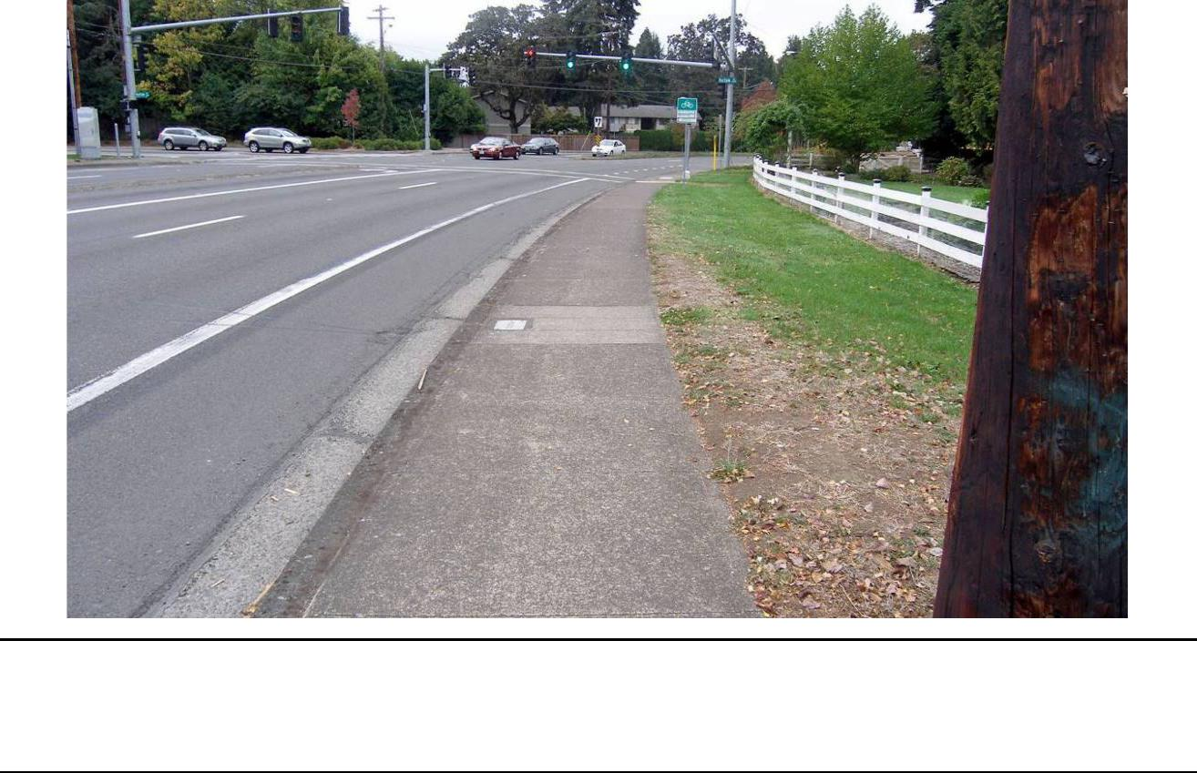

Figure 7.1-2. Property on South Side of Chad Drive with No Existing Sidewalk; Note Manhole Cover and Electrical Box Reflecting Buried Utilities
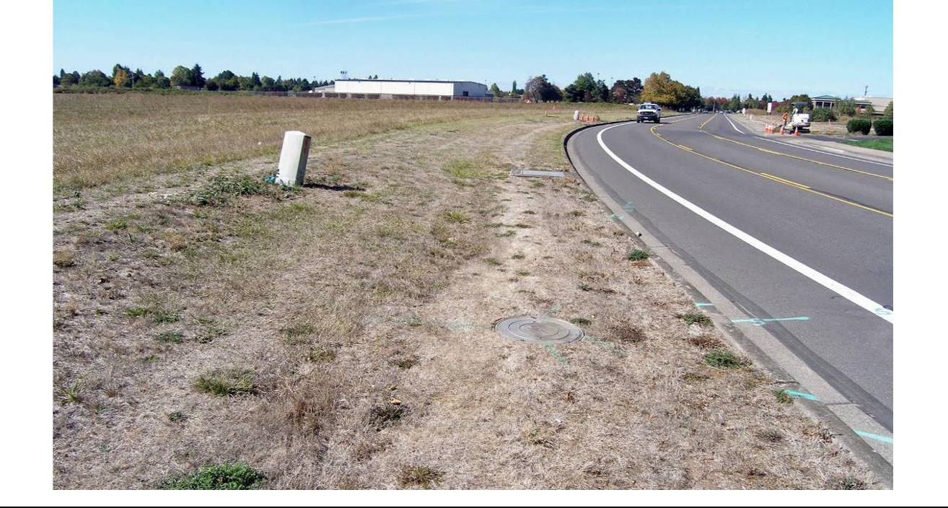

Lane Transit District | DRAFT FINAL Cultural Resources Technical Report | July 7, 2017
City of Eugene | MovingAhead Project | 7-7

7.1.3. Historical Background and Records Review

The Willakenzie area, the region north of the Willamette River on either side of Coburg, was historically agrarian in nature, having been initially settled and farmed starting in the 1850s. While few remnants of this early history remain evident on the landscape, road and place names serve as reminders of the pioneers who settled in the area, including Harlow Road (named for Mahlon Harlow, pioneer of the early 1850s), Tandy Turn (named for the pioneer Tandy family), Cal Young Road (on which the Cal Young House still stands), and Gillespie Butte, among others.

During the early settlement years, the path of today’s Coburg Road became an important route for both communication and transport of agricultural goods to local markets and beyond. A road petition presented to the Lane County Court at its first meeting in 1852, “. . . established a road from Spores’ ferry at the McKenzie River to Skinner’s ferry across the Willamette. The basic course of today’s Coburg Road–the first “highway” built under the auspices of the county court–was thus established. With a steady influx of money from the gold mines to the south and a ready market for agricultural goods, the Willakenzie area flourished” (Johnson, 1989:5).

Through the early twentieth century, the area retained its rural, agricultural character, and local growth was concentrated in Eugene on the Willamette River’s southern bank. Urban development began spreading north after World War II, and by the 1950s new residential development was creating a “demand for basic services, which eventually resulted in the annexation of the Willakenzie area” (Johnson, 1989:16). While few, if any, of the earliest buildings in the area remain, large tracts of 1940s through 1960s development–including platted neighborhoods–continue to characterize the Willakenzie area.

Documentary research was conducted using primary and secondary source materials on file at Oregon SHPO (to identify properties designated as NRHP-listed or -eligible, or Statewide Planning

Goal 5-protected historic resources) and other appropriate archives. This research included the following sources:

- Oregon SHPO NRHP and State Inventory files

- Lane County Inventory and Goal 5 Historic Resources - all in SHPO database; it seems that Lane County does not maintain a current list

- City of Eugene Planning Division (Historic Resources)

- NRHP database for listed properties and districts

Analysts conducted a review of historical maps and records to aid in identifying sections of the corridor where historic resources were anticipated. The maps included GLO survey plats, master title plats for early land claims, and USGS quadrangles (Figures 7.1.3 through 7.1-5).

Review of the Oregon SHPO database and the NRHP database for listed properties has, at present, resulted in the identification of only one previously evaluated historic resource (Ferry Street Bridge), and no listed NRHP properties along the portion of the Coburg Road Corridor where improvements are proposed (north of the Willamette River). NRHP properties are located south of the river along the corridor, but no improvements are proposed along that section.

July 7, 2017 | DRAFT FINAL Cultural Resources Technical Report | Lane Transit District
7-8 | MovingAhead Project | City of Eugene

Figure 7.1-3. Location of the Coburg Road Corridor on the USGS Eugene 15’ Quadrangle, 1910
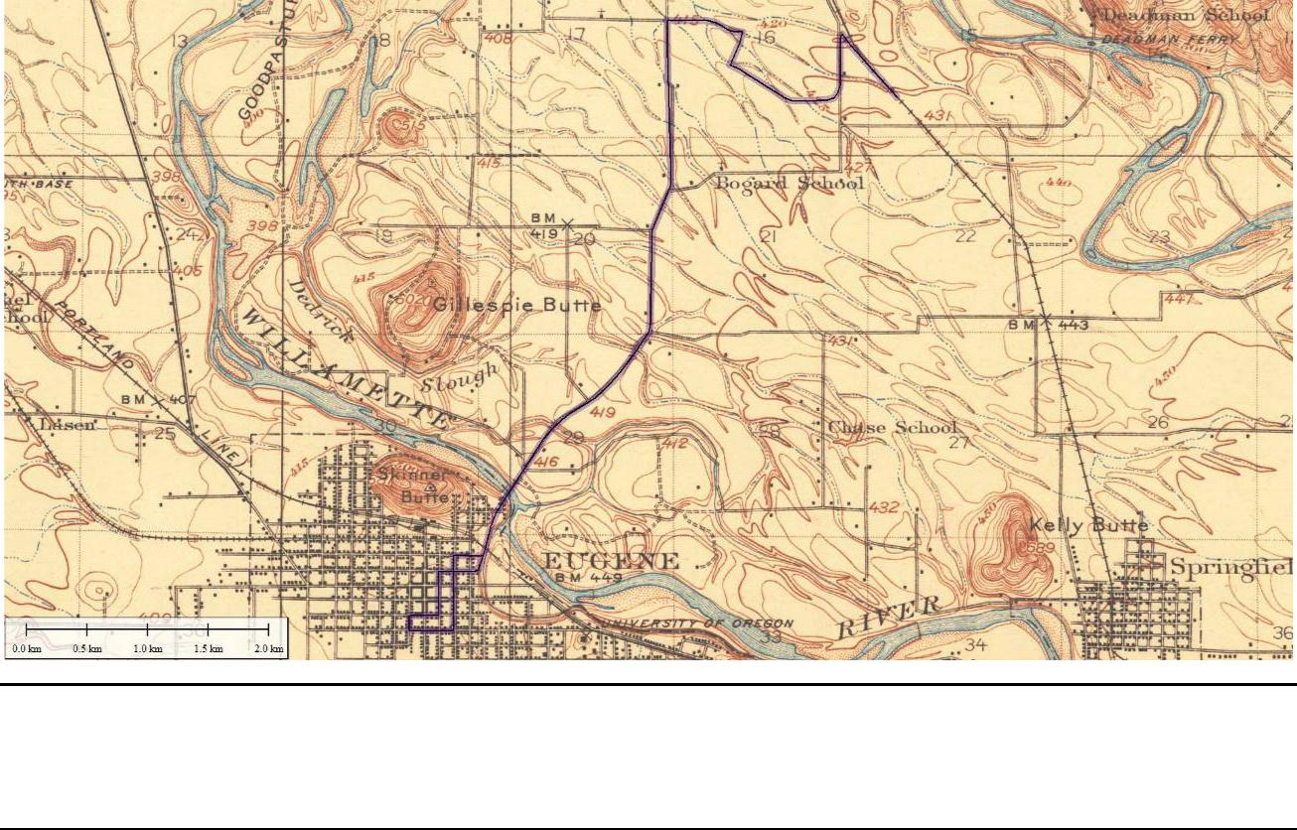

Figure 7.1-4. Location of the Coburg Road Corridor on the USGS Eugene 15’ Quadrangle, 1940
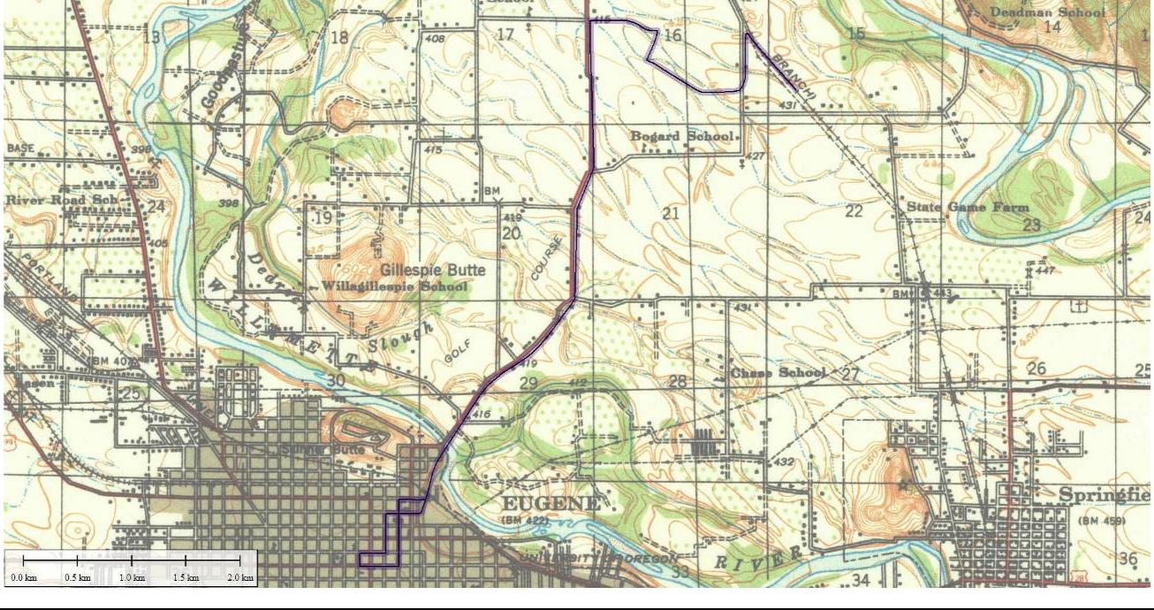

Lane Transit District | DRAFT FINAL Cultural Resources Technical Report | July 7, 2017
City of Eugene | MovingAhead Project | 7-9

Figure 7.1-5. Alignment of the Coburg Road Corridor as Shown on the USGS Eugene East 7.5’ Quadrangle, 1976 (Reduced)
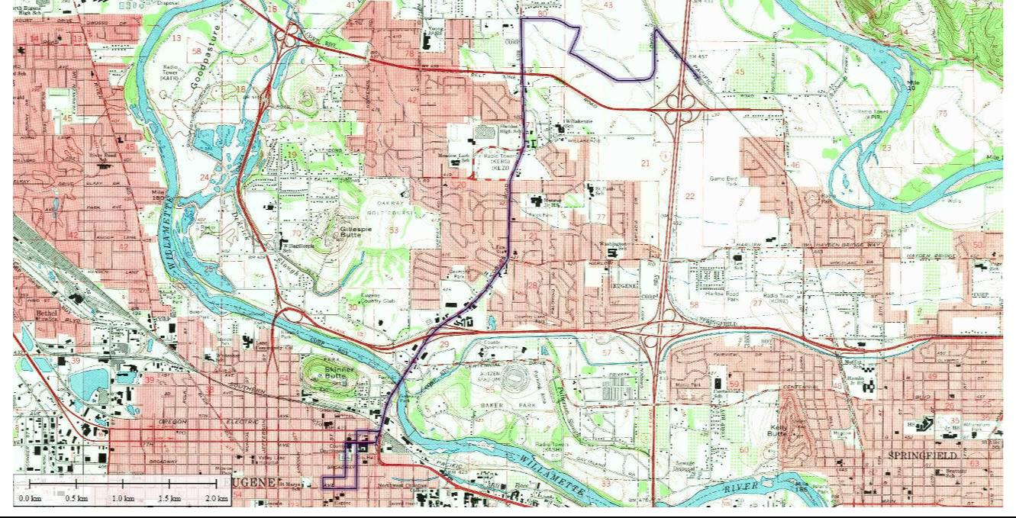

Although a historical context for the Willakenzie area (including the present corridor north of the Willamette River) was prepared for the City of Eugene in 1989, there has been no systematic historic resource inventory of the neighborhoods around the corridor. The relative recency of the neighborhoods and commercial areas (largely post-World War II) is probably a major factor in the lack of surveys to date.

7.1.4. Historical Reconnaissance Results

Review of the Oregon SHPO database and the NRHP database for listed properties along the Coburg Road Corridor has resulted in the identification of only one historic resource—the Ferry Street Bridge— along the proposed APE corridor north of the Willamette River. No resources are formally listed on the NRHP, and no City Landmarks appear to be close to the proposed corridor.

Because the portion of the corridor north of the river was developed primarily in recent decades, most of the potentially eligible historic resources identified during the reconnaissance of the APE were constructed between 1940 and 1968. A total of 23 individual properties and one potential historic district was identified from the SHPO database and the windshield survey as eligible or potentially eligible (Tables 7.1-3 and 7.1-4 and Figures 7.1-6 and 7.1-7).

The residential resources along the west side of Coburg Road may be considered contributing resources in districts that have not yet been fully identified or evaluated; it is unclear whether any of those buildings along the APE would be considered individually historically significant. Overall impacts to the potential district(s) may be minimal given that a number of the residences that may be affected by the proposed alternatives do not face directly onto Coburg Road; impacts to individual properties may not constitute negative impacts to the district as a whole. Most resources are post-World War II vintage and have not been the subject of comprehensive survey/inventory efforts.

July 7, 2017 | DRAFT FINAL Cultural Resources Technical Report | Lane Transit District
7-10 | MovingAhead Project | City of Eugene

Table 7.1-3. Potential NRHP-Eligible Properties Identified Along Coburg Road Corridor, Enhanced Corridor Alternative

_{Preliminary} Long- Long-term


^{Address} ^{Tax Lot Date} _{Evaluation}a ^{term Indirect /} Direct Cumulative

Ferry Street Bridge |  | 1950 | EC/ES
1 Club Road | 1703293201000 | 1964 | EC
11 Coburg | 1703293200500 | 1968 | EC
20 Coburg | 1703293200200 | 1967 | EC
West side Coburg Road, |  | 1940-1960 | EC (potential
Frontier Drive to Bailey Lane |  | 1940-1960 | district)
2590 Pioneer Pike | 1703291101000 | 1951 | EC
2595 Pioneer Pike | 1703291100701 | 1950 | EC
2344 Pioneer Pike | 1703204406000 | 1952 | EC
780 Coburg | 1703204405800 | 1941 | EC
970 Coburg | 1703204400900 | 1941 | EC
2692 Tandy Turn | 1703204400201 | 1941 | EC
1008 Coburg | 1703204106900 | 1952 | EC
1030 Coburg | 1703204107000 | 1948 | EC
2690 Forrester | 1703204106300 | 1960 | EC
2691 Forrester | 1703204103400 | 1958 | EC
2693 Sharon Way | 1703204101900 | 1960 | EC
656 Cherry Drive | 1703291160007 | 1941 | EC
777 Coburg | 1703204404900 | 1952 | EC
945 Coburg | 1703204401702 | 1940 | EC
1091 Coburg | 1703204106400 | 1940 | EC
1209 Coburg | 1703204101000 | 1953 | EC
1209 Coburg | 1703204101000 | 1953 | (no district)
1465 Coburg | 1703201002900802 | 1940-1956 | EC
1755 Coburg | 1703212206700 | 1962 | EC
89355 N. Game Farm Road | 1703150000900 | 1928 | EC


T


S, T


S
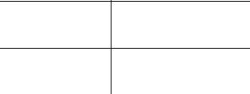

S, T
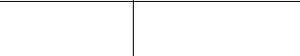

T S


T S

T

S


S, T

S, T

- Preliminary evaluation includes EC and ES; potential NRHP districts are noted. KEY: S = Enhanced Shelter

T = Tax Lot Sliver Acquisition

Lane Transit District | DRAFT FINAL Cultural Resources Technical Report | July 7, 2017
City of Eugene | MovingAhead Project | 7-11

Figure 7.1-6. Coburg Road Enhanced Corridor Alternative Cultural Resources Area of Potential Effect
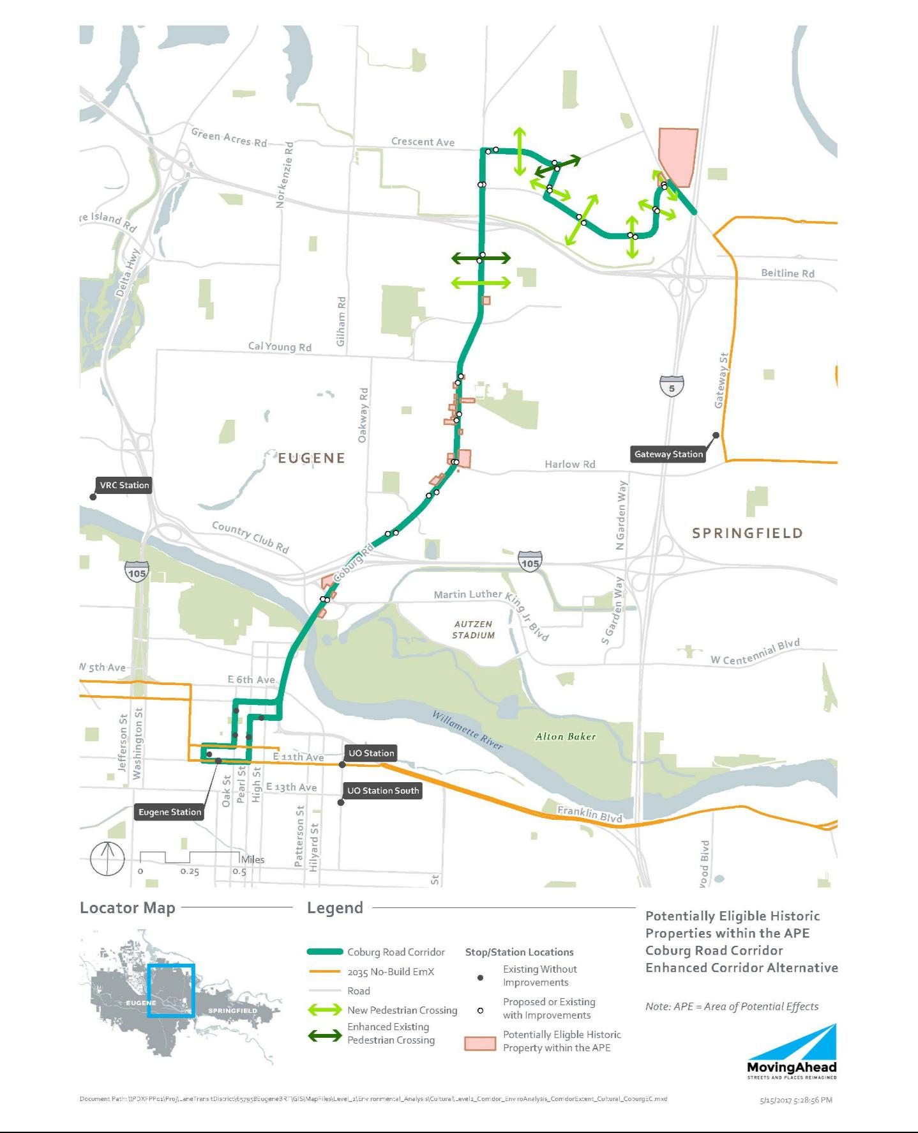

July 7, 2017 | DRAFT FINAL Cultural Resources Technical Report | Lane Transit District
7-12 | MovingAhead Project | City of Eugene

Table 7.1-4. Potential NRHP-Eligible Properties Identified Along Coburg Road Corridor, EmX Alternative

_{Preliminary} Long- Long-term


^{Address} ^{Tax Lot Date} _{Evaluation}a ^{term Indirect /} Direct Cumulative

Ferry Street Bridge |  | 1950 | EC/ES
1 Club Road | 1703293201000 | 1964 | EC
11 Coburg | 1703293200500 | 1968 | EC |  | S
20 Coburg | 1703293200200 | 1967 | EC | T | S
West side Coburg Road, |  | 1940-1960 | EC (potential | S, T | S, V
Frontier Drive to Bailey Lane |  | 1940-1960 | district) | S, T | S, V
2590 Pioneer Pike | 1703291101000 | 1951 | EC
2595 Pioneer Pike | 1703291100701 | 1950 | EC
2344 Pioneer Pike | 1703204406000 | 1952 | EC | S, T
780 Coburg | 1703204405800 | 1941 | EC |  | S, P
970 Coburg | 1703204400900 | 1941 | EC | S, T
2692 Tandy Turn | 1703204400201 | 1941 | EC | S, T
1008 Coburg | 1703204106900 | 1952 | EC
1030 Coburg | 1703204107000 | 1948 | EC
2690 Forrester | 1703204106300 | 1960 | EC
2691 Forrester | 1703204103400 | 1958 | EC
2693 Sharon Way | 1703204101900 | 1960 | EC
656 Cherry Drive | 1703291160007 | 1941 | EC | S
777 Coburg | 1703204404900 | 1952 | EC | S
945 Coburg | 1703204401702 | 1940 | EC?
1091 Coburg | 1703204106400 | 1940 | EC
1209 Coburg | 1703204101000 | 1953 | EC
1209 Coburg | 1703204101000 | 1953 | (no district)
1465 Coburg | 170320100290080 | 1940-1956 | EC
1465 Coburg | 2 | 1940-1956 | EC
1755 Coburg | 1703212206700 | 1962 | EC
89355 N. Game Farm Road | 1703150000900 | 1928 | EC | S, T


- Preliminary evaluation includes EC and ES; potential NRHP districts are noted. KEY: S = EmX Station

T = Tax Lot Sliver Acquisition

P = Planting Strip (effect from improvements adjacent to the tax lot) V = Visual Effect (other than station)

Lane Transit District | DRAFT FINAL Cultural Resources Technical Report | July 7, 2017
City of Eugene | MovingAhead Project | 7-13

Figure 7.1-7. Coburg Road EmX Alternative Cultural Resources Area of Potential Effect
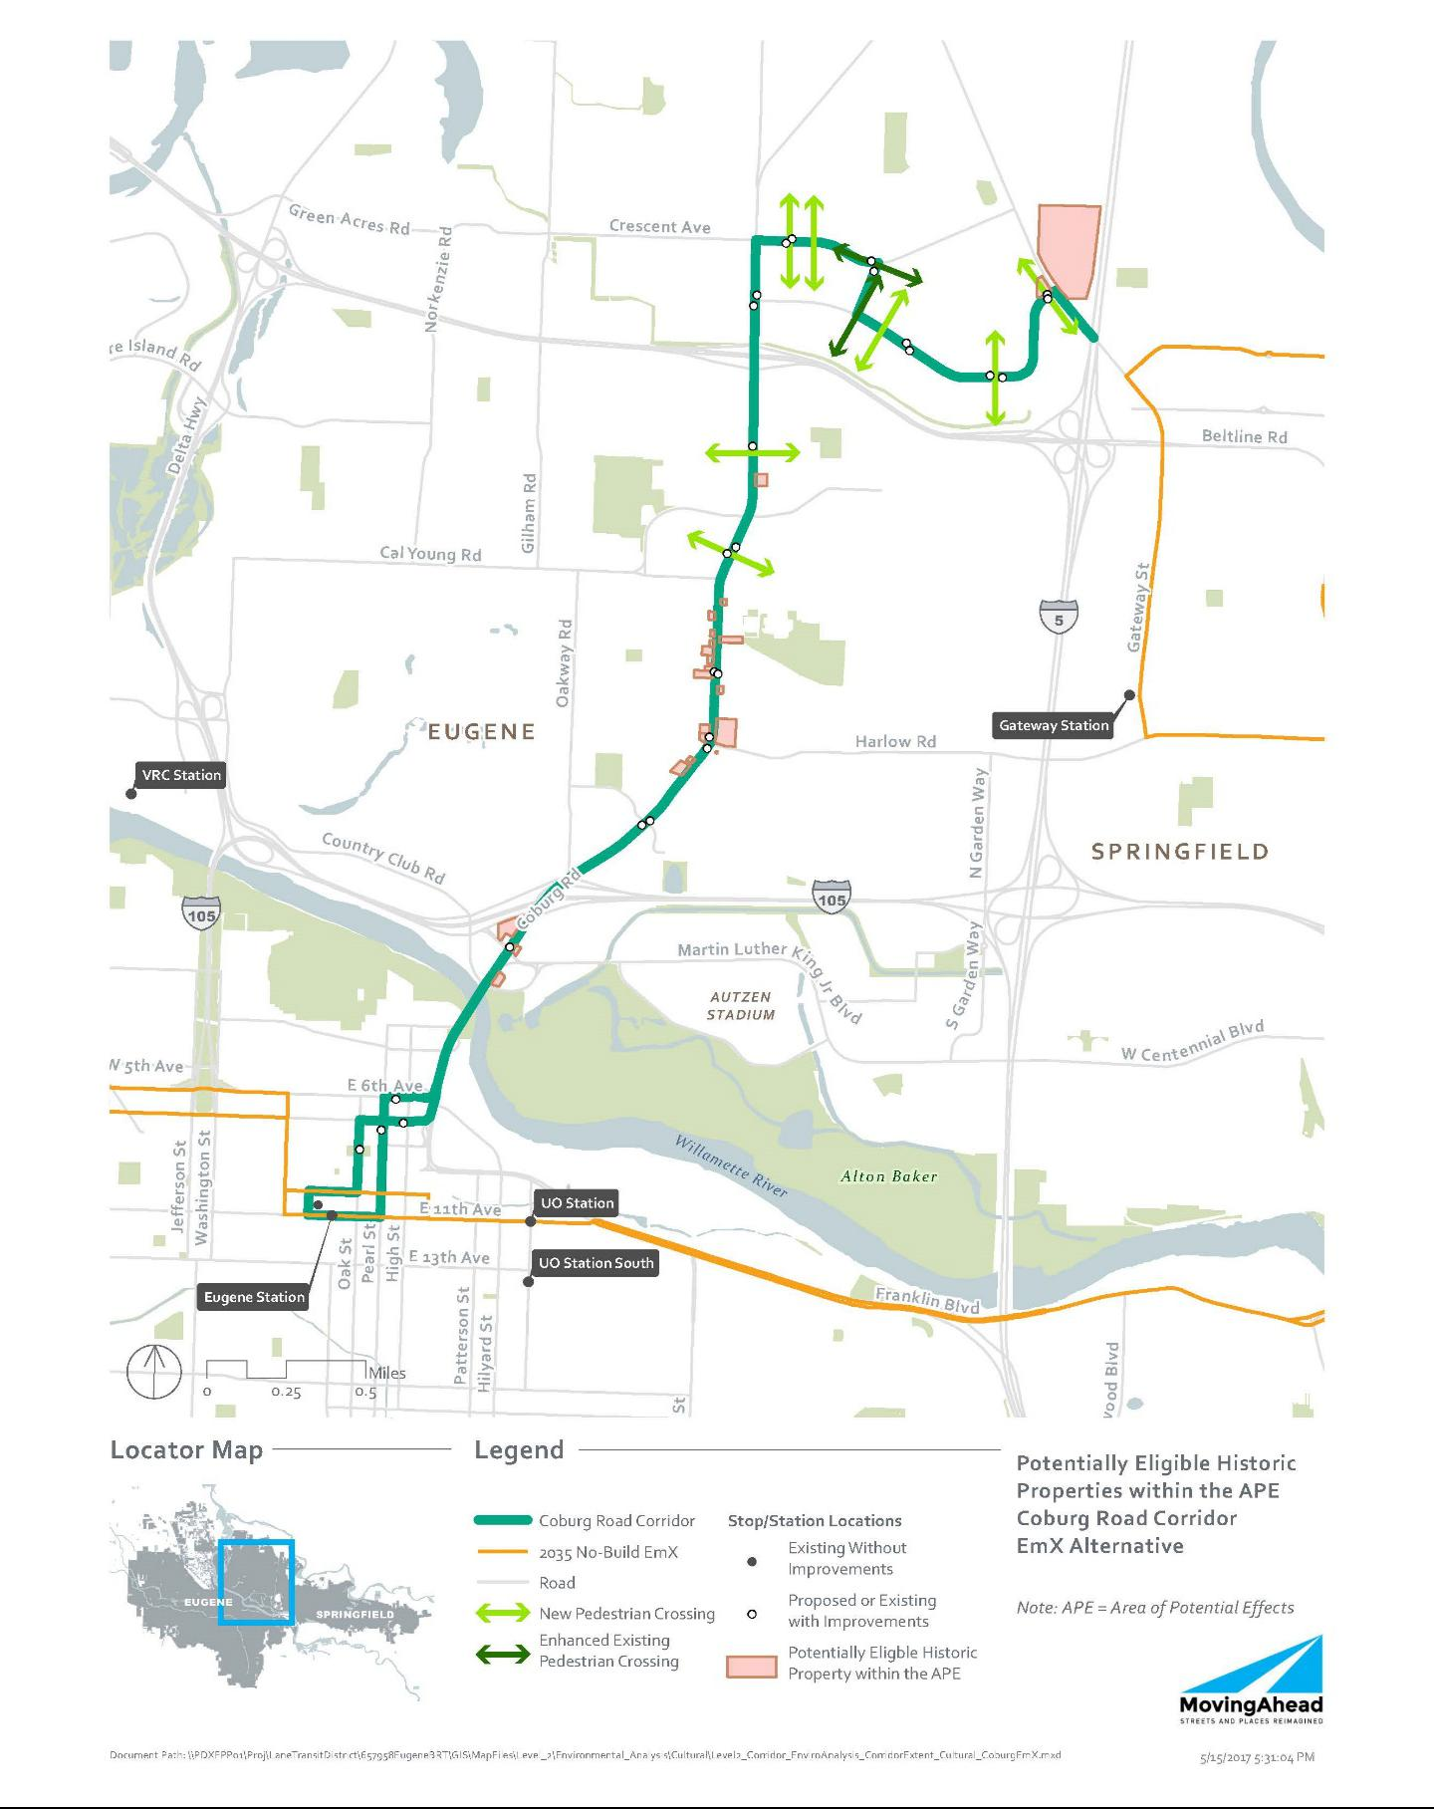

July 7, 2017 | DRAFT FINAL Cultural Resources Technical Report | Lane Transit District
7-14 | MovingAhead Project | City of Eugene

7.2. Environmental Consequences

The alternatives for the Coburg Road Corridor, specifically north of the Willamette River, have some potential to negatively impact a number of individual or grouped historic resources. Although only a limited number of eligible or potentially eligible resources have been identified along the corridor, approximately 40 percent of those resources may face an effect by the proposed project.

The larger EmX stations, Enhanced Corridor stops, and road widening would have the most impact on historic resources, which is anticipated in eight locations along the EmX alternative. There are no City Landmark sites or NRHP resources along the route that may be affected by either alternative.

7.2.1. Long-Term Direct Impacts

Direct impacts are anticipated primarily for the EmX Alternative (at eight locations), but there is one location along the Enhanced Corridor Alternative where a resource may be subject to a direct long-term impact. the impacts would most likely originate from construction of stations or road widening that may require a property acquisition from the tax lot or that may be constructed in a manner that would potentially obscure or otherwise interfere with the attributes that make the historic resource eligible for the NRHP.

7.2.1.1. No-Build Alternative

No impacts to historic, archaeological or cultural resources are anticipated under the No-Build Alternative.

7.2.1.2. Enhanced Corridor Alternative

Direct impacts to historic resources are outlined in Table 7.1-3. Under the Enhanced Corridor Alternative, seven resources are anticipated to be affected by direct, long-term impacts based on the current design.

7.2.1.3. EmX Alternative

Direct impacts to historic resources are outlined in Table 7.1-4. As many as eight historic resources may be affected by direct, long-term impacts under the EmX Alternative.

7.2.2. Indirect and Cumulative Effects

Indirect impacts are also anticipated for the build alternatives. The impacts would not result in a physical impact to the resource, but may include the construction of stations or road widening sufficiently close to affect the visual character of the historical setting or other attributes that contribute to its NRHP eligibility. Under Section 106, the impacts may affect a property, but may not necessarily result in an adverse effect.

7.2.2.1. No-Build Alternative

No impacts to historic, archaeological, or cultural resources would occur under the No-Build Alternative.

Lane Transit District | DRAFT FINAL Cultural Resources Technical Report | July 7, 2017
City of Eugene | MovingAhead Project | 7-15

7.2.2.2. Enhanced Corridor Alternative

Indirect impacts to historic resources are outlined in Table 7.1-3. Five of the 24 identified historic resources are indirectly impacted under the Enhanced Corridor Alternative. Under Section 106, the impacts may affect a property, but may not necessarily result in an adverse effect.

7.2.2.3. EmX Alternative

Indirect impacts to historic resources are outlined in Table 7.1-4. It is expected that four historic resources would sustain indirect impacts under the EmX Alternative. Under Section 106, the impacts may affect a property, but may not necessarily result in an adverse effect.

7.2.3. Short-Term Construction-Related Impacts

Aside from the direct impacts noted above, it is assumed that there would be no additional short-term impacts (noise, air, access, etc.) to historic resources associated with construction.

7.3. Potential Mitigation Measures

As a part of Section 106 (36 CFR Part 800) and NEPA, federal transportation agencies are required to seek ways to avoid, minimize, or mitigate adverse effects on historic properties.

Minimization or avoidance of ROW needs would reduce or eliminate impacts. Reduction or elimination of property acquisition from historic properties in the project corridor that are eligible for NRHP would avoid or minimize adverse effects on Section 106 resources. One design strategy could involve shifting new stop and station locations away from historic properties to reduce or eliminate impacts.

If it is not feasible to avoid historic properties, an FOE form should be prepared for each of the historic properties impacted by the project. Given the current project description and the types of activities and features that would be implemented, adverse effects to historic properties can likely be avoided for the Coburg Road Corridor.

Mitigation / conservation measures may be required for construction contractor compliance if the project plans change and project effects to the NRHP-eligible properties would be greater than stated in this report. An Inadvertent Discovery Plan should also be in place prior to construction, outlining measures to be undertaken in the event of an unanticipated archaeological discovery.

July 7, 2017 | DRAFT FINAL Cultural Resources Technical Report | Lane Transit District
7-16 | MovingAhead Project | City of Eugene

- Martin Luther King, Jr. Boulevard Corridor Environmental Consequences

8.1. Affected Environment

8.1.1. Archaeological Background and Records Review

Documentary research was conducted using primary and secondary source materials on file at the Oregon SHPO, Lane County, and other appropriate archives. The archaeological site and project records that the Oregon SHPO maintains were examined using the Internet-based OARRA system and reviewed to identify previous archaeological investigations conducted in the vicinity of the Martin Luther King, Jr. Boulevard Corridor and archaeological sites previously recorded in this area. Projects, as well as individual historic and archaeological site data, were collected for an area within approximately 1 mile of the proposed corridor alternatives. This information was identified as being either within the APE (the area defined within 350 feet of the project corridor where changes are planned in the Enhanced Corridor or EmX Alternatives) or being within 1 mile of this APE. Analysts gathered properties identified as NRHP-listed or -eligible, or identified as Statewide Planning Goal 5-protected historic resources within the APE to determine project impacts as well as information on properties in the general geographic area from which to develop greater historical context. Historical maps, including GLO, Sanborn Insurance, and USGS, depicting the project vicinity were also inspected.

Fifty archaeological investigations have been conducted within 1 mile of the Martin Luther King, Jr. Boulevard Corridor APE (Table 8.1-1) and 12 archaeological sites are recorded in this area (Table 8.1-2). Twenty-four of the investigations were associated with transportation improvement projects, 15 were parts of projects in downtown Eugene, 9 were for utilities-related projects, 1 was an archaeological overview document, and 1 was a Master's thesis documenting the first African-American neighborhood in Eugene. The downtown Eugene projects include five associated with construction of the new federal courthouse, five with redevelopment of other downtown properties, and five with improvements to the Ferry Street Bridge.

The western portion of the Martin Luther King, Jr. Boulevard Corridor APE passes through five of the previous investigation areas. This western portion of the APE turns south onto Coburg Road to cross the Ferry Street Bridge. An archaeological survey for a fiber optic line paralleled Coburg Road through this area, and a survey for a planned interceptor sewer route along Club Road passed beneath Coburg Road at the north end of the bridge. Two of the Ferry Street Bridge improvement investigations focused this area just north of the bridge as well, and the resulted in the identification of archaeological site 35LA1329, an early twentieth century community trash dump. This area just north of the bridge was also the locale of Eugene's first African-American neighborhood, documented in a Master's thesis.

The portion of the corridor APE along Coburg Road passes through site 35LA1329, the community trash dump, on the north side of the Ferry Street Bridge and sites 35LA1277 and 35LA1466 are on either side of the south end of the bridge. Overall, 12 archaeological sites are recorded in the 1-mile study area surrounding the APE (Table 8.1-2). Eleven are historical sites, 10 found in central Eugene. The central Eugene sites include seven refuse scatters (35A1277, 35LA1320, 35LA1329, 35LA1334, 35LA1466, 35LA1478, 35LA1589), two foundations/footings with associated refuse (35LA1330, 35LA1335), and a

Lane Transit District | DRAFT FINAL Cultural Resources Technical Report | July 7, 2017
City of Eugene | MovingAhead Project | 8-1

Table 8.1-1. Previous Investigations Conducted within 1 Mile of Martin Luther King, Jr. Boulevard Corridor
Project Description | Results | Reference
 | In Current APE
Interceptor and sewer survey | Negative | Follansbee, 1977 (SHPO #2522)
U.S. Sprint fiber optic line survey | Negative in current area | Minor, 1987 (SHPO #8292)
Ferry Street Bridge road improvement | Recorded 35LA1329 | INFOTEC, 1992 (SHPO #16090)
survey and probing
Ferry Street Bridge monitoring | Artifact clusters in 35LA1329 | Minor, 1997a (SHPO #16097)
Cultural demolition of first Eugene | Master's the sis | Beckner, 2009 (SHPO #26630)
African-American neighborhood
 | Within 1 Mile of APE
Downtown Eugene survey of 12 lots | Negative | Minor, 1979 (SHPO #573)
Charnelton parking structure testing | Recorded 35LA1330 | Bowyer, 1997 (SHPO #16222)
and monitoring
Eugene / Springfield archaeological | Regional overview | Silvermoon et al., 1984
resources overview |  | (SHPO #16223)
Level 3's proposed optic line | Negative | Ellis et al., 1999 (SHPO #16707)
(Springfield-Eugene) survey
I-105 at Delta Highway on-ramp | Negative | Connolly, 2000 (SHPO #17193)
survey
Eugene Library monitoring and | Recorded 35LA1335 | Minor, 2000 (SHPO #17531)
artifact recovery
Ferry Street Bridge monitoring at | Recent artifacts recovered | Minor, 1998a (SHPO #17772)
South Wood Lane dump site
Ferry Street Bridge monitoring on | Recent artifacts recovered | Minor, 1997b (SHPO #17773)
Club Road
I-5 / Beltline Interchange survey | Negative | Connolly, 2001a (SHPO #17774)
Eugene-Springfield LTD Bus Rapid | Negative | Oetting, 2000 (SHPO #17775)
Transit survey
Eugene Millrace Industrial District | Artifacts found in imported fill | Minor, 1998b (SHPO #18496)
(Ferry Street Bridge) monitoring | deposits
Eugene Federal Courthouse | Recorded 35LA1277 | Maass and O'Bannon, 2003
archaeological investigations |  | (SHPO #18502 and #19013)

July 7, 2017 | DRAFT FINAL Cultural Resources Technical Report | Lane Transit District
8-2 | MovingAhead Project | City of Eugene

Table 8.1-1. Previous Investigations Conducted within 1 Mile of Martin Luther King, Jr. Boulevard Corridor
 | Project Description |  | Results | Reference
 | McKenzie and Willamette River |  | Recent artifacts noted | Connolly et al., 2003
 | bridges, I-5 detour and repair sections |  |  | (SHPO #18581)
 | survey and probing
 | I-105 (Willamette River to I-5) probing |  | Negative | Helzer and Dexter, 2004
 |  |  |  | (SHPO #19164)
 | Federal Courthouse monitoring and |  | Recovered artifacts from | Byram, 2004a (SHPO #19337)
 | artifact recovery |  | 35LA1277
 | Federal Courthouse monitoring and |  | Recovered artifacts from | Byram, 2004b (SHPO #19342)
 | artifact recovery |  | 35LA1277
 | Bridge 08329 (I-5 northbound over |  | Negative | Winterhoff and Connolly, 2006
 | Willamette River) survey |  |  | (SHPO #20720)
 | Courthouse (Highway 99W, High |  | Recovered artifacts from | Minor, 2006 (SHPO #21189)
 | Street to Hilyard Street) monitoring |  | 35LA1277
 | Eugene millrace diversion dam and |  | Recorded 35LA1456 | Minor et al., 2007 (SHPO #21577)
 | intake (35LA1456) assessment
 | Eugene millrace intake (35LA1456) |  | Negative | Toepel, 2008 (SHPO #22080)
 | probing
 | OR99 (Barger Drive to Washington / |  | Negative | O'Neill and Ruiz, 2008
 | Jefferson) survey |  |  | (SHPO #22097)
 | Federal Courthouse monitoring |  | Recorded 35LA1466 | Minor, 2008 (SHPO #22107 and
 |  |  |  | #22241)
 | I-5 Lane County Interstate sign |  | Negative in current area | Buchanan and Reese, 2008
 | replacement survey and probing |  |  | (SHPO #22141)
 | I-5 bridges vertical clearance |  | Negative | Buchanan and Chapman, 2008a
 | improvements survey |  |  | (SHPO #22154)
 | I-5 bridges vertical clearance |  | Negative | Buchanan and Chapman, 2008b
 | improvements probing |  |  | (SHPO #22155)
 | I-5/Beltline Interchange Unit 2 survey |  | Negative | Connolly, 2008 (SHPO #22196)
 | Bridge 08329 (I-5 Willamette River) |  | Negative | Buchanan and Reese, 2009a
 | expanded APE survey |  |  | (SHPO #22291)
 | Region 2 CCTV Project monitoring |  | Negative | Knowles and Connolly, 2009
 |  |  |  | (SHPO #22730)
 | Bridge 08329 (I-5 Willamette River) |  | Negative | Buchanan and Reese, 2009b
 | revised APE survey |  |  | (SHPO #22994)
 | Lane Transit District | DRAFT FINAL Cultural Resources Technical Report |  | July 7, 2017
 | City of Eugene |  | MovingAhead Project | 8-3
Table 8.1-1. Previous Investigations Conducted within 1 Mile of Martin Luther King, Jr. Boulevard Corridor
Project Description | Results | Reference
Northwest Pipeline GP Willamette | Negative | Buchanan and Reese, 2009c
reroute documentation |  | (SHPO #23023)
Eugene train depot monitoring | Recorded 35LA1478 | Hart, 2010 (SHPO #23211)
P20 Path survey (I-5 Willamette River | Negative | Chapman and Punke, 2010
Bridge replacement) |  | (SHPO #23287)
I-5 Willamette River Bridge | Recorded three features at | Chapman, 2010a (SHPO #23349)
replacement inadvertent discovery | Eugene Millrace (35LA1456)
and monitoring in 2009

I-5 Willamette River Bridge inadvertent discovery at Bent 5

I-5 bridges vertical clearance improvements, I-105 bridge #08689E survey

LTD West Eugene EmX Expansion survey

Covey (EU29) cell tower survey

WestTown on 8th monitoring

Patterson (EU08) cell tower survey

I-5 MLK Jr. (EU30) cell tower survey

Glenwood Connector survey

I-5 Willamette River Bridge replacement monitoring in 2012 and 2013

EUG Polk (Trileaf #612180) cell tower survey

South Bank Path (Walnut Street to Knickerbocker Bridge) survey

OR47638 Eugene cell tower survey

Feature of Eugene Millrace Chapman, 2010b (SHPO #23409)

(35LA1456) documented

Negative Adams and Chapman, 2011

(SHPO #24362)

Negative Oetting, 2011a (SHPO #24606)

Negative Holschuh and Gall, 2012

(SHPO #25418 and #25695)

Recorded 35LA1320 Hart and McCornack, 2007

(SHPO #25822)

Negative Holschuh, 2013b (SHPO #25905)

Negative Holschuh, 2013d (SHPO #25951)

Negative Minor, 2013 (SHPO #25967)

Recorded four features at Eugene Fuld and Chapman, 2014

Millrace (35LA1456) (SHPO #26316)

Negative Finley, 2014 (SHPO #26747)

Recorded seven Eugene Millrace Toepel, 2015 (SHPO #27659)

(35LA1456) features and three

other historical built features

Negative Finley, 2016 (SHPO #28009)

Source: Oregon Archaeological Records Remote Access System, Oregon SHPO. (2016, August).

July 7, 2017 | DRAFT FINAL Cultural Resources Technical Report | Lane Transit District
8-4 | MovingAhead Project | City of Eugene

Table 8.1-2. Archaeological Sites Recorded Within 1 Mile of Martin Luther King, Jr. Boulevard Corridor
Site Number / Name | Location | Description | NRHP Eligibility
35LA45 | T17S, R3W, sec. 30 | Prehistoric lithic scatter | Unevaluated
35LA1277 / Agripac Site | T17S, R3W, sec. 32 | Historical refuse scatter, probably | Unevaluated
 |  | residential
35LA1320 | T17S, R3W, sec. 31 | Historical refuse scatter, probably | Unevaluated
 |  | residential trash pit
35LA1329 / Ferry Dump | T17S, R3W, sec. 29 | Historical refuse scatter, Eugene community | Unevaluated
 |  | dump
35LA1330/Hendricks | T17S, R3W, sec. 31 | Historical foundation and refuse scatter | Unevaluated
House Lot
35LA1334 | T17S, R3W, sec. 32 | Historical refuse scatter | Unevaluated
35LA1335 / New Eugene | T17S, R3W, sec. 31 | Historical architectural features (footings, | Unevaluated
Library Site |  | wells) and trash pits
35LA1456 / Eugene | T17S, R3W, sec. 33 | Historical millrace diversion dam/ intake | Eligible
Millrace Diversion Dam |  | features
and Intake
35LA1466 / Eugene Iron | T17S, R3W, sec. 32 | Historical refuse scatter in documented iron | Unevaluated
Works |  | works location
35LA1478 / Eugene | T17S, R3W, sec. 30 | Historical refuse scatter in documented | Unevaluated
Train Depot |  | train depot location
35LA1589 / Skinner's | T17S, R3W, sec. 30 | Historical refuse scatter | Unevaluated
Lost
35LA1590 / Eugene | T18S, R3W, sec. 6 | Section of historical electric street railway | Unevaluated
Street Railway |  | tracks, including rails, ties, spikes, joiners
(Willamette Street, 19th
to 24th Avenues)

Source: Oregon Archaeological Records Remote Access System, Oregon SHPO. (2016, August).

section of track from the Eugene street railway system (35LA1590). the eleventh historical site, 35LA1456, is the Eugene millrace diversion dam and intake complex located upstream on the Willamette River, at the east end of the current study area. The remaining site is 35LA45, a prehistoric lithic scatter south of Gillespie Butte. Site 35LA1456 has been determined Eligible for inclusion in the NRHP by the Oregon SHPO. The other 11 sites have not been evaluated for eligibility to the NRHP.

The GLO cadastral survey plat for T17S, R3W shows that Martin Luther King, Jr. Boulevard and the current APE corridor crosses a loop of what was the primary channel of the Willamette River in 1853. At that time, the Willamette River flowed in a large loop to the north in Sections 28 and 29, which was cut

Lane Transit District | DRAFT FINAL Cultural Resources Technical Report | July 7, 2017
City of Eugene | MovingAhead Project | 8-5

off by river flooding in the late nineteenth century. The east portion of this loop is now Patterson Slough and the west part is the duck pond and slough on the west side of Alton Baker Park. At the west end of the APE corridor, a road leading to the south bank of the river and a crossing the re labeled "Skiner's Ferry" is shown on the approximate alignment of the modern Ferry Street Bridge. the Plat of Claims shows that the APE corridor passes into three DLCs: the east end is in DLC No. 57 of Mahlon H. Harlow; the portion between the two sloughs (hence inside the 1853 river loop) passes through DLC No. 65 of John Seasures; and the west end at the Ferry Street Bridge crosses into DLC No. 64 of Eugene F. Skinner.

8.1.2. Archaeological Survey Results

The Martin Luther King, Jr. Boulevard Corridor does not have an EmX Alternative for consideration, so no systematic pedestrian archaeological survey of this corridor was conducted. The No-Build Alternative and the Enhanced Corridor Alternative involve improvements that require either no disturbance or only small scale ground disturbances (e.g., new traffic signals, bus stop improvements). The only substantial construction currently proposed for either alternative is construction of a third left turn lane at the intersection of Martin Luther King, Jr. Boulevard and Coburg Road, and a bus-only receiving lane on Coburg Road.

This intersection, including the areas likely to be included in this construction, was surveyed as part of the Coburg Road Corridor survey on September 27, 2016, and no prehistoric or demonstrably historical artifacts, features, or sites were observed in this area. It should be noted that, like the other corridors examined, Martin Luther King, Jr. Boulevard has been a transportation route for many years and the adjoining lands have been developed and built upon for decades as well. The road has been resurfaced and widened; adjoining sidewalks and driveways have been built and revised; and the underlying buried utility infrastructure has been installed and augmented. This ongoing development has very likely disturbed most, if not all, of the ground along Martin Luther King, Jr. Boulevard.

The potential for intact archaeological materials, surface or buried, in the Martin Luther King, Jr.

Corridor is considered low.

8.1.3. Historical Background and Records Review

Martin Luther King, Jr. Boulevard—formerly Centennial Boulevard and historically composed of sections of Patterson, Kirkpatrick and Campbell Roads—extends east within the Eugene city limits from Coburg Road to Interstate 5. The name was changed from Centennial Boulevard to Martin Luther King, Jr. Boulevard in 2003. Historically, through the mid-twentieth century, the route traversed farm and orchard land, including the expansive Chase Gardens area to the east of present-day Autzen Stadium. Within the last 50 years, the area has developed to include residential neighborhoods, office developments, student apartment housing, and University of Oregon athletic facilities (including Autzen Stadium and PK Park), leaving little of its agricultural past visible on the landscape.

Documentary research was conducted using primary and secondary source materials on file at Oregon SHPO (to identify properties designated as NRHP- listed or -eligible, or Statewide Planning

Goal 5-protected historic resources) and other appropriate archives. This research included the following sources:

- Oregon SHPO NRHP and State Inventory files

July 7, 2017 | DRAFT FINAL Cultural Resources Technical Report | Lane Transit District
8-6 | MovingAhead Project | City of Eugene

- Lane County Inventory and Goal 5 Historic Resources

- City of Eugene Planning Division (Historic Resources)

- NRHP database for listed properties and districts

Analysts conducted a review of historical maps and records to identify sections of the corridor where historic resources were anticipated. In addition to the above databases and listings, historical maps were also consulted. The maps included GLO survey plats, master title plats for early land claims, and USGS quadrangles (Figures 8.1-1 through 8.1-3).

A review of the Oregon SHPO database and the NRHP database for listed properties has, at present, resulted in the identification of three previously evaluated historic resources. No listed NRHP properties were identified along the Martin Luther King, Jr. Boulevard Corridor. Likewise, no City Landmarks are located along the corridor.

Figure 8.1-1. Location of the Martin Luther King, Jr. Boulevard Corridor on the USGS Eugene 15’ Quadrangle, 1910
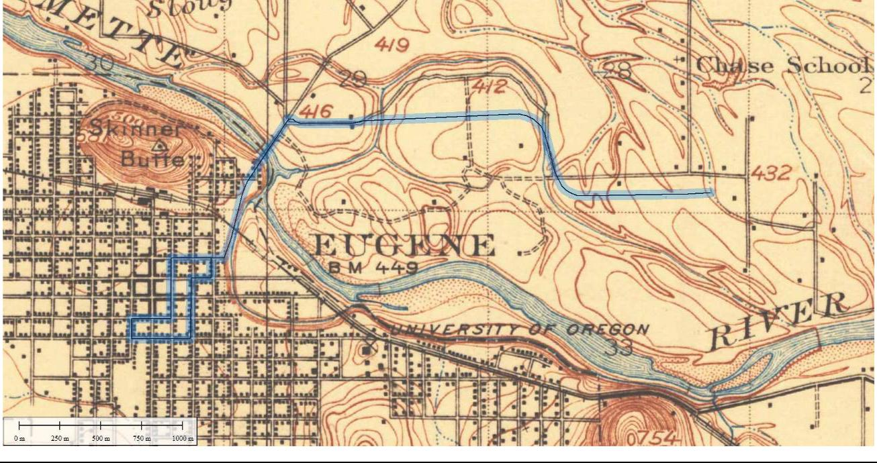

Lane Transit District | DRAFT FINAL Cultural Resources Technical Report | July 7, 2017
City of Eugene | MovingAhead Project | 8-7

Figure 8.1-2. Location of the Martin Luther King, Jr. Boulevard Corridor on the USGS Eugene 15’ Quadrangle, 1940
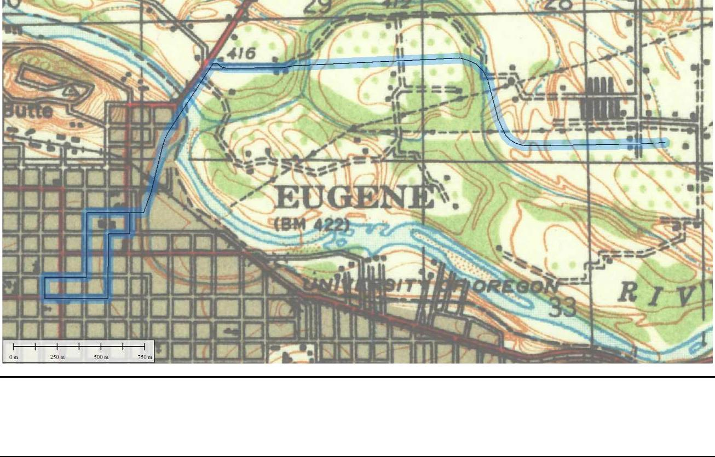

Figure 8.1-3. Alignment of the Martin Luther King, Jr. Boulevard Corridor as Shown on the USGS Eugene East 7.5’ Quadrangle, 1976 (Reduced)
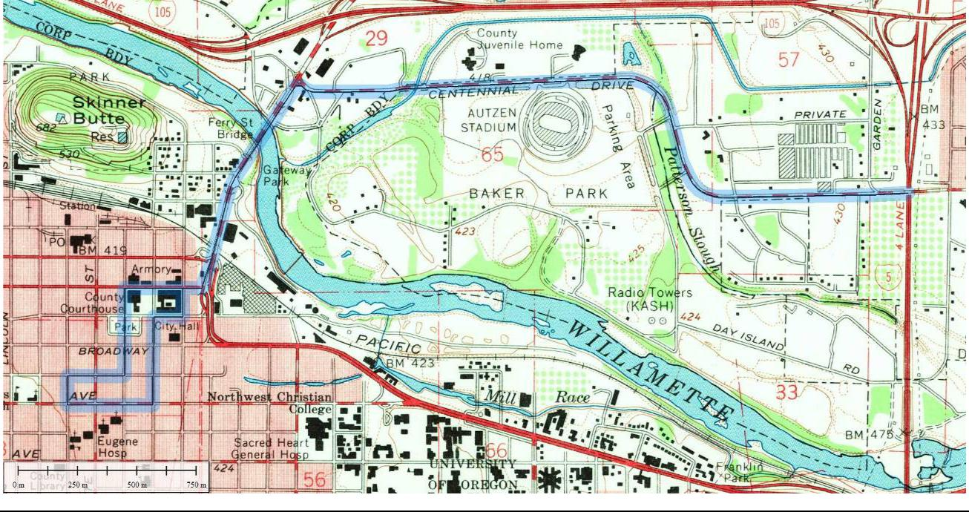

July 7, 2017 | DRAFT FINAL Cultural Resources Technical Report | Lane Transit District
8-8 | MovingAhead Project | City of Eugene

8.1.4. Historical Reconnaissance Results

The Martin Luther King, Jr. Boulevard Corridor north of the river was constructed relatively recently (after World War II) at which time this area began its transition from agricultural lands to incorporate more commercial and residential use. Four historic resources were identified, from the Oregon SHPO database and the windshield survey, as eligible or potentially eligible (Table 8.1-3 and Figure 8.1-4). There appear to be no historic resources that would be directly, adversely impacted by the project.

Table 8.1-3. Inventory of Identified Historic Resources along Martin Luther King, Jr. Boulevard Corridor with Anticipated Effects for Enhanced Corridor Alternative

Address | Tax Lot | Date | Preliminary | Long-term | Long-term
Address | Tax Lot | Date | Evaluationª | / Direct | Indirect /
 |  |  | Evaluationª | / Direct | Cumulative
Ferry Street Bridge |  | 1950 | EC/ES
11 Coburg | 1703293200500 | 1968 | EC
415 Lindley Lane | 1703331200100 | 1937 | EC
3395 Regent | 1703332100304 | 1966 | EC
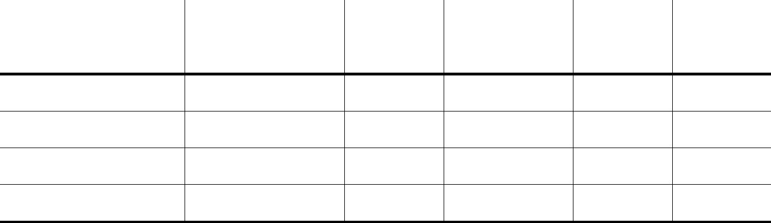

- Preliminary evaluation includes EC and ES.

8.2. Environmental Consequences

The alternatives for the Coburg Road Corridor, specifically north of the Willamette River, where improvements are proposed, appear to result in no impacts to eligible or potentially eligible historic resources. Four eligible or potentially eligible resources have been identified along this corridor, none of which would be adversely affected, either directly or indirectly, by the proposed project.

There is only one build alternative for this corridor – the Enhanced Corridor Alternative. There are no City Landmark sites or NRHP resources along the route that might be affected by project implementation.

8.2.1. Long-Term Direct Impacts

Direct impacts would most likely originate from construction of enhanced stops or road widening that may require property acquisition from the tax lot or that may be constructed in a manner that would potentially obscure or otherwise interfere with the attributes that make the historic resource eligible for the NRHP. Anticipated impacts, or lack thereof, to identified historic resources are summarized in Table 8.1-3.

8.2.1.1. No-Build Alternative

No impacts to historic, archaeological or cultural resources are anticipated under the No-Build Alternative.

Lane Transit District | DRAFT FINAL Cultural Resources Technical Report | July 7, 2017
City of Eugene | MovingAhead Project | 8-9

Figure 8.1-4. Martin Luther King, Jr. Boulevard Enhanced Corridor Alternative Cultural Resources Area of Potential Effect
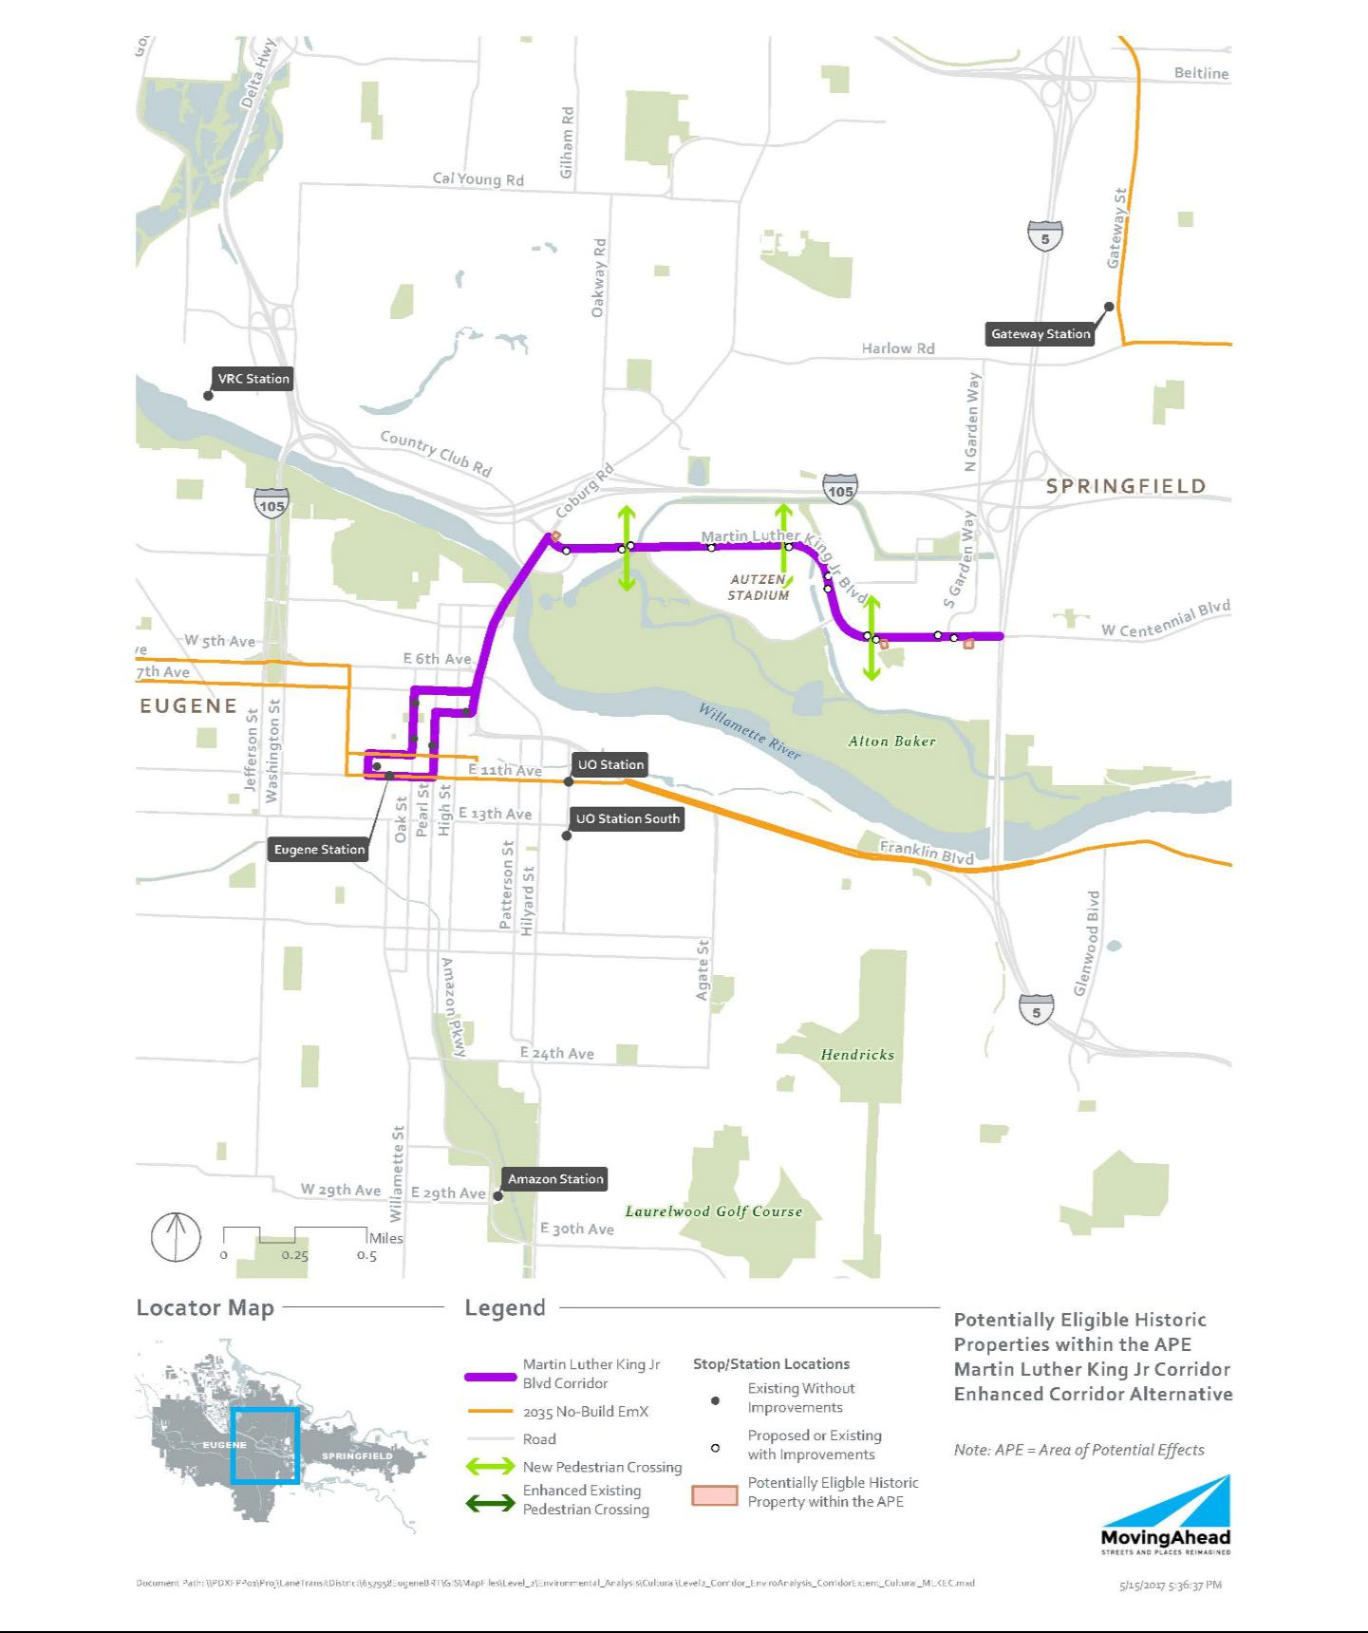

July 7, 2017 | DRAFT FINAL Cultural Resources Technical Report | Lane Transit District
8-10 | MovingAhead Project | City of Eugene

8.2.1.2. Enhanced Corridor Alternative

Under the Enhanced Corridor Alternative, no resources are anticipated to sustain direct, long-term effects based on the current design.

8.2.2. Indirect and Cumulative Effects

Indirect impacts would not result in a physical impact to the resource but may include the construction of enhanced stops or road widening sufficiently close to affect the visual character of the historical setting of the property or other attributes that contribute to its NRHP eligibility. Under Section 106, the impacts may affect a property, but may not necessarily result in an adverse effect.

8.2.2.1. No-Build Alternative

No impacts to historic, archaeological or cultural resources are anticipated under the No-Build Alternative.

8.2.2.2. Enhanced Corridor Alternative

No historic resources are anticipated to sustain indirect impacts under this alternative.

8.2.3. Short-Term Construction-Related Impacts

Aside from the direct impacts noted above, it is assumed that there would be no additional short-term impacts (noise, air, access, etc.) to historic resources associated with construction.

8.3. Potential Mitigation Measures

As a part of Section 106 (36 CFR Part 800) and NEPA, federal transportation agencies are required to seek ways to avoid, minimize, or mitigate adverse effects on historic properties.

Minimization or avoidance of ROW needs from historic resource would reduce or eliminate the potential for an adverse effect under Section 106. Reduction or elimination of property acquisition from historic properties in the project corridor that are eligible for NRHP would avoid or minimize adverse effects on Section 106 resources. One design strategy could involve shifting new stop and station locations away from historic properties to reduce or eliminate impacts.

If it is not feasible to avoid historic properties, an FOE form should be prepared for each of the historic properties impacted by the project. Given the current project description and the types of activities and features that would be implemented, adverse effects to historic properties can likely be avoided for the Martin Luther King, Jr. Boulevard Corridor.

Mitigation / conservation measures may be required for construction contractor compliance if the project plans change and project effects to the NRHP-eligible properties would be greater than stated in this report. An Inadvertent Discovery Plan should also be in place prior to construction, outlining measures to be undertaken in the event of an unanticipated archaeological discovery.

Lane Transit District | DRAFT FINAL Cultural Resources Technical Report | July 7, 2017
City of Eugene | MovingAhead Project | 8-11

Blank Page

July 7, 2017 | DRAFT FINAL Cultural Resources Technical Report | Lane Transit District
8-12 | MovingAhead Project | City of Eugene

- References

The following references were relied on in making this report:

- The statutes and rules referred to in Section 3.2, Relevant Laws and Regulations

- Heritage Research Associates’ files for previous projects in the analysis area

- Conversations with project team

- Guidelines for Conducting Historic Resource Surveys in Oregon, Revised 2011, State Historic Preservation Office, Oregon Parks and Recreation Department

Historic Resource Citations

Carter, Liz, and Michelle Dennis. (1996). “Eugene Area Historic Context Statement.” Eugene, Oregon:

Planning and Development Department.

City of Eugene Planning Division (Historic Resources). http://pdd.eugene-or.gov/Maps/HistoricMap.

Historic Preservation Northwest (HPNW). (2005). Eugene’s Historic River Road. Prepared for City of Eugene Planning and Development Department, Eugene, Oregon. November.

Johnson, Maura. (1989). Willakenzie Area Plan Historic Context. Prepared for City of Eugene Planning Division. August.

Archaeological Resource Citations

Adams, Ron L., and Judith A. Chapman. (2011). Archaeological Survey of the Interstate-5 Bridges Vertical Clearance Improvement Project: Interstate-105 East Bound Bridge (#08689E), Eugene, Oregon. Report by Archaeological Investigations Northwest, Inc., Portland, to KPFF Consulting Engineers, Portland. Archaeological Investigations Northwest Report No. 2646. Oregon SHPO Report #24362.

Baker, R. Todd. (2010). Cal Young Cell Tower (EG01) Cultural Resource Survey. Report by SWCA Environmental Consultants, Portland, to Terracon Consultants, Inc., Mountlake Terrace, WA. Oregon SHPO Report #23485.

Baker, R. Todd, and Sam L. Carter. (2014). Cultural Resource Survey Proposed Telecommunications Tower Site, Site Name: EUG Spearmint, Eugene, Lane County, Oregon. Report by Terracon Consultants, Inc., Mountlake Terrace, WA, to Verizon Wireless. Oregon SHPO Report #26635.

Baxter, Paul W. (2007). Archaeological Survey and Subsurface Reconnaissance of the Beltline Highway @ Coburg Road Interchange, Lane County. Report by the State Museum of Anthropology, University of Oregon, Eugene, to the Geo-Environmental Services Unit, Oregon Department of Transportation, Salem. Museum report 2007-073. Oregon SHPO Report #21419.

Lane Transit District | DRAFT FINAL Cultural Resources Technical Report | July 7, 2017
City of Eugene | MovingAhead Project | 9-1

Baxter, Paul W., and Thomas J. Connolly. (1984). A Cultural Resource Investigation of the River Road - Santa Clara Sewerage System for the City of Eugene, Oregon. Report by Baxter & Connolly Archaeological Data Consultants, Eugene, to Department of Public Works, City of Eugene. BC/AD Consultants Report No. 2. Oregon SHPO Report #5939.

Baxter, Paul W., and Rick Minor. (1987). Preliminary Archaeological Investigations at the Proposed Eugene, GWEN Site, Lane County, Oregon. Report by Heritage Research Associates, Inc., Eugene, to URS Corporation, Sacramento, CA. Heritage Research Associates Report No. 54. Oregon SHPO Report #8214.

Beckner, Chrisanne. (2009). Cultural Demolition: What Was Lost When Eugene Razed its First Black Neighborhood. Unpublished Maters the sis, Interdisciplinary Studies Program: Historic Preservation, University of Oregon, Eugene. Oregon SHPO Report #26630.

Benson, C., W. Honey, and D. Griffin. (1983). Archaeological Survey in the Coburg and Junction City Vicinity, Lane County, Oregon. Report by the Department of Anthropology, Oregon State University, Corvallis, to Jones and Stokes, Sacramento, CA. Oregon SHPO Report #4973.

Bland, Richard L., and Thomas J. Connolly. (2006). Exploratory Archaeological Survey of the Chad Drive Extension, Lane County, Oregon. Report by the State Museum of Anthropology, University of Oregon, Eugene, to Public Works Engineering, City of Eugene. Museum Report 2006-072. Oregon SHPO Report #20598.

Boersema, Jana. (1999). Cultural Resources Surface Survey of Santa Clara Avenue Property

(TL 17-04-11-43-00800), for the City of Eugene, Lane County, Oregon. Report by Heritage Research Associates, Inc., Eugene, to Planning and Development, City of Eugene. Heritage Letter Report 99-13. Oregon SHPO Report #16814.

Bowyer, Gary C. (1997). Archaeological Investigations for the Charnelton Parking Structure, Eugene, Oregon. Report by Western Resources Consulting, Eugene, to Planning and Development, City of Eugene. Report No. WRC-18. Oregon SHPO Report #16222.

Bowyer, Gary C., and Lou Ann Speulda. (1994). Test Excavations at Dorris Ranch Early-House Site. Report by INFOTEC Research Inc., Eugene, to Willamalane Park and Recreation District. Oregon SHPO Report #23582.

Bowyer, Gary C., and Lou Ann Speulda. (1997). Cultural Resources Survey of 2990 County Farm Road, For Low Income Housing, Lane County, Eugene, Oregon. Report to the City of Eugene. Oregon SHPO Report #15945.

Boynton, Michael J., Todd Ogle, Jo Reese, and Jason M. Allen. (2007). Archaeological and Historical Resource Survey of Bonneville Power Administration Land for the Relocation of Transmission Towers, I-5 McKenzie River to Goshen Grade Design-Build Project, Hwy. 1 over Franklin Boulevard and UPRR (Goshen) Bridge No. 06836A. Report by Archaeological Investigations Northwest, Portland, to Bonneville Power Administration, Portland. Archaeological Investigations Northwest Report No. 1892. Oregon SHPO Report #21163.

July 7, 2017 | DRAFT FINAL Cultural Resources Technical Report | Lane Transit District
9-2 | MovingAhead Project | City of Eugene

Brockington and Associates. (2013). Archaeological Sensitivity Assessment of Webb U.S. Army Reserve Center, Lane County, Oregon. Report by Brockington and Associates, Inc., Norcross, GA, to Directorate of Public Works, Department of the Army, Headquarters, 88th Regional Support Command, WI. Oregon SHPO Report #26035.

Buchanan, Brian G., and Judith A. Chapman. (2008a). Archaeological Baseline Survey report for the Interstate-5 Bridges Vertical Clearance Improvements Project, Marion, Linn, and Lane Counties, Oregon. Report by Archaeological Investigations Northwest, Inc., Portland, to KPFF Consulting Engineers, Portland. Archaeological Investigations Northwest Report No. 2119. Oregon SHPO Report #22154.

Buchanan, Brian G., and Judith A. Chapman. (2008b). Archaeological Shovel Testing for the Interstate-5 Bridges Vertical Clearance Improvements Project, Marion, Linn, and Lane Counties, Oregon. Report by Archaeological Investigations Northwest, Portland, to KPFF Consulting Engineers, Portland.

Archaeological Investigations Northwest Report No. 2194. Oregon SHPO Report #22155.

Buchanan, Brian G., and Jo Reese. (2008). Phase One Archaeological Survey and Shovel Testing for the I-5 Lane County Interstate Sign Replacement Project, Lane and Linn Counties, Oregon. Report by Archaeological Investigations Northwest, Portland, to KPFF Consulting Engineers, Portland. Oregon SHPO Report #22141.

Buchanan, Brian G., and Jo Reese. (2009a). Archaeological Survey of the Expanded Area of Potential Effect at Bridge 08329 (I-5 Willamette River Bridge) Bundle 220, within the Whilamut Natural Area, Lane County, Springfield, Oregon. Report by Archaeological Investigations Northwest, Portland, to OBEC Consulting Engineers, Eugene. Archaeological Investigations Northwest Report No. 2269. Oregon SHPO Report #22291.

Buchanan, Brian G., and Jo Reese. (2009b). Archaeological Survey of the Revised Area of Potential Effect at Bridge 08329 (I-5 Willamette river Bridge) Bundle 220, within the Whilamut Natural Area of Alton Baker Park, Springfield and Eugene, Lane County, Oregon. Report by Archaeological Investigations Northwest, Portland, to OBEC Consulting Engineers, Eugene. Archaeological Investigations Northwest Report No. 2376. Oregon SHPO Report #22994.

Buchanan, Brian G., and Jo Reese. (2009c). Northwest Pipeline GP Willamette Reroute, Eugene, Lane County, Oregon. Report by Archaeological Investigations Northwest, Portland, to Oregon State Historic Preservation Office, Salem. Archaeological Investigations Northwest Report No. 2443. Oregon SHPO Report #23023.

Byram, R. Scott. (2004a). Interim Report of Archaeological Monitoring and Recovery at the Wayne L. Morse United States Courthouse, Eugene, Oregon. Report by R. Scott Byram, Consulting Archaeologist, Eugene, to U.S. General Services Administration, Auburn, WA. Oregon SHPO Report #19337.

Byram, R. Scott. (2004b). Second Update of Archaeological Investigations at the U.S. Courthouse, Site, Eugene, Oregon. Report by R. Scott Byram, Consulting Archaeologist, Eugene, to General Services Administration, Auburn, WA. Oregon SHPO Report #19342.

Lane Transit District | DRAFT FINAL Cultural Resources Technical Report | July 7, 2017
City of Eugene | MovingAhead Project | 9-3

Carlisle, Kendra. (2008a). Roosevelt Blvd. from Beltline Hwy. to Chambers Connection: Pavement Preservation, City of Eugene, Lane County, Oregon. Report by Heritage Research Associates, Inc., Eugene, to the Oregon Department of Transportation, Salem. Oregon SHPO Report #22628.

Carlisle, Kendra. (2008b). Archaeological Investigations for the Middle Fork Willamette River Loop Path (Dorris Ranch to Clearwater Park) in Lane County, Oregon. Report by Heritage Research Associates, Inc., Eugene, to OBEC Consulting Engineers, Eugene. Heritage Research Associates Report No. 321. Oregon SHPO Report #22365.

Castronuevo, Agnes F., and Patrick Garrison. (2016). EUG Tin Archaeological Survey Report. Report by Terracon Consultants, Mountlake Terrace, WA, to Verizon Wireless. Oregon SHPO Report #28201.

Chapman, Judith A. (2010a). Inadvertent Discovery and Archaeological Monitoring Results in 2009 for the Willamette River Bridge (#08329) Replacement Project (Bundle 220) Eugene, Oregon. Report by Archaeological Investigations Northwest, Inc., Portland, to OBEC Consulting Engineers, Eugene. Archaeological Investigations Northwest Report No. 2444. Oregon SHPO Report #23349.

Chapman, Judith A. (2010b). Inadvertent Discovery Results at Bent 5 for the Willamette River Bridge (#08329) Replacement Project (Bundle 220) Eugene, Oregon. Report by Archaeological Investigations Northwest, Inc., Portland, to OBEC Consulting Engineers, Eugene. Archaeological Investigations Northwest Report No. 2492. Oregon SHPO Report #23409.

Chapman, Judith A., and Michele L. Punke. (2010). Archaeological Survey of the P20 Path at the I-5 Willamette River Bridge (#08329) Replacement Project (Bundle 220) Eugene and Springfield, Lane County, Oregon. Report by Archaeological Investigations Northwest, Inc., Portland, to OBEC Consulting Engineers, Eugene. Archaeological Investigations Northwest Report No. 2480. Oregon SHPO Report #23287.

Connolly, Thomas J. (1983). A Cultural Resource Investigation of a Proposed Force Sewer Main Route in Eugene, Oregon. Report by Thomas J. Connolly Cultural Resource Consultant, to Metropolitan Wastewater Management Commission, Springfield. Oregon SHPO Report #4975.

Connolly, Thomas J. (1984a). Archaeological Reconnaissance of the Greenway Park Archaeological Site, Eugene, Oregon. Report by BC/AD Consultants, Eugene, to Parks and Recreation Department, City of Eugene. Oregon SHPO Report #5938.

Connolly, Thomas J. (1984b). Archaeological Testing of Three Localities on the Proposed River Road/Santa Clara Sewerage System, Eugene, Oregon. Report by BC/AD Consultants, Eugene, to Department of Public Works, City of Eugene. BC/AD Consultants Report No. 4. Oregon SHPO Report #5940.

Connolly, Thomas J. (1987). Archaeological Survey of a Revised Alignment for the West 11th Ave. - Garfield St. Section of the Florence - Eugene Highway (OR 126), Lane County. Report by the State Museum of Anthropology, University of Oregon, Eugene, to the Environmental Section, Oregon Department of Transportation, Salem. Oregon SHPO Report #8213.

July 7, 2017 | DRAFT FINAL Cultural Resources Technical Report | Lane Transit District
9-4 | MovingAhead Project | City of Eugene

Connolly, Thomas J. (2000). Archaeological Survey of the I-105 at Delta Highway On-Ramp (MP 0.45-0.81), Eugene-Springfield Highway (I-105), Lane County. Report by the State Museum of Anthropology, University of Oregon, Eugene, to the Environmental Services Section, Oregon Department of Transportation, Salem. Oregon SHPO Report #17193.

Connolly, Thomas J. (2001a). Archaeological Survey of the I-5/Beltline Interchange, Eugene-Springfield Highway, Lane County. Report by the State Museum of Anthropology, University of Oregon, Eugene, to the Environmental Services Section, Oregon Department of Transportation, Salem. Oregon SHPO Report #17774.

Connolly, Thomas J. (2001b). Exploratory Archaeological Survey of the I-5/Beltline Interchange, Eugene-Springfield Highway, Lane County. Report by the State Museum of Anthropology, University of Oregon, Eugene, to the Environmental Services Section, Oregon Department of Transportation, Salem. Oregon SHPO Report #18138.

Connolly, Thomas J. (2008). I-5 @ Beltline Interchange, Unit 2 (Springfield/Eugene), Lane County. Report by the State Museum of Anthropology, University of Oregon, Eugene, to the Geo-Environmental Services Section, Oregon Department of Transportation, Salem. Museum Report 2008-059. Oregon SHPO Report #22196.

Connolly, Thomas J., Margaret Helzer, and Brian O'Neill. (2003). McKenzie and Willamette River Bridges, I-5 Detour and Repair Sections, Pacific Highway (I-5), Lane County. Report by the State Museum of Anthropology, University of Oregon, Eugene, to the Environmental Services Section, Oregon Department of Transportation, Salem. Oregon SHPO Report #18581.

Edwards, Ian. (2004a). Archaeological Survey of BR 08445 - Oregon Hwy 99 over Interstate 5 (Mile Post 190.5) Lane County, Oregon. Report by the State Museum of Anthropology, University of Oregon, Eugene, to Environmental Services, Oregon Department of Transportation, Salem. Oregon SHPO Report #19467.

Edwards, Ian. (2004b). Archaeological Survey of Bridge 08870 Interstate 5 over Oregon Highway 99 Connector (MilePost 190.76), Lane County, Oregon. Report by the State Museum of Anthropology, University of Oregon, Eugene, to Environmental Services, Oregon Department of Transportation, Salem. Oregon SHPO Report #19500.

Edwards, Ian. (2004c). Archaeological Survey of Bridge 06836A (Interstate 5 over Franklin Blvd & UPRR-- Goshen at MP 188.9), Lane County, Oregon. Report by the State Museum of Anthropology, University of Oregon, Eugene, to Geo-Environmental Services, Oregon Department of Transportation, Salem. Oregon SHPO Report #19506.

Edwards, Ian, and Tobin C. Bottman. (2005). Archaeological Survey of Bridge 08182 N/S (Interstate 5 Northbound/Southbound over Game Farm Road at Milepost 195.8), Lane County, Oregon. Report by the State Museum of Anthropology, University of Oregon, Eugene, to Geo-Environmental Services, Oregon Department of Transportation, Salem. Museum Research Report 2005-155. Oregon SHPO Report #21006.

Lane Transit District | DRAFT FINAL Cultural Resources Technical Report | July 7, 2017
City of Eugene | MovingAhead Project | 9-5

Edwards, Ian, and Teresa E. Cabebe. (2006). Archaeological Survey of Bridge 08180N/S (Interstate 5 Northbound and Southbound over the McKenzie Overflow at Milepoint 196.2), Lane County, Oregon. Report by the State Museum of Anthropology, University of Oregon, Eugene, to Geo-Environmental Services, Oregon Department of Transportation, Salem. Museum Research report 2006-169. Oregon SHPO Report #21140.

Edwards, Ian, and Bruce Dahlstrom. (2005). Archaeological Survey of Bridge 08178 N/S (McKenzie Overflow, Interstate 5 at MilePost 196.69), Lane County, Oregon. Report by the State Museum of Anthropology, University of Oregon, Eugene, to Environmental Services, Oregon Department of Transportation, Salem. Museum Research Report 2005-18. Oregon SHPO Report #19497.

Ellis, David V., Judith S. Chapman, David A. Ball, Bonnie J. Mills, and John L. Fagan. (1999). Cultural Resources Survey of Level 3's Proposed Fiber Optic Line from Springfield to Eugene, Oregon. Report by Archaeological Investigations Northwest, Inc., Portland, to Parsons Brinckerhoff Quade & Douglas, Inc., Portland. Archaeological Investigations Northwest Letter Report No. 275. Oregon SHPO Report #16707.

Fields, Richard A. (2006). A Cultural Resources Survey of the Eugene Warehouse Compound of the Willamette National Forest, Eugene, Lane County, Oregon. Report by the Pacific Northwest Region, USDA Forest Service. Oregon SHPO Report #21040.

Finley, Aimee. (2002). Results of an Archaeological Survey of the Alvey Substation, Lane County, Oregon.

Report by Applied Archaeological Research, Portland, to Bonneville Power Administration, Portland.

Applied Archaeological Research Report No. 289-6. Oregon SHPO Report #17954.

Finley, Aimee. (2014). Results of a Cultural Resources Inventory of the EUG Polk (Trileaf #612180) Cell Site, Eugene, Lane County, Oregon. Report by Applied Archaeological Research, Portland, to Trileaf, Inc., Chandler, AZ. Applied Archaeological Report No. 1367. Oregon SHPO Report #26747.

Finley, Aimee. (2016). Results of a Cultural Resources Study of the OR47638 Eugene Cell Site, Eugene, Lane County, Oregon. Report by Applied Archaeological Research, Portland, to Martin Environmental Solutions, Inc., Jacksonville, FL. Applied Archaeological Report No. 1629. Oregon SHPO
Report #28009.

Follansbee, Julia A. (1977). Cultural Resources Survey for the Proposed Eugene Interceptor and Sewage Treatment Plant Expansion. Report by Julia A. Follansbee Archaeological Consultant, to Lane Council of Governments, Eugene. Oregon SHPO Report #2522.

Fuld, Kristen A., and Judith A. Chapmen. (2014). Results of Archaeological Monitoring for the Willamette River Bridge (#08329) Replacement Project (Bundle 220) in 2012 and 2013, Eugene, Oregon. Report by Archaeological Investigations Northwest, Inc., Portland, to OBEC Consulting Engineers, Eugene.

Archaeological Investigations Northwest Report No. 3215. Oregon SHPO Report #26316.

Griffin, Dennis. (2014). the Discovery and Recovery of a Groundstone Artifact at Fairfield Elementary School, Eugene, Oregon. Report by the Oregon State Historic Preservation Office, Salem. Oregon SHPO Report #26690.

July 7, 2017 | DRAFT FINAL Cultural Resources Technical Report | Lane Transit District
9-6 | MovingAhead Project | City of Eugene

Hart, Linda P. (2010). Archaeological Monitoring for Parking Lot Improvements at the Eugene Train Depot (Site 35LA1478), City of Eugene, Lane County, Oregon. Report by Heritage Research Associates, Inc., Eugene, to OBEC Consulting Engineers, Eugene. Heritage Letter Report 10-8. Oregon SHPO Report #23211.

Hart, Linda P., and Kevin McCornack. (2007). Archaeological Monitoring and Testing for the WestTown on 8th Construction Project, Eugene, Lane County, Oregon. Report by Heritage Research Associates, Inc., Eugene, to Metropolitan Affordable Housing Corporation, Eugene. Heritage Research Associates Report No. 309. Oregon SHPO Report #25822.

Helzer, Margaret, and Jaime Dexter. (2004). Willamette River-Pacific Highway Section, I-105, Lane County. Report by the State Museum of Anthropology, University of Oregon, Eugene, to Environmental Services, Oregon Department of Transportation, Salem. Oregon SHPO Report #19164.

Holschuh, Dana L. (2013a). Archaeological Survey of the River Road (EG13) Telecommunications Facility Project Area, Lane County, Oregon. Report by Archaeological Services LLC, Vancouver, WA, to Adapt Engineering, Inc., Portland. Archaeological Services of Clark County Survey Report No. 13885.

Oregon SHPO Report #25927.

Holschuh, Dana L. (2013b). Archaeological Survey of the Patterson (EU08) Telecommunications Facility Project Area, Lane County, Oregon. Report by Archaeological Services LLC, Vancouver, WA, to Adapt Engineering, Inc., Portland. Archaeological Services of Clark County Survey Report No. 13886. Oregon SHPO Report #25905.

Holschuh, Dana L. (2013c). Archaeological Survey of the Fox Hollow and Amazon Road (EG46) Telecommunications Facility Project Area, Lane County, Oregon. Report by Archaeological Services LLC, Vancouver, WA, to Adapt Engineering, Inc., Portland. Archaeological Services of Clark County Survey Report No. 13935. Oregon SHPO Report #26143.

Holschuh, Dana L. (2013d). Archaeological Survey of the I-5 MLK Jr. (EU30) Telecommunications Facility Project Area, Lane County, Oregon. Report by Archaeological Services LLC, Vancouver, WA, to Adapt Engineering, Inc., Portland. Archaeological Services of Clark County Survey Report No. 13891.

Oregon SHPO Report #25951.

Holschuh, Dana L. (2014). Archaeological Survey of the Laurel Hill (EG41) Telecommunications Facility Project Area, Lane County, Oregon. Report by Archaeological Services LLC, Vancouver, WA, to Adapt Engineering, Inc., Portland. Archaeological Services of Clark County Survey Report No. 14980. Oregon SHPO Report #26307.

Holschuh, Dana L., and Alexander W. Gall. (2012). Archaeological Survey of the Covey (EU29) Telecommunications Facility, Lane County, Oregon. Report by Archaeological Services LLC, Vancouver, WA, to Adapt Engineering, Inc., Portland. Archaeological Services of Clark County Survey Report No. 12812. Oregon SHPO Reports #25418 and #25695.

INFOTEC, Inc. (1992). Cultural Resources Technical Report, Ferry Street Bridge, Eugene, Oregon. Report by INFOTEC Research, Inc., Eugene, to Oregon Department of Transportation and Federal Highway Administration. Oregon SHPO Report #16090.

Lane Transit District | DRAFT FINAL Cultural Resources Technical Report | July 7, 2017
City of Eugene | MovingAhead Project | 9-7

Knowles, Julia A., and Thomas J. Connolly. (2009). Archaeological Monitoring of the Region 2 CCTV Project, Lane County. Report by the State Museum of Anthropology, University of Oregon, Eugene, to Geo-Environmental Services Section, Oregon Department of Transportation, Salem. Museum Research Report 2009-054. Oregon SHPO Report #22730.

Lebow, Clayton G. (1987). Cultural Resource Survey of the Dorris Ranch, Lane County, Oregon. Report by INFOTEC Research, Inc., Eugene, to Willamalane Park and Recreation District, Springfield. IRI Report No. PNW87-5. Oregon SHPO Report #9153.

Maass, Alex, and Patrick O'Bannon. (2003). Cultural Resource Study for the Proposed New Federal Courthouse Site, Lane County, Eugene, Oregon. Report by Historical Research Associates, Inc., Portland, to Herrera Environmental Consultants. Oregon SHPO Reports #18502 and #19013.

Maceyko, Jeff, and Dana Holschuh. (2013). Archaeological Survey of the Blanton Ridge (EG42) Telecommunications Facility Project Area, Lane County, Oregon. Report by Archaeological Services LLC, Vancouver, WA, to Adapt Engineering, Inc., Portland. Archaeological Services of Clark County Survey Report No. 13918. Oregon SHPO Report #26203.

Martin, Michael A. (2002). Cultural Resource Assessment, Delta Ponds, Eugene, Oregon. Report by Portland District, U. S. Army Corps of Engineers. Oregon SHPO Report #18214.

McAlister, Kaylon. (2013). Oak Hill School Pedestrian Survey and Metal Detector Investigation, Lane County, Oregon. Report by the State Museum of Anthropology, University of Oregon, Eugene, to Oak Hill School, Pleasant Hill, Oregon. Museum Research Report 2013-028. Oregon SHPO Report #26084.

McClintock, Robin, and James C. Bard. (1998). Cultural Resource Survey, Bonneville Power Administration Albany-Eugene Transmission Line Rebuild, Southerly 9.3 Miles. Report by CH2MHill, Corvallis, to Bonneville Power Administration, Portland. Oregon SHPO Report #16589.

Minor, Rick. (1978). Cultural Resource Survey for the Coburg Road Storm Sewer Extension, Eugene, Lane County, Oregon. Report by the Department of Anthropology, University of Oregon, Eugene, to Department of Public Works, City of Eugene. Oregon SHPO Report #228.

Minor, Rick. (1979). Cultural Resources Survey of 12 Lots in Downtown Eugene. Report by the Department of Anthropology, University of Oregon, Eugene, to Housing and Community Conservation Department, City of Eugene. Oregon SHPO Report #573.

Minor, Rick. (1987). Cultural Resources Survey for the US Sprint Fiber Optic Cable Project, Eugene, Oregon to Seattle, Washington. Report by Heritage Research Associates, Inc., Eugene, to US Sprint. Oregon SHPO Report #8292.

Minor, Rick. (1997a). Preliminary Report on Archaeological Monitoring at Site FSB-H3, Ferry Street Bridge Project, Eugene, Oregon. Report by Heritage Research Associates, Inc., Eugene, to OBEC Consulting Engineers, Eugene. Oregon SHPO Report #16097.

July 7, 2017 | DRAFT FINAL Cultural Resources Technical Report | Lane Transit District
9-8 | MovingAhead Project | City of Eugene

Minor, Rick. (1997b). Archaeological Monitoring Along Club Road East of Ferry Street Bridge, Eugene, Lane County, Oregon. Report by Heritage Research Associates, Inc., Eugene, to Technical Services Branch, Oregon Department of Transportation, Salem. Heritage Letter Report 97-35. Oregon SHPO Report #17773.

Minor, Rick. (1998a). Archaeological Monitoring of Storm Drain Installation at the South Wood Lane Dump Site, Ferry Street Bridge Project, Eugene, Lane County, Oregon. Report by Heritage Research Associates, Inc., Eugene, to Technical Services Branch, Oregon Department of Transportation, Salem. Heritage Letter Report 98-27. Oregon SHPO Report #17772.

Minor, Rick. (1998b). Archaeological Monitoring in the Eugene Millrace Industrial District for the Ferry Street Bridge Improvement Project, City of Eugene, Lane County, Oregon. Report by Heritage Research Associates, Inc., Eugene, to OBEC Consulting Engineers, Eugene. Heritage Research Associates Report No. 220. Oregon SHPO Report #18496.

Minor, Rick. (2000). Progress Report on Archaeological Monitoring and Data Recovery at the Site of the New Library, Eugene, Lane County, Oregon. Report by Heritage Research Associates, Inc., Eugene, to Public Works, City of Eugene. Heritage Letter Report 2000-25. Oregon SHPO Report #17531.

Minor, Rick. (2006). Archaeological Monitoring for the ORE 99W: High Street-Hilyard Street Section, U. S. Courthouse District, Eugene, Lane County, Oregon. Report by Heritage Research Associates, Inc., Eugene, to OBEC Consulting Engineers, Eugene. Heritage Research Associates Report No. 301. Oregon SHPO Report #21189.

Minor, Rick. (2008). Archaeological Monitoring for the Courthouse District Transportation Improvement Phase 2 Project, U. S. Courthouse District, Eugene, Lane County, Oregon. Report by Heritage Research Associates, Inc., Eugene, to OBEC Consulting Engineers, Eugene. Heritage Research Associates Report No. 320. Oregon SHPO Reports #22107 and #22241.

Minor, Rick. (2013). Archaeological Survey for the Glenwood Connector Project, Springfield, Lane County, Oregon. Report by Heritage Research Associates, Inc., Eugene, to OBEC Consulting Engineers, Eugene. Heritage Letter Report 13-20. Oregon SHPO Report #25967.

Minor, Rick, George Kramer, and Kathryn Toepel. (2007). An Archaeological Assessment of the Eugene Millrace Diversion Dam and Intake (35LA1456) for the I-5 Willamette River Bridge (#08329) Project, Lane County, Oregon. Report by Heritage Research Associates, Inc., Eugene, to HDR, Portland.

Heritage Research Associates Report 314. Oregon SHPO Report #21577.

Musil, Robert R. (2012). Archaeological Survey of the Nature Conservancy's Willamette Confluence Preserve, Lane County, Oregon. Report by Heritage Research Associates, Inc., Eugene, to the Nature Conservancy Willamette Valley Field Office, Eugene. Heritage Research Associates Report 369. Oregon SHPO Report #26265.

Musil, Robert R. (2013). Archaeological Survey of the Murphy Company Expansion Project, Lane County, Oregon. Report by Heritage Research Associates, Inc., Eugene, to the Murphy Company, Eugene. Heritage Letter Report 13-56. Oregon SHPO Report #26134.

Lane Transit District | DRAFT FINAL Cultural Resources Technical Report | July 7, 2017
City of Eugene | MovingAhead Project | 9-9

Musil, Robert R. (2015). Archaeological Survey of Three Additional Parcels for the Willamette Confluence Preserve, Lane County, Oregon. Report by Heritage Research Associates, Inc., Eugene, to the Nature Conservancy, Eugene. Heritage Letter Report 15-16. Oregon SHPO Report #27827.

- Donnchadha, Brian, and Sunshine Schmidt. (2013). A Cultural Resource Survey of the Proposed Eugene Substation LSN Fiber Interconnection in Lane County, Oregon. Report by Bonneville Power Administration, Portland. Oregon SHPO Report #25835.

Oetting, Albert C. (1998). Cultural Resources Surface Survey of 2440 Willakenzie Road for the City of Eugene, Lane County, Oregon. Report by Heritage Research Associates, Inc., Eugene, to Planning and Development, City of Eugene. Heritage Letter Report 98-7. Oregon SHPO Report #16391.

Oetting, Albert C. (2000). Archaeological Reconnaissance of the Lane Transit District's Bus Rapid Transit Phase 1 Pilot Corridor Between Eugene and Springfield, Lane County, Oregon. Report by Heritage Research Associates, Inc., Eugene, to Parametrix, Inc., Portland. Heritage Letter Report 00-21. Oregon SHPO Report #17775.

Oetting, Albert C. (2008a). Archaeological Survey of the Delta Ponds Pedestrian Bridge Project, City of

Eugene, Lane County, Oregon. Report by Heritage Research Associates, Inc., Eugene, to OBEC Consulting Engineers, Eugene. Heritage Letter Report 08-03. Oregon SHPO Report #22303.

Oetting, Albert C. (2008b). Archaeological Discovery Probes for the Delta Ponds Pedestrian Bridge Project, City of Eugene, Lane County, Oregon. Report by Heritage Research Associates, Inc., Eugene, to OBEC Consulting Engineers, Eugene. Heritage Letter Report 08-9. Oregon SHPO Report #22304.

Oetting, Albert C. (2011a). Archaeological Survey of the Lane Transit District West Eugene EmX Extension Project and Locally Preferred Alternative (LPA), City of Eugene, Lane County, Oregon. Report by Heritage Research Associates, Inc., Eugene, to Lane Transit District, Eugene. Heritage Letter Report 11-33. Oregon SHPO Report #24606.

Oetting, Albert C. (2011b). Programmatic Agreement SHPO Tracking Archaeological Investigation for the Fern Ridge Bike Path Project: Chambers Street - Arthur Street, City of Eugene, Lane County, Oregon. Report by Heritage Research Associates, Inc., Eugene, to Highway Division, Oregon Department of Transportation, Salem. Oregon SHPO Report #25111.

Oetting, Albert C. (2016). Cultural Resource Survey for the Commerce Street Connector Path and Bridge Project, City of Eugene, Lane County, Oregon. Report by Heritage Research Associates, Inc., Eugene, to Department of Public Works, City of Eugene. Heritage Letter Report 16-07. Oregon SHPO Report #28181.

O'Neill, Brian. (2009). Subsurface Reconnaissance in the OR99 Barger Avenue to Washington/Jefferson Streets (Eugene), Lane County, Project. Report by the State Museum of Anthropology, University of Oregon, Eugene, to Geo-Environmental Services, Oregon Department of Transportation, Salem.
Museum Research Report 2009-012. Oregon SHPO Report #22309.

O'Neill, Brian, and Thomas Connolly. (2006). Pedestrian Survey of the West 11th - Garfield (West Eugene Parkway) Project, Lane County. Report by the State Museum of Anthropology, University of Oregon, Eugene, to Geo-Environmental Services, Oregon Department of Transportation, Salem. Museum Research Report 2006-121. Oregon SHPO Report #20818.

July 7, 2017 | DRAFT FINAL Cultural Resources Technical Report | Lane Transit District
9-10 | MovingAhead Project | City of Eugene

O'Neill, Brian, and Christopher Ruiz. (2008). Pedestrian Survey for Cultural Resources in the OR 99 Barger Avenue to Washington/Jefferson Streets (Eugene), Lane County, Project. Report by the State Museum of Anthropology, University of Oregon, Eugene, to Geo-Environmental Services Unit, Oregon Department of Transportation, Salem. Museum Research Report 2008-046. Oregon SHPO Report #22097.

Oregon State Historic Preservation Office (SHPO). (2016, August). Oregon Archaeological Records Remote Access System.

Pettigrew, Richard M. (1980). Report on the Archaeological Survey of the Beltline Road-Highway 99N Section, Roosevelt Boulevard (Eugene), Lane County. Report by the State Museum of Anthropology, University of Oregon, Eugene, to Environmental Section, Oregon Department of Transportation, Salem. Oregon SHPO Report #2229.

Pettigrew, Richard M. (1983). Report on the Archaeological Survey of the Proposed West 11th-Garfield Street Section, Florence-Eugene Highway, Lane County. Report by the State Museum of Anthropology, University of Oregon, Eugene, to Environmental Section, Oregon Department of Transportation, Salem. Oregon SHPO Report #5411.

Pettigrew, Richard M. (1996). Archaeological Survey of the Lane Community College School Forest Property, Lane County, Oregon. Report by Richard M. Pettigrew Archaeologist, Eugene, to Kristine Sohnrey, Eugene. SHPO Report #15569.

Pettigrew, Richard M., and David L. Cole. (1977). Archaeological Survey of the Valley River Bicycle-Pedestrian Bridge, Lane County, Oregon. Report by the State Museum of Anthropology, University of Oregon, Eugene, to the Highway Division, Oregon Department of Transportation, Salem. Oregon SHPO Report #188.

Ragsdale, Emily, K., Frederick Anderson, Catherin Bialas, Natalie K. Perrin, Lindsay Ponte, and James Grant. (2014). Cultural Resource Investigations of the Alvey-Fairview Transmission Line Rebuild Project, Lane, Douglas, and Coos Counties, Oregon. Report by Historical Research Associates, Inc., Portland, to Bonneville Power Administration, Portland. Oregon SHPO Report #26324.

Shindruk, Darby. (2012). Archaeological Monitoring at Willakenzie Crossing Development Project, Eugene, Oregon. Report by Byram Archaeological Consulting, LLC, to Metropolitan Affordable Housing Corporation, Eugene. Oregon SHPO Report #25049.

Silvermoon, Jon, Kathryn Elsesser, Scott Stuemke, Matthew Ruane, Ben Settecase, Philip Hiles, and C. Melvin Aikens. (1984). Archaeological Resources of the Eugene-Springfield Metropolitan Area, Oregon: Overview and Management Recommendations. Report by the Department of Anthropology, University of Oregon. Oregon SHPO Report #16223.

Smith, Mike, and Alexander W. Gall. (2010). Cultural Resources Survey of the Goodpasture Island Planned Unit Development Project Area, Eugene, Oregon. Report by Archaeological Services of Clark County, Vancouver, WA, to GDL Construction, Inc., Portland. ASCC Survey Report No. 10638. Oregon SHPO Report #25327.

Lane Transit District | DRAFT FINAL Cultural Resources Technical Report | July 7, 2017
City of Eugene | MovingAhead Project | 9-11

Stipe, Frank. No date (n.d.). A Cultural Resources Survey for the EUG Baldy View Alt. 3 Cellular Communications Tower Site, Lane County, Oregon. Report by Tetra Tech, Bothell, WA, to Verizon Wireless. Oregon SHPO Report #22394.

Stipe, Frank. (2013). A Cultural Resources Survey for the LCC Cellular Communications Tower Site, Lane County, Oregon. Report by Tetra Tech, Bothell, WA, to Verizon Wireless. Oregon SHPO

Report #25899.

Teoh, Melissa L. (2015). Cultural Resources Survey for Springfield Utility Board Structure Replacement and Fiber Installation Project in Lane County, Oregon. Report by Bonneville Power Administration, Portland. Oregon SHPO Report #27610.

Tisdale, Lucie. (2016). Main Line Valve 78-1 to Winchester Compressor Station Facility Modifications Project, Pipeline Milepost Stopples 7.16 to 7.3, Cultural Resource Survey Summary and Recommendations. Report by Archaeological Investigations Northwest, Inc., Portland, to Williams Northwest Pipeline LLC. Archaeological Investigations Northwest Report No. 3602. Oregon SHPO Report #27996.

Toepel, Kathryn A. (1994a). Archaeological Survey of Wetlands Enhancement Project, Valley River Village, Eugene, Oregon. Report by Heritage Research Associates, Inc., Eugene, to Valley River Village, Eugene. Heritage Letter Report 94-23. Oregon SHPO Report #14587.

Toepel, Kathryn A. (1994b). Archaeological Survey of Valley River Village (Parcel 4), Eugene, Oregon. Report by Heritage Research Associates, Inc., Eugene, to Valley River Village, Eugene. Heritage Letter Report 94-14. Oregon SHPO Report #14588.

Toepel, Kathryn A. (1994c). Cultural Resource Survey of Game Farm/Deadmond Ferry Roads and International Way Projects, City of Springfield, Lane County, Oregon. Report by Heritage Research Associates, Inc., Eugene, to City of Springfield. Heritage Letter Report 94-26. Oregon SHPO Report #14740.

Toepel, Kathryn A. (2005). Cultural Resource Survey for the Bonneville Power Administration Thurston-Willakenzie 115-kV Transmission Line Relocation, City of Springfield, Lane County, Oregon. Report by Heritage Research Associates, Inc., Eugene, to Bonneville Power Administration, Portland. Heritage Letter Report 05-53. Oregon SHPO Report #19988.

Toepel, Kathryn A. (2008). Preliminary Results of Archaeological Probing at the Eugene Millrace Intake (35LA1456) for the Willamette River Bridge 08329N/S Replacement Project (Bundle 220), Eugene, Lane County, Oregon. Report by Heritage Research Associates, Inc., Eugene, to Oregon Bridge Delivery Partners, Salem. Oregon SHPO Report #22080.

Toepel, Kathryn A. (2014). Cultural Resource Survey for the Lane County School District No. 4J Roosevelt Middle School Replacement Project, City of Eugene, Lane County, Oregon. Report by Heritage Research Associates, Inc., Eugene, to Environmental Solutions LLC, Blue River, Oregon. Heritage Letter Report 14-19. Oregon SHPO Report #26808.

July 7, 2017 | DRAFT FINAL Cultural Resources Technical Report | Lane Transit District
9-12 | MovingAhead Project | City of Eugene

Toepel, Kathryn A. (2015). Cultural Resource Survey for the South Bank Path Project: Walnut Street to Knickerbocker Bridge, Eugene, Lane County, Oregon. Report by Heritage Research Associates, Inc., Eugene, to Public Works Engineering, City of Eugene. Heritage Letter Report 15-25. Oregon SHPO Report #27659.

Tveskov, Mark. (1994). Archaeological Survey of West Eugene Parkway/West 11th NCL Wetland Mitigation Sites, Lane County. Report by the State Museum of Anthropology, University of Oregon, Eugene, to Environmental Services, Oregon Department of Transportation, Salem. Oregon SHPO Report #14452.

Wessen, Gary. (1987). US Sprint Fiber Optic Cable Project Eugene, Oregon to Seattle, Washington; Addendum #4 to the Report: Cultural Resources Survey of Proposed Regeneration Stations and Point of Presence Sites from Eugene to Seattle. Report by Dames & Moore, San Diego, CA, to US Sprint. Oregon SHPO Report #8473.

White, Laura C., Brian L. O'Neill, and Thomas J. Connolly. (1994). Cultural Resource Inventory of PP&L's Eugene-Medford 500 kV Transmission Line; Lane, Douglas, and Jackson Counties, Oregon. Report by the State Museum of Anthropology, University of Oregon, Eugene, to Pacific Power and Light Company, Portland. OSMA Report 94-3. Oregon SHPO Report #27425.

Winterhoff, Quent, and Thomas Connolly. (2006). Archaeological Survey of Bridge 08329 (Willamette River, Interstate 5 Northbound at Mile Point 192), Lane County. Report by the State Museum of Anthropology, University of Oregon, Eugene, to Geo-Environmental Services, Oregon Department of Transportation, Salem. Museum Report No. 2006-105. Oregon SHPO Report #20720.

Other Citations

Central Lane Metropolitan Planning Organization (MPO). (2011, December). Regional Transportation Plan. (RTP)

CH2M HILL, Inc. (CH2M). (2016). MovingAhead Alternatives and Design Options Considered but Eliminated Technical Memorandum.

CH2M HILL, Inc. (CH2M). (2017). MovingAhead Draft Section 4(f) Technical Report.

CH2M HILL, Inc. (CH2M), Environmental Science & Assessment, Heritage Research Associates, Michael Minor & Associates, and Wannamaker Consulting. (2015). MovingAhead Environmental Disciplines Methods and Data Report.

CH2M HILL, Inc. (CH2M), Wannamaker Consulting, DKS Associates (DKS), and John Parker Consulting.

(2016). Moving Ahead Level 2 Definition of Alternatives.

DKS Associates (DKS), John Parker Consulting, and CH2M HILL, Inc. (CH2M). (2016). MovingAhead Transportation Analysis Methodology Report.

Federal Transit Administration (FTA). (2006, May). Transit Noise and Vibration Impact Assessment Manual.

Lane Transit District | DRAFT FINAL Cultural Resources Technical Report | July 7, 2017
City of Eugene | MovingAhead Project | 9-13

Lane Council of Governments (LCOG), Lane County, Eugene, Springfield. (1987, as updated in 2015, December 31). Metro Plan, Eugene-Springfield Metropolitan Area General Plan. (Metro Plan). http://www.lcog.org/DocumentCenter/View/137.

Lane Transit District (LTD). (2014). Lane Transit District Long-Range Transit Plan.

Lane Transit District (LTD). (2015, Amended June 2015). Lane Transit District Capital Improvement Plan.

Lane Transit District (LTD) and City of Eugene. (2015). MovingAhead Fatal Flaw Screening Technical Memorandum.

National Park Service. (1989). the Secretary of the Interior's Standards for Rehabilitation (Revised).

Oregon Department of Transportation. (2007, January). Traffic Noise Manual.

Wannamaker Consulting. (2015). MovingAhead Phase 1 Steps.

July 7, 2017 | DRAFT FINAL Cultural Resources Technical Report | Lane Transit District
9-14 | MovingAhead Project | City of Eugene

Appendix A: Glossary and Naming Conventions

This appendix includes a detailed list of acronyms, abbreviations, and technical terms used throughout this report. It also includes naming conventions used in the MovingAhead Project.

Acronyms and Abbreviations

 | Table A-1. | Acronyms and Abbreviations
 | Acronyms and | Definitions
 | Abbreviations | Definitions
 | /H-RCP | Historic Structures or Sites Combine Zone
 | /WP | Waterside Protection
 | /WQ | Water Quality
 | °C | degree(s) Celsius
 | µg/L | microgram(s) per liter
 | µg/m³ | microgram(s) per cubic meter
 | AA | Alternatives Analysis
 | AAC | all aluminum conductor
 | AASHTO | American Association of State Highway and Transportation Officials
 | AAI | All Appropriate Inquiry
 | ACS | American Community Survey
 | ADA | Americans with Disabilities Act
 | AEO | Annual Energy Outlook
 | APE | Area of Potential Effect
 | API | Area of Potential Impact
 | approx. | approximately
 | ARTS | All Roads Transportation Safety Program
 | ATR | Automated Traffic Recording
 | BAT | business access and transit
 | BEST | Better Eugene Springfield Transit
 | BFE | Base Flood Elevation
 | BMP | best management practice
 | BPA | Bonneville Power Administration
 | BRT | bus rapid transit
 | Btu | British thermal unit
 | c | circa
 | CAA | Clean Air Act
 | CAFE | Corporate Average Fuel Economy
 | CEQ | Council on Environmental Quality
 | Lane Transit District | DRAFT FINAL Cultural Resources Technical Report | July 7, 2017
 | City of Eugene | MovingAhead Project | A-1

 | Table A-1. | Acronyms and Abbreviations
 | Acronyms and |  | Definitions
 | Abbreviations |  | Definitions
 | CERCLA |  | Comprehensive Environmental Response, Compensation, and Liability Act of 1980
 | CERCLIS |  | Comprehensive Environmental Response Compensation and Liability Information System
 | CFR |  | Code of Federal Regulations
 | CFU |  | Colony-Forming Unit
 | CH2M |  | CH2M HILL, Inc.
 | CIG |  | Capital Investment Grant
 | CIP |  | Capital Improvements Program
 | City |  | City of Eugene
 | CO |  | carbon monoxide
 | CO2 |  | carbon dioxide
 | CO2e |  | carbon dioxide equivalent
 | COGP |  | County Opportunity Grant Program
 | Corps |  | U.S. Army Corps of Engineers
 | CRL |  | Confirmed Release List
 | CSZ |  | Cascadia Subduction Zone
 | CTR |  | commute trip reduction
 | CWA |  | Clean Water Act
 | CY |  | cubic yard
 | dB |  | decibel
 | dBA |  | A-weighted decibel
 | DBE |  | Disadvantaged Business Enterprise
 | DEIS |  | Draft Environmental Impact Statement. Also referred to as Draft EIS.
 | DEQ |  | Oregon Department of Environmental Quality
 | DKS |  | DKS Associates
 | DLS |  | Donation Land Claim
 | DOE |  | Determination of Eligibility
 | DOGAMI |  | Oregon Department of Geology and Mineral Industries
 | DOT |  | Department of Transportation
 | Draft EIS |  | Draft Environmental Impact Statement. Also referred to as DEIS.
 | Draft Envision |  | Draft Envision Eugene Community Vision (Envision Eugene, 2016, July)
 | Eugene
 | Draft Eugene 2035 |  | DRAFT Eugene 2035 Transportation System Plan (City of Eugene, 2016; Draft Eugene
 | TSP |  | 2035 TSP)
 | DSL |  | Oregon Department of State Lands
 | DU |  | dwelling unit
 | EA |  | Environmental Assessment or each
 | July 7, 2017 |  | DRAFT FINAL Cultural Resources Technical Report | Lane Transit District
 | A-2 |  | MovingAhead Project | City of Eugene

 | Table A-1. | Acronyms and Abbreviations
 | Acronyms and | Definitions
 | Abbreviations | Definitions
 | EC | City of Eugene Code
 | EC | eligible contributing
 | EC | Enhanced Corridor Alternative (in some tables)
 | ECLA | Eugene Comprehensive Lands Assessment (ECONorthwest, 2010, June)
 | ECSI | Environmental Cleanup Site Information database (Oregon DEQ, 2016)
 | EFH | essential fish habitat
 | EIS | Environmental Impact Statement
 | EJ | Environmental Justice
 | EmX | Emerald Express, Lane Transit District’s Bus Rapid Transit System
 | EmX | EmX Alternative (in some tables)
 | EOA | Equity and Opportunity Assessment
 | EPA | U. S. Environmental Protection Agency
 | ES | eligible significant
 | ES NR | eligible significant NRHP
 | ESA | Endangered Species Act or Environmental Site Assessment
 | ESH | essential indigenous anadromous salmonid habitat
 | ESU | Evolutionarily Significant Unit
 | EWEB | Eugene Water & Electric Board
 | FAST Act | Fixing America’s Surface Transportation Act
 | FEIS | Final Environmental Impact Statement. Also referred to as Final EIS.
 | FEMA | Federal Emergency Management Agency
 | FHWA | Federal Highway Administration
 | FIFRA | Federal Insecticide, Fungicide, and Rodenticide Act of 1974
 | Final EIS | Final Environmental Impact Statement. Also referred to as FEIS.
 | FOE | Finding of Effect
 | FPPA | Farmland Protection Policy Act, 7 U.S.C. 4201-4209 and 7 CFR 658
 | FRA | Federal Railroad Administration
 | ft | foot (feet)
 | ft² | square foot (feet)
 | FTA | Federal Transit Administration
 | FTN | Frequent Transit Network
 | FY | fiscal year
 | GAN | Grant Anticipation Note
 | GARVEE | Grant Anticipation Revenue Vehicle
 | GHG | greenhouse gas
 | GIS | geographic information system
 | Lane Transit District | DRAFT FINAL Cultural Resources Technical Report | July 7, 2017
 | City of Eugene | MovingAhead Project | A-3

 | Table A-1. | Acronyms and Abbreviations
 | Acronyms and | Definitions
 | Abbreviations | Definitions
 | GLO | General Land Office
 | Heritage | Heritage Research Associates, Inc.
 | HGM | Hydro-geomorphic
 | HMTA | Hazardous Materials Transport Act of 1975, with amendments in 1990 and 1994
 | HOV | high-occupancy vehicle
 | HPNW | Historic Preservation Northwest
 | I-5 | Interstate 5
 | I-105 | Interstate 105
 | IOF | Immediate Opportunity Fund
 | ISA | International Society of Arboriculture
 | ISTEA | Intermodal Surface Transportation Efficiency Act
 | kV | kilovolt(s)
 | LaneACT | Lane Area Commission on Transportation
 | LCC | Lane Community College
 | LCDC | Land Conservation and Development Commission
 | LCOG | Lane Council of Governments
 | Ldn | day-night sound level
 | LE | Listed Endangered
 | LEP | limited English proficiency
 | Leq | equivalent sound level
 | LF | lineal foot (feet)
 | LGAC | Local Government Affairs Council
 | LGGP | Local Government Grant Program
 | LID | Local Improvement District
 | Lmax | maximum sound level
 | Lmin | minimum sound level
 | LNG | liquefied natural gas
 | LOS | level of service
 | LPA | Locally Preferred Alternative
 | LRAPA | Lane Regional Air Protection Agency
 | LRFP | LTD’s Long-Range Financial Plan
 | LRT | Light Rail Transit
 | LRTP | LTD’s Long-Range Transit Plan
 | LT | Listed Threatened
 | LTD | Lane Transit District
 | LUST | leaking underground storage tank
 | July 7, 2017 | DRAFT FINAL Cultural Resources Technical Report | Lane Transit District
 | A-4 | MovingAhead Project | City of Eugene

 | Table A-1. | Acronyms and Abbreviations
 | Acronyms and | Definitions
 | Abbreviations | Definitions
 | LWCF | Land and Water Conservation Fund
 | m | meter(s)
 | MAP-21 | Moving Ahead for Progress in the 21st Century
 | MBTA | Migratory Bird Treaty Act
 | Metro Plan | Metro Plan, Eugene-Springfield Metropolitan Area General Plan (LCOG et al., 1987, as
 |  | updated on 2015, December 31)
 | mg/kg | milligram(s) per kilogram
 | MI | mile(s)
 | mL | milliliter(s)
 | MMA | Michael Minor and Associates, Inc.
 | MOA | Memorandum of Agreement
 | MOE | Measure of Effectiveness
 | MPC | Metropolitan Policy Committee
 | mpg | miles per gallon
 | mph | miles per hour
 | MPO | Metropolitan Planning Organization
 | MTIP | Metropolitan Transportation Improvement Program Federal FY 2015 to Federal FY 2018
 |  | (Central Lane MPO, adopted 2014, October, as amended)
 | Mw | Earthquake moment magnitude
 | N/A | not applicable
 | NA | not applicable; no data available
 | NAAQS | National Ambient Air Quality Standards
 | NAC | Noise Abatement Criteria
 | NAVD88 | North American Vertical Datum of 1988
 | ND | nodal development
 | NEPA | National Environmental Policy Act of 1969, as amended, 42 U.S.C. 4321-4347
 | NFA | no further action
 | NHPA | National Historic Preservation Act
 | NMFS | National Marine Fisheries Service
 | NO2 | nitrous dioxide
 | NOx | nitrous oxides
 | NPDES | National Pollutant Discharge Elimination System
 | NPMS | National Pipeline Mapping System
 | NPS | Department of Interior’s National Park Service
 | NR | Natural Resource
 | NRCS | Natural Resources Conservation Service
 | Lane Transit District | DRAFT FINAL Cultural Resources Technical Report | July 7, 2017
 | City of Eugene | MovingAhead Project | A-5

 | Table A-1. | Acronyms and Abbreviations
 | Acronyms and | Definitions
 | Abbreviations | Definitions
 | NRHP | National Register of Historic Places
 | NS | no standard established
 | NW Natural | Northwest Natural
 | O3 | ozone
 | O&M | operations and maintenance
 | OAR | Oregon Administrative Rule
 | OARRA | Oregon Archaeological Records Remote Access
 | ODA | Oregon Department of Agriculture
 | ODEQ | Oregon Department of Environmental Quality
 | ODFW | Oregon Department of Fish and Wildlife
 | ODOE | Oregon Department of Energy
 | ODOT | Oregon Department of Transportation
 | OHP | Oregon Highway Plan
 | OPA | Oil Pollution Act of 1990
 | OPRD | Oregon Parks and Recreation Department
 | OR | Oregon
 | ORBIC | Oregon Biodiversity Information Center
 | ORS | Oregon Revised Statutes
 | OTIB | Oregon Transportation Infrastructure Bank
 | Pb | lead
 | PCB | polychlorinated biphenyl
 | PEM | Palustrine Emergent Wetland
 | PM | particulate matter
 | PM10 | particulate matter – 10 microns in diameter
 | PM2.5 | particulate matter – 2.5 microns in diameter
 | PMT | Project Management Team
 | ppb | parts per billion
 | PPE | personal protective equipment
 | ppm | parts per million
 | PROS | Parks, Recreation, and Open Space
 | PUC | Public Utilities Commission
 | Qls | landslide and debris avalanche deposits
 | Qtg | terrace and fan deposits
 | Qty | quantity
 | RCRA | Resource Conservation and Recovery Act of 1976
 | RFFA | reasonably foreseeable future action
 | July 7, 2017 | DRAFT FINAL Cultural Resources Technical Report | Lane Transit District
 | A-6 | MovingAhead Project | City of Eugene

 | Table A-1. | Acronyms and Abbreviations
 | Acronyms and | Definitions
 | Abbreviations | Definitions
 | ROW | right of way
 | RRFB | Rectangular Rapid Flash Beacon
 | RTP | Central Lane Metropolitan Planning Organization Regional Transportation Plan (LCOG,
 |  | adopted 2007, November; 2011, December). (The RTP includes the Financially
 |  | Constrained Roadway Projects List)
 | SARA | Superfund Amendments and Reauthorization Act of 1986
 | SARA III | Emergency Planning and Community Right to Know Act of 1986; part of the SARA
 |  | amendments
 | SC | sensitive critical
 | SCC | Standard Cost Categories
 | SCORP | Statewide Comprehensive Outdoor Recreation Plan
 | SDC | Systems Development Charge
 | SDWA | Safe Drinking Water Act
 | sec | second(s)
 | Section 4(f) | Section 4(f) of the Department of Transportation Act of 1966
 | Section 6(f) | Section 6(f) of the LWCF Act of 1965
 | Section 106 | Section 106 of the National Historic Preservation Act of 1966 (36 CFR 800.5)
 | SF | square foot (feet)
 | SHPO | Oregon State Historic Preservation Office
 | SIP | State Implementation Plan
 | SMU | Species Management Unit
 | SO2 | sulfur dioxide
 | SOC | species of concern
 | SSGA | Small Starts Construction Grant Agreement
 | STA | Special Transportation Area
 | STIP | Statewide Transportation Improvement Program
 | SV | Sensitive Vulnerable
 | SY | square yard(s)
 | TAP | Transportation Alternatives Program
 | TAZ | traffic analysis zone
 | TCE | Temporary Construction Easement
 | TD | transit-oriented development
 | TDM | Transportation Demand Management
 | TEA-21 | Transportation Equity Act for the 21st Century
 | Teoe | siliciclastic marine sedimentary rocks
 | TESCP | Temporary Erosion and Sediment Control Plan
 | TIF | Tax Increment Financing
 | Lane Transit District | DRAFT FINAL Cultural Resources Technical Report | July 7, 2017
 | City of Eugene | MovingAhead Project | A-7

 | Table A-1. | Acronyms and Abbreviations
 | Acronyms and | Definitions
 | Abbreviations | Definitions
 | TIP | Transportation Improvement Program
 | TMDL | total maximum daily load
 | TOD | transit-oriented development
 | TPAU | Department of Transportation – Transportation Planning Analysis Unit
 | TPR | Transportation Planning Rule
 | TransPlan | Eugene-Springfield Transportation System Plan (City of Eugene et al., adopted 2002, July)
 | TRB | Transportation Research Board
 | TSI | Transportation System Improvement
 | TSM | Transportation System Management
 | TSP | Transportation System Plan
 | UGB | Urban Growth Boundary
 | UMTA | Urban Mass Transit Administration
 | Uniform Act | Uniform Relocation Assistance and Real Property Acquisition Policies Act of 1970, as
 |  | amended, 42 U.S.C. 4601 et. seq., 49 CFR Part 24
 | URA | Urban Renewal Area
 | U.S.C. | United States Code
 | USDOT | U.S. Department of Transportation
 | USFWS | U.S. Fish and Wildlife Service
 | USGS | U.S. Geological Survey
 | UST | underground storage tank
 | v/c | volume-to-capacity
 | VHT | vehicle hours traveled
 | VMT | vehicle miles traveled
 | VOC | volatile organic compound
 | WEEE | West Eugene EmX Extension
 | WEG | wind erodibility group
 | YOE | year of expenditure

Source: MovingAhead Project Team. (2015, March).

July 7, 2017 | DRAFT FINAL Cultural Resources Technical Report | Lane Transit District
A-8 | MovingAhead Project | City of Eugene

Terms

 | Table A-2. | Terms
 | Terms |  | Definitions
 | Accessibility |  | The extent to which facilities are barrier-free and useable for all persons with or
 |  |  | without disabilities.
 | Action |  | An “action,” a federal term, is the construction or reconstruction, including
 |  |  | associated activities, of a transportation facility. For the purposes of this
 |  |  | Handbook, the terms “project,” “proposal,” and “action” are used
 |  |  | interchangeably unless otherwise specified. An action may be categorized as a
 |  |  | “categorical exclusion” or a “major federal action.”
 | Agricultural / Forest / |  | AG, EFU-25, EFU-30, EFU-40, F-1, F-2, and NR
 | Natural Resource
 | Alignment |  | Alignment is the street or corridor that the transit project would be located
 |  |  | within.
 | Alternative Fuels |  | Low-polluting fuels which are used to propel a vehicle instead of high-sulfur
 |  |  | diesel or gasoline. Examples include methanol, ethanol, propane or compressed
 |  |  | natural gas, liquid natural gas, low-sulfur or "clean" diesel and electricity.
 | Alternatives Analysis (AA) |  | The process of evaluating the costs, benefits, and impacts of a range of
 |  |  | transportation alternatives designed to address mobility problems and other
 |  |  | locally-defined objectives in a defined transportation corridor, and for
 |  |  | determining which particular investment strategy should be advanced for more
 |  |  | focused study and development. The Alternatives Analysis (AA) process provides
 |  |  | a foundation for effective decision making.
 | Area of Potential Effect |  | A term used in Section 106 to describe the area in which historic resources may
 |  |  | be affected by a federal undertaking.
 | Area of Potential Impact |  | An Assessment’s Area of Potential Impact for the project is defined separately for
 |  |  | each discipline.
 | Auxiliary Lanes |  | Lanes designed to improve safety and reduce congestion by accommodating cars
 |  |  | and trucks entering or exiting the highway or roadway, and reducing conflicting
 |  |  | weaving and merging movements.
 | Base Fare |  | The price charged to one adult for one transit ride; excludes transfer charges, and
 |  |  | reduced fares.
 | Base Period |  | The period between the morning and evening peak periods when transit service
 |  |  | is generally scheduled on a constant interval. Also known as "off-peak period."
 | Boarding |  | Boarding is a term used in transit to account for passengers of public transit
 |  |  | systems. One person getting on a transit vehicle equals one boarding. In many
 |  |  | cases, individuals will have to transfer to an additional transit vehicle to reach
 |  |  | their destination and may well use transit for the return trip. Therefore, a single
 |  |  | rider may account for several transit boardings in one day.
 | Bus Phase |  | An exclusive traffic signal phase for buses and/or BRT vehicles.
 | Bus Rapid Transit (BRT) |  | A transit mode that combines the quality of rail transit and the flexibility of buses.
 |  |  | It can operate on bus lanes, high-occupancy vehicle (HOV) lanes, expressways, or
 |  |  | ordinary streets. The vehicles are designed to allow rapid passenger loading and
 |  |  | unloading, with more doors than ordinary buses.
 | Lane Transit District |  | DRAFT FINAL Cultural Resources Technical Report | July 7, 2017
 | City of Eugene |  | MovingAhead Project | A-9

 | Table A-2. | Terms
 | Terms |  | Definitions
 | Business Access and Transit |  | In general, a BAT lane is a concrete lane, separated from general-purpose lanes
 | (BAT) Lane |  | by a paint stripe and signage. A BAT lane provides Bus Rapid Transit (BRT) priority
 |  |  | operations, but general-purpose traffic is allowed to travel within the lane to
 |  |  | make a turn into or out of a driveway or at an intersecting street. However, only
 |  |  | the BRT vehicle is allowed to use the lane to cross an intersecting street.
 | Busway |  | Exclusive freeway lane for buses and carpools.
 | Capital Improvements |  | A CIP is a short-range plan, usually 4 to 10 years, which identifies capital projects
 | Program (CIP) |  | and equipment purchases, provides a planning schedule, and identifies options
 |  |  | for funding projects in the program.
 | Categorical Exclusion (CE) |  | A CE means a category of actions that do not individually or cumulatively have a
 |  |  | significant effect on the human environment and for which, therefore, neither an
 |  |  | environmental assessment nor an environmental impact statement is required.
 | Chambers Special Area |  | S-C
 | Zone
 | Charter Tree |  | A tree defined by the Eugene Charter (City of Eugene, 2002, updated 2008) as “…
 |  |  | (a living, standing, woody plant having a trunk 25 inches in circumference at a
 |  |  | point 4-½ feet above mean ground level at the base of the trunk) of at least fifty
 |  |  | years of age within publicly owned rights of way for streets, roads, freeways,
 |  |  | throughways, and thoroughfares and within those portions of the city which
 |  |  | were in the incorporated boundaries of the city as of January 1, 1915, shall be
 |  |  | designated historic street trees and recognized as objects of high historic value
 |  |  | and significance in the history of the city and deserving of maintenance and
 |  |  | protection.” These trees have special historic importance to the City and require
 |  |  | special processes be followed if their removal is proposed, including a public vote
 |  |  | on the project proposing the removal.
 | Charter Tree Boundary |  | Defined by the Eugene Charter (City of Eugene, 2002, updated 2008) as “…those
 |  |  | portions of the city which were in the incorporated boundaries of the city as of
 |  |  | January 1, 1915.” Trees within this boundary may, if they meet certain criteria, be
 |  |  | granted the special title and protective status of a Charter Tree, defined above.
 | City of Eugene Zoning |  | Industrial (I-2 and I-3), Commercial (C-3), Mixed-Use (C-1, C-2, GO, S-C, S-CN, S-
 | Classifications |  | DR, S-DW, S-E, S-F, S-HB, S-JW, S-RN, S-W, and S-WS), Single-Family Residential
 |  |  | (R-1), Multi-Family Residential (R-2 and R-3), Institution (PL and PRO), Agricultural
 |  |  | / Forest / Natural Resource (AG, EFU-25, EFU-30, EFU-40, F-1, F-2, and NR), Office
 |  |  | (E-1 and E-2), Special Area Zone (Non-Mixed Use) (S-H and S-RP), Downtown
 |  |  | Westside Special Area Zone (S-DW), Chambers Special Area Zone (S-C)
 | Clean Air Act Amendments |  | The comprehensive federal legislation that establishes criteria for attaining and
 | of 1990 |  | maintaining the federal standards for allowable concentrations and exposure
 |  |  | limits for various air pollutants; the act also provides emission standards for
 |  |  | specific vehicles and fuels.
 | Collector Streets |  | Collector streets provide a balance of both access and circulation within and
 |  |  | between residential and commercial/industrial areas. Collectors differ from
 |  |  | arterials in that they provide more of a citywide circulation function, do not
 |  |  | require as extensive control of access, and are located in residential
 |  |  | neighborhoods, distributing trips from the neighborhood and local street system.
 | Commercial |  | C-3
 | July 7, 2017 |  | DRAFT FINAL Cultural Resources Technical Report | Lane Transit District
 | A-10 |  | MovingAhead Project | City of Eugene

 | Table A-2. | Terms
 | Terms |  | Definitions
 | Commuter Rail |  | Commuter rail is a transit mode that is a multiple car electric or diesel propelled
 |  |  | train. It is typically used for local, longer-distance travel between a central city
 |  |  | and adjacent suburbs, and can operate alongside existing freight or passenger rail
 |  |  | lines or in exclusive rights of way.
 | Compressed Natural Gas |  | An alternative fuel; compressed natural gas stored under high pressure. CNG
 | (CNG) |  | vapor is lighter than air.
 | Conformity |  | The ongoing process that ensures the planning for highway and transit systems,
 |  |  | as a whole and over the long term, is consistent with the state air quality plans
 |  |  | for attaining and maintaining health-based air quality standards; conformity is
 |  |  | determined by metropolitan planning organizations (MPOs) and the U.S.
 |  |  | Department of Transportation (U.S. DOT), and is based on whether
 |  |  | transportation plans and programs meet the provisions of a State
 |  |  | Implementation Plan.
 | Congestion Mitigation and |  | Federal funds available for either transit or highway projects that contribute
 | Air Quality (CMAQ) |  | significantly to reducing automobile emissions, which cause air pollution.
 | Cooperating Agency |  | Regulations that implement the National Environmental Policy Act define a
 |  |  | cooperating agency as any federal agency, other than a lead agency, which has
 |  |  | jurisdiction by law or special expertise with respect to any environmental impact
 |  |  | involved in a proposal (or a reasonable alternative) for legislation or other major
 |  |  | federal action significantly affecting the quality of the human environment.
 | Coordination Plan |  | Required under Moving Ahead for Progress in the 21st Century (MAP-21), the
 |  |  | coordination plan contains procedures aimed at achieving consensus among all
 |  |  | parties in the initial phase of environmental review and to pre-empt
 |  |  | disagreements that can create delays later on in a project.
 | Corridor |  | A broad geographical band that follows a general directional flow connecting
 |  |  | major sources of trips that may contain a number of streets, highways, and
 |  |  | transit route alignments.
 | Corridor Transit Service |  | The amount of transit service provided in each corridor, measured by daily vehicle
 | Characteristics |  | hours traveled, daily vehicle miles traveled, and daily place-miles of service.
 | Demand Responsive |  | Non-fixed-route service utilizing vans or buses with passengers boarding and
 |  |  | alighting at pre-arranged times at any location within the system's service area.
 |  |  | Also called “Dial-a-Ride.”
 | Diesel Multiple Unit (DMU) |  | Each unit carries passengers and can be self-powered by a diesel motor; no
 |  |  | engine unit is required.
 | Documented Categorical |  | A DCE means a group of actions that may also qualify as Categorical Exclusions
 | Exclusion (DCE) |  | (CEs) if it can be demonstrated that the context in which the action is taken
 |  |  | warrants a CE exclusion; i.e., that no significant environmental impact will occur.
 |  |  | Thus, these actions are referred to as DCEs. Such actions require some National
 |  |  | Environmental Policy Act documentation, but not an Environmental Assessment
 |  |  | or a full-scale Environmental Impact Statement.
 |  |  | DCEs documentation must demonstrate that, in the context(s) in which these
 |  |  | actions are to be performed, they will have no significant environmental impact
 |  |  | or that such impacts will be mitigated.
 | Lane Transit District |  | DRAFT FINAL Cultural Resources Technical Report | July 7, 2017
 | City of Eugene |  | MovingAhead Project | A-11

 | Table A-2. | Terms
 | Terms |  | Definitions
 | Downtown Westside |  | S-DW
 | Special Area Zone
 | Draft Environmental Impact |  | The DEIS is the document that details the results of the detailed analysis of all of
 | Statement (DEIS) |  | the projects alternatives. The DEIS contains all information learned about the
 |  |  | impacts of a project and alternatives.
 | Earmark |  | A federal budgetary term that refers to the specific designation by Congress that
 |  |  | part of a more general lump-sum appropriation be used for a particular project;
 |  |  | the earmark can be designated as a minimum and/or maximum dollar amount.
 | Effects |  | Effects include ecological, aesthetic, historic, cultural, economic, social, or health,
 |  |  | whether direct, indirect, or cumulative. Effects may also include those resulting
 |  |  | from actions that may have both beneficial and detrimental effects, even if on
 |  |  | balance the agency believes that the effect will be beneficial. Effects include:
 |  |  | (1) direct effects that are caused by the action and occur at the same time and
 |  |  | place, and (2) indirect effects that are caused by the action and are later in time
 |  |  | or farther removed in distance but are still reasonably foreseeable. Indirect
 |  |  | effects may include growth-inducing effects and other effects related to induced
 |  |  | changes in the pattern of land use; population density or growth rate; and
 |  |  | related effects on air and water and other natural systems, including ecosystems
 |  |  | (40 CFR 1508.8).
 | Electrical Multiple Unit |  | The EMU is heavier than a light rail vehicle, but it is powered in the same way by
 | (EMU) |  | an overhead electrical system.
 | EmX |  | Lane Transit District’s Bus Rapid Transit System, pronounced “MX,” short for
 |  |  | Emerald Express.
 | Environmental Assessment |  | A report subject to the requirements of the National Environmental Policy Act
 | (EA) |  | (NEPA) demonstrating that an Environmental Impact Statement (EIS) is not
 |  |  | needed for a specific set of actions. The EA can lead to a Finding of No Significant
 |  |  | Impact (FONSI).
 | Environmental Impact |  | A comprehensive study of likely environmental impacts resulting from major
 | Statement (EIS) |  | federally-assisted projects; EISs are required by the National Environmental
 |  |  | Policy Act.
 | Environmental Justice |  | A formal federal policy on environmental justice was established in February
 |  |  | 1994 with Executive Order 12898, "Federal Actions to Address Environmental
 |  |  | Justice in Minority Populations and Low-income Populations." There are three
 |  |  | fundamental environmental justice principles:
 |  |  | • To avoid, minimize, or mitigate disproportionately high and adverse human
 |  |  | health and environmental effects, including social and economic effects, on
 |  |  | minority populations and low-income populations.
 |  |  | • To ensure the full and fair participation by all potentially affected
 |  |  | communities in the transportation decision-making process.
 |  |  | • To prevent the denial of, reduction in, or significant delay in the receipt of
 |  |  | benefits by minority and low-income populations.
 | Envision Eugene |  | The City of Eugene’s Comprehensive Plan (latest draft or as adopted). Envision
 |  |  | Eugene includes a determination of the best way to accommodate the
 |  |  | community’s projected needs over the next 20 years.
 | July 7, 2017 |  | DRAFT FINAL Cultural Resources Technical Report | Lane Transit District
 | A-12 |  | MovingAhead Project | City of Eugene

Table A-2. | Terms
Terms |  | Definitions
Evaluation Criteria |  | Evaluation criteria are the factors used to determine how well each of the
 |  | proposed multimodal alternatives would meet the project’s Goals and Objectives.
 |  | The Evaluation Criteria require a mix of quantitative data and qualitative
 |  | assessment. The resulting data are used to measure the effectiveness of
 |  | proposed multimodal alternatives and to assist in comparing and contrasting
 |  | each of the alternatives to select a preferred alternative.
Exclusive Right of Way |  | A roadway or other facility that can only be used by buses or other transit
 |  | vehicles.
Fatal Flaw Screening |  | The purpose of a Fatal Flaw Screening is to identify alternatives that will not work
 |  | for one reason or another (e.g., environmental, economic, community). By using
 |  | a Fatal Flaw Screening process to eliminate alternatives that are not likely to be
 |  | viable, a project can avoid wasting time or money studying options that are not
 |  | viable and focus on alternatives and solutions that have the greatest probability
 |  | of meeting the community’s needs (e.g., environmentally acceptable,
 |  | economically efficient, implementable).
Finding of No Significant |  | A document prepared by a federal agency showing why a proposed action would
Impact (FONSI) |  | not have a significant impact on the environment and thus would not require
 |  | preparation of an Environmental Impact Statement (EIS). A FONSI is based on the
 |  | results of an Environmental Assessment (EA).
Fixed Guideway System |  | A system of vehicles that can operate only on its own guideway constructed for
 |  | that purpose (e.g., rapid rail, light rail). Federal usage in funding legislation also
 |  | includes exclusive right of way bus operations, trolley coaches, and ferryboats as
 |  | "fixed guideway" transit.
Fixed Route |  | Service provided on a repetitive, fixed-schedule basis along a specific route with
 |  | vehicles stopping to pick up and deliver passengers at set stops and stations; each
 |  | fixed-route trip serves the same origins and destinations, unlike demand
 |  | responsive and taxicabs.
Geographic Information |  | A data management software tool that enables data to be displayed
System (GIS) |  | geographically (i.e., as maps).
Goals and Objectives |  | Goals and objectives define the project’s desired outcome and reflect community
 |  | values. Goals and objectives build from the project’s Purpose and Need
 |  | Statement.
 |  | • Goals are overarching principles that guide decision making. Goals are broad
 |  | statements.
 |  | • Objectives define strategies or implementation steps to attain the goals.
 |  | Unlike goals, objectives are specific and measurable.
Guideway |  | A transit right of way separated from general purpose vehicles.
Headway |  | Time interval between vehicles passing the same point while moving in the same
 |  | direction on a particular route.

Lane Transit District | DRAFT FINAL Cultural Resources Technical Report | July 7, 2017
City of Eugene | MovingAhead Project | A-13

 | Table A-2. | Terms
 | Terms |  | Definitions
 | Heritage Tree |  | The City of Eugene Urban Forest Management Plan (City of Eugene Public Works
 |  |  | Department Maintenance Division, 1992) defines “Heritage Trees” as: “Any tree
 |  |  | of exceptional value to our community based on its size (relative to species),
 |  |  | history, location, or species, or any combination of these criteria.” Such a tree
 |  |  | cannot be removed “except when otherwise necessary for the public health,
 |  |  | safety, or welfare.”
 | Hydrology |  | Refers to the flow of water including its volume, where it drains, and how quickly
 |  |  | it flows.
 | Impacts |  | A term to describe the positive or negative effects upon the natural or built
 |  |  | environments as a result of an action (i.e., project).
 | In-vehicle Travel Time |  | The amount of time it takes for a transit vehicle to travel between an origin and a
 |  |  | destination.
 | In-vehicle Walk and Wait |  | The amount of in-vehicle travel time plus time spent walking to transit, initial wait
 | Travel Time |  | time, transfer wait time (if any), and time walking from transit to the destination.
 | Independent Utility |  | A project or section of a larger project that would be a usable and reasonable
 |  |  | expenditure even if no other projects or sections of a larger project were built
 |  |  | and/or improved.
 | Industrial |  | I-2 and I-3
 | Institution |  | PL and PRO
 | Intergovernmental |  | A legal pact authorized by state law between two or more units of government,
 | Agreement |  | in which the parties contract for, or agree on, the performance of a specific
 |  |  | activity through either mutual or delegated provision.
 | Intermodal |  | Those issues or activities that involve or affect more than one mode of
 |  |  | transportation, including transportation connections, choices, cooperation, and
 |  |  | coordination of various modes. Also known as "multimodal."
 | Jefferson Westside Special |  | S-JW
 | Area Zone
 | Joint Development |  | Ventures undertaken by the public and private sectors for development of land
 |  |  | around transit stations or stops.
 | Key Transit Corridors |  | Key Transit Corridors are mapped in Envision Eugene and are anticipated to be
 |  |  | significant transit corridors for the City and the region
 | Kiss & Ride |  | A place where commuters are driven and dropped off at a station to board a
 |  |  | public transportation vehicle.
 | Land and Water |  | 16 U.S.C. 4601-4 et seq. The Land and Water Conservation Fund (LWCF) State
 | Conservation Fund (LWCF) |  | Assistance Program was established by the LWCF Act of 1965 to stimulate a
 | Act of 1965 |  | nationwide action program to assist in preserving, developing, and providing
 |  |  | assurance to all citizens of the United States (of present and future generations)
 |  |  | such quality and quantity of outdoor recreation resources as may be available,
 |  |  | necessary, and desirable for individual active participation. The program provides
 |  |  | matching grants to states and through states to local units of government, for the
 |  |  | acquisition and development of public outdoor recreation sites and facilities.
 | Landscape Tree |  | A living, standing, woody plant having a trunk that exists on private property.
 | July 7, 2017 |  | DRAFT FINAL Cultural Resources Technical Report | Lane Transit District
 | A-14 |  | MovingAhead Project | City of Eugene

Table A-2. | Terms
Terms |  | Definitions
Lane Regional Air |  | LRAPA is responsible for achieving and maintain clean air in Lane County using a
Protection Agency (LRAPA) |  | combination of regulatory and non-regulatory methods
Layover Time |  | Time built into a schedule between arrival at the end of a route and the
 |  | departure for the return trip, used for the recovery of delays and preparation for
 |  | the return trip.
Lead Agency |  | The organization that contracts and administers a study. For transit projects, FTA
 |  | would typically fill this role. The lead agency has the final say about the project's
 |  | purpose and need, range of alternatives to be considered, and other procedural
 |  | matters.
Level of Detail |  | The amount of data collected, and the scale, scope, extent, and degree to which
 |  | item-by-item particulars and refinements of specific points are necessary or
 |  | desirable in carrying out a study.
Level of Service (LOS) |  | LOS is a measure used by traffic engineers to determine the effectiveness of
 |  | elements of transportation infrastructure. LOS is most commonly used to analyze
 |  | highways, but the concept has also been applied to intersections, transit, and
 |  | water supply.
Light Rail Transit (LRT) |  | Steel wheel/steel rail transit constructed on city streets, semi-private right of
 |  | way, or exclusive private right of way. Formerly known as "streetcar" or "trolley
 |  | car" service, LRT's major advantage is operation in mixed street traffic at grade.
 |  | LRT vehicles can be coupled into trains, which require only one operator and
 |  | often are used to provide express service.
Limited (or Controlled) |  | Restricted entry to a transportation facility based upon facility congestion levels
Access |  | or operational condition. For example, a limited access roadway normally would
 |  | not allow direct entry or exit to private driveways or fields from said roadway.
Liquefaction |  | A phenomenon associated with earthquakes in which sandy to silty, water
 |  | saturated soils behave like fluids. As seismic waves pass through saturated soil,
 |  | the structure of the soil distorts, and spaces between soil particles collapse,
 |  | causing ground failure.
Liquefied Natural Gas (LNG) |  | An alternative fuel; a natural gas cooled to below its boiling point of 260 degrees
 |  | Fahrenheit so that it becomes a liquid; stored in a vacuum bottle-type container
 |  | at very low temperatures and under moderate pressure. LNG vapor is lighter than
 |  | air.
Local Streets |  | Local streets have the sole function of providing direct access to adjacent land.
 |  | Local streets are deliberately designed to discourage through-traffic movements.
Locally Preferred |  | The LPA is the alternative selected through the Alternatives Analysis process
Alternative (LPA) |  | completed prior to or concurrent with National Environmental Policy Act analysis.
 |  | This term is also used to describe the proposed action that is being considered for
 |  | New Starts or Small Starts funds.
Low-Income Persons |  | Those whose median household income is at or below the Department of Health
 |  | and Human Services poverty guidelines. For a four-person household with two
 |  | related children, the poverty threshold is $24,300 (year 2016 dollars).

Lane Transit District | DRAFT FINAL Cultural Resources Technical Report | July 7, 2017
City of Eugene | MovingAhead Project | A-15

Table A-2. | Terms
Terms |  | Definitions
Maintenance area |  | An air quality designation for a geographic area in which levels of a criteria air
 |  | pollutant meet the health-based primary standard (national ambient air quality
 |  | standard, or NAAQS) for the pollutant. An area may have on acceptable level for
 |  | one criteria air pollutant, but may have unacceptable levels for others.
 |  | Maintenance/attainment areas are defined using federal pollutant limits set by
 |  | EPA.
Maintenance facility |  | A facility along a corridor used to clean, inspect, repair and maintain bus vehicles,
 |  | as well as to store them when they are not in use.
Major Arterial |  | Major arterial streets should serve to interconnect the roadway system of a city.
 |  | These streets link major commercial, residential, industrial, and institutional
 |  | areas. Major arterial streets are typically spaced about 1 mile apart to assure
 |  | accessibility and reduce the incidence of traffic using collectors or local streets for
 |  | through traffic in lieu of a well-placed arterial street. Access control, such as
 |  | raised center medians, is a key feature of an arterial route. Arterials are typically
 |  | multiple miles in length.
Major Investment Study |  | An alternatives analysis study process for proposed transportation investments in
(MIS) |  | which a wide range of alternatives is examined to produce a smaller set of
 |  | alternatives that best meet project transportation needs. The purpose of the
 |  | study is to provide a framework for developing a package of potential solutions
 |  | that can then be further analyzed during an Environmental Impact Statement
 |  | process.
Metro Plan Designations |  | Commercial, Commercial / Mixed Use, Government and Education, Heavy
 |  | Industrial, High Density Residential / Mixed-Use, High Density Residential, Light-
 |  | Medium Industrial, Low Density Residential, Medium Density Residential,
 |  | Medium Density Residential / Mixed-Use, Mixed-Use, Parks and Open Space,
 |  | Major Retail Center, Campus Industrial, University Research
Metropolitan Planning |  | The organization designated by local elected officials as being responsible for
Organization (MPO) |  | carrying out the urban transportation and other planning processes for an area.
Minimum Operable |  | A stand-alone portion of the alternative alignment that has independent utility,
Segment |  | allowed by FTA to be considered as interim termini for a project. A minimum
 |  | operable segment (MOS) provides flexibility to initiate a project with available
 |  | funding while pursuing additional funding to complete the remainder of the
 |  | project.
Minor Arterial |  | A minor arterial street system should interconnect with and augment the urban
 |  | major arterial system and provide service to trips of moderate length at a
 |  | somewhat lower level of travel mobility than major arterials. This system also
distributes travel to geographic areas smaller than those identified with the higher system. The minor arterial street system includes facilities that allow more access and offer a lower traffic mobility. Such facilities may carry local bus routes and provide for community trips, but ideally should not be located through residential neighborhoods.

July 7, 2017 | DRAFT FINAL Cultural Resources Technical Report | Lane Transit District
A-16 | MovingAhead Project | City of Eugene

Table A-2. | Terms
Terms | Definitions
Minority | A person who is one or more of the following:
 | • Black: a person having origins in any of the black racial groups of Africa
 | • Hispanic or Latino: a person of Mexican, Puerto Rican, Cuban, Central or South
 | American, or other Spanish culture or origin, regardless of race
 | • Asian American: a person having origins in any of the original peoples of the
 | Far East, Southeast Asia, or the Indian subcontinent
 | • American Indian and Alaskan Native: a person having origins in any of the
 | original people of North America, South America (including Central America),
 | and who maintains cultural identification through tribal affiliation or
 | community recognition
 | • Native Hawaiian and Other Pacific Islander: a person having origins in any of
 | the original peoples of Hawaii, Guam, Samoa, or other Pacific Islands
Mitigation | A means to avoid, minimize, rectify, or reduce an impact, and in some cases, to
 | compensate for an impact.
Mixed-Use | C-1, C-2, GO, S-C, S-CN, S-DR, S-DW, S-E, S-F, S-HB, S-JW, S-RN, S-W, and S-WS
Modal Split | A term that describes how many people use different forms of transportation.
 | Frequently used to describe the percentage of people using private automobiles
 | as opposed to the percentage using public transportation, walking, or biking.
 | Modal split can also be used to describe travelers using other modes of
 | transportation. In freight transportation, modal split may be measured in mass.
Mode | A particular form or method of travel distinguished by vehicle type, operation
 | technology, and right-of-way separation from other traffic.

Moving Ahead for Progress in the 21st Century (MAP-21)

Moving Ahead for Progress in the 21st Century (MAP-21) was signed by President Obama on July 6, 2012, reauthorizing surface transportation programs through FY 2014. It includes new and revised program guidance and regulations with planning requirements related to public participation, publication, and environmental considerations.

MovingAhead Project The City of Eugene and LTD are working with regional partners and the

community to determine which improvements are needed on some of our most important transportation corridors for people using transit, and facilities for people walking and biking. MovingAhead will prioritize transit, walking, and biking projects along these corridors so that they can be funded and built in the near-term.

The project will focus on creating active, vibrant places that serve the community and accommodate future growth. During Phase 1, currently underway, the community will weigh in on preferred transportation solutions for each corridor and help prioritize corridors for implementation. When thinking about these important streets, LTD and the City of Eugene refer to them as corridors because several streets may work as a system to serve transportation needs.

Multi-Family Residential R-2 and R-3

Multimodal Multimodal refers to various modes. For the MovingAhead project, multimodal

refers to Corridors that support various transportation modes including vehicles, buses, walking and cycling.

Lane Transit District | DRAFT FINAL Cultural Resources Technical Report | July 7, 2017
City of Eugene | MovingAhead Project | A-17

Table A-2. | Terms
Terms |  | Definitions
National Environmental |  | A comprehensive federal law requiring analysis of the environmental impacts of
Policy Act of 1969 (NEPA) |  | federal actions such as the approval of grants; also requiring preparation of an
 |  | Environmental Impact Statement for every major federal action significantly
 |  | affecting the quality of the human environment.
New Starts |  | Federal funding granted under Section 3(i) of the Federal Transit Act. These
 |  | discretionary funds are made available for construction of a new fixed guideway
 |  | system or extension of any existing fixed guideway system, based on cost-
 |  | effectiveness, alternatives analysis results, and the degree of local financial
 |  | commitment.
No Action or No-Build |  | An alternative that is used as the basis to measure the impacts and benefits of
Alternative |  | the other alternative(s) in an environmental assessment or other National
 |  | Environmental Policy Act action. The No-Build Alternative consists of the existing
 |  | conditions, plus any improvements that have been identified in the Statewide
 |  | Transportation Improvement Program.
Nonattainment Area |  | Any geographic region of the United States that the U.S. Environmental
 |  | Protection Agency (EPA) has designated as not attaining the federal air quality
 |  | standards for one or more air pollutants, such as ozone and carbon monoxide.
Notice of Intent |  | A federal announcement, printed in the Federal Register, advising interested
 |  | parties that an Environmental Impact Statement will be prepared and circulated
 |  | for a given project
Off-Peak Period |  | Non-rush periods of the day when travel activity is generally lower and less
 |  | transit service is scheduled. Also called "base period."
Office |  | E-1 and E-2
Oregon Statewide |  | The 2013-2017 Oregon Statewide Comprehensive Outdoor Recreation Plan
Comprehensive Outdoor |  | (SCORP), entitled Ensuring Oregon’s Outdoor Legacy (OPRD, No Date), constitutes
Recreation Plan (SCORP) |  | Oregon’s basic 5-year plan for outdoor recreation. The plan guides the use of
 |  | LWCF funds that come into the state; provides guidance for other OPRD-
 |  | administered grant programs; and provides recommendations to guide federal,
 |  | state, and local units of government, as well as the private sector, in making
 |  | policy and planning decisions.
Park and Ride |  | Designated parking areas for automobile drivers who then board transit vehicles
 |  | from these locations.
Participating Agency |  | A federal or non-federal agency that may have an interest in the project. These
 |  | agencies are identified and contacted early-on in the project with an invitation to
 |  | participate in the process. This is a broader category than "cooperating agency"
 |  | (see Cooperating Agency).
Passenger Miles |  | The total number of miles traveled by passengers on transit vehicles; determined
 |  | by multiplying the number of unlinked passenger trips times the average length
 |  | of their trips.
Peak Hour |  | The hour of the day in which the maximum demand for transportation service is
 |  | experienced (refers to private automobiles and transit vehicles).
Peak Period |  | Morning and afternoon time periods when transit riding is heaviest.

July 7, 2017 | DRAFT FINAL Cultural Resources Technical Report | Lane Transit District
A-18 | MovingAhead Project | City of Eugene

Table A-2. | Terms
Terms |  | Definitions
Peak/Base Ratio |  | The number of vehicles operated in passenger service during the peak period
 |  | divided by the number operated during the base period.
Place-miles |  | Place-miles refers to the total carrying capacity (seated and standing) of each bus
 |  | and is calculated by multiplying vehicle capacity of each bus by the number of
 |  | service miles traveled each day. Place-miles highlight differences among
 |  | alternatives caused by a different mix of vehicles and levels of service.
Preferred Alternative |  | An alternative that includes a major capital improvement project to address the
 |  | problem under investigation. As part of the decision making process, the
 |  | Preferred Alternative is compared against the No Action or No-Build Alternative
 |  | from the standpoints of transportation performance, environmental
 |  | consequences, cost-effectiveness, and funding considerations.
Purpose and Need |  | The project Purpose and Need provides a framework for developing and
 |  | screening alternatives. The purpose is a broad statement of the project’s
 |  | transportation objectives. The need is a detailed explanation of existing
 |  | conditions that need to be changed or problems that need to be fixed.
Queuing |  | Occurs when traffic lanes cannot fit all the vehicles trying to use them, or if the
 |  | line at an intersection extends into an upstream intersection.
Record of Decision (ROD) |  | A decision made by FTA as to whether the project sponsor receives federal
 |  | funding for a project. The Record of Decision follows the Draft EIS and Final EIS.
Regulatory Agency |  | An agency empowered to issue or deny permits.
Resource Agency |  | A federal or state agency or commission that has jurisdictional responsibilities for
 |  | the management of a resource such as plants, animals, water, or historic sites.
Revenue Hours |  | Hours of transit service available for carrying paying riders.
Ridership |  | The number of people using a public transportation system in a given time
 |  | period.
Ridesharing |  | A form of transportation, other than public transit, in which more than one
 |  | person shares the use of the vehicle, such as a van or car, to make a trip. Also
 |  | known as "carpooling" or "vanpooling."
Right of Way |  | Publicly owned land that can be acquired and used for transportation purposes.
Safe, Accountable, Flexible, |  | SAFETEA-LU was passed by Congress July 29, 2005, and signed by the President
Efficient Transportation |  | August 10, 2005. Includes new and revised program guidance and regulations
Equity Act (SAFETEA-LU) |  | (approximately 15 rulemakings) with planning requirements related to public
 |  | participation, publication, and environmental considerations. SAFETEA-LU covers
 |  | FY 2005 through FY 2009 with a total authorization of $45.3 billion.
Scoping |  | A formal coordination process used to determine the scope of the project and
 |  | the major issues likely to be related to the proposed action (i.e., project).
Screening Criteria |  | Criteria used to compare alternatives.
Section 4(f) of the |  | 23 U.S.C. 138 and 49 U.S.C. 303. Parks are subject to evaluation in the context of
Department of |  | Section 4(f) of the Department of Transportation Act of 1966, which governs the
Transportation Act of 1966 |  | use of publicly-owned/open to the public park and recreation lands, government-
 |  | owned wildlife lands, and historic resources.

Lane Transit District | DRAFT FINAL Cultural Resources Technical Report | July 7, 2017
City of Eugene | MovingAhead Project | A-19

Table A-2. | Terms
Terms |  | Definitions
Section 4(f) resources |  | (i) any publicly owned land in a public park, recreation area, or wildlife and
 |  | waterfowl refuge of national, state, or local significance, or (ii) any land from a
 |  | historic site of national, state, or local significance

Section 6(f) of the LWCF Act of 1965

Section 106

The LWCF’s most important tool for ensuring long-term stewardship is its “conversion protection” requirement. Section 6(f)(3) strongly discourages conversions of state and local park, and recreational facilities to other uses. Conversion of property acquired or developed with assistance under the program requires approval of the Department of Interior’s National Park Service (NPS) and substitution of other recreational properties of at least equal fair market value, and of reasonably equivalent usefulness and location.

Section 106 of the National Historic Preservation Act of 1966 requires that federal agencies take into account the effect of government-funded construction projects on property that is included in, or eligible for inclusion in, the NRHP.

Shuttle A public or private vehicle that travels back and forth over a particular route,

especially a short route or one that provides connections between transportation systems, employment centers, etc.

Single-Family Residential R-1

Special Area Zone (Non- S-H and S-RP

Mixed Use)

Springfield 2030 Currently underway, this update to the City of Springfield’s Comprehensive Plan

will guide and support attainment of the community’s livability and economic prosperity goals and redevelopment priorities.

Springfield Transportation The City of Springfield’s Transportation System Plan looks at how the
System Plan (TSP) transportation system is currently used and how it should change to meet the
long-term (20-year) needs of the City of Springfield’s residents, businesses, and visitors. The Plan, which identifies improvements for all modes of transportation, will serve as the City of Springfield’s portion of the Regional Transportation System Plan prepared by Lane Council of Governments (LCOG). It was prepared in coordination with Oregon Department of Transportation, LCOG, and the Oregon Department of Land Conservation and Development. The TSP was adopted March 11, 2014.

State Implementation Plan A state plan mandated by the Clean Air Act Amendments of 1990 that contains
(SIP) procedures to monitor, control, maintain, and enforce compliance with national
standards for air quality.

Strategy An intended action or series of actions which when implemented achieves the
stated goal.

Street Tree A living, standing, woody plant having a trunk that exists in the public right of

way.

Study Area The area within which evaluation of impacts is conducted. The study area for

particular resources will vary based on the decisions being made and the type of resource(s) being evaluated.

Throughput The number of users being served at any time by the transportation system.

July 7, 2017 | DRAFT FINAL Cultural Resources Technical Report | Lane Transit District
A-20 | MovingAhead Project | City of Eugene

Table A-2. Terms

Terms

Title VI

Definitions

This Title declares it to be the policy of the United States that discrimination on the ground of race, color, or national origin shall not occur in connection with programs and activities receiving federal financial assistance and authorizes and directs the appropriate federal departments and agencies to take action to carry out this policy.

Transit Oriented A strategy to build transit ridership, while discouraging sprawl, improving air

Development (TOD) or quality and helping to coordinate a new type of community for residents. TODs
Nodal Development are compact, mixed-use developments situated at or around transit stops.
Sometimes referred to as Transit Oriented Communities, or Transit Villages.

Transit System An organization (public or private) providing local or regional multi-occupancy-

vehicle passenger service. Organizations that provide service under contract to another agency are generally not counted as separate systems.

Transitway A Bus Rapid Transit (BRT) priority lane generally with a concrete lane, with or
without concrete tracks with grass-strip divider, and a curb separation, traversable by general-purpose vehicles at signalized intersections.

Transportation Demand Strategies to attempt to reduce peak period automobile trips by encouraging the
Management (TDM) use of high occupancy modes through commuter assistance, parking incentives,
and work policies that alter the demand for travel in a defined area in terms of the total volume of traffic, the use of alternative modes of travel, and the distribution of travel over different times of the day.

Transportation A program of intermodal transportation projects, to be implemented over several
Improvement Program (TIP) years, growing out of the planning process and designed to improve
transportation in a community. This program is required as a condition of a

locality receiving federal transit and highway grants.

Travel Shed Synonymous with “corridor” (see Corridor). A subarea in which multiple

transportation facilities are experiencing congestion, safety, or other problems.

urban plaza An urban plaza is a place that can be used for socializing, relaxation, and/or

events.

v/c ratio Used as a principal measure of congestion. The “v” represents the volume or the

number of vehicles that are using the roadway at any particular period. The “c” represents the capacity of a roadway at its adopted level of service (LOS). If the volume exceeds the capacity of the roadway (volume divided by capacity exceeds 1.00), congestion exists.

Vehicle Hours of Delay Cumulative delay experiences by transit vehicles during high traffic periods.

Water Quality Refers to the characteristics of the water, such as its temperature and oxygen

levels, how clear it is, and whether it contains pollutants.

Whiteaker Special Area S-W

Zone

Lane Transit District | DRAFT FINAL Cultural Resources Technical Report | July 7, 2017
City of Eugene | MovingAhead Project | A-21

Blank Page

July 7, 2017 | DRAFT FINAL Cultural Resources Technical Report | Lane Transit District
A-22 | MovingAhead Project | City of Eugene

Appendix B: Construction Activities

General Construction Methods

The following section describes how construction of the Locally Preferred Alternative (LPA) would likely be staged and sequenced. This description is based on Lane Transit District’s (LTD’s) experience with the Franklin, Gateway, and West Eugene EmX Corridors. The final plan for construction methods, sequencing, and staging will be determined in coordination with the contractor and permitting authorities.

Utility work will generally be completed before the transportation infrastructure is constructed. Utility work, often conducted by local utility companies, occurs separately from project-related construction. After completing required utility relocation and other preparatory site work, the contractor will begin with construction of new transit lanes, bike lanes, sidewalks, and any other “flatwork.” The contractor will modify existing signals or construct new traffic signals as part of this work. In some cases, the contractor may construct the signal footings but install signal arms after initial work is complete. Flatwork for stations, including curbs, ramps, and station footings, will be completed as the work progresses along the alignment. Streets and street segments will be restored to normal operations after this work is complete. The contractor is expected to progress approximately two blocks every 2 weeks, with additional time required – up to 2 weeks – for each enhanced stop or EmX station. Additional time will be required at intersections that require new or substantially modified traffic signals. The construction sequencing will be determined through coordination between the contractor and local residents, businesses, and property owners regarding construction scheduling preferences. It is expected that, for each major segment, the work would start at one end of the segment and progress to the other end of the segment. All flatwork is expected to be completed in two construction seasons.

Stations will be fabricated during the second construction season and installed during the subsequent (final) construction season, along with landscaping, fare machines, real-time passenger information, enhanced stop or EmX station amenities, and other similar items.

The contractor and LTD will coordinate closely with the Oregon Department of Transportation (ODOT) and with the City of Eugene (as appropriate to the jurisdiction) on traffic control. Depending on the segment, ODOT or the City will review and approve traffic plans for construction.

On streets with multiple lanes in each direction (or multiple lanes in one direction for one-way streets), at least one lane of traffic will be open at all times. Flaggers will coordinate travel at intersections and other points of congestion, as necessary. On streets with a single lane, it may be necessary to close one direction of traffic for certain periods. In those situations, flaggers will be used to manage the traffic flow safely. The contractor and LTD will also coordinate with businesses to ensure that the project maintains access for patrons and deliveries.

Coordination with Businesses and Residents

LTD’s Franklin, Gateway, and West Eugene EmX projects demonstrated LTD’s commitment to communicating with impacted businesses, residences, and travelers, both before and during

Lane Transit District | DRAFT FINAL Cultural Resources Technical Report | July 7, 2017
City of Eugene | MovingAhead Project | B-1

construction. As with those projects, LTD will contact all businesses and residents along the alignment well before construction begins to solicit local concerns, issues, and scheduling preferences. Businesses and residents will also be able to communicate with the contractor and LTD during construction. LTD’s construction liaison will provide e-mail updates and serve as an ongoing point of contact to address concerns and to provide information to affected businesses, residents, and other interested persons. LTD will provide a 24-hour hotline to quickly address construction concerns from businesses and residences.

LTD will also work to enhance activity at businesses affected by construction. This can be done through attractive signage, direct communications with the public (e.g., direct mail and advertising), and community events (e.g., street fairs). These techniques succeeded in keeping business areas active during previous EmX projects.

July 7, 2017 | DRAFT FINAL Cultural Resources Technical Report | Lane Transit District
B-2 | MovingAhead Project | City of Eugene

