FINAL TECHNICAL REPORT
October 1, 2007, through April 30, 2009

Project Title: Assessment of Gas in Place and Production in Illinois CBM Reservoirs

ICCI Project Number: 07-1/8.1A-2
Principal Investigator: Satya Harpalani, SIU
Project Manager: Francois Botha, ICCI

ABSTRACT

The primary objective of this study was to assess the technique used to determine the gas-in-place (GIP) of Illinois coals and estimate the critical parameters governing gas transport in typical CBM reservoirs in order to project long-term gas production.

The technique used in field operations to determine GIP was replicated in the laboratory in order to measure the “lost gas” during travel time for core to reach the surface. Since the initial rate of gas release is extremely fast, this component can be significant and may be underestimated by the linear extrapolation method currently used. The laboratory results with zero “lost time” were compared with the results obtained using the conventional technique. The difference between the two was found to be ~ 10%, which is not very significant. However, for similar test carried out for San Juan coal, the error was 25%, suggesting that GIP under-estimation can be significant. The results were also used to estimate the sorption time, a measure of gas diffusion in coal matrix. It was twelve days for Illinois coals compared to one day for San Juan coal, again indicating that the slow diffusion rate in coal matrix can have a negative effect on production rate.

The diffusion coefficient (D) for methane diffusion in coal matrix, as well as the variation in its value, was measured in the laboratory. The results showed that the value of D increased significantly with decrease in pressure. The results further showed that the impact of this on gas production can be significant for high gas content coals but not for low gas content coals. This was followed by laboratory estimation of coal permeability for decreasing pressure under best field replicated conditions. The results showed that there is a definite increase in permeability with decreasing pressure although it is not as dramatic as that typically encountered in other basins. Two numerical models, developed to predict permeability changes with continued production, did not match the laboratory established trend well, although one was found to be better than the other.

Finally, using laboratory established trends for variation in diffusion and permeability coefficients for Illinois coals, long-term gas production was simulated using a commercial CBM simulator. The simulation period was then divided into distinct time steps and different values of the two parameters were used for each period. The overall production for the entire period was thus established and compared with results where single values were used for the entire duration. The results showed that the overall production improved significantly, suggesting that gas production will probably not be as dire as currently projected.
EXECUTIVE SUMMARY

The overall objective of this study was to support coalbed methane (CBM) operations in Illinois by re-assessing the gas content of coal and projecting long-term methane production using trends for gas transport parameters established in the laboratory. Specifically, the work included four components. Fist, accuracy of the technique typically used in the field to determine gas-in-place (GIP) was assessed since it is believed to underestimate the gas content. Second, the transport of gas in coal matrix was studied by estimating the value of diffusion coefficient (D) and its variation with decreasing pressure. Third, in an effort to identify the “best” numerical model to predict flow trends using geomechanical and matrix shrinkage parameters, a pressure-permeability trend was established in the laboratory under ideal field replicated conditions and compared with that obtained using numerical models. Finally, using laboratory established permeability and diffusion trends, long-term gas production rate was predicted for a typical operation in southern Illinois and compared with that obtained using single values.

One of the most important parameters impacting a CBM operation is GIP, estimated using core/cuttings of coal recovered from exploratory wells and measuring the amount of gas released over time. There is evidence from production data in mature US basins that the technique underestimates the total gas content. The “lost gas”, representing the amount of gas lost while the core travels to the surface, is estimated assuming a linear relationship between the volume desorbed and square root of time for initial desorption time. Since the desorption rate is extremely rapid during the initial phase, this represents a critical component of the total gas content. Furthermore, a second parameter required in planning a CBM operation, sorption time, which is a measure of diffusion of gas in coal matrix, also becomes known from the results of this test. Since sorption time is dependent on the rate of gas release, its value will also be affected if the technique to estimate gas content is not accurate. Hence, one of the primary tasks of this study included carrying out “simulated” canister tests using core of coal, that is, with zero “lost time” and “lost gas”, and the measured total gas content was compared with the estimated GIP using the conventional technique. For comparison, the test was repeated for San Juan Basin coal since it is a very well understood basin with 25+ years of production data.

The second task of this study was to establish a trend for variation in diffusion behavior of coal. Since diffusion is the first transport phenomenon determining the producibility of a reservoir, it has a critical role in CBM production. For Illinois coals, the diffusion rate has been found to be extremely slow. However, a recent study showed that this improves significantly at low pressures, suggesting enhanced diffusion with continued production.

Modeling flowrates has been difficult and rather unsuccessful for CBM production in southern Illinois. The models developed to date are all based on principles of geomechanics and matrix shrinkage. They are, therefore, believed to be applicable to flow in core just as they are to field operations. Hence, effort was made to establish a pressure-permeability trend in the laboratory under conditions identical to those assumed in the models. Using basic geomechanical parameters (Young’s modulus and Poisson’s ratio) and shrinkage characteristics, two numerical models were used to establish the theoretical variation in permeability. The laboratory established trend was then compared with that obtained from modeling.

As a final step, the laboratory established trends of variation in permeability and diffusion coefficients were used to simulate long-term gas production from a five-well reservoir in southern Illinois. First, treating the two parameters as constants, production rate for a ten-year period was established. Since the simulator is not capable of handing variable input parameters, the ten-year period was then divided into different time steps. For each time-step, the value of the two parameters, sorption time and permeability, were varied, the change depending on the laboratory established trends. The production for these individual periods was then combined to obtain the overall production for the entire period. The two projected production trends were compared.

The results of the GIP estimation work showed that the underestimation for Illinois CBM reservoirs was 10-12%, which is not trivial. However, for San Juan coals, the underestimation was ~25%. The GIP estimation technique, therefore, needs improvement although the impact on Illinois CBM will probably not be significant. The estimated sorption time for Illinois coals was just over eleven days while that for San Juan coal was one day, suggesting favorable gas diffusion in San Juan coals. The results of the diffusion work clearly showed a bi-modal trend, with the value of D remaining nearly constant at high pressures and increasing exponentially at low pressures. In itself, the finding favors movement of gas in Illinois coals. However, for the low gas content measured in Illinois coals, the increase would probably not be significant.

The permeability of coal was found to increase with decreasing pressure although the increase was not as dramatic as that encountered in the San Juan Basin. Nevertheless, permeability of coal is expected to increase with continued production. The modeling exercise showed that the agreement of the laboratory established trend with one of the two most commonly used models in the San Juan Basin, Palmer and Mansoori, was excellent for one of the coals tested. For second coal type, however, both models matched the results for pressures above 300 psi. Below this pressure, neither of the two models gave acceptable fit since one overestimated the permeability while the other underestimated it. Hence, the “best” model could not be identified, probably due to the shallow depth of Illinois coals and the associated low stresses.

The simulation results revealed that the actual gas production rate over a ten-year period can be significantly higher than that projected using traditional simulation, where permeability and sorption time are treated as constants throughout the simulated period. The technique used by dividing the total period in to different time-steps, however, is cumbersome and “unfriendly”.

The conclusion of the study is two-fold. First, the error in estimated GIP, permeability increase and improved diffusion with continued production each has a positive impact on future production although it is not significant. However, the overall impact of the three factors combined showed a substantial improvement in gas production rates.
OBJECTIVES

Overall Objective: The overall objective of this research study was to support coalbed methane (CBM) operations in Illinois by assessment of the estimated gas-in-place (GIP) of coal and projection of long-term methane production rates.

Specific Project Objectives: In order to achieve the primary objective, the following specific objectives were pursued during the project period:

- Accurate determination of the gas content of Illinois coals by estimating the amount of “lost gas” during GIP estimation for a new CBM field.
- Evaluation of the diffusion characteristics of Illinois coals, primarily the variation in the diffusion parameter over time, and its impact on gas production rate.
- Modeling the changes in permeability of Illinois coals with continued production.
- Projection of methane production rates using the established trends for variation in diffusion and permeability parameters with continued production.

The study was divided into following tasks:

Task 1 – Coal Characterization Test: This task included collection of coal samples from methane producing areas, primarily the Delta region in southern Illinois, and carrying out basic tests like moisture and ash analysis. Sorption isotherms for the coals were also established in order to obtain the Langmuir constants for the coals since these are required input parameters for simulation of long-term gas production.

Task 2 – “Simulated” Canister Test: This task was aimed at evaluating the accuracy of the technique used to determine the gas content of coal. A CBM operation commences with drilling exploratory wells to conduct well tests and retrieve cores in order to measure the gas content and estimate the GIP for a reservoir. Along with gas content, this test also provides an estimate for the sorption time (), a measure of the diffusion behavior of coal. This task focused on assessment of the “lost gas”, the amount that is lost while the core is in transit to the surface, an important component of the total gas content.

Task 3 – Estimation of Diffusion Coefficient: This task was aimed at estimating the diffusion coefficient (D) for Illinois coals and its variation with continued production. Since D is typically not considered a critical parameter controlling gas production in other basins, a constant value is used for the entire life of a producing reservoir. For Illinois coals, however, this gas transport property is crucial since sorption times are typically very long. Also, there is evidence that its value varies significantly with continued production. In this study, the impact of treating D as a variable, rather than a constant, on gas production rate was assessed.

TASK 4 – Modeling CBM Production in Southern Illinois: This task was aimed at modeling the flow of gas in Illinois coals. There were two sub-tasks. The first one involved measuring the changes in permeability of coal with continued production, that is, reduction in pressure, under best field replicated field conditions. The goal was to evaluate the application of existing numerical models, developed in terms of basic properties of coal, to successfully predict the changes in flow behavior with continued production. This was followed by the second sub-task, where gas production was simulated to evaluate the impact of variation in the values of the two parameters, diffusion and permeability, on long-term production rates.

INTRODUCTION AND BACKGROUND

This section introduces the CBM potential and production trend in Illinois, discusses the basics of CBM production, importance of the topics pursued in this study and their impact on long-term gas production in producing areas of the State, primarily the Delta field. The results and techniques developed are, of course, applicable to other CBM producing coals as well.

Estimates of CBM reserves in Illinois vary between 14 and 21 trillion cu ft (TCF), of which ~3 TCF is believed to be recoverable with the existing technology [1, 2]. The presence of gas bearing seams, with coals of reasonable gas content, indicate significant potential for CBM production. CBM production in the State is currently underway by one operator, BPI Energy. The second operator, CNX Inc., has recently acquired significant acreage in Illinois and has started exploration. Although 120 wells are currently producing methane, success and future of CBM production in Illinois is somewhat uncertain.

Physical Structure of Coal: Coal is generally characterized as having dual porosity, micropore and macropore, system. The micropores occur as part of the coal matrix and serve as storehouse for over 95% of the gas in adsorbed form [3]. The macropore system consists of a network of closely spaced natural fractures, surrounding the matrix blocks, called the cleat system [4]. Methane flow in the cleat system is permeability-controlled and is dependent on cleat parameters, like the aperture, continuity and spacing. The movement of gas in the coal matrix, on the other hand, is diffusion-controlled and is dependent on pore distribution and connectivity.

Gas Storage in Coal: Gas is stored in coal primarily as adsorbed on the organic surfaces. Since coal has a very large internal surface area, and methane is tightly packed in a monomolecular layer, large quantities of gas can be adsorbed in coal. For a given pressure, the amount of gas sorbed is best described by an isotherm, a plot of the quantity of sorbed gas as a function of pressure. The most commonly used adsorption model for coal is the Langmuir isotherm.

Determination of Gas Content: Gas content of a coal reservoir, one of the most important parameter in determining its producibility, is expressed as the volume of gas per unit mass of coal at standard temperature and pressure. Estimating the total gas content of coal requires estimation of three components: “lost gas”, representing the volume of gas lost prior to sealing the sample in a desorption canister; “desorbed gas” is the gas volume released from the desorption canister; and “residual gas” is the amount that remains sorbed within coal at the end of the desorption period. The latter two quantities are measured using cores/cuttings of coal recovered during drilling. However, the “lost gas” can not be measured, and is estimated in order to determine the original GIP. The detailed procedure can be found in the literature [5].

In order to estimate the “lost gas”, the volume of desorbed gas is plotted as a function of the square root of desorption time. Typically, the initial portion of the plot, believed to be linear, is extrapolated for the “lost time” to provide an estimate of the “lost gas”. However, there is evidence from more mature CBM producing basins in the US that the actual ultimate recovery of methane is significantly higher than the estimated GIP. Since this is physically impossible, it raises a question about the GIP estimation technique. For Illinois Basin, given the lower gas content, accurate estimation of “lost gas" is critical.

It is well known that the rate of desorption is extremely rapid during the initial period. It was, therefore, hypothesized that the initial part of this plot is not linear, but rather shaped like an isotherm, which is extremely steep initially. This would result in a significant increase in the “lost gas” estimate and thus in the estimated GIP, explaining the production in other basins, where reservoirs that were expected to produce for 8-10 years have produced gas for more than 20 years. Furthermore, gas production rate is very sensitive to the parameter, sorption time (), defined as the time required to release 63% of the total adsorbed methane. This is a required parameter in production forecasting and is determined from the estimated GIP, making this quantity even more critical.

Effect of Sorption Time on Gas Production: At initial reservoir conditions, sorbed gas is in equilibrium with free gas within the cleat network. When pressure is reduced as a result of production, gas at the matrix-cleat interface desorbs and enters the fracture network as free gas. This establishes a concentration gradient across the coal matrix, resulting in diffusion of gas. Fick’s Law, relating the mass transfer of gas driven by a concentration gradient and dependent on the diffusion coefficient, is given as:

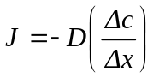 (1)

where, J is the mass flux in moles per unit area per time, D is the diffusion coefficient for a coal-methane system, and Δc/Δx is the concentration gradient. A review of the different methods of estimating the diffusion coefficient is given in a prior ICCI report [6].

The effect of diffusion is included in production modeling by using cleat spacing and sorption time, which is directly related to the diffusion characteristics of coal. The relationship is given by the following relationship:

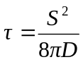 (2)

where, τ is the sorption time, s is the cleat spacing, and D is the diffusion coefficient. Since sorption time is a required parameter when simulating CBM production, the effect of diffusion is indirectly incorporated during simulation of long-term gas projections.

For CBM operations in Illinois, the sorption time has been measured to be extremely long, as much as 300 days, sometimes longer. The production rate may, therefore, be strongly dependent on diffusion rather than permeability, as it is typically believed to be in other US basins. However, given the structure of CBM simulators, the impact of a variable D can only be evaluated by using a variable sorption time, and this variation should be incorporated when simulating production from a CBM reservoir.

Modeling of Flow Behavior: Several numerical models have been developed recently to predict changes in coal permeability with continued production [7-12]. However, no single model has been able to predict the trend accurately, highlighting the complexity of modeling gas flow in coal. All models are based on principles of geomechanics and matrix shrinkage, and use the basic parameters, Young’s modulus, Poisson’s ratio, sorption characteristics and shrinkage coefficient as input parameters. They are independent of size and, therefore, are just as applicable for modeling flow in core as they are for field operations. Recent effort to identify the “best model” for a producing region in the San Juan Basin by comparing laboratory established permeability trend with trends predicted by various models has shown good results. The key issue in order to do this successfully is to replicate the exact conditions that are assumed in the models.

To date, no effort has been made to model flow behavior of Illinois Basin coals. It is not known whether any of the existing models would work adequately for CBM producing coals, given the unique features of Illinois CBM reservoirs. Hence, experimental work involving flow measurement through core of coal under best replicated field conditions and establishing a pressure-permeability trend was believed to be timely in order to determine the capability of existing models to predict permeability with continued production.

Simulation of Long-term Gas Production: Typically, simulation is used as a tool to project production from a reservoir. However, application of simulators is based on availability of reliable input parameters. Typically, field values of these parameters become available using production data as a calibration tool, using the so called “history matching” exercise. Where limited data is available, these parameters are obtained using laboratory measured values and trends, with appropriate adjustment to account for the scale effect. Finally, the simulators must also be instructed to use the most appropriate numerical model.

EXPERIMENTAL PROCEDURES

Diffusion/Sorption Experiments

Sample Preparation: Powdered samples were used for sorption and diffusion experiments in order to minimize the experimental duration by reducing the distance that gas molecules must diffuse through, prior to entering the "free" phase. Chunks of coal were first broken into lumps, approximately half inch in size. These were then ground in a ball mill and sieved to obtain the desired sample size of 40-100 mesh (0.425-0.149 mm), with an average radius of 0.0125 cm. Prior to starting an experiment, approximately 90 g of pulverized sample was placed in environmental chamber for 24 hours at reservoir temperature for moisture equilibrium. Following this, six grams of sample was used for moisture and ash analysis following the ASTM procedures D 3173-87 and D 3174-97 [13, 14], and the rest was used for the sorption/diffusion experiment.

Experimental Setup and Procedure: The experimental setup consisted of a sample cylinder and a reference cylinder, both made of stainless steel and capable of withstanding high pressure. A schematic of the experimental setup is shown in Figure 1. The sample cylinder was connected to the reference cylinder through a two-way valve. A micro-filter was provided between the sample and reference cylinders to prevent movement of coal particles from one to the other. Since the process of sorption is extremely sensitive to temperature, the entire setup was placed in a constant temperature water bath with an accuracy of +/-0.2ºC. Precise monitoring of pressure variation in the sample cylinder is critical in order to calculate the amount of gas diffusing from the coal matrix. Hence, a highly sensitive pressure transducer was connected to the reference cylinder, which in turn, was connected to a high resolution Data Acquisition System (DAS) for monitoring and recording the pressure data. Prior to starting an experiment, calibration of the setup was carried out, which involved determining the volume of void space in the sample cylinder using a non-adsorbing gas, like helium.

The diffusion experiment was performed for increasing and decreasing pressure steps, that is, for ad- and de- sorption. Initially, the pressure in the sample cylinder was set to zero. The reference cylinder was then subjected to a pressure of 100-150 psi and allowed to equilibrate. The valve between the sample and the reference cylinders was opened as quickly as possible. The DAS was programmed to take readings at 0.5 second intervals at this stage since rate of methane adsorption is extremely rapid during the initial period. Acquiring data at this pace continued until the pressure variation became small, ~ 0.1 psi/ hr. After this, readings were taken at 50 second intervals and continued for approximately 20 hours. There was negligible change in pressure after this and the sample was believed to be completely saturated with methane at equilibrium pressure. The procedure was repeated for a step-wise pressure increment of 150 psi to a final pressure of ~1000 psi. Following this, the entire procedure was repeated in reverse, that is, decreasing pressure steps of 150 psi.

When conducting a diffusion experiment, sorption isotherms are a natural by-product. Hence, at the end of the experiment, diffusion and sorption characteristics for the sample tested became known.

“Simulated” Canister Test

Sample Preparation: Drill cuttings were used as samples for this experiment. Two separate experiments were carried out, first one using a sample taken from Survant seam in Illinois Basin, provided by BPI Energy. Since gas content of coal is well understood in the San Juan Basin, the second experiment was carried out using a sample obtained from

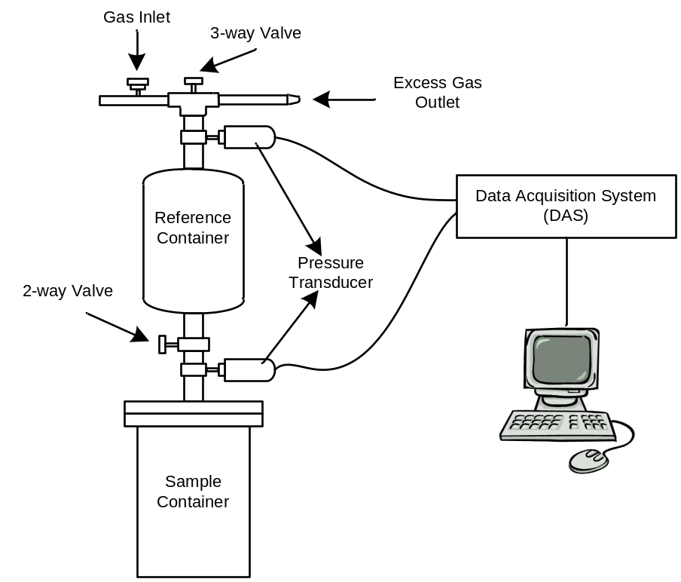

Figure 1: Schematic of the experimental setup for diffusion/sorption experiments.

there. Prior to starting the experiment, the sample was allowed to attain moisture equilibrium. Following this, it was weighed and preserved until the experiment started.

Experimental Setup: The experimental setup consisted of a vessel, capable of withstanding high pressure, and an inverted burette to collect and measure the volume of gas desorbing from the sample. A schematic of the setup is shown in Figure 2. The high pressure vessel was placed in a water bath to maintain in situ temperature. A gas circuit designed to facilitate easy injection/bleeding of gas into, and out of, the vessel was attached to the vessel. To monitor the gas pressure inside the vessel, a pressure transducer was provided. Except for the injection port, the setup replicated the canister tests conducted in the field at most CBM sites.

Experimental Procedure: First, the sample was saturated with methane at reservoir temperature and pressure. Sufficient time was allowed for the gas to sorb completely. After attaining equilibrium, free gas present inside the vessel was bled to atmosphere. Following this, gas was allowed to desorb and bleed out, where the volume of gas was collected in the burette by water displacement. The time for each gas collection period was recorded. Since the rate of sorption varies with time, frequency of gas collection was also varied, from once every five minutes during the initial desorption period to a few days towards the end of the experiment. The volume of desorbed gas was estimated using the volume of water displaced, after applying the correction for head difference between the burette and vessel. The gas desorption was assumed to be complete when the

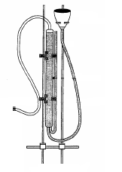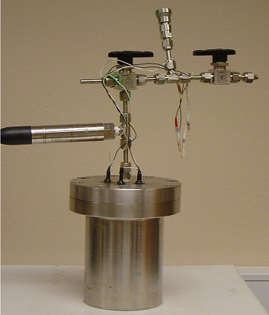
Burette
Fluid
Reservoir
3-Way Valve
2-Way Valve
Pressure Transducer
Water Bath
Drill Cuttings
Formation Water

Figure 2: Schematic of the “simulated” canister desorption setup.

incremental volume of gas collected in the burette was close to zero. At the end of the measurement period, cumulative volume of gas desorbed was estimated and plotted as a function of the square root of time to obtain a plot similar to that obtained after canister desorption test in the field.

Permeability Experiments

Sample Procurement and Preparation: The samples used in this part of the study were provided by BPI Energy from their drilling program in the Illinois Basin and the Illinois State Geological Survey (ISGS). Two experiments were conducted using core taken from Survant and Seelyville seams. Cores were preserved in their native state to prevent any damage due to weathering by storing them in air-tight containers in absence of light. Prior to testing, three to four inch length of core was cut and the two ends polished to enable proper placement in the triaxial cell.

Experimental Setup: In order to replicate the conditions in situ, controlling and monitoring of external stress levels and gas pressure are critical. The experimental setup for permeability measurement was, therefore, capable of independent control of stress conditions, gas pressure (upstream and downstream), and measurement of gas flowrate. Figure 3 shows a schematic of the experimental setup. The setup comprised of a triaxial cell, a loading system and a means to monitor and measure flowrate. The unique feature of the experimental setup was that it replicated the best in situ stress conditions under zero horizontal strain, that is, the core was not permitted to physically expand/contract, just like it cannot under in situ conditions due to lateral confinement. Second, vertical stress, which is a replication of the overburden stress, was kept constant throughout the experiment. Zero horizontal strain was achieved by changing the horizontal stress when the sample started to swell/shrink as a result of ad/de- sorption. A circumferential extensometer was employed to record and monitor the horizontal strain due to mechanical loading/adsorption. The vertical stress was applied by placing the cell in a load frame while the horizontal stress was applied by connecting the cell to a hydraulic pump. Perforated steel discs were placed at two ends of the sample to distribute and collect gas. The temperature of the cell was kept constant by using a heating blanket and temperature controller. The gas lines at the inlet and outlet ends were placed in the water bath, set at same temperature as that of the cell. A relief valve was used to keep the downstream pressure constant and to apply and maintain a pressure gradient to measure gas flowrate though the sample.


Circumferential Extensometer
Triaxial Cell
Fixed Volume Cylinder
Water Bath
Heat-Shrink Tubing
Gas Cylinder
Heating Blanket
Hydraulic Pump
Perforated Disc
To Atmosphere
To Atmosphere
DAS
Vertical Stress
Horizontal Stress
Hydraulic Line
Gas Flow
Gas Line
2-Way Valve
3-Way Valve
Relief Valve
Pressure Transducer

Figure 3: Schematic of the experimental setup for permeability experiment.

Experimental Procedure: For the first experiment (Survant seam coal), the sample was subjected to vertical and horizontal stresses of 1000 and 700 psi respectively, both representative of estimated in situ stresses. The initial pore pressure for this sample was 470 psi, once again, representative of pre-production in situ pressure. After the sample was completely saturated with methane at 470 psi, flowrate measurement was carried out by applying a pressure gradient across the two ends of the sample and permeability was estimated. The pressure was then reduced in steps of 100 psi, down to 75 psi. The reduction in pore pressure lead to desorption, which in turn, resulted in shrinkage of the sample. To prevent this, horizontal stress was reduced to ensure zero lateral strain. Following this, a set of flowrate measurements were carried out and permeability estimated for the pressure step. The procedure was repeated in a step-wise manner.

The second experiment was carried out using a core obtained from Seelyville seam. The applied vertical and horizontal stresses for this sample were 1800 and 1200 psi respectively, and the initial pore pressure was 800 psi. Flowrate measurements and permeability calculations were first carried out 800 psi. The pore pressure was then reduced to 600, 400, 300, 200 and, finally, 75 psi.

RESULTS AND DISCUSSION

Task 1 – Coal Characterization Test

The pressure and time data recorded during the experiment provided the basis for all calculations. The amount of gas adsorbed at a given pressure was calculated based on Gibbs isotherm principle. Since the difference between Gibbs and absolute adsorption is significant at high pressure, absolute volume was calculated using the following relationship [15]:

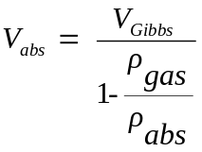 (3)

where, V_{abs} and V_{Gibbs} are the absolute and Gibbs sorbed volumes respectively, and ρ_{gas} and ρ_{abs} are the gas densities in gaseous and adsorbed phases respectively. The phase density for adsorbed methane was taken to be 0.421 g/cm³. Finally, the theoretical isotherm was established using Langmuir isotherm model, given as:

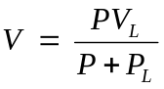 (4)

where, P is the equilibrium gas pressure at each step, V is the volume of gas adsorbed, V_{L} is Langmuir Volume, the maximum volume of gas that can be sorbed at infinite pressure, and P_{L} is Langmuir Pressure, the pressure at which sorbed volume is half of the maximum volume.

Adsorption experiments were carried out using samples from Davis and Dekoven seams at in situ temperatures of 73ºF and 69ºF. The results are shown in Figures 4 and 5. The values of Langmuir constants obtained for these samples are shown in Table 1. The table also includes the results of preliminary analysis conducted. It is evident from Figures 4 and 5 that the isotherms are of Type 1 according to Brunauer’s classification [16]. Also, the Davis sample exhibited higher sorptive affinity than Dekoven sample. This may be due to the greater depth of Davis seam compared to Dekoven. As expected, the sorbed volume increased with decrease in temperature for both samples.

Table 1: Results of the basic coal characterization test for Davis and Dekoven samples.

Sample | Depth (ft) | Ash (%) | Moisture (%) | Temp (ºF) | Adsorption
 |  |  |  |  | V_{L} (scft) | P_{L} (psi)
Davis | 505 | 9.3 | 2.3 | 73 | 555 | 310
 |  |  |  | 69 | 591 | 304
Dekoven | 475 | 13 | 1.1 | 73 | 504 | 433
 |  |  |  | 69 | 591 | 515

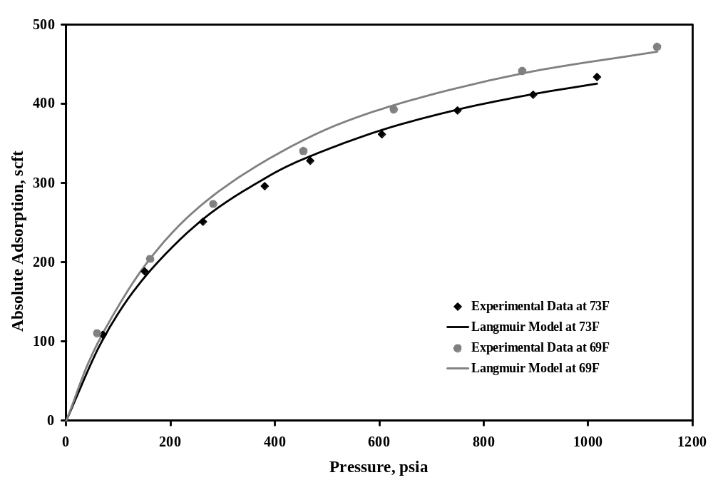

Figure 4: Adsorption isotherms for Davis sample.

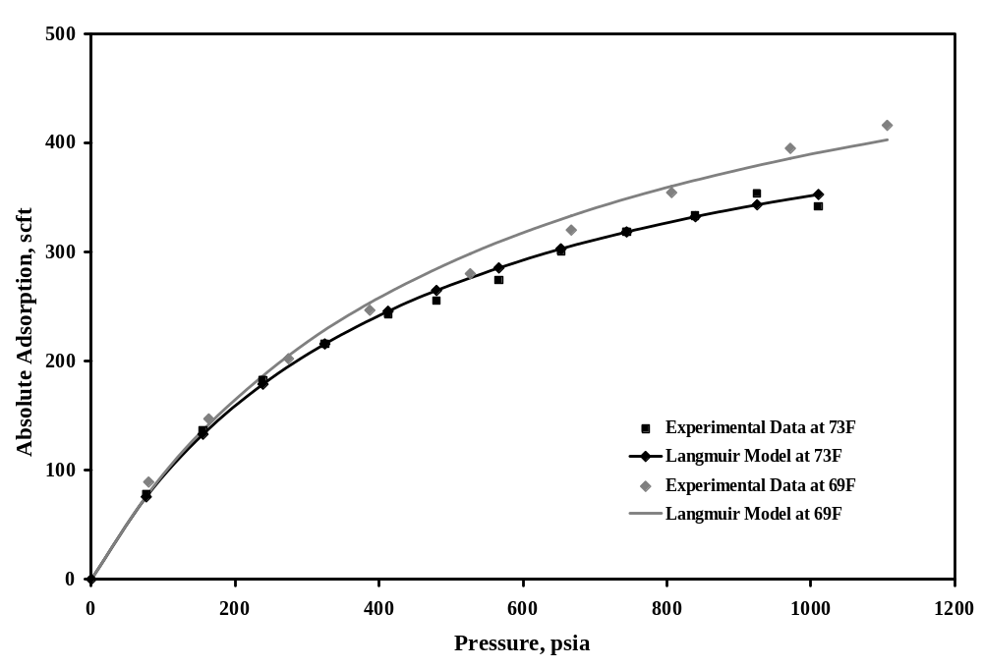

Figure 5: Adsorption isotherms for Dekoven sample.

Task 2 - “Simulated” Canister Test

Two separate experiments were conducted, one using coal cuttings from Survant seam in Illinois Basin, provided by BPI Energy, and the second using cuttings from San Juan Basin. A known quantity of moisture-equilibrated sample was placed in the pressure vessel and allowed to equilibrate with methane at 450 psi. After methane adsorption was complete, gas pressure in the container was reduced to atmospheric. Following the procedure described in the previous section, the cumulative volume of gas desorbed was estimated and plotted as a function of square-root of time. This is shown in Figure 6. The total volume of gas desorbed from the sample was 3.54 ml/g (113 scft) and the total time required for the gas to desorb completely was 2136 hrs (89 days).

Following this, effort was made to determine the accuracy of lost gas estimation, as it is currently conducted in field. The “lost time”, as estimated in the field, is equal to the time required by the drilled core to reach the surface. For this sample, the “lost time” was assumed to be two hours. Figure 7 shows the results of the test, along with the estimated “lost gas”, following the procedure practiced in the field. For “lost time” of 2 hours, the amount of “lost gas” was estimated to be 0.18 ml/g, whereas the measured amount of gas lost was 0.63 ml/g. The error in measurement of lost gas for this coal is, therefore, 0.45 ml/g, or 12% of the total gas-in-place.

The second experiment was conducted for a sample obtained from the San Juan Basin. The purpose of this experiment was to provide a basis for calibrating the results obtained for Illinois sample. The weighed and moisture-equilibrated sample was first saturated
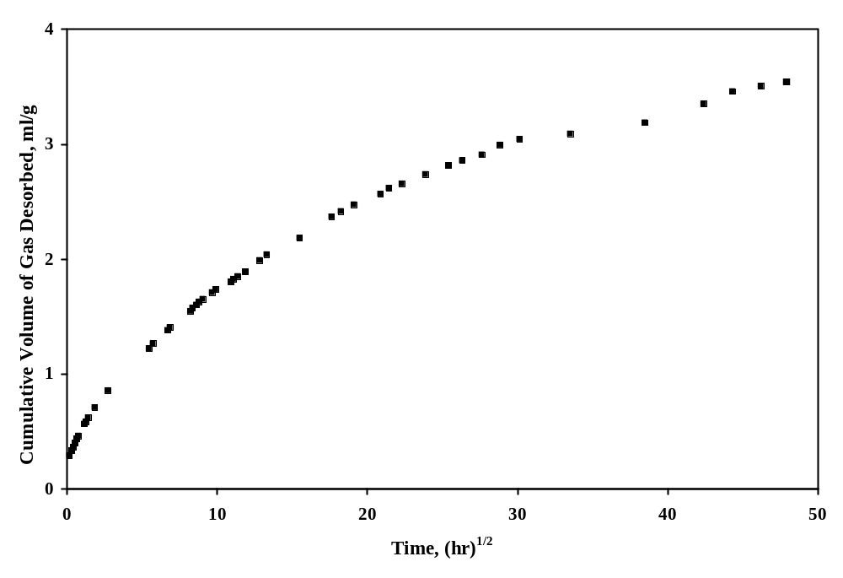
Figure 6: Variation in cumulative volume of gas desorbed as a function of square-
root of time – Survant sample.
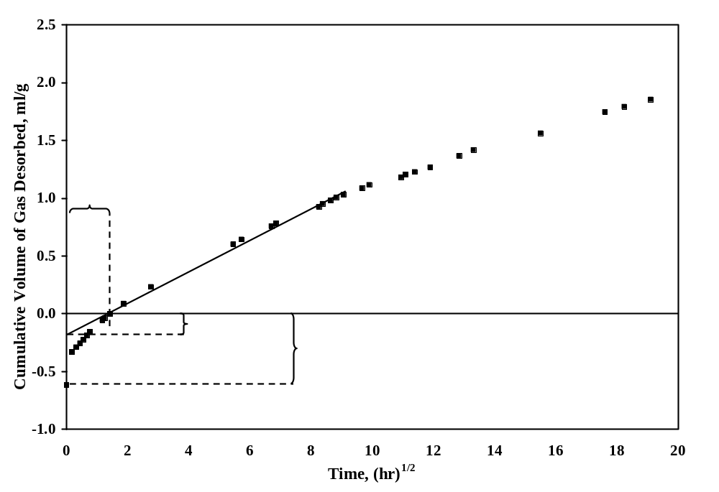
Figure 7: Cumulative volume of gas desorbed as a function of square root of time for Survant sample – estimated and measured “lost gas”.
with methane at 900 psi. Following the same procedure, results obtained are shown in Figure 8. The total volume of gas desorbed from the sample was 8 ml/g (255 scft), somewhat lower than the gas content measured in San Juan Basin. Figure 9 shows the estimated “lost gas”, along with that measured during the test. For “lost time” of two hours, the volume of lost gas was estimated to be 0.7 ml/g, whereas the measured volume was 2.7 ml/g. The error in estimation of lost gas is, therefore, 2 ml/g, or 25% of the gas-in-place.

Since the sample used in the first experiment was taken from Survant seam from a depth of 350 ft, the “lost time” is considerably less compared to the San Juan sample, taken from a depth of ~2400 ft. Hence, the exercise was repeated for the Survant sample using thirty minutes as “lost time”. The results are shown in Figure 10. This changed the estimated “lost gas” to 0.1 ml/g, changing the error to 10% of the total gas content. The error reduction from 12 to 10% when “lost time” was changed from two hours to 30 minutes suggests that regardless of the “lost time” the error in “lost gas” would probably be within a rather narrow range.

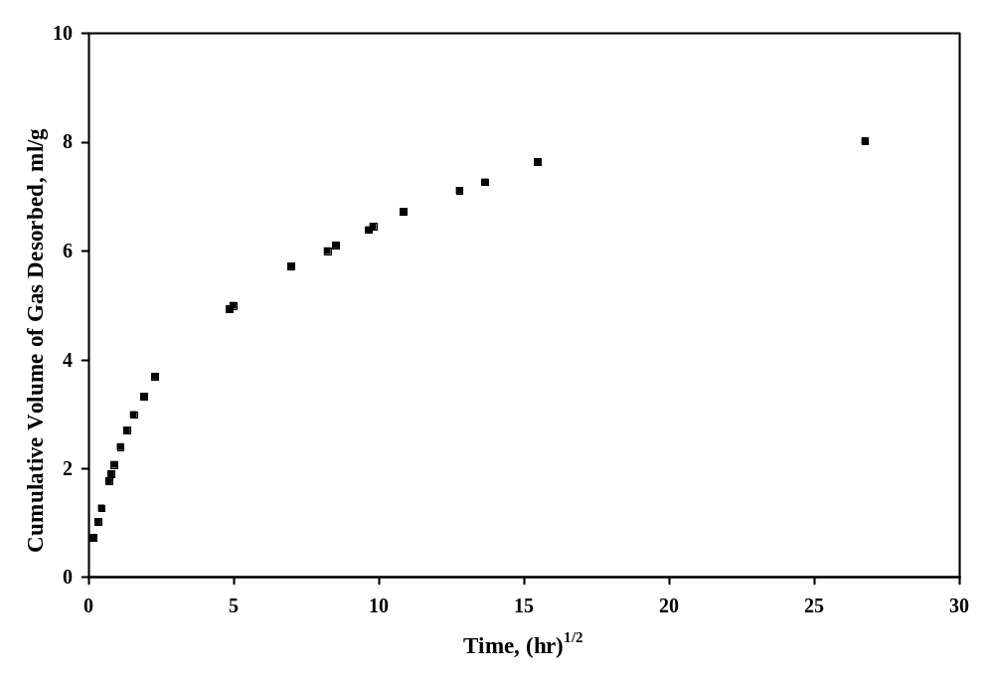
Figure 8: Variation of cumulative volume of gas desorbed as a function of
square root of time – San Juan sample.

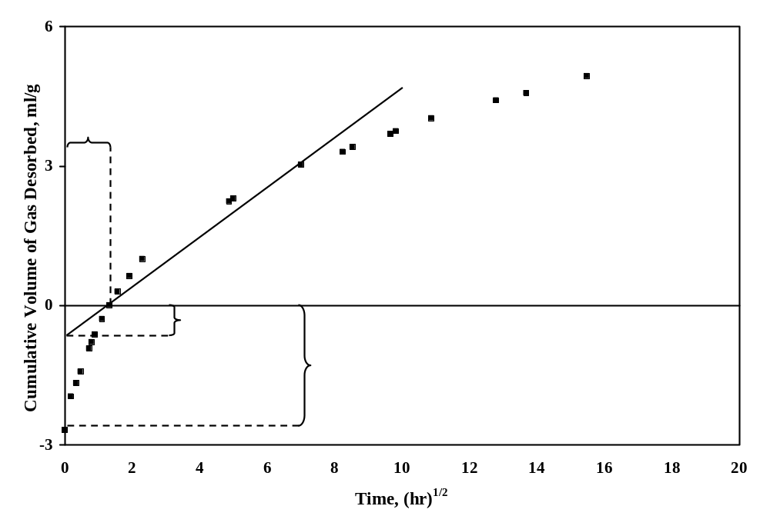

Figure 9: Cumulative volume of gas desorbed as a function of square root of time
for San Juan sample – estimated and measured “lost gas”.

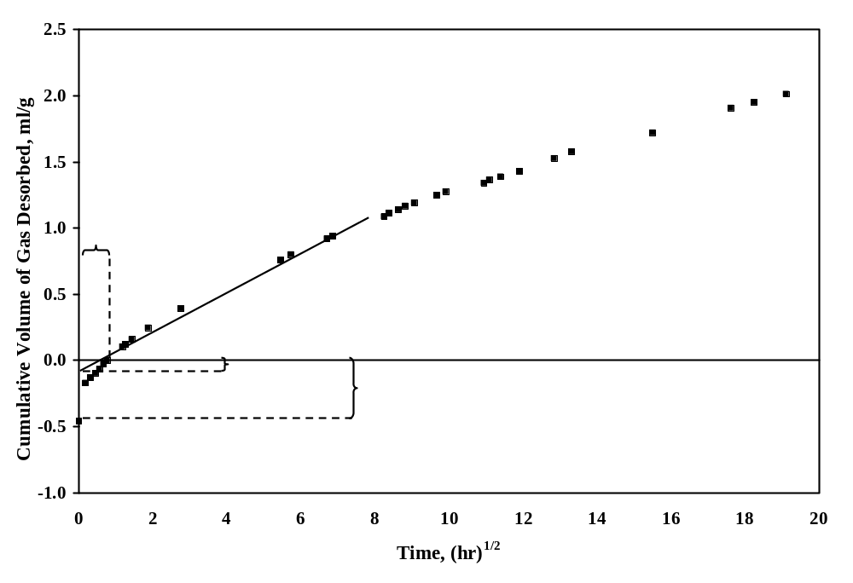
Figure 10: Estimated and measured “lost gas” for “lost time” of 30 minutes –
Survant sample.

Task 3 – Estimation of Diffusion Coefficient

Estimation of diffusion coefficient (D) requires continuous monitoring of pressure change over time in the sample cylinder. Following the procedure described in the previous section, this was conducted for every pressure step for ad/de- sorption step for pressure changes in the sample cylinder. Gas content, and change in gas content, was calculated for each time interval for every pressure step. To calculate D, a model derived from Fick’s Law and valid for spherical particle, was employed as given below [17]:

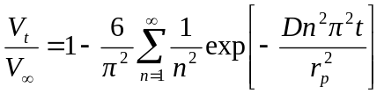 (5)

where, V_{t} is the total volume of gas ad/de-sorbed in time interval t (scf/ton), V∞ is the total gas adsorbed or desorbed in infinite time (scft/ton), D is diffusion coefficient (cm²/sec), r_{p} is diffusion path, or radius, of the spherical particle (cm) and t is time (second). For short times (<600 seconds) and when the volume of gas desorbed is less than 50%, that is, V_{t}/V∞ < 0.5, equation (5) may be simplified as [18]:

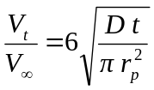 (6)

A total of four experiments were performed using samples from Davis and Dekoven seams at two temperatures, 73ºF and 69ºF. Starting with the first equilibrium pressure of 70 psi, pressure in the sample cylinder was increased in steps to 100-150 psi for all four samples. During desorption, Davis seam sample was equilibrated at 828 psi. Following this, pressure in the sample cylinder was reduced to atmospheric in nine steps. In general, a decrease in desorption time was observed for decreasing pressures and, therefore, an increase in the value of D. A typical desorption plot for the results is shown in Figure 11.

For each test, additional pressure steps were used during the desorption part since decreasing pressure is analogous to primary depletion, deserving higher precision.

The established variation in the value of D for Davis and Dekoven samples as a function of pressure is shown in Figures 12 and 13 respectively. It is evident that there is a negative correlation between D and pressure for increasing and decreasing pressures. Similar variation in the diffusion coefficient has been reported by other researchers in the past [6, 19]. Furthermore, the value of D was found to be higher for Davis than Dekoven sample. This, coupled with the higher sorptive affinity exhibited by Davis coal, suggests a relationship between the amount of gas sorbed and diffusion behavior. Finally, since the gas pressure in both seams is approximately 450 psi, it can be concluded that diffusion would improve with continued production.

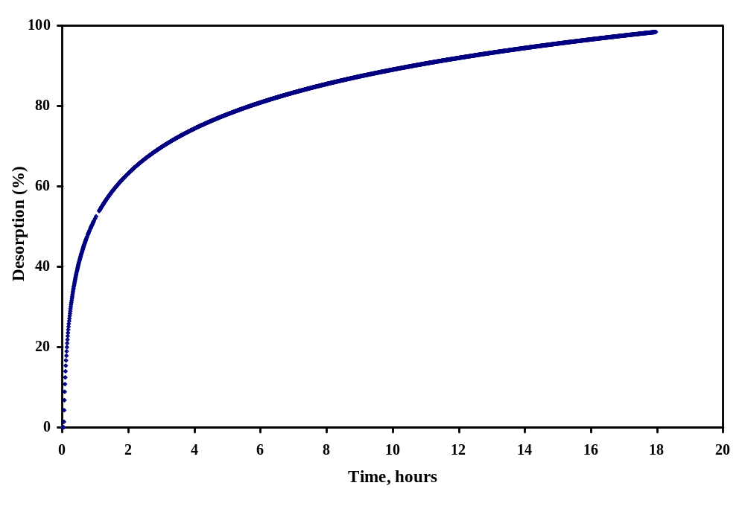

Figure 11: Typical desorption plot for Davis sample for 345-438 psi step.

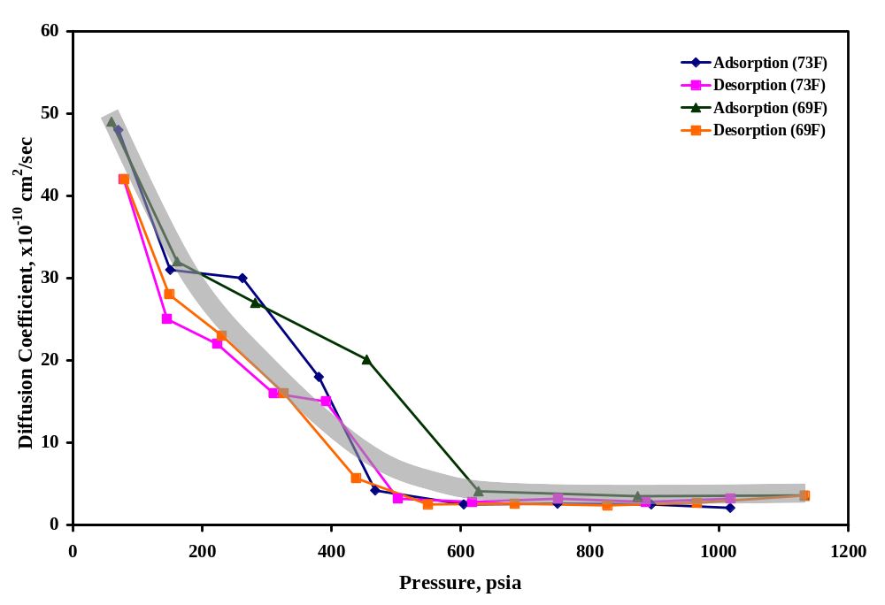

Figure 12: Variation of diffusion coefficient with pressure for Davis sample.

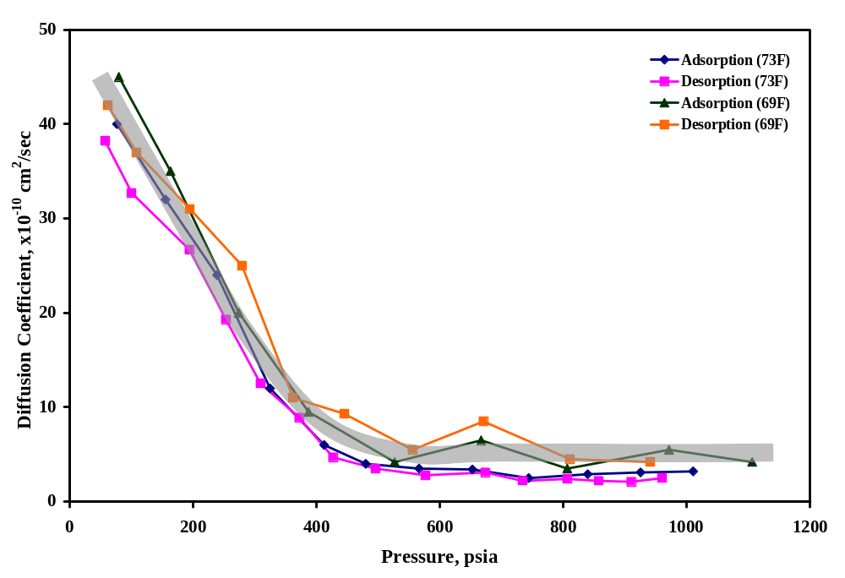

Figure 13: Variation of diffusion coefficient with pressure for Dekoven sample.

As mentioned earlier, from an operation point of view, the behavior during desorption is more critical. Hence, desorption isotherm was plotted along with the pressure-D plot for Dekoven coal, as shown in Figure 14. The pressure-D relationship is apparently bi-modal in nature. At high pressures, there is little change in the value of D with decreasing pressure. However, below a certain pressure, D increases with decreasing pressure almost exponentially. Significant sorption also takes place at low pressures, once again, suggesting the dependency of D on the amount of gas desorbed.

Since gas flow in coal matrix is governed by diffusion rather than permeability, effort was made to further investigate the relationship between D and the amount sorbed. As mentioned earlier, the value of D is not employed directly in production modeling; rather sorption time () is used along with the cleat spacing (S).

Since gas content decreases with continued production, the time required to desorb 63% of the total gas-in-place would also decrease. To illustrate this, variation in sorption time was plotted against gas content for both Davis and Dekoven coals, as shown in Figure 15. A cleat spacing of five per inch was used to estimate sorption time, which is typical in Illinois Basin [20]. It is evident from the figure that sorption time decreases exponentially with decrease in gas content. However, the average gas content for Davis and Dekoven coals is ~165 scft and Figure 15 shows little decrease in sorption time for gas content below 200 scft. This suggests that decrease in sorption time will not be significant in the Basin, a rather disappointing finding.

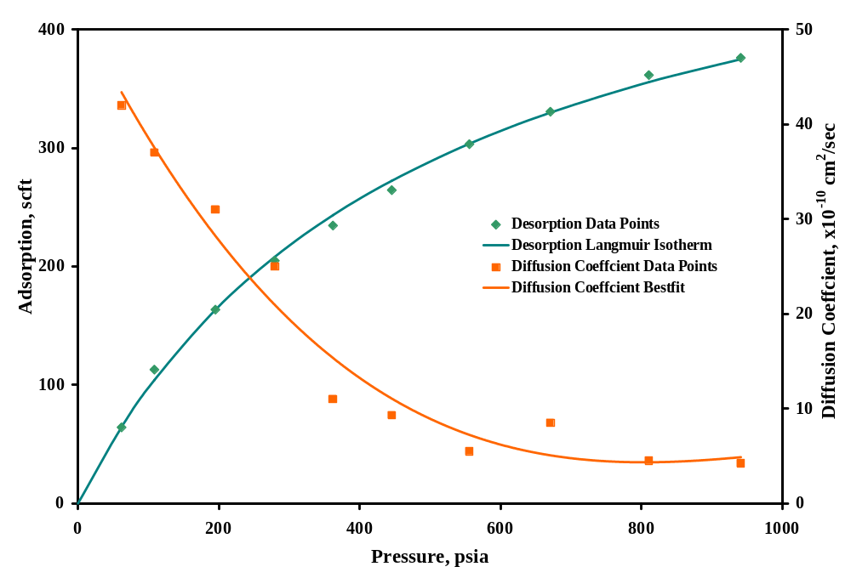

Figure 14: Variation of sorbed volume and diffusion coefficient with pressure for
Dekoven sample.

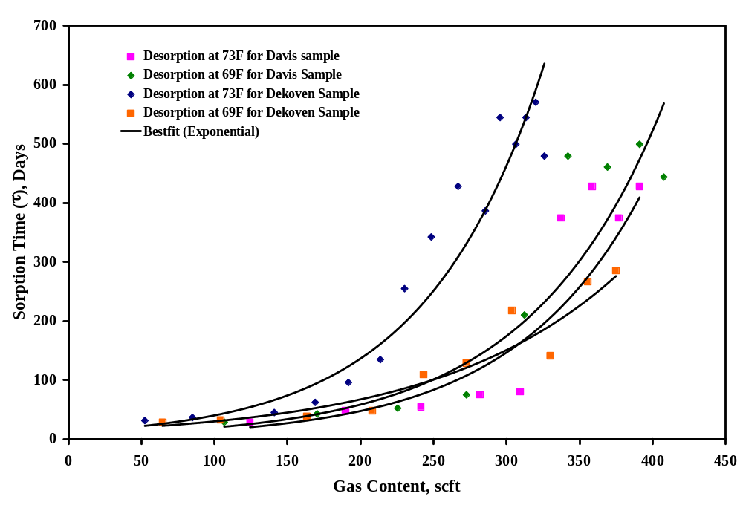

Figure 15: Variation of sorption time with gas content for Davis and Dekoven coals.
TASK 4 – Modeling CBM Production in Southern Illinois

Measurement of Permeability

Permeability Calculation: The procedure is given in detail in a previous ICCI report [21].

Permeability Results: Following the procedure outlined, flowrate measurements were carried out for 470-75 psi pressure range for Survant core and permeability was calculated. At each pressure step, the sample was allowed to equilibrate for several days, followed by flowrate measurement, while maintaining uniaxial strain condition throughout the experiment. The ratio of estimated permeability at each pressure and initial permeability was then plotted as a function of pressure. This is shown in Figure 16. Overall, the measured increase in permeability was 180% for pressure reduction of 400 psi. The pressure-permeability trend is similar to that seen for San Juan coals except that it is much more dramatic there. However, the overall increase in permeability suggests that gas production would improve with continued production although the increase would not be as dramatic as typically encountered in other basins.

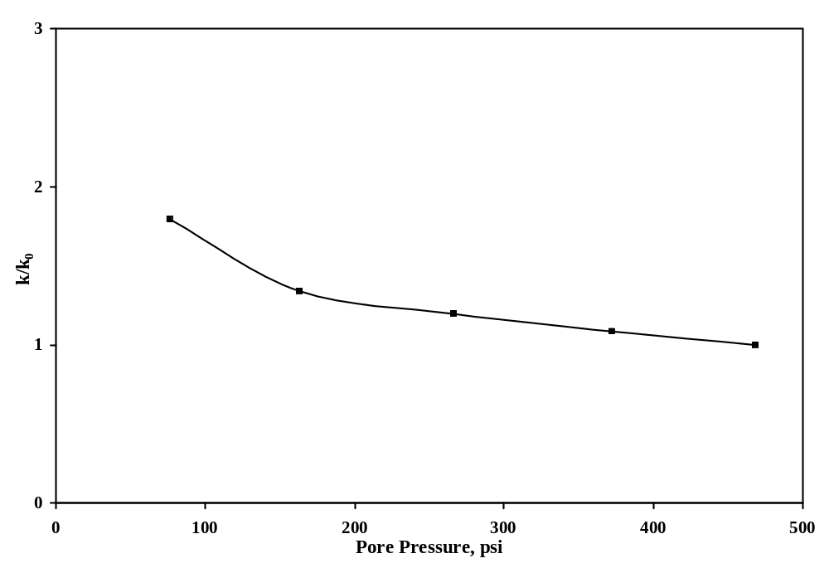

Figure 16: Permeability variation trend with pressure - Survant sample.

The second experiment was carried out using a coal sample taken from Seelyville seam in the Illinois Basin and permeability trend was established for 800-75 psi pressure range. The results are shown in Figure 17. The overall increase in permeability was found to be four times, suggesting that gas production would increase significantly with continued production. Also, the increase in permeability is a function of depth since Seelyville seam is significantly deeper than Survant. Similar trends for San Juan coals have shown permeability increase of more than twelve times in the laboratory, again suggesting a direct relationship with depth since CBM operations in the San Juan Basin are at much greater depth.

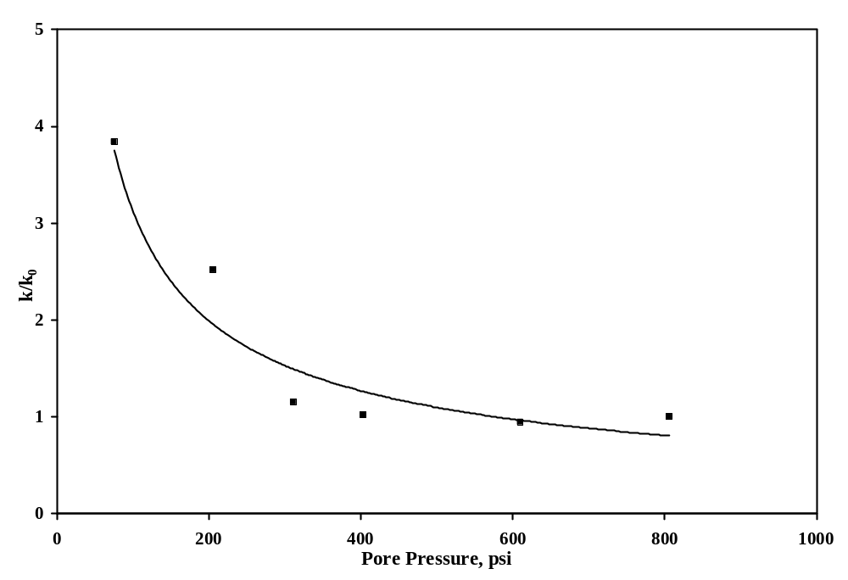

Figure 17: Permeability variation trend with pressure - Seelyville sample.

As a final step, effort was made to model the variation in permeability with depletion. Two existing models, based on fundamentals of poro-elasticity, were selected. The models are both independent of size and, therefore, should be able to model flow in a core just as well as in field operations. Both models assume the deformation of coal in situ to be under uniaxial strain condition, just as the experimental work replicated. The first model, by Palmer and Mansoori [7], is given as:

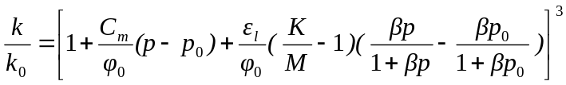 (7)

where, k and k₀ are natural fracture permeability and permeability at virgin reservoir pressure respectively (md), E is Young’s modulus (psi), ν is Poisson’s ratio, K and M are the bulk modulus and constrained axial modulus (psi), p and p₀ are reservoir pressure and virgin reservoir pressure (psi) respectively, ε_{l} (dimensionless) and β (psi⁻¹) are the parameters of Langmuir curve match to volumetric strain due to matrix shrinkage, and c_{m} is given as:

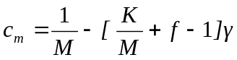 (8)

where, γ is grain compressibility of coal (psia⁻¹), f is a dimensionless parameter between zero and 1, and K and M are expressed as a function of E and ν as follows:

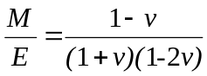 and 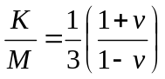 (9-10)

The second model, by Shi and Durucan [9], is given as:

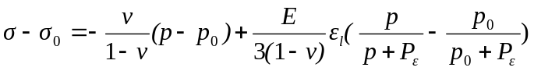 (11)

and

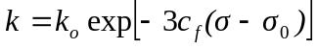 (12)

where, α_{s} is the volumetric shrinkage coefficient (scft⁻¹) and c_{f} is the cleat compressibility with respect to changes in effective horizontal stress (psi⁻¹). Using these models, the permeability variation was estimated and compared with the laboratory measured data, as shown in Figures 18 and 19.

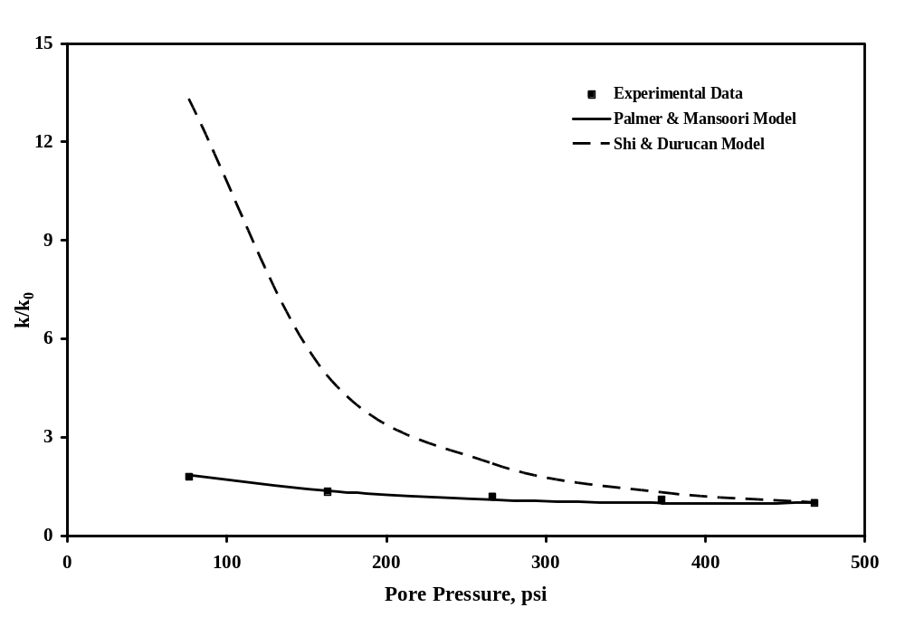
Figure 18: Modeled and measured permeability trend as a function of pressure -
Survant sample.

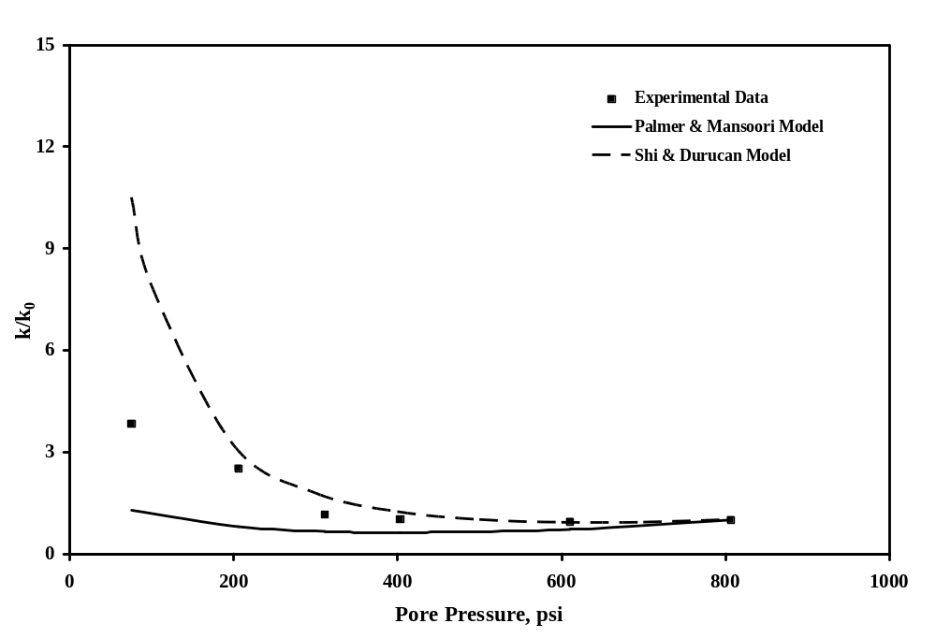

Figure 19: Modeled and measured permeability trend as a function of pressure –
Seelyville sample.

Figure 18 suggests that the Palmer and Mansoori model provides excellent agreement with laboratory data whereas Shi and Durucan model overestimates permeability increase for the entire pressure range. However, for Seelyville sample, both models provide excellent agreement for pressures up to ~300 psi. Below that, Shi and Durucan model overestimates permeability increase whereas Palmer and Mansoori model underestimates it. While this does not indicate superiority of one model over the other, Palmer and Mansoori model provides better prediction for the coal tested. This statement is somewhat pre-mature and should be used with caution.

Modeling of CBM Production in Southern Illinois

A detailed simulation exercise was carried out to determine the effect of varying permeability and diffusion coefficient on long-term gas production. The simulator used for the study was COMET3, which is based on oil reservoir simulation. The coal and reservoir properties data used for the simulation exercise is shown in Table 2. A five-well grid with a well spacing of 64 acres was constructed to perform the simulation, as shown in Figure 20.

Table 2: Input parameters used for simulation.

Coalbed Properties
Depth of coal seam | 475ft
Permeability | 14 md, variable
Cleat Spacing | 0.2 inch
Coal Density | 1.35 g/cm³
Gas-in-Place Composition | 6% N₂, 93.5% CH₄, 0.5% CO₂
Sorption Characteristics
Langmuir Volume | 501 scft
Langmuir Pressure | 433 psi
Sorption Time | variable
Reservoir Properties
Temperature | 73ºF
Reservoir Pressure | 450 psia
Initial Gas Content | 165 scft (daf)
Drainage Area | 5600 x 4395 ft²
No. of Wells | Five

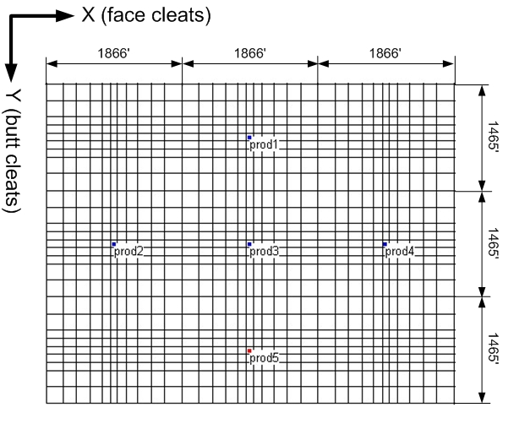
Figure 20: Five-spot well grid used for simulation.

In the first simulation exercise, three different values of diffusion coefficient were used to simulate gas production. The results are shown in Figure 21. It is evident from the figure that diffusion coefficient does not have a significant impact on long-term production rate. The higher diffusion coefficient (42 x 10⁻¹⁰ cm²/sec) results in slightly higher production rate during the initial production period. This is expected given the basis of the model, where  does not have a significant impact on gas production.

A second set of simulation was carried out to investigate the effect of permeability and sorption time on production. The results are shown in Figure 22. The figure shows that, for a high permeability reservoir (25 md), reduction in sorption time from 500 days to 30 days resulted in increased production. However, this is not true for a low permeability reservoir (14 md), suggesting that diffusion is not the controlling mechanism in gas deliverability for a low permeability reservoir. Nevertheless, this is inconclusive, since the simulator used in the modeling exercise is not very sensitive to sorption time.

The COMET3 simulator treats sorption time and permeability as constant parameters for the entire duration of simulation. However, diffusion coefficient varies with pressure during CBM production, as shown in Figure 12 and 13, and hence, so would the sorption time. A third set of runs was, therefore, carried out to investigate the coupled effect of diffusion coefficient and permeability on production rate. Two separate cases were considered. For the base case, sorption time and permeability was kept constant at 500 days and 14 md respectively for the entire simulation period. This was followed by dividing the simulation period into four time-steps. Depending on the reservoir pressure, different values of sorption time and permeability obtained from the results of the experimental work under task 3 and 4 were assigned for each step. The results of this simulation exercise are shown in Figure 23, where the production rate for each part is shown by individual short lines whereas the gray band is obtained by joining these to provide the overall production rate. The overall production is significantly higher than that obtained for the base case. This indicates a major shortcoming of the simulator since it is not capable of handling variable input parameters with continued production.

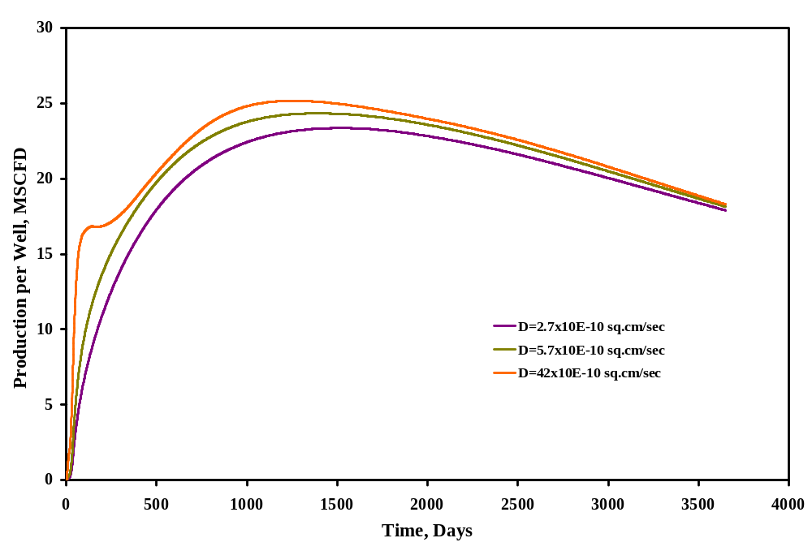

Figure 21: Effect of varying diffusion coefficient on gas production rate.

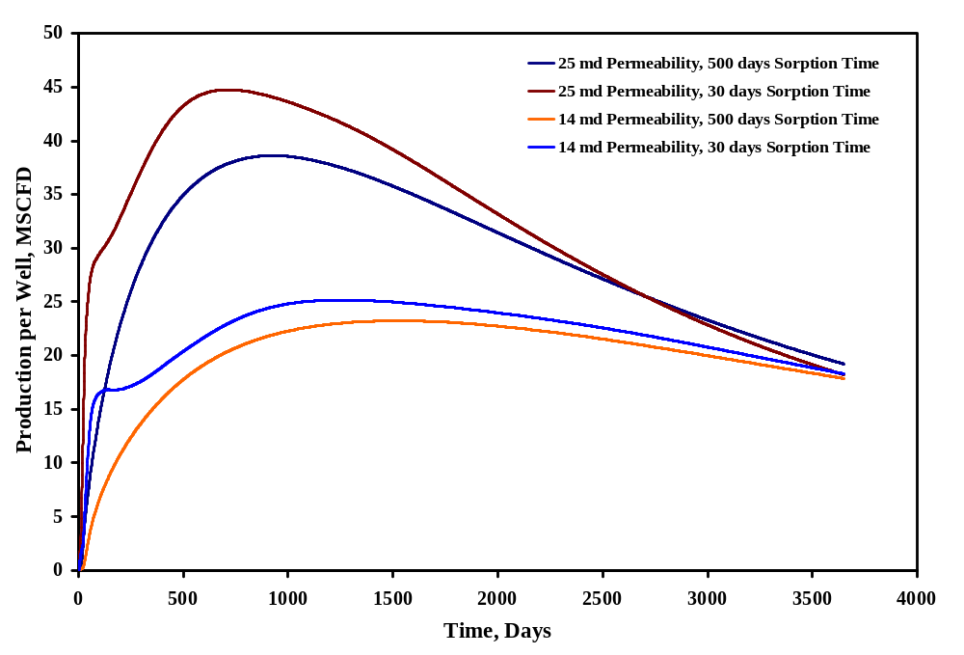

Figure 22: Effect of varying permeability and sorption time on gas production rate.

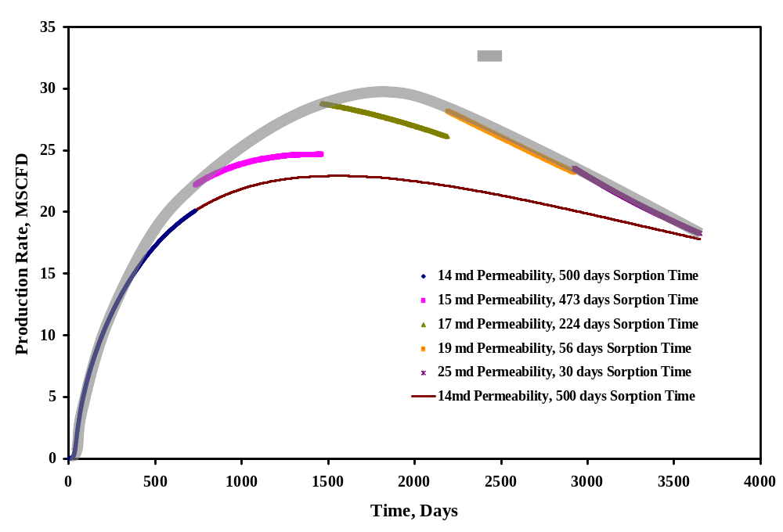

Figure 23: Comparison of two cases: a) base simulation and b) effect of variable
D and permeability.

CONCLUSIONS AND RECOMMENDATIONS

Based on the work completed, following conclusions are made:

1. There can be a significant error in estimation of the gas-in place using the canister desortption method and the standard technique to estimate “lost gas”. The error for coals with high gas content can be as high as 25% whereas for low gas content coals, it is lower, 10-15%. Given the low gas content of Illinois coals, this may have an impact on the resource estimates for CBM reservoirs in the State. However, for deeper coals, this would certainly result in a significant difference between the actual and estimated amount of “lost gas” since the “lost time” is significantly longer. This would also result in a substantial error in estimation of sorption times.
2. The value of diffusion coefficient, D, is definitely not a constant over the life of a CBM reservoir. There is a negative correlation between D and pressure for the pressure range encountered in Illinois. On a broader level, the value of D can be represented bi-modally, its value remaining constant at high pressures, and increasing continuously when accompanied by substantial desorption of gas. Although sorption time () calculated using D decreases exponentially with decrease in gas content, it is not significant for low gas content reservoirs. Hence, the improvement in gas production in the Illinois Basin as a result of this might not be significant.

3. The laboratory results suggest that permeability of coal in southern Illinois would increase with continued production although the increase is probably not going to be as dramatic as that typically observed in the San Juan Basin.
4. The results of the numerical modeling exercise suggest that the permeability trend can be better modeled by the Palmer and Mansoori model for Illinois coals. The Shi and Durucan model overestimates the permeability increase significantly. This conclusion, however, is somewhat premature and requires further investigation.
5. Based on the simulation study, gas production from low permeability reservoirs is not controlled by diffusion although this may be due to the simulator algorithm, which underplays the importance of diffusion. However, for high permeability reservoirs, diffusion can become a controlling factor in methane production, at least during the initial production period. This favors CBM production in Illinois since coal permeability has been measured to be good.
6. The simulation exercise showed that treating sorption time and permeability as pressure dependent variables resulted in a significant improvement in gas production rate and the overall recovery.

As a recommendation for future research, different approaches to re-charge coal with methane should be studied in detail since the primary shortcoming of methane bearing coals in Illinois appears to be the low gas content. This study has shown conclusively that diffusion characteristics favor high gas content coals since there is a large increase in the value of D for these coals. Same can be said for increased permeability since this is the result of matrix shrinkage, which in turn, is a direct consequence of the amount of gas desorbed. Finally, sorption time is shorter for high gas content coals. Enhanced coalbed methane techniques as a means to re-charge CBM reservoirs appear to be an attractive option. However, this would happen only if carbon credits become a reality in the US, a distinct possibility in the near future.

REFERENCES

- Tedesco, S. A. 2003. “Coalbed Methane Potential and Activity in the Illinois Basin.” AAPG Annual Meeting, May 9-14, 2003, Salt Lake City, Utah.
- . . . .Anon, 2001, North American Coalbed Methane Resource Map.
- Gray, I. 1987. “Reservoir Engineering in Coal Seams: Part I –The Physical Process of Gas Storage and Movement in Coal Seams.” SPE Reservoir Engineering. 2(1):28-34.
- Close, J. C. 1993. “Natural Fractures in Coal.” Eds. Law, B. E. and Rice, D. D., Hydrocarbons from Coal, AAPG Studies in Geology, v. 38, 119-132.
- McLennan, J. D. et al. 1995. A Guide to Determining Coalbed Gas Content. Gas Research Institute, Chicago, Illinois.
- Harpalani, S. 2006. Impact of Gas Release Characteristics on CBM Deliverability in Illinois. Final Technical Report. ICCI Project Number: 04-1/5.1A-2.
- Palmer, I., and J. Mansoori. 1998. “How Permeability Depends on Stress and Pore Pressure in Coalbeds: A New Model.” SPE Reservoir Evaluation and Engineering. 1(6):539-544.
- Palmer, I. et al. 2007. “Permeability Changes in Coal Seams during Production.” Coalbed Methane SPE Regional Technology Workshop, March 27-29, 2007, Durango, Colorado.
- Shi, J. Q., and S. Durucan. 2005. “A Model for Changes in Coalbed Permeability During Primary and Enhanced Methane Recovery.” SPE Reservoir Evaluation and Engineering. 8(4):291-299.
- Robertson, E. P., and R.L. Christiansen. 2006. “A Permeability Model for Coal and other Fractured Formations, Sorptive-Elastic Model.” SPE 104380, SPE Eastern Regional Meeting, October 11-13, Canton, Ohio.
- Cui, X., and R. Bustin. 2005. “Volumetric Strain Associated with Methane Desorption and its Impact on Coalbed Gas Production from Deep Coal Seams.” AAPG Bulletin. 89(9):1181 –1202.
- Gu, F., and R.J. Chalaturnyk. 2006. “Numerical Simulation of Stress and Strain due to Gas Sorption/Desorption and Their Effects on In Situ Permeability of Coalbeds.” Journal of Canadian Petroleum Technology. 45(10):52-62.
- ASTM standards D3173-03, 2003. “Standard Test Method for Moisture in the Analysis Sample of Coal and Coke.” ASTM International, West Conshohocken, PA, 2003, DOI: 10.1520/D3173-03, www.astm.org.
- ASTM standard D3174-04, 2004. “Standard Test Method for Ash in the Analysis Sample of Coal and Coke from Coal.” ASTM International, West Conshohocken, PA, 2003, DOI: 10.1520/D3174-04, www.astm.org.
- Sudibandriyo, M. et al. 2003. “Adsorption of Methane, Nitrogen, Carbon Dioxide and Their Binary Mixtures on Dry Activated Carbon at 318.2K and Pressure up to 13.6 MPa.” Langmuir. 19(13):5323-5331.
- Brunauer, S. et al. 1940. “On a Theory of van der Walls Adsorption of Gases.” The Journal of the Chemical Society. v. 62, 1723-1732.
- Clarkson, C. R., and R.M. Bustin. 1999. “The Effect of Pore Structure and Gas Pressure upon the Transport Properties of Coal: A Laboratory and Modeling Study. 2. Adsorption Rate Modeling.” Fuel. 78(11):1345-1362.
- Mavor, M. J. et al. 1990. “Measurement and Evaluation of Coal Sorption Isotherm Data.” SPE 20728, SPE 65th Annual Technical Conference and Exhibition, New Orleans, Louisiana.
- Cui, X. et al. 2004. “Selective Transport of CO₂, CH₄, and N₂ in Coals: Insights from Modeling of Experimental Gas Adsorption Data.” Fuel. 83(3):293−303.
- Strapoc, D. et al. 2008. “Variability of Geochemical Properties in a Microbially Dominated Coalbed Gas System from the Eastern Margin of the Illinois Basin.” International Journal of Coal Geology. 76(1-2):98-110.
- Harpalani, S. 2005. Gas Flow Characterization of Illinois Coal. Final Technical Report. ICCI Project Number: 03-1/7.1B-2.

DISCLAIMER STATEMENT

This report was prepared by Dr. Satya Harpalani, Southern Illinois University, with support, in part, by grants made possible by the Illinois Department of Commerce and Economic Opportunity through the Office of Coal Development and the Illinois Clean Coal Institute. Neither Dr. Harpalani and SIU, nor any of its subcontractors, nor the Illinois Department of Commerce and Economic Opportunity, Office of Coal Development, the Illinois Clean Coal Institute, nor any person acting on behalf of either:

(A) Makes any warranty of representation, express or implied, with respect to the accuracy, completeness, or usefulness of the information contained in this report, or that the use of any information, apparatus, method, or process disclosed in this report may not infringe privately-owned rights; or

(B) Assumes any liabilities with respect to the use of, or for damages resulting from the use of, any information, apparatus, method or process disclosed in this report. Reference herein to any specific commercial product, process, or service by trade name, trademark, manufacturer, or otherwise, does not necessarily constitute or imply its endorsement, recommendation, or favoring; nor do the views and opinions of authors expressed herein necessarily state or reflect those of the Illinois Department of Commerce and Economic Opportunity, Office of Coal Development, or the Illinois Clean Coal Institute.

Notice to Journalists and Publishers: If you borrow information from any part of this report, you must include a statement about the state of Illinois' support of the project.

