Once completed this template is to be submitted in Word format (as an attachment) via email to project_reports@grdc.com.au

Reports will only be evaluated by the GRDC if they:
- Are submitted in Word format
- Are sent via email to the correct email address project_reports@grdc.com.au

Include within the email
- GRDC project code and title
- GRDC Manager and Contract Administrator for this project
- Any sensitivities in the report

Please do not embed this completed template within any GRDC forms.

The report should be limited to a maximum of ten (10) pages.

Final Technical Report Template
Final Technical Report
[Insert project title]

Project code: | [insert GRDC project code]
Prepared by: | [insert researcher name]
[insert researcher email address]

[research organisation’s name]

[insert research administrator name]
[insert research administrator email address]

Date submitted to GRDC: | [day, month and year]

REPORT SENSITIVITY
Does the report have any of the following sensitivities?
Intended for journal publication YES/NO
Results are incomplete YES/NO
Commercial/IP concerns YES/NO
Embargo date YES/NO DATE DD/MM/YYYY

DISCLAIMER:
Any recommendations, suggestions or opinions contained in this publication do not necessarily represent the policy or views of the Grains Research and Development Corporation (GRDC). No person should act on the basis of the contents of this publication without first obtaining specific, independent professional advice.
The Grains Research and Development Corporation may identify products by proprietary or trade names to help readers identify particular types of products. We do not endorse or recommend the products of any manufacturer referred to. Other products may perform as well as or better than those specifically referred to. The GRDC will not be liable for any loss, damage, cost or expense incurred or arising by reason of any person using or relying on the information in this publication.

Caution: Research on Unregistered Pesticide Use
Any research with unregistered pesticides of unregistered products reported in this publication does not constitute a recommendation for that particular use by the authors or the authors’ organisations.
All pesticide applications must accord with the currently registered label for that particular pesticide, crop, pest and region.
Copyright © All material published in this publication is copyright protected and may not be reproduced in any form without written permission from the GRDC.

Abstract
This will also be used as the web summary. As such it is recommended that key words or phrases be included when writing it to assist search engines in finding your material. An introductory paragraph should engage your reader. It lets the reader know what the topic/subject of the report is and explains why the research is relevant.
The abstract should be a fully self-contained description of your report. It should summarise the thrust of the work, highlight the results and provide the main recommendation without the reader needing to click through to other pages for more information. It is imperative that is written in clear, everyday language – avoid jargon.
It should answer the questions:
- why the work was done (state the problem and motivation for undertaking the work)
- how the work was done (what approach did you take and what was the extent of your work)
- what industry benefit/s will arise from the work (what were the results and implications of your work)
The abstract should be a maximum of 10 lines or 200 words. This is the most difficult to write but effort should be made to ensure it is challenging enough for more information to be requested by the reader.

Please note.
Confidential reports
All reports will be communicated to industry by the GRDC. Confidential material should be provided in a separate section to the final report and clearly marked confidential so it can be removed before making the rest of the report publically available. If this is not possible, a public summary should be provided along with the final report.

Executive Summary
We write an executive summary for readers who want to quickly understand the results, recommendations and main, supporting points of our research. Your executive summaries must be succinct and clear. These guidelines will help you write effective executive summaries:
The Executive Summary should be a maximum of 2 A4 pages. The Executive Summary is the most important part of the document in that it will be GRDC’s main communication tool with industry.
The Executive Summary should summarise project objectives, significant results, conclusions and recommendations for future actions. It should answer the questions:
- why the work was done
- what was achieved
- when and how industry can benefit from the work
- who can benefit from the results

Contents

Abstract 3
Executive Summary 4
Contents 5
Background 6
Project objectives 7
Methodology 8
Results 9
Discussion of Results 10
Conclusion 11
Implications 12
Recommendations 13
Appendix A. Appendix Title 14
Glossary and Acronyms 15
References 16

Background
The Background should discuss the origins of the research project and previous research studies that are of relevance to the topic at hand. This section should provide a general overview of those prior research studies and projects, not an in-depth review. A more in-depth discussion of previous studies may be made in upcoming sections of the report.
Project objectives
In this section, the report will discuss the goals of the research program/project being carried out. Is the goal to enhance an already-existing technology? What are the objectives of the project? Here you will identify the end goal of the research. Outline the scope of the project (including the limitations of the research, and how the outcome can be determined to have been achieved).
Methodology
Describe the strategy of the project leading to the methods chosen. Technical language is expected, though should be mindful that non-technical people may be reading the document. The methods should also be described as to how they relate to the objectives and underlying issues to be addressed. What research methods and/or strategies are being used to conduct the research? Will the approach be quantitative, qualitative, a mixed-method approach, or other?

Photos/images
All photos/images used in reports must also be supplied in high resolution for printing purposes (above 3MB in file size). Separate files may be required for larger MB pictures.

The following information should be included with any photograph:
- the name and contact details of the photographer;
- the name and contact details of each person appearing in the photograph
- the date on which the photograph was taken; and
- A detailed description of the image and what it depicts.

Permission to have their photograph taken and used for this purpose should be obtained from any person appearing in any photograph provided to the GRDC.

Location
NOTE: Where field trials have been conducted please include location details: Latitude and Longitude, or nearest town, using the table below (please add additional rows as required):
 | Latitude (decimal degrees) | Longitude (decimal degrees)
Trial Site #1
Nearest Town
Trial Site #2
Nearest Town

If the research results are applicable to a specific GRDC region/s (e.g. North/South/West) or Agro -Ecological Zone/s please indicate which in the table below:
Research | Benefiting GRDC Region  (can select up to three regions) | Benefiting GRDC Agro-Ecological Zone (see link: http://www.grdc.com.au/About-Us/GRDC-Agroecological-Zones ) for guidance about AE-Zone locations
Experiment Title | Choose an item.  Choose an item.  Choose an item. | ☐ Qld Central  ☐ NSW NE/Qld SE  ☐ NSW Vic Slopes  ☐ Tas Grain  ☐ SA Midnorth-Lower Yorke Eyre  ☐ WA Northern  ☐ WA Eastern  ☐ WA Mallee | ☐ NSW Central  ☐ NSW NW/Qld SW  ☐ Vic High Rainfall  ☐ SA Vic Mallee  ☐ SA Vic Bordertown-Wimmera  ☐ WA Central  ☐ WA Sandplain

Results
Description of the results from the project, amalgamated as appropriate, include graphs / photos and statistical analysis.

Photos/images
All photos/images used in reports must also be supplied in high resolution for printing purposes (above 3MB in file size). Separate files may be required for larger MB pictures.

The following information should be included with any photograph:
- the name and contact details of the photographer;
- the name and contact details of each person appearing in the photograph
- the date on which the photograph was taken; and
- A detailed description of the image and what it depicts.

Permission to have their photograph taken and used for this purpose should be obtained from any person appearing in any photograph provided to the GRDC.

Discussion of Results
A detailed discussion of what these mean in terms of key findings, farm practice or modified approaches to the underlying issue when interpreted for on-farm use compared with the objectives.
Conclusion
Conclusions should include why the results and findings are important, what they mean in on farm terms, their utility as it may vary in different regions or environments.

The conclusion of the report indicates why the preceding information is important. It briefly revisits the main points of the report to gesture towards future implications of the research. While the conclusion does not introduce new topics or ideas, it does consider the broader implications of the research question, discuss possibilities for future research, and restate the significance of the research findings.
Implications
Assessment of the impact of the outcomes on industry in Australia (where possible provide a statement of costs and benefits).

Recommendations
The conclusion of the report indicates why the preceding information is important. It briefly revisits the main points of the report to gesture towards future implications of the research. While the conclusion does not introduce new topics or ideas, it does consider the broader implications of the research question, discuss possibilities for future research, and restate the significance of the research findings.
Appendix A.
Appendix Title

Glossary and Acronyms
Below is a sample Abbreviations and Acronyms list. Be sure to include on this page all abbreviations and acronyms that appear in the report

DAFWA | Department of Agriculture and Food, Western Australia
DAP | di ammonium phosphate
DArT | Diversity Arrays Technology
DAT | days after treatment
Db | bulk density
DAFWA | Department of Agriculture and Food, Western Australia

References
This section provides the information a reader would need to locate the articles, journals, and/or other publications referred to in the report.

Social Media Posting
GRDC uses social media to showcase research investments and disseminate timely, relevant and practical information to key stakeholders in the grains industry. Our audiences are predominantly growers and agricultural advisers.
Social Media Accounts:
Facebook: https://www.facebook.com/theGRDC
Twitter: https://twitter.com/theGRDC
YouTube: http://www.youtube.com/user/theGRDC
LinkedIn: http://www.linkedin.com/company/thegrdc

Is there any reason why this report cannot be communicated on social media?

  - (Insert info here)

If no, please provide the following:

- Who is the target audience for this content? (e.g., growers, adviser, researchers, policy makers, etc.)
  - (Insert info here)

- At what time of year is this content most relevant to the target audience?

  - (Insert info here)

- On which of GRDC’s social media accounts would you like this content posted? Please provide text (2-3 sentences for Facebook and LinkedIn and 140 characters for Twitter), images, graphs, or charts that support the content. Where applicable, please include any relevant Twitter handles (usernames) for project staff.

  - (Insert info here)

Samples:
Facebook: Twitter:
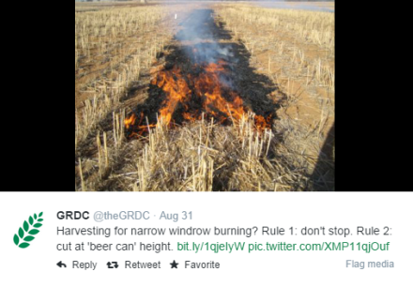
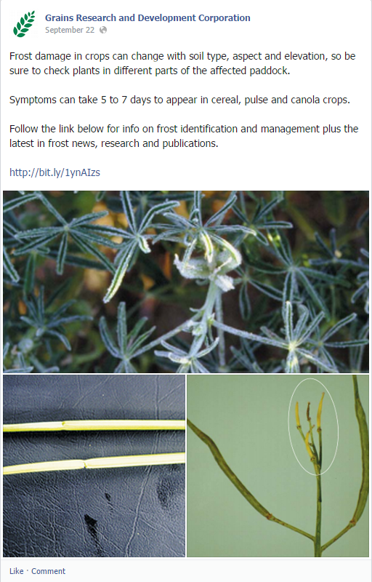

Contact the social media team at socialmedia@grdc.com.au with any questions.

Please note that publication of content to GRDC social media accounts is at the discretion of GRDC’s social media team.

