

University Career Center

Congrats!Ifyou’rereadingthismessage, then you’ve decided to undertake

step-by-step

the job search process. Some of you

may be well on your way down your chosen career path. For others, you may still be deciding which path to choose, or perhaps

you’re rethinking your career. Wherever you are in the career planning process, this guide can help.

Finding a summer job, co-op,
internship, or full-time position

is more than securingactionemployment.Itisa process of discovery, exploration,

commitment and action. This is not a process that can be completed successfully without careful thought and

reflection. However, the time you commit Passionwillnotgounrewarded.

By following this guide and utilizing

the services offered through the Career Center
you can discover what you love
to do and have a passion for, what

energizes and motivates you,

and how to further develop your skills and talents.

2

Once you have made those
discoveries, this guide can assist you in

gaining the tools needed to complete

a job search or graduate school application.

It’s designed to take you

through today’s_{tools}jobsearchprocessand

contains examples for writing:

• resumes,

• cover letters,

• and other pieces of professional

communication.
It also has advice regarding: tips

• finding an internship,

• practicum or full-time position,

- interviewing tips,

- and advice for those considering grad school.

Remember, we’re here to help
you through this journey. Contact

our office if you have any questions and take

advantage of the many services that we offer

exclusively to you, our students and alumni.

Best of luck!

University Career Center Staff

6 our services

- career development

- how to network

- gaining experience

- graduate/professional school

- how to find a job

- writing resumes and CVs

- the interview

- the job offer - how to say “yes” or “no” professionally

- in conclusion

3

Case Western Reserve University / C A R E E R C E N T E R



We are here to assist you

with all phases of your career

development. Read on and learn

how we can help.
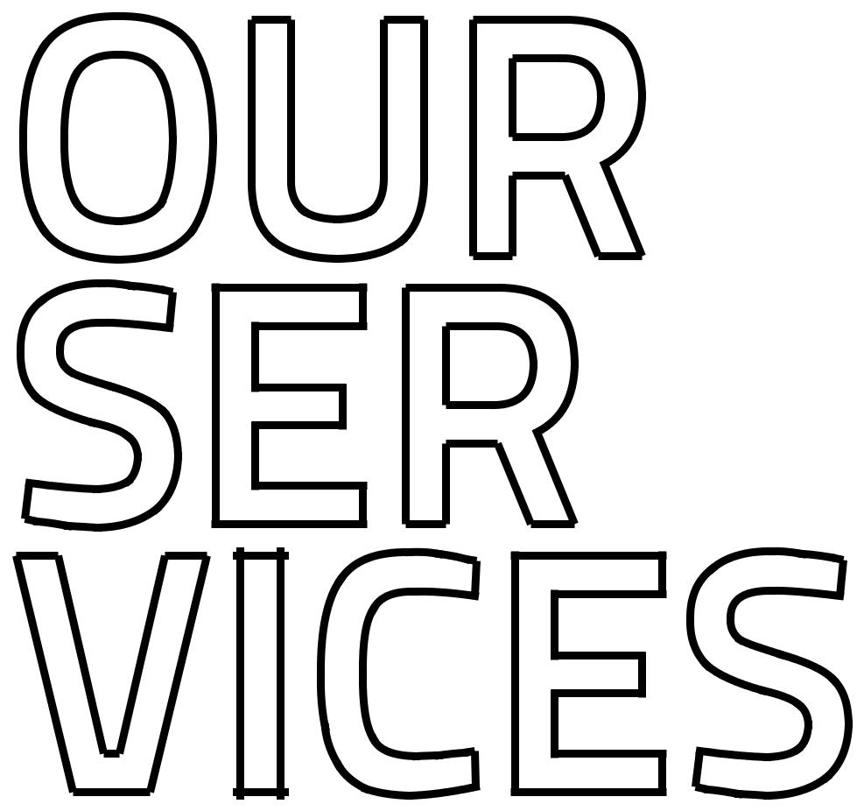

4 5

Case Western Reserve University / C A R E E R C E N T E R

INDIVIDUAL APPOINTMENTS

Come talk with us about your major, career choice, experiential learning opportunities, job search or graduate/ professional school options. Stop by our office in 229 Sears Library Building, call 216.368.4446, email careers@ case.edu or log in to Handshake to schedule an appointment.

DROP-IN CONSULTING HOURS
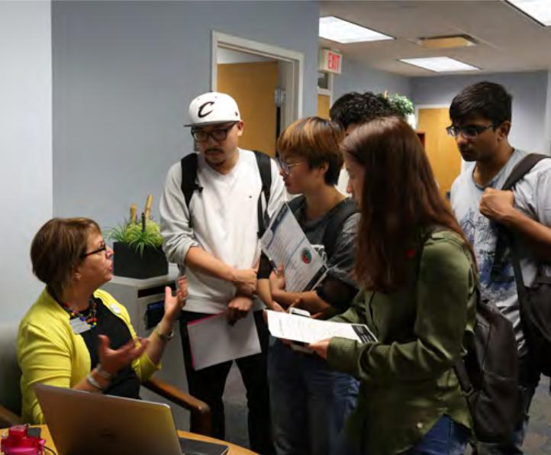
Have a quick question? Drop by our office Monday through Thursday 11 a.m. to 1:45 p.m. during the school year - no appointment necessary. Adjusted hours available during the summer.

SELF-ASSESSMENTS

With help from our career development team and the Myers-Briggs Type Indicator or Strong Interest Inventory, you can get closer to deciding on a major or a career. More information on page 14.

EXPERIENTIAL LEARNING ASSISTANCE

We can help point you in the direction of an internship, practicum or career connection with an alum.

INTERVIEW PREPARATION

We offer a variety of ways to help you prepare for job, internship and grad or professional school interviews. This includes mock interview appointments and interview preparation software you can use to develop and perfect your response.

CAREER FAIRS

Hosted each semester, our career fairs help connect students with recruiters for networking, internships, practicum and jobs. See page 58 for more details.

INFO SESSIONS & ON-CAMPUS INTERVIEWS

Employers recruit on campus year-round, hosting info sessions and interviews. Interviews are held right here on campus in the Career Center. All employer events are posted in Handshake at case.joinhandshake.com.

6
WORKSHOPS AND EMPLOYER PANELS

Held around campus at various times of the year to help you with career preparation. You can also request a workshop for your club or organization at students.case.edu/careers/student/services

MYCAREER

Houses our premiere online resources, including our career management database Handshake. MyCareer contains employer information, positions, career guides and global resources. Log in at students.case.edu/My/Career

HANDSHAKE

Database including thousands of positions posted by prospective employers, including internships, co-ops, student employment and professional positions accessible through students.case.edu/My/Career. These repources are provided exclusively for CWRU students and alumni with new positions posted daily.

GRADUATE/PROFESSIONAL SCHOOL PLANNING

Our career development team can help guide you through the various steps of deciding if graduate school is right for you, selecting a program and applying successfully.

Learn more about our events, services and resources at:

students.case.edu/careers

7

Case Western Reserve University / C A R E E R C E N T E R

KENIECE’S PERSPECTIVE

In summer 2012, the summer before my freshman year, I made it a goal to secure career exploration opportunities every summer of my undergraduate career. Addition-ally, I made it a goal to only seek employment with companies that embraced values that I cared about like diversity and inclusion and community service.

As a freshman, I was often encouraged to focus less on my career development and more on making it through the first semester; but I knew how competitive the process could be to secure work experience, so I leveraged my time in the classroom to make connections with student organizations and local recruiters for companies of interest.

Since the spring of 2013, I have participated in five internship programs, including ITS, Tax, and Audit Intern at a Big Four accounting firm, Investment Operations Intern at a wealth management firm, and Internal Audit Intern with the world’s largest food company. I started The EXCEL Club, a business club to help other students identify and prepare to pursue career opportunities, and I became a Career Peer in the Career Center. All of these opportunities helped me identify what it is I like to do, what fits my working style, and what environment is most conducive to my professional develop-ment; more importantly, I’ve been able to identify things I do not like to, what does not fit my working style, and what environment is not conducive to my professional development. As the future CEO of my own company, I will continue to capitalize on learning opportunities offered through my work experiences.

8

WHAT’S THE TAKEAWAY?
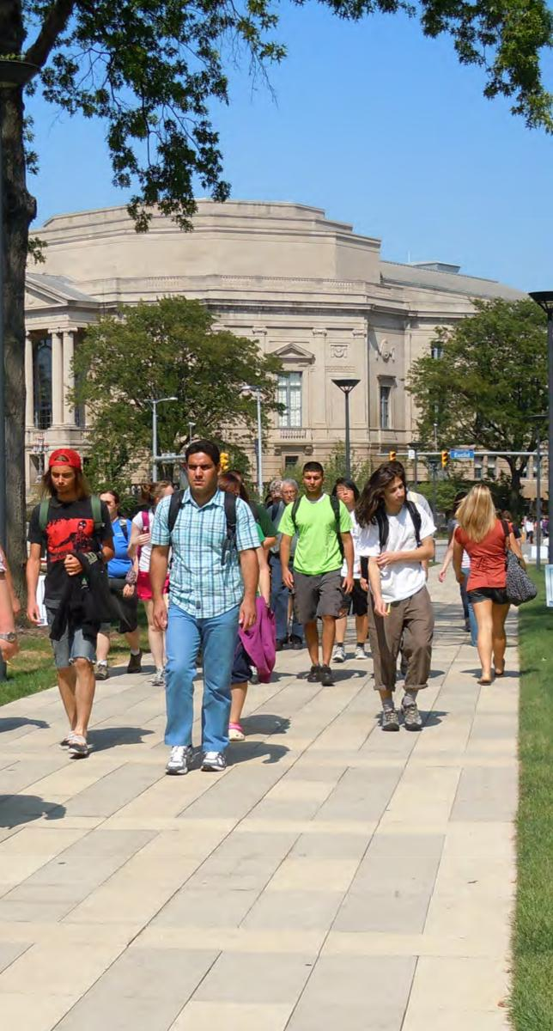

My advice to students is simple: invest in career planning and preparation early. A great way to begin the process is to review this Career Search Guide and become familiar with the services offered by the Career Center. Additionally, join student groups created to strengthen your professional development, and gain work experience during the school year if possible. Do not feel pressured to choose a major that does not fit what you want to do, and explore your op-tions both in the classroom and in the field. The earlier you begin exploring career opportunities, the earlier you can begin finding out what it is that truly you want to do!

Keniece Gray
Career Center Career Peer

Class of 2017

9

Case Western Reserve University / C A R E E R C E N T E R



Discovering your career path is
about more than simply finding
a job or internship. It’s about
finding your unique path, and
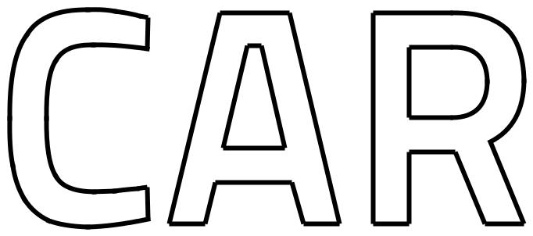

we’re here to help guide your

development.


10 11

Case Western Reserve University / C A R E E R C E N T E R

FOUR-PHASE CAREER
DEVELOPMENT MODEL

Our services are guided by our Four-Phase Career Development Model and designed to provide a transformational impact on your journey to a purposeful career, and prepare you with important career management skills that will be useful throughout your professional life. Here is a brief description and some recommendations for each phase:

ONE

Self-awareness:

Identify individual personality,

skills, interests and values

determining how they relate to

major and career choice.

• Meet with a career development professional to discuss potential interests and aspirations

• Discuss the possibility of taking a career assessment, like Myers-Briggs Type Indicator or the Strong Interest Inventory

• Attend the Choices Fair to explore majors and meet with faculty /staff from academic programs

• Join Handshake and complete your profile to

explore opportunities on and off campus.

• Check out Career Connections, spring break shadwoing with alumni for first-year
undergraduate students.

12

TWO

Career/Industry Knowledge:

Gain in-depth knowledge of various job functions, fields, industries organizations and projected job market trends for career decision making and planning.

- Explore online career/industry resources available including Career Insider (Powered by Vault) and O*NET Online

- Create a LinkedIn profile and use LinkedIn’s Find Alumni search function to view the careers of CWRU Alumni and current students

- Use the Alumni Career Network to request informational interviews with CWRU alumni, other students and outside professionals to gain insight on various career fields/ industries

- Do a deeper dive in your interest area by participating in a fall break Spartan Externship.

THREE

Career Decision Making:

Reflect on what has been learned through self-awareness, experiential learning and industry job market trends to choose the best career path for you.

- Devote significant time to experiencing and working in different professional environments through internships, co-ops or job shadowing.

- Continually evaluate your competencies, interests and values; determine how they fit into your career field(s) of interest.

- Explore your options regarding graduate/ professional school and determine if that is needed to reach your career goals.

FOUR

Plan and Act:

Develop a proactive plan of actions to

secure the opportunity you are seeking.

Implement Your Plan – Job Search

- Create a list of targeted employers and contacts, and use the Alumni Career Network to request informational interviews

- Utilize Handshake, LinkedIn, CareerShift to find job opportunities and potential contacts

- Network with parents, friends, alumni and others

Implement Your Plan – Graduate/Professional School

- Complete applications and take the appropriate entrance exams.

- Request references from faculty members and employers. Start an electronic credentialing file for graduate/professional school application materials online at Interfolio.com

- Use appointments with career counselors, resources in the Career Center, and workshops for help with resumes, correspondence, admissions essays, and interview strategies.

13

Case Western Reserve University / C A R E E R C E N T E R

IT’S IMPORTANT TO RECOGNIZE THE SKILLS AND COMPETENCIES YOU GAIN DURING YOUR

COLLEGE EXPERIENCE AND HOW THEY APPLY TO YOUR FUTURE CAREER.

CAREER DEVELOPMENT

Your skills and competencies, interests, personality, and values play an important role in your career choice. Understanding these factors can assist your career development in a number of ways.


• Help you select a career field that is a good fit
for your personality.

• Increase your awareness of your learning style
so you can benefit from career-related education.

• Help you understand your personality
preferences in order to manage job challenges
that inevitably arise during the course of your
career.

• Help you know your personality in an effort
to aid you on a job search, both in marketing

yourselfand evaluating opportunities.

We offer both the Myers - Briggs Type Indicator (MBTI) and Strong Interest Inventory to help you identify career-related interests, abilities, values, and other personality characteristics that might influence career decision-making.

Make an appointment with a career educator to learn how you can use these tools.

14

SKILLS ACTIVITY

Review the top 9 qualities employers seek in new

college hires and ask yourself: Which skills do I have?

Which ones do I need to develop?

- Exercising reason to analyze issues, make decisions, and solve problems

- Articulating thoughts and ideas clearly in writing and/or orally, to people inside or outside of your organization

- Building collaborative relations and managing conflict with colleagues and customers representing diverse cultures, races, genders, religions, lifestyles, and viewpoints

- Selecting and using appropriate technology to accomplish tasks or solve problems

- Leveraging the strengths of others to achieve common goals; using empathy to guide and motivate

- Organizing, prioritizing, and delegating work
- Demonstrating personal accountability and effective work habits (e.g., punctuality, time and workload management)

- Demonstrating integrity and ethical behavior, acting responsibly with the interests of the larger community in mind, learning from your mistakes

- Identifying and articulating your skills, strengths, knowledge and experiences relevant to your career goals

- Job Outlook 2016 Spring Update, National Association of Colleges and Employers

INTERESTS ACTIVITY

Take some time to think about the following open-ended statements designed to help you identify interests that can inform your career decisions.

I’m curious about:

I ask questions about:

I’m concerned about:

I like to think, read, or talk about:

My favorite classes are:

Outside of classes I like to:

Something I’d like to try is:

Something I would like to know more about is:

15

VALUES RANKING ACTIVITY

- Rank the following 15 values according to their importance to you (1 = most important; 15 = least important).

- On a separate sheet of paper, identify and then list 3 occupations that might allow you to use your top 5 values.

VALUES RANK (1-15)

High Earnings

Helping Society

Complex Problem Solving

Recognition

Work-life Balance

Adventure

Competition

Status/Prestige

Structure

Independence

Creativity

Exercising Competence

Influencing People

Location

Fast Pace

PERSONAL TRAITS ACTIVITY


- Put a check mark by your 10 strongest personal traits below.

- Put a second check mark by the 5 traits you would most like to use at work. On a separate sheet of paper, give detailed examples of times when you demonstrated these 5 traits at work, in an internship, or elsewhere.

PERSONAL TRAITS RANK (1-15)

Independent

Team-oriented

Precise

Imaginative

Analytical

Organized

Open-minded

Patient

Resourceful

Results-oriented

Diplomatic

Thorough

Efficient

Outgoing

Articulate

16 17

Case Western Reserve University / C A R E E R C E N T E R



Gone are the days when you could

simply go to one of the online job

sites and easily find the perfect job

or internship. So what has changed,

and why is developing your network

throughout your college experience

even more crucial today?


18 19

Case Western Reserve University / C A R E E R C E N T E R

Find out about jobs, careers, companies and the work culture through networking and informational interviews with people in the field that you are considering.

WHAT IS NETWORKING?

A network by definition is an extended group of people with similar interests or concerns who interact for mutual assistance or support. Can you carry on a conversation with someone? Do you have family and friends you can connect with? Then that is networking. Social networking for information on careers and opportunities is the key to finding those positions that may not be advertised on job search sites. It may assist you in connecting with a professional you can shadow to help validate your decision on a major or introduce you to a career you hadn’t considered.

Personal referrals can go a long way toward helping you get in a door that may otherwise have been closed.

SO WHY IS NETWORKING TODAY MORE IMPORTANT THAN EVER?

Networking has always been an effective way to find opportunities, but the increased competition in the job market, the fast-changing hiring needs of companies, and oversaturation of online resume posting have made effective networking a more crucial part of developing your career and finding new opportunities, ideally BEFORE they become advertised to the entire world!

20

HOW DO I BEGIN NETWORKING?

While the thought of networking may seem overwhelming, it really does not have to be so intimidating. Getting started early, well before you need an internship or job, is crucial. Networking is a process that is not necessarily improved by frantic urgency. Here are some tips to get started:

- Start by talking to your family and friends, your professors, grad students and other students. Let them know that you are looking for the opportunity to exchange information with their contacts to explore a certain career field or learn about their experience with a particular company.

- Attend on-campus events, including employer information sessions, panels, career fairs, workshops, networking events, alumni events, Greek Life events, etc. Remember, the key is to actually talk to people you don’t know and ask good questions about potential career goals and professional areas of interest.

- Create a LinkedIn account and develop a profile that shows credibility and depth that will entice people to connect and engage with you in an informational interview, phone call or Skype. Specialized resources have been developed by LinkedIn for college students and new graduates at students.linkedin.com. Or, join Twitter (twitter.com) and follow employers and people who are working in your field of interest.

- Reach out and contact someone in a role related to your career interest at a company you’re interested in. Contact information is readily available online. Use our Alumni Career Network or CareerShift (found in MyCareer) to search for employer contacts. Send an email introducing yourself and ask about the possibility for an informational interview. You’ll be surprised by how easy it really is; just give it a shot!

- Create an Excel spreadsheet with a list of companies you are interested in researching or exploring, the names of people connected to those companies along with their contact information, dates/details of correspondence, and sync to Google or Outlook calendar for dates of future follow-up inquiries.

21

Case Western Reserve University / C A R E E R C E N T E R

INFORMATIONAL INTERVIEWS

An informational interview can be a very effective way for you to find out more about a specific career path or company, as well as uncovering hidden job opportunities. These networking opportunities can also be called informational meetings and take place in person, via phone, or even Skype. Many people wonder about which kind of job they will like or what they can do with a particular major. Surprisingly, very few people take advantage of the best ways to answer questions about careers: ask the professionals who are already doing the job. It can be as simple as striking up conversations with friends and others about their occupations. But to take full advantage of this career exploration tool requires time, commitment, and organization for a more methodical approach.

THE WHAT AND WHY OF INFORMATIONAL INTERVIEWS

Informational interviews usually last 20 to 30 minutes and are highly focused conversations for the following purposes:

- Learn about the realities of working in a particular occupation
- Decide among different occupations
- Focus your career goals
- Discover careers you never knew existed
- Gain the perspective of how to break into a particular field
- Uncover the hidden job market

22
TIPS FOR INFORMATIONAL INTERVIEWS

Making a request for an informational interview can be intimidating at first. Saying the wrong thing or fear of rejection can keep you from developing a viable network before graduation. To make the request a bit easier on yourself, you may want to try reaching out to a “warm” contact first. This could be from a personal referral, a friend of a friend, or a more distant connection such as a CWRU student or alumni who studied the same major as you, or who is interning or working in a shared field of interest. Contact people you know first, then work on expanding your networking using tools such as the Alumni Career Network or LinkedIn.

An email request should definitely be a short and focused introduction. You want to quickly establish common ground with the person by letting them know specifically what you are seeking from them informationally, and why they are the right person for this short, informational meeting, phone call, or Skype. Being flexible and showing gratitude for their time is also important. Never ask someone else to “help find you a job” or “get you in with a company” as that is your job, not theirs. Most people are willing to help by sharing information if they do not feel over-obligated. The next page offers some sample email requests for an informational interview/meeting.

Requests by phone should include preparing a general script of what you want to say. For example, one might say, “Hello, my name is Jane Smith, and I’m calling at the suggestion of Joanne Jones (or, “I got your name from the alumni directory at CWRU”). I’m a junior at CWRU and am interested in a career in genetic counseling. I’m currently looking to develop an inside perspective on the job market and I thought you would be a good source of advice. Would it be possible to set up a time to meet with you, or phone you, for 10-15 minutes during the next two weeks?”

23

Case Western Reserve University / C A R E E R C E N T E R

MAKING YOUR REQUEST

After you obtain the name and contact information of potential contacts, either email or call them to request an informational interview. The emphasis is on asking for help or more information about the field, rather than selling yourself and asking them to find you a position. See the sample messages to the right for an example.
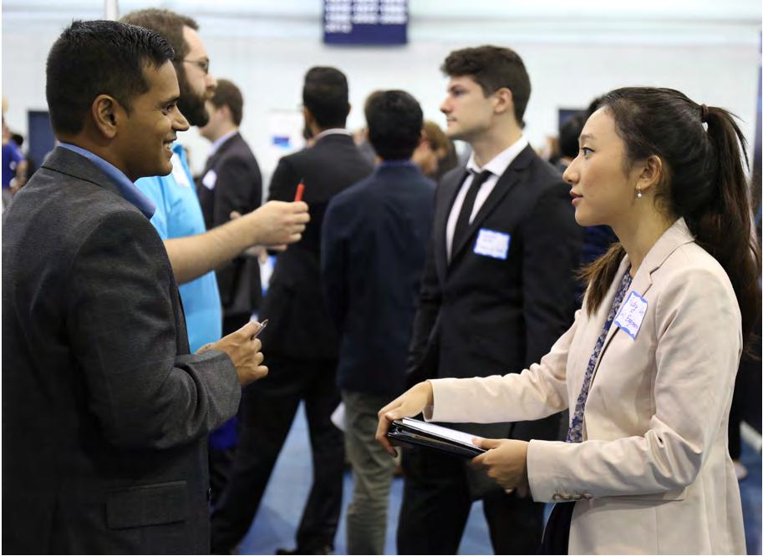

24

SAMPLE EMAILS

FOR REQUESTING

AN INFORMATIONAL

INTERVIEW

(OR MEETING)

Sample Informational Meeting Request Email

Subject: Meeting Request

Dear __________,

I’m a sophomore business major at CWRU, and I came across your

Alumni Career Network profile as I was exploring future internship

opportunities. It looks like you’ve had some success in that area and

I would really appreciate an opportunity for a short informational

meeting, phone call or Skype in the near future. I am happy to be

flexible based on your availability. Thanks for your time!

Sincerely,

June Meredith
Sample Informational Meeting Request Email

Subject: Meeting Request

Dear __________,

I’m a first year student at CWRU trying to decide on the right major for me, and I came across your LinkedIn profile as I was looking at other students at Case majoring in biology. It looks like you’re doing some interesting research projects, and I hope to gain insight on how you chose biology as a major, and what your future aspirations are within this field of study. I would really appreciate an opportunity for a short informational meeting, phone call or Skype with you in the near future if you’re open to it. I am happy to be flexible based on your availability. Thanks for your time!

Sincerely,

Becki Ross

Sample Informational Meeting Request Email

Subject: Meeting Request

Dear __________,

I’m a recent graduate from CWRU with a master’s degree in biomedical engineering, and saw that you were also a member of the Biomedical Engineering Society Network on LinkedIn. I’ve been researching the biomedical job market in Chicago and based on your profile you may have some valuable insight and experience since you currently work there. I would really appreciate an opportunity for a short informational meeting, phone call or Skype with you in the near future if you’re open to it. I am happy to be flexible based on your availability. Thanks for your time!

Sincerely,

Raj Toprani

25

Case Western Reserve University / C A R E E R C E N T E R

PREPARING FOR AN INFORMATIONAL INTERVIEW

In order to gain valuable information, you need to do some research in advance. Looking at the Alumni Career Network profile of the interviewee in detail while paying close attention to their position description, skills, work history and other details of their profile can help you generate some good questions to ask them. Of course, these tools are not the only way to prepare. Some nifty searching online can uncover various lists of questions to ask people in all types of professions.

GOOD QUESTIONS TO ASK

Always try to use a professional and conversational tone when conducting the interview, especially when doing so by phone. Be sure to make your questions specific to the field you want to enter.

SOME TYPICAL INFORMATIONAL INTERVIEW QUESTIONS ARE:

- How did you get into this field?

- Where did you work before your current employer?

- What is a typical career path in this field?

- What are some good tips for a job search in this field?

- My current major is _____. What other classes/majors would you recommend for someone looking to enter this field?
- What other activities might I participate in that may help in my job search?

- What trade or professional associations would you recommend?

- How important is it to pursue an advanced degree in this field?

- Would you recommend obtaining an advanced degree?

- If so, which programs or schools may be stronger in this field?

- From the research I've done so far, I've developed a list of companies I am interested in. Can you tell me which you most recommend and why?
- I have a copy of my resume. Would you look at it and let me know what you think?

- Can you recommend the names of two other people with whom I should talk?

THANK YOU EMAILS AFTER AN INFORMATIONAL INTERVIEW

It is always proper etiquette to thank someone with an email after they have spent some of their valuable time to meet or speak with you. If they give you permission to keep in touch, it is also a good idea to keep them posted on any positive developments. Most people appreciate this, and it’s a nice way to maintain your network.

Follow up in another month or so, especially if you don’t hear anything after your initial thank you message. Let the person know that you followed up on his/her advice, and inform him or her of any new developments.

If a resume was not exchanged previously, you can send one along with your thank-you letter requesting that your networking contact keep you in mind if he or she hears of anything.

Informational interview Thank You Email Sample

To: Madeleine.Cannes@image.com

From: Hanna.Charles@case.edu

Date: Dec. 19, 2016

Subject: Thank you from Hanna Charles

Dear Ms. Cannes:

I want to sincerely thank you for the time you spent with me

last week discussing the publishing industry. Your willingness to

share information about the field, and your feedback regarding

the strength of my background, was most appreciated. Your

perspective on the publishing field was helpful as I determine which

career path to pursue. I now have a better understanding of how

to approach my job search. I plan to follow up this week on your

suggestion to contact Stuart Media, Inc. The opportunities there

seem to follow what I am looking for in a company. Again, thank

you for your assistance.

Sincerely,

Hanna Charles

26 27

SOCIAL NETWORKING

Social networking can be an effective part of your job search strategy. Sites like Twitter, Facebook, and LinkedIn can help you make connections, find job listings, and prepare for interviews.

USE SOCIAL NETWORKING TO:

- Gather background information about the recruiters with whom you will be interviewing. Know their interests to make stronger connections in the interview.

- Connect with alumni and gain added insight into their employers. You can ask questions here that you can’t in an interview, such as “Do you like working there?” and “Can you negotiate salary?”

- Create a positive internet presence.
- Put your elevator pitch in your bio or summary.
- Present a consistent image throughout all your online platforms (LinkedIn, Facebook, etc.)

SOCIAL NETWORKING RULES:

- Follow the same etiquette you would if communicating by phone or in-person.

- Remember, every contact is forming an impression.

- Maintain your professionalism every time you communicate with an employer.

- Send a thank-you note any time someone gives you advice or assistance.

“Remember to treat social media as a professional tool. The way you communicate
with your friends on Facebook, Twitter, etc, is not the way that you should communi-
cate with a potential employer. If you don’t want someone to see certain pictures or
information about you, don’t put it on your page or make sure your page is set so that

only your friends can see your information.”

Beth M.
The SCA Center for Conservation Service

ONLINE PRESENCE CHECKLIST

Post content on the internet cautiously and periodically and check all the information you have (or someone else has about you) online; companies use the internet as a screening tool.

Here’s a quick list of what you should check:

- Email
- Google and other search engines
- Blogs
- Twitter, Facebook, Instagram and other social networking sites
- Forum /Discussion Board Posts

EMAIL

Your email address should be professional. Consider using a dedicated email address just for job searching.

ONLINE SEARCH ENGINES

“Search” yourself to see what information people can find about you online. Make sure that what you find is ap-propriate for a potential employer to read. Review your profile, pictures, and who is linked from your site and vice versa. Is there anything you wouldn’t want a potential employer to see? If you’re concerned, make your profile private and be careful what you put on the front page. Anyone may be able to see the information on that page, even if your profile is private.

BLOGS

If you have a blog, make sure all content is something you wouldn’t be embarrassed by if an employer or colleague were to read it. Whether you write about your interviews, your current jobs, or your personal life, review all your online information; potential employers can (and will) find it. If you have friends who write about you, check to make sure that what they are writing is appropriate.

HOW CAN THE CAREER CENTER HELP YOU NETWORK?

We can assist you through the Alumni Career Network. This is a network of alumni volunteers who are happy to speak with students and alumni and provide informational interviews. No, they can’t get you a job, nor should you expect that they will help you find a job, but they will offer advice and perhaps other contacts to start you on the road to success. To learn more about the Alumni Career Network, contact the Career Center at 216.368.4446.

28 29

LINKEDIN

LinkedIn is the world’s largest professional network on the Internet with more than 433 million members in over 200 countries and territories. There are more than 40 million students and recent college graduates on LinkedIn. They are LinkedIn’s fastest-growing demographic. Using LinkedIn will help you greatly in establishing connections, developing relationships, and exploring companies and industries. As it continues to evolve, your LinkedIn profile will be thought of as an online version of your resume. There are many facets of LinkedIn to learn. This section will serve as a general overview of LinkedIn, and we have included additional links to content developed by LinkedIn for college students and recent graduates. For more information about LinkedIn or to have your profile critiqued after incorporating the suggestions in this guide, please contact the Career Center.

BUILDING A PROFILE

Before you can use LinkedIn effectively, you must create your own profile. Log in at www.linkedin.com to create an account and follow the prompts to begin. LinkedIn lets you control your profile’s content and structure, and offers a variety of interesting sections and features to ensure your profile best represents your professional and academic experiences, skills and interests. Your profile is similar to your resume in that it is carefully and professionally written, including information that is relevant to your career objectives and job/internship search. Your profile differs from your resume in that it does not have a length limitation and may have sections and features not traditionally used on a resume. For example, a LinkedIn profile often includes a photo, headline and summary which are very important to brand yourself properly as an aspiring professional.

PHOTO

Include a photo! We recommend that the photo be a “headshot” of you, alone, wearing professional attire. We suggest that you do not use a cropped photo of yourself taken with a group of people. Remember it will be the first image that students, alumni, and other networking contacts have of you.

HEADLINE

Underneath your name will be a short “headline”. Your headline is the first thing other LinkedIn users will see, so make sure it is simple and engaging. Create a meaningful statement that speaks your major and what you are aspiring to professionally. For example, “Economics major and aspiring financial analyst”, “Recent Biomedical Engineering Graduate”, “English major and emerging writer/editor.” If you’re not sure what you are aspiring to yet, you can list your major and year in school.

30

LINKEDIN SUMMARY

The summary is a short version of what you do and why, or what you would like to do and why. Connect with your reader by writing in the first person and showing passion for your field of study and what you are aspiring to professionally. The summary is your opportunity to expand further on your personal brand. Here you can describe your greatest attributes, ambitions, and interests. When writing your summary, it is important to remember the audience. Here are some sample summaries highlighting this approach:

I am driven by the desire to improve myself and those around me. My varied passions and interests include philosophy, history, literature, education and social justice, and I endeavor to incorporate what I learn into my own life and work to improve our society. My fields of interest include clinical counseling and adult education.

As I progress through my undergraduate experience, I continue to narrow down my potential career paths and I aspire to be involved in Higher Education and Research.

Economics and international studies junior offering an excellent combination of analytical ability and interpersonal skills. My strengths include examining data and problems from multiple perspectives, while adapting and learning new processes, in order to contribute pragmatic and creative solutions.

Industrious, intelligent, and enthusiastic college student with strong academic profile, outstanding work ethic and relevant work experience. I’m currently employed in a summer internship that complements my coursework in biomedical engineering.

A second-year undergraduate student at Case Western Reserve University studying Electrical Engineering and Computer Science. Interested in big data challenges, machine learning, and wireless technologies.

31

Case Western Reserve University / C A R E E R C E N T E R

EXPERIENCE, PROJECTS, VOLUNTEERING, AND ORGANIZATIONS

These sections resemble the similarly-titled sections on your resume. They will likely contain the majority of the information you share on your profile informing others of what you have done in the past. When updating these sections, include internships, work experience, extracurricular activities, and volunteer experiences. Describe each experience in enough detail to inform the reader about your responsibilities and accomplishments for each position. Be sure to include action verbs, industry-specific keywords, actions taken, and results achieved.

SHOWCASING EDUCATION ON LINKEDIN

Include Case Western Reserve University, the degree you are seeking or have earned, and your declared major(s) and minor(s). If you are a current student or recent graduate, include your expected graduation year. Highlight academic honors and academic projects, such as a thesis or other course projects. Include any relevant courses you have taken and associate them with the proper Education entry utilizing the drop-down menu.

LISTING SKILLS

This section allows you to include keywords that you feel represent the skills that you possess and have demonstrated in your experience. It’s important to know which skills are in demand for the position you are seeking. You can find relevant keywords that describe which skills are important to be successful in certain professional roles or positions by looking at advertised position descriptions of interest to you. You can also observe what skills other students and alumni are listing on their profiles that may be relevant to you. While you can add up to 50 skills to your profile, initially, try to add at least 10 skills. It is acceptable to list interpersonal skills in addition to technical or industry-specific skills. Here are some of the most popular skills listed by Case Western Reserve’s students:

- Research
- Public Speaking
- Leadership
- Management
- Social Media
- Project Management
- Strategic Planning
- Customer Service
- Data Analysis
- Matlab
- Java
- Microsoft Office

32
RECOMMENDATIONS

Recommendations are given for a particular experience and can be written by supervisors, colleagues, clients, or supervisees. These can be very powerful endorsements that complement your education, experience and skills included on your LinkedIn profile. Recommendations are typically short on LinkedIn – 3-4 sentences should suffice.

To ask for a recommendation, you can click on your profile tab which brings you to your profile page. On this page, at the bottom right corner of your photo there is “View profile as” box with a little arrow (pointed down) button on its right side. You click on the arrow, and it opens a scroll down menu. One of the choices in this menu is “Ask to be recommended”. Ideally, you should choose people that know your work well and can speak concisely regarding how they observed your work or assisted them.

When asking for a recommendation, make sure you customize your message with content focused on exactly what you are looking for and how they can best help. Also be sure to thank them for their time and offer to help them with the recommendation content if needed. Do not use the generic, automated recommendation request message. Finally, quality of recommendations is more important than quantity.

FOR MORE TIPS AND IN-DEPTH INSTRUCTION, VISIT STUDENTS.LINKEDIN.COM AND DISCOVER THE POWER OF LINKEDIN!

33

Case Western Reserve University / C A R E E R C E N T E R



What our employers have to say ...

Experiential Learning is key. Sometimes
your dream job turns out to be anything
but. So, use Experiential Learning as a
way to get a glimpse into what jobs really
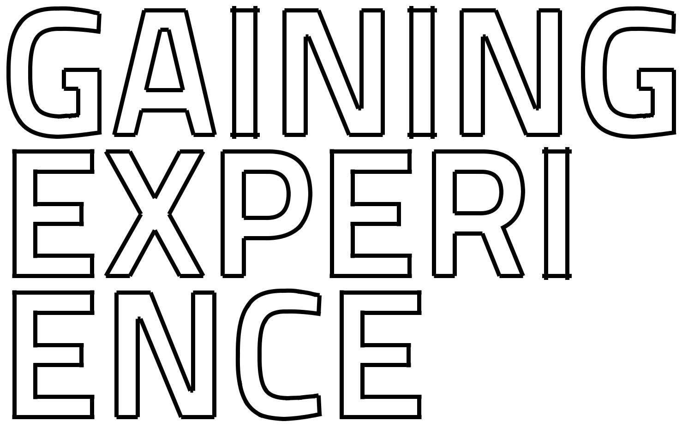
entail.

Marci N.
The Sherwin-Williams Company

34 35

Case Western Reserve University / C A R E E R C E N T E R

EXPERIENTIAL LEARNING (EL)

You may have heard that experiential learning is a major part of the undergraduate experience at CWRU. We’re here to tell you to believe what you hear. Our annual survey of graduating seniors (the First Destination Survey) indicates that, in recent years, 98%-99% of students have participated in some form of experiential learning by the time they graduate. If so many students are participating in EL, then surely there’s something really great to it, right? Yes, indeed, there is. Now let’s establish what experiential learning is at CWRU.

Experiential Learning is defined at Case Western Reserve University as an innovative approach to education that emphasizes hands-on experience. The Career Center coordinates and supports four primary experiential learning programs: Career Connections, Spartan Externship, Internship and Practicum. Other experiential learning programs at CWRU include: Co-op (through the Case School of Engineering), research (through SOURCE), community service (through CCEL), and Study Abroad (Center for International Affairs).

Experiential learning is all about exploring—exploring new opportunities, new theories, new cultures and careers.

It’s also about testing yourself in new environments outside of the classroom. Consider the senarios below:

- You’ve thought about a career as a financial analyst, but how do you know you’ll like it? Explore it. Roll up your sleeves and intern at a private equity firm for 40 hours a week. You’ll know.

- You’ve been studying Spanish for five years and want to take your education to the next level. How do you do that? Go to Spain. Explore Madrid. Immerse yourself.

- Your professor keeps referring to her research in class. It sounds interesting. You’d like to help, but how? Pitch yourself as a research assistant. Do the research. Publish a paper.

All of these experiences are designed to be transformative and educational. They’re designed to propel you towards your future in a meaningful and practical manner. Regardless of the form of EL in which you participate, the benefits are clear and plentiful. You will:

- Learn about yourself. What your strengths are. What you’re capable of. What you’re interested in.

- Enhance academic knowledge by testing classroom theories in a real-world setting.

- Build a network of professional contacts.

- Acquire new skills relevant to your career.

- Clarify academic and career goals.

36

And let’s not forget that employers and graduate/professional schools look very highly upon students who have participated in EL. They want experienced people who’ve taken the initiative to create a career path for themselves, learned valuable lessons along the way, and grown into professionals who can make a contribution. EL helps you stand out as such a person.

We encourage you to consider early in your academic career all of the experiential learning opportunities available to you and to begin mapping out a potential career pathway for yourself. As the chart below illustrates, certain experiences are designed for first and second-year students, while others are better suited to upper-level students. Knowing what your options are and how different experiences connect to and complement each other will help you successfully navigate your customized plan.
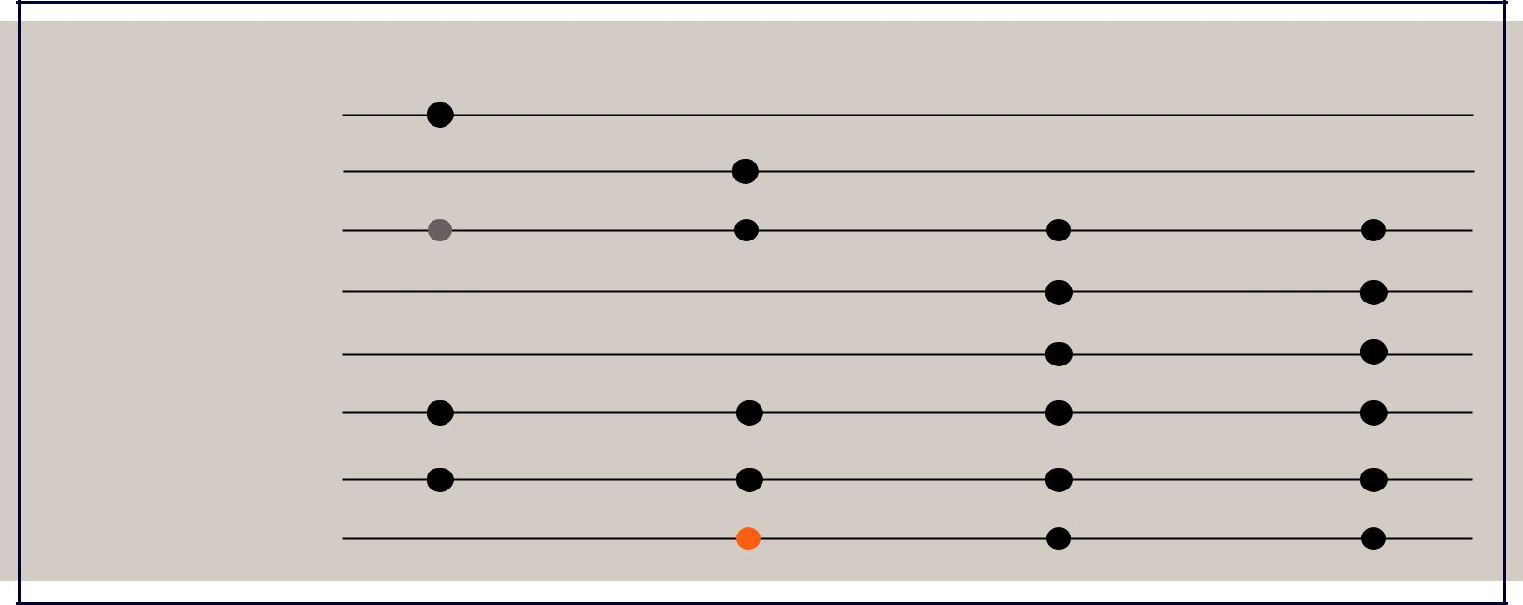

FIRST YEAR SECOND YEAR THIRD YEAR FOURTH YEAR

Career Connections

Spartan Externship

Internship

Practicum

Co-op

Research

Community Service

Study Abroad

= possible, but not typical
= spring semester

37

Case Western Reserve University / C A R E E R C E N T E R

HOW DO I FIND AN INTERNSHIP OR CO-OP?
For assistance in finding an internship (local, national, or international), developing learning objectives, creating a resume, or preparing for an internship interview, students should contact the Career Center to schedule an appointment with a counselor.

In addition to working with a career counselor during your search process, students should consider employing the following strategies:

- Utilize online resources, such as Handshake, Going Global, and CareerShift, featured on the Career Center’s MyCareer website: students.case.edu/My/Career/

- Talk with people in your network about their company, position, internship, etc. Learn more about how they got where they are, what they like and dislike, what skills and qualities make for a great fit between employee and organization, what opportunities they may have or expect to have that could be a good fit for you, and what information and advice they have to offer to someone in your position.

Create a target list of organizations at which you would like to get experience. Note those that are of the very greatest interest to you, those that have current openings posted, and those where you have a networking connection, whether direct or indirect. Then prioritize your list. Pair networking and online application as you work your way through your list.

- Propose your own internship!Sometimes the best way to find an internship that matches your specific career goals and interests is to contact employers in your field and pitch yourself as a potential intern. If you’re strategic, tactful, and articulate in your communication with employers, there’s a chance they will stop and pay attention to your proposal. Though this approach may take more preparation and planning than simply searching for existing opportunities, the payoff is an internship experience tailored to your career goals which, we think, makes the added effort well worth your while.

What do our employers have to say about that?

“Not all career experience comes from jobs, co-ops and internships. Look for creative opportunities for experiential learning; volunteer, write a blog, find a hobby or start a small business within your career field”.

Robert G.
Precision Castparts Corporation

38

DIFFERENT FORMS OF EL

CAREER CONNECTIONS

The Career Connections program is designed to match first year undergraduate students with alumni for the purpose of exploring career options. The “connection” may be in the form of a shadowing experience or an individual meeting for an inside look at careers or industries through informational interviewing, networking and observation.

The Career Connections experience takes place during spring break. Alumni and students are identified and matched based on background, interests, location and availability.

We know that exploring career options raises a lot of questions. The goal of Career Connections is to give you a learning opportunity outside the classroom. The benefits are:

- Assistance from the Career Center and Alumni Relations to match you up with your requested contact
- Exposure to career opportunities relating to academic majors at a location of your choosing
- Alumni interaction and guidance in careers, course of study and campus/professional organizations

Requirements: submit registration forms, write a brief statement about your goals for the future, prepare a current resume and attend a workshop. Contact the Career Center for more information about this great program!

SPARTAN EXTERNSHIP

Spartan Externship is an exciting new program providing second year undergraduate students with a short term, occupational immersion experience related to their career interests that can last multiple days at select employer locations. It’s meant to serve as a more in-depth experiential learning opportunity than the Career Connections program and serves as the “next step in the ladder” within the Career Center’s experiential learning opportunities. In addition, it could serve as a pathway to present/future internships or co-op experiences.

These opportunities are likely to take place during fall break in late October, and will be posted on Handshake earlier in the fall semester. Interested students will apply for externships by completing an online registration form and submitting a resume. There will also be a required workshop to prepare for this unique experience. Contact the Career Center for more information about this new program!

39

Case Western Reserve University / C A R E E R C E N T E R

INTERNSHIPS

Internships are hands-on learning opportunities available to all undergraduate and graduate students at CWRU who wish to explore a particular career path in order to clarify career goals. Internships may be part-time or full-time, paid or unpaid, though most are paid. By design, internships are broader-based, exploratory experiences.

As such, students should consider pursuing internships early in their academic careers in order to effectively incorporate the experience into their career planning process. It is recommended that students enter internships with learning objectives in mind and share those objectives with a mentor or supervisor at the internship site.

Special note for International students: Paid work experience for international students attending Case Western Reserve University are subject to USA work authorization requirements, which means the experience must be tied to a CWRU program such as Practicum and Co-op. Consulting with the Career Center or Co-op Office and the International Student Services office (students.case.edu/international) is required before accepting a job offer.

PRACTICUM

If you’ve explored the Career Connections Program and internships, the next logical step to take along your career pathway is toward Practicum. Practicum is an experiential learning collaboration between a student, a faculty advisor of his or her choosing, and an employer, coordinated by the Career Center’s Assistant Director of Experiential Learning.

The program is designed for upper-level undergraduate students who wish to pursue a particular, identified career path. While completing a practicum assignment, a student works in a professional setting.

For full-time practicum, a student does not take classes. During the fall or spring semesters, the student must work for a minimum of 14 weeks or 560 hours; during the summer, he or she must work for a minimum of 10 weeks. The student will maintain full-time student status during the experience, but will not pay tuition, only an activity fee.

For part-time practicum during the fall or spring semesters, a student must be working a minimum of 15 and maximum of 20 hours per week for the duration of the semester, 14 weeks. During the summer terms, students must be working a minimum of 20 hours per week for a minimum of 10 weeks.

While credit is not awarded for Practicum, students who successfully complete the program, as determined by the Career Center’s Assistant Director of Experiential Learning and the student’s faculty advisor, with recommendations from the employer, receive transcript notation.

40

Below is just a small sampling of employers and locations where former Practicum students have worked:
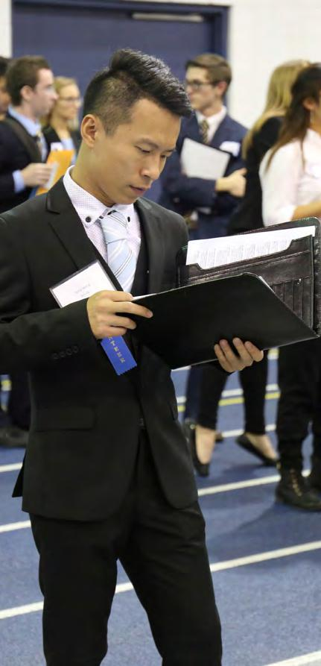

- Facebook (CA)

- Deloitte (Chicago, IL)

- Johnson & Johnson (NJ)

- Live Nation (NYC)

- The Motley Fool (D.C.)

- Bizdom (Cleveland)

- Boehringer Ingelheim (Columbus)

- Fender (Scottsdale, AZ)

So, if you’re ready to take that next step toward your career and become a Practicum student, please contact the Career Center. We’ll go over the program components with you in detail, help you find suitable Practicum positions, and walk you through the registration process. Ideally, you should begin planning for a practicum at least one full semester in advance of when you want to have it.

41

Case Western Reserve University / C A R E E R C E N T E R

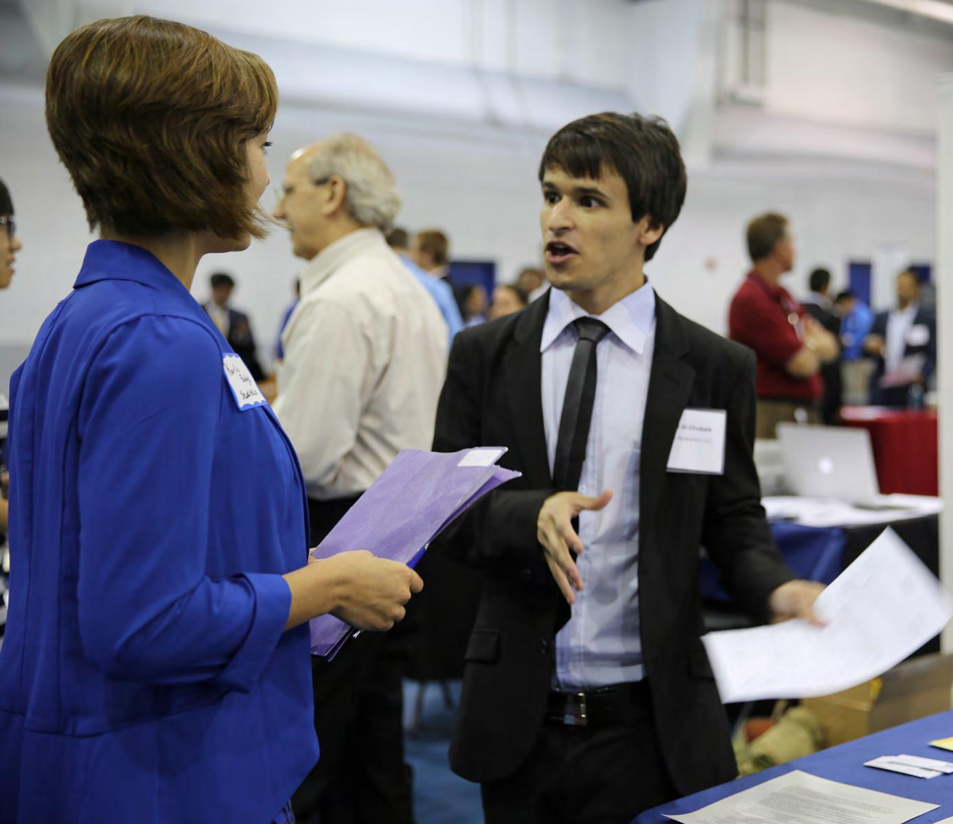
CWRU LAUNCHNET

Do you have an idea for a product or service (a medical device, a manufacturing process, a software application, a hardware platform, a performing arts organization,… or anything at all), that you think might be appealing to others? Are you unsure how to turn your idea into a business plan, or to market, manufacture, distribute, or finance your idea?

CWRU LaunchNet is a great place to start.

Open to all CWRU students and alumni, regardless of academic major, CWRU LaunchNet helps individuals or groups turn their ideas into products and services.

CWRU Launchnet introduces entrepreneurship through hands-on learning and mentorship from dedicated, experienced staff, and a network of venture coaches. In addition to delivering customized one-on-one instruction, and offering self-directed electronic resources, CWRU Launchnet produces start-up launch activities, business development pitch competitions, and other events, helping you hone your business development, collaboration, and presentation skills.

Even if you aren’t looking to start your own business, you may be interested in gaining experience by working with or for a small business. CWRU Launchnet maintains close relationships with the area’s small businesses and can put you in touch with students, alumni, and others who may be looking for help.

Visit CWRU Launchnet today : Thwing Center or the Sears [thinkbox]. Or register at case.edu/cwrulaunchnet to stay update through newsletters or to arrange a meeting.

A new business venture or an alternative (or additional) career path may be in your future.

The CWRU Launchnet is a service of the Case Western Reserve University Career Center. It receives generous support from the Burton D. Morgan Foundation.

42 43

Case Western Reserve University / C A R E E R C E N T E R

EXPERIENTIAL LEARNING CONTINUED CCEL

The mission of the Center for Civic Engagement & Learning is to create an engaged campus by providing and supporting opportunities for community service and collective action while promoting civic awareness and leadership through:

- One-time and ongoing projects and programs that introduce students and faculty to community service opportunities that support learning and benefit the community

- Curricular and logistical assistance to faculty utilizing service learning as a pedagogical tool
- Assistance to students seeking community-based capstone projects and service learning coursework
- Work-study and paid placements in the community

- Support of the community service efforts of campus organizations

- Opportunities for community organizations to raise awareness of service events at their sites

For more information about the different ways in which you can participate in civic engagement and active learning with CCEL, please visit their website at students.case.edu/civicengagement.

CO-OP

Like Practicum, Co-op is a structured, intensive work experience designed for upper-level students, particularly those who are pursuing careers in the field of engineering.

According to the Co-op website, Co-op is a full-time paid work experience for the duration of summer/fall or spring/summer. Students work in a position relevant to their major field of study. The first co-op takes place during the junior year and students are encouraged to have a co-op for a second time in their senior year. Co-op is voluntary, non-credit, and proper registration for co-op maintains full-time status for students.

Co-op is a formalized academic program and is considered an extension of the classroom. Co-op provides students with a comprehensive education that blends curriculum with meaningful work experience and adds a unique dimension to the student’s education. Co-op accelerates and inspires intellectual, personal and professional development.

For more information please visit the Co-op Program’s website at engineering.case.edu/coop.

STUDY ABROAD

Interested in exploring other cultures? Want to add to your college experience through study overseas? In recent years, Case Western Reserve University students have studied in a host of countries — in every continent but Antarctica!

CWRU offers many different types of study abroad programs through the Office of Study Abroad. You may spend a full year or a semester in a tradi-tional immersion arrangement or you may choose shorter term programs, such as the three-week summer in Bordeaux, France. If you wish to study in a non-English speaking country, you must have proficiency in that language. In most cases, your financial aid and scholarships can be used to cover study abroad expenses. For more information, please contact The Center for International Affairs, which houses the Office of Study Abroad at case.edu/studyabroad.
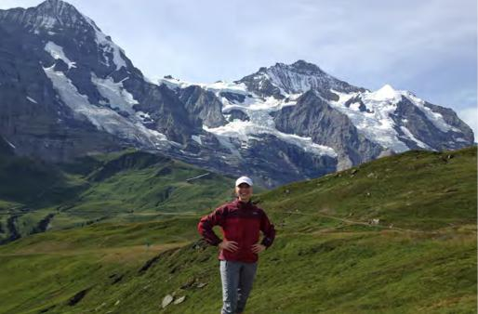

SOURCE

The ability to conduct high-level undergraduate research is a signature feature of the CWRU undergraduate experience. Whether you’re interested in doing research with faculty here at CWRU or at other research institutions, the SOURCE office is the place to go.

According to the SOURCE website, the goal of the SOURCE office is to assist and prepare students to engage in research and creative endeavors, and to guide and, where appropriate, supplement institutional, departmental, and divisional work with this effort. All this means is that the SOURCE office is here to help students learn about UR-CE (undergraduate research and creative endeavors) and opportunities, to assist faculty members in posting opportunities, assist with funding, and to facilitate the celebration of UR-CE activities. For more information, visit the SOURCE website at case.edu/provost/source.

44

45

Case Western Reserve University / C A R E E R C E N T E R



Considering graduate/professional
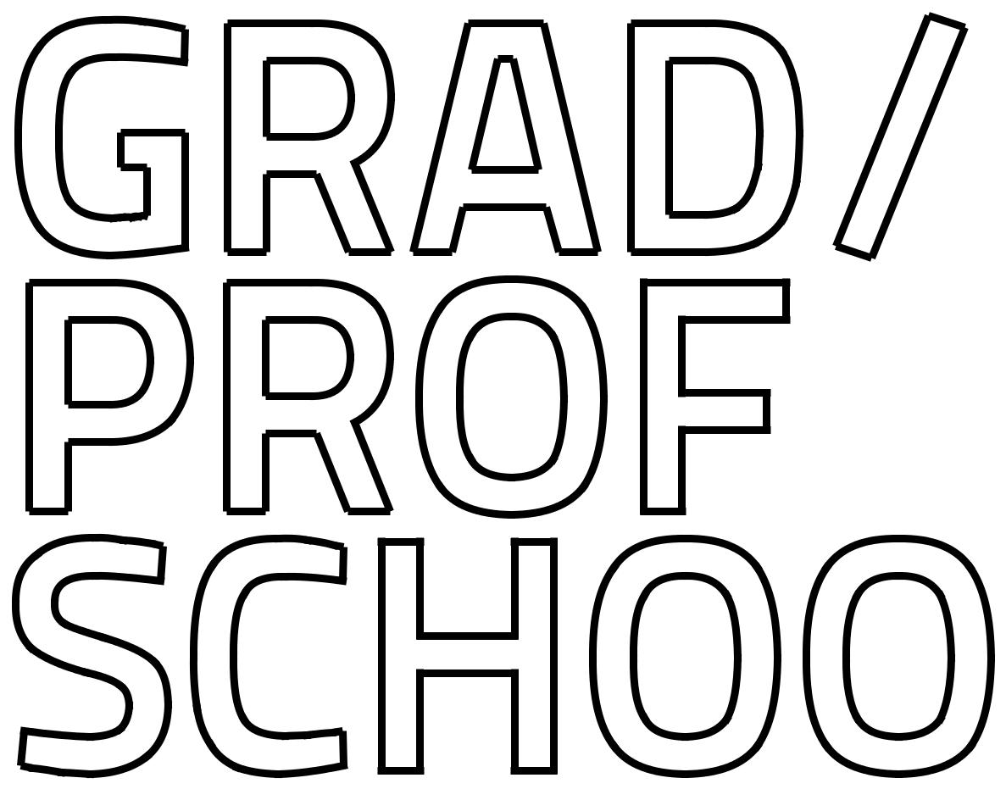
school to further your education
and skills? This can sometimes be an
overwhelming process with so many
programs and options to consider. Let
us break it down for you and show

you steps to consider as you begin the

process.


46 47

Case Western Reserve University / C A R E E R C E N T E R

SO YOU’RE CONSIDERING GRADUATE/PROFESSIONAL SCHOOL?

Attending graduate/professional school will give you the opportunity to gain specialized knowledge in your field. You will participate in such activities as research or observe and learn through field placements in your specialty.

Are you considering a master or doctoral degree? What does your career path require? There are a lot of questions surrounding your decision to continue your education; we have tried to touch on some common questions that may help you make the best decision.

APPLYING TO GRADUATE OR PROFESSIONAL SCHOOL

- Do I want to continue my education right now?
- Do I need to continue my education now for the field I want to enter?

Positive reasons for going to a graduate/professional school:

- You have a definite academic goal and/or career ambition
- You have researched the discipline in your field and have weighed the costs of the degree against the benefits
- You are truly dedicated to learning and prepared for several years of intensive study

Negative reasons for going to graduate or professional school:

- You are going because you don’t know what else to do
- You are going as a way of putting off entering the world of work
- You are going because you feel pressured by others (e.g.; family, academic advisor)

Advantages to working first:

- Can recharge your batteries
- Can allow you to gain content-specific experience
- Can help you gain confidence
- Can spur motivation
- Can let you take advantage of an employer offered program such as continuing education credits or tuition reimbursement

48

HOW DO I KNOW IF I NEED AN ADVANCED DEGREE?

Speak to your professors, family and friends, or contact the Career Center to speak to a volunteer with the Alumni Career Network who can give you information about your field and the education or certifications required.

Also check out onetonline.org and enter a profession into the Occupation Quick Search. It will provide you with information regarding the educational requirements typically needed for your profession of intereest.

GATHER INFORMATION ON PROGRAMS

As you research programs, bear in mind your needs, expectations, and desired experiences. Explore programs that have your area of speciality within your field and/or faculty members conducting research in a topic that inter-ests you. Look nationwide to select the best school for you. A number of web-based resources are available to help you gathering information:

- Peterson’s Guide to Graduate School

- PhDs.org

- GradSchools.com

- GradPortal.org

- Diverse Issues in Higher Education at diverseeducation.com/top100/top100listing

TIPS:

Contact the schools that interest you to request more information. Read professional journals or consider joining a professional organization to network with others in your field. Get their suggestions for matriculation.

QUESTIONS:

How long is the program? Will any of my undergraduate

course credits transfer? What kind of funding or assistance

is available? Where will I live? Is there graduate housing

available? What about facilities, teaching methods, career

assistance, completion rates, size of institution and student

mix? These are all questions you should ask to make a good

choice.

49

Case Western Reserve University / C A R E E R C E N T E R

OK, SO NOW IT’S TIME TO RANK YOUR CHOICES:

- I believe that I am a competitive applicant for this program, and they have everything I am looking for.

- Admission to this program may be a stretch, but I am very interested in this program and I have nothing to lose and everything to gain.
- I feel highly confident that I will be admitted based their criteria and they have what I am looking for. This school is a safe bet.

NOW IT’S TIME TO MAKE IT COUNT!

GATHERING LETTERS OF RECOMMENDATION

Obtaining recommendations should be a first step in your application timeline, since this process can be time consuming. When possible, meet in person with each contact and see if they would be willing to write you a positive recommendation and give them enough time to complete the process.

Use a site like Interfolio to store all your letters of recommendation. Access at: www.interfolio.com

Recommendations should come from people who have worked with you recently and in an academic and/or professional capacity. Supply them with a list of your accomplishments, transcripts and resume or CV to assist them in writing the recommendation.

IDEAS FOR PEOPLE WHO CAN PROVIDE YOU WITH A REFERENCE
APPLYING TO GRADUATE OR PROFESSIONAL SCHOOL

SUBMIT APPLICATIONS

When you receive the application, make sure you understand the obligations and deadlines for enrollment. Build a timeline that is realistic so you can plan for all enrollment tasks you must complete. Applications and catalogs can be ordered on-line from your chosen schools. Remember that CWRU faculty are an excellent resource and can assist with a selection and the application process.

HOW WILL THEY DECIDE WHETHER OR NOT TO ACCEPT YOU?
Grades: Never misrepresent your GPA. They will request a transcript. Understand the importance of academics and maintaining as high a GPA as possible throughout your undergraduate education.

Graduate Admission Exam Scores: Plan to take the appropriate entrance exam during your junior year or, at the latest, fall of your senior year.

Registration materials and information for exams is available online. Get a review guide and use it to prepare. Taking exams early gives you the opportunity to retake in case you don’t do so well; people’s scores typically improve 10% the second time around.

Applications: Complete every question. Include honors and activities from high school as well as college. Join professional associations related to your field of study - a faculty member could recommend an appropriate organization - and include them as well.

- Professor
- Academic Advisor
- University Administrator
- Former Employer/Supervisor
- High School Teacher

REQUIRED GRADUATE ADMISSION EXAMS

- Law School- LSAT
- Medical School- MCAT
- Dental Admissions Test: DAT
- Professional Programs: GMAT or GRE

A number of companies offer test prep services, Kaplan and The Princeton Review are among the best known. Practice tests are available, often at low or no cost. Prep courses are also available, usually at considerable cost ranging from hundreds to thousands of dollars.

Statement of Purpose Essay: Show your vision for the future and present yourself as unique with a strong opening statement. Let them know you have something to offer the program as much as the program has something to offer you. Your essay must be perfect. Ask others to read it - including a Career Center staff members - for content and grammatical or typographical errors.

Check out Donald Asher’s book, Graduate Admissions Essays. Check online for other resources.

- Stay within specified length limitation

- Write in an active voice

- Include real life examples

- Make sure your enthusiasm shines through

50

51

Case Western Reserve University / C A R E E R C E N T E R

CAMPUS INTERVIEW

Once you have applied, you may be required to go on campus to interview with one or more representatives.

Treat this as you would any other professional interview. Dress appropriately and be prepared.

QUESTIONS TO CONSIDER FOR GRADUATE/PROFESSIONAL SCHOOL INTERVIEWS

- What do you want to be [a physician, attorney, social worker, etc.]?
- Has your college career prepared you for a career in [medicine, law, etc.]? Why or why not?
- What qualifications do you have that make you think that you will be successful in [medicine, law, etc.]?
- What do you think it takes to succeed in a school like ours?
- What qualities should a successful [physician, lawyer, social worker, etc.] possess?
- Do you think your grades are a good indication of your academic achievement? Why or why now?
- What do you know about our school? What interests you about our school/program?
- What two or three things are most important to you in the [medical, legal, etc.] profession?
- What is your greatest accomplishment to date?
- What is one of your weaknesses?
- How would you reform the [health care, justice, etc.] system in the US?
- How do you plan to pay for your education?
- What [specific] career do you seek following graduation?
- Why should we select you over other applicants?

GAINING ACCEPTANCE OR BEING REJECTED

When you have gained acceptance into a program and you state your intention to enroll, you should notify the other schools that you applied to (remember, these people will be your future colleagues!). There may be a time when a school puts you on a waiting list. If this happens, don’t panic, there still may be a chance that you will be accepted. Do not, however, decline admission into one program because you are on a waiting list for another. That is a gamble that may not pay off. Finally, remember: if you don’t succeed in being admitted to grad school the first time, try again! Some schools value a candidate’s persistence.

GRADUATE/PROFESSIONAL SCHOOL COSTS

Make sure you have an understanding of the degree program and the career it will lead to. Too many people go to graduate school and then never work in the field in which they got their education. If you are sure, then you need to know how you will pay for this during the time period it takes to complete your degree. Talk to an admissions representative and/or a financial aid representative at the school you will be attending. They have all the latest facts and resources to help you finance your education. Check out the latest government incentives as well.

52
HOW CAN THE CAREER CENTER ASSIST YOU?

- Resume and CV reviews
- Mock interviews to prepare for admissions interviews
- Assistance with writing or editing your personal statement/statement of purpose

SUGGESTED TIMELINE - A typical timeline for most graduate/professional school applicants follows:

18 MONTHS TO DEADLINE

- Research institutions and programs of interest
- Investigate national scholarships and other potential sources of funding
- Register and prepare for appropriate graduate admission exams
- Ask people for suggestions of good programs

15 MONTHS TO DEADLINE

- Take required graduate admission tests
- Obtain application materials from the schools that you are highly considering
- Check on application deadlines and admission policies
- Check to see if you need to register for a national application service (some schools use these to streamline application process)

12 MONTHS TO DEADLINE

- Obtain letters of recommendation. Write thank-you notes to each person who writes a letter on your behalf
- Submit completed applications
- Take graduate admission exams if you haven’t already

6 MONTHS TO DEADLINE

- Check with all institutions to make sure your file has been received and is complete
- Visit institutions that accept you
- Apply for financial aid and assistantships
- Send deposit to institution of your choice
- Contact the people who wrote your recommendations to inform them of your success
- Notify other programs that accepted you

53

Case Western Reserve University / C A R E E R C E N T E R

You have come so far and
worked so hard to get to this
exciting yet daunting crossroads.
With some planning, perseverance

and some guidance, you will soon
be on your way to a successful

career.


54 55

Case Western Reserve University / C A R E E R C E N T E R

HOW DO I FIND A JOB?

In order to find a job, you have to actively look for one—emphasis on actively. Fortunately, the Career Center provides several different resources to help you with your search.

PEOPLE

Of all the resources you’ll utilize during your job search,

people are undoubtedly the most important. Why?

Because ultimately it will be a person who decides to hire you and that person will probably rely on the feedback and recommendations of other people. So, it’s in your best interest to connect with those who have the potential to help you most. You can start by scheduling an appointment with a career educator in the Career Center. He or she can connect you with appropriate resources, help you develop a search strategy, and guide you through the search process. The next step is to talk to family members, friends, faculty members, anybody who may have connections in your field of interest. Have a particular company or organization in mind? Take the initiative and write a letter of inquiry.


QUICK TIPS FOR THE JOB SEARCH PROCESS:

Get organized! Set aside some dedicated time each week to devote to your search.

Keep track of positions you find, contacts, deadlines, etc. Update your voice-mail message, e-mail signature, Facebook profile, LinkedIn profile, etc. with professional
messages. Contact three people who know you well to serve as references.

If you’re applying for creative positions, create a portfolio of your best work.

56
Inquiry/Outreach Email Example

To: Maureen.McCormack@creative_connections.com

From:: Casey.murray@case.edu

Date: Sept. 17, 2017

Subject: Informational meeting request

Dear Ms. McCormack:

I am reaching out to you in the hopes of learning more about CreativeConnections. As a

current student working to complete a BA in Psychology at Case Western Reserve Uni-

versity, I aspire to work in marketing for a firm offering dynamic marketing concepts and

strategies.

My undergraduate experiences include a substantial foundation in marketing theory and

practice, plus my honors thesis is focused on buyer behavior, and analyzing why consum-

ers and industrial purchasers buy particular products and services. I believe these experi-

ences would support the work done at CreativeConnections.

Could we arrange to meet or speak by phone? I would like to learn more about the ser-

vices provided and type of positions you’ve held at CreativeConnections. I will contact you

in the next two weeks to arrange a time.

Thank you for your consideration.

Sincerely,

Casey Murray

57

Case Western Reserve University / C A R E E R C E N T E R

CAREER FAIRS

One of the most helpful and potentially rewarding resources available to you is the career fair. We offer two career fairs for CWRU students and alumni every year: the University Career Fair, held in October; and the Get Experienced! Internship & Career Fair, held in February.

The major value career fairs offer you is face-time with employers. In what has become an increasingly virtual job search process, the ability to talk with employers about your career interests, accomplishments and qualifications, face-to-face, is a precious one and one of which you should take full advantage. Here’s how:

BEFORE THE FAIR, IT’S ALL ABOUT THE PREPARATION:

- Clarify your goals—why are you attending? Are you attending to simply learn about opportunities in your field? Perhaps you’re attending because you aren’t sure what to major in and want to know what careers exist for different majors? Or are you attending to network with professionals and hope to make a strong enough impression to land an interview? Each goal requires a slightly different strategy.

- Research companies and organizations. Review the official Employer Guide in Handshake before the fair to learn about the companies attending and their hiring needs. Once you’ve identified some companies and organizations you’d like to visit at the fair, conduct some additional research on them so that you can engage in meaningful (and impressive) conversation with the companies’ representatives.

- Create a polished resume and print several copies. Now that you know which companies you’d like to visit at the fair and what they’re looking for, create a resume that persuasively markets your skills and qualifications to the participating employers’ needs. See the resume section of this guide for help and meet with a career counselor before finalizing.

- Prepare and practice a quick introduction of yourself. While the greatest benefit to attending a career fair is face-time with employers, you often don’t get a ton of it, so you have to make the most of the time you do get. You have to make a lasting impression from the moment you begin talking, which means you need to plan and practice what you’ll say ahead of time. Create a 60-second “commercial” or “elevator speech” in which you describe who you are, what you’re looking for and essentially why you’re someone they need to know.

58

DURING THE FAIR, PUT YOUR PREPARATION TO WORK:

- Dress appropriately in professional business attire (leave the hoodies and flip-flops at home!).

- Prioritize your time. Make sure you talk to your top-choice employers. You could talk to them first, while you’re fresh and energized or, if you’re a bit nervous in the beginning, warm up with some other employers first.

- Take notes. If you’re intending to meet with several employers by the end of the day, make sure to take a break in between visits to jot down some notes about your conversation. These notes will come in handy later when you follow up.

- Ask intelligent questions. Use this time to ask recruiters questions you couldn’t answer during your preliminary research. They’ll be impressed that you know so much already and that you’re interested to learn more, andyou’ll gain valuable insight into the company for the next step in the job search process—the interview.

- Collect relevant information. Go ahead, grab the brochures and freebies at the company tables, but most importantly, make sure you collect the business cards of recruiters with whom you talk. You can’t follow up with them if you don’t have their contact information!

AFTER THE FAIR, WORK YOUR NEWLY ACQUIRED CONTACTS:

- Follow up with recruiters via email or LinkedIn and reiterate your interest in their company. If they suggest you “apply online,” do so, and then follow up to let them know you completed the application process.

CAREER FAIRS:
Prepare for each company you plan to visit by learning about their products/services, history and markets/

industry. That way, you can skip to asking the recruiter about other things such as job responsibilities,

culture or the recruitment process. It also shows that you are a prepared individual interested in that

company.

Mike P.

Avery Dennison

Make connections with employers at career fairs, but don’t expect a job. Use it as a networking opportunity.

Krista H.

American Greetings

59

Case Western Reserve University / C A R E E R C E N T E R

PROFESSIONAL ORGANIZATIONS OR ASSOCIATIONS

Professional organizations often provide career-related resources on their websites that are tailored to their specific field. We encourage you to get involved with associations connected to your course of study, your intended career. To learn which professional organizations may be most revelant to you, talk to a faculty member in your discipline or field, check out an online database such as the one offered through Directory of Associations at directoryofassociations.com or look for ideas on LinkedIn.

ONLINE RESOURCES

There’s no doubt about it, opportunities are out there. You just have to know where to look. Below is a list of online resources available through the MyCareer portal on the Career Center’s website:

Handshake— the Career Center’s primary online career management system. All positions listed in this system are from employers who are actively seeking and recruiting CWRU students and alumni. New positions are added daily so create a Saved Search to optimize your results!

- Activate your account at cwru.joinhandshake.com. Use your abc123@case.edu email address.
- Complete you profile and decide whether to make it viewable to other students and employers.
- Upload your resume and search for INTERNSHIP, CO-OP, PRACTICUM and FULL-TIME positions targeted to CWRU students and alumni.

- RSVP for events including info sessions, workshops and career fairs.
- Apply to and sign up for on-campus interviews.

CareerShift—the internship and job search resource of choice for students who want exposure to as many opportunities in their field as possible. CareerShift is a job aggregator and seeks out opportunities on the web wherever they exist—on job boards, company websites, you name it—and brings them into its database for easy searching. In addition to helping you find opportunities, CareerShift can also help you find contacts at specific companies or in broad industries of interest. How many job search sites do you know of that can hook you up like that?

Big Interview— a simple system that combines training and video-based practice to help improve your interview technique and build your confidence. Use Big Interview to learn and practice your interview skills, whether you’re interviewing for a job or graduate school

60

GoinGlobal – Are you searching for international opportunities? This is a career and employment resource that includes worldwide job openings, internship listings, industry profiles and country-specific career information.

Vault Career Intelligence – can help you conquer today's challenging job and internship market.

Download industry, career and employer profiles. Get the scoop on the hiring process, career paths, and more.

Current Jobs for Graduates – a tailored resource for finding internships and full-time positions in the liberal arts, fine and performing arts, and humanities. Editors hunt down new, hard-to-find positions that often elude more generalized job boards.

The Versatile PhD – an online resource to help STEM, humanities, and social science PhDs identify, prepare for, and succeed in non-academic careers. You have access to detailed information on a wide range of specific PhD- friendly careers, provided by PhDs in those careers, job listings and much more.

The Athlete Network – the leading provider of a wide range of dedicated career development services within collegiate athletics. Review job listings with companies that hire student athletes, networking opportunities with a community of current/alumni student athletes, and more.

Liquid Compass – every nursing job and employer in one place. Get a complete list of job openings for current nursing students, new-grad RNs, and graduate nurses in the Cleveland area and throughout the United States. Updated daily.

Glassdoor – Co-founded by a CWRU alumnus, Glassdoor holds a growing database of over 6 million company reviews, CEO approval ratings, salary reports, interview reviews/questions, and more, all written by employees at their respective companies.

AfterCollege – has a lofty vision: to help every helps college student and recent graduate discover their career path. Their patented job-matching algorithm pairs new job seekers with opportunities that fit their degree, school, skills and interests making the job search and the candidate search more efficient for everyone.

All of these resources are accessible through our website at students.case.edu/my/Career

61

Case Western Reserve University / C A R E E R C E N T E R

OCI/RECRUITMENT SERVICES

On-campus Interviewing or “OCI” allows companies to conduct interviews on campus in the Career Center for internship and entry-level positions in areas that engage in high-volume recruitment like accounting, banking, consulting, finance, engineering, management and software development.

OCI is available to CWRU students and alumni up to one year past graduation, and employers set criteria to determine who would be best qualified to interview for each position.

The OCI process is managed through Handshake – so if you want to know who is coming, when, and for what positions, check there regularly!

Note: Employers interviewing in the fall may be interviewing for positions that begin in January or the following May. Employers that interview in the spring are usually interviewing for positions that begin almost immediately, usually in May or June. Check Handshake for exact dates.

FALL SEMESTER OCI:

September - Accounting employers

October – Day after University Career Fair – “OCI Friday” – All Career Fair employers

October – November - All employers

SPRING SEMESTER OCI:

February – Day after Get Experienced! – “OCI Tuesday“ – All Career Fair employers February – April – All employers

TIP: It is essential that once you apply for an OCI, you stay on top of follow- up and communication with the employer to avoid missing an opportunity.

62
SO WHAT SHOULD I EXPECT IF I APPLY FOR AN OCI POSITION?

DIFFERENT INTERVIEW SCHEDULE TYPES

Employers can choose from several different schedules:

- PRE-SELECT TO ALTERNATE – The most popular schedule. The employer reviews resumes submitted via Handshake and invites a number of preselected candidates to sign up for interview timeslots. Pre-selected candidates sign up on the designated date(s).The employer can also designate candidates as “alternates.” Alternates have a designated timeframe to sign up, if timeslots are available.

- ROOM RESERVATION ONLY – Employer reserves a room in the Career Center and sets up the schedule directly with you via email or phone. Resumes are typically sourced from a Handshake posting, the employer’s website, or a campus event, such as a career fair or information session.

OTHER IMPORTANT THINGS TO KNOW . . .

You must upload a resume to Handshake and submit it for OCI positions. We strongly recommend you have your resume reviewed by a Career Center staff member before you apply.

Some employers may require you to also apply through their website. Follow directions carefully! Don’t wait until the last minute to apply. Employers may not invest in a trip to campus if they don’t feel they have enough candidates.

63

Case Western Reserve University / C A R E E R C E N T E R

JOB SEARCH ADVICE FOR INTERNATIONAL STUDENTS

FINDING EMPLOYMENT

The American labor market is currently very competitive and every student—domestic or international—has to be flexible and diligent in the job search. Finding employment as an international student is very challenging, but possible.

Jobs will not come to you— you must seek them out and put effort into getting employment. The Career Center offers many different services and resources and all students are encouraged to use our office in their job search. To compete in the U.S. job market you will need to be prepared with the following:

RESUME: This is a summary of your education, experience and skills. Follow the resume format section of this guide to help you draft a resume. Be sure your resume contains no misspellings, incorrect grammar or any other mistakes! No personal information should be put on a resume, other than your contact information. This includes birthdates, gender, etc. Do not put a picture on your resume either. Resumes should be clearly copied or printed onto high-quality paper, preferably white or ivory.

INTERVIEW TECHNIQUES: Going through a job interview is a unique and sometimes challenging experience. You have to balance a number of qualities--being open and direct without being perceived as pushy; acting friendly without becoming too familiar; talking honestly without sounding boastful. Each interview is different, as the people you will talk to are individuals who have their own ideas of whom they want to hire. Before you go on an interview, think about your strong and weak points, how you can present these in a positive, upbeat manner, why you want to work for this particular employer, and what you can offer the employer, etc. You will have job interviews which are disasters (this is inevitable) but when you do, realize that there are other opportunities out there and just persevere. When you have an interview, be on time--and plan for delays in getting there! If you are late for an interview you can probably forget about the job. Check out additional interview tips in the interviewing section of this guide, and spend some time learning and practicing using The Big Interview at students.case.edu/ my/careeer.

AN INTERVIEW WARDROBE: What you wear for an interview tells a lot about how serious an employee you would be. You should dress appropriately for the type of job you are seeking. Your clothes must be clean and neatly pressed. A suit with a blouse or dress shirt and tie is considered business professional. A blouse, dress shirt, or sweater and trousers or skirt are business casual. Casual attire such as jeans, t-shirt, sweatshirts, athletic attire and flip-flops are inapporpriate for most interview situations.

64

REFERENCE LIST: You should find 3-4 people who agree to serve as professional references — current or prior supervisors, professors or student club advisors are good choices. Follow the reference tips in the resume section of this guide to help you put together a reference list. Be sure to ask people before you list them as references. If the individual seems hesitant this doesn't necessarily mean that they don't think you are qualified

— they just may not feel they know you well enough to take on this responsibility. Allow the person to decline and ask someone else who is more comfortable in this role.

QUESTIONS ABOUT YOUR IMMIGRATION STATUS: One question that arises frequently is "what do I tell an employer about my immigration status?" This is a difficult question and one for which no easy answer is available. It is inappropriate for an employer to ask about citizenship, although the employer may state that you will be required to provide proof of authorization to work in the U.S. if hired. Whether an employer can legally decide not to hire you, due solely to you having limited work permission, is subject to question, but it is probably something that would be very difficult to pursue. It is best to be honest if asked about your status but emphasize that you do have authorization to work in the U.S. and that a change of status may be possible to allow an extended period (i.e., H-1B status). The cost of hiring and training a new employee is high, and employers do not want to lose a valuable, trained professional who is contributing to the company.

If you have questions as it relates to your work authorization, we suggest consulting with International Student Servics. www.students.case.edu/international

OTHER RESOURCES FOR INTERNATIONAL STUDENTS

The GoinGlobal database contains state, metro and US-wide H1B records gathered directly from the US Department of Labor (DOL), the government agency responsible for all H1B submissions. Once a year, DOL makes available a listing of all companies who have submitted H1B visa applications for the prior 12 months, from September to October. The records contained in GoinGlobal’s database are the most recent records available.

The GoinGlobal USA City Career Guide collection contains listings of the companies who have submitted the largest number of applications for specific metro areas and all 50 states. Records can be sorted by company or number of applications submitted. The H1B Plus database contains all 400,000-plus DOL H1B records and allows for searches based on: industry, job title, company, location, wage and number of applications. Access to H1B Plus requires a special subscription, available to you, as a CWRU student. Find the information at: online.goinglobal.com/H1BInfo.aspx

For a listing of H1B Visa employers by state, follow the link online.goinglobal.com/H1BStateList.aspx Information provided courtesy of “GoinGlobal.”

65

Case Western Reserve University / C A R E E R C E N T E R



Who has read and checked your
resume? Your roommate? Your
parents? Your academic advisor?
That’s great, but don’t forget to let a
career development professional at the
Career Center take a look. We talk to
employers every day and we know what

they are looking for in a resume.

64 | - 79 | WRITING AN EFFECTIVE RESUME
80 - 85 |  | RESUME EXAMPLES
86 | - 97 | CIRICULUM VITAE
98 | - 101 | COVER LETTERS
102 - 103 |  | THANK YOU EMAILS/REFERENCES


66 67

Case Western Reserve University / C A R E E R C E N T E R

WRITING AN EFFECTIVE RESUME

The importance of creating a marketable resume is evident to anyone who has already participated in the job search process. You must be able to produce an excellent resume and be prepared to elaborate on and articulate your skills and accomplishments in an interview. Remember that there is no such thing as a perfect or final resume. It is a living document that is always evolving. Once you have completed a rough draft of your resume, contact the Career Center to schedule your resume review, or come to our drop-in consulting hours!

WHAT IS A RESUME?

A resume is a one or two page summary of relevant information giving a prospective employer an idea of who you are by outlining what you have done and highlighting your experiences and qualifications as they pertain to the needs of the position and/or organization. In outline form, you define how your education, skills, and experience related to the position(s) you are seeking.

A well-designed resume should be a clear and concise summary of your experiences, skills, achievements, and qualifications. Your resume will serve the following purposes:

SELF-INVENTORY: You will be better prepared to discuss your capabilities and career goals once you’ve analyzed your present and past experiences.

SECURING AND INTERVIEW AND INTERVIEW AGENDA: An employer will use your resume as a guide during an interview.

REMINDER: Your resume will be useful to employers as they consider you for a position after an interview.

An effective resume, above all else, accurately reflects who you are. Make it work for you. To get the best results from your job search, you have to market yourself effectively. A targeted and well-written resume is an essential component of a directed and effective job search.

EVALUATE YOUR EXPERIENCES

The best place to start in preparing your resume is to do an inventory of your past experiences. Make sure you consider all of your past experiences, including jobs, internships, extracurricular activities, academic accomplishments, and volunteer work. Under each of the areas, list what your experience entailed, including:

- tasks or duties performed
- level of involvement, leadership responsibilities
- accomplishments and outcomes (Consider how you have made an impact)
- specific skills and abilities used (e.g., analytical, research, creative)

68

Critique what you have recorded as if you were the employer, and remember to tailor your resume to highlight those items that reflect your career objective. You may even elect to write more than one resume if you plan to apply for positions in different fields and will be focusing on different skills (e.g., research vs. sales).

SECTIONS OF A RESUME

Make your resume work for you! Evaluate your experiences and decide how to best display your skills, experiences and achievements. You should include the following sections: Summary or Objective, Education and Experience. After that, it’s up to you to choose what fits you and your experiences. Possible sections include: Skills, Research Experience, Teaching Experience, Community Involvement, Leadership Activities, Honors, Professional Memberships, Campus Activities, Project Experience, Volunteer Work, and Relevant Coursework.

SUMMARY: THE MOST IMPORTANT SECTION OF A RESUME

- Read first for only about 10 seconds; reader makes the decision to continue based on the information provided here.

- Sometimes easier to write after the rest of the resume – pull out important information from body of resume.
- Defines who you are in the first couple of words and also what you’ve done in the past. Tailored for each position.
- Includes skills and qualities you possess, areas of expertise or strengths. These must be supported by accomplishments within other sections of the resume.

ENTRY-LEVEL SUMMARY STATEMENT EXAMPLES

Example 1

- More than two years of progressive accounting and auditing experience
- Auditor internship with Ernst & Young in New York City
- Magna Cum Laude graduate with BS in Accounting

Example 2
Honors psychology student with demonstrated leadership and innovation experience. Seeking a summer 2018 internship opportunity in a non-profit organization focused on community development.

69

Case Western Reserve University / C A R E E R C E N T E R

ENTRY-LEVEL SUMMARY STATEMENT EXAMPLES CONTINUED

Example 3

Multilingual business student with extensive entrepreneurial and marketing experience. Awarded 2016 Student Leader Award for exemplary service in student government. Fluent in Spanish and Portuguese.

Example 4

- Academically-gifted second year student excelling at math and physics.
- Consistently displayed leadership abilities as President of sorority.
- Strong qualifications in customer relationship management and employee supervision/training.

GRADUATE-LEVEL SUMMARY STATEMENTS

Example 1

Mechanical engineer offering two years of research experience in combustion, controls, design, and actuation technology. Proven leadership and teamwork skills. Seeking a full-time career opportunity in the automotive industry.

Example 2

Doctoral candidate in Biochemistry with 10+ years of experience in the healthcare industry. Skilled in project management, research, and facilitating presentations. Seeking a full-time healthcare consulting opportunity.

Example 3

PhD candidate in Operations Research with more than five years experience in linear/integer programming, statistics, logistics and combinatorial optimization. Research interests include forecasting, revenue management, inventory management and simulation.

Example 4

Experienced scientist with expertise in protein purification and microarray technology. Exceptional leadership abilities and outstanding oral and written communication skills. Able to work independently or as part of a multidisciplinary team.

70
OBJECTIVE

Some students may choose to use an Objective Statement instead of a Summary. An Objective is more focused on the specific type of opportunity you are seeking. In addition, it should also include skills that you have to offer. Remember to tailor this for each position you apply for.

Example 1

Seeking a summer 2017 internship opportunity in financial services. Offering strong leadership and organizational skills and relevant coursework in accounting and finance.

Example 2

To obtain a full-time opportunity in chemical engineering. Possess strong laboratory and research skills.

Example 3

Seeking a Research Assistant position at the Cleveland Clinic to continue to build on my 3+ years of undergraduate research experience.

Example 4

Mechanical Engineering junior who offers strong technical and problem-solving skills seeks a mechanical engineering co-op or internship opportunity for summer/fall 2018.

71

Case Western Reserve University / C A R E E R C E N T E R

EDUCATION

- Degrees earned (abbreviated consistently), school names, locations, and graduation dates

- Include GPA if greater than 3.0

- Exchange programs should be listed underneath the sponsoring school

- Study Abroad can be included with Name of University, Location, Time Frame: incorporate bullet points highlighting your studies and the transferable skills you developed.

- Relevant Coursework: Just use course titles; no need for course numbers. Don’t include every course you’ve taken. Focus on classes that might set you apart from others in your major or are in a specialty area that may be of interest to an employer.

Example 1

CASE WESTERN RESERVE UNIVERSITY, Cleveland, OH

Bachelor of Arts, English and History, May 2016

- GPA: 3.6/4.0

Example 2
CASE WESTERN RESERVE UNIVERSITY | Cleveland, OH
Ph.D, Chemical Engineering | August 2016
M.S., Chemistry | May 2012
THE OHIO STATE UNIVERSITY | Columbus, OH
B.S. in Biology and Chemistry
GPA: 3.52, Graduated Cum Laude
Example 3
Case Western Reserve University, Cleveland, OH
Ph.D., Mechanical Engineering, May 2015 | GPA: 3.8 / 4.0
Dissertation: “xxx”
Advisor: Professor Jan Jones, Ph.D
M.S., Mechanical Engineering, May 2013 | GPA: 3.5 / 4.0
Thesis: “xxx”
Advisor: Professor Bob Smith, Ph.D
University of Cincinnati, Cincinnati, OH | GPA: 3.7 / 4.0
B.S., Mechanical Engineering, June 2011

72

EXPERIENCE

- Start with your most recent experience and work backwards
- List the company/organization name, city and state/country, your title and dates
- List bulleted statements that describe meaningful achievements/accomplishments, showing where and how you added value to the position you held. See page 74 for sample statements.

- PAR approach – Problem, Action, Result, stated in any order
- Action + goal/result/skill developed
- Always start with a strong ACTION VERB (see the list on pages 90-91) and include any measurable/ quantifiable (if at all possible) result(s)

- Continue this approach for each of the jobs you held

EXPERIENCE EXAMPLE TEMPLATE

Company /Organization Location
Title Dates
• Action verb + goal / result

• Action verb + skill developed

73

Case Western Reserve University / C A R E E R C E N T E R

EXPERIENCE SECTION EXAMPLES

Heartland Community Hospital Heartland, GA

Dietary Technician Intern January 2015-May 2015

- Planned a healthy menu selection for patients to ensure balanced nutrition

- Kept daily record of food, refrigerator, and dishwasher temperatures

- Conducted inventory control and ordered food products as needed

- Coordinated activities for 12+ food service employees to increase employee morale

Case Western Reserve University: Structures and Systems Lab Cleveland, OH

Research Assistant, Professor Ronald Science, Ph.D June 2015-Present

- Developed analytical model for a fuel injector and simulated the system in Simulink.

- Designed and constructed control systems lab exercises involving PID and PPF control.

- Programmed systems in C. Derived design equations for actuators that included entities such as deflection and block force. Validated design metric using MTS hydraulic force/displacement system.

Goodrich Corporation, Landing Gear Division Cleveland, OH

Intern August 2017-Present

- Designed and managed a Six-Sigma project focused on decreasing the frequency of structural deformations in landing gears during various phases of the heat treatment process.
- Defined a rigorous testing protocol for software packages designed to accurately predict structural deformations in steel due to thermal stresses.

Case Western Reserve University, Department of Computer Science Cleveland, Ohio

Lab Assistant (August 2015 – present)

- Supervise labs of approximately 50 computers and answer student questions on the software

- Balance a full-time course schedule while working 15 hours per week

Case Western Reserve University, Office of Admissions Cleveland, Ohio

Office Assistant (Summer 2017)

- Demonstrated organizational skills by filing documents and training others to new filing processes.

- Entered and processed data into an Excel spreadsheet in a timely manner, maintaining 99% accuracy

74
TRANSFERABLE SKILLS

To be successful in the workplace, you have to possess transferable skills. Transferable skills are skills you can transfer from one experience to the next and are a product of your talents, traits and knowledge. These skills can determine how you respond to new activities, work situations or jobs. Everyone has transferable skills, though it isn’t always obvious when and how you have used them. It’s your job to identify these skills and highlight them on your resume.

For example, the fact that you served customers their food during a summer job isn’t necessarily going to win you points with a recruiter. However, describing on your resume how working in this situation helped you develop your

interpersonal skills is relevant.

Before: Served customers their food.

After: Successfully interacted with a wide range of people while providing exceptional customer service.

Transferable skills can be non-job specific skills that you have acquired during any activity or life experience. Draw from activities and experiences such as: campus and community activities, class projects, and assignments, hobbies, athletic activities, internships and co-ops, research, volunteer experiences and part-time jobs.

SKILLS MOST DESIRED BY EMPLOYERS

According to the National Association of Colleges and Employers (NACE),

the top attributes employers seek on a candidate’s resume are:

1. | Leadership | 11. | Interpersonal skills (relates well to others)
2. | Ability to work in a team | 12. | Computer skills
3. | Communication skills (written) | 13. | Detail-oriented
4. | Problem-solving skills | 14. | Organizational ability
5. | Communication skills (verbal) | 15. | Friendly/outgoing personality
6. | String work ethic | 16. | Strategic planning skills
7. | Initiative | 17. | Creativity
8. | Analytical/quantitative skills | 18. | Tactfulness
9. | Flexibility/adaptability | 19. | Entrepreneurial skills/risk-taker
10. Technical skills

Source: Job Outlook 2016, National Association of Colleges and Employers
www.naceweb.org/s11182015/employers-look-for-in-new-hires.aspx | 75

Case Western Reserve University / C A R E E R C E N T E R

TRANSFERABLE SKILLS CHECKLIST

Check off the skills you already have, and then use these phrases to help build your resume.
TRANSFERABLE SKILLS CHECKLIST CONTINUED

Check off the skills you already have, and then use these phrases to help build your resume.

COMMUNICATION

___speaking effectively

___writing clearly and concisely

___listening attentively and objectively

___expressing ideas

___facilitating group discussions

___interviewing

___editing

___responding appropriately to +/- feedback

___using various media to present ideas imaginatively

___providing appropriate feedback

___negotiating

___perceiving nonverbal messages

___persuading

___reporting information

___describing feelings

___public speaking

___using various styles of written communication

___conveying a positive self image to others

RESEARCH/PLANNING/INVESTIGATION

___forecasting/predicting

___creating ideas

___identifying problems

___imagining alternatives

___identifying resources

___gathering information

___solving problems

___setting goals

___extracting important information

___analyzing

___developing evaluation strategies

___data analysis and testing validity of data

___designing an experiment or model

___formulating questions

___making conclusions

___conceptualizing

___observing and discovering

___defining needs

HUMAN RELATIONS/INTERPERSONAL

___developing rapport

___being sensitive

___listening

___conveying feelings

___providing support for others

___motivating

___sharing credit

___helping others

___counseling

___cooperating

___keeping a group “on track”

___being patient

___interacting effectively with peers, superiors,

and subordinates

___persuading others

___being willing to take risks

___teaching/instructing others

___demonstrating effective social behavior

___perceiving feelings and situations

PROFESSIONAL BEHAVIOR

___implementing decisions

___cooperating with others

___enforcing policies

___being punctual

___managing time and stress

___attention to details

___working effectively under pressure

___taking initiative in job-related duties

___discerning appropriate behaviors for the

workplace

___meeting goals

___enlisting help

___accepting responsibility

___setting and meeting deadlines

___organizing

___making decisions

___seeking opportunities for professional development

___evaluating personal and professional

CRITICAL THINKING/PROBLEM SOLVING

___anticipating problems before they occur

___defining problems and identifying possible causes

___identifying possible solutions and selecting the most appropriate ones

___creating innovative solutions to complex problems

___involving group members to evaluate solutions

___developing plans to implement solutions

___multi-tasking

___identifying a general principle that explains interrelated experience

___delegating with respect

___culteral competency and understanding of

diversity and inclusion

strengths and weaknesses

76

77

Case Western Reserve University / C A R E E R C E N T E R

TRANSFERABLE SKILLS CHECKLIST CONTINUED

Check off the skills you already have, and then use these phrases to help build your resume.

ORGANIZATION/MANAGEMENT/LEADERSHIP/ ___identifying people who can contribute to

DECISION MAKING solutions of problems or tasks

___initiating new ideas and tasks ___facilitating brainstorming activities

___handling details ___developing goals for an organization

___coordinating tasks ___prioritizing tasks

___coaching/mentoring ___encouraging and inspiring

___counseling ___negotiating agreements

___managing conflict ___ taking responsibility for decisions

___motivating and leading people

___organizing people/tasks to achieve a specific goal

___following up with others to evaluate progress FINANCIAL MANAGEMENT

___conducting meetings ___developing a budget, accurately estimating

___giving praise and credit to others for a job well done expenses and income

___solving problems/mediating ___keeping accurate and complete financial

___taking risks records

___implementing sound decisions ___accounting

___managing groups ___assessing

___delegating responsibility ___ensuring timeliness of payments

___teaching/instructing ___fundraising

___promoting change ___calculating

___selling ideas or products ___projecting/forecasting

___making decisions with others ___investing

___analyzing tasks
TRANSFERABLE SKILLS EXAMPLES IN A RESUME

Before: Oversaw floor of residents.

After: Effectively resolved conflicts arising periodically on a floor of over 50 residents to ensure a safe

and comfortable living environment.

Before: Responsible for supervising shift.

After: Demonstrated ability to work effectively under pressure, accept responsibility, as well as

cooperate and implement decisions. Promoted to shift supervisor after 6 months at company,

based on performance. Supervised 8 employees including training, workflow management and

delegation

Before: Led team of 3 in a chemical engineering class project.

After: Used persuasive skills to convince team to take a nontraditional approach to semester project.

Interacted effectively with team and professor to lead team to highest marks possible.

Before: Sold computers to customers.

After: Improved communication skills by asking relevant questions and listening attentively and

objectively to customer needs. Extracted important information from dialogue to make best possible recommendations to customers. Earned Sales Employee of the Month Award based on total sales and customer satisfaction ratings.

Before: Helped tutor middle school students.

After: Provided one-on-one small group tutoring to 25+ students in math, english and biology. Developed

original study tips guide for students.

78 79

Case Western Reserve University / C A R E E R C E N T E R

ACHIEVEMENT PHRASES

It is important to describe your experience in terms of your accomplishments/achievements.

The following questions can serve as stimuli in identifying and writing your career achievements.

- Did you help increase sales? membership? contributions?
- Did you save the company money? time?
- Did you implement a new procedure or system?
- Did you suggest or "roll out" any new products or programs for your organization?
- Did you receive any awards or special recognition?
- Did you train anyone? If yes, how many individuals did you train?
- Were you asked to do a special project?
- Did you exceed your goals or objectives?

SAMPLE ACHIEVEMENT PHRASES

- Developed an accounting system that eliminated duplications and resulted in $25,000 annual savings.
- Developed a safety training program for 12 supervisors that reduced incidents by 46%.
- Led company in sales for the last 3 years.
- Automated the inventory system that reduced warehouse materials by 30%.

- Improved customer service and reduced complaints by 12%.
- Coordinated inventory control, manufacturing and customer service functions to reduce average shipping time by 11%.

80
RESUME STYLE TIPS

FORMATTING

- Information should be presented in reverse chronological order, aligned and spaced consistently

- Leave adequate margins / white space around and throughout the resume (no smaller than 0.5 inches and up to 1.0 inches)
- Avoid using color, graphics, or graphical enhancements

- Consider using numbers and characters, instead of writing the words out. This will draw the eye directly to the page. (e.g. 7 vs. “seven”, $ vs. “dollars,” % instead of “percent”)

FONT

- Must be consistent – Use only 1 font style throughout the resume.

- Consider using easy-to-read fonts such as: Times New Roman, Garamond, Verdana, Arial, Sans Serif
- Typically should not be smaller than 10 point font and not condensed.

LENGTH

- One to two pages maximum; and as a general guideline, 2 pages is typically for those with more experience.
- Second page must have name and page number in header/footer and enough information to fill at least

1/2 the page, if used

GRAMMAR

- Use a variety of action verbs; do not repeat the same word over and over

- Sentence fragments are acceptable

- Do not use first person (I, our, my)

- Do not rely on spelling and grammar check to be your proofreader – triple check everything

- Use appropriate subject-verb tense and action verb tense (e.g., all positions that you held previously should be in
the past tense)

- Be consistent in use of verb tense, formatting and style, including dashes, periods, commas and semi-colons

81

Case Western Reserve University / C A R E E R C E N T E R


ADDITIONAL TIPS

- Closely look at the job description and clearly illustrate how you may be a match

- Remember that your resume is an extension of who you are as a candidate
- Once you get it on paper, READ IT and have others (3-5) review it to ensure that your resume is meaningful (to what you want to do next), well-written and concise.

- Save resumes as Last Name, First Name “Resume”.doc (e.g., Smith, Jane Resume.doc)

LETTERHEAD

- Name should be big and bold to stand out on a resume

- Include email and phone number. Campus and home addresses are optional. Name on page 2, if applicable
- Consistent on all other correspondence, including cover letters, thank you letters, and reference list

Example:
Joseph M. Smith

12345 Cedar Road, #222• Cleveland, OH 44106 • joseph.smith@case.edu • 216.555.1234

82 83

Case Western Reserve University / C A R E E R C E N T E R

EXAMPLES

Jane Smith

123 Main Street, Cleveland, OH 44106, jane.smith@case.edu, (216) 123-4567

OBJECTIVE / SUMMARY

A clear, concise statement describing your skills/experience and expressing your goal (can include: knowledge, experience or skills offered, job function/position desired, organization type, industry, or field desired)

Javier Spartan

Javier.Spartan@case.edu

216-368-1000

Campus: Home:

12 Spartan Way 100 East Street

Cleveland, OH 44106 Columbus, OH

OBJECTIVE

RESUME

EDUCATION

Case Western Reserve University

B.S. Major

- GPA: 3.65

- Minor in Finance

- Studied abroad for 3 weeks in Johannesburg, South Africa

RELEVANT COURSEWORK

Class 1 (Just use course title, not course #s)

Class 2

Class 3

EXPERIENCE

Company

Title

- Action + goal

- Action + result

- Action + skill developed

Cleveland, OH

May 20XX

Class 4

Class 5

Class 6

City, State

Dates

Career opportunity in technical sales where project engineering experience, leadership abilities, and
demonstrated customer relations skills will work to increase the company’s return on investment.
EDUCATION |  | The Objective is specific about the posi-
 |  | tion and type of employment desired.
Case Western Reserve University, Cleveland, OH |  | tion and type of employment desired.
 |  | It also tells exactly how Brian will be of
B.S. Computer Science, May 2016 |  | It also tells exactly how Brian will be of
 |  | value to the organization.
• | GPA: 3.2/4.0 | value to the organization.

- Business coursework includes: marketing, finance, management, accounting and human resources

TECHNICAL EXPERIENCE

General Electric Advanced Materials, Newark, OH

GE Quartz Crucibles and Information Technology Intern/Project Engineer, May 2015 – August 2015

• Managed AIM System Project: Implemented a non-destructive measurement gauge. Saved company

$6,000+ per quarter.

• Trained operators and drafted MPI and quality documents for AIM System.

• Supported the QFIS Migration: Transitioned production for legacy GE Lighting IT systems.

Documented and diagnosed computer problems running Wonderware InTouch in plant. Designed

production reports.

• Automated Sales Operations Project: Reduced a weekly 6 hour data-mining process to 10 minutes.

84

Case Western Reserve University, Department of Computer Science Cleveland, OH
Lab Assistant Month, 20XX – present

- Supervise labs of approximately 50 computers and answer student questions on software

- Provide troubleshooting assistance and developed a new program for new hire training

- Balance a full-time course schedule while working 15 hours per week

Case Western Reserve University, Office of Admissions Cleveland, OH
Office Assistant August 2015-May 2016

- Demonstrated organizational skills by filing documents. Followed strict confidentiality guidelines

- Processed and entered data into Excel spreadsheet in a timely manner. Maintained 99% accuracy

SKILLS

- Technical: C programming, MATLAB, C++, LabVIEW, and Interactive C

- Languages: Fluent in French, Conversational in Italian

LEADERSHIP AND ACTIVITIES

- Undergraduate Student Government, Secretary

• | Emerging Leaders Program graduate | January 2015-Present
• | Sorority, Philanthropy Chair | August 2015-Present
 |  | August 2013-May 2014
VOLUNTEER EXPERIENCE

- Rainbow Babies and Children’s Hospital, Child Life Volunteer

• | Habitat for Humanity, Volunteer | August 2013– Present
 |  | September 2014 – August 2015
• Facilitated preparation for customer audits and participated in monthly customer production calls

SALES/CUSTOMER SERVICE EXPERIENCE

Best Buy, Columbus, OH

Sales Associate, June 2012 – August 2014 (Seasonal)

- Improved sales techniques and customer service skills while working in desktop computing department.
- Recognized as “Sales Associate Employee of the Month” in July 2013.

- Trained over 15 new employees in day to day operations and quality customer service.

SKILLS |  | Describe campus leadership activities
Technical |  | Describe campus leadership activities
• | Systems: Windows, Linux, Unix, Macintosh | with the same detail you would use to
• | Programming Languages: C++, Perl, VBA, and HTML | describe relevant jobs.

- Software: Maple, Simulink, Lab View, MS Office

Additional

- Effective human relations and teamwork skills honed in customer-oriented situations and group settings
- Readiness to learn and use new concepts, programs, and languages as the need arises

- Able to accomplish multiple projects under time constraints

CAMPUS LEADERSHIP
Sigma Alpha Epsilon Fraternity, CWRU
Vice President of Recruitment, August 2014 – May 2016
•Created and held position on Grievance Board. | 85
•Increased recruitment of members by 20% in 2 years. | 85
•Participated in a total of 60+ hours of community service activities

December 2016
August – December 2015
CARMEN O. SPARTAN

Carmen.Spartan@case.edu

HENRY SPARTAN | (216) 555-5555 │HENRY.SPARTAN@CASE.EDU
HENRY SPARTAN | 402 SOUTH TEA STREET │ CLEVELAND, OHIO 44106

EXAMPLES

- Euclid Avenue Cleveland, Ohio 44106
216-111-2222

OBJECTIVE

An entry- level position in biomedical engineering emphasizing biomechanics and medical instrumentation.

OBJECTIVE

Recent graduate with excellent editing and Spanish language skills along with proven leadership experience Seeks opportunity

to begin editing career with The Plain Dealer.

EDUCATION

Case Western Reserve University (CWRU), Cleveland, OH

The objective brings immediate attention to relevant skills.

EDUCATION

Case Western University, Cleveland, Ohio

B.S. Biomedical Engineering, May 2016

GPA: 3.8/4.0

Related Coursework:

- Engineering Mechanics

- Fluid Mechanics

- Solid Biomechanics

- Medical Imaging

- Biomedical Instrumentation (I/II)

- Thermodynamics

- Introduction to Electronics

- Signals and Systems in BME

- Control Systems in BME

- Engineering Physiology
Bachelor of Arts, English Literature

- Minor: Spanish Major

- GPA: 3.82/4.0, Graduated Magna Cum Laude

Study Abroad, Madrid, Spain

International University Name

- Broadened language skills in Spanish (Fluent)
- Gained global knowledge and relevant skills in cross-cultural competency, adaptability, and ability to interact with diverse populations

WORK EXPERIENCE | August - December 2016
Editor-in-Chief | August - December 2016

RESUME

86

Senior Research Thesis

“Induction of a Joint Structure by Controlled Micromotion During Fracture Healing”

- Conducted experiments with the goal of creating a joint structure in a rat femur through micromotion mechanical stimulation of an induced fracture
- Created a finite element model of the fracture site

- Project included written proposal, formal technical research report, and research presentation at the 2015 Northeast Biomedical conference

Design Projects

- Designed and built a short span truss that analyzed stress distributions, and determined displacements under multiple loads
- Designed and built a working ECG and temperature monitoring system

RELEVANT EXPERIENCE

Cleveland Clinic, Cleveland, Ohio

Intern, January 2015 – Present

- Conducted center of pressure experiments to measure balance control when applying mechanical and electrical stimulation to anterior tibialus and Achilles tendons.
- Collected and analyzed data from threshold testing of electrical stimulus on the sole of the foot.

COMPUTER PROFICIENCY

- MATLAB and Simulink

- Mathcad

- Basic knowledge of programming languages: BASIC, C, HP-VEE, Pspice, Ventx3

ADDITIONAL SKILLS

Fluent in Spanish

AFFILIATIONS

Member, CWRU Engineering Society, September 2014 – Present
- Student Literary and Arts Magazine, CWRU, Cleveland, OH

- Manage team of 12 students to keep magazine on track and fulfill objectives in promoting student arts

- Provide project management, raised and allocated funds, trained personnel

- Act as liaison to university administration to complete publication and meet deadlines

Undergraduate Writing Consultant | August 2014 – May 2015
Writing Center, CWRU, Cleveland, OH | August 2014 – May 2015
- Taught 80 students grammar and collegiate writing skills on a one-to-one basis

- Analyzed research papers to provide feedback to students on writing skills development

International Business Intern | May – August 2014
Mexican Counsel for Exterior Commerce, Guadalajara, Mexico | May – August 2014
- Assisted international investment program, client relations, translation, and international trade research departments

- Created international trade databases by industry; assisted logistics convention in Manzanillo, Mexico

Spanish Tutor | September 2013– May 2014
Department of Modern Languages, CWRU, Cleveland, OH | September 2013– May 2014
- Tutored 16 undergraduate students in Hispanic history and culture through lecture and active learning exercises

Intern to the Assistant Director of Development
Office of Advancement January 2012 – August 2013

CWRU, Cleveland, OH

- Assisted university departments with strategic planning and packaging of fundraising programs

- Developed and implemented publicity/promotional materials for $5 million capital campaign and university events

COMPUTER SKILLS

Microsoft (Office, Project, Publisher, Outlook), Inspiration

HONORS AND LEADERSHIP
• | English Honors Society | 2015-2016
• | Regent’s Academic Scholar | 2012-2016
• | Presidential Honor Roll | 2014-2016
• | Cycling Club Vice-President | 2014-2015
87

Salma Student

Summer 2012

Summer 2013

January – December 2014

123 45TH STREET, #100, CLEVELAND, OH 44106 ▪ SALMA.STUDENT@GMAIL.COM ▪ PHONE: (216) 555-1212

SUMMARY

Knowledgeable, hard-working, conscientious and compassionate nurse enjoys working with diverse staff and

patient populations while utilizing strong clinical, interpersonal, and organizational skills.

GABRIEL LIN, LSW

13056 23RD AVE NE, SEATTLE, WA 98125 | (216) 673-4066 | GABE.LIN@GMAIL.COM

EDUCATION

Mandel School of Applied Social Science, Case Western Reserve University, Cleveland, OH

Master of Social Work, Concentration in Alcohol and Other Drug Abuse | May 2016
Capital Normal University, Beijing, China

EDUCATION

Case Western Reserve University, Cleveland, OH

Bachelor of Science in Nursing, Frances Payne Bolton School of Nursing,

CLINICAL HIGHLIGHTS

Hospital Experience - 1,624 total hospital hours completed by May 2015 including the following:

Seidman Cancer Center, UH: Heme/Onc/BMT preceptorship (336 hours)

- Cared for full patient assignment, passed meds, communicated inter-professionally

- Experience with symptom management, patient/family education, end-of-life care

- The Cleveland Clinic: Operating Room & Cardiothoracic Step-down units totaling 336 hours

- Demonstrated ability to correctly perform sterile technique in all settings

- Cleveland VA Medical Center: Medical ICU & Spinal Cord Injury totaling 112 hours

January 2016

GPA 3.3/4.0

Bachelor of Science in Psychology | June 2014
RELATED EXPERIENCE | Sep 2015 – May 2016
Recovery Resources, Cleveland, OH | Sep 2015 – May 2016
Clinical Team Intern

- Initially co-facilitated and eventually facilitated a women’s intensive outpatient group that met four times per week for three hours at a time, over a period of six months and updated progress notes
- Conduct comprehensive mental health and substance use assessments

- Co-facilitated a dual-diagnoses unisexual intensive outpatient group with clients has schizophrenic disorders
- Observed individual counseling, and eventually conducted individual behavior health counseling

- Conducted intakes and registered new clients

Women’s Recovery Center, Cleveland, OH
Sep 2015 – May 2015

RESUMEEXAMPLES

88

Community Experience and Senior Capstone (372 clinical hours completed)

- First Place Award Winner, SOURCE: Intersections Research Symposium, December 2014

- University Hospitals Otis Moss Jr Health Center (Senior Capstone Experience 300 hours)

- Performed patient intakes, medicine reconciliations; administered adult/pediatric immunizations

- Cleveland Metropolitan School District: Developed and implemented nutrition education program; Asthma Educator for Open Airways – American Lung Association; Assisted in the Special Education classroom

LEADERSHIP & VOLUNTEER ACTIVITIES

VP of Membership Development, Panhellenic Executive Board January – December 2015

- Planned, organized, and promoted Greek community events, including bi-annual speakers for the entire Greek community.

- Developed new member wellness event to educate all new members in each area of health: physical, mental, emotional, social, occupational, spiritual, and multicultural.

Assistant to House Manager, Kappa Alpha Theta

- Managed a budget of approximately $2500 per month for food for 25 women, 5 meals/week.
Justice, Panhellenic Judicial Board, Panhellenic Council January – December 2013

- Heard cases & recommended sanctions for the purpose of education & betterment of the individual and the campus community.

CWRU Dance Marathon: SpartanTHON |  | Spring 2015
• | Collaborated with a team of six to host fundraising event that raised $52K for UH Rainbow Babies &
Children’s Hospital
WORK EXPERIENCE |  |  | Summer 2014
Nurse Technician I, Georgetown University Hospital, Washington, D.C. |  |  | Summer 2014
- Communicated with physicians, pharmacy, and lab to enter orders in hospital computer system.

- Provided timely, compassionate, technically competent nursing assistance to patients.

- Managed front desk, phones, patient charts, and visitors to the floor.

Hospital Administrative Intern, GB Health Cooperative, Chicago, IL

• Developed procedures for new hospital equipment use and trained hospital volunteers.

• Managed a $1,000 budget and worked with Scholastic to provide 500 books to pediatric patients.

• Taught myself Microsoft Access to record hospital volunteer activity and information.

Nanny, The M. Family, Chicago, IL

- Engaged 6 year-old only child in a variety of summer enrichment activities and provided social and emo-tional support in a safe, friendly environment; helped with day-to-day family chores.

Clinical Team Intern

- Managed cases for ~8 women including making appointments with clients to identify and determine case management needs, develop treatment plans, update referral resources, and update status with absent clients

- Initially observed and eventually co-facilitated intensive outpatient groups; wrote progress notes for treatment
- Observed and made progress notes for weekly domestic violence education and bi-monthly art therapy groups
- Conducted phone screening for incoming callers, scheduled appointments for intake and assessment.
- Filed, update urine log, input BH admissions, wrote monthly treatment reports and contacted outside facilities such as DCFS case workers and probation officers
Capital Normal University, Beijing, China | Mar 2011 - Mar 2014
Research Assistant, Children Development Psychology Lab | Mar 2011 - Mar 2014
Mental Health Field Practice Course | Mar 2013 - Jun 2013

- Interviewed Bipolar and Schizophrenic inpatients regarding their symptoms at An-Ding Hospital, the biggest mental health hospital in Beijing, in order to build knowledge of these disorders.
OTHER EXPERIENCE

Versace China Limited, Beijing, China Feb 2014 – July 2014

HR Intern

- Collected and maintained staff information, paperwork, work attendance reports, and exit interview questionnaires
- Assisted with recruitment, including developing website ads, CV screening, and arranging interviews
- Conducted reference and background checks on prospective employees

- Answered employees’ HR-related questions

CERTIFICATES:

WA: Social Worker Associate Advanced License; Chemical Dependency Professional Trainee

Certification

TRAINING: HIV/AIDS for Health Professionals Training; Gambling as a Co-Occurring Disorder

OTHER SKILLS: Proficient in Microsoft Office applications; Mandarin speaker; electronic patients

record system; SPSS; quantitative research and statistic methods

89

CURRICULUM VITAE

The curriculum vitae or CV is commonly used when applying to positions in academia, a fellowship or grant, or international opportunities. The CV includes similar information to a resume, but includes more emphasis and depth on academic accomplishments including teaching, research and publications. This document varies in length depending on experiences, number of publications, presentations, from two to 20+ pages (in the case of active senior faculty).

WHAT IS THE DIFFERENCE BETWEEN A RESUME AND A CV?

- Research, teaching and academic administration positions in academia or medicine, dental medicine, government and industry research, or for some fellowships and grants.

- A resume is a one or two page summary of your skills, education and experience related to a specific career objective in the public or private sector. A goal of resume writing is to be brief and concise.

- A CV is a longer (two or more pages), detailed synopsis of an individual’s educational background and experience as typically related to the interests of academia. It includes academic credentials and accomplishments, as well as teaching and research experience, publications, presentations, awards, honors, affiliations and other details.

- A CV displays your academic credentials and accomplishments in great detail.

WHAT IS THE PRIMARY PURPOSE OF A RESUME / CV?

- As a job search tool, the purpose is to land an interview
- Supporting document with a grant or contract funding proposal
- Requirement for an annual review by your employer
- Requirement with an application for membership in a professional society / organization
- Background document for an introduction at an important convention/conference presentation

90
TIPS

The best CVs are drafted with a particular application in mind, and clearly target a specific job opportunity. As you prepare your CV, think about what the university/organization is likely to value:

- Your education and the quality and quantity of your research (achievement and potential).

- Your previous teaching experience.
- The ways you have “added value” to your current department or organization and made your presence known.

Provide relevant information in a format that is easily grasped by the reader:

- Ask yourself whether or not each item you list enhances the search committee’s understanding of your candidacy for the particular position for which you are applying.

Ask yourself these questions:

- Is the CV well-designed, organized and attractively laid out, with appropriate use of bold and italics?

- Are categories such as education, research and teaching clearly labeled?

- Is it easy to find sections of interest to search committee members, such as publications, postdoctoral experience, and professional associations?
- Has your advisor and at least one other person with knowledge of your field reviewed and critiqued it?

- Has it been proofread several times to eliminate typographical errors?

If you are uncertain as to whether or not you should use a CV, ask yourself:

- Am I sending this document to other PhDs?

- Is my PhD required or desired for this position?

- Is my scholarship relevant to this position?

- Am I applying for international positions?

If the answers to these questions are | Check out “The CV Doctor” for before and after CV examples
“yes”, you will probably use a CV | and information.
whichprovides more detail about
your academic background than a
resume.

91

Case Western Reserve University / C A R E E R C E N T E R

RESUMES VS. CVs

Topic/Area Resumes

Accomplishments State accomplishments and

transferable skills that pertain to your

job target.

Education Current students and recent graduates

should place towards the top and

emphasized as much as experience.

Dates of degrees may or may not be

stated.

Chronology Important! Experience should typically

be in reverse chronological order with

all time dates of activity covered.

Appearance and Length Important! The first page must grab

the reader’s attention, and the most

important information should be easily

found in seconds (usually toward the

top). Rarely longer than two pages.

CVs

State accomplishments but the

focus is more on are based more on

credentials than performance.

An essential feature of the CV: degrees and credentials must should be described in detail and dates of degrees should always be stated.

Experience should typically be in reverse chronological order, but there may be content under various headings listed in order of importance, so therefore, time coverage is not quite as important as on a resume.

Important! The first page should grab the readers’ attention, but also entice them to spend time to read it through. Depending upon experience, publications, etc. it can be much longer than two pages.

RESUMES VS. CVs

Topic/Area Resumes

Summary Statement A summary statement or objective is

often used, informing the employer of

what your target position and what

you have to offer in terms of skills,

experience and accomplishments that

are attractive to the employer.

Headings A more or less standard set of

headings, with several optional

headings available.

CVs

A summary statement is typically not used. Education is listed just below the name and address. Occasionally, a job objective is used, but only if the goal is different from what an employer would expect.

A standard set of headings, with some variance in the order, and with more optional ones available to allow for a more academically-focused document (e.g. publications and presentations).

92

93

Case Western Reserve University / C A R E E R C E N T E R

CV EXAMPLES

94

Justin Flores

1209 Detroit Avenue, Apt. 4C
216-555-5490
Lakewood, Ohio 44107

justin.flores@case.edu

EDUCATION
Ph.D., Literature
Case Western Reserve University, Cleveland, Ohio
Department of English, Dissertation Advisor: Dr. Li Camp, Ph.D.

- Dissertation: Three Writers in Transition: A Study in the Poetics of Influence in the Literature of Alberto Kuerten (Brazil), Lisa Kaufmann (North America), and Isabella Vilas (Argentina).

M.A. Comparative Literature June 2011
The Ohio State University, Columbus, Ohio

- Thesis: The Language of the Working Class in America: An Examination of the Short Stories of J. Stein-
beck, S. Crane, and T. Wolfe. Advisor: Dr. Mark V. Singleton, Ph.D.

B.A. English and Spanish | May 2007
The University of Nebraska, Lincoln, Nebraska

Graduated Magna Cum Laude

HONORS AND AWARDS
Excellence in Teaching Award, 2009
Four Years Rhodes Scholar Finalist, 2007
State of Nebraska Scholar, 2006-2007

Dean’s List and President’s List, 2005-2007

TEACHING EXPERIENCE
English Instructor May 2012 - Present
Case Western Reserve University, Department of Enlish
Courses taught (total of six sections):

- English Composition
- Expository Writing
- Major American Writers
- Designed paper assignments and examinations, graded, conducted class discussions for all three courses serving over 100 students.

Teaching Assistant August 2009-June 2010
The Ohio State University, Department of English
Courses taught (total of five sections):

- Narrative Literature
- Interpretation of Literature
- Business Spanish (non-credit course offered by the Continuing Education Department)
- Received Excellence in Teaching Award, 2009

S. Walker CV, pg. 2

RELATED EXPERIENCE
Peace Corps Volunteer, Quintana Roo, Mexico August 2007-August 2009

- Taught English as a second language in various village community centers
- Instructed all ages, from pre-school to adults and served over 500+ students in 2 years
- Gained Spanish language competency through cultural immersion and provided translation services to community members

Tutor, Central Nebraska Hispanic Community Center Summers 2004-2007

- Taught English to non-English speaking immigrants in an evening adult-centered education program
- Worked with 42 adults and children in small group settings and one-on-one.

DEPARTMENTAL/CAMPUS INVOLVEMENT
Co-Chair, Course Review Committee for the course Major American Writers | Spring 2014
Case Western Reserve University
Recommendations accepted by the General Education Program
Member, University Lecture Series Committee | August 2010-May 2011
The Ohio State University
Researched and reviewed credentials of proposed lecturers, secured bids and booked contracts for campus

lecturers,

Student Member, Search Committee for the Vice President of Academic Affairs Spring 2009
The University of Nebraska

- Reviewed application materials, participated in screening and selection process

PUBLICATIONS
Smith, S. A., Rothwell, M. K., & Flores, J.K. (2015). Latin American Poets of Influence: A Review of Early
Modern Literature, Transitions, and Culture. International Journal of English and Literature, 6(5), 362-385.

Lopez, T.C., Flores, J.K., Sullivan, R.T., & Myers, E.L. (2014). The Origins and Influence of Magical Realism on
Prominent Latin American Writers. International Journal of Latin American Literature, 4(2), 172-198.

PROFESSIONAL AFFILIATIONS
• Modern Language Association 2012-Present

• Society for Spanish & Portuguese Historical Studies 2014-Present

LANGUAGE SKILLS

- Fluent in Spanish
- Intermediate Portuguese

95

CVEXAMPLES

Kesha S. Walker

Department of Anthropology | 2719 Hammond Place
Case Western Reserve University | Cleveland, OH 44106
238 Mather Memorial Bellflower Road | Cell: 216-555-7270
Cleveland, OH 44106 | kesha.walker@case.edu
EDUCATION
Case Western Reserve University, Cleveland, OH | August 2015
PhD and M.A. in Anthropology (dual degree)
•Concentration in Medical Anthropology
•Dissertation: Patient Voices: A Construction of Illness Experiences in Diabetes
•GPA: 3.75
Princeton University, Princeton, NJ | June 2013
B.A. in Psychology
•GPA: 3.51, Graduated Cum Laude

HONORS AND AWARDS

- Case Western Reserve University Graduate Fellowship

- Princeton General Grant, 2012

- Princeton Senior Fellowship, 2011-2012

- Woodrow Wilson Scholarship, Princeton University, 2010

RESEARCH EXPERIENCE

Department of Bioethics, Case Western Reserve University, Cleveland, OH

Research Assistant, Cervical Health Study 2013-Present

- Contribute to qualitative data analysis of focus group interviews conducted with youth in Durban, South Africa

Center for Advancement in Substance Abuse, Annapolis, MD

Veteran’s Health Care System, Research Coordinator July 2012- August 2013

- Recruited and screened potential subjects; tracked participation and subject payment

- Performed clinical interviews to collect information about subjects’ alcohol and drug consumption over a four-week period

- Conducted relevant literature reviews and collaborated with Principal Investigator to prepare presenta-tions and publications

Department of Psychology, Princeton University, Princeton, NJ

Senior Fellowship Research August 2011 – May 2012

- Explored the psychological impact of diabetes on adolescents living in rural Pennsylvania using visual ill-ness narrative (patient-created videotaped accounts

- Compared perspectives on illness experience using videotaped material with interview data from partici-pants and their diabetes care provider

RESEARCH INTERESTS

Chronic illness experience in adolescence, adolescent identity, illness narratives, patient-doctor communi-

cation, visual methods in anthropological research

PUBLICATIONS

Walker SA, Diehl MK, Walsh JR, Cassagrande AF, Petrovich KL, Payton BD. “Assessing Adolescents with

Insulin-Dependent Diabetes Mellitus: Using Visual Illness Narratives and Interviews of Patients and their

Clinicians.” Journal of Adolescent Health. Submitted Manuscript. 2014.

Walker SA, Dielk, MK, Coetzer HU. “Traditional Remedies and Indigenous Healing Methods: the Current

Status and Possible Future of the Ethnomedicine in South Africa.” Journal of Medical Anthropology. Janu-

ary, 2013, Vol. 53, No. 4.

PRESENTATIONS

Walker KA. “Be a Scream Rather Than a Sigh”: Self-Advocacy, Power, and the Construction of Self Among

Youth with Disabilities. Society for Applied Anthropology Annual Meeting. Houston, Texas. June 3, 2014.

Walker KA, Diehl MK, Walsh JR. “Assessing Adolescents with Insulin–Dependent Diabetes Melltius: A Com-

parative of Narrative, Patient Interview, and Provider Perspectives.” Western Psychological Association

23rd Annual Conference, Orlando, Florida. October 18, 2011

Walker SA, Diehl MK, Walsh JR, Cassagrande AF, Petrovich KL, Payton BD. “Providing Patient and Family

Centered Care: Advancing the Quality of Healthcare in the 21st Century.” Trenton, NJ, March 18, 2010.

ACTIVITIES

- Kids as Self Advocates, National Advisory Board Co-Chair, 2014. Board Member 2012

- Pennsylvania Health Care and Rehabilitation Services, Respite Worker, Summers 2010 & 2011

- Princeton University Composition Center, Writing Tutor, 2009-2011.

PROFESSIONAL AFFILIATIONS

- American Anthropological Association, 2010-Present

- Society for Medical Anthropology, 2011-Present

- Society for Applied Anthropology, 2011-2012

96

97

ACTION WORDS FOR YOUR RESUME / CV or COVER LETTER

accelerated | collected | developed | expressed
accomplished | commanded | devised | facilitated
accounted | compared | diagnosed | fixed
achieved | computed | directed | followed
acted | compiled | discovered | forecasted
adapted | completed | dispensed | formulated
adjusted | composed | displayed | gained
administered | confronted | distributed | gathered
advised | conserved | diverted | generated
advocated | constructed | doubled | guarded
analyzed | consulted | drafted | guided
applied | contacted | dramatized | handled
appraised | contributed | edited | healed
approved | controlled | eliminated | helped
assembled | converted | encouraged | increased
assigned | convinced | enforced | identified
assisted | cooperated | entered | influenced
audited | coordinated | entertained | imagined
budgeted | corresponded | established | implemented
built | counseled | estimated | improved
bought | counted | evaluated | initiated
calculated | created | examined | inspected
carried | critiqued | exchanged | inspired
carved | defended | executed | installed
cataloged | delegated | exercised | instructed
charted | delivered | exhibited | interpreted
checked | designed | expanded | interviewed
classified | detected | experimented | introduced
coached | determined | explained | invented

98

investigated

judged

launched

led

learned

listened

located

maintained

managed

measured

mediated

met

mentored

modeled

modified

monitored

motivated

moved

negotiated

obtained

operated

ordered

organized

packaged

packed

performed

persuaded

planned

prepared

prescribed | reported | surveyed
presented | represented | synthesized
prevented | researched | tailored
printed | restored | taught
processed | reviewed | tested
produced | revised | traced
projected | revitalized | tracked
promoted | saved | traded
proposed | scheduled | trained
protected | selected | transferred
provided | sold | utilized
purchased | sent | visualized
quoted | serviced | wrapped
raised | served | wrote
read | shaped
realized | simplified
received | solved
recognized | sorted
recorded | started
recruited | streamlined
redesigned | strengthened
reduced | stretched
referred | structured
registered | studied
relieved | succeeded
removed | suggested
reorganized | summarized
repaired | supervised
repeated | supplied
replaced | supported

99

CORRESPONDENCE OVERVIEW

What are you writing? Whether it’s an email requesting an informational interview, a cover letter, or a thank-you note, this is your chance to show off your stellar writing skills and to make the connections between what you have to offer and what an organization is looking for. Choose lively words, but remember to write like you speak so that the image you present in writing matches who you are in person. Remember the 3 Be’s:

- Be interesting

- Be authentic

- Be brief

COVER LETTERS

Your cover letter should include the position you are applying for, with the specific company, and how you learned about the position (especially if someone from the company or the field recommended that you apply). Highlight your qualifications that relate to the position and request an interview.

Cover letters should be addressed to a specific individual whenever possible. This may require some research, including using your CWRULink account for an employer contact name. It might take some time and work, but it’s worth it. If you cannot find a contact person, use “Dear Hiring Manager” or something similar.

FIVE ADDITIONAL TIPS FOR COVER LETTERS:

- Use a standard business letter format - one page maximum (3-5 paragraphs)!

- Address your letter to the hiring manager, using name and title.

- Using a narrative approach, state WHY you are interested in the opportunity and/or the organization for which you are applying.
- Create a tailored document for each opportunity.

- Proofread, spell-check, then proofread again.

100

Outline of a Cover Letter

Your Present Address
City, State Zip Code

Date of Letter
(Skip 3-4 blank lines)

Individual’s Name
Individual’s Title
Company Name
Street Address
City, State Zip Code
(Skip 1 - 2 blank lines)

Dear ____________:
(Skip 1 blank line)

First Paragraph: Indicate the specific position or type of work for which you are applying, and how

you learned of the opening. Mention why you are interested in the position, the organization, its
products or services.
(Skip 1 blank line)
Second Paragraph: Promote yourself! Review the job description and explain how your academic

background, specific achievements, and unique qualifications make you a good fit for this specific

position. Indicate what you can do for the employer and how you can add value. Don’t just reiter-

ate what’s on the resume, complement it. Highlight or elaborate on key pieces from your resume
that would be marketable to the employer.
(Skip 1 blank line)
Third Paragraph: Indicate your desire for a personal interview. You may want to indicate
a specific date range or simply advise the employer of your flexibility. Close the letter with a
statement that will encourage a response. For example, say you will be in the city where the
organization is located on a certain date and would welcome an opportunity for an interview.
Remember to include your main phone number (make sure your voicemail is working) and email.
Thank the employer for their time and/or consideration.
(Skip 1 - 2 blank lines)

Sincerely,
(Skip 1-2 blank lines)

Your Name Typed
COVER LETTER EXAMPLES

101

Case Western Reserve University / C A R E E R C E N T E R

COVER LETTER EXAMPLES

102

Cover Letter Example 1

1304 Happytown Road

Parma Heights, Ohio 44139

April 15, 2015

Mr. Franklin Bennington

Employment Manager

American Aircraft, Inc.

32 Cardinal Drive A

Chicago, Illinois 60604

Dear Mr. Bennington:

I am writing to apply for the Structural Dynamics Engineer position with ACME

Engineering that was posted in Case Western Reserve University’s CWRULink

system. I am completing my Bachelor of Science degree in Aerospace Engineering

in May 2015 and am prepared to immediately contribute my skills and education to

assist in furthering the goals of the company.

Enclosed you will find my resume for your review. As indicated, I completed a co-op

assignment at Wright Patterson Air Force Base in the Flight Dynamics Laboratory,

where I was involved in developing computer simulations of the dynamic responses

of the Air Force fleet to battle-damaged runways. This experience was extremely

valuable, and solidified my commitment to a career in the structural dynamics field.

Additionally, as an outcome of research completed for my senior class project, I

presented a technical paper and co-authored a publication on stress analysis of

concrete structures. I am also experienced at writing specifications and reviewing

contractor proposals.

I am excited for the opportunity to work for ACME and feel my engineering

background along with my leadership, research, and work experiences make me an

excellent fit for this position. Please contact me if you need additional information. I

look forward to discussing my qualifications with you in person, and am available for

an interview at your convenience. Thank you for your time and consideration.

Sincerely,

Chloe Z. Callahan

Cover Letter Email Example 2

Dear Mr. Bennington:

ACME Engineering has a long standing reputation for its commitment to quality and

safety.

With this in mind, I am forwarding my cover letter and resume for the Structural

Dynamics

Engineer position posted in Case Western Reserve University’s CWRULink system. I

am completing my Bachelor of Science degree in Aerospace Engineering in May 2015

and am confident that my skills and education are in line with what you seek

- A co-op assignment developing computer simulations of the dynamic responses of the Air Force fleet to battle-damaged runways at Wright Patterson Air Force Base in the Flight Dynamics Laboratory.

- Advanced coursework in structural dynamics.

- Presentation skills including a technical paper and co-authorship of a publication on stress analysis of concrete structures.
- Experienced at writing specifications and reviewing contractor proposals.

In addition to these qualifications, I am capable of working successfully both

independently and on a multi-disciplinary team. I take pride in my ability to

communicate with staff on all levels and learn new skills and techniques quickly.

I am excited for the opportunity to work for ACME and feel my engineering

background along with my leadership, research, and work experiences make

me an excellent fit for this position. Furthermore, I look forward to discussing

my qualifications with you in person, and am available for an interview at your

convenience. Please contact me for additional information. Thank you for your time

and consideration.

Sincerely,

Chloe Z. Callahan

103

THANK-YOU LETTERS

Good manners and an effective job search tool make thank-you letters a winning combination.

Highlight a few points that you felt really showed how you would be a great fit for the company and say so. Thank the interviewer(s) for their time and let them know that you want the job or admission into their program. It’s best to send your thank-you letter within

48 24 hours of the interview. A handwritten note card or a short email works. All in all, your thank-you letter should be very brief. A few well written sentences are plenty!

WHO SHOULD YOU THANK?
Anyone who has spent more than 15 minutes helping you ad-vance toward your career goals. If you interview with several people, be sure to collect busi-ness cards so that you can email them later.

104
Thank-You Example

Dear Ms. McCormack:

I enjoyed meeting with you on January 14 to discuss opportunities in marketing at Creative Connections. Your company’s commitment to creative and innovative design impressed me. I ap-preciated the opportunity to learn more about the company’s interest in expanding their market share. I would like to reiterate my strong interest in the Assistant Director position, and in work-ing with you and your marketing staff. As I mentioned in my interview, my internship experience provided me with an excellent foundation in marketing research, and I look forward to applying my skills at CreativeConnections. Thank you again for your time. If you have any additional ques-tions about my candidacy, please do not hesitate to contact me. I look forward to hearing from you soon.

Sincerely,

Casey Murray
Reference Page Example:

Rose Green

1234 Bellflower Lane • Cleveland, OH 44106 • (216) 555-1212 • rxr999@cwru.edu

References

Dr. Joan E. Cervone

President J & M Enterprises

9876 Easton Center Way

Beachwood, OH 44122

- 867-5309 joan@jme.com
Current Cooperative Education supervisor

Dr. Edward Alberts

Professor, Weatherhead School of Management

Case Western Reserve University

10900 Euclid Avenue Cleveland, OH 44106

- 368-0000 exa999@cwru.edu
Took three 300 and 400 level major courses with this faculty member

Ms. Connie du Monte

Managing Director

Commercial Credit Administration

123 North Payne

Parma, OH 44420

- 234-0000 connie@cca.com
Former internship supervisor

REFERENCES

References should be a document separate from your resume. This list will be provided to the employer at their request; it is not necessary to send it with your cover letter and resume, unless specifiedspecifically requested. Use the same

fonts and font sizes as on your resume. List name, title, address, phone number, and email address for each of your references. You may also choose to list the relationship between you and the reference (e.g., current supervisor, research advisor). Several copies of your references should be brought with you to the interview, along with several copies of your resume, carried in a professional looking binder, padfolio or briefcase.
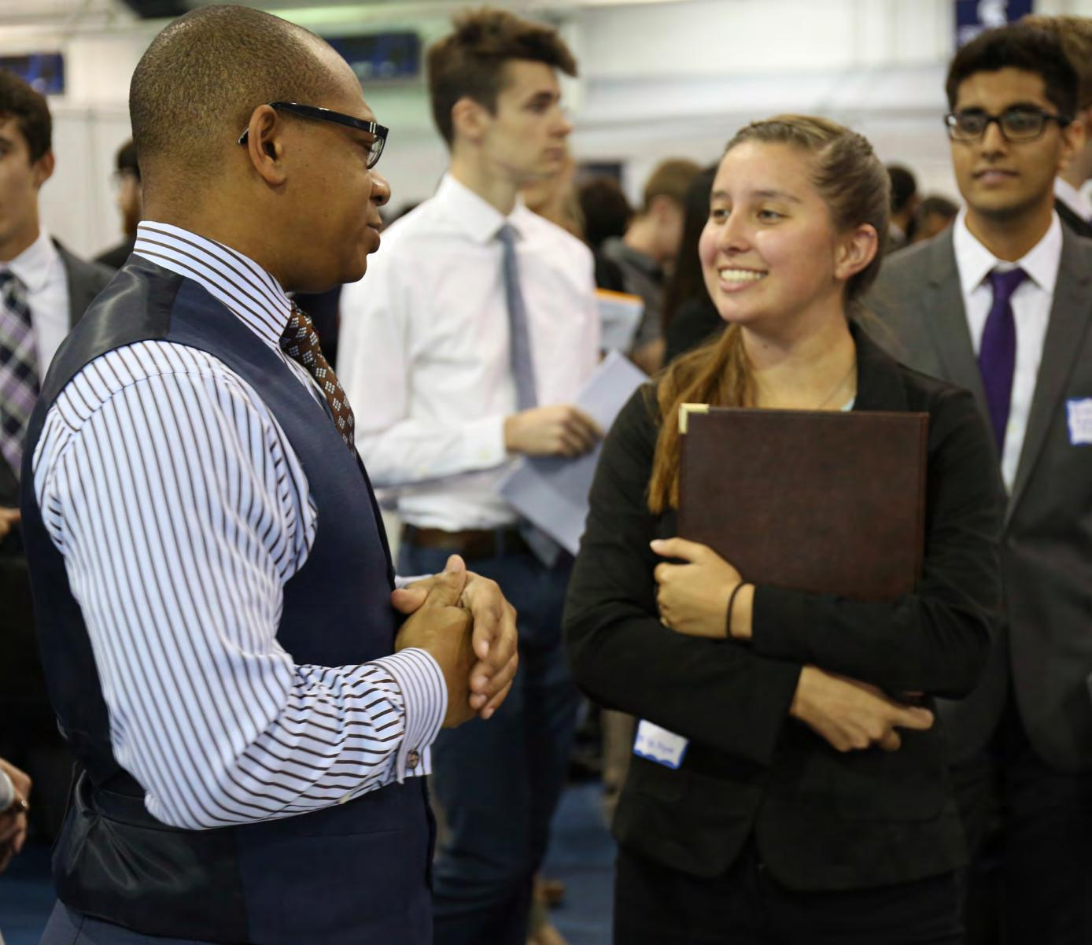
WHO SHOULD YOU LIST AS A REFERENCE?

Three is the most common number of references requested, though you may choose to ask more individuals and use them based on circumstances (e.g., the position or school/program to which you are applying). Ask people who knows you in an academic or professional manner. This means knowing your integrity, your initiative, your professional responsibility, and could be a professor, current or former supervisor, academic or club advisor, coach, committee member, or volunteer coordinator. Do not use family members as professional references.

Have a conversation, in person ideally, in which you ask if they will serve as a positive reference for you. You want those who know you well and have agreed to represent you in the best possible light. If a prospective reference is hesitant, it may be in your best interest to ask someone else. You should tell your references about your career goals and how the position(s) or program(s) supports those goals. Provide them with a copy of your resume or CV, and possibly even cover letters, position or program descriptions, or even a list of things you might hope they would speak to.

Keep your references informed about job or internship search or graduate school application process (e.g., if you have an interview and think it went well and that the next step is a reference check, it’s a good idea to provide a head’s up to your references in the form of a phone call or email message).

After you have accepted a position or a spot in a graduate program, be sure to send thank you notes to all of your references.

106



Your resume and networking
paid off and you have scheduled
an interview. What should you

expect? How should you prepare?
Read through the next section for

interview process guidance.


108 109

Case Western Reserve University / C A R E E R C E N T E R

INTERVIEWING

If you want the job, you have to arrive on time (or 10-15 minutes early), look the part and know your story. What skills do you bring to the table? What makes you stand out? What do you know about the company?

With these things in mind, you can improve your interviewing skills so you can demonstrate your awesomeness.

RESEARCH YOUR POTENTIAL EMPLOYER

One of the mistakes that many job-seekers make is not researching the company with whom they are interviewing. This step can’t be skipped or brushed aside no matter how great you are. Start your research before you apply to the position. This may not be a difficult task with help from the internet, however, you may still run into some situations where information is hard to access.

Where should you begin your research? Some helpful places to start are Handshake and the Career Center website. Also, look through publications like Standard & Poor’s, Dun & Bradstreet, and the Wall Street Journal. Has the company just released a new product that has received attention? How were their sales over the last four quarters? Have there been any major announcements about the company? Those are some of the questions you should have as you look through the information you gather.

OTHER IMPORTANT POINTS ARE:
• | Annual sales | • | Geographic locations
• | Benefits | • | Product lines
• | Career growth potential | • | Services
• | Company growth potential | • Size of the organization
• | Company History | • | Structure of organization
• | Competition | • | Subsidiaries
• | Corporate Headquarter location | • | Training programs

110
LOOK THE PART

First impressions are generally lasting and your appearance at an interview is very important. Your clothes need to be professional looking. That means the outfit is tailored, conservative, and businesslike; so unless your interviewer tells you otherwise, plan on this:

- A nicely tailored suit or dress in generally darker colors (e.g., black, brown, navy, gray); hemlines on dresses or skirts should be two inches or more below the knee

- A light-colored shirt
- Coordinated tie
- Dress socks or neutral or dark-colored pantyhose with no runs
- Dress shoes that are polished and closed-toe.
- Trimmed moustache and/or beard
- Minimal jewelry
- Clear nail polish or a conservative-colored polish. Light make-up.
- Properly combed and styled hair
- Do not wear any cologne or perfume. It might smell great but your interviewer could be allergic!
- Take out all your visible body piercings (nose, eyebrow, tongue, etc.).
- Make sure that your clothing is ironed or pressed.
- Bring a nice padfolio or briefcase to carry extra resumes and your references. Have a pad and something to write with.

- Also remember to not smoke, chew gum, or eat during your interview. (Avoid smoking before the interview as well.)

Talk to one of the Career Center’s career development professionals if you have questions about appropriate dress and appearance in interviews. Remember: You never get a second chance to make a first impression. When in doubt, make an appointment with for a mock interview. We can even record it for playback so you can critique yourself!

111

Case Western Reserve University / C A R E E R C E N T E R

PHONE INTERVIEWS

There are two main types of phone interviews – unexpected and scheduled. In order to be prepared for the unexpected phone call, make sure you have all necessary materials near you at all times during your job search:

- Copy of your resume to allow you to easily answer questions about your past experiences.

- File of “employer research” to help you quickly come up with a few questions about the company for your interviewer.
- Notepad and a pen to record the caller’s name and number along with any notes you want to take during the interview.
- Your calendar to schedule the next interview.

If you get an unexpected interview and the time truly isn’t convenient, ask if you could talk at another time and suggest some alternatives. Don’t forget to choose a quiet location for your phone interview. Make sure that your phone message is professional, in case a prospective employer has to leave a message.
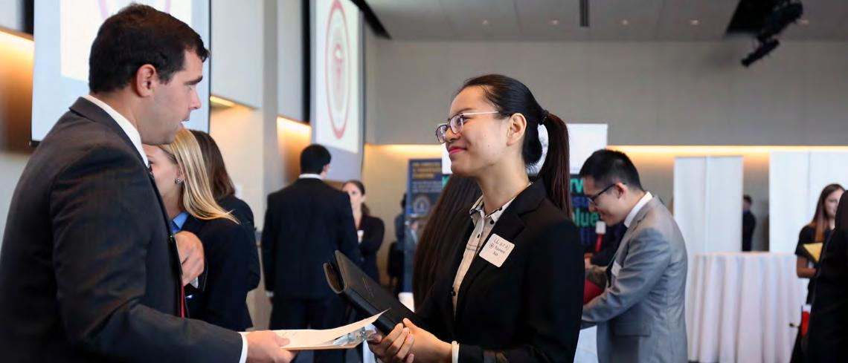

112
SCHEDULED INTERVIEWS - PHONE OR SKYPE

Prepare for a scheduled phone interview just as you would for a face-to-face interview. These suggestions will also hold true for a Skype Interview. Research the company, prepare questions to ask the interviewer, compile a list of your strengths and weaknesses, and practice answers to typical interview questions.

- Keep your resume near you so you can refer to it.
- Have a short list of your accomplishments available to review.

- Have a pen and paper handy for note taking.

- Turn off call-waiting so your call isn’t interrupted.

- Use a quiet location with minimal distractions.

- Make sure your cell phone has a good connection to avoid a dropped call or static on the line, and ensure the battery is fully charged.

PRACTICE INTERVIEWING

Make an appointment with the Career Center to do a mock interview. A staff member will ask you questions, and listen not only for content, but also tone as well as rate and clarity of your speech. Some things to consider include: Are you speaking slowly and clearly? Can you easily be heard? Is your voice portraying you as a confident and enthusiastic candidate? Listen for “ums” and “uhs” and “okays” so you can practice reducing them from your conversational speech.

Also, check out The Big Interview at students.case.edu/my/career. It’s a simple system that combines interview training and video-based practice to help improve your interview technique and build your confidence.

ACCORDING TO NATIONAL ASSOCIATION OF COLLEGE EMPLOYERS 2016 JOB OUTLOOK, THE TOP 5 ATTRIBUTES EMPLOYERS WANT FROM A NEW COLLEGE GRAD:

- Leadership
- Ability to work in a team
- Communications skills (written)
- Problem-solving skills
- Communication skills (verbal)

113

Case Western Reserve University / C A R E E R C E N T E R

DURING THE PHONE INTERVIEW CONTINUED

Do:

- Smile. Smiling will project a positive image to the listener and will change the tone of your voice. Before the interview, consider spending a few minutes listening to your favorite song or watching a funny video on YouTube.

- Speak slowly and enunciate clearly.

- Use the person's title (Mr. or Ms. and their last name.) Only use a first name if they ask you to.

- Stand up; your voice projects more readily and you sound more confident. (phone interview only)

- Dress as you would for an in-person interview; you’ll feel more confident and in turn, more easily maintain a professional attitude.
- Confirm the caller's name and company. Get the caller's telephone number.

- Keep a glass of water handy in case you need it.

- Take your time – it's perfectly acceptable to take a moment or two to collect your thoughts.

- Give succinct answers. Make sure to speak slowly and articulately. When you have answered the question, allow for that possibly uncomfortable moment of silence. This will let the interviewer know that you are through, and then the person will proceed.

- Remember your goal is to set up a face-to-face interview. After you thank the interviewer, ask if it would be possible to meet in person.

Don’t:

- Smoke, chew gum, eat, or drink.

- Be preoccupied with anything else (check email, flip through a book, surf the internet, etc.) while interviewing.

- Interrupt the interviewer.

- Ask about salary and benefits; a phone interview is not the appropriate time for this conversation; save it for subsequent conversations.
- Rely on your body language to convey meaning. Avoid jokes and sarcastic remarks.

- Wear earrings during the interview; earrings can rub against the phone handset, creating an awkward, distracting noise.
- Use a speakerphone.

AFTER THE INTERVIEW

Take notes about what you were asked and how you answered. Remember to say "thank you." Within 24 hours, follow the interview with a thank you note that reiterates your interest in and enthusiasm for the job.
20 QUESTIONS

You usually won’t know what questions your interviewer will ask you, but here is an idea of some common questions that you can anticipate. Visit the Career Center website for more examples and consider scheduling a mock interview for practice.

- Tell me about yourself.

- Why did you choose this college (or major) and how did you arrive at this decision?

- What is your GPA? How do you feel about it? Does it reflect your abilities?

- What has been your greatest challenge?

- If you could change a decision you made, what would you change and why?

- Describe a leadership role of yours and tell why you committed your time to it.

- Describe the project or situation that best demonstrates your analytical abilities.

- How do you deal with pressure?

- Give me a situation in which you failed, and how you handled it.

- Why are you interested in our organization?

- What interests you about this job?

- What is your most significant accomplishment?

- What motivates you?

- If I asked people who know you for one reason why I should hire you, what would they say?

- Describe the type of manager you prefer.

- Tell me about a project of which you are particularly proud and your contribution.

- Describe a situation where you had to work with someone who was difficult; how did you handle it?

- What type of work environment appeals to you most?

- Where do you see yourself in 3-5 years?

- We are looking at a lot of great candidates; why are you the best person for this position?

114 115

BEHAVIOR-BASED INTERVIEWS

Chances are that you will encounter the behavior-based interview at some point in your search. This type of interviewing is based on the simple idea that past behavior is a good indicator of future behavior.

To give a good answer to behavior-based interview questions:

- Think critically about your past experiences that stand out.

- Choose examples related to academics, work/volunteer, or student organization experience. Personal accomplishments like running a marathon, or obtaining a high honor in a national organization work too, but avoid sharing personal relationships or issues as examples.

- Use the STAR method (page 118).

SAMPLE QUESTIONS AND WHAT THE INTERVIEWER IS LOOKING FOR

PROBLEM SOLVING

Give me an example of a problem you solved and the process you used to solve it.

DECISION MAKING

What was the most difficult decision you have made in the last six months?

INITIATIVE

Tell me about your efforts to “sell” a new idea to your supervisor.

HANDLING DETAILS

Of your course assignments, which required the greatest amount of effort in planning/organization?

How would you assess your effectiveness in completing the assignment?

PLANNING

Give me an example of a time when you did not meet a deadline. How did you handle it?

HANDLING AMBIGUITY

Describe a situation in which you were required to operate with little or no structure or direction.

How did you respond?

116

INTERPERSONAL SKILLS

Tell me about a time when you had to adapt to a wide variety of people.

CONFLICT MANAGEMENT

Describe a situation where you had to resolve a conflict or difference of opinion.

LEADERSHIP

Tell me how you’ve led a group or a team to achieve a goal.

MANAGING STRESS

Describe your biggest disappointment.

TECHNICAL EXPERTISE

How have you put your technical skills to use?

CUSTOMER SERVICE

Give me an example of a time when you had to address an angry customer.
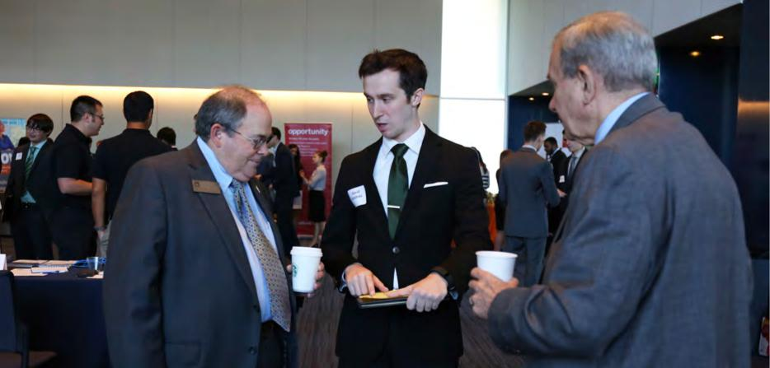

117

Case Western Reserve University / C A R E E R C E N T E R

BE THE "STAR" OF YOUR INTERVIEW

The letters stand for Situation, Task, Action, Result and they are the key to making a good answer great. Most questions are about your past or current attitudes, and your work, academic, or service experiences.

So When talking about these, you should try to choose specific examples to illustrate your answer. Describe the Situation you were in, the Task you were asked to accomplish, the Action you took and why, and the Results of your actions.

Organize your responses using the STAR formula and you’ll avoid long, rambling responses and make a positive impression with your interviewer.

Here’s an example of a response that uses this method to address an employer’s questions about a student’s lackluster GPA:

SITUATION

I entered my sophomore year with a low GPA. I had always done well in school, but I didn’t handle the transition to college well.

TASK

I knew that if I wanted to succeed, I had to develop better study habits and manage my time better.

ACTION

I created a calendar and marked the due dates for all of my assignments and tests. Then I set aside certain hours each day for studying, allowing more for peak times like mid-terms or finals. I made up my mind not to change the plan until after the first semester grades so I could give it a chance to work.

RESULT

My grades improved immediately; I used this system for the whole year and earned a 3.2 while still having time for other activities. My GPA has been strong ever since.

118

As you can see from the example, the STAR method can help you answer tough questions clearly and concisely.

Practice using this method as you prepare for your interview so you can shine when it really matters!

CASE STYLE INTERVIEW

If you are interested in going into consulting, you should prepare to tackle the case style interview. Many firms use case interviews to test a candidate’s communication, critical thinking, and analytical skills. They want to see that you can listen well, respond quickly to issues, and summarize your results clearly.

In a case style interview, you will be given a business problem or scenario that generally falls into one of three types: the brainteaser, the guesstimate, or the business scenario.

Brainteasers are used to gauge your ability to think logically and creatively to solve a problem.

Examples: “If we call oranges ‘oranges’, why don’t we call bananas ‘yellows’ or apples ‘reds’?” or “Why are manhole covers round?”

Guesstimates require you to answer “how many” or “how much” of something. Remember that your goal is to reduce a huge problem into smaller, more manageable parts. Rough calculations are accepted as long as they are realistic, and you don’t have to get the exact answer (although you should be close). Example: “How much money is spent each year on energy efficient light bulbs in Ohio?”

Business scenario questions may be based on real or hypothetical situations. They may test your common sense and ability to ask appropriate questions to get important information. Make sure that you know the specific problem to be addressed and consider general business issues, such as market share and competition. Listen to your interviewer if he/she is trying to assist or guide you.

Example: “A small airline company based out of Cleveland wants to add a new route between Cleveland and New York. The CEO wants your advice on whether they should go forward with service to the new destination.”

119

Case Western Reserve University / C A R E E R C E N T E R

PREPARING FOR A CASE STYLE INTERVIEW

To prepare, make sure that you are familiar with the three basic types of questions you may be asked. Research examples of case questions and schedule a case style mock interview with the Career Center. Always be on time for the interview and bring some paper, a pencil, a watch (to keep track of time) and a calculator (you may not be able to use it). In the case that you cannot use your calculator, make sure that you practice simple calculations like averages and percentages. Make sure your materials are all held neatly in a padfolio or briefcase.

DURING THE CASE STYLE INTERVIEW

Be sure to listen to the question being asked so that you are addressing the right issue. Take notes when the interviewer is telling you the case and repeat it back once she/he finishes. You will also want to ask for details to clarify the case, such as the company type, market share, competition, long term and short term goals. Break the problem into manageable parts and prioritize them. Think about issues before speaking and as you are responding, write down or chart your answer. This will help you recall some assumptions you made along the way. It will also help to keep your response organized and logical, while also showing the interviewer that you are making logical assumptions that can be supported by calculations.

Keep an eye on the clock so that you cover the case fully and provide a complete summary within the time allotted. The interviewer may also provide some feedback at the end. Be sure to listen and if you feel like you made a mistake, don’t panic. Ask the interviewer for feedback on ways you could have answered better.

RESOURCES FOR CASE STYLE INTERVIEWS
Books

- Ace Your Case: The WetFeet Insider Guide to Consulting Interviews - An introduction to the case interview, with explanations of the most common question types and how to answer them. Detailed examples of good and bad answers. Each books contains different sample cases.

- Case in Point9: Complete Case Interview Preparation, by Marc P. Cosentino - Focuses on the skills you will need to handle a case interview confidently. Includes recently asked case questions and Ivy case drills.
- Case Interview Secrets: A Former McKinsey Interviewer Reveals How to Get Multiple Job Offers in Consulting, by Victor Cheng - Step-by-step instructions on how to dominate the case interview, considered by many to be the most complex, most difficult, and most intimidating corporate job interview in the world.

- Crack the Case System: How to Conquer Your Case Interviews, by David Ohrvall

- Vault Guide to the Case Interview, 8th edition - Frameworks for constructing and handling case questions, plus practice questions. Vault has an entire series of guides dedicated to the field of consulting and the case inter-view.

120

Case Western Reserve University / C A R E E R C E N T E R

CASE INTERVIEW PREP WEBSITES
While each of these sites sells services, all have high quality free resources available.

• CaseInterview.com - Site of Victor Cheng, author of Case Interview Secrets. Those interested can sign up to receive his highly informative free newsletter.
• CaseQuestions.com - Site of Marc Costenino, author of Case in Point.
• ConsultingCase101.com - Lots of practice cases for every scenario you could conceive.

CONSULTING COMPANY WEBSITES
Listed alphabetically; many contain not only solid interview advice but sample cases.
• Bain & Company
• Boston Consulting Group
• Deloitte Consulting, LLP
• McKinsey & Company
• Oliver Wyman

QUESTIONS YOU MAY WANT TO ASK

At some point during the interview you will be invited to ask questions and you should be prepared. Ask questions that reflect your interest in the organization and/or in the position. Your questions should reflect your research of the company. Did you notice anything in the company’s annual report that you are interested in learning more about? What did you learn at the company’s information session held the night before the interview? What questions did you have when you looked at their website?

Below is a list of general questions that you might also want to keep in mind. Remember, you should make up specific questions for each interview.

- Describe the type of work I would be doing or the types of projects I will be working on.

- What are the short-term and long-term objectives of the organization?

- How is the training or orientation program for new employees structured?

- What characteristics would the ideal job candidate have for this position?

- Can you tell me about the people I would be reporting to?

- What do you see as the most challenging aspects of the position?

- When and how will job evaluations take place?

- What percentage of your [co-ops, interns] are hired after graduation?

- What are the areas of anticipated growth for the company?

- Inquire into the structure of the company and how your department fits in.

- What are the opportunities for advancement?

- What is your (the interviewer’s) position in the company? (Ask for a business card)
• What is the next step in this search? | 121
• When can I expect to hear from you about my candidacy?

CAN THEY ASK ME THAT? LEGAL AND ILLEGAL QUESTIONS

INQUIRY AREA ILLEGAL QUESTIONS

National Origin/ Citizenship Are you a U.S. citizen? Where

were you/your parents born?

What is your “native tongue”?

Age How old are you? When did

you graduate? What’s your

birth date?

Marital/Family Status What’s your marital status? With

whom do you live? Do you plan to

have a family? When? How many

kids do you have? What are your

child-care arrangements?

Affiliations What clubs or social

organizations do you belong to? If

clubs are of a religious or political

nature, information may be used

as a determinant to your hiring.

LEGAL QUESTIONS

Are you authorized to work in the United States? What language do you read/ speak/write fluently? (This question is okay only if this ability is relevant to the performance of the job.)

Are you over the age of 18?

Would you be willing to relocate if necessary? Would you be able and willing to travel as needed for the job? (This question is okay if it is asked of all applicants for the job.) Would you

be able and willing to work overtime as necessary? (This question is okay assuming it is asked of all applicants for the job.)

List any professional or trade groups or other organizations that you belong to that you consider relevant to your ability to perform this job.

INQUIRY AREA

Personal

Disabilities

Arrest Record

Military

ILLEGAL QUESTIONS

How tall are you? How much do you weigh? (Questions about height and weight are not acceptable unless minimum standards are essential for the safe performance of the job.)

Do you have any disabilities? Please complete the following medical history. Have you had any recent or past illnesses or operations? If yes, list them and give dates when these occurred. What was the date of your last physical exam? How’s your fam-ily’s health? When did you lose your eyesight? How? Do you need an accommodation to perform the job? (This question can be asked only after a job offer has been made.)

Have you ever been arrested?

If you’ve been in the military, were you honorably discharged?

LEGAL QUESTIONS

Are you able to lift a 50-pound weight and carry it 100 yards, as that is part of the job?

Are you able to perform the essential functions of this job? (This question is okay if the interviewer has thoroughly described the job.) Can you demonstrate how you would perform the following job-related functions? As part of the hiring process, after a job offer has been made, you will be required to undergo a medical exam. (Exam results must be kept strictly confidential, except medical/ safety personnel may be informed if emergency medical treatment is required, and supervisors may be informed about necessary job accommodations, based on exam results.)

Have you ever been convicted of _____? (The crime named should be reasonably related to the performance of the job in question.)

In what branch of the Armed Forces did you serve? What type of training or education did you receive in the military?

122 123

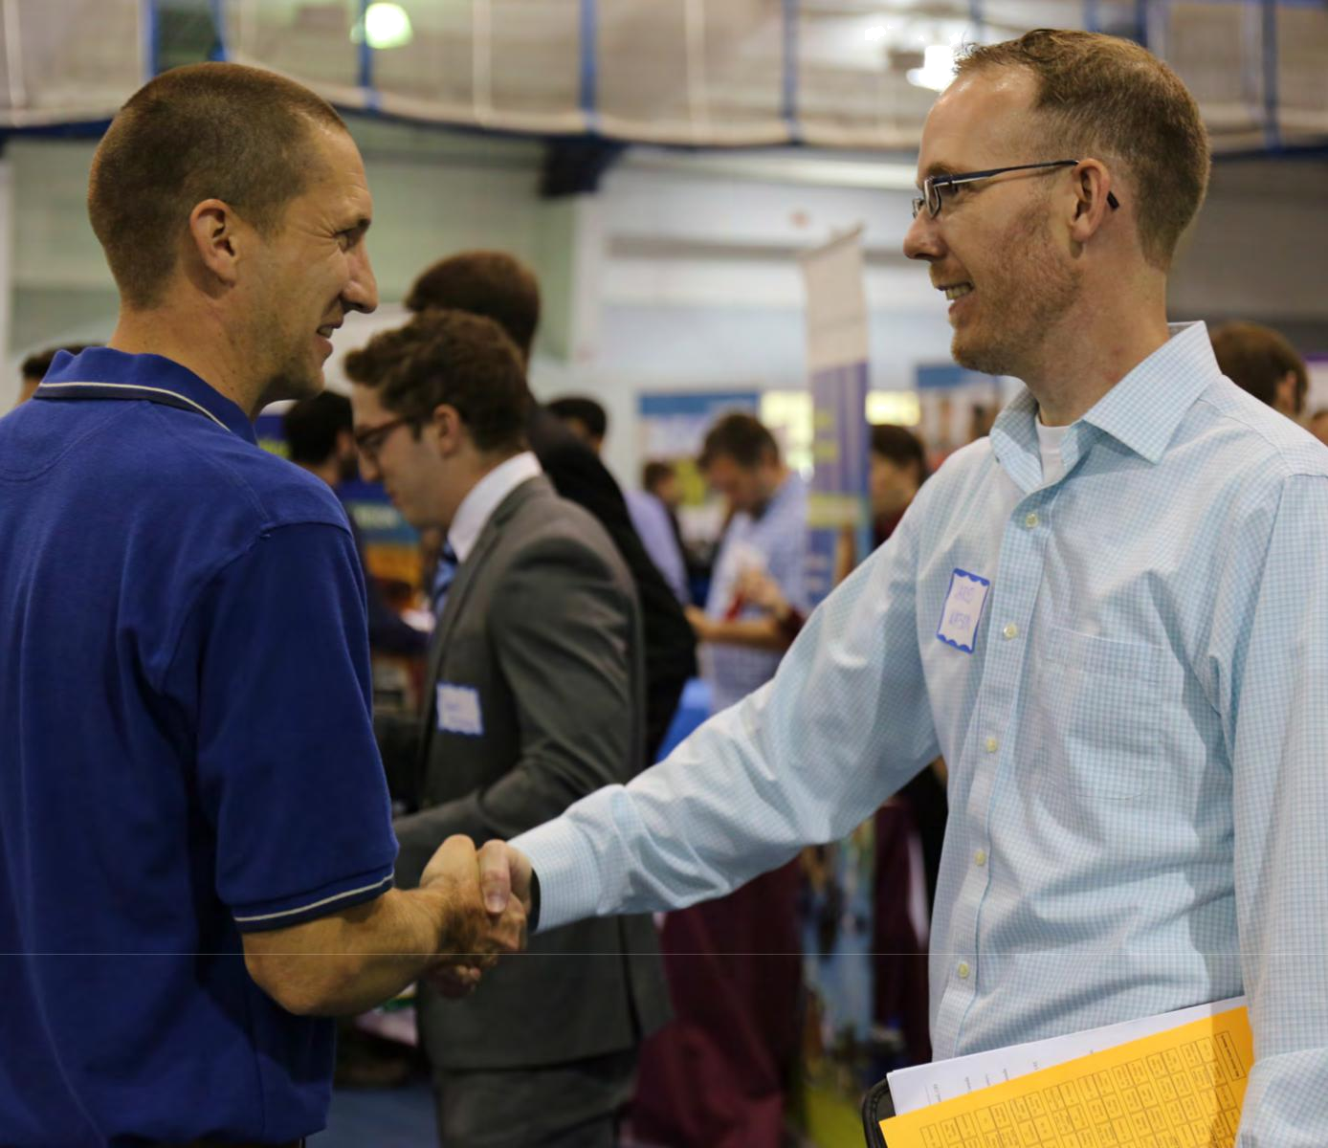
INTERVIEWING RECAP:

PREPARATION

Make sure you can talk about what is on your resume. The more comfortable you are with telling your story, the better. Arrive about 10-15 minutes ahead of schedule and wait patiently for the interviewer.

HANDSHAKE

A firm handshake reflects confidence. Don’t squeeze so hard that you hurt the interviewer. On the other hand, don’t offer a flimsy or loose handshake either.

NON-VERBAL COMMUNICATION

Make sure you stand and sit up straight, make eye contact, and actively listen. All of these things are part of your non-verbal communication that lets the interviewer know that you are alert and engaged.

EYE CONTACT

Look your interviewer in the eye in a friendly manner. You don’t have to stare, but you also want to avoid frequently looking up, down, or to the side, as these suggest lack of confidence. It is okay to look away when thinking of an answer to a challenging question.

SPEECH

Correct grammar is important during an interview. Stay away from slang words and text talk.

POSITIVE ATTITUDE

Your attitude should reflect an optimistic, self-confident person. Even when talking about challenges you’ve faced, courses you didn’t like, or your biggest failure, you want to demonstrate that you can take responsibility and solve a problem. Don’t dwell on the negative parts of the story; focus on what you learned and how you grew.

RELAX

Sure, this is easier said than done, but try not to let your nerves get the best of you. Remember that your skills (shown on your resume) earned you the interview and so now it’s your chance to talk about them in more detail! Take deep breaths and stay calm. Schedule a mock interview so you can feel a lot more comfortable for the real thing. We will help you learn to be “comfortable being uncomfortable!”

124 125

Case Western Reserve University / C A R E E R C E N T E R

You have finally received that

phone call, email or letter

saying that the company you

interviewed with would like to

make you a formal job offer.

Congratulations!


Now, what do you do? Is the salary enough? Is the offer everything

you hoped it would be? If not, how is the best way to handle that,

and what about the other companies you are in the process of

interviewing with? The next few pages provide some tips for

evaluation, negotiation, professional communication and etiquette.

126 127

Case Western Reserve University / C A R E E R C E N T E R

NEGOTIATION

Once you have been offered a job you have the opportunity to discuss the terms of that offer with your potential employer. First, be sure you understand the offer itself: type of work, salary, benefits, start date, location, training period, relocation requirements, supervisor, etc. If the organization extending the offer has not provided this information, ask for it. It’s impossible to make a well-informed decision without it.

Next, it is important to understand what salary is reasonable to expect for this position. Research salary ranges for your field allowing for differences by geographic location. Also, keep in mind that salaries vary among metropolitan, suburban and rural areas. Use a cost of living calculator to determine how much money you will need to earn in a specific location to meet your needs.

Remember that salary alone does not determine the worth of an offer. Consider all aspects of the total compensation package such as benefits, vacation, commute time, parking fees, start date, performance review schedule, and the industry experience you’ll gain.

HOW TO NEGOTIATE

Before entering any negotiation, be clear about what you want. This does not mean you’ll get exactly that, but it will help you determine what you are willing to concede.

When negotiating, approach the employer early in your decision-making process and maintain professionalism throughout all interactions. Remember, this is a business transaction.

Before you contact the employer, plan what you will say and practice aloud. A friend or someone in the Career Center can critique your reasoning and help you prepare for questions.

Always begin by expressing genuine interest in the position and the organization, emphasizing the areas of agreement and leaving room for compromise elsewhere.
CONSIDERATIONS FOR SALARY NEGOTIATION

- Entry-level employees generally do not have a lot of room to negotiate; increasing salary often requires special approval.

- Public sector employees typically have salary scales for classes of jobs, and inexperienced hires usually start at the first step on the scale.

- To an employer, having a high GPA or being a fast learner are normally not justifiable reasons for a higher salary.

- Employers are less likely to negotiate in a tight economy.

- Employers need to consider equity for other candidates and existing employees.

WHAT ELSE TO NEGOTIATE

Start Date: new employees must accrue vacation time and it may be a while before you’re eligible; if you want to take some time off before you start, negotiate this time in advance.

Performance Bonus: received at the end of the year and based upon your performance or the organization’s performance.

Early Performance Review and Salary Review: propose an early review date tied to a potential salary increase.

Vacation: if you want an extended vacation in December and you start work in August, negotiate in advance for time off.

Professional Development: employers often cover professional association dues and conference fees; some employers offer tuition reimbursement as well.

Be prepared to support your points of disagreement, outlining the parts you would like to alter, your suggestions on how this can be done and why it would serve the company’s best interests.

Be prepared to defend your proposal. Provide reasons to support your request, such as relevant internship experience, special skills or current competing job offers.

Relocation Expenses: reimbursement for moving expenses.

Flex Time: nonstandard work hours can help lessen commute time and accommodate other interests.

Signing Bonus: a onetime cash bonus received when you start working.

SALARY RESOURCES

online.onetcenter.org
www.bls.gov
www.salary.com

www.salaryexpert.com

128

129

Case Western Reserve University / C A R E E R C E N T E R

WHAT ELSE TO NEGOTIATE

Do:

- Make sure you've done your research on the salary you should expect for the position you're seeking.

- Be aware of your strengths and achievements. Also be sure to demonstrate the value you'll bring to the employer.
- Let the employer make the first salary offer.

- If asked, say you expect a salary that is competitive with the market -- or give a salary range that you find acceptable.
- Thank the employer for the offer when it is made.

- Get the offer in writing.

- Ask for time to consider the offer. Consider all factors (benefits, commute, industry experience, team you’ll be working with) before making any job offer decisions.
- Negotiate if the offer made is inadequate.

- Consider negotiating other aspects of the total compensation package (e.g. shorter review time, better title, better bonuses, vacation time) in lieu of negotiating salary.
- Understand that if an employer gives you what you’ve asked for, they expect that you will accept their offer.
- Send a brief thank you note after accepting an offer.

Don’t:

- Bring up salary before the employer does. Delay salary negotiation until you know exactly what the position entails.
- Inflate your current earnings just to get a higher salary offer.

- Feel obligated to accept the first salary offer.

- Get overly aggressive in negotiating the salary you want. Be respectful and realistic.

- Focus on salary alone. Consider the entire compensation package (vacation time, insurance, bonuses).

- Enter salary negotiations as part of an ego trip or part of a game or test of wills.

- Accept an offer if you’re not sure about the job or company. It’s worth the wait for the right career “fit”.

130
When all goes as planned, you’ll be able to accept the offer that works best for you. The tough part will be declining offers you received. The acceptance goes beyond saying “yes!” It means yes. Once you commit, the company expects you to follow through. Once you have made a commitment, send a note thanking the other employer(s) you have interviewed with and let them know that you have accepted another offer. This will be appreciated by the employer and will keep your positive interactions with them intact. Chances are that if you stay in the same field for a while you will see them again, so trust us on this.
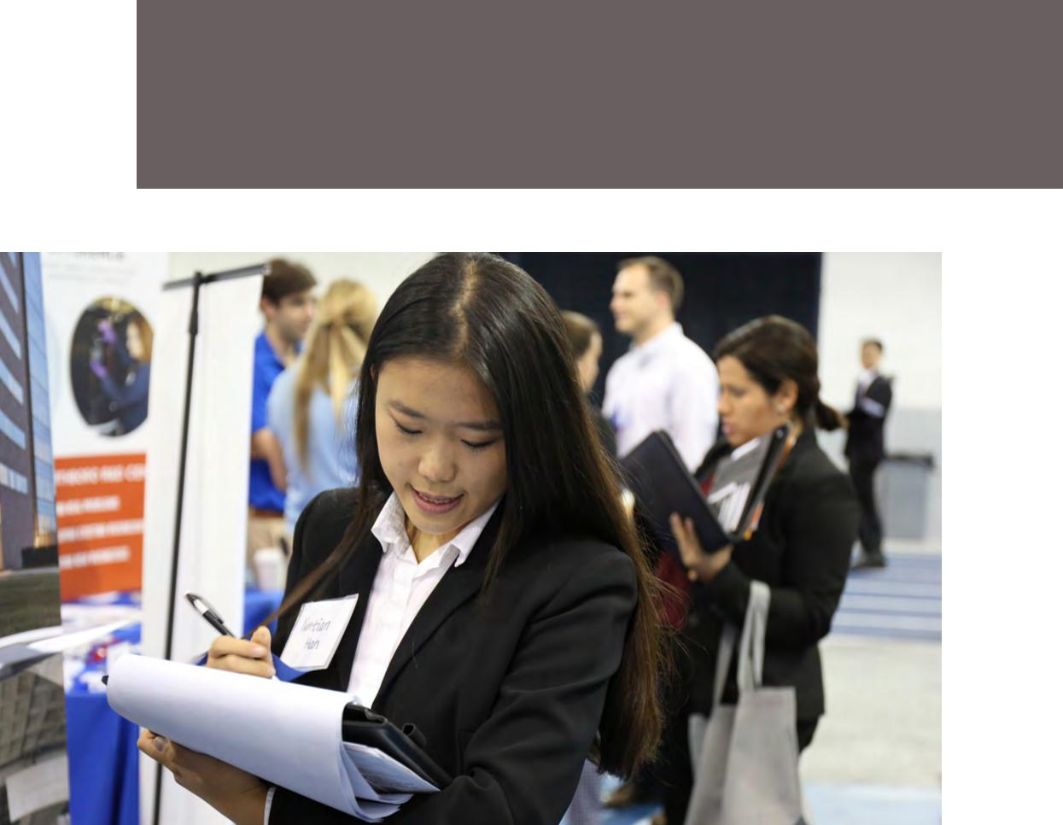

131

Case Western Reserve University / C A R E E R C E N T E R

ACCEPT/REGRET EXAMPLES

Email of Acceptance Example

Date: [date and time stamped]

To: grace.ashby@adventures.com

From: Manny.Kim@case.edu

Subject: Java Programmer with adeventures.com

Dear Ms. Ashby:

Thank you for extending an offer of employment with adventures.com. I am

pleased to accept your offer for the position of Java Programmer at an annual

salary of $60,000. I believe your position offers an excellent opportunity to

work in a challenging and supportive environment.

As we discussed, I plan to start work on July 10, 2018. I understand that this is

contingent upon my passing a routine physical exam and background check,

and I am proceeding with the necessary arrangements.

Please let me know if you need additional information. I appreciate the per-

sonal time and attention you have given me throughout this process. I look

forward to working together.

Sincerely,

Manny Kinn

Decline Email Example

Date: [date and time stamped]

To cassie.wilson@centurytechnoligies.com

From: kelley.kitely@case.edu

Subject: Software Developer Offer with Century Technologies

Dear Ms. Wilson:

Thank you for offering me a position as a Software Developer with Century Tech-

nologies. I found our discussions during the interview process helpful to learn

more about the details of this position. I appreciated the time you allowed me to

consider your offer.

After considerable thought about my career goals, I have chosen to accept an

offer from an employer headquartered closer to my family. At this time, I must

respectfully decline your kind offer. This was a difficult decision for me, although

I believe it is the appropriate one at this time in my career.

I want to thank you for the time and consideration you have given my candidacy.

It was a pleasure meeting you and learning more about Century Technologies.

Sincerely,

Kelley Kitely

132 133

We hope that the advice and ideas in this Career Search Guide will help
make your transition to the “real world” just a bit easier and a little
less uncertain. When it comes to graduating, the future can seem both

exciting and daunting. We are here to help you, wherever you are in the

career development process, and we look forward to meeting each and
every one of you.



Wishing you the best of luck in
your education and career! The

University Career Center Staff
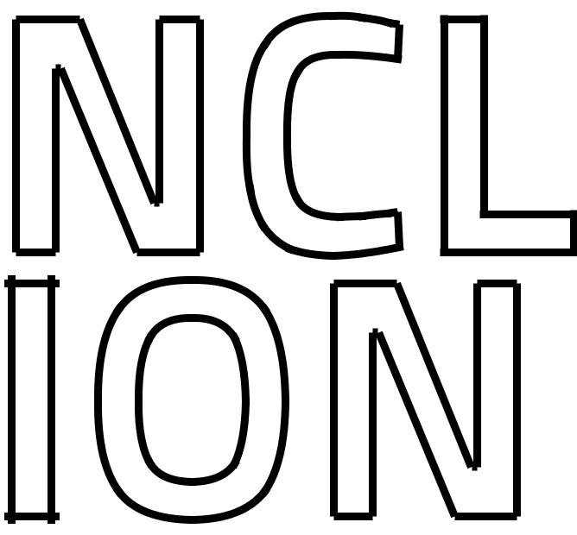

We would like to thank all who contributed to the writing and editing
of this guide. For an appointment call 216.368.4446 or email careers@
case.edu. For employer advertising information for our next guide,

email employers@case.edu.

134 135

Case Western Reserve University / C A R E E R C E N T E R

Career Search Guide / 2017-2018

Case Western Reserve University Career Center

10900 Euclid Avenue

229 Sears Library Building

Cleveland, OH 44106

Hours: Monday - Friday, 8:30 a.m. to 5 p.m.

P: 216.368.4446


E: careers@case.edu
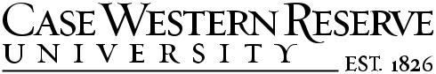

W: students.case.edu/careers

