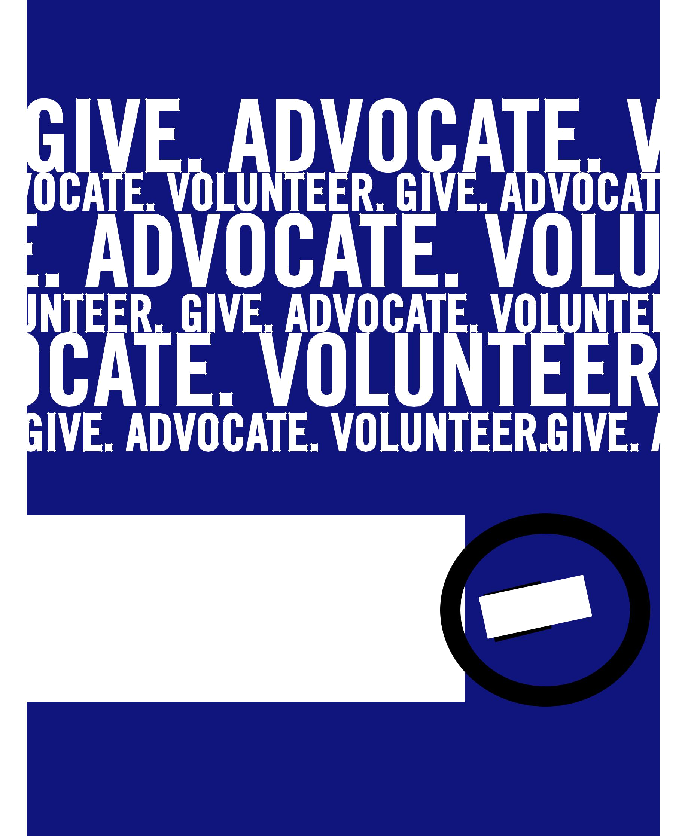

ADVOCACY
TOOLKIT

UNITED WAY OF PENNSYLVANIA
0

1
Table of Contents

UWP Priorities For The Common Good………………….…………………………2

Proposed UWP Criteria for Identifying Policy Issues……………..………5

United Way and Advocacy FAQs………….……………..........…………………7

Why United Way Advocates…………………..…………………………...….…10

The Why, What And How Of Public Policy And Advocacy……………...12

United Way’s Values And Principles………………………………………….…13

Network Citizenship Considerations.................……………….…...…14

Advocacy Strategy Chart………………………………………………………….…….15

Advocacy Checklist…………………….………………………………………………….16

Step-By-Step Guide To Powermapping…………………..………………………..18

Guidelines For Effectively Telling Your Story…………………………………..20

Setting Up Meetings With Members Of Congress……………………….22

Sample Email To Scheduler……………………………………………………..…..….23

Follow-Up Phone Call: Sample Talking Points………….……………………..24

Sample Email To Scheduler If Meeting Is Confirmed/Denied………25

Tips For Meeting Your Members Of Congress………..………………………..26

Effective Advocacy Helpful Tips…………………….……………………………….28

Anatomy of a Typical Legislative Meeting…………..………………………..29

Sample Scenarios With Advice

Potentially Divisive Social Issue………………………..……………..…30

Competing United Way Positions on the Same Issue……...31

No State or Federal Position…………….……………………………..32

How A Bill Becomes A Law………………………..………………………..….33

23-Month Pennsylvania Legislative Cycle……………………….……………35

Social Media and Advocacy……………………………………………………36

Example Social Media Messaging (PA 2-1-1)…………………………………38

Helpful Internet Resources for Pennsylvania Advocates…………..…..39

Digital Advocacy Resources………………………..…………………………..…..40

1
Priorities for the Common Good

2017- 2018

United Way fights for the health, education and financial stability of every person in each community. United Way has the expertise and relationships to develop meaningful and lasting cross-sector solutions to community challenges. Through the generosity of donors, United Ways are able to reduce burdens on public sector programs.

PA 2-1-1: Measuring Need, Connecting Volunteers and Assisting People in Need

Imagine a service that can provide policymakers with data that identifies the most pressing unmet health and human service needs in communities. 2-1-1 is like 4-1-1 but for health and human services and disaster relief. The 2-1-1 system is funded by a combination of United Way support, grants and private contributions, and contracts. This service is a one-stop connection for any Pennsylvanian to get a referral for any service because 2-1-1 possesses the most comprehensive database of public and private resources available in communities. United Way is leading the charge to make sure this service is available to all Pennsylvanians.

UWP supports:

- Investment of state funds for upfront costs to create a public-private partnership, strengthen 2-1-1 and assure a consistent experience for every user in the state.
- Explore ways to increase the efficiency of state and local governments by contracting to provide services currently offered through government-operated information phone lines and providing data for health and human service planning at the state and local level.
- Working closely with state agencies including the Departments of Aging, Health, Human Services, and the Pennsylvania Emergency Management Agency to define shared goals to save taxpayer dollars by connecting Pennsylvanians in need to the right services at the right time.

Early Childhood Education and Out of School Time Activities to Prepare PA’s Kids for the Jobs of Tomorrow

United Way’s network goals include increasing school readiness and assuring that children read at grade level by third grade, successful completion of middle school and increasing high school graduation rates. Local United Ways advance these goals in numerous ways, including funding high quality early education slots, summer learning programs, truancy prevention and after school programs. United Way of Pennsylvania supports policies which increase access to high quality and affordable early learning and out of school time activities. Both are essential to developing a qualified work force for Pennsylvania’s future.

Researchers know that a child’s brain is 90 percent developed by age five, making the early years a critical time in child development. Positive outcomes of high quality early childhood

2
education include reducing the need for special education and remedial instruction, increasing the likelihood of graduation and college enrollment, and decreasing dropout rates, crime and incarceration. Every dollar invested returns up to $17 in savings and benefits to the state.

Studies have also demonstrated that out of school time programs offer another opportunity for disadvantaged students to gain ground. Students in quality OST programs attend school more often, have higher grades and standardized test scores, and show improvements in their behavior. OST programs also improve work habits and lead to higher levels of persistence. Summer programming offsets the summer slide, which can prevent students from beginning a new school year an average of one month behind in academic progress they attained at the end of the prior school year. Pennsylvania also faces work force shortages in several fields during the coming decades, including science and technology, health care and accounting. We have an opportunity to align OST programs to help address these work force needs and prepare students for family-sustaining jobs. UWP supports the following related initiatives:

- Assuring all children have access to consistent, high quality and affordable early learning. United Way supports increased funding for pre-Kindergarten and Head State programs with investments targeted to at- risk kids.

- Creating a forum for out of school time program funders, providers, schools and policy makers to identify stable sources of funding, consider quality program standards, and foster partnerships to support out of school time activities.

- Incentives for aligning out of school activities with Pennsylvania’s projected work force needs in order to prepare Pennsylvania’s kids for high-demand, family sustaining jobs.

- Increased state and federal funding for the child care development block grant to support the healthy development and school readiness needs of children, including a focus on increasing quality.

Income Stability and Family Self-Sufficiency: Breaking the Cycle of Poverty

United Way’s goals are to increase family-sustaining employment, assure access to income supports for those who need it, address challenges to the affordability of housing and help families grow savings and assets.

Poverty is a common measure used to identify needs; however, there are also many working families in Pennsylvania who cannot satisfy all of their core expenses. Pennsylvania will experience work force shortages as the baby-boomer generation retires and technology continues to advance. People need training and education to fill these gaps, but most of these career paths offer family-sustaining wages. Providing support to working low and median income families by advocating for tax credits such as the Earned Income Tax Credit, and job training and career development policies is vital to the work United Ways are doing to break the cycle of poverty and ensure a workforce that is able to meet rising living costs.

3

UWP supports the following related initiatives:

- State and federal Earned Income Tax Credits to support working families and reduce poverty.

- Maintaining Pennsylvania’s strong laws, which prohibit predatory lenders from taking advantage of individuals with limited to no income.
- Improving Pennsylvania’s affordable housing options in rural and urban areas for media and low-income individuals and families, along with veterans, seniors and the disabled.
- Job training and career development policies which align to address impending work force shortages.

Expanding access to vital health care programs including Medicaid and CHIP which provide all essential health benefits including behavioral health services. This benefits the health of Pennsylvania children and families, and also contributes to income stability since one significant health issue or prescription can push the working poor who don’t have access to an employer sponsored health care plan into poverty.

State Budgeting to Strengthen Communities

State government relies on thousands of nonprofits to deliver services to Pennsylvanians. Nonprofits pride themselves on their ingenuity and their commitment to serve the public, and take very seriously the public trust that is placed in their work. We urge the Governor and the legislature to take steps which will assure that their service delivery partners are supported to complete this work.

United Way of Pennsylvania will advocate for funding levels which support our work to fight for the health, financial stability and education of every person in each community in our state. We urge the General Assembly and the Governor to recognize that funding levels for many services have not kept pace with increases in demands, nor increases in costs of providing services, and to invest in health and human service programs which demonstrate positive outcomes or provide basic safety net services for Pennsylvanians.

Every commonwealth budget impasse is devastating to the service delivery system. They result in service disruptions or waiting lists for much-needed help for Pennsylvania’s vulnerable citizens. Even where providers are able to maintain services due to borrowing or drawing on organizational reserves, the impasse causes resources to be diverted away from services.

United Way of Pennsylvania supports amendments to state law which protect Pennsylvania’s service recipients and service providers by assuring that federal dollars allocated to the Commonwealth, and state dollars for essential services that directly impact the health and safety of Pennsylvanians, continue to be paid during a budget impasse. We also support changes to the state budget process which will decrease the likelihood of future budget impasses.

4

Source: United Way of Pennsylvania
UNITED WAY OF PENNSYLVANIA CRITERIA FOR IDENTIFYING POLICY ISSUES FOR ADVOCACY

United Ways relate to many different stakeholders: health and human service providers, government, business, labor, the education and health care communities, media and other funders. Agreeing on a framework for selecting issues for advocacy is needed to guide our public policy work. The following criteria have been developed to assist the Public Policy Committee and Board in selecting issues for advocacy.

- Is the issue a priority for local United Ways (for example as reflected in the responses to the issues survey) and can it be easily communicated to key UW constituencies?

- Is there an initiative being advanced by the Administration or the Legislature that United Way should respond to?

- Does the issue represent a “bread and butter” issue i.e. the capacity to affect United Ways’ fundraising?

- Does the issue affect the infrastructure of the voluntary sector—a “crosscutting issue”?

- Would a public policy response to this issue or initiative assist local United Ways with their community impact work?

- Will there be low or no negative impact to United Way for advocating on this issue?

- Can the desired solution be achieved in a reasonable amount of time?

CRITERIA FOR PRIORITIZING ISSUES FOR ADVOCACY

Once a list of issues is identified using these criteria, the Public Policy Committee and Board, will approve priorities for advocacy work, guided by the following criteria:

- Does United Way have the legitimacy to advocate on the issue?

- Will United Way’s involvement make a difference on the issue and will resulting change be significant enough to merit the effort?

- Does UWP have the resources to significantly impact the issue, or to work in partnership with others to do so?

5

CRITERIA FOR EVALUATING PARTICIPATION IN COALITIONS

Staff will utilize the same criteria listed above to evaluate invitations to participate in state-level advocacy coalitions convened by other organizations. Staff will also review the membership of the coalition in making a determination about whether to participate, and will re-evaluate UWP’s participation if the membership composition of the coalition changes. Coalition members’ missions and positions should align with UWP’s mission and vision. Staff may ask the public policy committee to weigh in with recommendations or concerns related to questions about the impact of coalition participation on local United Way relationships.

6

Source: United Way of Pennsylvania

United Way and Advocacy – Frequently Asked Questions

United Way has a vital role to play in strengthening democracy, advancing freedom of expression and adding richness and diversity to community life. Throughout our history, Americans have turned to nonprofit organizations to provide a strong, collective voice to inform and influence public policy. Non-profit organizations – including their board members, volunteers and community partners – have tremendous potential to improve laws and by doing so, to improve the lives of people they serve.

Non-profits need to understand how public policy impacts their programs (think funding levels for high quality early childhood education programs or the Education Improvement Tax Credit) as well as the operations of the nonprofit (think sales tax exemption or the purely public charities property tax exemption). Public policy includes government laws, regulations and budgetary funding decisions.

What is advocacy?

Advocacy is educating and creating awareness among legislators and the general public of issues facing the community and the importance of aligning public policy to address the need. Advocacy does not endorse or oppose specific legislation, but rather informs the community at large how public policy decisions impact service provision.

Lobbying is a form of advocacy, but not all advocacy is lobbying. Most non-profits can and do engage in as much advocacy as possible to achieve their goals.

What are some examples of advocacy in action?

- Providing technical assistance or advice to a legislator or legislative body in response to a request.
- Making available nonpartisan analysis, study or research.

- Examinations and discussions of broad social, economic and similar problems. o Communicating with a legislative body about matters which might affect the

existence of the nonprofit organization, its power and duties, its tax exempt status, or the deduction of contributions to the organization.

7
What is lobbying?

Lobbying is one form of advocacy which involves either direct or grassroots communications with legislators or their staffs in order to influence specific pieces of legislation. Nonprofits can engage in some lobbying but there are IRS rules about how much – the amount of time and money – can be spent on these activities while still retaining the 501(c)(3) designation. State laws also require individuals and organizations who engage in lobbying activities (direct or grassroots) to register and report expenses. There are some exemptions, including an individual who does not receive economic consideration for lobbying, an individual who lobbies for his or her employer for 20 hours or less per calendar quarter, or an individual whose total economic consideration for lobbying is less than $2500 per calendar quarter.

Can non-profits lobby?

Yes. Contrary to popular opinion, non-profits are legally entitled to lobby and advocate for the causes and constituencies we represent. However, charitable organizations are prohibited from participating in partisan politics. Nonpartisanship reinforces your organizational status as a trusted community institution that is respectful of the personal views of your clients and constituents.

What kind of political activity is a non-profit absolutely not allowed to engage in? Non-profits may not use charitable resources for partisan or political activities. This means non-profit charities may not engage in promoting or opposing political candidates or parties in any way. Doing so will result in the loss of tax-exempt status.

Why have other United Ways decided to engage in advocacy?

There are other business reasons to advocate, aside from simply trying to influence public policy for the betterment of our communities. Advocacy can complement a non-profit’s other functions. It can help educate people about the nature and scope of the issues a non-profit addresses. It can help raise a non-profit’s visibility and help its fundraising. It can help give your non-profit’s constituents a chance to tell their stories in order to change policies that affect your community.

Who should be involved in advocacy?

Staff and board members should engage in advocacy on behalf of the nonprofit. Donors and volunteers can also lend a boost to nonprofit advocacy.

What should my organization do to assure proper governance of advocacy?

It is important to establish guidelines around your United Way’s advocacy agenda so that the network of staff leadership, board and volunteers all have consistent definitions and expectations. The Board should adopt a policy or process to guide public policy or advocacy decisions. This would include a definition of criteria used to determine the organization’s purview in public policy advocacy.

8
Some organizations may choose to develop a local public policy agenda with input from a committee of volunteers. Others could choose to build their advocacy program from the UWP public policy priorities. UWP staff is available to help local Boards set a policy for advocacy.

Can you recommend some criteria to use in determining what type of issues our nonprofit will advocate?

Consider the following:

- Is the issue related to your ability to achieve your mission?
- Are there aspects of the issue that impact the interests of your organization? o Does the issue or its resolution directly affect United Way interests, those of

participating agencies, or clients in programs funded by United Way? o Is there, or do you reasonably anticipate, a consensus among the

members/constituents of the organization on the position to be taken?

o Will your organization be perceived as legitimately concerned and an appropriate advocate for the position to be taken?

o Will the issue affect United Way’s ability to raise funds?
o What is the probability of success or of making a critical difference if United Way engages in advocacy on an issue?

Compiled by Kristen Rotz, President, United Way of Pennsylvania, and Jim Cawley, President and CEO, United Way of Greater Philadelphia and Southern New Jersey

Kristen Rotz has nearly fifteen years of advocacy experience in Pennsylvania, and has been responsible for grassroots advocate training and lobbying disclosure compliance for multiple statewide nonprofit organizations. Jim Cawley held elected offices at the state and county level, and he is an attorney with a strong understanding of how laws affect the framework for nonprofit organizations to get involved in advocacy. Jim and Kristen both believe advocacy is an appropriate and essential function for Pennsylvania United Ways to maximize their results in their communities.

UWP staff is available to help local United Way Boards develop accountable, non-partisan advocacy plans for organizations of all sizes. Please reach out us by contacting Kristen at 717-238-7365 or krotz@uwp.org.

9

Source: United Way of Pennsylvania

Why United Way Advocates

United Way believes everyone deserves the opportunity for a good quality of life. To achieve that ambitious vision, we cannot rely solely on providing and funding programs (indeed, an increasingly common axiom in the philanthropic world is that we cannot social-service our way to a thriving society). To achieve the greatest impact possible, we need to catalyze social and cultural change that will be more supportive of human development and self-sufficiency for the people we serve. Catalyzing change is the highest level of strategic impact United Way or any philanthropy could hope to achieve, as observed by Michael Porter and Mark Kramer in their canonic article Philanthropy’s New Agenda: Creating Value.

Advocating for change in attitudes, beliefs, behavior and policies, and mobilizing communities to push for such change therefore is central to achieving our mission. LIVE UNITED is our invitation for all to give, to advocate and to volunteer, and advocacy increasingly is a central strategy for achieving community impact. Not all “game changing” initiatives involve policy changes, but in many fields, such as health, human services, education and social justice, policy changes comprise a commanding share of potential high impact strategic goals.

ADVOCACY: THE LIVE UNITED WAY

United Way’s powerful brand and reputation, and the aggregated relationships and credibility of thousands of member United Ways, give us great potential to change the environment for the people and communities we serve, to increase their odds of success.

Our policy advocacy is most effective when we work together as a network to build a majority of support among policy-makers. Cooperation and collaboration among United Ways is essential to our ability to reach our community impact goals. No single United Way can increase the national high school graduation rate, or increase financial stability for low-income families across the United States. Under our community impact model, our ability to work productively with our colleague United Ways is critical.

This is particularly true in advocacy. While most United Ways have strong relationships with stakeholders and public officials in their areas, and can easily gain audiences with public officials, that access is not the same as having influence. Every United Way has access, but at the state and national level, we only have influence, some power over policy or cultural change, when we work together.

United Way’s approach to advocacy is to work through the relationships that individual United Ways, and especially their board members, donors and volunteers, can bring to an issue. The most effective advocates are those volunteers and donors, rather than United Way staff leaders. The best way to develop our policy goals is to consult and engage United Ways, their volunteers, staff and stakeholders as broadly as possible.

While we should strive for consensus, where there is a critical mass of agreement, United Ways who are neutral or opposed to a particular position should allow the network to move

10
ahead, and better still, support the network’s efforts in concrete ways. United Ways expect this respect from each other even if they or their specific United Way may not feel able to actively advocate on a particular issue.

In addition to advocating for local policies that advance the common good, United Ways are encouraged to advocate on state/provincial and federal policies. Likewise, state/provincial organizations and associations are encouraged to advocate on federal policies. In taking public policy positions, it is important for United Ways to be mindful of the effects their decisions may have on neighboring United Ways, on the United Way network more broadly, and on the United Way brand.

When United Ways take positions on policies that will affect a constituency beyond the scope of their service area, United Ways are advised to consult with their state/ provincial association (when present) on state policies and United Way Worldwide on federal policies or local policies that have national implications. Often times, the state United Way and United Way Worldwide can provide additional context that will prove helpful in evaluating positions. Additionally, to strengthen our public policy effectiveness and ensure consistent brand experience, it is helpful for those leading policy at the state and federal level to be knowledgeable of activities by United Way.

11

Source: United Way Worldwide

The Why, What and How of Public Policy and Advocacy

Three Reasons Why United Ways Can and MUST Advocate

- Community and systems-level change requires public policy.
- Policy impacts (helps or harms) our ability to improve lives.

- Volunteers and donors (especially millennials) want to be engaged in the causes they care about.

What is Advocacy?

Advocacy represents a range of activities – from raising public awareness about an issue to lobbying elected officials.

PUBLIC AWARENESS is the simplest form of advocacy and includes activities that many of you might already be doing such as: writing your story or encouraging civic participation.

GRASSROOTS MOBILIZATION is when you start to engage more voices in the work – be it donors, volunteers, Board members and beyond. This can look like: sending calls to action to teachers and parents; attending a public hearing; asking a volunteer to write a letter to the editor about how a policy change will affect your county.

LOBBYING: This involves advocating for or against specific legislation. 501c3s are permitted to lobby on ISSUES. What we can’t do is endorse individual politicians. And United Way is very conscious of staying nonpartisan in our work.

What Are United Way’s National Policy Priorities?

The UWW Policy team goes through an intensive process every two years to develop the national policy agenda. The process involves getting input from United Ways, consulting with national partners and policy experts, and ultimately, getting approval from the UWW U.S. Board.

The policy agenda is divided into 4 areas – Education, Income, Health and Community Strengthening. This is a critical resource for the policy team to communicate the network’s priorities to federal lawmakers – and a helpful guide for the network on our areas of focus.

How Do I Get Started?

The first step you can take is to join the UWW Policy listserv (PPN-L) and sign up for the Advocacy Connection newsletter for legislative updates and advocacy calls to action. Our network’s depth and reach is unparalleled if we work together with one voice. We are the nation’s largest publicly supported private charity with millions of donors and thousands of local partners. We are trusted community experts – it’s our responsibility/civic obligation to share what we know to inform decisions that affect our community.

12

Source: United Way Worldwide

United Way’s Values and Principles

ADVOCATE

United Ways are encouraged to speak up publicly for goals.

BE NONPARTISAN

Nonpartisan does not mean neutral, but United Ways should take care that the United Way brand does not become linked with any political party or a particular faction (e.g., labor vs. business).

AUTONOMY

Policy statements or choices to remain silent are decisions for each United Way.

BRAND STEWARDSHIP

Be aware that when we speak, the public does not make a distinction between their United Way and the United Way network or brand.

CONSIDERATION

Think broadly about the impact your advocacy may have on your neighbors and the network.

This is the responsibility that comes with local autonomy and brand stewardship.

CONSULTATION

Seek input and guidance from your peers, especially those who may be affected. Consultation is meant to draw on the wisdom and knowledge of our peers to ensure better decisions and actions.

NOTICE AND COMMUNICATION

If you are preparing to take a public stand that may affect your neighbors or the network, give your colleagues advanced notice. This requires reasonable effort to the extent you can identify and reach them. We recognize we may not know or be able to anticipate all consequences for other United Ways that may be affected.

COOPERATION

United Ways should help each other. If a colleague asks for help, try to provide it, even if their policy goal may not be a high priority for you.

DO NO HARM/MIND YOUR ELBOWS

Try not to take a position that hurts another United Way, and as a corollary, when another United Way takes a position that your United Way may not agree with, seek first to respect and support their decision, and engage them directly about your concerns.

POWER OF A NETWORK

We are all most effective when we advocate together, with local business and community partners at home, and United Way colleagues at the regional, state and federal level.

13

Source: United Way Worldwide

Network Citizenship Considerations For United Ways Making Policy Decisions

WHAT IS THE POLICY AREA OF JURISDICTION?

^{LOCAL} _{STATE} FEDERAL


 |  | FACTORS TO CONSIDER
 | Issue Is Non- |  | State Association |  | Specific Piece of
 | Controversial |  |  |  | Legislation
 |  |  | No State Association
 | Issue May Have |  |  |  | Issue Outside of
 | Issue May Have |  | Issues May Have |  | United Way Federal
 | Ripples through |  | Issues May Have |  | United Way Federal
 | Ripples through |  | Ripples through |  | Policy Agenda
 | Network |  | Ripples through |  | Policy Agenda
 | Network |  | Network
 |  | RECOMMENDED ACTION
 |  |  | Inform and Consult State
 | Vet and Decide |  | Association |  | Inform and Consult
 |  |  | Inform and Consult |  | Inform and Consult
 |  |  | Inform and Consult |  | United Way
 |  |  | Other United Ways in |  | United Way
 |  |  | State |  | Worldwide Policy
 | Inform and Consult |  |  |  | Team
 | Inform and Consult |  | Inform and Consult |  | Team
 | Those Impacted
 | Those Impacted |  | Those Impacted in


Addition to State
Partners

14

Source: United Way Worldwide

Advocacy Strategy Chart

Goals | Organizational | Constituents, | Targets |  | Tactics
 | Considerations | Allies
 |  | and Foes
1. List the Long-term | 1. List the resources | 1. Constituents: Who | A target is |  | For each target,
Objectives. | your | cares enough to join | always a |  | list the tactics
 | group has available, | in the fight? | person. It is |  | that each
 | including: |  | never an |  | constituent group
 |  | a) Whose problem is | institution or |  | can
 | a) people | it? | elected |  | best use to make
 | b) skills | b) What do they gain | body. |  | its power felt.
2. What are the | c) reputation | if they win? |  |  | Tactics must:
Incremental | d) access to money or | c) What risks are they | 1. Primary
Goals? | facilities | taking? | Targets: |  | • Be in context
 |  | d) What power do |  |  | • Be flexible and
a) What counts as |  | they have over the | a) Who has |  | creative
victory? |  | target? | the power to |  | • Be directed at a
b) How will you win | 2. List the Ways you | e) Into what groups | give you what |  | specific target
concrete | want to | are they organized? | you want? |  | • Make sense to
improvements? | Build your Grassroots |  |  |  | the membership
 | Organization – list | 2. Allies: Who cares | b) What power |  | • Be backed up by
 | #'s! | enough to help out? | do you have |  | a specific form of
 | a) Expand leadership | a) What do they gain | over them? |  | power
 | a) Expand leadership | a) What do they gain |  |  | Tactics include:
 | groups | if they win?
 | b) Build membership | b) What risks are they | 2. Secondary |  | • Official contact:
3. What are the | base | taking? | Targets: |  | meetings,
Short-term Goals or | c) Expand into new | c) What power do |  |  | letters, phone
Partial Victories that | constituencies | they have over the | a) Who has |  | calls
can be steps towards |  | target? | the power |  | • Educational,
the goal? |  | d) Into what groups | over the |  | awareness-raising
 |  | are they organized? | people with | events
 | 3. List the Internal |  | the power to | • Public pressure:
 | Problems | 3. Who are your | give you what | call-ins, e-mail or
 | that need to be | Opponents? | you want? | letter-writing
 | considered for |  |  | campaigns
 | success: | a) What will your | b) What power | • Media events:
 |  | victory cost them? | do you have | press
 |  | b) What will they | over them? | conferences,
 |  | do/spend to oppose |  | media releases,
 |  | you? |  | op-ed/editorials,
 |  | c) How strong are |  | etc.
 |  | they? |  | •Petition Drive,
 |  |  |  | election
 |  |  |  | campaign,
 |  |  |  | questions at town
 |  |  |  | hall meetings

15

Source: United Way Worldwide

Advocacy Checklist

MISSION LINK

- Is the subject of the proposal closely related to one or more of our impact goals?

- Would the proposal significantly advance one or more of our impact goals? Would it hinder our goals if we do not take a stand?
- How directly would the proposal affect our impact goal(s)?

ALIGNMENT WITH UNITED WAY BRAND AND PUBLIC ENGAGEMENT

- Is the policy issue one that builds and supports existing community and organizational work?
- Can we be involved in the issue in ways that are consistent with our organizational values?
- Is the issue one we can advance in a non-partisan way?

- Is the issue important to United Way Worldwide and other United Ways?

- Is there a broad base of support, leadership and involvement among our partners and constituencies for this issue?
- Have we explored opportunities to build consensus, or to constructively engage likely opponents?

- Would involvement help or hurt our credibility and non-partisan political capital over the longer term?

ABILITY AND ROLE OF UNITED WAY

- Would United Way’s voice or brand add value?

- What is the best way United Way can help achieve the impact goal? o Endorse and actively support the proposal?
o Convene community leaders to discuss pros and cons?
o Educate constituents and stakeholders more broadly on the issues involved?

- Would involvement for or against the proposal help or hurt our development of resources or important relationships?
- Can we clearly define what would be a successful result?

- Do we have adequate organizational support and leadership (capacity)?

- Are there financial considerations associated with this effort?

- Are there clear partners who can help us?

- Is there a broad base of support, leadership and involvement among our partners and constituencies for this issue?
- Have we explored opportunities to build consensus, or to constructively engage likely opponents?
- Would involvement help or hurt our credibility and non-partisan political capital over the longer term?

16

ABILITY AND ROLE OF UNITED WAY

- Would United Way’s voice or brand add value?

- What is the best way United Way can help achieve the impact goal? o Endorse and actively support the proposal?
o Convene community leaders to discuss pros and cons?
o Educate constituents and stakeholders more broadly on the issues involved? o Would involvement for or against the proposal help or hurt our development of

resources or important relationships?

- Can we clearly define what would be a successful result?

- Do we have adequate organizational support and leadership (capacity)?

- Are there financial considerations associated with this effort?

RISK ASSESSMENT

- Would our involvement cause significant, longstanding harm to critical donor /stakeholder relationships, our brand and reputation, or to our future sustainability?
- Is there clear legal latitude to engage in activities to advance this issue?

- Are we vulnerable to attacks on our motives (conflicts of interest, undue influence of donors or board members, partisanship), the integrity of our decision process or other threats to our reputation?
- Are the right people in our organization (e.g. the board, a committee or senior staff) making the decision?

CITIZENSHIP

- Have we consulted with neighboring United Ways, or those we think might be affected, to find out what their position is on the issue, and seek their advice on ways to proceed?
- Are there other United Ways in our region, state or the national network we should consult with before we adopt the proposed action, including a formal or informal state association?

- Does the proposal affect a United Way network issue? Should we consult with United Way Worldwide policy staff?
- Weighing all of the above, would the risks of taking action to support or oppose the initiative be justified by the possible rewards?

17

Source: United Way Worldwide
Step-by-Step Guide to Power Mapping

Anyone who is interested and involved in promoting positive change through advocacy needs to think about issue context and leveraging relationships. Power mapping is a conceptual strategy that helps individuals identify who they need to influence and how to do it successfully to push policy positions forward. It is a valuable tool for individuals actively working with communities, providing a simple set of steps to better understand and leverage relationships to achieve an issue campaign goal.

Goals of Power Mapping:

- To identify key stakeholders and relationships that can help influence a decision-maker and build support for your advocacy cause.
- To make a plan that effectively reaches influential targets by leveraging relationships and delivering effective messages.

Get started with the following easy steps! (Adapted from the Bonner Curriculum, developed by the Bonner Foundation)

Step 1: Identify your specific advocacy goal

- While issues people want to influence are complex, having a specific goal is an important part of the strategy.
- Example policy goal: Make recent improvements to the EITC & CTC permanent

Step 2: Choose your target

- A power map is a visual tool and should be drawn. The map starts with a person or institution who is a decision-maker you want to influence— this is your target. Remember, power maps are often worked out to solve a problem. The person or institution that can solve (or help solve) this problem is usually the target or center for the map.

- Because we are working in partnership on the EITC work, your target is one of many key decision-makers in a power map that would span the country!

Step 3: Map major institutions & stakeholders

- The next crucial step is identifying key institutional stakeholders that can influence the decision-maker.
- Map out all of the major institutions and associations who have important relationship with the target. For example, institutions could be chambers of commerce, local labor unions, school boards, churches, campaign donors, professional societies, charities, universities, or civic associations.

18

Step 4: Map individuals associated with the institutions

- Part of building a successful power map is determining key individuals who make decisions at each institution or association. Write down the names of 2-3 individuals who are associated with each institution to build your network.

Step 5: Map all other associations with this individual

- Think about how you, your organization, or people you know are connected to these key individuals. The goal is to identify easier ways to access these individuals or institutions that could help solve the problem by tapping into relationships that already exist.

Step 6: Determine relational power lines

- Step back and conceptually review the networks that are mapped out. You can do this by drawing lines connecting people and institutions that have relations to each other. You might find that some of the people and institutions are not only connected to the key target but also to each other. Your power map will begin to resemble a web.

Step 7: Target priority relationships

- Analyze the important connections and make some decisions. One way to do that is to circle the few people that have the most relational power lines drawn to them. Consider trying to involve these people through your group’s current relationships.

- Power mapping can be complex. Many problems will have multiple decision makers holding various levels of support or influence. To maximize success, make sure you know who is supportive of your cause and determine whether he or she makes key decisions that will move your priorities forward. You can use a physical map to visualize and plot various stakeholders to determine an action plan.

Step 8: Make a plan

- The map itself is only the first step in figuring out an advocacy strategy. After the map is complete, decide who the key stakeholders are, what actions should be taken, and what relationships should be leveraged for success. Create 3-5 action steps and consider how they fit within your bigger picture advocacy strategy.

19

Source: Move To Amend
Guidelines for Effectively Telling Your Story

The work United Way is doing to change communities makes for a compelling story to donors, partners and the public. Our story can engage people more deeply in our work and generate credibility and community support. Sharing your local perspective and experience can often provide the missing piece for elected officials as they make decisions regarding their constituents. For effective meetings with your elected officials, collect stories and/or state data to help emphasize your points.

Here some tips and considerations-

Know Your Audience

Who you’re talking to determines the tone and focus of your content. For example, a younger audience may be moved by a story from the point of view of one of their peers. A Republican office will respond to a different set of data than that used for Democratic offices. While certain audiences may have different expectations or preferences, they’re all human. Someone may want the statistics, but you also have to tell the human story behind those statistics.

Emphasize Results over Process

In the past, we have over-emphasized the “how” (how we leveraged partners and assets, jargon about programs) over the “what” (community results - the lives that have been improved by our work). Our latest research concludes that our stories have more impact when we emphasize the change taking place in the community – the families frequenting the farmers market, children using the rebuilt playground, youth accepting their high school diploma, adults getting a job, etc.

And consider starting your story with results. Results are concrete; without them, people are forced to just take our word for it that we’re making a difference. So lead with what matters most to your audience. Craft your story in an aspirational way about where you or your community is headed. You can even point to the success of other United Ways to paint a picture of what success will look like in your community.

Don’t Dwell on “The Problem”

Don’t fill your story with depressing statistics about poverty, crime and other social ills. People hear about these problems on the news every day. Our research shows people get overwhelmed and assume the problems are too big to put a dent in – and that’s when they tune out. You have limited real estate to sell your story, and your story is one of hope (and proof, if possible) that this essential financial stability impact work creates lasting solutions that build opportunity for all.

20
Weave Individual Stories into Bigger Picture

You may have an inspiring personal profile story of someone in your community, but

his or her story doesn’t speak to the power of the credits for all, unless you combine that “portrait view” of one person’s success with the “landscape view” of the community’s success. Consider starting with an individual and then showing how that individual’s success is just one example of the larger community change taking place (e.g., he or she’s family is one of x families that were able to buy school supplies because of the credits). Then you can loop back to end your story with the individual again. You’ve provided the audience with the bigger picture, but that human face is a compelling note on which to end the story.

Types of information that will be most useful for EITC/CTC Advocacy

- A story or anecdote from your state about how someone was impacted by work you’ve done.

- Information about a local initiative with results you want to brag about..

- Relevant data for your community.

(Contact United Way of Pennsylvania if you have any data requests).

My Storytelling Checklist

- Did I define my target audience?

- Did I focus on the “what” instead of the “how” (avoiding process/jargon)?

- Did I lead with results (or at least lead with an aspirational vision)?

- Did I emphasize positive solutions over the problem (avoiding depressing statistics)?

- Did I weave individual stories into larger narrative of community change?

21

Source: United Way Worldwide
SETTING UP MEETINGS WITH MEMBERS OF

CONGRESS

ARRANGING THE HILL VISITS

- Email the meeting request letter to the appropriate Senate/ House of Representative office scheduler. See sample email to place in the body of the email below.

- Within three days, call the Senate/House of Representative office and ask to speak with the scheduler or appointment secretary.

- Be specific about your reason for wanting the appointment. Be prepared to mention what you plan to talk about during the meeting. You are calling to follow-up on a request to meet with the Senator/ Congress member. Tell the scheduler you are happy to send the request again if it is convenient.

- If the scheduler is not available, leave a voicemail message that you are following-up on the scheduling request.

- A couple days prior to your visits, follow up with schedulers and confirm visits.

- Send thank yous out.

KEY CONSIDERATIONS

As you schedule the meeting, keep the following in mind:

- Ideally, meetings should be scheduled in half hour blocks.

  - If you are the only United Way representatives from your state, you have more flexibility.
- Capitol Hill schedulers may inform you that the Member of Congress is not available and offer a staff meeting instead. A staff meeting is fine but a meeting with the Member of Congress is highly preferable.

- A typical meeting with a Member of Congress or staffer is approximately 30 minutes long.

- Be sure to allow for at least 15 minutes between meetings and at least 20 minutes for meetings where attendees will need to walk between the House and the Senate.

22

Source: United Way Worldwide
SAMPLE EMAILS

TO SCHEDULER – HOUSE

Subject: Meeting Request

Hi Scheduler’s Name:

I am writing to request a meeting for United Way of ______ on DATE, between TIME RANGE.

The purpose of the meeting is to share about the important work United Way is doing in the [district/state] as well as to discuss important policy priorities, including those related to healthcare and tax reform.

The constituents that will be meeting with you are:

I will follow up with you on this request shortly. Thank you very much for your attention to this constituent meeting request. Please feel free to contact me at [contact information] anytime.

Sincerely,

TO SCHEDULER – SENATE

Hi Scheduler’s Name:

I am writing to request a meeting for United Way staff from __STATE__ on DATE, between TIME RANGE.

The purpose of the meeting is to share about the important work United Way is doing in the [district/state] as well as to discuss important policy priorities, including those related to healthcare and tax reform.

The constituents that will be meeting with you are:

I will follow up with you on this request shortly. Thank you very much for your attention to this constituent meeting request. Please feel free to contact me at [contact information] anytime.

Sincerely,

23

Source: United Way Worldwide
FOLLOW-UP PHONE CALL: SAMPLE TALKING POINTS

- Call the office number:

  - Hello, this is ________ and I am calling from United Way of ______. I would like to speak with [scheduler name] to follow up on a scheduling request that was submitted last week.

- Leave a message if the scheduler is unavailable:

  - Hello, this is ________ and I am calling from United Way of _____. I submitted a scheduling request to your office last week related to a Hill visit and I was calling to follow up to if [Representative/Senator last name] is available on DATE. If you could give me a call back at [phone number] or send me an email at [email address], I’d greatly appreciate it. I will also try you back in a few days. Thank you.

- If you are able to speak with the scheduler:

  - Hello, this is ________ and I am calling from United Way of _____. I am following up on a request for a United Way meeting with [Representative/Senator last name].

  - I was wondering if you had any information on whether [Representative/Senator last name] would be available between [enter time window] on DATE.

  - I am happy to resend the meeting request if you do not have the information. The meeting will include [list names].

o If the scheduler does not know if the Member of Congress will be able to meet: When would be a good time for me to call back?

o If the scheduler says the Member of Congress will NOT be able to meet: We’re very sorry to hear that [Representative/Senator last name] cannot meet. Would it be possible for the attendees to meet with the [Representative/Senator last name]’s chief of staff?
o If the scheduler says the Member of Congress CAN meet: That’s great. We appreciate [Representative/Senator last name]’s willingness to meet with us. What time would work best with [Representative/Senator last name]’s schedule? Will the meeting take place in the [Representative/Senator last name]’s office? [Confirm office number].

- Once you’ve scheduled the appointment:

- Send a confirmation email to the scheduler a couple days prior

24

Source: United Way Worldwide
SAMPLE EMAIL TO SCHEDULER

IF MEETING IS CONFIRMED

Hello ___,

Thank you for taking my call. Per our conversation, we are pleased that

[Representative/Senator last name] will be able to meet with our United Way attendees on DATE at [time] in [room]. Should you need additional information, please do not hesitate to contact me at [contact information].

Sincerely,

IF MEETING IS DECLINED

Hello ___,

Thank you for taking my call. Per our conversation, we understand that [Representative/Senator last name] or [Representative/Senator last name]’s staffer will not be able to meet with our United Way attendees on DATE. Please feel free to contact me at [contact information] if their schedules change or if you need additional information.

Sincerely,

25

Source: United Way Worldwide
TIPS FOR MEETING YOUR MEMBERS OF CONGRESS

ARRANGING THE MEETING

Plan your visit carefully, be clear about what it is you want to achieve, and determine in advance which Member or staff you need to meet with to achieve your purpose.

Remember To:

- Prepare a meeting request email that you can send to your Senate/House of Representative office

- Call Senate/House of Representative office and ask to speak with the scheduler or appointment secretary

- Be specific about your reason for wanting the appointment. You would like a meeting with your Member of Congress to discuss United Way’s Education, Income and Health policy priorities. Be prepared at the phone with a 5 minute brief about your topic of discussion.

- Ask for a fax number/email address where you can send the meeting request letter

- Follow up three days later to check on the response

- Ask United Way of Pennsylvania for assistance if you encounter any problems.

LEGISLATORS WANT TO HEAR FROM YOU

The first time you meet with the office of your legislator, you may be nervous. Keep in mind that legislators and their staff repeatedly say that the information nonprofits provide helps to inform their decision making.

Remember that:

- Legislators are almost always very eager to win your support

- Legislators want to put their best foot forward with their constituents

- Legislators are sincerely interested in your point of view

- You are the expert on your issue-you have the information that your legislator needs

MEETING WITH A STAFFER

Legislators try to meet with as many constituents as possible. However, if the legislator is unavailable to meet with you, DO NOT turn down the opportunity to meet with legislative staff.

Remember that:

- Be prompt and patient. When it is time to meet with a Member, be punctual and be patient. It is not uncommon for Members to be late, or to have a meeting interrupted, due to their crowded schedule. If interruptions do occur, be flexible. When the opportunity presents itself, continue your meeting with a Member's staff. Legislative staffs wield considerable power and often are able to give more time and attention to the issues than legislators can.

- Be prepared. Whenever possible, bring to the meeting information and materials supporting your position. Members are required to take positions on many different issues. In some instances, a Member may lack important details about the pros and cons of a particular matter. It is therefore helpful to share with the Member information and examples that clearly demonstrate the impact or benefits associated with a particular issue or piece of legislation

26

MEETING WITH THE LEGISLATORS

Remember that:

- Be political. Members of Congress want to represent the best interests of their district or state. Whenever possible, demonstrate the connection between what you are requesting and the interests of the Member's constituency. If possible, describe for the Member how you or your group can be of assistance to him or her.

- Be responsive. Be prepared to answer questions or provide additional information, in the event the Member expresses interest or asks questions. If meeting with a group, the group should meet, at least briefly, in advance to prepare for the visit. Be certain that members of the group agree on the objectives for the meeting and on the points to be addressed

- Ask the legislative staff in attendance for their business card(s)

- Be concise

- Present your view with conviction, but don’t put your legislator or legislative staff on the defensive

- It helps to cover your issue from the legislator’s perspective, tying it in with his or her past votes or interests

- Always tell the truth! Don’t bluff-if you don’t have the answer to a question, that’s perfectly fine. Tell the legislator and/or staff that you will provide the information and then be sure to provide it

- Make the ask

- Provide information, both orally and in leave-behind materials. Given the limited amount of time Members of Congress and staff have to read materials, you may want to write a one-pager summarizing all of your materials.

Suggested Agenda for Congressional Meetings

- Introduce yourself and ask about staff

- Present briefly about the United Way system and your United Way

- Detail your agenda

- Leave time for questions from the legislators

AFTER THE VISIT

Remember that:

- Be sure to summarize your discussion in a letter as a follow-up.

- You may also want to send a copy of your letter or other correspondence you receive from the legislator to United Way of Pennsylvania. We are in contact with legislative offices and your visit is important information for future lobbying work

  - WRITE A LETTER OF THANKS TO THE LEGISLATOR AND/OR STAFF.

27

Source: United Way Worldwide
Effective Advocacy Helpful Tips

- Be Authentic, Passionate and Professional. Maintain the right attitude about government and your role in it.

- Have a general understanding of how the executive and legislative branches work.

- Identify who represents you—get to know your elected officials and their staff.

- Meet with your legislators. Do your homework- review the legislators' background on their websites. Establish a personal connection by demonstrating genuine interest in learning more about him or her.

- Do not underestimate public officials. With few exceptions they are honest, intelligent, hard working people who want to do the right thing. Your job is to inform them of what you think is right.

- Know your issue. You don't have to be an expert, but be informed and be able to identify and convey the subject that concerns you. Do your homework and know the pros and cons of your position.

- Offer to the legislator yourself as an information resource on your issue.

- Present the facts in terms of where you work or live and demonstrate the impact of the issue on the officials’ constituency. Be yourself and tell your story.

- Write the appropriate Representative, Senator, Committee Chairs, the Governor and executive departments. Respectfully request written replies.

- Work closely with legislative staff.

- Attend "town meetings" when your Representative or Senator is in your district.

- Schedule appointments with your legislators during their time in their district offices.

- Develop and share specific recommendations with your public officials.

- Consider media involvement where appropriate. Consider "letters to the editor," invite the media to your public affairs events, provide special interest feature stories that include real life situations that support your position, participate in radio and television call-in programs, and consider "advertising" your position.

- Offer to write a letter to the editor recognizing the good work your legislator has done.

- Write thank you notes to staff that have been helpful in arranging meetings or providing information.

28

Source: Public Citizen
Anatomy of a Typical Legislative Meeting

Before the meeting

Arrive 10-15 minutes before your appointment to meet with your group. Review your talking points and message and review what each person will contribute to the meeting. Assign one person to begin the meeting and one person to end the meeting.

Introductions (5 minutes)

All the constituents should briefly introduce themselves at the start of the meeting. This is your chance to remind the legislator that you are constituents, but consider sharing a few unique details to underscore the fact that your group represents a broad cross section from the district.

Local stories and statistics (5 minutes)

Provide the legislator with local stories and / or some basic statistics from home. Lawmakers especially appreciate real-life examples that put a face on an issue. They also appreciate learning how federal money is spent in the district. (See sidebar that follows, "Five Conversations Your Legislators Want to Have," for more information.)

The request (5 minutes)

Stay on message! Make a clear request to the legislator or the staff. Ask for a commitment and then listen carefully to the response. Legislative offices will often need some time to con sider supporting or opposing legislation, but they will often share important insights into their thought process. Remember to thank them before you leave.

After the meeting

Briefly meet with your group outside the office to compare impressions and to identify any follow- up work that needs to take place, such as sending requested information to the office. Remember to get business cards from any staff you meet with and send a thank-you letter soon after your visit. These notes help you form long-term, business-like relationships with these offices.

29
Sample Scenarios With Advice

Please use these examples as a discussion tool at your United Way to contemplate what you would consider in making a decision in the various cases.

POTENTIALLY DIVISIVE SOCIAL ISSUE

EXAMPLES:

Marriage Equality

United Way of Anytown is urged by a major corporate supporter, who cites their own corporation’s anti- discrimination policy, to take a public position in favor of a state ballot initiative legalizing marriage equality. United Way of Anytown publicly endorses the ballot initiative.

Boy Scouts

In the same state with the ballot measure legalizing marriage equality, a board member of United Way of Township offers an observation that United Way of Township’s funding support of the Boy Scouts violates United Way of Townships’ values and its corporate anti-discrimination policy. The full board then votes to change its funding guidelines to bar funding to the Boy Scouts and other groups that violate the United Way’s anti- discrimination policy, but does not take a position on the marriage equality ballot initiative.

Living Wage

The policy committee of United Way of Metroplex, after considering its financial stability goals, recommends that the board approve support of a local Metroplex county ballot initiative that would raise the minimum wage. They decide to support by donating staff time and recruiting volunteers to make calls to voters.

CHECKLIST CONSIDERATIONS

- Mission (Direct link to community impact goals)

- Alignment (United Way values)

- Risk Assessment (stakeholder relationships, nonpartisan political capital)

COMMENTS/SUGGESTIONS

Former Speaker of the House Tip O’Neill was quoted in saying, “All politics is local.” But given our national brand, many times a local decision will suddenly impact surrounding United Ways or become a national headline that impacts all United Ways.

United Ways need to appreciate the significance of a political issue before moving to take a position. If an issue would strike a larger dialogue, it is important to broaden the discussion--consult with UWP or United Way Worldwide to consider broader implications.

30

Source: United Way Worldwide
COMPETING UNITED WAY POSITIONS ON THE SAME ISSUE

EXAMPLE

A state ballot initiative would significantly increase funding to low performing schools serving low-income students through a modest across-the-board tax. Two key local stakeholders, the chamber of commerce and a coalition of nonprofit education groups, ask United Way of Anytown to support the initiative.

United Way of Anytown knows that the United Way of Township, in the same state, is considering opposing the initiative.

CHECKLIST CONSIDERATIONS

- Citizenship (Consultation)

- Alignment (alternatives)

COMMENTS/SUGGESTIONS

Prior to taking a public position on a state or federal policy issue, such as a piece of legislation or ballot initiative, a United Way should consult with United Way Worldwide on federal issues and state United Way policy staff on state issues. If there is no state United Way, the local United Way can consult with its colleague United Ways throughout the state. United Ways should always strive to avoid using the United Way brand to publicly support positions on conflicting sides of an issue. United Ways may sometimes disagree or see issues differently, but they should try not to make that disagreement visible in public policy pronouncements. United Way’s influence on any policy issue is strongest when United Ways are aligned. United Way Worldwide and state United Way staff can help involved United Ways explore a joint policy position.

31

Source: United Way Worldwide
NO STATE OR FEDERAL POSITION: CONTROVERSIAL & NON-CONTROVERSIAL ISSUES

NON-CONTROVERSIAL ISSUE EXAMPLE

United Way of Anytown has a strong relationship with a state legislator and is approached by a closely allied chamber of commerce to partner on a bill that would move the community impact work forward. There is an active state United Way and this particular issue, while aligned with broader community impact goals, is not specifically outlined in the state policy agenda.

CHECKLIST CONSIDERATIONS

- Citizenship (Consultation)

- Ability (Opportunity to build broader partnerships)

COMMENTS/SUGGESTIONS

The United Way of Anytown should consult with the state United Way before taking action. The state United Way may have additional information about the politics and players behind the issue and could prove to be a helpful partner in moving the bill forward. In terms of public policy effectiveness, the state legislator would likely be happy to have many United Ways and the state association also supporting the bill.

CONTROVERSIAL ISSUE EXAMPLE

United Way of Anytown is located in a large urban area with chronic youth violence, often involving illegal guns. In the wake of a shooting spree in another state in which the perpetrator used an unlicensed handgun, the local youth advocacy community starts a campaign to urge Congress to enact new federal gun control legislation. The United Way of Anytown has been asked to support the advocacy campaign.

CHECKLIST CONSIDERATIONS

- Citizenship (Consultation)

- Alignment (choice of alternatives)

- Mission

COMMENTS/SUGGESTIONS

The United Way of Anytown should consult with United Way Worldwide public policy staff before taking a position on the federal legislation. Additionally, the local United Way should consider the impact of the advocacy position on other local United Ways that rely on donors who have strong views against gun control laws. If United Way Worldwide has not taken a position on gun control because of the politics surrounding the issue, the local United Way would be encouraged to refrain from supporting the advocacy campaign on the federal issue.

32

Source: United Way Worldwide
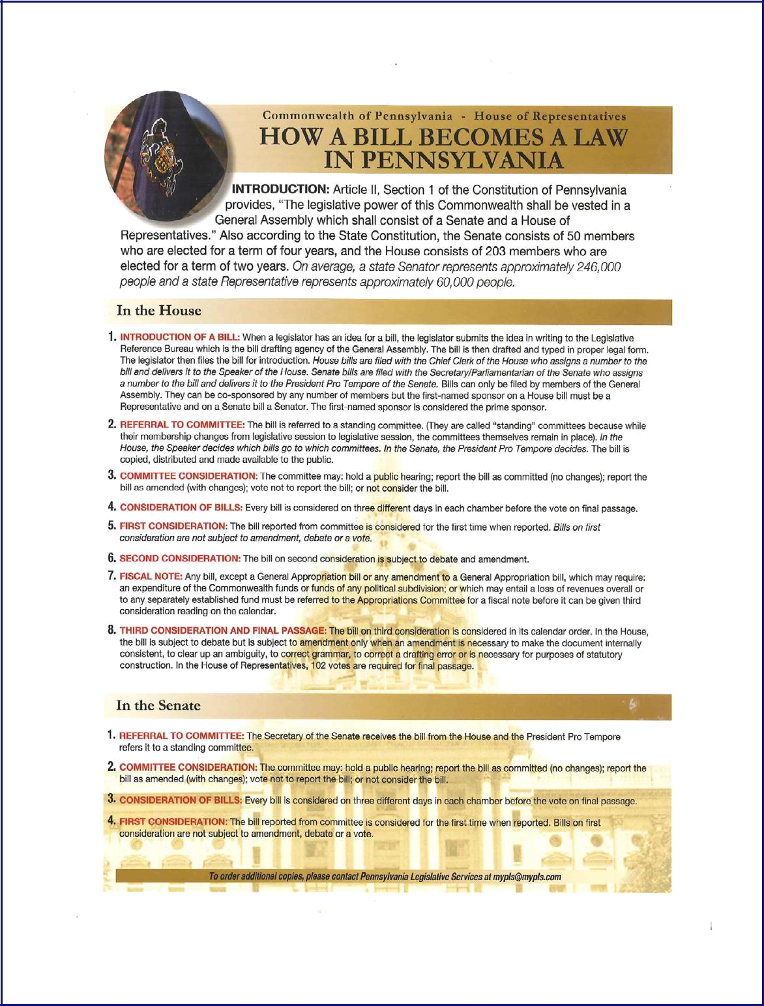

33

Source: PA Capitol
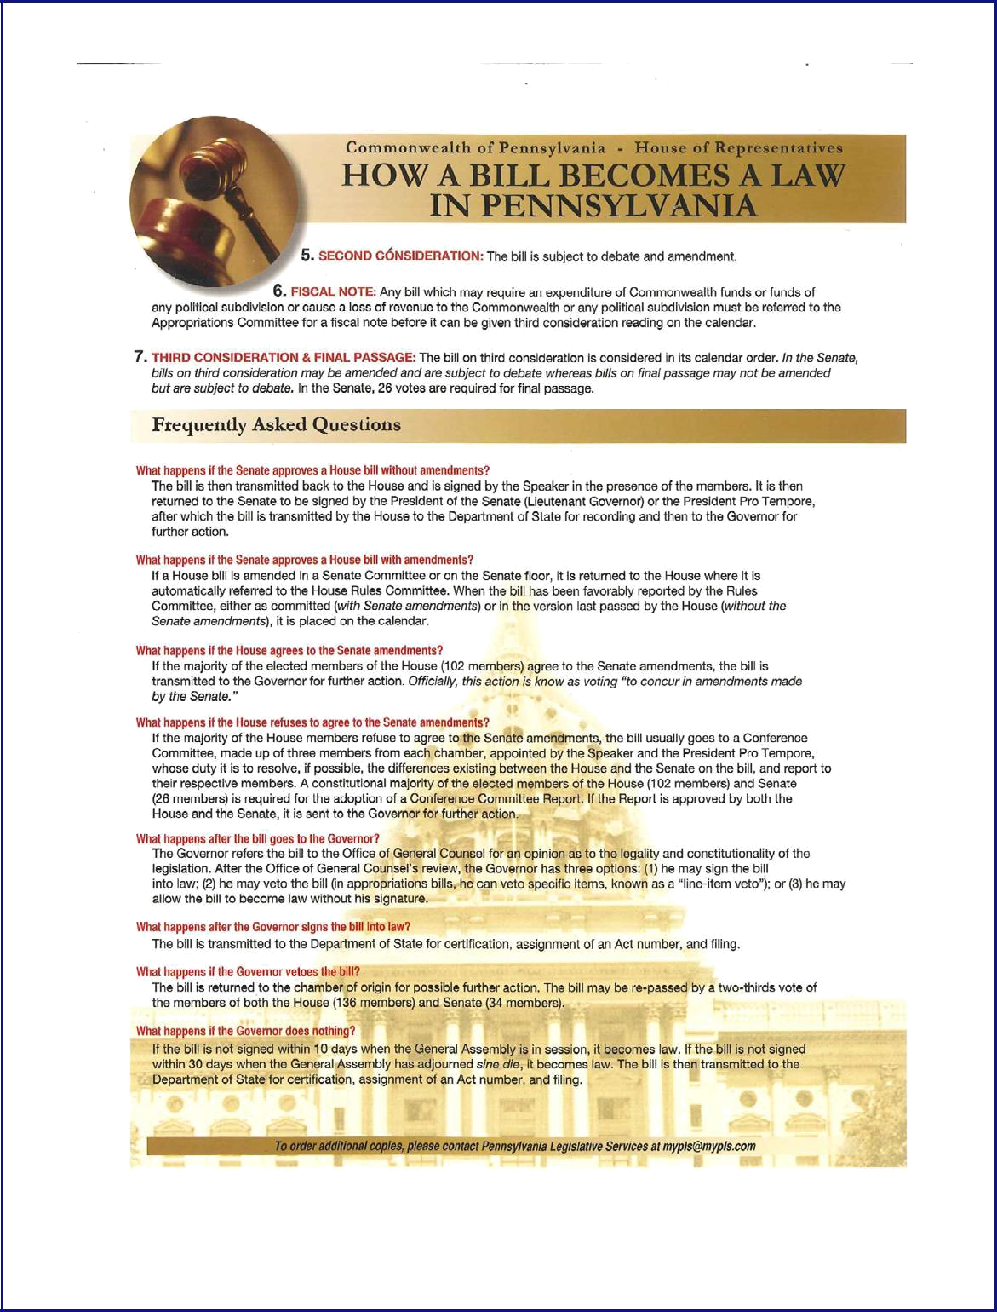

34

Source: PA Capitol

23-Month Pennsylvania Legislative Cycle

January: Legislative Cycle begins

February (Tuesday of first full week): Governor presents Budget Address to joint session of the General Assembly

Late February- early or mid-March: Senate and House Appropriations Committees budget hearings regarding the Governor's Proposal

June 30th: End of current Fiscal Year; Deadline for budget agreement for next Fiscal Year

July 1st :Beginning: of annual Fiscal Year

July and August: Typically summer recess for the General Assembly although legislative committees often use the time for public hearings, etc.

September - December: Fall legislative session

December - mid-January: Recess between legislative sessions

Mid-January: Beginning of spring legislative session

February (Tuesday of first full week): Governor presents Budget Address to joint session of the General Assembly

Late February- early or mid-March: Senate and House Appropriations Committees budget hearings regarding the Governor's Proposal

April or May of election year: General Primary election

June 30th: End of current Fiscal Year; Deadline for budget agreement for next Fiscal Year

July 1st : Beginning of annual Fiscal Year

July and August: Summer recess; legislators are campaigning in the district for the November elections

November (Tuesday of first full week): General Election

Up to November 30, 2006 - “Sine Die" Session - Defined as "without assigning a day for a further meeting or hearing; a final adjournment." Also called "Lame Duck" Session. Legislative session ends on or before Nov. 30th

35

Source: PA Capitol
Social Media and Advocacy

Facebook is the most text-friendly platform. You can use it to share longer updates about your work, calls to action for your members, and post news articles. All you need to get started is a manager with their own personal page.

- Post 3—5 per week

- Tag stakeholders

- Direct followers to your website


Use Twitter for short updates, alerts and applauding your partners for their work. Twitter is conversational—be a part of discussions. Keep post short and sweet—there is a 140 character limit.
- Post at least daily

- Use hashtags to organize topic

- Direct followers to your website


Instagram is the best way to share photos of your events. It’s great for making a visual case for your cause. Keep captions concise.
- Post as needed

- Tag the people in your photos

- Use hashtags to make content searchable by users


Periscope & Facebook Live are live-streaming services that are ideal for events and getting media attention even if reporters cannot attend in person. Periscope can be synced with Twitter, and Facebook Live is used natively.
- Promote events ahead of time on other platforms

- Respond to comments and questions during the livecast

Building Your Best Audience

Once your platforms are created, the most important thing to do is curate your ideal audience.

For legislative advocacy, this audience should include:

- Elected Officials

- Community leaders, individuals and related interest groups

- Local and state-level reporters

This is the audience that will need to be informed about your issues as you use social media as an advocacy tool. Many follows and likes will come simply from following the targets with your account first; the rest will come as your profile grows and becomes more credible in your field.

As you use the platform, don’t forget this target audience and post content that is useful to them, as well as useful for your purposes. To do this, keep in mind the 80/20 rule. Roughly 80% of your content should be informative and relevant to your issues, but not make any request of your audience. The other 20% can include asks and calls to action. The most successful media profile is one that enriches its audience and engenders loyalty, so that the audience is ready to advocate on its behalf when asked.

Creating Content

In a new media world, you have to create and deliver your own content, instead of relying on traditional media to spread your message. This can be both a challenge and opportunity for advocacy organizations. Consider the following tenets as you design content for social media:

- Quantity—Information is complete and full

- Quality—Information is truthful and accurate

- Relation—Information is relevant to the conversation

- Manner—Information is expressed in an easy-to-understand way

36

Source: Triad Strategies
Do’s and Don’ts of Social Media Engagement

Unlike your website, a one-way flow of information, social media is meant to be an active conversation for its users. Here’s how to strike a balanced discussion that advances your interests:

DO | DO NOT
Respond to questions | Spam elected officials or reporters with
 | non-stop comments
Share, retweet, amplify posts from your | Insult other users
supporters
Direct reporters and stakeholders to your | Let anyone and everyone at your
content by tagging them | organization manage your pages
Use hashtags (Facebook, Twitter, | Post repetitive content in a short
Instagram) to organize your content and | timeframe
join conversations

Specific United Way of Pennsylvania messaging and advocacy information can be found on our members only site in Marketing Materials (http://www.uwp.org/marketing-materials)

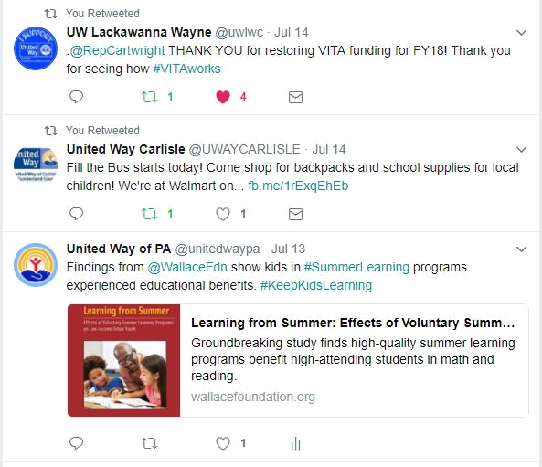

Tweet Examples (Pulled From @unitedwaypa)

37

Source: Triad Strategies/United Way of Pennsylvania
Example Social Media Messaging

Social Media Messaging for PA 2-1-1 Day

Purpose:

This messaging will be used to celebrate PA 2-1-1 Day on February 11th. Please feel free to further develop this messaging and use specific county data for your community.

Twitter Messaging:

- Celebrate #PA211Day with us! PA 2-1-1 is an info and referral service to connect you with the help you need!
- Do you need food, housing or health referrals? Dial 2-1-1 to find assistance now #PA211Day.
- If you or someone you know needs assistance with vital service, dial 2-1-1! #PA211Day

- In 2016, PA 2-1-1 connected Pennsylvanians to over 200,000 referrals! Getting those in need the help they seek is a reason to celebrate #PA211Day
- [Insert legislator twitter handle] support funding for PA 2-1-1! Help those in need find resources to utility help, food, housing and much more! #PA211Day
- [Insert legislator twitter handle] give your constituents the opportunity to find resources they need to support themselves and their families! Support PA 2-1-1! #PA211Day
- PA 2-1-1 is equipped with resources for citizens in a variety of areas and can reduce duplication of effort for information and referral. #PA211Day
- State government funding is needed to help PA achieve its full potential for leveraging 2-1-1 as a community strengthening tool! #PA211Day

Facebook Messaging:

- Please help us celebrate PA 2-1-1 Day! 2-1-1 is a three-digit dialing code, which is an information and referral phone line to connect Pennsylvanians with health and human services. In 2016 alone, over 200,000 referrals were made across the Commonwealth. Help us get the word out that 2-1-1 is an option for those in need to seek information and referrals to help in many different situations, including help with rent, food, utility assistance, and even tax preparation!

- PA 2-1-1 is an information and referral phone line connecting citizens with health and human services needs available in their community. In 2016, there were over 150,000 2-1-1 calls answered. Most of those calls dealt with utility assistance, housing assistance, food availability and tax preparation. 2-1-1 helps families, veterans, people down on their luck, and many others in both rural and urban areas. Today is PA 2-1-1 Day and it time to celebrate the great help 2-1-1 has been providing to those in our community! Help us spread the work on this great service and get those in need connected with help!

38

Source: United Way of Pennsylvania
Helpful Internet Resources for Pennsylvania Advocates

Pennsylvania Executive Branch
 | Governor's Office |  |  |  |  |  | http://www.governor.state.pa.us/
 | Attorney General |  |  |  |  |  | https://www.attorneygeneral.gov/
 | Auditor General |  |  |  |  |  | http://www.paauditor.gov/
 | State Treasurer |  |  |  |  |  | http://www.patreasury.gov/
 | Commonwealth of PA |  |  |  |  |  | http://www.pa.gov/
 | Pennsylvania Legislative Branch
 | The PA General Assembly |  |  |  |  |  | http://www.legis.state.pa.us/
 | PA State Senate |  |  |  |  |  | http://www.pasen.gov/
 | PA Senate Democratic Caucus |  |  |  |  |  | http://www.pasenate.com/
 | PA Senate Republican Caucus |  |  |  |  |  | http://www.pasenategop.com/
 | PA House of Representatives |  |  |  |  |  | http://www.house.state.pa.us/
 | PA House Democratic Caucus |  |  |  |  |  | http://www.pahouse.com/
 | PA House Republican Caucus |  |  |  |  |  | http://www.pahousegop.com/
 | United States Government
 | The White House |  |  |  |  |  | https://www.whitehouse.gov/
 | US Senate |  |  |  |  |  | https://www.senate.gov/
 | US House of Representatives |  |  |  |  |  | https://www.house.gov/
 | The Library of Congress |  |  |  |  |  | https://www.loc.gov/
 | Miscellaneous
 | PA Department of State |  |  |  |  |  | http://www.dos.pa.gov
 | PA Democratic State Committee |  |  |  |  |  | http://www.padems.com
 | PA Republican State Committee |  |  |  |  |  | https://www.pagop.org/
 | Pennsylvania Code Online |  |  |  |  |  | http://www.pacode.com/
 | Pennsylvania Bulletin Online |  |  |  |  |  | http://www.pabulletin.com/index.asp
 | IRRC |  |  |  |  |  | http://www.irrc.state.pa.us/
 | Governor's Office of the Budget |  |  |  |  |  | http://www.budget.pa.gov/
 | PA Politics |  |  |  |  |  | http://www.politicspa.com/
 | United Way of Pennsylvania
 | United Way of Pennsylvania |  |  |  |  |  | http://www.uwp.org/
 | United Way Worldwide |  |  |  |  |  | https://www.unitedway.org/
 | UWP Policy Agenda |  |  |  |  |  | http://www.uwp.org/sites/uwp.org/
 |  |  |  |  |  |  | files/2017%20Policy%20Agenda.pdf
 | United Way Social Media Guidelines |  |  |  |  |  | http://www.uwp.org/knowledge-cafe

39

Source: PA Capitol/United Way of Pennsylvania
Resources for Getting Started with Digital Advocacy

Tools for Getting Started:

Bambu sign up (note: only one person from each United Way can register):

http://online.unitedway.org/bambu

Share stories and social media content in one easy to use platform. Bambu is an employee engagement tool that we have tailored to serve our United Way Network. Under our contract, each Local United Way will have a single instance through which you can connect your organization’s Twitter and Facebook. From Bambu, we can share stories, blog posts, press hits, research and organization news all in one, easy to use platform. With each story, you can select pre-written social media copy, which you can customize for your audiences. Simple as that!

Canva: https://www.canva.com/

Tool to create custom graphics, particularly for social media. Includes suggested templates and automatically sized graphics for each platform. Canva for Work, which enables you to have a team and includes brand style guidelines, is free for nonprofits.

M+R Benchmarks Study 2017: http://mrbenchmarks.com/

Yearly benchmark survey of nonprofit online communications.

Noun Project: https://thenounproject.com/

Thousands of icons sourced by artists around the world that are available for use. For a $40/year subscription, you can customize icons with brand colors.

Storify: https://storify.com/

Digital curation tool used to pull elements from across different social media platforms to create a narrative and story.

Thunderclap: https://www.thunderclap.it/

Tool that allows a message to be mass shared on social media at a designated time. There are free or paid versions.

Twitter Analytics: https://analytics.twitter.com

Track your campaigns and get insights about your Twitter account.

United Way Brand Guidelines: https://online.unitedway.org/brand-standards-guidelines

Includes United Way color palettes, typography, brand tone and more.

40
United Way Studio to Go: https://uww.saepio.com/marketport/main.xhtml

United Way’s image library and mobile design studio. It includes templates and more.

Engagement Software:

5 Questions to Ask When Choosing Your Advocacy CRM: http://www.beekeepergroup.com/5- questions-to-ask-when-choosing-your-advocacy-crm/

CQ Engage: http://cqrcengage.com/

Nation Builder: http://nationbuilder.com/

VoterVoice: https://info.votervoice.net/

Social Media Scheduling Tools:

TweetDeck: https://tweetdeck.twitter.com/

Schedule Tweets in advance to be automatically sent out.

Hootsuite: https://hootsuite.com/

Tool to manage social media accounts and schedule posts in advance across platforms.

Buffer: https://buffer.com/

Social media scheduling tool with optional browser extension to schedule retweets of other accounts.

Other questions?

Contact Magige Livelsberger, Public Policy and Communications Manager at United Way of Pennsylvania, maggie@uwp.org , 717.238.7265 x203 or Sarah Yergeau, Manager of Digital Advocacy & Network Capacity Building at United Way Worldwide, sarah.yergeau@unitedway.org, 703.836.7112 x.502.

41

Source: United Way Worldwide
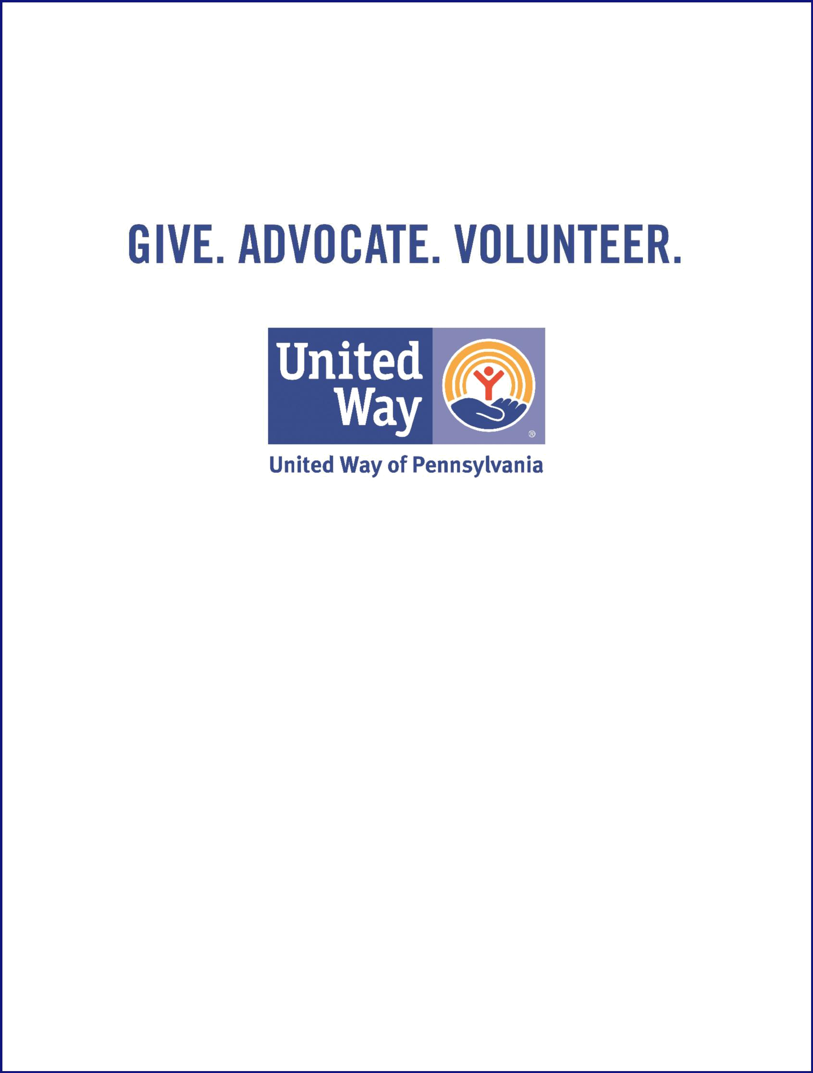

Kristen Rotz

President

krotz@uwp.org

Maggie Livelsberger

Public Policy and Communications Manager

maggie@uwp.org


United Way of Pennsylvania | @unitedwaypa
42 | | (717)-238-7365 | www.uwp.org
909 Green Street | Harrisburg, PA 17102 | | (717)-238-7365 | www.uwp.org

