Alleluia Butterflies
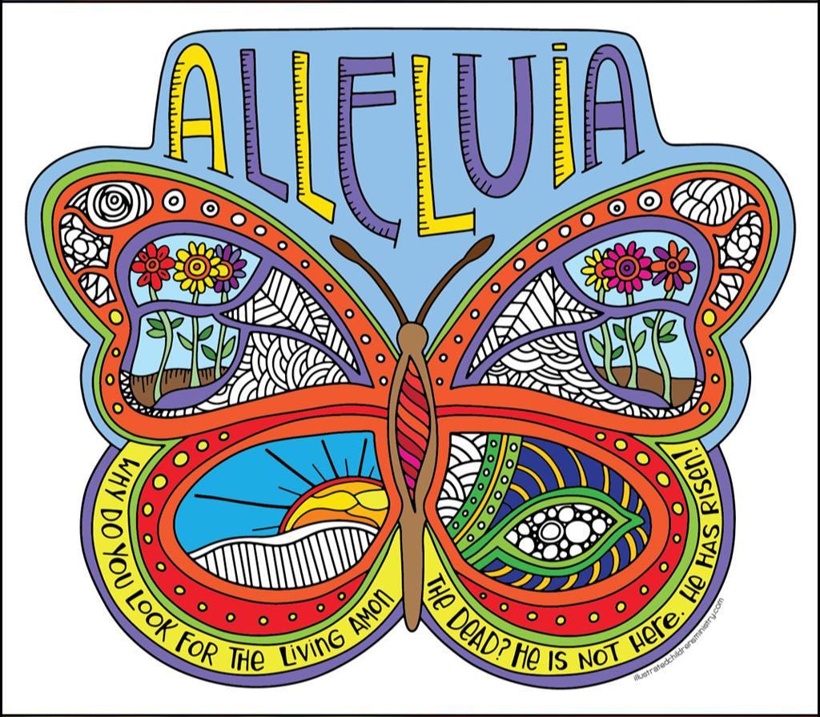

An Easter Coloring Project for Children, Youth, AND Adults!

Here’s how to help us decorate for Easter . . .

#1 – Detach the two butterfly images from this top sheet.

#2 – You’ll notice that one image is completely “drawn” and ready for coloring using the design already there. On the other copy, the right “forewing” and “hind wing” are blank. You can fill those sections with your own design – maybe even include your name or initials somewhere.

#2 – Use your best colored pencils, markers, or crayons to make both images your personal work of art! (No need to copy the image above! It’s just an example.)

#3 – Cut out your finished butterflies and use double-stick tape (best) or glue to join them, back to back.

#4 – Bring your colored & assembled butterfly to church by Palm Sunday. Look for the butterfly collection basket!
#5 – Come to church on Easter morning to see your butterfly in the air or on the windows of our entry hall, proclaiming

“Why do you look for the living among the dead? He is not here. He has risen!” ALLELUIA!

P.S. If you want to create more than one two-sided butterfly, Karen D. can email the file to you, and you can print the pages at home. Just send her a note at danielson.karen51@gmail.com.
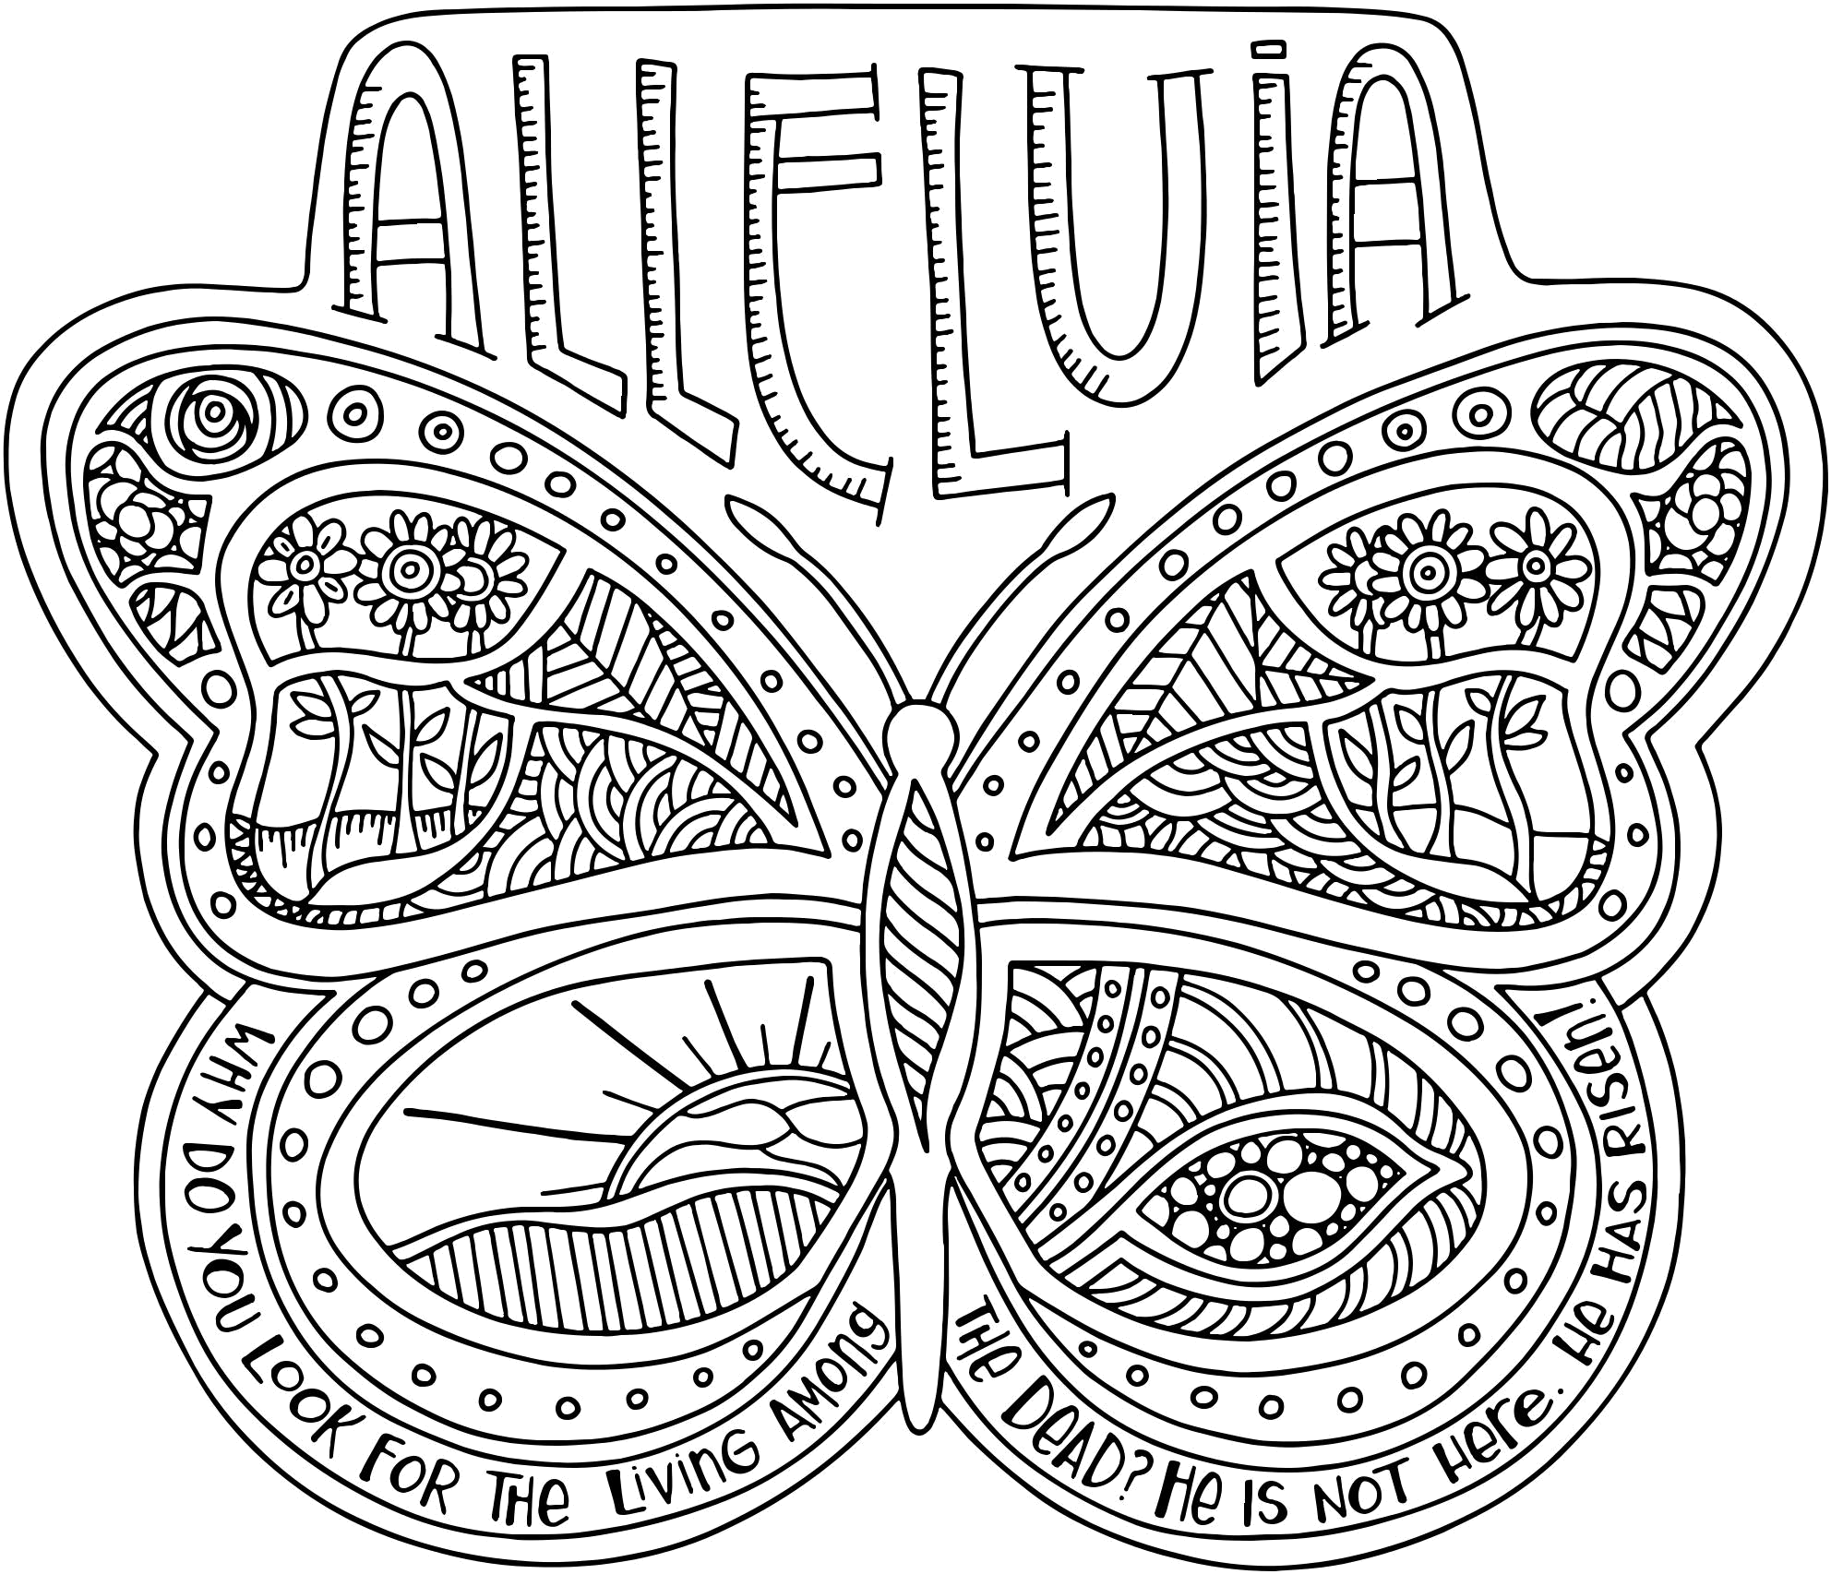

m i n i s

s
n
e
r
i l d
h
c
d
t e
a
t r
s
il l u

t

r

c

o

m
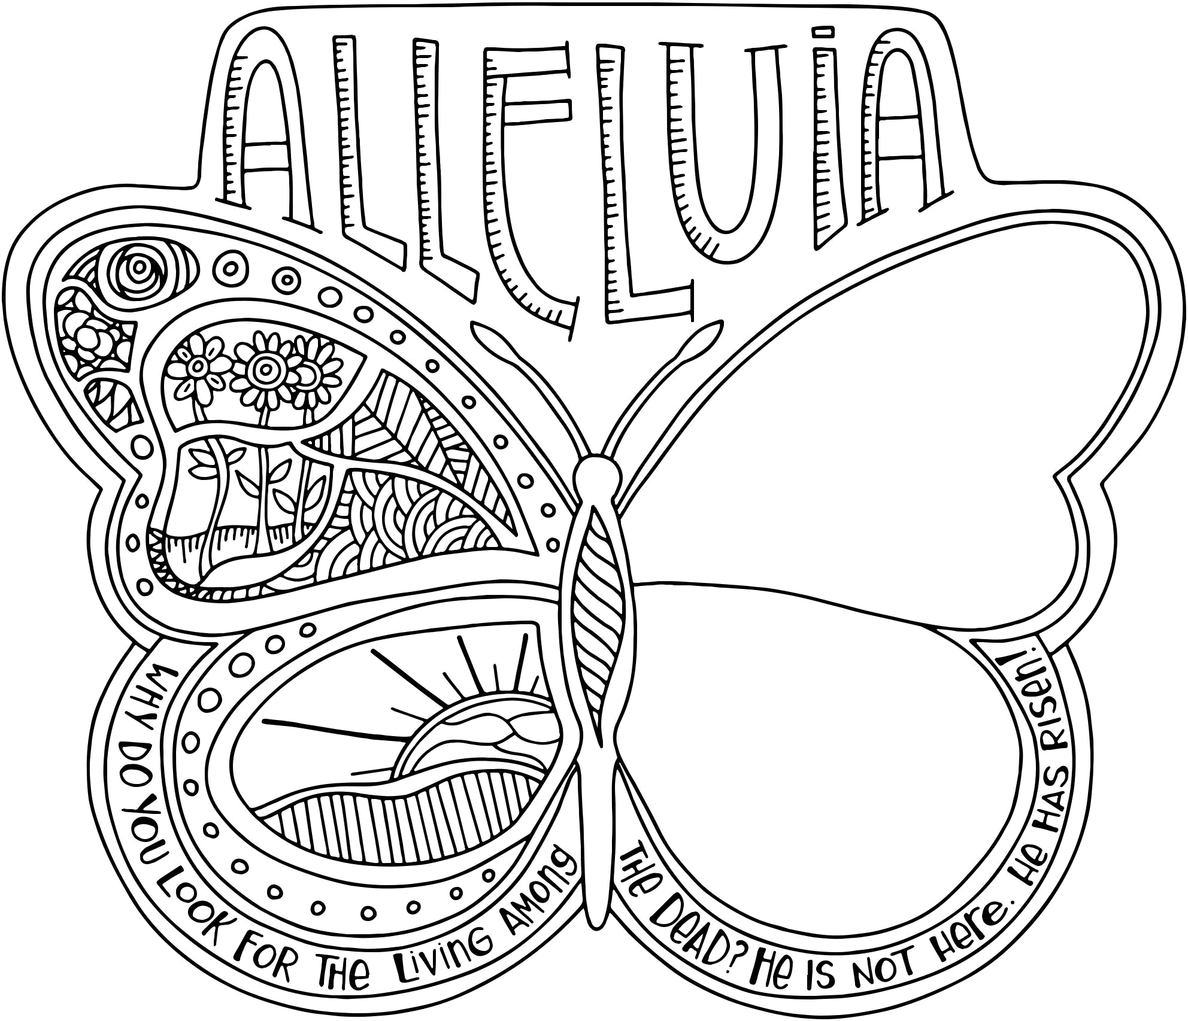

m i n i s

s
n
e
r
i l d
h
c
d
t e
a
t r
s
il l u

t

r

c

o

m

