Butter y Templates
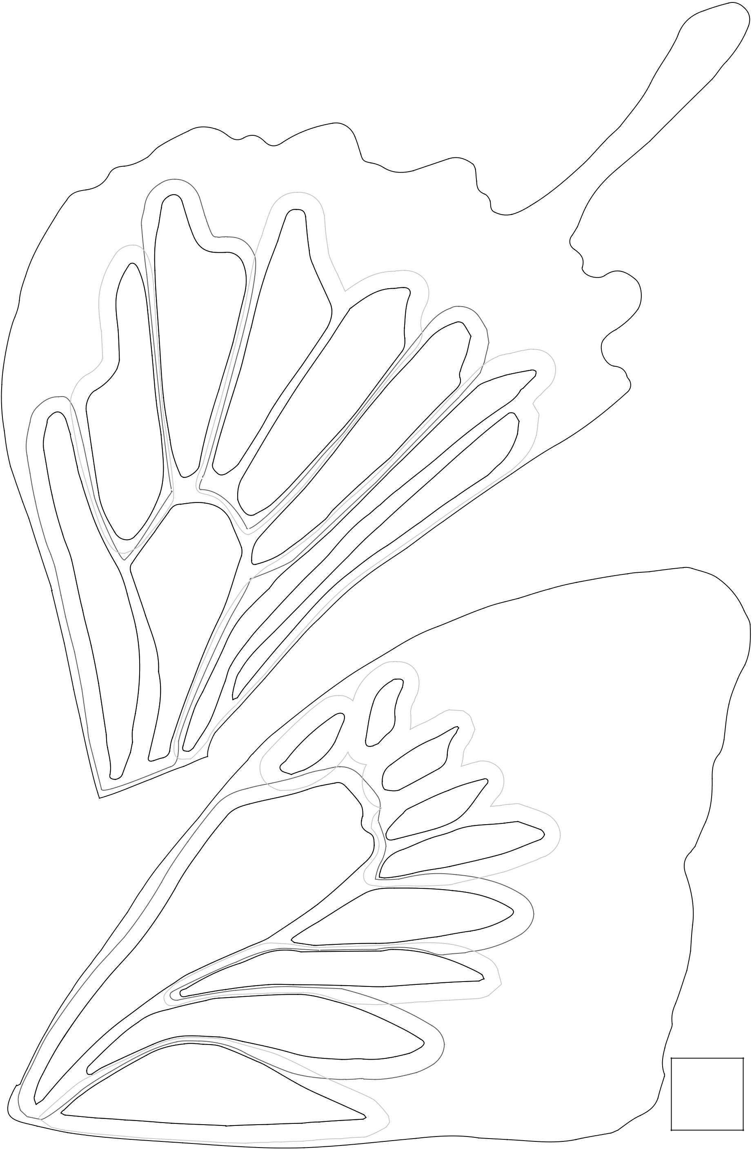
Templates are shown at 100% on 11” x 17” paper.

For each butter y, cut out 1 body, 1 top and bottom wing, and 1 top and bottom wing in reverse.

Cut Fabric P (black) along solid line. It sits on top of all other fabrics.

Cut along dotted lines for all other fabrics. (Some shapes are combined into one piece.)

Butter y 1 - Bottom Wing

A _{L}

L

L

A
L

L

A

A

L

P

Butter y 1 - Top Wing

L

A

L

L

L

A

L

A

L

P

1” square

aurie & nch Mariposa 7

Butter y Templates
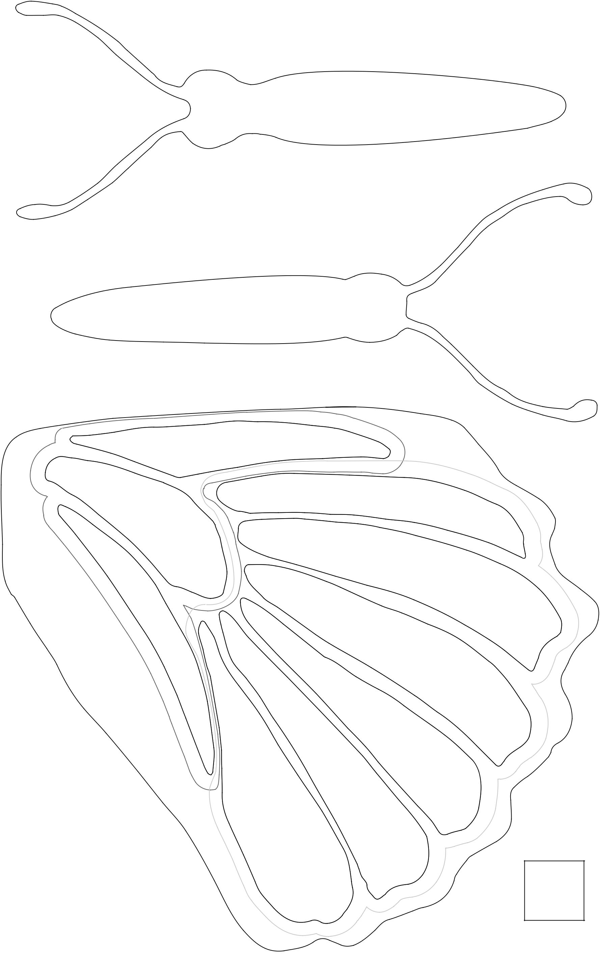
Templates are shown at 100% on 11” x 17” paper.

For each butter y, cut out 1 body, 1 top and bottom wing, and 1 top and bottom wing in reverse.

Cut Fabric P (black) along solid line. It sits on top of all other fabrics.

Cut along dotted lines for all other fabrics. (Some shapes are combined into one piece.)

P Butter y 2- Body

Butter y 1 - Body

P

N

Buttery

2
-

Bottom

Wing

N

N

P

M

M

M

M

M

M

1” square

aurie & nch Mariposa 8

Buttery

3
-

Body

Wing

Top

-
2

Buttery

P

N
Butter y Templates
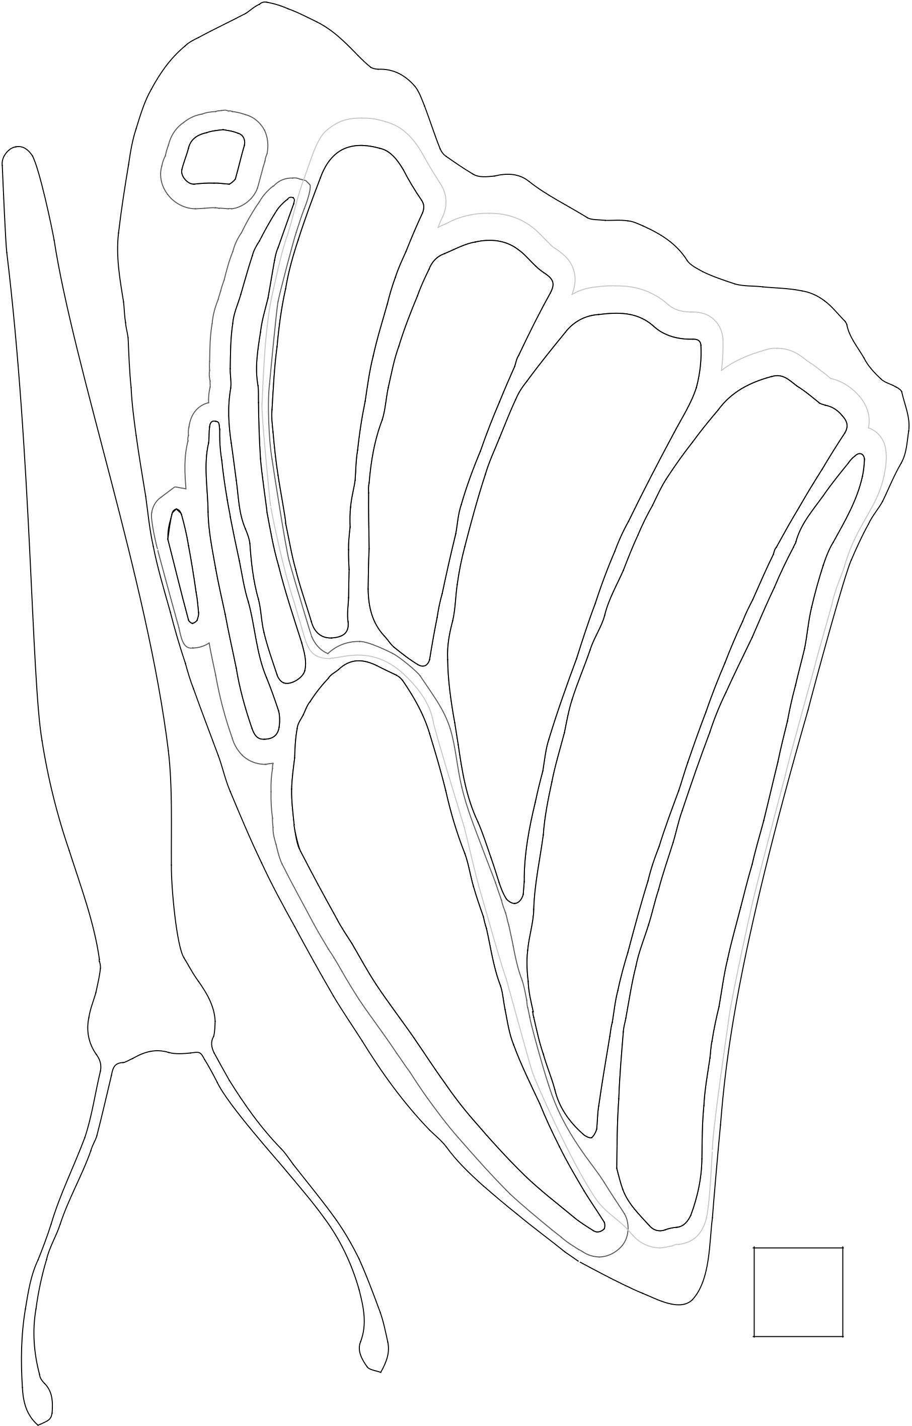
Templates are shown at 100% on 11” x 17” paper.

For each butter y, cut out 1 body, 1 top and bottom wing, and 1 top and bottom wing in reverse.

Cut Fabric P (black) along solid line. It sits on top of all other fabrics.

Cut along dotted lines for all other fabrics. (Some shapes are combined into one piece.)

N

M

M

M

N

M

N

N

M

P

1” square

aurie & nch Mariposa 9

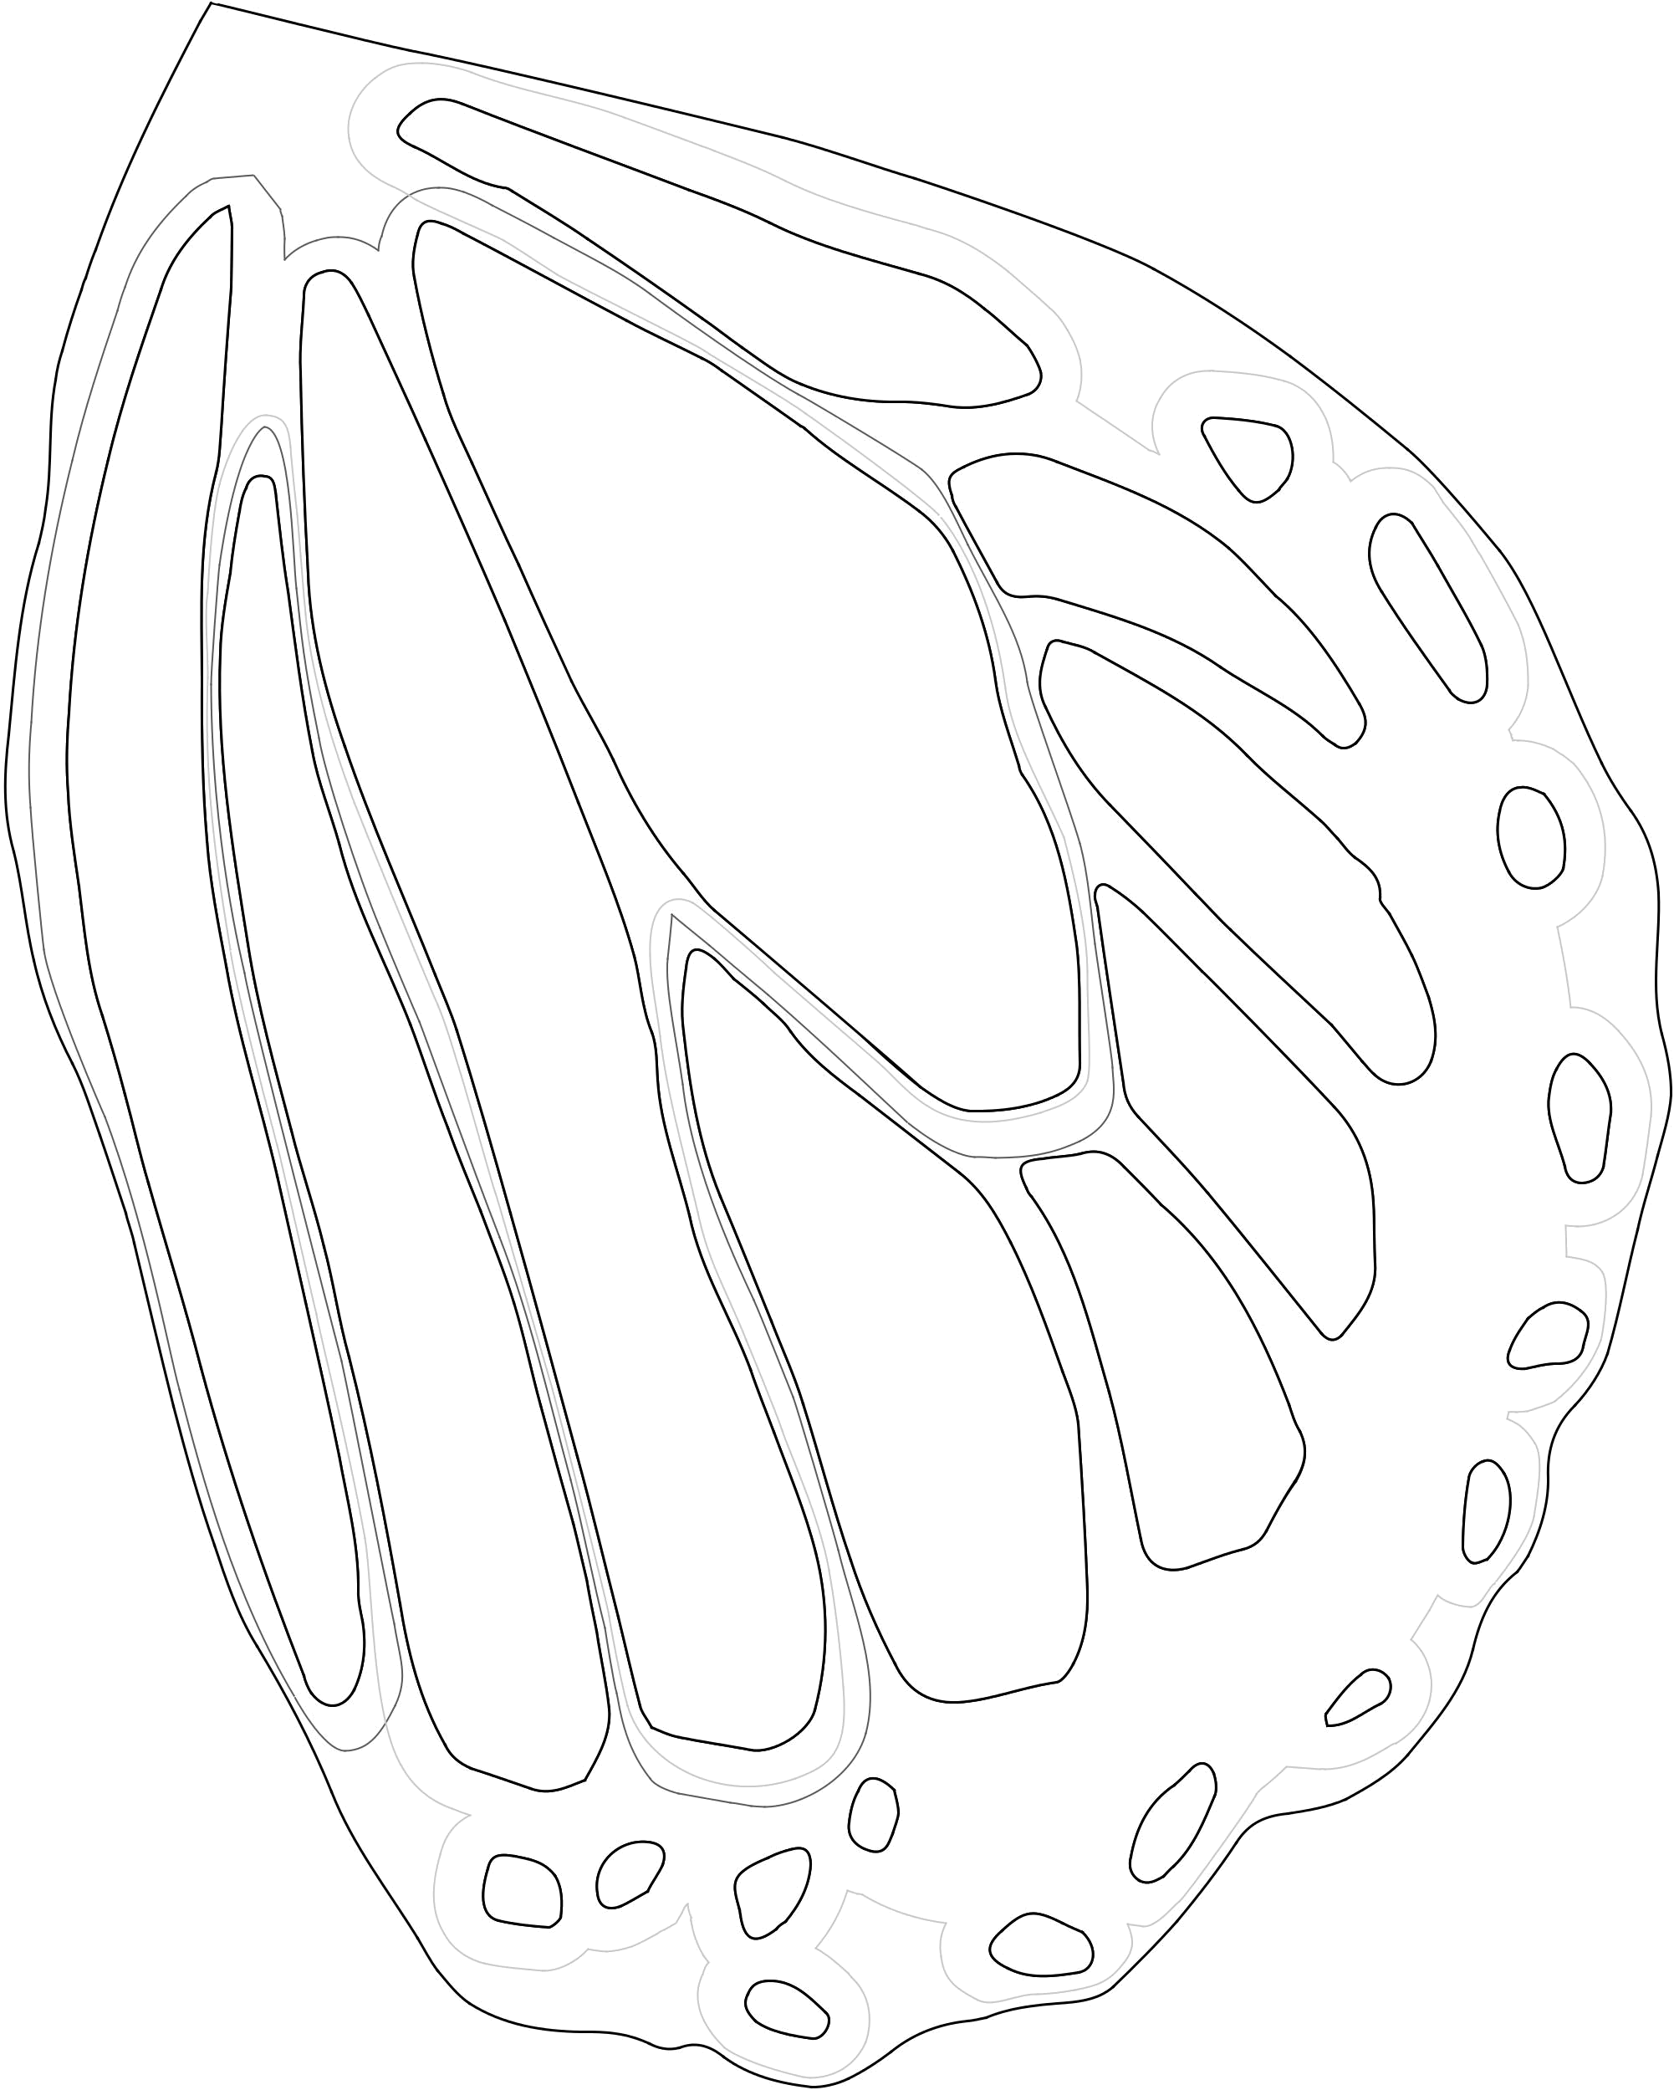

O

Buttery

3
-

Bottom

Wing

N

N

N

O O

O

O ^{O} O

O

O

O

O
O

O _{O}

O _{O}

_{O} O

O

P

O

O

Butter y Templates

Templates are shown at 100% on 11” x 17” paper.

For each butter y, cut out 1 body, 1 top and bottom wing, and 1 top and bottom wing in reverse.

Cut Fabric P (black) along solid line. It sits on top of all other fabrics.

Cut along dotted lines for all other fabrics. (Some shapes are combined into one piece.)


1” square

aurie & nch Mariposa 10

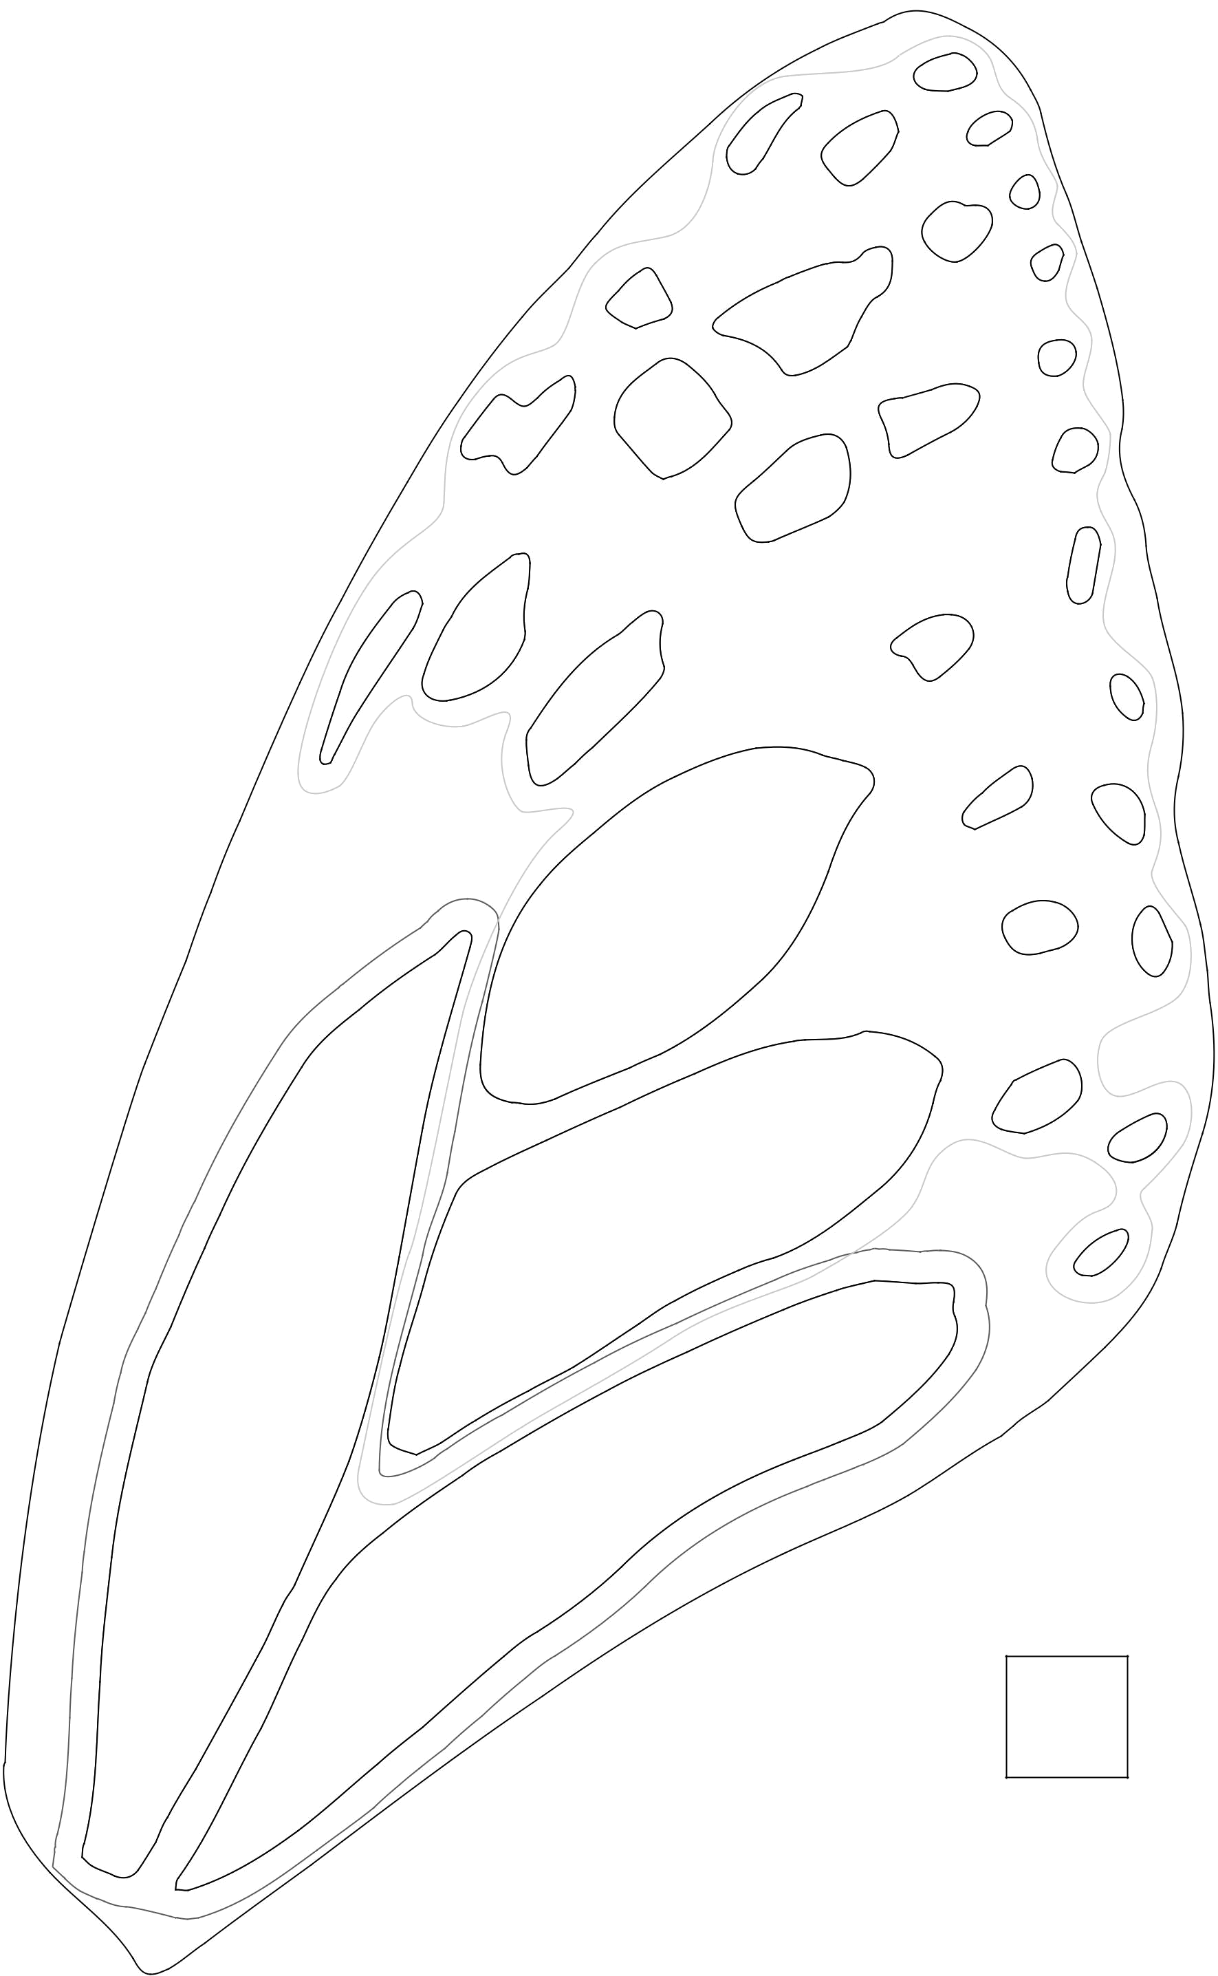
Butter y Templates
Templates are shown at 100% on 11” x 17” paper. |  | O
For each butter y, cut out 1 body, 1 top and bottom wing, and 1 top and
bottom wing in reverse. |  | O
Cut Fabric P (black) along solid line. It sits on top of all other fabrics. | O | O
Cut along dotted lines for all other fabrics. (Some shapes are combined into |  | O
one piece.) |  | O
 |  | O

O

O

 | Top | Wing
- | Top
3
Buttery

N

O ^{O}
O

O

O

_{O} O O

O O

P ^{O} O

O ^{O} _{O}

O

O

O

O

N

1” square

aurie & nch Mariposa 11

