

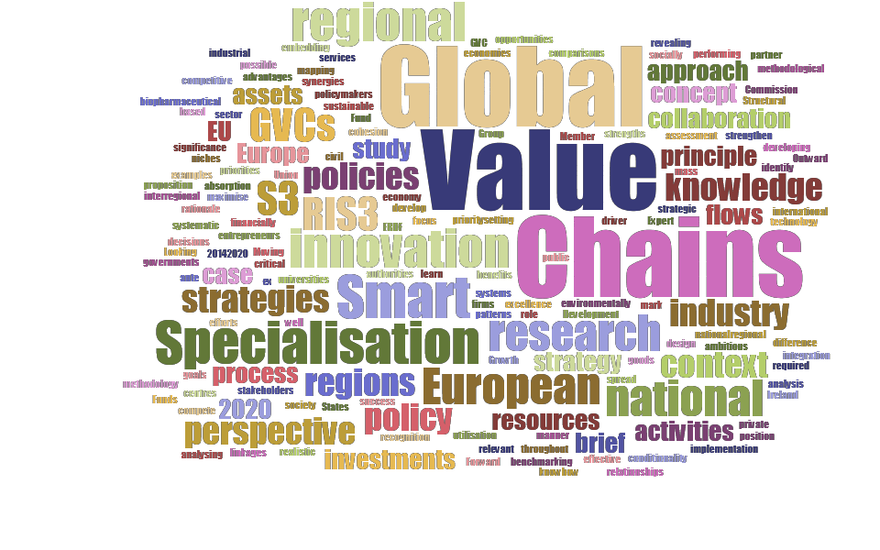

Global Value Chains and Smart Specialisation Strategy

*Thematic Work on the Understanding of Global Value Chains and their Analysis within the Context of Smart Specialisation*

Louis Brennan Ruslan Rakhmatullin

2015

EUR 27649 EN

This publication is a Science for Policy report by the Joint Research Centre, the European Commission’s in-house science service. It aims to provide evidence-based scientific support to the European policy-making process. The scientific output expressed does not imply a policy position of the European Commission. Neither the European Commission nor any person acting on behalf of the Commission is responsible for the use which might be made of this publication.

**JRC Science Hub**

<https://ec.europa.eu/jrc>

JRC98014

EUR 27649 EN

PDF

ISBN 978-92-79-54181-0

ISSN 1831-9424

doi:10.2791/44840

LF-NA-27649-EN-N

© European Union, 2015

Reproduction is authorised provided the source is acknowledged.

How to cite: L. Brennan, R. Rakhmatullin, 2015; Global Value Chains and Smart Specialisation Strategy. Thematic Work on the Understanding of Global Value Chains and their Analysis within the Context of Smart Specialisation; EUR 27649 EN; doi:10.2791/44840

All images © European Union 2015

Abstract:

**Global Value Chains and Smart Specialisation Strategy**

The paper elaborates the foundations and functioning of global value chains, the importance of their analysis within the S3 context, in line with the existing RIS3 framework. A methodological approach to analysing a country’s position in GVCs in terms of activities, flows and relationships is presented. The approach is illustrated with its application to the Irish pharmaceutical sector.

**Table of contents**

Executive summary 2

1. Introduction 4
2. The Manufacturing Context 5
3. The Value Chain and Global Value Chains 7
4. GVC Flows – Basic Concepts 11
5. Value-chain trade flows 12
6. GVCs and Smart Specialisation 14
7. Manufacturing in Ireland 15
8. The Pharmaceutical Industry 16
9. The Pharmaceutical Industry in Ireland 17
10. Ireland’s Pharmaceutical Industry in a GVC context 19
11. Conclusions 31

References 33

List of figures 35

List of boxes 36

**Executive summary**

**Policy context**

This brief has considered GVCs within the context of smart specialisation. A methodological approach has been described that analyses a country’s (region’s) position in GVCs. This approach has been applied to the case of the pharmaceutical industry in Ireland.

A similar approach can be applied to other locations pertaining to that industry or other industries. By doing so, the comparative advantage of the industry can be assessed and its degree of participation in the industry GVC can be assessed including establishing those locations that serve as its main sources of inputs and destinations of its outputs. Thus the linkages of the industry and their extent can be established.

At the same time, the analysis can reveal where along the value chain the industry is positioned and the extent of that positioning. Thus the analysis points to opportunities for maintaining/extending/deepening the country’s positioning on the GVC. Furthermore, by applying a similar analysis to other locations, a location can ascertain who else occupies significant parts of the industry value chain, and how strong their positions are and whether those clusters of GVC activities in these other competing regions/countries are similar/complementary to their own activities. Taking account of the previously identified linkages, this can indicate whether there might be opportunities to capitalise on complementarities in other locations and the development of inter-regional/trans- European linkages. To explore such opportunities requires engaging in the digging (D) stage of our MD3A process described in the brief. This implies a focus on the extant clusters of the industry GVC.

Since the data required at the digging stage may be unavailable or indeed difficult to access, there is a need to identify conduits/boundary spanners who are connected to the industry and have a deep knowledge of the industry cluster and its characteristics. These conduits/boundary spanners are likely to be found within national and regional development agencies and/or enterprise development agencies. For each location, one such individual might be assigned an S3 responsibility within the context of the industry GVC. Platforms – real and virtual - would need to be developed to facilitate engagement among such conduits/boundary spanners so that opportunities for intra-regional industry GVC linkages can be precisely identified and pursued and that match-making takes place.

**Key conclusions**

This paper has highlighted a number of important matters in relation to GVCs and S3. These are considered from the specific context of the case of the Irish pharmaceutical industry and more generally from a methodological perspective. We can suggest some general principles that can be followed. These entail engaging with the Industry and its stakeholders on a continuous basis, anticipating the likely evolution of the Industry globally, assessing the challenges and opportunities that are likely to ensue from future industry trajectories, and responding to those challenges and opportunities in a proactive manner.

This process of *Engaging, Anticipating, Assessing and Responding* (EAAR) is required to be followed on an on-going basis and must involve the active participation of all stakeholders. The on-going success of Ireland in the changing Pharmaceutical Industry is an instructive example of RIS3 in action from which specific lessons can also be observed:

2

I.

The provision of a compatible and supportive environment via a relevant infrastructure that encompasses a robust regulatory framework, research and technology and education.

The upgrading and sustaining of a national innovation system. The development of the requisite human capital pool.

The supporting and nurturing of collaboration among all stakeholders. The engagement in upgrading of existing activities in the industry and The anticipating and targeting of areas of growth within the industry.

II. III. IV.

V.

VI.

Finally in relation to some methodological perspectives, we have already observed that the macro analysis (followed in the preceding section and applied to the Irish pharmaceutical industry) offers very useful insights into the industry within a GVC context. However, this represents one stage of the M3DA process outlined in Section 3 viz. the mapping (M) stage. The subsequent stages of digging, determining, decomposing (3D) and ascertaining (A) call for micro level analyses. These are particularly important if regional authorities are to play a role in co-creating and developing European industrial value chains based on smart specialisation priorities.

This calls for the interregional knowledge building, mapping the matchmaking potential around GVCs between regional smart specialisation priorities, identifying some pilot examples of interregional value chains, key stakeholders, available equipment and

facilities and relevant methodology described national and regional specialisation areas.

actors/skills in smart specialisation areas and applying the above with a view to identifying opportunities for matching of

cluster

organisations in

identified

value

chains

of

smart

3

**1. Introduction**

The Smart Specialisation principle, which was initially defined by the ‘Knowledge for Growth’ Expert Group in 2008, requires EU regions and Member States (MS) to build on their own strengths and to manage a priority-setting process in the context of national and regional research and innovation strategies. Research and innovation strategies for smart specialisation (RIS3) have been placed at the core of the new European cohesion policy as an important driver for the achievement of the Europe 2020 strategy objectives from a regional perspective.

Smart specialisation, as a rationale for research and innovation policies, aims at promoting the collaboration between the regional and national authorities in charge of taking decisions on the design and implementation of the innovation policies and the relevant stakeholders involved in such a process (i.e., firms, entrepreneurs, universities, research centres, civil society). An assessment of existing national/regional assets implies looking *'inside'* the country/region; however, this might be insufficient for a smart specialisation strategy. A major novelty of the S3 approach is that each country/region has to make its strategic decisions by taking into account their position relative to other regions of Europe.

Smart specialisation requires EU MS and regions to focus their efforts and resources on a limited number of ambitious yet realistic priorities (niches or activities), where as a result, they would be able to develop excellence as well as compete in the global economy in a sustainable (financially, socially and environmentally) manner. When implemented, these strategies are expected to allow Member States and regions to strengthen their research and innovation systems, maximise knowledge flows, absorption and utilisation as well as spread the benefits of innovation throughout their economies.

There has been a general recognition by policymakers that the S3 concept is an important step towards reaching the Europe 2020 goals. At the same time, the European Commission has formally introduced smart specialisation as a legal pre-condition or ex ante conditionality for using the European Regional Development Fund (ERDF) in the new funding period (2014–2020). As a result, as of 2014, national and regional authorities across the European Union are required to prepare their RIS3, so that the Structural Funds are used more efficiently with the aim of increasing synergies between different EU, national and regional policies, as well as public and private investments. Thus national and regional governments across the European Union have been developing RIS3 strategies based on the principle of smart specialisation.

The RIS3 approach requires looking beyond the national/regional administrative boundaries. In other words, a country/region should be able to identify its competitive advantages through systematic comparisons with other countries/regions, mapping their national and the international context in search of examples to learn from, or to mark a difference with, and performing effective benchmarking.

Moreover, each country/region should be able to identify relevant linkages and flows of goods, services and knowledge revealing possible patterns of integration with partner regions. This is important in the case of both developed and for less developed countries/ regions that would often require to source know-how and technology from elsewhere. In this context the significance and role of Global Value Chains (GVCs) merit consideration. The position of businesses within global value chains in this respect is a crucial element to be considered. This type of analysis is particularly important as the S3 concept warns against 'blind' duplication of investments in other European regions. Any such blind duplication of efforts could lead to excessive fragmentation, loss of synergy potential, and ultimately could hamper the reach of the critical mass required for success. On the contrary, interregional collaboration should be pursued whenever similarities or complementarities with other regions are detected.

4

The above considerations led to a focus on the topic of GVCs in the context of S3 at the national peer review workshop that was held in Dublin on July 3-4, 2014 on the theme of ‘*Smart Specialisation: Moving Forward and Looking Outward’*. The discussions and debates that took place at that event prompted the writing of this policy brief. The coverage of the policy brief extends to a methodological approach to analysing a country’s (region’s) position in GVCs in terms of activities, resources, assets and relationships.

The brief contains an extensive and well-documented case study on how the methodology can be applied. The case study focuses on an industrial sector viz. the pharmaceutical industry. It does so in the context of Ireland analysing the industry from the GVC perspective and within the S3 context thus assessing Ireland’s current value proposition and pointing to where opportunities for further embedding of the industry in GVCs may exist. Accordingly, the paper represents the first attempt to understand S3 from the perspective of GVCs.

**2. The Manufacturing Context**

*‘The ideal strategy for a global company would be to put every factory it owned on a barge and float it around the world, taking advantage of short-term changes in economies and exchange rates’*

*Jack Welch, former CEO GE*

Recent decades have seen the global fragmentation of production1. Manufacturing has been transformed over recent decades with off-shoring including outsourcing contributing to significant changes in the Manufacturing landscape. Manufacturing has migrated to low cost economies while many established product firms in the developed economies have contracted out their manufacturing to specialist manufacturing firms.

Today we have globalised manufacturing networks involving many source locations and actors so that the concept of ‘made in the world’ has entered the discourse. Thus instead of parts, components and sub-assemblies being locally procured, the import content of production has tended to increase in recent decades. Concurrent with the hollowing out of their manufacturing activities, product firms have sought to drive value creation by embracing new business models that incorporate elements of *servitisation* so that the provision of products is accompanied by the delivery of a service component.

But there can be limits to the effective management of the complexity that large scale outsourcing entails especially when modularity involving design and manufacturing is low. And recently, there have been suggestions around the possibilities of a manufacturing renaissance in those economies which experienced a hollowing out of manufacturing over the past decades.

Examples of near-shoring (the transfer of activity to a country near or adjacent to the home country) and re-shoring (the transfer of activity back to the home country) have recently been observed in the case of a number of firms. Apart from cost and nimbleness considerations, a number of other factors obtain. These include an increasing consciousness of the vulnerabilities of globally dispersed value chains, a recognition of

1 Brennan, L., Ferdows, K., Godsell, J., Golini, R., Keegan, R., Kinkel, S., Srai, J.S. and

M. Taylor (2015). Manufacturing in the World: Where Next? International Journal of Operations and Production Management Vol. 35, No. 9, pp. 1253-1274, 2015.

5

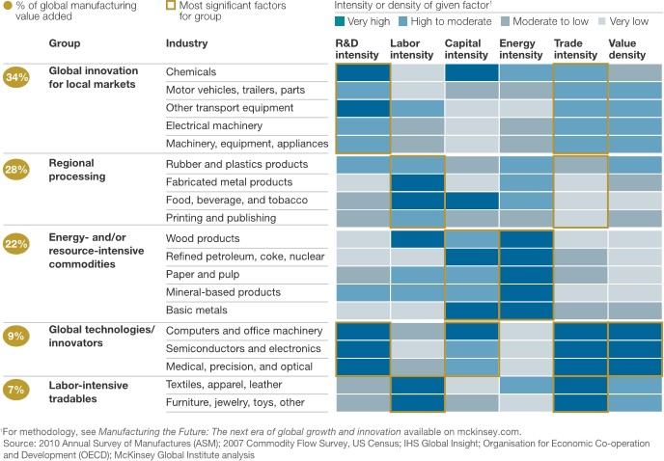

the benefits of co-location of design and manufacturing functions and an awareness of the limits to manufacturing fragmentation.

This may suggest that we may perhaps be close to a tipping point in terms of the global dispersion of manufacturing activities. There are also suggestions that the drivers of manufacturing configuration are evolving so that proximity to demand and innovative supply ecosystems come to dominate manufacturing configuration strategy2.

It is important to recognise that manufacturing is diverse and that fundamental differences exist between manufacturing industries . Five broad groups (global

3

innovation for

local

markets, regional processing, energy-/resource-intensive

commodities, global technological innovators and labour-intensive tradables) that possess very different characteristics and requirements have been identified by the McKinsey Global Institute. These vary in their sources of competitive advantage and how different factors of production influence where firms locate factories, carry out R&D and go to market. As presented in *Figure 1*, these groups can be characterised in terms of

their R&D intensity, labour intensity, capital and value intensity.

intensity, energy intensity, trade intensity

**Figure 1: The Diversity of Manufacturing (Manyika, et al, 2012)**

They also vary in terms of the degree to which service type activities

make up their

employment (*Figure 2*). High performing manufacturers (i.e. those who consistently deliver exceptional performance) in the high tech sector have strong R&D capabilities

2

George, K., Ramaswamy, S. and L. Rasey (2014). *Next-shoring: A CEO’s guide*.

McKinsey Quarterly, January.

3

Manyika, J., Sinclair, J., Dobbs, R., Stube, G., Rassey, L., Mischke, J., Remes, J.,

Roxburgh, C., George, K., O’Halloran, D. and S. Ramaswamy (2012). Manufacturing the future: The next era of global growth and innovation, McKinsey Global Institute, McKinsey and Company, November, pgs. 16.

6

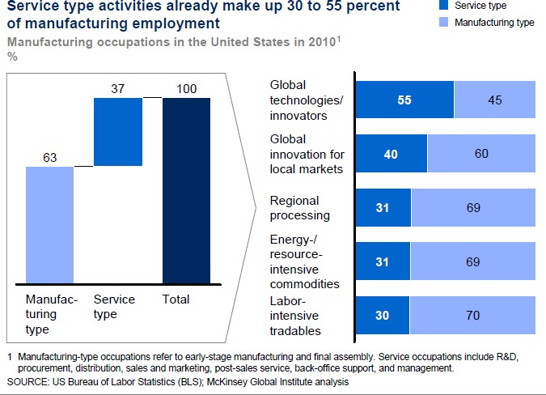

and a highly skilled workforce, strong supplier networks and collaboration, with increasing leveraging of the innovation and talent of a strong supplier network especially for those firms for which rapid new product and service innovation is significant to their competitive strategy. Two key priorities that have been highlighted for both governments and businesses are education and the development of skills.

In that regard, firms have to build their R&D capabilities, as well as expertise in data analytics and product design. Firms will need qualified, computer-savvy factory workers and agile managers for complex global supply chains. In addition to supporting on-going efforts to improve public education—particularly the teaching of math and analytical skills—policy makers must work with industry and educational institutions to ensure that skills learned in school fit the needs of employers.

Managers will need to adapt to the demands of sophisticated equipment and systems, to more sophisticated and higher-value work requiring more skill and understanding and to harness the special capabilities of both automation and humans and ensuring that they collaborate effectively. Analysing occupations in terms of the tasks - routine and

complex – that they involve, it is increasingly possible routine tasks, both manual and cognitive4.

to

programme and

automate

**Figure 2: Service type activities in Manufacturing (Manyika, et al, 2012)**

**3. The Value Chain and Global Value Chains**

The value chain describes the full range of activities that firms engage in to bring a product from its conception to its end use and beyond. This includes design, production, marketing, distribution and support to the final consumer (see Figure 3). The activities that comprise a value chain can be contained within a single firm or divided among different firms. Value chain activities can produce goods or services, and can be contained within a single geographical location or spread over wider areas. Global Value Chains are value chains that can be divided among multiple firms and dispersed across wide swaths of geographic space, hence the term ‘global value chain’5.

4 Anon (2014). To those that have shall be given, Economist, October 04.

5 [www.globalvaluechains.org](http://www.globalvaluechains.org/). Accessed on January 15, 2015.

7

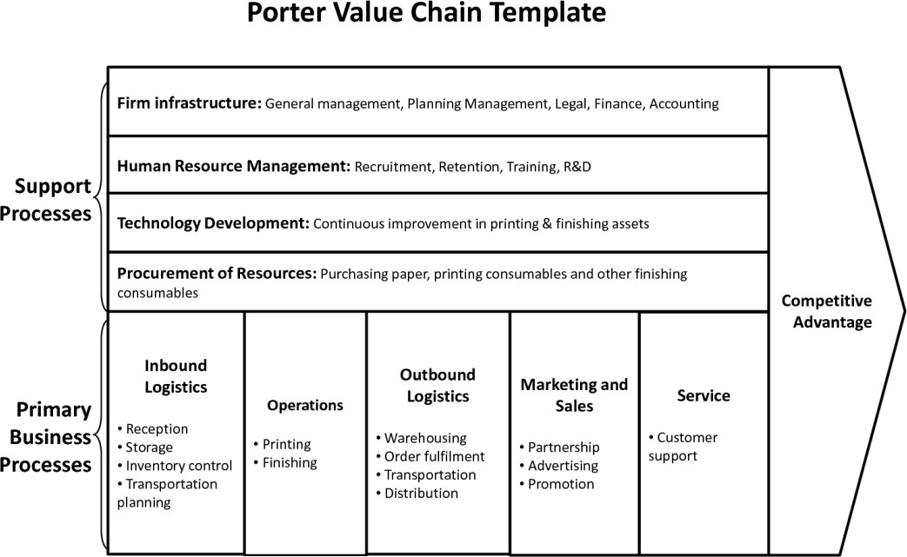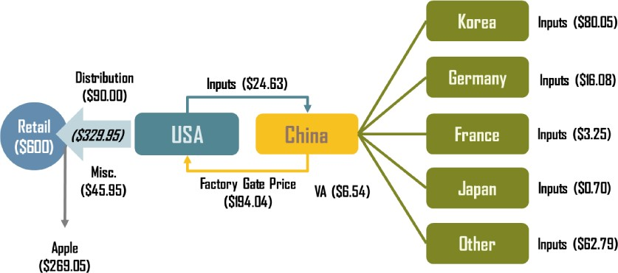

**Figure 3: The Value Chain**

Figure 4 provides an illustration of a global value chain based on Apple’s iPhone 4. In some instances, activities of the value chain may be embedded in established clusters that specialise in that particular activity.

Source: adapted from OECD (2011) "Global Value Chains: Preliminary Evidence and Policy Issues", Organization for Economic Co-operation and Development, DSTI/IND(2011)3, Paris, 2011

**Figure 4: The Global Value Chain for Apple’s iPhone 4**

Hence cluster analysis that reveals the extent to which a cluster forms part of a global value chain or chains can provide important insights around GVC participation. Global Value Chains represent the enactment of globalisation which at its heart is about flows: flows of materials, goods, information, knowledge, finance and people. Global Value

8



Chains are the basis of such flows. The on-going construction, deconstruction and reconstruction of such chains provides the infrastructure through which globalisation is enabled. The design, configuration and coordination of such chains to achieve maximum business performance are central to the role of multinational enterprises (MNEs). Integrating emerging technologies into such chains to create symbiotic business systems that yield maximum performance is the key to competitive advantage in today’s globalised world.

Global value chains make it possible to bring together all the raw materials & components that combine to make a product or service; to deliver it into use through distribution systems; to support users on a 24-hour basis; and to recover and integrate residue into a waste stream. These chains span the world, so that even mundane items now commonly involve the coordination of flows of goods, information, finance and people across several continents while navigating customs crossings, security screenings and identity verification. A global value chain may involve American designers, Indian software writers, Asian manufacturers and European system integrators and support provision.

Global value chains (GVCs) are ‘*organisational systems’* that operate across multiple nations, that are integrated, whose global integration is complex and whose technology base, or ‘engine’, is Information & Communication Technologies (ICT). Thus consistent with the role of ICT and related KETs as a means of upgrading activities in some sectors in countries/regions, they can also play an important role in GVC participation. GVCs drive firm-level competitive advantage through integrating global and local competitive and comparative advantages (firm specific & location specific advantages).

They build & defend longer-term competitive advantage through complex and hard to imitate firm-level assets / capabilities. Global value chains evolve through stages of development, or may be ‘born global’. Thus for example, if we consider the value chain for the JCB 3CX backhoe loader it evolved from having virtually all of its inputs locally sourced in the 1970s to where about two thirds of its inputs were globally sourced by 2010. By contrast, some firms such as some operating in the Internet space may operate within a value chain that is global from the

birth of the firm. GVCs incorporate ‘traditional’ or ‘conventional’ activities and functions but also involve ‘whole system’ activities from sourcing to customer

support and embody materials, information, financial and people flows and assets.

Global Value Chains are complex. The complexity of these chains may be seen, for example, in the activities necessary to bring a new automobile to

*Domestically*

*produced of exports*

*value*

*added*

includes not only the direct

value added created in the production of exported goods, but also the value

market. Flows

of ore,

steel,

petrochemicals,

added

contained

in its

performance plastics, glass, paint, rubber, mechanics,

domestic inputs.

electrics, electronics, software, upholstery, to name just some elements, must be coordinated to take the form of automobile parts, components and sub- systems. These inputs must all converge just-in-time in an assembly plant to be fashioned into an

*Imported value added of exports* is the value of the imported inputs used

directly

or indirectly

to

produce exports.

automobile.

The output is then

dispersed

geographically again through distributors, dealerships and Internet vendors into final ownership and

continuing service in the hands of individuals throughout the world.

The value chain takes an ‘*end-to-end*’ perspective in terms of activities, resources, assets, capabilities, relationships and financial and operating data. This facilitates thinking holistically across the chain and identifying opportunities in terms of new ideas and innovations that could emerge from a questioning of what is, what is not and what

9

could be. As firms have sought to maximise returns, they have embraced various strategies directed towards value capture including slicing the value chain, outsourcing, off-shoring (either in-house or contracted out), repositioning on the chain and/or collaborating with other parties on the industry value chain. Thus firms determine *value chain configurations*, i.e. the way in which the activities of the value chain are spatially arranged within the constraints of product physical and knowledge characteristics.

They take account of a multiplicity of factors that can include cost factors such as wage rates, productivity and inflation, the quality of business environments including the extent of political & economic risk, regulatory and tax considerations, technology, cluster effects involving related value creation activities, logistics considerations including value- to-weight ratio and just-in-time practices, degree of digitisation, economies of scale and customer needs (that influence the requirement for, and location of buyer-related support activities)6. Other considerations that may obtain particularly in the case of high- end manufacturing can include adequate infrastructure, talent availability, IP protection, energy costs and domestic supply networks.

GVC analysis concentrates on how different tasks, activities and types of operations positioned in the value-chain are distributed across locations 7 . Higher volumes of intermediate products such as parts, components and intermediate services are being produced in stages or processes across different countries and then exported to other countries for further production. As highlighted by UNCTAD (2013)8, a country’s exports can be divided into domestically produced value added and imported (foreign) value added that is incorporated into exported goods and services. Furthermore, exports can either go to a foreign market for final consumption or as intermediate inputs to be exported again to third countries (or back to the original country).

The analysis of GVCs takes into account both foreign value added in exports (the upstream perspective) and exported value added incorporated in third-country exports (the downstream perspective). Today, almost 60% of trade in goods is in intermediates and the average import content of exports is around 40% 9 . Given the increasing complexity and sophistication in GVCs, it has been difficult to identify who produces what kind of value for whom by what kind of activity in the chain10.

Gaining insight into GVCs requires the following five steps of analysis as follows:

i)

ii)

**Mapping** as in plotting out their various stages across geographies and firms. **Digging** into the each stage in terms of terms of activities, resources, assets, capabilities, relationships and financial and operating data.

**Determining** the chain orchestration in terms of actors, linkages and flows.

**Decomposing** the activities at each stage into occupations and associated tasks.

**Ascertaining** the participation possibilities by considering not only the status quo from *i*) to *iv*) above, but by also anticipating likely future chain trajectories.

iii) iv)

v)

6

Daniels, J.D., L. H. Radebaugh and D. P. Sullivan (2013). International Business:

Environments and Operations, Pearson.

7 Suder G., Liesch P.W., Inomata S., Mihailova I. and B. Meng (2014). The evolving geography of production hubs and regional value chains across East Asia: Trade in value-added, Journal of World Business.

8

UNCTAD

(2013).

Global

Value

Chains

and

Development.

Available

at

<http://unctad.org/en/publicationslibrary/diae2013d1_en.pdf>

9 Lamy, P. (2013). "Emerging economies: ‘shapers and makers’ in changing landscape"

– *WTO News: Speech by DG Pascal Lamy at Bigli University, Istanbul*.

10 Suder et al. op. cit.

10

**4. GVC Flows – Basic Concepts**

Three basic concepts of supply chain trade have been elaborated: *‘importing to produce’* (I2P), *‘importing to export’* (I2E) and ‘*value added trade’* 11 . I2P encompasses all imported intermediate inputs including raw materials and services while I2E encompasses all foreign intermediates that are used to produce goods and services that are subsequently exported. Since I2E is a recursive concept, double counting is pervasive. Some 28% of the value of cross-border trade in goods and services is overstated as a result of double or multiple counting12.

Growing global value chains means that a country's exports can increasingly rely on significant intermediate imports (i.e., value added by industries in upstream countries

i.e. countries where value chain stages are based that preceded those of the country in question).

A country's imported intermediates from another can contain intermediates from third countries and sometimes from the country itself. When these quantities are completely calculated – so that the origin of all primary factor inputs (the major primary factors are labour, capital, human capital (or skilled labour), land, and sometimes natural resources) in exports is identified – we have factor-content trade (the amounts of primary factors used in the production of a good or service that are traded), which is referred to as Value Added Trade.

The OECD-WTO Trade in Value Added (TiVA) database13 is a resource that provides a number of useful measures on Global Value Chains and covers 95% of global GDP. These focus on the estimation of the source(s) of value (domestic vs. foreign and/or by country and industry) that is added in producing goods and services for export14.

However, the broad sectoral classification for which these are presented hides important supply-chain specialisation occurring within sectors. It can also make sectoral comparisons between countries somewhat problematic. For example, the chemical sector in the TiVA tables can combine both base chemicals and pharmaceutical products. These subsectors differ in their use of intermediate products as well as their skill intensity and the TiVA outputs do not allow us to distinguish between which is being produced.

The database is organised by 58 countries incorporating all OECD countries and the major emerging economies and including EU27 countries. An industry classification based on ISIC Rev.3 provides a range of outputs for 1990, 1995, 2000, 2005, 2008 and 2009. These outputs incorporate gross trade indicators, value added embedded in gross trade flows, intermediate imports, value added embedded in final domestic demand and foreign final demand and revealed comparative advantage.

In addition, country and industry indicators that measure the importance of GVCs can be obtained from the data base. These measures are the following: the GVC participation index, the GVC length and the index of distance15 to final demand (*see Box 1*).

Data on value added trade by industry can provide useful indications on comparative advantages and competitiveness of countries, and hence form a basis for development strategies and policies16.

11 Baldwin R. and J. Lopez-Gonzalez (2014). Supply-Chain Trade: A Portrait of Global Patterns and Several Testable Hypotheses. The World Economy.

12

Backer, K. D. and S. Miroudot (2013). Mapping Global Value Chains, *OECD Trade*

*Policy Papers*, No. 159, OECD

13 [http://www.oecd.org/industry/ind/measuringtradeinvalue-addedanoecd-](http://www.oecd.org/industry/ind/measuringtradeinvalue-addedanoecd-wtojointinitiative.htm) [wtojointinitiative.htm](http://www.oecd.org/industry/ind/measuringtradeinvalue-addedanoecd-wtojointinitiative.htm)

14 OECD (2013). Interconnected Economies: Benefiting from Global Value Chains.

15 UNCTAD (2013). op. cit.

16 UNCTAD (2013). op. cit.

11

**5. Value-chain trade flows**

The big value-chain trade flows have been demonstrated to be in sectors such as transport equipment, electrical and optical equipment and chemicals17. Final-good shares of production have reduced in all sectors from 1995 to 2009 which is evidence that value chains have fragmented and that about half of the world's output of goods and services are sold as intermediate inputs.

The world is still more globalised for final goods than it is for intermediates; the domestic-sales-to-export split is about 60–40 for final manufactures while it is about 70– 30 for intermediates. Overall, world production is not yet very internationalised with the imported intermediates share of total world manufacturing at only 16 per cent and 8 per cent for the production of all goods and services18.

At the level of aggregation available today, most nations are largely self-sufficient in terms of intermediate inputs. However, smaller economies (e.g. Hungary) and certain sectors (e.g. electronic goods exports) have typically higher ratios of imported intermediate goods destined for the export market. At the same time, 80% of global trade is accounted for by value chains administered by MNEs such that global investment and trade ‘*are thoroughly entwined international production networks’*19. The emergence

17 Baldwin R. and J. Lopez-Gonzalez op. cit.

18 Baldwin R. and J. Lopez-Gonzalez op. cit.

19 UNCTAD (2013). op. cit.

12

**Box 1: Three measures of the importance of GVCs**

*The GVC participation index* indicates the extent to which a country is involved as part of a multi-stage trade process involving a vertically fragmented production process both as a user of foreign inputs for its own exports (measured as the value of imported inputs in the overall exports of a country, backward participation) and as a supplier of intermediate goods or services used in other countries’ exports (measured as the percentage of exported goods and services used as inputs to produce other countries’ exports, forward participation).

The higher the foreign value-added embodied in gross exports and the higher the value of inputs exported to third countries and used in their exports, the higher the participation of a given country in the value chain.

*The index of distance to final demand* addresses the question of where countries are located in the value chain. It measures how many stages of production are left before the goods or services produced by an industry in a given country reach final consumers.

*The GVC length*: The participation index does not provide information about the length of the value chain, i.e., the number of stages of production involved. The index of the number of production stages indicates how long the global value chains are and also highlights the domestic and international part of the value. This dimension may also be useful in terms of providing an indication of the scope for countries upgrading within GVCs, assuming that one can argue that longer (more fragmented) value chains provide more opportunities since they offer a greater number of participation possibilities.

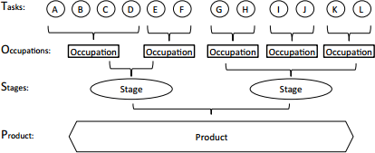

of GVCs suggests major paradigm changes 20 . These include a change of relevant strategic framework, from countries to firms and GVCs. Since a country cannot develop a competitive offer of goods or services in isolation, imports are a means for firms to access the most efficient inputs and free resources to focus on core competences. In addition, trade and FDI, both inward and outward, should be treated in an integrated framework.

A second paradigm change that has been highlighted21 relates to a change of relevant economic framework, from industries to tasks and business functions. In this regard, the objective is not to develop domestic industries that would capture all the segments of production or the whole value chain. Rather it is to identify the country’s best position in the GVC and the most competitive supply of tasks or business functions and acknowledging that an efficient manufacturing sector requires efficient and competitive services (e.g. financial intermediation, R&D, logistics, and marketing) as well as a skilled workforce and continuous innovation in products, processes and business models.

Thus it has been concluded that countries do not need to develop vertically integrated industries to participate in global trade but rather to develop capacities in specific segments (stages of production, tasks or business functions) of the value chain.

In this respect, Baldwin’s TOSP (Tasks, Occupations, Stages and Product) framework22 provides a useful means of identifying the possibilities for global value chain positioning (see *Figure 5*). A further paradigm change relates to a change in the relevant economic assets from endowments and stocks to flows23. GVCs have become the main channel of transfers such as capital, knowledge, technology standards and value-added services.

**Figure 5: Tasks, occupations, stages and product – the TOSP framework**

(Baldwin, R. (2012) Global Supply Chains: Why They Emerged, Why They Matter, and Where They Are Going, Working paper FGI-2012-1, Fung Global Institute, July).

20 Cattaneo, O., Gereffi, G., Miroudot, S. and D. Taglioni (2013). Joining, upgrading and being competitive in global value chains: a strategic framework, Policy Research working paper; no. WPS 6406. The World Bank.

21 Cattaneo et al (2013). op. cit.

22 Baldwin, R. (2012). Global Supply Chains: Why They Emerged, Why They Matter, and Where They Are Going, Working paper FGI-2012-1, Fung Global Institute, July.

23 Cattaneo et al (2013). op. cit.

13

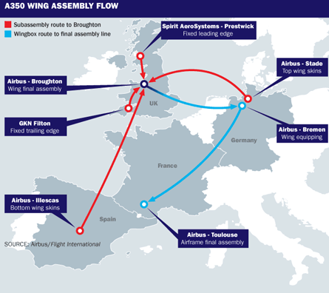

**6. GVCs and Smart Specialisation**

Trade and participation in GVCs are just intermediary objectives 24 . Instead the key consideration is how much value is captured by the country in terms of jobs, income, technology diffusion, sustainable development, etc. The ability of a country to participate in global trade and benefit from the transfers that will generate growth and development is now partially linked to its ability to join GVCs. *Thus competitiveness is not measured in terms of a country’s capacity to develop an integrated industry, but its capacity to identify its best position in GVCs*. A country’s competitiveness can be assessed at three levels relating to its capacity to join GVCs, remain part of GVCs and move up the value chain within GVCs. A further issue is a country’s capacity to disrupt GVCs which requires a somewhat different set of considerations.

Finally, in considering the potential to benefit from participation in GVCs, trade in integrated regions such as the European Union are more attractive to GVC lead firms for a number of practical reasons due to greater ease and lower costs of flows. Lead firms in GVCs carry brands and sell branded products and systems in final markets to individual consumers, other businesses, or government agencies.

These firms initiate, or ‘*lead*’, the GVC’s activities by placing orders with suppliers, giving them market power over suppliers25. In this respect, the European Union could develop a

number of competitive industries through the constitution of regional value already demonstrated in the case of Airbus in aeronautics (see *Figure 6*).

chains

as

**Figure 6: Assembly of an Airbus A350 Wing (**[**www.flightglobal.com**](http://www.flightglobal.com/)**)**

24 Cattaneo et al (2013). op. cit.

25

Sturgeon, T. and M. Kawakami (2010). Global Value Chains in the

Electronics

Industry: Was the Crisis a Window of Opportunity for Developing Countries? Policy Research Working Paper 5417. The World Bank. September.

14

In addition, it has been observed that a number of value chains tend to be regional, such as the bulk of the automotive industry26. However, it has argued that the objective is not necessarily to develop an integrated industry, but to capture an important part of the chain’s value-added by providing a regional bundle of tasks or services at pinch points of the GVC where opportunities can arise27.

**7. Manufacturing in Ireland**

Given that this brief focuses on one element of Ireland’s manufacturing sector, it is important to offer some perspective on that sector. Manufacturing plays a critical role in the Irish economy – as a driver of exports, as an employer, as a source of revenue and as a key driver of growth. In total, there are 12,790 manufacturing enterprises in Ireland. Most of these are small in scale, with 83 per cent employing less than 10 people (micro firms) and 95 per cent employing less than 50 people. In general, the larger firms are foreign owned, with the exception of a small number of firms involved in the food and engineering sectors. Overall, firms assisted by the two state agencies (the Industrial Development Agency (IDA) with responsibility for foreign enterprises and Enterprise

Ireland

(EI) with

responsibility

for

indigenous

owned enterprises) represent

approximately 92 per cent of total manufacturing employment. Historically employment

in manufacturing firms by ownership has been split almost evenly between Irish-owned and Foreign-owned firms.

In its report ‘*Future Skills Requirements of the Manufacturing Sector to 2020*’28, the Expert Group on Future Skills Needs predict, under the Competitive Manufacturing Scenario, employment to rise by 22,000 to 2016 and continue incrementally to increase by 43,000 by 2020. The report identified the skills needs for manufacturing generally and some specific needs for a number of manufacturing subsectors, namely; Engineering, Biopharma-Pharmachem, Medical Devices, Food & Beverages Consumer Products and ICT Hardware. Manufacturing firms across all sub-sectors reported that professional engineering and science occupations for those requiring experience, were the most frequently mentioned as being difficult to fill. Ireland has a developed National Innovation System that is currently based around a set of priority areas for publicly funded research. Several of these priority areas relate to Manufacturing. This is consistent with the EU’s positioning of Advanced Manufacturing as a KET. Ireland has made a significant investment in this KET in the last decade and is currently funding a number of Research and Technology centres which focus on Advanced Manufacturing, including a Materials & Surface Science Institute (MSSI), Tyndall National Institute, Irish Centre for Manufacturing Research (ICMR), and the I2E2 energy efficiency research centre.

Since the 1990s Ireland has invested in its research infrastructure through the direct funding of third level education institutions via a number of programmes for research – Programme for Research in Third Level Institutions (PRTLI) and through Science Foundation Ireland (SFI). In the case of SFI, it has funded the establishment of specialised research centres in a number of priority areas predominately in the Biotechnology and ICT fields since it was founded in the 1990s. These initiatives have

26 Sturgeon, T. , Memedovic J. Van Biesebroek and G. Gereffi (2009). Globalization of the Automotive Industry: Main Features and Trends, International Journal of Technological Learning, Innovation and Development, 2(1-2), pp. 7-24.

27 Cattaneo et al (2013). op. cit.

28 Forfas (2013). Future Skills Requirements of the Manufacturing Sector to 2020 Expert Group on Future Skills Needs, February.

15

both expanded and upgraded the pool of human capital in Ireland. They have been driven by the objectives of developing world-class research capabilities in strategic technologies to underpin the future development and competitiveness of Irish owned industry, facilitating the undertaking of R&D in Ireland by multinational companies in order to support the further development of that sector in Ireland, attracting more high technology companies to Ireland in the future, and enhancing the environment for the creation of new technology-based firms 29 . Ireland’s enterprise policy is focusing on realising the economic benefits of its investments to date in R&D infrastructures, by strengthening its IP framework, by brokering partnerships between firms and research institutes, and by reducing barriers for SMEs to engage in RD&I30.

**8. The Pharmaceutical Industry**

Since the Pharmaceutical sector is a highly globalised, innovation-driven industry with extensive co-operation and competition between large and small companies (OECD, 2013), it represents an appropriate sector to focus on in the context of GVCs and S3. The industry can be categorised into three groups: i) Biotechnology firms, ii) Traditional pharmaceutical companies – or more commonly known as ‘Big Pharma’ and. Iii) Generic drug companies. These three groups have tended to possess distinct capabilities and specialisation. Whereas Big Pharma dominated the industry for decades, the emergence of biotechnology firms and generic drug companies have undermined that dominance and threatened its traditional business.

The kinds of knowledge-based capital that support the competitive advantage of these three players in the pharmaceutical value chain have been considered31. The competitive advantage of biotechnology firms depends on advanced technological knowledge. This knowledge is built up not only through basic research but also through formal and informal collaboration on R&D with universities, other biotechnology firms and other actors with relevant technological competencies. A rich research network is thus a crucial asset of successful biotechnology firms.

Big Pharma’s capabilities for identifying commercially promising breakthroughs stem from knowledge of the latest technologies and market environments and of networks of biotechnology firms and other actors able to produce novel solutions, as well as a reputation as a reliable collaborator. Big Pharma companies’ ability to commercialise breakthroughs swiftly is supported by its experience in laboratory testing and regulatory approval procedures. Finally, large networks of customers and recognised brand names are important for marketing their drugs globally. Generic drug companies that thrive on the basis of cost competitiveness rely on efficient procurement networks to reduce material costs and a wide network of customers.

Developments in Biotechnology have spurred the growth of biotechnology firms and have steadily increased the significance of the biopharmaceutical (‘*biopharma*’) segment of the industry particularly in recent years with its rapid advance. While the biopharma sector is a relatively new area of the pharmaceutical industry, with the first biopharmaceutical drugs being approved in the 1980’s and 1990’s, forecasts predict that by 2016, seven of the top 10 blockbuster drugs will be biopharmaceuticals.

29 Ireland’s Smart Specialisation Strategy for Research and Innovation Background Paper S3 Platform Peer Review Workshop Dublin, 3-4 July 2014.

30 Ireland’s Smart Specialisation Strategy for Research and Innovation Background Paper op. cit.

31

Haanes, Knut and Fjeldstad, Øystein (2000.) Linking Intangible Resources and

Competition, European Management Journal. Vol. 18, Nº1, pp.52-62.

16

Biopharma manufacturing is complex and challenging due to the extreme complexity and variability of the process and the product and the highly regulated nature of the industry. Bioprocessing is regarded by the EU as a Key Enabling Technology (KET) with applications in multiple fields of manufacturing including medicine production and industrial processes and having a high potential for economic impact albeit involving a high level of Capital Expenditure and risk.

From a GVC perspective, the Pharmaceuticals industry is an example of where producer- driven, as opposed to buyer-driven GVCs, obtain. Producer-driven GVCs tend to be found in high-tech sectors that rely on technology and R&D. In such chains, lead firms are found upstream and control the design of products as well as most of the assembly which is fragmented in different countries32.

**9. The Pharmaceutical Industry in Ireland**

The Pharmaceutical industry forms an important part of the manufacturing sector in the Irish economy. Initial investments in the sector were primarily in bulk pharmaceuticals, now known as active pharmaceutical ingredients (APIs). Over the course of the 1970s, investment began to gravitate towards drug product manufacture. The 1990s saw this trend continue, with many established sites reinvesting significantly and expanding into shared service activities. The advent of the human genome project saw many Irish- based companies invest in biotech or biopharmaceutical operations. Currently, many players are investing in product and process development, thereby adopting the Development & Manufacturing model. In addition, a number of indigenous specialist pharmaceutical and chemical companies have been established, adding to the overall diversity of the sector33.

The majority of Irish sites have undergone significant transformation since they first established. This has helped Ireland to move away from its traditional status as a sourcing location, primarily for APIs. Many sites are now engaging in fully-integrated operations, offering a range of activities beyond pure manufacturing, including process and product development, manufacture for clinical trials, shared services, etc.

9 out of the top 10 world’s pharmaceutical companies have substantial operations in Ireland. There are over 30 FDA approved pharma/bio plants located in Ireland. There is a strong and transparent regulatory framework in force provided by IMB, FDA and EMA with an extraordinary compliance and regulatory track record. There are approximately 25,000 people directly employed in the industry with an almost similar number indirectly employed providing support services. In 2012, exports of 55 billion euro were reported. In that year Ireland was the largest producer of pharmaceuticals in the world and accounted for almost 4% of global Pharma-chem exports. Pharma-chem accounted for circa 45% of Ireland’s merchandise exports in 2012.

The Pharmaceutical sector in Ireland can be grouped into four main sub-groups: Primary Pharmaceuticals, Secondary Pharmaceuticals, Diagnostics and Biopharmaceuticals34.

The industry in Ireland has been responding to the global trends in the industry with value chain upgrading and an increasing concentration on bio-pharma. Irish subsidiaries are repositioning themselves in the global value chain as ‘strategic launch plants and

8th

32 Backer, K. D. and S. Miroudot (2013). op. cit.

33 This paragraph and the next paragraph drawn from IBEC’s Ireland Strategy in Action available at [http://www.pharmachemicalireland.ie/Sectors/PCI/PCI.nsf/vPages/PCI_](http://www.pharmachemicalireland.ie/Sectors/PCI/PCI.nsf/vPages/PCI_policy%7EPublications_and_Resources%7Estrategy-in-action/%24file/Strategy%20in%20Action.pdf)

[policy~Publications_and_Resources~strategy-in-action/$file/Strategy in Action.pdf](http://www.pharmachemicalireland.ie/Sectors/PCI/PCI.nsf/vPages/PCI_policy%7EPublications_and_Resources%7Estrategy-in-action/%24file/Strategy%20in%20Action.pdf)

34 Sourced from Enterprise Europe Network (2010). Pharmaceuticals in Ireland. Available at [http://www.een-ireland.ie/eei/assets/documents/uploaded/general/](http://www.een-ireland.ie/eei/assets/documents/uploaded/general/Pharmaceuticals%20Fact%20sheet.pdf)

[Pharmaceuticals Fact sheet.pdf](http://www.een-ireland.ie/eei/assets/documents/uploaded/general/Pharmaceuticals%20Fact%20sheet.pdf)

17



flexible multi-product plants’ that can produce the high-value stages of the chemical pharmaceutical process as well as small volume, high value niche products 35 . The improvement in Ireland’s R&D offering through the introduction and subsequent enhancement of the R&D tax credit coupled with the steps taken to develop the national science and technology infrastructure and upgrade the pool of human capital has led to greater R&D activity. This has been particularly pronounced in the area of process R&D with the co-locating of process R&D activity with existing manufacturing operations. With the growth of activity in the bio-pharma segment of the industry, Ireland has seen the development of a cluster in the area with over ten large-scale biopharmaceutical facilities. In all the total up and running or in planning by late 2014 was nineteen as compared to ten years earlier when there was only one facility36. More than 5,000 people were employed in Biotech development and manufacturing in 2014 with a 7% employment growth per annum since 2009. Ireland’s track record in the industry, its talent pool, tax advantages, regulatory stability and a national innovation system that encompasses extensive collaborations with the education sector have been important factors in the embedding of the pharmaceutical industry in Ireland via value chain upgrading and positioning in the fast-growing bio-pharma segment.

Ireland’s ambition is to be the hub of excellence in development and manufacturing for pharma-chem/biopharma with Ireland as the location of choice and with strategically relevant activities at the centre of the global supply chain. The movement towards the production of biopharmaceuticals on the part of existing companies coupled with the entry of new companies in the segment involves an *upskilling* for the industry. Globally the challenge of securing suitably skilled and experienced labour at all levels is considered to be the greatest constraint facing the fast growing biopharma segment.

Ireland has responded to this challenge with the establishment in 2011 of the National Institute for Bioprocessing Research and Training (NIBRT) Centre involving a partnership with industry and four leading academic institutions. In addition to the establishment of the NIBRT centre, Ireland has also invested in the establishment of the SSPC (Synthesis and Solid State Pharmaceutical Centre) and the PMTC (Pharmaceutical Manufacturing Technology Centre).

The strategic development of the Pharmaceuticals industry and of the biopharma segment of the industry in particular represents an instructive demonstration of smart specialisation in Action via GVC specialisation and the embrace of a holistic approach to development.

35 Enright, Shane and Dalton, Mary. The Impact of the Patent Cliff on Pharma-Chem Output in Ireland, SSISI paper, March 2014.

36 Cantillon, 2014. Biotech throws Ireland a valuable lifeline, Irish Times November 15, 2014, pg. 20.

18

**Box 2: National Institute for Bioprocessing Research and Training (NIBRT) Centre**

The state-of-the-art facility was funded by the Irish Government (IDA Ireland) and counts among its clients many of the leading companies in the industry. Its mission is to conduct world-class *research* in key industrial areas of bioprocessing, to *train* highly skilled personnel for the bioprocessing industry and to provide flexible, multipurpose bioprocessing research and training *facilities*.



The strategy is closely aligned with Europe’s KETs and Ireland’s own Research Prioritisation. Ireland’s Smart Specialisation in Biopharma is aligned very closely with the four Cs of **Competitive Advantage** based on the matching of R & I with business and the development of links, the adoption of technologies for diversification/modernisation of sectors and the exploration of emerging areas, policy **Choices** involving the selection of a limited number of priorities based on specialisation & integration in international value chains, **Critical Mass** of resources & talent and **Collaborative Leadership** involving stakeholders from academia, businesses, public administrations and civil society (i.e. quadruple helix) & synergies between funding instruments (EU, national, regional).

**10. Ireland’s Pharmaceutical Industry in a GVC context**

In section 3, the steps involved in gaining insight into GVCs were detailed as *Mapping, Digging, Determining, Decomposing and Ascertaining* (or *M3DA* for short). The analysis presented below of Ireland’s Pharmaceutical Industry in a GVC context focuses on the first step around mapping. To this end, use is made of the TiVA database.

In relation to this sector, the TiVA database contains data on Chemicals and non-metallic mineral products (ISIC Rev.3 codes 23-26). Although not an exact representation of the Pharmaceutical Industry, it does represent in the case of Ireland a close approximation of the Irish industry given the dominance of Pharmaceuticals in that grouping. Accordingly, we draw conclusions on the industry using the data for that grouping in the TiVA database.

a)

**Comparative positioning:** We first examine the Irish industry’s comparative positioning by considering both the revealed comparative advantage based on gross exports and based on domestic value added embodied in gross exports from 1995 to 2009 (see *Figures 7 and 8*). We find that in the case of both

measures, Ireland’s Pharmaceuticals Industry revealed comparative has more than doubled in that time frame.

advantage

**Figure 7: Revealed Comparative Advantage Based on Gross Exports**

19

**Index**

**Revealed Comparative Advantage Based on Gross**

**Exports of the Irish Pharmaceutical Industry**

3

2.5

2

1.5

1

0.5

0

1995 2000 2005 2009



**Figure 8: Revealed Comparative Advantage Based on Domestic Value Added Embodied in Gross Exports**

b)

Focusing on **gross trade indicators and value added embodied in gross trade**, we find that the industry exports globally with its largest exports going to Europe and in particular Belgium, France, Germany, Switzerland the UK, and to the USA (see *Figure 9*).

**Figure 9: Gross Exports of the Irish Pharmaceutical Industry**

20

**Index**

**Gross Exports of the Irish Pharmaceutical Industry**

Belgium

10% France

29% 7% Germany Spain

14%

Switzerland

United Kingdom

21% 3% United States

11% 5%

Rest of the World

**Revealed Comparative Advantage Based on Domestic Value Added Embodied in Gross Exports of the Irish Pharmaceutical Industry**

3.5

3

2.5

2

1.5

1

0.5

0

1995 2000 2005 2009



Likewise its largest imports come from Europe and in particular France, Germany, the Netherlands and the UK, and from the USA (see *Figure 10*). Ireland’s gross trade surplus has increased from under $4 billion in 1995 to over $38 billion in 2009 or as a percentage of GDP from 5.29% to over 17%.

**Figure 10: Gross Imports of the Irish Pharmaceutical Industry**

Looking at value added embodied in gross exports (*Figure 11*), we find that the proportion of domestic value added content of exports increased from about two- fifths in 2000 to almost two-thirds in 2009.

**Figure 11: Total Domestic Value-added Content of Exports**

When we consider the direct contributions made by the industry (see *Figure 12*) and the indirect contributions of domestic supplier industries made through domestic (upstream) transactions (*Figure 13*), we note that the contribution made by domestic supplier industries increased greatly from 2005 to 2009. The re-imported domestic value added is low attaining some $80 million in 2009.

21

**USD million**

**Total Domestic Value-added Content of Exports of the Irish Pharmaceutical Industry**

40,000

35,000

30,000

25,000

20,000

15,000

10,000

5,000

0

1995 2000 2005 2009

**Gross Imports of the Irish Pharmaceutical Industry**

6%

7% France

28% 7% Germany Netherlands United Kingdom

10% United States

42% Rest of the World



**Figure 12: Direct Domestic Industry Value Added Content of Gross Exports**

**Figure 13: Indirect Domestic Content of Gross Exports (Originating from Domestic Intermediates)**

22

**USD million**

**USD million**

**Indirect Domestic Content of Gross Exports (Originating from Domestic Intermediates) for the Irish Pharmaceutical Industry**

12,000

10,000

8,000

6,000

4,000

2,000

0

1995 2000 2005 2009

**Direct Domestic Industry Value Added Content of Gross Exports for the Irish Pharmaceutical Industry**

30,000

25,000

20,000

15,000

10,000

5,000

0

1995 2000 2005 2009

The foreign value added content of gross exports has fluctuated over the period 1995 to 2009 with the latest figure for 2009 at about one third. The breakdown

by country of origin is presented in *Figure 14* with European countries USA representing the greatest sources with India also featuring.

and

the

**Figure 14: Foreign Value Added Content of Gross Exports by country of origin**

Exports of value added as represented by domestic value added embodied

in

foreign demand by importing country are represented in *Figure 15*. European

economies along with the USA and to a smaller extent importing countries.

Japan

are

the

major

**Figure 15: Domestic Value Added Embodied in Foreign Final Demand by importing country**

23

**Domestic Value Added Embodied in Foreign Final Demand for the Irish Pharmaceutical Industry**

4% Belgium

8% France

8% Germany

39% 4% Italy

3% Japan

10% 4% Spain

20% United Kingdom

United States

**Foreign Value Added Content of Gross Exports of the Irish Pharmaceutical Industry**

5% France

5%

6% Germany

3%

29% Netherlands

4%

Norway

Spain

17%

3% United Kingdom

28% United States

India



The Services added value embodied in gross exports for the industry was about one third in 2009. This includes payments for intellectual property. The major source countries are shown in *Figure 16* and the trend in the amount of foreign services value added in gross exports is given in *Figure 17*.

**Figure 16: Services Value Added Embodied in Gross Exports by Source Country**

**Figure 17: Foreign Services Value Added Content of Gross Exports**

24

**USD million**

**Foreign Services Value Added Content of Gross Exports for the Irish Pharmaceutical Industry**

16,000

14,000

12,000

10,000

8,000

6,000

4,000

2,000

0

1995 2000 2005 2009

**Services Value Added Embodied in Gross Exports by Source Country for the Irish Pharmaceutical Industry**

4%

Germany

28%

Ireland

37%

United Kingdom

United States

22% Rest of the World

9%



A notable feature is the rapid growth recorded in Indirect Domestic Services Value Added Content of Gross Exports in 2009 compared to earlier periods (see *Figure 18*).

**Figure 18: Indirect Domestic Services Added Value Content of Gross Exports (Originating from Domestic Intermediates)**

Focusing on **intermediate imports**, we first consider the share of intermediate imports used in producing exports, as a percentage of total intermediate exports. This provides a measure of the importance of intermediate imports to produce exports and their role as a source of international competitiveness. As presented in *Figure 19*, over half of intermediate imports are used in producing exports and there is limited variation evident in this proportion in the time frame considered.

c)

**Figure 19: Re-exported Intermediates as a % of Total Intermediate Imports**

25

**Percentage**

**USD million**

**Re-exported Intermediates as a % of Total Intermediate Imports of the Irish Pharmaceutical Industry**

62

60

58

56

54

52

50

48

1995 2000 2005 2009

**Indirect Domestic Services Content of Gross Exports (Originating from Domestic Intermediates) of the Irish Pharmaceutical Industry**

8,000

7,000

6,000

5,000

4,000

3,000

2,000

1,000

0

1995 2000 2005 2009



d)

We next consider the **GVC participation indices** (*Figures 20-22*).

**Figure 20: Participation Index**

**Figure 21: Participation Index (backward)**

26

**Index**

**Index**

**Participation Index (backward) for the Irish Pharmaceutical Industry**

16

14

12

10

8

6

4

2

0

1995 2000 2005 2009

**Participation Index for the Irish Pharmaceutical Industry**

25

20

15

10

5

0

1995 2000 2005 2009

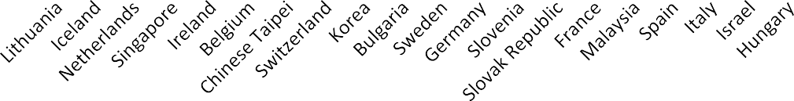

**Figure 22: Participation index (forward)**

The overall index recorded for 2009 was ranked in the top five (*Figure 23*) indicating that Ireland’s industry is relatively highly involved as part of a multi- stage trade process and that it is a relatively high participant in the industry global value chain. Significantly the nature of that involvement has changed over the time with the industry becoming less dependent on foreign inputs (*Figure 21*) and contributing more inputs to other countries’ exports (*Figure 22*). Thus the industry has become less reliant on inputs from outside Ireland and at the same time has embedded itself more significantly into the global value chain as it has increased its inputs into other countries’ exports.

**Figure 23: Top 20 Countries’ Participation Index for the Chemicals Industry (recall this is a close approximation for Ireland’s Pharmaceutical Industry)**

27

**Percentage**

**Index**

**2009 Top 20 Countries ' Participation Index for the Chemicals**

**Industry**

30

25

20

15

10

5

0

**Participation Index (forward) for the Irish Pharmaceutical Industry**

9

8

7

6

5

4

3

2

1

0

1995 2000 2005 2009



e)

Ireland’s **index of distance to final demand** (*Figure 24*) positions Ireland in the top 20 per cent of countries in terms of the ‘*upstreamness’* of its industry. Thus it is relatively more specialised in the production of inputs at the beginning/early stages of the global value chain. This is significant since the industry value chain is producer driven and hence the desirability of being positioned upstream.

**Figure 24: Index of Distance to Final Demand**

f)

The **index of the number of production stages** data (*Figures 25, 26 and 27*) reveal that Ireland has positioned itself in a greater number of stages of the global value chain over time.

**Figure 25: Index of the Number of Production Stages**

28

**Index**

**Index**

**Index of the Number of Total Production Stages for the Irish Pharmaceutical Industry**

2.2

2.1

2

1.9

1.8

1.7

1.6

1995 2000 2005 2009

**Index of Distance to Final Demand for the Irish Pharmaceutical Industry**

3.2

3.1

3

2.9

2.8

2.7

2.6

2.5

1995 2000 2005 2009



**Figure 26: Index of the Number of Domestic Production Stages**

**Figure 27: Index of the Number of International Production Stages**

Thus from the perspective of our GVC analysis, it is evident that

the Irish

Pharmaceuticals industry is well established and that its trajectory over the time period 1995 to 2009 has seen the industry position itself more effectively within a GVC context.

A recent study has positioned Ireland in ninth position in terms of its centrality in the global pharmaceuticals industry37. Ireland’s high participation indices in Pharmaceuticals can be related to investments of large pharmaceutical companies, especially from the USA38. Furthermore in a ranking39 of top European biopharma clusters based on inter ala

37 Hu, Y., Scherngell, T., Qiu, L. and Y. Wang (2015). R&D internationalisation patterns in the global pharmaceutical industry: evidence from a network analytic perspective, Technology Analysis & Strategic Management.

38 Backer, K. D. and S. Miroudot (2013). op. cit.

29

**Index**

**Index**

**Index of the Number of International Production Stages for the Irish Pharmaceutical Industry**

1.2

1

0.8

0.6

0.4

0.2

0

1995 2000 2005 2009

**Index of the Number of Domestic Production Stages for the Irish Pharmaceutical**

**Industry**

1.6

1.4

1.2

1

0.8

0.6

0.4

0.2

0

1995 2000 2005 2009

public research funding, venture capital (VC) funding, patents and number of companies, Ireland was ranked 10th. This high ranking was driven by the relatively high number of companies and the size of VC funding and less so by the level of public research funding and number of patents.

By applying the above analysis, we can derive a number of important insights into the industry and its positioning within a GVC context. For example, we can see where the value added associated with the industry is produced, whether domestically or imported, and if the latter what are the most significant source countries. Likewise, in terms of domestically produced value added, we can see what its most significant destination countries are. Thus we are able to map the extent and magnitude of the industry’s linkages with other locations of the GVC.

At the same time, as we have seen we can compare the industry to those in other countries in terms of participation within a GVC context, the number of stages of the value chain captured by Ireland relative to overall length of the value chain and that of other countries and where along the value chain, Ireland’s industry tends to be more concentrated. Importantly we can see how the industry has evolved over the time frame from 1995 to 2009 in terms of its activities, relationships and flows. Finally, the insights derived from the analysis enable a benchmarking of the industry to be obtained within a GVC context over time. All of the above insights are essential input into the development of any RIS3 strategies related to the industry.

Our GVC mapping of the pharmaceutical industry in Ireland has revealed that it has progressively evolved over time. Ireland’s comparative advantage has improved over the time period considered. Its participation in the industry GVC is high and as noted earlier the nature of that participation has changed over time so that it is contributing more inputs into the exports of other countries while relying less on the inputs of other countries for its exports. Furthermore, it has moved up the value chain by positioning itself more upstream in the value chain and along a greater part of the value chain. All of the above suggests a deepening embedding in the industry GVC. From the viewpoint of other countries and regions seeking to integrate industries into GVCs, the learning from the experience of the Irish Pharmaceutical industry includes the importance of embracing a holistic approach to development and aligning its S3 closely with the four Cs of **Competitive Advantage**, **Choices, Critical Mass** and **Collaborative Leadership**.

For Ireland itself, this mapping suggests that it needs to intensify its current approach. Simply maintaining its current approach is unlikely to suffice in terms of maintaining its GVC positioning and almost certainly not in terms of further moving up the value chain. As highlighted earlier, Ireland’s pharmaceutical industry falls short when ranked on the basis of public research funding and number of patents. Arguably, the paucity of patents relative to other locations can be attributed, at least in part, to its lower level of public research funding. Thus further investment in the development of advanced scientific human capital appears necessary as does the promotion and facilitation of greater collaborations on the part of the established research entities in Ireland with the leading established research entities in other countries and regions.

Accordingly, the development and upgrading of scientific human capital and the forging of collaborations with leading research entities elsewhere need to be pursued as a priority. These steps should result in greater success for Ireland in gaining European research funding leading in time to an increase in the number of patents and hence to new commercial possibilities within the industry GVC.

39 Top ten European Biopharma Clusters. Available at [http://www.genengnews.com/](http://www.genengnews.com/insight-and-intelligenceand153/top-10-european-biopharma-clusters/77900407/) [insight-and-intelligenceand153/top-10-european-biopharma-clusters/77900407/](http://www.genengnews.com/insight-and-intelligenceand153/top-10-european-biopharma-clusters/77900407/)

30

**11. Conclusions**

This brief has considered GVCs within the context of smart specialisation. A methodological approach has been described that analyses a country’s (region’s) position in GVCs. This approach has been applied to the case of the pharmaceutical industry in Ireland. A similar approach can be applied to other locations pertaining to that industry or other industries. By doing so, the comparative advantage of the industry can be assessed and its degree of participation in the industry GVC can be assessed including establishing those locations that serve as its main sources of inputs and destinations of its outputs. Thus the linkages of the industry and their extent can be established.

At the same time, the analysis can reveal where along the value chain the industry is positioned and the extent of that positioning. Thus the analysis points to opportunities for maintaining/extending/deepening the country’s positioning on the GVC. Furthermore, by applying a similar analysis to other locations, a location can ascertain who else occupies significant parts of the industry value chain, and how strong their positions are and whether those clusters of GVC activities in these other competing regions/countries are similar/complementary to their own activities. Taking account of the previously identified linkages, this can indicate whether there might be opportunities to capitalise on complementarities in other locations and the development of inter-regional/trans- European linkages. To explore such opportunities requires engaging in the digging (D) stage of our MD3A process described in the brief. This implies a focus on the extant clusters of the industry GVC.

Since the data required at the digging stage may be unavailable or indeed difficult to access, there is a need to identify conduits/boundary spanners who are connected to the industry and have a deep knowledge of the industry cluster and its characteristics. These conduits/boundary spanners are likely to be found within national and regional development agencies and/or enterprise development agencies. For each location, one such individual might be assigned an S3 responsibility within the context of the industry GVC. Platforms – real and virtual - would need to be developed to facilitate engagement among such conduits/boundary spanners so that opportunities for intra-regional industry GVC linkages can be precisely identified and pursued and that match-making takes place.

This paper has highlighted a number of important matters in relation to GVCs and S3. These are now considered from the specific context of the case of the Irish pharmaceutical industry and more generally from a methodological perspective. From the Irish case we can suggest some general principles that can be followed. These entail the following:

I.

II. III.

**Engaging** with the Industry and its stakeholders on a continuous basis,

**Anticipating** the likely evolution of the Industry globally,

**Assessing** the challenges and opportunities that are likely to ensue from future industry trajectories, and

**Responding** to those challenges and opportunities in a proactive manner.

IV.

This process of Engaging, Anticipating, Assessing and Responding (*EAAR*) is required to be followed on an on-going basis and must involve the active participation of all stakeholders. The on-going success of Ireland in the changing Pharmaceutical Industry is an instructive example of RIS3 in action from which specific lessons can also be observed:

I.

The provision of a compatible and supportive environment via a relevant infrastructure that encompasses a robust regulatory framework, research and technology and education.

31

II. III. IV.

V.

VI.

The upgrading and sustaining of a national innovation system. The development of the requisite human capital pool.

The supporting and nurturing of collaboration among all stakeholders. The engagement in upgrading of existing activities in the industry and The anticipating and targeting of areas of growth within the industry.

Finally in relation to some methodological perspectives, we have already observed that the macro analysis followed in the preceding section and applied to the Irish pharmaceutical industry offers very useful insights into the industry within a GVC context. However, this represents one stage of the ***M3DA process*** outlined in Section 3 viz. the mapping (**M**) stage. The subsequent stages of digging, determining, decomposing (**3D**) and ascertaining (**A**) call for micro level analyses. These are particularly important if regional authorities are to play a role in co-creating and developing European industrial value chains based on smart specialisation priorities.

This calls for the interregional knowledge building, mapping the matchmaking potential around GVCs between regional smart specialisation priorities, identifying some pilot examples of interregional value chains, key stakeholders, available equipment and facilities and relevant actors/skills in smart specialisation areas and applying the methodology described above with a view to identifying opportunities for matching of

national and regional cluster specialisation areas.

organisations

in

identified value

chains

of

smart

32

**References**

1.

2.

Anon. (2014). To those that have shall be given, Economist, October 04.

Backer, K. D. and S. Miroudot (2013). Mapping Global Value Chains, OECD Trade Policy Papers, No. 159, OECD.

Baldwin R. and J. Lopez-Gonzalez (2014). Supply-Chain Trade: A Portrait of Global Patterns and Several Testable Hypotheses. The World Economy.

Baldwin, R. (2012). Global Supply Chains: Why They Emerged, Why They Matter, and Where They Are Going, Working paper FGI-2012-1, Fung Global Institute, July.

Brennan, L., Ferdows, K., Godsell, J., Golini, R., Keegan, R., Kinkel, S., Srai, J.S. and M. Taylor (2015). Manufacturing in the World: Where Next? International Journal of Operations and Production Management Vol. 35, No. 9, pp. 1253-1274.

Cantillon, 2014. Biotech throws Ireland a valuable lifeline, Irish Times November 15, 2014 pg. 20.

Cattaneo, O., Gereffi, G., Miroudot, S. and D. Taglioni (2013). Joining, upgrading and being competitive in global value chains: a strategic framework, Policy Research working paper; no. WPS 6406. The World Bank.

Daniels, J.D., L. H. Radebaugh and D. P. Sullivan (2013). International Business: Environments and Operations, Pearson.

Enright, Shane and Dalton, Mary. The Impact of the Patent Cliff on Pharma-Chem Output in Ireland, SSISI paper, March 2014.

Forfas (2013). Future Skills Requirements of the Manufacturing Sector to 2020 Expert Group on Future Skills Needs, February.

George, K., Ramaswamy, S. and L. Rasey (2014). Next-shoring: A CEO’s guide. McKinsey Quarterly, January.

Giffi, C. A., Roth, A.V., Chaudhuri, A., B. Gangula and M. Drew (2014). Cracking the generic code of hgh-performing manufacturers, Deloitte Review Issue 14, pp. 110-125.

Haanes, Knut and Fjeldstad, Øystein (2000). Linking Intangible Resources and Competition, European Management Journal. Vol. 18, Nº1, pp.52-62.

Hu, Y., Scherngell, T., Qiu, L. and Y. Wang (2015). R&D internationalisation patterns in the global pharmaceutical industry: evidence from a network analytic perspective, Technology Analysis & Strategic Management.

Ireland’s Smart Specialisation Strategy for Research and Innovation Background Paper S3 Platform Peer Review Workshop Dublin, 3-4 July 2014.

Lamy, P. (2013). 'Emerging economies: ‘shapers and makers’ in changing landscape' – WTO News: Speech by DG Pascal Lamy at Bigli University, Istanbul.

Manyika, J., Sinclair, J., Dobbs, R., Stube, G., Rassey, L., Mischke, J., Remes, J., Roxburgh, C., George, K., O’Halloran, D. and S. Ramaswamy (2012). Manufacturing the future: The next era of global growth and innovation, McKinsey Global Institute, McKinsey and Company, November, pgs. 16.

OECD (2013). Interconnected Economies: Benefiting from Global Value Chains.

3.

4.

5.

6.

7.

8.

9.

10.

11.

12.

13.

14.

15.

16.

17.

18.

33

19.

Sturgeon, T. and M. Kawakami (2010). Global Value Chains in the Electronics Industry: Was the Crisis a Window of Opportunity for Developing Countries? Policy Research Working Paper 5417. The World Bank. September.

Sturgeon, T., Memedovic O., J. Van Biesebroek and G. Gereffi (2009). Globalization of the Automotive Industry: Main Features and Trends, International Journal of Technological Learning, Innovation and Development, 2(1-2), pp. 7-24.

Suder G, Liesch P.W., Inomata S., Mihailova I. and B. Meng (2014). The evolving geography of production hubs and regional value chains across East Asia: Trade in value-added, Journal of World Business.

Top ten European Biopharma Clusters. Available at [http://www.genengnews.com/](http://www.genengnews.com/insight-and-intelligenceand153/top-10-european-biopharma-clusters/77900407/) [insight-and-intelligenceand153/top-10-european-biopharma-clusters/77900407/](http://www.genengnews.com/insight-and-intelligenceand153/top-10-european-biopharma-clusters/77900407/)

UNCTAD (2013). Global Value Chains and Development. Available at <http://unctad.org/en/publicationslibrary/diae2013d1_en.pdf>

[www.globalvaluechains.org](http://www.globalvaluechains.org/). Accessed on January 15, 2015.

20.

21.

22.

23.

24.

34

**List of figures**

Figure 1: The Diversity of Manufacturing (Manyika, et al, 2012) 6

Figure 2: Service type activities in Manufacturing (Manyika, et al, 2012) 7

Figure 3: The Value Chain 8

Figure 4: The Global Value Chain for Apple’s iPhone 4 8

Figure 5: Tasks, occupations, stages and product – the TOSP framework 13

Figure 6: Assembly of an Airbus A350 Wing (www.flightglobal.com) 14

Figure 7: Revealed Comparative Advantage Based on Gross Exports 19

Figure 8: Revealed Comparative Advantage Based on Domestic Value Added Embodied in Gross Exports 20

Figure 9: Gross Exports of the Irish Pharmaceutical Industry 20

Figure 10: Gross Imports of the Irish Pharmaceutical Industry 21

Figure 11: Total Domestic Value-added Content of Exports 21

Figure 12: Direct Domestic Industry Value Added Content of Gross Exports 22

Figure 13: Indirect Domestic Content of Gross Exports

(Originating from Domestic

Intermediates) 22

Figure 14: Foreign Value Added Content of Gross Exports by country of origin 23

Figure 15: Domestic Value Added Embodied in Foreign Final Demand by importing country 23

Figure 16: Services Value Added Embodied in Gross Exports by Source Country 24

Figure 17: Foreign Services Value Added Content of Gross Exports 24

Figure 18: Indirect Domestic Services Added Value Content of Gross Exports (Originating from Domestic Intermediates) 25

Figure 19: Re-exported Intermediates as a % of Total Intermediate Imports 25

Figure 20: Participation Index 26

Figure 21: Participation Index (backward) 26

Figure 22: Participation index (forward) 27

Figure 23: Top 20 Countries’ Participation Index for the Chemicals Industry (recall this is a close approximation for Ireland’s Pharmaceutical Industry) 27

Figure 24: Index of Distance to Final Demand 28

Figure 25: Index of the Number of Production Stages 28

Figure 26: Index of the Number of Domestic Production Stages 29

Figure 27: Index of the Number of International Production Stages 29

35

**List of boxes**

Box 1: Three measures of the importance of GVCs 12

Box 2: National Institute for Bioprocessing Research and Training (NIBRT) Centre 18

36

**How to obtain EU publications**

Our publications are available from EU Bookshop ([http://bookshop.europa.eu](http://bookshop.europa.eu/)), where you can place an order with the sales agent of your choice.

The Publications Office has a worldwide network of sales agents.

You can obtain their contact details by sending a fax to (352) 29 29-42758.

Europe Direct is a service to help you find answers to your questions about the European Union Free phone number (*): 00 800 6 7 8 9 10 11

(*) Certain mobile telephone operators do not allow access to 00 800 numbers or these calls may be billed.

A great deal of additional information on the European Union is available on the Internet. It can be accessed through the Europa server [http://europa.eu](http://europa.eu/)





JRC Mission

As the Commission’s

in-house science service, the Joint Research Centre’s mission is to provide EU policies with independent, evidence-based scientific and technical support throughout the whole policy cycle.

Working in close cooperation with policy Directorates-General, the JRC addresses key societal challenges while stimulating innovation through developing

new methods, tools

and standards, and sharing its know-how with

the Member States,

the scientific community and international partners.

*Serving society Stimulating innovation Supporting legislation*

doi:10.2791/44840

ISBN 978-92-79-54181-0

LF-NA-27649-EN-N