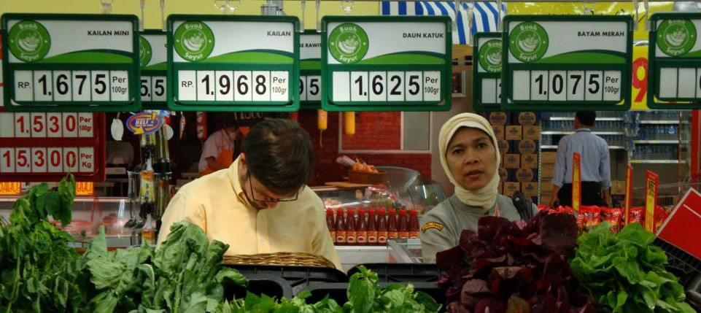

**Mapping the Value Chain**

Capacity Building for Research Workshop, Monday 1 September, 2014

Wendy Umberger, Ph.D.

Director & A/Professor Global Food Studies

Overview

•

Gain an understanding of terms and relationships between

* “markets”
* “value chains”
* “mapping value chains”
* “value chain analysis”

Highlight value chain mapping techniques Examples of mapping techniques

•

•

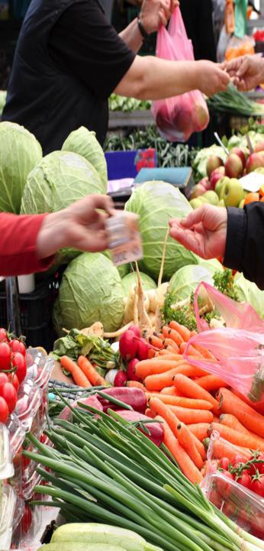

What is a “Market”

Set of all actual & potential buyers and sellers of a product

– Buyers share a particular need or want that can be satisfied through exchange with suppliers.

Many types of markets:

•

•

–

–

–

–

–

Input markets

Labour markets Commodity markets

Intermediate and wholesale markets Retail markets, end-consumer markets (e.g. food product markets)

•

*Markets interrelate with each other through the*

*exchange process. This can occur on a local, national or even global scale*

Marketing System

**Environment**

**Competitors**

**End user market**

**Marketing inter- mediaries**

**Company (marketer)**

**Suppliers**

**Environment**

2 Components of Markets

•

Demand-side:

Consumers, Customers, Users

of products and services etc.

* Marketers refer to the demand side as “the market”
  + Utility and Value (marginal utility)

•

Supply-side:

Producers, traders, wholesalers,

processors, retailers

* Marketers refer to the supply side as “the industry”
  + Production function and Costs (marginal costs)

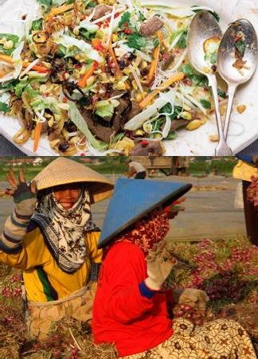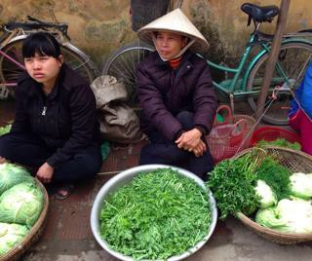

Products

‘Anything that can be offered to a market for attention, acquisition, use or consumption that might satisfy a want or need.’ (p. 9, Kotler, et al.)

Includes:

– physical objects, services, persons, places, organisations and ideas.

Satisfy consumers’ needs and wants Must be demand for product to have “value”

Vehicles for “need satisfaction”

Customer must “value”

•

•

•

•

•

•

Marketing involves

creating or refining the form, time, place and possession of commodity into a product and increasing its value to the consumer

Bringing buyers and sellers together Establishing prices

Making products more desirable Moving products

VALUE ADDING

•

•

•

•

•

•

Customer value

•

**Customer Value**

*The difference between the values the customer gains from owning and using a product and the costs of obtaining the product.*

Often times consumers perceive value differently than the product’s actual monetary value.

•



**VALUE CHAIN**

**THINKING**

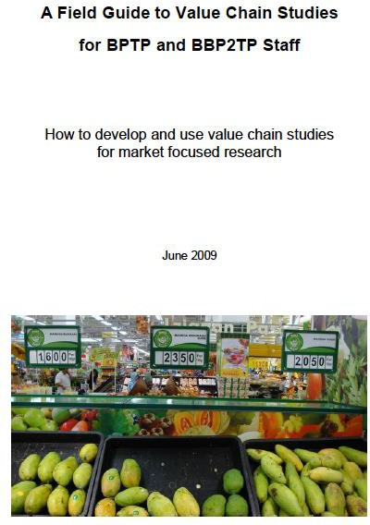

Prepared by: Prof Randy Stringer, Global Food Studies,

University of Adelaide

Australian Centre for Agricultural Research (ACIAR)



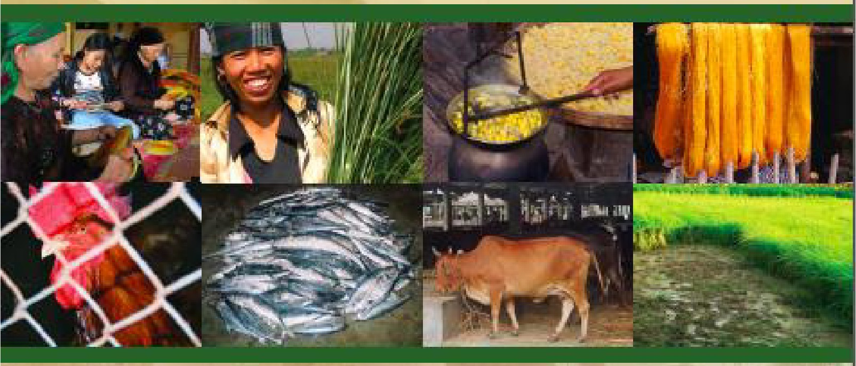

***m ,***

Making Value Chains

Work Better f 0 1 r the

Poor

A Tool**book** for Practit ionersof Value Chain An, al ysis

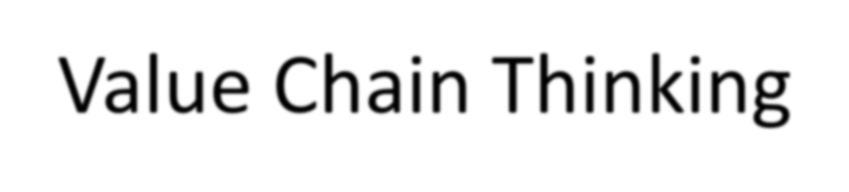

Value Chain Thinking

What is a food chain?

▪

A series of organisations that link together to deliver a product or service to a

consumer

Limitations of a traditional supply chain

▪

Each organisation concentrates on their own business and pushes the product

onto the next link in the chain

Advantages of a value chain

▪

The focus changes from supply push to consumer demand pull. Every

organisation works together to produce what the final consumer wants.

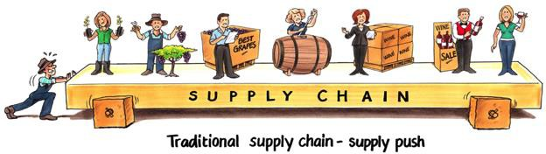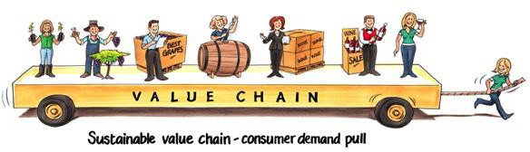



Value Chain Thinking

Traditional supply push

Value chain demand pull

Courtesy of Prof Andrew Fearne

Food Value Chain

Input Suppliers

Primary Producers

Processor

Retailer

Consumer

Information – Behavioural & Attitudinal

Relationships - Collaborative

Financial – Value Added

Wholesaler/Agent

Wholesaler/Agent

Service Providers (e.g. agronomy, veterinary, logistics, finance, waste management)

Value Chains vs Supply Chains

Supply chains

**Input**

**suppliers**

**Traders, and**

**collectors**

**Wholesalers**

**and retailers**

**Consumers**

**Farmers**

Supply side push

Upgrading options Distributional issues Governance

**Input**

**suppliers**

**Traders, and**

**collectors**

**Wholesalers**

**and retailers**

**Consumers**

**Farmers**

Market demand pull

Value chains

Knowledge, information, innovation, power, efficiency, value

A Value Chain Approach

•

Examination of interactions between different

actors (firms) in the chain and influencing the chain

* Descriptive
* Analytical

Different methods

“Right” or “Best” depends on

* What questions you want answered
* Budget (financial and time) available

•

•

Overview of Value Chain Analysis

(VCA)

VCA normally focuses on a very specific chain Product is followed through (mapped) each step in an existing chain to the final consumer

Mapping can involve determining

* Product Flow
* Information Flow
* Relationships

Used as a diagnostic tool to identify collaborative implementation projects that can benefit the whole chain

•

•

•

•

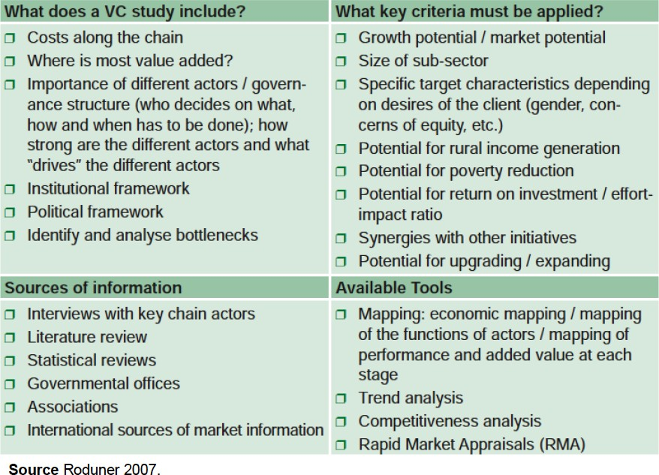

Value Chain Analysis

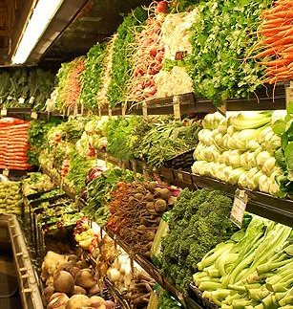

Objectives of Mapping

Value Chain

Part of value chain analysis Overview of the value chain

Identify constraints or blockages in chain Understand role of poor or targeted actors in the chain

Visualize networks and relationships Understand structure

Create awareness of all actors, markets and factors (e.g. infrastructure, policies, processes) affecting the performance of the value chain

•

•

•

•

•

•

•



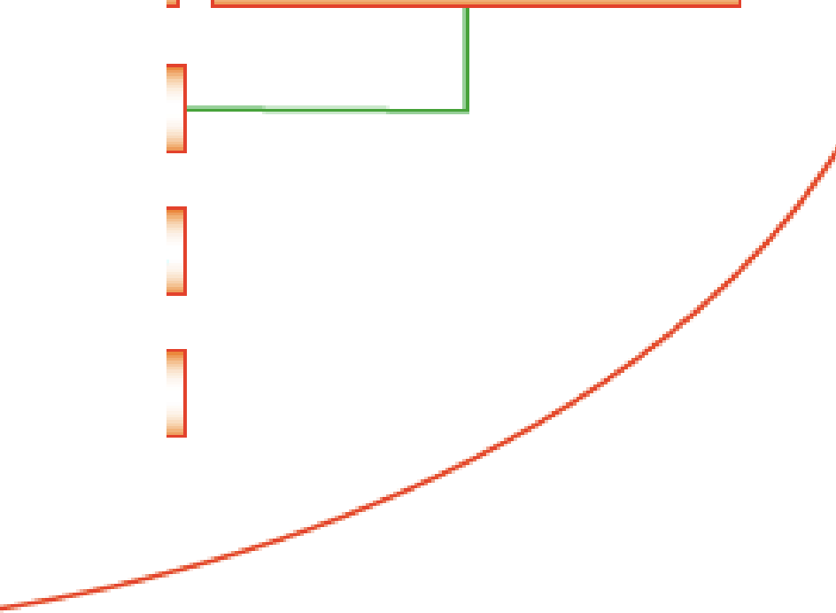

·e

n,

a

nce

U lp

g

1

A

h y·p

ot h et iea l value-chain in agr·i cultur,e

F,a nrners/ P'rodueers 1-- -

* G ove rn a 1nce
* Up,g r a d ing
* **Distributional l·ssue:s**

- ----1

Affe:mb, le r:s/Traders

P'roc e :ssor:s

R:,et

a

il-er:s

Tr a d er:s

Exporters

End -{u ser :s

Fioreig n Trader:s

* Goverinanc:e
* Upgrading
* **Dis1ributiona** I **Issues**

- ----1 Fio r,ei g n Di ·strib u:lio r:s

1-- -

-

Fior ,ei g rn **R:e ta** il-ers

t

Key Questions Addressed (1)

Who are the main actors and how many of each type are there?

What are the main activities and processes required

* E.g. what does each actor actually do? What is their “value add”?

How does product flow?

What is the volume of product handled by each actor or type of actor?

* Purchased, transformed and sold?

How do information and knowledge flow?

•

•

•

•

•

–

–

–

e.g. information about end market, prices, quality, timing, supply

Does information flow up the chain from the retailer?

Do firms share their market knowledge?

Key Questions Addressed (2)

What is the the relative monetary value of the product at each link

How many people are employed at each link?

* Socio-economic characteristics

What type of relationships and linkages exist between the businesses?

* Strength, length or history
* Power

What support services feed into the chain?

What are the key constraints faced by actors n the chain? What external factors are affecting the chain?

•

•

•

•

•

•

Market Structure and Conduct

Number of buyers and sellers

Homogeneity

– Type, variety, quality and end-use characteristics

Number of close substitutes

•

•

•

–

More substitutes means buyers are more price sensitive

•

•

Storability or perishability

Transparency of price formation

–

Open auctions or contracting

•

•

Ease of entry and exit (asset specificity)

Ease of commodity transfer between buyers and sellers

–

More mobile means more spatial price differences

•

Artificial restrictions on market

–

Government, policy, trade, collusion

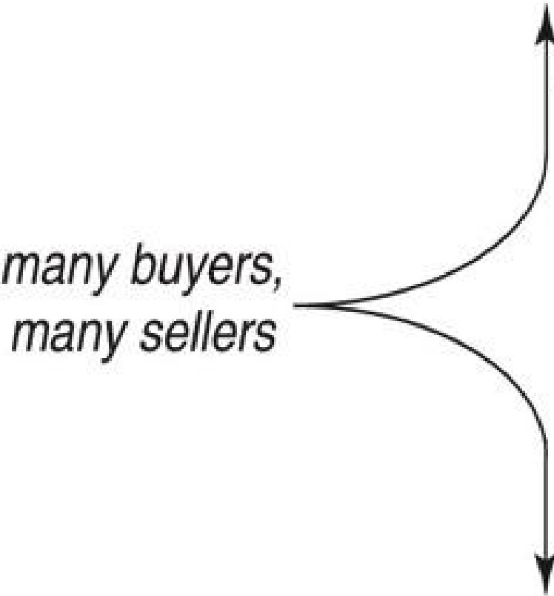

*higher*

*price, lower*I

*many buyersJ*

*one seller*

_ IM_o,n_o_po_lY._ _

)

*total surp,Jus*

0 1lli gopoly

)

*A thin market* has

*few* buyers *and*

*fe'W sellers.*

*Whethe r price is*

m *competitive*

*h*

*. h*

Perfect

.

*pnce,* . *1.*, *g*

0

" i:

*high or/ow depends on their relative negotiating power.*

a..

_co_m_1 p_e_it1_oit_n-_

*total surplus*

)

*lower price,*I *lower tota*.*l*

*surplus*

*one, buyer,*

*many- sellers*

Mon, opsony

, Qligopsony

Food Marketing Environment

Food market is affected by many different forces

* sociological
* government regulations and policy
* international trade conditions
* science and technology
* weather and other conditions affecting harvest conditions
  + Climate change
* economic cycles
* competitive conditions
* media

•



**Examples of Value**

**Chain Mapping**

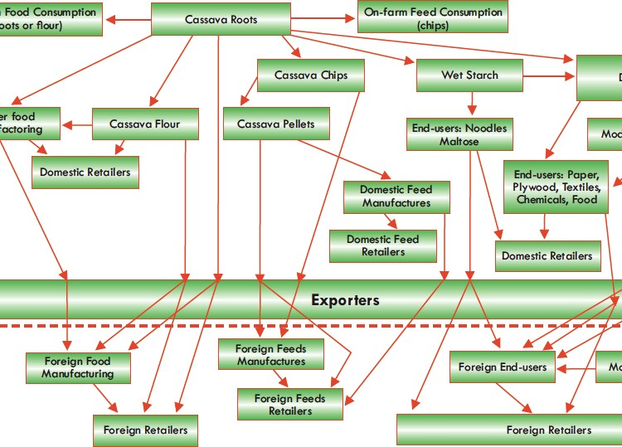

Example:

Mapping of Processes in Cassava VC

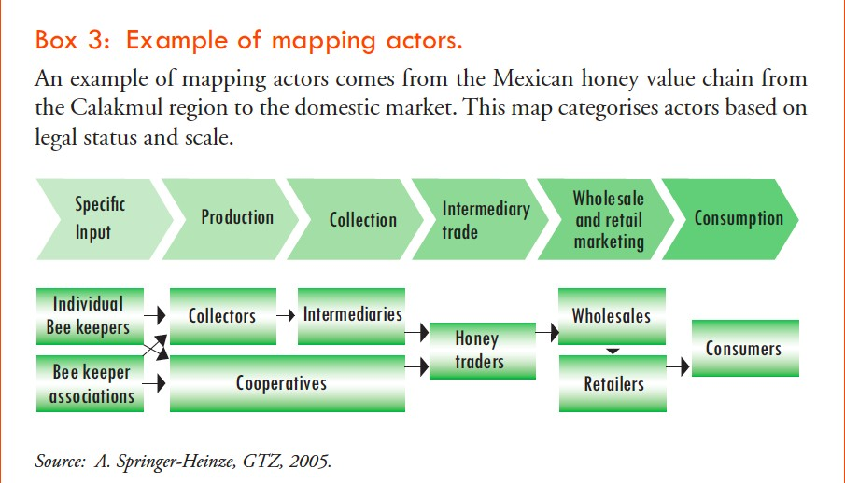

Mapping Actors

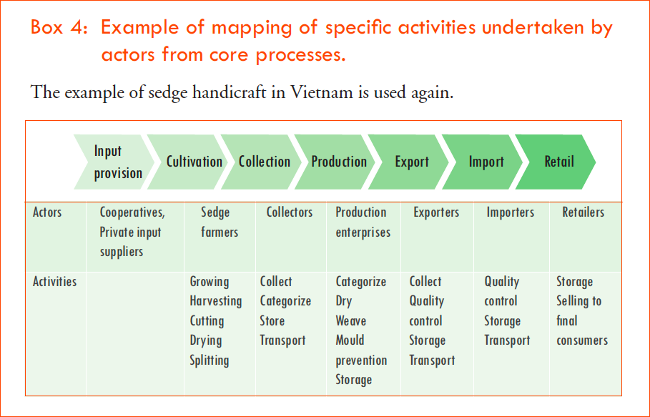

Mapping Activities Undertaken by Actors

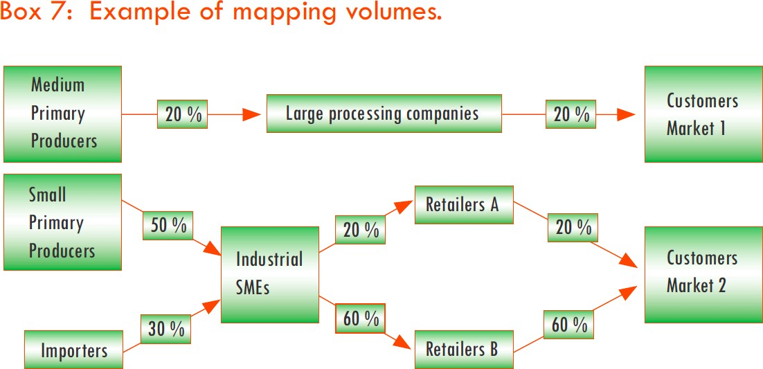

Mapping Volume by Actors (1)

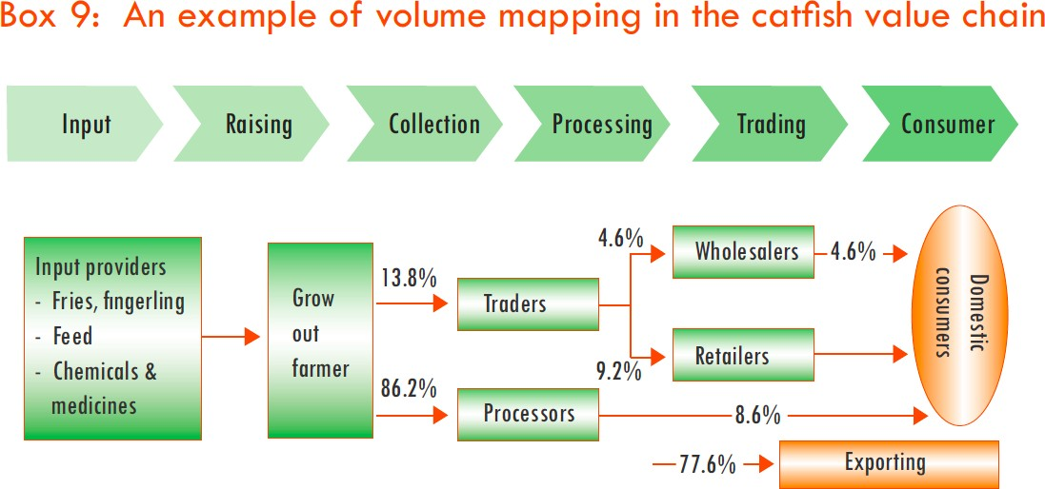

Mapping Volume by Actors (2)

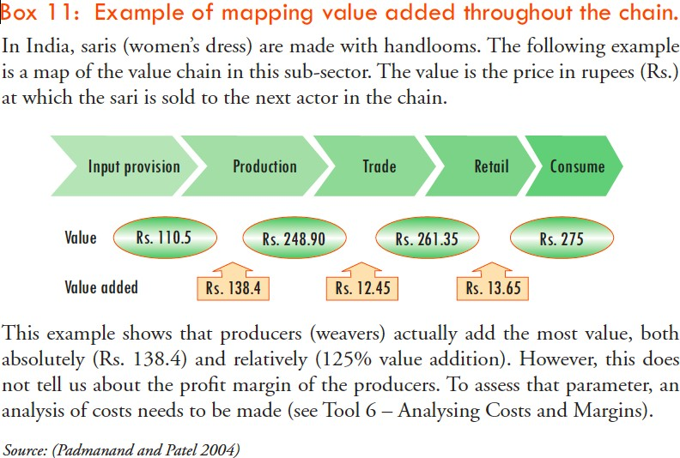

Mapping Value Adding

Interviews for Mapping

Aim is to develop a comprehensive picture entire value chain.

Multiple Stages:

Key Informant Interviews:

* identifying and meeting key partners and participants in the chain to understand any significant relationships among and between actors.
* Scoping study

In-depth interviews

* develop a comprehensive picture of the value chain from the supply of farming inputs, via production, processing, logistics, retailing and finally to consumption.

•

•

1.

2.

Main Interview Questions:

**Procurement**

Products & forms of product and volumes

purchased

Number & types of sellers, proportions from each Location of suppliers and purchases

What:

Who:

Where:

How much:

How much: How:

How:

Purchase price and other procurement costs

Risks (physical loss, theft, price change, etc) Technology of activity (vehicles, assets, methods)

Degree of coordination or integration with suppliers

» Credit, contracts, info exchange, resource provision, etc.

» Sources of information about suppliers, search cost

Seasonality and volatility Changes over past 5 years

Ask any surprising or interesting information

When:

When: Why:

Main Interview Questions:

**Value Adding**

Value added activities & volumes

» e.g Transportation, storage, sorting, packaging, cleaning, processing

What:

How much:

How much: Where:

How:

Composition of costs for each activity

Risks (physical loss, theft, prices etc.) Location of activities

Technology of activity

» assets, machinery, storage facilities, methods

Seasonality and volatility Changes over past 5 years

Any surprising or interesting information

When:

When: Why:

Main Interview Questions:

**Value Adding**

Value added activities & volumes

» e.g Transportation, storage, sorting, packaging, cleaning, processing

What:

How much:

How much: Where:

How:

Composition of costs for each activity

Risks (physical loss, theft, prices etc.) Location of activities

Technology of activity

» assets, machinery, storage facilities, methods

Seasonality and volatility Changes over past 5 years

Any surprising or interesting information

When:

When: Why:

Main Interview Questions:

**Sales and Marketing**

Products & forms of product & volumes Numbers and types of buyers, proportion to each Location of buyers and sales transaction

What:

Who: Where:

How much:

How much: Where: How:

How:

Sale price and costs of marketing activities

Risks

Location of activity Technology of activity

Degree of coordination or integration with buyers

» Credit, contracts, info exchange, resource provision, etc.

» Source of information about buyers, search cost

Seasonality and volatility Changes over past five years

Any surprising or interesting information

When:

When:

Why:

Main Interview Questions:

**Business Environment**

Who is your main competition? How do you compete?

What external threats do you face?

How do government policies, programs, and regulations affect you

What support from government would be useful?

•

•

•

•

•

Thinking About Market Structure

•

•

Number of actors at each stage

Type of actor (large, medium, small, vertically integrated?)

Total volume that different actors handle Market power, i.e. who has bargaining power

Has structure changed or is it changing?

•

•

•

Food Value Chain Research

Governance, Regulations, Policy

Social

Issues

(Health, Safety,

Culture)

Environmental Resource

Issues

Input Suppliers

Primary Producers

Processor

Retailer

Consumer

Information – Behavioural & Attitudinal

Relationships - Collaborative

Financial – Value Added

Wholesaler/Agent

Wholesaler/Agent

Service Providers (e.g. agronomy, veterinary, logistics, finance, waste management)

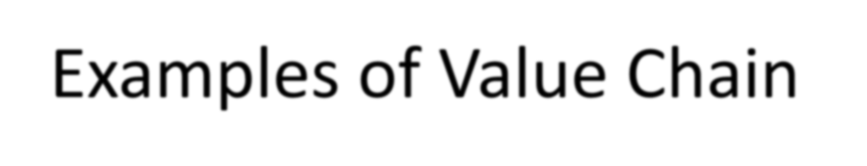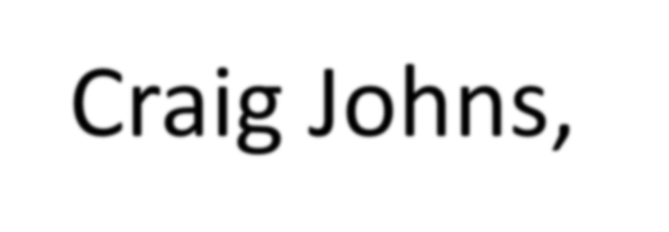

Examples of Value Chain

Mapping

Source: Craig Johns,

University of Adelaide



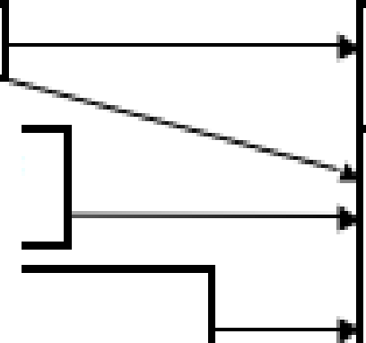

JQ

**_·A, . lt**

H IH c.on li!

mptlc n

ii'i

**m**

3l

,,,,

m

e

N.oJJ.GKSl

iOoops

8

**C**

::I

-....,

(J

0

._

!r,',1 1;;1

•

..'

I!!;!

§:

.I.l.l

**,,:i**

.i,

..!!:

*;*

**G KSI**

, C o o p s

**,!i:1 -**

..c **:z**

-

•

I

I:

d;i

!

**:Ii**

:E

:t,a

:::,

-

I:

'=

-

**"CJ**

"Q!;;I

-

>

I',!

I

i

**OJI,**

**ee**

**-;,**

i **m**iiiiiil

-

<!_ Cl

**"al**

m,

.... :E

-

ca ,

**C**

**C**

C,orpornte

Fa ,m s

Oir.el!ln ffle ld s (IEal!l't .!l:arv.al

f .a or ia,lilf U·S.

mpar ted

a .i w **M** .Jbtir l ill ii □

fl lsll e dl pll'>!ld Ci t ·rt>!;

'T .:i t;:i□d M.a.l;:i:,cs:l il. A

**INZ**

,

m

0::

w

**:Ii**

::,

m

**z**

0

0

◄-

C

o w□ p raDaS<s:l □g;

II!; & a hll llil

e.iwJ c:a If faad ng

**o,cal**

Nlla1r k et ,

**Processors,**

Nesl le, f lil'e, sche Vlag, I d om ii , , l H/1:r aJ,a a ,

In d:olla **to** , S,ali1 : 1usada , Ot hers

D1 o m es,ti c

**M,a-** ket



Moden 1

!Reta !lers;

Hyi:ienn:am t ,

:Sui:ienn:am t ,

.. nl-m:am t

IIFood Sewv1·c, e;

IHo tetli!, · •eBl::a.111r .antli!. IHios Jta9t , Sc oo h:1

Pro dlu 1 c t s

**Pas,** e rit:sre **MI k, U**HT & .s ,·t erl lsed Ll qu id **M** I**k., IM**Il · Powder,

sweetenedl Cond ensed!

**MIii** ' Cu l llllr, erJ **MIi k Dr** 11 ks ., Dril'n lktng

Yo gllil1u rt., Ic e ereaim

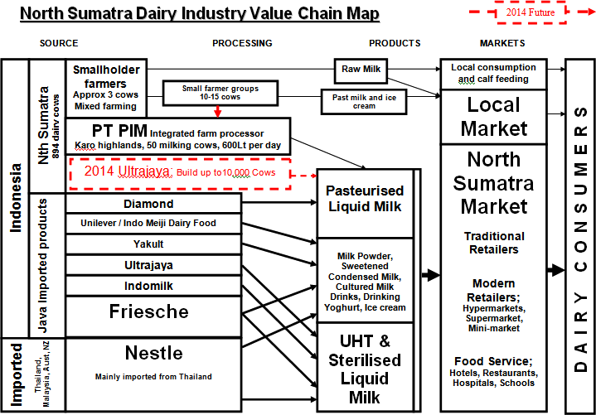

Source: Johns, Craig 2013. “Indo Dairy Trip Report Nth Sumatra / Java”

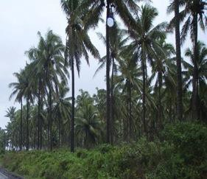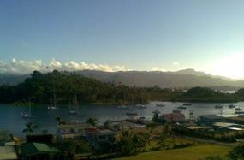

**PACIFIC PROJECT**

**CASE STUDY**

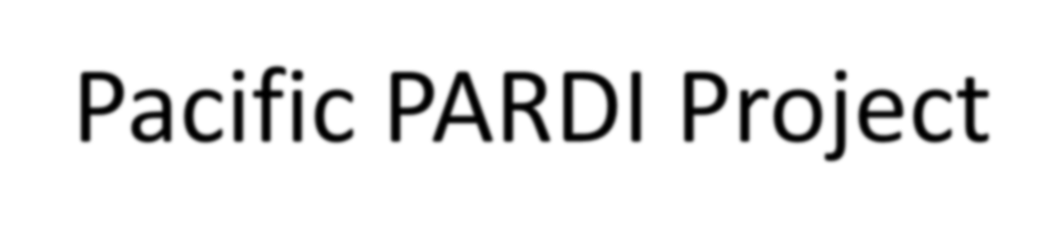

Pacific PARDI Project

▪

PARDI stands for ‘Pacific Agribusiness Research for

Development Initiative’

Funding is through the Australian Centre for International Agricultural Research (ACIAR)

University of Adelaide’s role in PARDI is to;

▪

▪

▪

▪

▪

Identify market and chains capable of increasing livelihood benefits Identify researchable constraints in these chains

Develop research based interventions with our collaborative

partners



Pacific PARDI Project

▪

Covers 6 Pacific countries

* Fiji, Vanuatu, Solomon's, Samoa, Tonga, Kiribati

▪

Across 3 broad Sectors

* Crops, Forestry and Marine

▪

Activities are both sector and country based i.e.

* Sectors; Canarium Nut, Cocoa, Pearls, Tilapia, Sea Cucumber, Taro, Breadfruit, Vegetables, Tamarind and Teak
* Cross sector; Fiji Retail Transformation

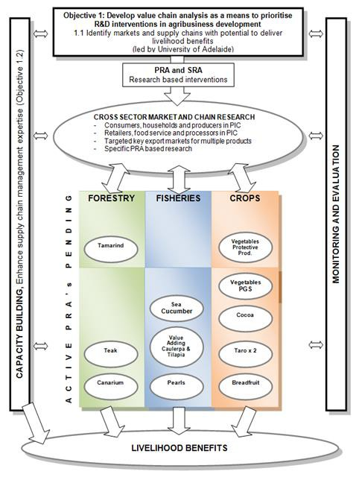

PARDI Framework



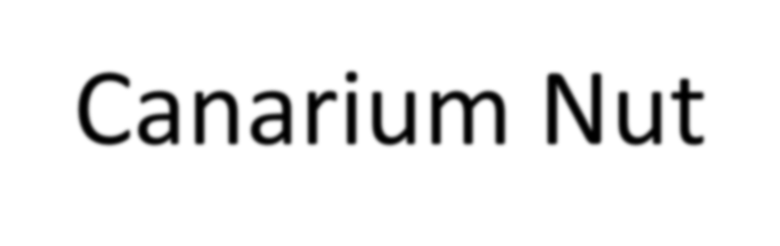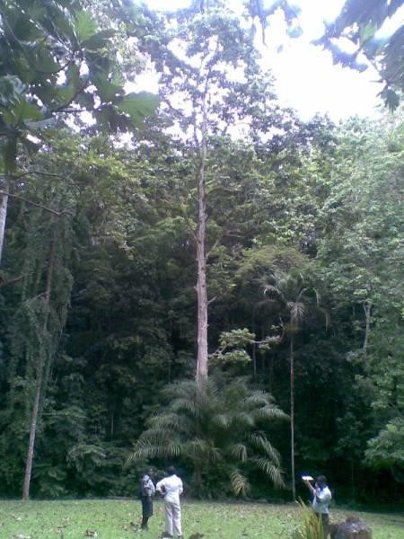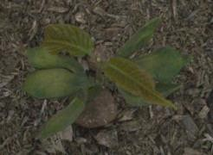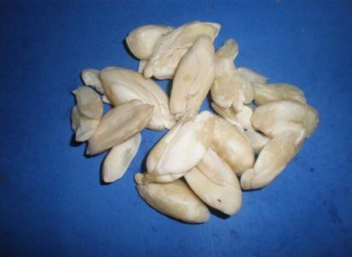

Canarium Nut

▪

Grows throughout the

South Pacific

▪

▪

▪

Vanuatu

Solomon Islands

PNG

▪

▪

Traditional cultural food

Traditional processing techniques



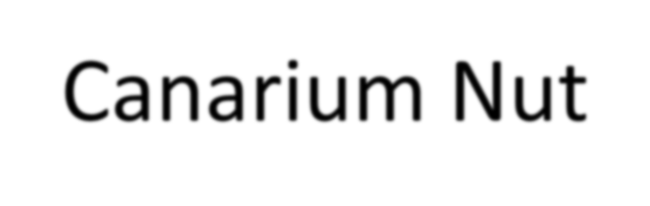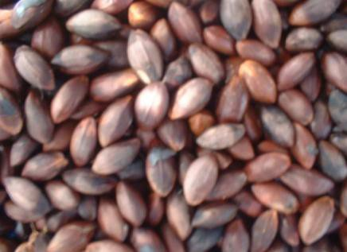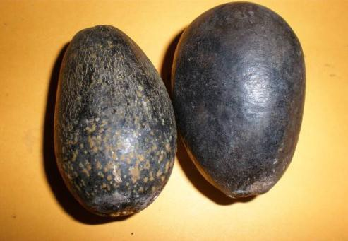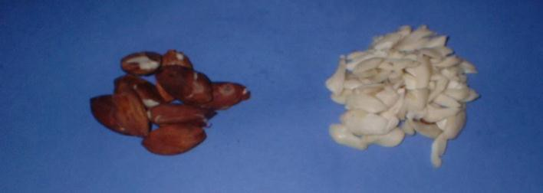

Canarium Nut

Nut- in- pulp

Nut –in-shell

Kernel

Kernel-in-testa



**Solomon ls,lands Canari'um Nut**

**Industry**

**MARKETS**

SE0 0 1NDA RY PROCESSING

-

F,oo dl Se rv ice, HoteIs, Cafe s, R.estatuarnits

I

■

I

■

Shane Tat ua

C om m un ity Based

r gan i sat i on

,(CBO ' s)

......

-

-•

>-

rt:

..

Mara:ghoto

_..,;;.

1---._

O

s

■

<a(

--

**C**

J ed CITT1 O r ga n i c

-

-

rt:

-■

Superm a r ets,

--

**0:::**

w

:!:

::J

*en*

**z**

0

0

SmalI Rietaile rs

Var iv.ao

-

-

n.C'ii

z

*C -*

0:::

-

Frarngiparni

.iJ;;e_u ea mi

•

wzoo

:!: <a( *a:,*

1Gentm l Mar et Sm alI Sta lIs

**CI IC:ICI**

w

z u

0:::

**C] IC] CJ**

1

<(00

Lill.. - r,:

I- CL

u

::J)

I-

::J

**z**

....

...

**C**

**ONI SU**

**M**

**E W**

**D IT**

**AT**

**HIOME, INI**

**VILLAGE OR BARTERED**

*C*

0

**HIIINI OR**

, ( Raw

**B E TWEEINI VILLAGES**

, Roasted or Value Addedt

rt:

....._ I

CL

II

...... .

HARVESTED BlJJrf REJIE,CT ED

."."." .I NOT HARVESTED

II

I COMME-RCI.!ti . lli"OJNFIDENCX

**u.,**

I-

::J

**z**

Lill..

0

w

:!:

::J

**...J**

0

>

**...J**

<(

I-

0

I-





Vanuatu Canar ium Nut Industry

FARMERS

MARKETS

C1<llcs.met i e s IMa n u f act u r e r s 1to LIII Volcan ic Earth, Ib..@ Summ it, Bru ce Hann et

-,

**J_**

I

FO OD SER'ilil.C E HOTELS

**00**

I-

::J

z

:J

.

L APITA CA FE

nuts, bi.so u i ts and (!Iii )

""

C

(

· ·

--'

"-.

CHA!IN RETAJIILER S

■

-

' "'

-

.-.

- .

**IIINll** "1I1D UAL REf AIIL OUTLETS

SOUTH PAC.IFIC. NUTS

Ortai[]l sn.igar snack 11 uts.)

■

0::

w

..

**0::** e

'-

W CL

-

■

u..

0

KA.VA STORE

■

I I

I I

I

ACTIV (.sn ack nuts and (]) ii )

::J

**00**

**z**

AC ll lrV st o re

..._

w

I

I

1§

II""

0:: .'I.:!

<( ...

..I

S1MALl!.JEIR IP1R!OOESSO RS

I

::J

..J

0

>

0

0

URBAN MlARKEI S

**u..** -

*V*

-

.1.......

FARMER S SE LL A.S NIU T' **IINI** .SH E LL O R AS RAW KERNIE L .S

E

-

-

I-

::J

**z**

RURAL IM IAR K EI

S A N D SI AL L S

**lJII"'"**

:,-

.I!....

-

..J

1 0

0

NSUM ED AT HOME, IN VIL LA1 GE OR BARTERED WITHIN OR BE TWEEN

<(

I-

0

I-

VILLAGE S 1{Ra

w o r Value A(l1d, 1edl

:;_.

-

IP"

-

I

H A R V E SI ED B U I R E J ECIED

**11"'"** ■

I

.

Iii..

NOi HAR.V E SI ED

,..,

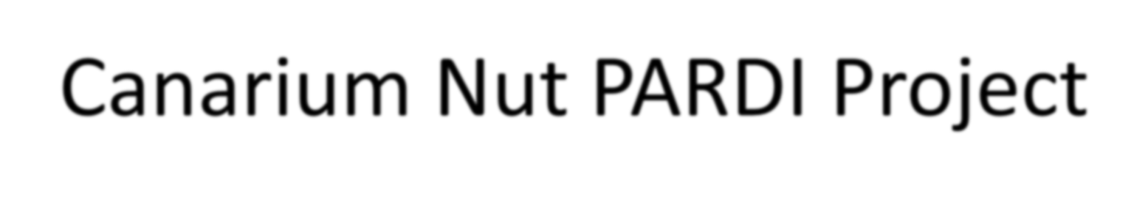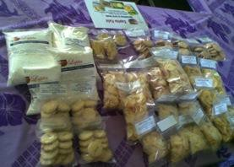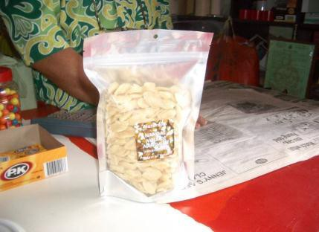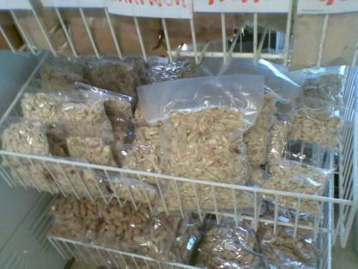

Canarium Nut PARDI Project

Priority issues and opportunities

▪

Unfulfilled domestic demand

Processing of the nut to stabilise it to ensure

consistent quality

Need to know more about consumer demand

▪

▪

Target Markets identified

▪

▪

Domestic Market; tourists in Vanuatu

Domestic Market; food service and hotels in Solomon Islands

Export Markets; to be explored more once domestic

demand is fulfilled and product quality improves

▪

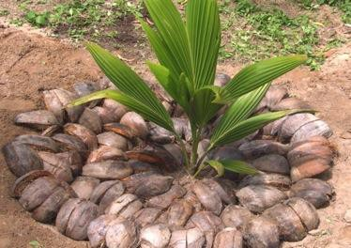

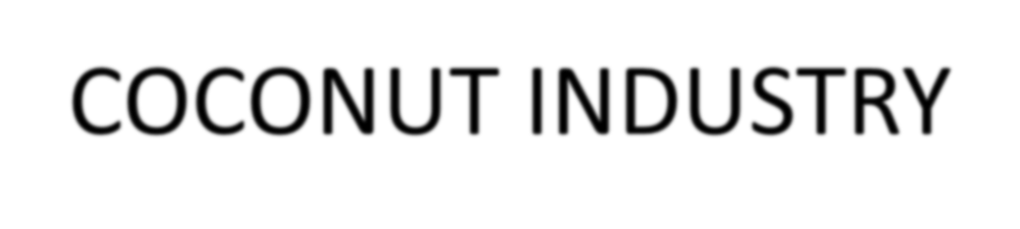

COCONUT INDUSTRY

▪

Grows throughout the

Pacific

▪

▪

All of the islands Specifically looking at Fiji,

Solomon Islands, Samoa and

Vanuatu

▪

Traditional uses

▪

Various products made

from the tree and the nut



COCONUT PRODUCT LIST

▪

Virgin Coconut Oil Edible

▪

▪

▪

Nutraceutical, functional food, health supplement

Ingredient in salads, smoothies, ice cream, butter replacement, confectionary etc Cooking oil; roasting, frying, baking cakes, popcorn, crackers, cookies etc

Virgin Coconut oil Inedible

* Soaps, cosmetics, spa products, body lotions etc
* Treatment of skin conditions and to promote hair growth

▪

By products

* Pressed dry cake for animal feed
* Shells, handicrafts, charcoal, activated carbon, biochar, coir fibre

▪

▪

Whole nuts, coconut water, milk, sugar, powder, cream, honey,

flour, dried pieces, biofuels, timber





**FIJI COC,ONUT INDUSTRY**

**lflRlMAJ,t:_'t lflft:.OCIE:SSlttG**

(closer to 1he grower)

**SIECOttDAJJ',t:_'t lflR.OCIE:SSlttG**

(mo re centralised and Iinked to the market)

**lfllRODUCl S**

**MA.RKIE:l S**

-.I

I-.

**Adrian Tarte** Organic 6.JIM vco

**0/S Processoc**

**Virgin Coconut Oil**

Organlc/H ACCP/Fll lrirlld8

**RETAIL**

**V'J**

**z**

'

**c**I-**:::**

_.,

,.

**HEALTH SHOPS**

_.,

(f)

**PURE**

**FIJI**

0

-

a.

-

**Harish** aiIM vco

-

I-

u

0

**PHARMACY**

**X**

LLJ

-

-

I-

**cc**w

-

_.,

_.,

_.,

_.,

**Food:**

llg8 rbon 1'0r I183I1:n COOMlng OIi

Food lngrMl8nt

**r**

■

**Jagdish** BJIM vco

ROUTE TRADE

.

.. ■

RETAIL

Cl

.

>-

**...I**

**0.**

**0.**

::::,

**en**

- ■

■

G. **Haynes** *aw.* ..-o:.

u

-'

0

cc:

I-

**z**

j:::

_.,

HEALTH SHOPS

**Body:**

I-

I-

**V'J**

.. ■

■

.

LLJ

Women Groups

**:5;**

0

**C**

**PHARMACY**

**C01m81:lc1**

Soap El:id;• ol I Spa

(I..

**cc** -::{

**...J** 0

**a.**

:r:

**Mokosoi**

-

l?

**IDD3I** m3r1t ti:, TDUr1 Q"T1 Tnld In

l-ln+.lr: i:.lmnr-+RTI

I-

**Peni** vcor8ta11

By-Products

[r,' ClM 8, Sil 811, COIr Abr8

**Whole of Nut Approach;**

Anlm 3I 1'Md, Soap, Sll8 II ll3ndl crart1, a1moal, Act! 3bd Clrbon (fllbr **1**:i. ,

MUICll. Eco m 3h. I ut flllH

_.,

■

r:-.

z

**Others**

--- I-

-

-

0

I-

::::,

**z**

**0**

**0**

**0**

**0**

**V'J**

**c:::**

u

0

u

**J**

I

-

- -

Sport & Hnltll dr1nM I, Vln8Q3 r

**Mobile Unit**

-

**Coconut Water**

I

Cl

-

**LLJ :z**

**c-**

**...J** ll.

ll.

**0**

??

**Sap Sugar**

*??*

-

-

I

cc:

w

??

*??*

-

**BIIVH,:, MIi , MIi PD'.".'ll r,**

i""rll:.m Rnm·

I

I

I

**0**

**:::c**

OJm 811:lc Go t Po \'/H, air

**1,** G8nH3tori.

Outer Is. cr Central

- ■ ■

- ■

""

I

...J 0

(f)

**PalITW11ood** Fiji

Local I E1port to Fr.in C8 & Au1t ( El:iral)

**Tirrber,** floor1ng, 1'uml"b.Jr8

■

...J""

cc w

**:5;** I-

z

0

u

....

I

■

others

...

-

Export Processor

-

RBD & Crude Oil

-

-

....

I

- Export Processor

...

CMFL

:z

**V'J**

I

Copra

-

■

I

Ir

**Biodiesel**

*??*

**VANUATU C:QC,ONUT INDUSTRY**

**,**

**GR**

**OWER**

**PRIMAR¥ PROCESSING**

t0itne grower)

**Sl!C0 1 ND AR¥ PROCESSING**

, ce_111,traI edan dIinlil:e.dtlili tne mart e.t)

**PR01 DU CTS**

**MARK.ET S**

,

.....

.

.i

,C,o p ra

,,Co p ra Traders

...

Export

**C**

**0**

I

I

-

:.:::;

I

IH

I

**u**

**::I**

**00**

I-

u

::J

0

0

0:::

**Cl.**

Biodi,esel

D[lfltesfic Govl:,IP owe

r , Ca

r s, Genera fo rs.

.

**'C**

...

**0**

**D..**

...

m

COPSL

Copra Mill

Export

..

I

•

**lo..**

C.

Crude Oil

***r-+***

_.,

Kl

0

0...

·u

C

**C1)**

,:(

...I

0

I

•

**Qll**

3:

0...

.A111i m -'II Frere,cill *J* N7

F xncrrt ff islil,?

Copra Meal fCake

C,

**F""lil**

_.

Virgin Coconut Oil

**RETAIL**

_.

I-

HEALTH **SHOPS**

::J

**z**

0

u

0

u

0

**D..**

w**X**

-

**PHARMACY**

I

.,

I

•

I

•

Food:

II nge sfi DJ1 fo:r h ea llth Coo k ,i nEJ,o i I

IF ,oo cl,i n 1:1re d ie nt

R:OUTE TRADE

HEALTH **SHOPS**

-

_.,

_.

**0**

Body:

Cosme ti c s S,oa ,p IBoclyo il

S:pa

I-

**RETAIL**

**(I.II**

w

0

**C**

0::::

w

**::ii**

::J

**00**

z

0

u

**PHARMACY**

I

.,

....

**f---t**

IUH:al 111131'M!!11. T OUJlfilll Tralte Ill 1Hn te111. AllpOlit iatc

Oth er

By-Products

Dry Cake, Sh,ell, Coir Fibr,e

I

.,

Animal feed, Mulch,

Activated carbon, Flour

I

C O:M:ME R.CIAL IN COl..T. IDEKCE

I

GRANT BOWKER

vco **Mill**

-

r**C**e**:**: (.)

·(-.) ·q-::

(.)

<( **a**"**.**'**.**

Sec,o nd ary

Pro c ,e sso rs lik 1e

, v o l ca n i c Earth

Small Sc,ale V1OO Pro d u ,c ,e,rs

,(DNlm!Y i n Port Vil a

using DME)

**a,** Cl

Qll C

u i::'

C

**Qll** C...

Cl m

,:( **C.**

**...I 0**

**0 0**

>-

...J

**a.**

**a.**

::::)

**(I)**

I-

::J

z

0

0

0

0

**(I.II**

**z**

0

-

I-

,:( w

I-_,

z 1-

I-

,:(

**...I**

0

**D..**

:I:

-- I-

-

**(I.II**

**ct::**

el

**w** :z

c_

...I Ill..

o a.

0

:::c

...I

0

...I

,:( w

I-

**(I.II** :z

-

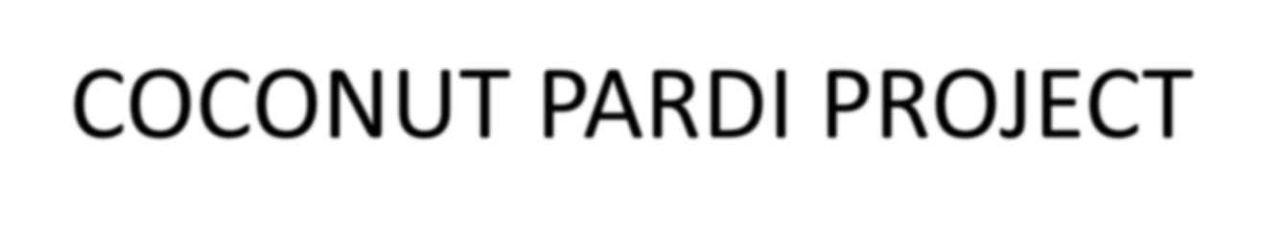

COCONUT PARDI PROJECT

Priority issues and opportunities

▪

▪

Research on health benefits

What is the point of difference to competitor countries

▪

Whole of coconut approach. Produce a mix of products depending on

location, size and the business and social justification

Target Markets identified

▪

Domestic Market; locals and tourists through health store, pharmacy, hotels

etc.

▪

▪

Niche Export: high value differentiated products

VCO consumers who are informed, health conscious and supportive of fair

trade, organic and the Pacific brand

Summary

•

•

•

Value Chain Mapping is part of Value Chain Analysis

No single “right” way to map Useful tool for identifying

–

–

–

–

–

–

Actors

Product flows Information Flows Relationships Issues in the chain

Opportunities for improvement

•

Government, Industry Associations and Universities can

play a role and all benefit from working together

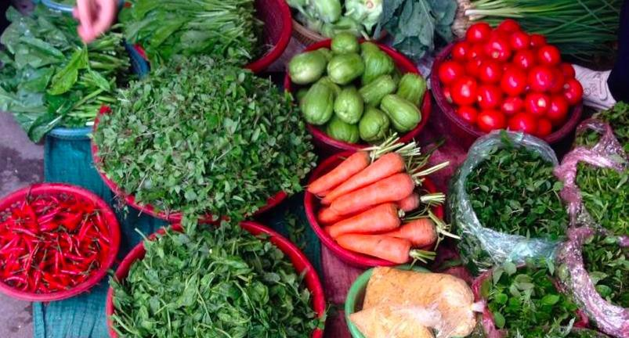

References

•

The Operational Guide for the Making Markets

Work for the Poor (M4P) Approach, DFID & SDC, UK and Switzerland, pp7-70

Kaplinsky, R & Morris, M 2001, A handbook for value chain research, IDRC.

Springer-Heinze, A 2007, ValueLinks manual: The methodology of value chain promotion.

Webber, M 2007, Using value chain approaches in agribusiness and agriculture in sub-saharan

•

•

•

Africa

World Bank