**Chapter 4: Value Chain Analysis**

85

**4.1 Origin of value chain thinking**

The attractiveness of the PSASV industry for new entrants and the competitive forces operating in the industry suggest scope for further analysis of the way in which firms operate and position themselves in this industry. The value chain approach is useful in this context to associate the way in which activities are performed in this industry for delivering value.

The value chain approach looks at the activities of an organization, and relates them to the competitive strengths of the organization. Value chains are built on the idea that an organization is more than a random compilation of machinery, processes, environment, technology, equipment, people, and money. Only if these inputs are arranged into systems is it possible to produce something of value for which customers will pay. This ability to perform particular activities and manage the linkages between activities is the basis of business competitive advantage. The provisions of primary activities in the value chain are concerned with the creation or delivery of a product or service. Each of these in turn is linked to support activities that help to improve effectiveness or efficiency. There are four main areas of support activities: procurement, technology development, human resource management, and infrastructure (systems for planning, finance, quality, information management, etc.). Thus, a firm’s line functions would likely have primary activities and streams (sales, marketing, manufacturing, operations, and IT) and staff functions would have supporting activities and streams. As well, there would be intersections of streams such as IT

fulfilment.

**4.2**

**Generic Value Chain**

**4.2.1**

Value

**The basics of a Value Chain**

chain refers to all the activities and services that bring a product or a service from

conception to end use in a particular industry, from input supply to production, processing, wholesale and finally, retail. It is called so because value is being added to the product or service at each step. Taking a value chain approach to business means addressing the major constraints and opportunities faced by businesses at multiple levels of the value chain.

Value chain analysis examines the structure and the dynamics of the value chain. The structure of the value chain influences the dynamics of firm behaviour and these dynamics influence how well the value chain performs in terms of value chain competitiveness.

The structure of a value chain can be characterized in terms of five elements:

86

1.

End market opportunities at the local, national, regional and global levels—the value

chain analysis prioritizes this element because demand in characteristics of a successful product or service.

Business and enabling environment at the local, national and

includes laws, regulations, policies, international trade

end markets defines the

2.

international levels—this

agreements and public

infrastructure (roads, electricity, etc.) that enable the product or service to move through the value chain.

Vertical linkages between firms at different levels of the value chain—these are critical for moving a product or service to the end market and for transferring benefits, learning and embedded services between firms up and down the chain.

Horizontal linkages between firms at the same level of the value chain—these can reduce transaction costs, enable economies of scale, increase bargaining power, and facilitate the creation of industry standards and marketing campaigns.

Supporting markets - these include financial services, cross-cutting services (e.g.,

business consulting, legal advice, telecommunications) and sector-specific services (e.g., irrigation equipment, design services for handicrafts).

3.

4.

5.

The participants in a value chain create the dynamic elements through the choices they make

in response to the value chain structure. These dynamic elements include:

1.

Upgrading - this means increasing competitiveness at the element level through product development and improvements in techniques or processes.

Inter-element cooperation - the extent to which elements work together to achieve increased business competitiveness.

Transfer of information and learning between elements - this is key to competitiveness since upgrading is dependent on knowledge of what the market requires and the potential returns on investments in upgrading.

Power exercised by the elements in their relationships with each other - this shapes the

incentives that drive behaviour and determines which elements benefit from participation in the value chain and by how much.

2.

3.

4.

Value chain analysis, which focuses on the dynamics of inter-linkages within the productive sector, especially the way in which chain elements are globally integrated, takes us a great deal further than traditional modes of economic and social analysis.

Value chain analysis overcomes a number of important weaknesses of traditional sectoral analysis which tends to be static and suffers from the weakness of its own bounded

87



parameters. Sectoral analysis struggles to deal with dynamic linkages between productive activities that go beyond that particular sector, whether they are of an inter-sectoral nature or between formal and informal sector activities. Value chain also goes beyond the firm-specific analysis of much of the innovation literature. By its concentration on inter linkages it allows for an easy uncovering of the dynamic flow of economic, organisational and coercive activities between players within different sectors even on a global scale. Furthermore the notion of organisational inter-linkages underpinning value chain analysis makes it easy to analyse the inter-relationship between formal and informal work and not to view them as disconnected spheres of activity.

Value chain analysis is also useful as an analytical tool in understanding the policy environment which provides for the efficient allocation of resources within the domestic economy, notwithstanding its primary use thus far as an analytic tool for understanding the

way in which firms participate in the global economy.

**4.2.1.1 The Simple Value Chain**

The value chain describes the full range of activities which are required to bring a product or service from conception, through the different phases of production involving a combination of physical transformation and the input of various producer services, delivery to final consumers, and final disposal after use. Considered in its general form, it takes the shape as described in Figure 4.1**.** As can be seen from this, production per se is only one of a number of value added links. Moreover, there is range of activities within each link of the chain. Although often depicted as a vertical chain, intra-chain linkages are most often of a two-way

nature – for example, specialised design agencies not only influence the nature of the

production process and marketing, but are downstream links in the chain.

**Figure 4.1: A simple value chain**

in

turn

influenced

by

the

constraints in these

Production:

Inbound logistics Transforming

Packaging

Design and product development

Consumption/ recycling

Marketing

Source: Creation by Author

The most important implication of applying

the value chain approach is the fact that all

decisions made at one step in the process have consequences for the following steps, and

88



often such decisions may be irreversible. For example, if you kill and dress the fish when you

catch it, this means you cannot sell it as a live fish later.

**4.2.1.2**

**The extended value chain**

In the real world value chains are much more complex than the one shown in figure 4.1. There tend to be many more links in the chain as shown in figure 4.2. The value chain does not only include a straight line. There are external activities that influence activities within the value chain. For the sake of simplicity, these external parts of the value chain may be called upstream activities and downstream activities. If we include the surrounding environment in this model, we are expanding the value chain. In such an expanded model, we

may distinguish between the core activities, which include the industry’s own activities, and

upstream and downstream activities. Upstream activities provide while downstream activities relate to the outputs from the industry.

**Figure 4.2: The extended value chain**

inputs

into

the

industry,

Source: Hempel, Nov 2010

The challenge is to define the company’s

place in the value chain,

and

to understand the

opportunities represented by the surrounding environment. Obviously, there are business opportunities in the upstream and downstream activities. If a company has the resources, it may enter into some of these activities as a strategic initiative.

Many large companies or corporations have adopted or co-opted some or all of such external

activities into their business concept. For example, a large producer may take on the role of

89

**Authorities/government**

* Infrastructure
* Legal and regulatory framework
* Education
* Research

**Upstream activities Downstream activities**

**Core activities**

Design and

product Production Marketing

development

**Core activities**

**Professional services** Medical/veterinary services Consultants

Lawyers

Raw material suppliers

Equipment suppliers Bank/insurance Transporters

**Market / consumers**

producer of supplies, such as packaging material, either because it is not readily available locally, or because it represents a substantial saving. Some of these external activities may be highly profitable, and one might ask therefore: why are we not involved in these activities? The usual answer is - it is not part of our core business. While that may be a valid reason, the

decision to go into parts of the external environment of the value chain should be based on an

analysis of the value chain capabilities and resources.

Many previously integrated

activities or outsource these

and the technologies involved in relation to the company’s

companies have decided to divest themselves of external

activities. Usually, such decisions are based on profit centre

thinking or on the belief that others can undertake these activities more efficiently and at less cost to the core activities.

In addition to the manifold links in a value chain, typically intermediary producers in a particular value chain may feed into a number of different value chains (Figure 4.3). In some cases, these alternative value chains may absorb only a small share of their output; in other cases, there may be an equal spread of customers. But the share of sales at a particular point in time may not capture the full story – the dynamics of a particular market or technology may mean that a relatively small (or large) customer / supplier may become a relatively large (small) customer/supplier in the future. Furthermore the share of sales may obscure the crucial role that a particular supplier controlling a key core technology or input (which may

be a relatively small part of its output) has on the rest of the value chain.

90

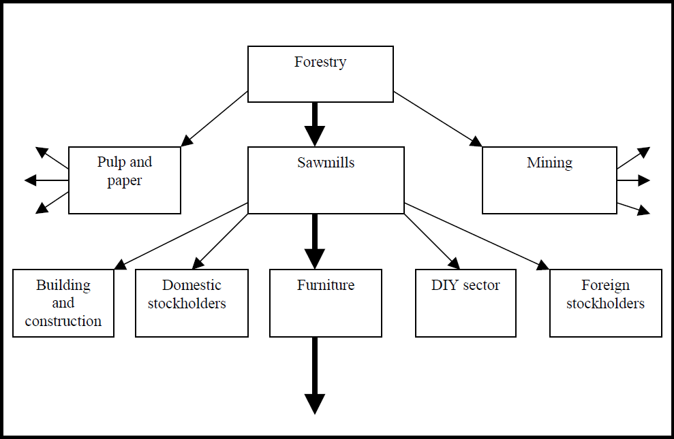

**Fig.4.3: Chain within Chain: Illustration**

**of Forestry**

Source: Kaplinsky and Morris, 2000

**4.2.1.3**

**Value Chain vis-à-vis related concepts**

There is a considerable overlap between the concept of a value chain and similar concepts used in other contexts. One important source of confusion – particularly in earlier years before the value chain as outlined above became increasingly widespread in the research and policy domain – was one of nomenclature and arose from the work of Michael Porter in the mid 1980s. (Kaplinsky and Morris, 2000)

Porter distinguished two important elements of modern value chain analysis:

1.

The various activities which were performed in particular links in the chain: Here he drew the distinction between different stages of the process of supply (inbound logistics, operations, outbound logistics, marketing and sales, and after sales service), the transformation of these inputs into outputs (production, logistics, quality and continuous improvement processes), and the support services the firm marshals to accomplish this task (strategic planning, human resource management, technology development and procurement).The importance of separating out these various functions is that it draws attention away from an exclusive focus on physical transformation. These functions need not be performed within a single link in the chain, but may be provided by other links (for example, by outsourcing). Confusingly, Porter refers to these essentially intra-link

activities as the value chain.

91

2. Porter complements this discussion of intra-link functions with the concept of the multi- linked value chain itself, which he refers to as the value system. The value system basically extends his idea of the value chain to inter-link linkages, and is the value chain as set out in figure 4.3

In essence, therefore, both of these elements in Porter’s analysis are subsumed by modern value chain analysis. The primary issue is one of terminological confusion, and this problem is exacerbated by Womack and Jones in their influential work on lean production. They similarly use the phrase value stream to refer to what most people now call the value chain.

Another concept which is similar in some respects to the value chain is that of the filiere (whose literal meaning in French is that of a thread) (Kaplinsky and Morris, 2000). It is used to describe the flow of physical inputs and services in the production of a final product (a good or a service) and, in terms of its concern with quantitative technical relationships, is essentially no different from the picture drawn in figure 4.3 or from Porter and Womack and Jones’ value stream. French scholars built on analyses of the value added process in US agricultural research to analyse the processes of vertical integration and contract manufacturing in French agriculture during the 1960s. The early filiere analysis emphasised local economic multiplier effects of input-output relations between firms and focused on efficiency gains resulting from scale economies, transaction and transport costs etc. It was then applied in French colonial policy on the agricultural sector and, during the 1980s, to industrial policy, particularly in electronics and telecommunications. The later work gave the modern version of filiere analysis an additional political economy dimension in so far as it factored in the contributory role of public institutions into what were essentially technical quantitative relationships, thereby bringing it analytically closer to contemporary value chain analysis. However a filiere tended to be viewed as having a static character, reflecting relations at a certain point in time. It does not indicate growing or shrinking flows either of commodity or knowledge, nor the rise and fall of actors. Although there is no conceptual reason why this should have been the case, in general filiere analysis has been applied to the domestic value chain, thus stopping at national boundaries.

A third concept which has been used to describe the value chain is that of global commodity chains, introduced into the literature by Gereffi during the mid-nineties (Kaplinsky and Morris, 2000). Gereffi’s contribution has enabled important advances to be made in the analytical and normative usage of the value chain concept, particularly because of its focus on the power relations which are embedded in value chain analysis. By explicitly focusing on

92

the coordination of globally dispersed, but linked, production systems, Gereffi has shown that many chains are characterised by a dominant party (or sometimes parties) who determine the overall character of the chain, and as lead firm(s) becomes responsible for upgrading activities within individual links and coordinating interaction between the links. This is a role of ‘governance’, and here a distinction is made between two types of governance: those cases where the coordination is undertaken by buyers (‘buyer-driven commodity chains’) and those in which producers play the key role (‘producer-driven commodity chains’). These two types

of the value chain have been described in the later section.

**4.1.2**

**Significance of Value Chain Analysis**

There are three main sets of reasons why value chain analysis is important in this era of rapid

globalisation. They are:

•

With the growing division of labour and the global dispersion of the production of components, systemic competitiveness has become increasingly important.

Efficiency in production is only a necessary condition for successfully penetrating global markets.

Entry into global markets which allows for sustained income growth – that is, making the best of globalisation - requires an understanding of dynamic factors within the whole

value chain.

•

•

**4.1.3**

**Different types of value chains**

Building on this concept of governance, Gereffi has made the very useful distinction between two types of value chain. The first describes those chains where the critical governing role is played by a buyer at the apex of the chain. Buyer-driven chains are characteristic of labour intensive industries (and therefore highly relevant to developing economies and firms) such as footwear, clothing, furniture and toys. The second describes a world where key producers in the chain, generally commanding vital technologies, play the role of coordinating the various links – producer-driven chains. Here producers take responsibility for assisting the efficiency of both their suppliers and their customers.

This distinction between different types of value chains is at this stage is still something of a research hypothesis, as is the suggestion that we are seeing a shift from a producer-driven to a

buyer-driven world. Some chains may embody both producer- and buyer-driven governance.

93

Producer-driven commodity chains are those in which large, usually transnational players play the central roles in coordinating networks (including their backward and forward linkages). This characteristic of capital and technology-intensive industries such as automobiles, aircraft, computers, semiconductors, and heavy machinery.

Buyer-driven commodity chains refer to those industries in which large retailers, marketers, and branded manufacturers play the pivotal roles in setting up decentralized production networks in a variety of exporting countries, typically located in the third world. This pattern of trade-led industrialization has become common in labour-intensive, consumer goods industries such as garments, footwear, toys, house wares, consumer electronics, and a variety of handicrafts. Production is generally carried out by tiered networks of third world contractors that make finished goods for foreign buyers. The specifications are supplied by the large retailers or marketers that order the goods.

The key shift that we are witnessing in an increasingly globalised and competitive world is a transition from income accruing from tangible activities to those arising from intangible activities in the value chain. This is because intangible activities are increasingly knowledge and skill-based and are imbedded in organisational systems; the knowledge they incorporate is important to recognise that the concept of skill embodies the idea of income. When we talk about skill, we refer to aptitudes and knowledge which are not widely available. This is both inherently relative, and dynamic. For example, two decades ago, primary and secondary educations were relatively skilled attributes in a labour-force; now they are very common. Thus tacit in nature, and this involves growing barriers to entry. By contrast, the capabilities in the tangible realm are increasingly widespread, particularly following the entry of China into the global economy.

The intangibles are to be found in all links – for example, the control of logistics in the production phase, the conceptual phase in advertising. But certain links in the value chain are particularly rich in intangible activities, such as design and branding, and the coordination of the chain itself. The shift from producer- to buyer-driven chains is therefore illusory and arises because at this point in the competitive cycle, branding and marketing are becoming increasingly important in many chains. However, closer examinations of chains will however show a pervasive shift to a wider arena of intangibles and it is because of this that a chain can simultaneously appear to be both buyer-driven and producer-driven. Similarly particular product families (for example, toys or clothing) may simultaneously have buyer-driven and producer-driven chains, depending on which intangibles the lead parties dominate.

94

**4.3**

**Service Value Chain**

**4.3.1**

**Value Chains in the Service Industry**

Just as the focus on building world-class Value Chains and collaborations in manufacturing began in the latter part of the 20th century; the attention needs to turn now on the Value chains within the service sector (Julie Drzymalski, 2012). Many questions need to be answered to determine whether or not existing models of frameworks, performance measures, network design and implementation are applicable to the service sector. Building a foundation for the Value chain in service industry is crucial to the execution of the activities within this sector (Ping & Jia, 2010).

First, an understanding of the external environment is crucial to any organization in order to allow for positive customer satisfaction. While goods-producing firms, tend to rely on generic Value Chain models such as Porter’s Value Chain model (Porter, 1985), or the SCOR model (Supply Chain Operations Reference Model), the focus is typically centred around profit with some level of quality and service. However, the service industry incorporates not-for-profit, as well as for-profit firms. And within those for-profit firms, the level of human-interaction within those services and the reliance on person-to-person interaction on overall success of the firm is quite disparate. Thus, the question is raised: Is a generic value chain model applicable for all service industries or is it service industry-specific?

The importance of developing foundational models of value Chain for the service industry is an imminent task and very little work has been accomplished to date. Therefore, a strong base of modelling the Value Chain in these industries must be explored to provide for future

growth and a higher level of quality and efficiency.

**4.3.2**

**Service Industry defined**

Most visibly, the main defining characteristic between a manufacturing and service firm is that, human labour is the primary component of the latter, while a physical product is that of the former. The characteristics that define each of these also differ. Many authors argue the definition of these characteristics.(Fisk, Brown, & Bitner, 1996) argue that the four major defining characteristics of a service industry from a goods industry are intangibility, inseparability of production and consumption, heterogeneity and perish ability. Others, such as Pride and Ferrel (Pride & Ferrel, 2003) argue that there are six main defining

characteristics: the previously-mentioned four and client-based relationships and customer

95

contact. While some may argue that goods industries also in corporate these last two, it is the service industry which relies on these characteristics as an inherent part of their service. In addition to intangibility, heterogeneity and perish ability, Baltacioglu et al. (Baltacioglu, Ada, Kaplan, & Kaplan, 2007) also argue that simultaneity is another significant piece of a service system.

Service systems can also be delineated from manufacturing systems by their processes. For example, Sengupta et al. argue that the decisions are very controlled in a goods industry with much standardization and little variation, while in a service system, the level of variation is significant due to local decision-making made by humans (Sengupta, Heiser & Cook, 2006). Whatever the characteristics may be, most authors agree that a service is an execution of an activity, rather than a tangible item. Table 4.1 illustrates some major differences of the characteristics of a manufacturing goods value chain and a service industry value chain. Traditionally, goods industries are push systems, with companies keeping high levels of raw and finished goods inventory. The suppliers in a service industry often are the goods and thus, must be responsive to the needs of the customers. Very often, these industries are dealing face-to-face with their customers and thus the relations between them are crucial. Thus, the metrics by which a service firm will measure itself must be distinct from a manufacturing firm.

Based on Porter’s value chain model, Armistead and Clark (Armistead & Clark, 1993) developed a value chain model for a service company based on the location of the related costs and the value they give rise to. The authors claim that there are typically five to seven primary processes within a service industry and by linking these processes to the resources utilized, the physical configuration of those resources and the flow of these processes from an external view, critical areas of potential problems, poor performance and bottlenecks can be seen more readily.

There is much literature on Value Chain operations and management, and while they differ in their Value Chain scope, the majority of them agree that Value Chain operations and processes include: sales, marketing, sourcing, manufacturing and transportation. Thus, if the product is actually an event, then some of these traditional value chain operations, in particular, manufacturing and transportation are not present in the traditional sense of the definition. New paradigms must be made in order to accommodate the prevalence of the services and its contribution to the GDP. Much work needs to be done in order to assure that these service industries are operating at an efficient level.

96

The attention paid to Value Chain management over the last three decades which has allowed firms to grow from the starting point of functional independence to inter-organizational integration, as suggested by Stevens (Stevens, 1989). The last stage, suggested by Hewitt (Hewitt, 1994) integrates intra-company and inter-company management. This last stage is the epitome of optimal value chain management and literature for manufacturing has reached

that level. What is now needed is the translation of that optimization to the service industry.

**4.3.3**

**Smiley Face Service Value Chain Model**

The smiley model is constructed with a goods producing company in mind. The question is if the model is also a good representation of a pure services value chain. The different stages in a services value chain probably mirror those in a goods value chain quite well, but the value added in the different stages would most likely be different in a services value chain.

There has been little research to date on pure services value chains, nonetheless services experts believe that such chains are being created in a variety of service sectors, including banking, tourism, audio-visual and possibly also education and health services, as well as IT and business processing services. A case study by the National Board of Trade focuses on the value chain of Mojang, a company in the video game industry. In the case of Mojang, most value is added in the brand and innovation, followed by design, R&D, and manufacturing and assembly. Distribution provides less value. More research on how services value chains looks like and where value is created could contribute to a revision of Stephenson’s model that provides a good representation of pure services Global Value Chain (GVC).

At a Conceptual level, Smiley Face Service Value Chain model has been developed as part of this research (figure 4.4). The model is an extension of the conceptual goods value chain (Source: World Economic forum, 2012) available in the literature.

The key difference between the goods and the service smiley face models are the replacement

of ‘Manufacture’, ‘Assembly’ and ‘Logistics’ in the goods value chain by ‘Development and Testing’, ‘Packaging’ and ‘Deployment’ respectively in the service value chain.

97

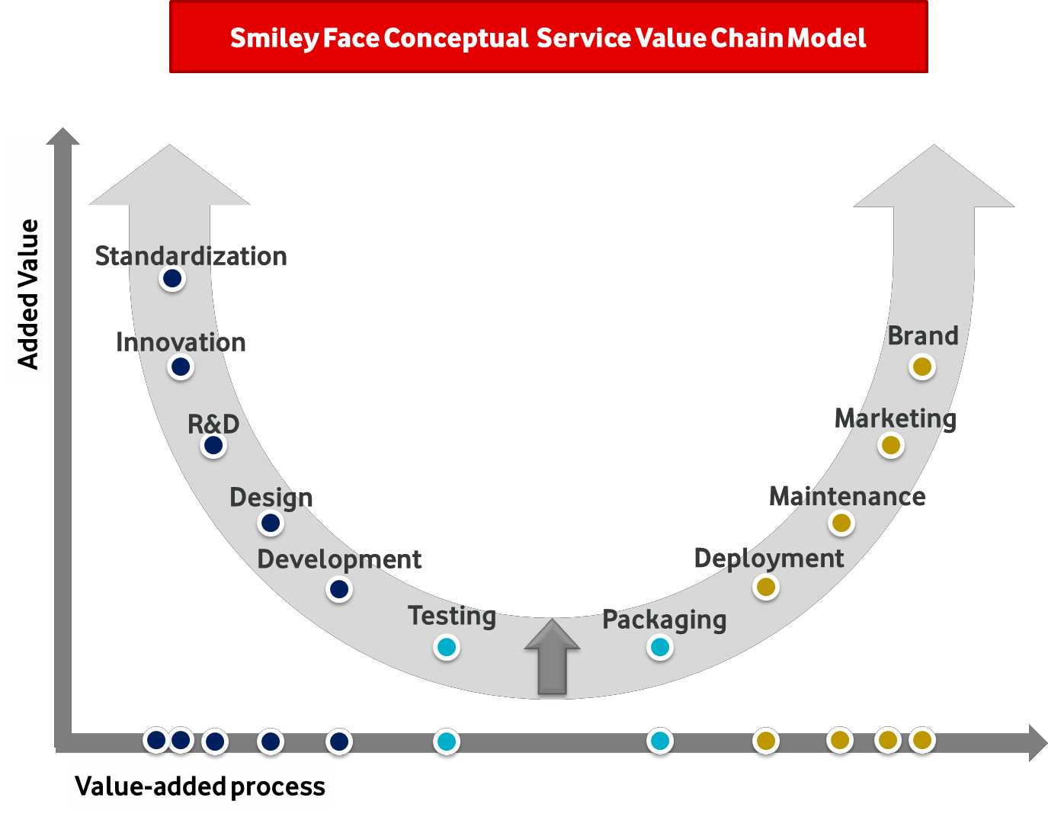

**Figure 4.4: Smiley Face Conceptual Service Value Chain Model**

Source: World Economic Forum (2012), Kommerskollegium 2013

The Organisation for Economic Co-operation and Development (OECD), in its Global Value Chains (GVCs) mapping exercise, has looked more closely at the business services sector, although still at an aggregate level. The OECD postulates that services are less prone to vertical specialisation when face-to-face contact between the provider and the consumer is required. A large part of the services sector is made up by small domestic companies that provide services directly to domestic consumers with limited foreign inputs. This is obviously not the case for all services industries. The OECD identifies the business services sector as a good example where fragmentation of production has occurred (and, moreover, as a key enabler of most GVCs, both goods and services).

Several factors appear to be important for the creation of services supply chains. In particular, there seems to be a strong correlation between human capital and services exports as well as a strong correlation between electronic infrastructure (as measured by internet penetration) and services exports. Human resource inputs have been shown in various case studies of services exporters to be overwhelmingly important for the decisions of IT firms on where to outsource services work. Factors including access to numbers of trained people, the quality of training

and the associated wage structures are determinant in these decisions.

98

**4.3.4**

**Commonalities and Differences between Service and Manufacturing Value**

**Chains**

The service sector has been gaining importance lately. As the service sector evolves, the study of its value chain starts also starts gaining attention. This section outlines the operational and strategic views on the management commonalities and differences between the two types of value chains.

In recent years, the service value chain, has attracted research attention (Sampson, 2000; Frohlich and Westbrook, 2002; Ellram et al., 2004). Service firms also transact with their suppliers and serve their downstream customers. This very much resembles the classic manufacturing value chain structure. In addition, service outsourcing becomes increasingly common a practice (Allen and Chandrashekar, 2000; Adler, 2003; Crockett and Ante, 2004). Hence, service value chain is of great strategic importance in today’s business. Before we can proceed to compare service value chains with manufacturing value chains, a definition of services should be provided. Frohlich and Westbrook (2002) used the standard industry classification (SIC) system to define service industries. As defined by the US Census Bureau, the US economy can be segmented into good-producing industries and non-good producing industries, where retail trade, wholesale trade and service industries all fall under the non- good producing sector. Such a classification is constructive in understanding the structure of the US economy and where the service industry is positioned. Unfortunately, it does not provide much meaningful information as to what service is. Sampson (2000) specifically discussed what service is. One set of definitions focuses on the intangibility of services. However, intangibility is only an important characteristic of services. Sampson (2000) argues that services have tangible part as well. A second definition describes services as a solitary unit that fails to reveal the dynamic aspect of services. For instance, Levitt (1972) defines services as a personal performance.

These definitions over-amplify one or more elements of the whole service value chain. The definition that Sampson (2000) supported took the process view and included the whole process, which certainly better fits the study of service value chains. Hence, we use Sampson’s definition of services where services act on people’s mind, on people’s bodies,

and on people’s belongings, on people’s information etc.

99

**4.3.4.1**

**Commonalities**

The commonalities between manufacturing value chain and service value chain have not been discussed much in extant literature. This is natural given that servicing and manufacturing share so much similar processes and the ultimate goals are both operational and / or financial success. A survey by Nie and Kellogg (1999) shows that many operations management educators who are manufacturing operations researchers are unwilling to accept the idea that service should be studied in different ways, using different theories, skills, competencies, and language. One reason for the denial to have service studies as a new field is that manufacturing and servicing businesses really have a lot in common. The set of commonalities are very likely much larger than the set of differences. Hence, we cannot exhaust the commonalities in this section. We highlight some of the studies that identified commonalities between manufacturing and service settings. Since commonalities often suggest transferability of techniques and managerial insights developed under manufacturing, the commonalities are worth discussing.

Some manufacturing value chain insights have been documented to fit the service value chains. For instance, Hurkens et al. (2006) documented a case where a service firm, Carglass, needed to procure physical goods. The authors showed that many aspects and evaluation processes are very similar to the procurement decisions under manufacturing settings. As a result, the idea of total cost of ownership (TCO) that is traditionally used in manufacturing settings (Degraeve and Roodhooft, 1999) can be applied in services as well.

The case served as documented evidence to show there are many decisions that exist both in

service

industries

and

manufacturing

industries.

Such

commonalities

imply

that

manufacturing techniques can be easily transferred to service settings, such as TCO. Another research that can attest to this point is the study by Stewart and Chase (1999). They applied the Generic Error Modeling System (GEMS) that has been used in manufacturing settings (MacCarthy and Wilson, 2001) to study service failures. They showed that GEMS can be applied to identifying failures in the service delivery process, where the steps of the delivery process are tangible. On strategic and operational level, management commonalities still exist between manufacturing and service value chains.

Demirkan and Cheng (2006) showed that the idea of letting the entity that is the closest to the demand coordinate the value chain also generates more profits for all partners in a service value chain. Anderson and Morrice (2000) revised the classic beer game in manufacturing value chain and fitted the game into a service value chain. More specifically, a mortgage

100

value chain was simulated where the whole mortgage generation process was coordinated by four steps, initialling, credit checking, surveying and titling. A class of MBA students played the game and the authors concluded that sharing of end-user demand information throughout the value chain contributed to the reduction of bullwhip effect.

Information sharing is a classic counter-measure developed in the manufacturing value chain. Sengupta et al. (2006) compared effects of strategic practices on the performance of value chains. Their correlation analysis suggested that information sharing positively correlates with the financial performance in both service and manufacturing value chain. Akkermans and Vos (2003) specifically studied the bullwhip effect in a service value chain. Using case study method, they identified the root causes and counter-measures of bullwhip effect along a service value chain. They found that demand signalling due to the distance between upstream players and end consumers also plays an important role in service value chains. Price variation due to promotion and marketing campaign is another cause of bullwhip effect that applies to the service value chain.

Overall, the management of manufacturing value chain and service value chain shares commonalities at various levels. Tactically, the existence of physical aspects along a service value chain certainly justifies the commonalities. Strategic coordination along service value chain is also needed. Many issues bothering manufacturing value chains surely are applicable

to service value chains.

**Table 4.1: Commonalities**

**Academic reference**

**between Manufacturing and Service Value Chains with**

**Article**

**Commonality**

Stewart and Chase (1999)

Causes of errors in delivery process

Anderson and Morrice (2000)

Existence of Bullwhip effect

Source: Zhou, Park and Yi, 2009

**4.3.4.2 Differences between Manufacturing and Service Value Chains**

Although we believe that the manufacturing and service value chains share a lot more in common than how much they differ, it is the smaller set, the differences, that ultimately determines how a service value chain can be effectively and efficiently managed. Some of the

commonalities, as the service value chain progresses, may be only temporary in nature. For

101

Akkerman and Vos (2003) Causes of bullwhip effect - demand signalling

Demirkan and Cheng (2006) SCM coordination - information

Hurkens et al. (2006) Procurement decision

instance, a regression analysis rejected the hypothesis that information sharing may have causal effect on performance for both manufacturing and service value chains (Sengupta, Heiser, and Cook, 2006). The results are worthy of further exploration since the data set are not longitudinal and the size of their data is fairly small. However, this serves as a good example where a commonality fails to hold after further inspection. In this section, the major particularities of service industries are presented. The differences can be summarized in Table 4.2

**Table 4.2: Differences between Manufacturing and Service Value Chains with Academic**

**reference**

**Article**

**Differences**

Ellram, Tate, and Billington (2004)

Customer involvement and Service Heterogeneity

Sampson (2000)

Intangibility

Sampson (2000)

Simultaneity of Production and Consumption

Source: Zhou, Park and Yi, 2009

The inherent particularities of service industries can be generally summarized as follows: labour intensive, customer involvement and service heterogeneity, intangibility, simultaneity of production and consumption, and customer-supplier duality.

* **Labour intensive:** Delivery of service products often involves many manual processes that require the interaction of human beings. Hence, solutions that use standardization and automation to improve operational efficiency are less applicable in the service industry (Sengupta, Heiser, and Cook, 2006).

Furthermore, labour intensive industries often require a more advanced scheduling system in order to better coordinate the preferences of their employees. This imposes another level of difficulties.

* **Customer involvement and service heterogeneity:** Customer often plays a critical role in service delivery process or sometimes even the service initiation process itself, for example, electronics repair service. The impact of customer involvement easily leads to service heterogeneity and impacts service quality (Ellram et al., 2004). The distinctive needs by customers essentially change the content of each service offered, which makes service quality

hard to measure and monitor (Zeithaml et al., 1996).

102

Sampson (2000) Customer-supplier duality

Akkerman and Vos (2003) Capacity versus Inventory

Zeithaml et al. (1996) Service quality is hard to measure and monitor

Sengupta, Heiser, and Cook (2006) Labour Intensive

* **Intangibility:** Service provided is often intangible, such as education. Sampson (2000) believes that intangibility leads to three issues, namely, difficulty to store, difficulty to account for, and difficulty to identify suppliers. An intangible good can be stored probably only in scientific novels. This characteristic significantly shifts the focus of management from buffering by inventory to managing capacity and ensuring capacity flexibility (Sengupta, Heiser, and Cook, 2006; Akkermans and Vos, 2003). Ellram et al. (2004) found that one of the ways that service procurement can be better controlled is to implement two way match of service receiving process. The invoices and a purchase document are matched upon receiving, where such process includes the matching of an invoice, purchase order, and shipping documents in manufacturing. Unfortunately, counting physical goods is missing in the service receiving process. The difficulty to identify suppliers makes the start of the procurement process extremely cumbersome. Ellram et al. (2004) documented that a service buyer is often not sure of the specification of the service being procured. Furthermore, due to the intangibility of service, the service quality is hard to measure. Unfortunately, both aspects play critical roles in evaluating potential suppliers.
* **Simultaneity of production and consumption:** unlike manufactured goods, services are created and consumed at the same moment. There is not a lead time in the middle to buffer against uncertainties. Sampson (2000) even called this essentially a JIT system. Combined with difficulty to store, it is then not surprising to see that a flexible capacity is critical to the success of a service value chain.
* **Customer-supplier duality:** The best example for the duality is the electronics repair service. In that case, a customer supplies the malfunctioning electronics and receives the

service to fix it. Sampson (2000) summarized four implications of the duality:

•

•

•

•

Service can not start until the supply of inputs from customers. Service tends to be heterogeneous.

Service has to be labour intensive.

Service location is closer to customers.

Hence, there does not exist the time of distribution and warehousing as in manufacturing to prepare for the final consumption. Instead, once the customer supplier provides the input, the service starts. This certainly challenges a manager’s ability of scheduling and capacity management. These structural characteristics certainly influence the strategies to manage a service value chain. Frohlich and Westbrook (2002) classified web-based integration model into four categories, an integration on both supply and demand sides, integration on either

103

demand or supply side, and a low level of integration. In their attempt to link the models with firm performance, only the hypothesis that low integration leads to inferior performance is supported for both the manufacturing and service value chains. While a manufacturing firm that fully integrates on both sides of the value chain outperforms those that integrate less, no statistical evidence was found to draw the same conclusion for a service firm. Moreover, they found that a manufacturer that integrates on only one side of the value chain performs better than low integrators, but still worse than those that fully integrate. In the service case, only demand side integration generates a performance that fall in the middle of a full integration and a low integration.

Supply side integration, however, did not have the same positioning effect. The authors (Sengupta et al) argue that the results may be due to the lagged development of service management. Similarly, Sengupta, Heiser, and Cook (2006) also studied value chain strategies and performance. The performance metrics are classed into operational and financial performances. Their regression results suggest that manufacturing value chain performance is impacted by strategic practices such as hedging, relationship development, and supplier network. In the service value chain case, information sharing, distribution network, and product customization are identified as significant influencers instead. Hence, the service value chain calls for distinctive strategic considerations. Integration along the whole value chain seems not to benefit the service firms. Demand side integration, that more likely focus on customers, is more likely to generate positive returns for a service firm. This can be mostly attributed to the inherent characteristics of service products. More interestingly, studies believe that manufacturing value chain management is in a more advanced stage that escapable of taking advantage of new initiatives.

On the other hand, service value chains are less developed. Thus, the idea of a full integration or hedging may have their applications for the service value chains in the future. Other than strategic level differences, operational level differences are also identified. One of the best known phenomena along value chain is the bullwhip effect. Despite the doubt on its existence along the service value chain (Froehlich and Westbrook, 2002), Akkermans and Vos (2003) specifically studied service value chain to identify the root causes of bullwhip effect and applicable countermeasures. Their results suggest that batch ordering and shortage rationing are not root causes in the service value chain. Batch ordering refers to the practice of ordering in large quantities and shortage rationing refers to the overstating of demand by buyers in procurement of scarce supplies. Among the well-known root causes of bullwhip effect in

104

manufacturing value chains, only demand signalling and price variation are identified as applicable. Price variation is driven by marketing campaigns / promotions and demand signalling leads to forecasting demand based on orders received from downstream buyers, but not on the actual demand. More interestingly, their case study reports that overloaded processing a service value chain does not prolong the lead time; instead, it deteriorates service quality. In order to reduce the amplification along the value chain, their study finds that capacity reservation is not feasible due to the delays caused by hiring and training. Every day low price is also less likely to maintain due to the strong resistance received from marketing. Sharing information, contrary to Anderson and Morrice’s simulation result (2000), only generates limited benefits since capacity cannot be easily adjusted accordingly. More plausible solutions are endeavours to reduce lead time and enforce a strict quality control process. Managers in their case study reveal that upstream quality issues often cascade down to affect and very likely delay later processes. Ellram et al. (2004) focused on the service procurement process. They realize that the management of service procurement is far lagging the practices in manufacturing firms or in the case of procuring physical goods. They documented that service contracts lack specification and the specification can be hard to develop. Unfortunately, managers usually do not recognize the existence of such problems. Service particularities also influence how the performances of a service value chain can be evaluated. For instance, Meters et al. (1999) studied the widely used data envelopment analysis (DEA) in service settings. Different from traditional manufacturing value chain, service firms often have a large number of branches or local establishments. They argue that a manufacturing firm may have at the maximum hundreds of facilities, while a commercial bank can have thousands of local branches. This surely complicates the structure of service value chains, put it another way, it’s a more complicated network. Furthermore, different from the manufacturing setting where all facilities are guided under consistent strategies, each local branch can have its own strategic priorities, such as serving a certain kind of customers or providing a particular type of services. Combined with the labour intensive nature and high customer involvement in-services, measuring performances of the service value chain, such as the commercial banking in this case, can be a very challenging task. Although DEA seems to have its natural appealing such cases, they suggest that one has to exercise caution in applying the method in evaluating service performances. For instance, it’s hard to draw a mutually exclusive list of inputs for each of the outputs since a service firm often offers multi-products using generic inputs. The generic inputs can be even uncountable.

105

Moreover, the inconsistency of strategic emphasis should be appropriately reflected in DEA weights, which can be hard to determine. As a result, there are many operational details specific to service value chains that a manager has to be aware of before making decisions.

Given the increasing importance of the service sector, service spending will only increase. The spending will not only include transactions within the service industry, but also the manufacturing services being traded in the market. Yougdahl and Loomba (2000) argued that even factory personnel should actively participate in design and deliver services beyond their core production to internal and external customers. Hence, more research attention will be needed in order to improve value chain management effectiveness and operational efficiencies. Overall, the goal is always to generate more values for the ultimate customers. Thus, both the practitioners and the academics will need to better understand the service

value chain for the service sector to gain and sustain competitive advantages.

**4.4**

**IT Value Chain**

ICT (Information and Communication Technologies) value chain can be broken down into five overlapping sectors (adapted from Wong 1998 and Molla 2000):

* Goods: Production of ICT consumer goods such as computer hardware and digital telecommunications, plus ICT producer goods: both capital goods (e.g., automated machinery for manufacturing PCs) and intermediate goods (chips, motherboards, hard disk drives, DVD drives, etc. used in computer manufacture).
* Software: Design, Production, and Marketing of Packaged and Customized software.
* Infrastructure: Development and Operation of enabling Network Infrastructure (Wong 1998, 325); both foundational telecommunications plus value-added networking services.
* Services: Professional services not covered in other categories such as consulting, training and technical services.
* Content: Production and Distribution of data content, including back-office processing and

digitization.

106

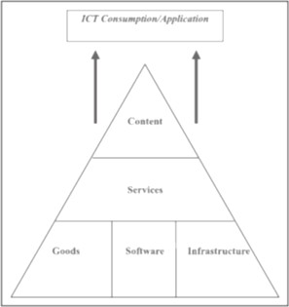

**Figure 4.5: ICT Value Chain**

Source: Worldwide web, Recreated by Author

At the next level, IT value chain consists of four primary activities and five supporting activities. The four activities have also been labelled as value streams. HP has defined these value streams with members of the IT4IT consortium, a team of customers and partners. The quality of each of these value streams is the basis by which IT creates competitive advantage

for its business customers.

•

The Strategy to Portfolio value stream is the portfolio of capabilities that IT fields for business competitive advantage. The portfolio needs to involve conscious choices.

The Requirement to deploy value stream is about how strategic demand is delivered and managed—how closely requirements that are delivered match business needs.

The Request to fulfil value stream is about operational demand—how well IT fulfils requests when system access, IT components, or PCs are needed.

The Detect to correct value stream is concerned with fixing things according to the

service design portion of Requirement to Deploy; in other words, is the right warranty in place, and does IT deliver to it?

•

•

•

107

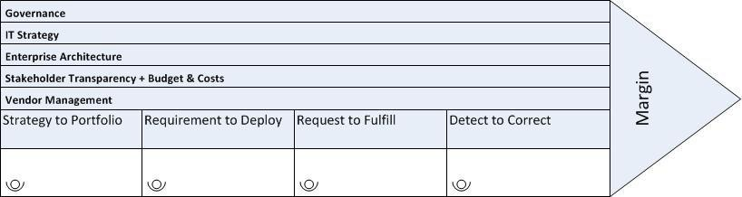

**Figure 4.6: IT Value Chain**

Source: Worldwide web, Recreated by Author

Extending the value chain to the core Software area, work requires a range of different skills that can be characterized through a variation on Porter’s (1985) notion of the value chain:

* Core operational skills: These are typically characterized in terms of the software lifecycle

(analysis—design—construction—implementation—maintenance),

with

a

particular

differentiation being made between relatively lower skilled downstream skills (required for the programming work within construction and maintenance) and relatively higher-skilled upstream skills associated with analysis and design.

* Other primary skills: These relate particularly to project management skills (required for the internal management of software development) and what we might call contact skills (ranging from rather lower-skilled sales/marketing to higher-skilled client account / contract management).
* Support activity skills: The range of skills required for administering the finance, human resources and technology management within the software firm, plus the higher-level skills needed for senior / strategic management.

In Figure 4.7, skills are divided into Primary and secondary activities and are shown based

upon there usage during various stages of software value chain

108

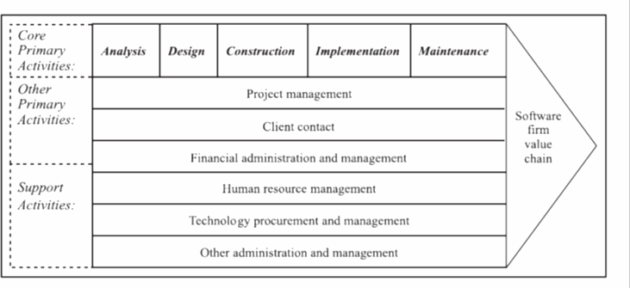

**Fig.4.7: Software Value Chain**

Source: Worldwide web, Recreated by Author

**4.4.1**

**Leveraging** [**IT value chain to maximize**](http://h30499.www3.hp.com/t5/Discover-Performance-Blog/IT-value-chain-How-enlightened-IT-executives-can-maximize-IT-s/ba-p/6146001)

**returns**

This section covers how the business notion of [value chains](http://h30458.www3.hp.com/us/us/ezine/it-execs/may/finding-your-true-value_1295277.html) can be applied to IT management. Viewing IT management this way fundamentally changes how IT thinks about its relationship with business customers. For IT leaders, this involves changing from thinking about the things IT does (the how part) to thinking about what these things enable (the what part). [Richard Hunter and George Westerman](http://www.amazon.com/dp/1422147614) said in their book, Real Business of IT: How CIOs Create and Communicate Value, which IT is like an exercise bike. The value proposition of the exercise bike is not in the pedals, handlebars, or the other components, it is

in the ability to lose weight and get in shape.

**4.4.2**

**Application of value chain thinking to IT management**

As mentioned earlier, IT is more than a random compilation of process, technology, environment, machinery, equipment, people, and money. IT leaders arrange these components into capabilities that internal or external customers pay money for. By doing so, we establish a major source of our business’s competitive advantage. IT, just like its business brethren, has primary and support activities in the IT value chain. The value of the IT exercise bike is the ability to reach a business goal.

Let’s first look at how IT creates competitive advantage for the business. IT organizations

achieve this by doing three things with increasing effectiveness and efficiency: We often do not consider how important IT mission is for the overall success to the enterprise. But, within

109

IT, we do amazing things. We are the digitizers of the enterprise, deliver that enterprise digitization and keep that business running across the year 24X7. Paper processes no longer exist for most of the organizations; when an IT-delivered capability does not work, the

business process no longer works.

**4.4.3**

**IT and Global Value Chains: Growth, Structure and Transformation**

The real impact of information technologies is being felt in terms of the globalization of information services. There are multiple reasons for this. The ones that apply in the physical case also apply here; these include improvements in searching by buyers, and matching buyers to sellers. However, certain other factors are specific to information products that are not packaged in physical form, and information services. One of the most important is the cost of transportation, distribution and delivery. This cost has been reduced substantially by the existence of the Internet and the web. As yet, the actual costs of transportation are not always low, since they require the use of telecommunications, where the price is often artificially high. However, these costs are dropping, and the real cost of transportation is quite low, due to substantial existing capacity through global fibre and satellite networks. Even where inter-regional costs of information logistics are high, the costs within market areas are often quite low.

Furthermore, the transaction costs of moving information from firms to the transportation medium (telecommunications) and back to a firm have been reduced by use of the web and browser interfaces.

New file formats and protocols (such as MP3 for music), coupled with low cost readers and players have made it possible to shift distribution of some forms of information products away from packaged formats, to on-line formats. As the relative costs of hardware and software have dropped, labour has become the limiting factor for production of many information products and services. The result is that low labour cost locations now have an absolute advantage in the total costs of producing many information products. Furthermore, since the costs of entry are also weighted towards labour, entry actually becomes easier for low labour cost locations. Thus, for example, the initial cost of producing the first release of a software package, might be three times more in a US location than that for an Indian location. As a consequence, in the last three decades, there has been a large increase in the provision of information services from sources in the East. The early examples were typically keyed data

entry. A typical example would be the conversion of traffic tickets from hand written to

110

punched card form. The nature of services provided has become more and more sophisticated over the years. Today, a wide range of information services are out-sourced often to off-shore

locations, including:

•

•

•

•

•

•

•

•

•

transcription of handwritten and voice data (e.g. doctors’ notes) creation of animation

data structuring and editing (technical data processing) management of accounting information

on-line email response

customer response by voice and email

technical support services (e.g. medical equipment) software maintenance

website maintenance

Current trends suggest that the services that are provided will shift towards higher levels of

technical and specialized knowledge. Some areas that are being addressed today include

•

•

•

•

•

•

•

•

•

teaching and tutoring engineering services graphics and graphic design

editing and publishing services

legal data, information and support services customer service management

medical diagnosis and advice research (analytical and clinical)

consulting and business development services

Some of these are in the early stages of development; others are already fairly

established.

well

**4.4.4**

**Significance of Offshore in Services Value Chain**

Over the past decade, the offshore services industry has experienced tremendous growth and emerged as a dynamic global sector that involves both developed and developing nations. Structural changes in the global economy precipitated by the information and communication Technology (ICT) revolution have allowed emerging nations for the first time to contribute

significantly to the world’s services industry. No longer relegated to manufacturing and

111

natural resource-intensive industries, developing countries now have an important opportunity to advance both their economic and social conditions. The global economic crisis has highlighted an important characteristic of the industry for developing countries: it demonstrated significant resilience to downturns due to its principle raison d’être to lower costs for all industries around the world and this focus leads the industry to constantly seek out lower cost destinations. This dynamics, in turn, opens up opportunities for new countries to enter the industry value chain.

The offshore services industry incorporates the trade of services conducted in one country and consumed in another, and it has transformed the way companies do business by allowing for the separation of the production and consumption of services. The scope of the industry has evolved over time and increasingly sophisticated activities are being exported. What began with the outsourcing of basic information technology (IT) services to external firms now includes a wide array of activities known as business process outsourcing (BPO), knowledge process outsourcing (KPO), and other advanced activities in the value chain such as research and development (R&D), which were previously considered core functions of the firm. Due to cost arbitrage advantages, developing nations are leaders in many of these offshore services and the industry has become an important source for employment and economic growth around the globe. Early market entrants rapidly specialized in service areas where they have competitive advantages; as they upgraded to higher value activities; new players joined the industry at lower points in the value chain. This provides emerging economies with an opportunity to drive sustainable growth through the expansion of the knowledge economy and to reduce their traditional dependence on manufacturing and natural resource industries.

The industry has evolved continuously since its inception, making efforts at categorization challenging. Despite these complexities, a fairly comprehensive, yet flexible, classification of the industry has emerged employing the global value chain (GVC) framework ( Gereffi & Fernandez-Stark, 2010). The GVC framework uses firm-level analysis to determine the different stages of production of goods or service and the value of each component (Gereffi et al., 2001). For manufacturing and extractive industries based on goods, value added is determined by the difference between the cost of the inputs and outputs at each stage of the chain. In the case of the offshore services industry, measuring value is complicated by the lack of reliable company level data and trade statistics for services (Sturgeon & Gereffi, 2009). To partially address this problem, the value of different services can be related to

112

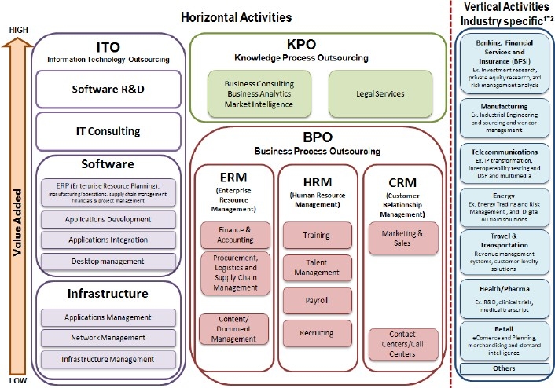

employee education level and work experience (Gereffi & Fernandez-Stark, 2010). By indicating the human capital required at different levels of the offshore services value chain, this classification provides decision makers in prospective players with an instrument to determine where they may be best suited to enter the value chain in order to achieve their desired outcomes.

Figure 4.8 below illustrates the global value chain for the offshore services industry ( Gereffi and Fernandez-Stark, 2010). Using this classification scheme, it is possible to identify the varied types of offshore service activities, to show which firms participate in which segments of the industry, and in turn, to locate the most important regions of the world in the industry’s development.

**Figure 4.8: Global Value Chain for the offshore services industry**

Source: OECD report

The industry is first subdivided into services that can be provided

across all industries

(horizontal services) and those services that are industry specific (verticals). Firm’s operating in the horizontal services tend to be process experts, while those in the vertical chains must have industry expertise and their services may have limited applicability in other industries. In horizontal services, all activities are related to supporting generic business functions, such

as network management, application integration, payroll, call centres, accounting and human

113

resources. In addition, they include higher value services, such as market intelligence, business analytics and legal services. These higher value horizontal services are referred to as knowledge process outsourcing (KPO).

Within horizontal services, ITO contains a full spectrum of low, mid and high value activities of the offshore services chain, BPO activities are in the low and middle segments, while KPO activities are in the highest value segment of the chain. The value of each activity is correlated with human capital (education level), that is to say, lower value-added services are performed by people with fewer years of formal education. Call centres or routine BPO activities, for example, can be performed by employees with just a high school diploma. Market research or business intelligence is typically carried out by employees with a minimum of a bachelor’s degree, while the highest-level research and analysis is carried out

by employees holding specialized masters degrees or PhDs.

114