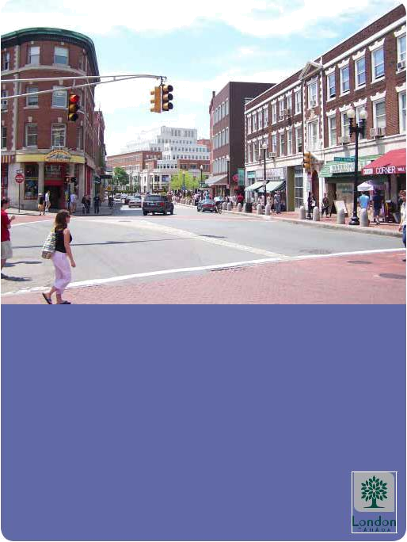

URBAN DESIGN BRIEF
TERMS OF REFERENCE

JANUARY 2009

INTRODUCTION

Urban Design Briefs are used to evaluate the

various elements of development

applications. These documents provide an

understanding of how and why projects are

designed in a particular manner, and gives

staff the opportunity to work co-operatively

with proponents. The City’s desire is to

elevate the quality of development projects

in London, and encourage well-designed,

functional projects.

The main purpose of the Urban Design Brief is to illustrate the design solution for a new development project in the City of London and how the solution was devised. It provides clear guidance on how a site should be developed and details the design principles for a site and the implementing policies to achieve these principles.
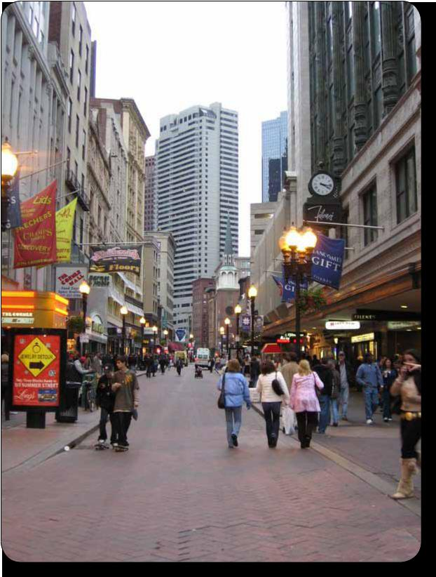

An Urban Design Brief will be required for larger-scale development projects, smaller developments requiring certain sensitivities

– such as those which propose infill/ intensification/redevelopment within the existing community – and for projects within specific areas such as the Downtown, Old East Village, and Wortley Village. Whether an Urban Design Brief is required for a particular proposal will be determined by the General Manger of Planning and Development or his/her delegate during the pre-applicaton consultation meeting.

The Brief will be submitted as part of a development application and will provide an analysis of the context of the site in the greater area of the community. The Brief can not simply be a reflection of, nor argument for, a preferred development scheme. The Brief is also not intended to replace a Planning Justification Report, but set the stage for what types of applications are required in order to realise the proposal. The Brief shall explain why the proposed development represents the optimum design solution.

The level of detail in the Urban Design Brief will be a reflection of the scale and/or sensitivity of the development project.

City of London 1

CONTENT

The Urban Design Brief is required to analyse not just the site, but the context of the site, and provide initial urban design ideas and corresponding design objectives. From this analysis, options are to be provided, along with a recommended design solution for a site and/or project.
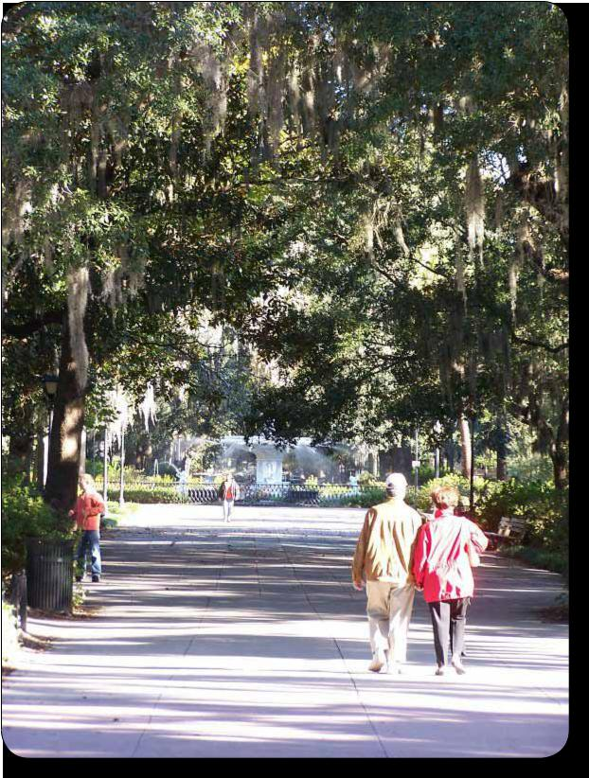

The Urban Design Brief will include two distinct sections. Section 1 will provide an analysis and proposed design principles, while Section 2 will describe how the development options will respond to the analysis and proposed design principles.

Section 1:

- Design Goals and Objectives

- Design Response to City Documents

- Spatial Analysis

Section 2:

- Conceptual Design

- Public Realm

- Sustainability Techniques

- Heritage Initiatives (where applicable)

These matters are described in the following paragraphs and some overlap across the different elements may occur.

- Terms of Reference - UD Brief

SECTION ONE

Design Goals and Objective | Spatial Analysis | • Topography;
Any development project carries with it | The spatial analysis consists of two plans. | • Surrounding Official Plan and Zoning
a specific desire for what it intends to | First the Regional Spatial Analysis Plan will | Designations
achieve. This section will allow the project’s | identify the community context at 400 and | • Photographs of the site and surrounding
designer(s) to convey this intent. | 800 metre radius from the site. This plan | area
 | should include the following: | • View corridors and vistas to and from the
Design Response To City Documents |  | site;
As part of the design response, a summary | • Regional Landmarks | • Composition of surrounding and
and evaluation of relevant City documents is | • Nodes (ie Shopping Areas, Community | neighbouring character and land uses;
required. The Design Brief needs to include a | Centres, Employment Areas, Public | • General analysis of the urban pattern
description of how the development accounts | Spaces, Transit Hubs) | (streets and blocks) in the immediate
for, and implements, the City’s Vision/ | • Neighbourhood or City Gateways and Focal | area (include figure-ground analysis of
strategies as established in: | Points | surrouding area);
 | • Major Transportation and Transit Routes | • Accessibility and Connectivity patterns
• The City’s Strategic Priorities and other | • Significant Regional View Corridors and | (automobile, cycling, pedestrian, transit
City-wide strategies, | Vistas (ie Views to the Downtown or | etc.) to and around the site;
• Official Plan policies, | Thames River) | • Landscaping in the area;
• Other applicable policy, design studies and | • The surrounding urban fabric | • Opportunities for tree preservation;
Guideline documents for the city and |  | • Edges, Paths, Barriers, Gateways,
specific area. | Second, the Site Spatial Analysis Plan will | Landmarks, Nodes (i.e. focal points, parks,
 | provide information on the imediate context | activity areas) within and around the
 | of the site. The following items should be | vicinity of the site.
 | considered:
 |  | (See page 4 and 5 for an example of a Spatial Analysis)
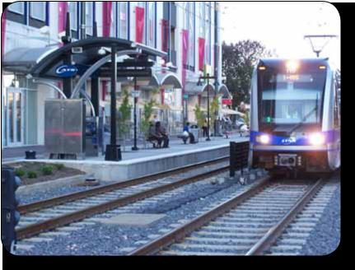

City of London 3

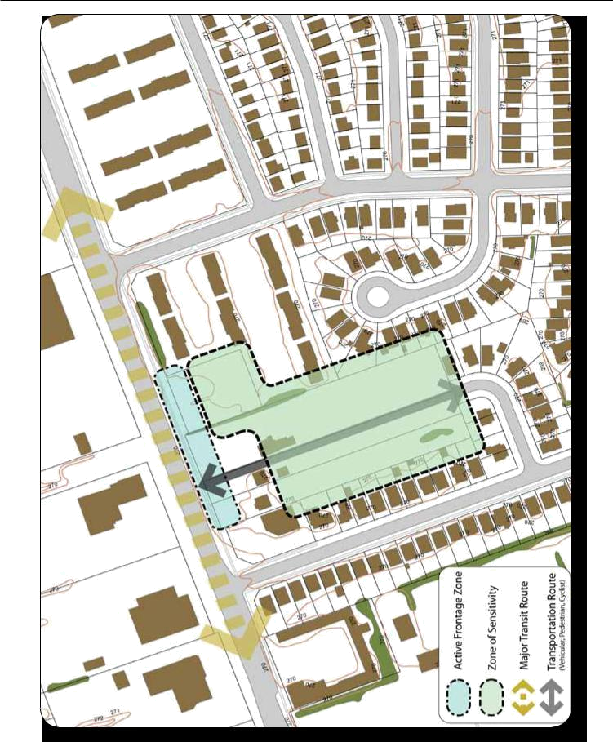

Spatial Analysis (Site specific)

- Terms of Reference - UD Brief

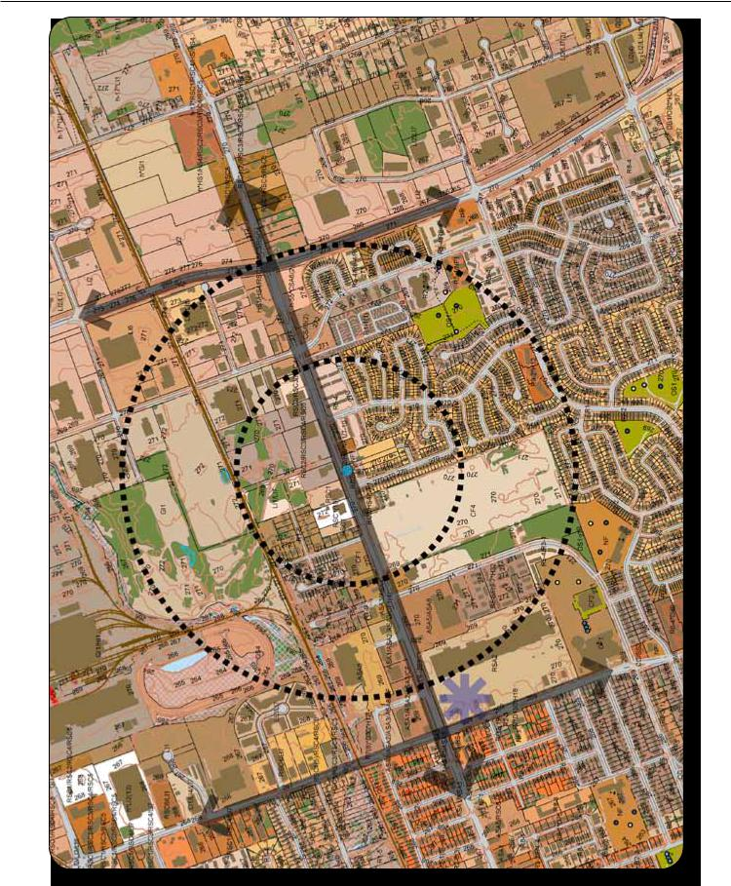

Spatial Analysis (Regional 400-800m)

City of London 5

SECTION TWO

Conceptual Design

Section Two of the Urban Design Brief, as per

the Submission Requirements (p. 8) should

be graphically oriented and supplemented

with text where necessary. Table One and

the subsequent page identify principles

that should be both considered through the

process and represented in the graphics

prepared for this Section.

Table 1
 |  | • Transit-oriented development
 |  | • Master planning for large sites
 |  | • How the design relates to its site and greater surrounding area
 |  | • Views in and out of the site – how does the building function
 | Site Design | as a view terminus – provide pedestrian perspectives (at-grade
 |  | views) and important views
 |  | • The location of buildings, as well as their orientation to the
 |  | street edge and sidewalks,
 |  | • The location of building entrances,
 |  | • Vehicular and pedestrian circulation
 |  | • How the building(s) addresses the street
 |  | • Street wall and treatment of grade level
 | Built Form | • Roof top and cornice lines
 |  | • Location of entrances and other openings
 |  | • How the building wraps a street corner or natural feature (if
 |  | applicable)
 |  | • The rhythm of at-grade openings
 |  | • Setbacks
 | Massing and | • Transition to adjacent uses/buildings, and among buildings within
 | Articulation | the site
 |  | • Shadowing impacts on the surrounding area (where applicable)
 |  | • Transition of scale
 |  | • Street proportion/street sections (building to street ratio)
 | Character and Image | • Response to the existing street character
 |  | • Role in the context of the neighbourhood
 |  | • Visual components
 |  | • Style
 | Architectural Treatment | • Details
 |  | • Materials
 |  | • Colours
 | Lighting | • How the site and building(s) will look at night
 | Signage | • How signage is being addressed and incorporated into the overall
 |  | design of the site
 |  | • Access to the site and on-site circulation for pedestrians, cyclists,
 |  | people with disabilities
 | Servicing | • Access to transit
 |  | • Shared service locations, parking, ramps, drop-offs, service areas
 |  | for garbage, loading, utilities, etc.
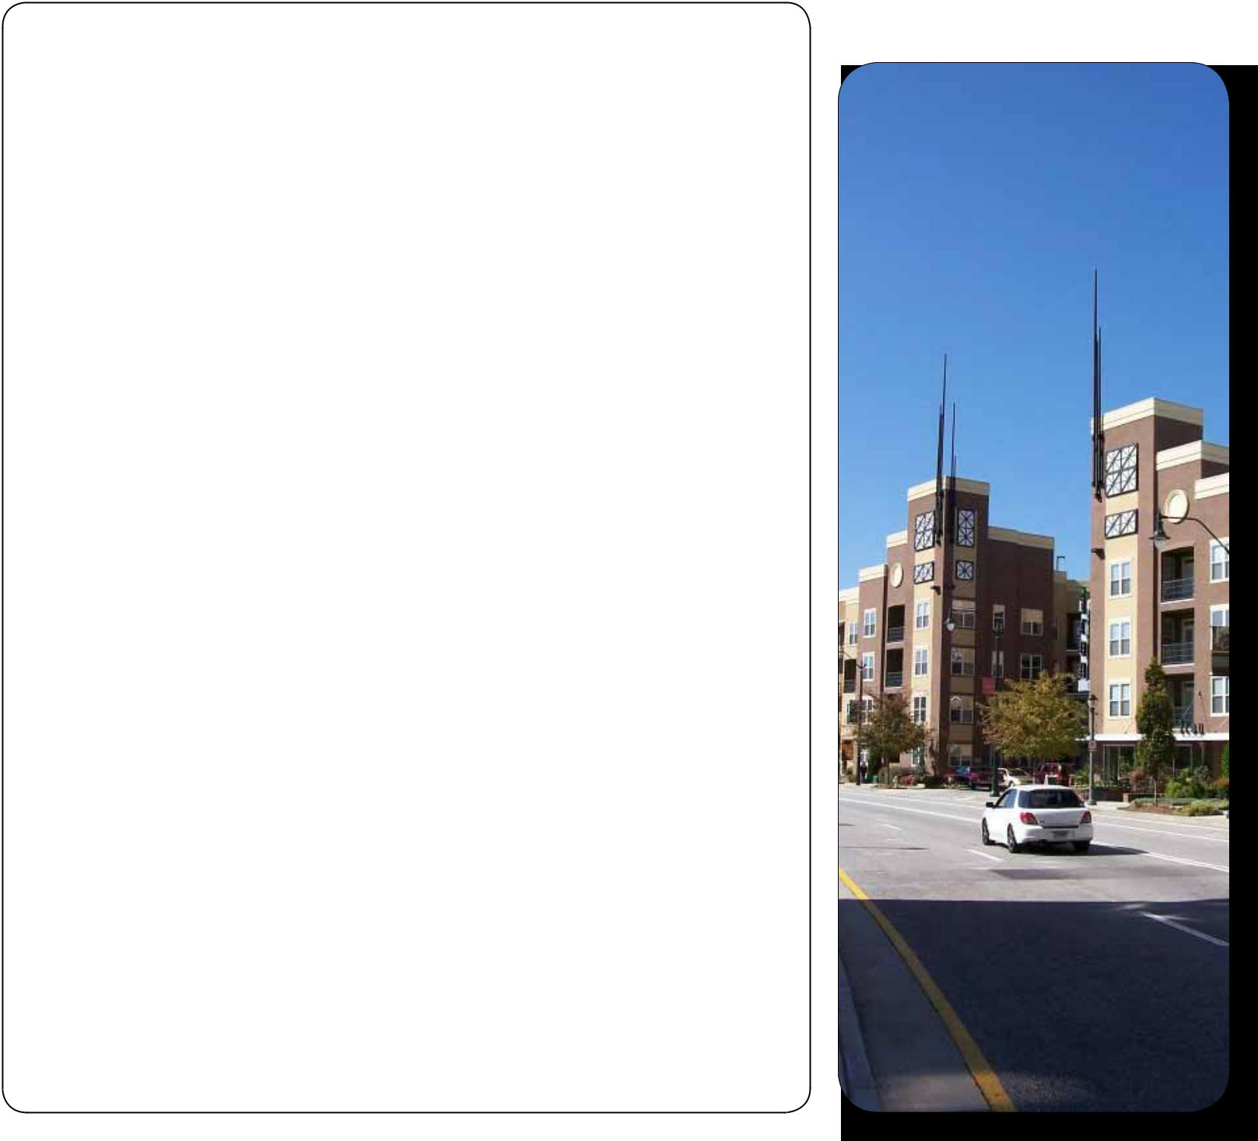

- Terms of Reference - UD Brief

Where a project involves mid-rise and tall buildings, the following additional issues need to be considered:

- Identify strategy and options for shaping/ designing tall building floor plates.

- Tall buildings can be broken into

3 distinct sections: base, middle and top. The base of the building must

be clearly defined andi n a scale that is compatible with adjacent streets, public spaces, and the neighbourhood. The middle section of the building requires a floor plate size which relates proportionately to the base and top.

The top of the building is what defines the overall character of the building and contributes to the skyline. Therefore, the top must be distinct and unique, without being garish nor kitsch.

- Shadowing caused by mid-rise and tall buildings should be minimised if at all possible, and allow adjacent landowners to maintain their access to privacy, sky view and natural light.

- Large, slab-like buildings rarely provide good urbanism and their mass should be broken down into smaller blocks, with smaller floor plates.
- Buildings on prominent sites (such as at the corner/intersection of two streets, and at the termination of cross-streets) must demonstrate how they will integrate with their context and enhance the landmark location.

- Design for comfort and safety (i.e. lighting, sun and wind protection, etc.)

- Different massing options may be required (through the use of site sections and perspective views) to evaluate accessibility to sunlight and sky views.

Public Realm

The design and function of the public realm, defined as the area in the Public Right-of-Way, is as important as the private areas and buildings that it touches. Good design must seamlessly traverse from one to the other, and respond to a variety of users.

The following items contribute to the public realm and should be considered as part of a comprehensive design solution.

- Public Spaces/Plazas, Continuity of the Streetscape, Façade Zones - Active at-grade pedestrian uses, Materials, Details, Site furnishing.

- Pedestrian circulation, relationship of building to the public realm.
- Design/function of private spaces, such as, open space, forecourts, walkways, gardens, plazas, courtyards.

- Linkages to the surrounding open space system including existing and proposed parks, paths, major pedestrian connections.

- Integration with transit.

- Landscape Design (landscape of street edge – surface parking lots where they meet the sidewalk, integrate with existing streetscape).

- Public Art (can include functional as well as decorative elements – benches, water features, light standards etc.).

- Streetscape improvements (street trees, lighting, street furniture etc).

- How addressing the transition space between building facade and public right-of-way – can be hardscaping (where a retail / commercial / lobby space meets the right-of-way) or soft landscaping (where a residential use meets the right-of-way).

Sustainability Techniques

Good design involves sustainable design. Although LEED and green building initiatives are important, a sustainable project accounts for not just the building, but how the development contributes to the progress of environmental sustainability of the area. The Design Brief should describe the following where applicable:

- How the development will reduce carbon emissions.
- The variety of energy efficiencies and sustainable design features proposed, such as: how energy/water consumption will be minimised, how buildings will be oriented, how the landscape design is sustainable, etc.

- If there is intent to apply for LEED (or similar) certification.

Heritage Initiatives

Where heritage properties and buildings exist as part of a development site, the preservation of buildings must be evaluated and preserved and enhanced where feasible. When the preservation of heritage buildings can be incorporated into the overall design solution, the following items should be considered:

- The Heritage character must be analysed and an appropriate response to the heritage attributes must be provided,
- The compatibility issues, must be evaluated in terms of the approach to incorporating heritage items versus new construction,

- Describe the details, materials, landscape, architectural pattern, and how these shall be reinforced, and the scale and rhythm of architecture maintained.

City of London 7

SUBMISSION REQUIREMENTS

The Brief shall include the design strategy that explains how the integration of the development with its surroundings shall occur. The Brief should be precise in language with illustrations detailing how quality can be achieved in, and throughout, the project. The following are the specific plans and documents that will form the brief:
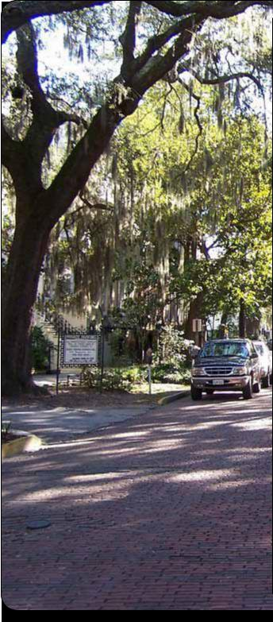

Section 1

- The Goals and Objectives and Response to City Documents are text based components of the brief that are to outline how these elements are being responded to in terms of design (ie Chapter 11 of the Official Plan);

- A Spatial Analysis should be completed similar to those shown pages 4 and 5, and include photographs of the site and surrounding area. This plan is to be supported by text where applicable.

Section 2

The following plans and/or drawings are required, depending on the site and/or project, for a complete urban design brief:

- Streetscape Elevations (An elevational plan that shows proposed buildings within their context along the street or through other significant view corridors)
- Streetscape Plan

Diagrams

•Plans (Site Plan, Landscape Plan -

interaction with the Public Realm)

- Sections (To include sections of the building(s) and the overall site. The section should explain how the proposed building(s) are to interact with the public realm (should also include a section of the public right-of-way and adjacent buildings)

- Illustrations (Illustrations must include, but are not limited to, the existing and proposed building context, property lines, street widths, building heights, setbacks and surrounding built form context.)

- 3-dimensional renders of the site and surrounding area
- Photographs or examples of other projects that represent the final desired product.

- Terms of Reference - UD Brief

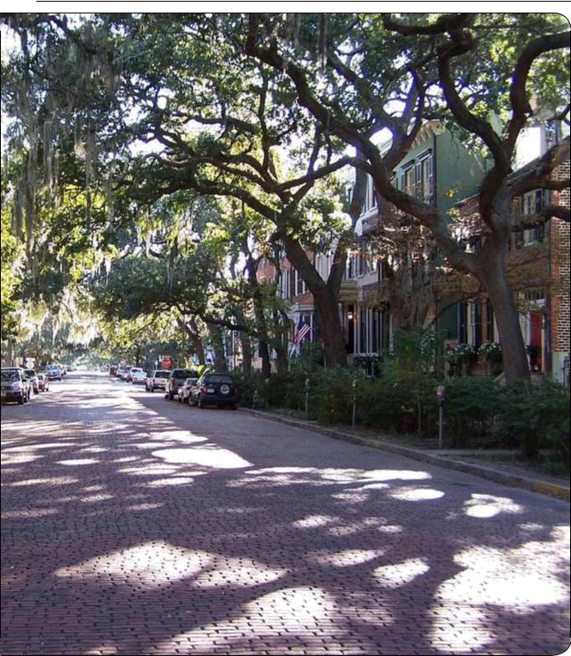
City of London | 9

