

National 4/5 Design Outcome 1 Unit Assessment

Analyse the factors influencing designers and design practice

Name………………………………………………………………………………………………………….Class……………….
Task 1 : Read over the design brief and fill out the boxes as required. You must then write your own design brief based on the information and design requirements.
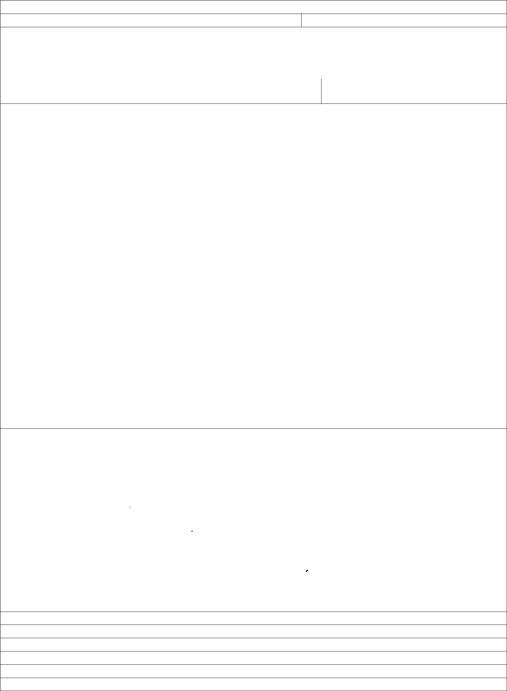

N4/N5 Jewellery Design Brief

Name: Class:

What are you planning to design?

Armpiece / Bracelet | Neckpiece | Large scale body jewellery
What is your theme/source of Inspiration?

Your teacher will discuss this with you to ensure it is suitable

Design and Designer Influences
You must explore the work of at least 2 designers (1 historical & 1 contemporary) and analyse two pieces of work
for each designer. The work must be relevant to your own design work.

Historical (pick at least one designer) |  | Contemporary (pick at least one designer)
Art Nouveau (Design style) |  | Arthur Hash | Louise Perrone
Archibald Knox |  | Nora Fok
Rene Lalique |  | Peter Chang
Frederic Boucheron |  | Marjorie Schick
Art Deco (Design style) |  | Ana Hagopian
Raymond Templier |  | Saloukee (Sarah Kelly)
Jean Foquet | Other………………………….. | Shaun leane | Other………………………………………
Target Market/Client

It could be a particular client with an individual style, a character from a stage show or a target market eg. Female catwalk model, teenage punky female etc. You must do your research on your target market and collect image(s) related to them.

Gender: | Age Group: | Style:
Male | Teenage | Stylish | Classic
Female | 18-25 | Funky | Arty
Unisex | 20-30 | Fashion conscious | Punk
 | 30+ | Vintage | Retro
 |  | Quirky | Miminal
 |  | Edgy
Target market /client:

Design Considerations

- The design should use a limited amount of colour, no more than three and be related to your theme.
- The design should be made mostly from paper but you can add other materials
- The piece must have a sculptural approach and be able to be easily seen

- The design should be easily worn
Are there any other design issues that you should consider as part of your brief?
Function | Materials
Ergonomics | Safety
Aesthetics/Style/Form | Cost
Notes:

N4/N5 Jewellery Design Brief

Based on the information you have provided overleaf you must write your own design brief which has the following;

- clear design requirements.
- Be clearly explained. Be specific avoid being vague.
- Be flexible enough to allow for creativity.

Example of a poorly written design brief;

“I am going to design a headpiece that has flowers on it, as I really like flowers. It should be bright and colourful and is aimed at 15-50 year olds.”

Teacher Feedback: What is the function? Where is it likely to be worn? What type of person would it appeal to, be specific. What are the restrictions regarding colour and materials? What is your source of inspiration? Think about the style and size

An Example of a properly completed design brief;

“I am going to design a headpiece for a special occasion like a red carpet event. The target market is young female, aged between 20 – 30 with an edgy style. It should be influenced by the floral theme but with a modern twist. The colours should be bright and warm and must be restricted to three colours. The design should fit comfortably on the head and be easy to take on and off. It must stand out in photographs and be clearly visible from a distance whilst containing detail and pattern which can be viewed close up.

In the space provided below you must write up your own design brief and get feedback on it before getting it typed up as this will be included in your overall submission.

Design Brief

Feedback

Task 2 : Complete profile of your chosen contemporary designer ( remember they should be relevant to the design work you are completing just now) . Find out as much information as you can and complete the boxes
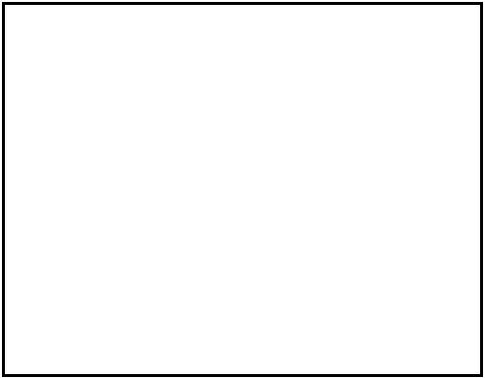

9. Target market

Does the designer design for a particular

target

market?.......................................................

....................................................................

....................................................................

....................................................................

....................................................................
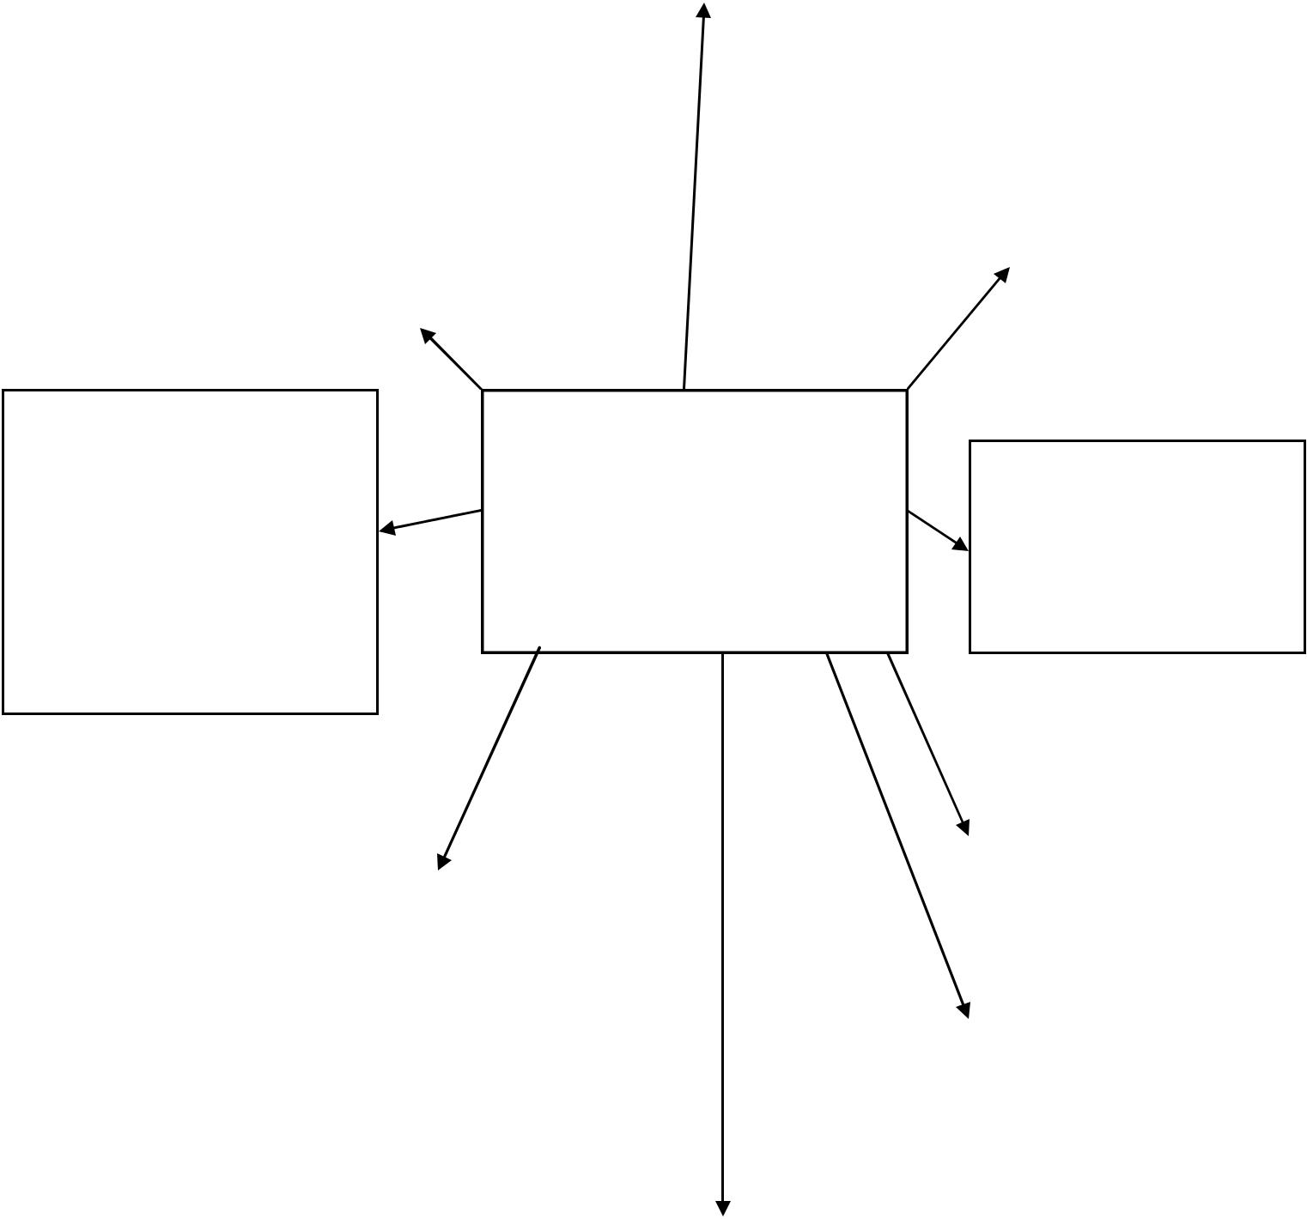

8. Materials |  | 1.Name...........................
What materials does the designer like to |  | ............................................
What materials does the designer like to |  | ............................................
use?................................................................. |  | ............................................
 |  | ............................................
................................................................................................................................................ |  | ............................................
........................................................................

7. Signature style

Does the designer have a trademark

style?....................................................

.............................................................

.............................................................

.............................................................

.............................................................

.............................................................

Designer

Profile

(Contemporary)

2. Dates of note

Born, died

etc………………………………

…………………………………

……….

 |  |  |  |  |  |  | 3. Nationality
6. What products are they |  |  | Stick a |  |  |  | 3. Nationality
most famous for. |  |  | Picture of the |  |  |  | Where were they
.................................................................. |  |  | Picture of the |  |  |  | born?................................................
 |  |  | designer here |  |  |  | born?................................................
.................................................................. |  |  | designer here |  |  |  | .........................
..................................................................
..................................................................
..................................................................
 |  |  |  |  |  |  | 4. Training
.................................................................. |  |  |  |  |  |  | 4. Training
................................................................. |  |  |  |  |  |  | Where did they
 |  |  |  |  |  |  | study?
 |  |  |  |  |  |  | ...........................................................
 |  |  |  |  |  |  | ...........................................................
 |  |  | 5. Influences |  |  |  | ...........................................................
 |  |  |  |  |  |  | ...........................................................
 |  |  |  |  |  |  | ...........................................................
 |  |  | Where did the designer take |  |  |  | ...........................................................
 |  |  | inspiration
 |  | from?...................................................
 |  | .............................................................
 |  | .............................................................
 |  | .............................................................
 |  | .............

Task 3/1 : Complete a design analysis of one of your chosen contemporary designer’s work. This is the first part you must do the same thing for a second design item.

 |  |  |  |  |  |  |  |  |  | ........................
 |  |  |  |  |  |  |  |  |  |  |  | 3. Materials
 |  |  |  |  |  |  |  |  |  |  |  |  |  |  |  |  |  |  | ............4. Cost
 |  |  |  |  |  |  |  |  |  |  | What is the product made of? |  |  |  |  |  |  | Espensive? Affordable? Value for
 |  | ……………….1. Name of
 |  |  |  |  |  |  |  |  |  | How is it made? What techniques
 |  |  |  |  |  |  |  |  |  |  |  |  |  |  |  |  | money?
 |  | product & |  |  |  |  |  |  |  |  |  |  | are
 |  |  |  |  |  |  |  |  |  |  |  |  |  |  |  |  | ...........................................................
 | designer……………………… |  |  |  |  |  |  |  |  | .................................................used?
 |  |  |  |  |  |  |  |  |  | .......................................................... |  |  |  |  |  |  | ...........................................................
 |  | ……………………………… |  |  |  |  |  |  |  |  |  |  |  |  |  |  | ............
 |  | ……………………………
 |  |  |  |  |  |  |  |  |  |  |  |  |  |  |  |  |  |  | ............5. Safety
 |  | Date………………………… |  |  |  |  |  |  |  |  |  |  |  |  |  |  |  |  | Is the object safe to use? Possible
 |  |  |  |  |  |  |  |  |  |  |  |  |  |  |  |  |  |  | hazards?................................................
 |  |  |  |  |  |  |  |  |  |  |  |  |  |  |  |  |  |  | .............................................................
 |  |  |  |  |  |  |  |  |  |  |  |  |  |  |  |  |  |  | .............................................................
 |  | 2. Back ground Info. |  |  |  |  |  |  |  |  |  |  |  |  |  |  |  |  | .............................................................
 |  |  |  |  |  |  |  |  |  |  |  |  |  |  |  |  |  |  | ............
 |  | Date: |  |  |  |  |  |  |  |  |  | 4Design
 |  | Does the product belong to s |  |  |  |  |  |  |  |  |  |  |  |  |  |  |  | .................................................................. | .............6. Target market
 |  | design movement. Eg Art |  |  |  |  |  |  |  |  |  | Analysis 1
 |  | and cultural Influences* have on |  |  |  |  |  |  |  |  |  |  |  |  |  |  |  |  | Who is the product aimed
 |  | Deco.? What impact does social
 |  | their work.? |  |  |  |  |  |  |  |  |  |  |  |  |  |  |  | at?..............................................................
 |  | ………………………………… |  |  |  |  |  |  |  |  |  |  |  |  |  |  |  | ..................................................................
 |  | ………………………………… |  |  |  |  |  |  |  |  |  |  |  |  |  |  |  | ..................................................................
 |  | …………………………………
 |  | ………………………………… |  |  |  |  |  |  |  |  |  |  |  |  |  |  |  | ..................................................................
 |  | …………………………………
 |  | ………………………………… |  |  |  |  |  |  |  |  |  |  |  |  |  |  |  | ..................................................................
 |  | ………………………………… |  |  |  |  |  |  |  |  |  | Design Object
 |  | …………………………………
 |  | …………………………………
 |  | …………………………………. |  |  |  |  |  |  |  |  |  |  |  |  |  |  |  |  | ...................7. Ergonomics.
 |  |  |  |  |  |  |  |  |  |  |  |  |  |  |  |  |  |  | How does it fit the human body? Is
 |  |  |  |  |  |  |  |  |  |  |  |  |  |  |  |  |  |  | it
 |  | 9. Function
 |  |  |  |  |  |  |  |  |  |  |  |  |  |  |  |  |  |  | .......................................comfortable?
 |  |  |  |  |  |  |  |  |  |  |  |  |  |  |  |  |  |  | .............................................................
 |  | What a product does and how well it does |  |  |  |  |  |  |  |  |  |  |  |  |  |  |  |  | .............................................................
 | this……………………………………………………… |  |  |  |  |  |  |  |  |  |  |  |  |  |  |  |  |  | ...................
 | …………………………………………………………
 | ………………………………………………………… |  |  |  |  |  |  |  |  |  |  |  | Form/style/Aesthetics
 |  |  |  |  |  |  |  |  |  |  |  |  | How the product looks
 |  |  |  |  |  |  |  |  |  |  |  |  | looks?..................................................................................
 |  |  |  |  |  |  |  |  |  |  |  |  | .............................................................................................
 |  |  |  |  |  |  |  |  |  |  |  |  | .............................................................................................
 |  |  |  |  |  |  |  |  |  |  |  |  | .............................................................................................
 | STEFFRemember |  |  |  |  |  | Social and cultural influences are things like – Fashion, eg. Punk, Glamour etc.
 |  |  |  |  |  |  | trends eg.Eco friendly, Recycled, Design movements eg. Art Deco, new
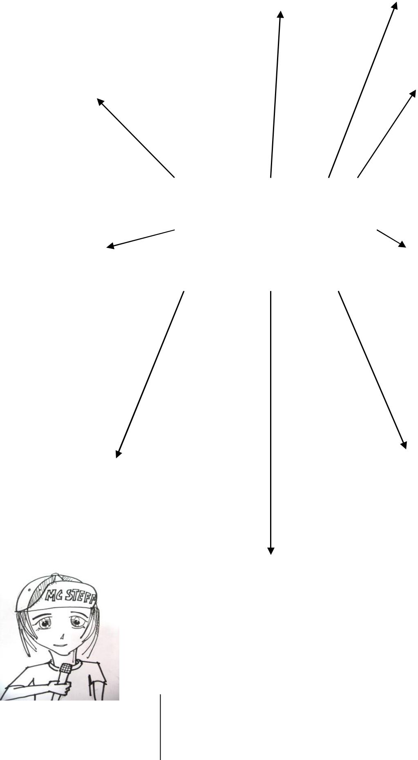
technology/ materials.
Task 3/2 : Complete a second design analysis of one of your chosen contemporary designer’s work.

 |  |  |  |  |  |  |  |  |  |  | 3. Materials
 |  |  |  |  |  |  |  |  |  | What is the product made of? |  |  |  |  |  |  |  | 4. Cost
 |  |  |  |  |  |  |  |  | How is it made? What techniques
 |  |  |  |  |  |  |  |  |  |  |  | are |  |  |  |  | Espensive? Affordable? Value for
 |  | 1. Name of product &
 | designer……………………… |  |  |  |  |  |  |  | .................................................used? |  |  |  |  |  |  | ..............................................money?
 |  |  |  |  |  |  |  |  | .......................................................... |  |  |  |  |  |  | ...........................................................
 |  | ………………………………
 |  |  |  |  |  |  |  |  | .......................................................... |  |  |  |  |  |  | ...........................................................
 |  | …………………………… |  |  |  |  |  |  |  |  | ........................ |  |  |  |  | ............
 |  | Date………………………… |  |  |  |  |  |  |  |  |  |  |  |  |  |  |  | 5. Safety
 |  | ……………………………… |  |  |  |  |  |  |  |  |  |  |  |  |  |  |  | Is the object safe to use? Possible
 |  |  |  |  |  |  |  |  |  |  |  |  |  |  |  |  |  | hazards?................................................
 |  |  |  |  |  |  |  |  |  |  |  |  |  |  |  |  |  | .............................................................
 |  |  |  |  |  |  |  |  |  |  |  |  |  |  |  |  |  | .............................................................
 |  | 2. Back ground Info. |  |  |  |  |  |  |  |  |  |  |  |  |  |  |  | .............................................................
 |  |  |  |  |  |  |  |  |  |  |  |  |  |  |  |  |  | ............
 |  | Date: |  |  |  |  |  |  |  |  | Design
 |  | Does the product belong to s |  |  |  |  |  |  |  |  |  |  |  |  |  |  |  | 6. Target market
 |  | design movement. Eg Art |  |  |  |  |  |  |  |  | Analysis 2 |  |  |  |  |  | at?
 |  | and cultural Influences* have on
 |  | Deco.? What impact does social |  |  |  |  |  |  |  |  |  |  |  |  |  |  |  | Who is the product aimed
 |  | their work.? |  |  |  |  |  |  |  |  |  |  |  |  |  |  | ..................................................................
 |  | ………………………………… |  |  |  |  |  |  |  |  |  |  |  |  |  |  | ..................................................................
 |  | ………………………………… |  |  |  |  |  |  |  |  |  |  |  |  |  |  | ..................................................................
 |  | …………………………………
 |  | ………………………………… |  |  |  |  |  |  |  |  |  |  |  |  |  |  | ..................................................................
 |  | …………………………………
 |  | ………………………………… |  |  |  |  |  |  |  |  |  |  |  |  |  |  | ..................................................................
 |  | ………………………………… |  |  |  |  |  |  |  |  | Picture of
 |  | …………………………………
 |  | ………………………………… |  |  |  |  |  |  |  |  | Design Object
 |  | …………………………………. |  |  |  |  |  |  |  |  |  |  |  |  |  |  |  | 7. Ergonomics.
 |  |  |  |  |  |  |  |  |  |  |  |  |  |  |  |  |  | How does it fit the human body? Is
 |  |  |  |  |  |  |  |  |  |  |  |  |  |  |  |  |  | it
 |  | 9. Function
 |  |  |  |  |  |  |  |  |  |  |  |  |  |  |  |  |  | .......................................comfortable?
 |  |  |  |  |  |  |  |  |  |  |  |  |  |  |  |  |  | .............................................................
 |  | What a product does and how well it does |  |  |  |  |  |  |  |  |  |  |  |  |  |  |  | .............................................................
 | this……………………………………………………… |  |  |  |  |  |  |  |  |  |  |  |  |  |  |  |  | ...................
 | …………………………………………………………
 | ………………………………………………………… |  |  |  |  |  |  |  |  |  |  | 8. Form/style/Aesthetics
 |  |  |  |  |  |  |  |  |  |  |  | How the product looks
 |  |  |  |  |  |  |  |  |  |  |  | .............................................................................................
 |  |  |  |  |  |  |  |  |  |  |  | .............................................................................................
 |  |  |  |  |  |  |  |  |  |  |  | .............................................................................................
 |  |  |  |  |  |  |  |  |  |  |  | ..................................................................................
 | RememberMC STEFF |  |  |  |  | Social and cultural influences are things like – Fashion, eg. Punk, Glamour etc.
 |  |  |  |  |  | trends eg.Eco friendly, Recycled, Design movements eg. Art Deco, new
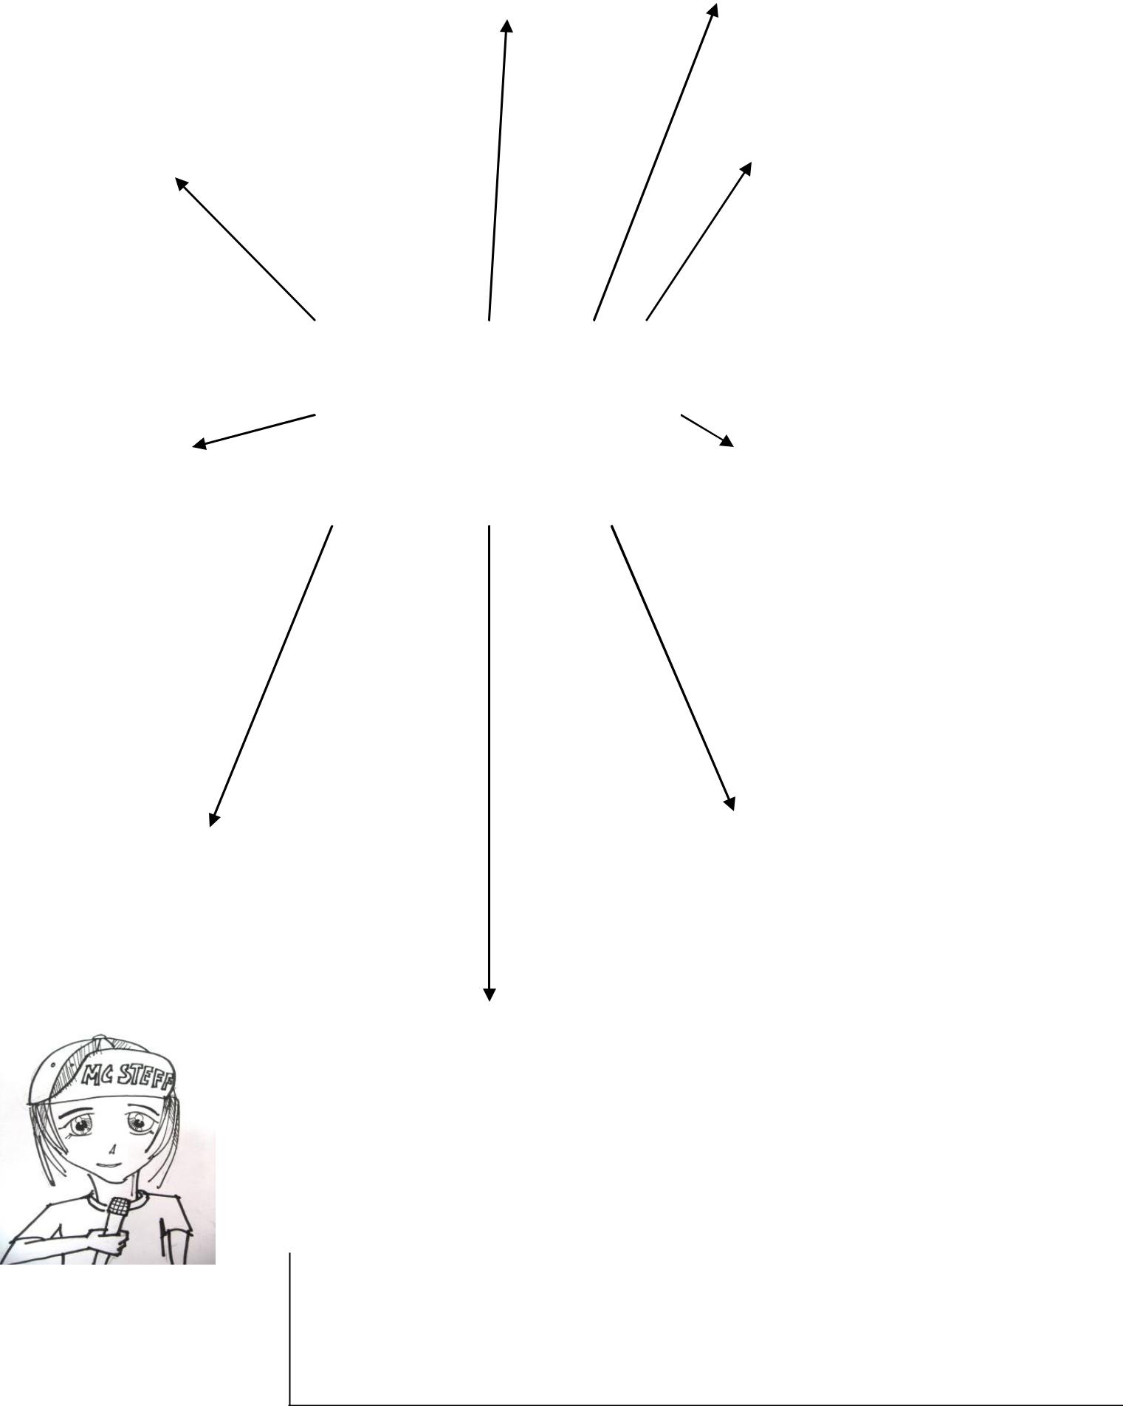
technology/ materials.

Task 4 : Complete profile of your chosen historic designer ( remember they should be relevant to the design work you are completing just now) . Find out as much information as you can and complete the boxes

9. Target market

Does the designer design for a particular

target

market?.......................................................

....................................................................

....................................................................

....................................................................

....................................................................
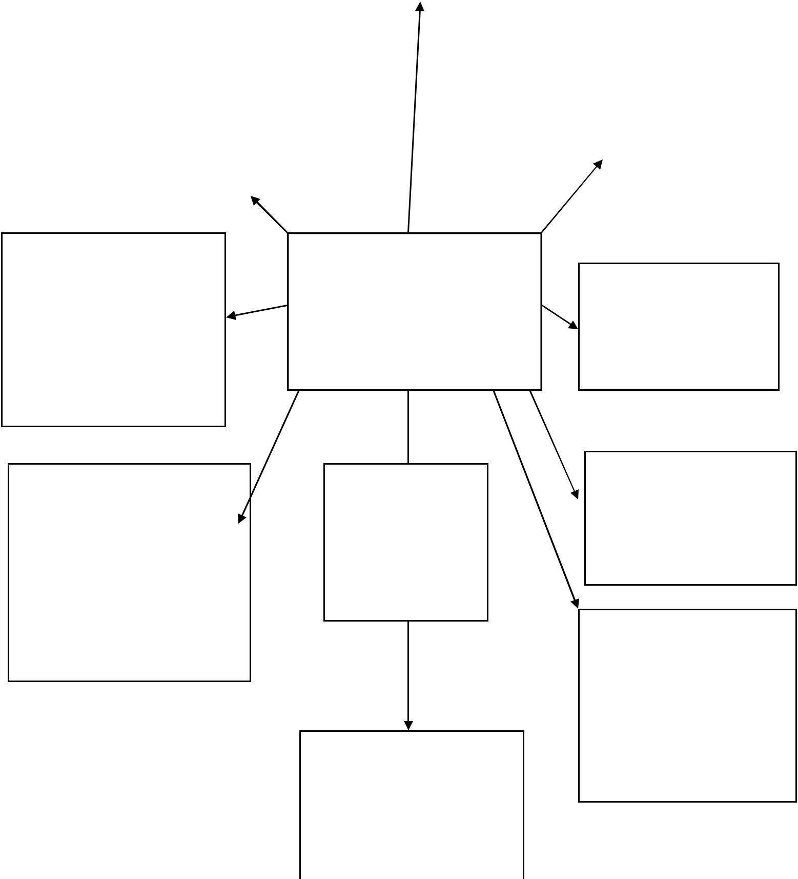

8. Materials |  | 1.Name...........................
What materials does the designer like to |  | ............................................
What materials does the designer like to |  | ............................................
use?................................................................. |  | ............................................
 |  | ............................................
................................................................................................................................................ |  | ............................................
........................................................................

7. Signature style

Does the designer have a trademark

style?....................................................

.............................................................

.............................................................

.............................................................

.............................................................

.............................................................

6. What products are they

most famous for.

..................................................................

..................................................................

..................................................................

..................................................................

..................................................................

..................................................................

.................................................................

Designer

Profile

(Historic)

Stick a

Picture of the

designer here

5. Influences

Where did the designer take

inspiration

from?...................................................

.............................................................

.............................................................

2. Dates of note

Born, died

etc………………………………

…………………………………

……….

3. Nationality

Where were they

born?................................................

.........................

4. Training

Where did they

study?.................................................

...........................................................

...........................................................

...........................................................

...........................................................

...........................................................

Task 5/1 : Complete a design analysis of one of your chosen historic designer’s work. This is the first part you must do the same thing for a second design item.

 |  |  |  |  |  |  |  |  |  |  | 3. Materials
 |  |  |  |  |  |  |  |  |  | What is the product made of? |  |  |  |  |  |  |  | 4. Cost
 |  |  |  |  |  |  |  |  | How is it made? What techniques
 |  |  |  |  |  |  |  |  |  |  |  | are |  |  |  |  | Espensive? Affordable? Value for
 |  | 1. Name of product &
 |  |  |  |  |  |  |  |  | used?
 | designer……………………… |  |  |  |  |  |  |  |  |  |  |  |  |  |  | money?..............................................
 |  |  |  |  |  |  |  |  | .......................................................... |  |  |  |  |  |  | ...........................................................
 |  | ………………………………
 |  |  |  |  |  |  |  |  | .......................................................... |  |  |  |  |  |  | ...........................................................
 |  | …………………………… |  |  |  |  |  |  |  |  | ........................ |  |  |  |  | ............
 |  | Date………………………… |  |  |  |  |  |  |  |  |  |  |  |  |  |  |  | 5. Safety
 |  | ……………………………… |  |  |  |  |  |  |  |  |  |  |  |  |  |  |  | Is the object safe to use? Possible
 |  |  |  |  |  |  |  |  |  |  |  |  |  |  |  |  |  | hazards?................................................
 |  |  |  |  |  |  |  |  |  |  |  |  |  |  |  |  |  | .............................................................
 |  |  |  |  |  |  |  |  |  |  |  |  |  |  |  |  |  | .............................................................
 |  | 2. Back ground Info. |  |  |  |  |  |  |  |  |  |  |  |  |  |  |  | .............................................................
 |  |  |  |  |  |  |  |  |  |  |  |  |  |  |  |  |  | ............
 |  | Date: |  |  |  |  |  |  |  |  | Design
 |  | Does the product belong to s |  |  |  |  |  |  |  |  |  |  |  |  |  |  |  | 6. Target market
 |  | design movement. Eg Art |  |  |  |  |  |  |  |  | Analysis 3 |  |  |  |  |  | at?
 |  | and cultural Influences* have on
 |  | Deco.? What impact does social |  |  |  |  |  |  |  |  |  |  |  |  |  |  |  | Who is the product aimed
 |  | their work.? |  |  |  |  |  |  |  |  |  |  |  |  |  |  | ..................................................................
 |  | ………………………………… |  |  |  |  |  |  |  |  |  |  |  |  |  |  | ..................................................................
 |  | ………………………………… |  |  |  |  |  |  |  |  |  |  |  |  |  |  | ..................................................................
 |  | …………………………………
 |  | ………………………………… |  |  |  |  |  |  |  |  |  |  |  |  |  |  | ..................................................................
 |  | …………………………………
 |  | ………………………………… |  |  |  |  |  |  |  |  |  |  |  |  |  |  | ..................................................................
 |  | ………………………………… |  |  |  |  |  |  |  |  | Picture of
 |  | …………………………………
 |  | ………………………………… |  |  |  |  |  |  |  |  | Design Object
 |  | …………………………………. |  |  |  |  |  |  |  |  |  |  |  |  |  |  |  | 7. Ergonomics.
 |  |  |  |  |  |  |  |  |  |  |  |  |  |  |  |  |  | How does it fit the human body? Is
 |  | 9. Function |  |  |  |  |  |  |  |  |  |  |  |  |  |  |  | it
 |  |  |  |  |  |  |  |  |  |  |  |  |  |  |  |  |  | .......................................comfortable?
 |  | What a product does and how well it does |  |  |  |  |  |  |  |  |  |  |  |  |  |  |  | .............................................................
 |  |  |  |  |  |  |  |  |  |  |  |  |  |  |  |  |  | .............................................................
 | this………………………………………………………
 |  |  |  |  |  |  |  |  |  |  |  |  |  |  |  |  |  | ...................
 | …………………………………………………………
 | …………………………………………………………
 |  |  |  |  |  |  |  |  |  |  |  | 8. Form/style/Aesthetics
 |  |  |  |  |  |  |  |  |  |  |  | How the product looks?
 |  |  |  |  |  |  |  |  |  |  |  | .............................................................................................
 |  |  |  |  |  |  |  |  |  |  |  | .............................................................................................
 |  |  |  |  |  |  |  |  |  |  |  | .............................................................................................
 |  |  |  |  |  |  |  |  |  |  |  | ..................................................................................
 | RememberMC STEFF |  |  |  |  |  | Social and cultural influences are things like – Fashion, eg. Punk, Glamour etc.
 |  |  |  |  |  |  | trends eg.Eco friendly, Recycled, Design movements eg. Art Deco, new
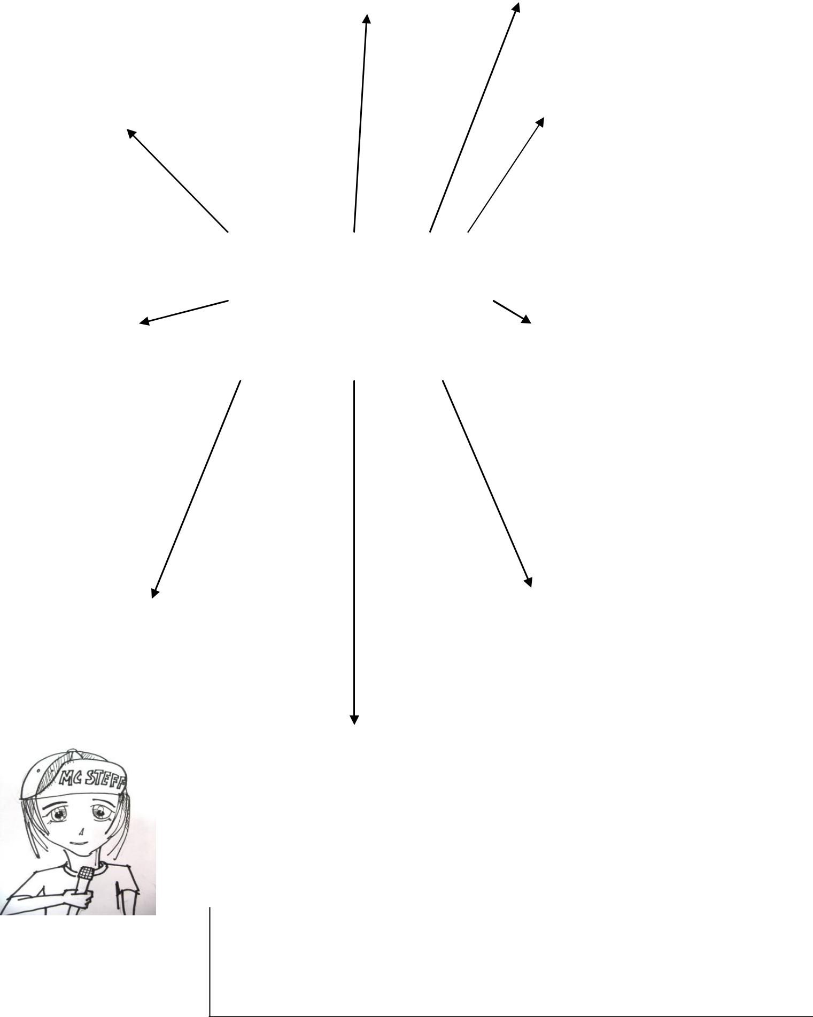
technology/ materials.
Task 5/2 : Complete a second design analysis of one of your Historic designer’s’ work

 |  |  |  |  |  |  |  |  |  |  |  | 3. Materials
 |  |  |  |  |  |  |  |  |  |  | What is the product made of? |  |  |  |  |  |  |  | 4. Cost
 |  |  |  |  |  |  |  |  |  | How is it made? What techniques
 |  |  |  |  |  |  |  |  |  |  |  |  | are |  |  |  |  | Espensive? Affordable? Value for
 |  |  | 1. Name of product &
 |  | designer……………………… |  |  |  |  |  |  |  | .................................................used? |  |  |  |  |  |  | ..............................................money?
 |  |  |  |  |  |  |  |  |  | .......................................................... |  |  |  |  |  |  | ...........................................................
 |  |  | ………………………………
 |  |  |  |  |  |  |  |  |  | .......................................................... |  |  |  |  |  |  | ...........................................................
 |  |  | ……………………………
 |  |  | Date………………………… |  |  |  |  |  |  |  |  |  |  |  |  |  |  |  | 5. Safety
 |  |  | ……………………………… |  |  |  |  |  |  |  |  |  |  |  |  |  |  |  | Is the object safe to use? Possible
 |  |  |  |  |  |  |  |  |  |  |  |  |  |  |  |  |  |  | hazards?................................................
 |  |  |  |  |  |  |  |  |  |  |  |  |  |  |  |  |  |  | .............................................................
 |  |  |  |  |  |  |  |  |  |  |  |  |  |  |  |  |  |  | .............................................................
 |  |  | 2. Back ground Info. |  |  |  |  |  |  |  |  |  |  |  |  |  |  |  | .............................................................
 |  |  | Date:
 |  |  | Date: |  |  |  |  |  |  |  |  | Design
 |  |  | Does the product belong to s |  |  |  |  |  |  |  |  |  |  |  |  |  |  |  | 6. Target market
 |  |  | design movement. Eg Art |  |  |  |  |  |  |  |  | Analysis |  |  |  |  |  | at?
 |  |  | and cultural Influences* have on
 |  |  | Deco.? What impact does social |  |  |  |  |  |  |  |  |  |  |  |  |  |  |  | Who is the product aimed
 |  |  | their work.? |  |  |  |  |  |  |  |  |  |  |  |  |  |  | ..................................................................
 |  |  | ………………………………… |  |  |  |  |  |  |  |  |  |  |  |  |  |  | ..................................................................
 |  |  | ………………………………… |  |  |  |  |  |  |  |  |  |  |  |  |  |  | ..................................................................
 |  |  | …………………………………
 |  |  | ………………………………… |  |  |  |  |  |  |  |  |  |  |  |  |  |  | ..................................................................
 |  |  | …………………………………
 |  |  | ………………………………… |  |  |  |  |  |  |  |  | Picture of
 |  |  | …………………………………
 |  |  | ………………………………… |  |  |  |  |  |  |  |  | Design ObjectPicture
 |  |  | …………………………………. |  |  |  |  |  |  |  |  |  | of |  |  |  |  |  | 7. Ergonomics.
 |  |  |  |  |  |  |  |  |  |  |  |  |  |  |  |  |  |  | How does it fit the human body? Is
 |  |  |  |  |  |  |  |  |  |  |  |  |  |  |  |  |  |  | it
 |  |  | 9. Function |  |  |  |  |  |  |  |  |  |  |  |  |  |  |  | .......................................comfortable?
 |  |  |  |  |  |  |  |  |  |  |  |  |  |  |  |  |  |  | .............................................................
 |  |  | What a product does and how well it does |  |  |  |  |  |  |  |  |  |  |  |  |  |  |  | .............................................................
 |  | this………………………………………………………
 |  | …………………………………………………………
 |  |  |  |  |  |  |  |  |  |  |  |  | 8. Form/style/Aesthetics
 |  | …………………………………………………………
 |  |  |  |  |  |  |  |  |  |  |  |  | How the product looks?
 |  |  |  |  |  |  |  |  |  |  |  |  | .............................................................................................
 |  |  |  |  |  |  |  |  |  |  |  |  | .............................................................................................
 |  |  |  |  |  |  |  |  |  |  |  |  | .............................................................................................
 |  |  |  |  |  |  |  |  |  |  |  |  | .................................................................................. |  |  | 8.
 |  | RememberMC |  |  |  |  | Social and cultural influences are things like – Fashion, eg. Punk, Glamour etc.
 |  |  |  |  |  |  | trends eg.Eco friendly, Recycled, Design movements eg. Art Deco, new
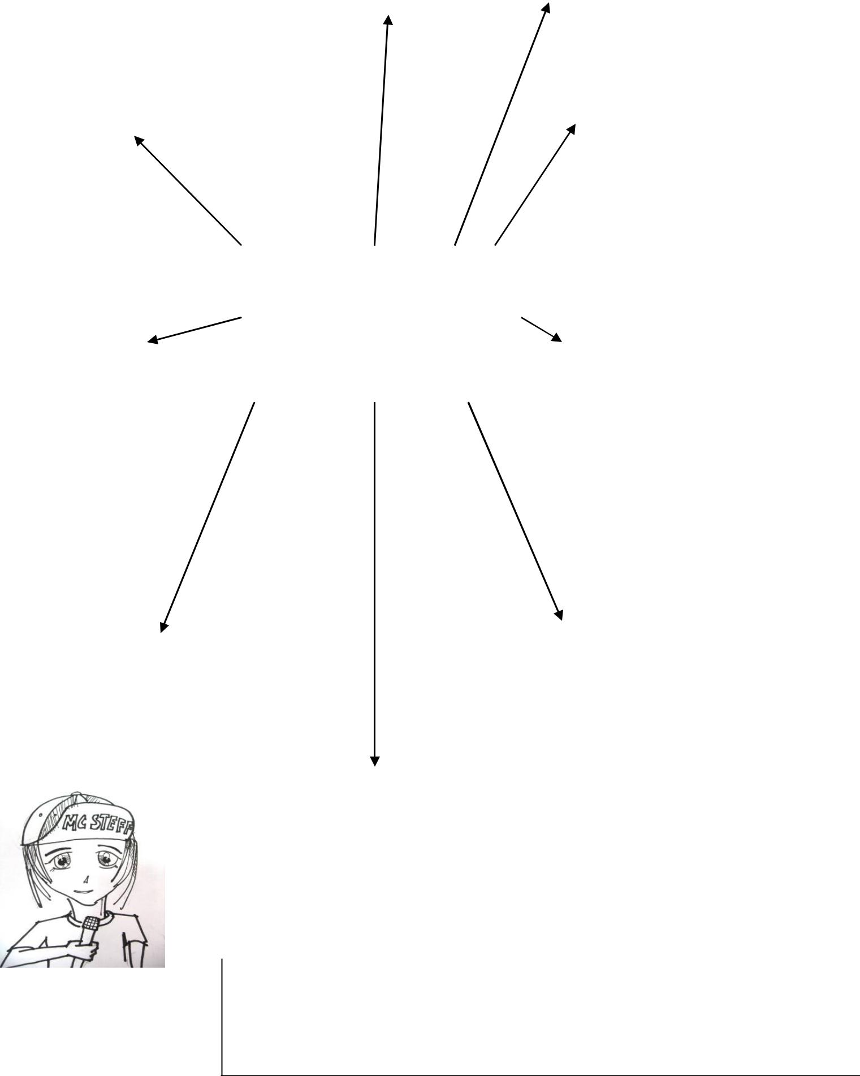
technology/ materials.
All evidence must be kept in this booklet. If there is any work that has been typed up or in any other format a hard copy must be kept and included with this booklet.

This work forms the basis of the internal assessment and will be reviewed on a pass/ basis.

 | Outcome | Assessment Standard & |  | Description | Pass/Fail | Work to complete
 |  | Description |  | of evidence
 | 1 Analyse | 1.1 | Describing how designers use design
 | 1 Analyse |  | material, techniques and technology in
 | the factors
 | influencing
 | designers
 | designers | 1.2 | Describing the impact of the designers’
 | and design |  | creative choices and design decisions
 | practice
 |  | 1.3 | Analysing the impact of social and
 |  |  | cultural influences on designers and their
 |  |  | work.

