APPENDIX 1


DRAFT DESIGN BRIEF

[insert name of project] Design Brief

[insert date]

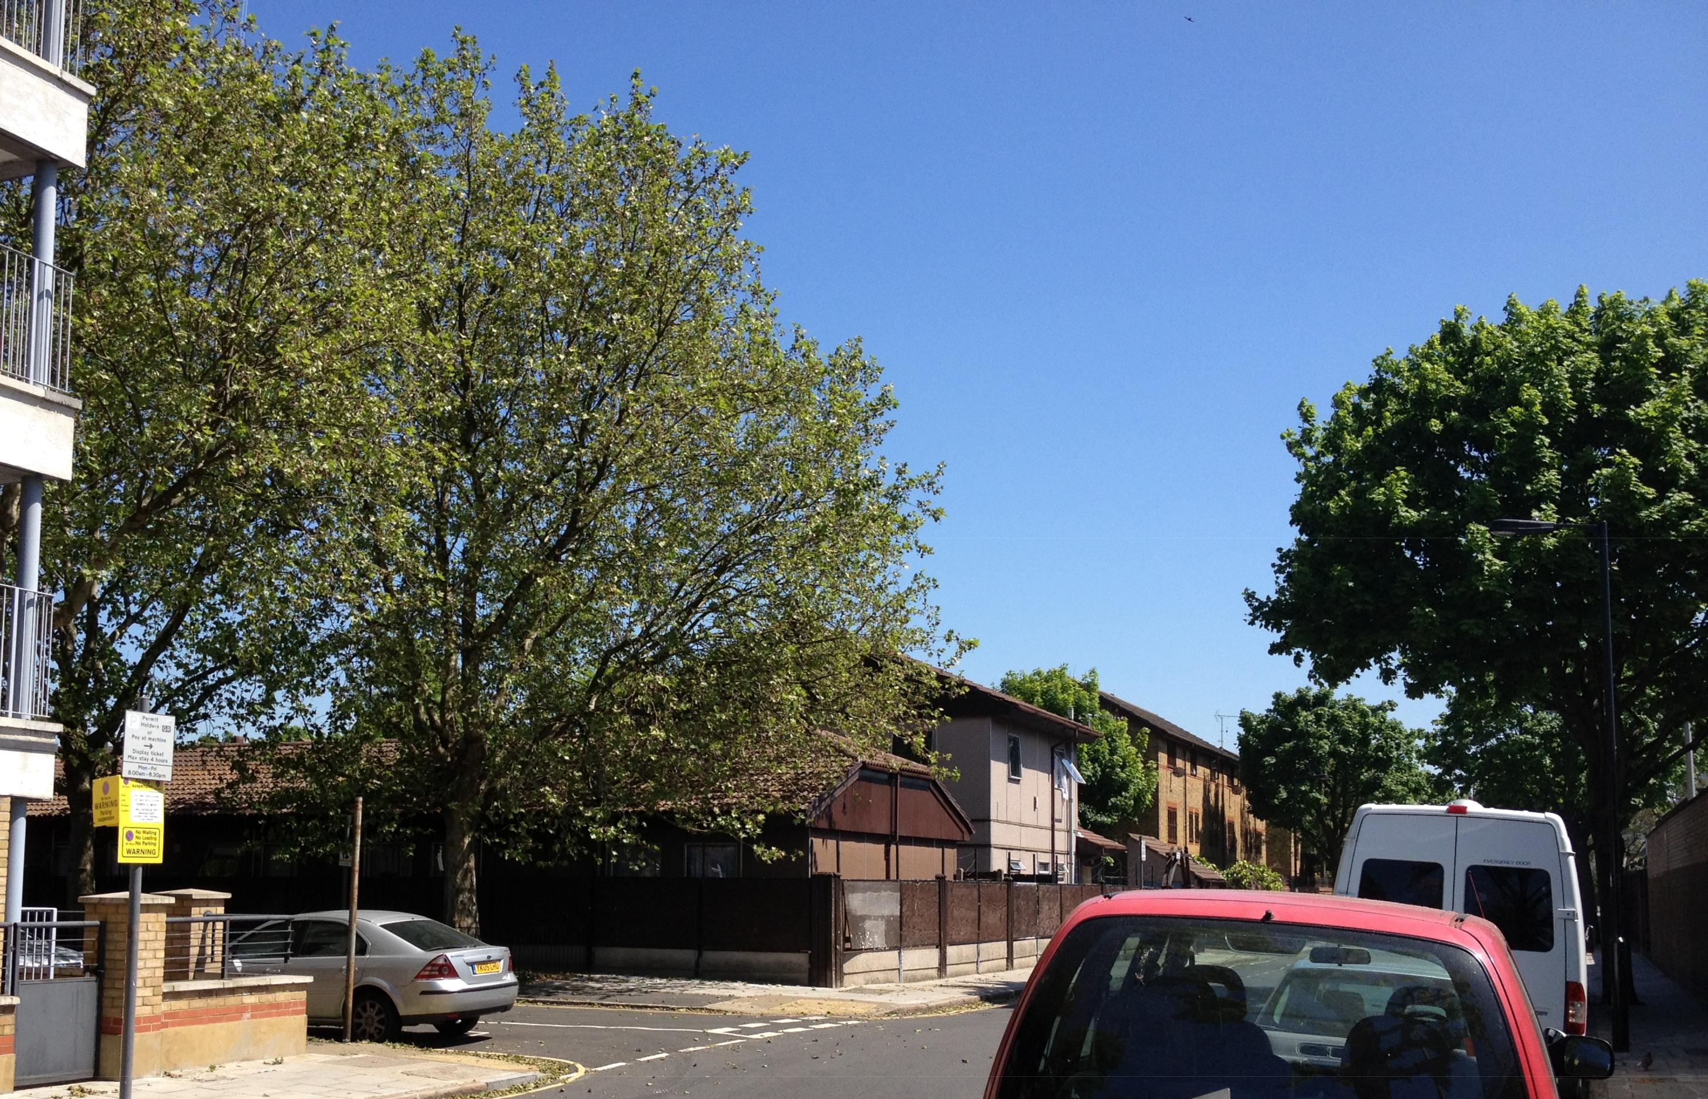

[insert name of project] Design Brief 1 [insert date]
[insert name of project] design brief

Issue and revision record

Revision | Date | Originator | Checker | Approver | Description

This document is issued for the party which commissioned it and for specific purposes connected with the above-captioned project only. It should not be relied upon by any other party or used for any other purposes

We accept no responsibility for the consequences of this document being relied upon by any other party, or being used for any other purpose, or containing any error or omission which is due to an error or omission in data supplied to us by other parties.

This document contains confidential information and proprietary intellectual property. It should not be shown to other parties without consent from the Council.

[insert name of project] Design Brief 2 [insert date]
Design brief for direct delivery new build housing schemes

Index

1.0 Vision

2.0 Introduction
2.1 Purpose of the document
2.2 Background
2.3 Southwark's objectives
2.4 Success criteria

3.0 Design principles for all projects
3.1 Planning policy context
3.2 Key documents
3.3 Design principles

4.0 Design requirements
4.1 Site considerations
4.2 Infrastructure
4.3 Neighbourhood
4.4 Public realm
4.5 The street
4.6 Outside the home
4.7 Dwelling space standards
4.8 Inside the home
- Lifetime Homes
- Wheelchair-accessible homes
- Inclusive design
4.9 Sustainable design

5.0 Engagement with stakeholders
6.1 Purpose of consultation
6.2 Mapping the stakeholders
6.3 Forms of consultation and inclusion
6.4 Use of consultation in decision-making

6.0 Site-specific design principles for [insert name of project]

6.1 Site specific objectives
6.2 Southwark's objectives
6.3 Southwark's success criteria

6.4 Context
6.5 Site description
6.6 Key issues for the site
6.7 Key issues for housing development
6.8 Consultation information

6.9 Information about the existing site

7.0 Appendices
7.1 References
7.2 Project directory

[insert name of project] Design Brief 3 [insert date]
1.0 Vision

The council is committing to building new truly affordable homes to meet the needs of current and future generations in Southwark. The new homes being developed will be the first significant numbers of new council homes completed since 2005. They will need to be good quality homes that the council can feel proud to own, that will stand the test of time, and that residents will be delighted to move into and enjoy for years to come.

In summary, our requirements for new housing in the borough are as follows:

- Homes should be designed to meet local housing need, which address residents' expectations – attractive, practical layouts, safe & secure, quiet and good value in terms of running costs;

- New housing developments should provide good long term assets for the council;

- Homes must be durable, robust, efficient to manage and maintain and highly sustainable;

- New homes should be designed so that they are suitable for a range of tenures and also be tenure blind;
- Homes need to be flexible and adaptable to meet the changing needs of the occupants,

- Homes must be designed from the outset to help residents to integrate with their local community;

- The opportunity should be taken to stitch the fabric of the area together well, through subtle and intelligent response to the locality;

- New developments must comprise good neighbourhood architecture using durable materials which weather well;

- Buildings should be designed to sit well in their locations, contributing positively to the quality of the local environment;

- Developments must be entirely inclusive, responding to the wide range of access requirements of local people;

- Constructive engagement is required with the widest range of stakeholders in the design of new homes and the regeneration of their neighbourhood;

- New developments must be capable of making a social and economic contribution in construction phase, and beyond;

Schemes meeting all these requirements will ensure the longevity and sustainability of Southwark’s new affordable housing.

[insert name of project] Design Brief 4 [insert date]
2.0 Introduction

2.1 Purpose of the document

The purpose of this document is to provide a statement of Southwark Council’s requirements for the new-build general needs housing proposed for the development site in Willow Walk. However, this is not a Planning Policy document; it is specific design guidance for the council's own home building programme.

2.2 Background

Southwark is a borough with high levels of deprivation, low median income levels and high levels of housing need. Southwark's Housing Strategy 2011-2016 identifies the fact that there is a shortage of affordable housing in the borough, particularly larger homes, with some 20,000 families on our waiting lists.

With Government policies reducing the levels of national housing budgets and making dramatic changes to welfare policies, the need is for Southwark to increase our housing stock to provide homes that have genuinely affordable rents, not the 80% of market rents that the Government has deemed "affordable". Our aim in this new programme is therefore to provide new homes for social rent, rather than affordable rent.

The Affordable Housing Fund has been created as a result of pooled "in lieu" payments from local development. This money will be used to fund new council-owned, council-funded and council-managed housing schemes. This model allows the council greater control over rent levels and management. It can also mean meeting local lettings policies, allowing the council to re-let existing homes and creating better mobility on estates, thereby providing people with appropriate housing which meets their needs. It is proposed that specialist housing, such as accessible or wheelchair-adapted homes also be delivered through this programme.

The strategy is to make use of sites around Southwark for the building and development of as many new affordable council homes as is possible within financial limits. Sites which will be prioritised for development are those which are underused, vacant or "problematic" for large-scale development. Sites are likely to be infill sites on our existing estates in the main, and the opportunity will be sought to enhance the existing environment, improve permeability and way-finding by means of the new development, which should fit and be well integrated into its surroundings.

2.3 Southwark's objectives

Southwark's strategic objectives, stated in the Housing Strategy 2009-2016, are as follows:

- Objective 1: Improve the quality of existing housing and use it more efficiently
- Objective 2: Increase the supply of good quality housing
- Objective 3: Enable choice while meeting housing needs
- Objective 4: Prevent homelessness and reduce the use of temporary accommodation

Within the scope of this provision of new council homes for social rent, the primary objectives are further developed as follows:

- Create exemplary developments which demonstrate that Southwark is in the forefront of provision of high quality council-developed accommodation.

- Establish a model for the design briefing for future council-led developments in the borough over the coming years, particularly in relation to Southwark’s 1,000 Council homes programme

- Create an environment and dwellings which demonstrate and promote Southwark as an inclusive, customer-focused borough
- Maximise social, community and financial benefit from the sites

- Create the first steps in making the future for our borough's residents a fairer one and meeting housing need.

[insert name of project] Design Brief 5 [insert date]
2.4 Success criteria

The Council is looking for the following success criteria for all new general needs and specialist housing:

 | Criterion | Description
 | Standards | Meet and exceed the standards described in Southwark’s planning policies
 |  | as noted in this document.
 | Design | The success of the design depends on the way the new housing sits with the
 |  | existing homes and buildings in the vicinity. The new housing should
 |  | enhance the whole neighbourhood.
 | Tenure mix | The majority of developments will provide both social housing (for rent of
 |  | shared ownership) and private housing, to ensure the creation of a balanced
 |  | community
 | Indicators | Demonstrate that the key issues in section 4 have been addressed
 | Sustainable | Demonstrate exceptional environmental performance of all new
 |  | developments, including designing energy-efficient developments using long-
 |  | lasting building materials and reducing water consumption.
 | Inclusive | The site and the buildings need to be easily accessed from the street, highly
 |  | legible and readily accessible to everyone regardless of their age, size, ability
 |  | or disability
 | Flexible and | The new homes need to be responsive to the changing needs of the
 | adaptable | households who live in them, including the elderly and the vulnerable
 | Quality | All schemes should be best practice exemplars of high quality housing design
 | Comfort | Appropriate levels of comfort as delivered by air quality, temperature control
 |  | and reduced noise levels
 | Function | The new homes must to respond to residents' needs and provide a robust,
 |  | easily maintained environment
 | Maintenance | Ease of cleaning and maintenance and replacement of plant and building
 |  | fabric elements is a key requirement so that the building quality can be
 |  | sustained easily and at a relatively low cost
 | Economic | Life cycle costing should form the basis of decision-making on costs and
 |  | specification. Higher capital investment options that help reduce the cost of
 |  | maintaining the buildings over their lifetime should be considered.
 | Enduring | A minimum 60-year life is required for the structure of all the new dwellings.
 |  | Individual components will have different life spans, and this must be agreed
 |  | with Southwark in advance of the design
 | Cost- | Minimal service charges will be required, so design will need to consider
 | effective | carefully the cost of lifts, plant, etc.
 | Consensus | The process of developing all projects will require consultation with a range of
 | building | stakeholders including adjoining owners, local residents, community groups,
 |  | Council members and so on. Refer to section 5 for details.

[insert name of project] Design Brief 6 [insert date]
Criterion | Description
Minimising | The disruption of construction work must be minimised in all developments, to
disruption | avoid causing nuisance to local people.
Employment | The development process should impact positively on local people by
generation | providing training and employment wherever possible

[insert name of project] Design Brief 7 [insert date]
3.0 Design principles for all projects

3.1 Planning policy context

Southwark’s vision for change and improvements over the next 15 years is set out in the Core Strategy, our key planning policy document. The Core Strategy is the central part of the borough’s development plan which includes the saved Southwark Plan 2007, our Area Action Plans as well as the Mayor’s London Plan. These are supported by a series of Supplementary Planning Documents (SPD) which provide more detailed guidance on how to apply our policies.

The homes delivered as part of the Council’s housing development programme will assist in increasing the supply of good quality affordable housing, contributing to the following targets:

- Policy 5 of the Core Strategy sets a housing target for the borough of 24,450 net new homes between 2011 and 2026 (1,630 per year)

- The London Plan sets the borough a housing target of 20,050 net new homes between 2011 and 2012 (2,005 per year)

- Core Strategy policy 6 sets an affordable housing target of 8,558 net affordable housing units between 2011 and 2026.

All the new homes built under the Council’s housing development programme will need to meet our planning policy requirements and targets as a minimum. This document highlights those requirements and provides signposts to the relevant plans, policies and guidance. A list of all the relevant planning documents is set out in 3.2 below

3.2 Key documents:

The following is a long list of reference documents which designers should be conversant with while preparing proposals for Southwark's new housing provision. The most relevant and top priority are those produced by Southwark, and they take precedence over all other documentation.

The following documents contain the relevant planning policies and standards that new development must meet. These are to be treated as minimum requirements.

- Core Strategy, April 2011
- Saved Southwark Plan, 2007
- Aylesbury Area Action Plan 2009
- Canada Water Area Action Plan 2012
- Elephant and Castle SPD 2012
- Draft Peckham and Nunhead AAP 2012
- Draft Dulwich SPD 2009
- Residential Design Standards SPD 2011
- Draft Bankside Borough & London Bridge SPD
- Draft Affordable Housing SPD, LB Southwark 2011
- Affordable Housing SPD 2008
- Sustainable Design and Construction, SPD 2009
- Sustainability Assessment SPD 2009
- Design and Access Statement SPD 2007
- Sustainable Transport SPD 2010
- Section 106 Planning obligations SPD, July 2007
- Draft Community Infrastructure Levy charging schedule 2012
- Southwark Guide to Housing Design and Specification, LB Southwark 2003
- Waste management guidance notes for residential developments 2011

Southwark housing documents:

[insert name of project] Design Brief 8 [insert date]
- Southwark Housing Strategy 2009 - 2016 - an overarching document setting out the strategic direction of housing for the next four years.
- Southwark Guide to Housing Design and Specification, LB Southwark 2003

- SE London Housing Partnership Wheelchair Homes Design Guidelines 2007 which is an appendix to the Residential Design Standards

Where Southwark does not provide any specific guidance, reference should be made to the following GLA planning documents:

- London Plan 2011 and early alterations 2012
- Interim London Housing Design Guide 2010
- Draft London Housing Supplementary Planning Guidance
- Shaping neighbourhoods: Children and Young People's play and informal
recreation: SPG 2012
- Stand and Deliver, Cycle Parking in London 2009.

General and additional guidance can be found in these documents:
- Building for Life (Design Council CABE)
- Building Regulations and British Standards
- Code for Sustainable Homes, BRE
- Equality Act 2010
- Lifetime Homes Standard 2010, Habinteg Housing Association

- Making Space for Waste, Designing Waste Management in New Developments - A Practical Guide for Developers and Local Authorities, Adept
- The Principles of Inclusive Design, CABE
- Manual for Streets, Department of Transport
- Safer Places - the planning system and crime prevention, ODPM 2004
- Secured by Design, Metropolitan Police

There are many other documents which may be relevant to Southwark's new housing provision which designers should be prepared to consider and refer to in their work.

3.3 Design principles

The overarching principles for the Council’s housing development programme can be summarised as follows:

- Design appropriate and timeless buildings which comprise good neighbourhood architecture;

- Design to a consistently high standard in terms of space, outlook, environment and amenity;

- Ensure that the public realm and the spaces between buildings can be used and managed well;

- Consider the impact on environmental services, such as parking provision and accessibility to parks, play and open spaces;
- Design tenure neutral homes to ensure a mixed and balanced community;

- Ensure good passive surveillance of the streets and open spaces so that new neighbourhoods are safe and enjoyable by all;

- Provide scope for creative design solutions which make efficient and imaginative use of the scarce opportunities of land;

- Employ modern, proven techniques to minimise their environmental impact. Innovation is welcomed, but not proto-types;

- Ensure that residents can make the best use of all internal and external private space;
- Listen to residents and maximise choice now and adaptability in the future.

Section 4 describes in more detail some of the requirements which will meet the design principles of this chapter.

[insert name of project] Design Brief 9 [insert date]
4.0 Design requirements

The design requirements for the new housing are defined by a number of essential legislative documents and design guidance which are summarised in section 3.0 above.

The purpose of this section is not to repeat the essential guidance, but to clarify areas of conflict or contradiction between the stated standards and to highlight items which can often be overlooked by designers.

In addition, this section looks at the good practice topics of Building for Life as guidance for the place-making and qualitative aspects of any new development which work towards shaping its success within the local context.

The headings for this section represent a logical progression from the immediate locality, through the site to the approach to the home, and then the quality and attributes of the home. This is followed by considerations of the climate mitigation requirements of LB Southwark for the site and the individual homes.
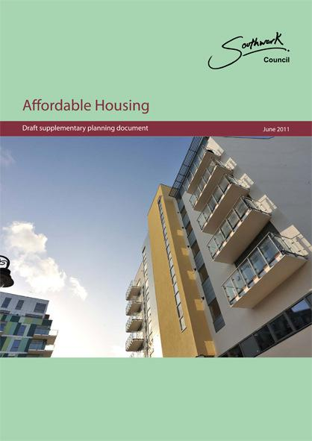

Generally, the housing mix (the proportion of social, intermediate and private housing) will vary depending on the location of the site within the borough. Reference should therefore be made to page 21 of Southwark's Draft Affordable Housing SPD.

On small sites the tenure and accommodation mix may be aggregated with that on other sites within the larger programme in order to provide appropriate housing on each site.

It should be noted that Secured by Design Accreditation is required for all developments.

Compliance with the Council’s requirements, as noted in the summary of relevant documents in section 3.2, and in the specific design requirements for Willow Walk, is assumed. Designs should therefore comply fully with all these standards.

Reporting on compliance where the standards are not easily achievable in a scheme will be in relation to Exception Reporting. However, it should not be assumed that any or all exceptions will be acceptable to the Council.

4.1 Site considerations

The layout and massing of a site in relation to its immediate context need to be considered from the outset to ensure that the new development is a good neighbour and minimises its impact on the adjacent properties.

Some of these requirements can be found in Southwark's Residential Design Standards:
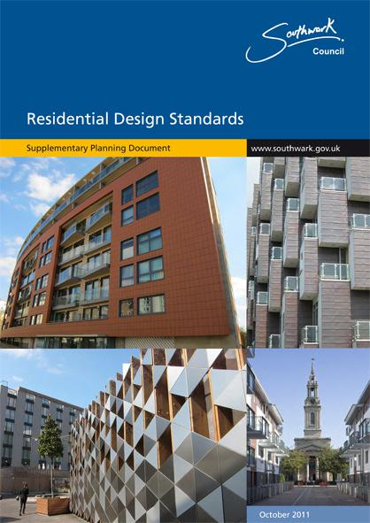

- Make the best use of the site to maximise its value, making the most of existing buildings, landscape or topography in the design;

- The development of a small site should be seen as an opportunity to harmonise the area around the site; considering the potential to remove obvious eyesores and adjacent spaces that do not work well;

- Taller buildings should be sited to the north of a development, with low-rise to at the south, to maximise daylight and sunlight penetration;

- New development should not cause excessive overshadowing of existing communal amenity space or neighbouring properties;

[insert name of project] Design Brief 10 [insert date]
- No new development should result in the complete loss of sunlight to an existing adjoining property;

- Where possible and appropriate, in larger sites, the development should consider the provision of good quality amenity spaces wherever possible, especially where existing facilities are being demolished in the new proposals.
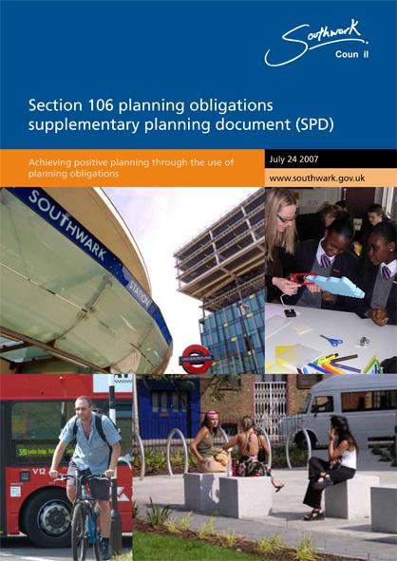

4.2 Infrastructure

The Community Infrastructure Levy will apply to any new private housing provided through the Council’s housing development programme. While this document is not yet adopted, the Council's S106 Planning obligations SPD 2007 is relevant.

4.3 Neighbourhood

All new developments should make a positive contribution to the local environment. A good guideline is whether the development looks as if it has grown there, rather than as if it has landed from some remote location. Instead, Southwark requires good neighbourhood architecture which is innately sensitive to its surroundings, and that means "landmark" or "iconic" buildings are rarely appropriate to this project.

Designers should be fully conversant with the neighbourhood of the site and its wider context, understanding the way it works, and appreciate the opportunities and challenges. Wherever possible the new development should be seen as an opportunity to knit the existing fabric, amenity and local community together where these have been fractured.

The key considerations for shaping good neighbourhoods are as follows:

- Ensure the development feels like a place with a distinctive character. This means site-specific proposals are required which are sensitive to the location and the opportunities offered;

- Integrate the scheme so that it is sympathetic to and works seamlessly with the existing streets, paths and surrounding development;
- Design the layout of the buildings and access to be simple for everyone to navigate;

- Design secure and permeable layouts with good street frontages where the new homes will overlook the streets and spaces so that there will be good natural security.

- Homes which have been designed with additional facilities or features, such as those for a wheelchair user or someone partially sighted, should not be distinguishable from other homes;

- Homes for some of the more vulnerable people in our society, such as wheelchair users or those with other disabilities, should not be grouped together or ghettoised in one particular area of a site, but spread throughout every development and located close to amenities and public transport.

4.4 Public realm

The public realm is a very important part of any scheme, as the quality of the environment is an indicator of the quality of the development. When the neighbourhood looks good, residents feel proud of it and look after their homes well.

The public realm includes not just the streets and pavements, but also the open space and local amenities which might exist already or might be provided in a scheme. It includes street furniture and signage, all of which contribute to the public realm.

- Ensure that public space is well designed with suitable management arrangements in place;

[insert name of project] Design Brief 11 [insert date]
- Consider the ecological value of any existing open space, trees and natural habitats and retain and enhance them wherever possible;

- Good quality, robust and endurable materials are required in order to maintain a high quality environment;

- Replacement of materials is also a key consideration: too often replacements are made with non-matching materials which become an eye-sore;

- Ensure that there is no space left over after planning (SLOAP); that all space has a designated purpose and ownership, so that maintenance responsibility is clear.
- Roads should always be designed to adoptable standards;

- Ensure that the building layout takes priority over the streets and car parking, so that the highways and streets do not dominate;
- Ensure that public spaces and pedestrian routes are overlooked and feel safe.

- There should be a clear and legible hierarchy of routes in the neighbourhood, and the new development will need to respond to that;

- The new buildings should have active frontages, with habitable rooms looking out over the street to ensure good overlooking and passive surveillance of the local environment. Windows and balconies facing the street will assist in meeting this requirement. Direct access from the street will reduce the amount of activity in communal areas.

Public amenity space

Public amenity space should be provided wherever possible, catering for all ages, including the young and the elderly for play and relaxation. Where possible, amenity spaces should be linked with other local amenity areas to enhance the benefit for the local neighbourhood. Good quality materials, robust and mature planting is required. Detailed landscape plans will be required as an integral part of the development proposals.

Considerations for the provision of public amenity space are as follows:

- Create attractive, engaging places for children and young people;

- Selection of the right location is crucial - not too close to homes to cause a noise nuisance, but close enough to be used well;
- Age and cultural background must be taken into consideration in the design;

- An inclusive design approach should be taken to ensure the space is useable by everyone;

- Consider ways of avoiding the creation of areas where anti-social behaviour can take place. This means amenity areas should be well-overlooked and on a well-used route. Avoid reliance on CCTV to monitor public areas.

Play space
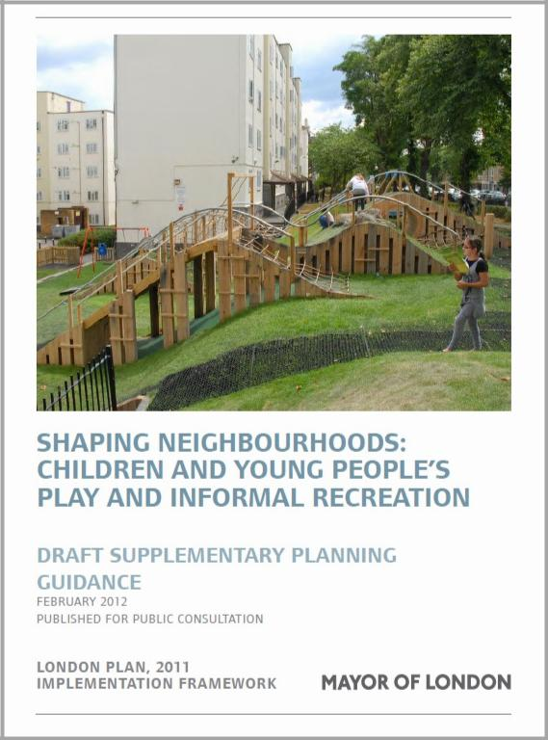

Play space is required in new developments which contain 10 or more child spaces. LBS Residential Design Standards provides details of the calculation of child bed spaces. Refer to page 26 for details.

Incidental imaginative play should be considered as this can be used by anyone. The provision of standardised play equipment is rarely conducive to imaginative play

Small children’s play areas should be integrated into all residential areas. The GLA's guidance on the recommended maximum distances for travel to play space should be adhered to, particularly when looking at an intervention in an existing estate where play
provision might be undersupplied or need improvement. Refer to Shaping Neighbourhoods:

Children and Young People's play and informal recreation: SPG 2012, page 50.

[insert name of project] Design Brief 12 [insert date]
4.5 The street

The layout and design of streets should promote active uses, where people feel safe and secure, and where they can meet and engage with neighbours. Large developments will provide an opportunity to link with and stitch together local roads and footpaths to enhance the area's connectivity and permeability. Smaller developments may only add buildings within an existing street pattern. However, the opportunity should be taken to examine the existing street layout and enhance it where possible.

Mews arrangements are not prohibited, but must be justified on a site-by-site basis.

The principles of street design are therefore as follows:

- All roads should be designed to be adoptable wherever possible;
- All streets should be designed as attractive public spaces;
- Streets should be designed to be pedestrian, cycle and vehicle friendly;
- Routes and open spaces are to be strongly linked to the surrounding area;

- Consider traffic calming measures where appropriate to avoid creating rat runs and to keep traffic speeds to safe limits;

- Entrances should face the street and be distributed regularly along a street to provide plenty of activity;

- Access must be provided for emergency, refuse collection, service and delivery vehicles in accordance with the requirements of the Manual for Streets;

- All street furniture, such as railings, refuse bins, signposts, seating, cycle racks, and so on, where installed should be well designed and of a consistent style;

- Avoid clutter on the streets, by removing unnecessary railings and amalgamate signage wherever possible to avoid multiple posts on the street.

Lighting

Light columns will need to conform to the Council’s requirements on adopted roads in terms of specification of fittings, spacing of columns and level of illumination.

In non-adopted areas, the choice of light fittings should:
- be appropriate to the design of the development;
- avoid light pollution;
- be attractive and robust;
- have affordable and easily available components for replacement in due course.

Additionally, whether light fittings are to the Council’s standard or not, care should be taken to ensure an even level of illumination which avoids creating pools of light as this can create difficulties for people with partial sight.

Parking
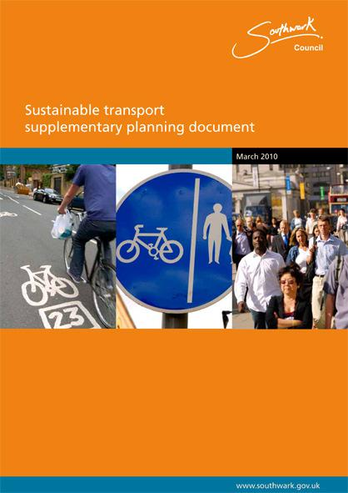

The car parking should be well integrated and situated so it supports the street scene and does not dominate it.

Southwark's Sustainable transport supplementary planning document (2010) is the essential design reference for parking standards. The borough's basic requirement is to minimise parking provision as far as possible, by the following means:

- Provide car parking spaces below ground or within buildings to reduce the impact on the street;

- Reduced car parking provision will be expected in areas of good public transport availability;

- Some areas will have zero parking requirement for all residents regardless of tenure (refer to the Core Strategy 2011 and Southwark Plan 2007 for details);

- Within Controlled Parking Zones, future residents would usually be exempted from obtaining parking permits;

[insert name of project] Design Brief 13 [insert date]
- Car clubs are encouraged throughout the borough;

- Dedicated parking for wheelchair users will be provided, with one dedicated space for every wheelchair-accessible home in the development. All parking for wheelchair-accessible homes is expected to be on site.

It should be noted that replacement car parking provision should be considered where garages are demolished to make way for a new development.

Where car parking is provided, the design must consider the following:

- Avoid having acres of hard surfaces by breaking up any run of parking spaces with planting and/or trees;
- Consider home zone treatment in areas of little traffic movement;

- Consider future-proofing the parking provision (anticipating the introduction of a CPZ in the future, for instance) and making allowances in the design and layout;

- Mobility scooters and electric cars should also be considered, with provision of electric charging points on street or on plot, as required.

Cycle parking

Bicycle and motor bike parking must be considered in all developments, alongside car parking. Safe and secure bicycle parking is essential for all developments as bicycle crime has the highest crime rate in the borough, with 2,200 thefts every year.

It is unreasonable to expect people to store bikes in their homes, and communal bike storage is prone to vandalism and theft, and therefore unlikely to be used. Safe, secure, well-lit covered bicycle storage should therefore be provided in all flatted developments, and an external store integrated with the design at the front of the home for dwellings accessed at street level.

4.6 Outside the home (including shared areas)

The design of the outside of the home has a direct impact on the quality of the immediate environment. This means that the design of refuse arrangements, meters, entrances, bike storage, etc, must be integral to the design of the buildings, and not an afterthought.

The key parameters of the design and quality of the new homes are as follows:

- All homes are designed to be tenure neutral, so that it is impossible to tell whether it is socially rented, shared ownership or privately owned;
- The design must be specific to the scheme;

- The buildings should exhibit architectural quality and look and feel welcoming and secure;

- The design incorporates attention to high quality detailing which looks as good close up as it does at a distance;

- Provision of some distinguishing features between houses on a street, such a different coloured front doors and different planting treatment, will make it easier for someone with cognitive disability or confusion to identify a particular dwelling;

- Direct access from the street to homes at ground level will reduce activity in communal areas.

[insert name of project] Design Brief 14 [insert date]
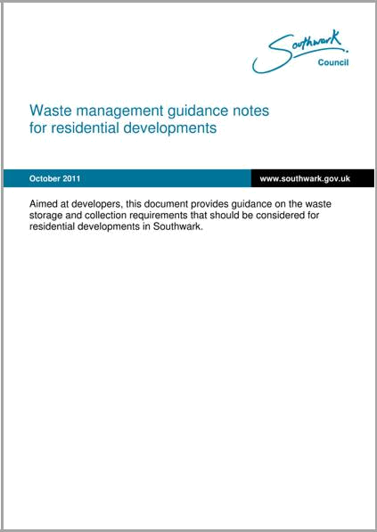
Refuse storage and disposal

Refuse collection and management systems are being developed and improved all the time, so provision in new developments must be future-proofed. Redundant dustbin stores can be seen in most streets in London, and are evidence of the changing nature of refuse storage.

Refer to Making Space for Waste, Designing Waste Management in New Developments - A Practical Guide for Developers and Local Authorities published by Adept for general guidance, and Southwark's Waste management guidance notes for residential developments for guidance specific to the borough.
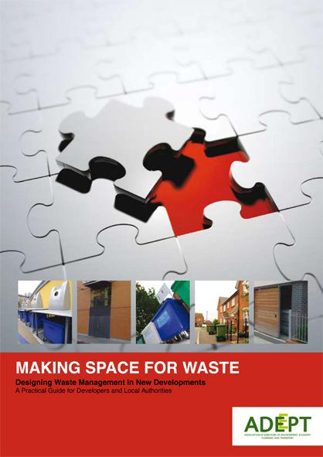

Recycling is an important aspect of Southwark's sustainable waste policies and provision should be made from the outset, both inside and outside dwellings. This will include both organic and inorganic waste.

Refuse storage areas, whether communal or individual, must be designed to be secure, with minimal visual impact and avoiding causing nuisance from smells and spills.

For all new developments, designers must consult with the current household waste contractor via arrangement by the client project officer before finalising development proposals.

Front gardens, boundary treatments and gates

It is important to have a distinction between the public domain of the street and the semi-public domain of the front of a dwelling in the form of a front garden area. This ensures that residents are clear about ownership and the extent of their responsibility in looking after the front of their property. Boundary walls, fences or railings and entrance gates are excellent indicators of ownership.

The principles of good design of the approach to the home and its boundaries for an inclusive environment are as follows:

- Make imaginative use of the land so that all dwellings make a positive contribution to the street scene;

- Ensure that the gate is easily distinguished from the railing, wall or fence so that people can find the entrance easily;

- Ensure that building numbers and/or names are large and clear enough to be read from the street and lit at night;

- Specify plants which are low growing or have foliage above head height to avoid creating places where someone can lurk;

- Ensure that plants do not spill over the footpath or through a railing in order to keep both private and public footpaths clear at all times;
- Lighting should be even across all surfaces, avoiding pooling and dark areas;

- Bins should be screened or enclosed, and service meters should be carefully integrated to minimise their visual impact.

Lifts

The question of installing lifts in a block of flats needs to be weighed carefully, balancing running costs, servicing requirements and benefits to the residents. A lift serving only a very few homes cannot be justified on a financial, maintenance or management basis. However, specialist housing may have a lift serving a lower height and fewer dwellings than general needs housing.

[insert name of project] Design Brief 15 [insert date]
If wheelchair-accessible homes are located on upper floors there should be two lifts in the common areas to ensure that one is working while the other is being maintained or repaired, one of which should be at least an 8-person lift.

Southwark maintains a huge number of lifts across the borough, and therefore has developed relationships and contracts with manufacturers and suppliers in order to provide the best and most reliable service to residents. Designers should therefore refer to the Council’s lift maintenance team for the design and choice of new lifts.

Shared circulation areas

The approach to a flat, through shared common areas should be regarded as an extension of the home itself, and therefore should be designed accordingly. Long, windowless, narrow corridors are not acceptable, nor are runs of double-banked flats, entered from both sides of a central corridor.

Access cores and corridors should always be designed so that they benefit from natural ventilation and daylight. This approach ensures people are able to orientate themselves within the building by looking out of the window, and it reduces running costs and energy consumption. A deck access system can be successful if it serves a small number of dwellings. Alternatively a cluster core approach may be used to maximise the number of homes off a circulation area, as long as dual aspect is maintained.

A simple circulation system which avoids the inclusion of unnecessary lobbies and fire doors will make a block easy to navigate and easily accessible by all.

Limiting the number of homes accessed from any entrance to between 8 and 20 will encourage ownership and neighbourliness, as people will get to know others who live in the same block. Larger blocks with few entrances tend to suffer from vandalism and graffiti from the lack of ownership, unless controlled by a concierge system.

Access control requirements should be designed in response to Secured by Design guidance. Audio-visual control is preferred for all flats as this addresses requirements of those with hearing difficulties as well as contributing to the overall safety of the block.

Lighting

Lighting should be provided in communal areas, such as the entrance area, corridors and lobbies. It should be consistent throughout these areas, without pooling and dark areas. In order to keep costs and energy consumption as low as possible, a low level of energy efficient lighting could be permanent, boosted with higher lighting levels controlled by timer switches.

Private amenity space

Southwark's Residential Design Standards SPD 2011 identifies the outdoor amenity space standards for houses and flats (Sections 3.1 and 3.2).

There should be adequate amenity space for all new dwellings, ideally located at the rear of dwellings, not overlooked from public areas and not interfering with
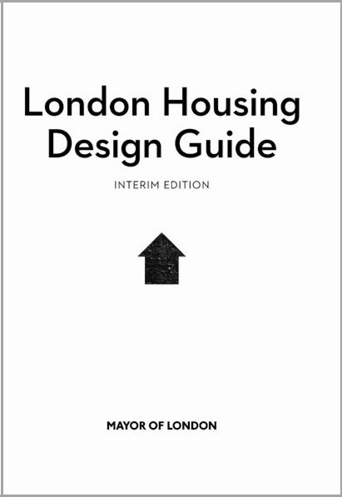

the privacy and amenity of neighbours. North-facing gardens should be avoided.

Communal gardens should be designed for all residents, with dwellings overlooking the space to provide passive surveillance. All homes in a flatted block should have access to communal garden space, which is ideally located at the rear of the property, as well as a private balcony or winter garden which is useable by all the family. Level access is required to this space by the Lifetime Homes standard. The GLA in the Interim London Housing Design Guide recommends a minimum depth of 1500mm of private amenity space but achieving this standard will be reviewed as a site specific requirement.

[insert name of project] Design Brief 16 [insert date]

4.7 Dwelling space standards

Southwark's Core Strategy highlights the importance of all new developments being of high quality with good living conditions. Minimum floor area standards (pages 13 and 14 of the Residential Design Standards, 2011) go some way to ensuring good living standards by requiring sufficient space for living. However, it is important to consider the shape of the dwelling to ensure that space can be used well, easily and flexibly. Irregular shaped rooms and narrow spaces can be difficult to use and furnish, even if they are of the correct overall size.

Across a scheme, the mix of dwelling types should cater for the full range of household sizes. Southwark will assess this using the average dwelling sizes set out in the table on page 13. The requirement is for the average size of homes in each bracket to be the same as or higher than the average. This is to ensure that there are sufficient of the larger homes within each typology.

Minimum width recommendations are as follows:

Room | Minimum | Application
 | width (m)
Main sitting area | 2.8 | 2 and 3 person dwellings
 | 3.2 | 4 person or larger homes
Double bedrooms | 2.75 | -
Private open space | 1.5 | -


Storage is a perennial problem in homes, and increasingly for households over the last few decades as personal possessions increase. The emphasis is therefore on good rather than adequate storage provision. The requirements stated here, extrapolated from the Interim London Housing Design Guide should be regarded as desirable.

Number of | Area of storage
people | m3
1p | 3
2p | 3
3p | 4
4p | 5
5p | 6
6p | 7
7p | 8


A reasonable proportion of the storage identified above should be provided in full height storage cupboards, with doors at full height to provide good access to all the storage space available. The majority of the general storage should be accessed from a circulation area and not from a room unless the useable space is not compromised by the need for access to the storage.

Kitchen layouts should be designed with a good range of worktop, base units and wall cupboards, appropriate for the size of the household. Cupboards for bulk purchase items, such as rice and cooking oil should also be considered. Flexibility is required for households to insert additional appliances, such as a tall fridge.

In addition to general storage, there should be adequate space for refuse storage internally and externally, including recycling provision.

In flats, there should be additional "dirty" storage for every household, located close to the dwelling and lockable. This should be big enough for a bicycle or a buggy, and full height so

[insert name of project] Design Brief 17 [insert date]
that the storage space is maximised. Where homes have gardens, a shed should be provided.

4.8 Inside the home

Our new homes should be places that our residents are proud and happy to live in. The layout needs to be simple and logical, easy to understand from the outset, with plenty of natural light and some sunlight penetration for physical well-being. There should be a convenient relationship between rooms.

- All homes should be designed with dual aspect for cross ventilation and good light penetration;

- If this is not possible, designers will have to prove that single aspect still achieves the comfort, views, daylight and ventilation of a dual aspect home;

- At least one wall with a window should face within 90º of south, and the main solar collecting glazing should face within 30º of south;
- Entrance into habitable rooms should be via a lobby or circulation area;

- Where possible living rooms should face the southern or western parts of the sky and kitchens face towards the north-east;
- Access to rear gardens should be from the kitchen or dining room or circulation area
- A balanced mix of single and double bedrooms in family homes is required;

- Wherever possible, space for washing machines and tumble dryers should be separated from the kitchen and located in a cupboard or in a dedicated utility space in larger homes. This keeps noisy activities away from areas which may be used for entertaining or working;

- Minimise noise nuisance by stacking rooms with the same function in blocks of flats;

- Avoid noise nuisance from communal areas and lifts ideally by designing a buffer zone between them and all habitable rooms. This could be an internal corridor or bathroom or storage;

- Floor to ceiling heights are a minimum of 2.4m between finished floor and finished ceiling;

- Sunlight and daylight requirements can be found on page 17 of Southwark’s Residential Design Standards 2011;

- Ideally there should be natural daylight and ventilation to bathrooms and kitchens as well as to internal circulation areas.

Southwark's vision of an inclusive environment will be addressed by the provision of homes which are broadly accessible, and adaptable to the changing needs of the household. In addition, there will be some fully-wheelchair-accessible homes. The detailed requirements can be found below:

Lifetime Homes
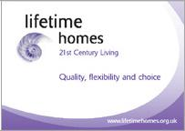

All homes will be designed to comply with the Lifetime Homes standard 2010 regardless of tenure, except for those which will be designed to full wheelchair-accessibility standard.

The Lifetime Homes standard is familiar to most designers, so there is no requirement to state the parameters of the standard here. However, there are a

small number of items which are worth emphasising here as they cause problems if not understood or incorporated from the outset. These are:

- Through-floor lift either not indicated on drawings, or shown incorrectly. It should be noted that:
o access is on a short side

[insert name of project] Design Brief 18 [insert date]
  - a 1500mm turning circle is required in front of the lift
  - a 300mm nib is required beside the lift car door on both floors

  - the lifting rail should be placed against a partition (unless it is protected at the rear)
  - the through-floor lift can only travel two storeys
- Bed space not shown at entrance level
- Bathroom not located at entrance or first floor level
- 300mm nib not maintained on the side of the leading edge of the door at entry level.
- Clear door opening width not possible because door does not open more than 90º
- Corridor width inadequate for width of door provided when turning 90^{o.} Example - 1050mm corridor and less than 775mm clear.

Consideration should also be given to designing for visitors who have disabilities. Refer to Inclusive design below.

Wheelchair-accessible homes

Fully wheelchair-accessible homes will be provided in all developments of 10 homes or more. There will be at least 10% provision of wheelchair accessible homes (in terms of habitable rooms) in addition to the remainder of the affordable housing development being designed to meet the Lifetime Homes standard. However, there may be site-specific requirements above this minimum standard for smaller developments, dependent on overall provision in the locality.

Wheelchair-accessible homes are to be designed fully in accordance with the South East London Housing Partnership’s Wheelchair Homes design guidelines.
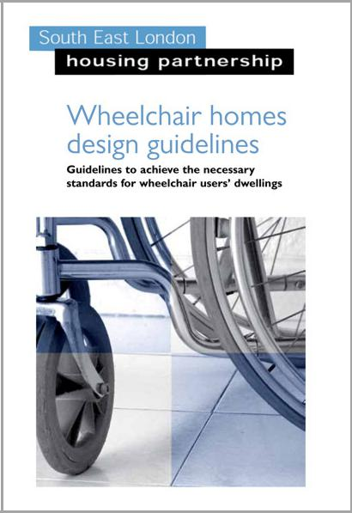

- wheelchair-accessible home is one which is designed to comply fully with the required standard. It should be fully fitted out with specialist kitchen and bathroom fittings and grab rails.

- summary of broad requirements is as follows:

  - The area of typical footprints for different sizes of wheelchair-accessible homes can be found on page 3 of the SE London Housing Partnership's Wheelchair homes design guidelines 2011. A range of wheelchair-accessible homes is to be provided, not just 2-bed flats. This means that some 1-bed flats are acceptable, as well as family homes of different sizes. Some wheelchair-users prefer accommodation on the ground floor while others feel vulnerable in this location and

prefer an upper floor flat, so both should be provided in any sizeable development

  - Stacking of wheelchair-accessible accommodation is acceptable as long as two lifts are provided in a block;

  - Kitchens and dining spaces are ideally located in the same room to avoid problems of opening connecting doors while carrying food and drinks;
  - Kitchens are preferred in an L or U-shaped with circulation outside this area;
  - Ideally no wheelchair-accessible home shall be more than two storeys high.

Inclusive design
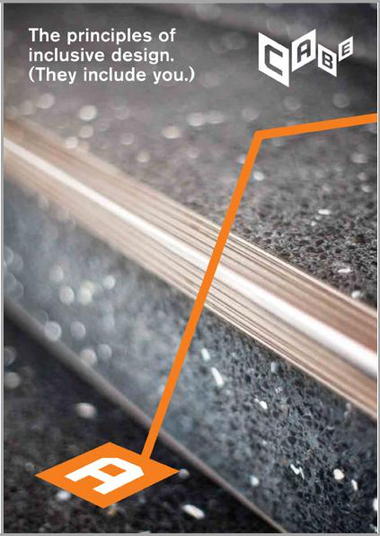

It is essential that Southwark’s new housing is considered in terms of the widest inclusivity, and not just in relation to the Lifetime Homes standard or wheelchair-accessible homes. Other considerations relate to people with disabilities who do not necessarily use a wheelchair, such as those with vision or hearing loss, and those with learning or mental disabilities.

The principles of inclusive design (Design Council/CABE) call for places to be:

- Inclusive - so everyone can use them safely, easily and with dignity;

[insert name of project] Design Brief 19 [insert date]
- Welcoming - with no barriers that might exclude some people;
- Convenient - so everyone can use them without too much effort or separation;

- Accommodating - for all people, regardless of their age, size, gender, mobility, ability, disability, ethnicity or circumstances;
- Responsive - taking account of what people say they need and want;
- Flexible - so different people can use them in different ways;

- Realistic - offering more than one solution to help balance everyone’s needs and recognising that one solution may not work for all.

Flexible and adaptable accommodation will provide for a good response to the changing requirements of a family. A few considerations are as follows:

- Twin rooms designed with two windows for later subdivision into two single bedrooms if required as children get older;

- Open plan homes are not desirable except for one-bedroom accommodation; However, a design with an alcove or L-shaped to accommodate the kitchen which is separated visually may be acceptable for small family homes;

- A range of family accommodation should be provided, some with a kitchen-dining room and separate living space which provides two socialising spaces in the home, and others with a separate kitchen with a living-dining space. Ideally the design should allow for the different functions to be separated if required;

- Rooms should be large enough and of a regular shape to enable alternative furniture arrangements.

4.9 Sustainable design
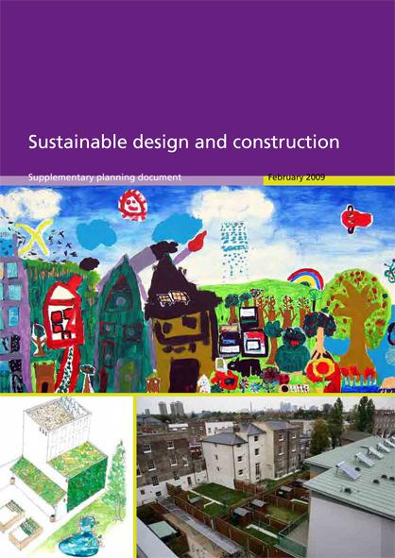

Southwark aims to demonstrate exceptional environmental performance of all new developments under the 1,000 Council Homes programme. This will include designing and energy-efficient development using long-lasting building materials and reducing water consumption.

Consideration of energy issues needs to happen right at the start of the design process. All development will need to be designed in accordance with the energy hierarchy. This approach can be summarised as follows:

- Be lean: use less energy
- Be clean: supply energy efficiently

- Be green: use renewable energy

This three-step process is described in more detail below:

- First, use good design to minimise the development’s energy needs

Before any mechanical systems are considered the development should be made as energy efficient as possible by maximising the use of sunlight, thermal mass and the site’s microclimate to provide natural lighting, heating and cooling of buildings.

Passive measures in the design may include the following:
- Thermal mass using solid construction rather than timber frame
- Orientation of homes for passive solar gain
- Recycled rainwater for WC flushing
- Passive stack ventilation
- Dual aspect design for cross ventilation
- Low energy lighting systems
- Sustainable urban drainage system (SUDS).

- Green and brown roofs should be considered where appropriate for biodiversity and reduction of storm water.

[insert name of project] Design Brief 20 [insert date]
- Then, make the most use of efficient energy, heating and cooling systems

If mechanical heating, cooling and ventilation are needed, they should be as efficient as possible. The priority is to use local (called “decentralised”) energy sources, in particular combined heat and power (CHP) or district heating systems. However, in smaller developments, a maximum of 25 new homes might be developed without a central plant system, and it should be noted that this is more easily applicable to flats than houses.

Regardless of size, residential developments should connect to area-wide CHP, CCHP or district systems where these exist and have the capacity, life and reliability required, or are being developed, within the following distances of the site
- Λεσσ τηαν 20 δωελλινγσ: 50 μετρεσ
• | 20-30 dwellings: | 100 metres
• | 31-40 dwellings: | 150 metres
• | Over 40 dwellings: | 200 metres

- Then, use renewable sources of energy

There may still be demand for energy (for appliances, lighting and machinery). As much as possible this remaining energy demand should be met through zero and low carbon energy sources, such as solar power, wind power, bio-fuel and geothermal energy.

Key considerations include:
- Simplicity of use and ease of understanding of the systems and control by residents;
- Consideration of whole life-cycle costs;

- Adoption of space efficiency principles throughout to promote the flexible use and allocation of facilities;

- Sustainable sourcing, including locally produced materials and, where possible, timber from renewable resources. Selection of contractors should take into account their environmental policies;

- Incorporation of environmentally benign heating and lighting provision;

- Provision of facilities and equipment to encourage the re-use and recycling of materials including, where practicable, water recycling;
- Ensuring all projects achieve Code for Sustainable Homes level 4* or higher;
- Measures to prevent wasted energy use both within the units and in common areas.

All projects will need to be accompanied by a Sustainability Assessment at planning submission stage. Reference should therefore be made to Southwark's Sustainability Assessments SPD 2009 for the format and content of the assessment.
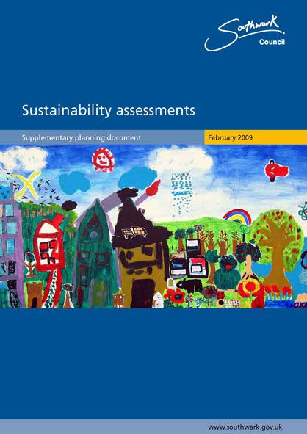

[insert name of project] Design Brief 21 [insert date]
5.0 Engagement with stakeholders

5.1 Purpose of consultation

Development of a hitherto unoccupied part of an estate, or an area which has previous uses is a controversial matter for the local residents, so the design work and consultation need to be considered in tandem.

Local people know and understand their own area better than anyone, and can make valuable contributions to the design process and the eventual proposals. Therefore, in all new developments, LB Southwark requires a high level of engagement with the local community from the outset to identify and meet aspirations where possible and to ensure broad support for the final proposals.

The direct purpose of stakeholder engagement with any redevelopment proposals is likely to be in order to:

- develop a masterplan or layout which meets their requirements
- design homes which meet their housing need
- design additional homes which can be marketed for private sale or shared ownership
- report a range of community engagement around decision-making
- demonstrate good stakeholder engagement
- obtain majority support for the design proposals

- draw up a detailed Statement of Community Engagement to accompany a planning submission in due course.

When carrying out consultation, it is important for the longevity of a scheme to be borne in mind, as proposals which suit the current residents may be superseded, for instance, as children grow up.

5.2 Mapping the stakeholders:

A major task is to identify the stakeholders in a particular location, and the list can be compiled by speaking to local people about the activities and groups which already exist in the area. Ensuring inclusion is very important, and this means considering the different age and cultural groups in the vicinity of the site.

Local people and groups:
- Local residents
- Future residents
- Local community groups
- Local businesses
- Voluntary organisations

Local politicians:
- Local councillors – consulted by Council officers
- Local MP – consulted by Council officers

Local advisors
- Crime Prevention Design Advisor (Secured by Design)

Statutory consultees at Southwark Council:
- Planning department
- Housing department (maintenance and management)
- Transport and streets department
- Regeneration department (as necessary)
- Environment department (including recycling / waste management and trees)
- Leisure department

[insert name of project] Design Brief 22 [insert date]
Other interested and affected groups
- Private landlords
- Housing Associations
- Developers
- Estate Agents

5.3 Forms of consultation and inclusion

Community engagement can include a variety of approaches, such as one-way communication or information delivery, consultation, involvement and collaboration in decision-making, and empowered action in informal groups or formal partnerships.

An open, inclusive approach to projects is essential, ensuring that individuals and groups with different experiences and expectations can positively influence the design of their future community. This can involve working with residents to form design review groups, and working with others to develop residents' design capacity to make decisions, as well as the more general open days and site visits.

A range of different consultation techniques should be used to encourage people to participate in a way which suits their needs. A few examples are:

- Open days and exhibitions/displays
- Walking audits
- Drop-in sessions at key locations and times
- Out-reach meetings
- Simple estate models or computer generated images
- Visits to other schemes
- Displays of other schemes
- Displays of proposals at a venue on site or nearby
- Block meetings, and other meetings for particular groups of residents
- Questionnaires and feedback forms
- Newsletters and fliers delivered to residents’ homes
- One-to-one and small group meetings when appropriate

The consultation process needs to include those sections of the community which are unable or unwilling to take part in conventional consultation events. It may be necessary to develop such methods as follows:

Method | Description
Stakeholder | The stakeholder interview is very useful technique for use with politicians and
interviews | statutory authorities, as well as leaders of community organizations. The use
 | of these interviews early in the development process can provide a raft of
 | initial information which will form the foundation of understanding of the
 | issues, challenges and opportunities of a community.
Home visits | Some residents require home visits in order to fully understand and consider
 | the issues raised during the consultation process. Such residents may have
 | disabilities, be unable to attend meetings, need an interpreter, suffer from
 | mental health problems, or simply be very concerned about the proposal, but
 | uncomfortable about voicing them in public.
Community | The involvement of the local community can assure the longevity and
website | usefulness of a community website, ensuring that the content is relevant,
 | immediate and addresses residents’ needs.
Outreach | It is essential to meet with informal groups, for their input is essential for the
work | success of any future development. It is often more effective to go and find
 | people where they feel comfortable, rather than bring them into what might
 | be an intimidating environment. This may include meeting young people who
 | are ‘hanging about’, parents through the school, older people in shopping
 | centres and luncheon clubs, women at women-only events, language groups
 | in cafes, etc.

[insert name of project] Design Brief 23 [insert date]
Method | Description
Consultation | The training and employment of local residents as consultation assistants can
assistants | provide a close link with the community.
Engaging | Translations of all written material and interpreters should be provided in local
with BAME | languages where necessary. Involve of any BAME (Black, Asian and
residents | Minority Ethnic) groups in the area can be sought through places of worship
 | or targeted projects.
Locations | The use of local facilities for consultation is essential to make attendance as
and times | easy as possible to those who may not be able or willing to travel far. The
 | timing of meetings is also a significant feature of the success of consultation,
 | and it may be necessary to hold a sequence of meetings at different times, in
 | order to be responsive to residents’ lives and commitments.

This broad approach encourages participation and developing capacity, enables local residents to take ‘ownership’ of the redevelopment of their neighbourhood. This lies at the heart of building and maintaining successful, thriving and inclusive communities, but also addresses the long-term sustainability of the new development or regeneration.

5.4 Use of consultation in decision-making

To be effective the consultation process needs to be open, inclusive, understandable and responsive to opinions, demonstrating how consultation has affected design decision-making.

The following list of themes for consultation is not exhaustive, but indicates the likely areas of interest of local people in any changes in their neighbourhood:

- Routes, streets and pedestrian access
- Parking provision - existing and proposed
- Amenity space - private and public
- Size of new homes and options for layouts
- Tenants' choice of fittings
- Height of new homes and overshadowing
- Numbers of new homes
- The impact of extra people/children on the neighbourhood
- Security and safety
- Construction and disruption

It will be important to record feedback on all the themes discussed in order to inform the design process, especially where the design has changed to accommodate views and opinions of stakeholders.

It is also essential to hold a consultation event for the wider community shortly before a planning application is submitted, to ensure that the views of stakeholders are heard and incorporated as far as possible in the final submission. This event and its outcomes should be recorded in the Statement of Community Engagement which is submitted with the planning application.

[insert name of project] Design Brief 24 [insert date]
6.0 Site-specific design principles for Willow Walk

6.1 Southwark's site-specific objectives

6.2 Success criteria

6.3 Context

6.4 Site description

6.5 Key issues for the site

Density:

Site plan:

Amenity space:

Streetscape:

Housing mix:

Life:

6.6 Key issues for the housing development

6.7 Design requirements

6.8 Consultation

6.9 Information about the existing site and buildings

Statutory applications

Asbestos

Contamination

Building Engineering Services

Fire safety

[insert name of project] Design Brief 25 [insert date]
7.0 Appendices

7.1 References

- Affordable Housing SPD 2008
- Affordable Housing SPD, 2011 (Draft)
- Building for Life (Design Council CABE)
- Building Regulations and British Standards

- Code for Sustainable Homes, BRE
- Core Strategy, Southwark, 2011
- Design and Access Statement SPD 2007
- Draft Community Infrastructure Levy charging schedule 2012
- Equality Act 2010

- Guide to Housing Design and Specification, Southwark 2003
- Interim London Housing Design Guide 2010
- Lifetime Homes Standard 2010, Habinteg Housing Association
- London Housing Supplementary Planning Guidance (Draft)

- Making Space for Waste, Designing Waste Management in New Developments - A Practical Guide for Developers and Local Authorities, Adept
- The Principles of Inclusive Design, CABE 2006
- Manual for Streets, Department of Transport
- Residential Design Standards SPD, Southwark 2011
- Safer Places - the planning system and crime prevention, ODPM 2004
- Saved Southwark Plan, 2007
- Section 106 Planning obligations SPD, July 2007
- Secured by Design
- Shaping neighbourhoods: Children and Young People's play and informal
recreation: Draft SPG 2012, GLA

- South East London Housing Partnership Wheelchair Homes Design Guidelines 2007

- Housing Strategy 2009 - 2016 - an overarching document setting out the strategic direction of housing for the next four years. Southwark
- Sustainable Design and Construction, SPD, Southwark 2009
- Sustainable Transport SPD 2010
- Sustainability Assessment SPD 2009
- Waste management guidance notes for residential developments 2011

7.2 Project directory

See next page for contact details

For site specific issues and contact details on planning policy, housing management and housing maintenance, please contact the Project Manager

[insert name of project] Design Brief 26 [insert date]

[insert name of project] Design Brief 27 [insert date]

PROJECT DIRECTORY - [insert name of project] Development

 |  |  |  |  |  |  |  |  |  |  |  |  |  |  |  |  |  |  |  |  |  |  |  | Rev 0
 |  | Company/ |  |  |  | First Name: |  |  | Last |  |  | Title: |  |  | E-mail Address: |  |  | Office Telephone: |  |  | Office Fax: |  |  | Mobile Phone:
 |  | Address: |  |  |  | First Name: |  |  | Name: |  |  | Title: |  |  | E-mail Address: |  |  | Office Telephone: |  |  | Office Fax: |  |  | Mobile Phone:

[insert name of project] Design Brief 28 [insert date]

