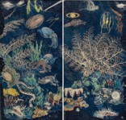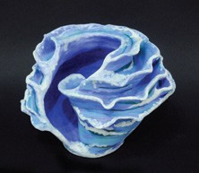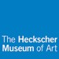

***Long Island’s Best***

**Artist Statement Example**

**Julia Candon**

*Evolve*

Stoneware

**Long Beach High School**

Grade: 11

Art Teacher: AnnMarie Pulice

While looking at the artwork in The Heckscher Museum, I found *The Night Sea* by Ann McCoy to be the most captivating. Her

colored lithograph intrigued me because it captured the colors and atmosphere of the underwater world. Growing up near the ocean, nature plays a role in my everyday life. I was able to create something abstract, yet maintain the idea of nature as well. As a ceramics student, I decided to use clay as my medium to create an abstract form derived from a shell. Like Ann McCoy, I was inspired by the ocean, its natural occurrences, and the beauty of sea life. The spiraling in the form of my sculpture is reminiscent of the constant movement of the waves and the design elements that exist in nature.

**Inspiration artwork:**

Ann McCoy, *The Night Sea*, 1978, Lithograph on Arches paper in two pieces, hand-colored with colored pencil.

Gift of Sheila and Martin Terens.

**From the exhibition:**

*Graphic Appeal: Modern Prints from the Collection*

2 Prime Avenue

Huntington, NY 11743

631.351.3250

Heckscher.org Education Department

631.351.3214

[Education@heckscher.org](mailto:Education@heckscher.org)

**For more information on *Long Island’s Best***

**visit** [**Heckscher.org/education_libest**](http://www.heckscher.org/education_libest)

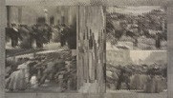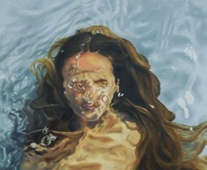

***Long Island’s Best***

**Artist Statement Example**

**Mieke McLaughlin**

*Flooded*

Oil on canvas **Manhasset High School** Grade: 11

Art Teacher: Michael Sansone

In *City Life*, John Digby created motion and activity through his use of collage. He took static drawings of a generic city from the

Victorian era, enlivened them by cutting them into vertical strips, and collaged them into an overlapping composition. Digby’s technique has the effect of distorting the images and creating energetic movement to capture the hustle and bustle of city life. Aside from the fact that Digby’s technique looks like ripples in water, I was intrigued by the energy that comes not from the city itself, but from Digby’s application and placement of his collage materials. As a painter, I was inspired by Digby’s work to explore the rippling movement and distortions created by overlapping forms, using oils as my medium. My decision to do a self-portrait with emotional ambiguity was intentional. As in *City Life*, the subject of my painting is not the figure portrayed, but the distortion created by overlapping forms and the dynamic movement of the water over the figure.

**Inspiration artwork:**

John Digby, *City Life*, 1994, Collage on paper. Anonymous gift.

**From the exhibition:**

*Street Life: Private Moments/Public Record*

2 Prime Avenue

Huntington, NY 11743

631.351.3250

Heckscher.org Education Department

631.351.3214

[Education@heckscher.org](mailto:Education@heckscher.org)

**For more information on *Long Island’s Best***

**visit** [**Heckscher.org/education_libest**](http://www.heckscher.org/education_libest)

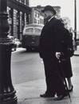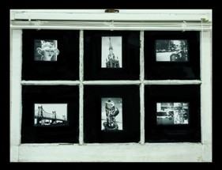

***Long Island’s Best***

**Artist Statement Example**

**Jake Bruno**

*6 Moments Observed from a Manhattan Window*

Mixed media **Connetquot High School** Grade: 12

Art Teacher: John Hargrave

I

was

interested

in

the

candid

photograph found in the exhibition

*Street Life: Private Moments/Public*

*Record*. Candid photography is both intrusive and intimate; it provokes deep connections to otherwise pedestrian subjects. Being recorded is the only thing that elevates these banal objects to the status of art. With this newfound regard for the ordinary, I was inspired to create my piece, which is composed of six analog photographs taken on the streets of New York City set into the glass panes of a deteriorating window; it gives six unique vignettes into the lives of both animate and inanimate objects. The window functions as both the lens of the camera and a slide projector; it frames what occurs and then displays it so it can be observed. These moments will last far longer than the window that captured them, everlasting in the mind’s eye.

**Inspiration artwork:**

N. Jay Jaffee, *Man in Bowler*, 1953 (printed 1980), Gelatin silver print. Gift of Paula W. Hackeling. **From the exhibition:**

*Street Life: Private Moments/Public Record*

2 Prime Avenue

Huntington, NY 11743

631.351.3250

Heckscher.org Education Department

631.351.3214

[Education@heckscher.org](mailto:Education@heckscher.org)

**For more information on *Long Island’s Best***

**visit** [**Heckscher.org/education_libest**](http://www.heckscher.org/education_libest)

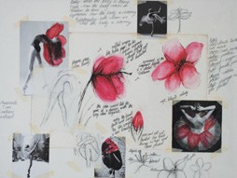

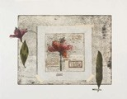

***Long Island’s Best***

**Artist Statement Example**

**Regina Ambrosio**

*Flora of the Feminine Figure*

Mixed media

**Deer Park High School**

Grade: 12

Art Teacher: Derek Mainhart

My

work

is

a

manifestation of

the

parallels between the female human

body and nature. By placing flower

and body alongside one another in my piece, I intend

for the viewer to see

the science of nature and, subsequently, embrace a seamless flow between botanical structure and the female form. Michelle Stuart's *Voyage to the South*

*Seas: Flora Australis* is as artistic as it is scientific. Inspired by this feat, *Flora of the Feminine F*igur*e* depicts the visual similarities between the physique of a dancer and the structure of a flower in a collage display that connects them aesthetically. I've paired the natural beauty of our environment with the beauty and elegance of a ballerina to represent a visual relationship between the two. Through the use of poetry and descriptive imagery, the text in my work furthers the visual relationship.

**Inspiration artwork:**

Michelle Stuart, *Voyage to the South Seas: Flora Australis*, 1989, Etching with aquatint and chine collé on paper. Gift of the American Academy of Arts and Letters, New York; Hassam, Speicher, Betts and Symons Funds.

**From the exhibition:**

*You Go Girl! Celebrating Women Artists*

2 Prime Avenue

Huntington, NY 11743

631.351.3250

Heckscher.org Education Department

631.351.3214

[Education@heckscher.org](mailto:Education@heckscher.org)

**For more information on *Long Island’s Best***

**visit** [**Heckscher.org/education_libest**](http://www.heckscher.org/education_libest)