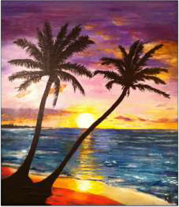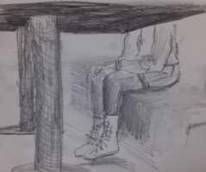

**Writing an artist statement**

**Talk about:**

**Why do you make your artwork?**

* **What inspires and motivates you?**

**How do you make your artwork?**

* **What tools, materials, and techniques did you use?**

**What does your art means to you?**

•

**Use “I” statements. Connect the artwork to it’s meaning and your inspiration.**

Example Artist Statements

ARTIST STATEMENT

I make art from unique vantage points. I like to look at the world from my own eyes and bring a new outlook to viewers. I am mostly inspired by line, therefore graphite pencil and ball-point pen are my favorite art-making tools. I was inspired to do this piece after dropping a fork on the floor of our local café. I saw my sister from a whole new view. These everyday viewings are what create my art.

I call this art “Sun set on the Gulf.” After spending a family vacation in Mexico, I came home with many beautiful photos. I decided to turn one photo into a painting. I wanted to paint the glowing sun and silhouette palm trees I remember from the trip. I used acrylic paint on canvas to make this art. I am inspired to make art that hold strong memories.

**Artist Statement Questions**

**These questions are a jumping off point. Answer as many questions as you would like. You may expand on questions.**

•

•

•

•

•

•

•

•

Describe your artwork in 3 sentences. What would you name this art and why? How did you create the art?

What did you learn while creating the art? What were your feelings while creating the art? What inspired you to create this art?

What is your favorite part?

What surprised you while creating this art?

**Statements must be totally grammar and error free!**