**Sample Artist Statements**

The attached artist statements represent well-written statements from Native artists who participated in a juried art exhibition co-sponsored by the Longhouse.

The statements are short, creative and touch on many of the elements important to a variety of Native artists in trying to describe their art works.

**All rights reserved by the artists for images and statements**

The following artists are represented:

**Jeffery Veregge, Port Gamble S’Klallam**

* Alien
* Cybertron Copper

**Misty Kalama-Archer, Puyallup**

* Salish Woman of Wealth High Class Robe
* Chief’s Lightning Regalia

**Heather Johnson-Jock, Jamestown S’Klallam**

* Gifts of the Forest

**Kelli Palmer, Confederated Tribes of Warm Springs**

* Wasco Turtle Cornhusk

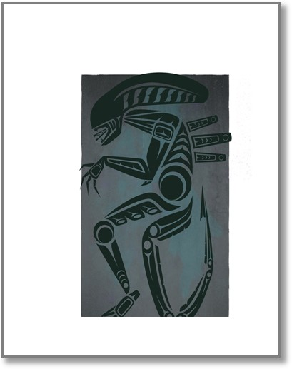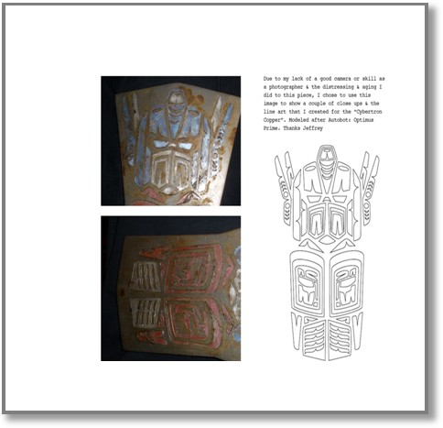

**Sample Artist Statements**

**Alien**

In 1979 Director Ridley Scott introduced true horror in outer space. His film “Alien” and the creature design based of of H.R Gigers illustrations gave us the Xenomorph, a monster that still to this day can still make me jump. I decided to create an image that was inspired by the films, because even though the being is intimidating, it is also sleek and has forms that are very pleasing to the eye. In our Native culture we see many animals that are known to hunt and kill man, yet when portrayed in art are quite beautiful. It was my goal to

take this fictional creature of death and attempt to give it both beauty and at the same time, an underling menace in my artistic interpretation of the Xenomorph.

**Title: Cybertron Copper**

“Autobots Roll Out” every boy that grew up in the 80’s knows this phrase and although it has since been solidified in the minds of the mainstream, I have always been a fan of the “Transformers”. In my first

attempt to take my style and give it dimension I choose the heroic Autobot Leader and my personal favorite Optimus Prime as my subject. I also wanted to make sure that both the design & the execution would work in harmony. As when we see Form-line transfer to carvings, the wood simply enhances the art and never distracts but adds to the overall feeling. I want my art to do the same; I realize as my subject material is from the Geek world that I need to both try and honor the traditional and yet be relevant to what I do. The Potlatch Copper was my inspiration for shape and what I thought

could inspire as far a look goes for: a Metal look. I also wanted to add something I love about the old art, that we see in museums. The wear, aging and distress.

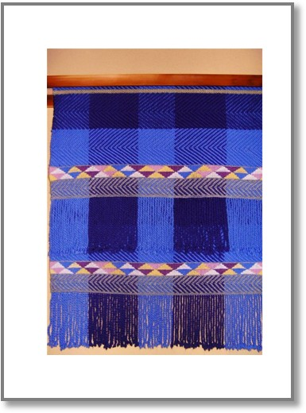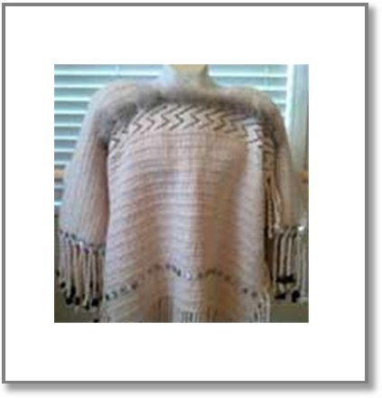

Borrowing form George Lucas & the Transformer films, I wanted that “used future” feeling. The end result: Cybertron Copper

‘**Salish Woman of Wealth’ High Class Robe**

Dream memory of the old high class robes of my ancestors influenced the creation of this traditional Salish woven art piece named ‘Salish Woman of Wealth’. Some place between sleeping and waking, her vision came to me and I created her. She dazzled me with interwoven dancing colors and geometric designs. In my Salish culture, people of high class including chiefs and leaders wear robes woven with wool that symbolize great wealth. ‘Salish Woman of Wealth’ robe is high class and wants to be seen, heard, worn, and acknowledged.

**Chief’s Lightning’ Regalia**

The teachings I received from Subiyay (Bruce Miller) influenced the creation of this Salish woven art piece named ‘Chief’s Lightning’ Regalia. I began to question deeply: What does it mean to carry chiefly attributes? What makes a good leader? As I wove this regalia, I meditated on Subiyay’s teachings about how a chief is someone who takes care of his family and the people in a humble way with compassion, and leads by example. ‘Chief’s Lightning’ Regalia

personifies these teachings. For, it is the chiefs and high class people who wear regalia woven of wool during special occasions such as ceremonies and potlatches!

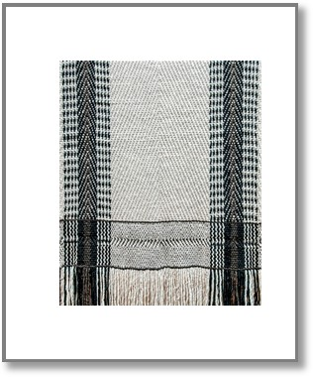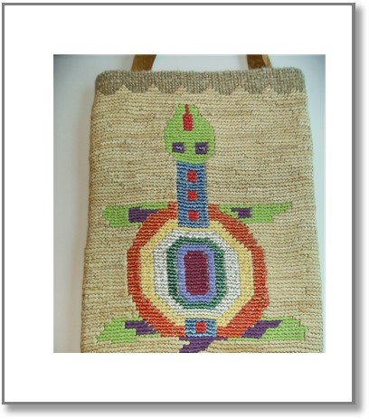

**Gifts of the Forest**

In creating this Salish robe, I chose to represent our connection to the forest in weaving this piece. As Salish people, so many of the gifts we create as artists are first gifts of the forest. Therefore I was inspired to honor this "original gift", and honor the splendor and beauty of the forest, through weaving

patterns representing the forest in its complexity, interconnectedness, and depth.

**Wasco Turtle Cornhusk**

My uncle came to my mom a few summers ago and asked her to give one last Native cornhusk basket class for him before her hands gave out to arthritis. I wanted to give it a try and learn as much as I could from my mom while I could. To my surprise I enjoyed working with cornhusk. I made miniature baskets one right after the other, and continued practicing to hone my weaving skills.

The rest of the summer I worked on my cornhusk baskets and read books researching

from the large storage baskets to the show purses that were made in the past. Inspired by the baskets I read about and saw in our local museum, I decided I wanted to make a large basket at least once. I cut my strings, mapped out my design and started. To my horror some of my strings turned out short! But I was determined to finish my project so I recounted my designs and ended with my little, sort, fat, colorful turtle. It taught me that baskets often take you in a new direction and you must find the beauty in the art you do.