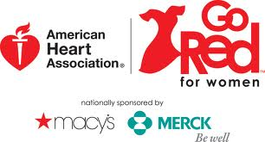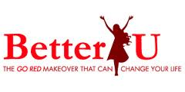

We are pleased to announce that the American Heart Association is accepting applications for women who would like to participate in the 2013 Go Red For Women BetterU Challenge – a challenge that could save your life.

Background: Research shows that most cardiac events can be prevented if women make small, yet life-saving choices for their hearts. Go Red For Women is the American Heart Association’s national movement to make women aware of their risk for heart disease and provide inspiration to take action to reduce that risk.

Participants in the Go Red For Women BetterU Challenge will take part in a 12-week program, with events scheduled Wednesday evenings from April 10– June 26. Each participant will be given an initial and follow-up wellness screening, in addition to learning about nutrition, exercise, CPR, and other aspects of heart and brain health.

The BetterU Challenge provides the education and tools for women to take charge of their health personally and for their family. The 12-week program will include the following lessons and activities, utilizing experts in the field and trusted information from the American Heart Association: 1) Getting Started On A BetterU, 2) Reduce Your Risk Factors, 3) Stick to Your Plan, 4) Surround Yourself with Support, 5) Weight Control for Your Heart, 6) Break Through Barriers, 7) Learn the Truth About Cholesterol, 8) Increase Your Blood Pressure IQ, 9) Get the Lowdown on Diabetes, 10) It’s All in the Family (History), 11) Live Smoke Free, 12) Pledge for a Healthy Future. Each participant will receive a BetterU booklet, a healthy heart starter kit, and before/after screenings. We’ll also follow-up for several months after the 12-weeks to empower participants to take charge of their health.

We are looking for a diverse group of women, 18 and over, who are ready to make a positive change to their health. Participant numbers are limited, so submit your application early.

Please fill out the online or attached application and return it to: puget.sound@heart.org or 710 2nd Avenue, Suite 900, Seattle, WA 98104. If you have questions, please call 206-632-6881. We look forward to an exciting 12 weeks with you!

With support from

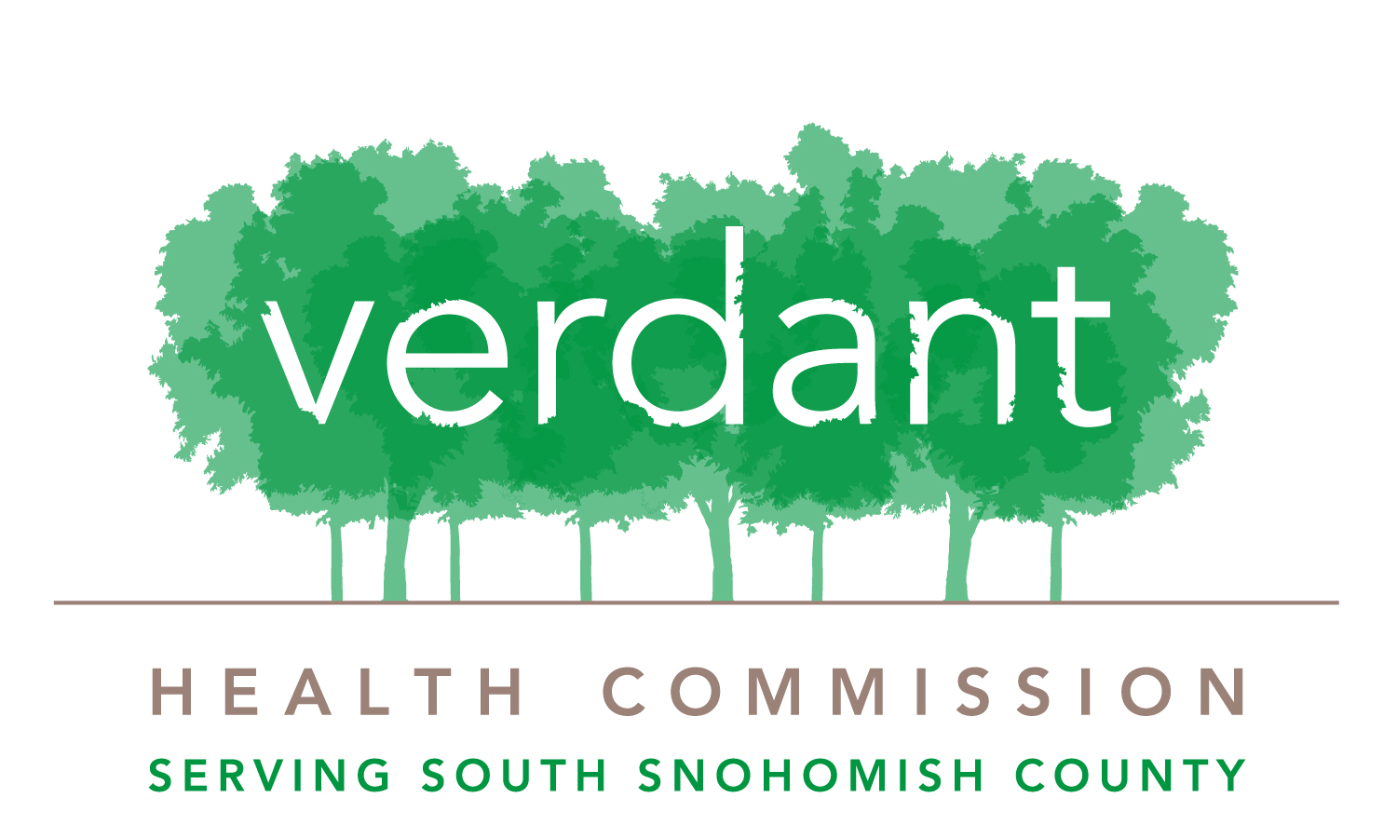
National Center Only

2013 Go Red For Women BetterU Challenge
PARTICIPATION AND PUBLICITY RELEASE AND WAIVER OF LIABILITY
Basic Information
First name: Last name:
Street Address: Apt #:
City: ______________________________________ State: ____________________________ Zip Code:
Daytime phone: (______)____________ Evening phone: (______)______________ Email:
Age: ______________ Birth date: ______ / _______ /_______ (Must be 18 years of age or older to participate)
Ethnicity: ◻ Asian/Indian ◻ African American ◻ Hispanic ◻ Caucasian/White ◻ Other
Health Insurance: Uninsured _______ Public Health Insurance (ex. Medicaid, Basic Health, etc.) _______ Private Insurance _________

heart health information
Are you a heart disease survivor? □ Yes □ No
Do you currently or have you previously suffered from the following?
□ Heart attack □ Heart transplant □ Stroke □ Congenital heart condition
□ High blood pressure □ High cholesterol □ Diabetes □ Obesity
□ Other
How old were you when you had your experience with heart disease?
Do you have a family history of heart disease? □ Yes □ No
If yes, who in your family has suffered from heart disease?
□ Mother □ Grandmother □ Father □ Grandfather □ Sibling □ Other

What inspires you to participate in this program?
________________________________________________________________________________________________________________________________________
________________________________________________________________________________________________________________________________________
________________________________________________________________________________________________________________________________________

With support from

2013 American Heart Association’s Go Red For Women® BetterU Challenge

This participation and publicity release and waiver of liability (the “Release and Waiver”) is effective as of the date of my signature below.

In order to support the AHA in its mission of fighting heart disease and stroke, I agree to the terms of this Release and Waiver. I acknowledge and understand that I have agreed to participate in the 2013 American Heart Association “Go Red For Women” BetterU Challenge. I acknowledge the potential risk of injury from participation in the Challenge, including the potential for bodily injury or even death, and while appropriate rules, supervision, and equipment may diminish this risk, the risk of serious injury does nevertheless exist. I hereby knowingly and freely assume all such risks, both known and unknown, and assume full responsibility for any and all injuries (including death) or loss arising from my participation in the Challenge.

I, on behalf of myself and my successors, heirs and assigns, agree to forever release and hold harmless the American Heart Association (“AHA”), Verdant Health Commission “Verdant”), and their respective franchisees, divisions, affiliates, parents, subsidiaries, venture partners and agencies, successors and assigns, and each of their respective officers, directors, employees, agents and legal representatives, and those acting with authority or permission from any of them (collectively, the "Released Parties"), from and against any claims or demands resulting from any and all injuries (including death) or loss (including damage to property) suffered by me arising out of or related to my preparation for or participation in the Challenge or any activities related thereto regardless of the cause thereof, including the negligence of the Released Parties. I fully and forever release and discharge the Released Parties from, and covenant not to sue the Released Parties, for any and all claims, demands, damages, rights of action, or causes of action, present or future, whether known or unknown, anticipated or unanticipated, resulting from or arising out of my preparation for, presence at, or participation in the Event or any activities related thereto, including claims resulting from the negligence of the Released Parties.

I agree to serve as a volunteer spokesperson on behalf of the AHA to further its mission of fighting heart disease and stroke. I will share my Health Story, (the term “Health Story” includes, among other things, my medical information), with the AHA, the public, and parties working with the AHA in support of its mission. I verify the truth and accuracy of all personal statements presented in my Health Story. I understand and agree that the AHA may share my Health Story, and my name, address, phone number and other contact information with various media outlets for publication, including newspapers, public relations agencies, television, radio, magazines, the Internet, including other health related Web sites, and with any other third parties working with the AHA to provide educational information on heart disease and stroke to the general public, for consideration for use in the AHA’s public relations and educational promotions and materials. The AHA may introduce me to media representatives, but the AHA has no obligation to do so. I will give interviews on my Health Story for use and publication in newspapers, magazines, television, radio or other media or with other third parties working with the AHA and will do so upon request of the AHA.

I assign to the AHA the right to use medical information about me. I also acknowledge that I have enough facts about the disclosure of the medical information to understand and consent to the disclosure.

I understand that the Released Parties might, in their sole discretion, undertake a production, or a deviation whether recorded on or transferred to print, videotape, film, slides, photographs, audio tapes, Web site, Internet, electronic media or other media, now known or later developed, of my Health Story (the“Productions”) and that my name, likeness, image, voice, appearance, performance and/or written words submitted to the AHA might be made a part of the Productions.

I grant the Released Parties and its designees the right to use my name, likeness, image, voice, appearance, performance and/or written words submitted to the AHA as embodied in the Production or any derivation, whether recorded on or transferred to print, videotape, film, slides, photographs, audio tapes, web site, internet, electronic media or other media, now known or later developed. This grant includes, without limitation, the right to edit, mix or duplicate and to use or re-use the Production in whole or part as the AHA or other Released Party may elect. The AHA or the Released Parties shall have complete ownership of the Productions in which I appear, including copyright interest, and I acknowledge that I have no interest or ownership in the Productions or its copyright.

I also grant the Released Parties and their designees the right to broadcast, exhibit, publish, and otherwise distribute the Productions either in whole or in part, and either alone or with other products, for commercial or non-commercial use or any other purpose the AHA or its designees in their sole discretion may determine. The rights granted the Released Parties herein are unrestricted, absolute, perpetual, and worldwide.

I hereby waive all rights and release the Released Parties from, and shall neither sue nor bring any proceeding against, any such parties for any claim or cause of action, whether now known or unknown, for defamation, invasion of right to privacy, publicity or personality or any similar matter, or based upon or relation to the use and exploitation of the Productions. I hereby waive my rights, if any, to receive any additional compensation for use of the Productions. I also waive the right to inspect or approve the finished Productions or any part or element thereof that incorporates, in whole or in part, the Productions or Health Story.

I have given nothing of value to any employee of a Released Party for the right to appear in any Production.

I agree that there shall be no obligation to utilize the authorization granted by me hereunder, or for the released parties to use the Health Story or any other information I have provided. I acknowledge, recognize and agree that all decisions whether to use any of the information I provide, or to use me as a spokesperson, rests solely with the AHA, or any other agent of the AHA, and that their decisions in this regard are final and not subject to dispute by me or any other participant. The terms of this Release and Waiver shall commence on the date hereof and be without limitation.

If any provision of this Release and Waiver is deemed to be invalid or unenforceable to any extent, the remainder of this Release and Waiver shall not be affected, and each remaining provision of this Release and Waiver shall be valid and enforceable to the fullest extent permitted by law.

This Release and Waiver shall be governed by and construed in accordance with the laws of the State of Texas, regardless of such state’s conflict of laws provisions. Any suit or action arising shall be filed in a court of competent jurisdiction with the District Courts in Dallas County, Texas. I hereby consent to the personal jurisdiction of said court within the State of Texas, and waive all defenses of lack of personal jurisdiction and forum non convenience.

I HEREBY WARRANT AND CERTIFY THAT I AM AT LEAST 18 YEARS OF AGE AND HAVE THE RIGHT TO CONTRACT IN MY OWN NAME. I HAVE READ THIS RELEASE AND WAIVER AND HAVE BEEN GIVEN AN OPPORTUNITY TO BARGAIN IN REGARD TO ITS TERMS. I FULLY UNDERSTAND ITS TERMS AND THAT I HAVE GIVEN UP SUBSTANTIAL RIGHTS BY SIGNING IT. I HAVE SIGNED IT FREELY AND VOLUNTARILY WITHOUT ANY INDUCEMENT, ASSURANCE OR GUARANTEE BEING MADE TO ME. I INTEND MY SIGNATURE TO BE A COMPLETE AND UNCONDITIONAL RELEASE OF ALL LIABILITY TO THE GREATEST EXTENT ALLOWED BY LAW. THIS RELEASE AND WAIVER SHALL BE BINDING UPON ME AND MY HEIRS, LEGAL REPRESENTATIVES AND ASSIGNS.

Name Date

Signature

