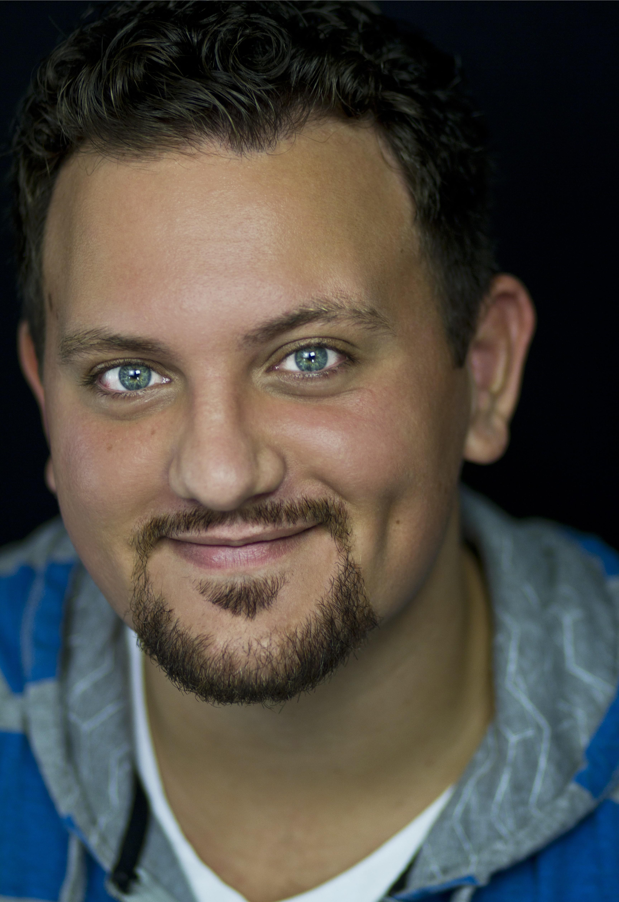
GREG JERNIGAN

Hair: Dark Brown |  |  |  |  | Eyes: Blue | Weight: 260 | Height: 6’3”
910-545-6906 |  |  |  |  | www.gregjernigan.com |  | jernigan.greg@gmail.com
FILM/TV
Mob VFX Reel |  |  |  |  | Al Capone |  | AMC
The Hunt with John Walsh |  |  |  |  | David Burgert |  | CNN/Zero Point Zero Productions
Mysteries at the Museum |  |  |  |  | Fred Oesterreich |  | The Travel Channel
Under the Dome |  |  |  |  | Rough Patron/Bouncer |  | CBS/Exec.Prod: Steven Spielberg
NATIONAL TOUR
Classics |  |  |  |  | Zaroff-Most Dangerous Game |  | Chamber Theatre Productions
Eureka |  |  |  |  | Fibonacci/Pythagoras |  | Chamber Theatre Productions
Encore |  |  |  |  | Brom Bones-Sleepy Hollow |  | CTP/Prod.Director: Spring Sirkin
EXPERIENCE
Blithe Spirit |  |  |  |  | Charles |  | West Virginia University
Down the Road |  |  |  |  | Dan |  | West Virginia University
Curtains |  |  |  |  | Darryl Grady |  | Shenandoah [SSMT]
South Pacific |  |  |  |  | Commander Harbison |  | Shenandoah [SSMT]
Guys and Dolls |  |  |  |  | Big Jule |  | West Virginia University
Julius Caesar |  |  |  |  | Casca |  | West Virginia University
Stage Beauty |  |  |  |  | King Charles II |  | West Virginia University
Dead Man’s Cell Phone |  |  |  |  | Gordon |  | West Virginia University
The Grapes of Wrath |  |  |  |  | Pa Joad |  | West Virginia University
Dracula |  |  |  |  | Van Helsing |  | West Virginia University
ECU Storybook Theatre |  |  |  |  | Various |  | Traveling theater group [3yrs]
The Imaginary Invalid |  |  |  |  | Argan |  | ECU/Loessin Playhouse
Of Thee I Sing |  |  |  |  | Francis Gilhooley |  | ECU/Loessin Playhouse
An Ideal Husband |  |  |  |  | Lord Goring |  | The Magnolia Arts Center
Historical Interpreter |  |  |  |  | Valentine Beale |  | Roanoke Island Festival Park
The Tempest |  |  |  |  | Stephano |  | ECU/Loessin Playhouse
James and the Giant Peach |  |  |  |  | Aunt Sponge |  | ECU Family Fare Series
A Funny Thing/Forum |  |  |  |  | Marcus Lycus |  | The Paramount Theater
Footloose |  |  |  |  | Garvin |  | The Paramount Theater
Ubu Roi |  |  |  |  | Ubu Roi |  | AMDA Studio One
Much Ado About Nothing |  |  |  |  | Sir Leonato |  | AMDA Studio One
Moon Over Buffalo |  |  |  |  | Paul Singer |  | The Bodenhamer Auditorium
The Rainmaker |  |  |  |  | Jimmy Curry |  | The Bodenhamer Auditorium
A Christmas Carol |  |  |  |  | Mr. Fezziwig |  | The Bodenhamer Auditorium
Romeo & Juliet |  |  |  |  | Balthasar |  | The Bodenhamer Auditorium
TRAINING
West Virginia University
MFA Acting, Morgantown, WV
East Carolina University
BFA Theatre Education K-12, Greenville, NC
The American Musical and Dramatic Academy
The Studio Program, NYC
SPECIAL SKILLS

Stage Combat, Fencing, RP, Belch on Command, Animal and cartoon impressions, can wiggle ears.

